Synthesis and characterisation of the new oxyfluoride Li⁺ ion conductor, Li₅SiO₄F
Bo Dong†,*, Jinhui Yan†, Brant Walkley†, Kenneth K. Inglis‡, Frédéric Blanc‡,§,*, Stephen Hull⊥, Anthony R. West†,*
† University of Sheffield, Department of Material Science and Engineering, Mappin Street, Sheffield S1 3JD, UK
‡ University of Liverpool, Department of Chemistry, Crown Street, Liverpool L69 7ZD, UK
§ University of Liverpool, Stephenson Institute for Renewable Energy, Crown Street, Liverpool, L68, 7ZD, UK
⊥ The ISIS Facility, STFC, Rutherford-Appleton Laboratory, Didcot, Oxfordshire OX11 0QX, UK
KEYWORDS: Lithium silicon oxyfluoride, Li⁺ ion conductor, solid state electrolyte.
ABSTRACT: A new polymorphic phase, Li₅SiO₄F, with Li⁺ ion dynamics that are structurally distinct from Li₄SiO₄, is described. The γ polymorph forms at 750-775 °C, melts incongruently at 800 ºC and crystallizes in a monoclinic unit cell: a = 8.67(1) (Å), b = 16.51(1) (Å), c = 11.23(2) (Å), β = 96.61(4) (º) and V = 1602.3(3) (Å³). The α polymorph forms at 650 ºC and appears to be metastable. The γ polymorph has a Li⁺ ion conductivity of 1.2x10⁻⁷ Scm⁻¹ at 40 ºC, that is several orders of magnitude higher than both the α polymorph and Li₄SiO₄, with an associated activation energy of 0.51(1) eV. Variable temperature ¹⁹F and ⁷Li static NMR measurements show the absence of F⁻ mobility but the existence of Li⁺ mobility and confirm that Li⁺ is the main charge carrier in both polymorphs of Li₅SiO₄F. ⁷Li line narrowing NMR experiments suggest that the barrier to local Li hopping is fairly small (0.2-0.3 eV) with faster Li⁺ ion dynamics in γ-Li₅SiO₄F compared to α-Li₅SiO₄F. γ-Li₅SiO₄F has negligible electronic conductivity, is stable in contact with Li metal and is a new type of stoichiometric, mixed anion, Li⁺ ion conductor.
INTRODUCTION
Batteries are increasingly used in electrical storage systems to store energy from intermittent sources (e.g. solar and wind) within electrical power grids and for electric or hybrid electric vehicle propulsion.¹ Safety issues associated with lithium batteries are usually caused by the organic liquid electrolyte, which may become flammable when lithium dendrite formation occurs during battery cycling, leading to short circuiting and overheating.² One solution to this issue involves the use of solid electrolytes; however, additional problems may then arise due to (i) the low conductivity of most potential lithium solid electrolytes and (ii) high impedance associated with solid-solid interfaces in an all-solid-state lithium battery.
For many years, there has been significant interest in doped Li₄SiO₄ and related LISICON (derived from LIthium SuperIonic CONductor) materials as solid electrolytes,³⁻⁶ with the commercialisation of a thin film, solid state lithium battery using LIPON (lithium phosphorus oxynitride) solid electrolyte.⁷ Li₄SiO₄ is stable in contact with a lithium metal anode but its conductivity is too low (less than 10⁻¹⁰ Scm⁻¹ at 25 ºC)⁸ for practical applications.⁹ Many doping studies of Li₄SiO₄ and related materials have been carried out,⁹ leading to enhanced conductivity. These have usually involved cation doping within a fixed oxide framework; the enhanced conductivity is associated with either Li interstitials or Li vacancies which arise due to charge compensation of aliovalent dopants.¹⁰ Considering the similar sizes of the O²⁻ and F⁻ ions (octahedral radii of 1.26 Å for O²⁻ and 1.19 Å for F⁻)¹¹, several oxyfluoride cathode (LiFeSO₄F¹² and LiFePO₄F¹³) and anode materials (Li₂VO₂F¹⁴ and KNb₂O₅F¹⁵) have been successfully synthesised and showed enhanced capacities and cyclabilities. In contrast, the possibility of aliovalent anion doping of solid state electrolyte materials, such as Li₄SiO₄, has been little studied.
During an unsuccessful attempt to dope Li₄SiO₄ with LiF, we have instead, prepared a new phase, Li₅SiO₄F, whose high temperature γ polymorph has comparable Li⁺ ion conductivity to cation-doped Li₄SiO₄ materials. This is the first example of a high lithium ion conductivity solid electrolyte in a silicate-fluoride system and demonstrates the potential of such mixed anion systems for novel solid electrolyte applications. In this paper, we report the synthesis of Li₅SiO₄F, the existence of two polymorphs (α and γ) and the Li⁺ ion dynamics of both phases using impedance spectroscopy and variable temperature ⁷Li NMR experiments. The results obtained from impedance spectroscopy give bulk conductivity data but cannot always explicitly identify the conducting species. The temperature dependent ⁷Li NMR line width and spin-lattice relaxation rates, which are very sensitive to Li⁺ mobility, show explicitly that Li⁺ is the charge carrier in both phases of Li₅SiO₄F and highlight the faster Li⁺ ion mobility of the γ phase over the α phase in this new Li⁺ ion solid electrolyte.

EXPERIMENTAL
Li₂CO₃ (Sigma-Aldrich, 99%), SiO₂ (Alfa Aesar, 99.5%) and LiF (Alfa Aesar, 99%) starting materials were dried at 180 ºC and stored in a desiccator. As an exploration into the possible doping of Li₄SiO₄ with LiF and subsequently into compound formation, numerous samples in the composition triangle Li₂O-LiF-SiO₂ were prepared (Table Supplementary 1). The starting materials were weighed according to the desired stoichiometry, ground with a mortar and pestle using acetone for 30 min, dried, pressed at 15 MPa for 1 min into pellets of diameter 9.8 mm and thickness 1-2 mm, placed in a gold boat and transferred to a muffle furnace. Pellets were heated at 400 ºC (heating rate, 5 ºC/min) for 2 h to drive off CO₂, cooled to room temperature, reground, repelleted and heated to temperatures in the range 600 to 800 ºC (heating rate, 5 ºC/min) for 10 h. The α- and γ- forms of Li₅SiO₄F were obtained at 650 and 750-775 ºC, respectively, with each temperature chosen to yield products that did not change on prolonged heating.
A Bruker D2 X-ray diffractometer with Cu Kα radiation (λ= 1.5418 Å) was used for phase identification. Patterns were recorded over the range 15° to 80°. For indexing, a Stoe STADI P X-ray diffractometer with Cu Kα₁ radiation (λ=1.5406 Å) and a linear position sensitive detector (PSD) was used with WinXpow and PDF 2016 software.
Pellets for impedance measurements were sintered at their synthesis temperature for 4 h before coating opposite faces with Au paste to form electrodes and attached to the Pt leads of a conductivity jig which was placed inside a horizontal tube furnace. Impedance data were recorded in air with a Solartron analyser, model 1260 with 100 mV ac voltage and frequency range 10⁻² to 10⁶ Hz.
DSC data were collected using a NETZSCH 404C instrument at 10 ºC/min heating/cooling rate under 50/50 Ar/air atmosphere. Data were analysed using Proteus Analysis software. X-ray fluorescence (XRF) measurements were carried out with a PANalytical Zetium Spectrometer using a Rh X-ray tube.
For electrochemical testing, the new phase Li₅SiO₄F, was pressed into 1 mm thick pellets and heated at 750 ºC for 4 h. A half-cell, Li/Li₅SiO₄F/Li, was constructed using a Swagelok test cell. Cyclic voltammetry was carried out between 0 V and 6 V in 10 mV steps for two cycles using a Perkin-Elmer VMP tester.
Solid-state NMR experiments were obtained at 9.4 T on a Bruker Avance III HD spectrometer. Variable temperature ⁷Li static spectra were collected with a Bruker 4 mm HXY Magic Angle Spinning (MAS) probe in double resonance mode below 21 °C and with a Bruker 4 mm HX high temperature MAS probe between 21 and 380 °C with the X channel tuned to ν₀(⁷Li) = 155.5 MHz. ⁷Li spectra were obtained with a π/2 pulse of 1.5 μs at a rf amplitude of ν₁(⁷Li) = 83 kHz. Spin-lattice relaxation rates (T₁⁻¹) were obtained with a saturation recovery pulse sequence and fitted to a reverse exponential of the form: 1 – exp(–τ/T₁)ª, where τ and a are variable delays and the stretched exponential coefficient (between 0.75 and 1), respectively. Spin-lattice relaxation rates in the rotating frame (T_{1ρ}⁻¹) were obtained with a spin-lock experiment of form: π/2–τ_{spin-lock}–acq, at spin-lock frequencies of ν₁(⁷Li) = 20, 33 and 50 kHz and data fitted to a stretched exponential of the form: exp(–τ/T_{1ρ})ª, where a was set between 0.5 and 1.
Variable temperature ¹⁹F NMR static spectra were obtained with a Bruker 4 mm HX high temperature MAS probe between 21 and 150 °C with the ¹H channel detuned to ν₀(¹⁹F) = 376.5 MHz. ¹⁹F static spectra were obtained with π/2 pulses at an rf amplitude of ν₁(¹⁹F) = 83 kHz. ¹⁹F fast MAS spectra were recorded with a Bruker 1.3 mm HXY MAS probe (in double resonance mode) with the ¹H channel detuned to ν₀(¹⁹F) = 376.5 MHz and using a pulse – acquire sequence with π/2 pulses at an rf amplitude of ν₁(¹⁹F) = 200 kHz. Quantification of the fluoride content from fast MAS data used the CF₃CH₂OH reference as an external standard. Temperature calibrations were performed with the ²⁰⁷Pb chemical shift thermometer Pb(NO₃)₂ ¹⁶⁻¹⁷ and by following the γ-to-β phase transition of CuI at 369 °C using ⁶³Cu NMR.¹⁸⁻¹⁹ All temperatures reported are actual sample temperatures with an estimated accuracy of ± 5 °C between -163 and 147 °C and ± 10 °C between 147 and 377 °C. All spectra were obtained under quantitative conditions (with recycle delays longer than 5x the spin lattice relaxation times T₁). ⁷Li and ¹⁹F spectra were referenced to 10 M LiCl in D₂O at 0 ppm and neat CF₃CH₂OH at -77.03 ppm (corresponding to CFCl₃ at 0 ppm).²⁰

RESULTS AND DISCUSSION
Synthesis and characterization of Li₅SiO₄F
Initial attention focused on the possible synthesis of F-doped Li₄SiO₄ but it became apparent that, instead of successful doping, other previously-unreported phases were showing up in the XRD results, with indications of enhanced lithium ion conductivity from preliminary conductivity measurements. An exploratory study of compound formation in the system Li₂O-SiO₂-LiF was required to isolate the highly conducting new phase.
The results of solid state reaction between Li₂O (using Li₂CO₃ as starting material), LiF and SiO₂ fell into two groups, depending on the overall composition, as shown in the ternary composition triangle, Fig. 1. Compositions bounded by Li₂O, Li₂SiO₃ and LiF could be heated safely to 800 ºC without loss of fluoride, as evidenced by XRF data (Table 1) and ¹⁹F MAS spectra (Fig. S1). XRD analysis of the products of heating a range of compositions in this area, Table S1 and Fig. S2, showed the formation of a new phase which was phase-pure at the composition Li₅SiO₄F. Results of the XRF analysis of γ-Li₅SiO₄F, Table 1, match the expected sample composition, within error. Additionally, the ¹⁹F MAS spectra recorded against an external standard show the presence of one fluoride (± 0.1) per formula unit. Both datasets confirmed the Li₅SiO₄F composition and therefore, that compositions in this region of the ternary composition triangle can be reacted satisfactorily without loss of fluoride or lithium.
Li₅SiO₄F is polymorphic, Fig. 2; the form labelled α is the reaction product at ~ 650 ºC and the form labelled γ is the reaction product at ~ 750 ºC. Transformation of the α to γ polymorph occurs at temperatures above ~ 650 ºC and is not reversible on reheating the γ polymorph at 600-650 ºC, indicating that the α polymorph is probably metastable. The α to γ transformation was not accompanied by any significant weight loss, as shown by weight measurements on a sample before and after transformation and therefore, the α form is not an oxy-carbonate phase. The γ form melts at ~793 ºC, as shown by DSC, Fig. 3, with a sharp endotherm on heating at ~793 ºC. XRD patterns recorded after brief melting at 850 ºC followed by rapid cooling showed a mixture of phases including Li₄SiO₄ and LiF. This indicates that melting of Li₅SiO₄F is incongruent; if the melting were congruent then instead, γ-Li₅SiO₄F should be the main product of crystallization on cooling. The exotherm observed on cooling at~758 ºC, Fig. 2, is attributed to crystallization of the liquid in the fully or partially melted sample.
XRD data for γ-Li₅SiO₄F were indexed on a monoclinic unit cell with a = 8.67(1) (Å), b = 16.51(1) (Å), c = 11.23(2) (Å), β = 96.61(4) (º) and V = 1602.3(3) (Å³), Table S2. All lines shown for γ-Li₅SiO₄F in Fig. 2 were indexed and were well within a Δ2θ difference window of 0.05º for experimental and calculated peak positions. We do not know the structure of γ-Li₅SiO₄F and the pattern of α is, as-yet, unindexed. As we do not, yet, have a structural model for γ-Li₅SiO₄F, it is not possible to carry out Rietveld refinement since this is a structure refinement, not structure determination technique.
The structures of γ and α polymorphs are not solid solutions derived from Li₄SiO₄, as their XRD data are significantly different from that of Li₄SiO₄ (Fig. 2) and are different from that of any other known lithium silicate phase. There is no unreacted LiF present (Fig. 2) as also confirmed by the ¹⁹F MAS NMR spectra of both polymorphs (Fig. S1) which does not show the known ¹⁹F signal of LiF (expected at -204 ppm).²¹ From the formula Li₅SiO₄F, we anticipate that the structure contains two anions, SiO₄⁴⁻ and F⁻, without any replacement of O by F in the silicate tetrahedra.

Electrical properties
Impedance data for γ-Li₅SiO₄F with gold electrodes at different temperatures in air are shown in Fig. 4. The impedance complex plane plots (a-d) consist of a high frequency arc and a low frequency inclined spike, which starts to show curvature at the highest temperatures (d). M’’/Z’’ spectroscopic plots for one temperature, 95 °C, (e) show overlapping high frequency peaks. Since M’’ peaks represent the component of the sample with the smallest capacitance, which is usually the bulk component, this indicates that the Z’’ peak, and the associated Z* arc, also represent the bulk response of the sample.
C’ spectroscopic plots (f) show a limiting high frequency capacitance, C with value 4 x 10⁻¹² Fcm⁻¹. This corresponds to the bulk permittivity ε∞’, with a value, 45.2, given by ε∞’ = C/ε₀, where ε₀ is the permittivity of free space, 8.854 x 10⁻¹⁴ Fcm⁻¹. The C’ data also show a partially-resolved intermediate frequency plateau, of value ~8 x 10⁻¹² Fcm⁻¹ and a large increase at lower frequencies to values approaching 10⁻⁵ Fcm⁻¹. The intermediate frequency plateau is unlikely to represent a grain boundary contribution to the impedance since its value is much smaller than expected for a typical grain boundary whose capacitance, based on geometric considerations, is usually 1-3 orders of magnitude larger than the bulk capacitance.
An alternative possibility is that the intermediate frequency plateau represents a dipole contribution to the ac conductivity, similar to that which has been evidenced recently in impedance data of yttria-stabilized zirconia, YSZ.²²⁻²³ Dipolar processes do not contribute to long range dc conduction; they are represented, ideally, by an equivalent circuit that contains a resistance, R in series with a blocking capacitance, C. Conduction processes, by contrast, are represented by a parallel combination of a resistance, capacitance and constant phase element, CPE; the CPE is required to model deviation from ideal, Debye-like behaviour and effectively, is a parallel combination of a frequency-dependent resistor and frequency-dependent capacitor.
The new circuit element used to model the high frequency part of the bulk impedance data of YSZ²³ is a combination, in parallel, of the element that represents bulk dc conduction, R₁, C₁, CPE₁ and an element that represents dipolar processes, R₂, C₂. This forms the left side part of the master equivalent circuit shown in Fig. 5. Inclusion of the dipole element R₂, C₂, in Fig. 5 does not affect the magnitude of the dc conductivity, R₁⁻¹, whose value is obtained from the intercept of the arc or low frequency spike on the Z’ axis of the Z* plots, Fig. 4 (a).
In order to model the low frequency, inclined spike in the impedance complex plane plots (a-d) and the large increase in capacitance seen at low frequencies (f), an additional element in the equivalent circuit is required that is in series with the bulk element. This additional element represents blocking of ionic conduction, in this case of Li⁺ ions (confirmed by NMR measurements, discussed below) across the sample-electrode interface, but is not a simple capacitor since the angle to the real, Z’ axis of the inclined spike is less than 90º. Instead, a second constant phase element, CPE₃ is required in the equivalent circuit, Fig. 5. At higher temperatures, the low frequency impedance data show curvature in the inclined spike which indicates that CPE₃ is terminated at the lowest frequencies by a finite parallel resistance, R₃.
Impedance data were fitted to the equivalent circuit, Fig. 5, using ZView software,²⁴ but for any given data set, the frequency range was insufficient to allow all parameters in the master circuit (Fig. 5) to be varied. At lower temperatures, component R₃ was too large to be detected and refined and was excluded from the fit shown in Fig. 6. By contrast, at higher temperatures, element C₁ (fixed at 1 pF cm⁻¹) was excluded from refinement of the fit shown in Fig. 7.
Fig. 8 shows Arrhenius plots of the bulk conductivities, R₁⁻¹, of α-, γ-Li₅SiO₄F and, for comparison, Li₄SiO₄. Conductivities and activation energies of α-Li₅SiO₄F and Li₄SiO₄ are similar whereas the conductivity of γ-Li₅SiO₄F is several orders of magnitude higher, especially at lower temperatures and with a smaller activation energy, 0.51(1) eV. γ-Li₅SiO₄F is therefore, an entirely new Li⁺ ion conductor, that is structurally distinct from Li₄SiO₄ and its doped derivatives. γ-Li₅SiO₄F is a stoichiometric phase and not a solid solution derived from Li₄SiO₄ whose conductivity has been increased by doping. It may, therefore, be amenable to conductivity enhancement by suitable doping.
Inclusion of R₃ in analysis of the higher temperature data gives a method to estimate ionic, t_{i} and electronic, t_{e} transport numbers because the existence of R₃ implies a finite, dc leakage current through the sample-electrolyte combination. Since discharge of Li⁺ ions is regarded as unlikely at these temperatures, R₃ provides an estimate of the residual electronic conductivity of the sample. Since R₃>>R₁, we make the assumption that R₁ is the ionic resistance, R₃ is the electronic resistance and calculate the electronic transport number from the ratio R₁:R₃. This gives a value, for the data shown in Fig. 7, of t_{e} = 0.005 at 143 ºC.
Cyclic voltammetry tests were carried out at room temperature on pellets of γ-Li₅SiO₄F over the voltage range 0 – 6V, with the following observations: the colour of γ-Li₅SiO₄F remained white over several cycles; there was no indication of any significant redox processes occurring for biases up to 6 V, Fig. 9; the XRD pattern of γ-Li₅SiO₄F did not change after the CV test. These observations are a good indication that γ-Li₅SiO₄F is stable in contact with Li metal, unlike titanate-based perovskites such as Li_{(0.5+3x)}La_{(0.5-x)}TiO₃ which reduce readily in contact with Li metal. The sensitivity of the equipment used to record the I-V plot in Fig. 9, showed a small current was detected with increasing voltage, from which the resistance of the sample-electrode combination under those conditions was estimated. The value obtained, ~ 15 MΩ at room temperature, is comparable to that estimated by extrapolation of the Arrhenius plot to 25 ºC of 38 MΩ. It therefore corresponds approximately to the bulk resistance R₁. The relatively short timescales used to record data points for the I/V plot were insufficient to be able to detect R₃ in the I/V data.

NMR spectroscopy
Information regarding Li⁺ ion dynamics of both α- and γ-Li₅SiO₄F phases were obtained from variable temperature ⁷Li static NMR spectra, Fig. 10. At room temperature, both phases show a complex NMR line shape typical of ⁷Li in various overlapping environments containing the ⁷Li–⁷Li dipolar broadened central transition (+1/2 ↔ −1/2) with full width at half-maximum (fwhm) of ~13.5 and ~13 kHz for α-Li₅SiO₄F and γ-Li₅SiO₄F, respectively, along with the ⁷Li satellite transitions observed at ~ ± 500 ppm. Below room temperature, the ⁷Li central NMR line of γ-Li₅SiO₄F broadens (fwhm ~13.6 kHz), highlighting the presence of Li mobility under ambient conditions. As temperature increased, the central transition narrows further, indicating averaging of the ⁷Li–⁷Li dipolar interactions due to an increase in Li⁺ mobility, Fig. 11 (a). The onset of this motional narrowing of the NMR line widths is observed at 24 ºC for γ-Li₅SiO₄F, at much lower temperature than that of α-Li₅SiO₄F (126 ºC), highlighting the faster Li⁺ diffusion in γ-Li₅SiO₄F.
At the inflection point of the temperature-dependent line narrowing, Fig. 11 (a), the Li⁺ jump rate τ⁻¹ is estimated from the NMR line width at fwhm in the low temperature rigid-lattice regime, Δ_{ωrigid lattice}. The inflection points are obtained using a sigmoidal regression fit and jump rates τ⁻¹ of ∼8.5(1) × 10⁴ and ∼8.6(1) × 10⁴ s⁻¹ at 220 and 130 ºC for α-Li₅SiO₄ and γ-Li₅SiO₄F are extracted, respectively. The onset of motional narrowing occurs at a much lower temperature for γ-Li₅SiO₄F than α-Li₅SiO₄F, and indicates faster Li⁺ ion dynamics in the former phase. When compared to Li₄SiO₄, the onset of Li⁺ motion occurs at ~100 ºC, highlighting the faster Li⁺ ion dynamics in γ-Li₅SiO₄F.²⁵ Note that within a similar temperature window, the ¹⁹F static NMR lineshape of both phases remain constant (fwhm ~35 kHz) suggesting the absence of mobile fluoride ions, Fig. 12.
The temperature dependence of ⁷Li spin-lattice relaxation (SLR) rates in the laboratory frame (T₁⁻¹) and the rotating frame (T_{1ρ}⁻¹) for α-Li₅SiO₄F and γ-Li₅SiO₄F are shown in Fig. 11 (b). The changes in relaxation rates arise from changes in the local magnetic interactions through increased Li ion mobility and hence provide information on Li⁺ ion dynamics on the orders of the Larmor (MHz) and spin-lock frequencies (kHz) for SLR experiments.²⁶⁻²⁷
In α-Li₅SiO₄F, T_{1(ρ)}⁻¹ values are relatively temperature-independent below room temperature, highlighting little Li mobility. Above 120 ºC, T_{1(ρ)}⁻¹ rates increase as the temperature increases, and indicate the ⁷Li slow motional regime (ωτc ≫ 1 where ω and τ_{c} are the probed frequencies and correlation times of the motion, respectively). Using the Arrhenius equation, activation barriers of 0.20(1) and 0.30(2) eV are extracted from the low-temperature flanks of the T₁⁻¹ and T_{1ρ}⁻¹ rates, respectively. Here, in this regime, the T_{1(ρ)}⁻¹ values are characteristic of local processes such as hops between local energy minima that may contribute to unsuccessful jumps to neighbouring Li sites.^{26, 28-29} These energy barriers do not probe long range translational Li⁺ diffusion and are therefore not directly comparable with the results obtained with the conductivity data given above (Fig. 5).
In the case of γ-Li₅SiO₄F, T_{1(ρ)}⁻¹ values below -60 ºC vary weakly with temperature. Between -60 and 60 ºC, T_{1ρ}⁻¹ rates increase and a small activation barrier of 0.08(1) eV was obtained. This value is very small and probably probes atomic vibration rather than Li diffusion, which is not observed in T₁⁻¹ values due to the shorter timescale probed. Above 60 ºC, both T₁⁻¹ and T_{1ρ}⁻¹ rates increase with temperature, indicating a slow motional regime and local Li⁺ hops with activation barriers of 0.22(1) and 0.21(1) eV, respectively.
Fig. 11 (b) also gives the SLR data obtained by Xu and Stebbins for Li₄SiO₄.³⁰ In the temperature range 110–240 ºC, an activation barrier of ~0.3 eV was obtained, higher than what is observed for both α-Li₅SiO₄F and γ-Li₅SiO₄F in the same temperature range. Above 240 ºC, the activation barrier decreases for Li₄SiO₄ to ~0.2 eV, closer to what is observed for both α-Li₅SiO₄F and γ-Li₅SiO₄F, Fig. 11 (b) and suggesting that the Li diffusion pathways in these two phases are similar.

CONCLUSIONS
Appropriate reaction conditions to avoid loss of fluoride on heating mixtures of Li₂CO₃, LiF and SiO₂ have been determined. In the phase diagram Li₂O-LiF-SiO₂, the tie-line Li₂SiO₃-LiF separates those compositions that contain more SiO₂, and lose fluoride on heating in air at 800ºC, from those that are stable under similar reaction conditions.
On the join Li₄SiO₄-LiF, a new polymorphic phase, Li₅SiO₄F, stable to ~800 º C has been prepared and two polymorphs (α- and γ-) have been identified; XRF analysis confirmed its composition and showed that F loss did not occur during synthesis. The γ polymorph of Li₅SiO₄F was indexed on a monoclinic unit cell with parameters, a = 8.67(1), b = 16.51(1), c = 11.23(2) Å, β = 96.61(4) º and V = 1602.3(3) Å³.
Impedance measurements on sintered pellets showed a homogeneous bulk response with no significant grain boundary impedance. The possibility of an additional ac conductivity associated with dipole reorientation was detected on replotting impedance data using the permittivity formalism and an equivalent circuit containing a combination of conducting and dipolar elements was proposed and shown to fit the data well. A low frequency spike characteristic of ion blocking at the sample – electrode interface and therefore, of Li⁺ ion conduction, was detected in the impedance data. From the curved nature of the spike at high temperatures and low frequencies, an estimate of the electronic transport number was made with t_{e} = 0.005 at 143 ºC.
The α-Li₅SiO₄F polymorph shows higher Li⁺ ion conductivity than the α-Li₅SiO₄F polymorph with a value of eg ~ 1.2x10⁻⁷ S cm⁻¹ at 40 °C. This value is several orders of magnitude higher than that of undoped Li₄SiO₄; γ-Li₅SiO₄F also has a smaller activation energy, 0.51(1) eV.
Solid state ⁷Li NMR experiments indicate Li⁺ mobility in both α-Li₅SiO₄F and γ-Li₅SiO₄F, highlighting its potential use as a solid electrolyte while ¹⁹F NMR reveals the absence of mobile fluoride ions. Faster Li⁺ ion dynamics were observed in γ-Li₅SiO₄F compared to α-Li₅SiO₄ with motional narrowing of the ⁷Li NMR line shape observed at lower temperatures and smaller activation barriers for local hops over multiple timescales in relaxometry experiments. Lower activation barriers were observed for both α-Li₅SiO₄F and γ-Li₅SiO₄F compared to Li₄SiO₄ in the same temperature range, indicating improved Li⁺ mobility.
The crystal structures of neither α- nor γ- polymorphs of Li₅SiO₄F are known and are under investigation; their powder XRD patterns are clearly different from that of Li₄SiO₄ and the structures cannot simply be regarded as solid solutions based on Li₄SiO₄. Both impedance measurements and ⁷Li static NMR data show that the two polymorphs of Li₅SiO₄F have Li⁺ diffusion properties and represent a new family of Li⁺ ion conductors stable in contact with Li metal which may find possible application in thin film solid state battery development.

AUTHOR INFORMATION
Corresponding Authors:
1. b.dong@bham.ac.uk
1. a.r.west@sheffield.ac.uk
2.3. frederic.blanc@liverpool.ac.uk
Notes
The authors declare no competing financial interest.

ACKNOWLEDGMENTS
BD thanks STFC and EPSRC for a Global Challenge PhD studentship. KKI thanks the EPSRC for a Doctoral Training Studentship.

REFERENCES
(1). Larcher, D.; Tarascon, J-M. Towards greener and more sustainable batteries for electrical energy storage. Nature Chemistry, (2014), 7, 19.
(2). Kamaya N.; Homma K.; Yamakawa Y.; Hirayama M.; Kanno R.; Yonemura M.; Kamiyama T.; Kato Y.; Hama Y.; K. Kawamoto, A. Mitsui. A lithium superionic conductor. Nature Materials, (2011), 10, 682.
(3). Hu, Y-W.; Raistrick, I.D.; Huggins, R.A. Ionic Conductivity of Lithium Orthosilicate-Lithium Phosphate Solid Solutions. Journal of the Electrochemical Society, (1977), 124, 1240.
(4). Hodge, I.M.; Ingram, M.D.; West, A.R. Ionic Conductivity of Li₄SiO₄, Li₄GeO₄, and Their Solid Solutions. Journal of the American Ceramic Society, (1976), 59, 360.
(5). Khorassani, A.; West, A.R. New Li⁺ ion conductors in the system Li₄SiO₄-Li₃AsO₄. Solid State Ionics, (1982), 7, 1.
(6). Dissanayake, M.A.K.L.; West, A.R. Structure and conductivity of an Li₄SiO₄–Li₂SO₄ solid solution phase. Journal of Materials Chemistry, (1991), 1, 1023.
(7). Bates, J.B.; Dudney, N.J.; Gruzalski, G.R.; Zuhr, R.A.; Choudhury, A.; and Luck, C.F. Electrical properties of amorphous lithium electrolyte thin films. Solid State Ionics, (1992), 53-56, 647.
(8). West, A.R. Ionic conductivity of oxides based on Li₄SiO₄. Journal of Applied Electrochemistry, (1973), 3, 327.
(9). Robertson, A.D.; West, A.R.; Ritchie, A.G. Review of crystalline lithium-ion conductors suitable for high temperature battery applications. Solid State Ionics. (1997), 104, 1.
(10). Quintana, P.; Velasco, F.; West A.R. Lithium ion conducting solid solutions in the system Li₂O-Ga₂O₃-SiO₂. Solid State Ionics. (1989), 34, 149.
(11). Shannon, R.D.; Prewitt, C.T. Effective ionic radii in oxides and fluorides. Acta Crystallographica Section B, (1969), 25, 925.
(12). Recham, N.; Chotard, J-N.; Dupont, L.; Delacourt, C.; Walker, W.; Armand, M.; Tarascon J-M. A 3.6 V lithium-based fluorosulphate insertion positive electrode for lithium-ion batteries. Nature Materials, (2009), 9, 68.
(13). Khasanova, N.R.; Drozhzhin, O.A.; Storozhilova, D.A.; Delmas, C.; Antipov, E.V. New Form of Li₂FePO₄F as Cathode Material for Li-Ion Batteries Chemistry of Materials, (2012), 24, 4271.
(14). Chen, R.Y.; Ren, S.H.; Knapp, M.; Wang, D.; Witter, R.; Fichtner, M.; Hahn, H. Disordered Lithium-Rich Oxyfluoride as a Stable Host for Enhanced Li⁺ Intercalation Storage. Advanced Energy Materials, (2015), 5, 1401814.
(15). Han, Y.L.; Yang, M.H.; Zhang, Y.; Xie, J.J.; Yin, D.G.; Li G.L. Tetragonal Tungsten Bronze Framework as Potential Anode for Na-Ion Batteries. Chemistry of Materials, (2016), 28, 3139.
(16). Stebbins, J.F.; Xu, Z.; D. Vollath. Cation exchange rates and mobility in aluminum-doped lithium orthosilicate: High-resolution lithium-6 NMR results. Solid State Ionics, (1995), 78, L1.
(17). Beckmann, P.A.; Dybowski, C. A Thermometer for Nonspinning Solid-State NMR Spectroscopy. Journal of Magnetic Resonance, (2000), 146, 379.
(18). Becker, Temperature dependence of NMR chemical shifts in cuprous halides. Journal of Chemical Physics, (1978), 68, 3785.
(19). Wu, J.; Kim, N.; Stebbins, J.F. Temperature calibration for high-temperature MAS NMR to 913 K: 63Cu MAS NMR of CuBr and CuI, and 23Na MAS NMR of NaNbO₃. Solid State Nuclear Magnetic Resonance, (2011), 40, 45.
(20). Corcoran, O., Nicholson, J.K., Wilson, I.D. Rapid multi-component detection of fluorinated drug metabolites in whole urine from a ‘cassette’ dose study using high resolution ¹⁹F NMR spectroscopy. Analytical Communications (1999), 7, 259.
(21). Shigenobu H.; Kikuko H. Accurate Determination of NMR Chemical Shifts in Alkali Halides and Their Correlation with Structural Factors. Bulletin of the Chemical Society of Japan (1990), 63, 913.
(22). Maso, N.; West, A.R. Electronic Conductivity in Yttria-Stabilized Zirconia under a Small dc Bias. Chemistry of Materials, (2015), 27, 155
(23). Hernandez, M.A.; West, A.R. Dipolar relaxation and impedance of an yttria-stabilised zirconia ceramic electrolyte. Journal of Materials Chemistry A, (2016), 4, 1298.
(24). ZView® For Windows. Available at: http://www.scribner.com/software/68-general-electrochemistr376-zview-for-windows/
(25). Wilkening M.; Heitjans P. Extremely slow cation exchange processes in Li₄SiO₄ probed directly by two-time ⁷Li stimulated-echo nuclear magnetic resonance spectroscopy. Journal of Physics: Condensed Matter (2006), 18, 9849.
(26). Böhmera R.; Jeffrey K.R.; Vogel M. Solid-state Li NMR with applications to the translational dynamics in ion conductors. Progress in Nuclear Magnetic Resonance Spectroscopy (2007), 50, 87.
(27). Heitjans, P.; Kärger, J. Diffusion in Condensed Matter, Springer-Verlag: Berlin, (2005).
(28). Kuhn, A.; Sreeraj, P.; Pöttgen, R.; Wiemhöfer, H-P.; Wilkening, M.; Heitjans, P. Li Ion Diffusion in the Anode Material Li₁₂Si₇: Ultrafast Quasi-1D Diffusion and Two Distinct Fast 3D Jump Processes Separately Revealed by ⁷Li NMR Relaxometry. Journal of the American Chemical Society, (2011), 133, 11018.
(29). Vinod, C.C.; Heitjans, P. Chapter One - Solid-State NMR Studies of Lithium Ion Dynamics Across Materials Classes. Annual Reports on NMR Spectroscopy, (2016), 89, 1.
(30). Xu, Z.; Stebbins, J.F. Cation Dynamics and Diffusion in Lithium Orthosilicate: Two-Dimensional Lithium-6 NMR. Science, (1995), 270, 1332.
(31). Engauge Digitizer software. Available at: http://plotdigitizer.sourceforge.net

Caption of figures and tables
Fig 1. Compositions studied in the ternary system Li₂O-SiO₂-LiF; see Table S1 for results. Products obtained from compositions within the dashed triangle do not belong to this ternary system because LiF and SiO₂ are not compatible at 800 ºC.
Fig 2. Comparison of the XRD patterns, Cu Kα₁ radiation, of Li₄SiO₄, LiF, α-Li₅SiO₄F and γ-Li₅SiO₄F.
Fig 3. DSC results of γ-Li₅SiO₄F. The sample was heated (blue line) from 400 ºC to 850 ºC at 10 ºC/min under 50/50 Ar/Air atmosphere, and then cooled (green line) from 850 ºC to 400 ºC at 10 ºC/min under the same atmosphere.
Fig 4. Impedance data for γ-Li₅SiO₄F pellets sintered at 775 ºC and measured in air. (a-d) complex plane plots Z*, (e) spectroscopic plots of –Z’’ and M’’, (f) spectroscopic plots of C’.
Fig 5. Master equivalent electrical circuit used to model the impedance data.
Fig 6. (a) Impedance complex plane plot, (b) Spectroscopic plots of C’ at 95 ºC showing fits to experimental data.
Fig 7. Impedance complex plane plot at 143 ºC showing fit to experimental data.
Fig 8. Arrhenius plots of conductivities of Li₄SiO₄, α-Li₅SiO₄F and γ- Li₅SiO₄F. Activation energies are in eV.
Fig 9. Cyclic voltammetry test over the voltage range 0-6 V with 0.1 mV/s ramp rate.
Fig 10. ⁷Li static NMR spectra of (a) α-Li₅SiO₄F and (b) γ-Li₅SiO₄F as a function of temperature.
Fig 11. (a) Temperature dependence of the ⁷Li static NMR line width (full width at half maximum) of α-Li₅SiO₄F (blue) and γ-Li₅SiO₄F (red) fitted with a sigmoidal regression curve (solid line). Dashed lines indicate the onset of motional narrowing of the NMR line width. (b) Arrhenius plot of spin-lattice relaxation rates in the laboratory frame (T₁⁻¹, circle) and rotating frame (T_{1ρ}⁻¹, triangles) against temperature of α-Li₅SiO₄F (blue), γ-Li₅SiO₄F (red) and Li₄SiO₄ (black). Li₄SiO₄ data are obtained from Xu and Stebbins³⁰ and extracted using Plot Digitizer.³¹ Lines are guides to the eye. Error bars are within the size of the symbols. Data below -100 ºC are shown in Fig. S3.
Fig 12. ¹⁹F static NMR spectra of (a) α-Li₅SiO₄F and (b) γ-Li₅SiO₄F as a function of temperature.
Table 1. X-ray fluorescence results of γ-Li₅SiO₄F synthesised at 775 ºC.

Figure 1

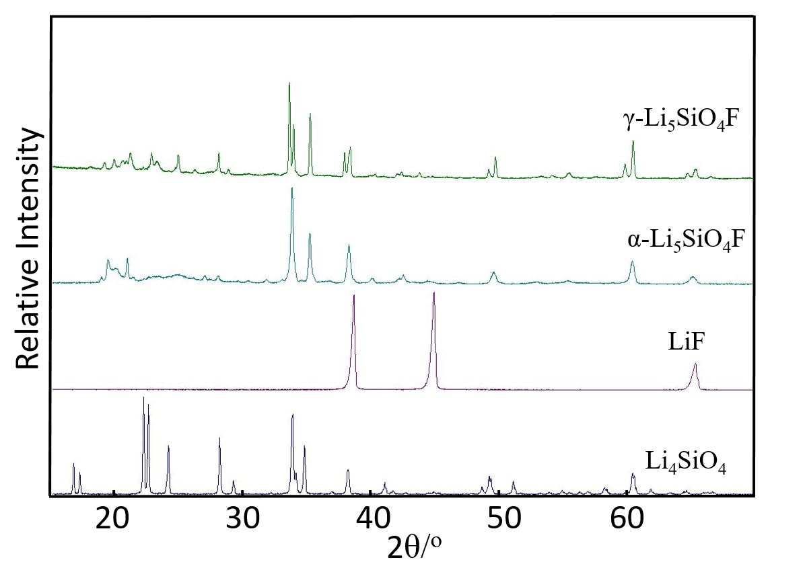
Figure 2

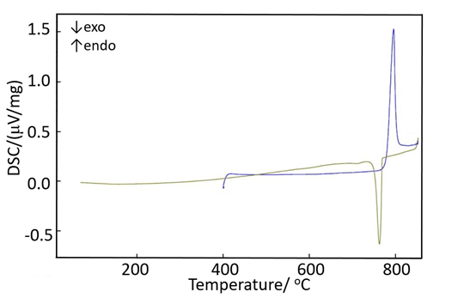
Figure 3

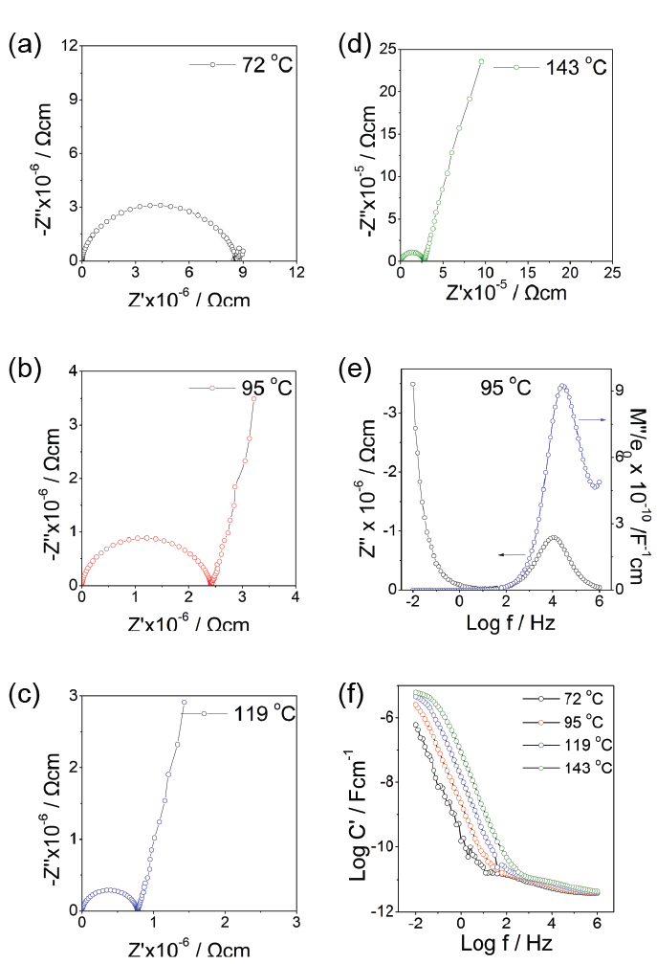
Figure 4

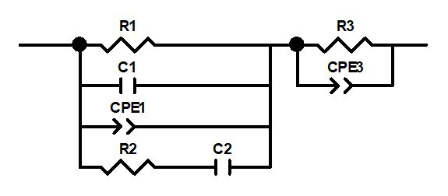
Figure 5

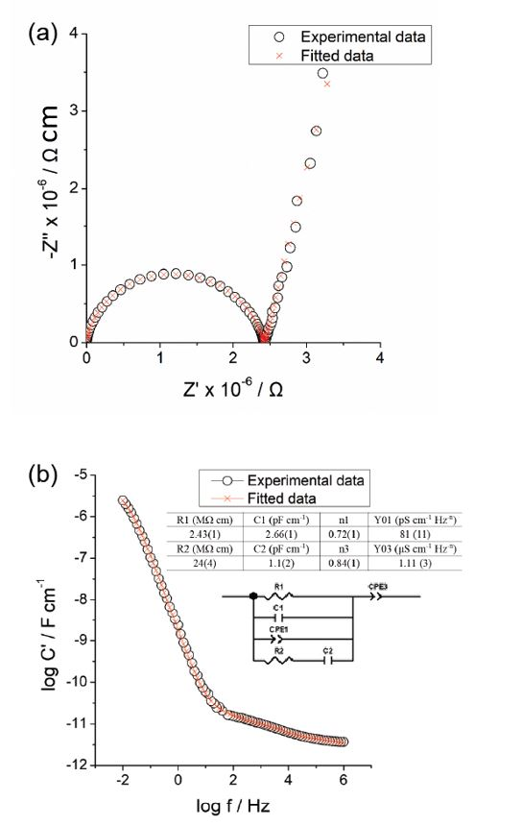
Figure 6

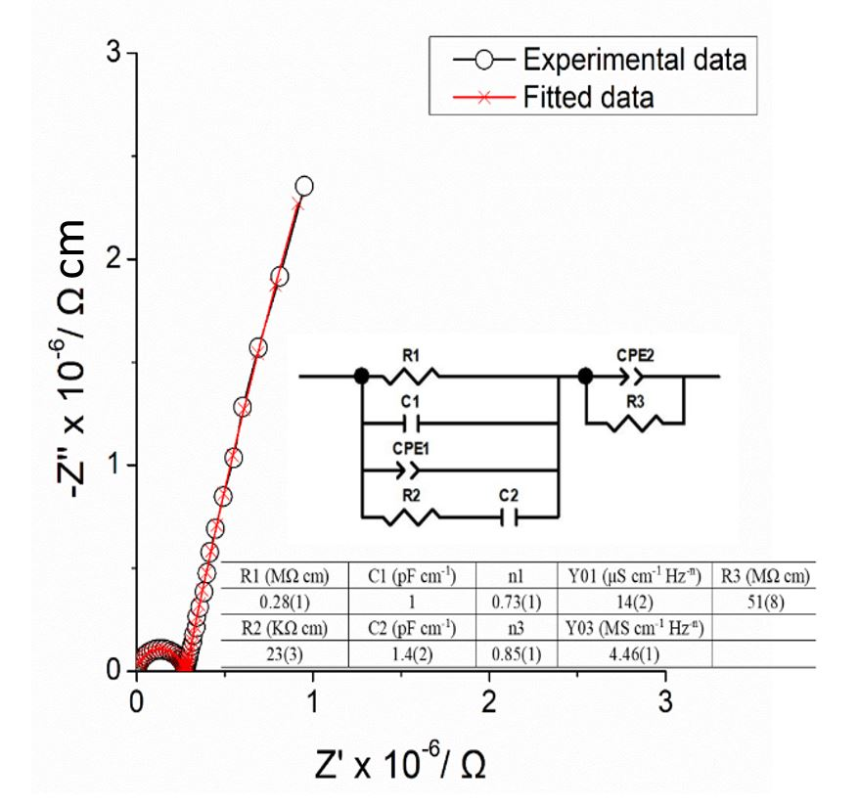
Figure 7

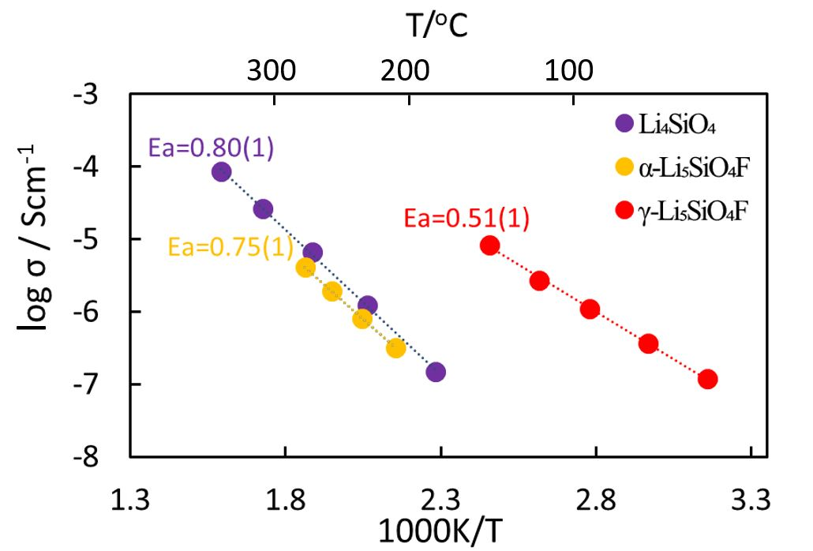
Figure 8

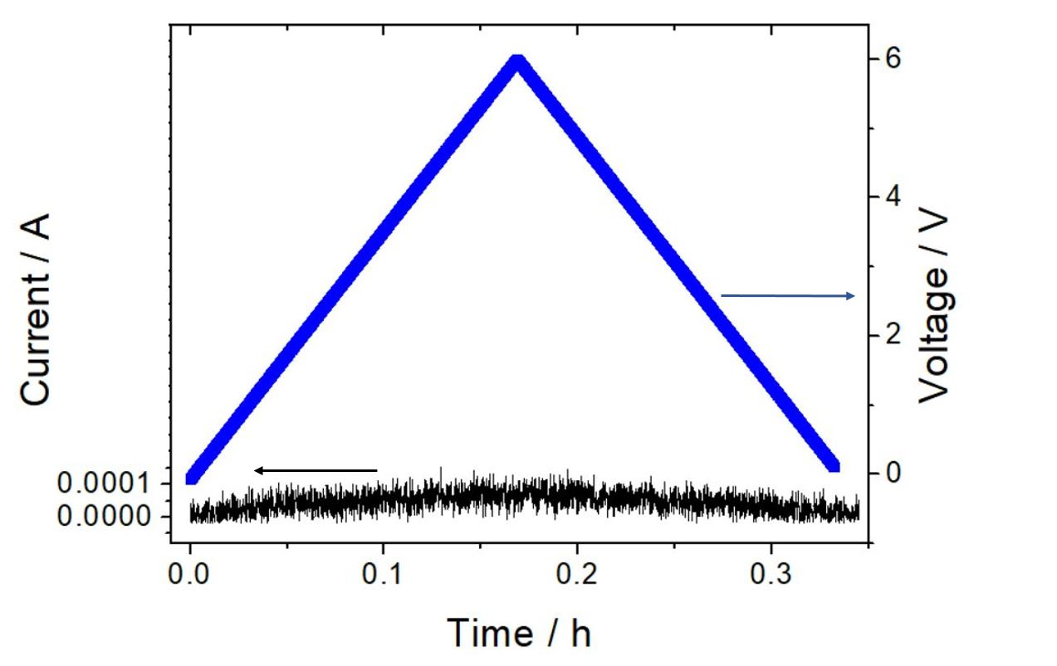
Figure 9

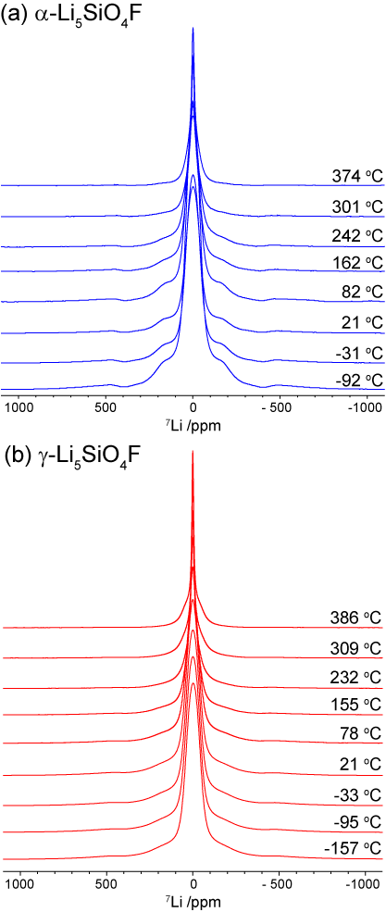
Figure 10

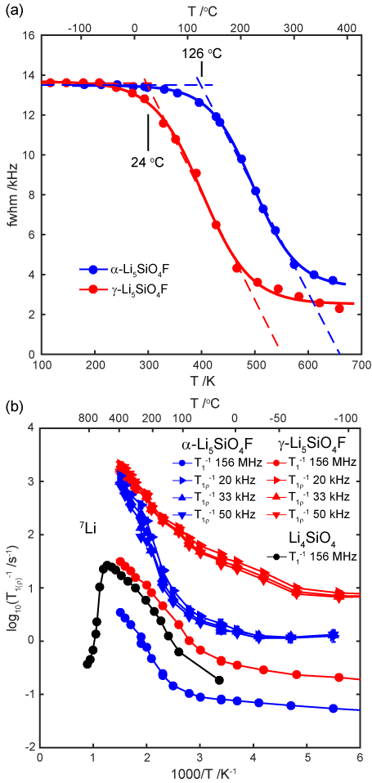
Figure 11

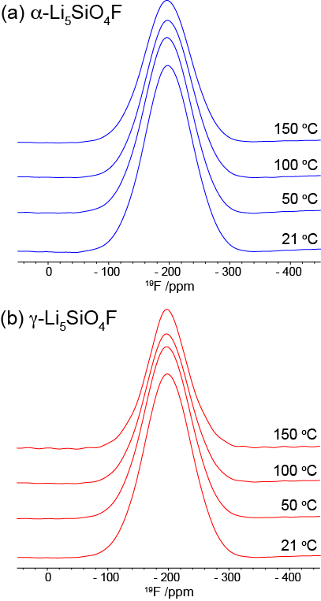
Figure 12

Table 1
Element | Experimental  Concentration, weight% | Expected composition of Li₅SiO₄F, weight%
Si | 18.8(8)% | 19%
F | 11(2)% | 13%
O | 45(6)% | 44%

