Formation of Oxygen Radical Sites on MoVNbTeOx by Cooperative Electron Redistribution
Yuanyuan Zhu†*, Peter V. Sushko†, Daniel Melzer‡, Eric Jensen†, Libor Kovarik§, Colin Ophus¶, Maricruz Sanchez-Sanchez‡, Johannes A. Lercher†,‡* and Nigel D. Browning†, #*
†Physical & Computational Sciences Directorate, §Institute for Integrated Catalysis and Environmental Molecular Sciences Laboratory, Pacific Northwest National Laboratory, Richland, Washington 99352, USA
‡Department of Chemistry and Catalysis Research Center, Technical University of Munich, Garching 85748, Germany
¶National Center for Electron Microscopy, Molecular Foundry, Lawrence Berkeley National Laboratory, Berkeley, California 94720, USA
#Department of Materials Science and Engineering, University of Washington, Seattle, Washington 98195, USA

Supporting Information Placeholder
ABSTRACT: A novel pathway of increasing the surface density of catalytically active oxygen radical sites on a MoVTeNb oxide (M1 phase) catalyst during alkane oxidative dehydrogenation is reported. The novel sites form when a fraction of Te⁴⁺ is reduced and emitted from the M1 crystals under catalytic operating conditions, without compromising the structural integrity of the catalyst framework. Density functional theory calculations show that this Te reduction induces multiple inter-related electron transfers, and the associated cooperative effects lead to the formation of O– radicals. The in situ observations identify complex dynamic changes in the catalyst on an atomistic level, highlighting a new way to optimally tailor structure and dynamics for highly active catalysts.
Production of ethene from ethane via selective oxidative dehydrogenation (ODH) is an emerging alternative to conventional ethane steam cracking. ^{1, 2} One of the fundamental challenges for alkane ODH is to develop catalysts that are highly active for C-H bond cleavage and less active for oxygen addition.^{3, 4} To be competitive with steam cracking, catalysts must convert ethane with a selectivity exceeding 95% with a conversion exceeding 60%.⁵
MoVNbTeO_{x} (Te-M1⁶) is, among the family of Mo-V-based M1 oxides (including oxides containing Mo-V, Mo-V-Sb-Nb, Mo-V-Te-Nb), by far the best catalyst for ethane ODH.^{7, 8} the Te-M1 structure (Figure 1a-1c) also shows excellent activity and selectivity in conversion of propane to acrylic acid.⁹⁻¹² The catalytically active sites are associated with an ensemble of 5 V- and Mo-centered octahedra in S2, S4, and S7 positions.¹³⁻¹⁵ This ensemble is surrounded by a framework of pentagonal units {(Mo,V)₅Nb} stacking along the out-of-plane direction forming M1 nanorods. The ability to abstract the first H atom is attributed to V=O groups forming O⁻ radicals via charge transfer resonance (Figure 1d).^{13, 16} Although the V atoms are generally believed to be solely responsible for activating alkanes, there are indications that the stoichiometry of Te-M1 has an influence in the overall activity and selectivity.¹⁷ In particular, the Te-O species occupying the hexagonal channels (S12) adjacent to the active centers S2-S4-S7 have been hypothesized to impact the catalytic that the
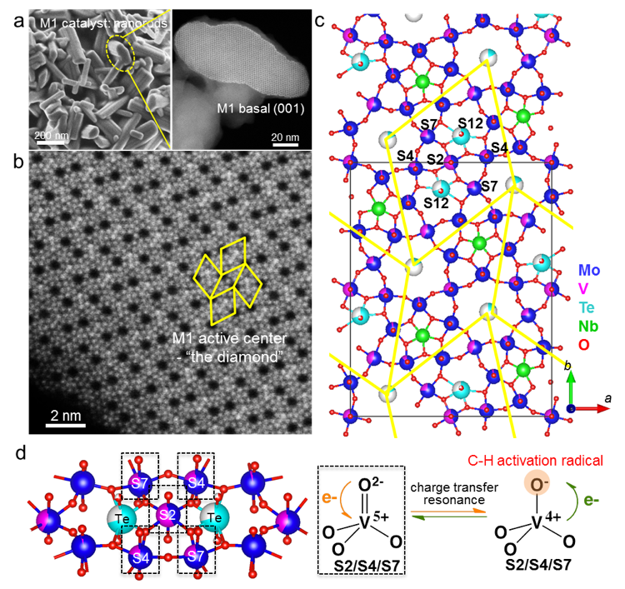
Figure 1. a) SEM image of the rod-like Te-M1 and STEM overview of its (001) basal plane (SI section 1). b) High-resolution low-angle annular dark field STEM image (SI section 2.1) of the proposed active centers (S2-S4-S7 in the yellow-diamonds). c) Atomic model of the Te-M1 phase (unit cell in black frame). d) Scheme of the proposed V=O active site on Te-M1.

overall working structure of Te-M1 may significantly differ from that of the pristine material.¹⁸ While recent in situ STEM analysis showed only local structural changes such as the TeOx units in the S12 sites depending on the environmental conditions, there is no consensus on the evolution of those Te species or on the effect on the activity.^{19, 20} Here, the dynamics and evolution of MoVNbTeOx M1 surface structures for extended periods under conditions mimicking those of ethane ODH are reported, relating the reduction and removal of Te as key surface reaction to maximize the concentration of sites active in oxidation.
Figures 2a and 2b show atomic evolution of two thin Te-M1 particles at various stages after in situ ethane ODH in 0.9 mbar 3C₂H₆/2O₂/5He at 400 °C obtained by environmental scanning transmission electron microscopy (ESTEM²¹) (SI section 2 and 3). Great care was taken to minimize beam effects throughout the experiments (SI section 2.2). Notably, as ethane ODH proceeds, progressive structural changes were observed near the proposed active centers,^{13, 14} particularly at the Te site (indicated by arrows in Figure 3). To quantify this structural evolution, intensity line profiles were taken along the Te sites in Te-S2-Te as well as along the S7-S2-S7 and S4-S2-S4 directions averaged over ~ 250 locations (SI section 5). Though the apparent change in Te intensity depends on particle thickness (SI section 4), the normalized Te intensities show a clearly decreasing trend with time on stream (Figure 2c). Multi-slice STEM simulations show that although increasing the Te thermal displacement could lead to a reduction in intensity, it requires a very large Debye-Waller factor to fully account for the observed effect (SI section 6). This leads us to conclude that some of the Te cations located in the hexagonal channels are reduced to Te⁰ and gradually emitted from the catalyst as part of the evolution of the catalyst under reaction
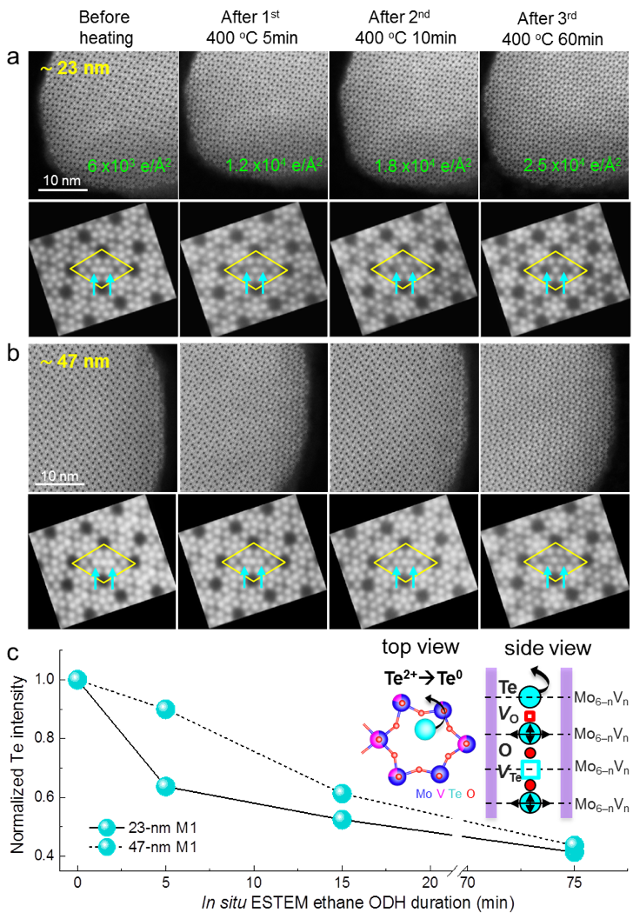
Figure 2. Atomic ESTEM snapshots of two Te-M1 particles, a) 23 m and b) 47 nm in thickness, before and after ethane ODH at 400°C for three heating durations in 0.9 mbar 3C₂H₆/2O₂/5He. Accumulated electron dose (in green) was carefully monitored. Averaged images of Te-M1 active centers (yellow diamonds) show representative structural evolution. c) Te intensity (by Gaussian fitting with 95% confidence) normalized to pristine as a function of ESTEM duration.
conditions. Furthermore, Fourier transform inspections (SI section 7) show that the impact of this Te loss on the M1 crystalline framework was negligible. For more than 3 hours the M1 framework was preserved under ethane ODH conditions (SI section 3). Note that the M1 particles examined here were thinned for atomic imaging. Typical rod-like M1 crystals are at least ~400 nm long and the reduction of the concentration of Te is expected to be less dramatic than observed here (as indicated by the thicker particle in Figure S9b).
Further comparison of the ESTEM results after heating in different gas environments (Figures 3) suggests that the Te-M1 structural evolution is controlled by both the elevated temperature and the O₂ partial pressure. For all three gas environments tested, after 75 minutes at 400 °C the Te intensity was reduced (< pristine “1.0”), accompanied by a decrease in the Te-Te distance. This is in good agreement with Auoine et al., who related the displacement to the partial reduction of Te⁴⁺ to Te²⁺.²⁰ However, the present experiments unequivocally establish that the reduction does not stop at the partial reduction, producing Te⁰ that is subsequently desorbed from the structure under the operating conditions. The degree of Te depletion, and the mean oxidation state of the remaining Te (as indicated by Te-Te distance) depends on the gas
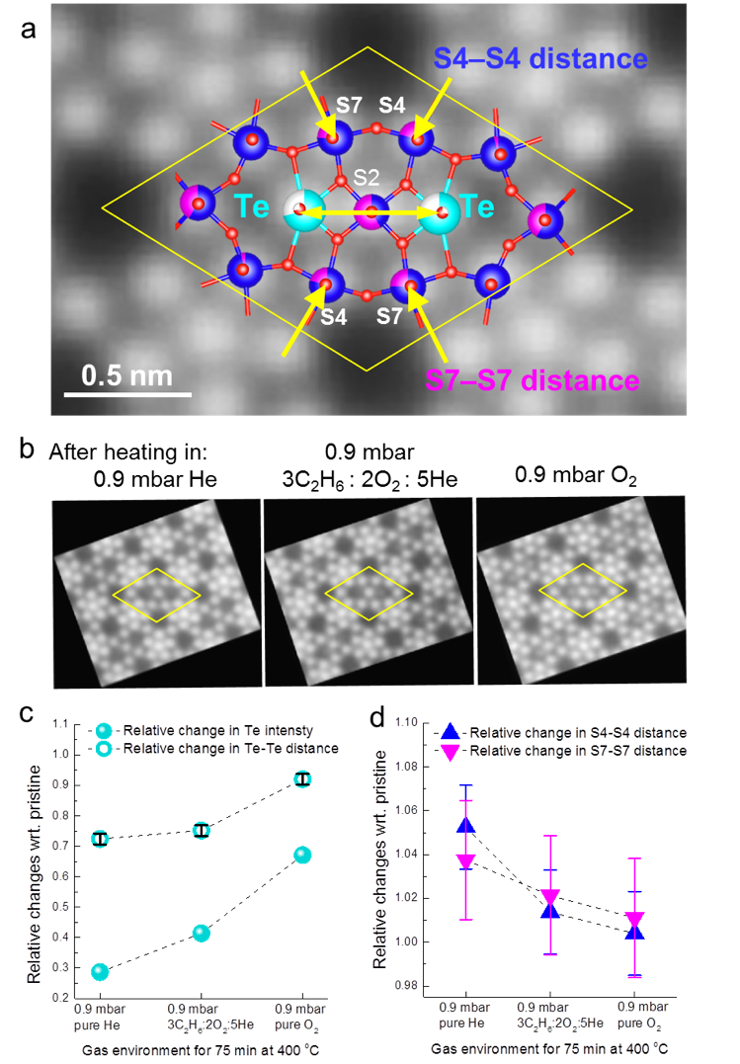
Figure 3. a) Schematics illustration of the three line profiles performed: S3-Te-S2-Te-S3, S4-S2-S4 and S7-S2-S4. b) ESTEM averaged active centers of three Te-M1 particles with a similar thickness after 75 min at 400°C in three gas environments. Relative changes in c) Te intensity and Te-Te distance, and d) S4-S4 and S7-S7 distance with respect to pristine structure as a function of gas feed.
increases in the S4-S4 and S7-S7 distances are reversely dependent on the oxygen partial pressure of the gas feed. This result suggests that the Te-M1 crystal constitutes a robust framework supporting thermally and chemically dynamic S12-S2-S4-S7 active sites.
To understand the origin and consequences of Te emission, we investigated the stability of O and Te vacancies (V_{O} and V_{Te}) and analyzed the corresponding lattice distortions and charge density distributions using ab initio modeling (SI section 8). We find the formation energy of a V_{Te} in stoichiometric Te-M1 to be 6.6 - 8.1 eV depending on the V distribution in the hexagonal ring. To model M1 in a reducing environment, we considered V_{O}s and found they were most stable in the quasi-1D Te–O–Te chains, with a formation energy < 2.0 eV. In the presence of these V_{O}s, the V_{Te} formation energy drops to 1.6–3.2 eV. Both V_{O} and V_{Te} induce redistribution of the electron density and displacement of the lattice atoms. Once the Te–O–Te chain becomes oxygen deficient, nearly all electron density associated with the V_{O}s localizes on the neighboring Te, changing its oxidation state from 4+ to 2+. Thus, the electrostatic interaction between Te and the rest of the lattice decreases, which explains the low V_{Te} formation energies in oxygen deficient Te-M1. In the important step of further reducing Te²⁺ to Te⁰, extraction of each Te atom is accompanied by removal of two electrons from the top of the M1 valence band. Analysis of the charge density shows that the reduction of Te⁴⁺ to Te²⁺ does not have a substantial impact in the charge distribution in the M1 framework. However, the effect of emitting TeO from the hexagonal channels results in a charge distribution similar to increasing the V concentration; that is, Mo, V, and O species become more oxidized (Figure 4). This facilitates the formation of transient O– species either via localization of the holes at the top of the O 2p band or via local charge redistribution between O^{2–} and Mo⁵⁺ or V⁴⁺ ions. These O⁻ radicals could activate alkanes in a similar way as the V-O⁻ generated at a vanadyl group. ^{13, 14} Since the V_{Te} formation energy strongly depends on the local V/Mo ratio and the V location in the hexagonal-ring – a higher V concentration corresponds to a stronger interaction of Te with the V/Mo tetrahedra forming the ring – V-rich rings retard Te diffusion out of the M1 framework.
The specific location of charges, and thus the O⁻ species created by TeO emission cannot be established unequivocally by DFT. However, it is unambiguous that the emission of TeO from the lattice channels leads to depletion of electronic states at the top of
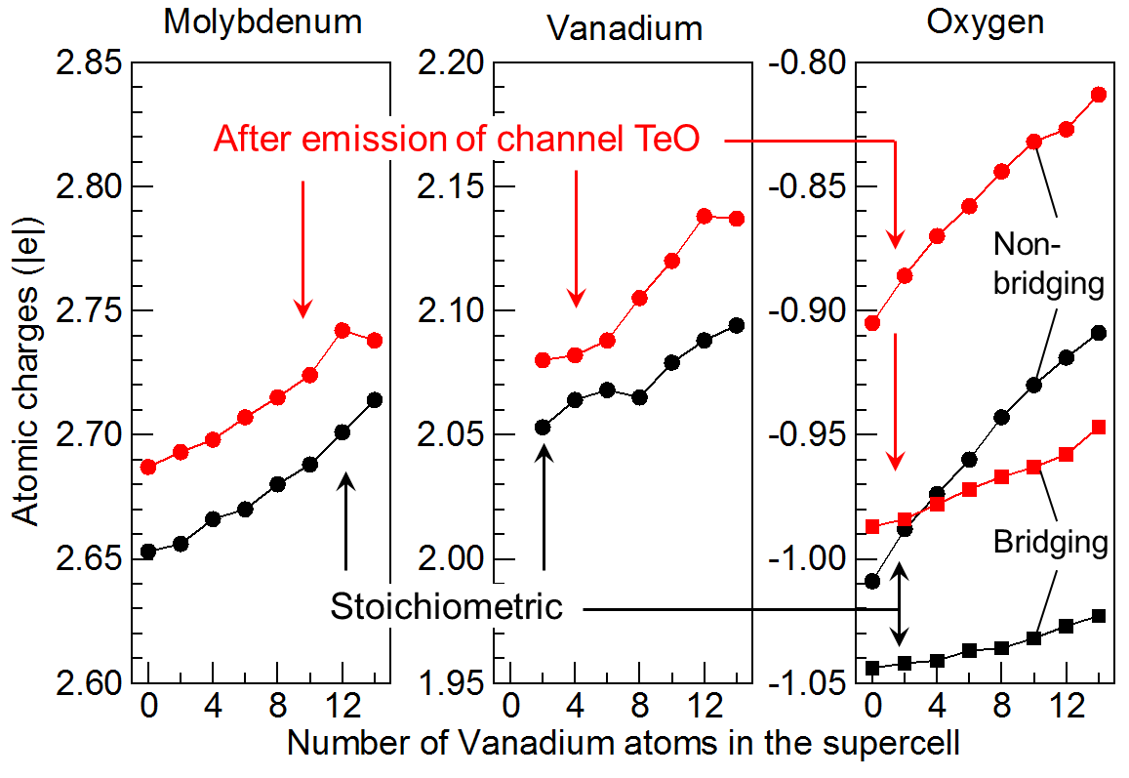
Figure 4. Average atomic charges as a function of Vanadium concentration in the stoichiometric M1 lattice (black) and the M1 lattice after TeO emission (red). Increasing V% and emission of TeO induces depletion of the electron density at all species.

the valence band, particularly in V-rich regions. For quantification, we analyzed the one-electron densities of states (DOS) projected on each atom type (Figure S13). At the V/Mo ratio of 1 : 5, both Mo and V have non-zero occupancy of the d-shells, giving rise to the DOS peak near the Fermi level. As the V/Mo ratio increases, this peak is noticeably depleted and the O 2p band edge moves close to the Fermi level in line with prior reports on M1 surfaces and band bending.²² Thermal disorder at elevated temperatures broadens the band edges and can promote electron transfer from the O 2p states to the metal d states, giving rise to transient oxygen radicals.
In view of these results we propose that, in addition to the V=O group, other redox active sites are formed by the fractional reduction. The sequential steps for the generation of these sites on Te-M1 are schematically shown in Figure 5 (i-iii). Firstly, the reducing environment leads to V_{O} in the 1D Te-O-Te chains and to the reduction of Te⁴⁺ to Te²⁺. The resulting Te²⁺ couples with 2e⁻ and is emitted as Te⁰, depleting the n-type character of the M1 surface. This electronic structure change facilitates transient single e⁻ transfer between O^{2–} and both V and Mo d⁰ shells, i.e., formation of O– radicals. Figure 5 (iii-v) illustrates a potential pathway for

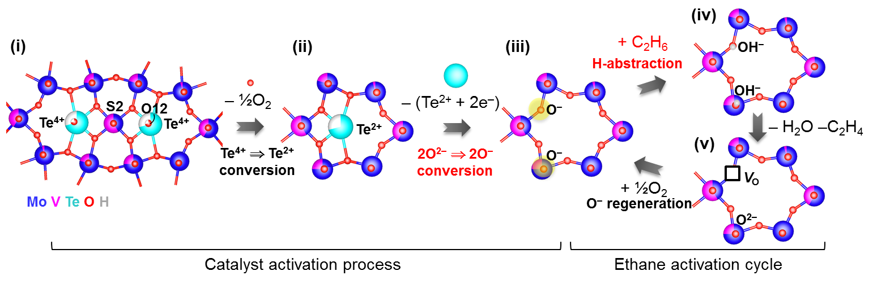
Figure 5. Schematic of the cooperative activation steps: (i) thermal treatment in a reducing environment induces Te⁴⁺ to Te² conversion; (ii) the emission of Te⁰ results in the formation of chemically active O– species; (iii) in the presence of alkane molecules, these O– species abstract this first H of the alkanes and form surface OH–; (iv) surface OH– groups recombine and leave the surface; (v) interaction of the resulting surface with O₂ in the reaction gas regenerate O–.

ethane ODH on such a site. The O⁻ radicals induces H abstraction forming an OH⁻.²³ The surface OH– groups recombine and form H₂O and surface V_{O}.²⁴ Finally, two V_{O} can be populated with O₂ restituting two O⁻,²⁵ thus, completing the cycle. It should be noted that the mechanism depicted in Figure 5 (iii) is catalytic: the active O⁻ is regenerated after each turnover without necessity of emitting additional Te atoms from the solid.
It is unclear yet whether these new O⁻ sites act in concert with the V=O groups or constitute separate catalytic sites. Nevertheless, once the emitted Te has generated the radical species, the rate of initial hydrogen abstraction is hypothesized to increase as the concentration of redox active sites increased. Our catalyst tests show such a boost of the M1 catalytic activity in the first hours under reaction conditions (SI section 9). We observed that the ethene formation rate increased by 13% in the first 30 hours on stream to reach a steady state. This agrees well with the DFT calculations, suggesting that a fast Te depletion occurs in the regions between the surface and the first V-rich ring in each hexagonal channel upon the exposure to the high temperature and slightly reducing conditions. After that point, Te emission slows down and the material reaches a pseudo-steady state with respect to TeOx species. Furthermore, the timescale of the changes observed in ESTEM regarding TeOx units (SI section 6) is comparable to the changes observed in the catalytic activity in the first hours under reaction conditions. Thus, we attribute this increase of activity to the dynamic response of the material to a change in reaction conditions. Exposing the M1 oxide to a slightly reductive atmosphere during ODH is hypothesized to induce the reduction of a small fraction of Te⁴⁺ to Te⁰ generating active O- species. The positive role of Te to generate O⁻ radicals would also be commensurate with the higher catalytic activity of Te-M1 comparing to other M1 structures.^{26, 27}
The present results show how the reduction of a small fraction of Te⁴⁺ to Te⁰ in the Te-M1 catalyst generates redox active O⁻ radical sites. The gradual increase in activity of Te-M1 with time on stream is hypothesized to be associated with the generation of these sites. Te emission occurs via generation of oxygen vacancies in the Te-O-Te chains and causes an electron redistribution equivalent to increasing the V/Mo ratio in the M1 lattice. This cooperative activation mechanism points to a potentially general pathway of oxygen activation in complex oxides that would allow to optimize catalytic activity via adjustment of reaction conditions and material properties.
ASSOCIATED CONTENT
Supporting Information
The Supporting Information is available free of charge on the ACS Publications website.
Catalyst synthesis, ESTEM experiment details, additional DFT information and catalyst kinetic test. (PDF)

AUTHOR INFORMATION
Corresponding Author
*yuanyuanzhu2014@gmail.com, *johanneslercher@hotmail.com,
*Nigel.Browning@pnnl.gov
Notes
The authors declare no competing financial interests.
ACKNOWLEDGMENT
This research is part of the Chemical Imaging Initiative and a seed project conducted under the Laboratory Directed Research and Development Program at Pacific Northwest National Laboratory (PNNL). A portion of the research was performed using Environmental Molecular Sciences Laboratory (EMSL), a national scientific user facility sponsored by the Department of Energy's Office (DOE) of Biological and Environmental Research and located at PNNL. CO’s work at the Molecular Foundry was supported by the Office of Basic Energy Sciences, of the U.S. DOE under Contract No. DE-AC02-05CH11231.
REFERENCES
(1) Gaertner, C. A.; van Veen, A. C.; Lercher, J. A., J. Am. Chem. Soc. 2014, 136, 12691.
(2) Schlogl, R., Angewandte Chemie-International Edition 2015, 54, 3465.
(3) Cheng, M.-J.; Goddard, W. A., III, J. Am. Chem. Soc. 2015, 137, 13224.
(4) Bose, S. K.; Marder, T. B., Science 2015, 349, 473.
(5) Gaertner, C. A.; van Veen, A. C.; Lercher, J. A., Chemcatchem 2013, 5, 3196.
(6) Li, X.; Buttrey, D. J.; Blom, D. A.; Vogt, T., Top. Catal. 2011, 54, 614.
(7) Nguyen, T. T.; Aouine, M.; Millet, J. M. M., Catal. Commun. 2012, 21, 22.
(8) Botella, P.; Garcia-Gonzalez, E.; Nieto, J. M. L.; Gonzalez-Calbet, J. M., Solid State Sciences 2005, 7, 507.
(9) DeSanto, P.; Buttrey, D. J.; Grasselli, R. K.; Lugmair, C. G.; Volpe, A. F.; Toby, B. H.; Vogt, T., Zeitschrift Fur Kristallographie 2004, 219, 152.
(10) Pyrz, W. D.; Blom, D. A.; Vogt, T.; Buttrey, D. J., Angewandte Chemie-International Edition 2008, 47, 2788.
(11) He, Q.; Woo, J.; Belianinov, A.; Guliants, V. V.; Borisevich, A. Y., Acs Nano 2015, 9, 3470.
(12) Melzer, D.; Xu, P.; Hartmann, D.; Zhu, Y.; Browning, N.; Sanchez-Sanchez, M.; Lercher, J., Angew Chem Int Ed Engl. 2016, 55, 8873.
(13) Grasselli, R. K.; Buttrey, D. J.; DeSanto, P.; Burrington, J. D.; Lugmair, C. G.; Volpe, A. F.; Weingand, T., Catal. Today 2004, 91-2, 251.
(14) Ishikawa, S.; Murayama, T.; Ohmura, S.; Sadakane, M.; Ueda, W., Chem. Mater. 2013, 25, 2211.
(15) Schlogl, R., Top. Catal. 2011, 54, 627.
(16) Millet, J.-M. M., Top. Catal. 2006, 38, 83.
(17) Grasselli, R. K.; Buttrey, D. J.; Burrington, J. D.; Andersson, A.; Holmberg, J.; Ueda, W.; Kubo, J.; Lugmair, C. G.; Volpe, A. F., Jr., Top. Catal. 2006, 38, 7.
(18) Haevecker, M.; Wrabetz, S.; Kroehnert, J.; Csepei, L.-I.; d'Alnoncourt, R. N.; Kolen'ko, Y. V.; Girgsdies, F.; Schloegl, R.; Trunschke, A., J. Catal. 2012, 285, 48.
(19) Blom, D. A.; Vogt, T.; Allard, L. F.; Buttrey, D. J., Top. Catal. 2014, 57, 1138.
(20) Aouine, M.; Epicier, T.; Millet, J. M. M., Acs Catalysis 2016, 6, 4775.
(21) Zhu, Y.; Browning, D. N., Chemcatchem 2017, DOI: 10.1002/cctc.201700474
(22) Heine, C.; Haevecker, M.; Trunschke, A.; Schloegl, R.; Eichelbaum, M., PCCP 2015, 17, 8983.
(23) Sterrer, M.; Berger, T.; Diwald, O.; Knozinger, E.; Sushko, P. V.; Shluger, A. L., J. Chem. Phys. 2005, 123.
(24) Fu, H.; Liu, Z. P.; Li, Z. H.; Wang, W. N.; Fan, K. N., J. Am. Chem. Soc. 2006, 128, 11114.
(25) Zhang, K. H. L.; Sushko, P. V.; Colby, R.; Du, Y.; Bowden, M. E.; Chambers, S. A., Nature Communications 2014, 5.
(26) Deniau, B.; Thi Thao, N.; Delichere, P.; Safonova, O.; Millet, J.-M. M., Top. Catal. 2013, 56, 1952.
(27) Nguyen, T. T.; Deniau, B.; Delichere, P.; Millet, J. M. M., Top. Catal. 2014, 57, 1152.

SYNOPSIS TOC
