TEM Study of Early-Stage Grain Growth in Nanocrystalline Mg-9Al Thin Films during Heat Treatment
Karen Kruska^{a*}, Aashish Rohatgi^{b}, Rama S. Vemuri^{c}, Libor Kovarik^{c}, Niranjan Govind^{c}, Nigel D. Browningª
ªFundamental and Computational Science Directorate, Pacific Northwest National Laboratory, Richland, WA, United States.
^{b}Energy and Environment Directorate, Pacific Northwest National Laboratory, Richland, WA, United States.
^{c}Environmental Molecular Sciences Laboratory, Pacific Northwest National Laboratory, Richland, WA, United States.
*corresponding author, email: karen.kruska@pnnl.gov
Keywords: TEM, heat treatment, Mg alloys, grain size, activation energy, grain growth exponent
Due to their low weight and good castability, Mg-Al alloys are great candidate materials to replace steels and Al components in automotive parts. However, the kinetic processes in these alloys during casting and heat-treatment are not well understood. In this study magnetron-sputtering was used to create Mg-9Al thin films with a nano-crystalline grain structure. The grain growth evolution in the early stages of heat treatment at 150, 200 and 300 C was observed with BF TEM. The activation energy for grain growth as calculated from the Arrhenius equation is 31.1kJ/mol, which is significantly lower than in bulk alloys. This is attributed to the geometry of the thin films, the large number of grain boundaries and possible internal stresses in the films.

Introduction
Magnesium (Mg) has the potential to provide 60%-75% mass savings relative to steel or cast iron, and 25-35% mass savings relative to aluminum [1]. Such mass-savings are attractive for lightweighting vehicles to help the automotive industry meet government mandated fuel economy and greenhouse gas emission standards. As such, U.S. Department of Energy has been investigating Mg alloys to enable their broader use in the high-volume automotive market [2]. This article is part of a broader program at PNNL, in support of DOE’s objectives, to understand the kinetics of microstructural evolution during processing of Mg alloys, focusing on the heat-treatment in Mg-Al alloys in the work presented here.
Mg-Al based alloys, such as AZ91 (Mg-9 wt.% Al-0.7 wt.% Zn), are attractive lightweight candidates for replacing steel and Al alloys in automotive parts due to a combination of castability, strength and ductility [3-7]. The as-cast microstructure of AZ91 consists of α-Mg matrix and a α + β Mg₁₇Al₁₂ eutectic, the actual morphology being strongly influenced by the local cooling rate. As-cast AZ91 can be subjected to different heat-treatments to modify its microstructure and improve its properties. E.g. the T6 treatment for AZ91 involves solution treating at 413°C for 16-24 h followed by cooling/quenching, and artificially ageing at 168°C for 16h [8]. The solutioinization is done to obtain a homogeneous distribution of Al in the HCP α-Mg matrix [6, 7] and artificial aging is done to produce Mg₁₇Al₁₂ precipitates and increase the strength via precipitation strengthening mechanism. Depending on the duration and temperature of the aging heat treatment, continuous or discontinuous β-precipitates will form and alter the alloys mechanical and corrosion properties [6]. However, the significant time spend at elevated temperatures during such heat-treatments can lead to undesirable grain-growth, thus, lowering the strength and negating the precipitation strengthening from the T6 treatment [9] Therefore, if high-strength Mg alloys and their heat treatments are to be developed, an understanding of the kinetics driving the changes in the microstructure is crucial. This work will focus on the grain-growth aspect of Mg-Al alloy.
Thein et al. studied the kinetics of grain growth in two (Mg–5 wt%–Al and Mg–5 wt%–Al–10.3 wt%–Ti) mechanically alloyed nano-crystalline Mg-Al-composite materials made by ball milling [10]. The activation energies for grain growth observed in these nano-materials were greater than for pure cast Mg and in the same order of magnitude as for an AZ31B alloy with a microcrystalline grain structure. This is in contrast with similar studies conducted on pure nano-crystalline Cu and Ag, possibly due to the high number of impurities in mechanically alloyed materials [11-13].
Dannenberg et al. found the activation energy for grain growth in nano-crystalline Ag thin films to be 53kJ/mol which is low compared to the activation energy for grain boundary diffusion, 95 kJ/mol. They therefore attribute the lower activation energy to surface diffusion [13]. Simoes et al. found the same trend in nano-crystalline Cu thin films where the activation energy for grain growth was 35 kJ/mol compared to 100 kJ/mol in microcrystalline Cu, which the authors mostly attribute to increased grain boundary mobility [11].
In this work, transmission electron microscopy (TEM) was used to study the grain-size evolution in nanocystalline Mg-9Al solid solution thin films heat treated inside the microscope. New insights into non-equilibrium growth kinetics of AZ91 in the thin-film geometry, comprising a large number of grain boundaries and high surface area, compliments the data obtained [14-16] on conventional micron-scale grain-size materials [14-16], binary diffusion couples [17] and mechanically alloyed nanocrystaline powder [10]. Many existing studies are examining heat treatment times of many hours or days [3, 4, 14, 18, 19]. As the activation energy for grain growth in other thin film systems was found to be much smaller than in the respective microcrystalline systems, short heat treatment times were selected for this study.
Experimental methods
Binary Mg-Al alloy thin films of about 60 nm thickness and a target composition of Mg-9 wt.% Al were deposited by magnetron sputtering. The deposition rates for Mg and Al were calibrated and films were deposited at XX V at a rate of XX nm/sec. The Mg-Al films were deposited on a 25 nm amorphous Si₃N₄ TEM support membrane with a viewing area of 30x400 µm. Compositional quantification was performed on Mg-Al film sputtered on a silicon wafer and using an EDAX EDS system in a JEOL XXXXF SEM. The as-sputtered films were heated in vacuum inside the TEM using a Gatan single-tilt heating stage. The heat-treatments were carried out at 150 ˚C, 200 ˚C and 300 ˚C for times between 5 and 190 min. The heat-treatment temperatures were reached in ~90 s, while cooling to room-temperature (at the end of the heat-treatment duration) was achieved in ~120 s in each case. The heat-treatment temperature was as indicated by the vendor-provided heating-stage controls. Each heat-treatment for a given time and temperature was conducted on a fresh as-sputtered thin film sample. TEM analysis of heat-treated films was performed after cooling in an aberration-corrected, monochromated FEI Titan 80-300™ operated at 300 kV and a JEOL ARM at 200kV. EELS analysis was performed with a high-resolution GIF at a convergence angle of 27.5 mrad and a collection angle of 82.6 mrad with a dispersion of 0.25 eV/chan. The Mg K₁ edge at 1305 eV and the Al K₁ edge at 1560 eV were used for quantification. The grain-size measurements of the films were performed on bright-field images using the linear intercept method described in ASTM E112 and on at least 2 micrographs (for each heat-treat condition) taken at 36k x magnification. Horizontal parallel lines were drawn across the TEM image of a heat-treated film to obtain several hundred intercepts in each case. A FEI Helios FIB was used to lift out a cross-section of the as-sputtered thin film as described in [20] for determination of the film thickness and through-thickness microstructure.
Grain growth analysis
Under the assumptions that the free energy of all grain boundaries is the same - independent of grain size and time – and that there are no pinning forces impeding grain boundary mobility, Burke and Turnbull described grain growth with the parabolic relationship [21] :
$D^{2}-{D_{0}}^{2}=K∙t$. (1)
D is the average grain size, D₀ is the average grain size at time t=0 and K is a constant. Experimentally, this equation only holds for few very pure metals. It has been found in the literature that grain growth in less pure metals and alloys can be described by
$D^{n}-{D_{0}}^{n}=K∙t$. (2)
where n is often referred to as the grain growth exponent and has been reported to reach values as high as 12 [22]. In cases where $D≫D_{0}$ , $D_{0}$ is sometimes neglected simplifying equation (2) to $D={(Kt)}^{1/n}$ [23]. This simplification is not possible for the data acquired this study, as short heat treatment times were considered. The activation energy Q for grain growth can now be determined from an Arrhenius plot:
$K=K_{0}\exp\left(-\frac{Q}{RT}\right)⇒\ln{K=\ln{K_{0}-\frac{Q}{RT}}}⁡$ , (3)
where R is the gas constant and T is the temperature. There exists an n ∊ ℝ, n≥2 for which $D^{n}-{D_{0}}^{n}$ is proportional to t. In this study $D^{n}-{D_{0}}^{n}$ was determined for integers with 2 ≤ n ≤ 15. In each case the adjusted R² was determined to find the best linear fit.
It was found that the increase in grain size from the as-sputtered film to the films after 5 minutes of any heat treatment was particularly striking. Partially, this significant increase in grain size can be attributed to the analysis method: TEM characterization of the cross-section of the thin films revealed that the columnar grain structure present in the as-sputtered films is lost during heat treatment in favor of an equiaxed grain structure. As the linear intercept method is meant to give an indicator of the diameter, and therefore the volume, of equiaxed grains. The initial average grain size $\overline{D_{0}}$ as measured with the linear intercept method was 14.5 nm. This value was adjusted to represent an equiaxed grain of the same volume. Assuming $\overline{D_{0}}$ to be the diameter of a 60 nm (i.e. film thickness) tall cylinder representing a columnar grain, $D_{0}=26.6 nm$ is the diameter of a sphere (i.e. an equiaxed grain) with the same volume.
Results
Figure 1 shows the TEM bright-field (BF) images revealing the grain structure in a Mg-9Al thin film after isothermal heat treatment at 150˚C for 0, 5, 30 and 60 min. The grain structure of the nanocrystaline films is clearly revealed by the bright-field contrast. The diffraction patterns (e.g. at t = 0 and 60 min) confirm the nanocrystaline nature of the films. As shown in the image at t=0 min, the diffraction pattern of the as-sputtered film matches a hexagonal pure Mg pattern. After heat treatment (image at t = 60 min) the number of rings in the diffraction pattern has increased, suggesting formation of β-phase. However, the β phase cannot be distinguished from the α phase in the TEM bright field image. An increase in grain size is notable with increasing heat treatment time from 0 to 60 min. The (stripey) variation in contrast across single grains in the as-sputtered film suggests that there may be internal strains from the sputtering, which are relaxed in the early stages of heat treatment. While the grain structure is columnar in the as-sputtered film, the heat treated films show some overlapping “buried” boundaries which are a result of the now equiaxed grains (arrows in Figure 1). Figure 2 shows the grain size evolution during isothermal heat treatment at 200 ˚C. As expected, the grain size increases more rapidly than at 150 ˚C. There is a distribution in grain sizes, however, the grain size distribution appears to be fairly normal, without any large abnormal grains. Grain growth at 300 ˚C (Figure 3) is even more rapid. While the majority of grains appear to have a normal size distribution, few cases of abnormal grain growth have been observed at this temperature (see Figure 4). The micrographs used for the grain size measurements were acquired from areas away from such abnormal grains. Figure 5 illustrates the grain size evolution with time for the three heat treatment temperatures 150˚C, 200 ˚C and 300 ˚C. The scatter bars account for the variation in line length : # of intercepts for the individual lines used in the linear intercept method. They indicate the variation in grain size rather than uncertainty in measurement. Higher temperatures lead to more rapid grain coarsening.
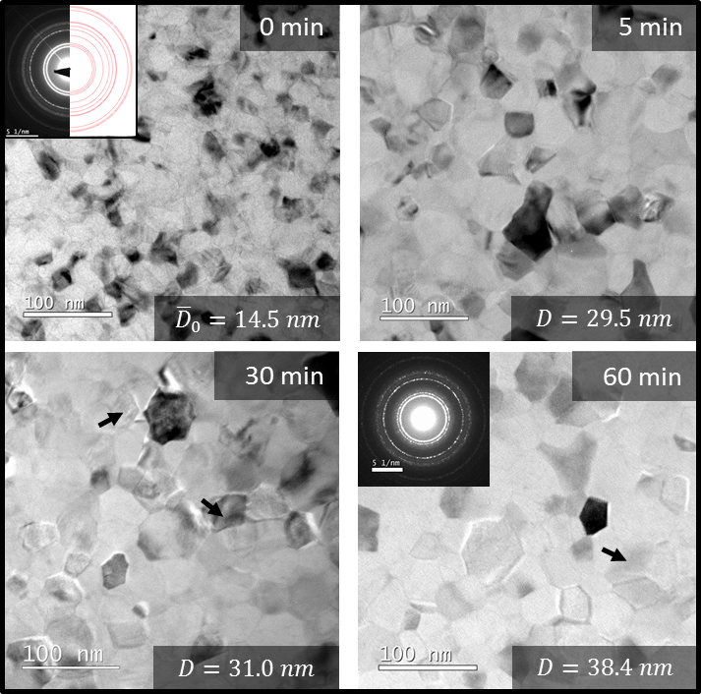
Figure 1: TEM bright field images of Mg-9Al film heat treated at 150˚C. The inset in image for t = 0 shows the experimental (Mg-9Al) and a simulated diffraction pattern of hcp Mg.

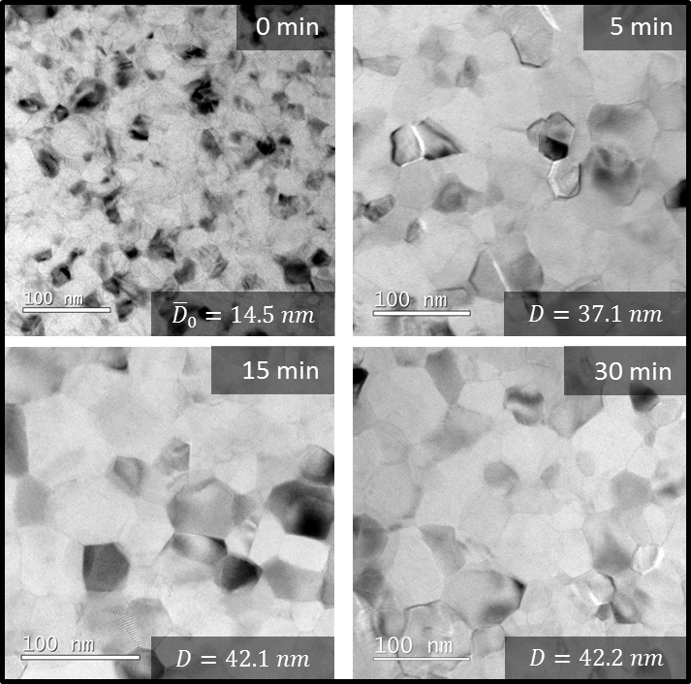
Figure 2: TEM bright field images of Mg-9Al film heat treated at 200˚C.

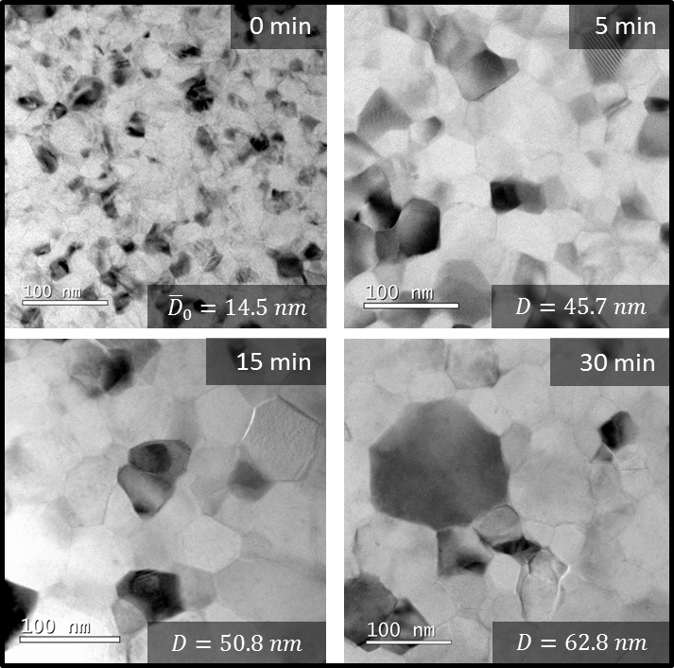
Figure 3: TEM bright field images of Mg-9Al film heat treated at 300˚C.

To determine the grain growth parameter $n$, the correlation of the linear fits of $D^{n}-{D_{0}}^{n}$ versus t was evaluated with the adjusted R². If R² = 1, all data points lie on the fitted line. Figure 6A shows that, for all three temperatures, the fit improves initially when $n$ is increased, but no significant improvement of the fit was achieved when $n$ was increased to integers greater than 7. Figures 6B-D show the resulting linear fits at $n=7$.
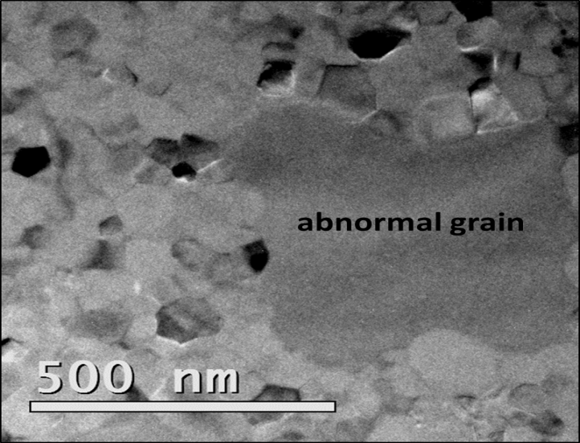
Figure 4: TEM bright-field image showing abnormal grain growth observed after heat treatment at 300 ˚C

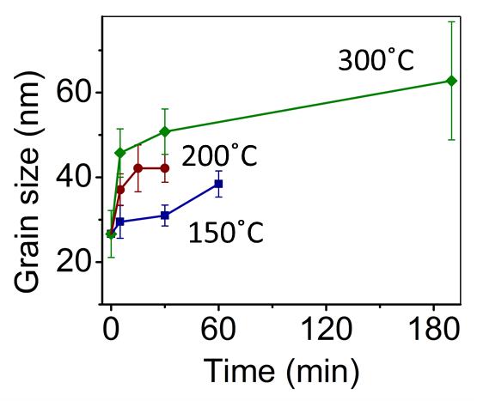
Figure 5: Grain size evolution in Mg-9Al during isothermal heat treatment.

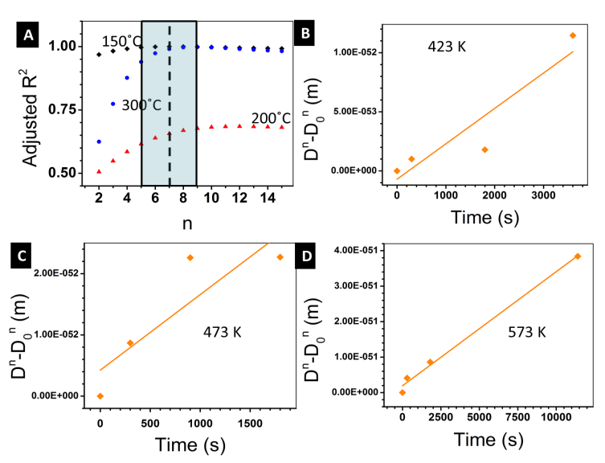
Figure 6: A) Adjusted R² showing the correlation between the data and the fit. No significant improvement was seen increasing n to numbers greater than 7. B)-D) Linear fits for n=7.

The activation energy Q for grain growth can now be determined from an Arrhenius plot as shown in Figure 7A, where $\ln{K}$, as determined with $n=7$ is plotted versus the inverse of the Temperature, $\frac{1}{T}$. The slope of the graph is -3741, this corresponds to an activation energy of 31.1 kJ/mol.
In a few studies, a definite maximum of the quality of fit could be determined and non-integer values were determined for the grain growth exponent $n$ [13]. However, in other studies only approximate values of n were given [11, 22]. To understand the influence of the choice of n on Q, the respective Ks were determined for 2 ≤ n ≤ 15 and Q was calculated for every case.
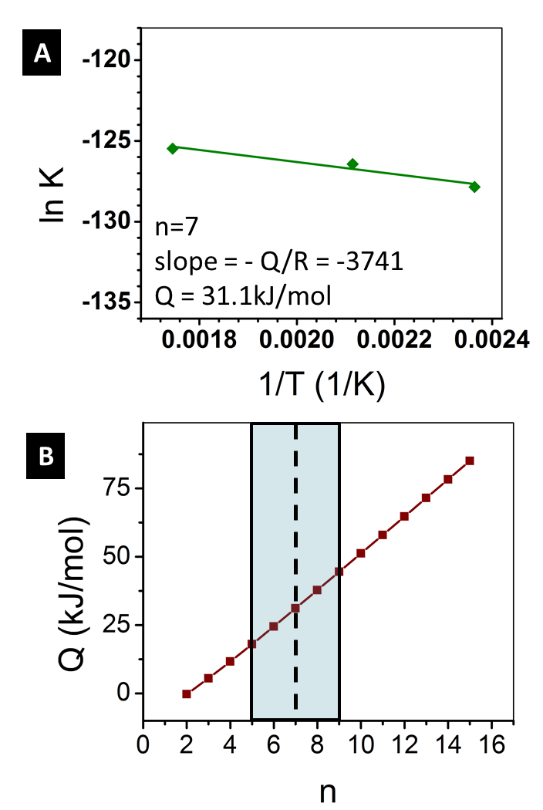
Figure 7: A) ln K versus 1/T. The slope of the fit corresponds to –Q/R and allows for determination of the activation energy. B) Activation energy as obtained for 2≤n≤15.
Figure 7B shows how the calculated Q(n)=Q_{n} increases almost linearly with increasing n. For n=2 a positive slope was obtained, resulting in a negative activation energy (Q₂ = -0.3 kJ/mol), which is in disagreement with the observed kinetics. To account for the uncertainty induced by the spread in grain sizes at a given temperature and time, and the relatively small number of data points, an error of ±2 is suggested for the exponent n. Thus, assuming n=7±2, the activation energy for grain growth in Mg-9Al thin films is Q= 31.1 ± 13.4 kJ/mol. Choosing a large value of n, e.g. as large as 15, does not make a lot of sense, as the quality of the fit is (if not significantly) decreasing for large n in every case (see Fig. 6A) and there is no reason to expect such a large value of n. Even for this extreme assumption, the corresponding activation energy was calculated to be Q₁₅= 85 kJ/mol, which is still below the activation energy of 92 kJ/mol for grain growth in pure Mg [24].
Discussion
Grain growth in Mg-9 wt.% Al thin films was studied using TEM imaging after heat-treatment at temperatures between 150-300C. Grain growth was analyzed using a general form of equation proposed by Burke and Turnbull, and activation energy for grain growth was determined. In Mg-Al alloys n was previously reported to be 4 or 5 with micron scale grain size [15, 16, 25], and 6 or 7 in mechanically alloyed nanocrystalline powder [10]. Therefore, it is reasonable to expect that the grain growth exponent in this study using nanosructured thin films is close to that of similar nanocrystalline materials [11].
In the literature, a value of grain growth exponent n > 2 is typically cited as evidence of mechanism(s) restraining the grain growth process. These mechanisms may include solute drag, solute segregation at grain boundaries, grain boundary pinning due to second phase precipitates (formed during grain growth or pre-existing), thermal grooving, and surface oxidation. Considering that the value of n for Mg-9 wt.% Al films in the present work is found to be 7, i.e. significantly greater than 2, one or more mechanisms hindering grain growth are likely active.
While the as-sputtered films comprises α Mg grains supersaturated with 9 wt.% Al (~10 at.% Al), the Mg-Al equilibrium phase diagram shows that the equilibrium solubility of Al in Mg at 150, 200 and 300C is ~2,~3 and ~6 at.% Al, respectively [26]. Therefore, excess Al solute atoms in the α Mg matrix are likely to hinder the grain growth via solute drag during heat-treatment. Moreover, heat-treatment of the as-sputtered α matrix results in the precipitation of β-Mg₁₇Al₁₂, which may hinder grain growth by grain boundary pinning. For example, Figure 8 shows a line profile across one of the grains after 5 minute of heat treatment at 300°C. The EELS line profile through the grainshows that the Al concentration on either side of the grain is ~9 at.% (~10 wt.%), which is close to the as-sputtered Mg-9 wt.% Al composition. Within the grain, the Al concentration is ~41 at.%, indicating that the grain is a β-Mg₁₇Al₁₂ precipitate.A β-phase particle has already formed within a very short time at 300°C. Since the as-sputtered α-phase contains ~8 at.% Al, formation of β-Mg₁₇Al₁₂ phase (i.e. 41 at.% Al) during heat-treatment implies a 5-fold local Al enrichment. Therefore, Al segregation to grain boundaries, as a precursor to nucleation of Mg₁₇Al₁₂ precipitates, is a likely candidate that slows down grain growth in the initial stages of heat-treatment. After ~5 min. or so, when the β precipitates have formed, the Al remaining in solid solution together with the precipitates may cause the growth to level off below the ideal parabolic growth rate and requiring a higher (i.e. n > 2) grain growth exponent.
Regarding the grain boundary pinning efficacy of precipitates, the expression for Zener pinning is written as [27]:
Pz = 3Fγ/2r (4)
Where Pz is the pinning pressure exerted by the particles on a unit area of the boundary, F is the volume fraction of randomly distributed spherical particles of radius r, and γ is the specific grain boundary energy. As seen in Fig. 8A, the size of the Mg₁₇Al₁₂ precipitates in current work is on the same order of magnitude as the α grains themselves. Therefore, owing to their relativelly “large” size, the efficacy of β precipitates is expected to be lower than if they had been present as discrete particles (smaller than the α grains) within the α grains or on the grain boundaries.
Heat treatment of metal films can lead to thermal grooving along the grain boundaries at the surface of a specimen. When the grain size approaches the film thickness, thermal grooving can cause the cessation of further grain growth, and this phenomenon is called the specimen thickness effect [28]. Thermal grooves can “anchor” a grain boundary and prevent grain growth, particularly if the boundary is normal or near-normal to the surface [28] as is the case for columnar grains. In the present experiments, the columnar structure of the grains appears to be lost very rapidly and replaced by equiaxed grains before thermal grooving can occur. Further, since the grain growth to a size similar to the film thickness (~60 nm) was observed only at the longest heat treatment at the highest temperature (see Fig. 5), thermal grooving mechanism can be excluded from present consideration. It should be pointed out that the columnar geometry was accounted for in the determination of the average grain size in the as-sputtered samples. However, transformation of originally columnar grains into equiaxed grains during the initial stages of heat treatment likely requires significant grain boundary migration, more so than if the original grains were equiaxed. This fact may also introduce temporary delay in grain growth confined to the very early stages (minutes) of heat treatment which was not accounted for in the present analysis.
Finally, magnetron sputtering fabrication process was carried out under high-vacuum and the Mg-Al thin films are expected to contain relatively low levels of impurities. In-between experiments, the specimens were stored in a dessicator under Ar atmosphere. Although the films were, due to handeling, exposed to air for several hours before the heat treatments, EDX revealed no significant amount of oxide in the films (~3 at. % measured). Thick surface oxides would be expected to enhance the grain boundary pinning effect of thermal grooving, however, there was no evidence of such oxides in the current work.

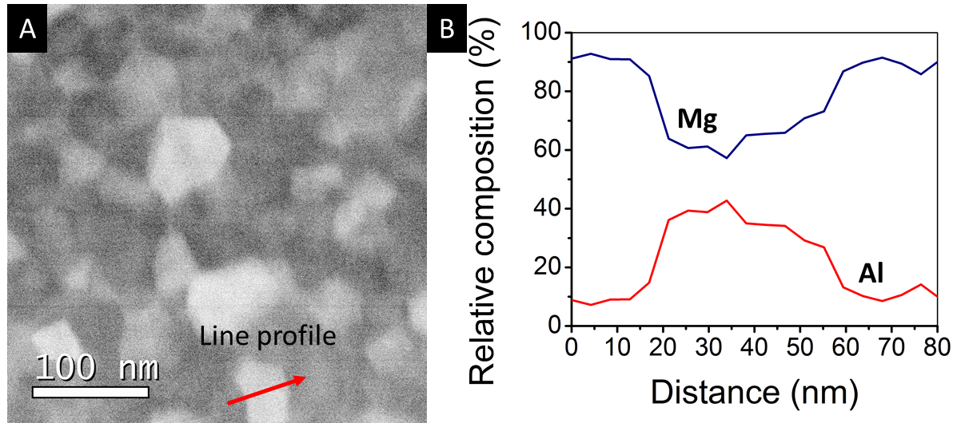
Figure 8: A) STEM ADF image of Mg-9Al thin film heat treated for 5 min at 300˚C. B) Relative compositions in at.% as quantified with EELS.

Although there are a number of mechanisms in the nanocrystalline thin film system that impede grain boundary mobility and lead to a high grain growth exponent, the activation energy for grain growth (31.1. kJ/mol) determined in the present work is much lower than in microcrystalline pure Mg [24], bulk Mg-Al alloys [16] and even in mechanically alloyed nanopowder [10].
The activation energy for grain boundary diffusion in Mg is reported to be 92 kJ/mol and in Al it is 84 kJ/mol [29], suggesting a mechanism different from grain boundary diffusion to be responsible for the low activation energy measured in this work.
A likely explanation for the low activation energy for grain growth is the strong effect of surface diffusion in the thin film, as was observed for Cu and Ag films [11, 13]. That the grain growth parameter in those pure metal systems was relatively low (n=3) compared to this study, supports the hypothesis that the Al supersaturation in the matrix and the formation and growth of β-Mg₁₇Al₁₂ precipitates lead to such a high n. However, it is surprising that the activation energy is so low in comparison to the mechanically alloyed Mg–5 wt%–Al nanopowder (119 kJ/mol) studied by Thein [10], where surface diffusion should have also played a large role in reducing the activation energy. It is possible that in the work of Thein [10], impurities induced during the mechanical alloying process via ball milling were responsible for grain boundary pinning and led to increased activation energy closer to bulk values.
Conclusions
Thin films of Mg-9 wt.% Al were fabricated by sputtering and subjected to heat-treatment at 150, 200 and 300C for times ranging from 5 - 190 min to . The microstructure and grain growth in the films were analyzed and the following conclusions can be made:
- The grain growth parameter n was determined to be 7±2 for the temperature-time combinations studied here, which is in agreement with the analysis by Thein on mechanically alloyed nanocrystalline Mg-5Al.
- The high grain growth parameter is likely a result of the rapid precipitation of the β-phase during the early stages of heat treatment.
- The activation energy for grain growth was determined to be 31.1 ± 13.4 kJ/mol. This value is significantly lower than in microcrystalline pure cast Mg (91 kJ/mol) or microcrystalline AZ91 (115 kJ/mol) and attributed to the strong surface diffusion in thin film systems.
- Heating magnetron-sputtered thin films inside the TEM and subsequent grain size analysis is a suitable technique to study early-stage grain size evolution kinetics in Mg-alloys starting out at a non-equilibrium solid solution.

References
1. Powers, W.F., Automotive materials in the 21st century. Advanced materials and processes, 2000. 157(5): p. 38-42.
2. U.S. Department of Energy Vehicle Technologies Program Multi-Year Program Plan 2011-2015, Dec. 2010. [cited 2011 8th March]; Available from: http://www1.eere.energy.gov/vehiclesandfuels/pdfs/program/vt_mypp_2011-2015.pdf.
3. Contreras-Piedras, E., et al., Growth kinetics of cellular precipitation in a Mg–8.5Al–0.5Zn–0.2Mn (wt.%) alloy. Materials Science and Engineering: A, 2010. 527(29–30): p. 7775-7778.
4. Zhang, M.X. and P.M. Kelly, Crystallography of Mg17Al12 precipitates in AZ91D alloy. Scripta Materialia, 2003. 48(5): p. 647-652.
5. Zhou, J.P., et al., In situ observation of ageing process and new morphologies of continuous precipitates in AZ91 magnesium alloy. Materials Letters, 2007. 61(25): p. 4707-4710.
6. Braszczyńska-Malik, K.N., Discontinuous and continuous precipitation in magnesium–aluminium type alloys. Journal of Alloys and Compounds, 2009. 477(1–2): p. 870-876.
7. Cerri, E. and S. Barbagallo, The influence of high temperature exposure on aging kinetics of a die cast magnesium alloy. Materials Letters, 2002. 56(5): p. 716-720.
8. Avedesian, M.M. and H. Baker, ASM speciality handbook: magnesium and magnesium alloys, in New York: ASM International. 1999. p. 79.
9. Wang, X.J., et al., Heat treatment of vacuum high pressure die cast magnesium alloy AZ91. International Journal of Cast Metals Research, 2014. 27(3): p. 161-166.
10. Thein, M., L. Lu, and M. Lai, Kinetics of grain growth in nanocrystalline magnesium-based metal–metal composite synthesized by mechanical alloying. Composites Science and Technology, 2006. 66(3-4): p. 531-537.
11. Simoes, S., et al., In situ TEM study of grain growth in nanocrystalline copper thin films. Nanotechnology, 2010. 21(14): p. 145701.
12. Dannenberg, R., et al., In-situ TEM observations of abnormal grain growth, coarsening, and substrate de-wetting in nanocrystalline Ag thin films. Thin Solid Films, 2000. 370(1–2): p. 54-62.
13. Dannenberg, R., et al., TEM annealing study of normal grain growth in silver thin films. Thin Solid Films, 2000. 379(1–2): p. 133-138.
14. Wang, Y., G. Liu, and Z. Fan, Microstructural evolution of rheo-diecast AZ91D magnesium alloy during heat treatment. Acta Materialia, 2006. 54(3): p. 689-699.
15. Miao, Q., et al., Grain growth kinetics of a fine-grained AZ31 magnesium alloy produced by hot rolling. Journal of Alloys and Compounds, 2010. 493(1–2): p. 87-90.
16. Bhattacharyya, J.J., S.R. Agnew, and G. Muralidharan, Texture enhancement during grain growth of magnesium alloy AZ31B. Acta Materialia, 2015. 86: p. 80-94.
17. Kulkarni, K. and A. Luo, Interdiffusion and Phase Growth Kinetics in Magnesium-Aluminum Binary System. Journal of Phase Equilibria and Diffusion, 2013. 34(2): p. 104-115.
18. Cáceres, C.H., et al., Section thickness, macrohardness and yield strength in high-pressure diecast magnesium alloy AZ91. Materials Science and Engineering: A, 2005. 402(1-2): p. 269-277.
19. Crawley, A.F. and K.S. Milliken, Precipitate morphology and orientation relationships in an aged Mg-9% Al-1% Zn-0.3% Mn alloy. Acta Metallurgica, 1974. 22(5): p. 557-562.
20. Kruska, K., et al., Nanoscale characterisation of grain boundary oxidation in cold-worked stainless steels. Corrosion Science, 2012. 63: p. 225-233.
21. Burke, J.E. and D. Turnbull, Recrystallization and grain growth. Progress in Metal Physics, 1952. 3: p. 220-292.
22. Huang, J.S., et al., Recrystallization and grain growth in bulk Cu and Cu(Sn) alloy. Materials Chemistry and Physics, 1997. 49(1): p. 33-41.
23. Novikov, V.Y., On description of grain growth kinetics. Scripta Materialia, 1998. 39(7): p. 945-949.
24. Frost, H.a.A., MF, Deformation Mechanism Maps. 1983, Pergamon Press: Oxford. p. 44.
25. Wang, X., et al., Grain growth kinetics of bulk AZ31 magnesium alloy by hot pressing. Journal of Alloys and Compounds, 2012. 527: p. 193-196.
26. Magnesium and Magnesium Alloys, ASM Specialty Handbook, M.M.A.a.H. Baker, Editor. 1999, ASM International,. p. 37.
27. C.C. Koch, I.A.O.k., S. Seal and S. Veprek, Structural Nanocrystalline Materials – Fundamentals and Applications. 2007, Cambridge University Press: UK. p. 110.
28. Mullins, W.W., The effect of thermal grooving on grain boundary motion. Acta Metallurgica, 1958. 6(6): p. 414-427.
29. J.W. Martin, R.D.D., Stability of Microstructure in Metallic
Systems. 1976, Cambridge University Press.

