The effects of presentation time on preference for curvature of real objects and meaningless novel patterns

Guido Corradi1* , Jaume Rossello-Mir1, Javier Vaño_1,
Erick Chuquichambi1, Marco Bertamini2 and Enric Munar1

1 Human Evolution and Cognition Group (EvoCog), University of the Balearic Islands and IFISC, Associated Unit to CSIC, Palma de Mallorca, Spain
2 Department of Psychological Sciences, University of Liverpool, UK

Abstract
Objects with curved contours are generally preferred to sharp-angled ones. In this study, we aim to determine whether different presentation times influence this preference. We used images of real objects (experiment 1) and meaningless novel patterns (experiment 2). Participants had to select one of two images from a contour pair, curved and sharp-angled versions of the same object/pattern. With real objects, the preference for curved versions was greatest when presented for 84-ms, and it faded when participants were given unlimited viewing time. Curved meaningless patterns were preferred when presented for 84 and 150 ms. However, in contrast to real objects, preference for meaningless patterns increased significantly in the unlimited viewing time condition. Participants discriminated poorly between the two versions (curved and sharp-angled) of the meaningless patterns in the 84- and 150-ms presentations (experiment 3). Therefore, in short times with meaningless patterns, participants selected mostly the curved version without being aware of the difference. In conclusion, presentation time, type of stimulus and their interaction influence preference for curvature.

Keywords: visual preference, empirical aesthetics, preference for curvature, pair comparison task.
The effects of presentation time on preference for curvature of real objects and meaningless novel patterns

When asked to choose between two similar objects, differing only in the curvature or angularity of their contours, people tend to choose the curved contour alternative (Gómez-Puerto et al., 2017; Munar, Gómez-Puerto, Call, & Nadal, 2015; Munar, Gómez-Puerto, & Gomila, 2014). Using different experimental paradigms, people also prefer curvature in lines (Bertamini, Palumbo, Gheorghes, & Galatsidas, 2015; Hevner, 1935; Lundholm, 1920; Poffenberger & Barrows, 1924), typefaces (Kastl & Child, 1968; Velasco, Woods, Hyndman & Spence, 2015), car interior designs (Leder & Carbon, 2005), familiar objects (Bar & Neta, 2006, 2007; Leder, Tinio, & Bar, 2011; Munar, Gómez-Puerto, Call, & Nadal, 2015), meaningless patterns (Bertamini et al., 2016; Fantz & Miranda, 1975; Jadva, Hines, & Golombok, 2010; Palumbo & Bertamini, 2016; Palumbo, Ruta, & Bertamini, 2015; Silvia & Barona, 2009; Velasco et al., 2016), furniture (Dazkir & Read, 2012), interior architecture (Vartanian et al., 2013; Vartanian et al., 2017), and product designs (Westerman et al., 2012). Preference for curvature is common to western and non-western adults (Bertamini et al., 2015; Dazkir & Read, 2012; Gómez-Puerto et al., 2017; Hevner, 1935; Kastl & Child, 1968; Leder & Carbon, 2005; Leder et al., 2011; Lundholm, 1920; Munar et al., 2015; Palumbo & Bertamini, 2016; Palumbo et al., 2015; Poffenberger & Barrows, 1924; Silvia & Barona, 2009; Vartanian et al., 2013; Velasco et al., 2016; Westerman et al., 2012), toddlers (Jadva et al., 2010), newborns (Fantz & Miranda, 1975), and even to great apes (Munar et al., 2015).

Munar et al. (2015) showed that preference for curvature is common to humans and great apes. But they also found differences in preference between species as a function of presentation time. Great apes exhibited preference for curved objects when they were shown until the participants’ response, but not when shown briefly (84 ms). Conversely, humans preferred curved objects when they were shown briefly but not when they were shown until the participants’ response. Using other experimental paradigms, Palumbo and Bertamini (2016) found effect sizes of η_{p}² = .68 when stimuli were presented for 120 ms (Experiment 1), and η_{p}² = .48 (Experiment 2) and η_{p}² = .42 (Experiment 3) when they were presented until the participants’ response. Thus, it seems that in humans contour has a stronger effect on preference with shorter presentation times.

Meaningfulness could also modulate the effect of contour on preference. Bar and Neta (2006) reported a larger effect size using images of real objects (d = 0.94) than meaningless patterns (d = 0.67). However, Leder et al. (2011) reported a larger effect size with meaningless patterns (d = 1.1) than with real object images (d = 0.6). Both studies used the same presentation time (84 ms), the same like-dislike task and the same stimuli. Westerman et al. (2012) found similar effect sizes in meaningless patterns (d = 0.46) and in real objects (d = 0.47), using designs of packaging and presentation time until the participants’ response.

Our study aimed to explore the effects of presentation time on preference for curvature and calrify the results from Munar et al. (2015). Experiment 1 was designed to determine how presentation time affects preference for curved contours of images of real object, using six presentation time conditions with a between-subjects design. We hypothesised that the shorter the presentation time, the stronger the preference for curvature (Munar et al., 2015). The results indicated that the effect of preference for curvature decreased as the presentation time increased. This tendency could result from the influence of meaning and content-related information as the presentation time increased. To test this hypothesis, Experiment 2 was designed to determine the impact of presentation time on preference for curvature of meaningless patterns. In this case, we hypothesised that the preference for curved contours would not be affected by longer presentation times, given the absence of meaning or content-related information processes. The results confirmed a stronger effect with longer presentation time compared to brief presentations (84 and 150 ms). Experiment 3 was designed to ascertain the extent to which participants discriminate between the meaningless patterns during these brief presentations.

Experiment 1

Participants

One hundred ninety-one graduate students from the University of the Balearic Isles. took part in the experiment. None of them were aware of the goals of the experiment. They had normal or corrected-to-normal vision. Participants provided written informed consent to take part in the experiment procedure, which was approved by the Ethical Committee of the University.

Materials

The stimuli were 160 grey-scale images of real objects taken from Bar and Neta’s (2006, 2007) studies. They had a resolution of 340 x 340 pixels, and when shown on a 19-inch screen at 1440 × 900 px (89.37 PPI), their size was of 9.66 × 9.66 cm. The images were paired in order to create two sets. A set of 36 contour pairs (targets) was created, each consisting of two versions of the same object that differed especially in the curvature/angularity of its contour (e.g., a sharp basket and a curved basket). Additionally, a set of 36 content pairs was created consisting of different objects with the same kind of contour, thus differing in their semantic content (e.g., sharp padlock and sharp handbag) (Figure 1). These distractors were included to disguise the purpose of the experiment. This aspect of the procedure meant that there were pairs with the same contour and different content. If all stimuli were targets the participants could have always used a strategy in favour of one of the two categories: curved or sharp.

The experiment consisted of two blocks with 72 pairs/trials in each. Both were identical, except that, for each pair, the alternatives appeared on the opposite side of the screen. The images appeared at 170 pixels from the centre of the screen on the horizontal axis. Block order and trial order were randomized for each participant. The training set consisted of 8 pairs. Tasks were performed on individual computers in similar light conditions and distance to the screen (45 cm). Tasks were programmed with Opensesame (v. 2.7) experimental psychology software (Mathôt, Schreij, & Theeuwes, 2012).
--------------------------------------------------
Please insert Figure 1 about here
--------------------------------------------------

Procedure

Participants were randomly assigned to six different presentation times of the stimuli: 34 ms, 48 ms, 84 ms, 150 ms, 500 ms, and until-response. A between-subject design was selected to test presentation times because of the length of the procedure.

Participants chose between the two options placed presented on the left and right sides of the screen. The chosen image was then shown enlarged twice its original size for one second. Participants were instructed to ‘Select one of the two images, the image selected will be shown again enlarged’. The instructions avoided the use of the words ‘liking’, ‘preference’ and ‘wanting’. Each trial started with a fixation cross for 500 ms, followed by a pair of stimuli on each side of the screen. Stimuli were displayed for the time specified in each condition, and then occluded by two grey squares, except in the until-response condition. Responses were given with the keyboard’s arrows, left or right. The selected image was shown again twice the previous size for 1000 ms centered on the screen. This additional presentation was aimed at stimulating the act of approaching the preferred image by enlarging it, as in (Munar et al., 2015). In the until-response condition, images remained on screen until participants responded.

Results

Based on the idea that big differences in response time (RT) can be caused by different cognitive processing, we conducted an analysis to detect extreme short and long RTs. We calculated Q1, Q3 and the Interquartile Range (IQR) for every participant. Response times under Q1–1.5·IQR or 300 ms were considered short responses, and those over Q3+1.5·IQR were considered long responses. These short and long trials were excluded from the subsequent analyses (1478 trials, 5.38% of all responses). However, analyses with the excluded trials yielded the same results.

We analysed the effects of presentation time on dichotomic responses (choice of curved or sharp version) with generalized linear mixed effects models (Hox, 2010; Snijders & Bolker, 2012). This method accounts simultaneously for the between-subject and within-subject effects of the independent variables (Baayen, Davidson, & Bates, 2008). It is thus especially suitable for understanding human preferences, which may vary from person to person, and from image to image (Silvia, 2007). In setting the model up, we followed Barr, Levy, Scheepers, and Tily’s (2013) guidelines. They suggest modelling the maximal random effects structure justified by the experimental design, which, in addition to avoiding the loss of power and reducing Type-I error, enhances the possibility of generalizing results to other participants and stimuli. However, as noted by Barr et al. (2013), when using maximal models, the process of parameter estimation will occasionally fail to produce a solution. In these cases, they recommend simplifying the model’s structure stepwise. All analyses were carried out within the R environment for statistical computing (R Core Team, 2016). We used the mixed() function of the ‘afex’ package (Singmann, Bolker, Westfall & Aust 2016), with likelihood ratio tests to produce the inferential statistics and p-values. Also, lsmeans() from the ‘lsmeans’ package (Lenth, 2015) was used to create the predicted marginal means, contrasts and comparisons for fixed factors of models. The models were primarily set up to study the impact of presentation time. However, in order to account for the effects of block and response lateralization in each participant, we included them in the models.

Following the literature (Bar & Neta, 2006; Munar et. al., 2015), we chose 84 ms as default reference for the intercept. The maximal model that converged included presentation time by participant and item as random effects. We performed a study of influential cases based on Cook’s distance (Cook’s D). This measure evaluates each participant’s influence on the results by examining the impact of its removal from the data set. This analysis revealed 7 influential cases whose Cook’s D value exceeded the recommended cut-off point, which was .021. It is calculated as 4/(n - k - 1), where n is the sample size and k the number of predictor variables. Thus, 7 participants (1 from the 34-ms group, 1 from the 150-ms, 2 from the 300-ms and 3 from the until-response conditions) were excluded from the analysis.

The results of the generalized linear mixed model revealed a main effect of presentation time, χ² = 12.93, p = .024, and no significant effects of response lateralization, χ² = 0.32, p = .572, or block, χ² = 0.27, p = .6. To verify whether the proportion of chosen curved stimuli in each group was above chance, we tested each group against .5 with Holm-Bonferroni correction through the ‘lsmeans’ package. The results showed no statistically significant difference in the 34-ms group (.54, 95 % CI [.48, .59], z = 3.97, p = .37) and in the until-response group (.5, 95 % CI [0.44, 0.56], z = 0.08, p = .93). The other groups showed significant preference for curvature: 48 ms (.58, 95 % CI [.53, .63], z = 3.06, p = .01), 84 ms (.61, 95 % CI [.56, .67], z = 3.97, p < .001), 150 ms (.59, 95 % CI [.53, .64], z = 3.11, p = .01) and 300 ms (.57, 95 % CI [.52, .63], z = 2.52, p = .04). Pairwise comparisons between these four groups did not yield any significant difference between them (Figure 2).
--------------------------------------------------
Please insert Figure 2 about here
--------------------------------------------------
We also analysed response times with a linear mixed model, which predicted response time by the presentation time group and preference with random effects by item and participant. Results estimated the following response time (RT) for each group: until-response = 930 ms, 95% CI [844, 1015], 300-ms presentation time = 537 ms, 95% CI [456, 618], 150-ms presentation time = 503 ms, 95% CI [455, 618], 84-ms presentation time = 639 ms, 95% CI [558, 720], 48-ms presentation time = 719 ms, 95% CI [645, 718], 34-ms presentation time = 605 ms 95% CI [523, 689].

Discussion

Results confirmed that participants chose curved objects more often than sharp-angled ones. However, this preference was influenced by presentation time. Participants in the 34 ms and until-response conditions showed no preference for curved stimuli. Presentations of 34 ms may have not been long enough to inspect both stimuli and compare them. Results from experiments that manipulated presentation time in visual discrimination tasks (Gintautas et al., 2011; Vancleef & Wagemans, 2013) and other tasks (Fei-Fei, Iyer, Koch & Perona, 2007) suggest that indeed 34 ms may not be enough time to inspect the two stimuli. The results of the until-response condition agree with those in Munar et al. (2015), and probably owe to the greater influence of the meaning and semantic content on preference. If this interpretation is correct, preference for meaningless patterns –lacking semantic content–, should be maintained even in long presentation times. To test this prediction, we carried out a second experiment using meaningless novel patterns from Bertamini et al. (2015).

Experiment 2

Participants

Ninety-one undergraduate students at the University of XXXX (72 females, age M=21.88, SD=5.56, all adults) took part in the experiment. None of them were aware of the goals of the experiment and had normal or corrected-to-normal vision. Participants provided written informed consent to take part in the experiments. The experimental procedure was approved by the Ethical Committee of XXXX.

Material

The stimuli were 160 grey patterns generated following the procedure described in Bertamini, Palumbo, Nicoleta and Galatsidas (2016). The procedure to create the novel patterns was (1) to select points randomly placed between two concentric circles and (2) these points were connected by lines, becoming vertices of the pattern. This procedure generates the sharp-angled version. Curved versions were created from sharp-angled ones using a cubic spline, which generated curves on the original vertices. Psychopy (Peirce, 2009) software (v 1.84) was used to create the patterns. Each image had a resolution of 340 x 340 pixels so, when shown on a 19-inch screen at 1440 × 900 px (89.37 PPI), their presented size was 9.66 × 9.66 cm. Two experimental sets (contour and content) and one training set were created. Pairs were constructed using the same 26 vertices and differed on contour (curved or sharp) in the contour set. Pairs were matched in contour but not in the number of vertices in the content set. The training set consisted of 8 pairs that had the same combinations as the contour and content sets. There were two experimental blocks. Experimental pairs were shown twice on opposite sides. Block order and trial order were randomized.

Procedure

The experiment was designed to be similar to Experiment 1 except that the stimuli were meaningless patterns instead of images of familiar objects. The procedure was the same as Experiment 1, even the instructions, but we only used three presentation times: 84 ms, 150 ms, and until-response. As our interest were in the progress from 84 ms to the until-response condition, we did not use values lower than 84 ms. On the other hand, as the results with 150 ms and 300 ms were almost the same, we used only one of these presentation times.

Results

As in Experiment 1, we analysed the effects of presentation time on participants’ dichotomic responses with generalized linear mixed effect models. The maximal model that converged included presentation time by participant and item as random effects. The study of influential cases based on Cook’s distance of participants revealed 2 influential cases whose Cook’s D value exceeded the recommended cut-off point, which was 0.46, calculated as in Experiment 1. Both participants were from the until-response condition and were excluded from further analysis. We followed the same procedure and same criteria as in the first experiment to remove trials with extreme response times from the analysis (772 trials, 5.9% of all responses). Analyses with the excluded trials also yielded the same results.

The results of the generalized linear mixed model of responses revealed a main effect of presentation time, χ² = 15.44, p < .001. In order to check whether the proportion for curved stimuli was significantly different than chance level, we tested each group against .5 with Holm-Bonferroni correction using the ‘lsmeans’ package. All groups showed significant difference from .5: 84-ms group (.59, 95 % CI [.51, .67], z = 2.26, p = .041), 150-ms group (.6, 95 % CI [.52, .67], z = 2.32, p = .041), and until-response group (.77, 95 % CI [.70, .82], z = 6.92, p < .001). Pairwise comparisons between the three levels revealed statistically significant differences between the 84-ms and the until-response conditions, z = 3.56, p < .001, and between the 150-ms and the until-response conditions, z = 3.52, p < .001, but not between the 84-ms and 150-ms conditions, z = 0.044, p = .96 (Figure 3). As in Experiment 1, there was no effect of response lateralization, χ² = 2.12, p = .145, or block, χ² = 0.041, p = .84.

We analysed RT with a linear mixed model that included as predictor presentation time and as random effects, item and participant. The model estimated the following RT for each group: until-response = 1032 ms, 95% CI [890, 1174], 150-ms = 467 ms, 95% CI [329, 603], and 84-ms = 510 ms, 95% CI [375, 645].

As the until-response condition showed greater preference for curvature, we analysed a possible relationship between selection of curved version and RT in the until-response condition. This way, a generalized mixed model with centred log-transformed RTs revealed no effect of RT on selection of curved version (β = -.44, 95 % CI [-1.08, 0.33], χ² = 1.47, p = .22). Moreover, participants took a bit longer when they selected the sharp-angled version (M = 882 ms) than the curved one (M = 842 ms).

--------------------------------------------------
Please insert Figure 3 about here
--------------------------------------------------
Discussion

Experiment 2 used the same procedure as Experiment 1 to test preference for curvature with meaningless novel patterns. Participants showed a preference for curved meaningless patterns over sharp-angled ones. Probability of choosing the curved version was .77 in the until-response condition, .59 in 84-ms condition and .6 in 150-ms condition. Preference for curvature was significantly higher than chance in all conditions but, contrary to our expectation, it was not equally strong in all three conditions. Preference for curvature was statistically higher in the until-response condition than in the 84- and 150-ms conditions. This means that the effect was stronger in unlimited viewing time.

Palumbo and Bertamini (2016) varied the presentation time using the same kind of stimuli we used: 120 ms in Experiment 1 and until-response in Experiments 2 and 3. It is interesting that the effect size was greater in Experiment 1 (η_{p}² = .68) with limited presentation time than in Experiments 2 (η_{p}² = .48) and 3 (η_{p}² = .42) in the until-response condition. However, the difference between their results and ours could not come from the presentation time but from several other sources: instructions, type of presentation, and kind of response. Instructions in Palumbo and Bertamini’s were about liking in Experiments 1 and 2, and attractiveness in Experiment 3. Our instructions were about selecting one of the two stimuli, and they used a like/dislike response in Experiment 1 and a rating scale in Experiments 2 and 3, presenting only one stimulus in each trial.

Therefore, unlike Palumbo and Bertamini’s (2016) experiments in which participants rated only one stimulus in each trial, our participants had to carry out a more complex comparison. To select one of the two figures, we assume that they had to discriminate and compare them. To carry out the discrimination, comparison and selection processes is more difficult for short presentation times than for long ones. Poorer discrimination would result in weaker selection preference for the curved figure because the participant answer would be more random. Thus, a higher preference for curved figures in the until-response condition could come from the difficulty of the discrimination process in short presentation times. In Experiment 3, we checked the possible different difficulty between the three presentation time conditions as potential explanation of the differences between conditions in preference for curvature.

Experiment 3

Participants

Twenty-three graduate students from the University of the XXXX (16 females, age M=22.34, SD=4.89, all adults) took part in the experiment. None of them were aware of the goals of the study. They had normal or corrected-to-normal vision. Participants provided written informed consent to take part in the experiment. The procedure was approved by the Ethical Committee of the XXXX.

Material

We used the same kind of stimuli as in Experiment 2, with the same distance, measures and apparatus. However, we needed to create new pairs of stimuli in which the two stimuli were exactly the same. This way, we matched 72 pairs of stimuli. There were two types of pairs: the pairs in which the two images were the same, and the pairs in which the two images were different. This second type of pairs could vary in (I) contour (curved or sharp-angled) or (II) the points where they were created (different patterns). This way, we created 4 types of pairs: (a) same pattern and different contour, (b) different pattern and same contour –half of them curved and the other half sharp-angled, (c) same pattern and same curved contour, and (d) same pattern and same sharp-angled contour. Our interest was in the pairs with the same pattern and different contour, that is, pairs (a) (Figure 4). The rest of the trials were to balance the different features (contour versus pattern) and conditions (same versus different). The aim of the experiment was to know whether participants discriminate the two stimuli in pairs (a) in the three presentation time conditions. So, we called pairs (a) targets and the other three types, distractors. There were 18 pairs of each type. They were presented in each of the three blocks: 84-ms, 150-ms, and until-response conditions. Eight practice trials were used, 2 of each type of pair.

--------------------------------------------------
Please insert Figure 4 about here
--------------------------------------------------

Procedure

Participants’ task was to decide whether the two images were exactly the same or different, emphasizing the word “exactly”, repeating it, because the two stimuli of the target pairs were quite similar but different. There were two blocks with restricted presentation times (84 ms and 150 ms) and one with until-response condition. Eight training trials with feedback were carried out prior to the 84-ms and until-response blocks. Feedback consisted of a screen with the word “Incorrect” if the answer was wrong and then the trial was repeated. A trial consisted of a 500-ms fixation cross, followed by a pair of stimuli. The pair remained on the screen for the presentation time (84 ms or 150 ms) and were then occluded by two grey squares, except for the until-response condition. Participants responded with A or L on the keyboard. Half of the participants answered “same” with the A key and the other half answered “same” with the L key. The order of blocks was: practice (84 ms), 84-ms block, 150-ms block, practice (until-response) and until-response block. The 72 trials of each block were presented in randomized order. Before each practice block, participants were instructed.

Results

Three participants were removed because they answered approximately at chance level (.5) in trials (b) –same contour and different pattern- in the until-response condition. As the task was quite easy in these trials, it could mean that they did not perform the task properly and were pressing the keys at random. We followed the same procedure and the same criteria as in the previous experiment to remove trials with extreme response times (320 trials, 7.41%).

We analysed the effects of presentation time (84 ms, 150 ms, until-response) on participants’ responses (correct or incorrect) on stimuli type (a) (same pattern, different contour) with generalized linear mixed effects model (Hox, 2010; Snijders & Bolker, 2012). The maximal model that converged included presentation time by participant and item as random effects. The study of influential cases based on Cook’s distance of participants revealed no influential cases whose Cook’s D value exceeded the recommended cut-off point, which in this case was .22, calculated as in the previous experiments. We used the mixed() function from the “afex” package (Singmann et al., 2016) with likelihood ratio tests to produce the inferential statistics and p-values.

The results of the generalized linear mixed model revealed no significant effect of lateralization and a main effect of presentation time, χ² =293.54, p < .001. Holm-Bonferroni corrected tests indicated that the probability of giving a correct response in 150-ms presentation time (.32, 95% CI [.25, .40]) was significantly lower than in 84-ms presentation time (.43, 95 % CI [.36, .52]), z = 3.16, p = .0015, and in the until-response condition (.89, 95 % CI [.85, .93]), z =13.9, p < .001. Also, probability of giving a correct response in the 84-ms presentation time was significantly lower than in the until-response condition, z = 11.8, p < .0001 (Figure 5).

--------------------------------------------------
Please insert Figure 5 about here
--------------------------------------------------

We analysed reaction time with a linear mixed model that predicted it by presentation time and accuracy with random effects by item and participant. The estimated reaction times for the until-response condition were 1426 ms (95% CI [1312, 1541]) for correct responses, and 1184 ms (95% CI [976, 1384]) for incorrect ones. The estimated reaction time for the 150-ms condition was 885 ms (95% CI [744, 1027]) for correct responses and 665 ms (95% CI [535, 775]) for incorrect ones. The estimated reaction time for the 84-ms condition was 1081 ms (95% CI [951, 1212]) for correct responses and 975 ms (95% CI [848, 1096]) for incorrect ones.

Discussion

The aim of Experiment 3 was to test discrimination accuracy in the three presentation times of Experiment 2. These pairs had a curved and a sharp-angled version of the same pattern. For that reason, we only analysed pairs (a): same pattern and different contour. The results indicated noticeable difference in discrimination between short and long presentations. While the average accuracy is around 90% in the until-response condition, it is below the chance level in the 84- and 150-ms conditions. There was a tendency to perceive both figures as identical in short presentations. Interestingly, there are results using a pairwise comparison task (Kramer & Ritchie, 2016; Adamic et al., 2009; Nachmias, 2011; Phelps et al., 2015) that show a general principle: the more similar two stimuli are, the more precise is the discrimination, provided that the participant can discriminate them. In our case, meaningless novel patterns were quite similar, but our results using 84 and 150 ms showed that participants did not discriminate them. This seems to indicate that they did not have enough time to visually inspect the two stimuli.

Hence, we highlight two main conclusions from the results of Experiment 3. First, there is no conscious discrimination when pairs are presented for 150 ms or less. Second, there are significant differences between short and long presentations. Thus, the higher preference for curved figures with long presentation in Experiment 2 could come from a higher conscious discrimination of the pairs.

General Discussion

We report two experiments on visual preference that used a paired comparison paradigm (Experiments 1 and 2). The task consisted of selecting one of the two stimuli that appeared side by side on screen. The stimuli varied in contour: curved or sharp-angled. Participants preferred curved stimuli over sharp-angled ones. However, presentation time modulated this preference. This modulation is different in images of real objects and meaningless novel patterns. Participants preferred real objects with curved contours when presented for 48-, 84-, 150-, and 300-ms. They showed no preference when the pairs were presented until the participants’ response. With meaningless patterns, participants also showed the effect of preference for curvature in brief conditions (84-, and 150 ms), but it increased significantly in the until-response condition, unlike real objects that it disappeared.

We need an explanation for the differential results from the two kinds of stimuli. In brief presentations, there is no difference between real objects and meaningless patterns, so the effects are similar. It means that participants based their preference on contour in a similar way with both stimuli. Here the decision has to be based mainly on visual aspects or on a subsequent analysis of the sensory memory, that is after low- and mid-level processing (Groen, Silson, & Baker, 2017).

However, in the until-response condition, the effect disappeared with real objects and increased significantly with meaningless patterns. As the disappearance of the effect with real objects does not occur with meaningless patterns, it seems to be due to a stronger influence of meaning and content-related information processing as the real objects are displayed longer. Other studies (Fei-Fei, Iyer, Koch, & Perona, 2007; Vessel & Rubin, 2010) have indicated that preferences in real-world scenes with long presentations are mainly based on semantic associations. Thus, basic visual features, such as contour, are less critical in preference for long presentations of real objects.

On the other hand, preference for curvature with meaningless patterns in until-response condition was maintained and it increased significantly in relation to short presentations of the same stimuli. This increase was unexpected. We hypothesised that the difference between short and long presentations could come from the difficulty to discriminate the two patterns in short presentations, as curved and sharp-angled versions were similar unlike images of real objects that differences between objects were clear. Experiment 3 results showed a failure to discriminate between curved and sharp-angled versions of meaningless patterns for 84- and 150-ms presentations. Therefore, participants in Experiment 2 with short times preferred the curved version without consciously discriminating it. It means that preference for curved meaningless patterns is happening at a low level for 84 and 150-ms, before we are aware of the difference between patterns. In addition, this preference increases significantly when time condition is unrestricted.

In line with this interpretation and using the same presentation, we obtained preliminary results showing that humans and great apes first fixate, and the time to fixate is lower in the curved than in the sharp-angled version (Gómez-Puerto, Munar, Kano, & Call, 2015). This could be the way to select the curved version without being aware of the difference between the two stimuli. This way, participants initially do not need to discriminate precisely between the two stimuli.

According to our results, the increase of preference for curved meaningless patterns in the until-response condition comes from, at least partially, a better visual discrimination of the two patterns. However, we cannot rule out other contributions. For example, longer presentation time could lead to more salient curvature because the type of the contour is the most distinguishable feature between the two stimuli. The conjoint evaluation of these stimuli would intensify the type of contour as time increases. As a consequence, participants would base their decision on this feature to a greater extent. As there is a general preference for curvature, the number of chosen curved stimuli would increase. Another possibility is that participants may try to base their decisions on an interpretation of the shape; that is, trying to attribute meaning to the stimulus. This phenomenon is called pareidolia and is frequently reported in random images (Liu et al., 2014; Takahashi & Watanabe, 2015). Thus, the rationale could be that participants base their preference for meaningless patterns on associations with other objects. Because the smooth curve is the most probable arrangement to join two segments in natural scenes (Sigman, Cecchi, Gilbert, & Magnasco, 2001), the curved versions would be matched to “real objects” and, as a consequence, produce higher preference (Kotabe, Kardan, & Berman, 2017). As these two possible contributions to the increase of the effect in the until-response condition can be related to a longer inspection time, we analysed the possible relationship between preference for the curved version and response time (RT). The analysis shows no relationship between these two variables, which does not support these possible contributions. Nonetheless, we have to consider that RT variable is not exactly equivalent to inspection time, that is, longer RTs could be due to other factors beyond the inspection time.

Despite the fact that our results about the influence of the type of stimuli and presentation time on preference for curvature are clear, we must note that we used a specific experimental paradigm. The paired comparison task has the particularity of presenting two stimuli at once. We assume that the observer inspects both of them, and the effect of preference for curvature is a consequence of this inspection. However, most research on preference for curvature used trials with only one stimulus with dichotomic responses (Bar & Neta, 2006, 2007; Leder et al., 2011; Palumbo & Bertamini, 2016; Vartanian et al., 2013), rating scales (Bertamini et al., 2016; Dazkir & Read, 2012; Palumbo & Bertamini, 2016; Silvia & Barona, 2009), and implicit measures (Bertamini et al., 2016; Palumbo et al., 2015). Therefore, more research using these other paradigms is needed to confirm our results and conclusions.

In conclusion, visual preference for curvature is a robust effect. This preference is influenced by presentation time and type of stimulus. Using images of real objects, the effect seems to be maximal at short-medium presentation times (48-300 ms) and fades in the until-response condition. Using meaningless abstract patterns, the effect is similar to real objects at short-medium presentation times (84-150 ms) but it increases in the until-response condition. Therefore, the time course of preference for curvature with familiar objects and meaningless patterns is similar for short presentation times but different for long ones. The processes for the two types of stimuli must be different. We assume that long presentation gives rise to an increasing contribution of semantic content that leads to preference based on such content instead of on curvature. When shapes have no meaning, preference for curvature is preserved or even heightened in long presentation. This might result from the intensified weight of the curvature in the discrimination and decision processes. However, more research will be needed to clarify the involvement of specific factors.

References

Adamic, P., Babiy, V., Janicki, R., Kakiashvili, T., Koczkodaj, W. W., & Tadeusiewicz, R. (2009). Pairwise comparisons and visual perceptions of equal area polygons. Perceptual and Motor Skills, 108(1), 37–42. http://doi.org/10.2466/PMS.108.1.37-42
Augustin, M. D., Leder, H., Hutzler, F., & Carbon, C. C. (2008). Style follows content: On the microgenesis of art perception. Acta Psychologica, 128(1), 127–138. https://doi.org/10.1016/j.actpsy.2007.11.006
Baayen, R. H., Davidson, D. J., & Bates, D. M. (2008). Mixed-effects modeling with crossed random effects for subjects and items. Journal of Memory and Language, 59, 390–412. 10.1016/j.jml.2007.12.005
Bar, M., Neta, M. (2006). Humans prefer curved visual objects. Psychological Science 17, 645–648. http://dx.doi.org/10.1111/j.1467-9280.2006.01759.x
Bar, M., & Neta, M. (2007). Visual elements of subjective preference modulate amygdala activation. Neuropsychologia, 45, 2191-2200. 10.1016/j.neuropsychologia.2007.03.008
Barr, D. J., Levy, R., Scheepers, C., & Tily, H. J. (2013). Random effects structure for confirmatory hypothesis testing: Keep it maximal. Journal of Memory and Language, 68, 255–278. 10.1016/j.jml.2012.11.001.
Bertamini, M., Palumbo, L., Gheorghes, T. N., & Galatsidas, M. (2016). Do observers like curvature or do they dislike angularity? British Journal of Psychology, 107, 154–178. http://doi.org/10.1111/bjop.12132
Dazkir, S. S., & Read, M. A. (2012). Furniture form and their influence on our emotional responses toward interior environments. Environment and Behavior, 44(5), 722–732. http://doi.org/10.1177/0013916511402063
Fantz, R. L., & Miranda, S. B. (1975). Newborn-infant attention to form of contour. Child Development, 46(1), 224–228. http://doi.org/10.2307/1128853
Fei-Fei, L., Iyer, A., Koch, C., & Perona, P. (2007). What do we perceive in a glance of a real-world scene? Journal of Vision, 7(1), 10. http://doi.org/10.1167/7.1.10
Gintautas, V., Ham, M. I., Kunsberg, B., Barr, S., Brumby, S. P., Rasmussen, C., ... & Kenyon, G. T. (2011). Model cortical association fields account for the time course and dependence on target complexity of human contour perception. PLoS Computational Biology, 7(10), e1002162. http://dx.doi.org/10.1371/journal.pcbi.1002162
Gómez-Puerto. G., Munar, E., Kano, F. & Call, J. (2015). Eye-tracking of primate's preference for curvature. Poster session presented at the European Conference on Visual Perception, Liverpool, UK.
Gómez-Puerto, G., Munar, E., & Nadal, M. (2016). Preference for curvature: A historical and conceptual framework. Frontiers in Human Neuroscience, 9, 712.
Gómez-Puerto, G., Rosselló, J., Corradi, G., Acedo-Carmona, C., Munar, E., & Nadal, M. (2017). Preference for Curved Contours Across Cultures. Psychology of Aesthetics, Creativity, and the Arts. http://doi.org/10.1037/aca0000135. https://dx.doi.org/10.3389%2Ffnhum.2015.00712
Groen, I. I. A., Silson, E. H., & Baker, C. I. (2017). Contributions of low- and high-level properties to neural processing of visual scenes in the human brain. Philosophical Transactions of the Royal Society B, 1–22. http://doi.org/10.1098/rstb.2016.0102
Hevner, K. (1935). Experimental studies of the affective value of colors and lines. Journal of Applied Psychology, 19(4), 385–398. Retrieved from http://psycnet.apa.org/journals/apl/19/4/385/
Hox, J. J. (2010). Multilevel analysis. Techniques and applications (2nd ed.). New York: Routledge.
Jadva, V., Hines, M., & Golombok, S. (2010). Infants’ preferences for toys, colors, and shapes: sex differences and similarities. Archives of Sexual Behavior, 39(6), 1261–73. http://doi.org/10.1007/s10508-010-9618-z
Kastl, A. J., & Child, I. L. (1968). Emotional meaning of four typographical variables. Journal of Applied Psychology, 52(6, Pt.1), 440–446. http://doi.org/10.1037/h0026506
Kotabe, H. P., Kardan, O., & Berman, M. G. (2017). The nature-disorder paradox: A perceptual study on how nature is disorderly yet aesthetically preferred. Journal of Experimental Psychology: General, 146(8), 1126–1142. http://doi.org/10.1037/xge0000321
Kramer, R. S. S., & Ritchie, K. L. (2016). Disguising Superman: How glasses affect unfamiliar face matching. Applied Cognitive Psychology, 845(August), 841–845. http://doi.org/10.1002/acp.3261
Leder, H., & Carbon, C.C. (2005). Dimensions in appreciation of car interior design. Applied Cognitive Psychology, 19(5), 603–618. http://doi.org/10.1002/acp.1088
Leder, H., Tinio, P. L., & Bar, M. (2011). Emotional valence modulates the preference for curved objects. Perception, 40, 649-655. https://doi.org/10.1068/p6845
Lenth, R. (2015). lsmeans: Least-squares means. R package version 2.21-1. https://CRAN.R-project.org/package=lsmeans
Liu, J., Li, J., Feng, L., Li, L., Tian, J., & Lee, K. (2014). Seeing Jesus in toast: Neural and behavioral correlates of face pareidolia. Cortex, 53(1), 60–77. http://doi.org/10.1016/j.cortex.2014.01.013
Lundholm, H. (1920). The affective tone of lines: Experimental researches. Psychological Review, 28(1), 43–60.
Mathôt, S., Schreij, D., & Theeuwes, J. (2012). OpenSesame: An open-source, graphical experiment builder for the social sciences. Behavior Research Methods, 44(2), 314-324. doi:10.3758/s13428-011-0168-7
Munar, E., Gómez-Puerto, G., Call, J., & Nadal, M. (2015). Common visual preference for curved contours in humans and great apes. PloS One, 1–15. http://doi.org/10.1371/journal.pone.0141106
Munar E, Gómez-Puerto G, Gomila A (2014) The evolutionary roots of aesthetics: an approach-avoid- ance look at curvature preference. In: Scarinzi A, editor. Embodied Aesthetics: Proceedings of the 1st International Conference on Aesthetics and the Embodied Mind. Philosophy of History and Culture, 34. Leiden: Brill Academic Publishers. pp 3–17.
Nachmias, J. (2011). Shape and size discrimination compared. Vision Research, 51(4), 400–407. http://doi.org/10.1016/j.visres.2010.12.007
Palumbo, L., & Bertamini, M. (2016). The curvature effect : A comparison between preference tasks. Empirical Studies of the Arts, 34(1), 35–53. http://doi.org/10.1177/0276237415621185
Palumbo, L., Ruta, N., & Bertamini, M. (2015). Comparing angular and curved shapes in terms of implicit associations and approach/avoidance responses. Plos One, 10(10), e0140043. http://doi.org/10.1371/journal.pone.0140043
Peirce, J.W. (2009) Generating stimuli for neuroscience using PsychoPy. Frontiers in Neuroinformatics, 2, 10. doi:10.3389/neuro.11.010.2008
Phelps, A. S., Naeger, D. M., Courtier, J. L., Lambert, J. W., Marcovici, P. A., Villanueva-Meyer, J. E., & MacKenzie, J. D. (2015). Pairwise comparison versus Likert scale for biomedical image assessment. American Journal of Roentgenology, 204(1), 8– 14. http://doi.org/10.2214/AJR.14.13022
Poffenberger, A. T., & Barrows, B. E. (1924). The feeling value of lines. Journal of Applied Psychology, 8(2), 187–205.
R Core Team. (2016). R: A language and environment for statistical computing. Vienna, Austria: R Foundation for Statistical Computing. Retrieved from http://www.Rproject.org
Sigman, M., Cecchi, G. a., Gilbert, C. D., & Magnasco, M. O. (2001). On a common circle: Natural scenes and Gestalt rules. Proceedings of the National Academy of Sciences, 98(4), 1935–1940. http://doi.org/10.1073/pnas.98.4.1935
Silvia, P. J. (2007). An introduction to multilevel modeling for research on the psychology of art and creativity. Empirical studies of the arts, 25(1), 1-20. https://doi.org/10.2190/6780-361T-3J83-04L1
Silvia, P. J., & Barona, C. M. (2009). Do people prefer curved objects? Angularity, expertise, and aesthetic preference. Empirical Studies of the Arts, 27(1), 25–42. http://doi.org/10.2190/EM.27.1.b
Singmann, H., Bolker, B., Westfall, J., & Aust, F. (2016). afex: Analysis of factorial experiments. R package version 0.18-0. https://CRAN.R-project.org/package=afex
Snijders, T. A. B., & Bosker, R. J. (2012). Multilevel analysis. An introduction to basic and advanced multilevel modeling (2nd ed.). London: SAGE Publications.
Takahashi, K., & Watanabe, K. (2015). Seeing objects as faces enhances object detection. i-Perception, 6(5), 1–14. http://doi.org/10.1177/2041669515606007
Vancleef, K., & Wagemans, J. (2013). Component processes in contour integration: A direct comparison between snakes and ladders in a detection and a shape discrimination task. Vision research, 92, 39-46. https://doi.org/10.1016/j.visres.2013.09.003
Vartanian, O., Navarrete, G., Chatterjee, A., Fich, L. B., Leder, H., Modrono, C., … Skov, M. (2013). Impact of contour on aesthetic judgments and approach-avoidance decisions in architecture. Proceedings of the National Academy of Sciences of the United States of America, 110, 10446–10453. http://doi.org/10.1073/pnas.1301227110
Vartanian, O., Navarrete, G., Chatterjee, A., Fich, L. B., Leder, H., Rostrup, N., … Skov, M. (2017). Preference for Curvilinear Contour in Interior Architectural Spaces : Evidence From Experts and Nonexperts Preference. Psychology of Aesthetics, Creativity, and the Arts. Advance online publication. http://doi.org/10.1037/aca0000150
Velasco, C., Salgado-Montejo, A., Elliot, A. J., Woods, A. T., Alvarado, J., & Spence, C. (2016). The shapes associated with approach/avoidance words. Motivation and Emotion. http://doi.org/10.1007/s11031-016-9559-5
Velasco, C., Woods, A. T., Hyndman, S., & Spence, C. (2015). The taste of typeface. I-Perception, 6(4), 1–10. http://doi.org/10.1177/2041669515593040
Westerman, S., Gardner, P. H., Sutherland, E. J., White, T., Jordan, K., Watts, D., & Wells, S. (2012). Product design: Preference for rounded versus angular design elements. Psychology & Marketing, 29(August), 595–605. http://doi.org/10.1002/mar

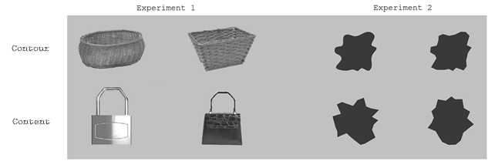
Figure 1. Examples of stimuli from experiment 1 and 2. In experiment 1, contour stimuli matched contents but not contours (curved and sharp-angled) and content stimuli matched contours but not contents. In experiment 2, contour stimuli matched patterns but not contours, and content stimuli matched contours but not patterns.

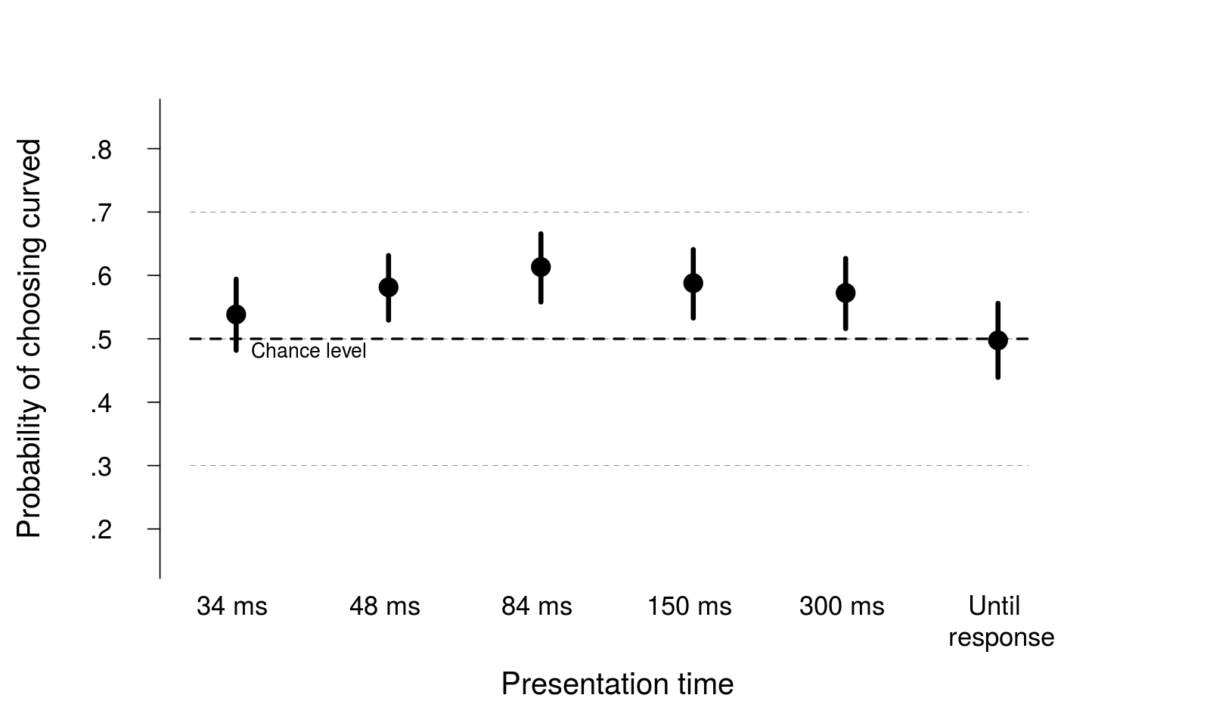
Figure 2. Model estimates of fixed effects of presentation times on preference for real objects. Bars depict 95% confidence interval.

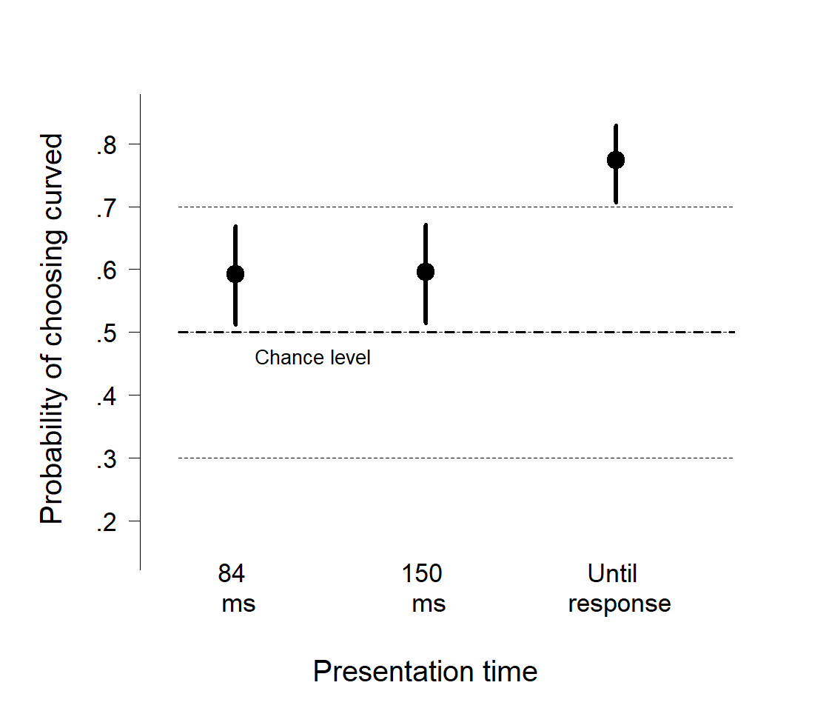

Figure 3. Model estimates of presentation time with meaningless patterns. Bars depict 95% confidence interval

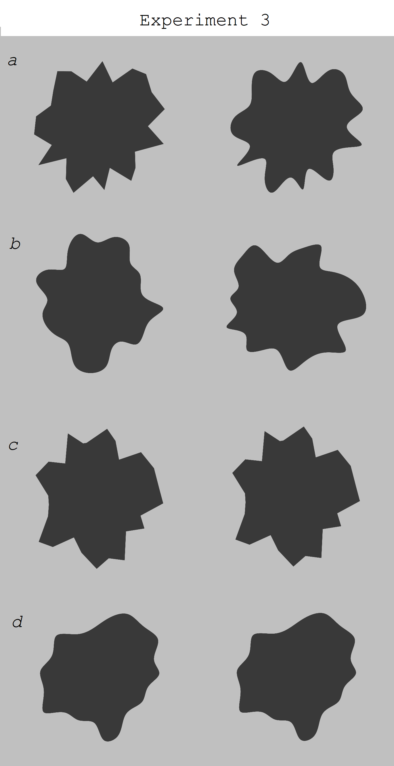

Figure 4. Stimuli used in experiment 3: (a) same pattern and different contour, (b) different pattern and same contour, (c) same pattern and same curved contour, and (d) same pattern and same sharp-angled contour.
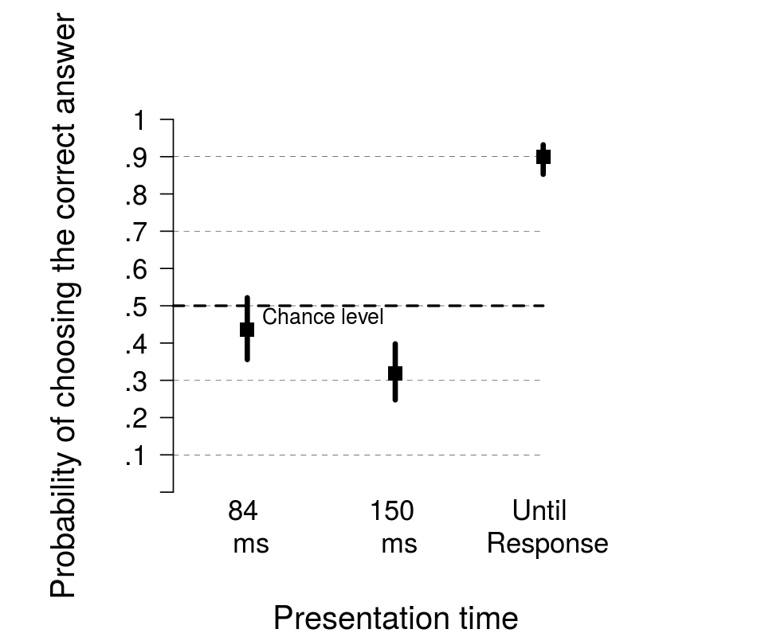

Figure 5. Model estimates for pairs a (different contour, same pattern) in the discrimination task. Bars depict 95% confidence interval.

