Corrigendum: The relationship between cognitive ability and chess skill:
A comprehensive meta-analysis

Original article: Burgoyne, A. P., Sala, G., Gobet, F., Macnamara, B. N., Campitelli, G., & Hambrick, D. Z. (2016). The relationship between cognitive ability and chess skill: A comprehensive meta-analysis. Intelligence, 59, 72-83. https://doi.org/10.1016/j.intell.2016.08.002

We adjusted for dependent performance measures using a method based on Cheung and Chan's (2004, 2008) method. Cheung and Chan's method adjusts the sample size to be between the sample N and the cumulative sample N, and applies this to the average of the dependent effect sizes. Their adjustment formula is as follows: adjusted N = ((N-1)/C)+1, where C accounts for the correlation between dependent effect sizes, in addition to the overall average effect size, and the number of dependent effect sizes per sample. We inadvertently used the formula as follows: adjusted N = (N -1)/(C+1) and then applied this formula to each individual effect size (rather than an average). We did not realize this until recently.

The overall conclusion that cognitive ability contributes meaningfully to individual differences in chess skill is unchanged; most important, the meta-analytic average of correlations between chess skill and broad cognitive abilities is similar to the originally reported value and still statistically significant (.24, p < .001, in the original analyses, vs. .22, p < .001, in the corrected analyses). However, as shown below in Table 1, there are changes in some specific conclusions. Most notably, while the correlations of chess skill with fluid intelligence (Gf) and short-term/working memory (Gsm) are unaffected, the correlations of chess skill with crystallized intelligence (Gc) and processing speed (Gs) are no longer statistically significant. See Table 1 for a complete list of our reported results compared with the results using Cheung and Chan's approach. Questions can be directed to Alexander P. Burgoyne at burgoyn4@msu.edu.

References:
Cheung, S. F., & Chan, D. K-S. (2004). Dependent effect sizes in meta-analysis: Incorporating the degree of interdependence. Journal of Applied Psychology, 89, 780-791.
Cheung, S. F. & Chan, D. K-S. (2008). Dependent correlations in meta-analysis: The case of heterogeneous dependence. Educational and Psychological Measurement, 68(5), 760-777.

Table 1.
Results as Reported Compared with Results with Cheung and Chan's Adjustment Method
Results Description |  | Reported Results |  | Results with Cheung and Chan adjustment
Model 1: Meta-analytic average correlation between Gf and chess skill |  | $\overline{r}$ = .24, 95% CI [.18, .30],  p < .001. I² = 56.94 |  | $\overline{r}$ = .23, 95% CI [.16, .31],  p < .001. I² = 68.62
Model 2: Meta-analytic average correlation between Gc and chess skill |  | $\overline{r}$ = .22, 95% CI [.11, .32],  p < .001 |  | $\overline{r}$ = .13, 95% CI [-.05, .30],  p = .153
Model 3: Meta-analytic average correlation between Gsm and chess skill |  | $\overline{r}$ = .25, 95% CI [.13, .37],  p < .001 |  | $\overline{r}$ = .25, 95% CI [.13, .37],  p < .001
Model 4: Meta-analytic average correlation between Gs and chess skill |  | $\overline{r}$ = .24, 95% CI [.08, .39],  p = .004. I² = 50.36 |  | $\overline{r}$ = .19, 95% CI [-.03, .41],  p = .097. I² = 64.96
Model 5: Meta-analytic average correlation of Models 1 through 4 |  | $\overline{r}$ = .24, 95% CI [.19, .28],  p < .001 |  | $\overline{r}$ = .22, 95% CI [.16, .28],  p < .001
Meta-analytic average correlation of full-scale IQ and chess skill |  | $\overline{r}$ = .10, 95% CI [- .19, .38],  p = .483. I² = 75.13 |  | $\overline{r}$ = .10, 95% CI [- .19, .38],  p = .483. I² = 75.13
Meta-analytic average correlation of visuospatial ability and chess skill |  | $\overline{r}$ = .13, 95% CI [.05, .20],  p = .002 |  | $\overline{r}$ = .08, 95% CI [-.03, .20],  p = .143
Meta-analytic average correlation of numerical ability and chess skill |  | $\overline{r}$ = .35, 95% CI [.30, .40],  p < .001 |  | $\overline{r}$ = .34, 95% CI [.30, .39],  p < .001
Meta-analytic average correlation of verbal ability and chess skill |  | $\overline{r}$ = .19, 95% CI [.08, .28],  p < .001 |  | $\overline{r}$ = .12, 95% CI [-.04, .28],  p = .131
Skill level (ranked vs. unranked) moderator of correlation of Gf and chess skill |  | Q(1) = 8.37, p = .004 |  | Q(1) = 9.71, p = .002
Correlation between Gf and chess skill for ranked samples |  | $\overline{r}$ = .14, 95% CI [.02, .25],  p = .018 |  | $\overline{r}$ = .10, 95% CI [-.01, .21],  p = .089
Correlation between Gf and chess skill for unranked samples |  | $\overline{r}$ = .32, 95% CI [.27, .38],  p < .001 |  | $\overline{r}$ = .33, 95% CI [.24, .43],  p < .001
Skill level (mean rating < 2000 vs. ≥ 2000) moderator of correlation of Gf and chess skill |  | Q(1) = 1.99, p = .159 |  | Q(1) = 0.21, p = .647
Correlation between Gf and chess skill for higher-rated samples |  | $\overline{r}$ = -.10, 95% CI [-.34, .14],  p = .411 |  | $\overline{r}$ = -.11, 95% CI [-.41, .20],  p = .495
Correlation between Gf and chess skill for lower-rated samples |  | $\overline{r}$ = .10, 95% CI [-.04, .23],  p = .147 |  | $\overline{r}$ = -.02, 95% CI [-.22, .18],  p = .842
Age (adult vs. youth) moderator of correlation of Gf and chess skill |  | Q(1) = 9.83, p = .002 |  | Q(1) = 10.65, p = .001
Correlation between Gf and chess skill for adult samples |  | $\overline{r}$ = .11, 95% CI [-.01, .22],  p = .071 |  | $\overline{r}$ = .04, 95% CI [-.11, .18],  p = .628
Correlation between Gf and chess skill for youth samples |  | $\overline{r}$ = .32, 95% CI [.25, .38],  p < .001 |  | $\overline{r}$ = .31, 95% CI [.22, .39],  p < .001
Rank by age (ranked adult vs. ranked youth) moderator of correlation of Gf and chess skill |  | Q(1) = 0.932, p = .334 |  | Q(1) = 1.00, p = .317
Correlation between Gf and chess skill for ranked adult samples |  | $\overline{r}$ = .11, 95% CI [-.01, .22],  p = .071 |  | $\overline{r}$ = -.01, 95% CI [-.25, .22],  p = .916
Correlation between Gf and chess skill for ranked youth samples |  | $\overline{r}$ = .27, 95% CI [-.04, .53],  p = .092 |  | $\overline{r}$ = .18, 95% CI [-.11, .47],  p = .232
Skill level (ranked vs. unranked) moderator of correlation of visuospatial ability and chess skill |  | Q(1) = 6.39, p = .011 |  | Q(1) = 2.84, p = .092
Correlation between visuospatial ability and chess skill for ranked samples |  | $\overline{r}$ = .05, 95% CI [-.07, .16],  p = .420 |  | $\overline{r}$ = .03, 95% CI [-.10, .16],  p = .630
Correlation between visuospatial ability and chess skill for unranked samples |  | $\overline{r}$ = .25, 95% CI [.14, .35],  p < .001 |  | $\overline{r}$ = .25, 95% CI [.03, .47],  p = .027
Age (adult vs. youth) moderator of correlation of visuospatial ability and chess skill |  | Q(1) = 8.85, p = .003 |  | Q(1) = 5.16, p = .023
Correlation between visuospatial ability and chess skill for adult samples |  | $\overline{r}$ = .03, 95% CI [-.06, .12],  p = .491 |  | $\overline{r}$ = -.01, 95% CI [-.14, .12],  p = .905
Correlation between visuospatial ability and chess skill for youth samples |  | $\overline{r}$ = .24, 95% CI [.14, .33],  p < .001 |  | $\overline{r}$ = .22, 95% CI [.07, .37],  p = .003
Skill level (ranked vs. unranked) moderator of correlation of verbal ability and chess skill |  | Q(1) = 0.01, p = .945 |  | Q(1) = 0.29, p = .593
Correlation between verbal ability and chess skill for ranked samples |  | $\overline{r}$ = .18, 95% CI [.01, .33],  p = .039 |  | $\overline{r}$ = .06, 95% CI [-.20, .32],  p = .646
Correlation between verbal ability and chess skill for unranked samples |  | $\overline{r}$ = .17, 95% CI [.00, .33],  p = .052 |  | $\overline{r}$ = .16, 95% CI [-.10, .42],  p = .226
Age (adult vs. youth) moderator of correlation of verbal ability and chess skill |  | Q(1) = 2.13, p = .144 |  | Q(1) = 0.66, p = .418
Correlation between verbal ability and chess skill for adult samples |  | $\overline{r}$ = .25, 95% CI [.12, .38],  p < .001 |  | $\overline{r}$ = .20, 95% CI [-.06, .47],  p = .136
Correlation between verbal ability and chess skill for youth samples |  | $\overline{r}$ = .09, 95% CI [-.09, .27],  p = .340 |  | $\overline{r}$ = .06, 95% CI [-.15, .28],  p = .569

Publication bias analyses as originally reported.
In the present case, these analyses indicated that studies yielding a larger-than-average effect size were missing from the Gf model (10 studies). By contrast, the analyses suggested that studies yielding weaker-than-average effect sizes were missing from the Gsm, Gs, and full-scale IQ models (1 study, 3 studies, and 1 study, respectively). Given that the asymmetry fell on both sides of the means across the models, there is little evidence to suggest a systematic suppression of particular effect size magnitudes.

Publication bias analyses after Cheung and Chan adjustment.
In the present case, these analyses indicated that studies yielding a larger-than-average effect size were missing from the Gf model (1 study) and Gc model (3 studies). By contrast, the analyses suggested that studies yielding weaker-than-average effect sizes were missing from the Gsm, Gs, and full-scale IQ models (1 study, 2 studies, and 1 study, respectively). Given that the asymmetry fell on both sides of the means across the models, there is little evidence to suggest a systematic suppression of particular effect size magnitudes.

Funnel plots after Cheung and Chan adjustment, illustrating the relation between
effect size and standard error.

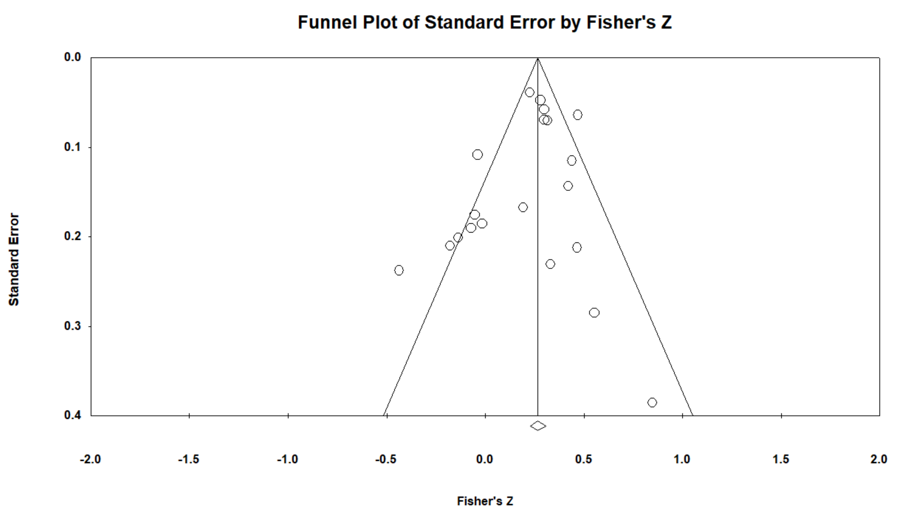
Figure 1. Funnel plot for Gf model after Cheung and Chan adjustment.

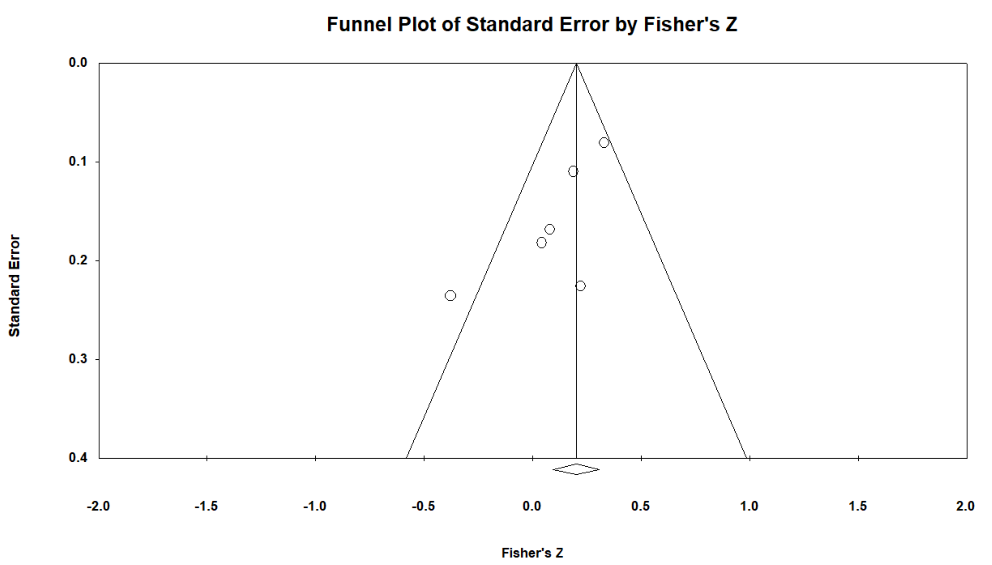
Figure 2. Funnel plot for Gc model after Cheung and Chan adjustment.

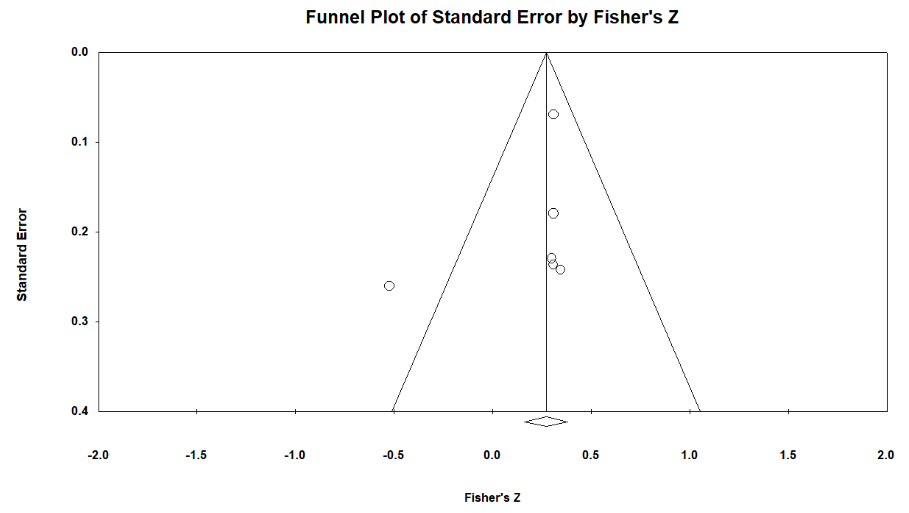
Figure 3. Funnel plot for Gs model after Cheung and Chan adjustment.

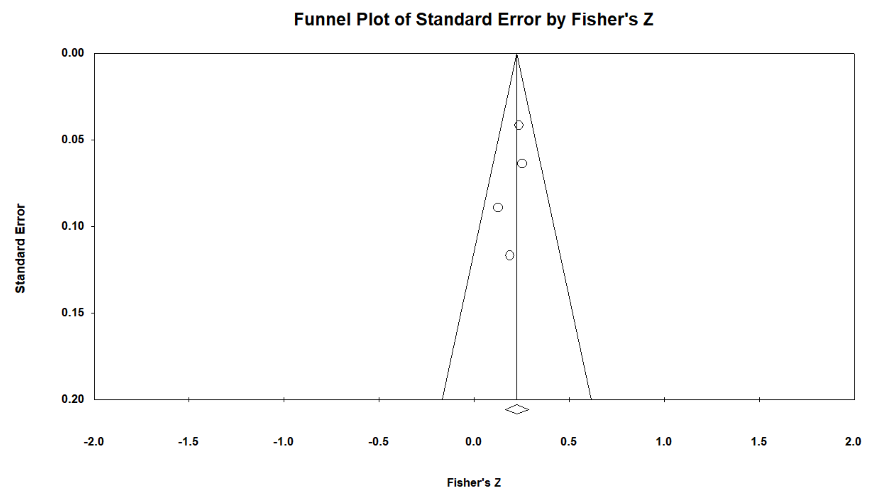
Figure 4. Funnel plot for Models 1-4 after Cheung and Chan adjustment.

