For: The Lancet Child & Adolescent Health
Title: WOrld Young Rheumatic Disease Day (WORD Day) – children and young people get rheumatic disease too!

Authors:
Yona Egert(1), Tsipi Egert (1), Wendy Costello (1), Berent J. Prakken (2,3), Eve MD. Smith (3,4) and Nico M. Wulffraat (2)

Addresses:
- European Network for Children with Arthritis (ENCA), https://www.enca.org/
- Department of pediatric rheumatology, University Medical Center Utrecht, Utrecht, the Netherlands
- Council of Pediatric Rheumatology European Society (PRES), https://www.pres.eu/
- University of Liverpool, Alder Hey Children’s Hospital, dept Pediatric Rheumatology, Liverpool, England
Correspondence to: NMW

Pediatric rheumatic illnesses are rare chronic inflammatory conditions of the musculoskeletal system, also referred to as rheumatic conditions, together effecting approximately 1 in 1,000 children (1). They include a wide range of illnesses extending from the relatively common to extremely rare, such as Juvenile Idiopathic Arthritis (JIA), Systemic Lupus Erythematosus (JSLE), Juvenile Dermatomyositis (JDM), and the autoinflammatory disorders including Familial Mediterranean Fever (FMF), Rheumatic fever, Kawasaki disease, Blau, CANDLE, CAPS and others (2).
Rheumatic disorders affect children in many ways. Some are systemic and impair the children’s overall health and wellbeing in severe ways over and above the damage they cause to internal organs e.g. kidneys, heart and brain. Others, more localized, affect primarily the joints or skin, significantly impacting upon the growing skeleton, causing pain and restricted joint movement which hamper daily activities and physical development. Add to this psychological and social challenges which are the fare of many children who battle chronic illness daily (3).
Because of their rarity, pediatric rheumatologic disorders are often unknown to health care providers causing a significant delay before a correct diagnosis is made (4-6). Family physicians do not expect children to suffer from illnesses mostly associated with older people, consequently making erroneous diagnoses, attributing swelling and pain to unreported injuries, growing or psychosomatic pain. Children are often not referred on to pediatric rheumatologists, and subsequently do not receive optimal care. Although many doctors are familiar with the adult manifestations of these illnesses, not all are aware of the clinical differences between the adult and pediatric versions of the illnesses. Pediatric rheumatological illnesses are different in clinical course compared to their adult counterparts, exhibiting distinct complications (for example, uveitis is a problem faced by JIA and not adult RA), and have different treatment options. In fact, even when a sick child becomes an adult, his illness will still follow the course of the pediatric illness (7). In addition, it is important to remember that since children are growing and developing during these years they also have specific needs relating to their physical, emotional and social development, which adults do not face.
The last 25 years, there have been many new treatment options for rheumatological patients (1). Previously, medicine had little to offer to children, and many spent their childhood in pain, accumulating disabilities and misshapen joints. The situation today is greatly improved due to pediatric focused medical research and the advent of biologic medicines, tested specifically in children. The majority of children who receive medical and other supportive treatment can reach symptomatic remission, with little or no permanent damage.
Since damage to joints, muscles and tendons is cumulative, the need for early diagnosis is urgent. Early detection usually provides a better prognosis, while delay, misdiagnosis and subsequent mistreatment can aggravate damage caused by the illness (8). In addition, valuable time is lost when damage to the joints is not reversed, causing some of it to become permanent.
To help ratify this situation, the European Society for Pediatric Rheumatologists, PReS (www.PRES.EU) and the parent/patient association ENCA (www.ENCA.org) are jointly inaugurating WORD Day, “WOrld Young Rheumatic Disease Day” (see figure 1). The objectives of this day are to raise parental and professional awareness to these illnesses. By giving parents tools to recognize symptoms which require medical attention, and educating them to ask the questions, this will enable them to become active partners in their child’s treatment. Research has shown that knowledge empowers (9). Knowledgeable children and parents cooperate better with their treatment regiments.
Raise awareness of pediatric rheumatic diseases amongst health care providers will help to aid the process of diagnosis, especially of rarer diseases. Information pertaining to these goals was recently updated in the EU project SHARE (www.printo.it/pediatric-rheumatology). This will help doctors recognize when to refer patients to pediatric rheumatologists (4). Supportive disciplines such as physiotherapy also stand to gain from the increased exposure to the latest news in diagnosis and treatments for these children. WORD pediatric day is also directed at the wider public, since it is important to raise social awareness to the needs of children with rheumatic illnesses. Teachers better understand the difficulties their ill students face, and are more equipped to adjust their environments. When friends and family are less apprehensive about the unknown, they are more accepting and less fearful.
WORD Day will be an annual event that will take place on the 18th of March from 2019 onwards. Through the international networks of PReS, ENCA and Young Pare (People with Arthritis network linked to EULAR), local face to face awareness events, hospital websites and educational programs will be aired on both the local and international stage in a range of different countries. Diverse local events will be designed and implemented by a local organizing committees in each country, to be run in hospital, universities and public areas (e.g. schools, museums, town centres). These are anticipated to include information stalls, talks and performances given by patients, information and training events for healthcare professionals, ‘peer education’ workshops involving medical student organisations.
A number of assertive social media campaigns including the patient voice, patient organisations and charities, promotional educational videos, radio and TV interviews with patients and doctors will accompany these events, each directed at a specific audience. In particular, WORD day will target doctors who are the first clinicians to come into contact with these patients (e.g. general pediatricians), parents, other health practitioners, educators. Materials to support the running of these events will be available through the PReS and ENCA websites. We will also connect to the European Reference Networks (ERN’s). The ERN for pediatric immune deficiencies and rheumatic conditions is called RITA (www.RITA.ern-net.eu), with active patient participation key to the group (10).
With these activities we aim to raise the awareness and knowledge level of parents, doctors, primary practitioners, teachers, and the general public to help first and foremost in early diagnoses, and a quick referral to specialized pediatric rheumatologists. We hope that awareness will have a ripple effect on all levels of practitioners who come in contact with these children, improving the level of treatment they receive and their prognosis worldwide.

References:
- Prakken B, Albani S, Martini A. Juvenile idiopathic arthritis. Lancet. 2011 Jun 18;377(9783):2138-49. doi: 10.1016/S0140-6736(11)60244-4. Review. PubMed PMID: 21684384.
- Paediatric Rheumatology. 2 ed. Foster HB, PA., editor. Oxford, UK: Oxford University Press; 2018.
- Lundberg V, Eriksson C. Health-related quality of life among Swedish children with Juvenile Idiopathic Arthritis: parent-child discrepancies, gender differences and comparison with a European cohort. Pediatr Rheumatol Online J 2017; 15: 26.
- van Dijkhuizen EHP, Egert T, Egert Y, Costello W, Schoemaker C, Fernhout M, Kepic M, Martini A, Scala S, Rotstein-Grein I, Vastert SJ, Wulffraat NM. Patient's experiences with the care for juvenile idiopathic arthritis across Europe. Pediatr Rheumatol Online J. 2018 Feb 8;16(1):10. doi: 10.1186/s12969-018-0226-0. PubMed PMID: 29422094;
- Smith E, Gray W, Taylor-Robinson D, Foster H, Beresford MW. Predictors of access to care in JSLE – Evidence from the UK JSLE cohort study. Annals of Rheumatic Disease 2012; 71: 676.
- Foster HE, Eltringham MS, Kay LJ, Friswell M, Abinun M, Myers A. Delay in access to appropriate care for children presenting with musculoskeletal symptoms and ultimately diagnosed with juvenile idiopathic arthritis. Arthritis Rheum 2007; 57: 921-7.
- Feger DM, Longson N, Dodanwala H, Ostrov BE, Olsen NJ, June RR. Comparison of Adults With Polyarticular Juvenile Idiopathic Arthritis to Adults With Rheumatoid Arthritis: A Cross-sectional Analysis of Clinical Features and Medication Use. J Clin Rheumatol 2018.
- Minden K, Horneff G, Niewerth M, Seipelt E, Aringer M, Aries P, et al. The time of DMARD start in Juvenile Idiopathic Arthritis determines the likelihood of a drug-free remission in young adulthood. Arthritis Care Res (Hoboken) 2018.
- Schoemaker CG, Armbrust W, Swart JF, Vastert SJ, van Loosdregt J, Verwoerd A, Whiting C, Cowan K, Olsder W, Versluis E, van Vliet R, Fernhout MJ, Bookelman SL, Cappon J, van den Berg JM, Schatorjé E, Muller PCEH, Kamphuis S, de Boer J,Lelieveld OTHM, van der Net J, Jongsma KR, van Rensen A, Dedding C, Wulffraat NM. Dutch juvenile idiopathic arthritis patients, carers and clinicians create a research agenda together following the James Lind Alliance method: a study protocol. Pediatr Rheumatol Online J. 2018 Sep 15;16(1):57. doi:10.1186/s12969-018-0276-3. Review. PubMed PMID: 30219072;

Figure 1
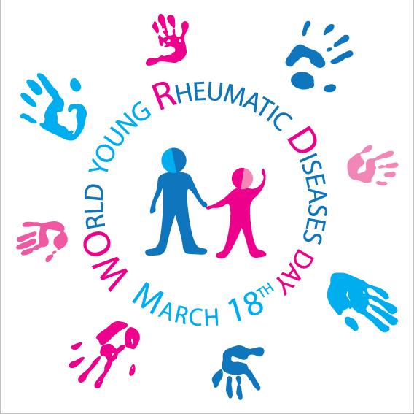

Legend to figure 1: Logo of WOrld young Rheumatic Diseases Day

