Machine Vision Characterisation of the 3D Microstructure of Ceramic Matrix Composites

W. J. R. Christian^{1*}, K. Dvurecenska¹, K. Amjad¹, C. Przybyla² & E. A. Patterson¹

1. School of Engineering, University of Liverpool, Liverpool, UK
2. Air Force Research Laboratory, Ohio, USA

*Email: W.J.R.Christian@liverpool.ac.uk

Abstract
A new approach to quantifying the microstructure of continuous fibre reinforced composites has been presented which reduces the time required to quantify the microstructure and, hence, to better understand the microstructure-sensitive response when compared to prior methods. The technique was demonstrated by characterising the voids and fibre orientation within a continuous SiC fibre reinforced SiNC ceramic matrix composite as these are known to affect both the oxidation and mechanical behaviour of the material. Microscopy data obtained via automated serial sectioning were analysed using standard digital image correlation algorithms to extract the 3D fibre orientation field, and histogram thresholding to extract the void shape and porosity distribution. Employing orthogonal decomposition, the dimensionality of the void shape data was also reduced, enabling interpretable comparisons between the fibre orientation field and the voids. The approach outlined here is applicable to studying the microstructure-sensitive response and optimization of processing for improved performance.

Keywords
Ceramic matrix composites, Serial sectioning and imaging, Void defects, Fibre orientation, Microstructure characterisation, Orthogonal decomposition, digital image correlation.

1. Introduction
Structural materials with higher temperature capabilities are increasingly sought after in the aerospace industry as they can be utilised within turbofan engines enabling higher combustion temperatures and thus cleaner emissions [1]. One group of materials that has been explored are ceramics such as silicon-carbide (SiC) and silicon-nitro-carbide (SiNC), which can support structural loads at temperatures in excess of 1500 °C [2]. However, these materials typically exhibit a low fracture toughness when compared to high temperature metal alloys such as Ni-based superalloys. Therefore, Ni-base superalloys are typically selected over ceramics even though they have a lower maximum use temperature and are approximately three times the density [3].
More recently, toughened ceramics have emerged in the form of continuous ceramic fibre-reinforced ceramic matrix composite (CMC) materials [1]. Specifically, CMCs employ weak fibre coatings or a porous matrix to promote deflection of damage around the fibres enabling these materials to retain significant load-bearing capacity even in the presence of defects or damage. This also has the effect of increasing the toughness of the bulk material as the deflected cracks require greater amounts of energy to propagate [4]. Silicon-carbide fibres in a silicon-nitro-carbide matrix (SiC_{f}/SiNC) is one such CMC which has the potential for applications in both gas turbine engines and spacecraft structures [5]. The deflection of cracks is sensitive to the microstructure of this material, with the properties of the interface between the fibres and matrix as well as the distribution of the fibres known to be significant characteristics [6]. It is difficult to control the precise microstructure and thus techniques are required to characterise microstructure in order to link it experimentally to mechanical behaviour.
Common approaches for the characterisation of CMCs typically involve microscopy [7] with more advanced approaches also using digital image correlation (DIC) to measure microscale deformations [4] or micro-indentation to measure local properties [8]. These techniques only provide information about the material microstructure as seen from the polished two-dimensional (2D) surface of the composite; however, the microstructure often appears drastically different when viewed on other planes through the material. This is due to the fibre architecture within the composite. Hence, volumetric characterisation techniques have been applied that provide more information about the entire 3D microstructure. A common approach is computed tomography, which can provide data across a wide range of resolutions from whole specimen scans [9] down to fibre-level resolutions to study crack morphology [10]. Serial-sectioning has also been used and can produce large volumes of high resolution data to assess the microstructure [11]. However, these image-based characterisation techniques produce large quantities of data that can be time-consuming to process and interpret; hence, automated analysis of microstructure is desirable. Techniques have been developed to reduce volumetric datasets to fibre orientation fields by measuring the orientation of texture in the data caused by the fibres [12] and, when the resolution is sufficiently high, determining the paths of individual fibres using Kalman filters [11]. Whilst this reduces the dimensionality of the data, it still creates large amounts of redundant information, as the fibres within bundles will typically have similar orientations. One approach to further reducing the redundancy in microstructure data has been to measure aspects of the microstructure visible in the data, e.g. fibre cross-sectional area, fibre coating thickness or fibre spacing, and then use principal component analysis to identify an orthogonal set of linear combinations of the measurements, these linear combinations are referred to as principal components. It has been found that a much smaller number of principal components are required to represent the microstructure of a CMC than the number of measurements that were originally acquired [6]. Another approach is to use clustering to identify different features of the microstructure based on appropriate measurements [13]. However, both these approaches require a set of suitable measurements which can be difficult to obtain. Void shape is one example of a microstructural feature that is difficult to describe using data from images. Orthogonal decomposition is an approach that has been used for shape recognition, such as aircraft identification [14], and also can be used to reduce the dimensionality of shape or image data in the form of a matrix to a small number of coefficients in a feature vector whilst retaining enough information to accurately reconstruct the shape from the vector [15]; for instance, it has recently been used in modal analysis [16]. The reduced dimensionality of the feature vectors enables computationally efficient comparisons between datasets, as well as comparisons between datasets that have different length-scales or are sampled at different grids points. These comparisons can be used to empirically predict the mechanical performance of a material [17] or to monitor the quality of manufactured components.
In this study, a process is proposed to extract microstructural information relating to fibre orientation and void shape from a large dataset comprised of optical micrographs of serial sections. Orthogonal decomposition has been used to dimensionally reduce the extracted void shape data and characterise the shapes. As described above fibre architecture is important for fracture toughness and voids are of interest because they provide routes through the material along which oxygen and water vapour can diffuse and oxidise fibre coatings when the CMC is loaded at high temperature [7]. The process has been applied to a SiC_{f}/SiNC composite specimen manufactured by the precursor infiltration and pyrolysis technique. However, this process could be applied to any continuous fibre reinforced composite for which equivalent data can be acquired; and allows the microstructure to be described using a comparatively small amount of data through the innovative use of image decomposition and digital image correction.
The paper is arranged as follows: the next section describes the proposed approach using image processing techniques to extract information about void shape and fibre orientation from serial section micrographs. The manufacture and microscopy of the SiC_{f}/SiNC specimen, to which the approach has been applied, is described in the third section with the results in the fourth section. In the fifth section the results and the potential applications of the new approach are discussed. Concluding remarks are provided in the final section.

2. Image Processing

2.1. Introduction
A new approach is described for extracting information about void shape and fibre orientation from serial-section optical micrographs of a fibre-reinforced composite. The approach has been applied to a 3.6 x 2.5 x 0.1 mm volume of a SiC_{f}/SiNC specimen. The manufacture of this specimen and microscopy are described in section 3. In brief, one hundred micrographs were obtained at increments of 1 µm. Each section micrograph consisted of a 6930 x 4800 pixels mosaic constructed from a set of images that were stitched together, one of these images is shown in Figure 1. These images had a spatial resolution of 0.522µm/pixel. The high spatial resolution was necessary for the void shapes to be accurately measured, but was not required for the fibre orientation measurements. This form of data is typical of that produced in modern optical characterisation of microstructures in composite materials and the quantity of data, approximately 3GB in this case, presents some challenges. Before information about the fibre orientation and void shape could be extracted, image processing was used to pre-process the mosaic micrographs. Figure 2 shows a flow-chart illustrating the image processes that were applied, shown as boxes, prior to void shape and fibre orientation information being extracted, shown as lozenges.

2.2. Pre-processing
The first step in the pre-processing was to align the mosaic micrographs to correct for the specimen moving small distances as it was serially sectioned. Whilst this motion was small, of the order of 10µm, it caused the surface of voids to appear jagged with occasional discontinuities when viewed in the direction perpendicular to the sectioning. As the SiC fibres had a typical diameter of 14µm and the thickness of each section was 1µm, the position of the cut fibre cross-sections remained similar between sections, such that two sequential mosaics appear almost identical except for a global translation in the plane of the section. Since equal numbers of fibres were orientated in the +45° direction as in the -45° direction relative to the normal of the plane of the section, the fibre-faces could be used to identify the translation of the mosaic without introducing any bias. These translations were determined using a two-dimensional cross-correlation to compare each mosaic with the previous mosaic. The cross-correlation between two similar but translated mosaics results in a correlation plot with a single peak close to its centre. When the two mosaics are perfectly aligned the peak is exactly at the centre of the correlation plot; however, if one mosaic is translated relative to the other, then the peak will be off-centre and its location relative to the centre defines the translation required to align the mosaics. The mosaic obtained from the first section was used to define the origin for the coordinate system and each subsequent section was then aligned with the previous section. Once all the mosaics were aligned, the orientation of individual fibres could be determined using digital image correlation (DIC), which is described in Section 2.5.
To extract information about the void shape, the mosaics required further processing so that material-free locations could be identified. This was performed using thresholding to identify fibres, matrix and voids which were distinguishable within the mosaics using the grey-level or intensity value of the pixels. The fibre cross-sections were highly reflective resulting in a high intensity value, the ceramic matrix had a lower reflectivity and thus a lower intensity value, and the voids either had an intensity value of zero because they absorbed the light or a very low grey value if the voids had filled with specimen mounting material. Otsu’s method [18] was used to determine the thresholds to separate these three features based on the measured intensities. This method uses statistical moments applied to the grey-value histogram to identify the ideal position for the thresholds. The position of the two thresholds on the histogram are shown at the top of Figure 3, with the effect of these thresholds on an exemplar volume shown at the bottom of the figure. Whilst it is important for the Otsu algorithm to split the histogram into three sections, the position of the threshold between the pixel values for the matrix and the fibres was not used in extracting the void shapes. Hence, once the thresholds had been established, the mosaics were converted to binary data where the value of pixels with a grey-level value below the lowest threshold was set to one and the remainder to zero.

2.3. Identification of voids
The voids were identifiable in the binarized mosaics; however, some other pixels that were not part of a void were also set to a value of one. These pixels were typically around the perimeter of each fibre cross-section, appearing as dark rings in the mosaics, and probably were caused by the coating applied to the fibres in order to modify the fracture behaviour of the material [11]. Since the fibres were densely packed, the rings of perimeter pixels overlapped and also connected with the voids; hence, they needed to be removed in order to isolate the voids. This was achieved using an image processing technique known as morphological opening [19]. Morphological opening is a combination of erosion and dilation, which are two common image processing techniques, applied using the Matlab function, “imopen”. First, the data was eroded using a spherical structuring element to create a new dataset that did not contain the fibre coating. The spherical structuring element is a sphere which is placed at every location in the stack of mosaics. At each location, the pixels contained within the sphere are examined, if any of the contained pixels have a value of zero then the pixel at the centre of the sphere is set to zero. The diameter of the sphere controls the size of features that are removed; for this study the diameter was 3.6µm which is approximately 150% of the fibre coating thickness. After erosion the voids were nominally the same shape as in the original binarized mosaic but their size had been reduced or eroded. This was corrected by performing dilation on each the stack of eroded mosaics. During dilation the same spherical structuring element was used. The sphere was placed at each location in the stack of eroded mosaics and the contained pixels were assessed, if any of the pixels had a value of one then the value of the pixel at the centre of the sphere was set to one. The effect of this operation was that the voids which had previously been eroded are returned to their original size whilst the fibre-coating did not reappear.
After morphological opening, the binarized mosaic contained unconnected contiguous regions or clusters of pixels with a value of one. Some of these clusters were too small to be voids and were likely noise or locations at which the fibre coating was particularly thick. To remove these small clusters, all of the clusters were placed in a list ordered by their volume from largest to smallest. The clusters on the list were progressively selected, starting with the largest, until the cumulative volume of the selected clusters was above a threshold, which was 95% of the total cluster volume. This meant that despite locating 8000 clusters initially, only 41 clusters were found to be of sufficient size to be classified as a void. The graph at the top of Figure 4 shows the increase in the cumulative volume as the largest clusters of pixels are selected as voids. The choice of the threshold for cumulative volume (95%) was arbitrary and potentially caused small voids to be misclassified. However, these voids would be significantly smaller than the selected voids and thus would have a comparatively negligible effect on the mechanical and oxidative behaviour of the bulk material. For example, the largest void was over 1500 times larger by volume than the 41st largest void, this can be seen at the bottom of Figure 4. Once the set of voids had been identified the dimensionality of the pixel data describing their shape was reduced and this is described in Section 2.4.

2.4. Characterisation of Individual Voids
The process described in the previous sub-section allowed the pixels corresponding to the voids in the microstructure to be identified. However, the number of pixels in each void was large which made it difficult to characterise them efficiently. For example, the single void shown at the top of Figure 5 consists of 14.4 million pixels. Hence, the dimensionality of the description of the voids was reduced to aid their characterisation. Initially, this was achieved by fitting a multi-faceted-shape, known as a convex hull, to enclose all of the pixels identified as belonging to a single void. Typically, a fitted shape had 100 to 300 vertices, so that a convex hull greatly reduces the dimensionality of the data. A convex hull was fitted around each void using the Quickhull algorithm [20] which is performed by the Matlab function, “convhulln”. The faceted shape is described as convex because it wraps around the object to which it is fitted but does not venture into crevices or holes on the object’s surface, an example of such a shape is shown at the bottom of Figure 5. An additional advantage is that it is much faster to display a convex hull on a computer screen than a complicated shape described by pixels.
Once a convex hull had been fitted, its volume and dimensions could be efficiently calculated. For example, the maximum distance between any two vertices on the hull, $D$, can be obtained by comparing each vertex on the hull with the remaining vertices. This can be used to quantify the level of irregularity of the void shape by calculating its sphericity, $α$. The volume of the void was divided by the volume of a bounding sphere, to calculate the sphericity as:

$α= \frac{6N_{pixels}V_{pixel}}{πD^{3}}$ (1)

where, $V_{pixel},$ is the volume of a single pixel and $N_{pixels}$, is the number of pixels identified as part of the void. When $α=1$ the void is spherical, otherwise $0<α<1$. This provides an indication of the length and thickness of the void. The metric is also invariant to the orientation of the void.
Whilst fitting a convex hull is an efficient method to obtain basic shape characteristics, it removes much of the detailed information about the shape and form of the void. Therefore, an alternative approach to reducing dimensionality was employed. For this approach, a cuboid that enclosed each void was projected onto three mutually orthogonal planes by calculating the average density of the material in the cuboid along lines that are normal to the projection plane (see Figure 6). The dimensionality of the projected images was further reduced by orthogonal decomposition [16] using Chebyshev polynomials. A statistical technique, described in further detail in [21], was used to determine the number of Chebyshev coefficients required for 95% of the projected images to have a relative reconstruction error of 5% or lower. For the exemplar shown in Figure 5, this was achieved using 66 coefficients and their values are shown as bar charts in Figure 7.

2.5. Digital Image Correlation for Extracting Fibre orientation Data
In the mosaics, the fibre cross-sections provided a random high contrast pattern that changed only a small amount between sequential sections as a result of fibre bending, twisting and apparent displacement due to the fibre angle being oblique to the sections. Hence, the 3D fibre orientation field was extracted using two-dimensional digital image correlation (DIC) to track the grey value pattern of the fibre cross-sections in small sub-images using a commercially-available DIC package (Istra-4D, Dantec, Germany). These sub-images are initially square sets of pixels that are tracked between images in order to measure displacements. The digital image correlation algorithm was applied to adjacent mosaics through the thickness of the specimen, i.e., the z-coordinate replaced the time coordinate in the usual application of DIC to images captured before and after an event, and the fibre cross-sections replaced the speckles normally employed in DIC measurements. The size of the mosaic images were exceptionally high (6930x4800pixels) compared to images used routinely in DIC; and hence, the resolution of the mosaics was first reduced from 0.522 to 1.04µm/pixel by averaging the intensity of tiles consisting of two-by-two squares of pixels and replacing the tile with a single pixel. This did not result in a significant reduction of accuracy, as the DIC algorithm was capable of tracking subpixel displacements, but did result in a 50% reduction in processing time. Since the dataset was still large even after down-sampling, the DIC algorithm took a long time to process the mosaic images; so the smallest possible sub-image size was used to minimise this computation time whilst increasing the spatial resolution of the fibre orientation field. However, when the sub-image was too small, the decorrelation occurred in some mosaics. Hence, the ideal sub-image size was determined based on the number of sub-images successfully correlated by the DIC algorithm in the first and last mosaics in the stack. This quantity was then normalised by dividing it by the number of sub-images in the first image. Figure 8 shows the proportion of successful correlations when using different sub-image sizes. As the sub-image size is decreased from 79 pixels down to 39 pixels the proportion of successful correlations gradually decreases from 89% to 80%. The relationship between sub-image size and successful correlations in this range appears linear and a line of best fit is shown for the six data points. As the sub-image size is further reduced, the number of correlations starts to rapidly decrease, until only 19% of the sub-images correlate when using a sub-image size of 29 pixels. A sub-image size of 39 pixels, equivalent to 40.6µm, was thus chosen to process all of the mosaic images as this is the smallest size before the number of correlations rapidly decrease. A sub-image spacing of 30 pixels was used, resulting in a grid of fibre-orientation measurements with a 31.2µm spacing. As the fibre bundles gradually changed shape whilst passing through the specimen from section to section, the reference mosaic was updated every 10 sections, equivalent to a depth of 10µm.
The output from the DIC algorithm is the displacement of each sub-image from mosaic to mosaic. A typical result is shown in Figure 9 for the x- and y-displacements from which it can been seen that the fibres are primarily orientated on the x-z plane. The fibre angle at the sub-image location is obtained by applying the inverse tangent function to the gradient of the line passing through each sub-image across five consecutive mosaics.

3. Experimental Method
The image processing described in the preceding section was applied to a 3.6 x 2.6 x 0.1 mm volume of a SiC_{f}/SiNC specimen which was serially sectioned in 1µm increments and viewed in a microscope to produce micrographs that were a mosaic containing 7200x5500 pixels although the specimen occupied typically 6930x4800 pixels. The specimen (S200, COI Ceramics, USA) consisted of a SiNC matrix reinforced using SiC fibres and was manufactured using the precursor infiltration and pyrolysis technique [5, 22]. The specimen was proprietary and thus its manufacture is only summarised here. This specimen started as SiC fibres arranged to form a framework. The fibres were then coated in boron nitride (BN) followed by silicon nitride (Si₃N₄), to help promote crack deflection in the finished material. After this, the framework was infiltrated with a liquid ceramic precursor before being cured in an autoclave, resulting in a specimen with the same net shape as the desired component. Pyrolysis was applied to the specimen by heating it to a high temperature in an inert atmosphere causing the precursor to thermally decompose into SiNC. The process of infiltrating and pyrolysing was repeated until an acceptably dense matrix was obtained. The fibres in the specimen were arranged as six layers of fabric with a plain weave. Finally, the specimen was sectioned at 90° to the plane of the weave, along a diagonal such that the fibres had a nominal orientation of ±45° relative to the normal of the section surface.
The specimen was inspected using a serial sectioning system (Robo-Met.3D, UES, USA). This system automates the process of grinding, polishing and then imaging a specimen such that the machine can process specimens with no additional operator input after initial setup. The images captured by the system typically have high levels of contrast and resolution which simplify the characterisation of the microstructure. The specimen was set in a mounting compound before being inserted in the serial sectioning system. Serial sectioning is an iterative process, which starts by removing 1µm of material from the specimen by grinding it on a course radial polishing pad, with the amount removed accurate to 0.25µm [23]. Subsequently, finer pads are used to achieve a highly polished surface on which individual fibre cross-sections can be observed using microscopy. After polishing, the specimen was placed on the translation stage of an inverted optical microscope (Axiovert 200 M, Zeiss, Germany) fitted with an Epiplan 20x/0.40 HD objective (Zeiss, Germany), resulting in a diffraction limit of 0.688µm. The microscope captured a six-by-six grid of overlapping images of the section surface where each image covered a 670µm by 500µm area. These images were then stitched into a mosaic. After the mosaic was captured the process was repeated so that sections through the microstructure at 1µm increments were obtained. Each mosaic was of a 3600µm by 2500µm area of the specimen with a spatial resolution of 0.522µm/pixel. This high spatial resolution was necessary for accurate quantification of the void shapes. One hundred sections were performed with a spacing of 1µm between each section, resulting in an analysed volume depth of 100µm and 3.17GB of image data. The depth to which the specimen was sectioned only allowed the local orientation of fibres in a thin slice through the material to be explored and was not sufficient to determine how the fibres were woven.

4. Results
The fibre orientation and voids were displayed on a common set of axes, allowing direct comparisons between the two datasets in Figure 10. The fibre angle in the x-z plane is shown for the specimen with the top 70 µm removed, i.e. for the bottom 30μm. In Figure 10 the layers of fibres can be distinguished from the fibre angle whilst the sphericity of the voids, calculated using equation (1), is indicated by their colour.
The Chebyshev coefficients obtained from the orthogonal decomposition of the projections of the cuboid enclosing each void was used to explore the shape of the voids. In general, lower order coefficients represent simpler characteristics of shape than higher order coefficients. The first six coefficients describe simple smooth shapes and can be used to determine the void orientation and whether the void increases in size along particular directions. Table 1 contains descriptions for the shapes described by these coefficients and the associated Chebyshev kernel functions are shown in Figure 11.
The fifth coefficient of the feature vector provides an indication of the angular orientation of the voids on the projection planes. When this coefficient is positive it indicates that the projection of the void has higher values along its diagonal from the bottom-left corner of the projection to the top-right corner. For example, if the fifth coefficient for the x-z projection of the void is positive, then the void is primarily orientated along the line $z=x$ in the specimen. When the fifth coefficient is negative the reverse occurs and the void is orientated top-left to bottom-right and thus along $z=-x$. It can be seen in Figure 11, that the fourth and sixth coefficients describe the horizontal and vertical components of the projected shape. Hence to ensure that that the void is not misclassified as skewed if the absolute value of the fourth or sixth coefficients is significantly higher than the fifth coefficient, the fifth coefficient was normalised by dividing its value by the Euclidean norm of the fourth, fifth and sixth coefficients given by:

$\tilde{s_{5}}=\frac{s_{5}}{\sqrt{({s_{4}}^{2}+{s_{5}}^{2}+{s_{6}}^{2})}}$ (2)

This normalisation also ensured that the coefficient had a range of between -1 and +1. This technique was applied to all three mutually perpendicular projections of each void. In the x-y and y-z projections most of the voids had a normalised 5th coefficient close to zero with only a couple of outliers and thus these results are not shown. When applied to the x-z projections, non-zero values were obtained that exhibited some similarity with the corresponding fibre angles as shown in Figure 12.
The feature vectors representing each projection can be concatenated to obtain a single feature vector that fully characterises the 3D shape of a void. These combined feature vectors can then be used to identify voids with similar shapes to other voids. This could be used to efficiently search through large amounts of data to compile a list of similar defects, prior to identifying the most relevant for further investigation. First, the largest void by volume was chosen and defined as a reference void. Comparisons between the feature vector for the reference void and the feature vectors for each of the remaining voids were then made using the Pearson correlation coefficient, which is calculated as [24]:

$Pearson Correlation Coefficient=ρ_{rc}=\frac{〈r-\overline{r},c-\overline{c}〉}{\left\|r-\overline{r}\right\|\left\|c-\overline{c}\right\|}$ (3)

where $r$, denotes the reference feature vector and $c$, the candidate feature vector. The notation $〈 , 〉$, denotes the inner product, $\left\| ∙ \right\|$, the vector norm and $\overline{ ∙ }$, the vector mean. Figure 13 shows the spatial distribution of the voids with the colour of each void defined by the similarity between its feature vector and the feature vector for the reference void. The reference void is the topmost void marked with an arrow and appears white as it has a Pearson correlation of one. The most similar void is close to the middle of the specimen, also marked with an arrow, and had a Pearson correlation of 0.920.

5. Discussion
The microstructure of CMCs is known to affect the macro-behaviour of the material [6]. Whilst research has been conducted on characterising fibre orientation [11], there has been less that explores the morphology of voids. Furthermore, the relationships between fibre orientation and void shape have not been explored. In this work, it was found that the grey-level value of images recorded in the microscope provided sufficient distinction between the fibres, matrix and voids in the microstructure to allow the void selection process illustrated in Figures 2 and 3. The characteristics of the voids and their distribution throughout the specimen was then investigated. This process could potentially be applied to specimens of any size, however the data storage required for the raw micrographs currently restricts its application to small portions of larger specimens. For example, to characterise the entire gauge section of a composite tensile specimen of the dimensions recommended by the American Society for Testing and Materials [25] would require a minimum of 25TB of data storage.
The voids in the composite material are in close proximity to the fibres, so it is expected that void shape will be directly affected by the local fibre orientation. To explore this interdependency, the fibre orientation was also extracted from the serial section images. Most techniques for determining the fibre orientation using images from microscopy or computed micro-tomography have been based on either measuring the shape of the fibre cross-sections [26] or tracking individual fibres as they pass through the material [27], this results in fibre orientation fields with very high levels of spatial resolution, but requires substantial computation time. Texture analysis techniques have also been used to identify fibre orientation [28] but this technique limits the resolution to tens or even hundreds of fibres. The DIC-based technique used in this study provides a new approach to quantifying fibre orientation with a spatial resolution dependent on the image resolution and nominal fibre diameter. It could also be used to study fibre waviness and misalignments of fibres that can result in strength reductions [28]. The method is significantly faster than methods based on fibre tracking, which can take up to a day to process the same data [23] compared to just over one hour when using the DIC-based technique.
The void shapes were quantitatively examined and compared with the fibre orientation. The sphericity was calculated and graphically shown in Figure 10 together with the fibre angles. These data have the potential to provide insights on the formation of voids in the material. Voids are locations where the pressure causing the flow of precursor is resisted by the fibre architecture. In the absence of other influences, the voids would be expected to take on a spherical shape to minimise the surface energy of the interface between the void and the ceramic polymer precursor. However, when additional forces are applied, either by the application of pressure during manufacturing or by fibres in close proximity, the voids become aspherical. By their nature, aspherical voids will have higher surface areas than spherical voids thus allowing a greater access to the matrix and fibres, which could increase the rate of oxidation of the fibre coating local to the voids during service.
The orientation of the voids was explored using the feature vectors representing the three orthogonal projections of each void. The direction in which the voids were skewed or biased was identified from a single normalised coefficient in the feature vector (see equation (2)). This coefficient was used to determine the extent to which each void was skewed relative to the Cartesian axis system on each of the three orthogonal planes. It was found that the voids were only significantly skewed on the x-z plane, which is also the plane on which the fibres are predominantly orientated, i.e., the plane of the weave. Therefore, comparisons were made between the fibre angle and void skewness on this plane using the compound plot in Figure 12, which qualitatively shows the correlation between these quantities. As the voids form after the fibre orientation has been defined by laying down the weave, this suggests that void shape is dependent on the arrangement of the surrounding fibres. The largest voids appear to be present at the edges of tows, which can be identified in the map of fibre angle as locations where regions of similarly orientated fibres narrow to a point, for example in the bottom-right of Figure 12, and correspond to the intersections of fibre bundles in the weave. Groups of voids have formed at these locations suggesting that the larger gaps at the weave intersections cause voids to form during infiltration of the polymer ceramic precursor.
The feature vectors for all three void projections were combined to obtain a single feature vector that describes the 3D shape of each void. These were used to identify voids that have similar shapes and thus would be expected to have been formed by similar processes and to have similar effects on mechanical behaviour. Comparisons can be made more efficiently using feature vectors as opposed to the full dataset, because the feature vectors succinctly describe the void shape. This allows similar features of the microstructure to be identified across large sample sets. Similar voids were identified in the specimen using the Pearson correlation between their feature vectors and the result of this analysis is shown in Figure 13. The largest void was selected as the reference and the most similar void to it identified. The most similar void shared shape characteristics with the reference void including an almost identical orientation on the x-z plane; however, a significant size discrepancy was observed.
The shape characterisation techniques described in this work allow the fibre angles and the form and distribution of voids in a CMC component to be analysed quickly with reduced effort. The void shapes were converted to feature vectors that describe their complex shapes using a comparatively small number of coefficients, resulting in a significant reduction in data dimensionality. These coefficients can then be used in one of two ways: (i) the general shape of the voids can be quantified by examining individual coefficients in the vector (this was used to determine the orientation of voids) and (ii) using the feature vector containing all of the coefficients to identify similar shapes at other locations in the specimen or in other specimens. The techniques developed in this study have been demonstrated by applying them to a large quantity of high resolution microscopy data containing 41 distinct voids. It is anticipated that the application of these techniques will decrease the time required to analyse micrographs during research and development as a result of the level of automation introduced. The techniques could also be applied in manufacturing to monitor for microstructural variation in CMC components by sampling components on a production line without subjective judgments from operators.

6. Conclusion
A methodology has been developed for characterising the angle of fibres as well as the shape and distribution of voids in fibre-reinforced composites using high-resolution micrographs obtained from serial sectioning. A silicon-carbide fibre/silicon-nitro-carbide composite specimen was used to explore the capabilities of this methodology. Orthogonal decomposition was applied to the extracted void shapes to reduce their dimensionality by describing them using feature vectors. These feature vectors uniquely describe each local defect and were used to qualitatively relate the shape of the voids to the orientation of the fibres that surround them. The feature vectors allow quantitative comparisons of void shape and orientation between specimens that could enable the development of novel ceramic matrix composite components as well as more rigorous quality assurance of manufactured components.

Acknowledgements
This effort was sponsored by the Air Force Office of Scientific Research, Air Force Material Command, USAF under grant number FA9550-17-1-0272. The U.S. Government is authorised to reproduce and distribute reprints of Governmental purpose notwithstanding any copyright notation thereon. Lt. Col. Dave Garner (EOARD) and Dr Jaimie S Tiley (AFOSR) were the program officers for this grant.

References
1. Brewer D. HSR/EPM combustor materials development program. Mat Sci Eng A. 1999; 261(1):284-291.
2. Naslain R. Design, preparation and properties of non-oxide CMCs for application in engines and nuclear reactors: an overview. Compos Sci Technol. 2004; 64(2):155-170.
3. Padture NP. Advanced structural ceramics in aerospace propulsion. Nat Mater. 2016; 15:804-809.
4. Tracy J, Waas A, Daly S. Experimental assessment of toughness in ceramic matrix composites using the J-integral with digital image correlation part II: application to ceramic matrix composites. J Mater Sci. 2015; 50(13): 4659-4671.
5. Gowayed Y, Pierce J, Buchanan D, Zawada L, John R, Davidson K. Effect of microstructural features and properties of constituents on the thermo-elastic properties of ceramic matrix composites. Compos Part B. 2018; 135:155-165.
6. Tracy J, Daly S. Statistical analysis of the influence of microstructure on damage in fibrous ceramic matrix composites. Int J Appl Ceram Tec. 2017; 14(3):354-366.
7. Ruggles-Wrenn M, Boucher N, Przybyla C. Fatigue of three advanced SiC/SiC ceramic matrix composites at 1200°C in air and in steam. International Journal of Applied Ceramic Technology. 2018; 15(1):3-15.
8. Yang LW, Liu HT, Cheng HF. Processing-temperature dependent micro- and macro-mechanical properties of SiC fiber reinforced SiC matrix composites. Compos Part B. 2017; 129:152-161.
9. Whitlow T, Jones E, Przybyla C. In-situ damage monitoring of a SiC/SiC ceramic matrix composite using acoustic emission and digital image correlation. Compos Struct. 2016; 158:245-251.
10. Bale HA, Haboub A, MacDowell AA, Nasiatka JR, Parkinson DY, Cox BN, et al. Real-time quantitative imaging of failure events in materials under load at temperatures above 1,600 degrees C. Nat Mater. 2013; 12(1): 40-46.
11. Zhou Y, Yu H, Simmons J, Przybyla CP, Wang S. Large-Scale Fiber Tracking Through Sparsely Sampled Image Sequences of Composite Materials. IEEE T Image Process. 2016;25(10): 4931-4942.
12. Smith RA, Nelson LJ, Xie N, Fraij C, Hallett SR. Progress in 3D characterisation and modelling of monolithic carbon-fibre composites. Insight. 2015; 57(3):131-139.
13. Madra A, Adrien J, Breitkopf P, Maire E, Trochu F. A clustering method for analysis of morphology of short natural fibers in composites based on X-ray microtomography. Compos Part A. 2017; 102:184-195.
14. Belkasim SO, Shridhar M, Ahmadi M. Pattern recognition with moment invariants: A comparative study and new results. Pattern Recogn. 1991; 24(12):1117-1138.
15. Teague M. Image-Analysis Via the General-Theory of Moments. J Opt Soc Am. 1980; 70(8):920-930.
16. Wang W, Mottershead JE, Ihle A, Siebert T, Reinhard Schubach H. Finite element model updating from full-field vibration measurement using digital image correlation. J Sound Vib. 2011; 330(8):1599-1620.
17. Christian WJR, DiazDelaO FA, Patterson EA. Strain-based Damage Assessment for Accurate Residual Strength Prediction of Impacted Composite Laminates. Compos Struct. 2018; 184:1215-1223.
18. Otsu N. A Threshold Selection Method from Gray-Level Histograms. IEEE T Syst, Man Cyb. 1979; 9(1):62-66.
19. Solomon C, Breckon T. Fundamentals of digital image processing: a practical approach with examples in Matlab; Chichester: Wiley-Blackwell; 2011.
20. Barber CB, Dobkin DP, Huhdanpaa H. The Quickhull algorithm for convex hulls. ACM T Math Software. 1996; 22(4):469-483.
21. Lopez-Alba E, Sebastian CM, Christian WJR, Patterson EA. The use of machine vision cameras for characterizing the operating deflection shape of an aerospace panel during broadband excitation. J Strain Anal Eng. 2018; Accepted.
22. Zawada L, Carson LE, Przybyla C. Microstructural and Mechanical Characterization of 2-D and 3-D SiC/SINC Ceramic-Matrix Composites, Final Report. Ohio: Air Force Research Laboratory; 2018
23. Bricker S, Simmons JP, Przybyla C, Hardie RC. Anomaly detection of microstructural defects in continuous fiber reinforced composites. In: Proc. SPIE 9401, Computational Imaging XIII (ed CA Bouman, KD Sauer); San Francisco, California, 8–12 February 2015 Washington: SPIE
24. Theodoridis S, Koutroumbas K. Pattern Recognition. Amsterdam: Elsevier Science; 2009.
25. ASTM D3039: Standard Test Method for Tensile Properties of Polymer Matrix Composite Materials. West Conshohocken: ASTM International. 2017
26. Yurgartis SW. Measurement of small angle fiber misalignments in continuous fiber composites. Compos Sci Technol. 1987; 30(4):279-293.
27. Nikishkov G, Nikishkov Y, Makeev A. Finite element mesh generation for composites with ply waviness based on X-ray computed tomography. Adv Eng Softw. 2013; 58:35-44.
28. Christian WJR, DiazDelaO FA, Atherton K, Patterson EA. Experimental Methods for the Manufacture and Characterisation of In-plane Fibre-waviness Defects. Roy Soc Open Sci. 2018; 5:180082.

Tables

Table 1: Descriptions of the features of the void shapes described by the first six coefficients used in the Chebyshev decomposition which are shown graphically in Figure 11.

Coefficient | Corresponding interpretation of void shape
1st | Equal to the density of the cuboid bounding the void.
2nd and 3rd | Indicates if the void increases in size in the vertical or horizontal direction respectively.
4th and 6th | Indicates if the void is approximately cylindrical with its axis orientated in the horizontal or vertical direction respectively.
5th | Indicates if the void is skewed.

Figures

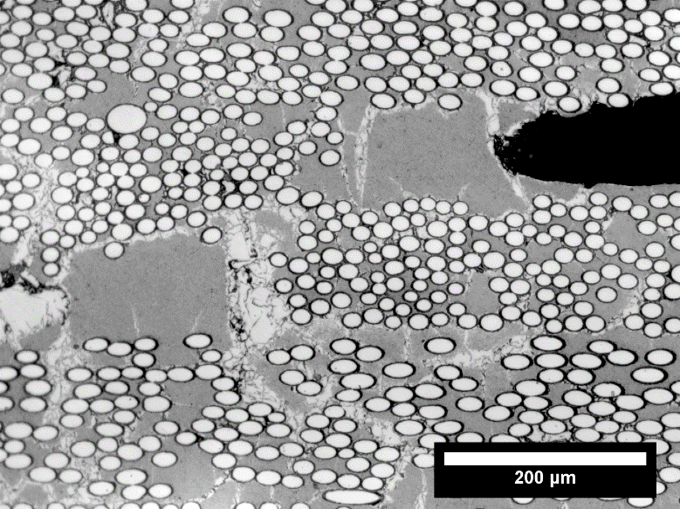

Figure 1: An example of one of the 36 microscope images used to create a single mosaic image.

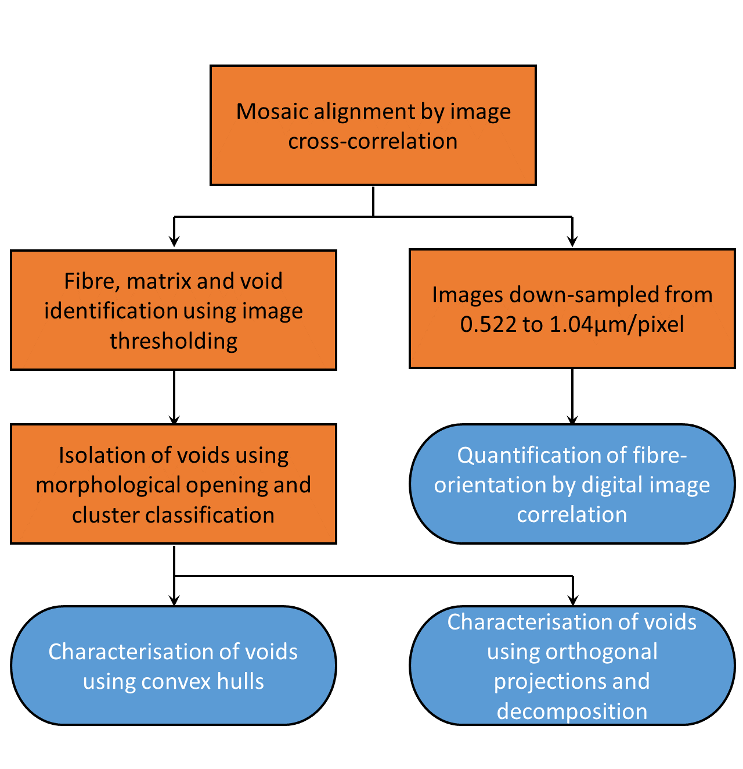

Figure 2: Flow chart of the data processing used to extract void shape and fibre orientation information. The boxes indicate image processes applied to the mosaics and the lozenges indicate the extraction processes used to extract void and fibre information from the mosaics.

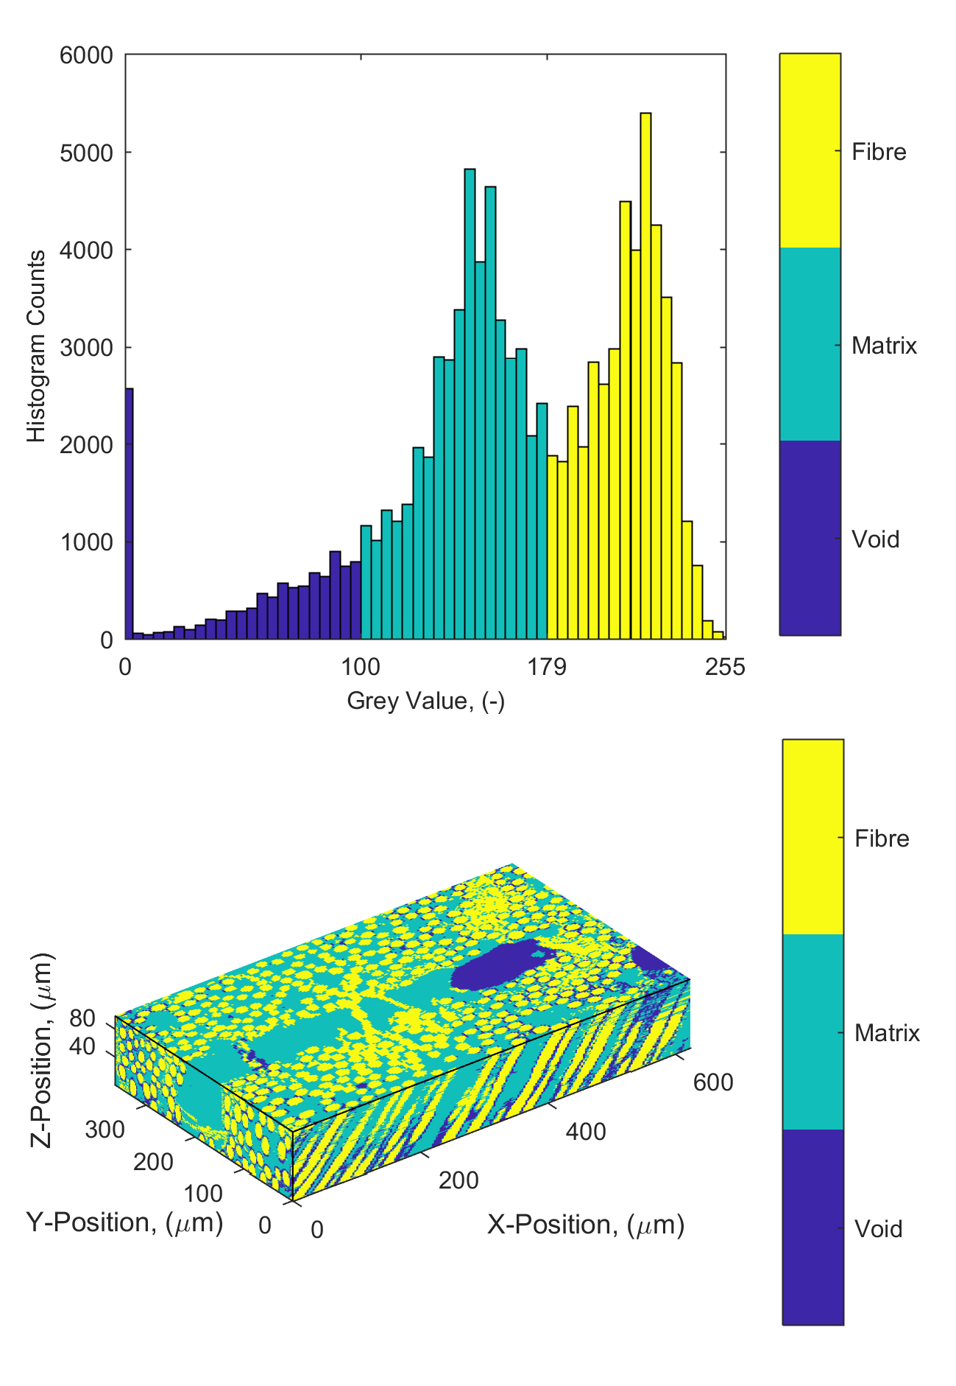

Figure 3: Histogram of grey values for all of the serial section data (top) and a portion of serial section data (bottom) colour coded to indicate the range of grey values within each band identified using Otsu's method.

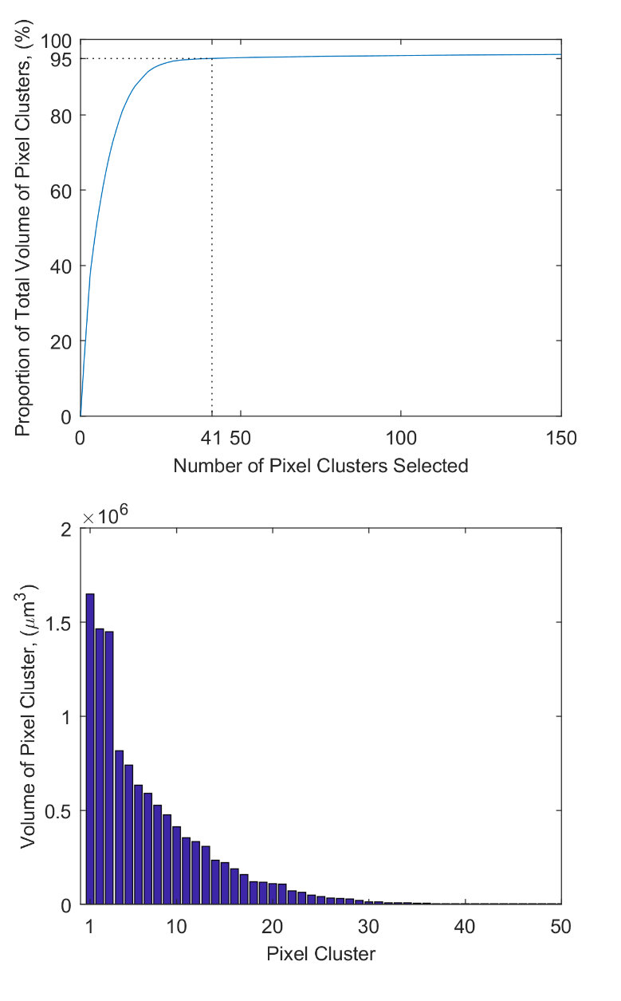

Figure 4: The cumulative volume of the selected pixel clusters as a function of the number of clusters selected from a ranked list starting from the largest by volume (top) and the rank ordered volumes of the largest 50 clusters (bottom).

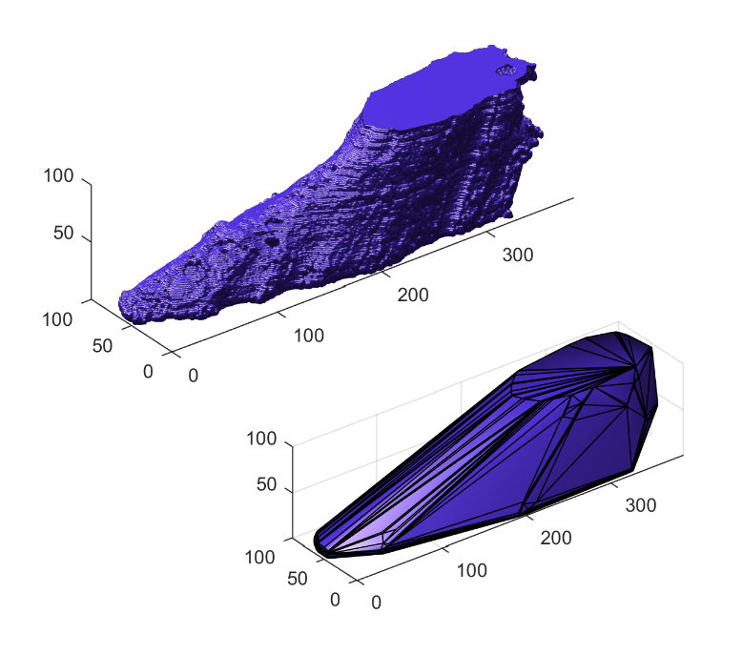
Figure 5: An exemplar void (top) described by 14.3 million pixels; when fitted with a convex hull (bottom) the same void is described using 206 vertices.

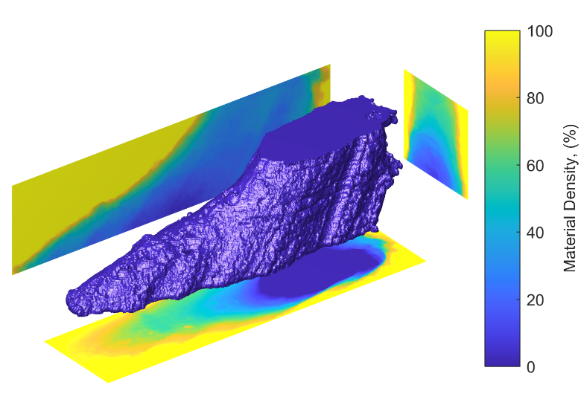
Figure 6: The three orthogonal projections of a cuboid enclosing the exemplar void shown in Figure 5, with a 3D rendering of the void at the centre of the image. The x-z plane is shown top-left, y-z plane is shown top-right and x-y plane is shown at the bottom.

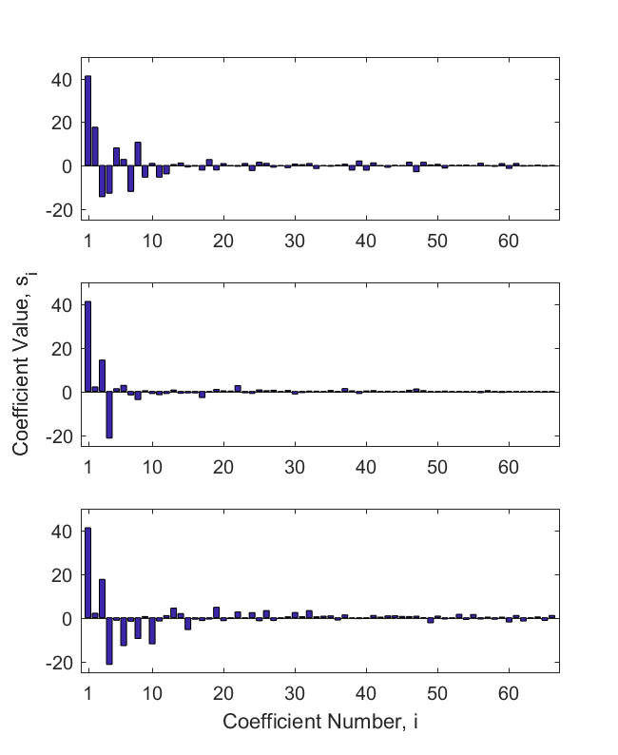
Figure 7: Bar charts showing the values of the Chebyshev coefficients representing the orthogonal projections shown in Figure 6, with the: x-z plane (top), y-z plane (middle) and x-y plane (bottom).

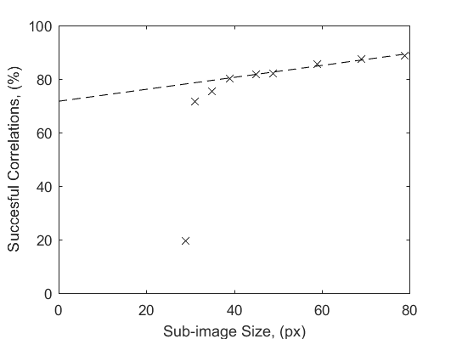
Figure 8: Proportion of the sub-images successfully correlated by DIC between the first and last mosaic image (crosses) with a line-of-best-fit for the six largest sub-image sizes (dashed line).

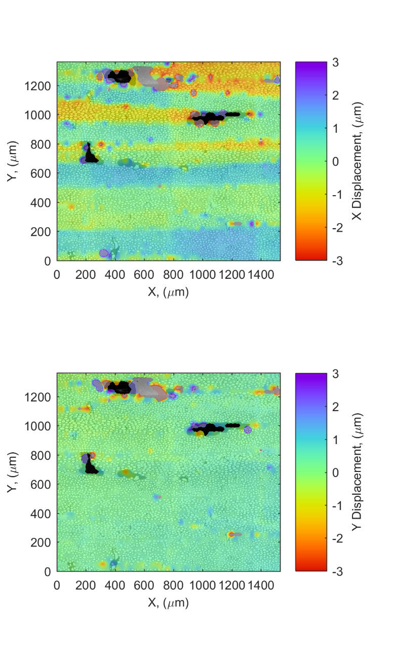

Figure 9: Typical sub-image x-direction (top) and y-direction (bottom) displacements from DIC as a transparent overlay on a corresponding mosaic from z=1μm. Positive values indicate the fibres coming out of the page are leaning to the right and negative values indicate the fibres are leaning to the left.

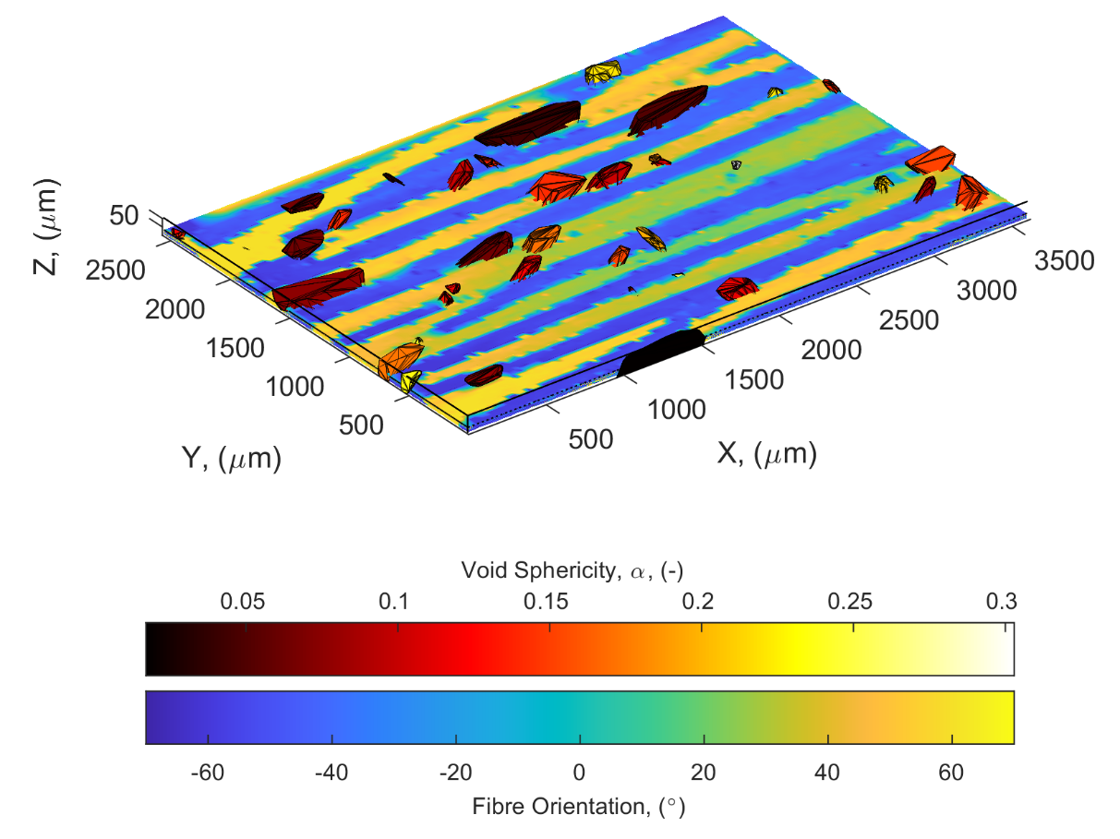
Figure 10: Local fibre angles in the x-z plane at z=30μm together with voids coloured to indicate their sphericity calculated using equation (1).

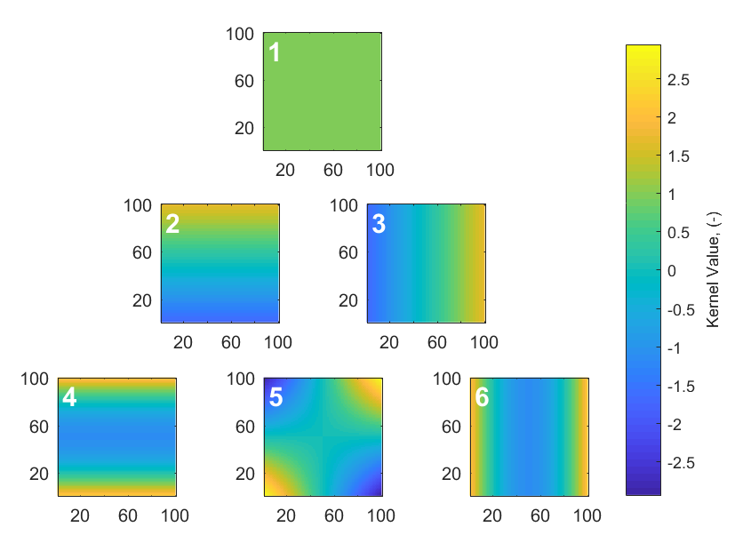
Figure 11: The Chebyshev kernel functions, corresponding to the first six coefficient (white number in the top-left corner of each function); the corresponding interpretations of void shape are described in Table 1.
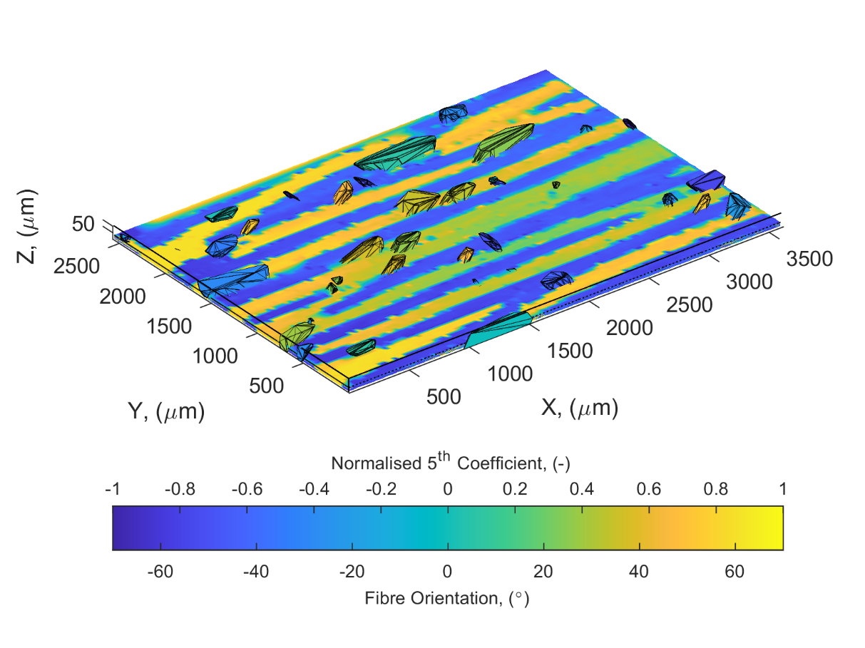

Figure 12: Local fibre angles in the x-z plane at z=30μm (corresponding to the data in Figure 10) together with voids coloured to indicate their orientation indicated by the value of the fifth Chebyshev coefficient (see Figure 11) from the decomposition of projection in the x-z plane of the density of a cuboid enclosing each void.

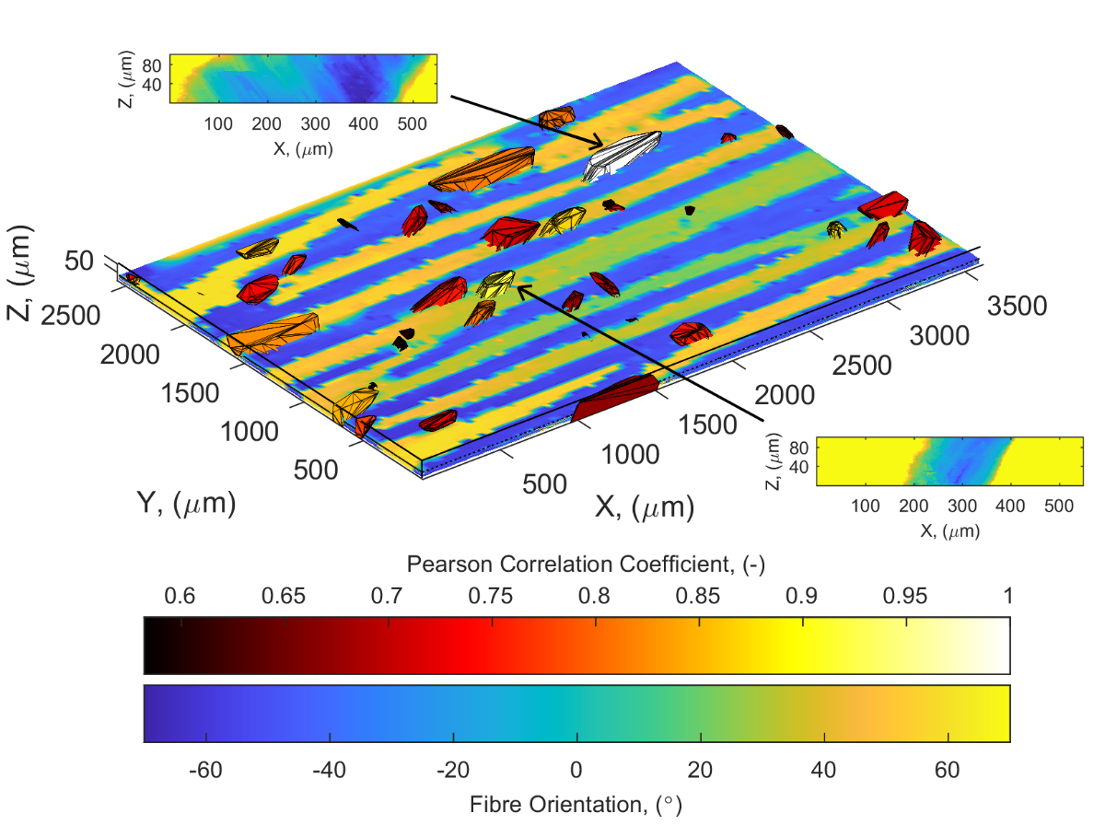
Figure 13: Similarity of voids with the reference void (shown in white) superimposed on fibre angle data from Figure 10. The top inset shows the projection onto the x-z plane for the reference void and the bottom inset shows the corresponding data for a similar void. The positions of these voids within the specimen are indicated by arrows.

