Title
Identifying barriers, conflict and opportunity in managing aquatic ecosystems

Authors
Robinson, L.A.^{1*}, Blincow, H. ¹, Culhane, F.E. ¹ and O’Higgins, T².
¹University of Liverpool, Department of Earth, Ocean and Ecological Sciences, Nicholson Building, Liverpool, L69 3GP, UK
²University College Cork, Cork, Ireland
*Corresponding author

Abstract
Inland aquatic ecosystems play an important part in the delivery and support of ecosystem services. However, these ecosystems are subject to stressors associated with human activities such as invasive species introduction and landscape alteration. There is a delicate balance between maintaining good status of the ecosystem whilst meeting the needs of those stakeholders dependent on the ecosystem services it supplies, and where there are many different stakeholders, each with different aspirations and dependencies on the ecosystem, it can be difficult to strike a balance on suitable management measures to put in place. A better understanding of the interactions between the human and ecological functions of the ecosystem (a socio-ecological systems (SES) approach) can enable an effective dialogue to be opened to secure management solutions of best fit. In this study we took a SES approach to explore the dependencies and interactions in the Lough Erne catchment with a range of stakeholders representing the use of the Lough. In particular, we explored how individual stakeholder goals were perceived to be affected by both the biodiversity and activities found in the catchment. Results suggest there are distinct components deemed integral to the success of stakeholder goals in this system, including ‘key habitat components’ and ‘policy relevant species’, as well as activities associated with ‘conservation and recreation’ and ‘scientific research’. Those components which were seen to limit the potential achievement of most goals included invasive species, and in particular, more recently introduced invasives, as well as extractive industries. Consideration of the similarity in goals based on their perceived interactions with the activities and biodiversity of the system indicated that there were shared dependencies between some stakeholders, but also differences that highlight the potential for conflict. Future management scenarios should take consideration of the key limiting and enabling factors identified here.

Keywords
Socio-ecological system; freshwater; biodiversity; human activities; modularity

Introduction
It is estimated that inland aquatic ecosystems make up 8-9% of the earth’s land surface (Janse et al. 2015). They are important due to their species richness, unique biodiversity and their supply of ecosystem services (Farber et al. 2006). Aquatic ecosystems can be impacted by a range of stressors such as nutrient loading (Rabalais, 2002), invasive species (Janse et al. 2015), climate change (Daufresne et al. 2009) and human alteration of the landscape (Allan and Johnson, 1997; Naiman et al. 2000). Rarely do these stressors act in isolation in terms of their effects on the ecosystem, and the activities required to meet the needs of one stakeholder may introduce stressors that impact the needs of another. US Pacific Northwest salmon fisheries provide one example of how different activities, such as fishing and hydroelectricity generation can have combined impacts upon valuable ecosystem components resulting in complex management challenges (Lackey, 2000; O’Higgins 2015).
To comprehensively understand ecological impacts of a changing system in line with the differing needs of stakeholders and society as a whole, a socio-ecological system (SES) approach can be taken (Ostrom, 2009). A SES is a systematic approach to understanding both socio-cultural and ecological structures together. It identifies interactions within a system including the activities, biodiversity, ecology, users, resources and social influences (Ostrom, 2009). Within this system it is important to recognise the differing drivers acting on stakeholders. For example, national and international policy commitments place pressure on particular stakeholders to meet objectives that may relate to conservation of key habitats or species, or the maintenance or growth of particular industries and these policy and sectoral objectives are frequently contradictory or not well aligned (O’Higgins 2017). Meanwhile, other stakeholders are acting to support or protect the immediate needs of the local community or their own livelihoods. In order to understand the dynamic and complex management needs of such a system, the importance of setting out the goals of all stakeholders and considering the interaction of these with the SES has been described (Reeves and Duncan, 2009). By recognising the dynamics and uses of the full SES, it is argued that more effective environmental management and planning can be adopted (Crooks et al. 2011). Such a holistic approach to environmental management has often been referred to as Ecosystem Based Management or the Ecosystem Approach (e.g. Mee et al., 2015).
Application of the SES approach frames situations dealing with complex social-ecological problems and allows the identification of key assumptions present in a given context, in addition to overlooked factors that may be important to the system overall or in other specific contexts (Bennett & Gosnell, 2015). Previous studies have succeeded in mapping social and the ecological parts of these systems, but the interactions between these parts can have emergent properties that need to be considered (Hamann et al. 2015). The SES framework allows information from different disciplines to be integrated in such a way that can be useful to managers making decisions in complex situations, but it has been difficult to operationalise (Leslie et al. 2015). However, developments have been made over different spatial and temporal scales related to resource management issues resulting in greater insights into management options than if the social and ecological systems were assessed alone (e.g. Dearing et al., 2014; Leslie et al., 2015; Hossain et al., 2017), and the framework has been used to embed ideas such as payments for ecosystem services (Bennett & Gosnell, 2015). Operationalising the SES approach can consist of a mapping phase, where stakeholders are consulted to provide input into the final map of the SES, followed by a quantitative analysis based on indicators and modelling to investigate management options (e.g. Leslie et al., 2015; Hossain et al., 2017). However, the use of formal models can be problematic in fully integrating social dimensions, such as aspects of human behaviour (Schluter et al., 2017). Thus, there is a place for both quantitate modelling and broader approaches to understand complex interactions.
Here we take a semi-quantitative approach where the SES in question is mapped conceptually based on perceptions of actors in the system in terms of the influence of particular resource units (e.g. the biodiversity and habitats of the system) and resource users (e.g. major activities dependent on and influencing the system) on the potential of them to reach their own goals. Lough Erne was chosen as the study site for this work due to its wide use by humans, historical importance and ecological changes over time. It is a transboundary water body, situated in County Fermanagh, Northern Ireland and is the 3rd largest lake in the UK and Ireland, measuring 109km², draining from a catchment of 4212km² (Lafferty et al. 2006). The Upper Lake is a Special Area of Conservation (SAC) and a designated RAMSAR site (O’Higgins, 2016). The Lough is used by a variety of stakeholders for multiple activities (e.g. fishing, hunting, boating, and hydroelectricity). So far over the past century, there have been many biological changes to the Lough (Figure 1). In the 1850s, the lake was relatively pristine (compared to modern times), with little evidence for anthropogenic disturbance. Introduction of nutrient loading in the 1900s resulted in eutrophication and an associated increase in phytoplankton concentrations (Battarbee, 1986). Construction of a Hydropower scheme followed and has been associated with reduced salmon runs (Mathers et al., 2002) and subsequent changes to the system include the displacement of Rudd by the introduction of roach as well as a decline in water clarity due to increasing point and diffuse nutrient sources associated with sanitation from a developing population as well as agricultural activity. Most recently, there has been the arrival of invasive species such as the zebra mussel (Dreissena polymorpha) (Rossell et al., 1998) which has been associated with an increase in water clarity (Maguire et al, 2006), but impacts some activities due to the fouling of boat hulls. There has also been the more recent invasive species introduction of Nuttall’s pondweed (Elodea nuttallii) which has led to an increased chance of floating pondweed mats becoming dislocated and blocking the entrance to the hydroelectric power plant (Clayton and Champion, 2006) whilst also limiting boat traffic (Zehnsdorf et al., 2015). Some attempts have been made to reduce the extent of Nuttall’s pondweed by shading and dredging, but the efforts have been expensive and benefits short-lived (Kelly et al., 2013).
This study will seek to explore the socio-ecological system of the Lough Erne catchment area by eliciting the goals of a range of stakeholders with dependencies on the ecosystem, and facilitating the assessment of how those goals are affected by other activities and the ecological structures (biodiversity) of the SES, thereby setting out the types of interactions found. The following objectives will be achieved:
- To identify all stakeholders with an interest in the Lough Erne system and their key goals.
- To identify the activities and biodiversity components that have a direct association with the Lough Erne aquatic ecosystem.
- To explore how goals identified under 1 are perceived to be affected by the activity and biodiversity components from 2, in terms of acting in either a positive, neutral or negative way towards the achievement of said goals.
In seeking to better understand the SES of study, we set out to identify the key stakeholders, activities and biodiversity components that feature in the area and the interactions between them. By considering these across a range of stakeholder goals, we aimed to identify any key limiters or enablers and where there was similarity in this, also exploring the potential for conflict due to differences in dependencies on the Lough system and its activities.

2. Methods
The approach taken was to pre-select the socio-ecological components of the study system (collectively referred to as ‘SES components’ throughout) building on structured typologies from relevant policies (see Borgwardt et al., this issue and Teixeira et al., this issue). We took this more structured top-down approach because we wanted to ask all stakeholders to each consider the same set of SES components, such that it would be possible to compare similarities and differences in the perceptions of stakeholders of the components of the SES in terms of the effects on the achievement of their goals. We acknowledge that the components selected do not cover all those that would make up a full SES (see Ostrom, 2009; Leslie et al., 2015), but we sought to focus on the manageable activities, main users and how biodiversity is perceived in the system. These categories are partially accountable for the changes in the system, and the interconnections between them. The method for selecting each set of components is described below.

2.1 SES Components

2.1.1. Stakeholders
Stakeholders were identified by starting with an outline of the users of the Lough system as identified by O’Higgins (2016), and adding to this through an online search using combinations of the following key search terms: ‘Lough Erne’, ‘activities’ and ‘wildlife’, and specific activity and biodiversity names, e.g. ‘waders’, ‘recreation’ and ‘fishing’. In order to effectively construct the SES for analysis, a diverse range of stakeholders were explored to ensure both relevant representatives of governance (e.g. local and national governmental departments) and resource users of the lough were included.

2.1.2 Activities
Activity components were identified for the SES, using stakeholder activities as an initial guide. This was then combined with evidence supplied by O’Higgins (2016) to further identify activities not previously distinguished based on relevant stakeholders. Activities included are those carried out in the catchment that can impact on and/or benefit from the Lough ecosystem in some way. Once a substantial list was created, these were placed under headings following the classification of activities developed by the EU (2006). The use of the EU classification also helped to ensure that all possible activities had been considered.

2.1.3 Biodiversity
O’Higgins (2016) was used as a starting point to identify the fish species (both native and non-native), aquatic plants, insects, amphibians, mammals and birds found within the Lough Erne catchment. This was supplemented by reviewing all management plans related to implementation of national and international biodiversity policies relevant to the area, as well as considering habitats and taxa named on the websites and social media pages related to the activities and stakeholders identified under 2.1.1 and 2.1.2. The biodiversity components included are all dependent on the aquatic ecosystem of the Lough Erne catchment in some way and include those listed in the biodiversity and conservation policies and directives relevant to the Lough Erne system, with others chosen due to their cultural significance. Components included specific focal taxa such as ‘common roach’ and ‘pike’, as well as broader components such as ‘amphibians’ and ‘rivers and streams’. This approach was taken to enable consideration of both the broad range of biodiversity and habitats representative of the Lough Erne ecosystem, as well as highlighting taxa that would be of policy or socio-cultural relevance.

2.2 Workshop
All stakeholders identified under 2.1.1 (15 in total) were invited to a workshop on the banks of the Lough in Co. Fermanagh, Northern Ireland – first through email, then by a follow-up phone call. Thirteen stakeholders were able to attend, representing a broad range of the major uses and interests in the Lough system. The participating stakeholders of the workshop were asked to partake in three exercises.
In the first exercise, stakeholders identified three medium term goals (of significance over a five year period) of their organisation that related to the Lough Erne system. After completion of exercise one, each stakeholder was asked to prioritise one goal they deemed the most pressing or important to take forward to use in exercises two and three.
For exercise two, stakeholders were given a set of 22 illustrated cards (Figure 2) which depicted the list of activity components identified as described in 2.1.2. Participants were asked to assign each activity type to one of the following categories based on how it would affect the achievement of their selected goal. In total, there were 6 categories: ‘strongly negative’, ‘negative’, ‘neutral’, ‘positive’, ‘strongly positive’ and ‘do not know’. Exercise three followed the same pattern, but each were given the set of 37 biodiversity component cards (Figure 2) (identified under 2.1.2) to place into the same six categories: from ‘strongly negative’ to ‘strongly positive’ with a ‘do not know’ pile. Cards were not given in any particular order.

2.3 Data Analysis

Unfortunately it was not possible to gather complete data from one of the stakeholders, and as such, analysis was undertaken on 12 of the 13 stakeholder responses going forward.

2.3.1. SES components
The overall connectance (represented here as the proportion of all possible interactions shown as positive or negative) and the distribution of all interactions between positive, strongly positive, negative or strongly negative categories was explored at the level of stakeholder goals (with activity and biodiversity components separately), activities (with goals) and biodiversity components (with goals). To ensure stakeholder anonymity, all analyses were undertaken at the level of the goals, rather than using the identity of stakeholders.

2.3.2. SES overall interactions
The Lough Erne socio-ecological system was visualised by exploring the similarity and dissimilarity in goals using modularity analysis.

Modularity
Modularity was used to identify sub-sets of goals with greater similarity due to their interactions with (1) activities and (2) biodiversity components (Beckett, 2016). This was based on Newman’s modularity measure, which uses simulated annealing to maximise weighted bipartite modularity. It was calculated at the stakeholder goal level using the ‘LDTR_LPA_wb_plus’ function (Beckett, 2016) in the R package ‘bipartite’ (Dorman et al., 2017). This was used to explore groupings of goals in terms of how they are affected by (1) activities and (2) biodiversity components. All interactions were included in the modularity analysis, incorporating both ‘don’t know’ and ‘neutral’ results; however ‘don’t know’ results had to be treated as an equivalent to a neutral result. In order to run the modularity analysis (which cannot incorporate missing values) categorical results were assigned scores as follows: ‘strongly negative’ (1), ‘negative’ (2), ‘neutral’ and ‘don’t know’ (3), ‘positive’ (4) and ‘strongly positive’ (5). Scores are depicted in terms of the shading used in the modules, with darker shading associated with higher scores.

3. Results

3.1 SES components

3.1.1. Stakeholder goals
The twelve stakeholders represented in the analysis, had a diverse range of goals that they had selected as being a priority issue with dependence on the Lough Erne socio-ecological system. Individual stakeholder goals ranged from protecting local heritage or biodiversity, engaging with communities, reducing the impact of invasive species, to increasing hydropower output from the hydroelectric dam and reducing impacts of pesticides in waterways (Table 1).
Connectance of goals with the activities undertaken in the Lough catchment ranged from 18 -95% (Figure 3a), with the majority of goals being perceived to have positive or negative interactions with around 75% of activities. For two goals, ‘Hydropower’ and ‘Drainage’, low levels of connectance overall (< 30%) were recorded, with many Lough activities recorded to have no net effect on the potential to achieve the selected goal. However, only two out of the 264 goal/activity interactions assessed were returned as a ‘do not know’ response, and the majority of interactions were perceived as a negative effect of the activity on the achievement of stakeholders’ goals (Figure 3a). The goals that featured a higher proportion of positive interactions with the Lough activities were the ‘Recreation’ and ‘Engagement’ goals, whilst the ‘Commercial’ goal had similar numbers of positive and negative interactions overall. The highest proportion of strongly negative interactions with activities was for the ‘Biosecurity’ goal (Figure 3a).
Connectance of goals with the biodiversity components ranged between 5 – 92% (Figure 3b), with biodiversity components perceived to have particularly low levels of relevance to achievement of the ‘Drainage’ and ‘Commercial’ goals. Of the 421 goal/biodiversity component interactions assessed, 23 were returned with a ‘do not know’ response, but in contrast to the interactions of goals with activities, for only three of the 12 goals was there the perception that there would be more negative effects (on achievement of goals) of biodiversity components, than positive effects. These were found in the case of the ‘Commercial’, ‘Hydropower’ and ‘Biosecurity’ goals. For a number of the goals (those with lowest connectance, see Fig 3b), there were high numbers of the biodiversity components where it was thought that there would be no net effect on achievement of the goal (a neutral response was given). Highest proportions of positive interactions with biodiversity components were recorded for the ‘Engagement’ and ‘Recreation’ goals (Figure 3b).

3.1.2 Activities
Connectance of individual activities with the stakeholder goals ranged between 33 – 100% (Figure 4), with ‘flood management’ and ‘hydroelectric power’ perceived to have relevance to the achievement of each of the 12 stakeholder goals. The lowest levels of connectance with stakeholder goals were recorded for ‘Wind farms’, followed by ‘Turf cutting’ and ‘Wildfowl hunting’. Two activities, ‘Conservation & restoration’ and ‘Scientific research’ had both high levels of connectance and only positive effects on goals of the stakeholders perceived, whilst five activities were only associated with negative interactions with goals and most of these were relevant to more than 50% of the stakeholders (Figure 4). Twelve of 22 activities were perceived to have negative effects on the potential to achieve goals, for 50% or more of the stakeholders. Most notable in terms of negative interactions, were ‘Mining & quarrying’, ‘Flood management’, ‘Boating/Watersports with engine’, ‘Hydroelectric power’ and ‘Roads & transport’. It was also of interest that 14 of 22 activities were perceived to have negative effects for some stakeholder’s goals and positive effects for others. Activities with mixed effects included ‘Tourism’, ‘Boating/Watersports without engine’, ‘Coarse Angling’, ‘Game Angling’ and ‘Boating infrastructure’.

3.1.3. Biodiversity
The biodiversity components ranged from 25-92% connectance with the 12 stakeholder goals explored, with lowest levels of connectance for the ‘Leaf beetle’, ‘Arable land’ and ‘Canadian pondweed’ (Figure 5). Both the broad ‘Rivers & Streams’ and ‘Lake’ components were perceived to have both high levels of connectance with, and mainly positive effects on, goals of stakeholders. For 25 of the 27 biodiversity components, a higher proportion of interactions with stakeholder goals were perceived to be positive, but in all cases, some negative effects on goals were also recorded. For 10 components, there were more negative interactions with achievement of goals than there were positive; these biodiversity components were almost all non-native taxa (Fig 5, Table 2). Nuttall’s pondweed and zebra mussels were noted to have a particularly high proportion of negative interactions with stakeholder goals.

3.2. SES overall interactions

3.2.1. Modularity
Although there was a high degree of overlap, modularity indicated four sets of stakeholder goals that share connections in terms of how activities and biodiversity components are perceived to influence their likely attainment (Figs 6 and 7). Across both sets, the ‘Biosecurity’ goal was identified as having a distinct set of interactions, whilst the grouping of goals in the remaining three modules differed dependent on whether interactions with activities (Fig 6) or biodiversity components (Fig 7), were being considered.
In terms of interactions with activities, four goals had mainly neutral or negative interactions with activities operating in the Lough (Module A.A, Fig. 6), only having positive interactions with a limited number of specific activities (e.g. ‘Flood management’ for the Drainage goal and ‘Hydroelectric Power for Hydropower and Drainage goals). For a second set of goals (Module A.B., Fig 6) strongly positive effects of a number of activities were indicated (e.g. conservation and recreation), but strongly negative interactions suggested for others. Negative effects included interactions with hydroelectric power, which had been perceived to be positive in terms of enabling achievement of the first set of goals, showing potential for conflict between sets of stakeholders over the regulation of particular activities. A third set of goals had in common that they were positively affected by activities associated with recreational use or environmental management (A.D., Fig. 6), but had neutral or negative interactions with some of the more extractive activities (e.g. mining and quarrying, hydroelectric power and commercial fishing).
For the first grouping of goals based on interactions with biodiversity components (Fig 7, Module BA), a wide range of species, broad taxonomic groups and habitats were perceived to have strongly positive effects on the achievement of stakeholder goals, which covered restoration of biodiversity, wader numbers, reductions in invasives and promoting a living landscape. This grouping of goals was meanwhile negatively associated with many of the non-native species, such as common roach, and Nuttall’s pondweed (Fig 7, Table 2), although there seemed to be differentiation between the non-natives in terms of how they were perceived for the Invasives goal, with some indicated as being neutral in terms of the likely effect on achievement of that goal (Fig 7). The Biosecurity goal was (strongly) negatively associated with almost all of the biodiversity components (Module BB, Fig 7), perhaps indicating the difficulty in limiting biosecurity breaches across any aspect of biodiversity. The second major grouping of goals based on biodiversity interactions, was dominated by neutral interactions with biodiversity, regardless of the type of biodiversity, and in particular in reference to the ‘Pesticides’, ‘Drainage’ and ‘Commercial’ goals (Module BC, Fig 7). This module also included the ‘Engagement’ goal, which was perhaps grouped in this module because like the other goals therein, it had a fairly consistent type of association across all biodiversity components; however, the type of association was more often positive than neutral, and no negative interactions were indicated. The final module based on associations with biodiversity components included two goals that had strongly positive associations with many of the larger more charismatic and culturally relevant broad taxa (e.g. Birds, Mammals, Amphibians) and specific species (e.g. Pollan, Eel, Eurasian otter and Atlantic salmon) but negative interactions with some of the non-native species, whilst positive interactions with others that were of interest in terms of recreational activities (e.g. common roach and ruddy duck) (Figure 7, Module BD).

4. Discussion
It has been suggested that a better understanding of the socio-ecological interactions in a system could enable finding management strategies that are both more successful and less contentious (Bohnet and Smith, 2008). In this study, the perceived effect of economic activities and biodiversity components of an extensive Lough system on the potential for stakeholders to achieve their goals was explored using a structured assessment delivered through facilitated workshop exercises. We set out to explore the functionality of the socio-ecological system (SES), in particular whether stakeholders identified key limiters or enablers to achieving their goals and whether there were shared or conflicting dependencies expressed. Twelve different goals were identified, suggesting the Lough provides multiple benefits and services and highlighting the potential difficulty in implementing effective management plans to meet the needs of each stakeholder.
4.1 Key limiters
‘Mining & quarrying’, ‘Boating/Watersports with engines’, ‘Flood management’ and ‘Hydroelectric power’ were all suggested to be limiters to achieving more than 65% of stakeholders’ goals in the Lough Erne SES explored. The conflict between the needs for generation of hydroelectric power and the potential to achieve goals around biodiversity conservation, ecosystem heritage and recreation (e.g. module A.A. in Fig 6) is well documented for aquatic ecosystems across the World (Dudgeon, 2006). In Lough Erne itself it seems that the concerns around the activities related to the hydroelectric dam spread wider than simply the acknowledged effect on the Salmon run (Mathers et al., 2002). However, this is a key activity in terms of governmental commitments to meet their renewable energy needs; still, this analysis helps to illustrate that multiple users of the system feel they are restricted in their ability to meet other (in some cases, international policy) goals because of this.
It is important to recognise that only a subset of stakeholders were represented in this analysis. One might expect that should goals of local residents, farmers and landowners have been better represented, there might have been a more balanced response for the interactions with ‘Flood management’. In those stakeholders represented, however, negative effects on goal achievement were noted for 9 of the 12 goals explored, with greatest concern expressed for the effect on goals around the ‘Living Landscape’ and the restoration of ‘Waders’ in the system. The result for ‘Mining & quarrying’ was more surprising since there is not much actual activity occurring within the Lough catchment (Cameron et al. 2014). At the same time, however, some areas of the Lower Lough catchment have been cleared for exploratory testing (DETINI, 2011) and it has been noted that, in general, public opinion of the mining sector is poor compared to other sectors, with pressure groups challenging the industry as a whole (Jenkins and Yakovleva, 2006).
‘Boating/Watersports with engine’ was perceived to have many more negative effects on goal attainment than those without engines (where most interactions were positive). The disturbance associated with motorised boats and watersports is well documented in terms of effects on resident and migratory taxa, but a key issue is likely to be with reducing the spread of invasives and other risks to biosecurity as boats have high potential to spread invasive species between water sources (Vander Zanden and Olden, 2008). It was notable that those goals perceived to have negative interactions with invasive species were also those where ‘boating/watersports with engine’ were seen to be limiting (Figs 6 & 7). By contrast, despite eutrophication influenced by agricultural activities in the catchment being widely documented (e.g. Battarbee, 1986), agriculture was only perceived to be limiting for 50% of the goals explored. This may be explained by the need to explicitly include the pressures introduced by activities (e.g. Knights et al., 2013), such that the pathways between activity, ecosystem state and the implications of this on user needs are evident (see Culhane et al., this issue). For example, nutrients (introduced by agriculture) are considered to be a major contributor to the recent proliferation of the invasive pondweed Elodea nutallii (Kelly et al., 2015).
Invasive species were shown to be one of the key limiters to achievement of stakeholder goals – notably ‘zebra mussels’ and ‘Nuttall’s pondweed’, having largely negative scores. The zebra mussel was first witnessed in Lough Erne in 1996 and its effects have been well documented due to the economic impact the species has had in many water bodies (Pejchar and Mooney, 2009). For those goals which seek to increase outdoor recreational activity and tourism, zebra mussels can cause damage to boating equipment as well as cause injuries to bathers. Goals which aim to protect biodiversity may also see issues with zebra mussels due to their effect on changing nutrient concentrations (Strayer, 2009) and the resulting consequences on primary production (Ludyanskiy et al. 1993). However, there has also been a notable improvement in water clarity in the Lough since zebra mussels were introduced (Maguire et al, 2006): it is interesting that overall effects of this invasive species are still perceived as negative for many goals of stakeholders dependent on the system. ‘Nuttall’s pondweed’, a relatively recent introduction that has been thriving in the system over the past decade, was also seen as a key barrier to achieving stakeholder goals. It is known to impact on boating because it makes waterways impassable (Zehnsdorf et al., 2015) as well as to make swimming unattractive. Floating mats of Nuttall’s pondweed can also block entrances to hydropower stations (Clayton and Champion, 2006).
Zebra mussels and Nuttall’s pondweed were not the only invasive species perceived to negatively impact stakeholder goals. For the broad ‘Biodiversity’ and ‘Living Landscape’ goals, most invasive species were deemed to have a strongly negative effect. However, the goal focused on managing the spread of invasive species through inland waterways (‘Invasives’, see Table 1), did not score all invasive species equally, reflecting the emphasis on those species that are both listed in the Alien species conventions and likely to be spread in waterways. In Great Britain alone, it has been estimated to cost the UK economy £25 million per year to control freshwater invasive species (Vernon and Hamilton, 2011). Their control is often difficult and unsuccessful and currently there is no control to effectively stop or eradicate Nuttall’s pondweed (Vernon and Hamilton, 2011), which is a concern for the SES studied here since it is perceived to be having a strongly negative effect on the achievement of half of all goals considered.
4.2 Key enablers
A key theme in the SES explored is the need to protect and conserve biodiversity as well as local economy and heritage. This theme was reflected by the fact that the ‘conservation and restoration’ activity was perceived to be relevant to all of the stakeholders’ goals explored and to have a strongly positive connection with eight stakeholders’ goals. Participants also recognized the need for ‘scientific research’ reflecting recent studies that have argued there is a need for more scientific research specific to Northern Ireland (LELP, 2017). No other activities were seen as key enablers across more than a handful of goals. In most cases associations with enabling activities were quite specific; for example, ‘Flood management’ was enabling for the ‘Drainage’, ‘Recreation’ and ‘Commercial’ goals, whilst ‘Boating infrastructure’ was for ‘Economy & heritage’, ‘Biosecurity’, ‘Recreation’ and ‘Engagement’ goals. This suggests that the needs of a range of users will require multiple different activities to be in place.
With regards to biodiversity components perceived by stakeholders to enable their goals, there are two key biodiversity groups. Policy relevant species (e.g. Pollan, Eel, Eurasian Otter) showed a high number of strongly positive results. This suggests that the policies in place play a vital role for stakeholders involved in this SES analysis. Likewise, ‘broad ecosystem habitat components’ contain many components widely perceived to have a positive influence on goal attainment, such as ‘lakes’, ‘rivers and streams’, ‘seasonally flooded grassland’, ‘sedge and reedbeds’, and ‘deciduous woodland’. The associations suggest positive associations reflecting the dependencies of a range of stakeholders on the broad system environment. Results were more mixed for the broad animal groups such as Amphibians, Mammals and Birds, with some goals being associated with strongly positive interactions, whilst others were neutral or even negative.
4.3 Conflict and opportunity across goals
In many cases, SES components were viewed positively regarding some goals and negatively regarding others. This highlights the potential for conflict in trying to meet the needs of a range of stakeholders. Of most concern were those components where there were both strongly positive and strongly negative dependencies noted. For example, five stakeholders perceived ‘hydroelectric power’ as strongly negative and three stakeholders perceived it to be strongly positive. It is an example of the potential conflict seen between stakeholders and the need for multiple outcomes to be considered for each goal to be successful. Mixed results were also seen for some biodiversity components although this was less prevalent. ‘Pike’ holds a mix of negative and positive results. As the only commercially fished species in the Lough, it plays an important role to both local livelihoods and biodiversity of the lough, with sanctuary areas created to protect the species (Rossell, 1994). But it was once listed as an invasive species, and perhaps is still seen as a large issue to the Lough’s biodiversity in policies, yet this does not necessarily mean it is not still an issue to users of the Lough. The modularity analysis undertaken helps to see groupings of goals with common perceptions of activity or biodiversity components. This illustrated that there are commonalities between small groups of goals in terms of those SES components they find to be limiting or enabling.
Perhaps what we gain most from such an exercise is a broader understanding of the system from the perspective of multiple users. One emergent property of the SES explored was that for some goals (e.g. Biosecurity) there were high levels of dependency across many of the components explored, whilst for others, there was relatively low connectance with the SES components. However, it should be noted that whilst some goals may be perceived to have low connectance with other activities occurring in the system in terms of their own goal attainment, their own associated activities (e.g. hydropower extraction, food management) were perceived by other stakeholders to be limiting to their own goals.

5. Conclusions
The multi-faceted use of Lough Erne has led to a diverse range of stakeholders and consequently, a diverse range of goals. These goals aim to increase activities on the Lough whilst also protecting its biodiversity, heritage and rural economy. Over the 12 stakeholder goals explored, we found there are distinct components which are deemed integral to the success of stakeholder goals. These components most notably include ‘key habitat components’, ‘policy relevant species’, ‘conservation and recreation’ and ‘scientific research’ activities. The limiting factors seen to be detrimental to stakeholder goals include a range of invasive species, most notably the ‘zebra mussel’ and ‘Nuttall’s pondweed’, ‘mining and quarrying’ and ‘boating with engines’. In order to reduce conflict and meet the needs of the majority of stakeholders and protect the overall socio-ecological functioning of the system, the use of consumptive activities and spread or management of invasive species needs to be looked at carefully.

Acknowledgements
This work was supported by the European Union’s Horizon 2020 Programme for Research, Technological Development and Demonstration under Grant Agreement no. 642317 – project AQUACROSS. Further funding was provided to HB and LAR from the University of Liverpool. We also thank two anonymous reviewers for their useful input.

References
Allan, J. and Johnson, L., 1997. Catchment‐scale analysis of aquatic ecosystems. Freshwater Biology, 37(1), pp.107-111.
Asplund, T.R., 2000. The effects of motorized watercraft on aquatic ecosystems. Wisconsin Department of Natural Resources.
Battarbee, R.W., 1986, January. The Eutrophication of Lough Erne Inferred from Changes in the Diatom Assemblages of ²¹⁰Pb-and ¹³⁷Cs-Dated Sediment Cores. In Proceedings of the Royal Irish Academy. Section B: Biological, Geological, and Chemical Science (pp. 141-168). Royal Irish Academy.
Beckett, S. J. 2016. Improved community detection in weighted bipartite networks. Royal Society Open Science, 3.
Bennett, D.E. and Gosnell, H. (2015) Integrating multiple perspectives on payments for ecosystem services through a social-ecological systems framework. Ecological Economics, 116, pp.172-181.
Bohnet, I. and Smith, D.M., 2007. Planning future landscapes in the Wet Tropics of Australia: a social–ecological framework. Landscape and Urban Planning, 80(1), pp.137-152.
Borgwardt, F., Culhane, F., Trauner, D., Texeira, H., Nogueira, A., Lillebo, A., Piet, G., Kummerlen, M., O'Higgins, T., McDonald, H., Arevalo-Torres, J., Barbosa, A. L., Hein, T. & Robinson, L. In review, this issue. Exploring variability in environmental impact risk from human activities across aquatic realms. Science of the Total Environment.
Cameron, D G, Bide, T, Parry, S F, Parker, A S and Mankelow, J M. 2014. Directory of Mines and Quarries, 2014: 10th Edition. (Keyworth, Nottinghsm, British Geological Survey).
Clayton, J. and Champion, P., 2006. Risk assessment method for submerged weeds in New Zealand hydroelectric lakes. In Macrophytes in Aquatic Ecosystems: From Biology to Management (pp. 183-188). Springer Netherlands.
Crooks, J.A., Chang, A.L. and Ruiz, G.M., 2011. Aquatic pollution increases the relative success of invasive species. Biological Invasions, 13(1), pp.165-176.
Daufresne, M., Lengfellner, K. and Sommer, U., 2009. Global warming benefits the small in aquatic ecosystems. Proceedings of the National Academy of Sciences, 106(31), pp.12788-12793.
Dearing, J.A., Wang, R., Zhang, K., Dyke, J.G., Haberl, H., Hossain, M.S., Langdon, P.G., Lenton, T.M., Raworth, K., Brown, S., Carstensen, J., Cole, M.J., Cornell, S.E., Dawson, T.P., Doncaster, C.P., Eigenbrod, F., Florke, M., Jeffers, Poppy, G.M. (2014) Safe and just operating spaces for regional social-ecological systems. Global Environmental Change, 28, pp.227-238.
DEFRA (2017). Agriculture in the United Kingdom 2016. In. Agriculture in the United Kingdom (ed.)
DETINI, 2011 Mining and exploration activity Northern Ireland. 2011 Minerals License Map. Department of Enterprise, Trade and Investment.
Dorman, C. F., Fruend, J., and Gruber, B. 2017. Package 'bipartite'. R Statistical Software.
Dudgeon, D., H., A. A., O., G. M., Zen‐Ichiro, K., J., K. D., Christian, L., J., N. R., Anne‐Helene, P. R., Doris, S., J., S. M. L. & A., S. C. 2006. Freshwater biodiversity: importance, threats, status and conservation challenges. Biological Reviews, 81, 163-182.
EU, 2006. Regulation (EC) No 1893/2006 of the European Parliament and of the Council of 20 December 2006 establishing the statistical classification of economic activities NACE Revision 2 and amending Council Regulation (EEC) No 3037/90 as well as certain EC Regulations on specific statistical domains. Official Journal of the European Union, L393/1.
Farber, S., Costanza, R., Childers, D.L., Erickson, J.O.N., Gross, K., Grove, M., Hopkinson, C.S., Kahn, J., Pincetl, S., Troy, A. and Warren, P., 2006. Linking ecology and economics for ecosystem management. Bioscience, 56(2), pp.121-133.
Hamann, M. Biggs, R. and Reyers, B. (2015) Mapping social-ecological systems: Identifying ‘green-loop’ and ‘red-loop’ dynamics based on characteristic bundles of ecosystem service use. Global Environmental Change, 34, pp.218-226.
Hossain, M.S., Dearing, J.A., Eigenbrod, F. and Johnson, F.A. 2017 Operationalizing safe operating space for regional social-ecological systems. Science of the Total Environment, 584-585, pp.673-682.
Janse, J.H., Kuiper, J.J., Weijters, M.J., Westerbeek, E.P., Jeuken, M.H.J.L., Bakkenes, M., Alkemade, R., Mooij, W.M. and Verhoeven, J.T.A., 2015. GLOBIO-Aquatic, a global model of human impact on the biodiversity of inland aquatic ecosystems. Environmental Science & Policy, 48, pp.99-114.
Jenkins, H. and Yakovleva, N., 2006. Corporate social responsibility in the mining industry: Exploring trends in social and environmental disclosure. Journal of cleaner production, 14(3), pp.271-284.
Kelly, J., Tosh, D., Dale, K. and Jackson, A. 2013. The economic cost of invasive and non-native species in Ireland and Northern Ireland. Report prepared for the Northern Ireland Environment Agency and the National Parks and Wildlife Service as part of Invasive Species Ireland. 86 pp
Kelly, R., Harrod, C., Maggs, C.A. and Reid, N. 2015. Effects of Elodea nuttallii on temperate freshwater plants, microalgae and invertebrates: small differences between invaded and uninvaded areas. Biological Invasions. 17, 2123-2138
Knights, A.M., Koss, R.S., Robinson, L.A., 2013. Identifying common pressure pathways from a complex network of human activities to support ecosystem-based management. Ecol. Appl. 23, 755–765. doi:10.1890/12-1137.1
Lackey, Robert T. 2000. Restoring wild salmon to the Pacific Northwest: chasing an illusion? In: Patricia Koss and Mike Katz (eds). What We Don’t Know about Pacific Northwest Fish Runs – An Inquiry into Decision-Making. Portland State University, Portland, Oregon, 91–143.
Lafferty, B., Quinn, R. and Breen, C., 2006. A side-scan sonar and high-resolution Chirp sub-bottom profile study of the natural and anthropogenic sedimentary record of Lower Lough Erne, northwestern Ireland. Journal of Archaeological Science, 33(6), pp.756-766.
LELP., 2017. Conservation Land Management Strategy. Lough Erne Landscape Partnership. Waterways Ireland.
Leslie, H.M., Basurto, X., Nenadovic, M., Sievanen, L., Cavanaugh, K.C., Cota-Nieto, J.J., Erisman, B.E., Finkbeiner, E., Hinojosa-Arango, G., Moreno-Baez, M., Nagavarapu, S., Reddy, S.M.W., Sanchez-Rodriguez, A., Siegel, K., Ulibarria-Valenzuela, J.J., Hudson Weaver, A., Aburto-Oropeza, O. (2015) Operationalizing the social-ecological systems framework to assess sustainability. PNAS, 112(19), p.5979-5984.
Ludyanskiy, M.L., McDonald, D. and MacNeill, D., 1993. Impact of the zebra mussel, a bivalve invader. BioScience, 43(8), pp.533-544.
Maguire, C., Rossell, R. and Roberts, D. 2006. Management of the impacts of zebra mussels in Northern Ireland and dermination of the effects on fish populations in Lough Erne through alteration of food web. Environment and Heritage Service Research and Development Series 06/25 Pp51.
Mee, L., Cooper, P., Kannen, A., Gilbert, A.J. and O’Higgins, T. (2015) Sustaining Europe’s seas as coupled social-ecological systems. Ecology and Society, 20, No. 1
Minchin, D., Maguire, C. and Rosell, R., 2003, July. The zebra mussel (Dreissena polymorpha Pallas) invades Ireland: human mediated vectors and the potential for rapid intranational dispersal. In Biology and Environment: Proceedings of the Royal Irish Academy (pp. 23-30). Royal Irish Academy.
Mosisch, T.D. and Arthington, A.H., 1998. The impacts of power boating and water skiing on lakes and reservoirs. Lakes & Reservoirs: Research & Management, 3(1), pp.1-17.
Naiman, R.J. and Turner, M.G., 2000. A future perspective on North America's freshwater ecosystems. Ecological applications, 10(4), pp.958-970.
O’Higgins, T.G. 2015. It’s Not Easy Being Green, A Systems Approach to Environmental Management. Dunedin Academic Press. Pp 120.
O'Higgins, T.G., 2016. Aquacross Case Study Storylines.
O'Higgins, T.G., 2017. You Can't Eat Biodiversity: Agency and Irrational Norms in European Aquatic Environmental Law. Challenges in Sustainability, 5(1), pp.43-51.
Ostrom, E., 2009. A general framework for analyzing sustainability of social-ecological systems. Science, 325(5939), pp.419-422.
Pejchar, L. and Mooney, H.A., 2009. Invasive species, ecosystem services and human well-being. Trends in ecology & evolution, 24(9), pp.497-504.
Planning Service (2006). Planning Policy Statement 15. Belfast: DOENI.
Pretty, J.N., Brett, C., Gee, D., Hine, R.E., Mason, C.F., Morison, J.I.L., Raven, H., Rayment, M.D. and Van der Bijl, G., 2000. An assessment of the total external costs of UK agriculture. Agricultural systems, 65(2), pp.113-136.
Rabalais, N.N., 2002. Nitrogen in aquatic ecosystems. AMBIO: A Journal of the Human Environment, 31(2), pp.102-112.
Reeves, G. H., and S. L. Duncan. 2009. Ecological history vs. social expectations: managing aquatic ecosystems. Ecology and Society 14(2): 8. [online] URL: http://www.ecologyandsociety.org/vol14/iss2/art8/
Rosell, R.S., 1994, December. Changes in fish populations in Lower Lough Erne: A comparison of 1972-3 and 1991-2 gill net survey data. In Biology and Environment: Proceedings of the Royal Irish Academy (pp. 275-283). Royal Irish Academy.
Rossell, R.S., Maguire, C.M. and McCarthy, T.K., 1998, December. First reported settlement of zebra mussels Dreissena polymorpha in the Erne System, Co. Fermanagh, Northern Ireland. In Biology and Environment: Proceedings of the Royal Irish Academy (Vol. 98, No. 3, pp. 191-193). Royal Irish Academy.
Schluter, M., Baeza, A., Dressler, G., Frank, K., Groenweld, J., Jager, W., Jansse, M.A., McAllister, RRJ, Muller, B., Orach, K., Schwarz, N., Wijermans, N. (2017) A framework for mapping and comparing behavioural theories in models of social-ecological systems. Ecological Economics, 131, pp.21-35.
Strayer, D.L., 2009. Twenty years of zebra mussels: lessons from the mollusk that made headlines. Frontiers in Ecology and the Environment, 7(3), pp.135-141.
Teixeira, H., Lillebo, A., Culhane, F., Robinson, L., Trauner, D., Borgwardt, F., Kummerlen, M., Barbosa, A. L., McDonald, H., Funk, A., O'Higgins, T., Van Der Wal, J. T., Piet, G., Hein, T., Arevalo-Torres, J., Iglesias-Campos, A., Barbiere, J. & Nogueira, A. In review, this issue. Flow linkages from biodiversity to ecosystem services supply: integrating across aquatic ecosystems.
Vander Zanden, M.J. and Olden, J.D., 2008. A management framework for preventing the secondary spread of aquatic invasive species. Canadian Journal of Fisheries and Aquatic Sciences, 65(7), pp.1512-1522.
Vernon, E. and Hamilton, H. (2011). Literature review on methods of control and eradication of Canadian pondweed and Nuttall’s pondweed in standing waters. Scottish Natural Heritage Commissioned Report No. 433.
Zehnsdorf, A., Hussner, A., Eismann, F., Rönicke, H. and Melzer, A., 2015. Management options of invasive Elodea nuttallii and Elodea canadensis. Limnologica-Ecology and Management of Inland Waters, 51, pp.110-117.
Zevenbergen, C., Veerbeek, W., Gersonius, B. and Van Herk, S., 2008. Challenges in urban flood management: travelling across spatial and temporal scales. Journal of Flood Risk Management, 1(2), pp.81-88.
Zhou, Q., Gibson, C.E. and Foy, R.H., 2000. Long-term changes of nitrogen and phosphorus loadings to a large lake in north-west Ireland. Water Research, 34(3), pp.922-926.

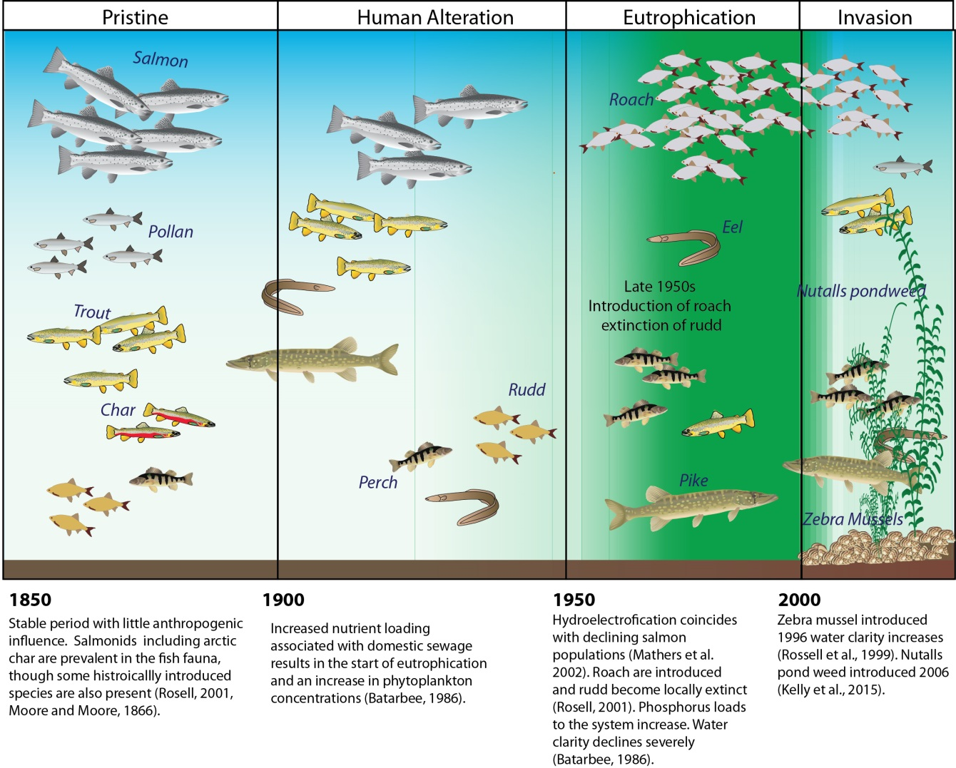
Figure 1: Lough Erne biological changes (taken from O’Higgins, 2016) presented in four distinct transitions. Pristine refers to little to no anthropogenic change to the aquatic system. Human alternation refers to nutrient changes brought on by human interaction with the Lough. Eutrophication denotes large nutrient loading and human disturbances. Invasion refers to the introduction of invasive species, most notable of which have been the Zebra mussel and Nuttall’s pondweed.

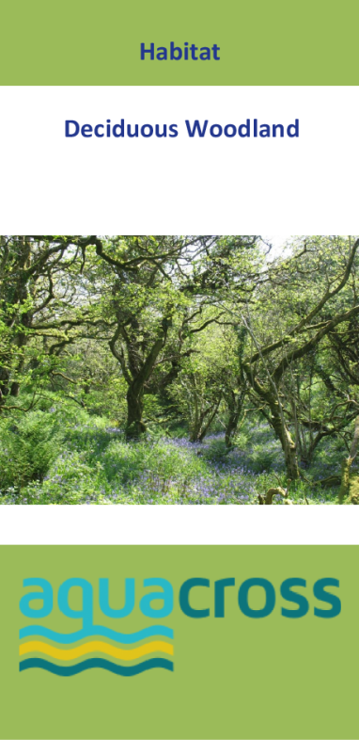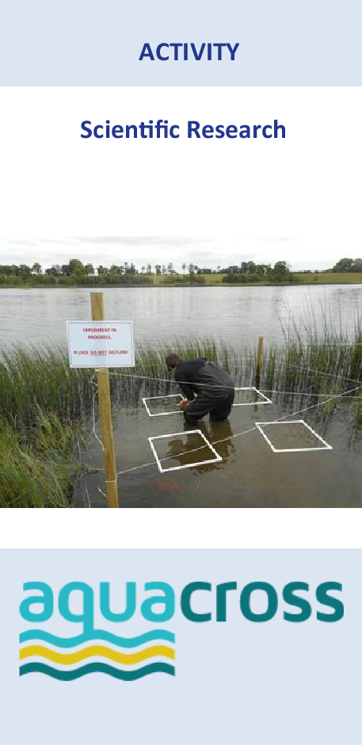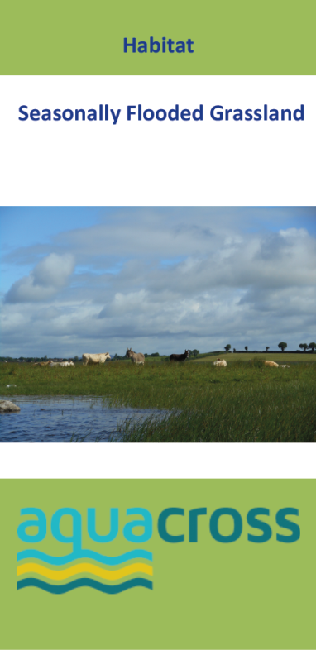
Figure 2: Example of illustrated cards given to stakeholders during exercises two and three of a workshop used to elicit perceptions of the relationship between biodiversity components and activities with the achievement of the goals of a diverse range of stakeholders engaged with the Lough Erne socio-ecological system. Different colours were used to define activity and biodiversity components.

Figure 3: The proportion of negative (blue), strongly negative (red), positive (green) and strongly positive (purple) scores across the (a) 22 activities, and (b) 37 biodiversity components explored for each of the 12 stakeholder goals (see Table 1). Numbers at the end of each bar indicate the overall connectance of the components with goals (as the percentage of all components that had either negative or positive interactions with that goal).

Figure 4: The proportion of negative (blue), strongly negative (red), positive (green) and strongly positive (purple) scores across the 12 stakeholder goals for each of the 22 activities. Numbers at the end of each bar indicate the overall connectance of the components with goals (as the percentage of all goals that had either negative or positive interactions with that component).

Figure 5: The proportion of negative (blue), strongly negative (red), positive (green) and strongly positive (purple) scores across the 12 stakeholder goals for each of the 37 biodiversity components. Numbers at the end of each bar indicate the overall connectance of the components with goals (as the percentage of all goals that had either negative or positive interactions with that component).

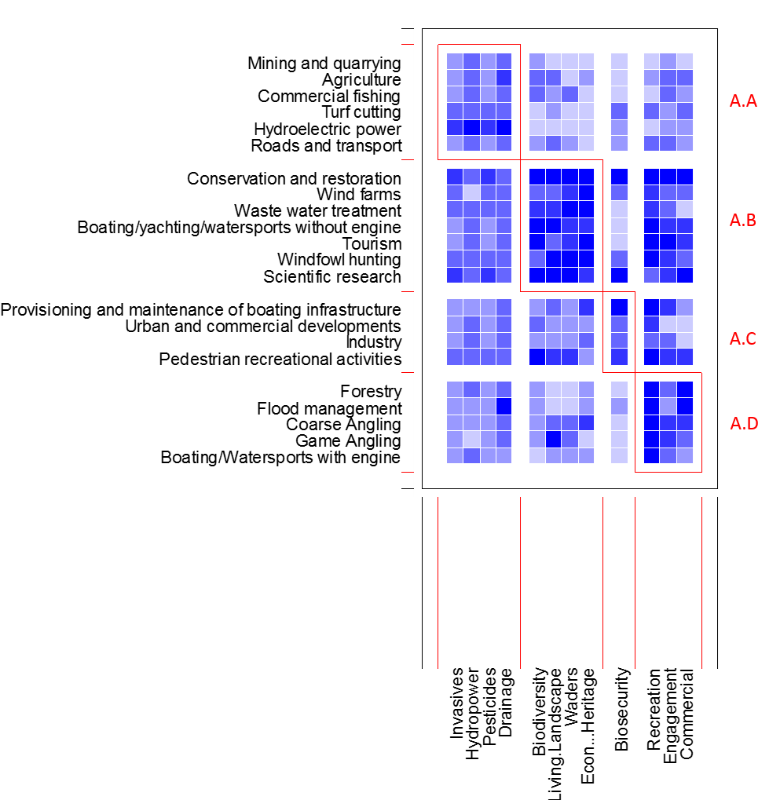

Figure 6: Visualisation of modular sub-sets of activities with the stakeholder goals they affect, weighted according to the type of interaction with darkest blue gradation of squares indicating strongly positive interactions and lightest blue indicating strongly negative. Modules are identified in red and labelled as A. (activity) A-D.
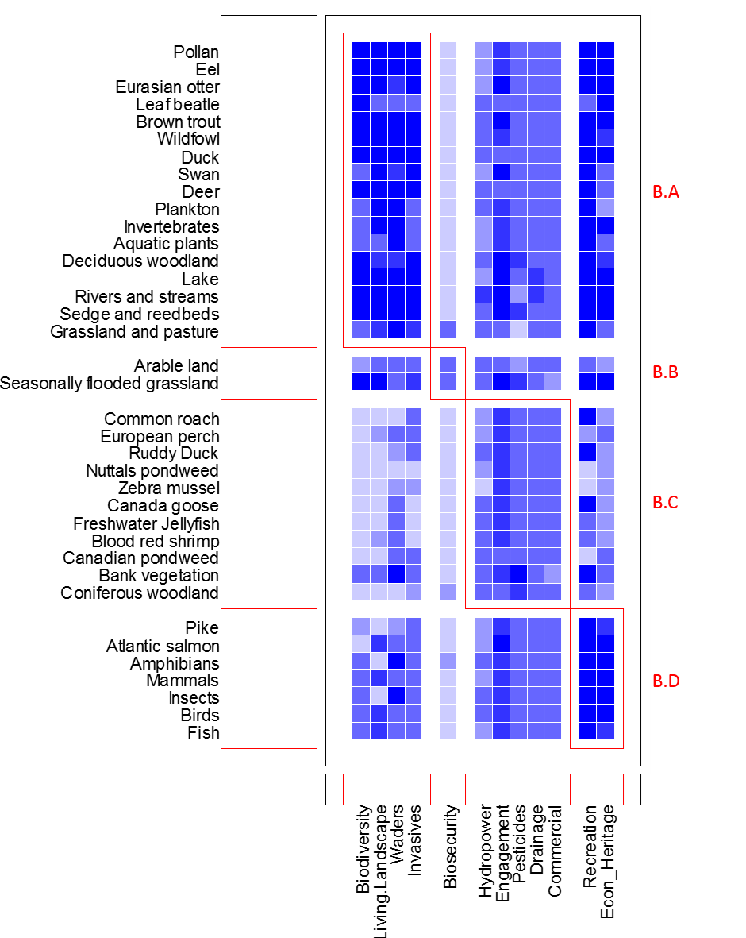
Figure 7: Visualisation of modular sub-sets of activities with the stakeholder goals they affect, weighted according to the type of interaction with darkest blue gradation of squares indicating strongly positive interactions and lightest blue indicating strongly negative. Modules are identified in red and labelled as B. (ecosystem component) A-D.

Table 1: The selected stakeholder goals identified by stakeholders as those of greatest priority over the short-medium term and to be affected by state of the Lough Erne biodiversity and/or activities taking place in the Lough and its catchment. Goals as defined by stakeholders and also with an abbreviated goal name and number as used throughout the presentation and discussion of results.
Stakeholder goal | Abbreviated Goal Name (Goal number)
Reverse declines in biodiversity | Biodiversity (G1)
Protect and restore biodiversity in the Erne Basin through a ‘living landscape’ approach | Living Landscape (G2)
To continue to develop conservation projects which are primarily focussed on attempting to reverse the decline in breeding waders on the Lough (particularly snipe, curlew, redshank) | Waders (G3)
Manage the spread of invasive species throughout inland waterways | Invasives (G4)
Reduce and eradicate issues with biosecurity | Biosecurity (G5)
To generate as much hydropower as possible | Hydropower (G6)
Create, assist and enable continued and increased outdoor recreation activities | Recreation (G7)
Increase public participation and awareness on catchment management | Engagement (G8)
To achieve a vision of a vibrant and sustainable rural economy through a coordinated approach to the protection and enhancement of Lough Erne’s unique heritage | Econ & Heritage (G9)
Mitigate risks of pesticides in water | Pesticides (G10)
Provide a drainage function to rivers in the catchment and maintain within statutory levels | Drainage (G11)
Management of commercial development | Commercial (G12)

