Effect of Inhibitor-Loaded Halloysites and Mesoporous Silica Nanocontainers on Corrosion Protection of Powder Coatings

Elena Shchukina,1 Dmitry Shchukin,1* Dmitry Grigoriev,2

1Stephenson Institute for Renewable Energy, University of Liverpool, L69 7ZF, Liverpool, UK. E-mail: d.shchukin@liverpool.ac.uk.

2Max Planck Institute of Colloids and Interfaces, D14476 Golm, Germany.

**Abstract**

We carried out the comparative study of the effect of inhibitor-loaded nanocontainers on the corrosion protection performance of polyester powder coatings by neutral salt-spray test (5 % NaCl, 35°C, different time). Halloysites and mesoporous silica particles loaded with corrosion inhibitor 8-hydroxyquinoline were homogeneously distributed in powder coating effectively reducing corrosion of the metal substrate over 1000 h of salt-spray test. Addition of only 2 wt.% of inhibitor encapsulated either in halloysites or in mesoporous silica particles to the powder coating is sufficient to decrease the delamination effect by >4 times and to suppress the formation of the blisters on the low carbon steel substrates.

**Keywords**

Nanocontainer, self-healing, halloysite, mesoporous silica, salt spray test, anticorrosion.

**Highlights**

1. Homogeneous distribution of nanocontainers in polyester powder coatings.

2. Controlled release of encapsulated 8-hydroxyquinoline at different pH.

3. Corrosion protection of nanocontainer-impregnated coatings over 1000 h of salt spray test.

4. Direct loading of free 8-hydroxyquinoline in the coating leads to the coating deterioration.

**1. Introduction**

Self-healing activity of the materials is based on their feedback action. The trigger for feedback action can be an external signal applied to the material (light, mechanical force) or changes of the internal properties (like local pH-changes during corrosion process) and overall material integrity [[1]]. The output of the trigger is the restored functionality of the initial material, in our case corrosion protection ability of the coatings. First simple approach for providing self-healing to the organic coatings is to directly introduce corrosion inhibitors in the pretreatment, primer or topcoat layer of the coatings [[2]]. The idea behind is the response to the coating damage by diffusive or stimuli-induced release of the inhibitor from the coating matrix. Direct introduction of the inhibitor into the coating matrix showed successful results for some classes of the inhibitors (like phosphate pigments); however, there are difficulties with application of inhibitors with very high or low solubility in paints [[3],[4]]. Very low solubility of inhibitor leads to its deficit in the damaged area. In case of too high solubility, metal substrate can be protected for only a relatively short time due to rapid spontaneous leaching of inhibitor from the coating [[5]]. Another drawback, which can appear due to high solubility, is the osmotic pressure initiating blistering and, finally, delamination of the coating [[6],[7]].

The new and promising solution to avoid interaction between inhibitor and coating matrix is to encapsulate the inhibitor into stimuli-responsive capsules [6,[8]]. Capsules or nanocontainers can isolate encapsulated corrosion inhibitor from coating matrix, prevent spontaneous leakage of inhibitor and, at the same time, provide controlled release of the inhibitor directly into the corroded area. There are several approaches demonstrated so far for the design of nanocontainer systems: (i) polymer containers [[9]], (ii) halloysites [[10]], (iii) nanocontainers with polyelectrolyte shell [[11]], (iv) layered double hydroxides [[12]], (v) ion-exchange organic resins [[13]], (vi) conductive polymer matrixes [[14]] and (vii) mesoporous inorganic materials [[15]]. Depending on the selected approach, the size of the containers can be varied from 20 nm to 50 µm and, besides permeability control, the shell can have other functionalities (magnetic, catalytic, conductive, targeting, etc.).

The current level of the development of nanocontainer-based self-healing coatings shows large number of the highly-efficient examples on the laboratory scale [[16],[17]]. However, there are two main difficulties for the transfer of the research to commercial applications: (i) the costs of the nanocontainers and (ii) lack of valid industrial test results (mostly salt-spray tests). The first problem requires the search for cheap nanocontainer hosts which can be available in large-scale quantities. Halloysites and mesoporous silica particles can be perfect candidates here. They are much cheaper comparing to the other types of nanocontainers and commercially available in large quantities [[18]]. Additional interest of using inorganic nanocontainers is mechanical and thermal stability, which allow their utilization in different coating layers (pre-treatment, primer, topcoat) subjected to high mechanical loads or significant thermal stresses.

Halloysites are defined as two-layered natural aluminosilicates chemically similar to kaolin, which have a predominantly hollow tubular structure in the submicrometer range [[19]]. Efficient self-healing properties of the benzotriazole and 8-hydroxyquinoline loaded halloysite nanotubes were demonstrated in zirconia-silica sol-gel coatings deposited on the surface of aluminium alloy A2024 [10]. To prevent undesirable leakage of the loaded inhibitor from the halloysite interior at neutral pH, the outer surface of the halloysite nanotubes can be modified by deposition of alternating polyelectrolyte multilayers (poly(allylamine hydrochloride)/poly(styrene sulfonate)) [[20]].

Another type of the nanocontainers with inorganic scaffold is mesoporous silica. It is inert to the most of the corrosion inhibitors and has high specific surface area (>1000 m2/g) [[21]]. The incorporation of inhibitor-loaded mesoporous nanocontainers into inorganic sol-gel coatings improved significantly the coating corrosion resistance [[22]]. On one hand, the coating barrier properties were enhanced by reinforcement of the coating matrix caused by introduction of mechanically stable, robust silica nanoparticles. On the other hand, the large amount of encapsulated inhibitor (up to 80 wt.%) and its controlled release upon corrosion attack provided superior corrosion inhibition. Additional advantage of the silica nanocontainers is the possibility to tailor hydrophobic surface functionality for solvent-born coatings. Mesoporous SiO2 functionalized with octyl groups and loaded with benzotriazole showed tenfold greater corrosion protection performance in polyester-based commercial coatings than for the coating without nanocontainers [[23]].

Despite large number of the papers devoted to the nanocontainer-based self-healing coatings, most of them use lab-scale analytical methods for characterisation of their self-healing performance: EIS, polarisation, SVET and various adapted electrochemical techniques. Only a few papers [[24]] analysed the efficiency of the nanocontainer-based coatings using industrial methods. Here, we attempt to decrease this “transfer gap” and present comparative analysis, done by industrial neutral salt-spray test (ISO 9227), of the corrosion protection performance of 8-hydroxyquinoline (8-HQ) loaded halloysites and mesoporous silica particles impregnated into polyester powder coating. Coatings with and without nanocontainers were tested on bare low carbon steel substrates.

**2. Experimental procedure**

*Materials*

Corrosion inhibitor 8-hydroxyquinoline, ethanol, acetone, HCl, NaOH and NaCl were purchased from Sigma-Aldrich and used without further purification. Halloysites were provided by Atlas Mining Company (Dragon mine deposit, Utah, USA) and mesoporous silica particles were purchased from Grace, USA (SYLOID® C803 silica). Halloysites are naturally occurring layered kaolin aluminosilicates with hollow tubular structure. The aluminum hydroxide and the silicon oxide layers are bond covalently with each other. The bilayer rolls up to a tube, i.e. a hollow cylinder with alumina layer inside and silica layer outside [[25]].

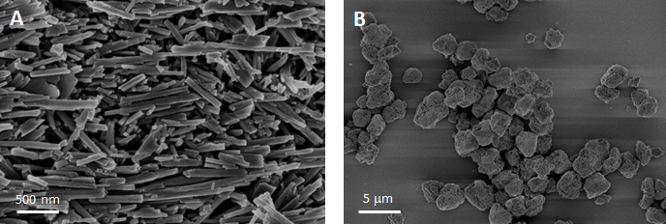

**Figure 1.** SEM images of halloysite nanotubes and mesoporous SiO2 particles used for encapsulation of corrosion inhibitor.

Halloysite nanotubes from Dragon Mine deposit have elongated form with average length around 1 µm with outer diameter around 50 nm and inner lumen of 15-20 nm diameter (Fig. 1a). Mesoporous SYLOID® C803 silica particles have irregular shape and average size of 3-4 µm (Fig. 1b). BET analysis demonstrated specific surface area of 60 m2/g with pore volume of 0.2 cm3/g for halloysites and 285 m2/g with pore volume of 1.4 cm3/g for mesoporous SiO2.

Powder coatings were prepared on the basis of polyester resin Crylcoat 2698-3 provided by Cytec Industries Inc., USA. Cold rolled low carbon steel plates for neutral salt spray tests were purchased from Rocholl GmbH (Germany) and had dimensions LxWxT = 150x75x2 mm and surface cleanliness grade SA2.5.

*Preparation of the coatings*

Loading of the nanocontainers with 8-hydroxyquinoline was performed from 33 wt.% acetone solution under reduced pressure. 50 ml of 33 wt.% 8-HQ were mixed with 5 g of empty nanocontainers (halloysites or mesoporous silica particles) and then introduced into a desiccator with reduced pressure. As the air goes out from the nanocontainer inner volume, the solution containing corrosion inhibitor fills all pores. The loading was performed three times followed by centrifugation of the nanocontainers suspended in water at 5000 rpm each time. The loading capacity was measured by TGA analysis of the prepared nanocontainers. The maximum 8-HQ loading inside halloysite nanotubes was 20±3 wt.% while loading capacity reached 77±4 wt.% for mesoporous SiO2.

On the next stage, 8-HQ loaded nanocontainers (10 wt.% of halloysites or 2.6 wt.% of SiO2) were mixed with the powder coating composition using a laboratory extruder in order to achieve the same concentration of inhibitor in the final coating for both halloysites and mesoporous silica (2 wt.%). The coating was deposited on the metal substrate and cured for 10 minutes at 190° C object temperature. The final coating thickness was 85±5 µm for all samples.

*Characterisation*

Scanning electron microscopy, SEM, (Zeiss Gemini LEO 1550) was employed to analyse the structure of nanocontainers. For characterisation of particles, a droplet of the particle water suspension was placed on the sample holder and left to dry at atmospheric pressure and room temperature. All samples were sputtered with gold/palladium mixture to avoid electron charging of the samples during SEM analysis. The samples were studied using an operating voltage of 3 kV. Nanocontainers in the coatings were analysed by the cross-section (done by microtome) of coated steel plates by embedding of cut out part in the epoxy resin matrix with subsequent careful polishing of the cross-section facet.

The coating thickness was measured with a coating thickness gauge, Surfix® Pro S, from PHYNIX, Germany.

Anticorrosion performance was tested by neutral salt-spray test (Ascott CC450XP salt spray chamber, ISO 9227, 5 wt% NaCl, 35°C, 1 mm scribe, 260 h and 1000 h time). Every coating sample was measured at least on three steel substrates. The delaminated coating was mechanically detached from rinsed and dried samples after 1000 h of salt spray test with the knife according to the DIN EN ISO 4628-8. In order to perform the numerical evaluation of delamination extent for the coated steel plates, the area of the detached coating was stained by tannic acid. 1 wt% aqueous solution of tannic acid with pH above 5 was dabbed on the scratched area and after some minutes of staining thoroughly rinsed with purified water in order to remove the residual tannic acid. On the scratched area where this ink contacted the bare steel surface, the intensive black coloration was occurred due to formation of iron-tannate complex. On the sites where the coating remained intact, tannic acid was rinsed away without visible staining [[26]]. This procedure allowed the strong enhancement of the contrast between the bare metal surface partially coloured by the corrosion products and the intact coating surrounding the delaminated area. The photographs of stained plates (at least 3 plates for one coating sample) were digitised and transformed to the binary form. The total amount of black pixels was counted and divided by the length of the scribe. Finally, the backward transformation yielded the averaged value of the delamination independent of the specific measuring point across the scribe.

Release studies of 8-HQ at different pH were performed spectroscopically adjusting the pH of the solution by HCl or NaOH. 1 g of the loaded nanocontainers was added to the 20 ml of water with adjusted pH. After a desired time period, the nanocontainers were centrifuged out at 5000 rpm and the released 8-HQ was measured in the supernatant at 240 nm.

Thermogravimetric analysis (TGA) was carried out using a TG 209 F1 device (Netzsch-Gerätebau GmbH, Germany) with a heating rate 10 °C/min under air atmosphere at 20°C - 600°C temperature change. In these conditions, the inhibitor completely burns out while the ceramic nanocontainers are stable. The specific surface area and pore volume of nanocontainers were obtained by means of N2 BET (Brunauer–Emmett–Teller) analysis (QuadraSorb SI Surface Area Analyzer and Pore Size Analyzer, Quantachrome Instruments, USA).

**3. Results and Discussion**

The highest loading efficiency was observed for both nanocontainer types after third loading cycle (see Experimental part). First loading cycle provided 12 wt.% inhibitor loading for halloysites and 34 wt.% of inhibitor for mesoporous SiO2, as was calculated from TGA. Next two cycles lead to the loading limit of 20 wt.% of 8-HQ for halloysites and 77 wt.% for silica. Further repetition of the loading did not result the increase of the quantity of 8-HQ in nanocontainers clearly indicating achieved loading limit.

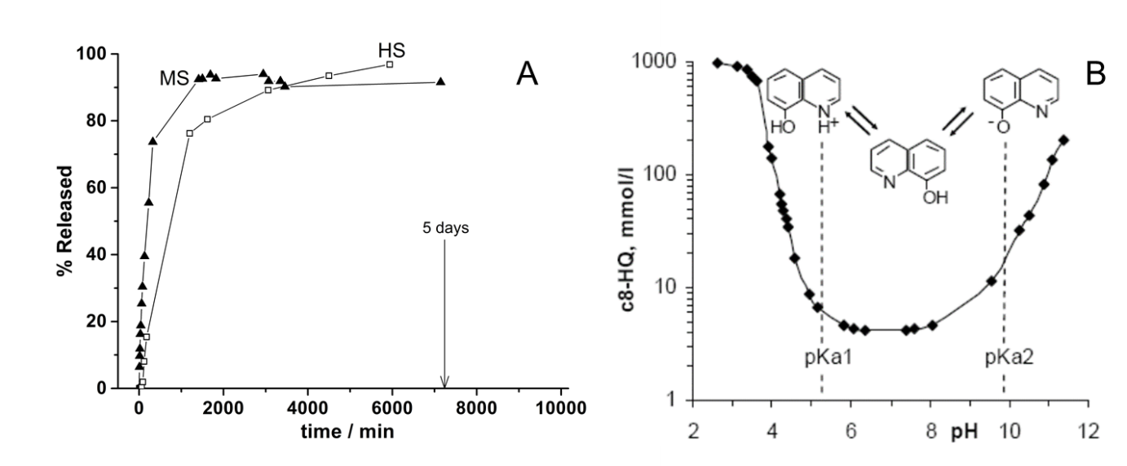

**Figure 2.** Release of the encapsulated 8-HQ at pH 7 in water for both nanocontainers (A) and pH accelerated solubility of 8-HQ (B).

Mesoporous silica shows higher release rate at initial stages (Figure 2a) due to the network of open pores while halloysite nanotubes have two “exits”, and, therefore, longer time is needed for 8-HQ to diffuse from the inner halloysite lumen. Complete release of the encapsulated 8-HQ appeared after 5 hours in water media at pH=7 for both halloysites and silica particles. The release speed can be significantly accelerated in acidic or alkaline pH range because of the amphoteric structure of the corrosion inhibitor (Figure 2b). Formation of the ionic forms of 8-HQ at low (cationic) and high (anionic) pH values initiates 100-times increase of the release speed which can be effectively employed for smart response of the 8-HQ loaded nanocontainers to the corrosion start. The chosen basic (>pKa2) pH values are typically achieved during the corrosion of steel or aluminium alloys and can be utilized as triggers [6]. On the other hand, the reduced release at pH = 7 limits the leaching of inhibitor from the coating.

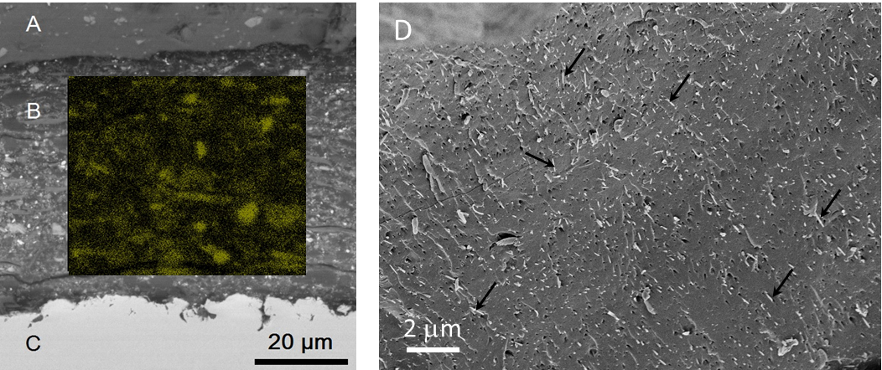

**Figure 3.** Left - SEM of mesoporous silica particles distributed in powder coating after curing (cross-section of the coating edge): (A)- outer coating surface, (B) – volume of the coating, (C) – metal substrate. The inset in the centre shows EDX signal from Si (green). Right - (D) SEM of halloysite nanotubes inside scratched (with scalpel) powder coating, top view. Halloysites can be seen as small fibres, as indicated by arrows.

The nanocontainers are well dispersed in the coating. Figure 3 shows that both nanocontainers do not create aggregates in the coating preventing the loss of the coating integrity. Even several aggregates can cause severe damage to the coating barrier properties [12]. Nanocontainers are distributed homogeneously in the whole coating volume with halloysites retaining their elongated tubular structure after coating deposition and curing. Average concentration of halloysites in the coating, as calculated from SEM/EDX data, is around 15 per 1 µm3. Bigger SiO2 particles are less concentrated with approximately 5 particles per 1 µm3. The concentration of nanocontainers is, in both cases, enough to provide sufficient release and adsorption of the inhibitor in damaged areas of the coating because two inhibitor layers are enough to terminate corrosion propagation [[27]].

Previously, we used SVET and EIS for analysis of the self-healing and barrier properties of inhibitor-loaded nanocontainers in coatings [10,[28]]. Mentioned laboratory tests clearly demonstrated the efficiency of the inhibitor-loaded halloysite nanotubes and mesoporous particles. However, more rigorous industrial tests are necessary before commercial application of the nanocontainer-based self-healing coatings.



**Figure 4.** Neutral salt spray test results for commercial polyester powder coating (A), coating with 8-HQ loaded halloysites (B) and 8-HQ loaded mesoporous silica nanoparticles (C) after 260 hours of the test.

As one can see in Figure 4, pure commercial coating reveals corrosion and degradation during first 260 hours of the neutral salt spray test. There is corrosion propagation under the coating from artificial scribe and also signs of the blistering corrosion. Coatings with inhibitor-loaded nanocontainers show much better corrosion protection ability with small signs of corrosion propagation under artificial scratch and no blistering effects. This is due to the sustained release of the 8-HQ into the scratched area triggered by local pH increase during corrosion process.

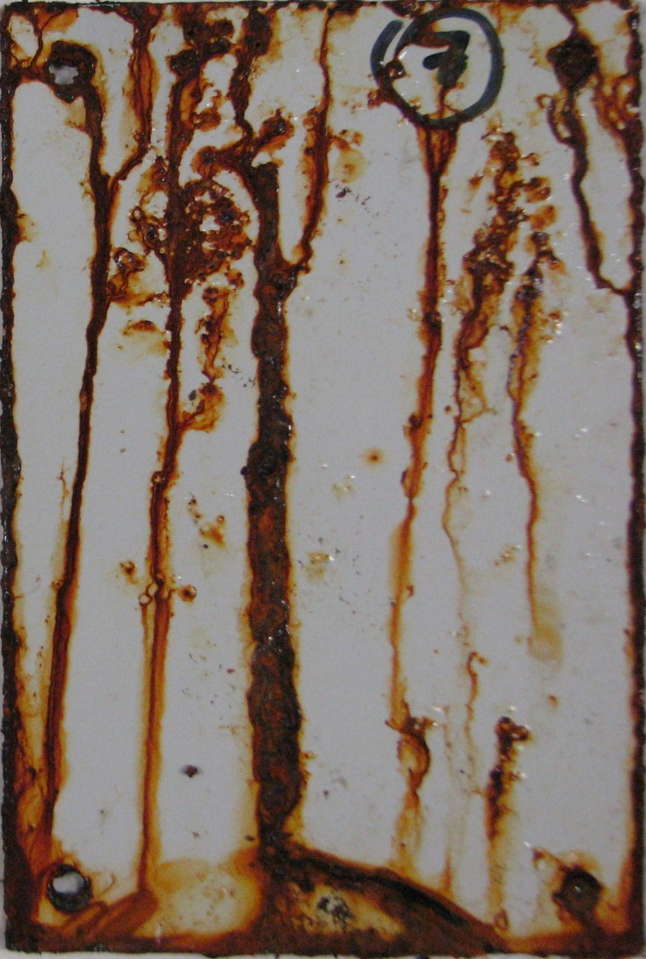

**Figure 5.** Neutral salt spray test results for commercial polyester powder coating with 5 wt.% of directly added 8-hydroxyquinoline after 260 hours of the test.

At the same time, direct addition of the 8-HQ in the concentration even 2.5 times higher (5 wt.%) than for encapsulated 8-HQ (2 wt.%) demonstrated complete deterioration of the coating with many signs of blistering (Figure 5). The latter indicates reduction of the barrier properties of the coating due to the interaction of the hydroxyl groups of 8-HQ with polyester derivatives of the coating matrix, which forms micropores in the coating facilitating the penetration pathways for Cl- ions.



**Figure 6.** Neutral salt spray test results for commercial polyester powder coating (A), coating with 8-HQ loaded halloysites (B) and 8-HQ loaded mesoporous silica nanoparticles (C) after 1000 hours of the test.

Continuous reduction of the corrosion protection for pure commercial coating with many blisters and delamination in the scratched area was demonstrated after 1000 h of the test while the coatings with 8-HQ loaded nanocontainers are still stable (Figure 6). Quantification of salt spray test (see Experimental part for details) showed >5 mm delamination for pure commercial polyester coating after 1000 h. Introducing 8-HQ loaded halloysites or mesoporous silica particles reduced the delamination to 1.2 mm and only small number of blistering sites was found for coating with mesoporous silica particles.

**4. Conclusion.**

Summarising the data presented above, we can conclude that the effect of inhibitor-loaded nanocontainers is based on the pH-controlled release of the 8-hydroxyquinolile inside the damaged (or corroded) area of polyester powder coatings. Local increase of the pH due to the corrosion process immediately accelerates the solubility of the encapsulated 8-hydroxyquinoline provoking its diffusion from nanocontainers to the defected area where it then chemisorbs on the anodic corrosion sites [[29]] and terminates corrosion.

Neutral salt spray tests (Ascott CC450XP salt spray chamber, ISO 9227, 5 wt% NaCl, 35°C, 1 mm scribe, 260 h and 1000 h time) demonstrated different corrosion protection performance of pure commercial polyester powder coating, powder coating with directly incorporated 8-hydroxyquinoline (5 wt.%) and power coatings with 8-hydroxyquinoline loaded halloysites or mesoporous silica particles. Addition of only 2 wt.% of inhibitor encapsulated in both nanocontainers is sufficient to decrease the delamination effect by >4 times and suppress the formation of the blisters even after 1000 h of salt spray test as compared to the pure commercial coating. At the same time, direct addition of 8-hydroxyquinoline into the coating resulted in complete coating degradation after 260 h of the salt spray test. This indicates that (i) the encapsulated inhibitor can be effectively used for corrosion protection due to its isolation from the coating matrix inside halloysite or silica nanocontainers where it stays in active, not-bounded form and (ii) halloysites and mesoporous silica particles can be homogeneously distributed in powder coating without formation of the aggregates.

**Acknowledgement.**

DS acknowledges ERC Consolidator grant ENERCAPSULE for financial support.

DG is grateful for the financial support of the Federal Ministry of Economics and Energy (BMWi), Germany in the framework of “EXIST Transfer of Research” program (Project “SigmA” Nr. 03EFCBB028) and G8 project “SMARTCOAT”, G8MUREFU2-FP-377-008. We thank Dr. M. Schenderlein and Mr. E. Scherke for the help in experimental work.

**References**

1. [] J.J. DiStefano, A.R. Stubberud, I.J. Williams, Schaum's outline of theory and problems of feedback and control systems: continuous (analog) and discrete (digital), McGraw-Hill, New York, 1995.
2. [] E.W. Brooman, Modifying organic coatings to provide corrosion resistance: Part II—Inorganic additives and inhibitors, Met. Finish, 100 (2002) 42-53.
3. [] M. Garcia-Heras, A. Jimenez-Morales, B. Casal, J.C. Galvan, S. Radzki, M.A. Villegas, Preparation and electrochemical study of cerium-silica sol-gel thin films, J. Alloys Compd. 380 (2004) 219-224.
4. [] M.F. Montemor, Functional and smart coatings for corrosion protection: A review of recent advances, Surface & Coatings Technology 258 (2014) 17-37.
5. [] A.J. Vreugdenhil, M.E. Woods, Triggered release of molecular additives from epoxy-amine sol-gel coatings, Prog. Org. Coatings 53 (2005) 119-125.
6. [] D.G. Shchukin, H. Mohwald, Self-repairing coatings containing active nanoreservoirs, Small 3 (2007) 926-943.
7. [] D. Raps, T. Hack, J. Wehr, M.L. Zheludkevich, A.C. Bastos, M.G.S. Ferreira, O. Nuyken, Electrochemical study of inhibitor-containing organic-inorganic hybrid coatings on AA2024, Corros. Sci. 51 (2009) 1012-1021.
8. [] D.G. Shchukin, H. Mohwald, Smart nanocontainers as depot media for feedback active coatings, Chemical Communications 47 (2011) 8730-8739.
9. [] S.R. White, N.R. Sottos, P.H. Geubelle, J.S. Moore, M.R. Kessler, S.R. Sriram, E.N. Brown, S. Viswanathan, Autonomic healing of polymer composites, Nature 409 (2001) 794-797.
10. [] D. Fix, D.V. Andreeva, D.G. Shchukin, Y.M. Lvov, H. Möhwald, Application of inhibitor-loaded halloysite nanotubes in active anti-corrosive coatings, Adv. Funct. Mater. 19 (2009) 1720-1727.
11. [] A.M. Pavlov, S.A. Gabriel, G.B. Sukhorukov, D.J. Gould, Improved and targeted delivery of bioactive molecules to cells with magnetic layer-by-layer assembled microcapsules, Nanoscale 7 (2015) 9686-9693.
12. [] J. Tedim, M.L. Zheludkevich, A.C. Bastos, A.N. Salak, A.D. Lisenkov, M.G.S. Ferreira, Influence of preparation conditions of Layered Double Hydroxide conversion films on corrosion protection,Electrochimica Acta 117 (2014) 164-171.
13. [] G. Williams, S. Geary, H.N. McMurray, Smart release corrosion inhibitor pigments based on organic ion-exchange resins, Corrosion Science 57 (2012) 139-147.
14. [] B.D. Mert, B. Yazici, S.B. Lyon, Electrochemical synthesis of novel conductive polymer and corrosion protection properties on aluminium, Corrosion Engineering Science and Technology 48 (2013) 506-512.
15. [] D. Borisova, H. Mohwald, D.G. Shchukin, Influence of embedded nanocontainers on the efficiency of active anticorrosive coatings for aluminum alloys part I: influence of nanocontainer concentration, ACS Applied Materials and Interfaces 4 (2012) 2931-2939.
16. [] H. Wei, Y. Wang, J. Guo, N.Z. Shen, D. Jiang, X. Zhang, X. Yan, J. Zhu, Q. Wang, L. Shao, H. Lin, S. Wei, Z. Guo, Advanced micro/nanocapsules for self-healing smart anticorrosion coatings, J. Mater. Chem. A 3 (2015) 469-480.
17. [] M.L. Zheludkevich, J. Tedim, M.G.S. Ferreira, "Smart" coatings for active corrosion protection based on multi-functional micro and nanocontainers, Electrochimica Acta 82 (2012) 314-323.
18. [] E. Joussein, S. Petit, J. Churchman, B. Theng, D. Righi, B. Delvaux, Halloysite clay minerals - A review, Clay Minerals 40 (1992) 383-426.
19. [] Y.M. Lvov, D.G. Shchukin, H. Mohwald, R.R. Price, Halloysite clay nanotubes for controlled release of protective agents, ACS Nano 2 (2008) 814-820.
20. [] F. Hoffmann, M. Cornelius, J. Morell, M. Froba, Silica-based mesoporous organic-inorganic hybrid materials, Angew. Chem. Int. Ed. 45 (2006) 3216-3251.
21. [] A. López-Noriega, D. Arcos, M. Vallet-Regí, Functionalizing Mesoporous Bioglasses for Long-Term Anti-Osteoporotic Drug Delivery, Chem.-Eur. J. 16(2010) 10879-10886.
22. [] D. Borisova, H. Möhwald, D. G. Shchukin, Mesoporous silica nanoparticles for active corrosion protection, ACS Nano 5 (2011) 1939-1946.
23. [] M.J. Hollamby, D. Fix, I. Dönch, D. Borisova, H. Möhwald, D. Shchukin, Hybrid polyester coating incorporating functionalized mesoporous carriers for the holistic protection of steel surfaces, Adv. Mater. 23 (2011) 1361-1365.
24. [] M.L Zheludkevich, S.K. Poznyak, L.M. Rodrigues, D.Raps, T. Hack, L.F. Dick, T. Nunes, M.G.S. Ferreira, Active protection coatings with layered double hydroxide nanocontainers of corrosion inhibitor, Corrosion Science 52 (2010) 602-611.
25. [] E. Ruiz-Hitzky, K. Ariga and Y. M. Lvov, Bio-inorganic Hybrid Nanomaterials: Strategies, Syntheses, Characterization and Applications, Wiley-VCH Verlag GmbH & Co. KGaA, Weinheim, Germany, 2008.
26. [] J.D. Hem, Complexes of ferrous iron with tannic acid, Chemistry of iron in natural water, Washington, US Govt. Print. Off., 1962, 75-94.
27. [] D. Grigoriev, D. Akcakayiran, M. Schenderlein, D. Shchukin, Protective organic coatings with anticorrosive and other feedback-active features: micro- and nanocontainers-based approach, Corrosion 70 (2014) 446-463.
28. [] D.G. Shchukin, S.V. Lamaka, K.A. Yasakau, M.L. Zheludkevich, M.G.S. Ferreira, H. Mohwald, Active anticorrosion coatings with halloysite nanocontainers, J. Phys. Chem. C 112 (2008) 958-964.
29. [] V.S. Sastri, Corrosion Inhibitors: Principles and Applications, Wiley-Blackwell, 1998.