This is the Author Accepted Manuscript of the following paper:

Title: Bluetongue risk under future climates
Authors: Anne E. Jones^{1*}, Joanne Turner ², Cyril Caminade^{1,4}, Andrew E. Heath³, Maya Wardeh¹, Georgette Kluiters², Peter J. Diggle⁵, Andrew P. Morse^{3,4}, and Matthew Baylis^{2,4}

Journal: Nature Climate Change

Accepted: 23 November 2018

Published online: 14 January 2019

URL: https://www.nature.com/articles/s41558-018-0376-6

DOI: 10.1038/s41558-018-0376-6

Bluetongue risk under future climates

Anne E. Jones^{1*}, Joanne Turner ², Cyril Caminade^{1,4}, Andrew E. Heath³, Maya Wardeh¹, Georgette Kluiters², Peter J. Diggle⁵, Andrew P. Morse^{3,4}, and Matthew Baylis^{2,4}

¹ Department of Epidemiology and Population Health, Institute of Infection and Global Health, University of Liverpool, Liverpool, UK
²Department of Epidemiology and Population Health, Institute of Infection and Global Health, University of Liverpool, Leahurst Campus, Neston, UK

³ School of Environmental Sciences, University of Liverpool, Liverpool, UK
⁴ NIHR, Health Protection Research Unit in Emerging and Zoonotic Infections, Liverpool, UK
⁵CHICAS, Lancaster University Medical School, Lancaster University, Lancaster, UK

*Corresponding author
Anne Jones
IBM Research
The Hartree Centre
STFC Laboratory Sci-Tech Daresbury
Warrington WA4 4AD
UK
+44 1925864047

Email: anne.jones@ibm.com

Keywords: bluetongue; climate change; vector-borne disease; epidemiology; uncertainty quantification

Summary

There is concern that climate change will lead to expansion of vector-borne diseases (VBD) as, of all disease types, they are the most sensitive to climate drivers¹. Such expansion may threaten human health, and food security via effects on animal and crop health. Here we quantify the potential impact of climate change on a VBD of livestock, bluetongue (BT), which has emerged in northern Europe in response to climate change^{2, 3, 4}, affecting tens of thousands of farms at huge financial cost and causing the deaths of millions of animals⁵. We derive future disease risk trends for northern Europe, and use a detailed spatial transmission model⁶ to simulate outbreaks in England and Wales under future climatic conditions, using an ensemble of five downscaled global climate models (GCMs)⁷. By 2100, BT risk extends further north, the transmission season lengthens by up to three months, and outbreaks are larger on average. A 1 in 20-year outbreak at present-day temperatures becomes typical by the 2070s under the highest greenhouse gas emission scenario. However, animal movement restrictions are sufficient to prevent truly devastating outbreaks. Disease transmission uncertainty dominates over climate uncertainty, even at the longest prediction timescales. Our results suggest that efficient detection and control measures to limit the spread of VBD will be increasingly vital in future, warmer climates.

Bluetongue (BT), a viral disease of ruminants transmitted by Culicoides biting midges, occurred for the first time in northern Europe in 2006³, causing a widespread outbreak which spread to the UK in 2007, most likely via wind-borne infected midges blown across the sea from mainland Europe⁸. BT re-emerged in France in 2015, and is currently of concern to northern continental Europe and the UK ^{9, 10}. BTV-8, the strain which caused the previous outbreak, has spread across central France, into Switzerland¹¹, and been detected in cattle imported from France into the UK¹², while a new outbreak of BTV-4 which began in the French Alps in 2017 has spread as far as Normandy¹³. Expansion of BT in southern Europe has been associated with an increase in the spatial extent of the Afrotropical midge vector¹⁴, but in northern Europe, native Culicoides are implicated as virus vectors¹⁵. Climate is likely to have played a role in both expansion routes^{2, 3, 4}. BT is sensitive to climate via multiple mechanisms affecting the ectothermic midge vector; population size, mortality rate and biting rate are temperature-dependent, as is the virus replication rate, which governs the time taken for an infected vector to become infectious¹⁶.

Climate change impact studies for VBD frequently use R₀(T), the basic reproduction ratio for disease transmission (as a function of temperature, T), defined as the expected number of secondary infections produced by the introduction of an infected individual into a completely susceptible population¹⁷. Previous studies using climate-based ecological niche or R₀(T) risk models have found trends of increasing BT risk over time^{18, 19}, and significantly increased risk in 2006, the year of the European outbreak⁴. While R₀(T) provides a useful indication of transmission potential (with values >1 indicating transmission can be sustained), it does not predict which individuals will be infected during the course of an outbreak, or what measures may be effective for disease control. This requires simulation of the disease on a realistic contact network, which for BT consists of 1) dispersal of infectious midges (either via free flight or wind-borne), and 2) movement of infected animals between farms. In the EU such movements are tightly controlled; member states are required to enforce restrictions on animal movements once a BT outbreak has been confirmed²⁰. A number of simulation models have been developed for BT and similar diseases, and driven with observed temperatures^{6, 9, 21, 22}. Quantifying the impacts of future climates on BT, and the measures needed to mitigate them, requires driving a simulation model with future climate scenarios. Such predictions are inevitably uncertain. Quantification of uncertainty in climate change projections has been well discussed^{23, 24, 25}, but studies on the impact of climate change on VBD have only considered predictive uncertainty (due to disease model error)²⁶, and not the inherently stochastic nature of disease transmission, which provides a scale against which uncertainties associated with climate change projections can be measured.

Here, we use observed climate data together with projections from the NASA Earth Exchange multi-model ensemble (NASA-5 hereafter) for two greenhouse gas emission scenarios (or Representative Concentration Pathways, RCP), to drive two distinct BT models. First, we consider BT risk across northern Europe, using a formulation of R₀(T) (BT model 1). For England and Wales, we use a stochastic simulation model (BT model 2), which incorporates observed animal movement data and dynamic movement restrictions. We consider the possible size and extent of current and future outbreaks and the efficacy of animal movement restrictions to control transmission. We characterize simulated outbreaks using median outbreak size (number of farms infected), the proportion of simulations for which the disease spreads beyond the introduction farm (denoted PNZO), and the median outbreak size for simulations where there is onward spread (denoted MNZO). We compare current temperature conditions (1985-2005) with two future periods: mid-century (2040-2060, 2050s hereafter), and late-century (2070-2090, 2080s hereafter). We quantify the uncertainty in BT model 2 disease projections arising from different sources, distinguishing between 1) predictive uncertainty across GCMs, 2) predictive uncertainty across emission scenarios, and 3) residual uncertainty, comprising natural inter-annual climate variability and the simulated natural stochastic variability of BT transmission.

Considering the current and future risk of BT transmission in northern Europe, BT model 1 indicates future expansion in both the season and the area suitable for transmission. Current temperatures are suitable (R₀(T)>1) over northern Europe from June to August in all but the coldest years, and suitable in September one year in two (Fig. 1a,b). Future projections based on the NASA-5 ensemble consistently indicate transmission in September by the 2050s, with a minority of years suitable in May and October, moving toward a majority of years for RCP 8.5 by the 2080s. For the worst-case scenario (NASA-5 max for RCP 8.5 in Fig. 1a,b), nearly every year is suitable for transmission from May to September by the 2050s, and May to October by the 2080s. Sustained BT transmission appears unlikely if infection is introduced outside these months. Meanwhile, the geographical domain with suitable temperatures expands to the north and the west (Fig. 2a-d and Supplementary Figs 1-3); by the end of the century under RCP 8.5, transmission in the UK could be possible from June to September across all but high-altitude areas of England and Wales.

For BT outbreaks in England and Wales simulated with BT model 2, time-series for current and future periods shows a trend of increasing outbreak size (Fig. 3). For current temperatures, nearly all simulations result in transmission beyond the introduction farm (PNZ0=0.86, Supplementary Table 1), with a MNZO of 440 farms (numbers presented to the nearest ten farms), and PNZO increases to 0.92 to 0.96 for future periods across the two emission scenarios. Outbreaks are approximately double the current size by the 2050s (MNZO of 760 and 850 farms for RCP 4.5 and 8.5), and slightly higher for RCP 4.5 by the 2080s (MNZO of 900), with a more dramatic increase to 1250 farms for RCP 8.5 by the 2080s. The simulations suggest that, were BT to have been introduced to England in 2006, temperatures would have resulted in an anomalously high outbreak (Fig. 3). The 2006 MNZO of 1,070, expected for current temperatures in around one per 20 simulation years (percentile 0.94, Supplementary Table 2), can be expected much more often in the future: around five to seven years in 20 by the 2050s for both emission scenarios and the 2080s for RCP4.5, and around 13 years in 20 by the 2080s for RCP 8.5.

Given the uncertainty in regional climate change projections and the complexity in modelling their impacts, some authors have argued that impact studies should consider not only the most likely outcomes, but also those which may be unlikely, but are potentially devastating²⁷. One concern regarding BT in the UK is the possibility of widespread outbreaks reaching high farm density areas in Wales, the south west and north west of England. Our simulations with BT model 2 show that, for the incursion scenario considered, this is unlikely for current climate conditions, if animal movements are restricted (Fig. 4a). Even in future climates, transmission is still mainly confined to the south of England and the Midlands (Fig. 4b). By removing all restrictions (Fig. 4c,d), we see the full potential impact of climate change and consequently the value of the restrictions: without them, future temperature conditions (Fig. 4d) result in region-wide transmission and a dramatic increase in MNZO from 630 to 13,400 farms for the 2080s with RCP 8.5 (Supplementary Table 1): over 11% of all farms in England and Wales. One in ten simulation-years has an outbreak size of more than 48,900 farms (42% of all farms), compared to only 2,180 with restrictions in place. For the “worst-case scenario” (NASA-5 GCM with the largest warming), the MNZO is as high as 39,400 farms (34% of all farms), with one in ten simulation-years having an outbreak size of more than 61,400 farms (53% of all farms), compared to 3,000 farms with movement restrictions in place.

Uncertainty decomposition for the BT model 2 simulations reveals that residual uncertainty (composed of inter-annual temperature variability and stochastic disease transmission variability) is the largest contribution to the total uncertainty (around 80%), and increases across the century (Fig. 5a). The second largest contributor is variation across GCMs and the third is variation across emission scenario, both of which also increase in the future, as outbreaks simulated with different GCMs and emission scenarios diverge. Decomposition for the median disease simulation (Fig. 5b), demonstrates that uncertainty due to natural temperature variability alone does not increase with time and therefore that the increase in residual uncertainty in Fig. 5a is due to increasing disease variability. This is caused by an expansion in the range of outbreak sizes moving through the projection period: with higher temperatures some introductions still result in no onward transmission, while the magnitude of the worst outbreaks increases. We note that this uncertainty is irreducible: it is not due to prediction lead time, model inadequacy or parameter uncertainty but instead a property of the disease system itself. Further analysis (Supplementary Table 3) reveals that disease variability dominates over climate uncertainty only when animal movement restrictions are employed, reflecting uncertainty in the success of the restrictions in controlling disease spread.

Our uncertainty results are consistent with a previous study of uncertainties in regional temperatures for the UK²⁴, which showed that inter-annual climatic variability dominated at shorter lead times, with the relative contribution of variability across GCMs first increasing before decreasing again in the second half of the century when projections for different emission scenarios begin to diverge. For our BT projections, GCM choice is still the largest source of climate-related uncertainty by the end of the 21st century, although here we selected the five GCMs to represent the spread across the full NASA ensemble of 21 GCMs. We note the total uncertainty in modelling future risk of BT is undoubtedly underestimated here, due to simplifications made in the disease model structure, uncertainty in model parameters, and the possibility of different times and frequencies of infection introduction, together with potential changes in farm distribution and animal movements due to future farming practices.

In BT model 2, we assume random dispersal of midges constrained to short-range active flight distances, due to a lack of direct data on midge dispersal by wind over land. Given the demonstrable impact that uncontrolled long-range transmission could have on the size and extent of a BT outbreak, an important challenge for future work is to accurately model longer-range midge dispersal during an outbreak. Another interesting question for future work, given the ongoing presence of BT in Europe, is to quantify expansion of BT-affected areas over multiple years, however, the precise mechanism by which BTV overwinters is not yet fully understood. As climate suitability for BT increases, we cannot rule out seasonally endemic transmission of BT within the UK itself. Here, we have not considered vaccination, which has previously been explored for current climate conditions^{9, 21, 28} and was implemented on a voluntary basis in the UK in 2008. With further development, BT model 2 could be used to explore the relative cost and efficacy of combining vaccination and movement restrictions, together with the potential to reduce disease uncertainty via improved surveillance.

Although our simulation model is parameterised for BT, the underlying transmission processes are similar for many VBDs, including epizootic haemorrhagic disease, African horse sickness and Schmallenberg^{29, 30}. While climate change will result in a large expansion of the areas suitable for VBD transmission, our results suggest that local vector dispersal alone may not be sufficient for rapid incursion of VBD into newly-suitable regions. Longer-range spatial movements of infection such as animal population movement or longer-range wind-driven vector movements pose a greater danger. Consequently, early, accurate disease detection and efficient strategies for control of high-risk population movements from infected areas will be increasingly important in order to minimize the impact of bluetongue and similar newly emerging VBD in a future, warmer world.

Corresponding author

Correspondence and requests for materials should be addressed to Dr Anne Jones.

Acknowledgements
This work was funded by BBSRC grant BB/J015806/1 awarded to MB, APM and PD and by the National Institute for Health Research Health Protection Research Unit (NIHR HPRU) in Emerging and Zoonotic Infections at the University of Liverpool in partnership with Public Health England (PHE) and Liverpool School of Tropical Medicine (LSTM). The views expressed are those of the authors and not necessarily those of the NHS, the NIHR, the Department of Health or Public Health England.

The UK Climate Projections (UKCP09) have been made available by the Department for Environment, Food and Rural Affairs (Defra) and the Department of Energy and Climate Change (DECC) under licence from the Met Office, UKCIP, British Atmospheric Data Centre, Newcastle University, University of East Anglia, Environment Agency, Tyndall Centre and Proudman Oceanographic Laboratory. These organisations give no warranties, express or implied, as to the accuracy of the UKCP09 and do not accept any liability for loss or damage, which may arise from reliance upon the UKCP09 and any use of the UKCP09 is undertaken entirely at the users risk. The authors would like to thank Debbie Hemming and Mike Kendon at the Met Office for providing the UKCP09 data. We acknowledge the E-OBS dataset from the EU-FP6 project ENSEMBLES (http://ensembles-eu.metoffice.com) and the data providers in the ECA&D project (http://www.ecad.eu). Climate scenarios used were from the NEX-GDDP dataset, prepared by the Climate Analytics Group and NASA Ames Research Center using the NASA Earth Exchange and distributed by the NASA Center for Climate Simulation (NCCS). We acknowledge the World Climate Research Programme's Working Group on Coupled Modeling, which is responsible for CMIP, and we thank the climate modeling groups for producing and making available their model output. For CMIP, the U.S. Department of Energy's Program for Climate Model Diagnosis and Intercomparison provides coordinating support and leads development of software infrastructure in partnership with the Global Organization for Earth System Science Portals. The authors would like to thank APHA for providing the agricultural census, animal movement and BTV case data. UK county boundaries were downloaded from OS OpenData (https://www.ordnancesurvey.co.uk). Contains OS data © Crown copyright and database right (2017).

Data pre-processing, analysis and visualisation was carried out using the NCAR Command Language (NCL) (Version 6.1.2) Boulder, Colorado: (UCAR/NCAR/CISL/TDD. http://dx.doi.org/10.5065/D6WD3XH5) and R (https://www.r-project.org/).

Author contributions
MB and AM conceived the work. JT and AJ developed the BT models with contributions from MB, CC, AM and GK. AJ designed, coded and optimised the C++ BT model 2 implementation together with AH. MW processed the agricultural census and animal movement data. CC pre-processed the temperature data and carried out the model integrations for BT model 1. AJ carried out the model integrations for BT model 2, prepared the figures and analysed the results with contributions from JT, MB, CC, AM GK and PD. All authors have read and approved the manuscript.

References

1. McIntyre KM, Setzkorn C, Hepworth PJ, Morand S, Morse AP, Baylis M. Systematic Assessment of the Climate Sensitivity of Important Human and Domestic Animals Pathogens in Europe. Scientific Reports 2017, 7(1): 7134.

2. Purse BV, Mellor PS, Rogers DJ, Samuel AR, Mertens PPC, Baylis M. Climate change and the recent emergence of bluetongue in Europe. Nat Rev Micro 2005, 3(2): 171-181.

3. Wilson A, Mellor P. Bluetongue in Europe: vectors, epidemiology and climate change. Parasitol Res 2008, 103(1): 69-77.

4. Guis H, Caminade C, Calvete C, Morse AP, Tran A, Baylis M. Modelling the effects of past and future climate on the risk of bluetongue emergence in Europe. Journal of The Royal Society Interface 2011: rsif20110255.

5. Velthuis AGJ, Saatkamp HW, Mourits MCM, de Koeijer AA, Elbers ARW. Financial consequences of the Dutch bluetongue serotype 8 epidemics of 2006 and 2007. Prev Vet Med 2010, 93(4): 294-304.

6. Turner J, Jones AE, Heath A, Wardeh M, Caminade C, Kluiters G, Bowers RG, Morse A, Baylis M. The effect of temperature, farm density and foot-and-mouth disease restrictions on the 2007 UK bluetongue outbreak. Scientific Reports 2018, In Press

7. Thrasher B, Xiong J, Wang W, Melton F, Michaelis A, Nemani R. Downscaled Climate Projections Suitable for Resource Management. Eos, Transactions American Geophysical Union 2013, 94(37): 321-323.

8. Gloster J, Burgin L, Witham C, Athanassiadou M, Mellor YS. Bluetongue in the United Kingdom and northern Europe in 2007 and key issues for 2008. Veterinary Record 2008, 162(10): 298-302.

9. EFSA. Bluetongue: control, surveillance and safe movement of animals. EFSA Journal 2017, 15(3).

10. Brown I, Thompson D, Bardgett R, Berry P, Crute I, Morison J, et al. UK Climate Change Risk Assessment Evidence Report: Chapter 3, Natural Environment and Natural Assets. Report prepared for the Adaptation Sub-Committee of the Committee on Climate Change, London; 2016 2016.

11. Defra. Bluetongue virus (BTV-8) in Europe: Updated Situation Assessment No.21. Department for Environment, Food and Rural Affairs, Animal and Plant Health Agency,Veterinary & Science Policy Advice Team - International Disease Monitoring: UK, 2017.

12. Veterinary Record BMJPG. Bluetongue confirmed in UK cattle. Veterinary Record 2017, 181(17): 435-435.

13. Defra. Bluetongue virus (BTV-4) in France: Updated Situation Assessment No.3. Department for Environment, Food and Rural Affairs, Animal and Plant Health Agency,Veterinary & Science Policy Advice Team - International Disease Monitoring: UK, 2018.

14. Calvo JH, Calvete C, Martinez-Royo A, Estrada R, Miranda MA, Borras D, et al. Variations in the mitochondrial cytochrome c oxidase subunit I gene indicate northward expanding populations of Culicoides imicola in Spain. Bulletin of Entomological Research 2009, 99(6): 583-591.

15. Carpenter S, Wilson A, Mellor PS. Culicoides and the emergence of bluetongue virus in northern Europe. Trends in Microbiology 2009, 17(4): 172-178.

16. Wittmann EJ, Baylis M. Climate Change: Effects on Culicoides -Transmitted Viruses and Implications for the UK. The Veterinary Journal 2000, 160(2): 107-117.

17. Diekmann O, Heesterbeek JaP, Metz JaJ. On the definition and the computation of the basic reproduction ratio R0 in models for infectious diseases in heterogeneous populations. J Math Biol 1990, 28(4): 365-382.

18. Brand SPC, Keeling MJ. The impact of temperature changes on vector-borne disease transmission: Culicoides midges and bluetongue virus. Journal of The Royal Society Interface 2017, 14(128): 20160481.

19. Samy AM, Peterson AT. Climate Change Influences on the Global Potential Distribution of Bluetongue Virus. PLOS ONE 2016, 11(3): e0150489.

20. Commission Regulation (EC) No 1266/2007 of 26 October 2007 on implementing rules for Council Directive 2000/75/EC as regards the control, monitoring, surveillance and restrictions on movements of certain animals of susceptible species in relation to bluetongue.

21. Bessell PR, Searle KR, Auty HK, Handel IG, Purse BV, Bronsvoort BMdC. Assessing the potential for Bluetongue virus 8 to spread and vaccination strategies in Scotland. Scientific Reports 2016, 6: srep38940.

22. Sumner T, Orton RJ, Green DM, Kao RR, Gubbins S. Quantifying the roles of host movement and vector dispersal in the transmission of vector-borne diseases of livestock. PLOS Computational Biology 2017, 13(4): e1005470.

23. Allen MR, Stott PA, Mitchell JFB, Schnur R, Delworth TL. Quantifying the uncertainty in forecasts of anthropogenic climate change. Nature; London 2000, 407(6804): 617-620.

24. Hawkins E, Sutton R. The Potential to Narrow Uncertainty in Regional Climate Predictions. Bull Amer Meteor Soc 2009, 90(8): 1095-1107.

25. Oppenheimer M, Little CM, Cooke RM. Expert judgement and uncertainty quantification for climate change. Nature Clim Change 2016, 6(5): 445-451.

26. Caminade C, Kovats S, Rocklov J, Tompkins AM, Morse AP, Colón-González FJ, et al. Impact of climate change on global malaria distribution. PNAS 2014, 111(9): 3286-3291.

27. Weaver CP, Moss RH, Ebi KL, Gleick PH, Stern PC, Tebaldi C, et al. Reframing climate change assessments around risk: recommendations for the US National Climate Assessment. Environ Res Lett 2017, 12(8): 080201.

28. Sumner T, Burgin L, Gloster J, Gubbins S. Comparison of pre-emptive and reactive strategies to control an incursion of bluetongue virus serotype 1 to Great Britain by vaccination. Epidemiology and Infection 2012, 141(1): 102-114.

29. MacLachlan NJ, Guthrie AJ. Re-emergence of bluetongue, African horse sickness, and other Orbivirus diseases. Veterinary Research 2010, 41(6): 35.

30. Bernd H, Matthias S, Dirk H, Ralf J, Mark H, Horst S, et al. Novel Orthobunyavirus in Cattle, Europe, 2011. Emerging Infectious Disease journal 2012, 18(3): 469.

Methods

Disease context: previous BT outbreaks in northern Europe and the UK

The impact of European outbreaks of BT on the farming industry have been severe: over 250,000 sheep died in southern Europe as a result of the outbreak that began in 1998³¹, and estimates of the total economic cost of the 2006/2007 BT outbreak in the Netherlands alone are of the order of hundreds of millions of USD⁵. BT is transmitted in southern Europe by the Afrotropical midge vector species, Culicoides imicola Kieffer (Diptera: Ceratopogonidae), and in northern Europe by four members of the Avaritia subgenus: C. chiopterus, C. dewulfi, C. obsoletus, C. scoticus; and two Pulicaris Group members: C. pulicaris and C. punctatus^{32, 33}. The 2007 UK outbreak was relatively small and geographically restricted: 135 farms in south-eastern England were affected, which has been attributed to a combination of the time and location of introduction, moderate temperatures in 2007 and the presence of foot and mouth disease movement restrictions prior to detection of BT⁶.

BT model 1, northern European R₀(T) model
We used a two-host, single vector formulation of R₀(T) (Equation 1) for BT transmission in cattle and sheep, similar to those used by previous authors^{34,35,4}. Within the expression for R₀(T), the biting rate, a, mortality rate of midges, μ and extrinsic incubation rate of the virus in the vector, ν are all temperature-dependent. The fixed parameters are b and β, the probabilities of transmission from vector to host and host to vector; φ, the proportion of bites on cattle; m_{i}, r_{i} and d_{i} for i=(C,S) the vector-host ratio, recovery rate and mortality rate for cattle and sheep respectively; and n_{C}, n_{S} and n_{V} are structural parameters governing the number of sub-stages in the model compartments. Parameters are set to values (Supplementary Table 4) corresponding to the equivalent parameters in BT model 2, with the exception of the vector-host ratio, m, which is set to a constant value of 4000 for both cattle and sheep (corresponding to the approximate mean value of the vector-host ratio during the summer months for BT model 2). Additionally, while BT model 2 uses recorded livestock population data for England and Wales, for the R₀(T) model we assumed a single fixed ratio of equal cattle and sheep numbers. With the parameter values used here the expression in Equation 1 leads to R₀ (T)>1 (the condition for sustained transmission) when temperature, T, is in the range 14.3 < T < 32.7 °C.

Equation 1

$$R_{0}\left(T\right)=\sqrt{\left(\frac{bβa^{2}}{μ}\right){\left(\frac{n_{V}ν}{n_{V}ν+μ}\right)}^{n_{V}}\left[\left(\frac{m_{C}ϕ^{2}}{d_{C}}\right)\left(1- {\left(\frac{n_{C}r_{C}}{n_{C}r_{C}+d_{C} }\right)}^{n_{C}}\right)+\left(\frac{m_{S}{(1-ϕ)}^{2}}{d_{S}}\right)\left(1-{\left(\frac{n_{S}r_{S}}{n_{S}r_{S}+d_{S}}\right)}^{n_{S}}\right)\right]}$$

BT model 2: Spatial simulation model
We used a stochastic-dynamic network model of BTV transmission between farms, developed initially for eastern England³⁶ and recently improved and extended to all of England and Wales⁶. Individual farms’ disease states are represented as susceptible, exposed, infectious or detected. Disease transmission between farms is modelled as a stochastic process via two routes: 1) continuous diffusion of infectious vectors from infectious farms, and 2) movement of infectious or exposed animals using a daily time-series of recorded animal movement data. Transition of farms from exposed to infectious and infectious to detected states are also stochastic. Infectivity of infectious farms is simulated using a deterministic dynamic model corresponding to the two-host single vector formulation of BT model 1. Both inter-farm and intra-farm model components incorporate temperature-dependent parameters (Supplementary Table 5), calculated from the 5-day moving average of daily temperatures at the farm location. UK standard movement restrictions³⁷ are enforced around detected farms: once BT is detected, there is a complete animal movement ban for all farms within a radius of 20km from the detected farm. Outside this, two zones are defined corresponding to two decreasing levels of undetected infection risk: a Protection Zone (PZ), which extends to a radius of 100km beyond the detected farm, and a Surveillance Zone (SZ) to a further 50km outside the PZ. Within PZ and SZ, animal movements are allowed but only towards a zone of equal or higher risk and only when the movement does not involve crossing a disease-free area.

The model was previously calibrated to the 2007 UK outbreak by adjusting the vector-host ratio and probability of detection parameters to match the approximate size and timing of the observed outbreak. It was then validated by comparing the spatial patterns of simulated outbreaks for 2007 with the location of farms affected⁶. We note that, if disease transmission variability is high, for robustness, all calibration should be avoided, and should be replaced by a larger ensemble of disease model runs to better sample the distributions of the BT model parameters. This would also enable parameter heterogeneity across both midge and livestock populations to be addressed. However, it would also present a practical challenge, since simulating the dynamics of BT risk is already computationally intensive, particularly for the large numbers of model runs required in climate change assessment.

Climate and farm data
Historical temperature data for the UK were obtained from the UKCP09 5km daily observed archive³⁸ This gridded dataset is derived from the UK Met Office archive of weather observations at synoptic stations, using regression to account for factors including altitude and coastal influence, and interpolation to transform the network values to a regular grid. Europe-wide 0.25° (approximately 28km) resolution historical gridded monthly temperatures were obtained for the same period from version 14 of the E-OBS dataset³⁹. Projections of daily mean temperature for northern Europe at 0.25° resolution were extracted from the NASA Earth Exchange Global Daily Downscaled Projections, NEX-GDDP⁷. This dataset consists of downscaled projections for 21 general circulation models (GCMs), conducted under the Coupled Model Intercomparison Project Phase 5 (CMIP5). We extracted projections for 1950 to 2099, for two greenhouse gas emissions scenarios⁴⁰ : RCP 4.5 and RCP 8.5 (representing an additional radiative forcing of 4.5 W/m² and 8.5 W/m², at the end of the 21st century), corresponding to a moderate stabilisation and rising radiative forcing respectively⁴¹. As BT model 2 is computationally expensive to run, we selected a sub-ensemble of 5 GCMs by analysis of UK temperatures from the full 21 GCM NASA ensemble, selecting the 5 GCMs to be representative of the full ensemble spread. To achieve this, we first merged the historical experiment (1950-2005) with the RCP 4.5 emission scenario (2006-2099). We then sub-selected the 5 GCMs which were closest to the minimum, 25th percentile, median, 75th percentile and maximum of the 21 GCM ensemble, according to the root mean square error (RMSE) with respect to each percentile across the merged period (Supplementary Fig. 4). The retained models and related RMSE are shown in Supplementary Table 6.

Sheep and cattle movements for England and Wales were extracted from the Animal and Plant Health Agency Animal Movement Licensing system (AMLS) and Cattle Tracing System (CTS) databases. Farm information, in the form of UK holding number (CPH), location, herd size and type (sheep/cattle/mixed) was obtained by merging cattle population data from the CTS database for the June of each year with the 2010 farm census. Movement data consisted of direct farm-to-farm movements and indirect movements between farms via markets. Indirect sheep movements, which are not recorded individually, were estimated at the farm level from numbers of sheep moved from farms to markets and markets to farms, using the same method as in previous work⁶. The combined cattle and sheep dataset was reduced to total numbers of animals moved between unique source and destination farms at a daily time resolution. Outside of the period of animal movement restrictions in 2007, the year of the UK BT outbreak, there were relatively small variations in the spatial and seasonal pattern of movements across years (Supplementary Fig. 5), and therefore only movement data for 2013, the most recent disease-free year available, were used.

Disease model integrations
We used BT model 1 to calculate R₀(T) for northern Europe using mean monthly temperatures from the E-OBS temperature archive and projections from NASA-5. We ran BT model 2 for England and Wales using daily time series of temperature at English and Welsh farm locations, first for the UKCP09 historical data and then for each NASA-5 GCM, for the common control period of current temperatures (1985-2005) and each future scenario, running 100 stochastic disease simulations per year. In each simulation with BT model 2, infection was introduced on 1 June into a farm selected at random in the county of Hampshire. This could represent introduction by import of an infected animal or by wind-borne infected midges from mainland Europe. In addition to the BT model 2 simulations with standard animal movement restrictions, a further two sets of simulations were run for the UKCP09 control period and the NASA-5 ensemble for the 2080s and RCP 8.5 only, with (1) no animal movements allowed and (2) unrestricted animal movements.

Uncertainty decomposition
We assessed the relative contribution of different sources of uncertainty to our BT model 2 future projections. Various methods have been used by previous authors for decomposition of climate impact model uncertainties^{42, 43}. Here, we use the “sum of squares”, part of the analysis of variance (ANOVA) procedure⁴⁴. In this method, the contribution to overall variance for changing each source between different categories (for example between different emission scenarios or different GCMs) is calculated as the sum of squares of the deviation of each category’s mean from the overall, or grand mean. The residual variation, or internal variability, is equivalent to the sum of squares of the individual values for each category from the category mean. In an additive model, these two components sum to the total variance (the sum of the squares of each value from the grand mean). In a non-additive model, interaction terms must be included in the sum, indicating that the magnitude of the variability due to one source depends on the value of another source: for example, if the uncertainty across different GCMs is greater for one emission scenario than another.

Seasonal and spatial patterns of projected changes in suitability for BT transmission over northern Europe (BT model 1)
Average observed temperature conditions for current climate conditions are suitable for BT transmission (R₀>1) in June, July and August across most of France, Germany, Belgium, the Netherlands and south-eastern England, with all but northern areas of England and Wales at risk of transmission during July and August (Supplementary Fig. 2). Current temperatures also permit BT transmission in lowland areas of France, coastal Belgium and the Netherlands together with south-eastern UK in September. The mid-century NASA ensemble-driven projections are similar for both emission scenarios (Supplementary Fig. 2). Ensemble mean temperatures are suitable for BT transmission across north-western continental Europe and southern England and Wales from June to September. In July and August, the suitable region for BT transmission in the UK has expanded to include southern Scotland. By the late century (Supplementary Fig. 3), the projections show a distinct difference between the two emission scenarios. For RCP 4.5, the pattern is very similar to those for mid-century. For RCP 8.5, conditions are favourable over north-western Europe and southern English coast from May to October, although UK transmission is only marginal during May and October. In this scenario, suitability in southern France begins to reduce in July and August as higher temperatures result in higher rates of midge mortality. For the UK, average conditions permit BT transmission across most of England and Wales from June to September, and countrywide, with the exception of the highlands of Scotland, during July and August.

Projected temperature changes and biases
Relative to E-OBS temperatures for 1985-2005, the NASA-5 projected temperature changes over N Europe in July and August range from +1 °C for RCP 4.5 by mid-century, +1.5°C for mid-century RCP 8.5 and late century RCP 4.5 to +3.4 °C at the end of the 21st century with RCP 8.5 (Supplementary Fig. 6). Comparison of both temperature (Supplementary Fig. 6) and BT model 1 R₀(T) (Supplementary Fig. 1) for E-OBS versus NASA-5 for the common control period indicates that, for May to August, the NASA-5 ensemble has a slight residual negative bias. This is most likely due to differences between the temperatures used in the bias-correction of the NASA-5 downscaled datasets⁴⁵, which are derived from merged reanalysis and monthly observations⁴⁶, and the arguably more accurate E-OBS temperatures we have used as the historical control, which are derived from daily observations³⁹. Since all the residual biases are negative it should be noted that our projected changes in R₀(T) for May to August may be conservative.

Sensitivity of BT model 1 to proportion of sheep and cattle
In BT model 1, we assume a single fixed proportion of equal cattle and sheep numbers at all locations. To test the sensitivity of BT model 1 to this assumption, we re-ran the model with cattle ratios of 0 (i.e. sheep-only), and 1 (cattle only). The results show that while R₀(T) increases for optimal locations, there are only minor changes in the spatial (Supplementary Fig. 7) and seasonal (Supplementary Figs 8,9) patterns of suitability (R₀(T)>1). We can therefore conclude that our BT model 1 results are robust to variations in species composition of farms.

Robustness and consistency of BT model 2 results across GCMs
Changes in PNZO (Supplementary Fig. 10) were positive and statistically significant at 95% confidence for three out of five GCMs (RCP 4.5/2050s), for four out of five GCMs (RCP 8.5/2050s and RCP 4.5/2080s) and all five models for RCP 8.5/2080s. The magnitude of the statistically significant increases varied across the models, with a maximum of 15.9% for RCP 4.5/2080s. Changes in MNZO for the 2050s varied widely across the ensemble, ranging from a 3% decrease to a 190% increase. For the 2080s all changes were positive and statistically significant, varying from a 23% increase to a 258% increase.

Sensitivity of BT model 2 uncertainty to large outbreaks, parameter uncertainty and disease introduction location
Uncertainty decomposition for reduced distributions (Supplementary Fig. 11), eliminating the most extreme outbreaks (which may influence the variance estimates due to their large magnitude), shows that, for the middle 95% of outbreak sizes (i.e. excluding events expected less frequently than 1 year in 20), the results are very similar to the results for the full distribution, with natural variability dominating over GCM and scenario uncertainty. The distribution must be further reduced to the middle 80% (thereby excluding events expected less frequently than 1 year in 5) before GCM uncertainty dominates over natural variability (from the 2040s onwards). We can therefore conclude that the dominance of natural variability is valid for less likely but still relatively common events, and not adversely affected by outbreaks which are extremely unlikely.

Computational intensity precluded simultaneous exploration of all sources of uncertainty in BT model 2. Instead, we considered the magnitude of two further uncertainty sources for present day temperatures, holding the others constant: 1. model parameter uncertainty and 2. introduction location uncertainty. The results (Supplementary Table 7) show that varying the location of disease introduction or varying BT model 2 parameters over ±10% of their point values results in a larger uncertainty spread than generated by varying temperatures over the period 1985-2005 (variance in outbreak size of 0.28 x 10⁶ and 0.27 x 10⁶ respectively when varying introduction region and parameters compared to 0.18 x 10⁶ for temperature).

Modelling limitations
The future temperature projections used here are only available at a relatively coarse resolution and may not fully capture changes experienced at the farm level. Arguably the most significant missing BT model component is a detailed spatial model of midge vector population dynamics and activity. This would require more comprehensive data from fieldwork to provide improved estimates of vector-to-host ratio and a better understanding of the relationships between host density, vector-host ratio and feeding preference⁴⁷. More data is also required to include other meteorological variables known to affect biting midge activity, such as humidity, precipitation, and wind^{16, 48}. Given numerous examples of incursion of BT to uninfected regions attributed to long-range wind-borne transport over water-bodies⁴⁹, and the detection of small numbers of Culicoides at high elevations⁵⁰, spread of infection over longer distances via convection and wind-driven dispersal over land may be possible. Previous studies have found statistical correlation between wind fields and serological data for bluetongue^{51, 52}, but the probability of movement of infected midges over distances greater than 100km was found to be very low. Simulating wind-driven dispersal is complex, and projected wind pattern changes under climate change are highly uncertain^{53, 54}. Therefore, this remains a future challenge.

Code availability
The full model code in C++ is available upon request by contacting AJ, JT or MB. Where possible within the limits of restrictions on confidential data (see data availability statement), data analysis scripts and related input data are available on the open science framework platform at: https://osf.io/kn28j/.

Data availability
The farm and animal movement data are not publicly available due to information that could compromise farmer privacy/consent. Data are only available from the Animal and Plant Health Agency and subject to a confidentiality agreement. The UKCP09 daily gridded climate dataset from 1960 to 2016 is now publicly available, following registration, at [http://catalogue.ceda.ac.uk/uuid/87f43af9d02e42f483351d79b3d6162a]. The E-OBS daily gridded climate dataset for Europe is publicly available, following registration, at [http://www.ecad.eu/download/ensembles/download.php]. The NASA NEX-GDDP ensemble is publicly available at the Climate Model Services of the National Aeronautics and Space Agency at [https://cds.nccs.nasa.gov/nex-gddp/]. The Ordnance Survey boundary data is publicly available at [https://www.ordnancesurvey.co.uk/opendatadownload/products.html#BDLINE].

Additional references

31. Baylis M. The Re-emergence of Bluetongue. The Veterinary Journal 2002, 164(1): 5-6.

32. Mehlhorn H, Walldorf V, Klimpel S, Jahn B, Jaeger F, Eschweiler J, et al. First occurrence of Culicoides obsoletus-transmitted Bluetongue virus epidemic in Central Europe. Parasitol Res 2007, 101(1): 219-228.

33. Meiswinkel R, Rijn Pv, Leijs P, Goffredo M. Potential new Culicoides vector of bluetongue virus in northern Europe. Veterinary Record 2007, 161(16): 564-565.

34. Gubbins S, Carpenter S, Baylis M, Wood JLN, Mellor PS. Assessing the risk of bluetongue to UK livestock: uncertainty and sensitivity analyses of a temperature-dependent model for the basic reproduction number. Journal of The Royal Society Interface 2008, 5(20): 363-371.

35. Hartemink NA, Purse BV, Meiswinkel R, Brown HE, de Koeijer A, Elbers ARW, et al. Mapping the basic reproduction number (R₀) for vector-borne diseases: a case study on bluetongue virus. Epidemics 2009, 1(3): 153-161.

36. Turner J, Bowers RG, Baylis M. Modelling bluetongue virus transmission between farms using animal and vector movements. Scientific Reports 2012, 2: 319.

37. Defra. GB Bluetongue Virus Disease Control Strategy. Department for Environment, Food and Rural Affairs: London, 2014.

38. Jenkins G, Perry M, Prior J. The climate of the UK and recent trends. Hadley Centre, Met Office, Exeter, 2009.

39. Haylock MR, Hofstra N, Klein Tank AMG, Klok EJ, Jones PD, New M. A European daily high-resolution gridded data set of surface temperature and precipitation for 1950–2006. J Geophys Res 2008, 113(D20): D20119.

40. Meinshausen M, Smith SJ, Calvin K, Daniel JS, Kainuma MLT, Lamarque JF, et al. The RCP greenhouse gas concentrations and their extensions from 1765 to 2300. Climatic Change 2011, 109(1-2): 213.

41. Vuuren DPv, Edmonds J, Kainuma M, Riahi K, Thomson A, Hibbard K, et al. The representative concentration pathways: an overview. Climatic Change 2011, 109(1-2): 5.

42. Teixeira EI, Zhao G, Ruiter Jd, Brown H, Ausseil A-G, Meenken E, et al. The interactions between genotype, management and environment in regional crop modelling. European Journal of Agronomy 2017, 88: 106-115.

43. Bosshard T, Carambia M, Goergen K, Kotlarski S, Krahe P, Zappa M, et al. Quantifying uncertainty sources in an ensemble of hydrological climate-impact projections. Water Resour Res 2013, 49(3): 1523-1536.

44. Déqué M, Rowell DP, Lüthi D, Giorgi F, Christensen JH, Rockel B, et al. An intercomparison of regional climate simulations for Europe: assessing uncertainties in model projections. Climatic Change 2007, 81(1): 53-70.

45. Thrasher B, Maurer EP, McKellar C, Duffy PB. Technical Note: Bias correcting climate model simulated daily temperature extremes with quantile mapping. Hydrology and Earth System Sciences 2012, 16(9): 3309-3314.

46. Sheffield J, Goteti G, Wood EF. Development of a 50-Year High-Resolution Global Dataset of Meteorological Forcings for Land Surface Modeling. J Climate 2006, 19(13): 3088-3111.

47. Lo Iacono G, Robin CA, Newton JR, Gubbins S, Wood JLN. Where are the horses? With the sheep or cows? Uncertain host location, vector-feeding preferences and the risk of African horse sickness transmission in Great Britain. Journal of The Royal Society Interface 2013, 10(83).

48. Elbers ARW, Koenraadt CJM, Meiswinkel R. Mosquitoes and Culicoides biting midges: vector range and the influence of climate change. Rev - Off Int Epizoot 2015, 34(1): 123-137.

49. Burgin LE, Gloster J, Sanders C, Mellor PS, Gubbins S, Carpenter S. Investigating Incursions of Bluetongue Virus Using a Model of Long-Distance Culicoides Biting Midge Dispersal. Transboundary and Emerging Diseases 2012, 60(3): 263-272.

50. Kirkeby C, Bødker R, Stockmarr A, Lind P, Heegaard PMH. Quantifying Dispersal of European Culicoides (Diptera: Ceratopogonidae) Vectors between Farms Using a Novel Mark-Release-Recapture Technique. PLOS ONE 2013, 8(4): e61269.

51. Hendrickx G, Gilbert M, Staubach C, Elbers A, Mintiens K, Gerbier G, et al. A wind density model to quantify the airborne spread of Culicoides species during north-western Europe bluetongue epidemic, 2006. Prev Vet Med 2008, 87(1): 162-181.

52. Sedda L, Brown HE, Purse BV, Burgin L, Gloster J, Rogers DJ. A new algorithm quantifies the roles of wind and midge flight activity in the bluetongue epizootic in northwest Europe. Proceedings of the Royal Society of London B: Biological Sciences 2012, 279(1737): 2354-2362.

53. Najac J, Lac C, Terray L. Impact of climate change on surface winds in France using a statistical-dynamical downscaling method with mesoscale modelling. International Journal of Climatology 2011, 31(3): 415-430.

54. Kjellstro¨M E, Nikulin G, Hansson U, Strandberg G, Ullerstig A. 21st century changes in the European climate: uncertainties derived from an ensemble of regional climate model simulations. Tellus A: Dynamic Meteorology and Oceanography 2011, 63(1): 24-40.

FIGURE LEGENDS

Figure 1 Monthly proportion of years suitable for BT transmission (frequency f(R₀(T) >1))
Mean over northern Europe (48 to 54°N, 5°W to 10°E) for BT model 1 driven by NASA-5 ensemble temperatures, for (a) 2050s and (b) 2080s, with E-OBS for control period (1985-2005) and NASA-5 ensemble GCMs for control period.

Figure 2 R₀(T) for current and future climate conditions
Calculated using BT model 1 for August (a,b) and September (c,d) driven by mean E-OBS temperatures for 1985-2005 (a,c) and NASA-5 ensemble mean projected temperatures for 2080s, RCP 8.5 (b,d). R₀(T)>1 indicates suitability for sustained BT transmission.

Figure 3 Median simulated BT outbreak size in England and Wales for BT model 2 driven by UKCP09 and NASA-5 temperatures
For the observed period, individual years (green dots) and 9-year running average (solid green line) are shown. For future periods, GCM ensemble mean of 9-year running average of median outbreak size for each GCM, for RCP 4.5 (blue line) and RCP 8.5 (red line), are shown, and range of median outbreak size for all GCMs for RCP 4.5 (blue shaded area) and RCP 8.5 (red shaded area). The envelope delineates the minimum and maximum in the NASA-5 ensemble. The area where the scenarios overlap is shaded accordingly. For reference, outbreak size for 2006 is shown by dashed green line.

Figure 4 Mean fractional infection in England and Wales for current and future periods with different animal movement restriction settings
Proportion of simulation-years for which a farm was infected for BT model 2 simulations with standard animal movement restrictions (a,b) and no restrictions (c,d) for model driven by UKCP09 temperatures for 1985-2005 (a,c) and NASA-5 ensemble temperatures for 2080s, RCP 8.5 (b,d).

Figure 5 Decomposition of variance for outbreaks simulated by driving BT model 2 with NASA-5 ensemble climate projections
Stacked areas show variance (sum of squares, SSQ, per simulation-year) for different NASA-5 ensemble GCMs and two emission scenarios, the interaction between them, and residual variance due to natural internal variability for (a) all simulations and (b) median simulation each year. SSQ are calculated over a nine-year moving window throughout the projection period.

FIGURE 1
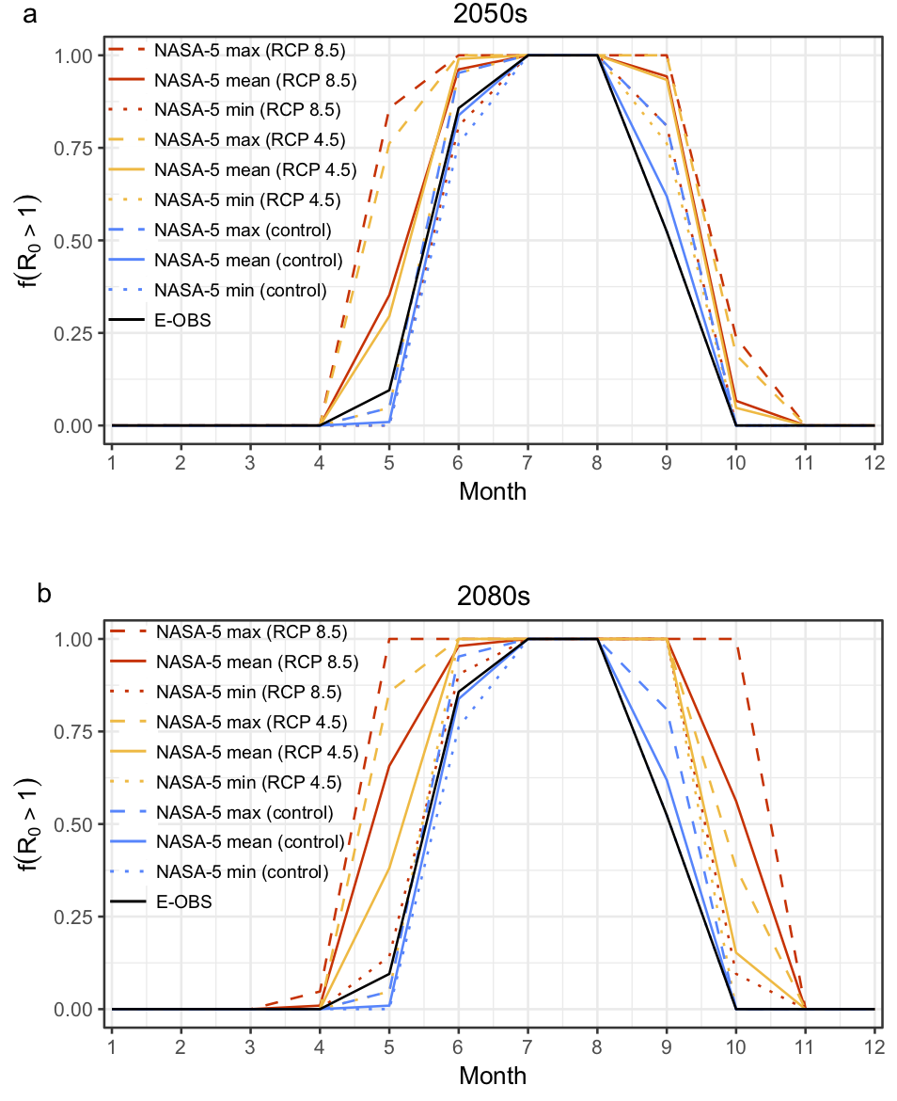
FIGURE 2
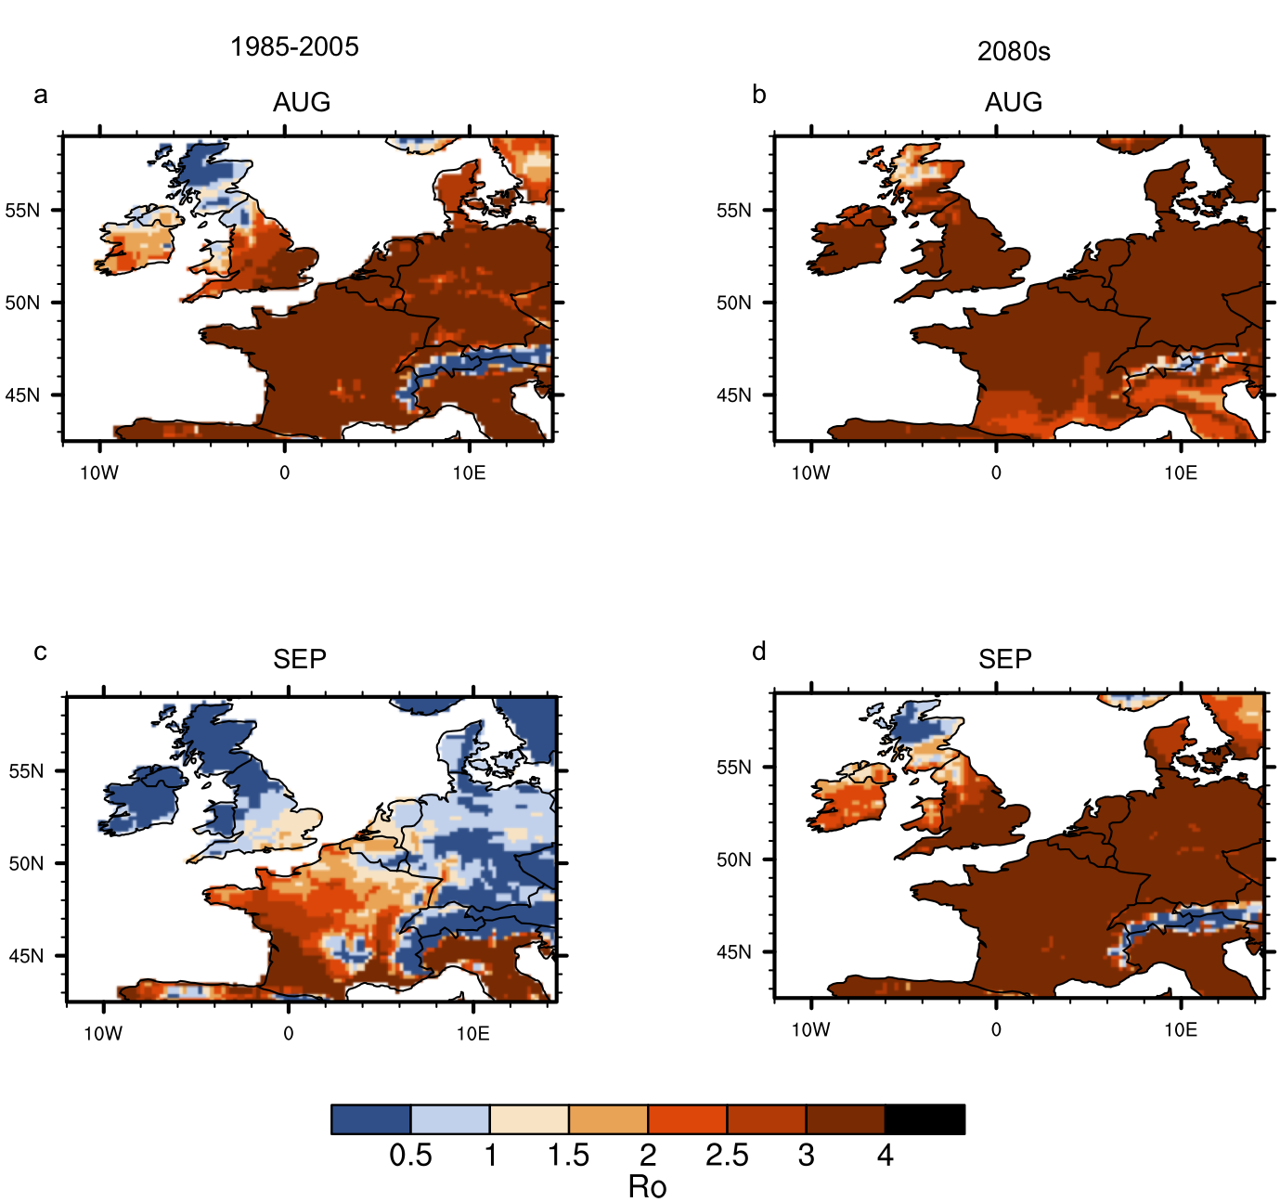

FIGURE 3
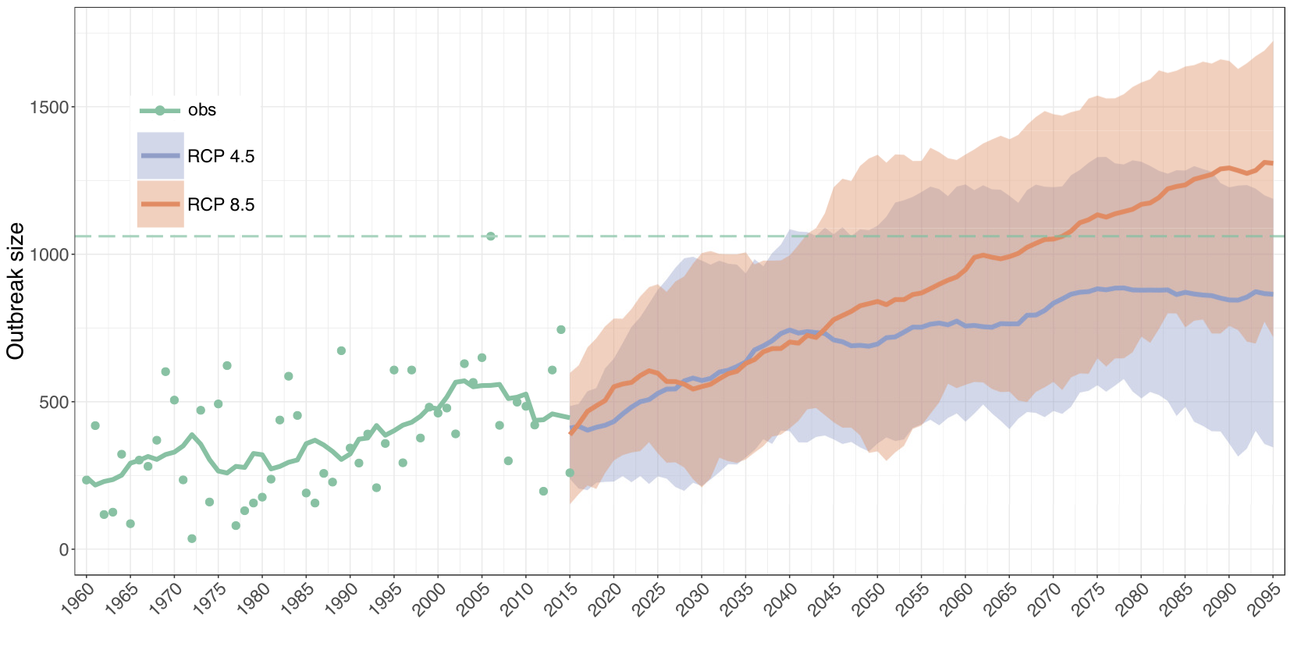

FIGURE 4
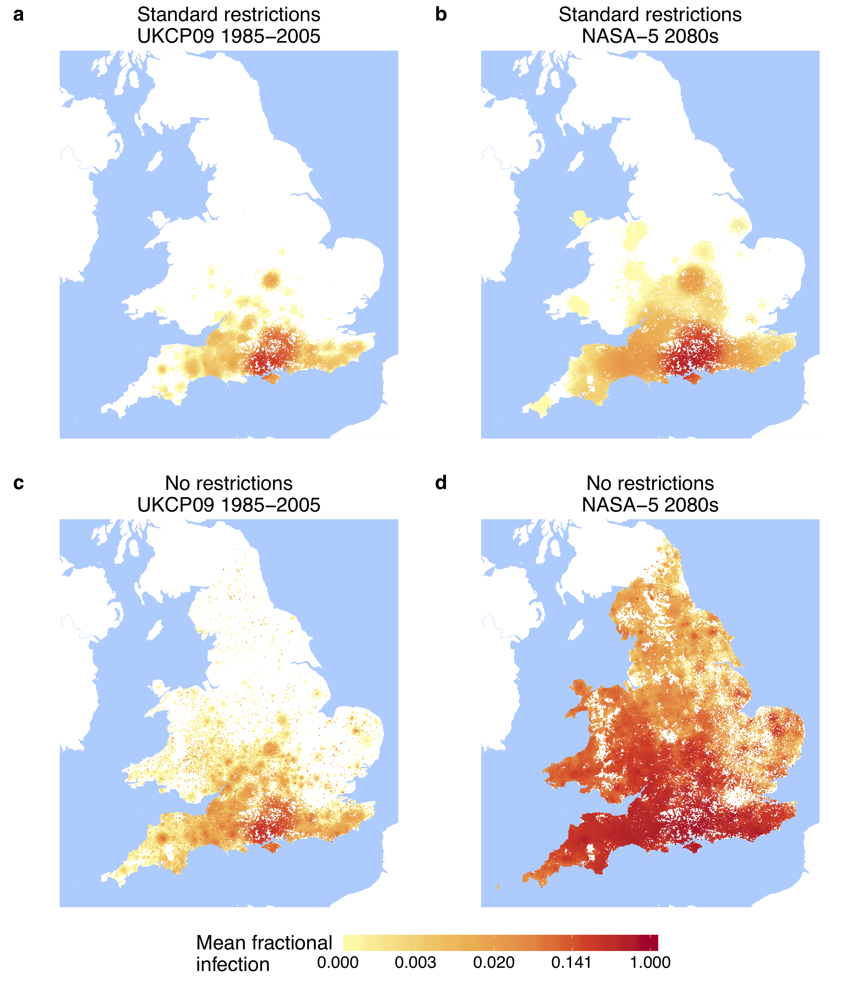

FIGURE 5
