Developing Consistent Molecular Dynamics Force Fields for Biological Chromophores via Force Matching
Kirsten Claridge, Alessandro Troisi*
Department of Chemistry, University of Liverpool, Liverpool L69 7ZD, U.K.
*E-mail: a.troisi@liverpool.ac.uk

Abstract
The role of environment in excitation energy transport in the pigment protein complexes (PPCs) of photosynthetic organisms is a widely investigated topic. The spectral density is a key component of understanding this protein-pigment interaction, however the typical approach for calculating spectral density, combining molecular dynamics (MD) with quantum chemistry (QC) calculations, suffers from the geometry mismatch problem, arising from the structural inconsistency between the forcefield (FF) and the QC calculation. Existing parameterisation methods demand much time consuming manual input, limiting the number of systems that can be studied. We present a method, utilising force matching for the auto-parameterisation of new pigment FFs for the use in spectral density calculations of PPCs and apply the method to 3 pigments. The use of these optimised FFs in spectral density computation results in a notable difference in comparison to the original FF.

1. Introduction
There is much interest in the pigment protein complexes (PPCs) of plants and photosynthetic bacteria due to their exceptionally high efficiency,¹ which is especially interesting when one considers that unlike other key ubiquitous biological components, their structural variability is very great. Additionally, experimental evidence from two-dimensional electronic spectroscopy (2D-ES) of long-lived coherence in the light harvesting Fenna-Matthews-Olson complex (FMO),^{2,3} and other PPCs^{4–7} has intensified the theoretical interest in such complexes. Whilst more recent evidence questions this discovery,⁸ the question of the role of environment in exciton energy transport (EET) in PPCs is still a widely discussed topic, as the protein-chromophore interaction is generally considered crucial in determining EET.^{9,10} The spectral density is the ideal quantity to study this interaction as it describes the frequency dependent system-bath coupling strength of the excitation of a chromophore contained in the protein. Numerous works have endeavoured to accurately compute the spectral densities of the chromophores of various PPCs,^{11–16} however most focus on only one or a couple of PPCs. To further develop the understanding of EET in PPCs, it would be beneficial to compute and compare the spectral density of many different PPCs. A typical approach to calculate the spectral density combines molecular dynamics (MD) methods with quantum chemistry (QC) calculations. In this method, the fluctuation of the excitation energy, , of chromophore i, along the MD trajectory is used to compute the classical correlation function,¹⁷ C_{i}, a subsequent Fourier transform of which gives the spectral density,:
.
It is obvious that in order to perform the MD, one must obtain forcefields (FFs) of the cofactors (chromophores, carotenoids, etc.) of the PPCs.
The need of FFs for new molecules is not a novel problem and much work has focused on the generation of FF parameters. A standard method to build a new FF is by analogy i.e. identifying analogous parameters from existing FFs. For the two of the most commonly used FFs, CHARMM¹⁸ and AMBER¹⁹, automated by analogy procedures have been developed, these are CGenFF²⁰ and GAFF²¹, respectively. The methods work in a similar fashion, utilising look-up tables and empirical rules to generate the new parameters. The results of both methods typically require further manual parameterisation before they can be implemented. Thus, further work has endeavoured to automate parameterisation in order to remove the need of manual adjustment and make the process easier and faster. For example, GAAMP²² utilises quantum mechanical (QM) data as reference to automatically produce parameters compatible with the CHARMM and AMBER FFs. Other work focuses on automatically parameterising force constants for the AMBER forcefield especially for transition metal complexes through the use of ab initio frequency calculations.²³ The JOYCE²⁴ procedure parameterises the intramolecular part of FF, using an iterative approach to fit to QM energies, gradients and the Hessian matrix, similarly the PICKY²⁵ procedure employs a least square fitting procedure to parameterise the intermolecular part, using QM energies. The QMDFF²⁶ constructs FFs from solely QM input also; utilising an equilibrium structure, Hessian matrix, atomic partial charges and the bond orders to generate specific, non-transferable FFs of molecules. The fitting of parameters to a flexible combination of theoretical and experimental data is possible with the ForceBalance²⁷ method, which automatically generates parameters through an iterative approach which minimises the difference between the FF parameters and target data. Recently this method was employed to improve the AMBER protein FF.²⁸ Other methods seek to simplify the parameterisation process, such as the FF Toolkit²⁹ which creates CHARMM compatible parameters from target QM data and the QuickFF³⁰ which employs a 3 step method to build parameters from ab initio data.
The previously discussed methods are general tools for developing new FFs as opposed to specially developed for spectral density calculations. FFs have also been generated with the specific use of spectral density calculations in mind. These methods also predominantly utilise QM calculations to produce target data, for example in the creation of FFs compatible with the popular AMBER FF for bacteriochlorophyll-a (bcl) (as well as other cofactors: methyl bacteriopheophytin-a and a ubiquinone derivative).³¹ Further work transformed these parameters to create a chlorophyll-a (chl-a) FF,³² compatible with another commonly used FF, CHARMM. Both these bcl and chl-a FFs have been utilised in several spectral density studies.^{12,33,34} However, other work has criticised the development of these parameters for lacking detailed validation against experimental structure data and so developed more validated parameters for the AMBER FF of the chromophores (and other cofactors) of the photosystem II (PSII) complex.³⁵ The resulting FFs of this work have also been used in the calculation of pigment spectral density.³⁶ However, multiple studies have shown the FF used for the chromophore(s) affects the resulting spectral density.^{13,37–40} An error appears due to the inconsistency between the equilibrium structures generated by the FF and those of the QC computation of the excitation energy, resulting in a spectral density which incorrectly describes the electronic-nuclear interaction. This problem is referred to as the geometry mismatch. In order to combat this problem, several FFs of carotenoids⁴¹ and an apocarotenoid FF⁴² have been created which reproduce well the QC structural properties. Although these FFs were found to reduce the geometry mismatch error, the parameterisation requires time consuming QC calculations and manual input, thus if one wishes to investigate a number of PPCs, containing different pigments, the effort and time required to develop such FFs is impractical. Another method to avoid the problem of the geometry mismatch was proposed by Lee and Coker,¹⁶ and later adopted by Padula et al⁴³ in which the quantum intramolecular vibrational modes are computed directly and the lower frequency intermolecular modes are incorporated through analytical electrostatic interactions. An alternative approach to allow the computation of multiple PPC spectral densities, would be to develop a method specifically aiming to produce FFs consistent with the QC part of the calculation for use in PPC spectral density studies.
We propose force matching as the ideal method to produce the desired consistency. The method was devised by Ercolessi and Adams for the development of interatomic potentials⁴⁴ and has since been applied to a range of systems, including developing interatomic potentials for Zr-Cu⁴⁵ and Mg,⁴⁶ flexible water model potentials,⁴⁷ creating FFs for semiconducting polymers,⁴⁸ generating free energy surfaces for chemical reactions⁴⁹ and most recently in the reparameterization of the single point charge water model.⁵⁰ Force matching has also been combined with combined Quantum Mechanics/Molecular mechanics (QM/MM) methods to create FFs for moieties/molecular fragments.⁵¹ Force matching is particularly advantageous in this case as FFs can be obtained which take the environment into account, additionally it effectively constrains towards chemically sensible parameters as unphysical parameters will lead to a high force. As previously discussed many methods of FF generation and/or parameterisation currently exist, which have been very powerful and useful in the development of FFs for the study of new molecules. However, their implementation predominantly uses QM calculations performed in vacuum or in continuum solvent. The protein scaffold is known to distort and influence the chromophore structure, thus such data may generate FFs that are not applicable to the realistic system. In this case, the difference in the forces resulting from the FF and the forces resulting from electronic structure (ES), of each atom in a collection of equilibrium structures, generated in the protein environment, are minimised by changing the intramolecular parameter values composing the FF. The aim of this work is to enable the generation of many FFs of biological chromophores embedded in a protein environment for use in spectral density calculations of PPCs.
2. Systems
2.1 Chromophores
As FMO is one of the most popular systems studied, the first new FF is for that of its chromophore: bacteriochlorophyll-a (bcl). In addition, FFs for the common chromophores chlorophyll-a (chl-a) and chlorophyll-b (chl-b) are developed, found in the water soluble chlorophyll-binding proteins (WSCPs). The structures of all the chromophores are shown in Figure 1. For each of these chromophores the FF is optimised for the bacteriochlorin/chlorin ring and immediate groups only (highlighted in red in Fig. 1), i.e. the phytyl chain and ester group are not included. This is because they are not involved in the conjugated system and so are often not included in the quantum calculation, thus it is not crucial that their geometry be consistent. This also reduces the computational demand.
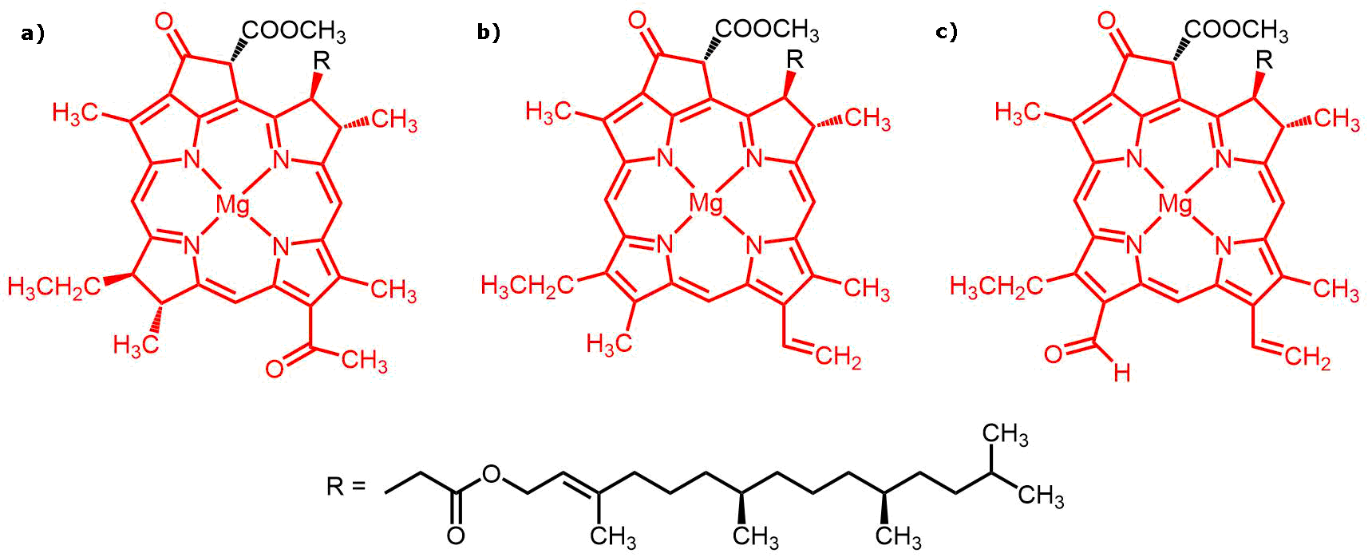
Figure 1: Structures of a) bcl b) chl-a and c) chl-b with portion of molecules for which FF is optimised highlighted in red.

2.2 Parameter Sets of Initial FFs
The general functional form of any FF is a sum of the potential energy of the non-bonded and the bonded interactions. The non-bonded component is the sum of the terms stemming from the van der Waals interactions and electrostatics, whilst the bonded component comprises terms from the bonds, angles and dihedrals. The parameters involved in these terms are defined for each type of atom in the FF. The exact forms of the functions describing these interactions and the values of the parameters included are dependent on the specific FF. In this case the FF used is the CHARMM FF. The functional form of which is:
where b denotes bond length, θ denotes bond angle size, and φ and ω denote dihedral and improper dihedral size respectively, u denotes the 1-3 atom distance of the Urey-Bradley component of angle bending from non-bonded interactions. The k_{X} parameters are force constants and X₀ parameters are equilibrium length/angle size. For the dihedral term, n is the multiplicity of the dihedral function and is the phase shift. The non-bonded term uses a standard 12-6 Lennard Jones potential for the van der Waals, where R_{min} corresponds to the point at which the potential crosses the x-axis and the electrostatic component is given by a Coulombic potential. Only the parameters of the intramolecular terms (bonds, angles, dihedrals and improper dihedrals) are optimised, as these have the greatest effect on the internal structure which is desired to be consistent. The multiplicity and phase shift of the dihedral term are pre-set as is equilibrium improper dihedral angle, and so these parameters are not changed in the optimisation. Meaning the overall parameter set to be optimised consists of: the bond; angle; dihedral angle; and improper dihedral angle force constants (k_{b}, , k_{φ} and , respectively) and the equilibrium bong length; and equilibrium bond angle (b₀ and , respectively), for each atom type.
The initial FF of bcl is taken from the by analogy FF created by CGenFF, whilst the chl-a and chl-b FFs are taken from literature ref. 52 and 53. The atom types assigned by these FFs are overly degenerate for the desired purpose, i.e. atoms are given the same atom type and so treated as ‘structurally similar’ when their internal electronic structure is different. In order to rectify this, new atom types must be assigned. The first step to achieve this is to quantitatively define what is ‘structurally similar’. The base framework of the chromophores consists of carbon, as with all organic molecules, and so comparing the lengths of standard C – C single bonds (~ 1.54 Å), double bonds (~ 1.35 Å) and conjugated bonds (~ 1.40 Å) shows significant differences in bonding structure are those of 0.05 Å and greater. Using this as a guide, an estimate of ‘structurally similar’ bond lengths can be defined as those within 0.01 Å of one another, whilst bond lengths with a difference of 0.03 Å or more are ‘structurally different’ and those lying between 0.01 Å and 0.03 Å must be considered further. Additionally, the chemistry of the atom can be considered, i.e. what bond type is it involved in e.g. C – O, C – N, C – C, and so on. Finally, any matching bond types within the 0.01 Å – 0.03 Å region can be categorised based on their bond angles. An example of this assignment, for bcl, is shown in Fig. 2. After this assignment was done, the total number of parameters to be optimised for each chromophore were as follows: bcl – 399 parameters; chl-a – 446 parameters; chl-b – 455 parameters. The atom type definition and parameter set for each pigment are provided in the Supporting Information.
Finally, it is important that the electrostatics are consistent with the rest of the FF. The partial charges for the CHARMM FF are determined using minimum HF water interaction energies and distances as target data as described in the supporting information of ref. 18. The charges for the chromophores were taken from literature.³⁶ It should be noted that whilst in this work the parameters of a CHARMM FF are optimised, the method can be applied to any molecular mechanics FF.
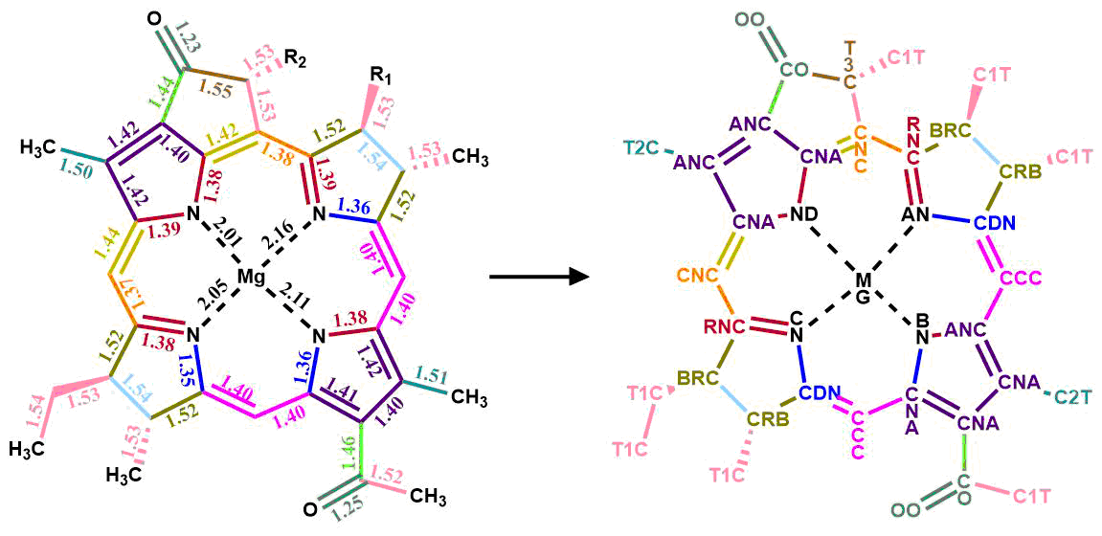
Figure 2: Colour coded illustration of assignment of atom type based on structure depicting the bond lengths (taken from a geometry optimisation of bcl) and the resulting atom type.
3. Method
3.1 Force Matching Procedure
The FF is optimised by minimising an objective function. For the FF of a molecule comprised of a set of parameters, [p], the objective function is given by:
where N is the number of atoms in the molecule, M is the number of reference structures and denotes the forces on atom i of structure j from DFT or MD. Gradient descent minimisation is based on the observation that from a point, r, of a function, f(r), the function will decrease fastest moving from r in the direction of the negative gradient of the function, ∇f(r). In other words, to minimise a function, one follows:
where α is a scaling factor to determine the step size of the descent. Previous work utilising force matching with a Monte Carlo optimisation showed that the objective function is convex without secondary minima⁴⁸ thus a gradient descent method is appropriate.
To calculate the descent direction of the FF parameter set, the gradient, G_{i}, of the objective function for each parameter, p_{i}, must be obtained numerically:
Then each parameter is changed using the negative of its gradient:
to create a new parameter set. The process continues until the objective function is minimised and the FF is considered optimised. In principle, one could use this new FF to generate new structures and iterate the process, however previous work⁴⁹ has shown the majority of improvement (93 – 96 %) is achieved in the first iteration and so no iteration is implemented here.
3.2 Computational details
3.2.1. Initial geometries
Structures of the chromophores were obtained from MD simulations of the chromophore in its protein environment, solvated by water. Utilising structures from the chromophores embedded in their environment removes the necessity to iteratively improve the FF as described in similar work⁴⁸, as the protein constrains the geometries. The proteins used were FMO, the water-soluble chlorophyll-a binding (WSCP-a) protein and water-soluble chlorophyll-b binding (WSCP-b) protein for bcl, chl-a and chl-b, respectively. Exploring geometries in the protein environment as opposed to in vacuum is important for FFs to be used in the study of PPCs, as the environment distorts the chromophore geometry. All MD was carried out using GROMACS 5.0.5 software.⁵⁴
The initial structures for FMO, WSCP-a and WSCP-b were taken from the Protein Data Bank, PDB: 3BSD and 5HPZ (used for both WSCPs), respectively. The missing residues of WSCP were built with the CHARMM-GUI website.⁵⁵ In FMO there are 4 bcls for which the Mg atom coordinates to a histidine residue (HIS). These were assigned a protonation state to allow this coordination, all other HIS residues were assigned protonation in position ε. The FF description of Mg coordination is well known to be difficult to determine. In this case we assume their treatment in the initial FF is valid. Axial coordination to the Mg atom of chromophores affects their spectroscopic properties^{56,57}. The rest of the residues in all the proteins were assigned their standard protonation state. For all proteins, the CHARMM36 FF and TIP3P⁵⁸ water model were used. The systems were solvated with water in a cubic box with edge length of 120 Å and 110 Å for FMO and the WSCPs, respectively. After a steepest-descent energy minimisation, a 200 ps NVT equilibration (300 K; Berendsen thermostat⁵⁹; τ_{T} = 0.1 ps) was run, followed by 200 ps NPT equilibration (1 bar; Berendsen barostat⁵⁹; τ_{P} = 0.1 ps), using a 2 fs integration step and constraining all bonds between hydrogen and other elements using LINCS.⁶⁰ Note that such bonds involving hydrogen have only a marginal effect on the excited states of the chromophores. A subsequent 10 ns of dynamics was run. The structures for the chromophores were then taken every 500 fs from a final 80 ps run (NVT ensemble). Each protein contains multiple chromophores; thus the structures were taken cycling through each chromophore, i.e. the first bcl structure was taken as bcl 1, the second as bcl 2, etc. for each structure.
3.2.2. Reference force calculation
The reference forces were calculated with density function theory (DFT) using the B3LYP functional and 6-311G* basis set with Gaussian 03. The forces (both DFT and MD) were computed in vacuum in order to preserve separation between the intramolecular and intermolecular part of the FF. As noted before for the type of FF used, the reference force calculation can be computed with any functional or basis set desired.
3.2.3. Minimisation Procedure
The procedure is as follows: the initial objective function, O([p^{initial}]), is calculated as given in equation (4), then for each parameter, p_{i}, of the set, the corresponding gradient, G_{i}, is computed as in equation (6), where the value of Δp_{i} is taken as 0.001% of the parameter. A new parameter set, [p^{new}], is then generated, by updating each parameter as described in equation (7), and its objective function computed, O([p^{new}]). The minimisation is considered complete once the decrease in the objective function, ΔO([p]), is consistently less than 0.01 kcal mol⁻¹ Å⁻¹.
As each parameter set consists of 100s of parameters, calculating each gradient numerically is time consuming. To circumvent this bottleneck, in the implementation of the algorithm the gradients are only recalculated if the objective function increases, i.e. if, otherwise the minimisation continues using the same set of gradients. In addition, the 5 parameter types: b₀, θ₀, k_{φ}, k_{b} k_{θ}; each affect the forces to a different magnitude, leading to gradients of differing magnitudes. The order of their affect, in the case of chromophores, is:
The b₀ parameters have a significantly greater effect on the forces and thus a much greater gradient. For a multi-variable function where one variable has a significantly greater gradient, the gradient descent method will rapidly minimise the function with respect to that variable and then the minimisation will progress exceedingly slowly. Thus, to avoid this slow down, the b₀ parameters are optimised separately first. Once decrease in the objective function is less than 0.0024 kcal mol⁻¹ Å⁻¹ this is considered complete. For the same reason , once the θ₀ parameters are optimised α is increased; once all their gradients are less than 0.5 degrees⁻¹ α is increased by a factor of 250. Furthermore, to reduce the objective function before the minimisation procedure, the b₀ and θ₀ parameters were set to those of the DFT optimised structure performed at the same level as the reference structure calculations.
3.2.4. Spectral Densities
The correlation functions were calculated according to eq. 1 (implemented as detailed in ref. 61). A subsequent Fourier transforms in the 0 ≤ t ≤ 16 ps range was used to obtain the spectral densities (equation 2). For each protein system, MD trajectories were obtained utilising the original FF and the optimised FF of the chromophore. The initial protein setup, energy minimisation and equilibration steps were performed as in Initial Geometries. A further 25 ns of dynamics (NVT) was run (with the same constrains on X-H bonds imposed using LINCS⁶⁰) The excitation energies for the spectral densities were computed from snapshots taken every 2 fs from the last 16 ps of this MD trajectory, using a QM/MM scheme within TDDFT linear response theory,⁶² performed using the QChem 4.2 software.⁶³ The MM part comprised all residues within a 35 Å radius of the pigment; included additively as point charges that affect the QM system. B3LYP⁶⁴/3-21G* was used for the QM part, which was reduced through the insertion of a link atom between carbon atoms 1 and 2 of the phytyl chain. The 3-21G* basis set was used to reduce computational time as it has been found (Fig. S2 in ref. 65) that there is good correlation between 6-31G* and 3-21G* for these systems. 4 roots were computed but only the lowest was considered. This is a standard approach similar to those used in refs. 66 and 67. As each of the proteins contains multiple pigments one pigment was arbitrarily selected from each, for the computation of the spectral density; these were: bcl 4, chl-a 2 and chl-b 2.
4. Results
The FFs were considered optimised to a local minimum once the change in objective function was less
than 0.01 kcal mol⁻¹ Å⁻¹ for 50 steps or more. The initial and resultant values of the objective functions are shown in Table 1 along with the overall change and the total number of steps of the algorithm. Interestingly, the parameters of the chls, taken from literature have greater initial objective functions than the bcl generated by analogy using CGenFF. This is surprising as even for traditional uses of MD, the automatically generated by-analogy FFs require further parameterisation before use and thus the literature values would be expected to be superior. The average of the final objective functions is 21.84 kcal mol⁻¹ Å⁻¹ indicating a minimum of a roughly similar value for all. In comparison to similar methods the final values are slightly worse (larger by a factor of 3-4) however they are within the same range as the mismatch observed between forces of different electronic structure calculations.⁴⁸
Table 1: Initial and final objective function, total decrease and the number of steps of the optimisation, for each pigment.
Chromophore | Initial O([p]) /kcal mol⁻¹ Å⁻¹ | Final O([p]) /kcal mol⁻¹ Å⁻¹ | Number of steps
bcl | 33.01 | 22.31 | 6919
chl-a | 40.49 | 21.49 | 5289
chl-b | 41.13 | 21.73 | 6694
Visualising the average error in force on each atom before and after optimisation, illustrates the improvement of the FF. The average error in force on each atom, Δf_{i}, is defined as:
This is depicted in Fig. 3 for each of the pigments. This visualisation provides further information than the final objective function alone; considering bcl and chl-a, it is clear the remaining error measured by the objective function is caused by a few atoms which still have a large error whilst the rest are well optimised. In contrast, for chl-b the remaining error is spread more evenly over the total molecule,
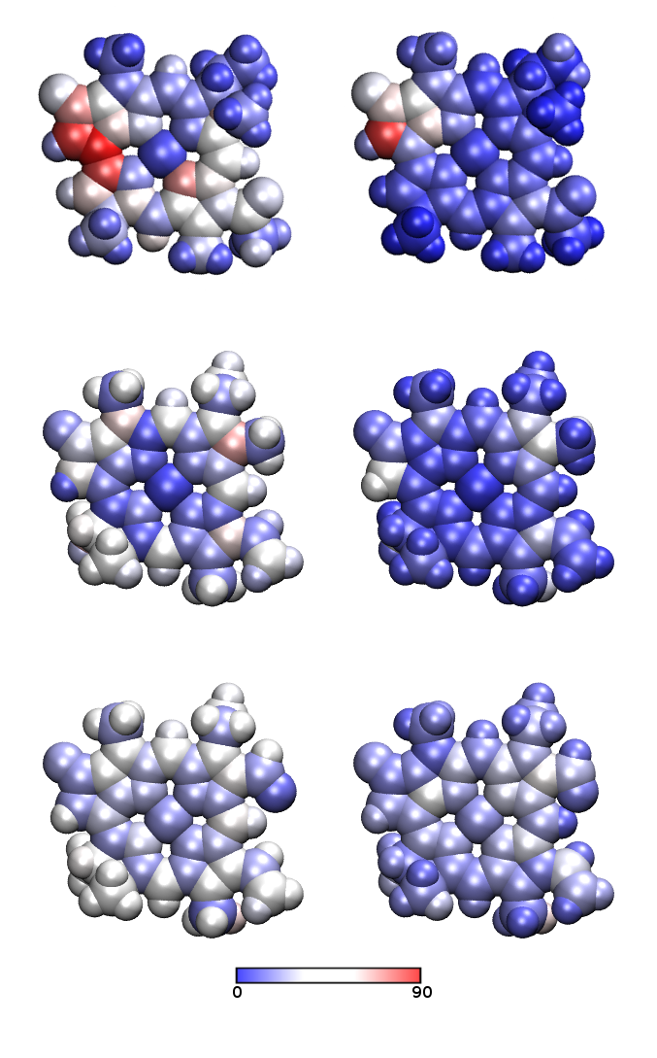
Figure 3: The atomic force error (in kcal mol⁻¹ Å⁻¹) before (left) and after (right) optimisation for bcl (top), chl-a (middle) and chl-b (bottom).
indicating some further optimisation may be required. Thus, visualisation of the average force error per atom is recommended to ensure full optimisation. For bcl and chl-a, the atoms where the force error remains large is likely the result of a poor atom type assignment. If an atom is assigned unsuitably, i.e. equivalent to another atom when it is in fact different, assigning parameter values that describe both atoms in the structure well is problematic. The result is either parameters describing one atom well and the other poorly or describing both poorly, and thus the error in the force(s) on the atom(s) will be greater. This observation provides potential routes of improvement for the algorithm. A process periodically calculating the average error per atom could be added to identify when the overall error is being caused by only a few atoms and then reassign these atom types. Additionally, a procedure could be developed to automatically assign atom types based on bond and angle types and sizes from the optimised structure to prevent any human error in atom type assignment.
Examining the final average error in force for each atom of bcl, it is evident there is one atom with a notably large error and three to four others also with a smaller but still significant error. In Fig. 4 the values of the average error in forces are shown and those with are highlighted (atom numbers 56, 57, 62, 64); we can see these are the same atoms with notably high force after optimisation as in Fig. 3. Further optimisation after reassigning the atom types of these atoms lead to a decrease of 1.5 kcal mol⁻¹ Å⁻¹ of the objective function. This example also clarifies that the main origin of the residual mismatch between empirical and ab initio force is the functional form of the empirical potential, unable to capture all the details of the electronic structure calculations.
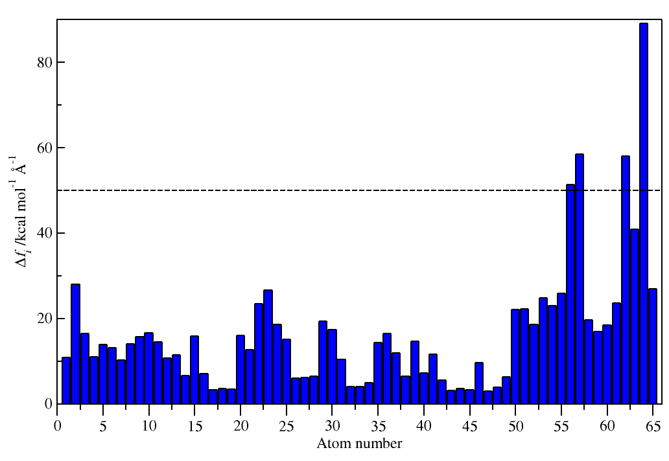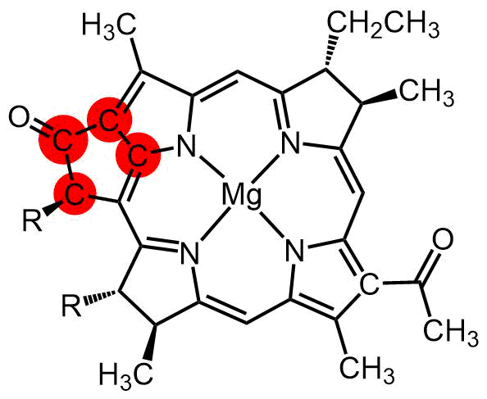
Figure 4: Left: Δf_{i} values for atoms in bcl. Right: bcl structure with atoms with Δf_{i} > 50 kcal⁻¹ Å⁻¹ highlighted in red.
To understand the structural change between the original and optimised FFs the change in the b₀ parameter can be examined. Furthermore, as the electronic properties of a molecule are highly dependent on its internal structure, such changes will give an indication of how deficient the original FF is in describing the molecular structure. Firstly, considering the bond length change defined as ‘structurally different’ previously in this paper (> 0.03 Å), the equilibrium bond parameters with a change of greater than 0.03 Å were identified. Next, changes in the bonding structure were determined by considering the typical bond lengths for C – C and C – N bonding structures (noted in Table 2). These results are summarised in Fig. 5, which contains tables for each pigment of the initial by-analogy value (i.e. before they were set equal to those of the optimised structure), b^{i}, final value, b^{f}, and the overall change, b^{change}, of the equilibrium bond length, as well as a depiction of all the bonds in the pigment these atom types correspond to. The bonds with a change greater than 0.03 Å are highlighted in orange and those with a change in bonding structure are highlighted in red. In majority of the b₀ changes in the bcl FF are decreases, conversely the chl-b optimised FF predominantly results in increases in bond lengths and chl-a has a more even combination of increases and decreases. This indicates there is no pattern of over- or under- estimation of bond lengths by the original FFs in comparison to the ES. The greatest number of changes, as well as the changes with greatest magnitude occur in the bcl FF. Contrary to the observation of higher initial objective functions for the chls, this is anticipated as the chl FFs from literature would be expected to have a somewhat better structural consistency than the purely by-analogy FF of bcl.
Table 2: The typical bond lengths of different bonding structures for C – C and C – N bonds.
Bond | Single /Å | Conjugated /Å | Double /Å
C – C | 1.54 | 1.40 | 1.35
C – N | 1.47 | 1.34 | 1.25
To briefly illustrate the possible effects of this revised force field on the exciton physics, the spectral densities of each pigment were computed with the original and optimised FFs as outlined in the methods section. The results are depicted in Fig. 6. It has previously been shown that the existence of an intramolecular vibrational mode that is quasi-resonant with transition energy increases transport efficiency in PPCs, through vibronic coupling.⁶⁸ As these optimised FFs generate more consistent structures, the differences in the high frequency part of the spectral density become especially important as they may correspond to intramolecular vibrations capable of improving transport efficiency through vibronic coupling. Whilst other work has shown that no such vibrations are present in FMO,⁴³ a quasi-resonant vibration has been found in the phycoerythrin PPC: PE545.⁶⁹ Thus, for PPCs for which it is unknown if an intramolecular vibration capable of vibronic enhancement exists, the differences due to the optimised FF, particularly in the high frequency (> 500 cm⁻¹) region, are especially important. From the spectral density the reorganisation energy, λ, can be calculated via:
For each pigment these are reported in Table 3, for the original FF, λ_{original}, and optimised FF, λ_{optimised}. The reorganisation energy is often used as a measure of the ‘total strength’ of the pigment-protein interaction; the reorganisation energies of all 3 pigments are lower with the optimised FF, suggesting
Bcl |  |  |  |  |  |  | 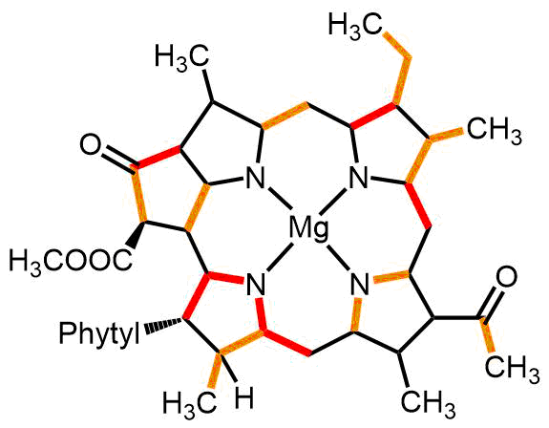
Parameter | /Å |  | /Å |  | /Å
C – C bonds
CNR CRB | 1.54 |  | 1.46 |  | -0.08
CDN CCC | 1.42 |  | 1.35 |  | -0.07
CNA CO | 1.44 |  | 1.50 |  | 0.06
CRB C1T | 1.55 |  | 1.51 |  | -0.04
CNC C3T | 1.42 |  | 1.38 |  | -0.04
CC C1T | 1.54 |  | 1.50 |  | -0.04
CNA CNC | 1.41 |  | 1.37 |  | -0.04
CO C3T | 1.54 |  | 1.50 |  | -0.04
CRB CDN | 1.51 |  | 1.47 |  | -0.04
C1T C1T | 1.54 |  | 1.51 |  | -0.03
C – N bonds
NA CNR | 1.44 |  | 1.33 |  | -0.11
NA CDN | 1.39 |  | 1.31 |  | -0.08
NB CNA | 1.30 |  | 1.35 |  | 0.05
 |  |  |  |  |  |  | 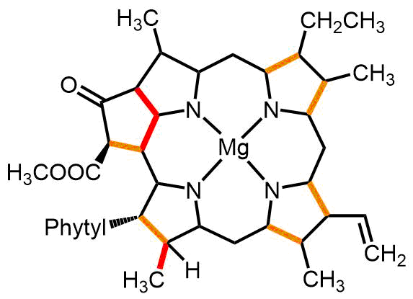
Chl-a
Parameter | /Å |  | /Å |  | /Å
C – C bonds
CPM2 CPA3 | 1.40 |  | 1.46 |  | 0.06
CPBN CPA3 | 1.40 |  | 1.45 |  | 0.05
CT2N CTN | 1.53 |  | 1.48 |  | -0.05
CT2N CT2N | 1.54 |  | 1.58 |  | 0.04
CTN CPM2 | 1.53 |  | 1.49 |  | -0.04
CPAN CPBN | 1.40 |  | 1.43 |  | 0.03
Chl-b |  |  |  |  |  |  |  | 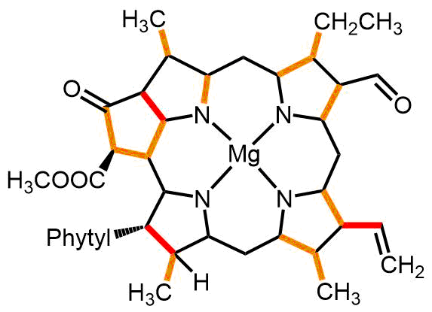
Parameter |  | /Å |  | /Å |  | /Å
C – C bonds
CT2N CT2N |  | 1.54 |  | 1.61 |  | 0.07
CN CPBN |  | 1.49 |  | 1.54 |  | 0.05
CPBN CPA3 |  | 1.40 |  | 1.45 |  | 0.05
C2 CTN |  | 1.58 |  | 1.62 |  | 0.04
CPM2 CPA3 |  | 1.40 |  | 1.44 |  | 0.04
CT2N CTN |  | 1.53 |  | 1.49 |  | -0.04
CPBN CPAN |  | 1.40 |  | 1.44 |  | 0.04
CTN CPM2 |  | 1.53 |  | 1.49 |  | -0.04
CTR CPBN |  | 1.50 |  | 1.53 |  | 0.03
CPBN CPA2 |  | 1.41 |  | 1.44 |  | 0.03
Figure 5: Tables of b₀ details for each pigment containing: the atom types of the bond; initial by-analogy value, b^{i}; final value, b^{f}; and the overall change, b^{change}, for bond types with b^{change} ≥ 0.03 Å. The corresponding bonds are highlighted in the pigment structure, in red for change in bonding structure and orange for a structural change. Note as some atoms have degenerate types, multiple bonds may be described by the same parameter hence the number of bonds in the tables and number of bonds highlighted is not equivalent.

the original FFs may systematically overestimate the value of λ and thus the strength of the pigment-protein interaction, further supporting the need to develop consistent FFs.
Table 3: Reorganisation energy computed from the spectral density with the original FF, λ_{original}, and optimised FF, λ_{optimised}.
Chromophore | λ_{original} /cm⁻¹ | λ_{optimised} /cm⁻¹
bcl 4 | 9 | 5
chl-a 2 | 59 | 44
chl-b 2 | 262 | 86
As the variance of the excitation energy is related to the integral of the spectral density, we illustrate the difference between the original and optimised FFs by computing the average of the excitation energy, E_{avg}, of a chromophore from each system (the same chromophore as used in the spectral density computation) and the fluctuation of the excitation energy, σ_{exc}, along a long MD trajectory (100 ns). The initial set up of the MD was as outlined in the Computational Details section describing the initial structure generation. The excitation energy was then computed along the trajectory every 500 ps, using the same method and functional/basis set combination as outlined for the excited state calculations of the spectral density. The results are summarised in Table 4. Bcl and chl-b both have notable changes in the average energy, with bcl 4 having a smaller average excitation energy by 0.07 eV and chl-b having a greater average excitation energy by 0.08 eV. The difference between the averages resulting from the 2 FFs of chl-a is much less, only 0.02 eV but the variance is notably reduced. The energy distributions of the excitation energies of each chromophore over the 100 ns are depicted in Figure 7. As one would expect the energy distributions to fit a normal distribution, Gaussian distributions have been fit to each (using E_{avg} and σ_{exc} from Table 4 as μ and σ respectively). This data demonstrates the magnitude of the affect that the FF has on the resultant spectral density.
Table 4: Average excitation energy, E_{avg}, and its fluctuation, σ_{exc}, for each bcl 4, chl-a 2 and chl-b, computed over 100 ns using the original FF and optimised FF.
Chromophore | FF | E_{avg} /eV | σ_{exc}
Bcl 4 from FMO | Original | 1.94 | 0.02
 | Optimised | 1.87 | 0.05
Chl-a 2 from WSCP-a | Original | 2.08 | 0.07
 | Optimised | 2.06 | 0.04
Chl-a 2 from WSCP-b | Original | 1.96 | 0.08
 | Optimised | 2.04 | 0.06

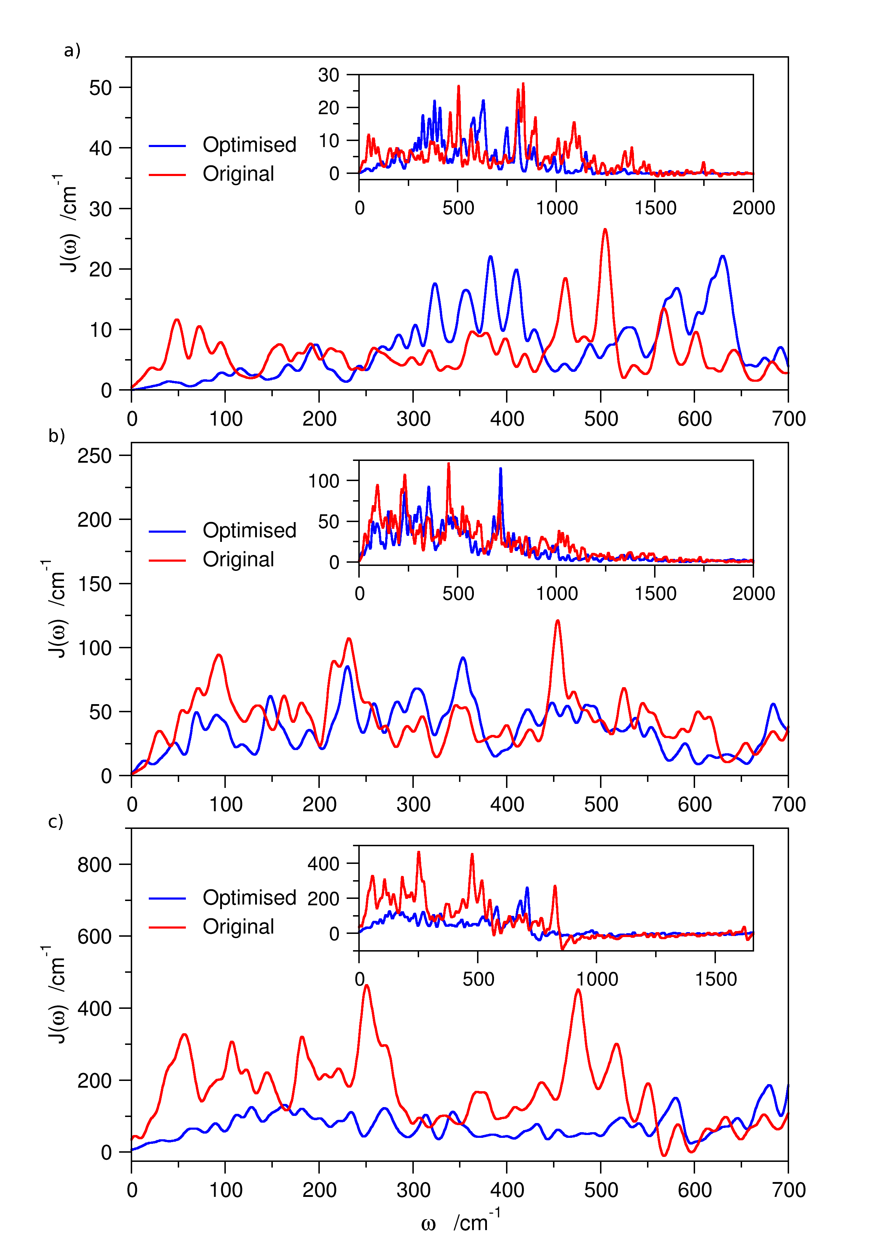
Figure 6: Spectral densities computed using the original FF (red line) and optimised FF (blue line) for the 3 chromophores: a) bcl 4, b) chl-a 2, c) chl-b 2
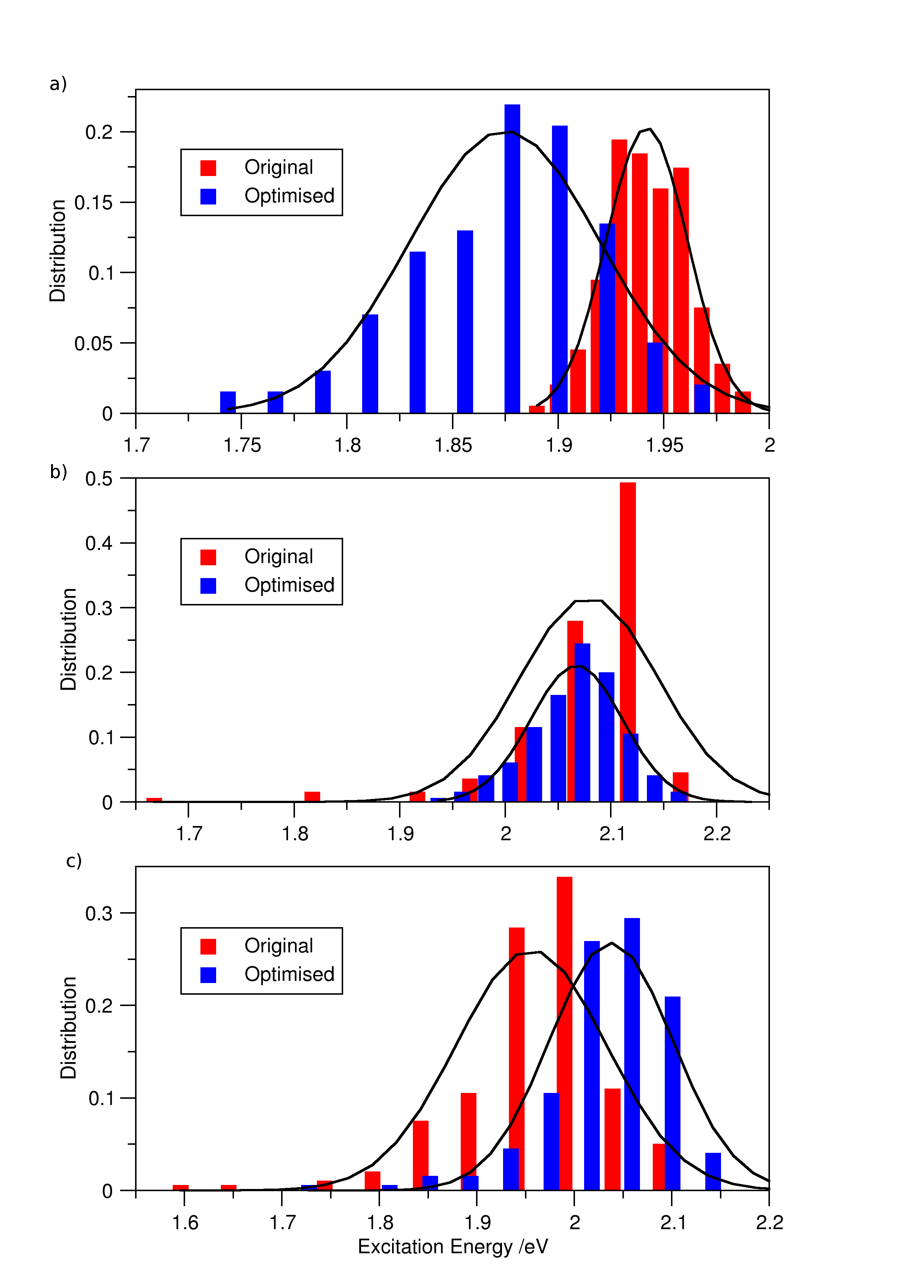
Figure 7: Excitation energy distributions of the original (red bars) and optimised (blue bars) FF over 100 ns run with their fitted normal distribution (black lines) for a) bcl 4 of FMO, b) chl-a 2 of WSCP-a and c) chl-b 2 of WSCP-b.

5. Conclusions
We have presented a new method to for the parameterisation of chromophore (and other pigment/cofactor) FFs for use in applications where the MD trajectory is followed by quantum chemical calculations on selected snapshots. The method insures that the empirical FF is consistent with the quantum chemical method of choice. We consider here the calculation of the spectral density relevant for electronic energy transfer in three different proteins containing three chromophores: bcl, chl-a and chl-b. This force matching method benefits from its automatic nature: once the initial FF is generated and both sets of forces are computed it requires no further manual input unlike other parameterisation methods, allowing the efficient generation of multiple FFs and therefore the study of multiple PPCs. The implementation of the algorithm could be improved by utilising a central difference in the gradient calculation to reduce errors and using a quadratically convergent second order optimisation method such as a Newton-CG method to reduce the required number of iterations. A further improvement could be the use of analytical gradients, deemed not necessary in this case where the computation was limited by the quantum chemical part, but useful is one is interested in the automatic parametrization of a large number of systems. The method is tuneable, applicable to both different molecular mechanics FFs and QC functionals, enabling the study of a range of PPCs with any desired MD and QC combination. We showed that it is possible, within the methodology, to verify whether the parametrization of the force field is sufficiently accurate or new atom types ought to be defined.
The spectral densities obtained from the optimized FF have been compared with those obtained from the original force field demonstrating the important changes introduced by improving the force field aligning it as much as possible with the quantum chemical component of the calculation. A step forward could be considered the calculation of the spectral density entirely from an ab initio QM/MM trajectory, an attempt that has been made very recently⁷⁰ (for different pigments in a different PPC). However, according to the authors, the calculations took an exceptional amount of time and computer power (roughly 9 months and 2 million CPU hours for just 50 ps long trajectory), thus such a method is still too expensive for efficient computation of multiple spectral densities, with additional concerns on the lack of proper equilibration in such short simulation time. As the most statistically meaningful comparisons are performed on very long trajectories, we used the latter to show that the reorganisation energies computed from the optimized FF are consistently lower than the original FFs. The observed differences in the high frequency region of the spectral density are potentially important to correctly identify the presence (or lack of) intramolecular vibrational modes capable of vibronic enhancement. In fact, intramolecular modes are the only one likely able to specifically couple with the electron energy transfer since recent work has shown the un-specificity of the local protein environment surrounding a pigment.⁶⁵
6. Supporting Information
Structures of chromophores with atom labels and tables of optimised parameter values.
7. Acknowledgements
This work was supported by the ERC through Grant No. 615834. We thank Dr. Daniele Padula for his assistance with the spectral density calculations.

8. References
(1) Blankenship, R. E. Molecular Mechanisms of Photosynthesis; Blackwell Science Ltd: Oxford, UK, 2002.
(2) Engel, G. S.; Calhoun, T. R.; Read, E. L.; Ahn, T.-K.; Mančal, T.; Cheng, Y.-C.; Blankenship, R. E.; Fleming, G. R. Evidence for Wavelike Energy Transfer through Quantum Coherence in Photosynthetic Systems. Nature 2007, 446, 782–786.
(3) Panitchayangkoon, G.; Hayes, D.; Fransted, K. A.; Caram, J. R.; Harel, E.; Wen, J.; Blankenship, R. E.; Engel, G. S. Long-Lived Quantum Coherence in Photosynthetic Complexes at Physiological Temperature. Proc. Natl. Acad. Sci. U. S. A. 2010, 107, 12766–12770.
(4) Collini, E.; Wong, C. Y.; Wilk, K. E.; Curmi, P. M. G.; Brumer, P.; Scholes, G. D. Coherently Wired Light-Harvesting in Photosynthetic Marine Algae at Ambient Temperature. Nature 2010, 463, 644–647.
(5) Wong, C. Y.; Alvey, R. M.; Turner, D. B.; Wilk, K. E.; Bryant, D. A.; Curmi, P. M. G.; Silbey, R. J.; Scholes, G. D. Electronic Coherence Lineshapes Reveal Hidden Excitonic Correlations in Photosynthetic Light Harvesting. Nat. Chem. 2012, 4, 396–404.
(6) Calhoun, T. R.; Ginsberg, N. S.; Schlau-Cohen, G. S.; Cheng, Y.-C.; Ballottari, M.; Bassi, R.; Fleming, G. R. Quantum Coherence Enabled Determination of the Energy Landscape in Light-Harvesting Complex II. J. Phys. Chem. B 2009, 113, 16291–16295.
(7) Harel, E.; Engel, G. S. Quantum Coherence Spectroscopy Reveals Complex Dynamics in Bacterial Light-Harvesting Complex 2 (LH2). Proc. Natl. Acad. Sci. U. S. A. 2012, 109, 706–711.
(8) Duan, H.-G.; Prokhorenko, V. I.; Cogdell, R. J.; Ashraf, K.; Stevens, A. L.; Thorwart, M.; Miller, R. J. D. Nature Does Not Rely on Long-Lived Electronic Quantum Coherence for Photosynthetic Energy Transfer. Proc. Natl. Acad. Sci. 2017, 114, 8493–8498.
(9) Chenu, A.; Scholes, G. D. Coherence in Energy Transfer and Photosynthesis. Annu. Rev. Phys. Chem. 2015, 66, 69–96.
(10) Curutchet, C.; Mennucci, B. Quantum Chemical Studies of Light Harvesting. Chem. Rev. 2017, 117, 294–343.
(11) Adolphs, J.; Renger, T. How Proteins Trigger Excitation Energy Transfer in the FMO Complex of Green Sulfur Bacteria. Biophys. J. 2006, 91, 2778–2797.
(12) Shim, S.; Rebentrost, P.; Valleau, S.; Aspuru-Guzik, A. Atomistic Study of the Long-Lived Quantum Coherences in the Fenna-Matthews-Olson Complex. Biophys. J. 2012, 102, 649–660.
(13) Renger, T.; Klinger, A.; Steinecker, F.; Schmidt am Busch, M.; Numata, J.; Müh, F. Normal Mode Analysis of the Spectral Density of the Fenna–Matthews–Olson Light-Harvesting Protein: How the Protein Dissipates the Excess Energy of Excitons. J. Phys. Chem. B 2012, 116, 14565–14580.
(14) Olbrich, C.; Strümpfer, J.; Schulten, K.; Kleinekathöfer, U. Theory and Simulation of the Environmental Effects on FMO Electronic Transitions. J. Phys. Chem. Lett. 2011, 2, 1771–1776.
(15) Olbrich, C.; Kleinekathöfer, U. Time-Dependent Atomistic View on the Electronic Relaxation in Light-Harvesting System II. J. Phys. Chem. B 2010, 114, 12427–12437.
(16) Lee, M. K.; Coker, D. F. Modeling Electronic-Nuclear Interactions for Excitation Energy Transfer Processes in Light-Harvesting Complexes. J. Phys. Chem. Lett. 2016, 7, 3171–3178.
(17) Valleau, S.; Eisfeld, A.; Aspuru-Guzik, A. On the Alternatives for Bath Correlators and Spectral Densities from Mixed Quantum-Classical Simulations. J. Chem. Phys. 2012, 137, 224103.
(18) Mackerell, A. D.; Brooks, B.; Brooks III, C. L.; Nilsson, L.; Roux, B.; Won, Y.; Karplus, M. Encyclopedia of Computational Chemistry; 1998.
(19) Ponder, J. W.; Case, D. A. Force Fields for Protein Simulations. Adv. Protein Chem. 2003, 66, 27–85.
(20) Vanommeslaeghe, K.; Hatcher, E.; Acharya, C.; Kundu, S.; Zhong, S.; Shim, J.; Darian, E.; Guvench, O.; Lopes, P.; Vorobyov, I.; et al. CHARMM General Force Field: A Force Field for Drug-like Molecules Compatible with the CHARMM All-Atom Additive Biological Force Fields. J. Comput. Chem. 2009, 31, NA-NA.
(21) Wang, J.; Wolf, R. M.; Caldwell, J. W.; Kollman, P. A.; Case, D. A. Development and Testing of a General Amber Force Field. J. Comput. Chem. 2004, 25, 1157–1174.
(22) Huang, L.; Roux, B. Automated Force Field Parameterization for Nonpolarizable and Polarizable Atomic Models Based on Ab Initio Target Data. J. Chem. Theory Comput. 2013, 9, 3543–3556.
(23) Burger, S. K.; Lacasse, M.; Verstraelen, T.; Drewry, J.; Gunning, P.; Ayers, P. W. Automated Parametrization of AMBER Force Field Terms from Vibrational Analysis with a Focus on Functionalizing Dinuclear Zinc(II) Scaffolds. J. Chem. Theory Comput. 2012, 8, 554–562.
(24) Cacelli, I.; Prampolini, G. Parametrization and Validation of Intramolecular Force Fields Derived from DFT Calculations. J. Chem. Theory Comput. 2007, 3, 1803–1817.
(25) Cacelli, I.; Cimoli, A.; Livotto, P. R.; Prampolini, G. An Automated Approach for the Parameterization of Accurate Intermolecular Force-Fields: Pyridine as a Case Study. J. Comput. Chem. 2012, 33, 1055–1067.
(26) Grimme, S. A General Quantum Mechanically Derived Force Field (QMDFF) for Molecules and Condensed Phase Simulations. J. Chem. Theory Comput. 2014, 10, 4497–4514.
(27) Wang, L.-P.; Martinez, T. J.; Pande, V. S. Building Force Fields: An Automatic, Systematic, and Reproducible Approach. J. Phys. Chem. Lett. 2014, 5, 1885–1891.
(28) Wang, L.-P.; McKiernan, K. A.; Gomes, J.; Beauchamp, K. A.; Head-Gordon, T.; Rice, J. E.; Swope, W. C.; Martínez, T. J.; Pande, V. S. Building a More Predictive Protein Force Field: A Systematic and Reproducible Route to AMBER-FB15. J. Phys. Chem. B 2017, 121, 4023–4039.
(29) Mayne, C. G.; Saam, J.; Schulten, K.; Tajkhorshid, E.; Gumbart, J. C. Rapid Parameterization of Small Molecules Using the Force Field Toolkit. J. Comput. Chem. 2013, 34, 2757–2770.
(30) Vanduyfhuys, L.; Vandenbrande, S.; Verstraelen, T.; Schmid, R.; Waroquier, M.; Van Speybroeck, V. QuickFF: A Program for a Quick and Easy Derivation of Force Fields for Metal-Organic Frameworks from Ab Initio Input. J. Comput. Chem. 2015, 36, 1015–1027.
(31) Ceccarelli, M.; Procacci, P.; Marchi, M. An Ab Initio Force Field for the Cofactors of Bacterial Photosynthesis. J. Comput. Chem. 2003, 24, 129–142.
(32) Palencar, P.; Vacha, F.; Kuty, M. Force Field Development on Pigments of Photosystem 2 Reaction Centre. Photosynthetica 2005, 43, 417–420.
(33) Renger, T.; Klinger, A.; Steinecker, F.; Schmidt am Busch, M.; Numata, J.; Müh, F. Normal Mode Analysis of the Spectral Density of the Fenna-Matthews-Olson Light-Harvesting Protein: How the Protein Dissipates the Excess Energy of Excitons. J. Phys. Chem. B 2012, 116, 14565–14580.
(34) Markovich, T.; Blau, S. M.; Parkhill, J.; Kreisbeck, C.; Sanders, J. N.; Andrade, X.; Aspuru-Guzik, A. Accelerating the Computation of Bath Spectral Densities with Super-Resolution. Theor. Chem. Acc. 2016, 135, 1–8.
(35) Zhang, L.; Silva, D.-A.; Yan, Y.; Huang, X. Force Field Development for Cofactors in the Photosystem II. J. Comput. Chem. 2012, 33, 1969–1980.
(36) Rosnik, A. M.; Curutchet, C. Theoretical Characterization of the Spectral Density of the Water-Soluble Chlorophyll-Binding Protein from Combined Quantum Mechanics/Molecular Mechanics Molecular Dynamics Simulations. J. Chem. Theory Comput. 2015, 11, 5826–5837.
(37) Kreisbeck, C.; Kramer, T. Long-Lived Electronic Coherence in Dissipative Exciton Dynamics of Light-Harvesting Complexes. J. Phys. Chem. Lett. 2012, 3, 2828–2833.
(38) Kim, C. W.; Park, J. W.; Rhee, Y. M. Effect of Chromophore Potential Model on the Description of Exciton-Phonon Interactions. J. Phys. Chem. Lett. 2015, 6, 2875–2880.
(39) Wang, X.; Ritschel, G.; Wüster, S.; Eisfeld, A. Open Quantum System Parameters for Light Harvesting Complexes from Molecular Dynamics. Phys. Chem. Chem. Phys. 2015, 17, 25629–25641.
(40) Chandrasekaran, S.; Aghtar, M.; Valleau, S.; Aspuru-Guzik, A.; Kleinekathöfer, U. Influence of Force Fields and Quantum Chemistry Approach on Spectral Densities of BChl a in Solution and in FMO Proteins. J. Phys. Chem. B 2015, 119, 9995–10004.
(41) Prandi, I. G.; Viani, L.; Andreussi, O.; Mennucci, B. Combining Classical Molecular Dynamics and Quantum Mechanical Methods for the Description of Electronic Excitations: The Case of Carotenoids. J. Comput. Chem. 2016, 37, 981–991.
(42) Andreussi, O.; Prandi, I. G.; Campetella, M.; Prampolini, G.; Mennucci, B. Classical Force Fields Tailored for QM Applications: Is It Really a Feasible Strategy? J. Chem. Theory Comput. 2017, 13, 4636–4648.
(43) Padula, D.; Lee, M. H.; Claridge, K.; Troisi, A. Chromophore-Dependent Intramolecular Exciton−Vibrational Coupling in the FMO Complex: Quantification and Importance for Exciton Dynamics. J. Phys. Chem. B 2017, 121, 10026–10035.
(44) Ercolessi, F.; Adams, J. B. Interatomic Potentials from First-Principles Calculations: The Force-Matching Method. Eur. Lett 1994, 26, 583–588.
(45) Cheng, Y. Q.; Sheng, H. W.; Ma, E. Relationship between Structure, Dynamics, and Mechanical Properties in Metallic Glass-Forming Alloys. Phys. Rev. B 2008, 78, 014207.
(46) Liu, X.-Y.; Adams, J. B.; Ercolessi, F.; Moriarty, J. A. EAM Potential for Magnesium from Quantum Mechanical Forces. Model. Simul. Mater. Sci. Eng. 1996, 4, 293–303.
(47) Sala, J.; Guàrdia, E.; Masia, M. Improving the Force Matching Algorithm: Application to a Simple Point Charge Flexible Model of Water. Comput. Phys. Commun. 2011, 182, 1954–1957.
(48) Do, H.; Troisi, A. Developing Accurate Molecular Mechanics Force Fields for Conjugated Molecular Systems. Phys. Chem. Chem. Phys. 2015, 17, 25123–25132.
(49) Kroonblawd, M. P.; Pietrucci, F.; Saitta, A. M.; Goldman, N. Generating Converged Accurate Free Energy Surfaces for Chemical Reactions with a Force-Matched Semiempirical Model. J. Chem. Theory Comput. 2018, 14, 2207–2218.
(50) Huang, I. S.; Tsai, M. K. Interplay between Polarizability and Hydrogen Bond Network of Water: Reparametrizing the Flexible Single-Point-Charge Water Model by the Nonlinear Adaptive Force Matching Approach. J. Phys. Chem. A 2018, 122, 4654–4662.
(51) Maurer, P.; Laio, A.; Hugosson, H. W.; Colombo, M. C.; Rothlisberger, U. Automated Parametrization of Biomolecular Force Fields from Quantum Mechanics/Molecular Mechanics (QM/MM) Simulations through Force Matching. 2007.
(52) Damjanovic, A.; Kosztin, I.; Schulten, K.; Kleinekathöfer, U. Excitons in a Photosynthetic Light-Harvesting System: A Combined Molecular Dynamics, Quantum Chemistry, and Polaron Model Study. Phys. Rev. E 2002, 65, 31919.
(53) Guerra, F.; Adam, S.; Bondar, A.-N. N. Revised Force-Field Parameters for Chlorophyll-a, Pheophytin-a and Plastoquinone-9. J. Mol. Graph. Model. 2015, 58, 30–39.
(54) Pronk, S.; Páll, S.; Schulz, R.; Larsson, P.; Bjelkmar, P.; Apostolov, R.; Shirts, M. R.; Smith, J. C.; Kasson, P. M.; van der Spoel, D.; et al. GROMACS 4.5: A High-Throughput and Highly Parallel Open Source Molecular Simulation Toolkit. Bioinformatics 2013, 29, 845–854.
(55) Lee, J.; Cheng, X.; Swails, J. M.; Yeom, M. S.; Eastman, P. K.; Lemkul, J. A.; Wei, S.; Buckner, J.; Jeong, J. C.; Qi, Y.; et al. CHARMM-GUI Input Generator for NAMD, GROMACS, AMBER, OpenMM, and CHARMM/OpenMM Simulations Using the CHARMM36 Additive Force Field. J. Chem. Theory Comput. 2016, 12, 405–413.
(56) Evans, T. A.; Katz, J. J. Evidence for 5- and 6-Coordinated Magnesium in Bacteriochlorophyll a from Visible Absorption Spectroscopy. BBA - Bioenerg. 1975, 396, 414–426.
(57) Katz, J. J. Coordination Properties of Magnesium In Chlorophyll from IR and NMR Spectra *. In Developments in applied spectroscopy; Springer US: Boston, MA, 1968; pp 201–218.
(58) Jorgensen, W. L.; Chandrasekhar, J.; Madura, J. D.; Impey, R. W.; Klein, M. L. Comparison of Simple Potential Functions for Simulating Liquid Water. J. Chem. Phys. 1983, 79, 926–935.
(59) Berendsen, H. J. C.; Postma, J. P. M.; van Gunsteren, W. F.; DiNola, A.; Haak, J. R. Molecular Dynamics with Coupling to an External Bath. J. Chem. Phys. 1984, 81, 3684–3690.
(60) Hess, B. P-LINCS: A Parallel Linear Constraint Solver for Molecular Simulation. J. Chem. Theory Comput. 2008, 4, 116–122.
(61) Allen, M. P.; Tildesley, D. J. Computer Simulation of Liquids; Oxford University Press, 1991.
(62) Casida, M. E.; Jamorski, C.; Casida, K. C.; Salahub, D. R. Molecular Excitation Energies to High-Lying Bound States from Time-Dependent Density-Functional Response Theory: Characterization and Correction of the Time-Dependent Local Density Approximation Ionization Threshold. J. Chem. Phys. 1998, 108, 4439.
(63) Shao, Y.; Gan, Z.; Epifanovsky, E.; Gilbert, A. T. B.; Wormit, M.; Kussmann, J.; Lange, A. W.; Behn, A.; Deng, J.; Feng, X.; et al. Advances in Molecular Quantum Chemistry Contained in the Q-Chem 4 Program Package. Mol. Phys. 2015, 113, 184–215.
(64) Becke, A. D. A New Mixing of Hartree–Fock and Local Density‐functional Theories. J. Chem. Phys. 1993, 98, 1372–1377.
(65) Claridge, K.; Padula, D.; Troisi, A. How Fine-Tuned for Energy Transfer Is the Environmental Noise Produced by Proteins around Biological Chromophores? Phys. Chem. Chem. Phys. 2018.
(66) Aghtar, M.; Strümpfer, J.; Olbrich, C.; Schulten, K.; Kleinekathöfer, U. Different Types of Vibrations Interacting with Electronic Excitations in Phycoerythrin 545 and Fenna-Matthews-Olson Antenna Systems. J. Phys. Chem. Lett. 2014, 5, 3131–3137.
(67) Chandrasekaran, S.; Aghtar, M.; Valleau, S.; Aspuru-Guzik, A.; Kleinekathöfer, U. Influence of Force Fields and Quantum Chemistry Approach on Spectral Densities of BChl a in Solution and in FMO Proteins. J. Phys. Chem. B 2015, 119, 9995–10004.
(68) Lee, M. H.; Troisi, A. Vibronic Enhancement of Excitation Energy Transport: Interplay between Local and Non-Local Exciton-Phonon Interactions. J. Chem. Phys. 2017, 146, 174703–174704.
(69) Kolli, A.; O’Reilly, E. J.; Scholes, G. D.; Olaya-Castro, A. The Fundamental Role of Quantized Vibrations in Coherent Light Harvesting by Cryptophyte Algae. J. Chem. Phys. 2012, 137, 174109–235102.
(70) Blau, S. M.; Bennett, D. I. G.; Kreisbeck, C.; Scholes, G. D.; Aspuru-Guzik, A. Local Protein Solvation Drives Direct Down-Conversion in Phycobiliprotein PC645 via Incoherent Vibronic Transport. Proc. Natl. Acad. Sci. U. S. A. 2017, 115, E3342–E3350.

TOC Graphic

