Bi_{2+2n}O_{2+2n}Cu_{2-δ}Se_{2+n-δ}X_{δ} (X= Cl, Br): a Three Anion Homologous Series
Quinn D. Gibson¹, Matthew S. Dyer¹, Craig Robertson¹, Charlene Delacotte¹, Troy D. Manning¹, Michael J. Pitcher¹, Luke M. Daniels¹, Marco Zanella,¹ Jonathan Alaria², John B. Claridge¹, Matthew J. Rosseinsky*¹
¹Department of Chemistry, University of Liverpool, Liverpool, United Kingdom L69 7ZD ²Department of Physics, University of Liverpool, Liverpool, United Kingdom L69 7ZE
*Corresponding Author
Abstract: Both layered multiple anion compounds and homologous series are of interest for their electronic properties, including the ability to tune the properties by changing the nature or number of the layers. Here we expand, using both computational and experimental techniques, a recently reported three anion material Bi₄O₄Cu_{1.7}Se_{2.7}Cl_{0.3}, to the homologous series Bi_{2+2n}O_{2+2n}Cu_{2-δ}Se_{2+n-δ}X_{δ} (X = Cl, Br), composed of parent blocks that are well studied thermoelectric materials. All the materials show exceptionally low thermal conductivity (0.2 W/mK and lower) parallel to the axis of pressing of the pellets, as well as narrow band gaps (as low as 0.28 eV). Changing the number of layers affects the band gap, thermal conductivity, carrier type and the presence of a phase transition. Furthermore, the way in which the different number of layers is accessed, by tuning the compensating Cu vacancy concentration and halide substitution, represents a novel route to homologous series. This homologous series shows tuneable properties, and the route explored here could be used to build new homologous series out of known structural blocks.

Introduction
Layered homologous series compounds, of the general formula M_{m}N_{n}, where M and N represent different layer types, often exhibit a range of properties when numbers of layers, m and n are varied. Some examples include the Ruddlesden-Popper phases¹, which are a series of intergrowths of rock salt type layers and perovskite layers, and the Bi_{2m}(Bi₂Se₃)_{n} type compounds². In both of these families, the stacking drastically affects properties, like the electronic conductivity³, ionic conductivity⁴, dimensionality⁵, and in the case of the Bi_{2m}(Bi₂Se₃)_{n} compounds, the topological character of the electronic structure⁶⁻⁸. Furthermore, homologous series are also common in both organic and intermetallic materials^{9,10}. Because the number of layers can tune the dimensionality of materials, homologous series have represented important structural families for layered superconducting materials such as the cuprates and iron arsenides^{11,12}. Generally, for materials where chemical substitution allows for degrees of freedom to tune properties, the stacking variable in a homologous series offers an extra degree of freedom.
Here we expand the previously reported Bi₄O₄Cu_{1.7}Se_{2.7}Cl_{0.3} compound¹³ to the homologous series (Bi₂O₂Cu_{2-δ}Se₂)_{m}^{δ+}(Bi₂O₂Se_{1-(m/n)δ}X _{(m/n)δ})_{n}^{δ-} (X=Cl,Br), through both computational and experimental methods. The materials corresponding to (m=2, n=1), (m=1, n=1), (m=2 ,n=1) and (m=3, n=1) were investigated, with the (m=1, n=1) and (m=1, n=2) materials forming phase pure compounds, allowing for crystal structure solution and properties measurements. These materials are composed of (Bi₂O₂Cu_{2-δ}Se₂) ^{δ+} and (Bi₂O₂Se_{1-δ/n}X_{δ/n})^{δ/n-} layers, analogous to the known compounds BiOCuSe and Bi₂O₂Se. This series can also be written as Bi_{2+2n}O_{2+2n}Cu_{2-δ}Se_{2+n-δ}X_{δ} for the special case where m=1. In this homologous series, the layers are partially charged by cation vacancies and Se/(Cl,Br) substitution, with the charges on one layer type balanced by the other. The number of layers can be tuned by simultaneously changing n and δ, increasing the number of Bi₂O₂Se layers while maintaining charge balance. Each member in the series appears to form only at a specific value of δ. This simultaneous tuning of n and δ represents a unique feature of this homologous series, and is due to the partially charged nature of the layers. This charge coupled partial substitution with metal vacancies could be a more general method of creating homologous series that would not otherwise form from charge neutral layered compounds. This approach is made possible with the inclusion of three anions, as two distinct anion sites in different layers allow the third anion to charge balance by substituting on one of the two distinct sites. The charge could also be balanced, in theory, by anion vacancies in one of the sites; however, anion vacancies in these types of layered materials are not often observed, and the inclusion of the third anion allows the anion sites to remain fully occupied. Three anion materials are rare, with only a few known structure types exhibiting three chemically distinct anions¹⁶⁻¹⁸.
In this homologous series, the change of stacking from n=1 to n=2 (for m=1) decreases the band gap, changes the carrier type from holes to electrons, removes a phase transition and reduces the thermal conductivity. Meanwhile, changing the halide from Cl to Br also reduces the thermal conductivity. Thus, the effect of the stacking in this series is nontrivial, and allows for a powerful tuning variable for properties.

Experimental Section
All materials were synthesized from a stoichiometric mixture of Bi₂O₃, Bi, BiOCl or BiBr₃, Cu and Se. BiBr₃ was handled in a He glovebox; all other materials used are air stable and safe to handle. The materials were ground together and sealed in an evacuated silica ampoule, followed by heating at 800 ˚C for 12 hours, before cooling to room temperature at 5 ˚C/min. The samples were then ground again and heated for another 12 hours at 800 ˚C. All final products containing Br were determined to be air stable. Dense pellets were obtained by uniaxially pressing the powders at 5 tonnes in an 8mm diameter press. The densities of the pellets used for measurements were 87(2), 84(2) and 93(2) percent of the theoretical density for Bi₄O₄Cu_{1.7}Se_{2.7}Br_{0.3}, Bi₆O₆Cu_{1.6}Se_{3.6}Br_{0.4} and Bi₆O₆Cu_{1.6}Se_{3.6}Cl_{0.4}, respectively.

Structural analyses were performed by Rietveld refinement of synchrotron powder X-ray diffraction (SXRD), recorded at beamline I11 (λ=0.826119 Å) at Diamond Light Source, U.K., and powder neutron diffraction (PND) data collected on GEM at ISIS, the U.K. time-of-flight spallation neutron source. Powders were contained within borosilicate capillaries for measurement of synchrotron X-ray diffraction data. For powder neutron diffraction (PND), powders were loaded into thin-walled vanadium cylindrical cans of 8 mm diameter, and data were measured at room temperature on five detector banks. Data were corrected for absorption effects before analysis. Rietveld refinements were carried out using Topas Academic¹⁹ and GSAS²⁰.
Laboratory Powder X-Ray Diffraction data used for initial characterization were collected on a Bruker D8 Advance diffractometer in Debye-Scherrer geometry using monochromated Cu Kα1 incident radiation with a scanning position sensitive detector. Samples were prepared as thin foils and were supported on a rotating sample stage during the measurement.

Energy Dispersive X-ray spectroscopy (EDX) was performed with a JEOL 2000FX equipped with an EDAX detector. Correction factors, for the different elements, were estimated measuring the EDX spectra of appropriate standards. Standards purity was confirmed using X-ray diffraction. Quantification was performed using an EDAX Genesis software.
Single-crystal X-ray diffraction data for Bi₆O₆Cu_{1.6}Se_{3.6}Br_{0.4} were collected on a suitable sample mounted on a Rigaku AFC-12K goniometer using a Rigaku Saturn 724+ area detector and 007HF Molybdenum rotating anode source. Samples were mounted under inert oil using a MiTeGen tip at RT. Data were integrated using SAINT²¹ and scaled using SADABS²². Structural solution was by direct methods using SHELXT²³ implemented in Olex2²⁴ and refined on F_{o}² by full-matrix least squares refinement via SHELXL-2013²⁵. Standard crystallographic refinement techniques were employed to model the split atomic sites and ADPs. Due to the inclusion of heavy atom bismuth, we were unable to account for all of the excess electron density, a feature typically identified with Bi-containing solid state structures.

All electronic structure calculations were performed using the plane-wave based density functional theory (DFT) package VASP²⁶. Core electrons were modelled using the projector augmented wave (PAW) method²⁷, with semi-core Bi 5d and Cu 3p states treated as valence electrons. Structural optimization was performed with a 550 eV plane-wave cutoff using the van der Waals functional optB86b-vdW²⁸, which includes the van der Waals interaction, important for layered compounds such as those studied here. The following k-point grids were used: Bi₆O₆Cu₂Se₄ - 32×32×6, Bi₆O₆Cu₄Se₅ - 10×10×10, Bi₈O₈Cu₂Se₅ - 11×11×11.

Following structural optimization, the electronic structure was calculated using the Perdew-Burke-Ernzerhof (PBE) functional²⁹, with an additional Hubbard U (U_{eff} =4 eV) parameter applied to the Cu d orbital ³⁰ and the inclusion of spin-orbit coupling (PBE+U+SOC). This PBE+U+SOC method has previously been applied to BiOCuSe, and underestimates the gap by about 0.4 eV^{13,30}. The density of states for the m=1, n=2, δ=0 compound, Bi₆O₆Cu₂Se₄, was computed at the PBE+U+SOC level by averaging data from two calculations with 32×32×6 and 38×38×7 k-point grids (Figure 6). A more accurate band gap was obtained for Bi₆O₆Cu₂Se₄ using the hybrid density functional HSE06³¹ with a reduced planewave cut-off of 400 eV, and a reduced k-point grid of 22×22×4.

Thermal conductivity, Seebeck coefficient, and resistivity measurements were performed using the thermal transport option (TTO) of the Quantum Design Physical Properties Measurement system (PPMS). All materials were measured in a pellet geometry, with two probes. The contact resistance is not expected to contribute a significant effect, due to the high resistances of the materials studied.
Diffuse reflectance measurements were taken on an Agilent Cary 5000 with diffuse reflectance accessory, scanning at 1 nm intervals between 3000 nm and 200 nm at a scan rate of 600nm/min. A reduced slit height was used to avoid the edges of the powder holder.

For the Selected-Area Electron Diffraction (SAED) and High Resolution Electron Microscopy (HREM), a small quantity of powder was dispersed in ethanol and ground in an agate mortar. A drop of the suspension was then deposited and dried on a nickel grid with a thin holey carbon film. The SAED patterns and HREM images were recorded using a Schottky field emission gun equipped JEOL JEM 2100FCs microscope operating at 200 kV.

Results and Discussion

Crystal structure of Bi₄O₄Cu_{1.7}Se_{2.7}Br_{0.3}
The crystal structure of Bi₄O₄Cu_{1.7}Se_{2.7}Cl_{0.3} (m=1, n=1, δ=0.3) was previously reported¹³. In order to expand this structure type, synthesis of a Br substituted analogue was attempted, with the compositions Bi₄O₄Cu_{2-δ}Se_{3-δ}Br_{δ} for δ = 0.2, 0.3 and 0.4. A Br analogue was found to form phase pure at the composition δ=0.3, corresponding to Bi₄O₄Cu_{1.7}Se_{2.7}Br_{0.3}. The refined structure of Bi₄O₄Cu_{1.7}Se_{2.7}Br_{0.3}, as solved from powder X-ray and neutron diffraction, is strictly analogous to that of Bi₄O₄Cu_{1.7}Se_{2.7}Cl_{0.3,} shown Figure 1, with alternating Bi₂O₂Cu_{1.7}Se₂ and Bi₂O₂Se_{0.7}Br_{0.3} layers.

When the structure of Bi₄O₄Cu_{1.7}Se_{2.7}Br_{0.3} is allowed to freely refine with the neutron data, the Cu occupancy is 0.838(2). The coherent scattering lengths for Se and Br are 7.97 fm and 6.795 fm, respectively, leading to a small but nontrivial contrast between the two atoms in the neutron refinement. The Br occupancy on the Se(1) site refines to 0.030(15) and on the Se(2) site to 0.37(2). This is roughly in agreement with charge balance and with the nominal values, though Br occupancy of the Se(2) site is slightly higher than nominal. From the X-ray refinement, the Cu occupancy was determined as 0.867(2), close to the nominal value of 0.85. While the Br content on the Se(1) site is within 2 standard deviations of zero, a small amount of Se/Br on that site completely ruled out.
Bi₄O₄Cu_{1.7}Se_{2.7}Br_{0.3} has slightly larger lattice parameters than Bi₄O₄Cu_{1.7}Se_{2.7}Cl_{0.3}: 3.920063(9) Å and 29.98794(8) Å compared to 3.90863(1) Å and 29.8997(2) Å, as expected from the larger size of Br compared to Cl. When the Br occupancy of the Se(2) is fixed at values deviating from the refined value, the thermal parameter changes to compensate; at higher Br occupancies, the thermal parameter decreases, compensating for the smaller scattering length of Br compared to Se (6.795 and 7.97, respectively) . The reduced Χ² also increases at fixed values deviating from the refined values, with fixed values of 0.4<Br andBr<0.2 causing the refinement to not converge. As such the neutron refinements can be said to be sensitive to the Br occupancy on the Se sites. For clarity, the nominal values for Bi₄O₄Cu_{1.7}Se_{2.7}Br_{0.3} will be used for discussion, with the caveat that the actual Br content may be slightly higher than nominal. A selected plot of the refinement for bank 3 is shown in Figure 3(a).
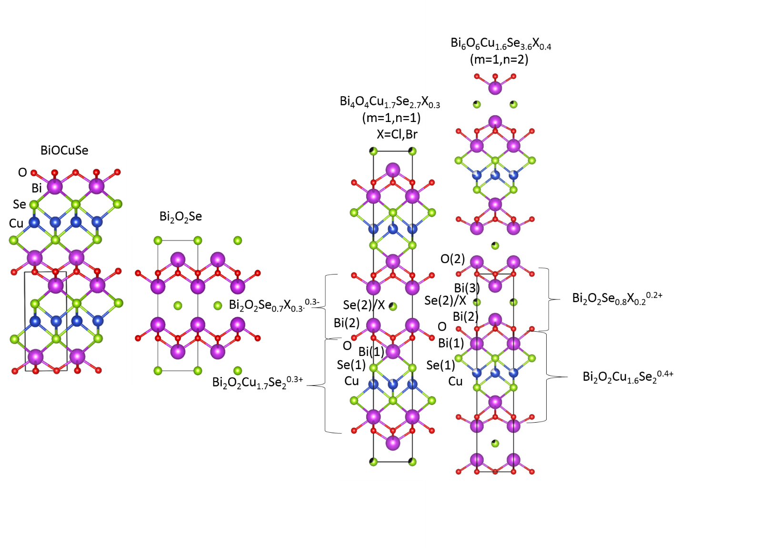
Figure 1. A view of the refined (m=1, n=1) and (m=1, n=2) structures Bi₄O₄Cu_{1.7}Se_{2.7}X_{0.3} and Bi₆O₆Cu_{1.6}Se_{3.6}X_{0.4} (X=Cl, Br), showing how they are composed of building blocks related to BiOCuSe and Bi₂O₂Se. The refined structures of Bi₄O₄Cu_{1.7}Se_{2.7}Br_{0.3} and Bi₆O₆Cu_{1.7}Se_{3.7}Cl_{0.4} were used for the models. Bi atoms are shown in purple, Cu in blue, Se in green, O in red and the halide X (Cl,Br) in black.

Calculation and Synthesis of Higher order Homologues
In order to expand the search to higher order homologues, electronic structure calculations were performed on various theoretical defect-free phases with different numbers of Bi₂O₂Cu₂Se₂ and Bi₂O₂Se slabs. The results of this are shown in Table 1, which show the calculated energies of various members of the homologous series as a function of m and n. These results showed that all compounds are essentially within error of zero meV away from the parent compounds BiOCuSe and Bi₂O₂Se. As such, their stability is likely governed by the Cu vacancy and halide chemistry, and, from a first approximation, all stackings are equally likely to be experimentally accessed.
Table 1. Table showing the calculated energies of various hypothetical compounds in the homologous series. Values for the energy compared to that of the parent materials (solid solution energies, E_{ss} = E(m,n) − 2mE(BiOCuSe) – nE(Bi₂O₂Se)) are reported for both the van der Waals density functional, optB86b-vdW and for PBE+U+SOC.
Compound | (m,n) | E_{ss}(meV/atom)
 |  | optB86b-vdW | PBE+U+SOC
Bi₄O₄Cu₂Se₃ | (1,1) | -0.2 | -0.1
Bi₆O₆Cu₂Se₄ | (1,2) | 0.0 | -0.1
Bi₈O₈Cu₂Se₅ | (1,3) | -0.5 | -0.2
Bi₆O₆Cu₄Se₅ | (2,1) | -0.7 | -0.1
As such, synthesis attempts were carried out for (m=1, n=2), (m=1, n=3) and (m=2, n=1) stackings, corresponding to the Cl-based compositions Bi₆O₆Cu_{2-δ}Se_{4-δ}Cl_{δ}, Bi₈O₈Cu_{2-δ}Se_{5-δ}Cl_{δ} and Bi₆O₆Cu_{4-δ}Se_{5-δ}Cl_{δ}, respectively. These were all attempted for δ=0.1, 0.2, 0.3, 0.4, 0.5 and 0.6. No evidence of an (m=2, n=1) phase was found, with the syntheses producing only the (m=1, n=1) phase along with BiOCuSe (Figure S6). In contrast, the (m=1, n=2) synthesis attempts produced a phase pure compound (by PXRD) at δ =0.4, corresponding to the formula Bi₆O₆Cu_{1.6}Se_{3.6}Cl_{0.4}.

The (m=1, n=3) series produced mixed phase diffraction patterns; however, peaks corresponding to the unit cell expected for an (m=1, n=3) phase were clearly present, most prevalent in the δ=0.2 composition. This phase can be indexed with a unit cell of a= 3.9005(7) Å, c= 54.382(2) Å with spacegroup I4/mmm, consistent with an (m=1, n=3) type structure. Impurities of Bi₂O₂Se and the (m=1, n=2) phase were observed. While a phase pure sample of the (m=1, n=3) phase Bi₈O₈Cu_{2-δ}Se_{5-δ}Cl_{δ} was not obtained, it is apparent that this member of the homologous series exists (see Figure S5). Synthesis of a phase pure sample and structure refinement would be of future interest.

For all synthesis attempts at δ =0, for all (m, n) values discussed, a mixture of Bi₂O₂Se and BiOCuSe was formed (Figures S1-S4). As such, it can be concluded that the presence of the halide is necessary for the formation of the homologous series, given the synthetic conditions used here. Given that that the calculated reaction energies for the δ =0 compounds are effectively zero, the effect of the halide and Cu vacancy must have a subtle effect that stabilizes the formation of these compounds.

As a phase pure sample of (m=1, n=2) Bi₆O₆Cu_{1.6}Se_{3.6}Cl_{0.4} was synthesized, the Br analogue of this compound was also investigated for the series Bi₆O₆Cu_{2-δ}Se_{4-δ}Br_{δ} for δ=0.1, 0.2, 0.3, 0.4, 0.5 and 0.6. A phase-pure compound was also identified at δ = 0.4, corresponding to the composition Bi₆O₆Cu_{1.6}Se_{3.6}Br_{0.4}. Single crystals suitable for single crystal X-ray diffraction were also found at this composition, mixed with the powder grains. All synthesis attempts at the hypothetical defect-free parent compounds, Bi₆O₆Cu₂Se₄, Bi₈O₈Cu₂Se₅, Bi₆O₆Cu₄Se₅, all simply produced combinations of BiOCuSe and Bi₂O₂Se, highlighting the requirement of the compensating Cu vacancies and Se/halide substitution to form the phases in the homologous series (Figures S1-S4).

Crystal Structure of Bi₆O₆Cu_{1.6}Se_{3.6}Cl_{0.4} and Bi₆O₆Cu_{1.6}Se_{3.6}Br_{0.4}
The structures of (m=1, n=2) phases Bi₆O₆Cu_{1.6}Se_{3.6}Cl_{0.4} and Bi₆O₆Cu_{1.6}Se_{3.6}Br_{0.4} were solved by a combination of single crystal X-ray diffraction and powder X-ray and neutron diffraction. These compounds both crystallise in the P4/nmm space group, as the 2 to 1 stacking removes the body centering. As Bi₂O₂ and Cu₂Se₂ layers are both fluorite type layers, they introduce a (1/2,1/2,0) shift to the unit cell (Figure 2). Therefore, an odd number of combined layers (such as the 2 Bi₂O₂ + 1 Cu₂Se₂ layers in the m=1, n=1 phases) leads to a body centred tetragonal cell, with two formula units per unit cell, whereas an even number (such as the 3 Bi₂O₂ + 1 Cu₂Se₂ layers in the m=1, n=2 phases) leads to a primitive tetragonal cell with one formula unit per unit cell. A comparison of the two homologous series structures is shown in Figure 1.

The change in stacking leads to an increase in the number of equivalent positions of O from one to two, and for Bi from two to three, as shown in Figure 2. This can be thought of as originating from two distinct Bi₂O₂ layers. The first Bi₂O₂ layer is adjacent to both a Cu_{1.6}Se₂ layer and an Se/X layer and contains two distinct Bi sites; Bi(1), which is adjacent to the Cu_{1.6}Se₂ the layer, and Bi(2), which is adjacent to the Se/X layer. The second Bi₂O₂ layer contains two equivalent Bi sites arising from Bi(3), which is adjacent to the Se/X layer. These three different Bi sites all have different Bi-Se(X) and Bi-O bond lengths (Figure 2). The refined lattice parameters were a = 3.90529(15) Å, c=21.0575(9) Å for Bi₆O₆Cu_{1.6}Se_{3.6}Cl_{0.4} and a = 3.90699(2 ) Å, c= 21.0624(4) Å for Bi₆O₆Cu_{1.6}Se_{3.6}Br_{0.4}, consistent with the larger size of Br versus Cl.

This (m=1, n=2) structure can be described as two Bi₂O₂Se_{0.8}X_{0.2}^{0.2-} layers separated by Bi₂O₂Cu_{1.6}Se₂^{0.4+} layers. It is worth noting that in the (m=1, n=1) compounds, the two layers have the same charge, whereas in (m=1, n=2) compounds, the formal nominal charge in the Bi₂O₂Se_{0.8}X_{0.2}^{0.2-} layers is half that of the Bi₂O₂Cu_{1.6}Se₂^{0.4+} layers, as the ratio of the layers has changed. From the single crystal data on Bi₆O₆Cu_{1.6}Se_{3.6}Br_{0.4 ,} a small splitting at the Se(1) (of the Cu_{1.6}Se₂ layer) site was found, creating extra electron density towards the Cu_{1.6}Se₂ layer; from the refinement, about 4% of the Se is displaced towards the Cu_{1.6}Se₂ layer. This extra split of Se site is designated as Se(3) This is consistent with the high concentration of Cu vacancies; it is likely that near Cu vacancies, the Se ions are able to relax towards the centre of the layer (Figure 2(c)).

When refining the X-ray data taken at I11 for Bi₆O₆Cu_{1.6}Se_{3.6}Cl_{0.4}, the Cu occupancy and Se/Cl ratio were allowed to freely refine. The Cu occupancy refined to 0.795(5), consistent with the nominal value (0.8). The Cl occupancy refined to 0.12(2), however, significantly lower than the nominal value of 0.2. Enforcing charge balance by setting the occupancy of Se to equal that of Cu led to no change in the goodness of fit, and resulted in Cu occupancy of 0.83(1) and a Cl occupancy of 0.17(1), also consistent with the nominal values. Due to the correlation of the Cl occupancy to the Cu occupancy, the real experimental uncertainty in these values is likely larger than the reported error. As such, for simplicity, the nominal values will be used for discussion. When allowed to freely refine on both the Se(1) (on the Bi₂O₂Cu₂Se₂ type slab) and the Se(2) (on the Bi₂O₂Se type slab) sites, the Cl occupancy on the Se(1) site always refined to within 0.02(2) or less. A small amount of Se/Cl mixing on the Se(1) site cannot be completely ruled out.
The single crystal X-ray refinement of Bi₆O₆Cu_{1.6}Se_{3.6}Br_{0.4} resulted in an occupancy of Cu of 0.819(18), consistent with the nominal value of 0.8. As the Se and Br cannot be distinguished by X-rays the Se/Br ratio was set to the nominal value. PND was used to determine Se/Br occupancy. In the neutron refinement, when allowed to freely refine, the Cu occupancy was 0.776(3). The Br occupancy of Se(1) refined to -0.03(3), which is within error of zero, and the Br occupancy at Se(2) refined to 0.301(29). By fixing the Br occupancy to various values, the sensitivity of the refinement to the Br occupancy was found to be similar to that of Bi₄O₄Cu_{1.7}Se_{2.7}Br_{0.3}. Due to the negative value at Se(1), the occupancy at Se(1) was set to zero. As such, Br is found to only occupy the Se(2) site, by neutron diffraction. As for Bi₄O₄Cu_{1.7}Se_{2.7}Br_{0.3}, The occupancy of the Se(3) site refined to 0.032(3), consistent with the single crystal refinement value of 0.04. A selected plot of the refinement for bank 3 is shown in Figure 3(b).

When the Cu occupancy is fixed to the single crystal refinement value of 0.819, the Br occupancy on Se(1) refines to 0.005(20), which is zero within error. The Br occupancy of the Se(2) site refines to 0.228(19), which is within error nominal value of 0.2. However, fixing the Cu occupancy to this value leads to a slightly higher χ ² (11.94 compared to 11.49 for freely refining Cu occupancy). Similarly to the Cl occupancy in Bi₄O₄Cu_{1.7}Se_{2.7}Cl_{0.3}, the correlation of the Br occupancy to the Cu occupancy in the refinement indicates that the real experimental uncertainty of these values is larger than the reported error. As for Bi₄O₄Cu_{1.7}Se_{2.7}Br_{0.3}, the nominal composition Bi₆O₆Cu_{1.6}Se_{3.6}Br_{0.4} , will be used throughout the text, with the caveat that the exact Br content may be somewhat higher than the nominal value.

Both the (m=1, n=2) compounds form at a nominal δ = 0.4 – deviation from this value produces impurities of Bi₂O₂Se and the (m=1, n=1) phase. As with the (m=1, n=1) compounds, no significant changes in lattice parameters were observed upon changing the nominal composition (impurity phases do form), suggesting a specific stable composition for each compound (see Tables S1-S3). While a homogeneity region for δ cannot be completely ruled out, it would be relatively small.

Due to the refinements indicating higher Br content than nominal EDX measurements were performed for both Bi₄O₄Cu_{1.7}Se_{2.7}Br_{0.3} and Bi₆O₆Cu_{1.6}Se_{3.6}Br_{0.4} (Figures S13-S14). These measurements indicated slight excess of Br and deficiency of Bi compared to the nominal. The charge from excess Br (an electron donor) could be compensated by Bi vacancies (a hole donor). The observation of a small amount of the (m=1,n=1) impurity phase in the neutron diffraction for Bi₆O₆Cu_{1.6}Se_{3.6}Br_{0.4} may be related to this apparent off stoichiometry. The precise defect chemistry of these compounds is expected to be complex and could be the subject of future study.

Table 2. Crystal data and structure refinement for Bi₆O₆Cu_{1.6}Se_{3.6}Br_{0.4}.
Identification code | QDG_129_4C2
Empirical formula | Bi₃Br_{0.2}Cu_{0.81}O₃Se_{1.8}
Formula weight | 884.84
Temperature/K | 293(2)
Crystal system | tetragonal
Space group | P4/nmm
a/Å | 3.8977(2)
b/Å | 3.8977(2)
c/Å | 21.031(2)
α/° | 90
β/° | 90
γ/° | 90
Volume/Å³ | 319.51(5)
Z | 2
ρ_{calc}g/cm³ | 9.197
μ/mm⁻¹ | 96.472
F(000) | 730.0
Crystal size/mm³ | 0.05 × 0.001 × 0.001
Radiation | MoKα (λ = 0.71073)
2Θ range for data collection/° | 3.874 to 52.738
Index ranges | -3 ≤ h ≤ 4, -4 ≤ k ≤ 4, -26 ≤ l ≤ 26
Reflections collected | 5123
Independent reflections | 256 [R_{int} = 0.0846, R_{sigma} = 0.0217]
Data/restraints/parameters | 256/1/23
Goodness-of-fit on F² | 1.180
Final R indexes [I>=2σ (I)] | R₁ = 0.0354, wR₂ = 0.0999
Final R indexes [all data] | R₁ = 0.0413, wR₂ = 0.1050
Largest diff. peak/hole / e Å⁻³ | 2.31/-2.25
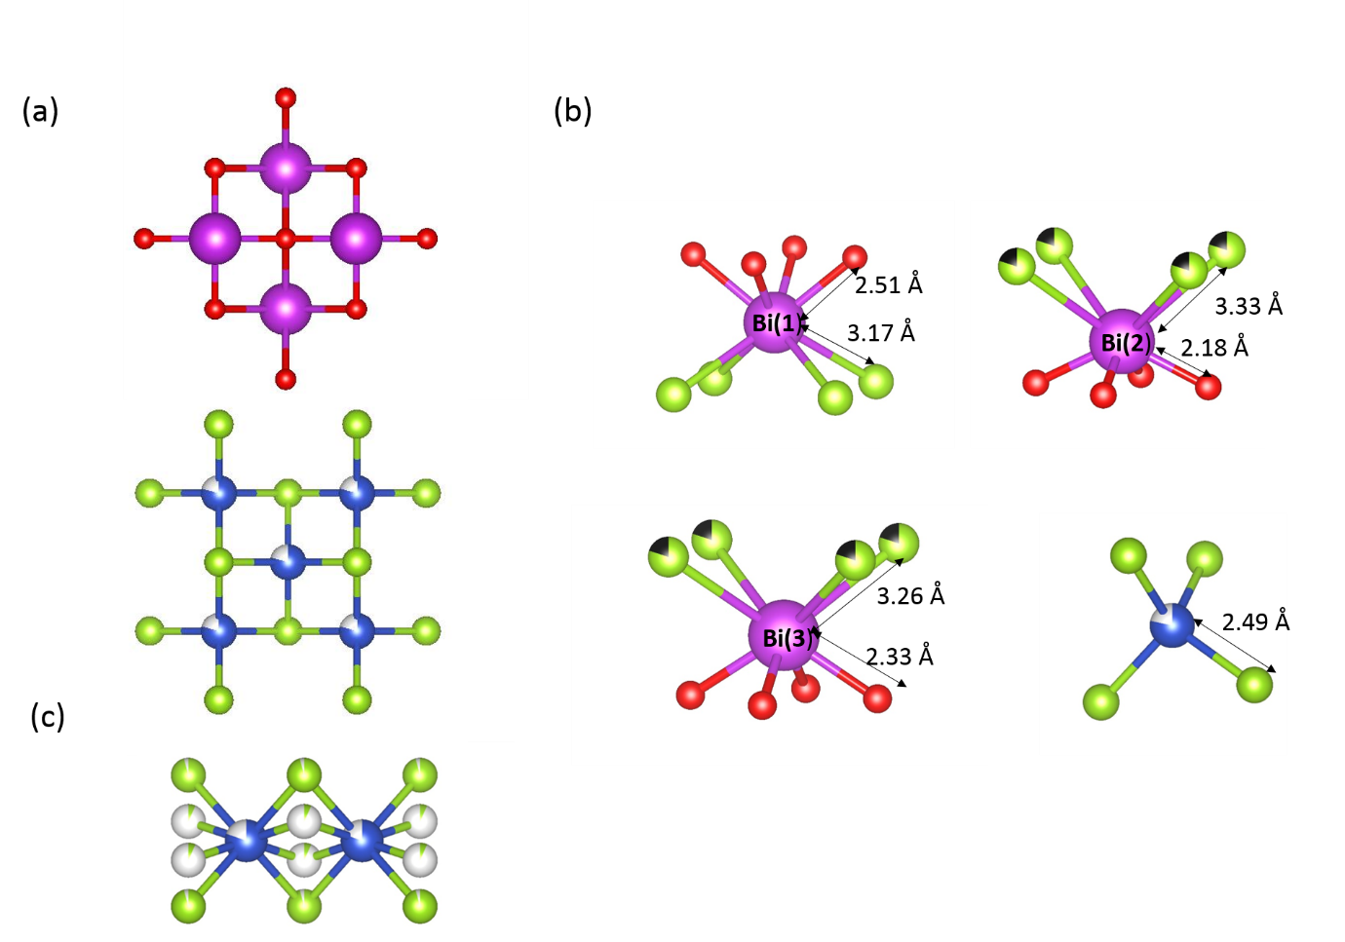
Figure 2. (a) Top down views of the Bi₂O₂ (top) and Cu_{2-δ}Se₂ (bottom) layers present in this homologous series. Stacking of a successive layer on each of these layers introduces a (1/2,1/2,0) shift to the unit cell in order to superimpose ions of opposite charges. (b) The bond lengths of the coordination polyhedra of the different Bi sites and the Cu site are shown for Bi₆O₆Cu_{1.6}Se_{3.6}Cl_{0.4}, highlighting the variation in bond lengths at each site. Bi(1) and Bi(2) are both part of the first Bi₂O₂ layer, which is adjacent to the both the Se/X layers and the Cu_{1.6}Se₂ layers, whereas Bi(3) is part of the second Bi₂O₂ layer, which is adjacent only to Se/X layers. While Bi(2) and Bi(3)have similar chemical environments, there is a slight variation in bond lengths. Bi(1) has a different chemical environment than either Bi(2) or Bi(3), being coordinated to only O and Se, with no halide mixing. (c) side view of the Cu_{1.6}Se₂ layer from the refined structure of Bi₆O₆Cu_{1.6}Se_{3.6}Br_{0.4}, showing the splitting of the Se site towards the centre of the layer, as refined using single crystal Xray data. This split off Se site is designated as Se(3) in the refinement
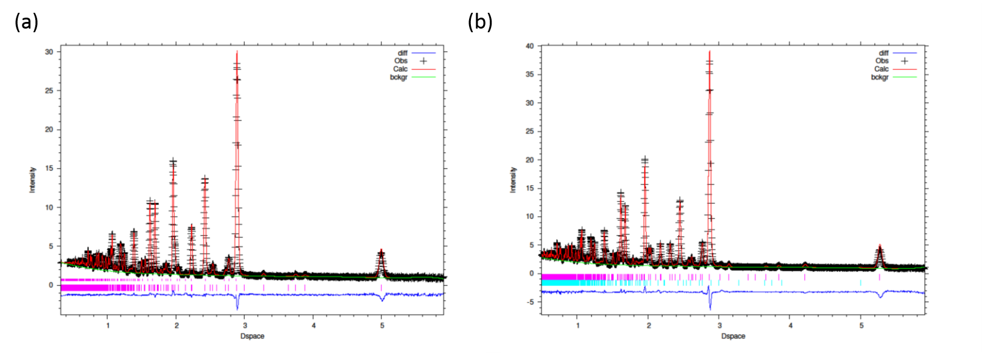
Figure 3. Selected Neutron refinements (bank 3) for Bi₄O₄Cu_{1.7}Se_{2.7}Br_{0.3} (a) and Bi₆O₆Cu_{1.6}Se_{3.6}Br_{0.4} (b). The wR_{p} values for the refinements on these banks are 0.0256 and 0. 0.0312, respectively.

Electron Diffraction
The structures of both the (m=1, n=1) and (m=1, n=2) phases were further probed by electron diffraction (Figure 4) and high resolution imaging of the individual layers (Figure 5). For both Bi₄O₄Cu_{1.7}Se_{2.7}Br_{0.3} and Bi₆O₆Cu_{1.6}Se_{3.6}Cl_{0.4} the unit cell repeat from the fast fourier transforms (FFT) of the high resolution images is the same as observed in the electron diffraction along the [100] zone axis (Figure 4), which is also consistent with the unit cells as determined by Xray and neutron diffraction, as discussed above.

In the images and diffraction patterns there is no indication of any stacking faults or defects, consistent with the lack of the (0,0,l) peak broadening in the powder diffraction data typically observed for materials with stacking faults. The different values for δ for each stacking sequence may help to suppress stacking defects, as a misplaced layer would also disrupt the charge balance, which would not be the case for materials formed from charge neutral layers.

In addition to the diffraction peaks expected for the structure derived from longer wavelength X-ray and neutron diffraction experiments, the [001] zone axis electron diffraction pattern for Bi₄O₄Cu_{1.7}Se_{2.7}Br_{0.3} also exhibits faint superlattice reflections; no superlattice reflections were observed along the [100] zone axis, possibly due to being too weak to be observed, or from the fact that this zone axis was measured on a different crystallite (Figure 4). These extra reflections were observed at h00, h = n and 0k0, k = n, which are forbidden reflections in a body-centred structure. As such, the body centering is broken. Furthermore, superlattice peaks are observed at (n/4, n/4, 0), but not (n/4,-n/4,0), indicating a superstructure modulation along the 110 direction with the associated removal of the fourfold rotation symmetry [001] axis and replacement with a twofold rotation in an orthorhombic superlattice. The exact nature of this reduction of symmetry would be of interest for future work. Not all crystallites exhibited these superlattice reflections, indicating the superstructure to be local in nature with varying correlation length, consistent with the lack of observation of these reflections in X-ray and neutron diffraction experiments.

The existence of a superstructure at room temperature is consistent with the observation of the onset hysteresis in the physical properties at around 320K for this (m=1, n=1) Bi₄O₄Cu_{1.7}Se_{2.7}Br_{0.3} (see Figure 9). The peaks may be too faint to observe using the other techniques, or the superstructure may be only locally ordered. Regardless, a deviation from the I4/mmm average structure refined against X-ray and neutron diffraction, towards an orthorhombic cell, is expected below 320K. Further studies may elucidate the nature of this distortion.
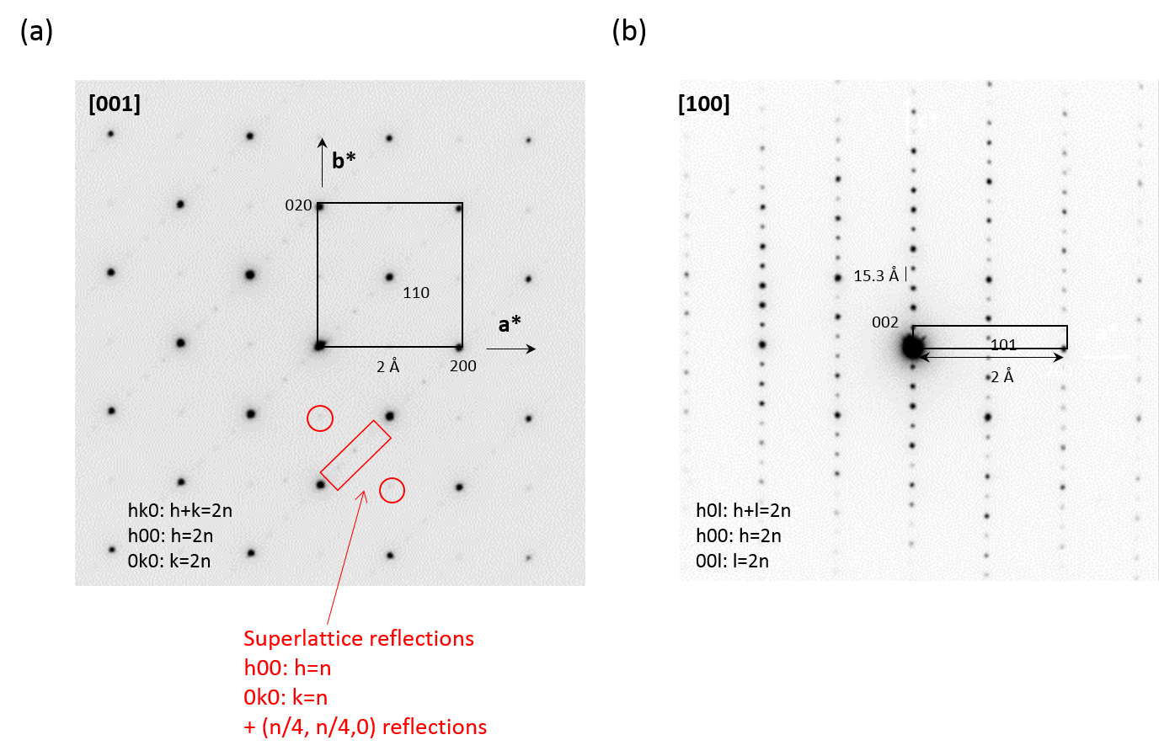
Figure 4. Electron diffraction images of Bi₄O₄Cu_{1.7}Se_{2.7}Br_{0.3} (m=1, n=1) taken perpendicular to the basal plane (a) and parallel to basal plane, measured on a different crystallite (b). Highlighted in red are the extra superlattice reflections observed in addition to the expected reflections given the unit cell of 3.92 Å x 29.99 Å in the space group I4/mmm for the (m=1, n=1) phase Bi₄O₄Cu_{1.7}Se_{2.7}Br_{0.3}. Circles correspond to reflection violating the body-centring, and the rectangle encloses reflections associated with the fourfold modulation along [110].
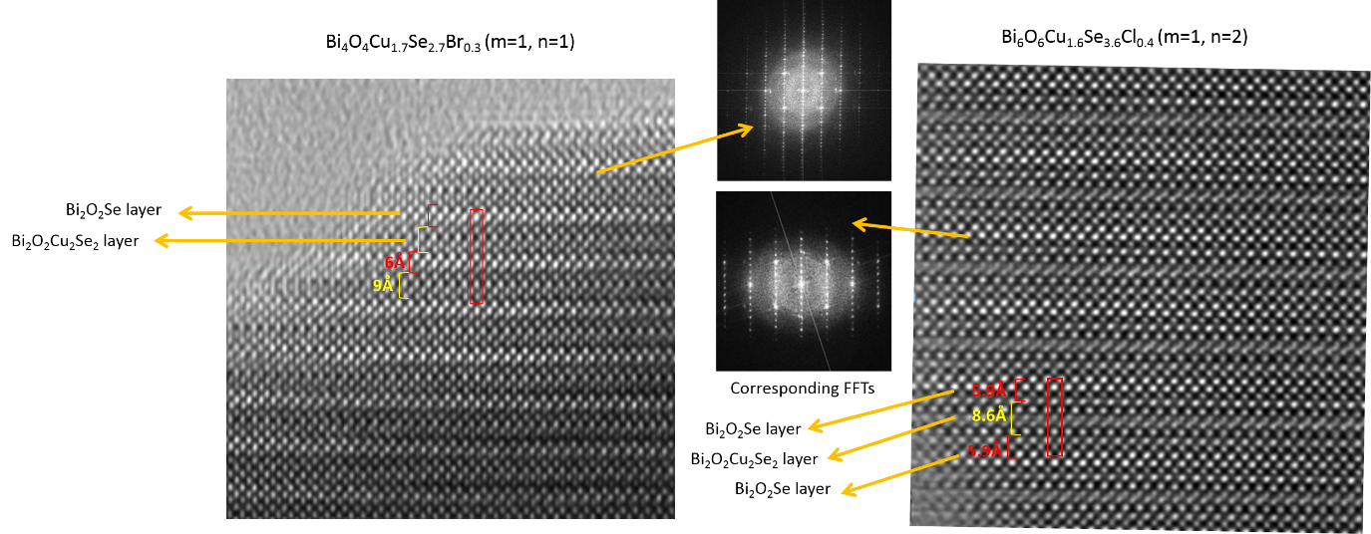
Figure 5. High resolution TEM images of Bi₄O₄Cu_{1.7}Se_{2.7}Br_{0.3} (m=1, n=1, left) and Bi₆O₆Cu_{1.6}Se_{3.6}Cl_{0.4} (m=1, n=2, right), showing the stacking of both compound types, as well as the corresponding Fast Fourier Transforms, both consistent with the unit cells determined by X-ray and Neutron diffraction, and the electron diffraction patterns.

Electronic Structure
The calculated electronic structure of the hypothetical defect free (m=1, n=2) phase Bi₆O₆Cu₂Se₄ (which can also be written Bi₃O₃CuSe₂), shown in Figure 6, shows similar features to that of BiOCuSe and the hypothetical Bi₄O₄Cu₂Se₃ (m=1, n=1). The electronic structure shown was calculated at the PBE+U+SOC level of theory, using the value of U used previously for Bi₄O₄Cu₂Se₃ and BiOCuSe^{13,30}. Hybrid functional calculations were performed as well for a more accurate band gap. These calculations showed agreement with PBE+U+SOC when a rigid band shift of 0.45eV is included (Figure S12). As calculated for Bi₄O₄Cu₂Se₃¹³, the valence band states originate mainly from the Cu-Se orbitals, while the conduction band states originate from the Bi and Se orbitals located on the Bi₂O₂Se type layer. The valence band especially looks very similar for both Bi₄O₄Cu₂Se₃ and Bi₆O₆Cu₂Se₄, indicating that the Cu-Se based valence band states remain largely the same. The most noticeable difference is the presence of distinct Bi sites contributing to the conduction band states, which splits the conduction band. The Bi sites that make up the conduction band, (Bi(2) and Bi(3)), have slightly different chemical environments, as discussed previously, and the conduction band orbitals now span over two slabs rather than one. This splits the conduction bands by about 0.1eV; this splitting is likely what makes the (m=1, n=2) phase have a slightly lower calculated band gap than the (m=1, n=1); the electronic structure using the Hybrid functional shows a band gap of 0.42eV (indirect) and 0.52eV (direct), which is 0.12 and 0.11 eV lower than the gaps calculated for the n=1 phase at the same level of theory. While a 0.1eV reduction in band gap would usually be considered quite small, in this case it represents a reduction of about 25%. While the band gap calculated here is unlikely to be quantitatively accurate, the qualitative trend should be retained.

Another difference is that as the P4/nmm space group contains a glide plane, the nonsymmorphic symmetry element creates protected four fold degeneracies at the X point. This degeneracy is protected by the glide plane symmetry element, and enforces multiple band character at this point, with a heavier and lighter band. This may lead to advantageous thermoelectric properties if the compound can be hole doped to about 0.1eV below E_{f}.
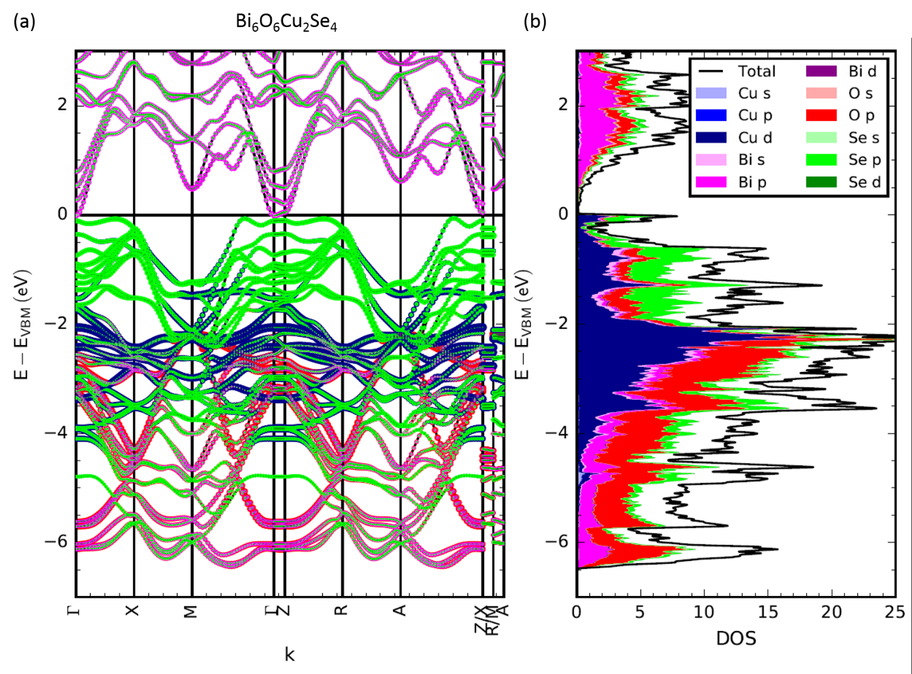
Figure 6. (a) Electronic Band Structure and (b) Density of States calculated for the hypothetical defect free Bi₆O₆Cu₂Se₄ (m=1, n=2), calculated using the PBE+U+SOC level of theory. The colour shows the contribution of various atomic orbitals to the states.

In order to probe the experimental band gap, infrared reflectivity data was taken on all three phase pure compounds (Figure 7). Due to the narrow nature of the band gaps, a precise fit to the data was not possible, as the reflectivity still shows features down to the low energy limit of the instrument. Figure 7 shows (F(R)*E)^{1/2}, where F(R) is the Kubelka Munk function of the reflectivity, F(R) = (1-R)²/2R . The intercept from the linear fit to this function gives the indirect band gap (which is calculated to be smaller than the direct gap for these materials). The direct gap fitting, to (F(R)xE)² is not linear except at energies above about 1.0 eV, and does not produce a suitable fit, whereas for an indirect gap the fit is linear from about 0.6-1.2eV. Extrapolating the indirect fit to zero gives values for E_{g} of 0.29(3) eV, 0.23(3) eV and 0.22(3) eV for Bi₄O₄Cu_{1.7}Se_{2.7}Br_{0.3}, Bi₆O₆Cu_{1.6}Se_{3.6}Cl_{0.4} and Bi₆O₆Cu_{1.6}Se_{3.6}Br_{0.4} respectively. These values can be considered to be a lower limit on the band gap, as a baseline zero cannot be established below about 0.5eV due to the limits of the instrument. An upper limit of the band gap of 0.5eV can be established for all three compounds. Comparing the curves against each other, the reflectivity for (m=1, n=1) Bi₄O₄Cu_{1.7}Se_{2.7}Br_{0.3} appears to be shifted towards slightly higher energies compared to the (m=1, n=2) phases. This is consistent with the electronic calculations, which predict a 0.12 eV larger gap for the (m=1, n=1) structures compared to the (m=1, n=2) structures.
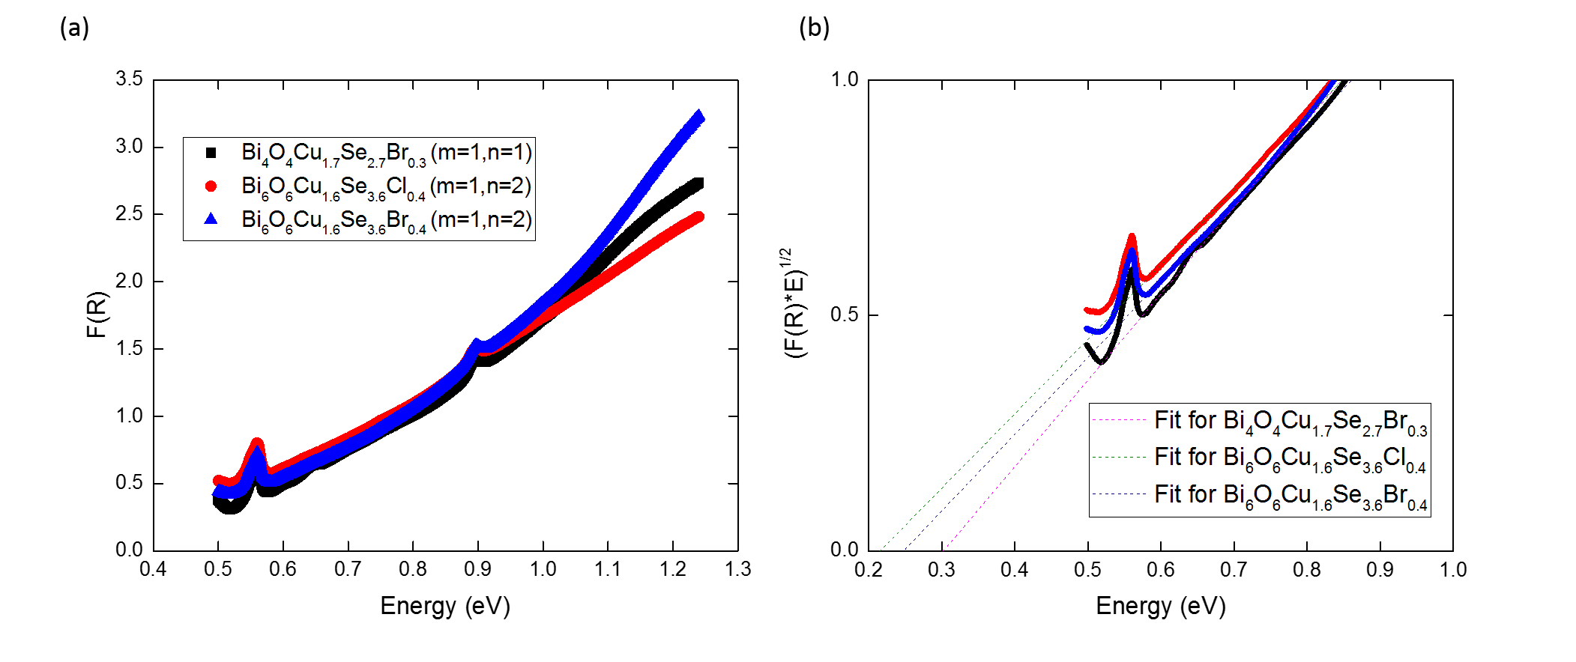
Figure 7. (a) A plot of the reflectivity versus energy for Bi₄O₄Cu_{1.7}Se_{2.7}Br_{0.3} (n=1, m=1), Bi₆O₆Cu_{1.6}Se_{3.6}Cl_{0.4} (m=1, n=2) and Bi₆O₆Cu_{1.6}Se_{3.6}Br_{0.4} (m=1, n=2). The data has been transformed using the Kubelka-Munk equation , F(R) = (1-R)²/2R . A shift towards higher energy for F(R), in the region 0.5 to 0.8 eV, is observed in the order Bi₆O₆Cu_{1.6}Se_{3.6}Cl_{0.4} (m=1, n=2), Bi₆O₆Cu_{1.6}Se_{3.6}Br_{0.4} (m=1, n=2), Bi₄O₄Cu_{1.7}Se_{2.7}Br_{0.3} (m=1, n=1). (b) Linear fits to (F(R)xE)^{1/2} versus energy; the extrapolation of the linear fit to zero represents the energy of the indirect band gap. The shift in the extrapolated lines shows the same trend as that for F(R).

Physical Properties
Thermal conductivity measurements parallel to the pressing axis of the pellet using the PPMS on all compounds showed exceptionally low thermal conductivities at room temperature, with values of 0.20(6), 0.16(2) and 0.13(1) W/mK, for Bi₄O₄Cu_{1.7}Se_{2.7}Br_{0.3}, Bi₆O₆Cu_{1.6}Se_{3.6}Cl_{0.4} and Bi₆O₆Cu_{1.6}Se_{3.6}Br_{0.4}, respectively (Figure 8). All compounds can be said to have exceptionally low thermal conductivities for crystalline compounds, as well as an unusual temperature dependence. In order to determine the trend of thermal conductivities in this family, the thermal conductivity was compared at 150K, as due to a reduction in both emissivity effects and thermal noise in the heating/cooling versus temperature profile, the thermal conductivity measurement at this temperature has significantly reduced error. These values are 0.196(9), 0.157(3) and 0.114(1) W/mK for Bi₄O₄Cu_{1.7}Se_{2.7}Br_{0.3}, Bi₆O₆Cu_{1.6}Se_{3.6}Cl_{0.4} and Bi₆O₆Cu_{1.6}Se_{3.6}Br_{0.4}, respectively. The (m=1, n=2) materials exhibit lower thermal conductivities than the (m=1, n=1) materials.

Furthermore, a general trend of the Br-containing materials having lower thermal conductivity than their Cl analogues is observed. This rules out the mass contrast in the Se/(Br,Cl) layers as a significant source of phonon scattering; if the mass contrast were important, the Br compounds should show a higher thermal conductivity, due Br having a much closer mass to that of Se. Replacing Cl with Br does however, have an effect on the lattice parameters as well as the bond lengths, which in turn affects the phonons. A full investigation on the source of the low thermal conductivity as well as the trends would be of interest for future study.

Table 3 shows a comparison of the thermal conductivities of various other “ultralow” thermal conductivity materials with those of the Bi_{2+2n}O_{2+2n}Cu_{2-δ}Se_{2+n-δ}X_{δ} homologous series reported in this work, assuming the upper limit of the thermal conductivity of 0.2-0.3W/mK at room temperature. Even considering this upper limit for the present materials, the room temperature thermal conductivities are amongst the lowest of all reported materials, with only CsAg₅Te₃ ³⁵, a nanofabricated Ag/Si superlattice³⁴ and nanostructured SnSe³⁸ achieving similarly low thermal conductivities at room temperature.

Figure 8(b) shows the Seebeck coefficients versus temperature for all compounds. Like Bi₄O₄Cu_{1.7}Se_{2.7}Cl_{0.3}, the (m=1, n=1) Bi₄O₄Cu_{1.7}Se_{2.7}Br_{0.3} is p-type with a room temperature Seebeck coefficient of +544(10) μV/K, compared to +610(10) μV/K for Bi₄O₄Cu_{1.7}Se_{2.7}Cl_{0.3.} In contrast, both (m=1, n=2) Bi₆O₆Cu_{1.6}Se_{3.6}(Br,Cl)_{0.4} are n-type, with room temperature values of -200 μV/K. This can be rationalized by the fact that these materials contain two Bi₂O₂Se layers (typically n-type⁴¹) and one Bi₂O₂Cu₂Se₂ type layer (typically p-type⁴²) and thus are expected to have properties more similar to Bi₂O₂Se when compared to the (m=1, n=1) compounds, which have an equal number of layers from both parents. These Seebeck coefficients are consistent with a low concentration of carriers.
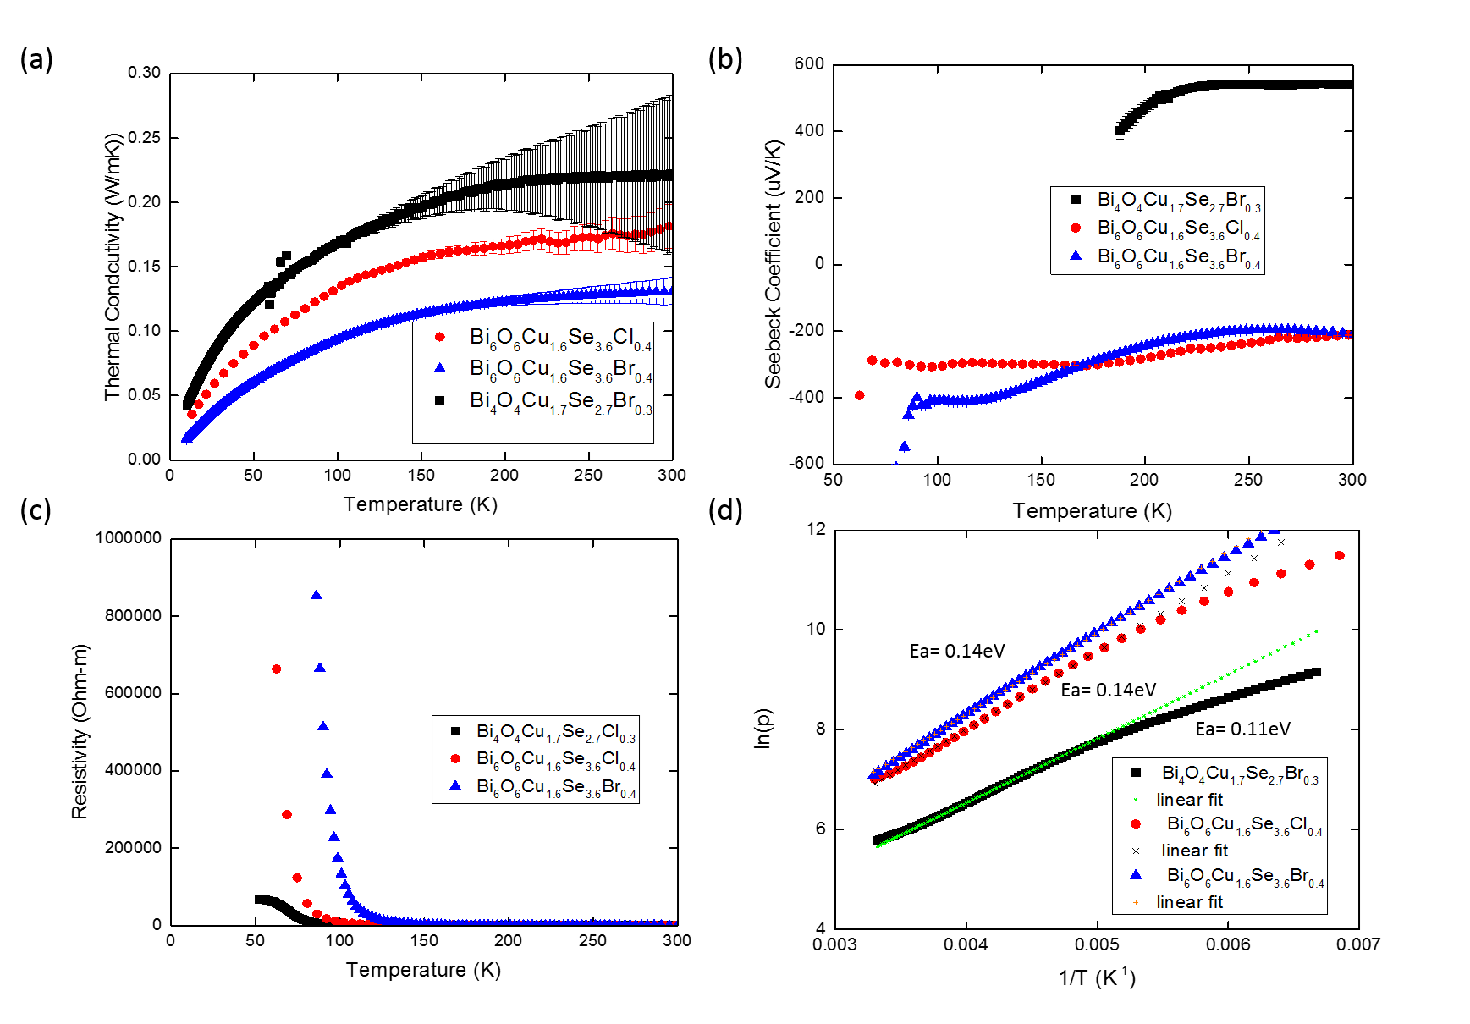
Figure 8. (a) Thermal conductivity (with the error bars shown) and (b) Seebeck coefficient versus temperature plots for (m=1, n=1) Bi₄O₄Cu_{1.7}Se_{2.7}Br_{0.3} (black), and the (m=1, n=2) Bi₆O₆Cu_{1.6}Se_{3.6}Cl_{0.4} (red), and Bi₆O₆Cu_{1.6}Se_{3.6}Br_{0.4} (blue). The errors in the Seebeck coefficient are smaller than the point sizes. The curves are cut off when the impedance of the samples becomes too large for the instrument to accurately measure the Seebeck coefficient. (c) Resistivity versus temperature and (d) log of resistivity versus reciprocal temperature plots for (m=1, n=1) Bi₄O₄Cu_{1.7}Se_{2.7}Br_{0.3} (black), and (m=1, n=2) Bi₆O₆Cu_{1.6}Se_{3.6}Cl_{0.4} (red), and Bi₆O₆Cu_{1.6}Se_{3.6}Br_{0.4} (blue). The linear fits are shown in (d) as well as the respective Arrhenius activation energies. The resistance of the sample becomes too large to be accurately measured at low temperatures, reflected in the temperature ranges shown for each material. The errors in the resistivity measurements are smaller than the symbols used.
Table 3. A comparison of the room temperature thermal conductivities of various “ultralow” thermal conductivities, along with those reported in this work for the Bi_{2+2n}O_{2+2n}Cu_{2-δ}Se_{2+n-δ}X_{δ} phases.
Compound | К (300K) W/mK | Reference
Cu₅FeS₄ | 0.5 | 32
CH₃NH₃PbI₃ | 0.5 | 33
Au/Si superlattice | 0.33 | 34
CsAg₅Te₃ | 0.2 | 35
InTe | 0.7 | 36
SnSe (a axis) | 0.5 | 37
SnSe (b, c axes) | 0.7 | 37
BiOCuSe | 0.7 | 39
Bi₂O₂Se | 0.8 | 40
Bi_{2+2n}O_{2+2n}Cu_{2-δ}Se_{2+n-δ}X_{δ} | 0.2-0.3 | This Work
Nanostructured SnSe | 0.2 | 38

Similarly to the previously reported (m=1, n=1) Bi₄O₄Cu_{1.7}Se_{2.7}Cl_{0.3}, Bi₄O₄Cu_{1.7}Se_{2.7}Br_{0.3} shows semiconducting behaviour, reaching high resistivities (>10⁶ MΩcm) below 100K (Figure 8(c)). In all property measurements, hysteresis is observed starting at 320K (Figure 9), which is most likely related to a subtle phase transition. This is supported by the observation of the superlattice reflections at room temperature (<320K) in the electron diffraction images of (m=1, n=1) Bi₄O₄Cu_{1.7}Se_{2.7}Br_{0.3} . This is consistent with the observation of similar hysteresis in Bi₄O₄Cu_{1.7}Se_{2.7}Cl_{0.3} at a lower temperature, indicating that the substitution of the halide has an effect on this transition. That both (m=1, n=1) compounds exhibit a phase transition that appears to be absent in the (m=1, n=2) compounds indicates that the different stacking has a subtle effect on the structural properties as well as physical properties.

The activation energy from the resistivity for the Bi₄O₄Cu_{1.7}Se_{2.7}Br_{0.3} (m=1, n=1) compound was determined to be 0.11 eV (Figure 8(d)). However, it was shown for Bi₄O₄Cu_{1.7}Se_{2.7}Cl_{0.3} that the activation energy is markedly different above and below the transition temperature. Therefore, the activation energy of 0.11 eV is likely not the intrinsic gap; the intrinsic band gap is not expected to vary significantly between Bi₄O₄Cu_{1.7}Se_{2.7}Cl_{0.3} (0.4 eV) and Bi₄O₄Cu_{1.7}Se_{2.7}Br_{0.3}, and the true band gap of Bi₄O₄Cu_{1.7}Se_{2.7}Br_{0.3} is likely close to 0.4eV, which is consistent with the upper and lower limits of the band gap (0.29(3)eV< E_{g}<0.5eV).

For the (m=1, n=2) compounds, the resistivity also shows semiconducting behaviour, with an activation energy of 0.14 eV for both compounds (Figure 8(d)). No hysteresis is observed (up to 350K), indicating the absence of the phase transition, consistent with the absence of any superlattice peaks observed for the (n=2, m=1) compound Bi₆O₆Cu_{1.6}Se_{3.6}Cl_{0.4}. The activation energy of 0.14 eV equates to a gap of 0.28eV, which would be consistent with the electronic structure calculations that predict a 0.12eV lower indirect band gap for the (m=1, n=2) compounds compared to the (m=1, n=1) compounds (Bi₄O₄Cu_{1.7}Se_{2.7}Cl₀.₃ exhibits an experimental transport gap of 0.4eV). This indicates that the transport gap of 0.28eV is likely intrinsic. This value is roughly consistent with that obtained from the optical measurements. Compared to the band gaps of the parent materials Bi₂O₂Se (0.8eV) and BiOCuSe (0.9eV), this represents a drastic decrease in the electronic band gap, which is true for all compounds in this homologous series. Such high resistivities for compounds with such low band gaps are extremely rare; in fact, much effort has gone into trying to make small band gap semiconductors, such as topological insulators, more insulating, as they often exhibit poor conductivity⁴³. That these compounds are so resistive without doping, despite having quite small bandgaps, indicates a possible charge compensation mechanism that may be related to the defect-based charge balance between the layers. Similarly insulating behaviour, albeit with a larger gap, was observed for the structurally similar BiOAgSe synthesized by ion exchange, and was attributed to charge compensation⁴⁴. These materials may be useful for thermoelectric applications if they can be made conducting via chemical doping or post synthetic treatment.
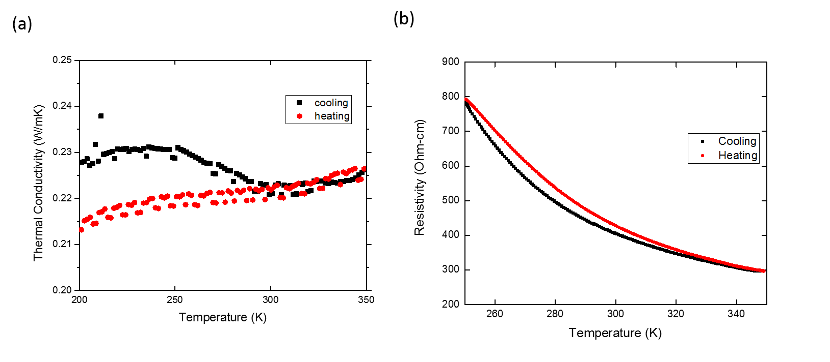
Figure 9. Close up of (a) thermal conductivity and (b) resistivity of Bi₄O₄Cu_{1.7}Se_{2.7}Br_{0.3} (m=1, n=1), showing the splitting of the heating and cooling curves. From the higher resolution resistivity measurement, this hysteresis begins near 320K, above room temperature, and converge again at 250K. These data were taken on the same sample as in Figure 8, with higher resolution to more easily see the hysteresis.
Conclusions
Bi_{2+2n}O_{2+2n}Cu_{2-δ}Se_{2+n-δ}X_{δ} (X=Cl, Br) is a new family of three anion compounds as well as a new homologous series. All members synthesized so far have very different properties from their parent materials BiOCuSe and Bi₂O₂Se. Changing the number of Bi₂O₂Se blocks n results in a decrease in band gap as well as a switch of the sign of the charge carriers. All the materials show exceptionally low thermal conductivities. This homologous series is stabilised by the partial charges on different layers afforded by the Cu vacancy and halide (either Cl or Br) for selenium substitution. This both introduces a new family of small band gap materials for study as well as opens up a new route to synthesizing new homologous series’ from known structural blocks.
ASSOCIATED CONTENT
Crystallographic Information Files (CCDC 1838929, CCDC 1842527 and CCDC 1842523), Neutron Refinement Tables, Supporting Information (1. Synthesis and Phase Fits, 2. Xray Diffraction, 3. Neutron Diffraction, 4. Electronic Structure Calculations, 5. Chemical Analysis)
AUTHOR INFORMATION
Corresponding Author
Matthew J. Rosseinsky (rossein@liverpool.ac.uk)
Author Contributions
The manuscript was written through contributions of all authors. All authors have given approval to the final version of the manuscript.
Funding Sources
Notes
The authors declare no competing financial interests
ACKNOWLEDGMENT
We thank EPSRC for funding under EP/N004884. We thank Diamond Light Source for access to beamline I11 (proposal EE17193) and Prof. Chiu Tang and Dr. Sarah Day for assistance on the beamline. We thank STFC for access to Polaris (Xpress proposals 1890005 and 1890006) and Dr. Ron Smith for running the measurements.

REFERENCES
(1) Ruddlesden, S.N.; Popper, P. The compound Sr₃Ti₂O₇ and its structure. Acta Crystallogr. 1985 , 11, 54-55.
(2) Imamov, R. M., and S. A. Semiletov. Imamov, R.M.; Semiletov, S.A. Crystal Structure of the Phases in the Systems Bi-Se, Bi-Te and Sb-Te. Sov. Phys. Crystallogr. 1971, 15, 845-850.
(3) Lee, K. H.; Kim, S.W.; Ohta, H.; Koumoto, K. Ruddlesden-Popper phases as thermoelectric oxides: Nb-doped SrO(SrTiO₃)_{n} (n= 1, 2). J. Appl. Phys. 2006, 100, 063717.
(4) Amow, G.; Davidson, I.J.; Skinner, S.J. A comparative study of the Ruddlesden-Popper series, La_{n+1}Ni_{n}O3_{n+1} (n= 1, 2 and 3), for solid-oxide fuel-cell cathode applications. Sol. State Ionics 2006, 177, 1205-1210.
(5) Moon, S.J.; Jin, H.; Kim, K.W.; Choi, W.S.; Lee, Y.S.: Yu, J.; Cao, G.; Sumi, A.; Funakubo, H.; Bernhard, C.; Noh, T.W. Dimensionality-Controlled Insulator-Metal Transition and Correlated Metallic State in 5 d Transition Metal Oxides Sr_{n+1}Ir_{n}O_{3n+ 1} (n= 1, 2, and ∞). Phys. Rev. Lett. 2008, 22, 226402.
(6) Xia, Y.; Qian, D.; Hsieh, D.; Wray, L.; Pal, A.’ Lin, H.; Bansil, A.; Grauer, D.; Hor, Y.S.; Cava, R.J.; Hasan, M.Z. Observation of a large-gap topological-insulator class with a single Dirac cone on the surface. Nature Phys. 2009, 6, 398.
(7) Weber, A.P.; Gibson, Q.D.; Ji, H.; Caruso, A.N.; Dedorov, A.V.; Cava, R.J.; Valla, T. Gapped surface states in a strong-topological-insulator material. Phys. Rev. Lett. , 2015, 25, 256401.
(8)Zhang, J.; Liu, X.; Huang, G.-Q. Topological surface states of infinitely adaptive series (Bi2Se3)_{m}(Bi₂)_{n}: A first‐principles study. Physica Stat. Sol. 2015, 252, 2090-2095.
(9) Choi, E.-Y.; Barron, P.M.; Novotny, R.W.; Son, H.-T.; Hu, C.’ Choe, W. Pillared Porphyrin Homologous Series: Intergrowth in Metal− Organic Frameworks. Inorg. Chem. 2008, 48,426-428
(10) Latturner, S.E.; Kanatzidis, M.G. RE (AuAl₂)_{n}Al₂(Au_{x}Si_{1− x})₂: A New Homologous Series of Quaternary Intermetallics Grown from Aluminum Flux. Inorg. Chem. 2008, 47, 2089-2097.
(11) Yamauchi, H.; Karpinnen, M.; Tanaka, S. Homologous series of layered cuprates. Physica C: Superconductivity. 1996, 263, 146-150.
(12) Hiraku, O.; Sato, S.; Kishio, K.; Shimoyama, J.; Tohei, T.; Ikuhara, Y. Homologous series of iron pnictide oxide superconductors (Fe₂As₂)[Ca_{n+1}(Sc, Ti)_{n}O_{y}](n= 3, 4, 5) with extremely thick blocking layers. Appl. Phys. Lett. 2010, 7, 072506
(13)
(14) Kusainova, A.; Berdonosov, P.; Akselrud, L.; Kholodkovskaya, L.; Dolgikh, V.; Popovkin, B. New layered compounds with the general composition (MO)(CuSe), where M= Bi, Nd, Gd, Dy, and BiOCuS: Syntheses and crystal structure. J. Sol. State Chem. 1994, 112, 189–191
(15) Boller, H. Die Kristallstruktur von Bi2O2Se Monatsh. Chem. 1973, 104, 916–919.
(16) Liu, R.; Song, Y.; Li, Q.; Ying, J.; Yan, Y.; He, Y.; Chen, X. Structure and physical properties of the layered pnictide-oxides:(SrF)₂Ti₂Pn₂O (Pn= As, Sb) and (SmO)₂Ti₂Sb₂O. Chem. Mater. 2010, 22, 1503–1508.
(17) Eul, M.; Johrendt, D.; Pöttgen, R. An Extension of Pnictide Oxide Chemistry–Salt Flux Synthesis and Structure of La₅Cu₄As₄O₄Cl₂. Z. Naturforsch. B 2009, 64, 1353–1359.
(18) Bartsch, T.; Benndorf, C.; Eckert, H.; Eul, M.; Pöttgen, R. La₃Cu₄P₄O₂ and La₅Cu₄P₄O₄Cl₂: synthesis, structure and 31P solid state NMR spectroscopy. Z. Naturforsch. B 2016, 71, 149–155.
(19) Larson, A.C.; Von Dreele, R.B. Los Angeles National Laboratory Report. 2000, 86-748.
(20) Coehlo, A.A. TOPAS Academic. Coelho Software. 2007.
(21) SAINT v7.68A (Bruker, 2009)
(22) SADABS-2008/4 (Bruker,2010)
(23) Sheldrick, G. M. SHELXT–Integrated space-group and crystal-structure determination Acta. Cryst. 2015, A71, 3.
(24) Dolomanov, O. V.; Bourhis, L. J.; Gildea, R. J.; Howard, J. A. K.; Puschmann, H. OLEX2: a complete structure solution, refinement and analysis program. J. Appl. Cryst. 2009, 42, 339.
(25) Sheldrick, G. M. Crystal structure refinement with SHELXL. Acta. Cryst. 2015, C71, 3.
(26) Kresse, G. Phys. Rev. B. Efficient iterative schemes for ab initio total-energy calculations using a plane-wave basis set. 1996, 54, 169.
(27) Blöchl, P. E. Projector augmented-wave method. Phys. Rev. B. 1994, 50, 17953.
(28) Klimeš, J.; Bowler, D. R.; Michaelides, A. Van der Waals density functionals applied to solids. Phys. Rev. B. 2011, 83, 195131.
(29) Perdew, J. P.; Burke, K.; Ernzerhof, M. Generalized gradient approximation made simple. Phys. Rev. Lett. 1996, 77, 3865.
(30) Zou, D.; Xie, S.; Liu, Y.; Lin, J.; Li, J. Electronic structures and thermoelectric properties of layered BiCuOCh oxychalcogenides (Ch= S, Se and Te): first-principles calculations. J. Mater. Chem. A 2013, 1, 8888-8896.
(31) Krukau, A.V.; Vydrov, O.A.; Izmaylov, A.F.; Scuseria, G.E. Influence of the exchange screening parameter on the performance of screened hybrid functionals. J. Chem. Phys. 2006 , 125, 224106
(32) Qiu, P.; Zhang, T.; Qiu, Y.; Shi, X.; Chen, L. Sulfide bornite thermoelectric material: a natural mineral with ultralow thermal conductivity. Energy Environ. Sci. 2014, 12, 4000-4006.
(33) Pisoni, A.; Jacimovic, J.; Barisic, O.S., Spina, M.; Gaál, R.; Forró, L.; Horváth, E. Ultra-low thermal conductivity in organic–inorganic hybrid perovskite CH₃NH₃PbI₃. J. Phys. Chem. Let. 2014, 14, 2488-2492.

(34) Dechaumphai, E.; Lu, D.; Kan, J.J.; Jaeyun, M.; Fullerton, E.E.; Liu, Z.; Chen, R. Ultralow Thermal Conductivity of Multilayers with Highly Dissimilar Debye Temperatures Nano Lett. 2015, 14, 2448-2455.
(35) Lin, H.; Tan, G.; Shen, J.-N.; Hao, S.; Wu, L.-M.; Calta, N.; Maliakas, M.; Wang, S.; Uher, C.; Wolverton, C.; Kanatzidis, M.G. Concerted rattling in CsAg₅Te₃ leading to ultralow thermal conductivity and high thermoelectric performance. Angew. Chem. Int. Ed. 2016, 55, 11431-11436.
(36) Jana, Manoj K., Koushik Pal, Umesh V. Waghmare, and Kanishka Biswas. Jana, M.K.; Pal, K.; Waghmare, U.V.; Biswas, K. The Origin of Ultralow Thermal Conductivity in InTe: Lone‐Pair‐Induced Anharmonic Rattling. Angew. Chem. Int. Ed. 2016 , 55, 7792-7796.
(37) Zhao, L.-D.; Lo, S.-H.; Zhang, Y.; Sun, H.; Tan, G.; Uher, C.; Wolverton, C.; Dravid, V.; Kanatzidis, M.G. Ultralow thermal conductivity and high thermoelectric figure of merit in SnSe crystals. Nature, 2014, 508, 373.
(38) Serrano-Sánchez, F.; Gharsalla, M.; Nemes, N.M.; Mompean, F.J.; , Martinez, J.L.; Alonso, J.A. Record Seebeck coefficient and extremely low thermal conductivity in nanostructured SnSe. Appl. Phys. Lett. 2015. 8, 106.
(39) Y.; Zhang, B.-P.; Lin, Y.-H.; Nan, C.-W.; Zhu, H.-M. Polycrystalline BiCuSeO oxide as a potential thermoelectric material. Energy Environ. Sci. 2012, 5, 7188-7195.
(40) Zhan, B.; Butt, S.; Liu, Y.; Jin-Le, L.; Nan, C.-W.; Lin, Y.-H. High-temperature thermoelectric behaviors of Sn-doped n-type Bi₂O₂Se ceramics. J. Electroceram.. 2015, 34, 175-179.
(41) Ruleova, P.; Drasar, C.; Lostak, P.; Li, C-P.; Ballikaya, S.; Uher, C. Thermoelectric properties of Bi₂O₂Se. Mater. Chem. Phys. 2010, 119, 299-302.
(42) Zhao, L.-D.; He, J.;Berardan, D.; Lin, Y.; Li, J.F.;Nan, C.W.; Dragoe,N. BiCuSeO oxyselenides: new promising thermoelectric materials. Energy Environ. Sci. 2014, 7, 2900–2924.
(43) Ren, Z.; Taskin, A.A.; Sasaiki, S.; Segawa, K.; Ando, Y. Fermi level tuning and a large activation gap achieved in the topological insulator Bi₂Te₂Se by Sn doping. Phys. Rev. B. 2012, 15, 155301
(44) Gamon, J.; Giaume, D.; Wallez, G.; Labégorre, J.B.; Lebedev, O.I.; AL Rahal Al Orabi, R.; Haller, S.; Le Mercier, T.; Guilmeau, E.; Maignan, A; Barboux, P. Substituting Copper with Silver in the BiMOCh Layered Compounds (M= Cu or Ag; Ch= S, Se, or Te): Crystal, Electronic Structure, and Optoelectronic Properties. Chem. Mat. 2018, 30, 549-558.

For Table of Contents Only

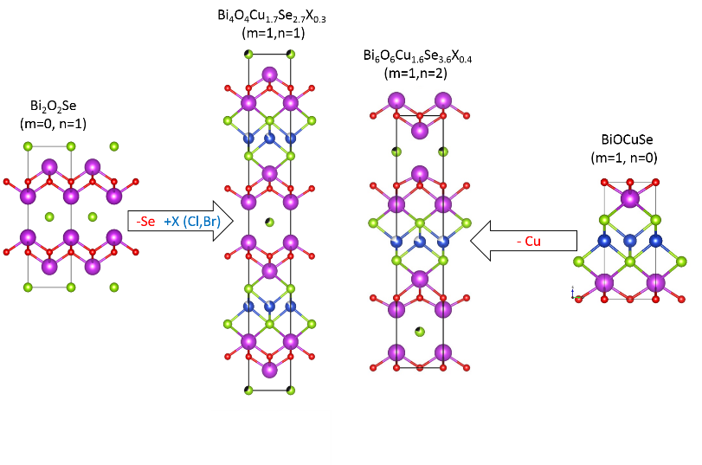
Synopsis: Here we report a new layered homologous series (Bi₂O₂Cu_{2-δ}Se₂)_{m}^{δ+}(Bi₂O₂Se_{1-(m/n)δ}X _{(m/n)δ})_{n}^{δ-} (X=Cl,Br), composed of the known structural blocks BiOCuSe and Bi₂O₂Se. These structures are accessed by combining charge compensating Cu vacancies and (Cl, Br) for Se substitution, in different layers. These new stacking homologoues have markedly different properties to the parent materials, and changing the layer stacking affects the properties including the band gap and thermal conductivity.

