Near Net Shape Manufacturing of Dental Implants using Additive Processes

Amr Elshaer1, Sawmya Nair 1, Hany Hassanin2

1 Drug Discovery, Delivery and Patient Care (DDDPC), School of Life Sciences, Pharmacy and Chemistry, Kingston University London, Penrhyn Road, Kingston upon Thames, Surrey, KT1 2EE, UK

2 School of Mechanical and Automotive Engineering, Kingston University, Roehampton Vale, SW15 3DW London.UK.

****Abstract****

Dental implantation was introduced as a restorative procedure to reinstate the teeth functions and put the patient in normal contour, comfort, speech and health. Dental implants have been used over the centuries and the production techniques have been developed over the years. One of the advanced technologies is additive manufacturing (AM) which enables high degree of freedom ability to produce complex shaped and customized parts similar to human teeth. AM facilitates the production of complex geometric structure without the need of preparing expensive tools, hence it is more cost effective and time saving process. The current chapter provides an overview of AM as a promising technology for near net shape production of dental in preparing customised dental implants. The chapter also explore the anatomy and mechanical properties of human teeth together with the requirements for the design of teeth implants. The chapter survey the current AM technologies used for dental implant, clinical implications and highlights the future trend of AM in the development of near net shaped dental implants.

****Keywords:**** Additive manufacturing, dental implant, 3D printing, clinical evaluation

# Introduction

Human teeth can get damaged or lost because of periodontitis, caries, gum disease, trauma, poor bone density, developmental defects, aging and genetic disorders [1]. Teeth restoration is important as damaged and lost teeth put the patient in severe pain by deteriorating the temporomandibular joint and cause speech disorders. Dental implantation was introduced as a restorative procedure to reinstate the teeth functions and put the patient in normal contour, comfort, speech and health. Dental implants can help in restoring the teeth function for patients who have lost their teeth (either partially or completely edentulous). Dental implants have been used over the centuries and can be traced back to ancient Egyptian and South American civilization. During the pre-Columbian era artificial teeth were made of dark stone. Over the years, dental implantable materials evolved and many materials were used over the centuries. During the 1900s aluminium, red copper, brass, silver, magnesium and gold were used to fabricate teeth implants. Early in the 20th century metal alloys, synthetic polymers and ceramics were introduced and achieved better performance compared to naturally derived materials. Developments of biocompatible dental materials and advances in the manufacturing processes of dental implant are growing rapidly to introduce high performance dental implant. One of the advanced technologies is additive manufacturing (AM). The high degree of freedom ability to produce complex shaped and customized parts are the most advantages of AM which enabled the advancement of many industries such as automotive [2, 3], aerospace [4, 5], biomedical [6-8], and art [9]. AM is not only a robust technology [10], but it is also one of the fast growing market. The estimated value of AM market was more than US$ 5.1 billion in 2015 with a an estimated annual growth rate (CAGR) of about 25.9% [11]. AM also offers short lead time and reduced number of processes. The dentistry workflow using traditional approach (A) and additive manufacturing approach (B) is shown in Figure 1. A typical dental implant requires getting an impression of the patient’ teeth, followed by preparation of the mould. Next, design, casting and finishing of the implant takes place before sending to density for implantation. On the other hand, additive manufactured implant can be archived directly by 3D printing of a digital design made using patient’ teeth scan.

Plaster model

Alginate/PVS impression

Send to the lab

Design and casting

Manual finish

Send to the dentist

Implant in patient

Implant design

Digital scan

3D printing

Implant in patient

A

B

Figure 1: Dentistry workflow using (A) traditional approach (B) and additive manufacturing approach

This chapter provides an overview of additive manufacturing as an important technology to for the manufacturing of dental implants. The structure and properties of teeth, requirements and materials for the design of teeth implants are explained and discussed. The review analysed the current AM technologies used for dental implant and highlights the challenges and future trend of AM in the development of teeth implants.

# Structure and Properties of Teeth

Teeth are most distinctive feature of humans and develop in two sets throughout their lifetime, primary and permanent. The oral cavity consists of upper jaw (maxillary), lower jaw (mandible), teeth, muscles, nerves, and blood vessels. Humans have primary arrangements of teeth, which consist of 10 maxillary teeth and 10 mandibular teeth, a total of 20. All primary teeth are replaced with their permanent corresponding ones. In addition, every human will have 32 permanent teeth, this will consist of 16 maxillary and 16 in the mandible. The first signs of tooth development are a narrow band known as dental lamina. Previous studies have revealed that Pituitary homeobox 2 (Pitx2) and Sonic hedgehog (Shh) are expressed in the lamina in some taxa [12-14]. Afterwards, teeth are initiated within the lamina, while tooth buds are formed at discreet locations in these bands by secondary thickening of the epithelium. Once the teeth are erupted, the teeth can only change with damage that naturally and inevitably occur within the mouth. Human teeth have specific shapes for each tooth for each position in the jaw. Basic shape of the teeth can vary, as it will be precise for dietary such as molar teeth, which are modified for shearing by having cusps with sharp cutting edges, therefore correct formation of teeth is crucial for animal and human survival.

The main structure of a tooth consists of a crown and one or more roots see Figure 2. The crown of the tooth shows out of the mouth and root is the part, which is firmly fixated into the jaw. The crown of a tooth is covered with enamel and has diverse shapes depending on the type of tooth. The main area of tooth is composed of dentin, which is the middle layer of the tooth. The pulp is soft inner tissue, and this is mainly in the crown position. Main four tooth tissues are enamel, cementum, dentin, and pulp, only the first three are hard tissue but pulp is a soft tissue. Enamel is refined from the epithelium of the mouth after dentin is produced and it is the most hard and extremely mineralized material in human body [15]. Dentin originates from underlying mesodermal tissue and pulp cavity contains soft tissues, which can restore the dentin due to tooth wear or damage. As over time, it will endure significant changes erosion or dental decay causing destruction of the hard tissues of the tooth crown. Development of the tooth crown starts as a tooth bud epithelium which forms a `cap'. At this stage enamel knot is present, and at the end of the stage when the cap is formed this relates to the opening of tooth crown shape. The root portion is covered with cementum to help attaching the teeth to the alveolar bone. The pulp interconnects with the periodontal ligament, which is a specialised tissue fiber via a hole in the apex of the tooth root. The pulp and periodontal ligament part of the tooth have good supply of blood and have connective nerves that conduct impulses from sensory receptor.

Nerves and blood vessels

Gingiva

Fissure

Enamel

Dentine

Enamel/ dentine junction

Pulp

Cancellous bone

Root

Crown

Cement

(a)

(b)

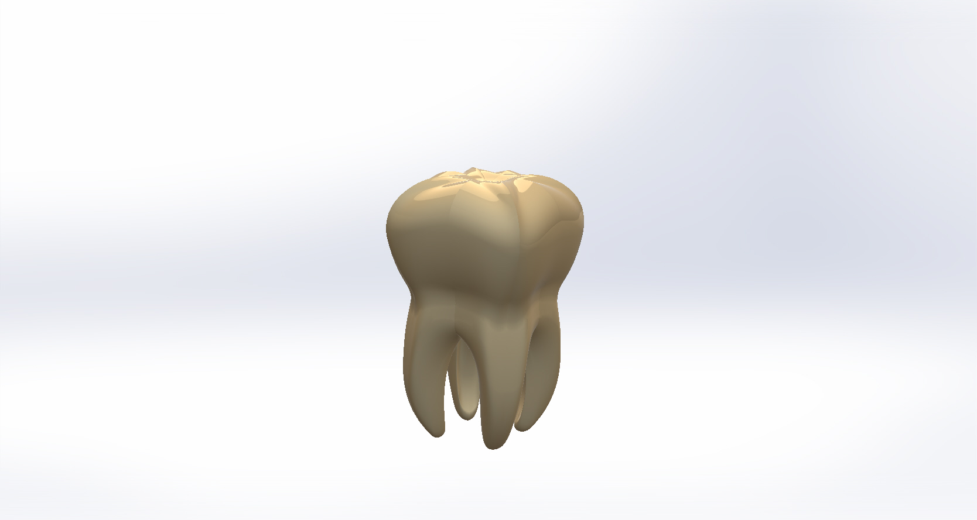

Figure 2: (a) Tooth model, (b) Schematic of structure of a tooth.

Important properties of teeth include hardness, elasticity, fracture toughness, and visco-elasticity. Hardness is a measure of how a material resists plastic deformation. On the other hand, elasticity is a measure of how a material behaves under external load and return back to the original shape after removing the load. The elastic properties of human teeth include the Young’s modulus, which is the ratio of stress to strain within the elastic region. In addition, the shear modulus is the ratio of transverse strain to longitudinal strain. Fracture toughness is defined as the ability of a material to initiate a crack or fracture. Finally, the visco-elasticity of a material is a characteristic that reveals both viscous and elastic behaviour when the material deforms.

Dental hard tissue includes both the enamel and dentin with different arrangements. When eating, enamel is the surface that in contact with food. Hydroxyapatite is the main mineral of enamel, which consists of crystalline calcium phosphate. It has different colours ranging from greyish white to pale yellow. Enamel is considered the hardest tissue as it does not contain any water. It shields the whole crown and protects the dentin. Enamel contains trichome rods with hexagonal prism shape of a diameter of 3–5 µm and varies in density and thickness over the surface of the tooth so that it is the hardest and thickest at the cusps. The enamel layer of primary teeth is half-thick when compared to the permanent teeth and therefore it is less hard. However, tooth enamel cannot be restored once it has been eroded [15].

Dentin structures are hydroxyapatite (70%), organic tissue (20%), and water (10%). Dentin is hard, and it is mainly made of phosphoric apatite crystallites. Cavities are formed by tooth decay which starts with a tiny hole on the enamel surface. Once it has passed through the enamel layer, it spreads deeper and wider into the soft dentin, which can then be easily decayed. Odontoblasts (outer surface of dental pulp) form a single layer that surrounds the pulp chamber. The channels in the dentinal tubules connect calcium ions of dentin and odontoblasts. Pain, temperature, and pressure are transferred to the dentinal tubules nerves through the surface of dental pulp channels. Factors, which affect the mechanical properties of dentin, include tubule orientation collagen fibril, tubule density, and age of the human dentin. The mechanical properties of dentine and enamel are summarised in Table 1.

Table 1: Mechanical properties of enamel and dentine [16]

|  |  |  |
| --- | --- | --- |
| **Teeth type** | **Elastic modulus** | **Hardness** |
| Dentine | 19.89±1.92GPa | 0.92±0.11GPa |
| Enamel | 80.35±7.71GPa | 4.88±0.35GPa |

# Requirements and Materials for Dental Implants

This section discusses the requirements that need to be considered in net shape manufacturing of dental implants. The materials used for dental implants should be biocompatible and possess adequate mechanical characteristics to enable long-term stability. Dental implants are subjected to tensile, shear and compressive forces. Ideally, a dental implant should have high fatigue, fracture toughness and high tensile strength. Bone tissues can also adapt their structure in response to forces exerted on them hence can have higher musculature and jaw performance. This should be taken into account when designing dental implants. Mechanical process hardening methods enhances the strength of the dental implant. Nonetheless, it could compromise the ductility. If ductility gets below 8%, brittle fractures will occur to the implant. Hence, most standardization bodies such as American Society for testing and Material (ASTM), American dental Association (ADA) and International Standardization Organization (ISO) require minimum of 8% ductility of dental implant materials. Besides, dental implantable materials should possess elasticity modulus/stiffness similar to the bone to avoid any stress-shielding [17].

Dental implants should have the ability to resist the surrounding reactive environment in human mouth [18]. Corrosion could take place especially with metallic implants because of the difference in the oxygen and electrolyte composition between the material and the surrounding tissue fluids. It is also believed that the risk of galvanic corrosion is higher in dental implants compared to bone implants. Stress corrosion cracking, fretting corrosion and risk of mechanical degradation are also common in dental implants. Materials used in preparing dental implants should not be toxic and any biodegradation products (cations or anions) should be removed easy by the body metabolic activity without depositing and accumulating in the tissues. Anodic oxidation and cathodic reduction facilitated by the implant biodegrading byproducts are reported to impair the cellular growth and stimuli transmission between cells [19].

Dental implant surface is a main feature that needs to be well designed. *In vitro* studies strongly suggest that rough surfaces of dental implants improve cellular behaviour and promote faster and better bone apposition. Rough surfaces facilitate cellular responses, cytoskeletal organization and maturation of bone tissues. Besides, rough surfaces stimulate faster osseointegration compared to smooth surfaces [20, 21]. The osteoblastic activity is believed to enhanced when the implant possess average surface roughness (Ra) of 1- 7 µm [22]. Many clinical studies reported high success rate and long survival term of dental implants with rough surfaces [23, 24]. Many techniques such as surface modifications, acid-etching, grit-blasting, sandblasting, anodization, discrete calcium-phosphate crystal deposition and surface coating with biological materials have been explored to alter dental implants surfaces.

Porosity, interconnectivity, and pore size within the dental implant are also believed to play mechanical and physiological role in the success of the dental implant. The porous structure of dental implants facilitates the exchange of fluids including nutrients, ions and cells within the bone substitute [25]. Mechanically, controlled porosity minimizes the elastic modulus mismatch between the implant material and the surrounding bone, therefore reduce the stress shielding effect for a longer and more stable fixation [26]. Nonetheless, high porosity improves the contact surface between the dental implant and the surrounding fluids. This mediates biodegradation and osteoinductive potential in the implant [27]. Also high porosity can weaken the material. Therefore, a good and controlled porosity should be achieved. Many researchers recommended a pore size between 100- 400 µm to enable bone cell distribution in the implants [28]. Smaller pores are believed to be occluded by the cells, this prevents the further cellular penetration and elaboration into the scaffold [29]. Spraying techniques co-sintering and plasma spraying have achieved some success in this area, however, none of these techniques but 3D printing managed to produce a scaffold with controlled surface and internal design. The mechanical property of the material used is another key factor to be considered during the designing of dental implants. The main challenge is that the elastic properties for the majority of dental implant materials are different to the surrounding bone tissues. The stiffness of the dental implants is measured by the elastic modulus (stiffness modulus) of the material used. A big variation between the elastic modulus of the implant and the surrounding cortical bone, which possess elastic modulus of 10- 26 GPa, results in stress shielding [30].

# Materials for Dental Implants

The main metal biomaterials are cobalt alloys, stainless steels, aluminium, titanium and titanium alloys [31-34] while the main ceramic biomaterials include hydroxiaptite, zirconia, alumina, and bio-glasses [35-37]. For dental applications, the majority of dental biomaterials are limited to titanium and its alloys and zirconia ceramics.

## Titanium and Titanium Alloys

Titanium has superior biocompatability properties due to its ability to form stable layer of oxide on the surface. Titanium is typically available in 4 grades determined by the amount of the oxygen content [33]. Pure titanium or unalloyed titanium contains trace impurities of iron, carbon, nitrogen, and oxygen can form alloys by reacting with other elements such as Cu, Fe, Al, Ar, Zn, Ur and Va. Titanium- vanadium-aluminium alloy is the most commonly used alloy and can be found in α, β and α- β forms depending on the concentrations of Al, Va used in their preparations. When it comes to biomedical applications, Titanium alloys are amongst the most attractive metals. They are popular materials used to replace hard tissues such as knee joints, hip joints, cardiac valve prostheses and bone platers and screws. Titanium alloys are also used in preparing various dentistry devices and implants such as bridges, crowns, overdentures and implants. Ti-6Al-4V is a typical material for many biomedical implants. Nonetheless, its release of aluminium and vanadium causes toxicity making it not suitable metal for permanent implants.Ti-6Al-4V is believed to have lower removal torque compared to commercially pure Ti and significantly lower bone contacts [38].

## Zirconia ceramics

Ceramics were used to replace metals to enhance the osseointegration of dental implants. Inert ceramics such as aluminum oxides, zirconium oxide and bioactive ceramics such as bioglasses and calcium phosphates are used to coat metal-based endosseous implants. Coating techniques such as sol-gel coating, sputter-deposition, biomimetic precipitation, electrophoretic deposition or plasma spraying are usually used to form a thin layer (between 1 to 100 µm) of ceramic on the metal dental implant [39]. Over time ceramics started to be used in fabricating dental implants. Oxide ceramics such as Yttria stabilised tetragonal zirconia polycrystalline possess high flexural strength (up to 1000 MPa) and resist corrosion and wear. The use of zirconia in preparing dental implants started over a decade ago [40]. Early attempts and clinical evaluations showed that zirconia has outstanding performance thanks to their superior mechanical properties and ease of machining using computer-aided design and computer-aided manufacturing (CAD-CAM). Zirconia exists in monolithic, tetragonal, and cubic crystalline/polymorphic forms. Transformation from the tetragonal to monolithic crystalline phase up on cooling is associated with a large volume increase which leads to implant failure. Therefore stabilizing agents such as yttria (3 mol%) are commonly added to zirconia to quench *t-m* transition at low temperatures. Yttria stabilized zirconia (3Y-TZP) is tougher because of the development of transformation zone which shields crack tips and inhibits the propagation of cracks. The use of ceramics in additive manufacturing of dental implants is still in the early stages. Further investigations are required to assess the mechanical behaviour and physiological responses of ceramics 3D printed dental implants prior to any clinical evaluations. Also preparing crack free zirconia implants remains challenging and further trials are required.

# Additive Manufacturing

The new manufacturing technology, additive manufacturing, refers to a group of processes that has the ability to create 3D parts by adding a material layer-by-layer, whether the material is metal, plastic, ceramics or others. Recently, AM becomes very vital to many industries and in research as well. This is evident by looking at the number of research publications in the past 15 years. Figure 11 shows Scopus search results of the number of publications per year. Additive manufacturing and 3D printing were used in the search. As shown, there is a growing research interest for additive manufacturing and 3D printing as the technology getting more mature for industry and research.

Figure 3: Research interest in additive manufacturing, as indicated by the number of publications globally per year.

AM processes typically start by creating a CAD model representing the physical geometry of specific physical part. The designed model is then uploaded to a 3D printer where it is placed and sliced into layers. The machine builds the part layer by layer until the physical part is completed. The international organization for standardization and American society for testing and materials (ISO/ASTM) introduced the standard of AM ISO/ASTM 52900:2015. According to the standard, AM were grouped into seven main groups as shown in Table 2

Table 2: AM technologies according to ISO/ASTM 52900

|  |  |  |  |  |
| --- | --- | --- | --- | --- |
| AM Process | Material Class | Techniques | Consolidation | References |
| Binder Jetting | Metal, Ceramics, Polymer, | Multi-Jet, Poly-Jet, , Ink-Jet | Binder polymerization | [41, 42] |
| Material Extrusion | Metal, Ceramics, Polymer, Composite | Fused Deposition Modelling (FDM) | Thermal | [43] |
| Powder Bed Fusion | Metal, Polymer, Composite | Selected Laser Melting (SLM), Electron Beam Melting (EBM), Direct Metal Laser Sintering (DMLS) | Laser, Electron Beam | [44] |
| Vat Photo-polymerization | Ceramics, Polymer | Stereo lithography (SLA), Digital Light Processing (DLP), Continuous Liquid Interface Production (CLIP) | Light | [45, 46] |
| Direct Energy Deposition | Metal, Composites | Laser Cladding (LC), Laser Energy Net Shaping (LENS), Laser Deposition Welding (LDW) | Laser | [47] |
| Sheet Lamination | Metal, Composite | Laminated Object Manufacturing (LOM), Solid Foil Polymerization (SFP), Ultrasonic Additive Manufacturing (UAM) | Cutting and Gluing | [48] |

## Binder Jetting

In binder jetting process, a nozzle selectively deposits binder droplets according to a CAD file and often cured using photo-polymerization. The print head of binder jetting printers is similar to those used in paper printers. The difference between the paper printers and binder jetting printers is that in paper printers can print papers in colours while binder jetting printers can print different materials [41, 42], see Figure 4.

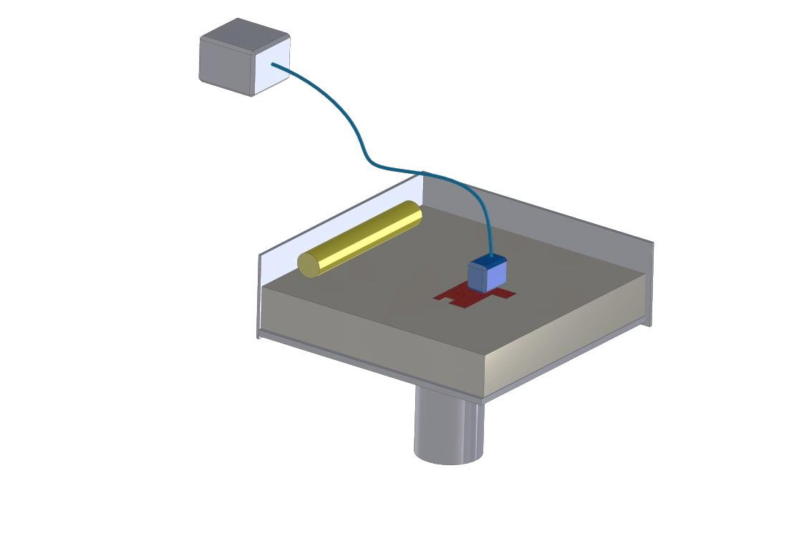

Binder

cartridge

re-coater

Powder bed

Inkjet head

Part

Building Platform

Figure 4: Schematic diagram of binder jetting process

Several researchers studied the use of binder jetting techniques to manufacture dental implants. Özkol et al. [49] investigated the use of ink-jet printing to fabricate Yttria stabilised zirocinia 3Y-TZP dental restorations. A 27% zirconia solution was prepared in water, boehmite solution, and dispersants. Zirconia suspension was injected into Hewlett Packard cartridge and printed using deskjet printer (HP DeskJet 930c, Hewlett Packard). The obtained implant had density of 96.9% and showed superior mechanical properties comparable with 3Y-TZP produced by cold isostatic pressing. The zirconia dental implant had a tensile strength of 763 Mpa and fracture toughness 6.7 ± 1.6 MPam0.5, Figure 5.

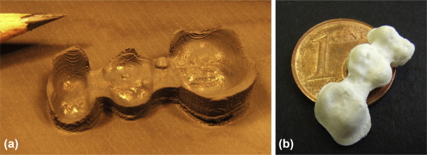

Figure 5: Sintered 3Y-TZP bridge framework fabricated by ink jet printing [49], reused with permission from Elsevier.

## Material extrusion

Material extrusion (ME) works by extruding molten or semi molten materials through a nozzle to create AM components line by line, Figure 6. Typically, the deposited materials are thermoplastic in the form of filaments [43]. As a result wide range of polymers are available in filaments form [50] .

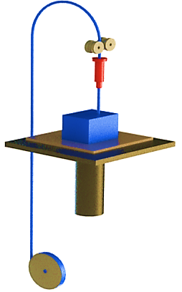

Material Filament

Feed Roller

Heated liquefier

Build Material

X

Y

Z

Build Stage

Figure 6: Schematic diagram of material extrusion process

Material Extrusion based on fused deposition modelling (FDM) was received a notable attention in the development of dental implants. Customized monolithic prosthetic zirconia restorations were established for a 3-unit fixed dental prosthesis and also for an implant-supported single-tooth [51]. The FDM process was used to fabricate the implant cast based on a 3D scanned model, Figure 7. Designing FDM based printed implant cast is expected to expand the use of the digital workflow in the dental applications which holds a great promises in precision and reproducible dentures. The precision of the developed restorations has proved to be clinically acceptable. The process was also used as a planning tool for dental implant surgeries by fabricating jaw bio-model [52]. Using FDM biomedical dental implant improves the safety of the implant surgery and helps in planning the treatment. Having a scanned model of the patient’s jaw enabled the dentist to precisely plan the surgery. In another application, FDM was implemented to fabricate bioresorbable polycaprolactone insertion as a 3D scaffold as a fresh extraction sockets to promote bone healing. The study found that the healing of the ridge after 6 months was better when compared to extraction sockets without the scaffold [53].

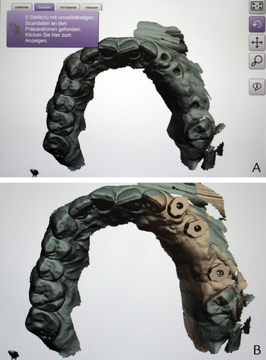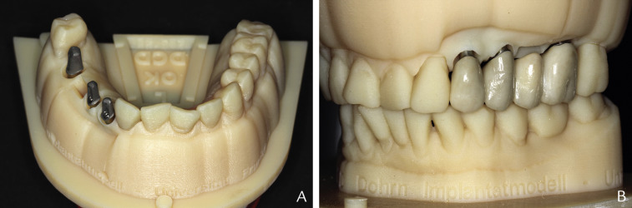

(a)

(b)

(c)

(d)

Figure 7: (a) 3D scan of the soft tissue, (b) 3D model of the dental implant, (c) abutments on FDM implant cast, (d) restoration on FDM implant [51], with permission from Elsevier.

## Powder Bed Fusion

In powder bed fusion process, a powder layer is spread uniformly onto a building platform. In the meanwhile, a laser or electron beam selectively consolidates the layer according to a CAD file. The process is repeated until all the layers are laser scanned and the geometry is created [44]. Selective laser melting (SLM) and electron beam melting (EBM) are two powder bed fusion processes have been available since the 1990’s. SLM is one of the most popular powder bed fusion systems used to build near net shape components, Figure 8. In SLM, a laser beam is used as an energy source to create the components layer by layer [6, 54].

Laser Source

Mirror

Laser Beam

Re-coater blade

Metal Powder

Metal Powder

Formed Object

Powder Platform

Build Platform

Figure 8: Schematic diagram of powder bed fusion process

There is a growing interest in using powder bed fusion processes for industrial applications. The capabilities of using powder bed fusion processes for in metal AM have enhanced significantly in the past two decades since it first became available. SLM offers many advantages over the other AM processes as it can build complex shaped parts with a high accuracy and better surface finish [31, 55, 56]. As a result, the process has been widely investigated to enhance the performance of dental implants. Customized implants with near full density, high mechanical strength and satisfactory accuracy fabricated using SLM shown to be an effective approach for high performance implants [57]. The new dental implant kept the geometry of the root, and showed improved Von Misses stresses and stability. Analog and threaded dental implants were designed by using the reverse engineering approach, Figure 9. The images of the two printed models using SLM are shown in Figure 9 a and b. The figure shows intact implants with no visible distortion cracks, and pores. However, the surfaces show the inherited roughness of SLM process. The pull-out strength of the threaded implants was considerably higher than those with analogue implants, see Figure 9 c.

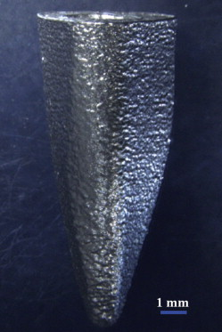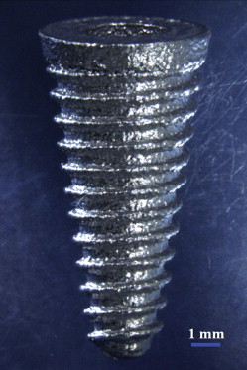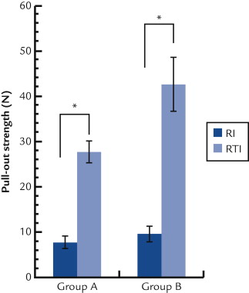

(a)

(b)

(c)

Figure 9: (a) Image of analog implant, (b) Image of threaded implant, (c) pull-out strength comparison between the customized analog and threaded implants, reused with permission from Elsevier, [57].

Tolochko et al. developed a process based on a combination of selective laser melting (SLM) and selective laser sintering (SLS) to create an implant with solid core and porous shell [58]. SLM was also used to prepare dental implants with gradient of porosity content from the core to the shall surface [59]. The titanium alloy dental implant had roughly spherical particles on the surface and showed modulus of elasticity of 104±7.7 GPa at the inner core and 77±3.5 GPa at the outer porous material. The prepared implants were etched with hydrofluoric acid to improve the surface roughness Figure 10.



Figure 10: SEM images of dental implants produced by SLM (a) after sintering, (b) an implant after sintering and etching [59] reused with permission from Elsevier.

Electron beam melting (EBM) is another powder bed technique in which an electron beam is used as energy source to selectively scanned on a layer of metal powder to build metallic components layer by layer. The electron beam velocity can reach a velocity of about 8000m/s while it is only about 10m/s for the laser beam in the SLM technology. Such high scan speed allows the electron beam to move rapidly from one place to another which helps in maximising the effect of multiple beams and allows the metal melt pools to be maintained simultaneously. On the other hand, preheated building platform and vacuum chambers are required in EBM to achieve dense AM parts. However, the process is only limited to conductive materials [60]. Schematic diagram of EBM processes is shown in Figure 11.

Electron beam column

Focus lens

Metal Powder supply

Metal Powder supply

Build platform

Formed Object

Metal Powder supply

Metal Powder supply

Figure 11: Schematic diagram of EBM technology.

Electron Beam Melting (EBM) printer was used to build an implant similar to the tooth geometry [61]. The printed implant is a one-component implant with 2 interfaces: implant/dental prosthesis and an implant /jaw bone, see Figure 12. It is believed that producing an identical implant to the original tooth will maintain the loading distribution on the jawbone and void any pre-insertion procedures such as boring and drilling. Mechanically the produced implant showed superior mechanical strength and elongation but poor ductility [61]. In general, samples produced by EBM have poor surface texture, which may require surface polishing post processing techniques for applications where parts with smooth surfaces are required. However, the inherited surface roughness of EBM samples holds benefits to AM dental implants. Ramakrishnaiah et al. [62] manufactured customized medical grade Ti–6Al–4V dental implant using EBM system. They found the rough surface roughness improves tissue ingrowth into implant porosities and enhance osseointegration. Results also showed good surface wetting, which promotes osteoblastic adhesion on the surface of the implant. However, they concluded that the rough surface roughness of EBM must be addressed for other intraoral dental restorations as it leads to accumulation of food and further gum problems. Therefore, surface-finishing techniques such as sand blasting, and milling were found useful to have dental implants with smooth surfaces. Yang et al. [63] studied the osseointegration and stability of EBM manufactured rough surface samples and compared it with smooth surface titanium samples. They revealed that the torsional resistance and osseointegration of the implant are improved with the rough surface created by the EBM implant. On the other hand, fixed and removable partial dentures dental applications require smooth dental parts with smooth surface to avoid accumulation of food and to improve patient comfort. Hence, improving surface finish using techniques such as sand blasting are recommended for such application and also may have another beneficial effect to reduce stress concentration [64]. EBM parts with improved surface finish can also be realized by altering the CAD model, slicing conditions, orienting the model direction in the building platform and by controlling the energy inputs [65].

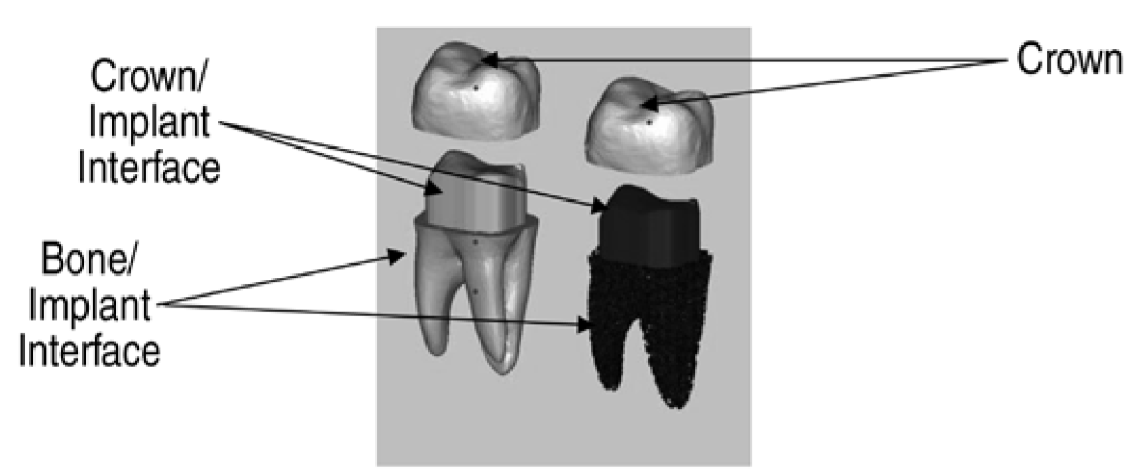

(a)

(b)

Figure 12: A solid dental implant (left) and lattice bone/implant (right) adapted from [61], (a) Model, (b) EBM implants, reused with permission from Springer.

Several other studies have investigated the manufacturing and characterisation of customised dental implants using EBM. Jamshidiniaa et al. [66] manufactured dental implant model with lattice structure for fatigue characterisation. Their study showed that their lattice design can withstand load of five million cyclic at 100 N. They also found that fatigue failure in their implant was because of non-melted particles and the sharp and rough surface of the structure, Figure 13. In another study by Jamshidiniaa [66], they investigated the properties of non-stochastic lattices dental implant. They manufactured different designs such as honeycomb, octahedral, cross, and studied mechanical behaviour of lattice structure when subjected to biting forces. They found that the deformation of the implant was increased with the increase of the cell size.

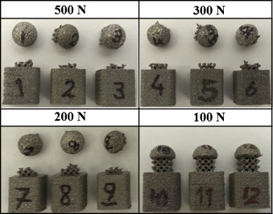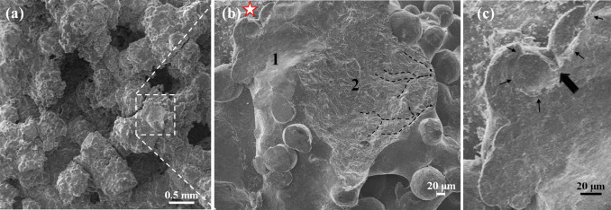

(a)

(b)

(c)

(d)

Figure 13: (a) Fatigue test samples with lattice structures under different cyclic loads, (b) SEM image of a broken lattice sample under 500-N load (c) higher magnification SEM image shows cracks initiation and stable growth step (1,2), (d) Crack initiation and brittle fracture [66], reused with permission from Elsevier.

## Vat photo-polymerization

Vat photo-polymerization is a popular technique to create 3D components from photo or UV sensitive materials, see Figure 14. Stereo-lithography apparatus (SLA) and continuous liquid interface production (CLIP) are two techniques used to manufacture polymer and ceramic parts [41]. The stereo-lithographic dental template has proved to allow an accurate and stable seat on surgical procedure of dummy mandibles. Hence, the process offers a proper planning and, therefore, safe flapless placement of dental implant [67, 68]. *Lee et al.* [69] printed zirconia dental implants using SLA. The authors mixed zirconia powder together with a light curable resin in methanol as an organic solvent. The layers were added on the top of one another and connected tightly upon the evaporation of methanol then a green block was prepared using solvent soluble slurry. The green block was solidified in methanol before sintering at 600 oC to burnout the binder then at 1450 oC to sinter the zirconia. The prepared dental implant had flexural strength of 539.1 MPa and microhardness of 1556 HV. Zirconia was also in Mitteramskogler et al studies who proposed the use of light to cure Lithography-based SLA printed implants [70]. Light curing produces implants with higher surface resolution and quality compared to thermal polymerization. During the light curing processes, the intensity of light and exposure time can be optimized according to the characteristics of the slurry used. The characteristics of zirconia dental implants prepared by SLA were reported in recent literature studies (*Osman et al* [71]. Osman and co-worker investigated the surface topography and dimensional accuracy of zirconia implants printed by SLA. The angle of printing was found to affect the mechanical characteristics of the implant. Vertical printing at an angle of 0o showed the highest flexure strength of 1006.6 MPa followed by tilted printing at 45o and horizontal printing at 90o, possibly because of the vector of the applied force. All the prepared implants were of high dimensional accuracy (root mean square value of 0.1 mm) and had micro-porosity ranging between 196 nm to 3.3 μm of which some were connected resulting in flaws. All the prepared implants were moderately rough with mean roughness of 1.59 ±0.41 μm that can mediate osseointegration.

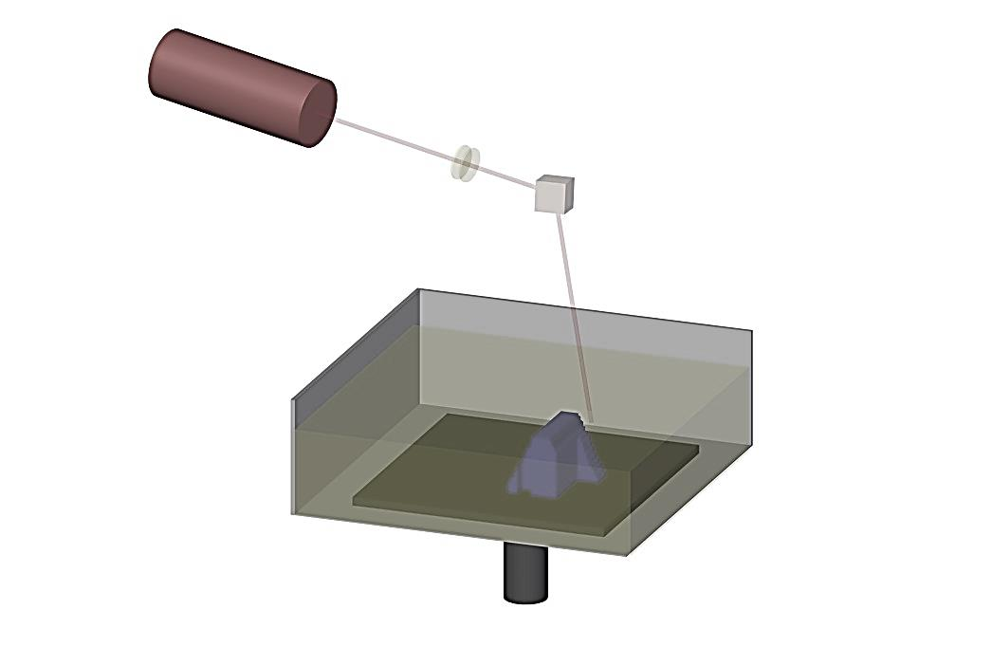

Laser

Lenses

Liquid photopolymer

Layered part

Moving platform

Scanning mirror

Laser beam

Figure 14: Schematic diagram of photo-polymerization process

## Sheet Lamination (SL) and Direct Energy Deposition

Based upon extensive study of the available literature, it can be concluded that, sheet, sheet lamination (SL) and direct energy deposition (DED) are two AM techniques that have not yet explored for dental applications. Extremely poor quality and large size limitation of both techniques, could be the possible reason behind that, which are not adequate for dental implant applications.

A summary of the research work that used AM in the dental implant applications is shown in Table 3. Powder bed fusion techniques such as selective laser melting and electron beam melting were mostly used to fabricate metal dental implants. This may be because both techniques can well process metals such as titanium super alloys with ease, high precision, and acceptable surface roughness. Stereo-lithography and fused deposition modeling are often enabled to support dental implant surgeries with their ability to manufacture accurate dental guided template, insert and moulds for patients’ teeth and jaws impression. In addition, zirconia dental implants were successfully manufactured using stereo-lithography of zirconia slurry and also using FDM from polymers fabricated moulds.

Table 3: Overview of AM technology used for dental implants

|  |  |  |  |
| --- | --- | --- | --- |
| AM technology | Materials | Dental applications | References |
| Selective laser melting | Ti-6Al-4V | Implants | [57-59] |
| Electron beam melting | Ti-6Al-4V | Implants | [61-64] |
| Ink-Jet | Zirconia | Implants | [49] |
| Fused deposition modelling | Thermos-plastic polymers | Implant cast, guided template, models | [51-53] |
| Stereo-lithography | Photo sensitive polymers, Zirconia | Guided template, models | [69-71] |

# Clinical evaluation of 3D implants

Many *in vitro* studies have been conducted to study the cellular response to 3D dental implants. For instance *Mangano et al* [72] studied the behaviour of human osteoblast, dental pulps stem cells on titanium implants printed with Selective Laser Sintering while *Mangano et al* [73] studied the effect of 3D printed Ti6Al4V alloy on rat calvarial osteoblasts. These studies concluded that titanium prepared with laser sintering improved the osteoblastic differentiation and enabled the production of endothelial growth factors and morphogenetic proteins which was attributed to the ability of the 3D printing method to control the topographical porosity.

Animal studies also reported the bone response to 3D printed dental implants. *Witek et al*. [74] compared the biomechanical and histomorphometrical behaviour of laser sintered titanium implants against alumina-blasted/acid-etched implant using male beagle dogs. The surfaces of the laser sintered implants demonstrated higher Sa and Sq which increases the blood clot retention during the healing process. Besides, the 3D implants showed higher torque after one and six week of implanting due to their higher surface texture with Sa mean value of 1.26 µm showing stronger bone response when compared to alumina-blasted/acid-etched implants with 0.56 µm. Moreover, the 3D printed implants showed superior bone area fraction occupancy and Bone-to-implant contact (BIC) when compared to alumina-blasted/acid-etched implants. *Stubinger et al.* [75] also evaluated the behaviour of titanium implants in Swiss Alpine sheep and reported similar findings to *Witek et al* studies. 3D printed dental implants deemed to have higher fixation strength and torque values when compared to standard machined or sandblasted and etched implants. The macroporous surface generated by the additive manufactured technique (DMLS). Another study conducted by *Ponader et al.* [76] prepared Ti-6Al-4V porous implants using elective electron beam melting (SEBM) and studied the ingrowth of osseous tissues in domestic pigs over 60 days. Over the sixty days, bone tissues have grown steadily inside the implant and managed to reach 46% at the end of the experiment. Nonetheless, some scarce bone-implant was formed around the compact specimen.

Clinical evaluations of dental implants using human participants were undertaken to understand the healing mechanism and the behaviour of bone tissues surrounding the 3D dental implants. Mangano and co-workers histologically and microscopically evaluated the formation of bone around DLMS dental implants. Micro-implants were implanted in the jawbone of four human participants which were retrieved after a healing period of 8 weeks. The bone-implant interface was evaluated using histomorphometric analysis and scanning electron microscopy. Calcium and phosphorus was revealed in the elemental analysis studies confirming the formation of new bone matrix over the DLMS implants. This suggests that the surfaces of DLMS implants can provide stratum for growth of bone tissues [77]. Besides the rough surface topography of the 3D implant enhances the differentiation and proliferation of the osteocytes. Bone is believed to be formed within the structure of the 3D dental implants by the migration of osteoblast precursors into the implant gaps , the cells grow until they reach confluence where the proliferation cease and cells begins to differentiate. On the other hand, the healing process is believed to begin after the insertion of the 3D implant. The process is triggered by the blood clot formation in the peri-implant gaps which cascades the formation of fibrins. Clinical studies also compared between immediately loaded and unloaded 3D printed implants. Shibli et al inserted 12 transitional immediately loaded and unloaded implants in the posterior maxilla of 12 edentulous patients and evaluated the surrounding tissues using histomorphometric analysis. After 2 months, all the inserted implants were found to enable the growth of new bone on the top of the mature pre-existing bone. The histological studies concluded that the bone-to-implant contact was higher in the loaded direct laser metal-forming implants compared to the unloaded ones [78].

Many clinical studies have also looked the survival and success rate of 3D printed dental implants. A successful dental implant should devoid any continuous peri-implant radiolucency, mobility and should not cause prothetic complication. Dental implants should not also cause any biological complications such as per-implant infection, exudation, suppuration, soft tissue inflammation, swelling and sensitivity. Failure of dental implants is common in the maxilla than in the mandible. Factors such as low bone intensity, poor quality of bone, use of implants with small diameter and short length attribute to the failure of the dental implant. Mangano and colleagues conducted a multi-centre clinical study to evaluate the survival rate of 201 3D printed dental implants [77]. The 3D implants prepared by showed a survival rate of 99.5% as one implant in the posterior maxilla was lost during the 1-year study. The early failure of this implant was due to the lack of Osseointegration. The success rate was reported to be 97.5% with 5 implants did not fulfil the implant requirements. A single implant (0.5%) caused sensitivity when functioning and two implants (1%) showed large gap between the implant shoulder and the bone contact, while the remaining 2 implants (1%) became loose [79]. Long term clinical studies were conducted as well to measure the survival rate of 3D dental implants. Mangano and co-workers collected clinical and radiographic data annually and over 3 years. The incidence of biological complications was reported to be 10.6% and prosthetic complications of 17.8% were reported [80]. Similar results were investigated by Tunchel et al 2016 [81]. Many techniques such as x-ray radiography, x-ray tomography histomorphometry, x-ray micro-CT and synchrotron radiation-based computed microtomography helped a lot in evaluating the bone macroscopic structure in the clinical studies.

# Conclusion and Future Outlook

Despite the huge advancements in dental implant fabrication, most of the conventional manufacturing technologies fail to fabricate a dental scaffold with controlled porosity and complex geometry. Additive manufacturing technologies enable customization of dental implants to accommodate the patients’ needs and conditions. They can produce any geometric structure without the need of preparing moulds or many tools. The flexibility, availability, and cost savings of AM have gained much interest in manufacturing dental implants. The process is facilitated by the advancement in computer-aided design/computer-aided manufacturing (CAD/CAM) technologies that empower accurate, fast scanning and modelling of patient dental structures. Literature reviews show that selective laser melting and electron beam melting were widely used to fabricate titanium dental implants. The two techniques have proven to process near net shaped titanium implants with high precision. In few studies, zirconia dental implants were also fabricated using fused deposition modelling and stereo-lithography, while the majority of the applications of the former two technologies were limited to dental guided template, insert and moulds. Additive manufacturing technologies will enable industries to control the microarchitecture and the geometry of customised dental implants. This means a better control over the mechanical properties of the teeth implants and the biological behaviour of the surrounding bone tissues. Clinical evaluations of 3D dental implants look promising as majority of the clinical studies reported high success and survival rate. **The investigated research presented in this chapter showed that understanding of AM processes for biomedical implants is still insufficient, dentists and manufacturers must understand the process limitations such as inspection, and quality control and the need to post processing in order to support the penetration of this technology into dental applications. Although AM proved capable to satisfy dental implants requirements, many of the presented research are in the early stages and more work are needed on the design, materials, and quality in order to well establish the technology to fit a broad range of dental applications.**

**References**

[1] R. Leal, F. M. Barreiros, L. Alves, F. Romeiro, J. C. Vasco, M. Santos*, et al.*, "Additive manufacturing tooling for the automotive industry," *International Journal of Advanced Manufacturing Technology,* pp. 1-7, 2017.

[2] P. Bubna, M. P. Humbert, M. Wiseman, and E. Manes, "Barriers to Entry in Automotive Production and Opportunities with Emerging Additive Manufacturing Techniques," *SAE Technical Papers,* vol. 0329, p. 8, 2016.

[3] C. K. Chua and K. F. Leong, *3D Printing and Additive Manufacturing: Principles and Applications*: World Scientific, 2014.

[4] K. Essa, H. Hassanin, M. Attallah, N. Adkins, A. Musker, G. Roberts*, et al.*, "Development and Testing of an Additively Manufactured Monolithic Catalyst Bed for HTP Thruster Applications," *Applied Catalysis A: General,* 2017.

[5] A. Uriondo, M. Esperon-Miguez, and S. Perinpanayagam, "The present and future of additive manufacturing in the aerospace sector: A review of important aspects," *Proceedings of the Institution of Mechanical Engineers, Part G: Journal of Aerospace Engineering,* vol. 229, pp. 2132-2147, 2015.

[6] L.-C. Zhang and H. Attar, "Selective Laser Melting of Titanium Alloys and Titanium Matrix Composites for Biomedical Applications: A Review " *Advanced Engineering Materials,* vol. 18, pp. 463-475, 2016.

[7] Y. L. Hao, S. J. Li, and R. Yang, "Biomedical titanium alloys and their additive manufacturing," *Rare Metals,* vol. 35, pp. 661-671, 2016.

[8] J.-Y. Lee, W. S. Tan, J. An, C. K. Chua, C. Y. Tang, A. G. Fane*, et al.*, "The potential to enhance membrane module design with 3D printing technology," *Journal of Membrane Science,* vol. 499, pp. 480-490, 2016/02/01/ 2016.

[9] Y. L. Yap and W. Y. Yeong, "Additive manufacture of fashion and jewellery products: a mini review: This paper provides an insight into the future of 3D printing industries for fashion and jewellery products," *Virtual and Physical Prototyping,* vol. 9, pp. 195-201, 2014.

[10] I. J. Petrick and T. W. Simpson, "3D printing disrupts manufacturing: how economies of one create new rules of competition: 3D printing may represent a disruption to the manufacturing industry as profound as the industrial revolution.(POINT OF VIEW)," *Research-Technology Management,* vol. 56, p. 12, 2013.

[11] Wohlers-Associates-Inc., "Additive manufacturing industry surpassed US$5.1 billion in 2015," *Metal Powder Report,* vol. 71, p. 288, 08 2016.

[12] G. J. Fraser, A. Graham, and M. M. Smith, "Developmental and evolutionary origins of the vertebrate dentition: molecular controls for spatio-temporal organisation of tooth sites in osteichthyans," *Journal of Experimental Zoology Part B: Molecular and Developmental Evolution,* vol. 306B, pp. 183-203, 2006.

[13] M. M. Smith, G. J. Fraser, N. Chaplin, C. Hobbs, and A. Graham, "Reiterative pattern of <em>sonic hedgehog</em> expression in the catshark dentition reveals a phylogenetic template for jawed vertebrates," *Proceedings of the Royal Society B: Biological Sciences,* vol. 276, pp. 1225-1233, 2009.

[14] F. J. Vonk, J. F. Admiraal, K. Jackson, R. Reshef, M. A. G. de Bakker, K. Vanderschoot*, et al.*, "Evolutionary origin and development of snake fangs," *Nature,* vol. 454, p. 630, 07/31/online 2008.

[15] E. Mahoney, F. S. M. Ismail, N. Kilpatrick, and M. Swain, "Mechanical properties across hypomineralized/hypoplastic enamel of first permanent molar teeth," *European Journal of Oral Sciences,* vol. 112, pp. 497-502, 2004.

[16] E. K. Mahoney, R. Rohanizadeh, F. S. M. Ismail, N. M. Kilpatrick, and M. V. Swain, "Mechanical properties and microstructure of hypomineralised enamel of permanent teeth," *Biomaterials,* vol. 25, pp. 5091-5100, 2004/09/01/ 2004.

[17] M. Niinomi and M. Nakai, "Titanium-based biomaterials for preventing stress shielding between implant devices and bone," *International Journal of Biomaterials,* 2011.

[18] V. Sansone, D. Pagani, and M. Melato, "The effects on bone cells of metal ions released from orthopaedic implants. A review," *Clinical Cases in Mineral and Bone Metabolism,* vol. 10, pp. 34-40, 2013.

[19] H. Zitter and H. Plenk, Jr., "The electrochemical behavior of metallic implant materials as an indicator of their biocompatibility," *J Biomed Mater Res,* vol. 21, pp. 881-96, Jul 1987.

[20] J. A. Shibli, S. Grassi, L. C. De Figueiredo, M. Feres, E. Marcantonio Jr, G. Iezzi*, et al.*, "Influence of implant surface topography on early osseointegration: A histological study in human jaws," *Journal of Biomedical Materials Research - Part B Applied Biomaterials,* vol. 80, pp. 377-385, 2007.

[21] J. A. Shibli, S. Grassi, A. Piattelli, G. E. Pecora, D. S. Ferrari, T. Onuma*, et al.*, "Histomorphometric Evaluation of Bioceramic Molecular Impregnated and Dual Acid-Etched Implant Surfaces in the Human Posterior Maxilla," *Clinical Implant Dentistry and Related Research,* vol. 12, pp. 281-288, 2010.

[22] A. Curtis and P. Clark, "The effects of topographical and mechanical properties of materials on cell behavior," *Critical Reviews in Biocompatibility,* vol. 4, pp. 343-362, 1990.

[23] E. Romeo, D. Lops, E. Margutti, M. Ghisolfi, M. Chiapasco, and G. Vogel, "Long-term survival and success of oral implants in the treatment of full and partial arches: A 7-year prospective study with the ITI dental implant system," *International Journal of Oral and Maxillofacial Implants,* vol. 19, pp. 247-259, 2004.

[24] P. G. Khayat and S. N. Milliez, "Prospective clinical evaluation of 835 multithreaded tapered screw-vent implants: results after two years of functional loading," *The Journal of oral implantology,* vol. 33, pp. 225-231, 2007.

[25] A. Lecomte, H. Gautier, J. M. Bouler, A. Gouyette, Y. Pegon, G. Daculsi*, et al.*, "Biphasic calcium phosphate: A comparative study of interconnected porosity in two ceramics," *Journal of Biomedical Materials Research - Part B Applied Biomaterials,* vol. 84, pp. 1-6, 2008.

[26] H. Kröger, P. Venesmaa, J. Jurvelin, H. Miettinen, O. Suomalainen, and E. Alhava, "Bone density at the proximal femur after total hip arthroplasty," *Clinical Orthopaedics and Related Research,* pp. 66-74, 1998.

[27] P. Habibovic, H. Yuan, C. M. Van Der Valk, G. Meijer, C. A. Van Blitterswijk, and K. De Groot, "3D microenvironment as essential element for osteoinduction by biomaterials," *Biomaterials,* vol. 26, pp. 3565-3575, 2005.

[28] Y. Kuboki, Q. Jin, and H. Takita, "Geometry of carriers controlling phenotypic expression in BMP-induced osteogenesis and chondrogenesis," *Journal of Bone and Joint Surgery - Series A,* vol. 83, pp. S1105-S1115, 2001.

[29] B. D. Boyan, T. W. Hummert, D. D. Dean, and Z. Schwartz, "Role of material surfaces in regulating bone and cartilage cell response," *Biomaterials,* vol. 17, pp. 137-146, 1996.

[30] C. Larsson, M. Esposito, H. Liao, and P. Thomsen, "The Titanium-Bone Interface In Vivo," in *Titanium in Medicine: Material Science, Surface Science, Engineering, Biological Responses and Medical Applications*, ed Berlin, Heidelberg: Springer Berlin Heidelberg, 2001, pp. 587-648.

[31] H. Hassanin, F. Modica, M. A. El‐Sayed, J. Liu, and K. Essa, "Manufacturing of Ti–6Al–4V Micro‐Implantable Parts Using Hybrid Selective Laser Melting and Micro‐Electrical Discharge Machining," *Advanced Engineering Materials,* vol. 18, pp. 1544-1549, 2016.

[32] M. A. El-Sayed, H. Hassanin, and K. Essa, "Effect of casting practice on the reliability of Al cast alloys," *International Journal of Cast Metals Research,* vol. 29, pp. 350-354, 2016/11/01 2016.

[33] H. Hassanin, L. Finet, S. C. Cox, P. Jamshidi, L. M. Grover, D. E. T. Shepherd*, et al.*, "Tailoring selective laser melting process for titanium drug-delivering implants with releasing micro-channels," *Additive Manufacturing,* vol. 20, pp. 144-155, 3// 2018.

[34] K. Essa, P. Jamshidi, J. Zou, M. M. Attallah, and H. Hassanin, "Porosity control in 316L stainless steel using cold and hot isostatic pressing," *Materials & Design,* vol. 138, pp. 21-29, 2018/01/15/ 2018.

[35] H. Hassanin and K. Jiang, "Net shape manufacturing of ceramic micro parts with tailored graded layers," *Journal of Micromechanics and Microengineering,* vol. 24, p. 015018, 2014.

[36] H. Hassanin and K. Jiang, "Infiltration-processed, functionally graded materials for microceramic componenets," in *2010 IEEE 23rd International Conference on Micro Electro Mechanical Systems (MEMS)*, 2010, pp. 368-371.

[37] H. Hassanin and K. Jiang, "Fabrication and characterization of stabilised zirconia micro parts via slip casting and soft moulding," *Scripta Materialia,* vol. 69, pp. 433-436, 2013/09/01/ 2013.

[38] C. B. Johansson, A. Wennerberg, and T. Albrektsson, "Quantitative comparison of screw-shaped commercially pure titanium and zirconium implants in rabbit tibia," *Journal of Materials Science: Materials in Medicine,* vol. 5, pp. 340-344, 1994.

[39] W. R. Lacefield, "Current Status of Ceramic Coatings for Dental Implants," *Implant Dentistry,* vol. 7, pp. 315-322, 1998.

[40] I. Denry and J. R. Kelly, "State of the art of zirconia for dental applications," *Dental Materials,* vol. 24, pp. 299-307, 2008.

[41] J. R. Tumbleston, D. Shirvanyants, N. Ermoshkin, R. Janusziewicz, A. R. Johnson, D. Kelly*, et al.*, "Continuous liquid interface production of 3D objects," *Science,* vol. 347, pp. 1349-1352, American Association for the Advancement of Science 2015.

[42] A. Cazón, P. Morer, and L. Matey, "PolyJet technology for product prototyping: Tensile strength and surface roughness properties," *Proceedings of the Institution of Mechanical Engineers, Part B: Journal of Engineering Manufacture,* vol. 228, pp. 1664-1675, 2014.

[43] R. Singh, "Process capability analysis of fused deposition modelling for plastic components," *Rapid Prototyping Journal,* vol. 20, pp. 69-76, 2014.

[44] S. Kaierle, A. Barroi, C. Noelke, J. Hermsdorf, L. Overmeyer, and H. Haferkamp, "Review on Laser Deposition Welding: From Micro to Macro," *Physics Procedia,* vol. 39, pp. 336-345, 2012 2012.

[45] H. Wu, D. Li, Y. Tang, B. Sun, and D. Xu, "Rapid fabrication of alumina-based ceramic cores for gas turbine blades by stereolithography and gelcasting," *Journal of Materials Processing Technology,* vol. 209, pp. 5886-5891, 9/19 2009.

[46] R. E. Williams, S. N. Komaragiri, V. L. Melton, and R. R. Bishu, "Investigation of the effect of various build methods on the performance of rapid prototyping (stereolithography)," *Journal of Materials Processing Technology,* vol. 61, pp. 173-178, August 1996 1996.

[47] S. Nowotny, S. Thieme, S. Scharek, T. Rönnefahrt, and R. A. Gnann, "FLEXILAS - Laser-Präzisionstechnologie zum Auftragschweißen mit zentrischer Drahtzufuhr," in *Die Verbindungs Spezialisten 2008*, ed, 2008, pp. 318-322.

[48] H. Bikas, P. Stavropoulos, and G. Chryssolouris, "Additive manufacturing methods and modelling approaches: a critical review," *The International Journal of Advanced Manufacturing Technology,* vol. 83, pp. 389-405, 2016.

[49] E. Özkol, W. Zhang, J. Ebert, and R. Telle, "Potentials of the “Direct inkjet printing” method for manufacturing 3Y-TZP based dental restorations," *Journal of the European Ceramic Society,* vol. 32, pp. 2193-2201, 2012/08/01/ 2012.

[50] AMT/8, " Additive manufacturing. General principles. Overview of process categories and feedstock," vol. BS EN ISO 17296, First ed, 2015, p. 8.

[51] J. Brandt, H.-C. Lauer, T. Peter, and S. Brandt, "Digital process for an implant-supported fixed dental prosthesis: A clinical report," *The Journal of Prosthetic Dentistry,* vol. 114, pp. 469-473, 2015/10/01/ 2015.

[52] Y. R. Kumar, "Bio-modelling using rapid prototyping by fused deposition," in *Advanced Materials Research* vol. 488-489, ed, 2012, pp. 1021-1025.

[53] B. T. Goh, L. Y. Teh, D. B. P. Tan, Z. Zhang, and S. H. Teoh, "Novel 3D polycaprolactone scaffold for ridge preservation - a pilot randomised controlled clinical trial," *Clinical Oral Implants Research,* vol. 26, pp. 271-277, 2015.

[54] D. D. Gu, W. Meiners, K. Wissenbach, and R. Poprawe, "Laser additive manufacturing of metallic components: materials, processes and mechanisms," *International Materials Reviews,* vol. 57, pp. 133-164, 2012/05/01 2012.

[55] H. Hassanin, K. Essa, C. Qiu, A. M. Abdelhafeez, N. J. Adkins, and M. M. Attallah, "Net-shape manufacturing using hybrid selective laser melting/hot isostatic pressing," *Rapid Prototyping Journal,* vol. 23, p. 720, 2017.

[56] A. Sabouri, A. K. Yetisen, R. Sadigzade, H. Hassanin, K. Essa, and H. Butt, "Three-dimensional microstructured lattices for oil sensing," *Energy & Fuels,* vol. 31, pp. 2524-2529, 2017.

[57] J. Chen, Z. Zhang, X. Chen, C. Zhang, G. Zhang, and Z. Xu, "Design and manufacture of customized dental implants by using reverse engineering and selective laser melting technology," *The Journal of Prosthetic Dentistry,* vol. 112, pp. 1088-1095.e1, 2014/11/01/ 2014.

[58] N. K. Tolochko, V. V. Savich, T. Laoui, L. Froyen, G. Onofrio, E. Signorelli*, et al.*, "Dental root implants produced by the combined selective laser sintering/melting of titanium powders," *Proceedings of the Institution of Mechanical Engineers Part L: Journal of Materials: Design and Applications,* vol. 216, pp. 267-270, 2002.

[59] T. Traini, C. Mangano, R. L. Sammons, F. Mangano, A. Macchi, and A. Piattelli, "Direct laser metal sintering as a new approach to fabrication of an isoelastic functionally graded material for manufacture of porous titanium dental implants," *Dental Materials,* vol. 24, pp. 1525-1533, 2008.

[60] C. Körner, "Additive manufacturing of metallic components by selective electron beam melting - A review," *International Materials Reviews,* vol. 61, pp. 361-377, 2016.

[61] G. Chahine, M. Koike, T. Okabe, P. Smith, and R. Kovacevic, "The design and production of Ti-6Al-4V ELI customized dental implants," *JOM,* vol. 60, pp. 50-55, 2008.

[62] R. Ramakrishnaiah, A. A. Al kheraif, A. Mohammad, D. D. Divakar, S. B. Kotha, S. L. Celur*, et al.*, "Preliminary fabrication and characterization of electron beam melted Ti–6Al–4V customized dental implant," *Saudi Journal of Biological Sciences,* vol. 24, pp. 787-796, 2017/05/01/ 2017.

[63] J. Yang, H. Cai, J. Lv, K. Zhang, H. Leng, Z. Wang*, et al.*, "Biomechanical and Histological Evaluation of Roughened Surface Titanium Screws Fabricated by Electron Beam Melting," *PLOS ONE,* vol. 9, p. e96179, 2014.

[64] N. Elmagrabi, C. H. Che Hassan, A. G. Jaharah, and F. M. Shuaeib, "High speed milling of Ti-6Al-4V using coated carbide tools," *European Journal of Scientific Research,* vol. 22, pp. 153-162, 2008.

[65] N. W. Hrabe, P. Heinl, R. K. Bordia, C. Körner, and R. J. Fernandes, "Maintenance of a bone collagen phenotype by osteoblast-like cells in 3D periodic porous titanium (Ti-6Al-4 V) structures fabricated by selective electron beam melting," *Connective tissue research,* vol. 54, p. 10.3109/03008207.2013.822864, 09/30 2013.

[66] M. Jamshidinia, L. Wang, W. Tong, R. Ajlouni, and R. Kovacevic, "Fatigue properties of a dental implant produced by electron beam melting® (EBM)," *Journal of Materials Processing Technology,* vol. 226, pp. 255-263, 2015/12/01/ 2015.

[67] C. Vasak, G. D. Strbac, C. D. Huber, S. Lettner, A. Gahleitner, and W. Zechner, "Evaluation of three different validation procedures regarding the accuracy of template-guided implant placement: an in vitro study," *Clinical implant dentistry and related research,* vol. 17, pp. 142-149, 2015.

[68] S. Kühl, M. Payer, N. U. Zitzmann, J. T. Lambrecht, and A. Filippi, "Technical Accuracy of Printed Surgical Templates for Guided Implant Surgery with the coDiagnostiXTM Software," *Clinical Implant Dentistry and Related Research,* vol. 17, pp. e177-e182, 2015.

[69] C.-P. Jiang, H.-J. Hsu, and S.-Y. Lee, "Development of mask-less projection slurry stereolithography for the fabrication of zirconia dental coping," *International Journal of Precision Engineering and Manufacturing,* vol. 15, pp. 2413-2419, November 01 2014.

[70] G. Mitteramskogler, R. Gmeiner, R. Felzmann, S. Gruber, C. Hofstetter, J. Stampfl*, et al.*, "Light curing strategies for lithography-based additive manufacturing of customized ceramics," *Additive Manufacturing,* vol. 1, pp. 110-118, 2014.

[71] R. B. Osman, A. J. van der Veen, D. Huiberts, D. Wismeijer, and N. Alharbi, "3D-printing zirconia implants; a dream or a reality? An in-vitro study evaluating the dimensional accuracy, surface topography and mechanical properties of printed zirconia implant and discs," *Journal of the Mechanical Behavior of Biomedical Materials,* vol. 75, pp. 521-528, 2017.

[72] C. Mangano, A. De Rosa, V. Desiderio, R. d'Aquino, A. Piattelli, F. De Francesco*, et al.*, "The osteoblastic differentiation of dental pulp stem cells and bone formation on different titanium surface textures," *Biomaterials,* vol. 31, pp. 3543-3551, 2010/05/01/ 2010.

[73] C. Mangano, M. Raspanti, T. Traini, A. Piattelli, and R. Sammons, "Stereo imaging and cytocompatibility of a model dental implant surface formed by direct laser fabrication," *Journal of Biomedical Materials Research - Part A,* vol. 88, pp. 823-831, 2009.

[74] L. Witek, C. Marin, R. Granato, E. A. Bonfante, F. Campos, J. Bisinotto*, et al.*, "Characterization and in vivo evaluation of laser sintered dental endosseous implants in dogs," *Journal of Biomedical Materials Research Part B: Applied Biomaterials,* vol. 100B, pp. 1566-1573, 2012.

[75] S. Stübinger, I. Mosch, P. Robotti, M. Sidler, K. Klein, S. J. Ferguson*, et al.*, "Histological and biomechanical analysis of porous additive manufactured implants made by direct metal laser sintering: A pilot study in sheep," *Journal of Biomedical Materials Research - Part B Applied Biomaterials,* vol. 101, pp. 1154-1163, 2013.

[76] S. Ponader, C. Von Wilmowsky, M. Widenmayer, R. Lutz, P. Heinl, C. Körner*, et al.*, "In vivo performance of selective electron beam-melted Ti-6Al-4V structures," *Journal of Biomedical Materials Research - Part A,* vol. 92, pp. 56-62, 2010.

[77] C. Mangano, A. Piattelli, M. Raspanti, F. Mangano, A. Cassoni, G. Iezzi*, et al.*, "Scanning electron microscopy (SEM) and X-ray dispersive spectrometry evaluation of direct laser metal sintering surface and human bone interface: a case series," *Lasers in Medical Science,* vol. 26, pp. 133-138, January 01 2011.

[78] J. A. Shibli, C. Mangano, F. Mangano, J. A. Rodrigues, A. Cassoni, K. Bechara*, et al.*, "Bone-to-implant contact around immediately loaded direct laser metal-forming transitional implants in human posterior maxilla," *Journal of Periodontology,* vol. 84, pp. 732-737, 2013.

[79] C. Mangano, F. Mangano, J. A. Shibli, G. Luongo, M. De Franco, F. Briguglio*, et al.*, "Prospective clinical evaluation of 201 direct laser metal forming implants: Results from a 1-year multicenter study," *Lasers in Medical Science,* vol. 27, pp. 181-189, 2012.

[80] F. Mangano, F. Luongo, J. A. Shibli, S. Anil, and C. Mangano, "Maxillary overdentures supported by four splinted direct metal laser sintering implants: A 3-year prospective clinical study," *International Journal of Dentistry,* vol. 2014, 2014.

[81] S. Tunchel, A. Blay, R. Kolerman, E. Mijiritsky, and J. A. Shibli, "3D Printing/Additive Manufacturing Single Titanium Dental Implants: A Prospective Multicenter Study with 3 Years of Follow-Up," *International Journal of Dentistry,* vol. 2016, 2016.