Self-loosening of bolted L-stub connections under a cyclic separating load
Jianhua Liu¹, Huajiang Ouyang², Zhiqiang Feng³,
Zhenbing Cai¹, Jinfang Peng¹, Yongqiang Du¹, Minhao Zhu^{1,} *
1. Tribology Research Institute, Southwest Jiaotong University, Chengdu 610031, China
2. School of Engineering, University of Liverpool, Liverpool L69 3GH, UK
3. Université d’Évry-Val d’Essonne, LMEE, Évry, France

Abstract
This paper presents a combined experimental and numerical study on bolted L-stub connections under simultaneous bending and axial excitation from a cyclic separating load, which has not been reported in the open literatures. The reduction of the clamping force is found from experiments. Additionally, the thread damage is analysed using an optical microscope, a white light interferometer, a scanning electron microscope (SEM) and an energy dispersive X-ray (EDX). The effects of the eccentricity, the excitation level and the initial clamping force on the reduction of clamping force and the damage of threads are also studied in experiments. It is found from the experimental results that the degrees of the thread damage and self-loosening increase with the increases of the excitation level and the eccentricity, and they decrease with the increasing initial clamping force. A three-dimensional finite element model is created to analyse the contact stress and the relative slip between the threads of the bolt and the nut, and the finite element results agree with the experimental measurements.
Key words: Bolted L-stub connections; Fretting wear; Loosening; Relative slip; Frictional energy dissipation

1 Introduction
Many structures and machines are assembled from simpler components through bolted joints due to the ease of repair and disassembly. When the components are assembled, a clamping force is commonly applied by turning the nuts or the heads of the bolts, and an axial extension is produced in the bolts. The clamping force decreases slightly in a static environment, while it decreases more rapidly in a dynamic environment. The reduction of the clamping force leads to loosening, or even fatigue fracture of bolted joints ^{[1]}. Some researchers have studied the effect of the self-loosening of bolted joints on the performance of some structures ^{[2-4]}. In Addition, the mechanisms and controls of self-loosening of bolted joints have been investigated.
Many investigations showed that the relative rotation between bolts and nuts was one of the reasons why the bolted joint would loosen under dynamic loads. Goodier and Sweeney ^{[5]} showed in the 1940s that the relative slippage between the contact thread surfaces led to self-loosening under axial dynamic load, and the degree of self-loosening increased with the increasing amplitude of the dynamic load. Junker ^{[6]} and Sakai ^{[7]} developed a testing equipment used to reproduce the self-loosening process of bolted joints under shear excitation. It was also experimentally found in their studies that one of the reasons for self-loosening was the relative slip between the threads and between the clamped members and the bolt/nut. Moreover, they used the force and moment equilibrium equations to study the onset of self-loosening. Hess et al. ^{[8-10]} studied the relative motion of a single bolted joint excited by axial harmonic vibration and loaded by gravity, the nut was found from experiments to move down or up at varying frequencies and amplitudes of axial vibration. Jiang et al. ^{[11]}, Zhang et al. ^{[12]} and Jiang et al. ^{[13]} found that the nut started to back off when the clamping force decreased below a certain critical value under dynamic shear load. This led to an obvious significant reduction of clamping force. Yokoyama et al. ^{[14]} developed a finite element model to investigate the dynamic behaviour of a bolted joint excited by a torsional load. It was found that the relative slippage between the threads would occur and the clamping force dropped quickly when the angle of twist reached a certain critical value. Ishimurar et al. ^{[15]} studied the effects of bolt locations, bolt preload, eccentric nut and washer on the self-loosening of bolted joints under repeated bending moments. It was found from their study that rotational displacement between the internal and the external threads was a reason of the self-loosening of bolted joints. Recently, Sawa et al. ^{[16]} and Hou ^{[17]} investigated the self-loosening behaviour of bolted joints under repeated temperature changes. Due to the difference between the clamped members and the bolts/nuts in the coefficient of thermal expansion, their deformations caused by the change of temperature were different. Relative slippage occurred between the contact surfaces, which led to loosening of bolted joints.
Some studies showed that plastic deformation was a reason of the self-loosening of bolted joints in a dynamic environment ^{[11, 17-22]}. Hou ^{[17]} suggested that plastic deformation caused by material creep was a major cause of the loss of clamping force. Liu et al. ^{[18, 19]} found that clamping force decreased quickly because of the plastic deformation in the early stage when the bolted joints were subjected to axial dynamic load. Yang et al. ^{[20, 21]} and Nassar et al. ^{[22]} theoretically and experimentally explored the self-loosening mechanism. The results indicated that if the cyclic axial loading was large enough to lead to plastic deformation of the bolt, the length of the bolt should increase and the compression of clamped members should decrease. This led to reduction of clamping force.
Additionally, some studies showed that stress relaxation caused the loss of clamping force ^{[23-26]}. Jin and Sun ^{[27]} provided the mathematical expressions to simulate the stress relaxation process of several materials, and explored the computational method of the residual stress for varying initial clamping forces. Caccese et al. ^{[28]} studied the change of clamping force in hybrid composite-to-metal bolted joints. The experimental results showed that stress relaxation was affected by temperature, stress distribution and moisture, which caused the reduction of clamping force. Ishimura et al. ^{[29]} and Hou ^{[17]} theoretically and experimentally studied the effect of stress relaxation on self-loosening of bolted joints under varying environmental temperature.
In the past, the mechanisms and the effects of fretting wear between the contact surfaces have been extensively studied ^{[30-34]}. Recently, some investigators started to notice the effect of fretting wear on loosening of bolted joints under cyclic loading ^{[18, 19, 35-40]}. Liu et al. ^{[19]} and Zhou et al. ^{[37]} studied the anti-loosening performance of three different coatings on bolts. The experimental results showed that the MoS₂ coated bolts had a good anti-loosening performance because of their excellent self-lubrication properties. Schmitt et al. ^{[38]}, Horn et al. ^{[39]} and Ibrahim et al. ^{[40]} suggested that clamping force decreased slowly because of fretting wear, which caused the friction between the contact threads to gradually decrease. The nut would start to back off and clamping force dropped obviously when the friction decreased below a certain critical value.
In summary, the causes for the loss of clamping force are relative slippage, plastic deformation of bolted joints, relaxation of the materials, fretting wear and embedding of the contact surfaces ^{[41]}. In this paper, the effects of eccentricity, the amplitude of cyclic separating loading and the initial clamping force on the thread damage and the self-loosening behaviour are studied. In order to explain the experimental findings in the tests, a finite element model is created, and the relative slippage and the frictional energy dissipation on the thread surface are analysed. To the authors' best knowledge, this work is the first attempt to study self-loosening of a bolted joint under a combined axial and bending excitation.

2 Experimental method
The equipment used in the tests is shown in Fig. 1. Two flanges made of high strength steel are clamped with a bolt and a nut. The thickness of the two flanges is 15 mm, and a rectangular groove is located in the centre of each flange. The bolts can move freely in the groove. The end of one flange is fixed on the test platform, and a cyclic separating load is applied at the end of the other flange. A washer-type load cell with a thickness of 15 mm is placed between the two flanges to measure the clamping force. As a result, the length of the testing bolts is 60 mm.
Eccentricity, denoted as L₀, is the distance between the axis of the testing bolt and the loading position of the cyclic separating load. Three levels of eccentricity are selected in the experiments. They are 40 mm, 60mm and 80mm. The amplitude of cyclic separating load, denoted as A_{F}, ranges from 2 kN to 4 kN. M12-1.75×60 mm Class 8.8 bolts coated with zinc are used in the experiments. According to some studies ^{[42, 43]}, the axial stress on the section of bolt caused by the initial clamping force should be made to be 50-60% of the yield strength of the bolt material, so the initial clamping force for the testing bolts ranges from 27.0 kN to 32.4 kN. Based on this, five levels of the initial clamping force are selected in the experiments: 26 kN, 28 kN, 30 kN, 32 kN and 34 kN.
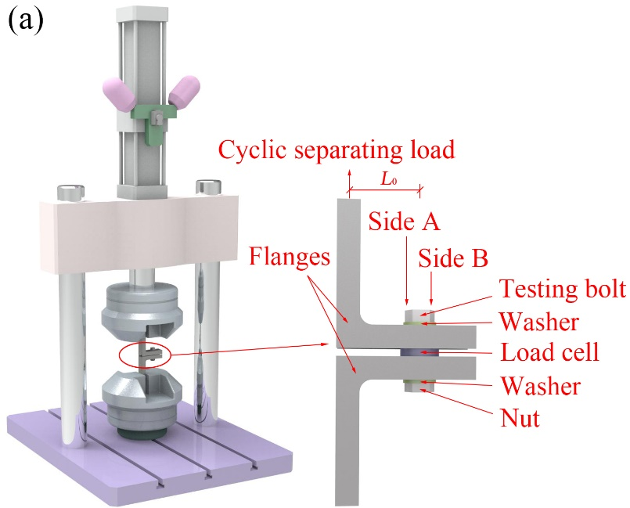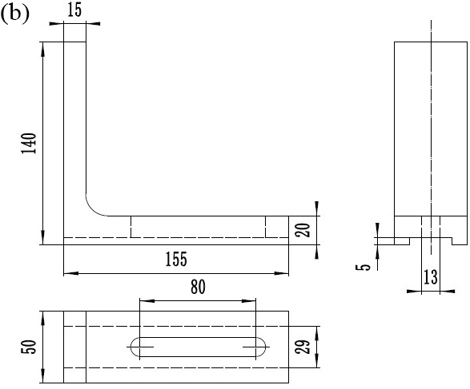
Fig. 1 Experimental setup: (a) Experimental equipment; (b) Geometry of the flange (mm)
The test is repeated for three separate times under each set of test parameters, and conducted at a frequency of 20 Hz in air at room temperature. After the tests, all bolts are cleaned using an ultrasonic cleaner. Firstly, the damage of the bolt surfaces is examined using an optical microscope (OM). Secondly, the bolts are cut by wire electrical-discharge machining (WEDM), and then the threads are also cleaned using an ultrasonic cleaner. Lastly, the thread damage is further analysed by a white light interferometer and a scanning electron microscope (SEM), and an energy dispersive x-ray system (EDS).

3 Experimental results

3.1 Damage analysis of thread surfaces
In order to facilitate the description of the thread damage, Side A and Side B are respectively defined as the side of the bolt near and further away from the loading position of the cyclic separating load (see Fig. 1). It can be observed from Fig. 2 that the damage is serious near the crest of the first thread. Additionally, the thread damage on Side A is more serious than that on Side B.
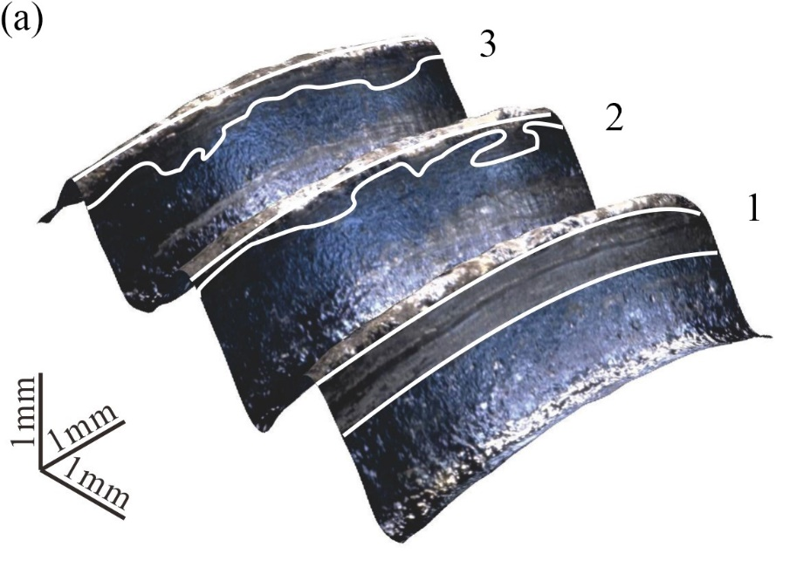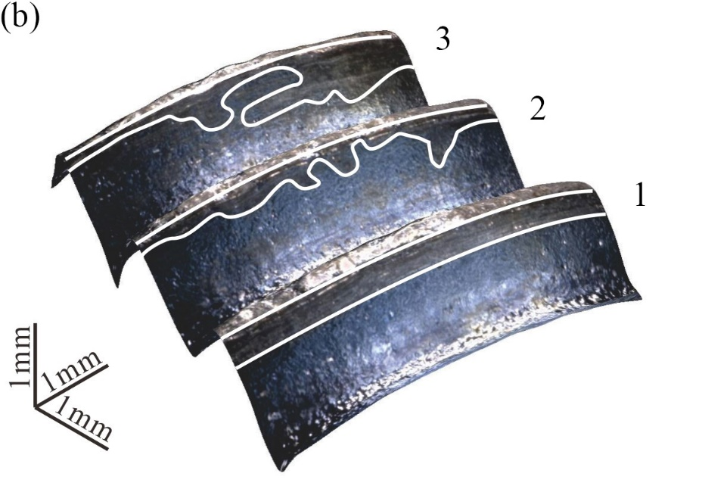
Fig. 2 OM images of thread surfaces (P₀=30kN, A_{F}=3kN, L₀=60mm): (a) Side A; (b) Side B
SEM and EDS are used to further analyse the damage of the first thread’s surface. As shown in Fig. 3, delamination and ploughing are the main damage characteristics. The damage characteristics show that the abrasive dust come off from the thread surface in the area denoted by I. Ploughing with plastic deformation, caused by adhesive wear because the material of the bolt and nut is identical, can be observed in area II. EDS analyses show that the contents of oxygen are low and little difference in different damage areas. This illustrates that the damage area is not oxidized and oxidation wear does not occur on the thread surface. Therefore, adhesive wear and delamination are the main wear mechanisms on the first thread’s surface.
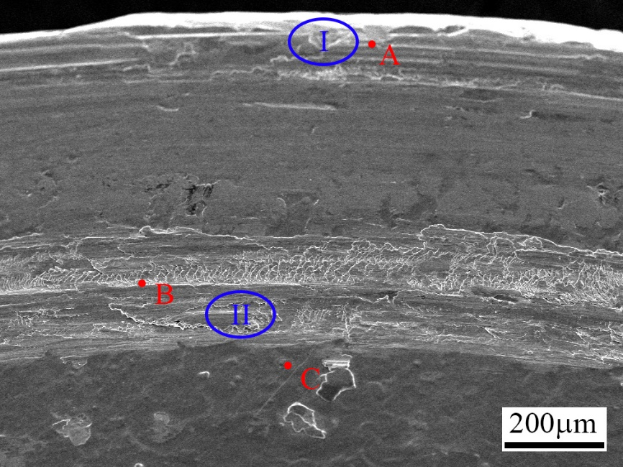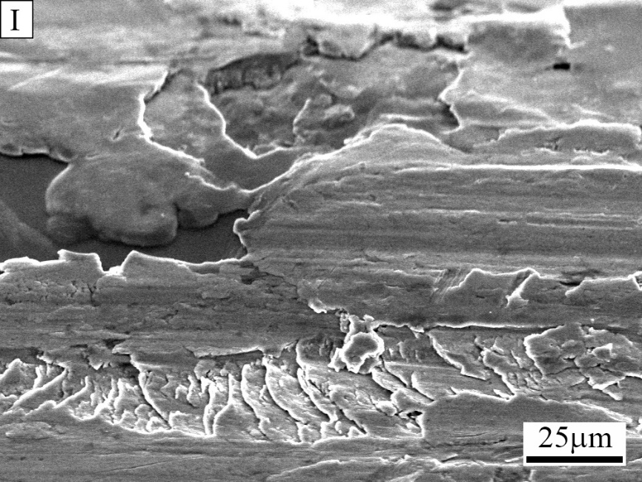
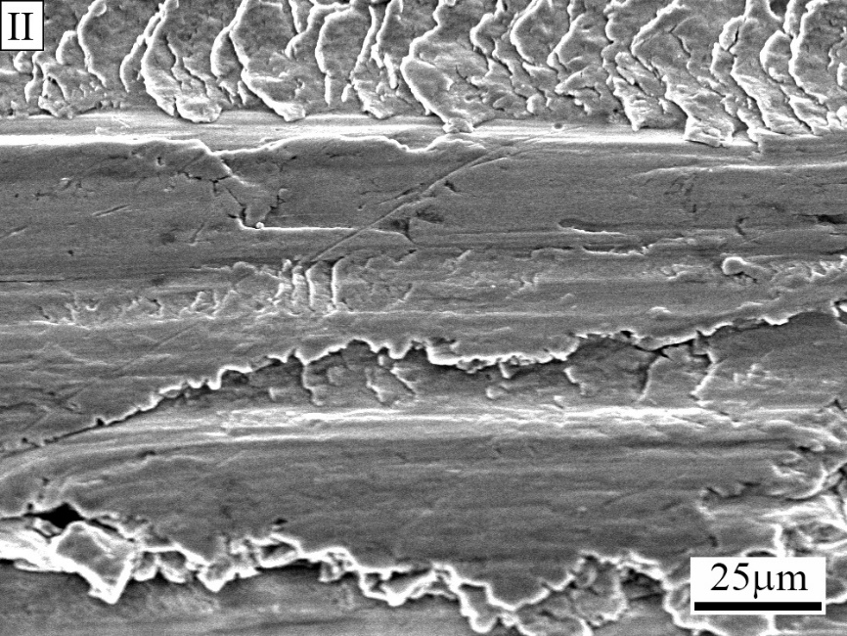
Fig. 3 Damage appearance and chemical composition of the first thread
(P₀=30 kN, A_{F}=3 kN, L₀=60 mm)

3.2 Effects on thread damage and clamping force loss

3.2.1 Effect of eccentricity
Fig. 4 shows OM images of thread surfaces at different eccentricity values. The thread damage is slight under small eccentricity, while it is serious under large eccentricity. The degree of thread damage on Side A is the same as that on Side B when the eccentricity is 40 mm. The damage on Side A of the first three threads is serious at the eccentricity of 80 mm. Due to the large eccentricity, the bending moment is high, and the relative slippage between the threads is large, which leads to serious thread damage.
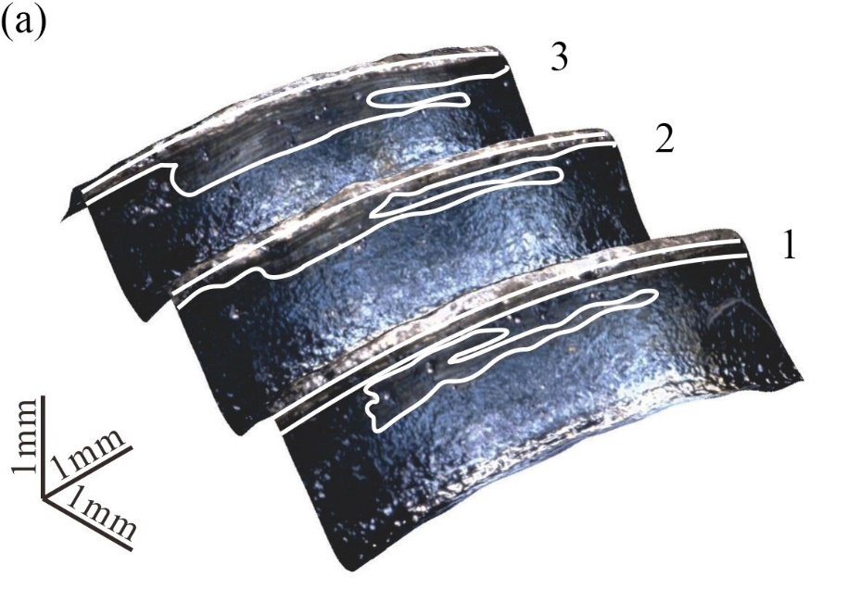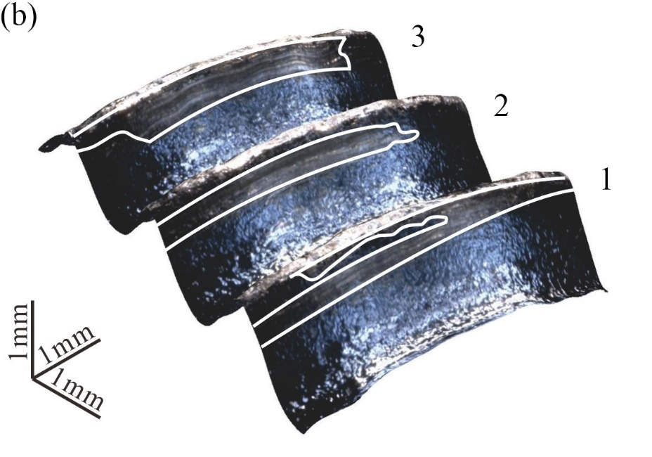
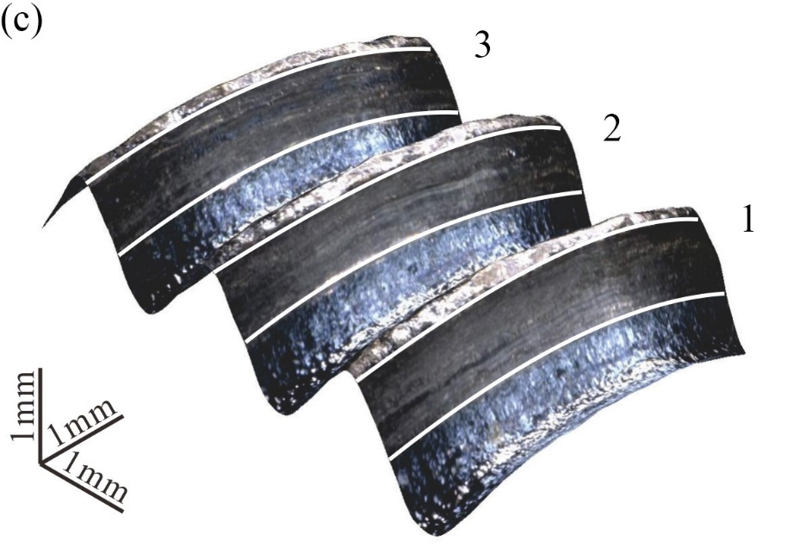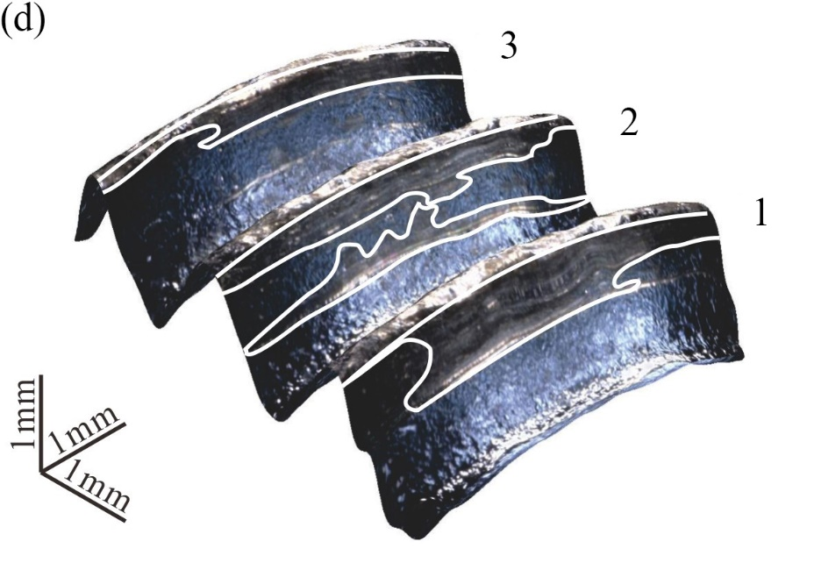
Fig. 4 OM images of thread surfaces at different eccentricity levels (A_{F}=3 kN, P₀=30 kN):
(a) Side A (L₀=40 mm); (b) Side B (L₀=40 mm); (c) Side A (L₀=80 mm); (d) Side B (L₀=80 mm)
A white light interferometer is used to study the damage of the first thread quantitatively. As shown in Fig. 5(a), a path on the first thread surface is defined in the radial direction. Fig. 5(b) shows the depth profile of the first thread at different eccentricity levels. It can be found that the depth and the width of the damaged area increase with the increase of eccentricity. Compared with the eccentricity level of 40 mm, the depth and the width increase by about 3 μm and 0.2 mm respectively at the eccentricity level of 80 mm.
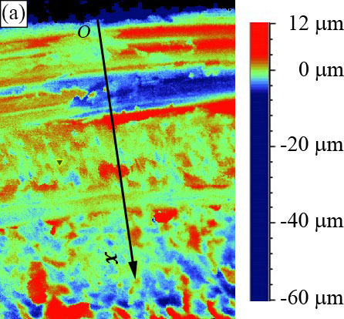
Fig. 5 Depth profile of the first thread at different eccentricity levels (A_{F}=3 kN, P₀=30 kN):
(a) Definition of the path on the first thread; (b) Depth profile of the first thread
As shown in Fig. 6, the main damage characteristic is ploughing with slight plastic deformation when the eccentricity is 40 mm. In addition, abrasive debris is found to be on the thread surface. EDS analyses show that the contents of oxygen are low and show little difference in different damage areas. Consequently, adhesive wear and abrasive wear are the main wear mechanisms. The thread damage shows ploughing characteristic in area I and delamination characteristic in area II when the eccentricity is 80 mm. EDS analyses show that the content of oxygen at point E is higher than that in other areas. As discussed earlier, the amplitude of relative slippage is large because of the high bending moment, the damage area is oxidized in air and oxidation wear occurs on the thread surface. Therefore, oxidation wear, adhesive wear and delamination are the main wear mechanisms.
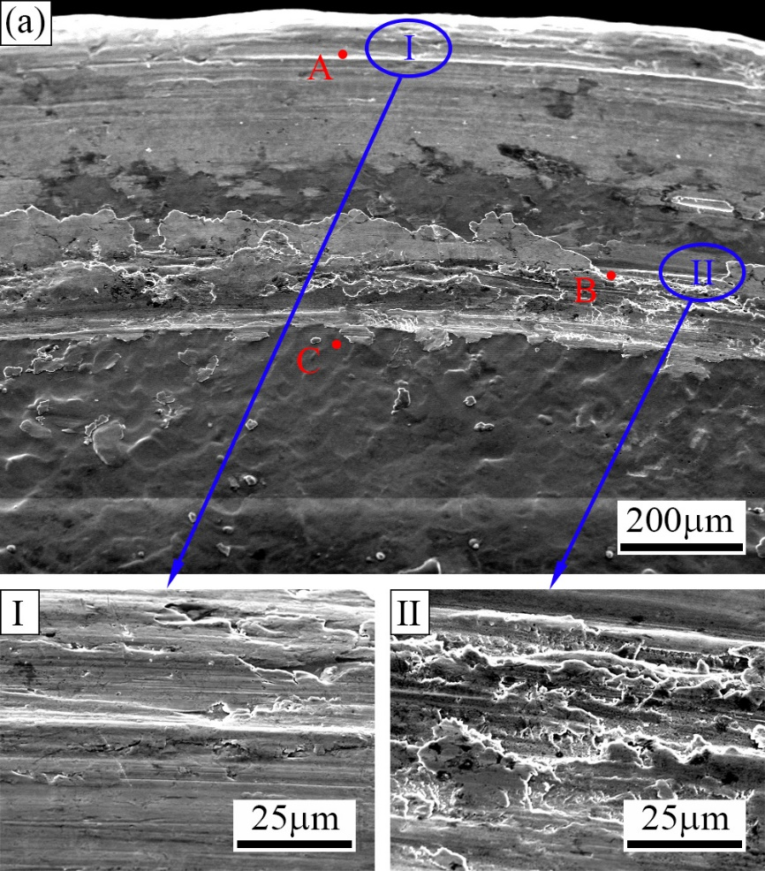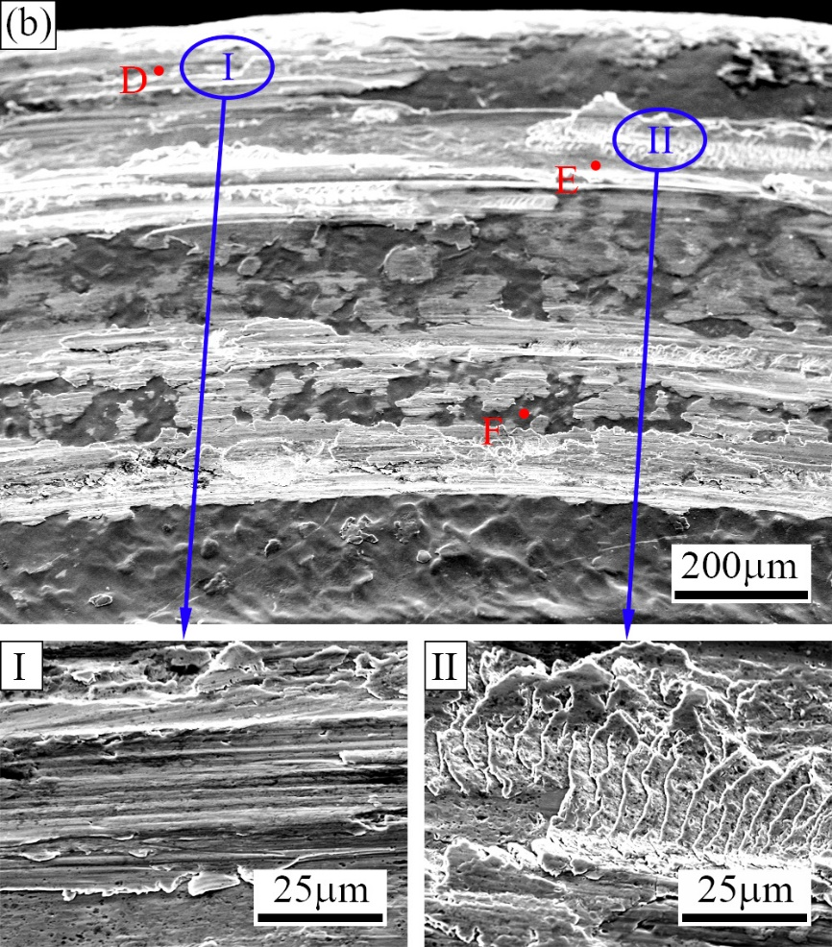
Fig. 6 Damage appearance and chemical composition of the first thread at different eccentricity levels (P₀=30 kN, A_{F}=3 kN): (a) L₀=40 mm; (b) L₀=80 mm
Function R_{F} is defined as the percentage of the residual clamping force to the initial clamping force, and it is referred to as R_{F}(10⁵) after 10⁵ loading cycles. Function R_{T}(10⁵) is defined as the percentage of the loosening torque to the tightening torque after 10⁵ loading cycles. As shown in Fig. 7, the degree of self-loosening increases with the increase of eccentricity. The earlier study ^{[44]} showed that plastic deformation was the main reason in the early stage of self-loosening of bolted joints subjected to eccentric excitation. With the increasing eccentricity, the plastic deformation and the degree of self-loosening increase in the first 100 loading cycles. Under low eccentricity, the scatter of experimental results is small. It is noted that the theoretical tightening torque is larger than the theoretical loosening torque under the same clamping force ^{[45]}. This means that R_{T}(10⁵) is always smaller than 100 percent. While R_{T}(10⁵) is found to be larger than 100 percent in experiments. In other words, the loosening torque may be larger than the tightening torque because of non-uniform damage of thread surface ^{[18]}. Additionally, the scatter of R_{T}(10⁵) is larger than that of R_{F}(10⁵) under the same experimental parameters.
Fig. 7 Effect of eccentricity on self-loosening (P₀=30 kN, A_{F}=3 kN):
(a) Clamping force versus cycles; (b) Losses of torque and clamping force

3.2.2 Effect of amplitude of cyclic separating load
Fig. 8 shows the OM images of thread surfaces at different amplitudes of cyclic separating load. Compared with Fig. 2, the slippage magnitude between the contact threads increases and the thread damage gets serious with the increasing amplitude of cyclic separating load. Similarly, the thread damage on Side A is more serious than that on Side B. It can be found from Fig. 9 that the depth and the width of the damaged area increase with the increase of loading amplitude. Compared with the loading amplitude of 2 kN, the depth and the width increase about by 2 μm and 0.28 mm respectively at the loading amplitude of 4 kN.
As shown in Fig. 10, the thread damage is slight at the loading amplitude of 2 kN, and ploughing with slight plastic deformation is the main damage characteristic. According to the EDS analyses, there is no oxidative wear on the thread surface. The main wear mechanism is adhesive wear. When the amplitude of the cyclic separating load is 4 kN, the damage characteristics are delamination and ploughing. As discussed earlier, the bending moment is large because of the high loading amplitude, separation between the contacting threads occurs, which causes the damage area to be oxidized in air. Oxidative wear occurs in the damage area, and the content of oxygen is higher than that on the undamaged area. Therefore, oxidative wear, delamination and adhesive wear are the main wear mechanisms.
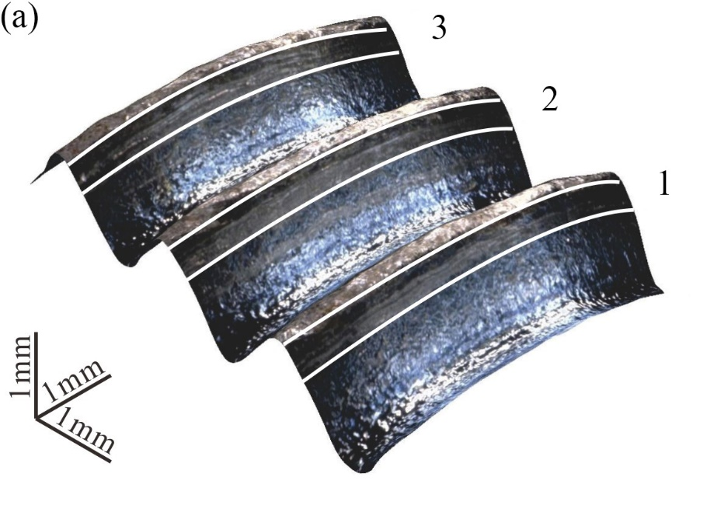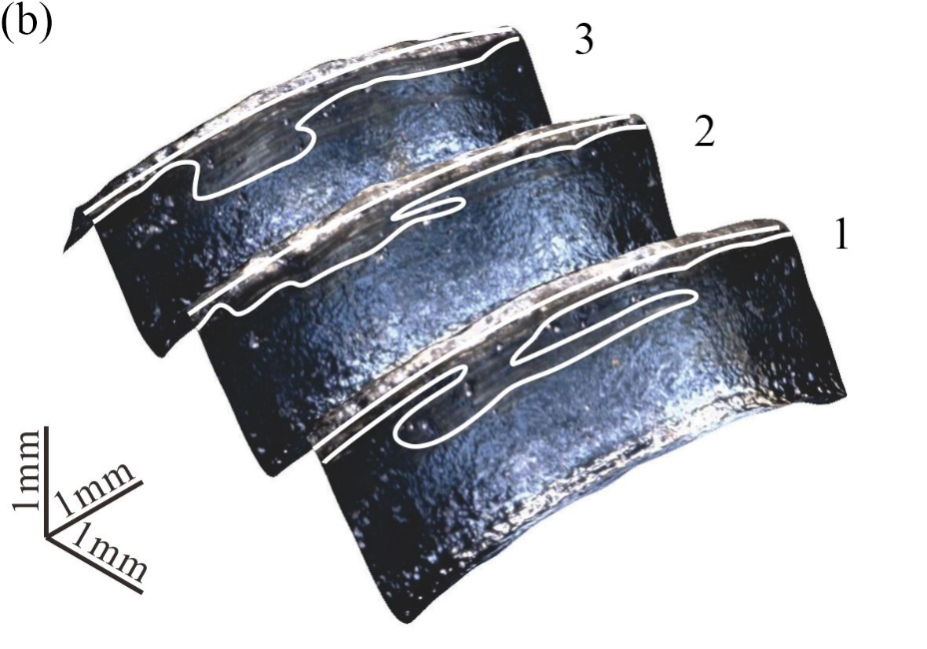
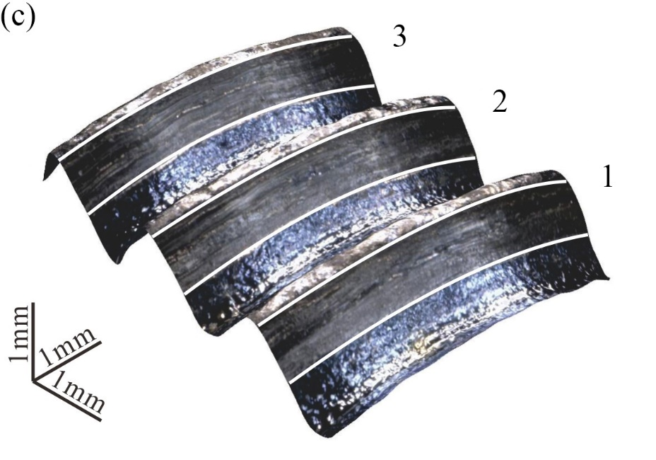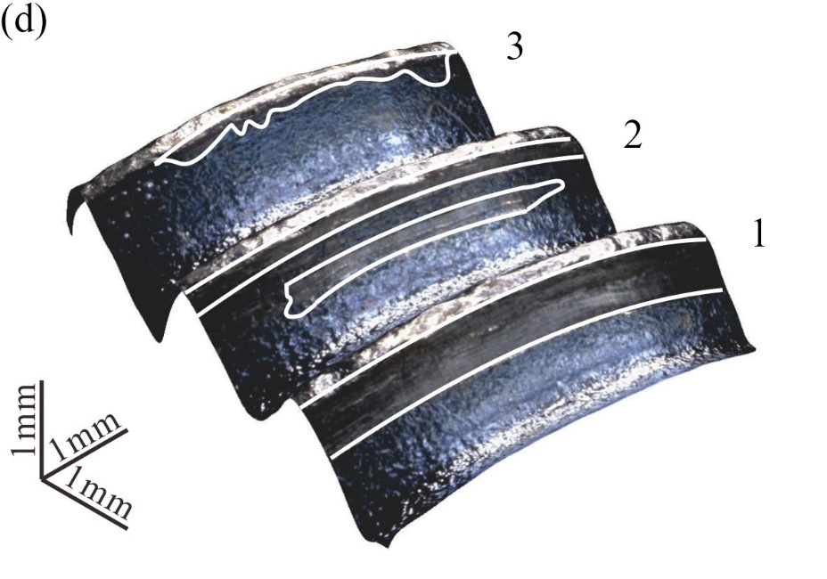
Fig. 8 OM images of thread surfaces at different amplitudes of cyclic separating load
(P₀=30 kN, L₀=60 mm):
(a) Side A (A_{F}=2 kN); (b) Side B (A_{F}=2 kN); (c) Side A (A_{F}=4 kN); (d) Side B (A_{F}=4 kN)
Fig. 9 Depth profile of the first thread at different amplitudes of cyclic separating load
(P₀=30 kN, L₀=60 mm)
Fig. 11 shows the effect of initial excitation amplitude on self-loosening. With the increase of the amplitude of the cyclic separating load, the plastic deformation caused by the cyclic separating load increases in the early stage, the damage of threads gets serious, and the degree of self-loosening increases. In addition, the loss of torque is small under a low amplitude of cyclic separating load, while the reduction of torque is large at the loading amplitude of 4 kN. Similarly, the scatter of R_{T}(10⁵) is larger than that of R_{F}(10⁵).
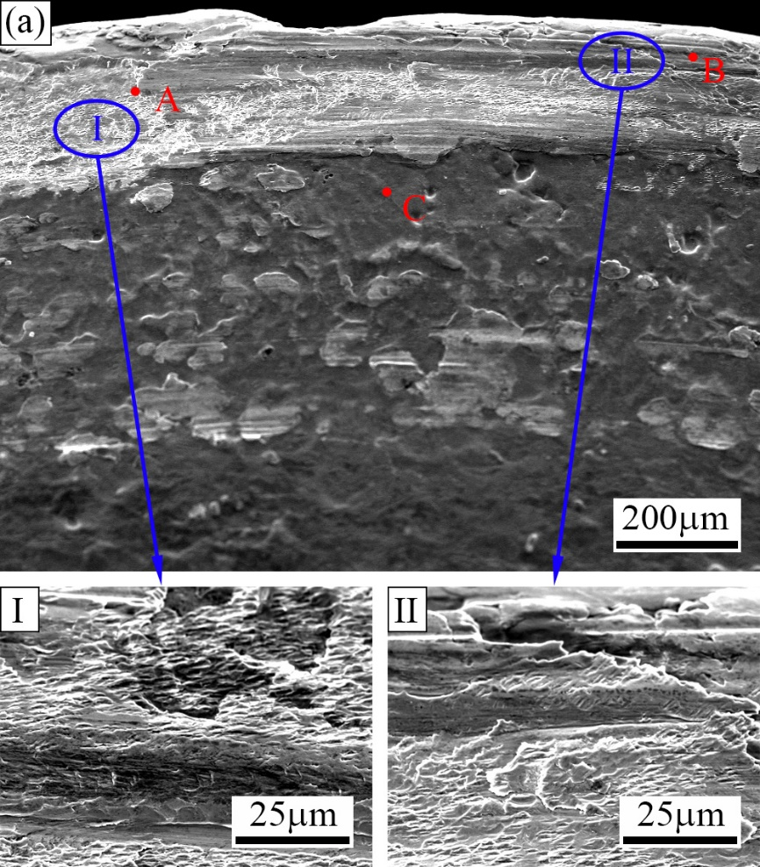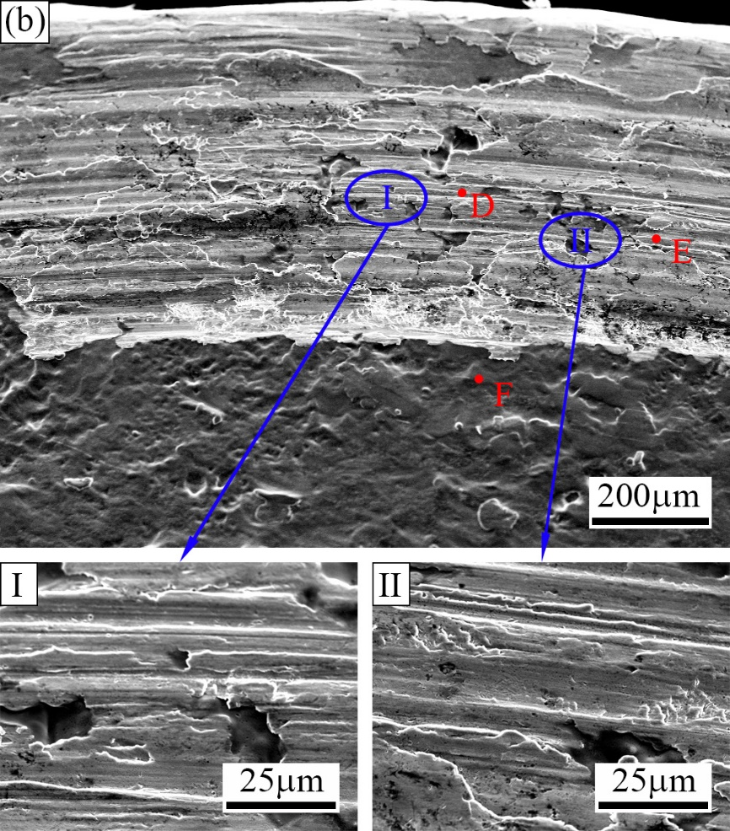
Fig. 10 Damage appearance and chemical composition of the first thread at different amplitudes of cyclic separating load (P₀=30 kN, L₀=60 mm): (a) A_{F}=2 kN; (b) A_{F}=4 kN
Fig. 11 Effect of initial excitation amplitude on self-loosening (P₀=30 kN, L₀=60 mm):
(a) Clamping force versus cycles; (b) Losses of torque and clamping force

3.2.3 Effect of initial clamping force
Fig. 12 shows the OM images of thread surfaces at different initial clamping forces. The damage of threads gets slight with the increasing initial clamping force. This is because the relative slippage between the contacting threads is not likely to occur under high initial clamping force, so the damage of threads is slight. Similarly, the damage of threads on Side A is more serious than that on Side B. It can be found from Fig. 13 that the depth and the width of the damaged area decrease with the increase of initial clamping force. Compared with the initial clamping force of 26 kN, the depth and the width decrease by about 2 μm and 0.29 mm respectively at the initial clamping force of 34 kN.
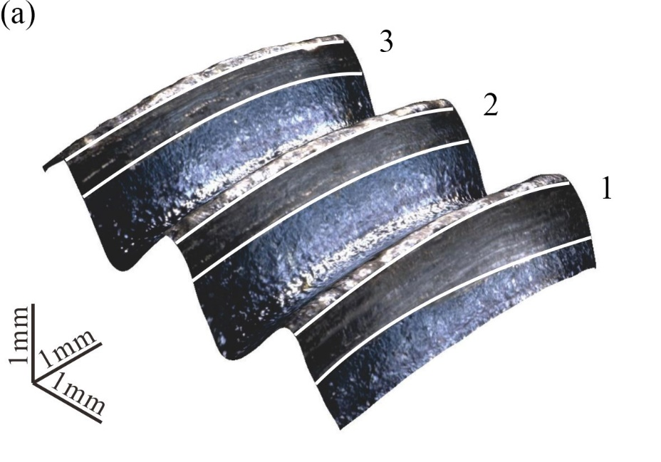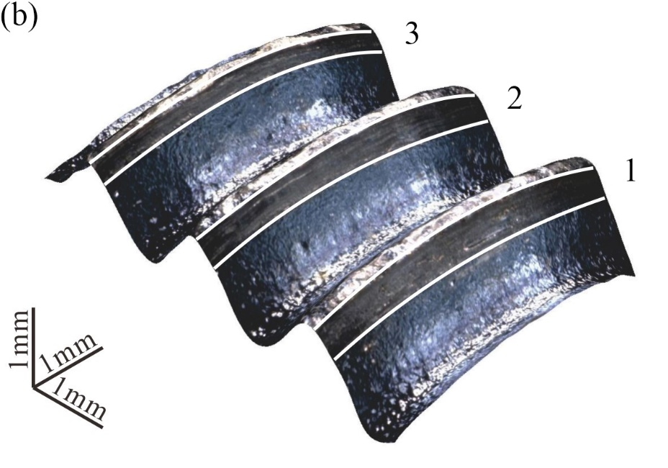
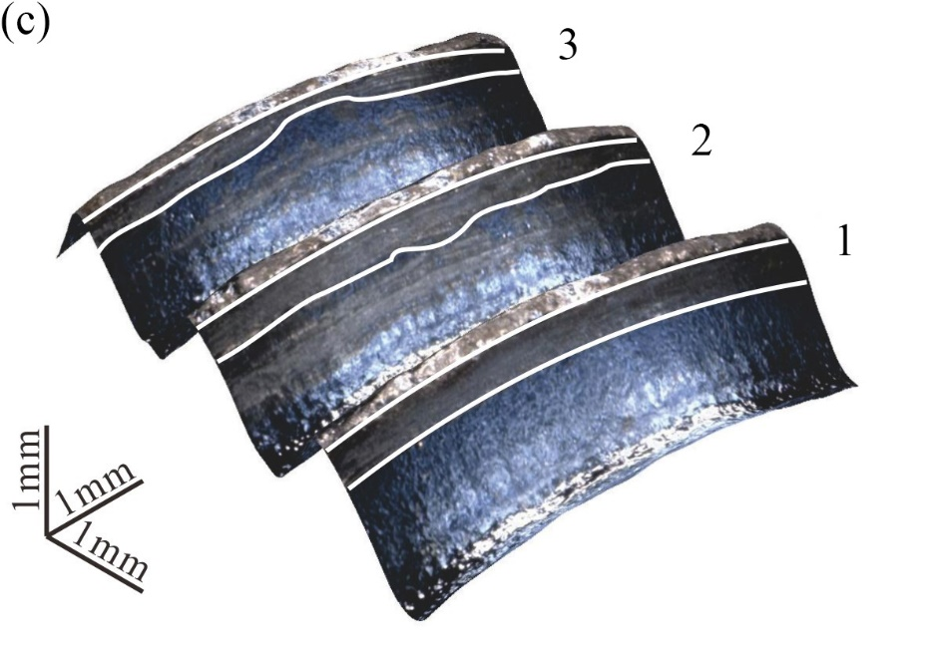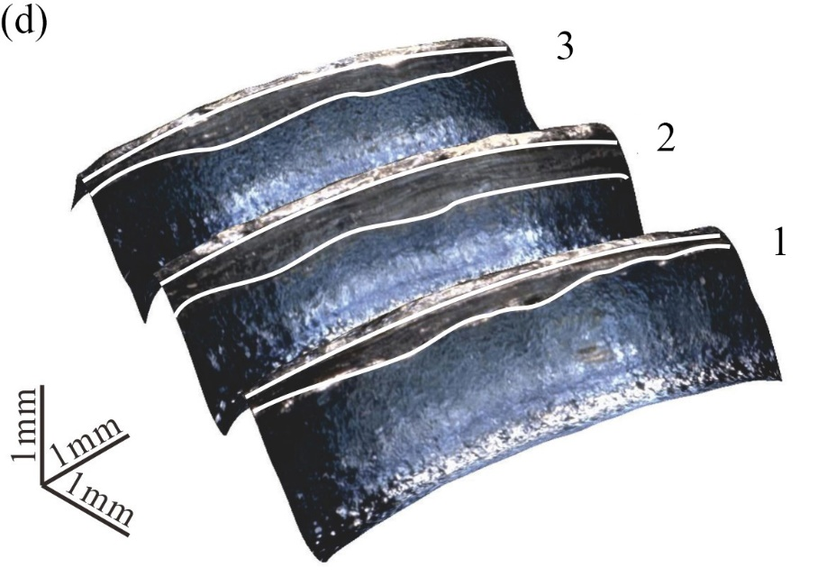
Fig. 12 OM images of thread surfaces at different initial clamping forces (A_{F}=3 kN, L₀=60 mm):
(a) Side A (P₀=26 kN); (b) Side B (P₀=26 kN); (c) Side A (P₀=34 kN); (d) Side B (P₀=34 kN)
Fig.13 Depth profile of the first thread at different initial clamping forces (A_{F}=3 kN, L₀=60 mm)
As shown in Fig. 14, delamination is the damage characteristic in areas I and II when the initial clamping force is 26 kN. As discussed earlier, the relative separation between the contact edges of threads is likely to occur under a low initial clamping force, and the damage area is oxidized in air. EDS analyses show that the content of oxygen in damage area is higher than that in undamaged area. Therefore, the main wear mechanisms are delamination and oxidative wear. When the initial clamping force is 34 kN, the damage is characteristic of delamination phenomenon in areas I and II. According to EDS analyses, the contents of oxygen are low and are almost the same across areas I and II. Therefore, the main wear mechanism is delamination.
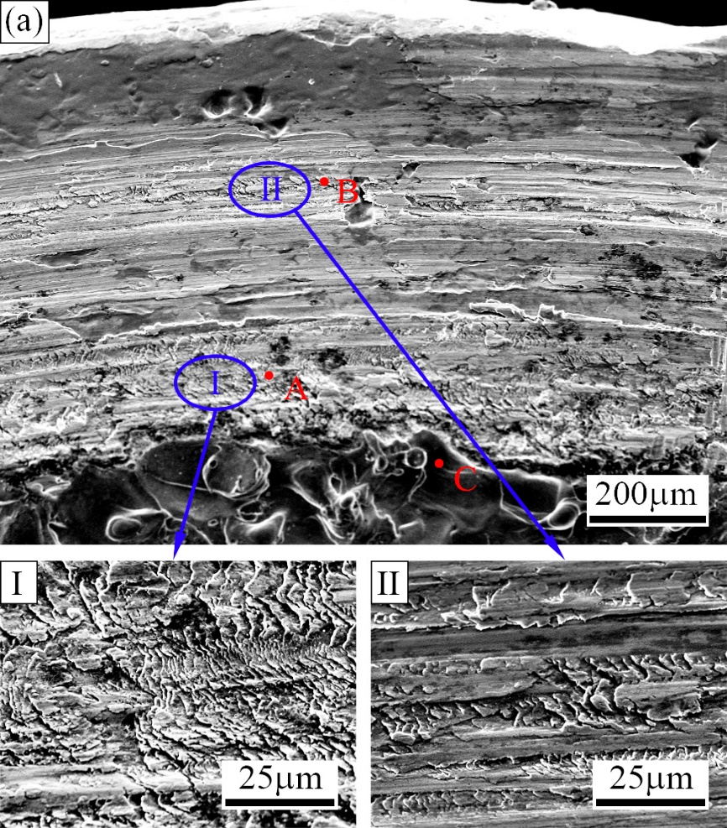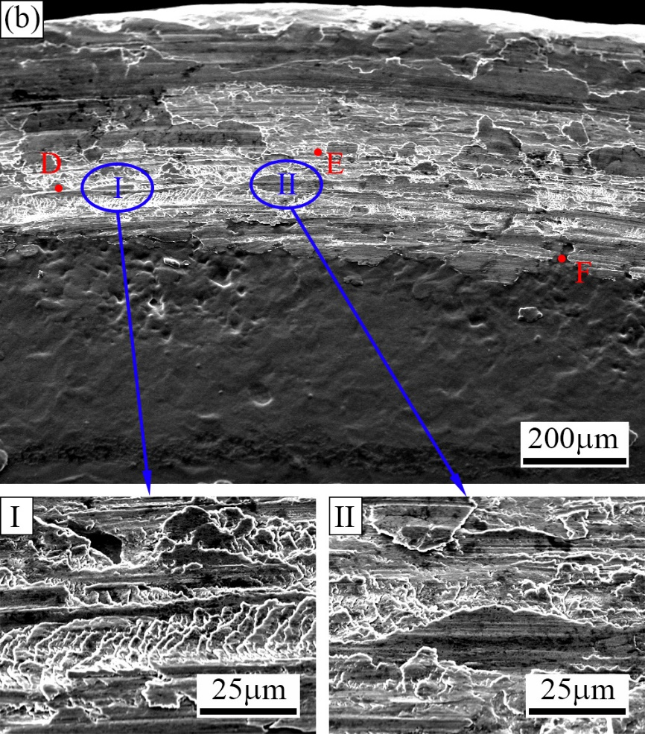
Fig. 14 Damage appearance and chemical composition of the first thread at different initial clamping forces (A_{F}=3 kN, L₀=60 mm): (a) P₀=26 kN; (b) P₀=34 kN
The effect of initial clamping force on the self-loosening are shown in Fig. 15. With the increase of the initial clamping force, plastic deformation of bolted joints decreases under the same cyclic separating load, and the thread damage gets slight. For the two reasons, the degree of self-loosening decreases with the increasing initial clamping force. Moreover, the change of clamping force at the initial preload of 26 kN is three times as that at the initial preload of 34 kN, while the change of torque is not obvious.
Fig. 15 Effect of initial clamping force on self-loosening (A_{F}=3 kN, L₀=60 mm):
(a) Clamping force versus cycles; (b) Losses of torque and clamping force

4 The finite element model
Fig. 16 shows the finite element model for a bolted joint subjected to a cyclic separating load. A bolt passes through a washer, the upper flange, a load cell, the lower flange and the other washer in turn, and finally is connected with a nut. The material of the two flanges, load cell and washers is considered to be elastic to improve the computational efficiency, and its Young's modules and Poisson's ratio are 200 GPa and 0.3 respectively. The material of the bolt and the nut is assumed to be elasto-plastic with linear strain-hardening and the constitutive equation can be written as^{[18]}:
(1)
where the Young's modules E=200 GPa, the strain-hardening parameter H=1.3 GPa, and yield stress σ_{s}=640 MPa.
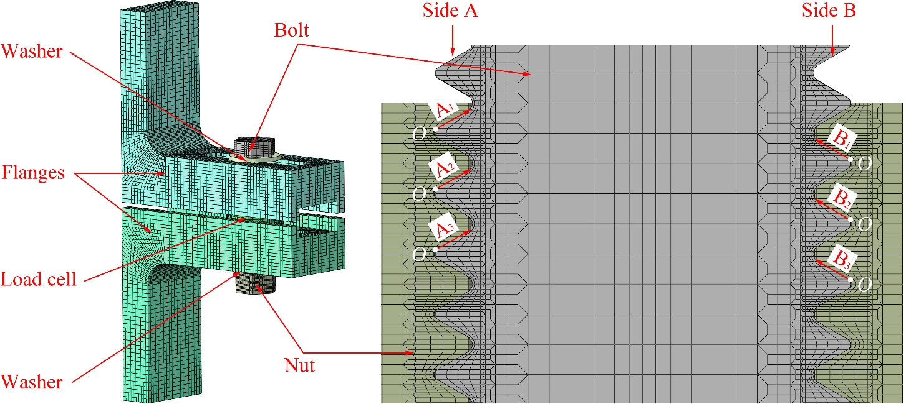
Fig. 16 Finite element model and definition of the six paths
To ensure the accuracy and convergence, binding constraints are used between the two washers and flanges. Five contact pairs are defined in this finite element model: the contact between the washer and the bolt, the contacts between the two flanges and the load cell, the contact between the nut and the washer and the contact between the threads. The Lagrange method and the penalty method are commonly used to solve contact problems in ABAQUS/Standard. The Lagrange method can be used to obtain an accurate solution, but it incurs heavier computational cost because of additional degrees of freedom and often an increasing number of iterations in this method. Without changing the positive definiteness and the order of the element stiffness matrix, approximate solutions can be obtained in a reasonable amount of analysis time using the penalty method. Considering the complexity of the contact between the threads, the penalty method with a friction coefficient of 0.15 is used for the five contact pairs. Eight-node linear reduced-integration hexahedral elements (C3D8R) are used in this finite element model. There are 753469 nodes and 458448 elements in total.
The lower flange is fixed in the initial step. Additionally, three analysis step are defined. To establish contact gradually, the upper flange is fixed and a small clamping force is applied on the cross section of the bolt in the first step. The constraints of the upper flange are released and an actual initial clamping force is applied in the second step. To simulate the change of clamping force, the method of applying the clamping force in the third step in ABAQUS is changed from "Applying force" to "Fix at current length". In addition, a cyclic separating load is applied to the end of the upper flange in this step.
The amplitudes of the cyclic separating load, denoted as A_{F}, are 2 kN, 3 kN and 4 kN. The initial clamping force, denoted as P₀, is applied on the cross section perpendicular to the axis of the bolt. The values of the initial clamping force are 26 kN, 30 kN and 34 kN. There are three levels of eccentricity denoted by L₀ between the bolt axis and the loading position of the cyclic separating load: 40 mm, 60 mm and 80mm.
To study the contact stress, the relative slippage between the threads and the frictional energy dissipation per square millimetre, three paths, denoted as A₁, A₂ and A₃, are defined on Side A of the bolt thread surfaces. Similarly, three paths, denoted as B₁, B₂ and B₃, are defined on Side B.

5 Finite element results
Two finite element meshes are presented to reveal the effect of mesh refinement of the bolt and the nut models: (1) Case I: each pitch of the thread is divided into 16 layers along the axis of bolt/nut and 144 segments along the circumferential direction; (2) Case II: each pitch of the thread is divided into 24 layers along the axis of bolt/nut and 192 segments along the circumferential direction. When the initial clamping force of 30 kN is applied on the cross section perpendicular to the axis of the bolt, the contact stress and slippage along path A₁ are shown in Fig. 17. For the two cases, there is a noticeable difference in the contact stress and slippage at the same distance away from the thread crests but this difference is not big. Consequently, Case I is used to mesh the bolt and the nut models to improve the computational efficiency.
Fig. 17 Contact stress and slippage along path A₁ (P₀=30 kN, L₀=60 mm)
Fig. 18 shows the contact stress, the slippage amplitude and the frictional energy dissipation per square millimetre along path A_{i} and B_{i} (i=1, 2 and 3) on thread surfaces. It can be found from Fig. 18(a) that the contact stress, denoted as σ_{n}, along path A_{i} and B_{i} firstly increases, then decreases with the increase of the distance from Point O, and it is largest at 0.30 mm away from the thread crests. As shown in Fig. 18(b), the slippage amplitude denoted by A_{δ} is slightly larger near the crests and roots of threads. It can be observed from Fig. 18(c) that the frictional energy dissipation per square millimetre denoted by E_{df} is largest at 0.15 mm away from the thread crests. This illustrates that the thread damage is serious near the thread crests, which is in agreement with the experimental observations shown in Fig. 2. The contact stress, the slippage amplitude and the frictional energy dissipation per square millimetre on path A_{i} are about 1.3 times as large as those at the same distance away from point O along path B_{i}, and they decrease with the increase of the number of the threads denoted by i. The maximum of the frictional energy dissipation per square millimetre on path A₃ is about half as large as that on path A₁. This indicates that the thread damage gets slight with the increasing number of the threads, which also agrees with the experimental observations shown in Fig. 2.
Fig .19 shows the contact stress, the slippage amplitude and the frictional energy dissipation per square millimetre along path A₁ and B₁ on the first thread’s surface at different eccentricity levels. When the eccentricity levels are 60 mm and 80 mm, the contact stress shows less difference at the same nodes, and it is larger than that at the eccentricity of 40 mm. Moreover, the slippage amplitude and the frictional energy dissipation per square millimetre increase with the increase of the eccentricity. Compared with the eccentricity level of 40mm, the maximum of the frictional energy dissipation per square millimetre on paths A₁ and B₁ increases by about 2.5 times at the eccentricity of 80 mm. This suggests that the thread damage increases with the increase of eccentricity, and it agrees with the experimental observations shown in Fig. 4.

Fig. 18 Contact stress, slippage amplitude and frictional energy dissipation along path A_{i} and B_{i}
(i=1, 2 and 3, P₀=30 kN, A_{F}=3 kN, L₀=60 mm):
(a) Contact stress; (b) Slippage amplitude; (c) Frictional energy dissipation per square millimetre
Fig. 19 Contact stress, slippage amplitude and frictional energy dissipation along path A₁ and B₁ at different eccentricity levels (P₀=30 kN, A_{F}=3 kN):
(a) Contact stress; (b) Slippage amplitude; (c) Frictional energy dissipation per square millimetre
As shown in Fig. 20, the contact stresses have a small difference at the same nodes when the amplitudes of cyclic separating load are 2 kN and 3 kN. In addition, the slippage amplitude is very small at the excitation amplitude of 2 kN. The slippage amplitude and the frictional energy dissipation per square millimetre increase with the increasing amplitude of cyclic separating load. Compared with the loading amplitude of 2 kN, the maximum of the frictional energy dissipation per square millimetre on paths A₁ and B₁ increases by about 10 times at the loading amplitude of 4 kN. This indicates that the thread damage becomes serious with the increasing amplitude of cyclic separating load, which agrees with the experimental observations shown in Fig. 8.
Fig. 20 Contact stress, slippage amplitude and frictional energy dissipation along path A₁ and B₁ at different amplitudes of cyclic separating load (P₀=30 kN, L₀=60 mm):
(a) Contact stress; (b) Slippage amplitude; (c) Frictional energy dissipation per square millimetre

The contact stress, the slippage amplitude and the frictional energy dissipation per square millimetre along paths A₁ and B₁ on the first thread’s surface decrease proportionally with the increase of the initial clamping force (Fig. 21). Compared with the initial clamping force of 34 kN, the maximum of the frictional energy dissipation per square millimetre on paths A₁ and B₁ increases by about 1.3 times at the initial clamping force of 26 kN. This suggests that the degree of the thread damage decrease with the increase of the initial clamping force, which also agrees with the experimental observations shown in Fig. 12.

Fig. 21 Contact stress, slippage amplitude and frictional energy dissipation along path A₁ and B₁ at different initial clamping forces (A_{F}=3 kN, L₀=60 mm):
(a) Contact stress; (b) Slippage amplitude; (c) Frictional energy dissipation per square millimetre

6 Conclusions
Experimental and numerical investigations of a bolted joint in bending as a result of a cyclic separating load are presented in this paper. The thread damage and the self-loosening process are analysed. From this study, the following conclusions can be made:
1. Under low bending moment (low eccentricity level and/or low excitation amplitude) and high initial clamping force, relative slippage between the threads is small, oxidation wear does not occur on the thread surface. Adhesive wear and delamination are the main wear mechanisms. While under high bending moment and low initial clamping force, adhesive wear, delamination and oxidation wear are the main wear mechanisms.
2. With the increases of the eccentricity and the excitation amplitude, the frictional energy dissipation per square millimetre on thread surfaces increases under the same initial clamping force, which results in more serious damage of thread surfaces. In addition, the plastic deformation of the bolted joint increases because of the increasing bending moment. Therefore, the degree of self-loosening increases with the increases of eccentricity and excitation amplitude.
3. With the increase of initial clamping force, the relative slippage between the threads is small, and the frictional energy dissipation per square millimetre on thread surfaces decreases under the same eccentricity and excitation amplitude. Moreover, the plastic deformation of the bolted joint caused by cyclic separating load is small under high initial clamping force. Therefore, a large initial clamping force will result in a good self-loosening resistance. It is noted that failure of bolted joints will occur when the initial clamping force is large enough and thus should be avoided.

Acknowledgements
The authors gratefully acknowledge the financial support provided by National Natural Science Foundation of China (Nos. 51705434 and U1534209), the Open Fund of State Key Laboratory of Traction Power (No. 2016TPL-Z03).

References
[1] N. A. Noda, X. Chen, Y. Sano, M. A. Wahab, H. Maruyama, R. Fujisawa, Y. Takase, Effect of pitch difference between the bolt-nut connections upon the anti-loosening performance and fatigue life, Mater. Design. 96 (2016) 476–489.
[2] A. Muszynska, P. Goldman, Chaotic responses of unbalanced rotor/bearing/stator systems with looseness or rubs, Chaos, Solitons Fractals 5 (9) (1995) 1683–1704.
[3] F. Chu, Y. Tang, Stability and non-linear responses of a rotor-bearing system with pedestal looseness, J. Sound Vib. 241 (5) (2001) 879–893.
[4] Z. Qin, Q. Han, F. Chu, Bolt loosening at rotating joint interface and its influence on rotor dynamics, Eng. Fail. Anal. 59 (2016) 456-466.
[5] J.N. Goodier, R.J. Sweeney, Loosening by vibration of threaded fastenings, Mech. Eng. 67 (1945) 798–802.
[6] G.H. Junker, New criteria for self-loosening faster under vibration, SAE, Trans. 78 (1969) 314-335.
[7] T. Sakai, Mechanism for a bolt and nut self-loosening under repeated bolt axial tensile load. J. Solid Mech. Mater. Eng. 5 (11) (2011) 627-639.
[8] D.P. Hess, K. Davis, Treaded components under axial harmonic vibration, Part 1: Experiments, J. Vib. Acoust. 118 (1996) 417-422.
[9] D.P. Hess, Treaded components under axial harmonic vibration, Part 2: Kinematic analysis, J. Vib. Acoust. 118 (1996) 423-429.
[10] D.P. Hess, S.V. Sudhirkashyap, Dynamic analysis of threaded fasteners subjected to axial vibration, J. Sound Vib. 193 (5) (1996) 1079-1090.
[11] Y. Jiang, M. Zhang, T.W. Park, C.H. Lee, An experimental investigation on self-loosening of bolted joints, J. Mech. Design 126 (5) (2004) 925-931.
[12] M. Zhang, Y. Jiang, C.H. Lee, Finite element modeling of self-loosening of bolted joints. J. Mech. Design 129 (2) (2007) 218-226.
[13] X. Jiang, Y. Zhu, J. Hong, X. Chen, Y. Zhang, Investigation into the loosening mechanism of bolt in curvic coupling subjected to transverse loading. Eng. Fail. Anal. 32 (2013) 360-373.
[14] T. Yokoyama, M. Olsson, S. Izumi, S. Sakai, Investigation into the self-loosening behavior of bolted joint subjected to rotational loading, Eng. Fail. Anal. 23 (2012) 35-43.
[15] M. Ishimura, T. Sawa, A. Karami, T. Nagao, Bolt-nut loosening in bolted flange connections under repeated bending moments. In: Proceedings of the ASME 2010 Pressure Vessels and Piping Conference, Bellevue, Washington, USA, 2010.
[16] T. Sawa, M. Ishimura, Y. Shoji, Y. Fukuba, Mechanical behavior of rotational screw thread loosening in bolted joints under repeated temperature changes, In: Proceedings of the ASME 2008 Pressure Vessels and Piping Conference, New York, USA 2008.
[17] S. Hou, Study on mechanism of loosening of threaded connection [D], Beijing, Beijing Institute of Technology, 2015.
[18] J. Liu, H. Ouyang, J. Peng, C. Zhang, P. Zhou, L. Ma, M. Zhu, Experimental and numerical studies of bolted joints subjected to axial excitation, Wear 346-347 (2016) 66-77.
[19] J. Liu, H. Ouyang, Z. Feng, Z. Cai, X. Liu, M. Zhu, Study on self-loosening of bolted joints excited by dynamic axial load, Trib. Int. 115 (2017) 432-451.
[20] X. Yang, S.A. Nassar, Z. Wu, A. Meng, Clamp load loss in a bolted joint model with plastic bolt elongation and eccentric service load, In: Proceedings of the ASME 2010 Pressure Vessels and Piping Conference, Bellevue, Washington, USA, 2010.
[21] X. Yang, S.A. Nassar, Z. Wu, A. Meng,, Nonlinear behavior of preloaded bolted joints under a cyclic separating load, J. Press. Vessel Technol. 134 (1) (2012) 011206.
[22] S.A. Nassar, X. Yang, S.V.T. Gandham, Z. Wu, Nonlinear deformation behavior of clamped bolted joints under a separating service load. J. Press. Vessel Technol. 133 (2) (2011) 021001.
[23] S.D. Thoppul, J. Finegan, R.F. Gibson, Mechanics of mechanically fastened joints in polymer–matrix composite structures – A review, Compos. Sci. Technol. 69 (3-4) (2009) 301-329.
[24] M. Xie, Joints for Composites Materials, 1st ed, Shanghai Jiaotong University Press, Shanghai, 2011.
[25] K.N. Shivakumar, J.H.Crews, Bolt clampup relaxation in a graphite/epoxy laminate, Long Term behaviour of Composites, ASTM STP. 813 (1983) 5-22.
[26] S.D. Thoppul, R.F. Gibson, R.A. Ibrahim, Phenomenological modeling and numerical simulation of relaxation in bolted composite joints, J. Compos. Mater. 42 (17) (2008) 1709-1729.
[27] Y. Jin, X. Sun, Study on stress relaxation of bolt metals at elevated temperatures, J. Southwest Jiaotong Univ. 33 (1) (1998) 46-51.
[28] V. Caccese, K.A. Berube, M. Fernandez, J.D. Melo, J.P. Kabche, Influence of stress relaxation on clamp-up force in hybrid composite-to-metal bolted joints, Compos. Struct. 89 (2) (2009) 285-293.
[29] M. Ishimura, S. Sawa, Y. Omiya, T. Sawa, Mechanism of screw thread loosening in bolted joints with dissimilar clamped parts under repeated temperature changes. In: Proceedings of the ASME International Mechanical Engineering Congress and Exposition, Montreal, Quebec, Canada, 2014.
[30] M. Zhu, Z. Zhou, On the mechanisms of various fretting wear modes, Tribol. Int. 44 (2011) 1378–1388.
[31] Z. Zhou, L. Vincent, Fretting wear, Science Press, Beijing, 2002 (In Chinese).
[32] K. Pereira, T. Yue, M. A. Wahab, Multiscale analysis of the effect of roughness on fretting wear, Tribol. Int. 110 (2017) 222–231.
[33] T. Yue, M. A. Wahab, Finite element analysis of stress singularity in partial slip and gross sliding regimes in fretting wear, Wear 321 (2014) 53–63.
[34] T. Yue, M. A. Wahab, Finite element analysis of fretting wear under variable coefficient of friction and different contact regimes, Tribol. Int. 107 (2017) 274–282.
[35] M. Zhang, L. Lu, W. Wang, D. Zeng, The roles of thread wear on self-loosening behavior of bolted joints under transverse cyclic loading, Wear 394-395 (2018) 30-39.
[36] K. Iyer, G.T. Hahn, P.C. Bastias, C.A. Rubin, Analysis and fretting in pinned connections, Wear 181 (1995) 524–530.
[37] J. Zhou, J. Liu, H. Ouyang, Z. Cai, J. Peng, M. Zhu, Anti-loosening performance of coatings on fasteners subjected to dynamic shear load, Friction 6 (1) (2018) 32-46.
[38] R.R. Schmitt, W.J. Horn, Viscoelastic relaxation in bolted thermoplastic composite joints. In: Proceedings of SAMPE Symposium and Exhibits, 35 (1990) 1336–1347.
[39] W.J. Horn, R.R. Schmitt, Relaxation in bolted thermoplastic composite joints. In: AIAA/ASME/ASCE/AHS/ASCE structures, structural dynamics, and material conference, Part 1, 1993. 485–494.
[40] R.A. Ibrahim, C.L. Pettit, Uncertainties and dynamic problems of bolted joints and other fasteners, J. Sound Vib. 279 (3-5) (2005) 857-936.
[41] The Association of German Engineers(VDI), Systematic calculation of high duty bolted joints, German, 2014.
[42] J.H. Bickford, Introduction to the design and analysis of bolted joints, 4th ed, Chemical Rubber Company Press, Florida, 2007.
[43] D. Cheng, Handbook of Mechanical Design, 5th ed, Chemical Industry Press, Beijing, 2012.
[44] Y. Du, J. Liu, X. Liu, Z. Cai, J. Peng, M. Zhu, Research on self-loosening behavior of bolted joints under eccentric excitation, J. Mech. Eng. 54 (1) (2018) 74.
[45] Y. Fujioka, T. Sakai, Rotating loosening mechanism of a nut connecting a rotary disk under rotating-bending force, J. Mech. Design 127 (6) (2005) 1191-1197.

* Corresponding author. Tel: +86 028 87600715; fax: +86 028 87600723 E-mail address: zhuminhao@swjtu.cn

