EXPERIMENTAL AND NUMERICAL STUDIES OF BOLTED JOINTS SUBJECTED TO TORSIONAL EXCITATION
XUETONG LIU¹, JIANHUA LIU^{1,} *, HUAJIANG OUYANG², ZHENBING CAI¹, JINFANG PENG¹, MINHAO ZHU¹
¹Tribology Research Institute, Southwest Jiaotong University,
111#, the section of the northbound 1, the Second Ring Road, Chengdu 610031, China
²School of Engineering, University of Liverpool, Brownlow Street, Liverpool L69 3GH, UK

The dynamic response of bolted joints subjected to torsional excitation is investigated experimentally and numerically. Firstly, the effects of the initial preload and the angular amplitude on axial force loss of the bolt were studied. Secondly, the change of hysteresis loops with the increasing number of loading cycles was found under a larger torsional angle. At last, a fine-meshed three-dimensional finite element model was built to simulate the bolted joint under torsional excitation, from which the hysteresis loops were obtained under varying angular amplitudes. The results of numerical analysis are in good agreement with those of experiments.
Key words: bolted joint; torsional excitation; self-loosening; hysteresis loop; numerical analysis.

Introduction
Bolted joints are widely used in connecting structural components because of their high reliability and easy assembly/disassembly. Bolt loosening occurs as a result of a decrease of the axial bolt force caused by many factors¹⁻³, such as external loading, initial preload, bolt material, thread pitch and so on. The self-loosening process can be divided into two stages⁴: plastic deformation of the bolt occurs in the early stage, and the second stage is featured by the relative rotation between male and female threads. Some researchers⁵⁻⁷ pointed out that clamp load loss was due to material deformation beyond its elastic limit. Recently, Liu et al.⁸⁻⁹ studied the self-loosening behaviour of bolted joints subjected to axial excitation by experimental and numerical methods. Fretting wear between the contact surfaces was found to be one of the reasons for the loss of clamping force. Padmanabhan et al.¹⁰ reported that energy dissipation in machine joints subjected to dynamic shear load resulted in damped dynamic response.
Ouyang et al.¹¹ investigated a single bolted joint excited by torsional vibration by experiments and an analytical model. A model with Jenkins elements was used to fit the hysteresis loops obtained in experiments. Oldfield et al.¹² proposed two simplified models of a bolted joint under harmonic torsional loading, and compared experimental hysteresis loops with those from a detailed numerical model, showing good consistency. Yokoyama et al.¹³ investigated the self-loosening mechanisms of a bolted joint subjected to torsional loading using three-dimensional FEM. The self-loosening mechanisms were explained by the means of the contact states between the thread surfaces and between the bearing surface of the bolt head and the surface of the clamped part. The study showed that self-loosening would not occur until the amplitude of the relative rotation angle applied to the bolted joint reached a critical value.
In this paper, the self-loosening behaviour of a single bolted joint subjected to harmonic torsional loading is studied by experimental method. The response curves of the bolted joint structure were obtained at varying testing parameters: initial preload of bolt and amplitude of angular excitation. For building an accurate finite element model with fine-meshed threaded parts, the coordinates of nodes on threaded parts were modified with a Matlab program, then a high-quality hexahedral mesh of the bolt and the nut were implemented in ABAQUS. On the basis of a fine-meshed finite element model, the response curves from numerical analysis were obtained and then compared with the experimental results, demonstrating high consistency.

Experimental method
The loosening test apparatus of a single-bolted connection subjected to torsional loading is shown in Fig.1. The upper and lower fixtures are made of high-strength quenched and tempered steel, where lower fixture is fixed and the gripping position of the upper fixture is subjected to torsional excitation through the clamping chunk of a fatigue testing machine. The bolt under test passes through successively the upper fixture, a washer, the lower fixture and a load cell, and connects these components by a nut. Moreover, the diameter of the inner holes of above-mentioned components is slightly larger than the nominal diameter of the testing bolts for avoiding the influence of undesirable friction. The testing nut is clamped by the holder and the clamp holder is fixed to the lower fixture by four bolts, which can prevent the testing nut from rotating during test. The load cell is connected to a data acquisition system, thereby the variation of axial bolt force can be monitored continuously.
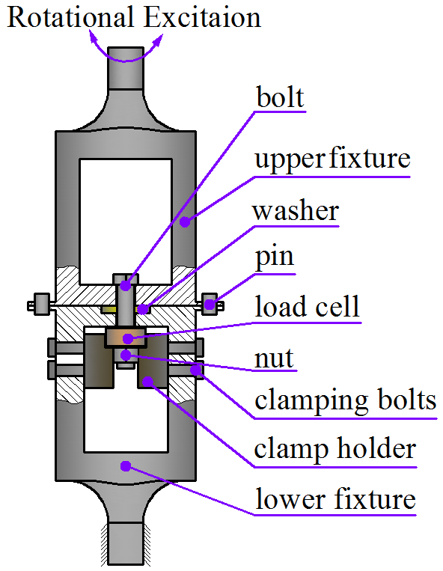
Fig. 1 Experimental setup
The testing procedure is presented below. Firstly, two pins are installed in locating holes respectively in order to ensure the central lines of the involved components aligned. Secondly, a preload is applied to the bolted joint using a torque wrench. Thirdly, the locating pins are removed. Subsequently, a set of testing parameters (torsion angle θ, excitation frequency f and number of cycles N) are imposed. At last, the loosening test is started by a computer-controlled system. The tests for each set of experimental parameters are conducted independently for three times.

Experimental results and discussion

3.1 Effects on self-loosening
According to ISO 3506-1:2009 and ISO 724:2010, the initial preload for M12 bolts made of 304 stainless steel (ASTM) ranges from 18 kN to 24 kN with a 1.5kN preload interval. When the torsional angle reached a critical value, loosening occurs¹³. In experiments, the critical value of torsional angle θ is 0.5 deg. Moreover, the loosening behavior is explored at increased torsional angles: 1 deg, 2 deg and 3 deg. In order to describe the loosening process, function R_{F}(N) is defined as the percentage of the clamp force remaining in the bolt to the preload after N loading cycles. As shown in Fig. 2(a), the curve of the loosening process can be divided into 3 stages. In the start-up phase (stage I), the bolted-connection structure experiences several torsion load cycles and axial bolt force decreases slowly. In stage Ⅱ, the loosening increases rapidly. Within 10 cycles, plastic deformation of the bolt material and the elimination of asperity on contacting surfaces cause a rapid decrease of the axial force. With the increase of loading cycles, the loosening test runs into stage III and the loosening increases gently.
As shown in Fig. 2(a), the residual bolt axial force increases with the increase of the preload, which means the loosening rate drops. This phenomenon can be explained as follows: On one hand, an increase of bolt preload gives rise to an increase of contact stress between internal and external threads. Most of the asperities on thread surfaces are removed during pre-tightening process. As a result, fretting wear between contact surfaces reduces under a certain cyclic torsional loading. On the other hand, an increased contact area of threads leads to a decrease of plastic deformation under the same loading cycles. As shown in Fig. 2 (b), the residual axial force of the bolt decreases with the increase of torsional angle. After 10⁴ cycles, the axial force drops obviously at an excitation amplitude of 2 deg, at 1 deg excitation suffers a moderate loss, and at 0.5 deg excitation reduces least. This is because deformation of a bolted joint is large and fretting wear between the contact surfaces is serious under high amplitude of angular excitation.

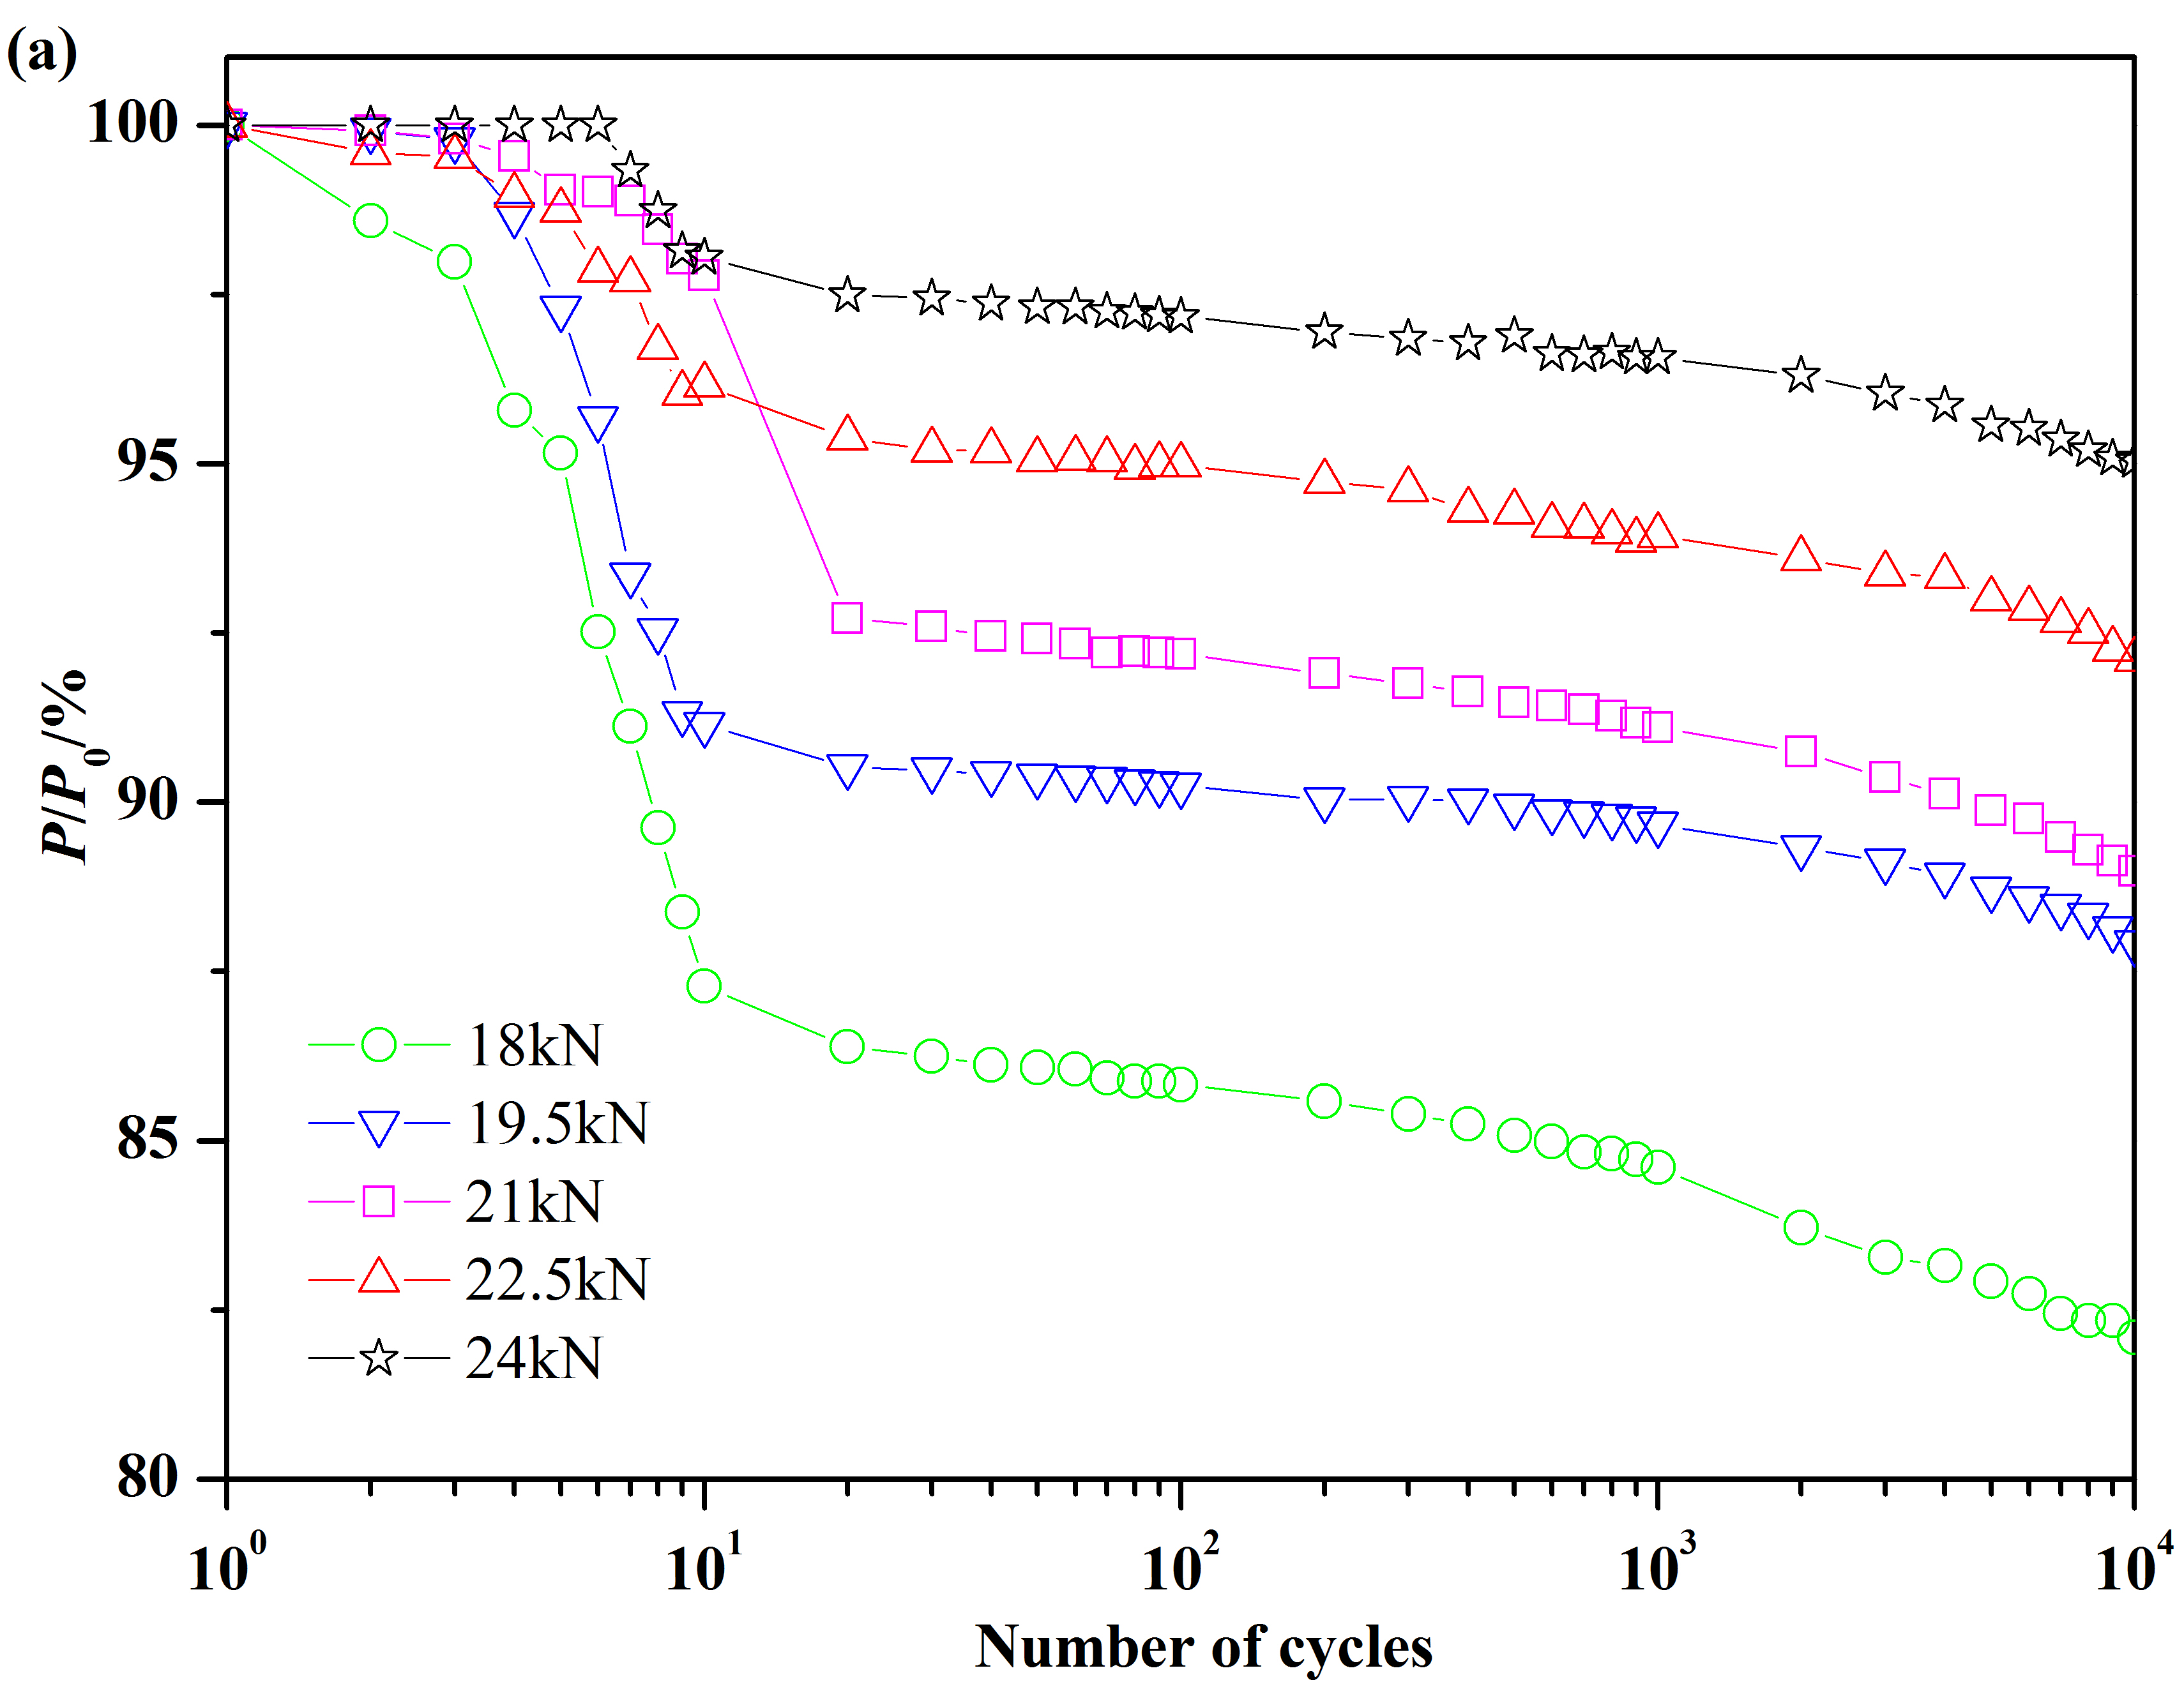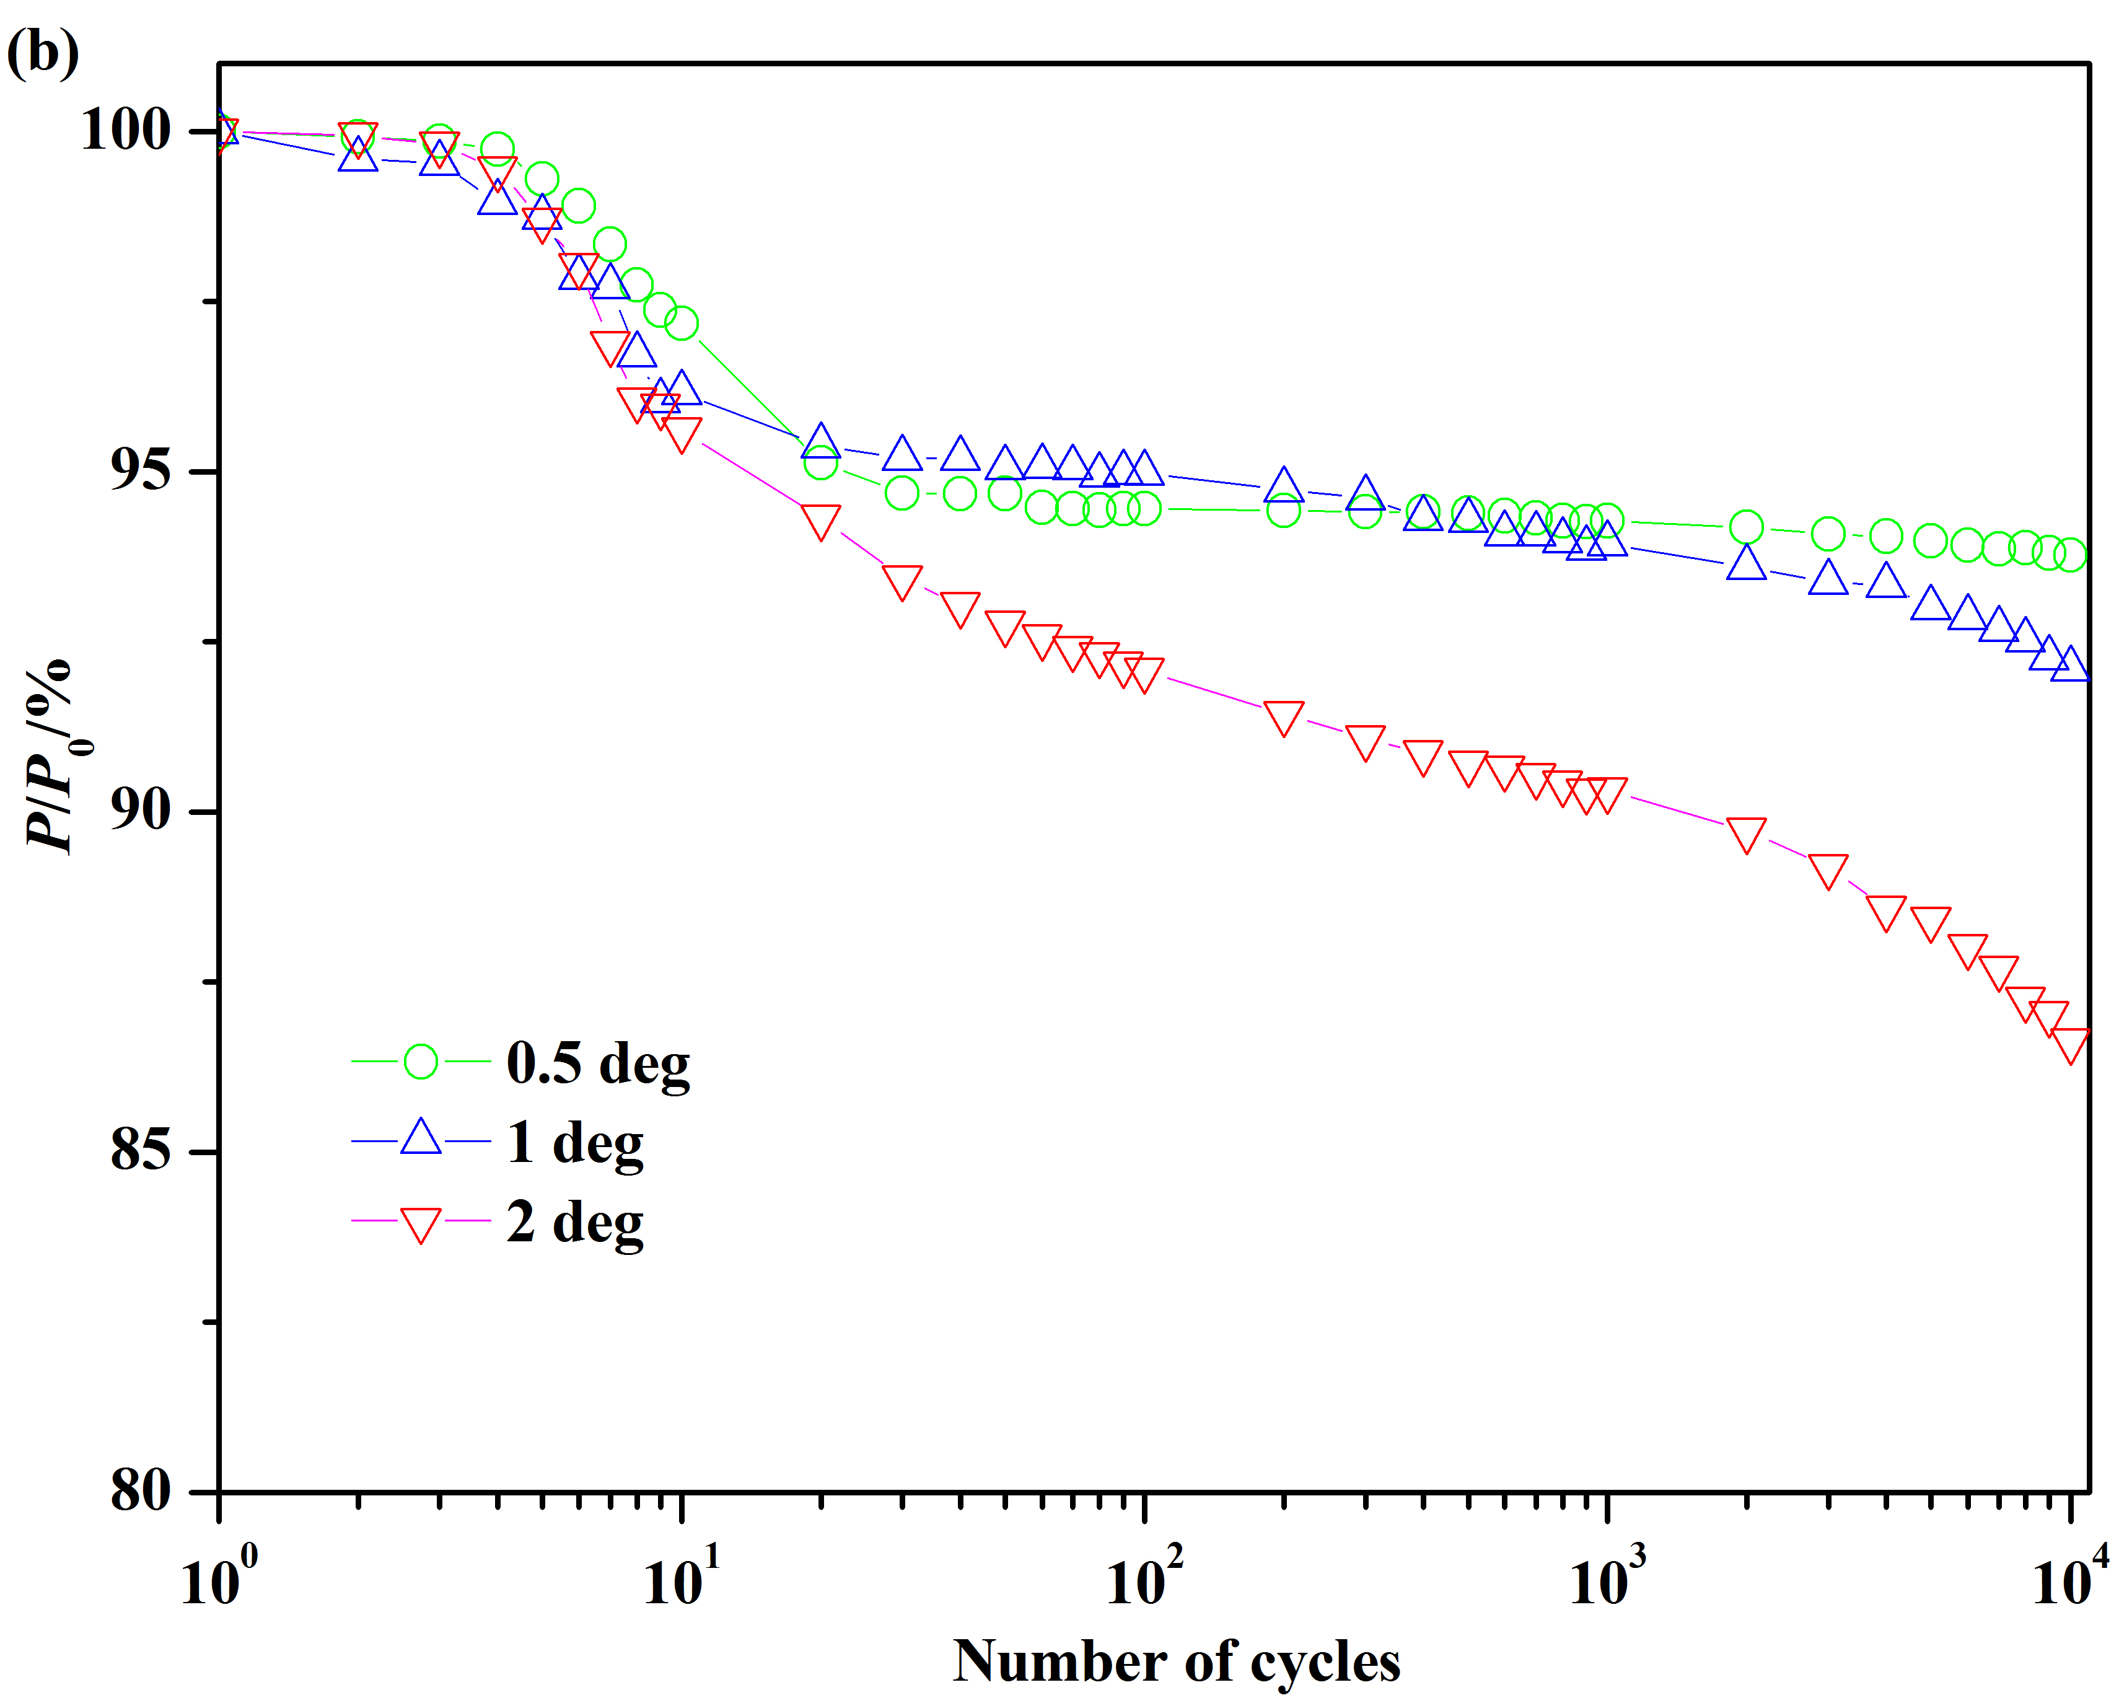
Fig. 2 Self-loosening curves under varying constant preloads and constant amplitudes of angular excitation
- Effect of preload (θ=1 deg); (b) Effect of angular amplitude (P₀=22.5 kN)

3.2 Hysteresis curves and energy dissipation
It can be seen in Fig. 3 that the hysteresis curves show different shapes. With the increasing number of the loading cycles, there exists a transforming process. During the first 400 loading cycles, gross slip occurs between the contact threads, and the hysteresis curve shows parallel hexagon. After 400 loading cycles, relative rotation does not occur between the contact threads, and the hysteresis curve transforms into a parallelogram. The response loops can be divided into 2 phases. In phase Ⅰ, there is no gross slip between the upper fixture and the washer, as well as between the lower fixture and the copper piece. The torque value increases rapidly with the increase of the angle of twist applied on the upper fixture. The gradient of the response curve remains constant with the increasing number of loading cycles, which is proportional to the torsional stiffness value of the bolted connection structure. Moreover, the maximal value of the torque in phase Ⅰ remains constant, which indicates that the coefficients of friction between the washer and the two fixtures remain the same value during the test. With the increase of the applied torsional angle, it enters phase Ⅱ. In phase Ⅱ, the gradient of the response curve presents intuitively a smaller value than that in phase Ⅰ, so the resultant torque value increases slowly with the torsional angle. Additionally, the gradient value of the response curve in phase Ⅱ increases slightly, indicating that the bolt material 304 stainless steel (ASTM) is cyclic hardening.
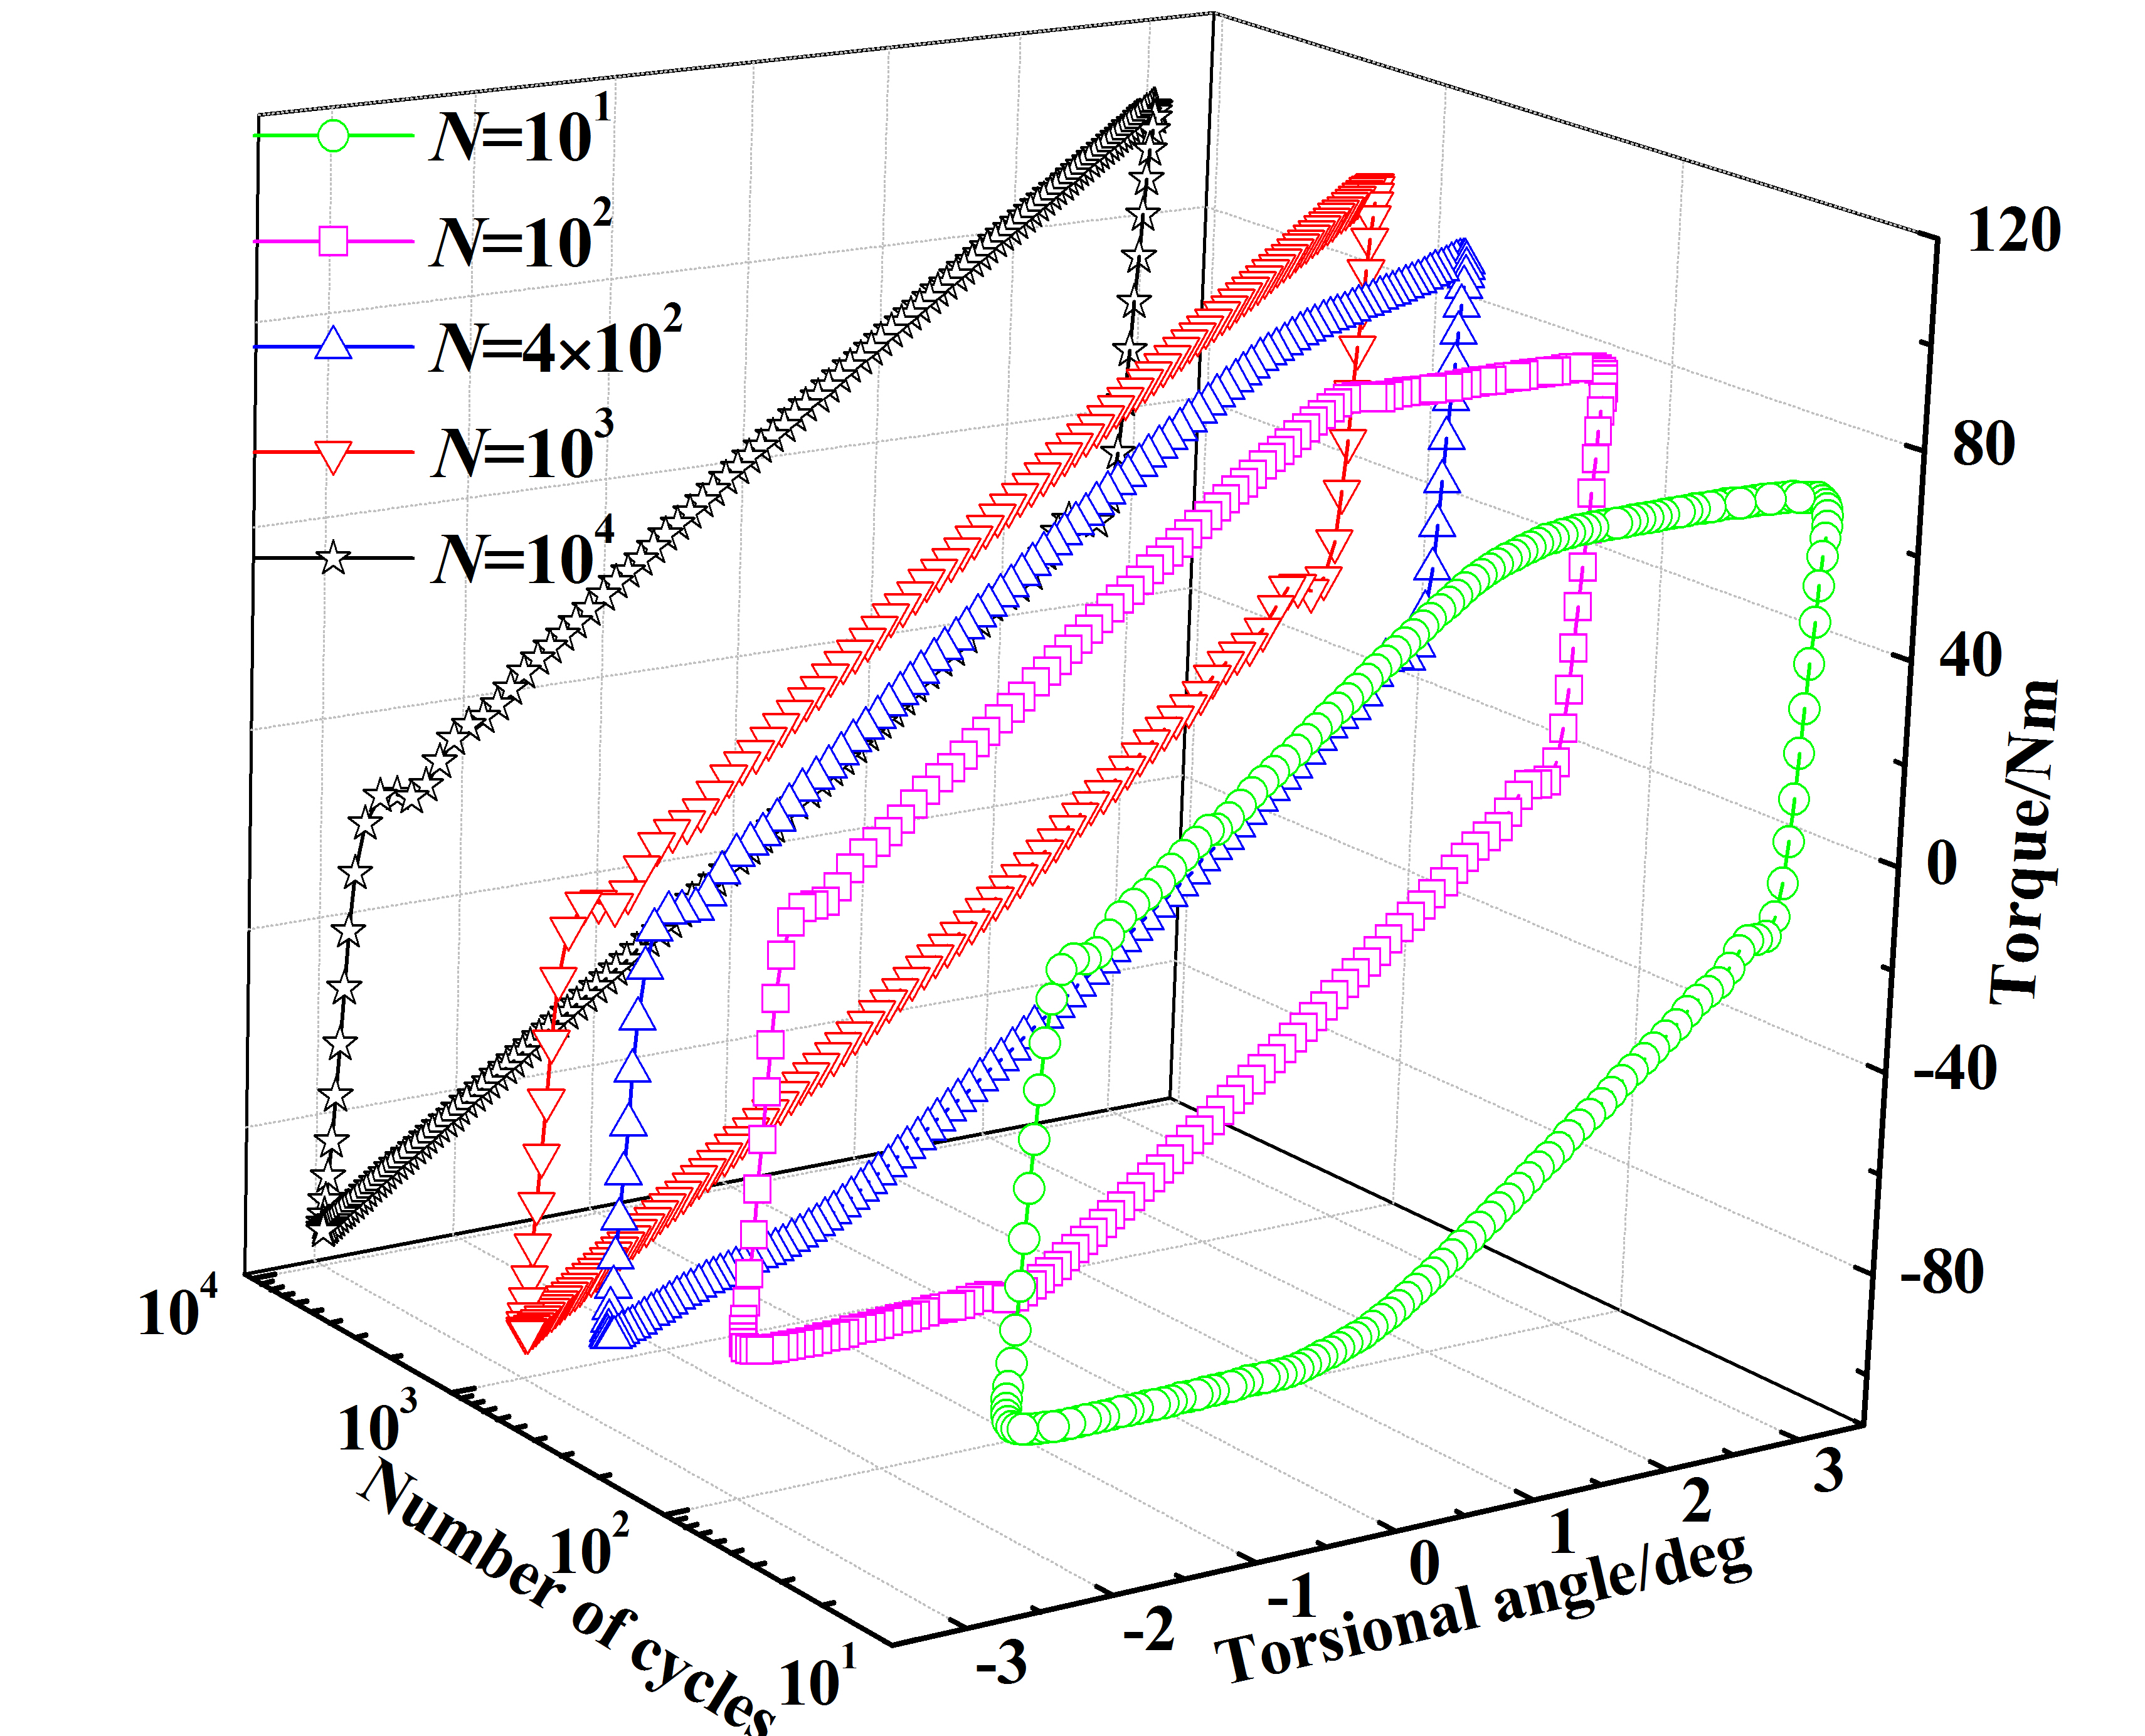
Fig. 3 Transformation of hysteresis curves with the number of loading cycles (P₀=21 kN, θ=3 deg)
Tab. 1 indicates that the dissipated energy increases with the increasing number of loading cycles. Due to fretting wear between the contact threads, the coefficient of friction increasing gradually. In addition, the torsional stiffness of the bolt increases slightly in experiments. As a result, the maximum value of the torque goes up and the area integrated by hysteresis curve correspondingly increases.
Tab. 1 Variation of dissipated energy with cycles (P₀=21 kN, θ=2 deg).
Number of cycles | 1 | 10 | 100 | 1000 | 10000
Dissipated energy (J) | 4.33 | 4.92 | 5.12 | 5.42 | 6.02

Numerical analysis

4.1 Description of finite element model
According to the research of Fukuoka, et al¹⁴, the external thread cross section profile can be mathematically expressed in form of polar coordinate. In order to build an accurate mesh of the threaded part, a Matlab program was compiled according to the mathematical expressions.
Fig. 4 shows the finite element model of the single bolted joint subjected to torsional loading. The nominal diameter d of the bolt is 12 mm, and the thread pitch P is 1.75 mm. In this finite element model, the engaged length between the bolt and the nut is in 6 pitches, the same as in the self-loosening experiment. Moreover, the other part of the bolt rod is not modeled with thread for the purpose of reducing modelling complicity and computational workload. When the preload and the external load are applied to the bolted joint model, the engaged threads and the material region near to them easily run into plastic deformation phase. Thus, it is necessary to define elastic-plastic deformation of the material properties for the bolt and the nut. In terms of the copper piece acting as washer, the Young’s modulus E used is 110 GPa. For the material of the other parts⁹, E is taken to be 200 GPa and Poisson’s ratios of all materials are taken to be 0.3.
The lower fixture is fixed, and the upper fixture is just allowed to twist around the bolt axis. The clamping holder is tied to the lower fixture. The other contact surfaces are defined as frictional contact. Preloads corresponding to experimental conditions is applied to the bolt. A torsional excitation is applied to the holding position of the upper fixture.
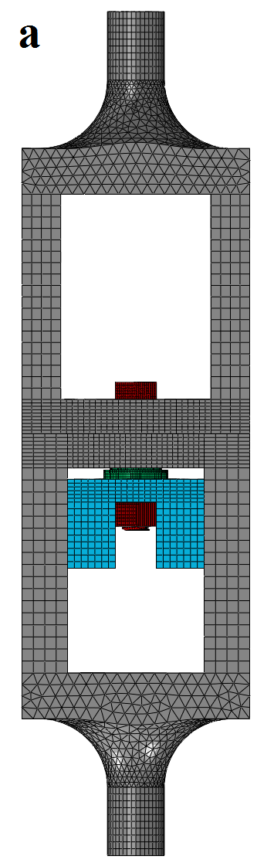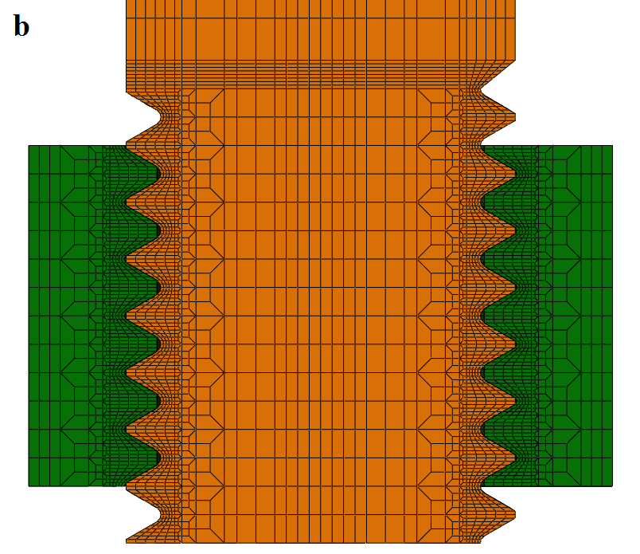
Fig.4 Finite element model and local view of fine meshed threads of bolt and nut
- The whole finite element model; (b) The engaged part of internal/external threads

4.2 Results of numerical analysis
Fig. 5 shows the hysteresis loops of the experimental and numerical results at different amplitudes of angular excitation when the preload is 22.5 kN. It can be seen that the gradients of numerical loops match with the experimental results very well.
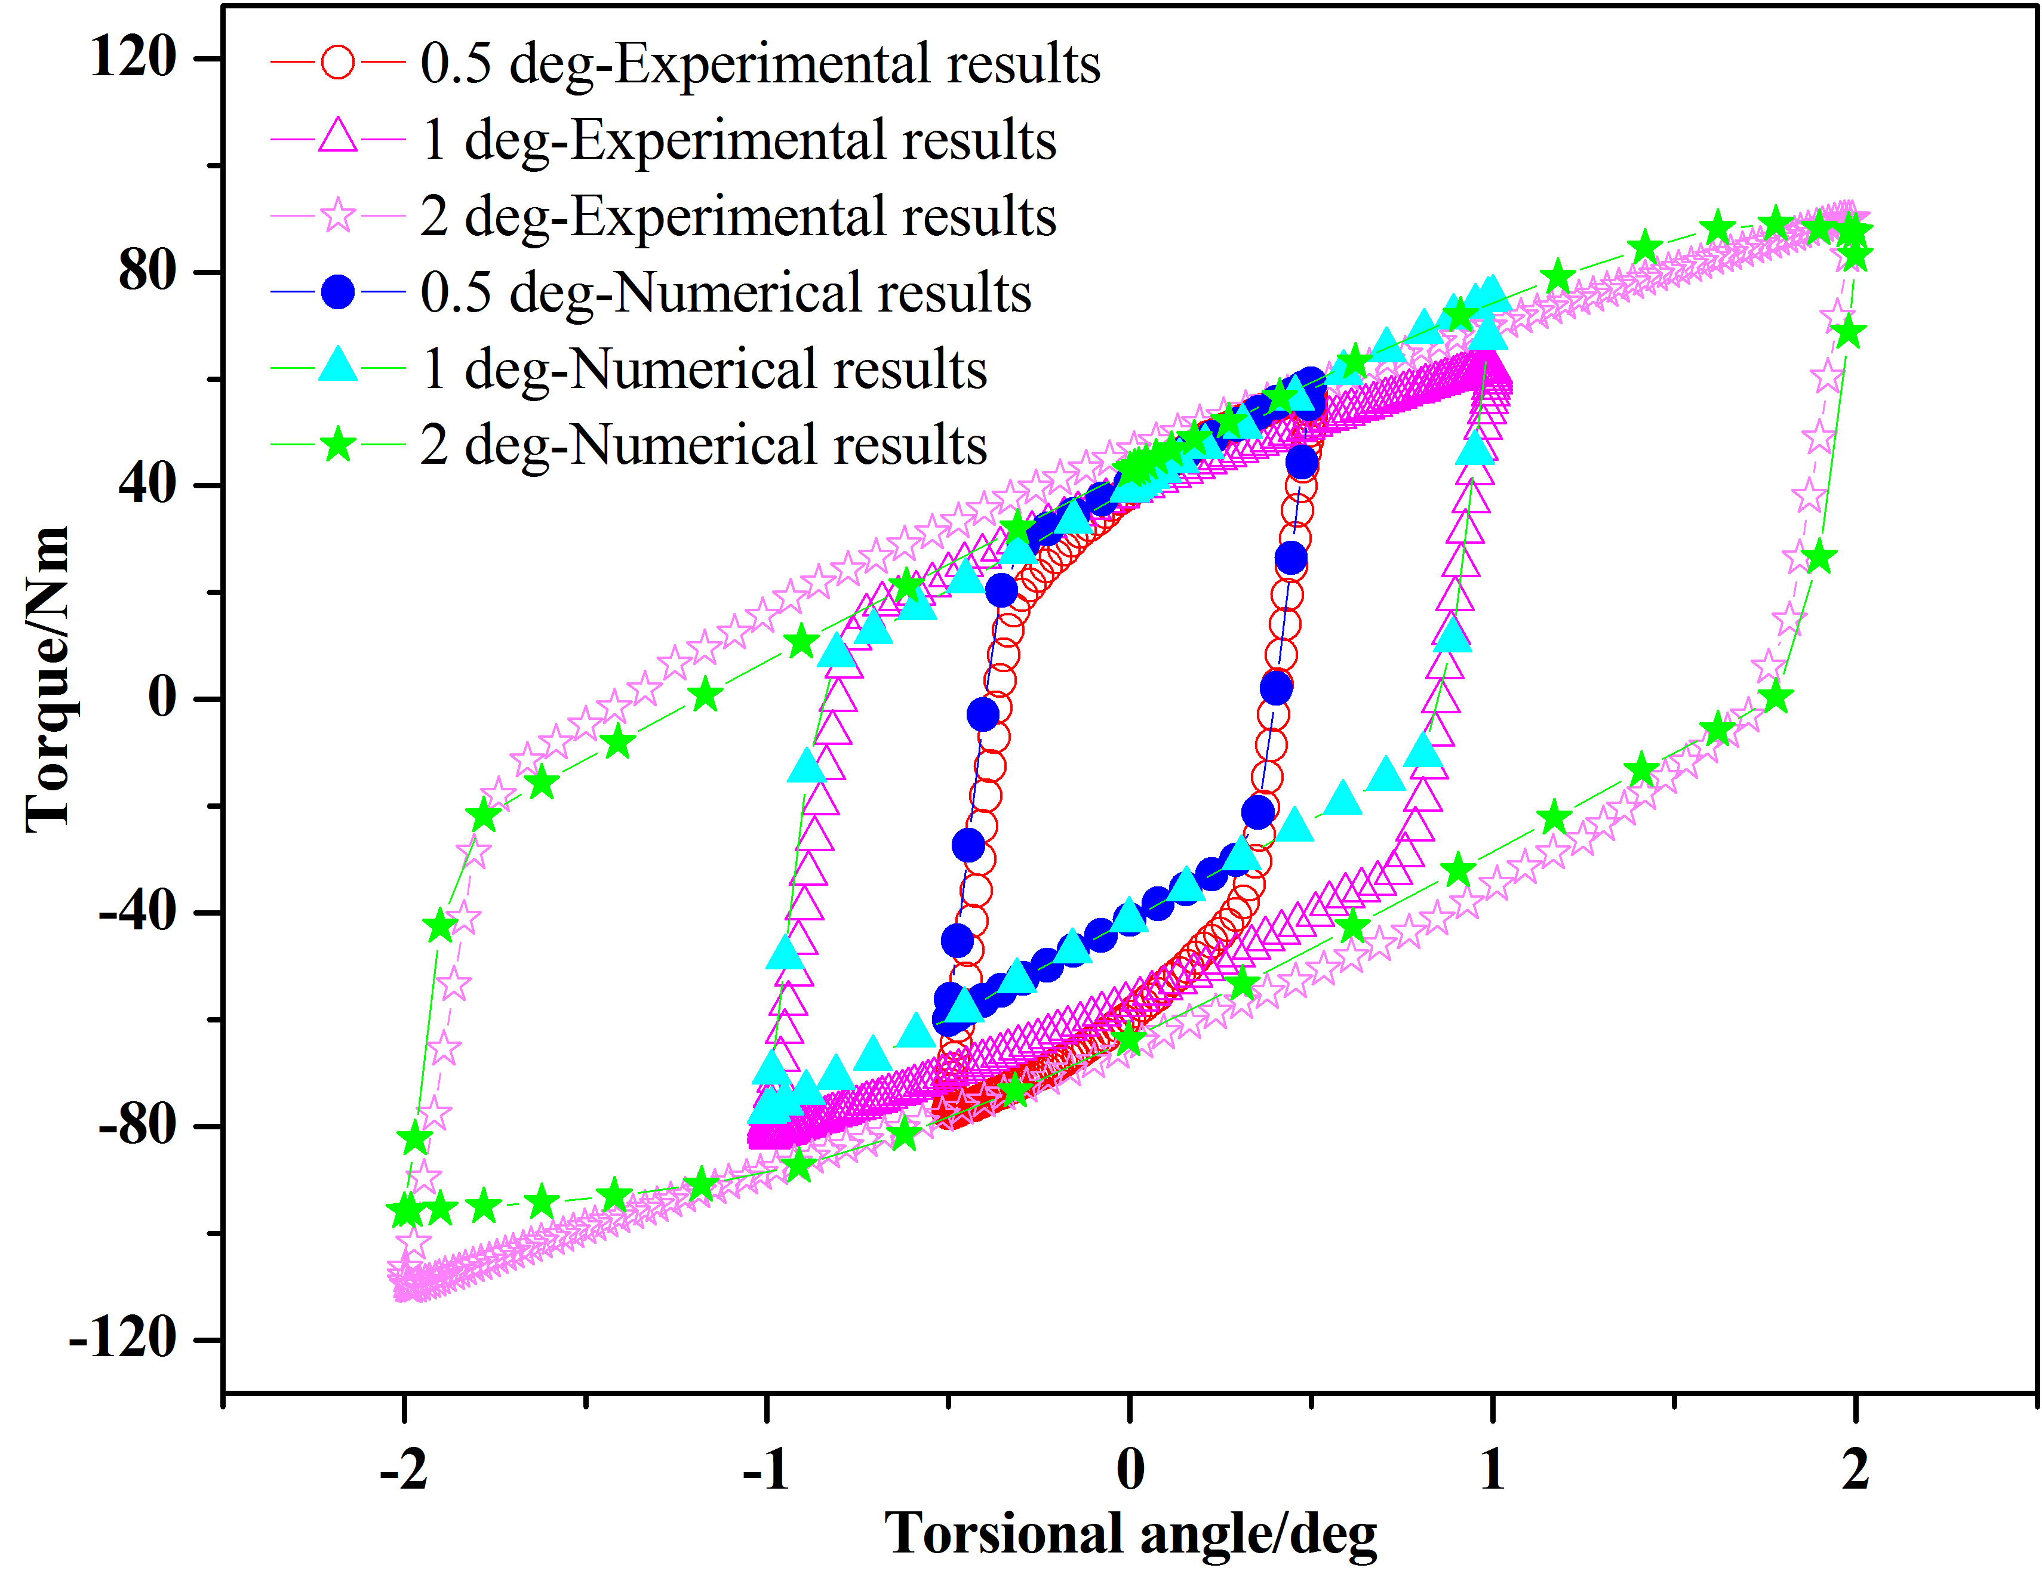
Fig.5 Hysteresis curves of experimental and numerical results (P₀=22.5kN)

Conclusions
In this paper, the loosening process and the dynamic response of bolted joints subjected to a harmonic angular excitation are investigated experimentally and numerically. The conclusions can be summarized as follows.
- The loosening process can be divided into 3 stages. The preload and the amplitude of angular excitation have a significant effect on the self-loosening process. Relative slip is not prone to occur between the contact surfaces because of the large contact stress under a high preload, and the bolted joint has a good anti-loosening performance. The larger amplitude of angular excitation will result in the more severe loosening.
- The hysteresis loops of the bolted joint transforms with the increasing number of loading cycles under a larger amplitude of angular excitation. During the first 400 cycles, the engaged threads experience gross slip, and the hysteresis curve shows a parallel hexagon shape. After 400 cycles, the coefficient of friction gets large because of fretting wear between the contact threads, and the shape of hysteresis curve transforms into a parallelogram shape.
- The hysteresis loops obtained by numerical analysis have good agreement with those measured in the experiments.

Acknowledgements
The authors gratefully acknowledge the support of the National Natural Science Foundation of China (No. U1534209, 51705434) and the Open Fund of State Key Laboratory of Traction Power, Southwest Jiaotong University (No. 2016TPL-Z03).

References
- A. Ibrahim and C. L. J. Sound Vib. 279. 3 (2005).
- N. G. Pai and D. P. Hess, J. Sound Vib. 253. 3 (2002).
- D. P. Hess, et al. J. Fail. Anal. Prev. 14. 5 (2014).
- Y. Jiang, et al., ASME. J. Mech. Des. 126. 5 (2004).
- S. A. Nassar and P. H. Matin, ASME. J. Press. Vess. Technol. 128 (2006).
- S. A. Nassar and P. H. Matin, ASME. J. Mech. Des. 129. 4 (2007).
- X. Yang, et al., ASME. J. Press. Vess. Technol. 134. 1 (2012).
- J. H. Liu, et al., Wear, 346-347 (2016).
- J. H. Liu, et al., Tribol. Int. 115 (2017).
- K. K. Padmanabhan and A. S. R. Murty, Proc IMechE, Part C: Mech. Eng. Sci. 205. 23 (1991).
- H. J. Ouyang, et al., Int. J. Mech. Sci. 48. 12 (2006).
- M. Oldfield, et al., Comput. Struct. 84. 1 (2005).
- T. Yokoyama, et al., Eng. Fail. Anal. 23. 7 (2012).
- T. Fukuoka, et al., J. Press. Vess. Technol. 130. 1 (2008)

* Corresponding author. Tel.: +86 2887601282; fax: +86 2887601304. E-mail address: jianhua-liu@live.cn (JIANHUA LIU).

