The effects of grooved rubber blocks on stick-slip and wear behaviours
X.C. Wang ª, J.L. Mo ^{a, *}, H. Ouyang ^{b}, X.D. Lu ª, B. Huang ª, Z.R. Zhou ª
ª Tribology Research Institute, School of Mechanical Engineering, Southwest Jiaotong University, Chengdu, 610031, China
^{b} School of Engineering, University of Liverpool, Liverpool, L69 3GH, UK
Abstract
This work presents an experimental and theoretical combined study of the effects of the elastic rubber blocks with different surface modifications on the friction-induced stick-slip oscillation and wear of a brake pad sample in sliding contact with an automobile brake disc. The experiments are conducted on the customised experimental setup in a pad-on-disc configuration. The experimental results show that (1) the friction system with the plain rubber block still exhibits visible stick-slip oscillation, but the intensity of the stick-slip oscillation is reduced to a certain degree compared with the Original friction system (without rubber block); (2) the grooved rubber blocks display a better ability to reduce the stick-slip oscillation compared with the plain rubber block; (3) the rubber blocks with a vertical groove (perpendicular to the relative velocity) or a horizontal groove (parallel to the relative velocity) or a diagonal groove (45° inclined to the relative velocity) on their surfaces can suppress the stick-slip oscillation more effectively with various degrees of success. The experimental results also reveal the varying effects of the different rubber blocks on wear. To explain the experimental phenomenon reasonably, a theoretical analysis is conducted to investigate the effects of different rubber blocks on both stick-slip oscillation and wear using ABAQUS. Furthermore, the analysis of the contact pressure on the pad interfaces and the deformation of the rubber blocks are studied to provide a possible explanation of the experimental results.
Keywords: Stick-slip oscillation; Wear; Damping; Groove; Rubber block
1 Introduction
Friction interaction between contacting surfaces is commonly present in nature, from the scale of the earth’s tectonic plates to the scale of atoms ¹⁻⁵. In general, friction can dissipate the energy of systems and act as a stabilization mechanism, however, it can also excite vibration in engineering and daily life under certain circumstances ⁶⁻⁸. One important kind of friction-induced vibration is the stick-slip oscillation which consists of two kinds of motion schemes: a stick regime in which the friction pair moves together and a slip regime in which there is relative motion between them ^{9, 10}.
Stick-slip oscillation widely exists in many different fields ¹¹⁻¹⁴. For example, stick-slip oscillation of the Earth’s plates can cause serious earthquakes, stick-slip vibration in car brakes can result in irritating noise, stick-slip vibration of a drill string can cause tool failure, etc. ¹⁵⁻²⁰. As a kind of non-smooth vibration, stick-slip oscillation is a complex nonlinear problem ²¹⁻²⁴. Usually, stick-slip motion is undesirable and thus should be suppressed or reduced.
For the sake of controlling stick-slip vibration, many scholars have made substantial efforts to understand its mechanism and the probable effective factors using both numerical and experimental methods ²⁵⁻²⁹. They found that stick-slip oscillation is quite sensitive to many factors, like the normal load, the relative velocity, the contact condition of the friction pairs, the lubrication condition, etc. ³⁰⁻³⁴. Moreover, a number of papers have shown that proper values of parameters, such as stiffness, damping, normal force, etc. could reduce stick-slip oscillation of a friction system ^{6, 35-38}.
Many studies showed that adding rubber blocks in a friction system is a very effective way to reduce common vibration ³⁹⁻⁴¹. These scholars suggested that the damping components, like the rubber blocks, etc., play a very important role in the energy absorption and dissipation and the structural stiffness changes. Furthermore, the rubber blocks would lead to the change of vibration of the friction system in an indirect, convenient, and economical way ^{39, 42-44}. The authors’ recent study also suggested that the damping component which is made of rubber with special surface modification in the form of grooves can reduce the common vibration effectively ^{45, 46}. Some scholars studied the stick-slip behaviours of different damping materials as the counter friction components ⁴⁷. However, there has not been any research on how rubber blocks acting as structural members in a brake system affect stick-slip oscillation. How they affect the surface wear of the counter brake friction components is still under exploration. Carrying out this study is the main motivation of this paper.
The aim of this work is to investigate the effect of the elastic rubber blocks which have different surface features on reducing stick-slip oscillation and wear. The experimental study is conducted on a customised brake system test rig containing a rubber block. Four kinds of rubber blocks are studied: one has a plain surface, and the other three have a surface groove in different orientations, are designed and manufactured to reveal their ability to reduce stick-slip oscillation and their effect on the interface contact state of the friction interface. To offer a possible explanation for the experimental phenomenon, a numerical study based on the interface contact pressure and the deformation of the rubber blocks is performed finally.
2 Experimental details and finite element model
2.1 Experimental setup
To reproduce stick-slip oscillation and test the capability of rubber blocks in reducing the stick-slip oscillation, a sophisticated customized pad-on-disc test rig is designed and made. The test rig shows the evident advantage of a simple mechanical structure and can easily produce friction-induced stick-slip oscillation at the contact interface. It also has a high repeatability of the experimental results. Moreover, the working conditions are easily controlled and adjusted, like the normal load, disc rotating speed, atmospheric condition, etc., to reproduce stick-slip oscillation.
The schematic diagram of the test rig is presented in Fig. 1. Five main parts are included in the test setup: drive system which is used to supply the power of the test rig, friction system which is the main part of the rig, loading system whose function is to provide the extra force of the experiment, signal collection and analysis system which is applied to collect and analysis the experimental data, support system which is fixed to the upper surface of the base by bolts. Except for the signal collection and analysis system, the left three systems are held onto the support system.
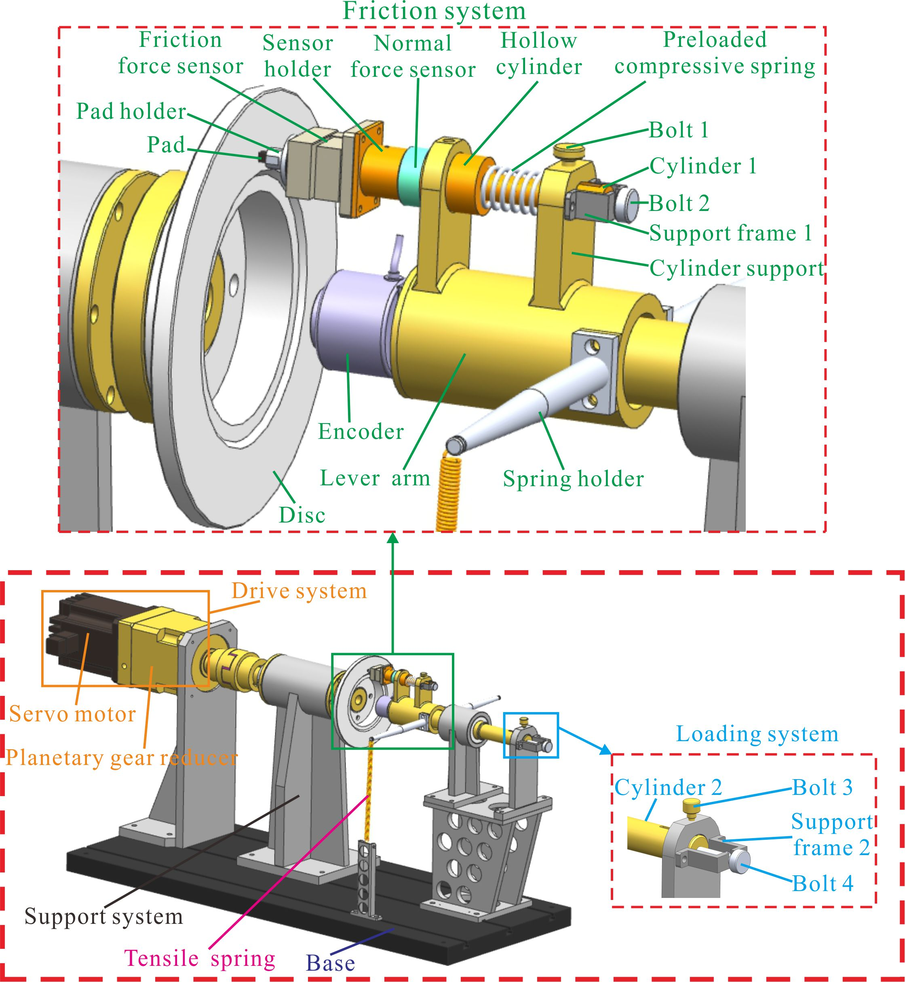
Figure 1. Schematic diagram of the experimental setup.
For the friction system, as illustrated in top red dashed rectangle in Fig. 1, the pad is housed in the pad holder which is mounted on friction force sensor (measurement range: 0-100 N; resolution: 1‰ Full Scale) that is fixed to the sensor holder. The sensor holder, the normal force sensor (measurement range: 0-200 N; resolution: 1‰ Full Scale) and the hollow cylinder are connected successively by cylinder 1 held by the cylinder support that is part of the lever arm. Bolt 2 is supported by support frame 1 which is fixed to the cylinder support and bolt 2 can be rotated freely to push cylinder 1 towards the disc to press the pad to the disc. The lever arm is fixed to cylinder 2 (can be seen in the loading system) by a bearing which allows the lever arm to rotate around cylinder 2 but inhibits it from moving along cylinder 2. The encoder (measurement range: 0-360º, resolution: 10″) is fixed to the lever arm to measure its angular displacement which equals to that of the pad.
In the loading system, the bolt 4 supported by support frame 2 is used to drive cylinder 2 towards or away from the disc to make the pad and disc contacted or separated from each other. Besides, the spring holder is fixed to the lever arm and the tensile spring is fixed to the other end of spring holder, and the other end of the spring is fixed to support system. In this work, an 8-channel signal acquisition and analysis system is used and connected to these sensors to measure and analyse the experimental data.
Before the test, cylinder 2 is pushed forward by turning bolt 4 to make the pad and disc contacted and then bolt 3 is turned to lock cylinder 2. Then bolt 2 is turned to push cylinder 1 to press pad to disc with a prescribed normal force measured by the normal force sensor. After that, the disc can be driven by the servo motor whose speed is adjustable, through the planetary gear reducer in front of the servo motor which provides a stable and precise speed control.
2.2 Experimental parameters
Before conducting the experiments of stick-slip oscillation, a sequence of pre-tests are carried out with different value of normal loads and rotational velocities. The results of angular displacement signal show that the original friction system (without rubber block) produces a continuous strong stick-slip oscillation under the normal force of 40 N and the velocity of 0.1 rpm. Therefore, subsequent tests are conducted with this value of normal load and velocity to present the influence of rubber blocks with various modifications on the stick-slip oscillation more clearly.
The disc is a solid car brake disc whose material is cast iron and the thickness is 15 mm, the internal and external diameters are 162 and 255 mm, respectively. The pad specimen is made of the brake pad friction material in $\text{7×7×13}$ mm. All experiments are conducted in a controlled ambient environment (the temperature of 24–27 °C, the relative humidity of 60±10%).
The contact surfaces of the pad and disc are cleaned by brush before each test. The running-in process of 1 hour is performed for every test that involves a different rubber block to build a fine contact between the pad and disc surface. Considering the randomness of the friction-induced vibration, every test structure is performed three times in this study to insure the repeatability of experiment results. In order to characterize interface contact and wear behaviors of the contacted interface, the SEM is used to examine the topographies of the pad surfaces after the stick-slip oscillation tests.
2.3 Details of rubber block
In this work, the rubber blocks with high damping property are applied to the pad-on-disc friction system to study their performance to influence stick-slip oscillation. And the rubber blocks are installed between the pad holder and the friction force sensor and held in place through two small bolts, as shown in Fig. 2 (a). There are four kinds rubber blocks that are all shaped as a thin disc in $\text{Φ 30 × 5 }$mm, but respectively with a plain surface, and with a horizontal surface groove (parallel to the relative velocity between pad and disc), with a diagonal surface groove (45° inclined to the relative velocity between pad and disc) and a vertical surface groove (perpendicular to the relative velocity between pad and disc), as shown in Fig. 2 (b). These grooved rubber blocks are selected basing on a sequence of pre-tests, in which the influence of rubber blocks on stick-slip oscillation display significant differences in their performance against noise when the grooves are parallel, 45°-inclined and perpendicular to the relative velocity between pad and disc. The grooves are 5 mm wide and 3 mm deep along a diameter of the rubber blocks. For ease of discussion of results in the following sections, the friction systems without a rubber block, with the rubber block of a plain surface, a vertical grooved surface, a diagonal grooved surface and a horizontal grooved surface are named Original system, Plain system, H-G system, D-G system, V-G system, respectively.
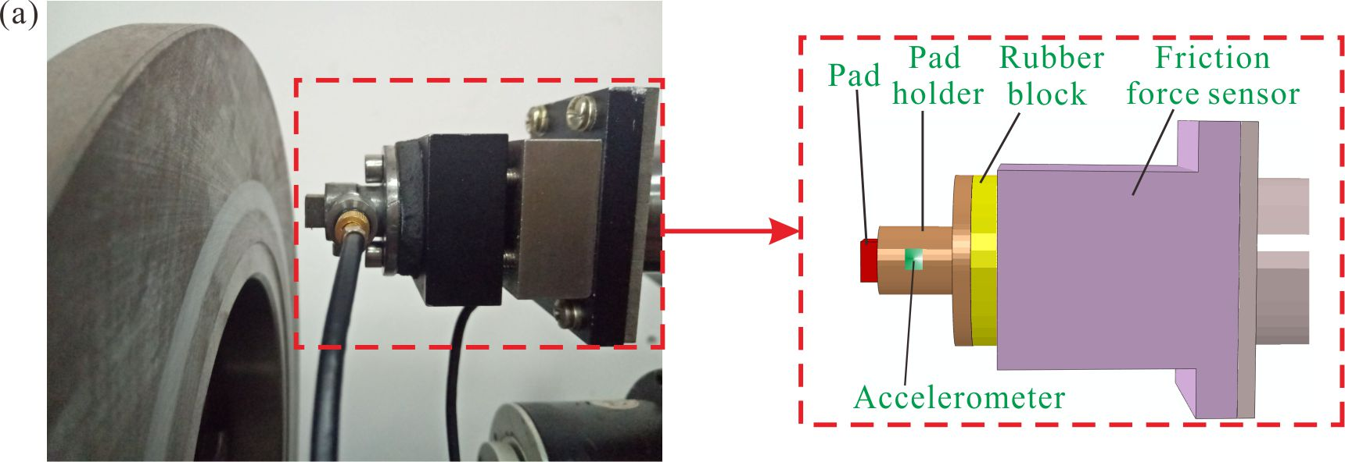
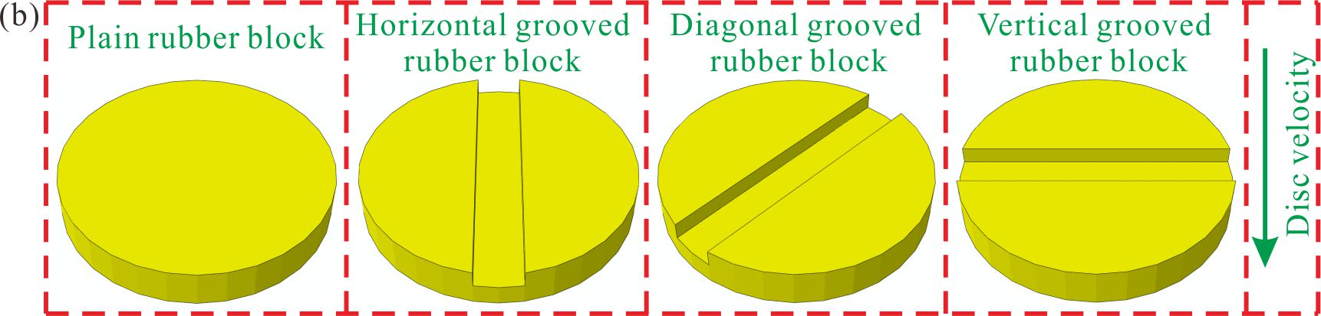
Figure 2. (a) Configuration of the rubber block subsystem and (b) schematic view of rubber blocks with different grooves.
2.4 Mechanical properties of rubber blocks
Before the stick-slip experiments, the mechanical properties of the rubber are tested by the Dynamic mechanical analysis (DMA) test. In the duration of the DMA tests, the mode of forced vibration mode is first chosen and then the oscillating stress is applied to the tested specimen, aiming at getting the strain produced in the tested sample. As an index of the rebound of material deformation, the storage modulus E’ expresses the material’s ability to store the energy of elastic deformation, furthermore, E’ is proportional to the maximum energy stored in the duration of one load cycle ⁴⁸. The loss modulus E’’ describes the energy dissipation as heat of a viscoelastic material when it is deformed in vibration. Loss factor is used to characterize the damping in materials, which is the ratio of E’’ and E’ ^{49, 50}.
In this work, the DMAQ800 dynamometer is used to conduct the DMA tests, and the schematic view of the dynamometer is shown in Fig. 3 (a). Before the test, the sample is put between the drive cylinder and the sample holder. The motor is used to supply the force to push the drive cylinder so that it can be moved up to press the sample, and the stress of the sample is indirectly measured by the strain sensor which is stored in the motor and the displacement sensor is used to measure the displacement. The compression mode is chosen and the frequency of vibration of the drive cylinder is set to be 10 Hz. And the temperature during the test is controlled at 35 °C. The range of the strain amplitude is 0-80 μm. The storage modulus, loss modulus and loss factor are got through the specific software which is associated with DMA. The DMA test results are demonstrated in Fig. 3 (b). Firstly, the storage modulus of the rubber decreases with the increase of the amplitude. Then, the loss modulus is found to first increase with the amplitude and then decreases with the amplitude in duration of 15-70 μm of the amplitude; the loss modulus was found to increase with the amplitude. It can be observed that the loss factor (tan delta) increases with the amplitude.
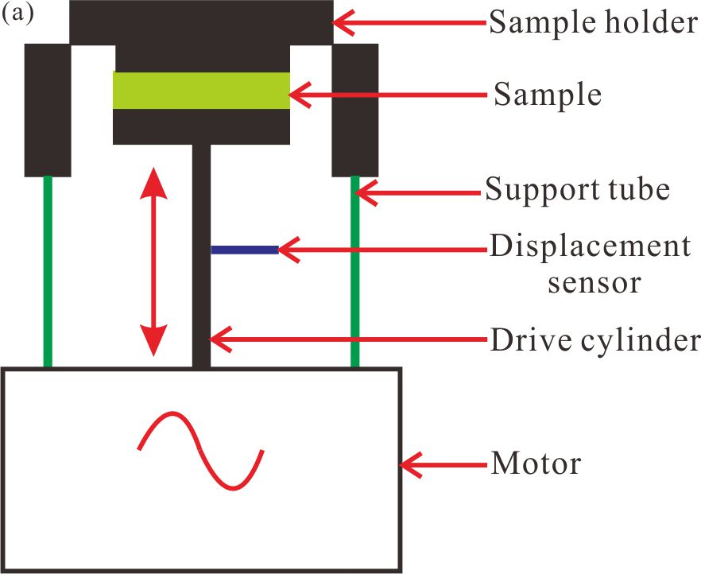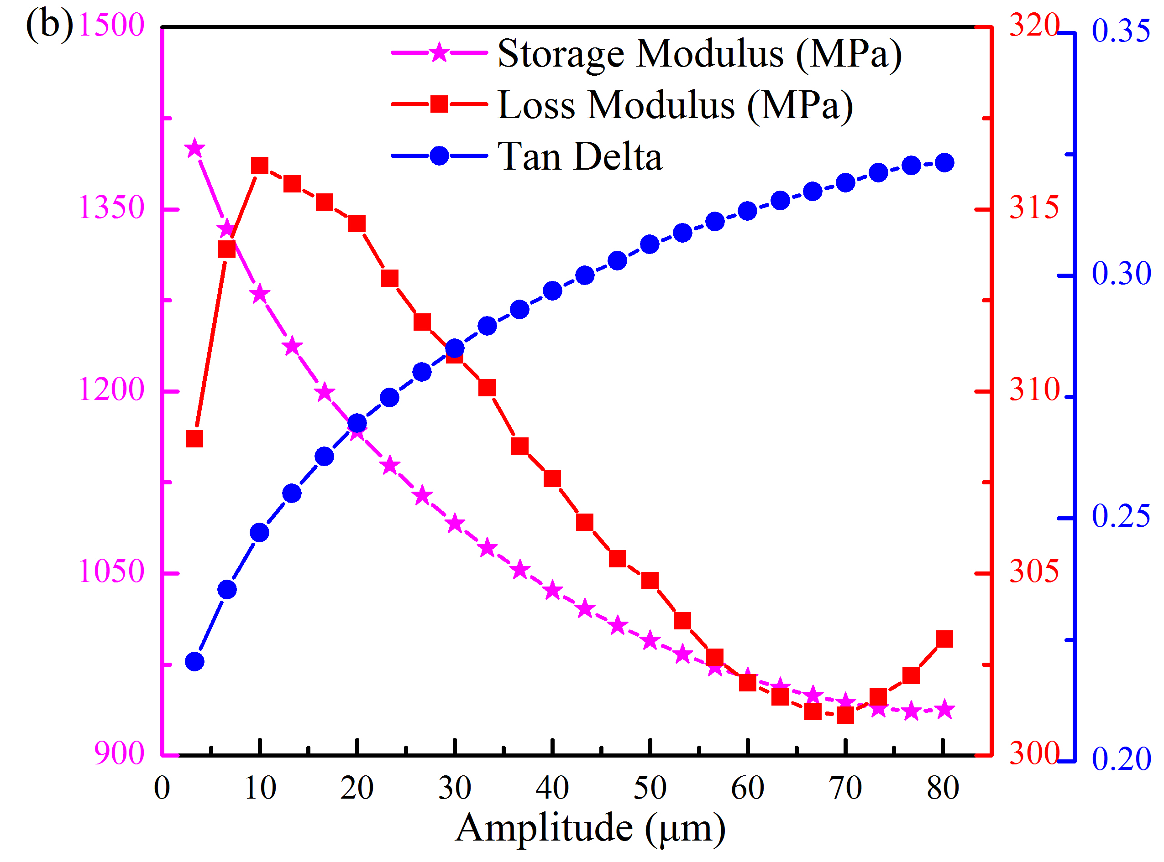
Figure 3. (a) Schematic view of the DMAQ800 and (b) DMA results of the rubber. DMA, dynamic mechanical analysis.
2.5 Finite element model (FE model)
According to the experimental friction system, a simplified three-dimensional FE model implemented in ABAQUS 6.14 is shown in Fig. 4 (a). The FE model is established basing on the geometry of the test rig shown in Fig. 1, which includes one disc, one pad, one pad holder, one rubber block, one friction force sensor, one normal force sensor, one sensor holder, and one hollow cylinder. The rubber block is considered an incompressible hyperelastic material and follows the Mooney-Rivlin model in ABAQUS. A uniaxial tensile test is conducted on the rubber block to obtain the stress-strain curve and the parameters of Mooney-Rivlin are identified based on the obtained curve as C10=0.36 and C01=0.09. Basing on the real material of the left parts, the material parameters in the FE model are shown in Table 1. In the view of the low values of the rotational velocity and normal load, the small size of pad specimen, the friction-generated heat is ignored due to its little effect on oscillation. All of parts of the numerical model are meshed with 3D hexahedral elements, moreover, the pad is meshed into relative finer elements compared with the disc to avoid mesh penetration. The total number of the 3D elements of the numerical model is up to 27641 and there are about 110859 degrees of freedom.
Fig. 4 (b) shows the constraint boundary conditions (BC for short in the Fig. 4 (b)) of the created numerical model. Based on the experimental setup in Fig. 1, the normal force is applied on the right end face of the hollow cylinder in the Z direction, correspondingly, the hollow cylinder is fixed in the X and Y directions except the Z direction. The shaft hole of the disc is free in the rotational direction around the Z axis and constrained on other directions. The velocity boundary condition of the disc is added on the shaft hole in the rotational direction around Z axis. In addition, the two bolts are used to attach the rubber block to the friction force sensor through the pad holder in the experiment setup. Therefore springs are installed to connect the bolts with pad holder in the tangential direction and the stiffness is set to be 1×10³ N/mm. In this FE model, the thread connections between some components (like the connection between the friction and normal force sensors) are set as the tie constrains. During the rotating process, the disc is in friction contact with the pad. Considering the harder material of the disc and the softer material of the pad in the FE model, the disc and pad surface are set as the master and slave surface, respectively. An FE mesh convergence test has shown that the current mesh is adequate and efficient, and thus is used throughout the numerical simulations in this work.
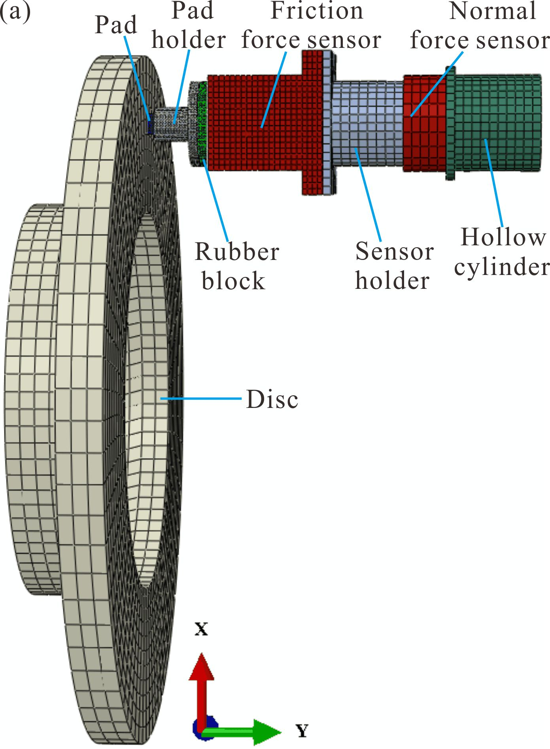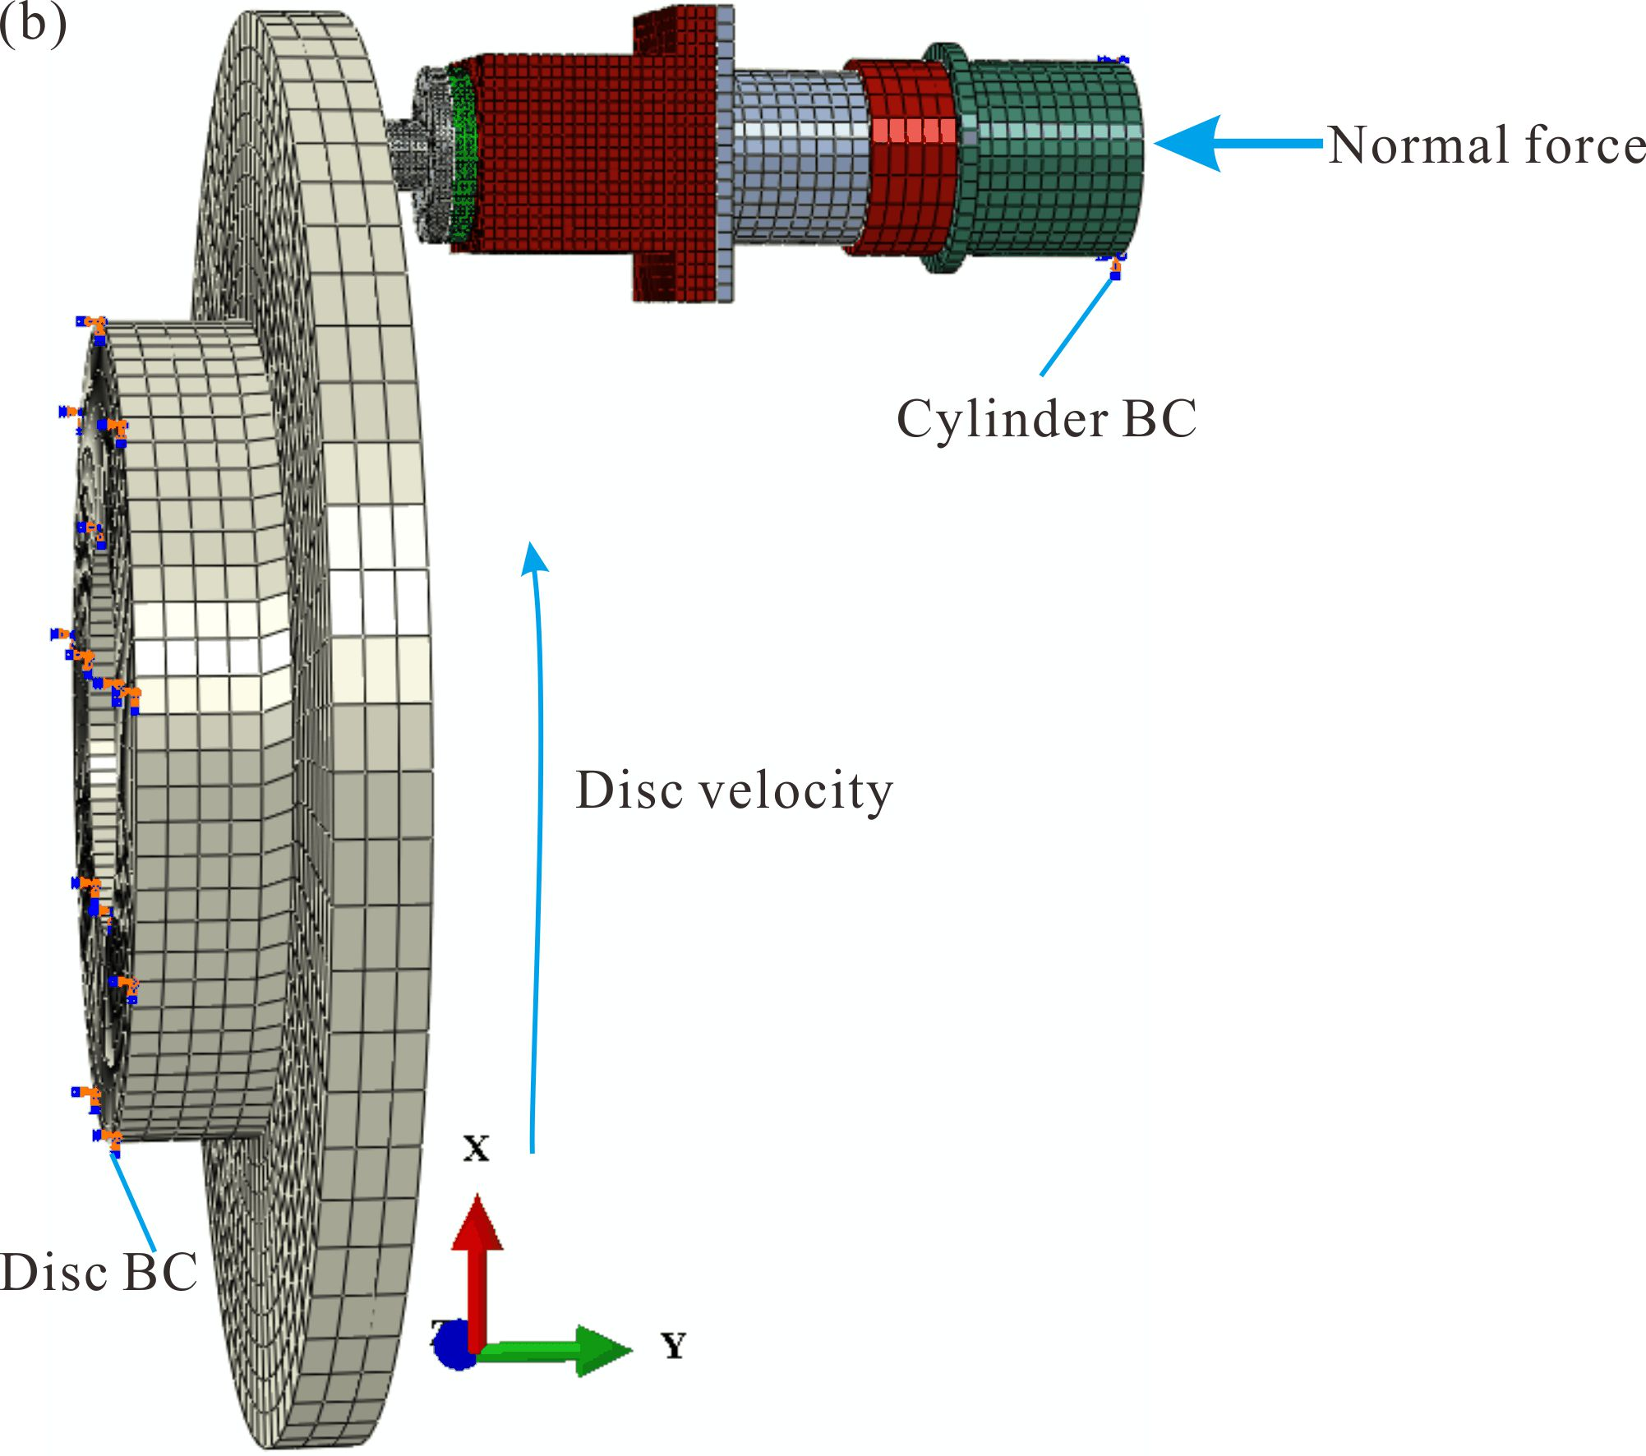
Figure 4. (a) The FE model of the experimental friction system and (b) its boundary condition. FE, finite element; BC, boundary condition.
Table 1. Material parameters of each component in the FE model.
Part | Density (g/cm³) | Young’s Modulus (GPa) | Poisson’s Ratio
Disc | 7.8 | 160 | 0.27
Sensor holder | 7.8 | 196 | 0.3
Pad holder | 7.8 | 196 | 0.3
Pad | 4.5 | 20 | 0.29
Force sensor | 7.7 | 190 | 0.28
Hollow cylinder | 7.8 | 196 | 0.3
Bolt | 7.8 | 196 | 0.3
3 Experimental results and discussion
3.1 Experimental results of the test
3.1.1 Stick-slip phenomenon for different systems
In order to study stick-slip oscillation of five brake systems, the pad’s angular displacement as a function of time of each friction system is measured by the encoder and the results are presented in Fig. 5 (a). The time period chosen represents the steady motion stage during which stick-slip oscillation is generated. The angular displacement of the Original system shows an obvious regular sawtooth appearance, which indicates that the Original system exhibits regular stick-slip oscillation. Similar behaviour is observed in the angular displacement signal of the Plain system. The angular displacement of the H-G system and the D-G system also show stick-slip oscillation, but the oscillation is irregular which is different from that of the Original system and the Plain system. A mixture of stick-slip oscillation and pure sliding can be found for the H-G system and the D-G system, and the D-G system shows the stick-slip oscillation more frequently compared with that of the H-G system. Furthermore, the angular displacement signal of the V-G system is very smooth during the whole duration of steady motion, which indicates that there is no stick-slip oscillation. In summary, there is no significant difference between the Original system and the Plain system in the stick-slip oscillation. The H-G system and the D-G system show reduced stick-slip oscillation to some extent compared with the Original system. The V-G system shows the best ability to suppress stick-slip oscillation.
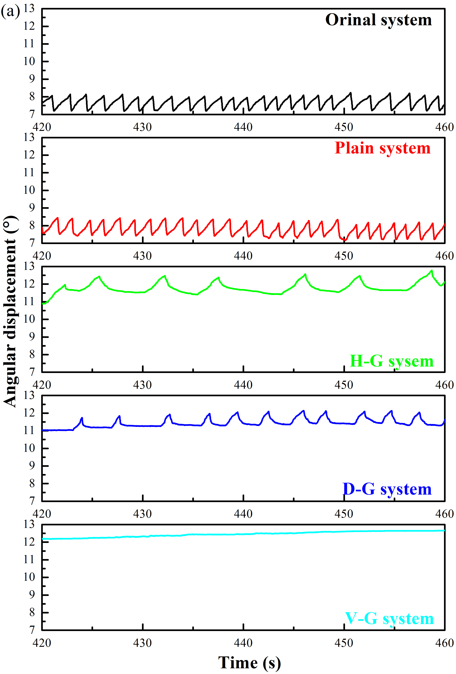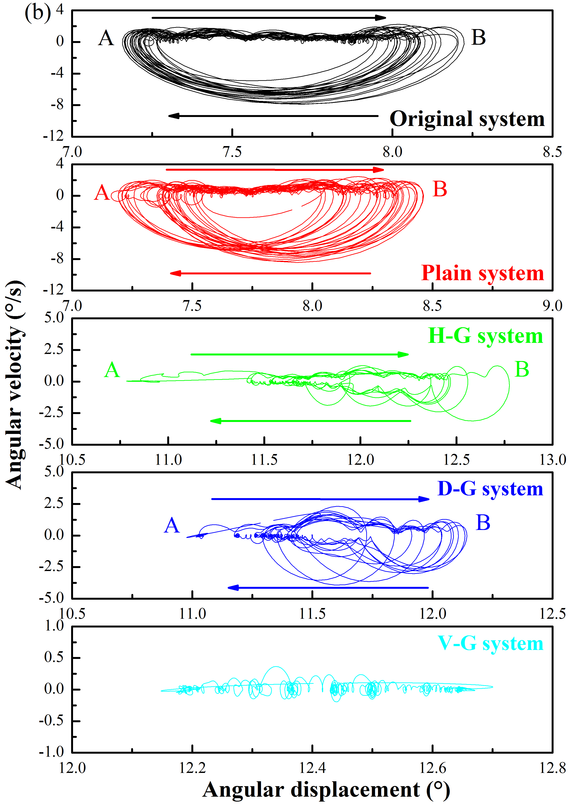
Figure 5. (a) The angular displacement and (b) the angular displacement–angular velocity of the five friction systems.
The limit cycle of stick-slip oscillation contains two kinds of motion regimes, i.e. stick regime and slip regime, and the larger limit cycle always represents stronger stick-slip oscillation. To demonstrate the intensity of stick-slip oscillation, the phase-plane diagram of the angular velocity against the angular displacement are shown in Fig. 5 (b). The angular velocity is calculated numerically as the first-derivative of the angular displacement by using the software Origin ⁵¹. Then the high-frequency components due to the noise in the displacement and velocity signals are removed by passing them through a Low Pass Filter whose filter frequency is set to 5 Hz. Obviously limit cycles form on the velocity-displacement phase plane for the Original system and the Plain system, respectively. And the limit cycles of these two systems are larger than those of the three others. Two motion regimes can be found in the limit cycles, which are the clear stick regime of A to B, and the slip regime of B to A. Although the stick-slip regime in the limit cycles can be found for the H-G system and the D-G system, they are much smaller compared with that of the Original system. The trajectory in the phase-plane, especially for the slip regime, is quite irregular across various cycles, which may be due to the different stick-slip amplitudes in the whole stage for the H-G system and the D-G system. Finally, there is no distinct stick regime found on the phase-plane for the V-G system.
To study the friction property of each brake system, the time histories of the friction force oscillation against time are given in Fig. 6. As can be seen, the friction force shows a visible stick-slip oscillation for the Original system, and the friction force increases slowly during each stick regime. Then it drops to the dynamic friction force after it reaches the static friction capacity. In comparison, the friction force also appears oscillatory for the Plain friction system, and there is no a significant difference in its magnitude compared with that of the Original system. Regarding the H-G system and the D-G system, the friction force still shows stick-slip oscillation, but the sliding motion lasts longer while the sliding period is not so regular. The difference between these two systems is that the D-G system exhibits the stick-slip oscillation more frequently. Finally, the friction force of the V-G system displays an almost constant value during the whole measurement duration. It can be preliminarily concluded that the Original system shows the most obvious stick-slip oscillation, and in general, adding the rubber block to the friction system can reduce the stick-slip oscillation, which may be due to the high damping capacity of the rubber block (as shown in Fig. 2). However, different rubber blocks show different ability to reduce the stick-slip oscillation, which will be explored in Section3.2.
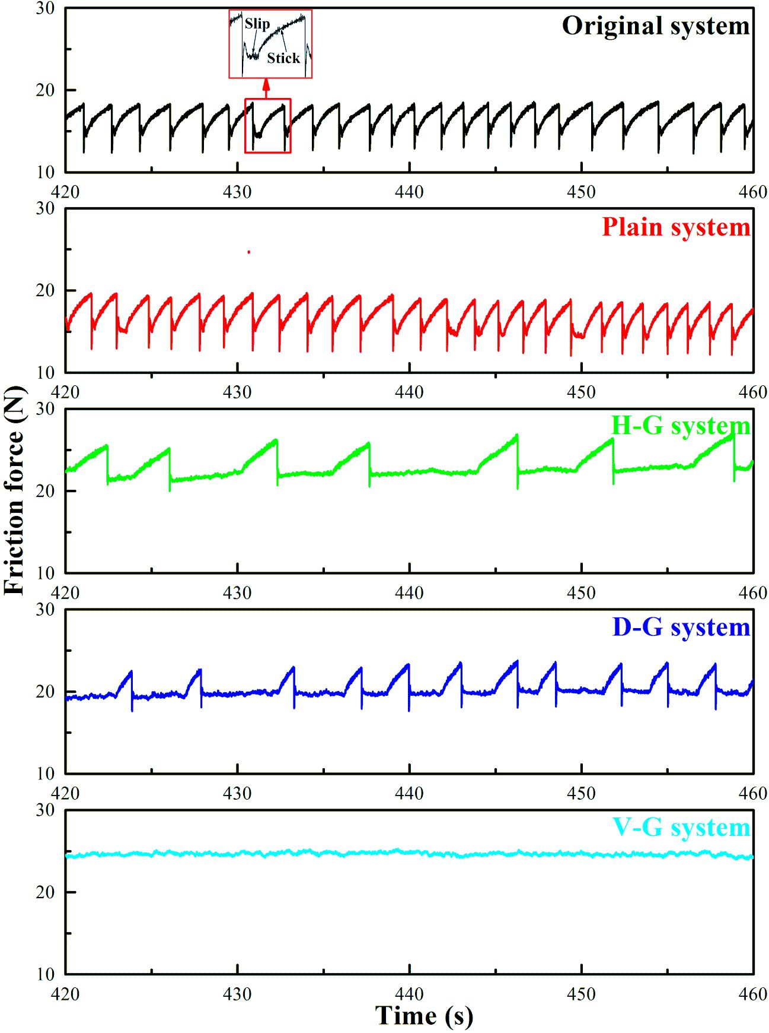
Figure 6. The friction force of five friction systems.
3.1.2 The characteristics of vibration acceleration for five systems
For the sake of further investigating the intensity of the stick-slip oscillation for the different brake systems, the vibration accelerations which are measured by the accelerometer (as shown in Fig. 2 (a)) in the tangential direction are measured during the whole experimental process and the results are shown in Fig. 7 (a). It can be found that for the Original system and the Plain system, the accelerations experience sudden jumps due to the sudden switching from stick regime to slip regime. Moreover, such jumps happen periodically because the regimes vary from stick to slip periodically. But the fluctuation of acceleration of the Plain friction system is not evident as that of the Original system, which means that the Plain system can reduce the stick-slip oscillation to a certain degree in relation to the Original system. The fluctuation of acceleration is also found for the H-G and the D-G system, but the frequencies of the fluctuations are much reduced compared with that of the Original system, especially for the H-G system. This corresponds to the fewer stick-slip events for these two systems in Fig. 5. In contrast, the vibration acceleration of the V-G system is very uniform–no fluctuation is found during the whole test duration, respectively. This is coincident with the fact there is almost no stick-slip oscillation in the V-G system.
In order to comprehensively evaluate the influence of the rubber blocks on the stick-slip oscillation, the values of root-mean-square (RMS) of the vibration accelerations for all of the friction systems are calculated, and then presented in Fig. 7 (b). These RMS values of vibration acceleration are 0.689 and 0.451 m/s² for the Original system and the Plain system, respectively. When a surface modification is introduced to a rubber block, the RMS values of accelerations are reduced in varying degrees. They are 0.275, 0.357, 0.090 m/s² for the H-G system, the D-G system and the V-G system, respectively. The results indicate that the friction system with the vertically grooved rubber block has the lowest vibration.
To further investigate the characteristics of the stick-slip oscillation in the frequency domain after the time domain, the Fast Fourier Transform is applied to translate the signal of the vibration acceleration from its original time domain representation to that in the frequency domain for each friction system. And the results of power spectral density (PSD) are got by frequency domain analysis below.
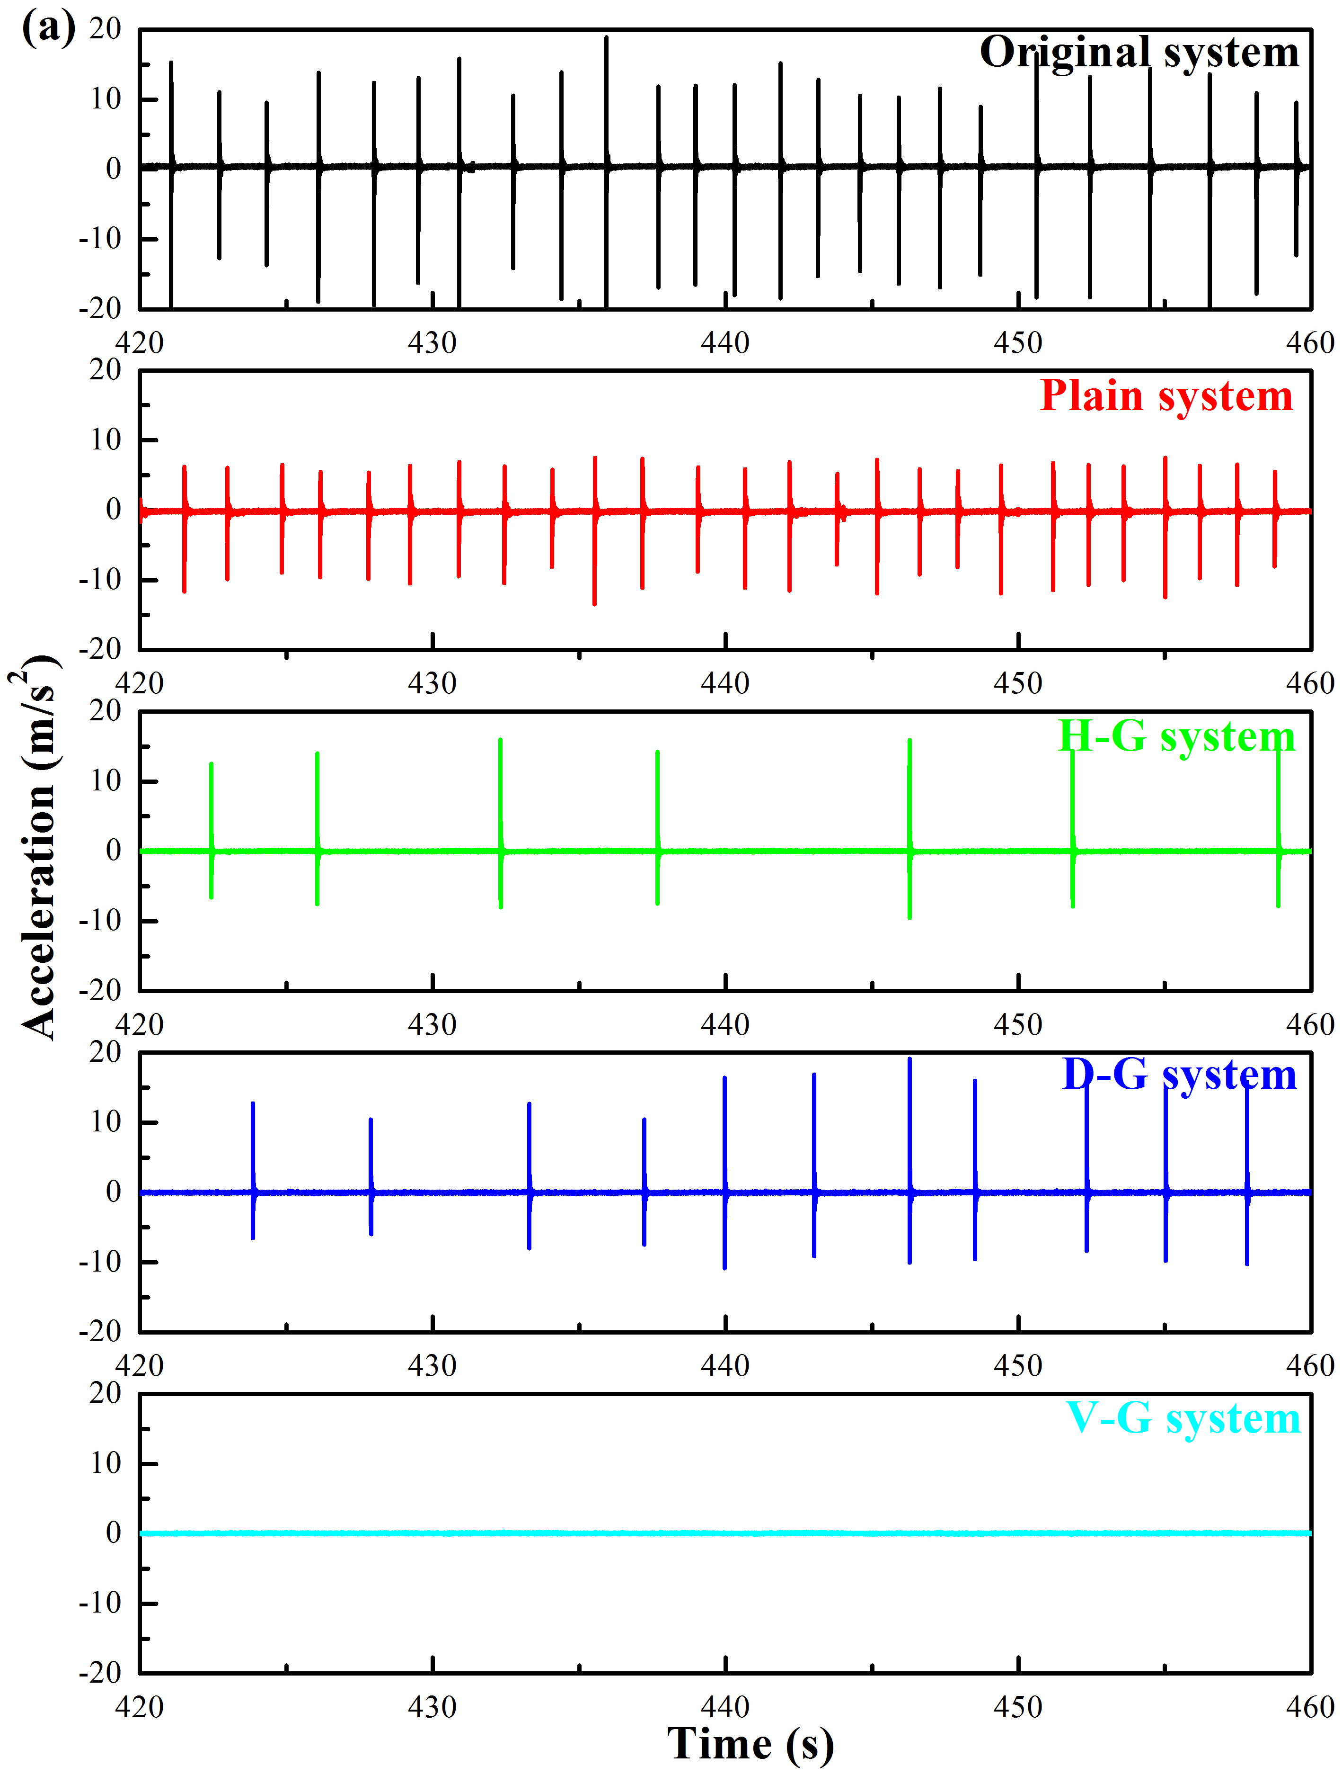
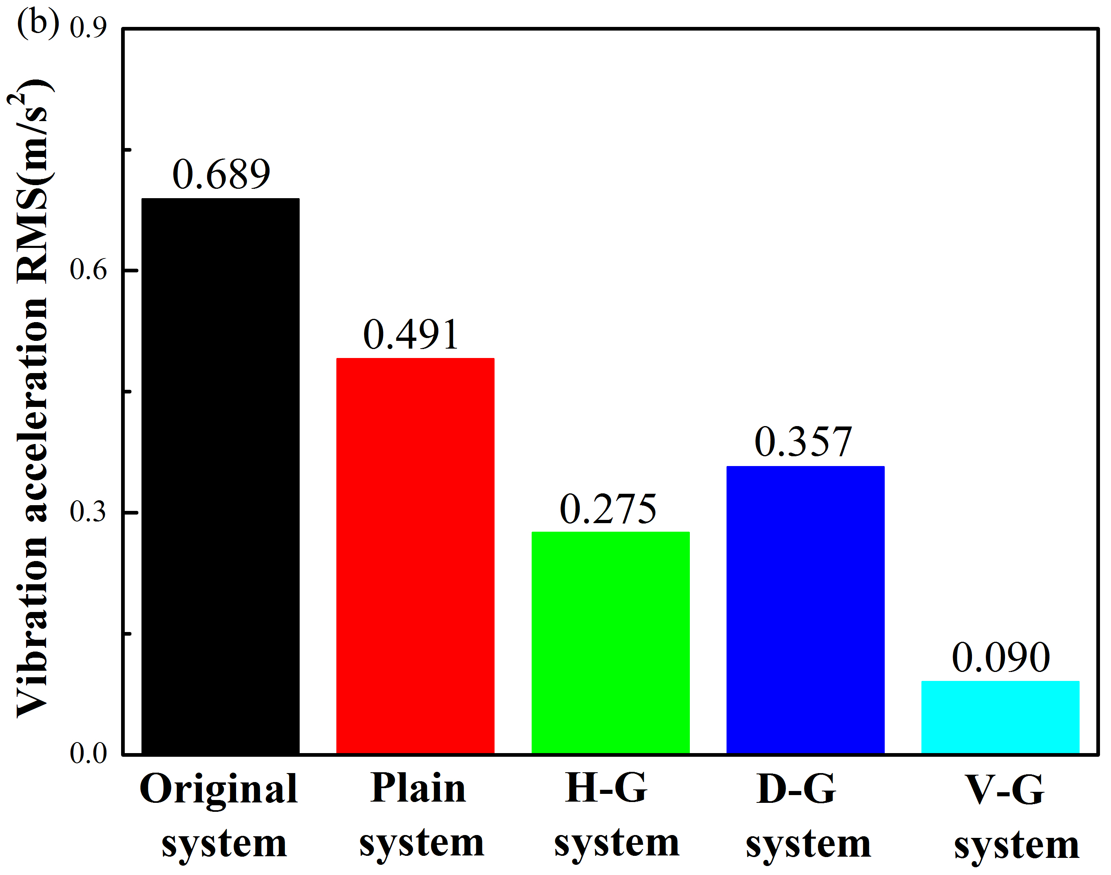
Figure 7. (a) The vibration acceleration signals and (b) the RMS values of vibration acceleration for friction systems. RMS, root mean square.
The PSD results are exhibited in Fig. 8. Obviously, the five brake systems share one dominant frequency at 150 Hz. The Original system possesses the most complex frequency components with another two dominant frequencies at 123 Hz and 183 Hz, respectively. A dominant frequency of 187 Hz can also be found in the Plain system. The spectra of the Original system and the Plain system look very similar. Another three the dominant frequencies of 50 Hz, 250 Hz and 299 Hz can be observed for the remaining three friction systems with grooved rubber blocks. The spectra of these friction systems have a similar pattern.
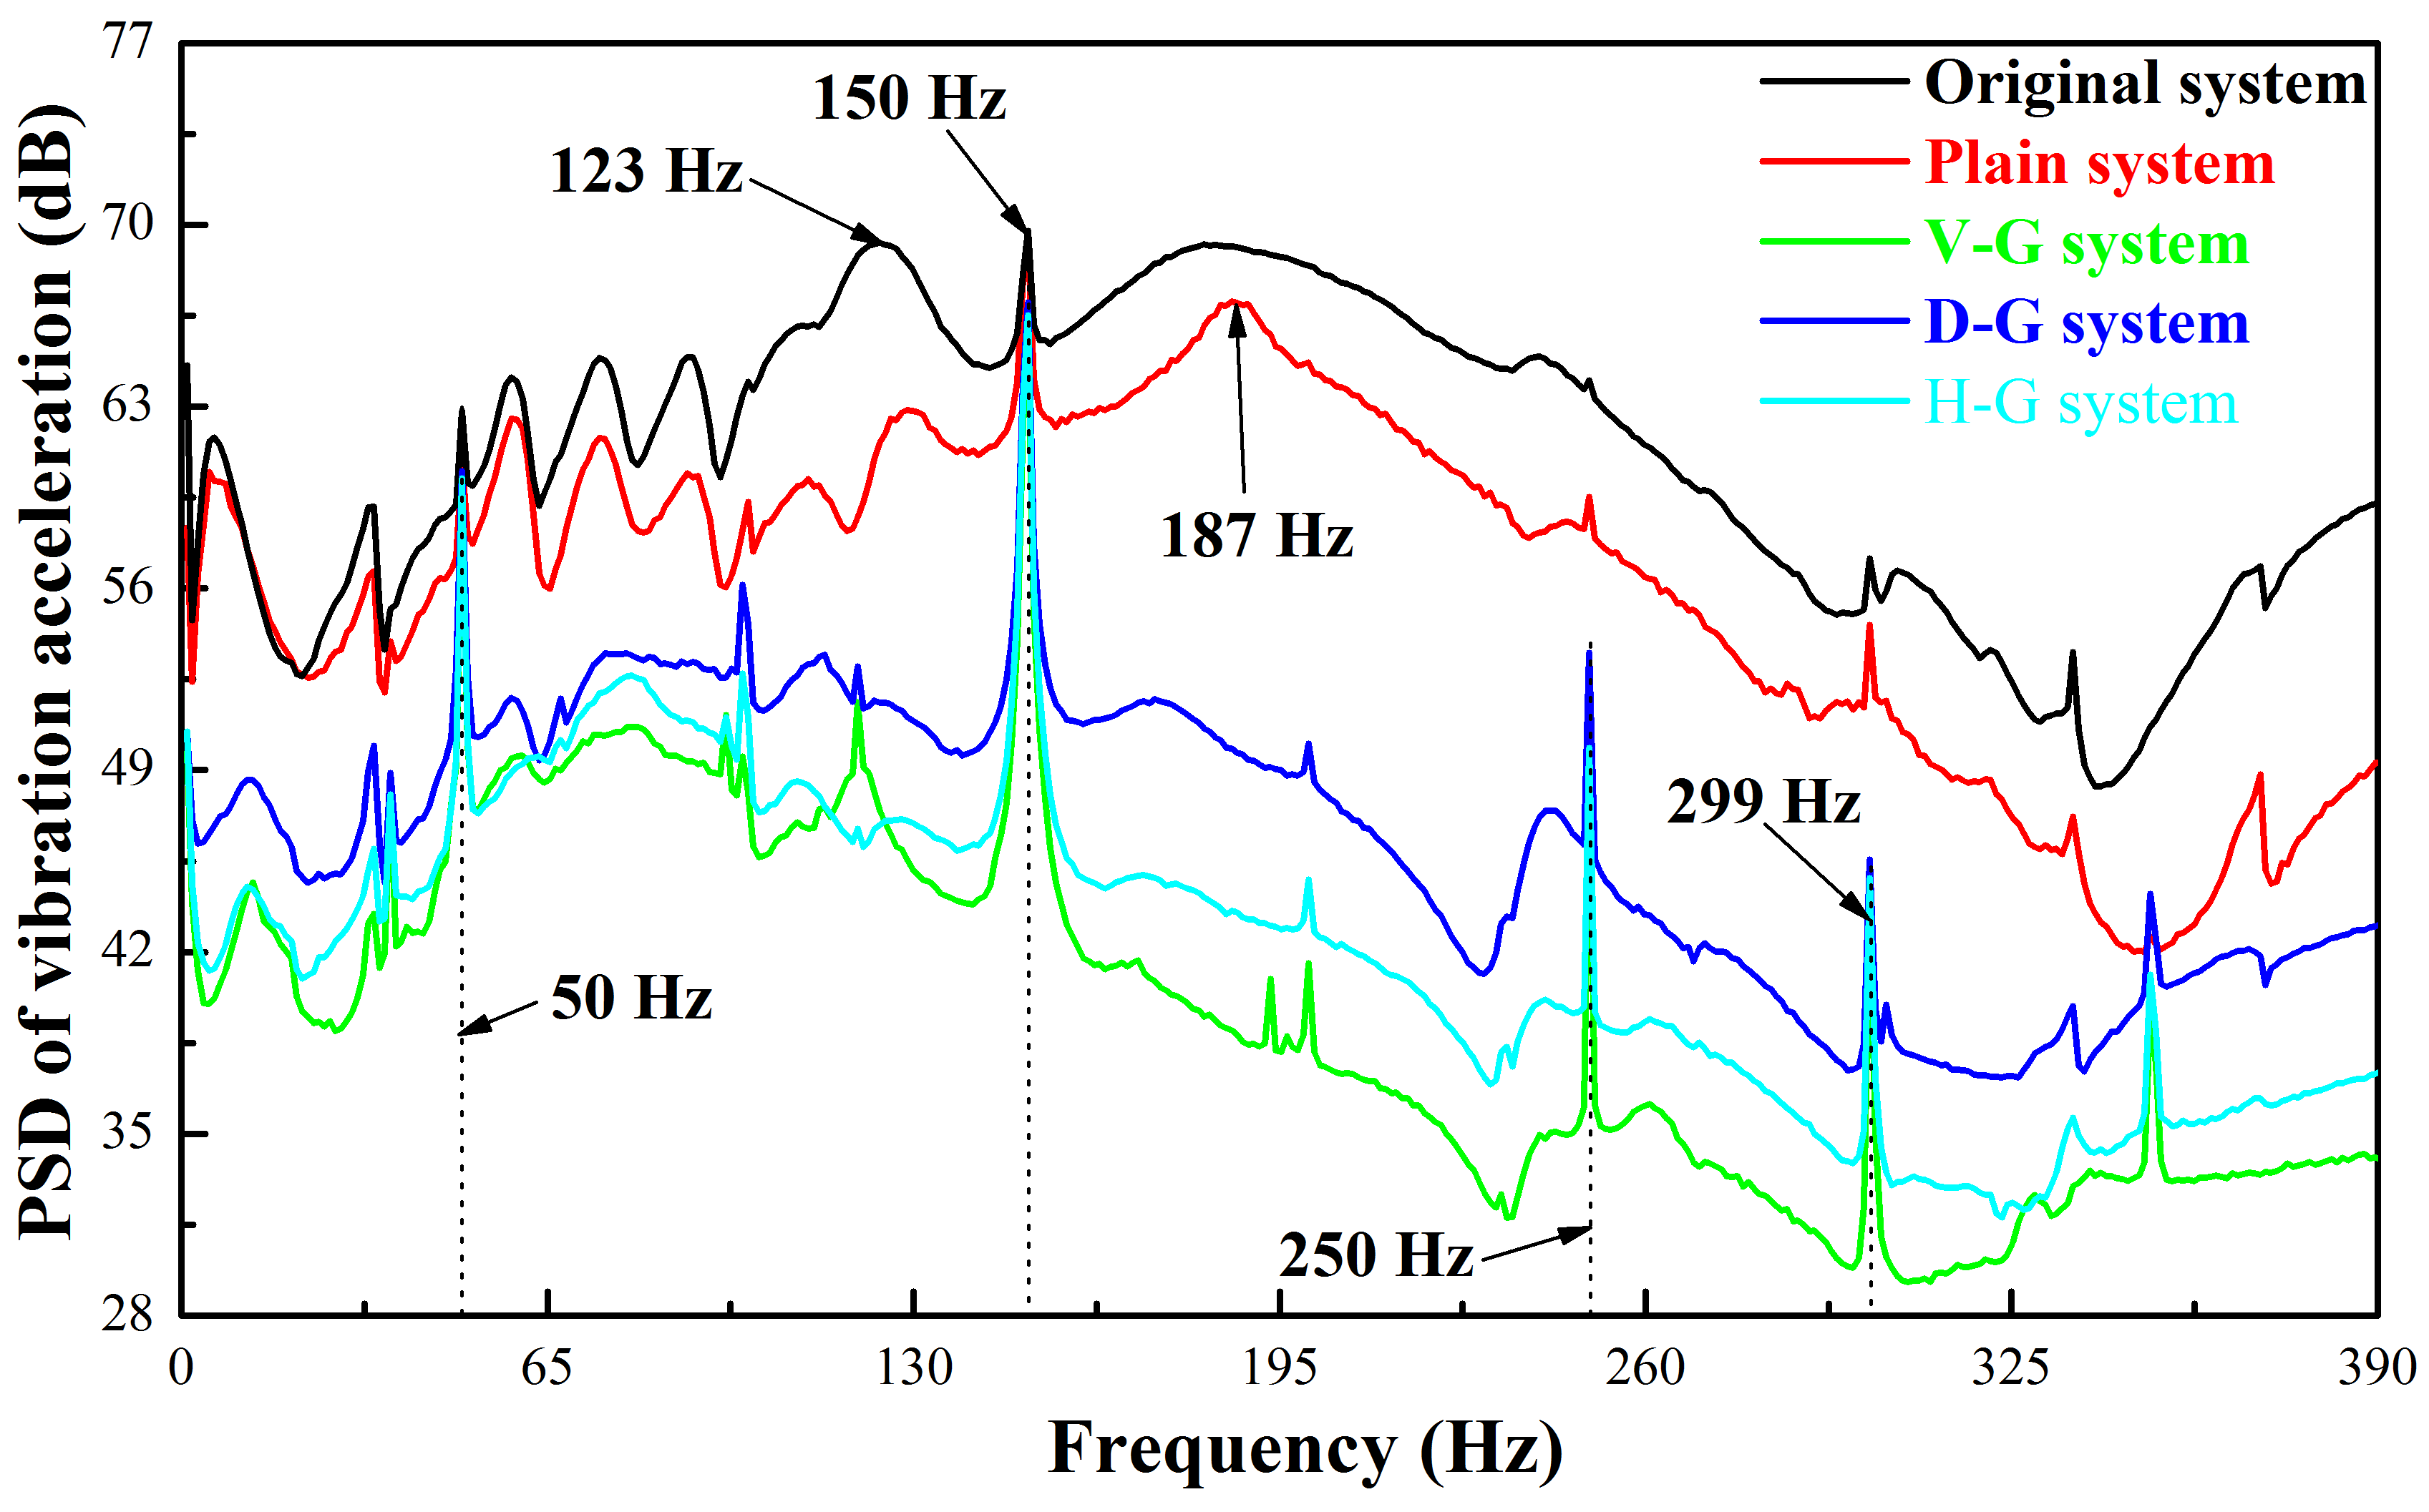
Figure 8. PSD results of the vibration acceleration for all friction systems. PSD, power spectral density.
Another important phenomenon is that the power level of the Original system is the highest, and the power levels are reduced in different degrees for the other friction systems. It is speculated that the good damping property of the rubber block makes a contribution to dissipating the power of the friction system. Furthermore, the power level of the Plain system is higher than those of the other three friction systems and the Original system has the highest power level. In terms of the power levels, the D-G system, the H-G system, the V-G system form a descending order. These results confirm that the friction system with the plain rubber block can reduce the vibration to a certain degree, adding the grooved rubber blocks leads to even lower vibration, and furthermore, the V-G system shows the greatest ability to reduce vibration. Why different rubber blocks show different capacity in reducing the vibration will be explored in Section3.2.
3.1.3 Wear of pads for five systems
Fiction-induced vibration originated from interface friction in the form of the stick-slip oscillation must have a certain relationship with the wear behaviour of the friction interface ⁵². For the sake of studying the wear characteristics of pad contact surfaces of the five friction systems, Fig. 9 displays the SEM images of surface topographies of the pad samples and the pictures on the left column are the whole surfaces of the pads of the five systems. Two distinct zones on the whole pad surfaces can be detected and are denoted as Area Ⅰ (slight wear area) and Area Ⅱ (severe wear area). It does not show a significant difference in Area Ⅰ compared with Area Ⅱ for five kinds of friction systems. The photos on the right column provide detailed wear features of Area Ⅱ of each pad to singularize the differentia.
The Area Ⅱ for each pad of friction system is mainly located near the leading edge. The Area Ⅱ of the Original system and the Plain system is smaller than that of other three systems. The Area Ⅱ of the H-G system and the D-G system is larger than that of the Original system, particularly, the V-G system shows the largest Area Ⅱ. A layer which is made of the compacted wear debris is observed in the Area Ⅱ of the Original system and the Plain systems. It can be conjectured that the wear debris formed on the interface of the pad cannot deviate from the contact area. Further, the wear debris gets rolled over and grinded repeatedly because of the small wear area for these two systems. Therefore, a compacted and relatively smooth wear debris layer will be formed due to the repeatedly pressed wear debris and such layer contributes to the stronger stick-slip oscillation for Original and the Plain systems compared with the other three friction systems ⁵³. Compared with the wear of Area Ⅱ of the Original system, the Area Ⅱ shows the more complex wear condition for the D-G system. Although the compacted wear debris layer can still be observed, the layer is not as large as that of the Original system, and Area Ⅱ shows some material detachment. For the H-G system, the obvious material detachment and a large friction layer with little wear debris can be observed. For the V-G system, not only material detachment and friction layer but also a crack can be observed on Area Ⅱ, which makes the pad surface rougher compared with that of the Original system. In addition, the area roughness (S_{a}) of each pad of the five kinds of friction systems is measured by a white light interferometer, and the results are listed in Table 2. This agrees with results of ⁵³ that smooth surface tends to generate obvious stick-slip oscillation and the increasing of the surface roughness will make a contribution to reduce the oscillation.
Table 2. The surface roughness of the pads after the tests.
System | Original system | Plain system | H-G system | D-G system | V-G system
Roughness (S_{a})/μm | 2.568 | 3.766 | 4.621 | 4.087 | 5.412
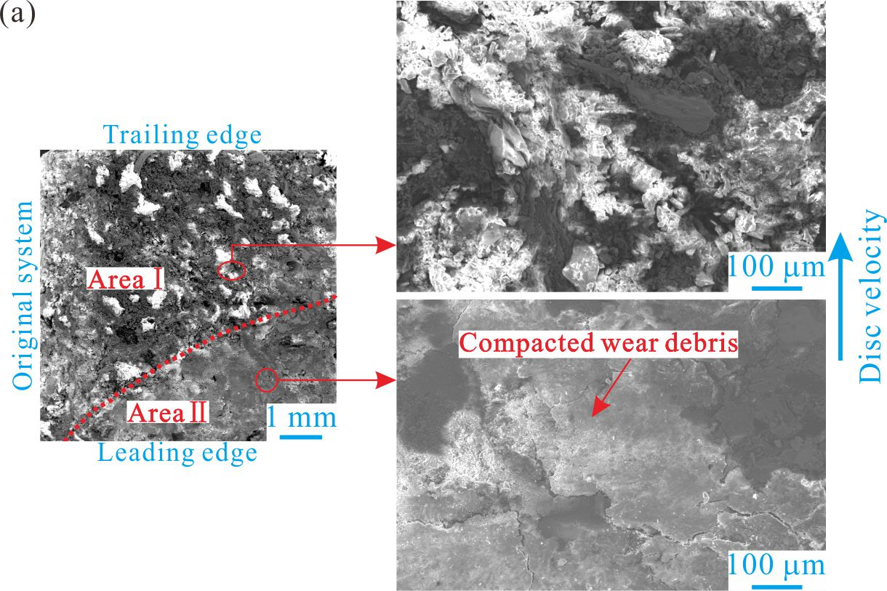
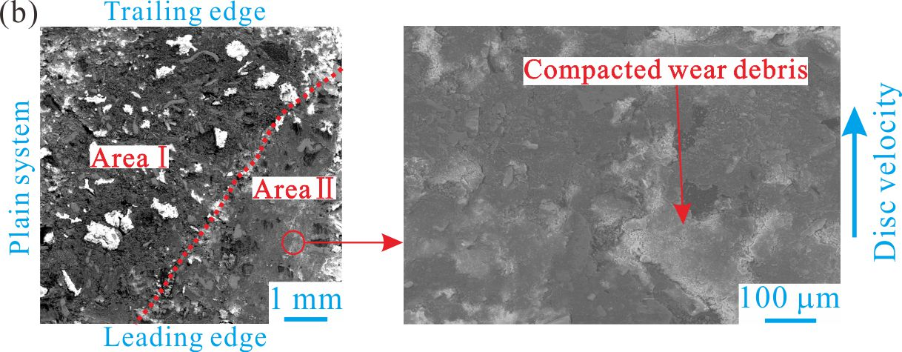
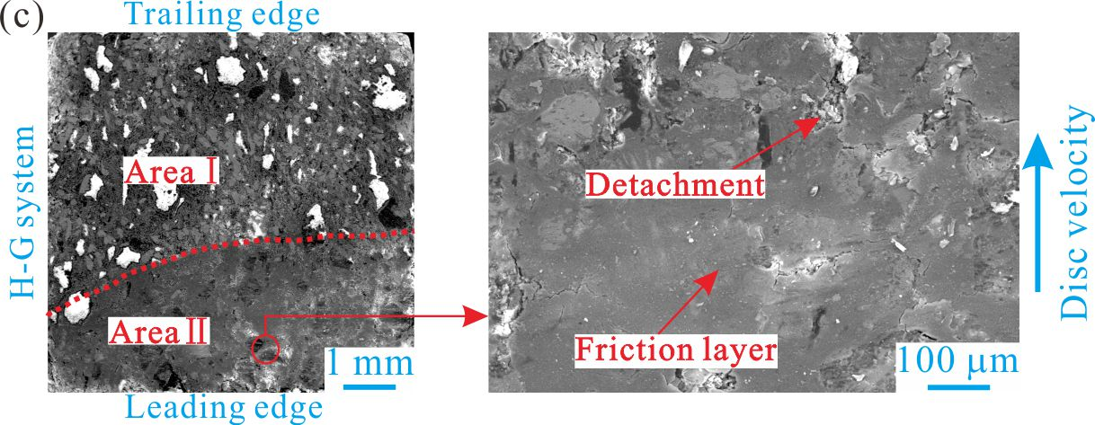
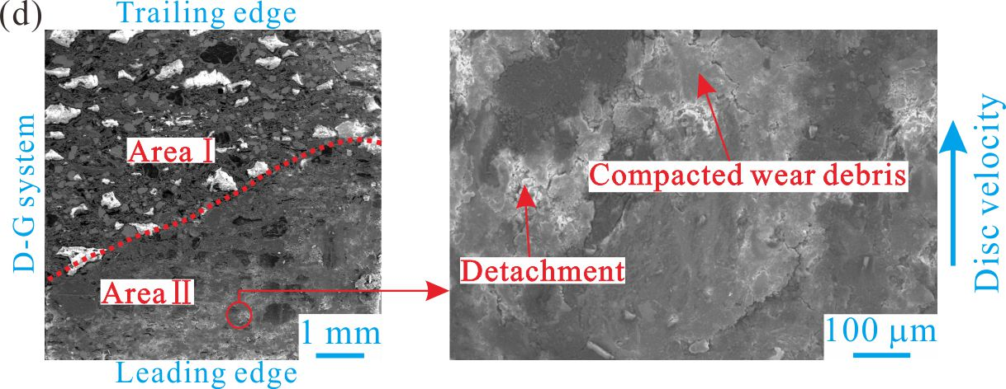
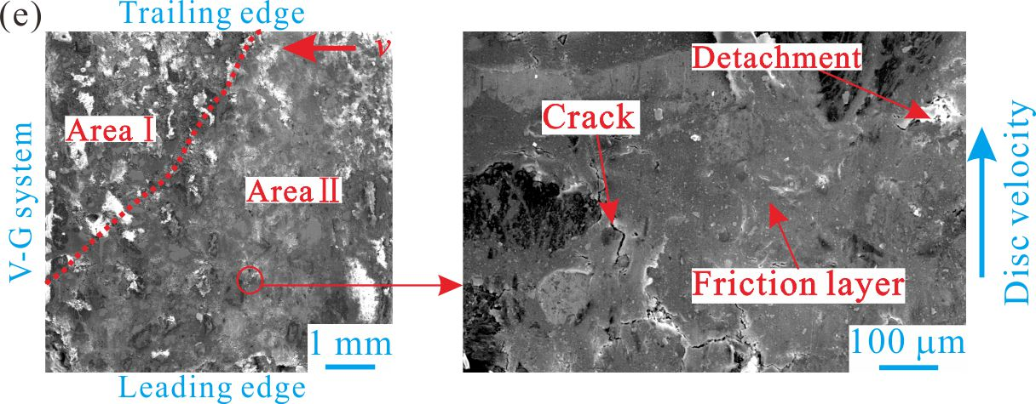
Figure 9. Continued from previous page.
3.2 An explanation of the experimental results
To provide a reasonable explanation of why the stick-slip oscillation differs for the friction systems with different rubber blocks, the contact pressure (CPRESS for short in the figures) distributions in MPa of the pad surfaces of the five friction systems are determined by ABAQUS and the results are presented in Fig. 10. Regarding the investigation of contact pressure distributions, the evaluation criterion of the potential of reducing the vibration is believed that the value of the highest contact pressure is lower, the distribution of the contact pressure is more uniform and the contact area is larger ^{54, 55}.
Fig. 10 shows that the highest contact pressure concentrates at the leading edge for each pad surface. On the contrary, the contact pressure at the trailing edge is almost zero for five friction systems. Moreover, regarding the Original system, the value of the highest contact pressure is obviously higher and the contact area is visibly smaller compared with those of other four systems with the rubber blocks. This phenomenon may be due to the good damping property and/or lower stiffness of the rubber block. The result of the contact pressure of the Original system agree well with the result of vibration acceleration signal in Fig. 7, which provides a reasonable physical explanation to the smaller Area Ⅱ and relatively obvious compacted wear debris layer on the pad contact interface of the Original system in Fig. 9. It suggests that the friction system with the rubber block can ease the concentration of contact pressure on the interface of pad, and then reduce the stick-slip oscillation.
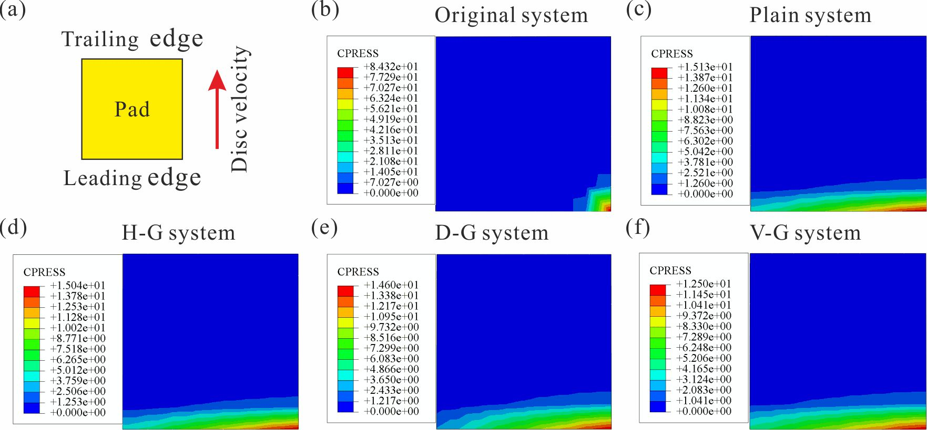
Figure 10. The contact pressure distribution of pad surfaces of five friction systems: (a) definition of the leading/ railing edge (b) Original system, (c) Plain system, (d) H-G system, (e) D-G system and (f) V-G system. CPRESS, contact pressure.
For all of the five brake systems, the contact pressure concentrates at the leading edge of the pad surface and the highest contact pressure which is in red color mainly locates at the leading point or along the leading edge. In contrast, the highest contact pressure of the Plain system is visibly reduced and its contact pressure spreads over a larger area. Focusing on the H-G system and the D-G system, the highest contact pressure value is further reduced. Although the contact area is larger than that of the Original system, it does not show a significant difference from that of Plain system. Apparently, the highest contact pressure of the V-G system is the lowest among all of the five friction systems; furthermore, its contact pressure spreads over the largest area. Therefore, the V-G system shows the lowest vibration and its Area Ⅱ of the pad surface is the largest and less wear debris is produced compared with the Original system. To further investigate why the friction system with the grooved rubber blocks shows the capability of reducing the stick-slip oscillation and friction and wear, the deformation features of the four rubber blocks are explored as follows.
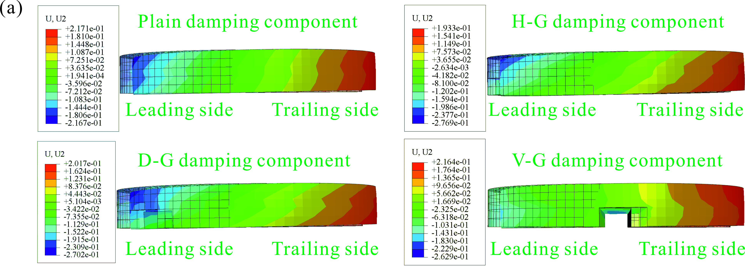
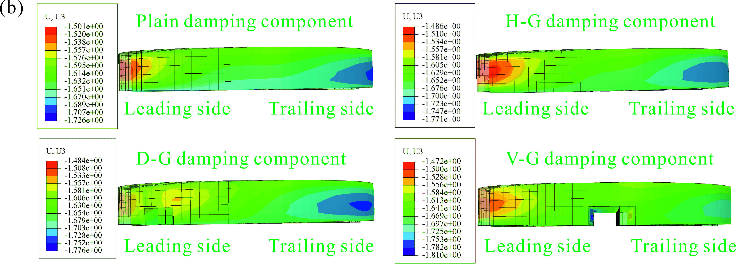
Figure 11. The deformations of the four rubber blocks: (a) the deformation in U2 direction, (b) the deformation in U3 direction.
Fig. 11 (a) presents the simulated normal deformation (denoted by U2 in the figure in mm) of different rubber blocks. The transparent rubber block with black element edge is is its initial undeformed shape before the process of friction, and the solid rubber block without element edge represents its deformed shape. It can be found that the deformation features of the four rubber blocks show a similar trend. All of them are bent about the normal direction (the leading sides go down and the trailing sides go up compared with the undeformed shapes). Furthermore, the deformation in the leading side is larger than that in the trailing side for all of the rubber blocks. However, the degrees of stretch and shear are different among them during the friction process. The plain rubber block shows the smallest deformation compared with that of the others. While for the rubber block having a groove, the deformation is bigger. Especially for the vertically grooved rubber block, the deformation is the biggest.
The deformation of each rubber block in the tangential direction (denoted by U3 in the figure in mm) presented in Fig. 11 (b) is smaller compared with that in the normal direction. And the deformations in the tangential direction also shows the similar trend: the plain rubber block shows the smallest deformation and the V-G rubber block shows the biggest deformation. In relation to the results of the contact pressure distribution in Fig. 10, it indicates that the deformation of rubber blocks contributes to easing the pressure concentration on the pad contact interface. Thus the eased pressure concentration helps to establish a favourable contact pressure distribution to meliorate the condition of interface contact, friction, and wear and finally reduce the stick-slip oscillation.
Next, experimental and numerical analyses are combined to give a reasonable explanation on how the V-G rubber block indirectly affects the stick-slip oscillation and the wear of pad surfaces by a comparison with the cases without the rubber block and with the plain rubber block, as presented in Fig. 12. The major concentration of the contact pressure is located in the leading point for the Original system, as shown in Fig. 12 (a), which is more likely to cause the partial separation of contact between the pad and the disc, especially on the trailing side.
On the other hand, the contact pressure spreads over a slightly larger area and becomes more uniform when the plain rubber block is added into the friction system, as shown in Fig. 12 (b). This is because the rubber block introduces a small flexibility into the system. The rubber block can help improve the contact condition between the pad and the disc (like a cushion) due to its deformation. Furthermore, the small modification of contact pressure helps to improve the wear of the pad surface, which reduces the stick-slip oscillation to a certain degree.
For the V-G rubber block in Fig. 12 (c), its deformation is greater compared with the Plain rubber block, and the contact condition between the pad and the disc is further improved. What is more, the contact pressure spreads over an even larger area, which makes the contact pressure more uniform compared with other systems. Therefore, adding the Plain rubber block in the system improves the contact condition of the pad and disc interface, and thus the wear of the pad surface, and reduce the stick-slip oscillation to a certain degree. The V-G rubber block further helps improve the contact condition and hinders the stick-slip oscillation.
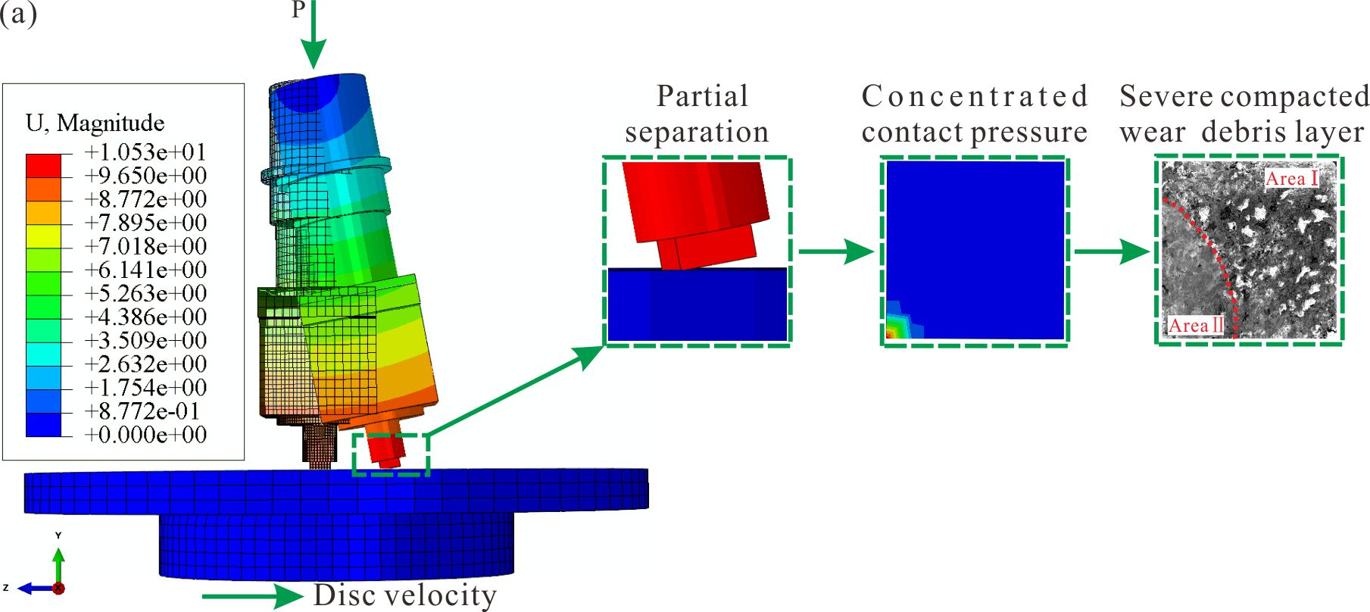
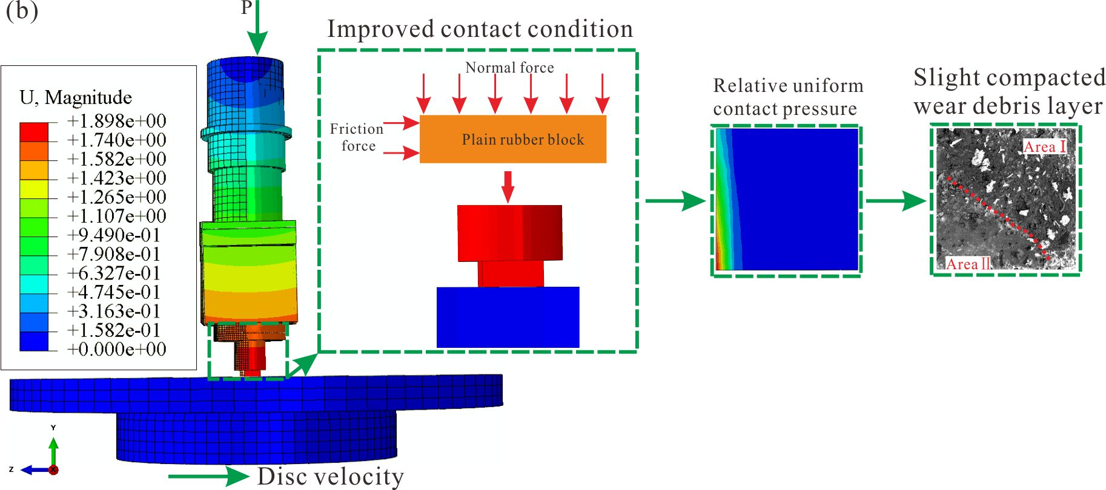
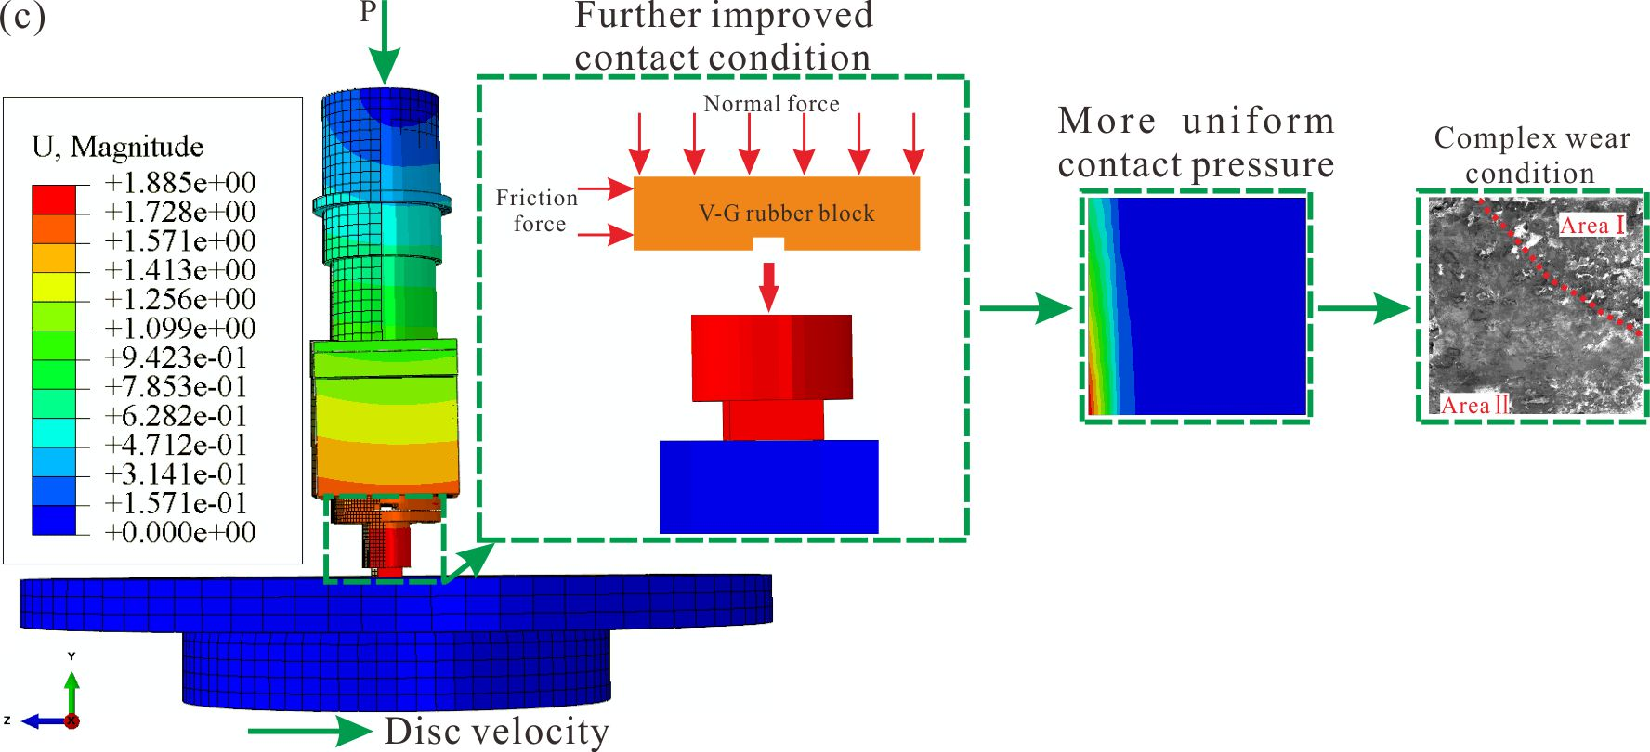
Figure 12. The effect of the rubber block on the contact pressure distribution: (a) Original system, (b) Plain system, (c) V-G system.
4 Conclusions
In this study, plain and grooved rubber blocks are introduced to the automobile brake systems to investigate the influence on the stick-slip oscillation. Grooved surface modification rubber blocks are in three configurations: vertical (the groove is perpendicular to the relative velocity, referred to as V-G), diagonal (the angle between the groove and the relative velocity is 45º, referred to as D-G) and horizontal (the groove is parallel to the relative velocity, referred to as H-G). It can be primarily concluded that:
(1) The dynamic behaviour of stick-slip oscillation is changed when adding different rubber blocks to the friction system. The Plain rubber block can reduce the stick-slip oscillation compared with the Original system (without any rubber block) to a certain degree. Adding a grooved rubber block to the friction systems produces a better ability to reduce the stick-slip oscillation. Among them, the H-G system shows some ability to reduce the stick-slip oscillation which is followed by the D-G system. The V-G system has the best performance to supress the stick-slip oscillation.
(2) The wear results shows that Area Ⅱ (the region that experiences severe wear) of the pad surface for the Original system and the Plain system is smaller compared with that of the other three systems and the former have an obvious compacted wear debris layer in Area Ⅱ. The pad surface of the V-G system shows the largest Area Ⅱ and the wear of this zone is complex-in addition to a friction layer, crack and detachment can be observed.
(3) The highest contact pressure of the pad surfaces is significantly reduced, the contact area is increased, and the likelihood of separation on the trailing side between the pad and the disc surface is greatly reduced by adding a rubber block to the friction system, which may be due to the cushioning effect of a rubber block as a softer material. The maximum contact pressure of the V-G system is the lowest and the contact pressure spreads over the largest area, and the separation between pad and disc is the smallest, among all the five systems under this investigation. This is the probable reason for visible reduction of stick-slip vibration of the V-G system.
(4) The findings obtained are believed to be also suitable to other applications involving friction-induced stick-slip vibration.
This work is a fundamental investigation of stick-slip oscillation for automobile brake systems. The presented method and results should be helpful to reduce the stick-slip vibration in the real automobile brake system. In the future, the influence of grooved rubber blocks with different structures on reducing stick-slip oscillation for the whole scale of automobile brake system will be explored. It is expected that design criteria of rubber blocks which can supress the stick-slip oscillation of the car brake systems will be proposed. Moreover, the effect of various rubber blocks on stick-slip oscillation will be explored with different types of discs in the future.
Notation
D-G The rubber block with a diagonal surface groove
E’ The storage modulus
E’’ The loss modulus
H-G The rubber block with a horizontal surface groove
RMS Root-mean-square
PSD Power spectrum density
V-G The rubber block with a vertical surface groove
Acknowledgements
The authors are grateful for the financial support of the National Natural Science Foundation of China (No. 51822508, No. 51675448 and No. 11672052).
References
1. Styron RH and Hetland EA. The weight of the mountains: Constraints on tectonic stress, friction, and fluid pressure in the 2008 Wenchuan earthquake from estimates of topographic loading. J Geophys Res-Sol Ea 2015; 120: 2697-2716.
2. Meyer L, Thedens M and Beyer M. Incendivity of aluminium bronze in mechanical friction contacts. J Loss Prevent Proc 2017; 49: 947-952.
3. Dong Y, Wu X and Martini A. Atomic roughness enhanced friction on hydrogenated graphene. Nanotechnology 2013; 24: 375701.
4. Li M, Liu L, Jiao N, et al. Probing crystallography-induced anisotropy and periodic property of atomic friction in MoS2 via fast Fourier transform processing. Nano/Micro Engineered and Molecular Systems (NEMS), 2016 IEEE 11th Annual International Conference on. IEEE, 2016; pp: 494-498.
5. Alnaqi AA, Barton DC and Brooks PC. Reduced scale thermal characterization of automotive disc brake. Appl Therm Eng 2015; 75: 658-668.
6. He B, Ouyang H, He S, et al. Stick–slip vibration of a friction damper for energy dissipation. Adv Mech Eng 2017; 9: 1687814017713921.
7. Nobari A, Ouyang H and Bannister P. Uncertainty quantification of squeal instability via surrogate modelling. Mech Syst Signal Proc 2015; 60-61: 887-908.
8. Hassan MZ, Brooks PC and Barton DC. The evaluation of disc brake squeal propensity through a fully coupled transient thermomechanical model. Proc IMechE, Part D: J Automobile Engineering 2012; 227: 361-375.
9. Capozza R, Rubinstein SM, Barel I, et al. Stabilizing stick-slip friction. Phys Rev Lett 2011; 107 (2): 024301.
10. Feeny B, Guran A, Hinrichs N, et al. A historical review on dry friction and stick-slip phenomena. Appl Mech Rev 1998; 51: 321-342.
11. Berger EJ. Friction modeling for dynamic system simulation. Appl Mech Rev 2002; 55 (6): 535-577.
12. Luo AC and Gegg BC. On the mechanism of stick and nonstick, periodic motions in a periodically forced, linear oscillator with dry friction. J Vib Acoust 2006; 128 (1): 97-105.
13. Ibrahim RA. Friction-induced vibration, chatter, squeal, and chaos—part II: dynamics and modeling. Appl Mech Rev 1994; 47: 227-253.
14. Ibrahim RA. Friction-induced vibration, chatter, squeal, and chaos—part I: mechanics of contact and friction. Appl Mech Rev 1994; 47: 209-226.
15. Khulief YA, Al-Sulaiman FA and Bashmal S. Vibration analysis of drillstrings with self-excited stick–slip oscillations. J Sound Vib 2007; 299: 540-558.
16. Zadeh AABJ and Behringer R P. Avalanches in a granular stick-slip experiment: detection using wavelets. EPJ Web of Conferences. EDP Sciences 2017; 140: 03038.
17. Centea D, Rahnejat H and Menday MT. Non-linear multi-body dynamic analysis for the study of clutch torsional vibrations (judder). Appl Math Model 2001; 25 (3): 177-192.
18. Goetz M, Levesley MC and Crolla DA. Dynamics and control of gearshifts on twin-clutch transmissions. Proc IMechE, Part D: J Automobile Engineering 2005; 219: 951-963.
19. Togo T, Shimamoto T, Yamashita F, et al. Stick–slip behavior of Indian gabbro as studied using a NIED large-scale biaxial friction apparatus. Earthquake Science 2015; 28: 97-118.
20. Park CW, Shin MW and Jang H. Friction-induced stick-slip intensified by corrosion of gray iron brake disc. Wear 2014; 309: 89-95.
21. Liu X, Vlajic N, Long X, et al. Nonlinear motions of a flexible rotor with a drill bit: stick-slip and delay effects. Nonlinear Dyn 2012; 72: 61-77.
22. Besselink B, van de Wouw N and Nijmeijer H. A semi-analytical study of stick-slip oscillations in drilling systems. J Comput Nonlin Dyn 2011; 6: 021006.
23. Motchongom-Tingue M, Djuidjé Kenmoé G and Kofané TC. Stick–slip motion and static friction in a nonlinear deformable substrate potential. Trib Lett 2011; 43: 65-72.
24. Formica G, Talò M and Lacarbonara W. Nonlinear modeling of carbon nanotube composites dissipation due to interfacial stick–slip. Int J Plasticity 2014; 53: 148-163.
25. Neis PD, Ferreira NF, Poletto JC, et al. Quantification of brake creep groan in vehicle tests and its relation with stick–slip obtained in laboratory tests. J Sound Vib 2016; 369: 63-76.
26. Kruse S, Tiedemann M, Zeumer B, et al. The influence of joints on friction induced vibration in brake squeal. J Sound Vib 2015; 340: 239-252.
27. Li Z, Ouyang H and Guan Z. Friction-induced vibration of an elastic disc and a moving slider with separation and reattachment. Nonlinear Dyn 2016; 87: 1045-1067.
28. Crowther AR and Singh R. Analytical investigation of stick-slip motions in coupled brake-driveline systems. Nonlinear Dyn 2007; 50: 463-481.
29. Socoliuc A, Bennewitz R, Gnecco E, et al. Transition from stick-slip to continuous sliding in atomic friction: entering a new regime of ultralow friction. Phys Rev Lett 2004; 92 (13): 134301.
30. Fuadi Z, Maegawa S, Nakano K, et al. Map of low-frequency stick–slip of a creep groan. Proc IMechE, Part J: J Engineering Trib 2010; 224: 1235-1246.
31. Jansen L, Hölscher H, Fuchs H, et al. Temperature dependence of atomic-scale stick-slip friction. Phys Rev Lett 2010; 104 (25): 256101.
32. Park JS, Lee SM, Joo BS, et al. The effect of material properties on the stick–slip behavior of polymers: A case study with PMMA, PC, PTFE, and PVC. Wear 2017; 378-379: 11-16.
33. Dong C, Shi L, Li L, et al. Stick-slip behaviours of water lubrication polymer materials under low speed conditions. Trib Int 2017; 106: 55-61.
34. Jang H, Ko K, Kim SJ, et al. The effect of metal fibers on the friction performance of automotive brake friction materials. Wear 2004; 256: 406-414.
35. Popp K and Rudolph M. Vibration control to avoid stick-slip motion. Modal Analysis 2004; 10: 1585-1600.
36. Mulliah D, Kenny SD and Smith R. Modeling of stick-slip phenomena using molecular dynamics. Phys Rev B 2004; 69 (20): 205407.
37. Crowther A, Zhang N, Liu DK, et al. Analysis and simulation of clutch engagement judder and stick-slip in automotive powertrain systems. Proc IMechE, Part D: J Automobile Engineering 2004; 218: 1427-1446.
38. Kim C, Kwon Y and Kim D. Analysis of low-frequency squeal in automotive disc brake by optimizing groove and caliper shapes. Int J Precis Eng Man 2018; 19: 505-512.
39. Triches Jr M, Gerges SNY and Jordan R. Reduction of squeal noise from disc brake systems using constrained layer damping. J Braz Soc Mech Sci Eng 2004; 26: 340-348.
40. Zhang Y, Allen AW, Yi J, et al. Understanding tire/road stick-slip interactions with embedded rubber force sensors. In: Advanced Intelligent Mechatronics (AIM), 2012 IEEE/ASME International Conference on IEEE Kaohsiung, Taiwan, July 11-14, 2012; pp: 550-555.
41. Fan R, Meng G, Yang J, et al. Experimental study of the effect of viscoelastic damping materials on noise and vibration reduction within railway vehicles. J Sound Vib 2009; 319: 58-76.
42. Sarlin E, Liu Y, Vippola M, et al. Vibration damping properties of steel/rubber/composite hybrid structures. Compos Struct 2012; 94: 3327-3335.
43. Matter M, Gmür T, Cugnoni J, et al. Identification of the elastic and damping properties in sandwich structures with a low core-to-skin stiffness ratio. Compos Struct 2011; 93: 331-341.
44. Gweon JH, Joo BS and Jang H. The effect of short glass fiber dispersion on the friction and vibration of brake friction materials. Wear 2016; 362-363: 61-67.
45. Wang DW, Mo JL, Zhang Q, et al. The effect of the grooved elastic damping component in reducing friction-induced vibration. Trib Int 2017; 110: 264-277.
46. Lu XD, Zhao J, Mo JL, et al. Improvement of dynamical and tribological properties of friction systems by introducing parallel-grooved structures in elastic damping components. Compos Struct 2018; 192: 8-19.
47. Audry MC, Fretigny C, Chateauminois A, et al. Slip dynamics at a patterned rubber/glass interface during stick-slip motions. The European Physical Journal E, Soft Matter 2012; 35 (9): 83.
48. Malas A, Pal P and Das CK. Effect of expanded graphite and modified graphite flakes on the physical and thermo-mechanical properties of styrene butadiene rubber/polybutadiene rubber (SBR/BR) blends. Mater Design 2014; 55: 664-673.
49. Pritz T. Loss factor peak of viscoelastic materials: magnitude to width relations. J Sound Vib 2001; 246: 265-280.
50. Lu YC and Shinozaki DM. Temperature dependent viscoelastic properties of polymers investigated by small-scale dynamic mechanical analysis. Exp Mech 2009; 50: 71-77.
51. OriginLab Corporation. Origin 8 SR2 help files.
52. Schön J. Coefficient of friction and wear of a carbon fiber epoxy matrix composite. Wear 2004; 257: 395-407.
53. Lee SM, Shin MW, Lee WK, et al. The correlation between contact stiffness and stick–slip of brake friction materials. Wear 2013; 302: 1414-1420.
54. Wang XC, Mo JL, Ouyang H, et al. Squeal Noise of Friction Material With Groove-Textured Surface: An Experimental and Numerical Analysis. J Trib 2015; 138: 021401.
55. Abu Bakar AR, Ouyang H, James S, et al. Finite element analysis of wear and its effect on squeal generation. Proc IMechE, Part D: J Automobile Engineering 2008; 222: 1153-1165.

* Corresponding author. Tel.: +86-28-87600601; fax: +86-28-87603142. E-mail address: mojiliang126@126.com (J.L. Mo), jlmo@swjtu.cn (J.L. Mo)

