((please add journal code and manuscript number, e.g., DOI: 10.1002/ppap.201100001))
Article type: Full paper

Critical assessment of the antimicrobial efficacy of cold atmospheric plasma for different intrinsic and extrinsic parameters

Cindy Smet, Maria Baka, Aaron Dickenson, James L. Walsh, Vasilis P. Valdramidis, Jan F. Van Impe*

–––––––––

Dr. C. Smet, Dr. M. Baka, Prof. J. F. Van Impe
BioTeC+ - Chemical and Biochemical Process Technology and Control (KU Leuven),
Gebroeders Desmetstraat 1, 9000 Gent, Belgium
OPTEC, Optimization in Engineering Center-of-Excellence (KU Leuven), Belgium
CPMF², Flemish Cluster Predictive Microbiology in Foods, www.cpmf2.be, Belgium
E-mail: jan.vanimpe@kuleuven.be

A. Dickenson, Dr. J. L. Walsh
Department of Electrical Engineering and Electronics (University of Liverpool), United Kingdom

Dr. V. P. Valdramidis
Department of Food Studies and Environmental Health, Faculty of Health Sciences (University of Malta), Msida 2080, Malta
Centre for Molecular Medicine and Biobanking (University of Malta), Msida 2080, Malta

–––––––––

Cold atmospheric plasma offers great potential for decontamination of heat-sensitive foods. CAP research is often case specific, due to its focus on specific target microorganisms and food products. In this work, the impact of different factors influencing the CAP efficacy is assessed: CAP set-up (DBD electrode, operating on He/O₂), type of pathogen, model system properties and experimental protocol. By using (food) model systems, the effect of product properties is accurately investigated. Moreover, remaining challenges are highlighted and solutions for future studies are suggested. Taking into account all influencing factors, this work provides guidelines and critical points (i.e., with respect to set-up, microorganisms, food properties and treatment protocol) that need to be included to ensure successful CAP treatment.
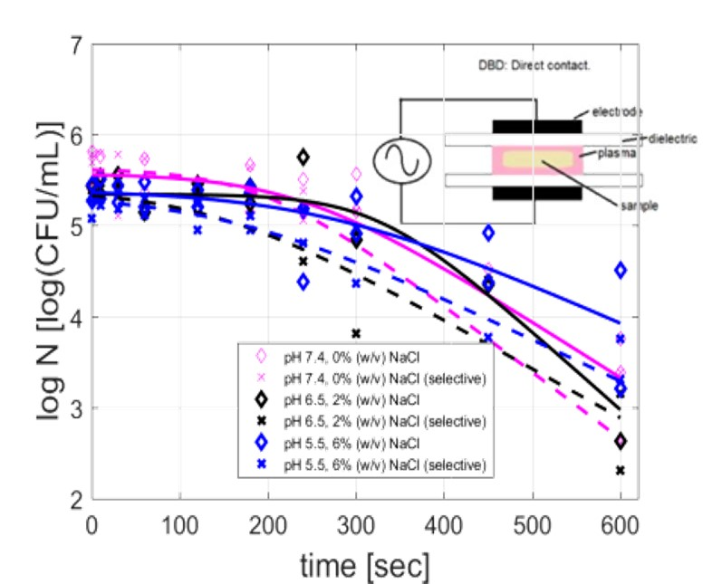

1 Introduction
In 2015, more than 340,000 food poisonings were reported. Salmonella (over 88000 confirmed cases) and Campylobacter (over 236000 cases) have been the most often reported pathogens, yearly responsible for 65 and 25 deaths, respectively. As in previous years, the most severe fatality rate (15%) among the cases has been found for Listeria monocytogenes, causing 210 deaths.^{[1]} Additionally, spoilage microorganisms present in food, cause huge amounts of products to be dumped each year.
In order to increase food safety and reduce food spoilage, novel non-thermal technologies, with important benefits compared to conventional inactivation techniques (e.g., pasteurization), are emerging. The driving force to implement non-thermal technologies is the possibility to decontaminate (heat sensitive) food products, using fast, energy efficient and safe methods.^{[2]} The potential of cold atmospheric plasma (CAP) in microbial inactivation has been studied since the mid 1990´s, but its possibility for food decontamination has been recognized more recently. Upon excitation via an externally applied energy source, gas molecules become ionized, resulting in mixtures of electrons, ions, atomic species, free radicals and UV photons.^{[3]} The CAP mode of action in the inactivation of microbial cells, although not yet fully unraveled, may be explained at different levels. Accumulation of charged particles and bombardment by free radicals may induce cell membrane rupture. Oxidation of the lipids, amino acids and nucleic acids with reactive oxygen and nitrogen species may cause changes that lead to microbial death or injury. In addition to reactive species, UV photons can modify microbial DNA.^{[4]}
In the last years, multiple research groups started to study the CAP efficacy, using different set-ups (i.e., jets vs. closed reactors) and operating parameters. Most of this research focuses on a specific food product and a specific target microorganisms.^{[5]–[8]} Because of the experimental diversity with respect to the food sample, results from most studies have a limited applicability. In addition, working with real food products has some important drawbacks: (i) the lack of reproducibility due to a high product variability and (ii) the problem that background microflora are present. For these reasons, reproducible research focusing on a more fundamental level, providing information on the efficacy or suitability of CAP treatment on food products is lacking. Tests performed on (food) model systems are able to solve part of the problem regarding the specificity of previous CAP related studies. Moreover, model systems are highly controllable, resulting in reproducible experiments and results. In conclusion, tests on model systems allow an accurate estimation of the inactivation efficacy, for various experimental conditions. Of course, some validation tests on real food products will be required to confirm the results.
In this work, different intrinsic factors of a model system are varied. The intrinsic factors (pH, salt concentration, food (micro)structure) relate to food properties and thus allow to mimic a
broad range of products. The food (micro) structure was defined as the organization of elements within a food and their interactions.^{[9]} The liquid and the gelled solid system assessed in this work represent two of the six different (micro)structures that can be present in food.^{[10]} These model systems, on which either Salmonella Typhimurium or Listeria monocytogenes have grown, are CAP treated and stored at different temperatures (extrinsic factor) following CAP treatment. Next to an investigation of the sensitivity of the food properties, other factors that have an impact on the CAP inactivation efficacy are discussed. Moreover, this study includes a critical assessment on the effect of the CAP set-up (design and operating conditions) and the impact of the protocol used on the outcome of CAP experiments, and furthermore comments on some remaining challenges regarding the implementation of the CAP technology.

2 Experimental Section
2.1 Experimental plan
The CAP inactivation efficacy was studied for treatment of model systems inoculated with Salmonella Typhimurium or Listeria monocytogenes. In order to assess the impact of intrinsic factors, cells were grown, treated and stored at different pH (7.4, 6.5 or 5.5) and salt concentrations (0, 2 or 6% (w/v) NaCl), ranges commonly found in food products.^{[11],[12]} Moreover, cells were grown/treated in/on two different model systems, mimicking treatment of liquid and solid(like) food products. After treatment, samples were stored at refrigeration (8°C) or room temperature (20°C).

2.2 Microorganisms and pre-culture conditions
Salmonella enterica serovar Typhimurium SL1344 was provided by the Institute of Food Research (IFR, Norwich, UK). The culture was stored at -80°C in Tryptone Soya Broth (TSB (Oxoid LTd., Basingstoke, UK)) supplemented with 25% (v/v) glycerol (Acros Organics, NJ, USA). Listeria monocytogenes LMG 13305 was obtained by the Belgian Co-ordinated Collections of Microorganisms (BCCM, Ghent, Belgium). The culture was stored at -80°C in TSB supplemented with 0.6% (w/v) yeast extract (Merck, Darmstadt, Germany) (TSBYE).
For each experiment, a purity plate was prepared by spreading a loopful onto a Tryptone Soya Agar plate (TSA (Oxoid Ltd., Basingstoke, UK)) (S. Typhimurium) or on Brain Heart Infusion (BHI (Oxoid Ltd., Basingstoke, UK)) (L. monocytogenes) supplemented with 1.2% (w/v) agar (Agar technical n°3, Oxoid Ltd., Basingstoke, UK) plate, and incubated for 24 h at 37°C. One colony from the purity plate was transferred into 20 mL TSB or BHI, and incubated (Binder KB series incubator; Binder Inc., NY, USA) at 37°C for 8 h under static conditions. Next, 200 µL from this stationary phase culture was added to 20 mL of fresh TSB or BHI and incubated under the same conditions for 16 h, yielding early-stationary phase populations for both S. Typhimurium and L. monocytogenes.

2.3 Growth stage prior to CAP inactivation
For cells grown planktonically in a liquid environment, 0, 2 or 6% (w/v) NaCl (Sigma Aldrich, MO, USA) was added to TSB without dextrose (Becton, NJ, USA) (S. Typhimurium) or BHI (L. monocytogenes). If needed, the pH (DocuMeter, Sartorius, Goettingen, Germany) was adapted by the addition of 5 M HCl (Acros Organics, NJ, USA). Cells were grown in petri dishes (diameter 5.5 cm) filled with 7 mL of the medium inoculated at 10³ CFU/mL, obtained by serial decimal dilutions of early stationary phase cells.
To create surface colonies on a solid(like) environment, gelatin at 5% (w/v) (gelatin from bovine skin, type B, Sigma-Aldrich, MO, USA) together with the appropriate NaCl concentration, was added to TSB or BHI. The medium was heated at 60°C in a thermostatic water bath (GR150-S12, Grant Instruments Ltd, Shepreth, UK), the pH adapted, and filter-sterilized using a 0.2 mm filter (Filtertop, 150 mL filter volume, 0.22 µm, TPP, Switzerland). 7 mL was pipetted into sterile petri dishes, left to solidify, and surface inoculated at approximately 3.0 x 10² CFU/cm² (surface area 23.8 cm², corresponding to 10³ CFU/mL) by homogeneously spreading 20 μL of the properly diluted inoculum onto each petri dish, using an L-shaped spreader. Petri dishes were sealed with parafilm and placed in a temperature controlled incubator (KB 8182, Termaks, Bergen, Norway) at 20°C until the early stationary phase was reached. Results from preliminary growth experiments were consulted to verify this point on the growth curve.

2.4 Sample inoculation for CAP treatments
Next, samples were diluted (using dilution medium with the same NaCl concentration and pH value as the growth medium) to obtain a cell density of 5.5 log(CFU/mL) (liquid carrier) or 5.5 log(CFU/cm²) (solid(like) surface). Solid samples were melted in a thermostatic water bath at 37°C (optimal temperature for microorganisms) prior to dilution.
For the treatment of the cells in a liquid carrier, 100 µL of the diluted medium was pipetted on empty 5 cm diameter petri dishes, resulting in a thin liquid layer with planktonic cells. Regarding CAP treatments on a solid(like) surface, the gelled surface was prepared in a 5 cm petri dish (surface area 19.6 cm²) at similar experimental conditions as the model system the cells were grown on. Next, 50 µL of the diluted sample was pipetted and spread on the solid(like) surface, which was allowed to dry in the laminar flow cabinet (Telstar Laboratory Equipment, Woerden, the Netherlands).

2.5 CAP: equipment and processing procedure
An enclosed Dielectric Barrier Discharge (DBD) set-up (enclosure: 22.5 cm x 13.5 cm x 10 cm) was used for all experiments (Figures 1a and b). The residence time of the gas in the enclosure, not airtight, was approximately 45 s. The plasma was generated in a gas mixture of helium (purity 99.996%, flow rate 4 L/min) and oxygen (purity ≥ 99.995%, flow rate 40 mL/min), with a total flow rate of 4.04 L/min. Helium was selected as a carrier gas as it (i) facilitates the generation of large area, spatially uniform discharges and (ii) reduces the complexity of the system, making it easier to identify changes resulting from the intrinsic and extrinsic factors tested in this study.
Samples, thus the media inside a small petri dish, were placed for direct treatment between two dielectrically coated (1 mm thick quartz) metallic electrodes with a separation of 8 mm. Prior to plasma ignition, the helium/oxygen gas mixture was flushed through the enclosure for a total of four minutes to remove the background air. To determine the inactivation kinetics, samples were treated up to 10 minutes at a peak-to-peak voltage around 7 kV at a frequency of 15 kHz. Measurements of the discharge current and applied voltage (Figure 1c) were used to calculate the mean dissipated power of the discharge, which was found to be 7.45 W (equates to 74.5 W/cm³ when treating liquid samples and 0.38 W/cm² when treating solid surfaces). Typical of a DBD generated in a helium rich environment, the measured current waveform shows a single discharge pulse per half cycle of the applied voltage which is superimposed on a sinusoidal displacement current. The appearance of the current waveform provides a strong indicator that the discharge was operating in a spatially homogenous form without the presence of filaments, which would typically appear as multiple short-duration current spikes.
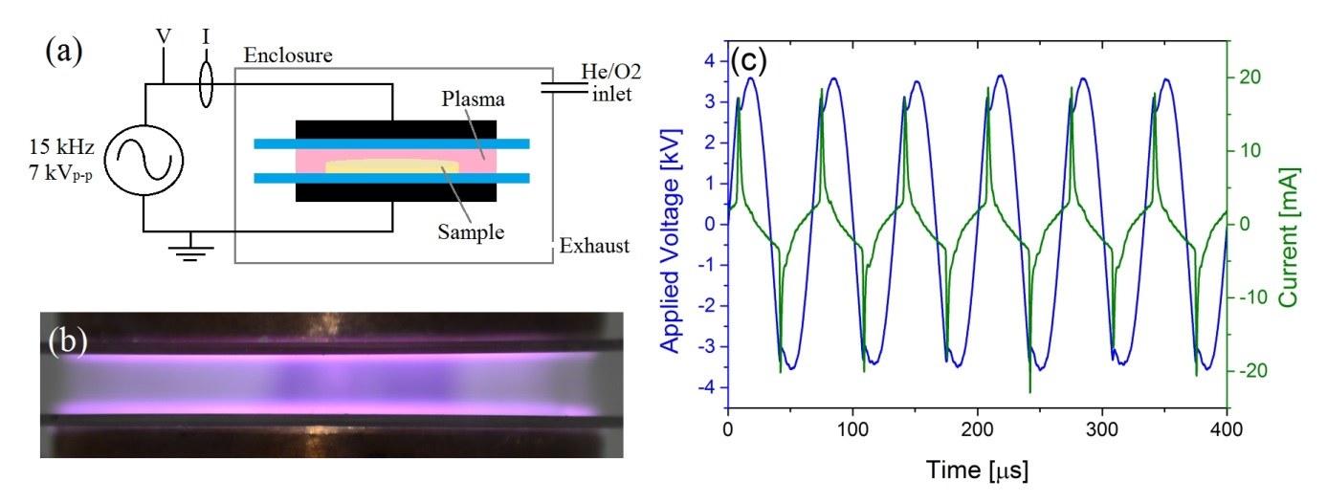
Figure 1. (a) Schematic showing the experimental setup, (b) Photograph of the discharge operating at a dissipated power of 7.45 W, and (c) Applied voltage and current waveforms (liquid sample).

Optical emission data was obtained using an Andor Shamrock 500i spectrometer, with a 500 mm focal length. An Andor iStar CCD 340 camera with a 1024 x 1024 pixel intensified sensor was employed to capture the wavelength resolved light passing through the spectrometer. Low resolution optical data was captured using a 600 l/mm grating and high resolution optical data of the OH emission profile was captured using a 2400 l/mm grating. To direct light from the discharge in to the spectrometer a quartz window was added to the discharge reactor and a collimating lens was positioned between the window and slit of the spectrometer.

2.6 Microbiological analysis
The cell density after CAP treatment was determined via viable plate counting. For cells inactivated in a liquid carrier, 900 µL of saline solution (0.85% (w/v) NaCl) was added to the sample. Afterwards, the diluted sample (1 mL) was transferred to a sterile Eppendorf, in order to prepare serial decimal dilutions with saline solution. For cells inactivated on the solid(like) surface, the content of the petri dish was liquefied (37°C) and homogenized (basic masticator, Led techno, Belgium) in a stomacher bag for 30 seconds. 1 mL was taken from this bag, and serial decimal dilutions were prepared.
For all samples, 2-4 dilutions were plated (49.2 µL) onto TSA or BHI-Agar plates using a spiral plater (Eddy-Jet, IUL Instruments), and stored at 37°C for 24 h before counting.
In order to determine potential sublethal cell injury, dilutions were also plated onto Xylose Lysine Deoxycholate Agar (Merck & Co, New Jersey, USA) for S. Typhimurium or PALCAM-Agar (VWR Chemicals, Leuven, Belgium) for L. monocytogenes, and stored up to 48 h at 30°C. Although included in the figures, for a detailed discussing regarding CAP and sublethal injury, the reader is referred to Smet et al.^{[13]} Cell counts shown in the figures in the results and discussion section were the mean of all countable dilutions for each sample. Experiments were performed in duplicate.

2.7 Storage procedure
Storage experiments were executed for S. Typhimurium at pH 7.4, 0% (w/v) NaCl and pH 5.5, 6% (w/v) NaCl, by treating samples for 5 min. Treated petri dishes (and controls) were sealed with parafilm, and stored at 8 (for 30 days) or 20°C (for 10 days). As the liquid carrier significantly evaporated due to the CAP generated, 100 µL of untreated dilution medium at the same experimental conditions was added prior to storage, in order to (i) facilitate possible cell recovery during storage and (ii) to mimic the solid system where also nutrients are available below surface.^{[13]} During storage, sampling took place at regular time intervals (ranging from every couple of hours to a few samples a week, depending on the storage temperature). The cell density was determined by plate counts as described above.

2.8 Modelling microbial kinetics and parameter estimation
The inactivation model of Geeraerd et al., was used to fit experimental data.^{[14]} This model describes a microbial inactivation curve consisting of a shoulder, a loglinear inactivation phase and a tail:
$\begin{matrix}\frac{dN\left(t\right)}{dt}=\frac{1}{1+C_{c}\left(t\right)}∙k_{max}∙\left(1-\frac{N_{res}}{N(t)}\right)∙N\left(t\right) \\ \frac{{dC}_{c}\left(t\right)}{dt}=-k_{max}∙C_{c}\left(t\right)\end{matrix}$ (2)
with N(t) [CFU/mL] the cell density at time t [h], N_{res} [CFU/mL] the residual cell density at the tailing phase, k_{max} [h⁻¹] the maximum inactivation rate and C_{c}(t) [-] a measure of the physiological state of the cells. Final log reductions were calculated from the difference between log N₀ and log N_{res}. If log N_{res} was not yet reached, log N(t =600 s) (or log N(t=180 s), for inactivation on a filter) was used to calculate the log reduction.
If growth was observed during storage, the model of Baranyi and Roberts was fitted:
$\begin{matrix}\frac{dN\left(t\right)}{dt}=\frac{Q\left(t\right)}{1+Q\left(t\right)}∙μ_{max}∙\left(1-\frac{N\left(t\right)}{N_{max}}\right)∙N\left(t\right) \\ \frac{dQ\left(t\right)}{dt}=μ_{max}∙Q\left(t\right)\end{matrix}$ (1)
with N(t) [CFU/mL] the cell density at time t [h], N_{max} [CFU/mL] the maximum cell density at the stationary phase, μ_{max} [h⁻¹] the maximum growth rate and Q(t) [-] a measure of the physiological state of the cells.^{[15]}
Parameters of both models were estimated via the minimization of the sum of square errors, using the lsqnonlin routine of the Optimization Toolbox of Matlab version R2009b (The Mathworks Inc.). Simultaneous with parameter estimation, the parameter estimation errors were determined based on the Jacobian matrix.

2.9 Statistical analysis
Analysis of variance (ANOVA) tests were performed to determine whether there were significant differences amongst means of logarithmically transformed viable counts and model system property parameters, at a 95.0% confidence level (α = 0.05). The Fisher´s Least Significant Difference test was used to distinguish which means were significantly different from which others. Standardized skewness and standardized kurtosis were used to assess if data sets came from normal distributions. These analyses were performed using Statgraphics Centurion XVI.I Package (Statistical Graphics, Washington, USA). Test statistics were regarded as significant when P was ≤ 0.05.

3 Results and Discussion
3.1 CAP system characteristics and design choice
A first critical factor determining the success of the CAP treatment is the choice of experimental set-up. Two widely used CAP electrode configurations include: (i) plasma jet devices or (ii) parallel plate reactors. Although plasma jets are easy to construct and operate they have several disadvantages when it comes to the treatment of biological samples. The high velocity flowing gas can complicate the treatment of liquid samples and the relatively small discharge area makes it difficult to uniformly treat samples. Furthermore, the entrainment of ambient air in to the helium plasma emerging from the jet orifice adds further complication to the discharge chemistry and can reduce the day to day repeatability of the experiments. Parallel plate systems overcome many of these challenges; yet, irregular and conductive samples can disrupt the discharge resulting in the undesirable formation of streamers.
In this investigation, experiments were performed using liquid and solid(like) model systems. As the main advantage of model systems is the uniformity and regularity of the samples, a parallel plate DBD design (Figure 1) was deemed the most suitable because the uniform (i.e., confirmed by the use of time resolved imaging) and direct discharge can be applied to the complete sample at once. The decision to operate in a closed He/O₂ environment was motivated by several reasons: (i) the longer lived reactive species are kept within the reactor, (ii) the plasma chemistry is not further complicated by the interference of outside parameters (e.g., ambient humidity). In remark, it needs to be considered that the model systems (or food products) might not be inert as water evaporation might occur, ‘contaminating’ the gas flow. All other CAP operating variables (treatment time, gas flow rate and composition, plasma power, frequency, distance to sample, see Section 2.5) were selected in order to obtain sufficient log reductions while still assuring plasma stability.
Optical emission spectroscopy was used to obtain an indication of the reactive species present in the discharge when treating solid(like) and liquid samples (Figure 2a). Several intense helium lines can be identified along with emission from OH, H and N₂. Certainly, the production of OH is a likely result of the electron driven dissociation of water molecules, which is known to be the predominant mechanism in helium discharges with a high H₂O content (i.e., outgassing of the sample).^{[16]} When treating solid(like) surfaces, the emission intensity of OH was slightly reduced in comparison to that observed when treating liquid samples (data not shown); however, OH emission was still observed, suggesting some H₂O was liberated from the gelled surface in to the gas phase.
The presence of excited Nitrogen (both the second positive and first negative systems) are an indicator that some air contamination is present in the reactor. This could be a remnant from contamination within the gas supply. Given that nitrogen emissions are often the most intense in helium discharges that contain even small fractions of N₂ it is suggested that air contamination within the discharge reactor is minimal.^{[17]}
The production of highly reactive excited and ground state species, including O, OH, H and NO, that are free to interact directly with microorganisms are well known to yield a rapid inactivation effect.^{[18]} Critically, when the microorganisms are suspended within a liquid layer the situation is considerably more complex, many of the short lived species within the discharge are unable to propagate beyond the gas-liquid interface.^{[19]}
To obtain a measure of the discharge temperature, the rotational temperature of the OH molecule was determined by obtaining a best-fit comparison against computational data at 320 K (Figure 2b). Given that temperature measurements of both the solid and liquid samples immediately after plasma exposure showed only minor increases above ambient (± 2°C), and moreover the gelled systems maintained their structure, it is likely that the measurement derived from the optical data is an overestimation. Several previous reports have demonstrated that the electronic quenching of OH(A) by water prevents thermalization of the rotational population distribution and only the rotational states with the smallest rotational numbers are thermalized and representative of the gas temperature.^{[20]}
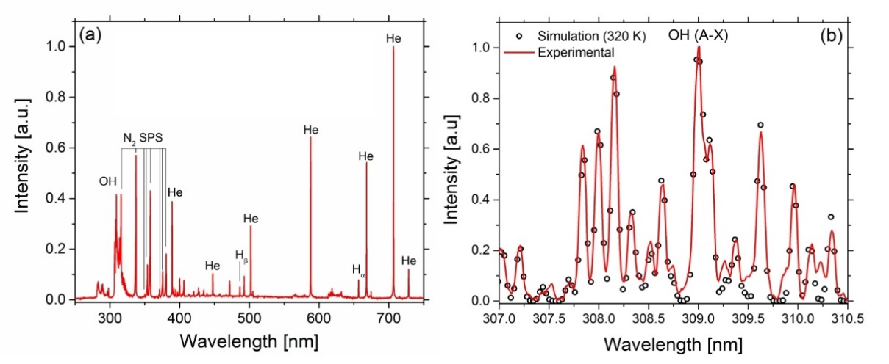
Figure 2. (a) Emission spectrum of the He/O2 discharge operating with a liquid sample, (b) Measured and simulated high-resolution emission spectra of the OH (A-X) emission band.

As the CAP efficacy is ultimately determined by the discharge chemistry, which is influenced by many factors regarding the design and operating conditions, changing these variables will also drastically change the outcome of the treatment. Therefore, it is crucial to select the optimal set-up based on the target application, which for these experiments was to operate in a closed and well controlled environment using a DBD electrode. It is worth noting that such conditions would not be suitable for a larger scale treatment of non-ideal samples, the cost of helium gas is prohibitively expensive and real-world samples are rarely geometrically uniform, which might result in the formation of filaments depending on the product to be treated.^{[21], [22]} Still, providing a similar oxygen/nitrogen chemistry, the trends identified in this manuscript will also apply for other CAP systems (i.e., design, carrier gas).

3.2 Effect of the microorganism
The CAP inactivation mechanism partly concerns the rupture of the cell membrane by charged particles and reactive species, and due to electroporation effects because of the direct treatment. Therefore, the structure of the cell wall influences the CAP efficacy and differences in the inactivation behavior of Gram positive (L. monocytogenes) and Gram-negative (S. Typhimurium) can be expected. As illustrated in Figure 3 (inactivation kinetics) and 4 (log reductions), L. monocytogenes is more difficult to inactivate. Often, Gram-positive bacteria, having no outer cell membrane but a thick peptidoglycan layer, are reported to the most resistant towards CAP. ^{[23]–[25]} While for Gram-negative microorganisms inactivation occurs due to both cell leakage and low level DNA damage, the mechanism of Gram-positive microorganisms consists of intracellular damage (due to high levels of reactive oxygen species) as the cell wall remains undamaged.^{[26]}
Research illustrates that not only the bacterial Gram-type, but moreover the type of species and strain determines the efficacy of the CAP treatment. Most studies focus on treatment of pathogenic bacteria, as food safety is a primary matter of concern.^{[27]} However, as problems regarding food spoilage increase, yeasts or molds inactivation using CAP treatment should be considered.^{[28], [29]}
As the microorganism proves to heavily influence the success of the treatment, this factor should be considered in order to optimize the CAP efficacy.

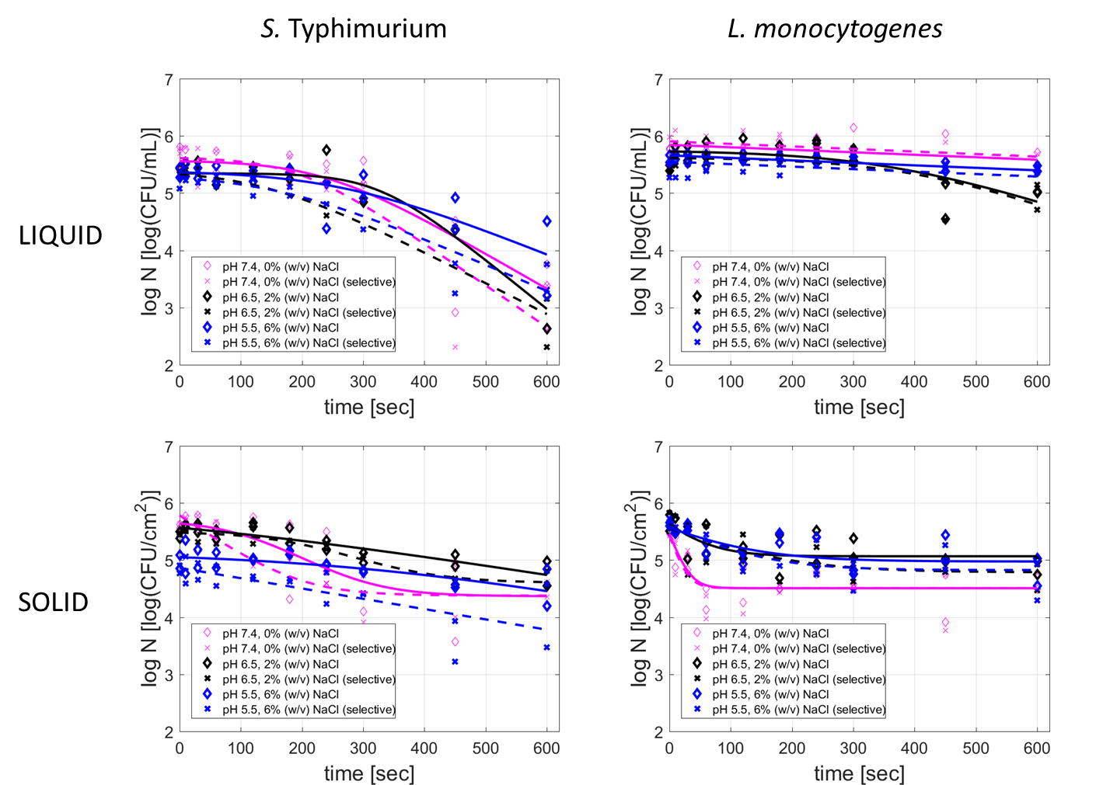
Figure 3. Survival curves of S. Typhimurium (left) and L. monocytogenes (right) after exposure to CAP. Cells were inactivated in a liquid (top) or on a solid(like) model system (bottom). Prior to CAP treatment, cells were grown at pH 7.4, 0% (w/v) NaCl, pH 6.5, 2% (w/v) NaCl or pH 5.5, 6% (w/v) NaCl. Experimental data (symbols) and global fit
(line) of the Geeraerd et al. model: total viable population (◊, solid line) and uninjured viable population (X, dashed line).^{[14]} RMSE values for the fits range from 0.0815 to 0.4567.

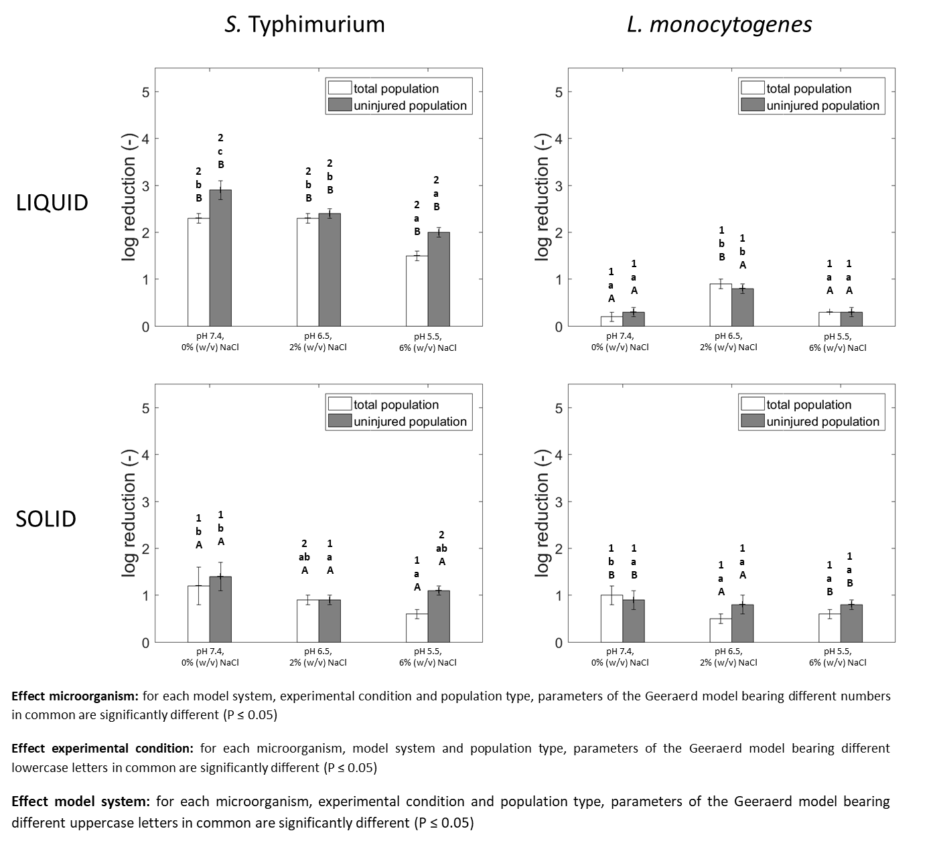
Figure 4. Log reduction (including statistical analysis) for S. Typhimurium (left) and L. monocytogenes (right) after exposure to CAP. Cells were inactivated in a liquid (top) or on a solid(like) model system (bottom). Prior to CAP treatment, cells were grown at pH 7.4, 0% (w/v) NaCl, pH 6.5, 2% (w/v) NaCl or pH 5.5, 6% (w/v) NaCl.

3.3 Effect of the model system properties
3.3.1 Experimental conditions of model systems
The results clearly indicate that the properties of the model system affect the inactivation kinetics of both S. Typhimurium and L. monocytogenes (Figure 3 and 4), as in most cases the most stressing experimental condition (pH 5.5, 6% (w/v) NaCl) results in a low inactivation efficacy. Severe osmotic stress and suboptimal pH values prior to CAP treatment (e.g., during cell growth) can result in stress hardening indicating that the cells adapt to the stressing environment and become resistant to subsequent stresses like CAP.^{[24], [30]} In Figure 5, it is evident that the combination pH/salt level has also an impact during subsequent storage. With respect to storage, the combined effect of CAP treatment and salt/pH stress (and storage temperature), results in a synergistic effect prolonging the storage life, confirming the hurdle concept. This extension was indicated by the lower CFU counts with respect to the storage time for CAP treated samples, as compared to the control. The effect of storage temperature on the microbial kinetics was extensively reported in Smet et al. (2017).^{[31]}
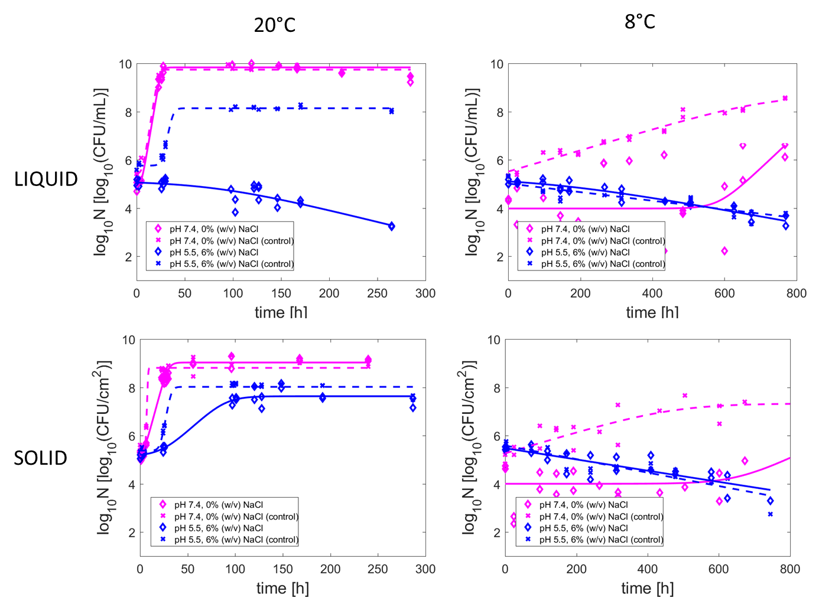
Figure 5. Growth/ inactivation curves of S. Typhimurium, both for CAP treated samples and untreated controls, stored for 10 days at 20°C (left) or for 30 days at 8°C (right). Cells were inactivated in a liquid (top) or on a solid(like) (bottom) model system. Prior to CAP treatment, cells were grown at pH 7.4, 0% (w/v) NaCl or pH 5.5, 6% (w/v) NaCl. Experimental data (symbols) and global fit (line) of the Baranyi and Roberts (1994) model (growth), or the Geeraerd et al. (2000) model (inactivation): CAP treated samples (◊, solid line) and controls (X, dashed line).^{[14], [15]} RMSE values for the fits range from 0.1078 to 1.3576.

Being one of the first CAP related studies focusing on food model systems, only few intrinsic factors were varied. It was opted to initially assess the impact of pH and salt concentration by combining both parameters at three different stress levels: optimal (pH 7.4, 0% (w/v) NaCl), intermediate stress (pH 6.5, 2% (w/v) NaCl) and severe stress (pH 5.5, 6% (w/v) NaCl). This selection was made in order to address significant differences to the influence of these intrinsic factors, instead of the variability of the CAP treatment. However, by implementing a more elaborate experimental design, the influence of each individual intrinsic factor can be assessed. Further on, this also creates the option of constructing secondary models, predicting the effect of intrinsic factors on the CAP inactivation efficacy. In conclusion, more variations within and outside the ranges selected, should be tested in order to draw more precise conclusions. Additionally, the effect of other intrinsic factors on the CAP efficacy could be incorporated in future research (e.g., the impact of natural sugars).

3.3.2 (Micro)structure of model systems
When comparing the CAP efficacy for the liquid and solid(like) model systems, no general trend can be deducted based on comparing inactivation kinetics or log reductions (Figure 3 and 4). For S. Typhimurium, the obtained log reductions at maximum treatment are significantly higher for the liquid system. For L. monocytogenes this trend is (for most experimental conditions) reversed, and the treatment efficacy is higher for the solid(like) model system as compared to the liquid carrier. This difference can be explained due to the fact that the effect of the food (micro)structure on the CAP inactivation efficacy is complex and twofold.^{[13]} The food (micro)structure is determined by (i) the growth morphology of the cells and (ii) the inactivation support during treatment. For the growth morphology, it was reported that cell immobilization when grown as surface colonies promotes cell resistance towards CAP treatment.^{[13]} This was explained by the fact that in a solid(like) system (surface colonies) nutrient limitations arise, creating starvation stress.^{[13], [32]} Regarding the inactivation support during treatment, it is assumed that on a solid(like) surface, CAP active species can easily reach and inactivate cells. In the liquid carrier, they first diffuse through the liquid before reaching the microbial cells, leading to a reduced effectiveness of the treatment (highly reactive short lived species).^{[13], [33]} The effect of the inactivation support is indicated by the inactivation kinetics in Figure 3, where a very long shoulder is present when inactivation occurs in a liquid carrier, which is (almost) not observed for CAP treatment on the solid(like) surface as the CAP species do not need to diffuse first. When assessing Figure 5, the (micro)structure proved to have only a minimal impact on the microbial kinetics during storage. However, recovery during storage proved more difficult for the liquid samples, which could be explained by the fact that more long lived reactive species (e.g., H₂O₂) are produced in this model system.^{[31]} The results of this study indicate the importance to consider both the cell prehistory (growth morphology) and the support system when designing or assessing CAP inactivation.
In remark, the influence of the food (micro)structure was only assessed for simple liquid or gelled (gelatin) model systems. Other structuring agents (e.g., agar, dextran) or more complex model systems could lead to different results. For example, as heterogeneous (micro)structures favor microbial growth in specific phases, it can be assumed this also affects microbial inactivation.^{[34]} Moreover, only planktonic growth and surface colonies were incorporated, whereas 80% of bacterial infections are biofilm related.^{[35], [36]} Research on biofilm treatment using CAP has been performed, but is mainly focused on abiotic surfaces. Studies discussing CAP inactivation of biofilms formed on food products (or food mimicking model systems) are limited and further research is required.^{[37]-[43]}

3.4 Effect of the experimental protocol
Although the food (micro)structure is proven to influence CAP treatment, the model systems are not easily comparable (Figure 3, 4). First of all, due to the characteristics of both systems, the data are expressed in different units: CFU/mL (liquid carrier) and CFU/cm² (solid carrier). This issue was overcome by only comparing (i) the shapes of the inactivation kinetics in combination with (ii) the final log reductions. Secondly, the sizes of both systems are different during treatment. Whereas the solid(like) surface is 23.8 cm² (7 mL volume), the volume of the liquid carrier is limited to 100 µL. As liquid samples of comparable size to the solid(like) carrier, did not result in cell reduction, the volume was restricted to obtain sufficient inactivation in order to characterize the kinetics. Still, the results in Figure 3 indicate that treatment of a solid(like) surface requires shorter treatment times. Therefore, it could be suggested that treatment of liquids with CAP could result more efficient with a different set-up.^{[44], [45]}
Moreover, preliminary work indicated that stationary phase colonies (high microbial load) could not be successfully inactivated. For this reason, the dilution and re-inoculation step (after the growth phase) was included in the protocol (Section 2.4). The microbial cell load will always affect the final reduction, regardless if the cells are homogeneously spread on a surface (i.e., after the dilution/re-inoculation step) or if they cluster together as colonies. In this work, a load of 10^{5.5} CFU/cm² for the solid(like) surface (10^{5.5} CFU/mL for liquid carrier) was selected, in order to ensure the formation of a monolayer of cells, assuming cell agglomeration does not occur. Fernandez et al. studied the effect of the microbial load on filter surfaces and have concluded that multilayers (which are formed starting around 2*10⁶ CFU/cm²) protect the cells in the bottom layers from the CAP treatment, impacting the treatment efficacy.^{[46]} Thus, the microbial load should always be considered. In reality, contamination levels on real food products are lower (i.e., ranging from a few CFU/g up to 10³ CFU/g), eliminating the problem of multilayer formation.^{[47]} In addition, the question remains if it is at all possible to inactivate (high cell density) colonies with CAP. Most studies inoculate the sample directly from the preculture and inactivate, so colonies were not actually formed. This study already takes into account the colony prehistory by including the growth phase prior to CAP treatment, but further research is required to overcome this issue and successfully treat stationary phase colonies.

3.5 On completing challenges in CAP related research
A first challenge relates to the possibility of induced resistance following CAP treatment. When cells were grown under stressing conditions (i.e., immobilization when grown as surface colonies, suboptimal pH, osmotic stress), cells resistant to CAP treatment were induced, as indicated by the presence of a tail (Figure 3). In addition, if CAP treatment induces stress-resistance, cells could prove resistant when stored under stressing conditions (e.g., 8°C) (Figure 5). As this was not observed during storage, it can be concluded that CAP treatment does not induce cross-resistance. Still, a more systematic assessment regarding the possibility of induced resistance following CAP treatment could be incorporated in future work, for example by means of characterization of CAP tolerant isolates, as performed by Karatzas et al. or Rajkovic et al. for high hydrostatic pressure.^{[48], [49]}
Secondly, while the main CAP inactivation mechanisms are hypothesized, a further detailed characterization is required. First of all, a proper use of diagnostics (i.e., detecting gas plasma species and active components in the (liquid) sample) is required, as the inactivation mechanisms are highly dependent of the plasma species created. Membrane damage could be detected by confocal laser scanning microscopy (CLSM) measurements, by means of live-death staining. Moreover, on a genetic level the differential gene expressions could be studied on a genome-wide scale (e.g., Sharma et al.).^{[50]} Also, specific regulations playing a role in the stress responses following CAP treatment could be identified by performing studies with knockout mutants with a different susceptibility to environmental stress.^{[51]–[53]}
Further research is also required regarding the effect of CAP on the food properties and quality parameters. Whereas most studies indicate a limited effect of the CAP (e.g., regarding pH, color, firmness), a more detailed approach is needed, e.g., by means of rheological experiments.^{[54], [55]} Furthermore, gustatory and olfactory evaluations are needed, together with a full knowledge on the impact on compounds like vitamins and nutrients.^{[55]} It is essential to define the CAP effect on the food products itself (including toxicology studies), as these results are a necessary input for CAP treatment to be recognized as GRAS.^{[56]}

4 Conclusion
The successfulness of a CAP treatment depends on different factors. Recommendations were provided regarding the selection of the set-up, on the impact of both the microorganism and the sample, all influencing the CAP inactivation efficacy and the storage life after treatment.
Controlled tests on model systems facilitate the assessment of the influence of factors intrinsic to the sample. Stresses inherent to the model system (pH, salt concentration, (micro)structure) were proven to result in an inefficient CAP treatment, indicating that the intrinsic factors (or thus the food properties) need to be carefully considered, and as a result maybe not all food products are suitable for CAP treatment. Moreover, it was highlighted that the protocol will also influence the efficacy of the treatment, and should be developed to mimic treatment processes as realistic as possible (i.e., also considering the size of the liquid (food) model systems). Although knowledge with respect to all CAP influencing factors will facilitate the future application of this novel technology, many other challenges remain and further research is required.

Acknowledgements: This work was supported by project PFV/10/002 (Center of Excellence OPTEC-Optimization in Engineering) of the KU Leuven Research Council, project G093013N of the Fund for Scientific Research-Flanders, by the Belgian Program on Interuniversity Poles of Attraction (IAP Phase VII – 19 DYSCO), initiated by the Belgian Federal Science Policy Office, and by the Post-Doctoral Mandate (PDM/16/125) by the research council of KULeuven for post-doctoral researchers. It was also partly supported by a Marie Curie FP7-Reintegration-Grant within the 7th European Community Framework Programme under the project Development of novel Disinfection Technologies for Fresh Produce (DiTec) (303939), the COST ACTION TD1208, the COST ACTION FA1202 BacFoodNet (1202), and The Engineering & Physicals Sciences Research Council (EPSRC), UK, grant EP/J005894/1 and EP/N021347/1.

Received: ((will be filled in by the editorial staff)); Revised: ((will be filled in by the editorial staff)); Published online: ((please add journal code and manuscript number, e.g., DOI: 10.1002/ppap.201100001))

Keywords: CAP efficacy; cold atmospheric plasma; influencing factors; model systems

[1] European Food Safety Authority European Centre for Disease and Control, EFSA J. 2015, 13, 3991.
[2] B. A. Niemira, Annu. Rev. Food Sci. Technol. 2012, 3, 125.
[3] X. T. Deng, J. . Shi, M. G. Kong, IEEE Trans. Plasma Sci. 2006, 34, 1310.
[4] A. Fernández, A. Thompson, Food Res. Int. 2012, 45, 678.
[5] A. Fernández, E. Noriega, A. Thompson, Food Microbiol. 2013, 33, 24.
[6] C. Gurol, F. Y. Ekinci, N. Aslan, M. Korachi, Int. J. Food Microbiol. 2012, 157, 1.
[7] B. Kim, H. Yun, S. Jung, Y. Jung, H. Jung, W. Choe, C. Jo, Food Microbiol. 2011, 28, 1.
[8] M. Selcuk, L. Oksuz, P. Basaran, Bioresour. Technol. 2008, 99, 5104.
[9] J. M. Aguilera, D. W. Stanley, K. W. Baker, Trends Food Sci. Technol. 2000, 11, 3.
[10] P. D. G. Wilson, T. F. Brocklehurst, S. Arino, D. Thuault, M. Jakobsen, M. Lange, J. Farkas, J. W. T. Wimpenny, J. F. Van Impe, Int. J. Food Microbiol. 2002, 73, 275.
[11] Food Microbiology, M. R. Adams, M. O. Moss, Eds., The Royal Society of Chemistry, Cambridge 2008.
[12] R. Roostita, G. H. Fleet, Int. J. Food Microbiol. 1996, 28, 393.
[13] C. Smet, E. Noriega, F. Rosier, J. L. Walsh, V. P. Valdramidis, J. F. Van Impe, Int. J. Food Microbiol. 2017, 240, 47.
[14] A. H. Geeraerd, C. H. Herremans, J. F. Van Impe, Int. J. Food Microbiol. 2000, 59, 185.
[15] J. Baranyi, T. A. Roberts, Int. J. Food Microbiol. 1994, 23, 277.
[16] D. X. Liu, P. Bruggeman, F. Iza, M. Z. Rong, M. G. Kong, Plasma Sources Sci T. 2010, 19, 025018.
[17] D. Li, D. Liu, T. He, Q. Li, X. Wang, M. G. Kong, Phys Plasmas. 2016, 22, 123501.
[18] M. G. Kong, G. Kroesen, G. Morfill, T. Nosenko, T. Shimizu, J. van Dijk, J. L. Zimmermann, New J. Phys. 2009, 11, 115012.
[19] S. A. Norberg, W. Tian, E. Johnsen, M. J. Kushner, J. Phys. D: Appl. Phys. 2014, 47, 475203.
[20] P. Bruggeman, F. Iza, P. Guns, D. Lauwers, M.G. Kong, Y. Aranda Gonzalvo, C. Leys, D.C. Schram, Plasma Sources Sci. Technol. 2010, 19, 015016.
[21] J. L. Walsh, M. G. Kong, Appl. Phys. Lett. 2011, 99, 081501.
[22] Cold Plasma in Food and Agriculture, N. N. Misra, O. Schlueter, P. J. Cullen, Eds., Academic Press, 2016.
[23] S. A. Ermolaeva, A. F. Varfolomeev, M. Y. Chernukha, D. S. Yurov, M. M. Vasiliev, A. a. Kaminskaya, M. M. Moisenovich, J. M. Romanova, A. N. Murashev, I. I. Selezneva, T. Shimizu, E. V. Sysolyatina, I. A. Shaginyan, O. F. Petrov, E. I. Mayevsky, V. E. Fortov, G. E. Morfill, B. S. Naroditsky, A. L. Gintsburg, J. Med. Microbiol. 2011, 60, 75.
[24] C. Smet, E. Noriega, F. Rosier, J. L. Walsh, V. P. Valdramidis, J. F. Van Impe, Innov. Food Sci. Emerg. Technol. 2016, 38, 393.
[25] K. Lee, K. Paek, W.-T. Ju, Y. Lee, J. Microbiol. 2006, 44, 269.
[26] L. Han, S. Patil, D. Boehm, V. Milosavljevic, P. J. Cullen, P. Bourke, Appl. Environ. Microbiol. 2016, 82, 450.
[27] N. N. Misra, B. K. Tiwari, K. S. M. S. Raghavarao, P. J. Cullen, Food Eng. Rev. 2011, 3, 159.
[28] G. Fleet, Crit. Rev. Biotechnol. 1992, 12, 1.
[29] V. Loureiro, M. Malfeito-Ferreira, Int. J. Food Microbiol. 2003, 86, 23.
[30] Y. Lou, A. E. Yousef, Appl. Environ. Microbiol. 1997, 63, 1252.
[31] C. Smet, M. Baka, L. Steen, I. Fraeye, J.L. Walsh, V.P. Valdramidis, J.F. Van Impe, Appl. Environ. Micriobiol., under review.
[32] A. M. Wesche, J. B. Gurtler, B. P. Marks, E. T. Ryser, J. Food Prot. 2009, 72, 1121.
[33] K. Oehmigen, M. Hähnel, R. Brandenburg, C. Wilke, K. D. Weltmann, T. Von Woedtke, Plasma Process. Polym. 2010, 7, 250.
[34] K. Boons, L. Mertens, E. Van Derlinden, C. C. David, J. Hofkens, J. F. Van Impe, Appl. Environ. Microbiol. 2013, 79, 3126.
[35] A. Hassan, J. Usman, F. Kaleem, M. Omair, A. Khalid, M. Iqbal, Braz. J. Infect. Dis. 2011, 15, 305.
[36] E. Giaouris, E. Heir, M. Hébraud, N. Chorianopoulos, S. Langsrud, T. Møretrø, O. Habimana, M. Desvaux, S. Renier, G.-J. Nychas, Meat Sci. 2014, 97, 298.
[37] N.-O. Hübner, A. Kramer, Skin Pharmacol. Appl. 2010, 23, 17.
[38] J. C. Joaquin, C. Kwan, N. Abramzon, K. Vandervoort, G. Brelles-Mariño, Microbiol. 2009, 155, 724.
[39] Z. Kovalova, M. Leroy, M. J. Kirkpatrick, E. Odic, Z. Machala, Bioelectroch. 2016, 112, 91.
[40] M. H. Lee, B. J. Park, S. C. Jin, D. Kim, I. Han, J. Kim, S. O. Hyun, K.-H. Chung, J.-C. Park, New J. Phys. 2009, 11, 115022.
[41] M. Vleugels, G. Shama, X. T. Deng, E. Greenacre, T. Brocklehurst, M. G. Kong, IEEE T. Plasma Sci. 2005, 33, 824.
[42] A. J. Zelaya, G. Stough, N. Rad, K. Vandervoort, G. Brelles-Mariño, IEEE T. Plasma Sci. 2010, 38, 3398.
[43] D. Ziuzina, L. Han, P. J. Cullen, P. Bourke, Int. J. Food Microbiol. 2015, 210, 53.
[44] T. Vukusic, M. Shi, Z. Herceg, S. Rogers, P. Estifaee, S. M. Thagard, Innov. Food Sci. Emerg. Technol. 2016, 38, 407.
[45] A. Abou-Ghazala, S. Katsuki, K. H. Schoenbach, F. C. Dobbs, K. R. Moreira, IEEE Trans. Plasma Sci. 2002, 30, 1449.
[46] A. Fernández, N. Shearer, D. R. Wilson, A. Thompson, Int. J. Food Microbiol. 2012, 152, 175.
[47] M. H. Zwietering, L. Jacxsens, J.-M. Membré, M. Nauta, M. Peterz, Food Control. 2016, 60, 31.
[48] A. Rajkovic, N. Smigic, M. Uyttendaele, H. Medic, L. de Zutter, F. Devlieghere, Food Microbiol. 2009, 26, 889.
[49] K. A. G. Karatzas, V. P. Valdramidis, M. H. J. Wells-Bennik, Appl. Environ. Microbiol. 2005, 71, 8390.
[50] A. Sharma, G. Collins, A. Pruden, J. Appl. Microbiol. 2009, 107, 1440.
[51] V. P. Valdramidis, K. P. Koutsoumanis, Curr. Opin. Food Sci. 2016, 12, 63.
[52] D. Millan-Sango, L. Han, V. Milosavljevic, J. F. Van Impe, P. Bourke, P. J. Cullen, V. P. Valdramidis, Food Bioprod. Process. 2015, 96, 154.
[53] L. Ragni, A. Berardinelli, L. Vannini, C. Montanari, F. Sirri, M. E. Guerzoni, A. Guarnieri, J. Food Eng. 2010, 100, 1, 125.
[54] M. Baier, M. Görgen, J. Ehlbeck, D. Knorr, W. B. Herppich, O. Schlüter, Innov. Food Sci. Emerg. Technol. 2014, 22, 147.
[55] B. Surowsky, O. Schlüter, D. Knorr, Food Eng. Rev. 2014, 7, 82.
[56] R. Thirumdas, C. Sarangapani, U. S. Annapure, Food Biophys. 2014, 10, 1.

Dr. C. Smet received her M.Sc. degrees in Chemical Engineering (2011) and Safety Engineering (2012) from the KU Leuven. She joined the BioTeC+ research division in 2012 and obtained her PhD May 2017. She has been working in the field of nonthermal food processing. Her research relates to the application of Cold Atmospheric Plasma (CAP) for food decontamination. More specifically, by studying the influence of the food properties (e.g., food (micro)structure or salt concentration) on the CAP efficacy, during treatment and storage.

Prof. J. Van Impe obtained a master’s degree in electrical and mechanical engineering from the University of Gent (1988), and a doctorate in applied sciences from the KU Leuven (1993). He founded the BioTeC+ (Chemical and Biochemical Process Technology and Control) research group, focusing on model based design, optimization and control of (bio-)chemical conversion processes, with applications in bioreactors, biological wastewater treatment systems and predictive microbiology. He is a full professor at the Department of Chemical Engineering. In the period 2005-2011 he has served as Departmental Head, while during the period 2006-2015 he was a visiting professor at the UAntwerpen.

Graphical Abstract

CAP treatment is often case specific and its efficacy depends on multiple factors. In this work, the effect of these factors is discussed: set-up, microorganism, sample and protocol. In addition, suggestions on how to tackle gaps and challenges in CAP related research are provided. By taking into account some critical points regarding the experimental design, a successful treatment can be ensured.

C. Smet, M. Baka, A. Dickenson, J. L. Walsh, V. P. Valdramidis, J. F. Van Impe*

Critical assessment of the antimicrobial efficacy of cold atmospheric plasma for different intrinsic and extrinsic parameters

