DOI: 10.1002/((please add manuscript number))
Article type: Full Paper

Chemical Control of Correlated Metals as Transparent Conductors

Jessica L. Stoner, Philip A. E. Murgatroyd, Marita O’Sullivan, Matthew S. Dyer, Troy D. Manning, John B. Claridge, Matthew J. Rosseinsky* and Jonathan Alaria*

Dr. M. O’Sullivan, Dr. T. D. Manning, Dr. M. S. Dyer, Dr. J. B. Claridge, Prof. M. J. Rosseinsky
Department of Chemistry, University of Liverpool, Crown Street, Liverpool, L69 7ZD, United Kingdom
E-mail: m.j.rosseinsky@liverpool.ac.uk
J. L. Stoner, P. A. E. Murgatroyd, Dr. J. Alaria
Department of Physics, University of Liverpool, Oxford Street, Liverpool, L69 7ZE, United Kingdom
E-mail: jonathan.alaria@liverpool.ac.uk

Keywords: (correlated metals, optical properties, electrical properties, chemical control, transparent conductors)

Correlated metallic transition metal oxides offer a route to thin film transparent conductors that is distinct from the degenerate doping of broad band wide gap semiconductors. In a correlated metal transparent conductor, inter-electron repulsion shifts the plasma frequency out of the visible region to enhance optical transmission, while the high carrier density of a metal retains sufficient conductivity. By exploiting control of the filling, position and width of the bands derived from the B site transition metal in ABO₃ perovskite oxide films, we show that pulsed laser deposition-grown films of cubic SrMoO₃ and orthorhombic CaMoO₃ based on the second transition series cation 4d² Mo⁴⁺ have superior transparent conductor properties to the first transition series 3d¹ V⁴⁺-based SrVO₃. The increased carrier concentration offered by the greater bandfilling in the molybdates gives higher conductivity while retaining sufficient correlation to keep the plasma edge below the visible region. The reduced binding energy of the n = 4 frontier orbitals in the second transition series materials shifts the energies of oxide 2p to metal nd transitions into the near-ultra violet to enhance visible transparency. The A site size-driven rotation of MoO₆ octahedra in CaMoO₃ optimizes the balance between plasma frequency and conductivity for transparent conductor performance.
1. Introduction

Transparent conducting materials have a wide variety of applications. They are a key component of photovoltaic and display technologies, and increasing demands are being made of such materials to continue the rapid growth of these industries.^{[1]} Suitable TCMs are identified primarily via a high electrical conductivity and a small optical absorption in the visible part of the spectrum (1.75 – 3.2 eV). Transparent Conducting Oxides (TCOs) are the current front-running commercial materials with Tin-doped Indium Oxide (ITO) and Fluorine-doped Tin Oxide (FTO) being the most widely used.^{[2, 3]} These compounds are wide band gap (> 3 eV ) semiconductor oxides with no intra-band transition in the visible spectrum, therefore offering high transparency. A high level of doping shifts the Fermi level into the conduction band to provide metallic-like electrical conduction, with the free carrier reflection edge (represented by the screened plasma energy ω_{p}) below the near-infrared region of the spectrum (< 1.75 eV). In these classical degenerately-doped semiconductor TCOs, there is direct competition between ω_{p} and the electrical conductivity σ, which are both controlled by the carrier density and effective mass but in antagonistic ways, as described in Equations 1 and 2, ^{[3, 4]}
$$ω_{p}=\frac{q}{2π∙\sqrt{ε_{0}ε_{r}}}∙\sqrt{\frac{n_{eff}}{m^{*}}}$$
(Equation 1)
where q is the electrical charge, ε₀ the permittivity of space, ε_{r} the relative permittivity of the compound, n_{eff} the effective carrier concentration and m* the effective mass of the carrier, and
$$σ=\frac{q^{2}∙τ∙n_{eff}}{m^{*}}$$
(Equation 2)
where τ is the scattering time of the carrier.
This competition governs the optimization of n_{eff} and m* in wide band gap TCOs, where increase in carrier density and a reduction of effective mass is pursued to maximize conductivity, at the cost of increasing the plasma frequency while simultaneously reducing transparency in the visible. The overall performance of the TCO is quantified by the Haacke Figure Of Merit^{[5]} (FOM), $ϕ_{TC}=\frac{T^{10}}{R_{s}}$,where T is the average transmittance in the visible and R_{s} is the sheet resistance. In practice, the maximum attainable conductivity in semiconductors is fundamentally limited, as increasing dopant concentration to raise the number of carriers decreases carrier mobility due to ionized impurity scattering and grain boundaries. ^{[6]} Other practical limitations of doped semiconductor TCOs include low solubility limit of the dopant, toxicity of common dopants such as fluorine in FTO (with the use of HF in the production process) and the scarcity of In increasing the cost of ITO. The current alternative to TCO materials is a very thin layer of a conventional metal such as Ag. In this case the overall performance of the material as a TCM is limited by the large electron mean free path of conventional metals (≈ 50 nm) increasing the interfacial scattering and therefore reducing the coating conductivity.
Recently, a new class of TCOs was introduced where the plasma frequency of a metal (SrVO₃), rather than a semiconductor, is controlled by the correlations produced by the electron-electron interaction, which is comparable in size to the electronic bandwidth and thus significantly modifies transport and optical properties. In these correlated metallic oxides,^{[7]} m* in Equations 1 and 2 is replaced with the renormalized effective mass $m_{r}^{*}={m_{band}^{*}}/{Z_{k}}$where $m_{band}^{*}$ is the free non-interacting electron effective mass and Z_{k} is the renormalization factor produced by the electronic correlations. As illustrated in Figure 1 (a), the coherent Drude-based plasma edge can be renormalized out of the visible range by these correlations. The resulting reduction of the conductivity due to the heavier electrons is compensated by the high carrier density of a metal and therefore less problematic for TCM performance than for a doped semiconductor. The additional benefit of the mass renormalization is that the electron mean free path in these correlated metals is shorter (< 10 nm) compared to conventional metals and therefore thin layers of materials can be deposited without reducing the conductivity.^{[7]}

2. Concept

This new approach offers opportunities to control the performance of correlated metal TCOs. ω_{p}(Z_{k},n_{eff}) calculated from equation 1 with n_{eff} = 2.2·10²² cm⁻³ observed for SrVO₃ is shown in Figure 1(a) (solid green line), with the reported plasma frequency of 1.33 eV shown as a green circle at Z_{k} = 0.33. The plasma frequency of SrVO₃ lies below the 1.75 eV threshold, and the conductivity could therefore be increased (lower panel Figure 1 (a)) without compromizing optical performance if ω_{p} was shifted towards this threshold, resulting in a reduced Z_{k} = 0.58 for the same n_{eff}. This suggests that the correlation in SrVO₃ may be too strong, and since there is no straightforward route to reducing the correlation strength in a given compound, alternative materials should be considered. Band filling is a materials design parameter that can be used to maximize the conductivity via the carrier density, as suggested by the ω_{p}(Z_{k}) calculated for the same $m_{band}^{*}$ as SrVO₃, but using the theoretical n_{eff} = 3.18·10²² cm⁻³ of the 4d² compound SrMoO₃ (Figure 1 (a) purple curve and purple square). As expected ω_{p} is shifted to higher energy and the 1.75 eV threshold is achieved for smaller Z_{k}. The optimum Z_{k} = 0.48 calculated for SrMoO₃ is close to the value of ≈ 0.5 measured by photoemission and suggest that SrMoO₃ could be under-correlated with the potential to increase the correlation using bandwidth control. ^{[8]}
In transition metal oxides, unlike post-transition metal closed shell-based semiconductors, such as doped ZnO, In₂O₃ and SnO₂, the influence of the low-lying occupied transition metal nd states on the optical properties must be considered, in particular the Laporte-allowed O 2p to metal nd charge-transfer inter-band transitions. We tackle this problem by controlling the B site transition metal frontier orbital energies and occupancies in the ABO₃ perovskite. The selection of a 4d² rather than a 3d¹ system will have a beneficial impact on the inter-band transition energy through its influence of both band filling and band position, as illustrated in Figure 1(b). In SrVO₃, where correlations shift the collective electron plasma response into the near infra-red, the main contribution to the remaining optical absorption in the visible is the high oscillator strength O 2p - V 3d charge transfer transition,^{[7]} where electrons near the top of the O 2p band occupy empty states above the Fermi energy E_{F} in the 1/6 filled t_{2g} band of d¹ SrVO₃, as indicated by a black arrow in Figure 1 (b). 4d orbital energies in the second transition series (purple arrow in Figure 1 (b)) are higher than those of the 3d orbitals in the first series (green arrow in Figure 1 (b)) for reasons traceable to the electronic structure of the hydrogen atom, illustrated by the 10 eV reduction in the 5th ionisation energy in the gas phase from V to Mo. While this difference is of course reduced by Madelung site potential and orbital overlap effects in the solid state, ligand to metal charge transfer energies are expected to be higher in the second transition series than the first as a result. The combined effect of metal frontier orbital energies and band filling when replacing 3d¹ V⁴⁺ with 4d² Mo⁴⁺ can push these strong inter-band transitions above the visible range (black arrows on the right side of Figure 1 (b)).
The 4d orbitals extend further beyond the core electrons than the 3d, which increases the bandwidth through better orbital overlap and reduces interelectron repulsion, diminishing the role of correlation measured by Z_{k}. If this decreases $m_{band}^{*}$ too far, the resulting under-correlated metals would have ω_{p} in the visible, as illustrated by the purple star in Figure 1 (c). In contrast to SrVO₃ where a lighter effective mass is required to reach the optimum plasma frequency, band narrowing driven by the size of the A site cation can be used to lower the effective mass of AMoO₃ perovskites via MoO₆ octahedral tilting to restore the optimal balance between ω_{p} and σ. On substitution of A = Sr²⁺ with the smaller A = Ca²⁺, cubic SrMoO₃ becomes orthorhombic CaMoO₃ due to octahedral tilts which reduce the coordination number of Ca and the Mo-O-Mo bond angle below the ideal 180° by an angle ϕ (inset of Figure 1 (c)). This tilting distortion reduces the Mo 4d - O 2p overlap and increases the effective mass to $m_{tilt}^{*}∝\frac{{d_{Mo-O}}^{3.5}∙m_{band}^{*}}{cos⁡\left(\frac{φ-π}{2}\right)}$, where d_{Mo-O} is the Mo-O interatomic distance. ^{[9]} This results in a lower plasma frequency as illustrated by the solid purple line in Figure 1 (c), which shows that for $m_{tilt}^{*}=1.3∙m_{band}^{*}$ and Z_{k} = 0.5, the plasma frequency would be at the edge of the visible, with the lowering of the conductivity from the reduced mobility outweighed by the enhanced transmission in the visible.

3. Electrical and optical properties of epitaxial SrMoO₃ and CaMoO₃ thin films

SrMoO₃ is a cubic perovskite (inset of Figure 2 (a)) and is one of the most conducting metallic oxides with a room temperature resistivity of 5.1 μΩ.cm . ^{[10]} Recent thin film studies have focused on its application for plasmonic ^{[11]} and microwave ^{[12]} technologies. To assess the influence of replacing 3d¹ V⁴⁺ with 4d² Mo⁴⁺ on the performance of correlated metal transparent conductors, we have grown SrMoO₃ films with a thickness of 47 nm and RMS surface roughness of 0.3 nm (Supporting Information, Figure S1) and studied their electrical transport and optical properties which are compared with Density Functional Theory (DFT) calculations (Figure 2). Highly (0 0 L) oriented SrMoO₃ have been obtained with a minor impurity (004) reflection from SrMoO₄, which could be due to surface oxidation in the SrMoO₃ sample(Figure 2 (a)), the lattice parameters for SrMoO₃ were calculated from reciprocal space mapping (Supporting Information, Figure S2) and out-of-plane diffraction with a = 3.96(2) Å, b = 3.97(2) Å in-plane and c = 4.01(1) Å suggesting a small tetragonal distortion with c/a = 1.01. The in-plane lattice parameters are close to the reported value for bulk cubic SrMoO₃ with a_{bulk} = 3.976 Å and a small tetragonal distortion is observed below 266 K in the bulk material. ^{[13]} Despite the relatively small lattice mismatch between SrMoO₃ and SrTiO₃ (-1.7%), the rocking curve presents a broad Gaussian (FWHM 0.92°) and narrow Lorentzian component (FWHM 0.065°) (inset of Figure 2 (a)), which indicate the presence of dislocations in the films. This is consistent with the higher room temperature resistivity of 18 μΩ.cm and lower Residual Resistivity Ratio (RRR) = ρ(300K)/ρ(4K) = 1.5 (Supplementary Information, Figure S3) compared to the RRR = 14 reported in single crystals.^{[10]}
The temperature dependence of the resistivity of SrMoO₃ is typical of a correlated metal where below a critical temperature T* = 85 K (Figure 2 (b)), electron-electron scattering is the dominant mechanism presenting a T² dependence. Above T*, the temperature dependence of the resistivity begins to deviate from the T² relationship and phonon scattering becomes important. The carrier concentration, n_{eff}, and mobility µ, as function of temperature are shown on Figure 2 (c). A carrier concentration of 3.15(7)·10²² cm⁻³ is found at 300K for SrMoO₃ and remains constant within error down to 5 K, in good agreement with the theoretical carrier concentration of 3.18·10²² cm⁻³ calculated for d² SrMoO₃. As expected from the band filling argument, this is higher than the theoretical value of 1.67·10²² cm⁻³ for d¹ SrVO₃ and the reported value of 2.2·10²² cm⁻³ for d^{1.2} SrVO_{2.90}. ^{[14]} The carrier mobility for SrMoO₃ is 11 cm²·V⁻¹·s⁻¹ at room temperature, corresponding to an average scattering time of 19 ps assuming an effective mass of 3 m_{0.} These values are similar to the value reported for SrVO₃, and confirms that the increased conductivity from 3.5·10⁴ S/cm for SrVO₃ to 5.6·10⁴ S/cm in SrMoO₃ is controlled by band filling. The mobility starts to increase at lower temperature to a maximum of 15 cm²·V⁻¹·s⁻¹ at 5K and a change of slope is observed at the same value as T*, confirming the change of dominant scattering mechanism from electron-electron below T* to phonon scattering above T*. Ellipsometry measurements (Supplementary Information, Figure S4) were fitted with a combination of Drude and Lorentz oscillators (Supplementary Information, Table S1) to extract the complex dielectric function presented in Figure 2 (c). The reduced plasma energy ω_{p}, defined as the energy at which the real part of the complex dielectric function ε₁ is equal to zero, is measured as 1.73 eV (purple dashed-dotted line in the top panel of Figure 2 (c)), consistent with previous reports giving a value between 1.75 and 2.0 eV. ^{[15, 16]} This shift of the plasma frequency towards the visible compared to SrVO₃ (arrow in top panel Figure 2 (c)) make SrMoO₃ an ideal system to maximize the conductivity.
The other drastic change in the optical properties between the 3d¹ and 4d² compounds is the shift of the strongest inter-band transition features in ε₂ (black arrow lower panel in Figure 2 (c)) from 3.02 eV in SrVO₃ to 4.34eV, well above the highest visible energy of 3.25eV, thus offering an enhanced window of transparency in SrMoO₃ (Supplementary Information, Figure S5). To confirm the origin of the shift of the inter-band transition, we compare the experimental dielectric constant to the DFT-calculated transition energies. The O 2p - Mo t_{2g} inter-band transitions for SrMoO₃ were calculated from the dipole transition matrix elements and shown with blue circles on Figure 2(d), where the size represents the strength of the transition, with the strongest transitions and their energies indicated with arrows. The measured and calculated transition features of SrMoO₃ are in excellent agreement, with a clear peak in ε₂ at 4.37eV, matching that of the strongest calculated transition. The broadening of this peak corresponds to the second and third most intense transitions indicated in Figure 2 (d). This analysis shows that the enhanced band filling and higher orbital energy of the t_{2g} bands, derived from a 4d² rather than a 3d¹ ion, increase E_{F} and raise the charge transfer transition energies outside the visible region of the spectrum. Together with the increased conductivity, this leads to a Haacke FOM of 9.4·10⁻⁴ S for SrMoO₃, which is fivefold higher than SrVO₃ ^{[7]} and close to epitaxial ITO (1.0·10⁻³ S) ^{[17]} for an equivalent thickness.
To further optimize the performance of 4d-based correlated transparent conductors, we investigate the chemical control of the optical and transport behaviour of AMoO₃ phases via the Mo-O-Mo angle as proposed in Figure 1 (c) by studying the electrical and optical properties of a 57 nm epitaxial CaMoO₃ thin film with a RMS roughness of 2.5 nm (Supplementary Information, Figure S6). The small size of the Ca²⁺ ions results in the tilting of the MoO₆ octahedra lowering the symmetry of the bulk crystal structure to a Pnma orthorhombic cell with a pseudo-cubic lattice parameter of a_{p.c.bulk} = 3.897 Å and a tilt angle ϕ ≈ 16.7 ° (inset of Figure 3 (a)). ^{[18]} Using the pseudo-cubic lattice parameters, CaMoO₃ has a lattice mismatch of 0.2 % with SrTiO₃ and the out-of-plane Bragg film peaks are found to overlap with the substrate. The observation of Pendellösung fringes suggests a highly coherent film growth (Supplementary information, Figure S7) and the presence of half-order peaks in the pseudo-cubic setting specific to the orthorhombic distortion (Figure 3 (a)) confirms that the film have retained the bulk structure. The calculated orthorhombic cell parameters in the Pnma settings are a = 5.55 (2) Å, b = 7.81 (2) Å and c = 5.45(2) Å, corresponding to a_{p.c.} = 3.89 (1) Å and a tilt angle ϕ ≈ 16.8 (5)°. The resistivity of CaMoO₃ at 300 K is 67μΩcm with a RRR of 2.3 (Supplementary Information, Figure S8) which is slightly higher than in the SrMoO₃ film. The temperature dependence of the resistivity (Figure 3(b)) exhibit a similar T² behaviour at low temperature with a T* = 120 K which is higher than in SrMoO₃. The higher RRR and T* suggest that the dislocation density in CaMoO₃ films is lower than in SrMoO₃ owing to the smaller lattice mismatch with SrTiO₃. The room temperature carrier concentration is found to be 2.4(2)·10²² cm⁻³ which is lower than the theoretical value (3.4·10²² cm⁻³), and the temperature dependences of the carrier concentration and the mobility (Figure 3 (b)) do not follow the same trend as SrMoO₃. The mobility presents a maximum at around T* but, instead of saturating, decreases again on further cooling. Similarly the carrier concentration starts increasing around T* and reaches 4.4(2)·10²² cm⁻³ at 5 K. These behaviors suggest that the correlation effects increase below T* and further increase the narrowing of the band leading to an increased n_{eff} and decreased mobility. Ellipsometry spectra (Supplementary Information, Figure S9) were fitted with a combination of Drude and Lorentz oscillators (Supplementary Information, Table S2) to extract the complex dielectric function presented in Figure 3 (c). The reduced plasma energy for CaMoO₃ is shifted to 1.3 eV compared to 1.73 eV for SrMoO₃ (black arrow on the top panel of Figure 3 (c)), far below the visible region which begins at 1.75 eV. As for SrMoO₃, the 4d² parentage of the t_{2g} band shifts the inter-band charge-transfer transitions out of the visible region as a broad peak at 4.25 eV. To verify that the shift in the plasma frequency is controlled by bandwidth tuning, the DFT-calculated density of states of CaMoO₃ is compared to SrMoO₃ (Figure 3 (d)). The t_{2g} bandwidths for SrMoO₃ and CaMoO₃ are calculated as 3.62 eV and 3.18 eV respectively. The ratio $\frac{ω_{p}CaMoO_{3}}{ω_{p}SrMoO_{3}}$= 0.75 is close to the ratio $\sqrt{\frac{n_{eff}CaMoO_{3}∙WCaMoO_{3}}{n_{eff}SrMoO_{3}∙WSrMoO_{3}}}$ = 0.77
showing that the reduction of plasma frequency is not only due to the smaller carrier concentration, but also from the larger effective mass of CaMoO₃, because the octahedral tilting reduces the Mo-O-Mo overlap compared to cubic SrMoO₃. This gives a lower plasma frequency, which outweighs the associated reduction in mobility because of the retained high carrier density. The position of charge transfer band is retained from the band position and filling approach and is chemically optimized. The reduced t_{2g} bandwidth raises the bottom of the band compared to the top of the O 2p band, which consists in perovskites of M-O non-bonding O 2p states that are less affected by the tilting. This fine tuning of the electronic band structure gives a superior Haacke FOM to cubic SrMoO₃. The orthorhombic CaMoO₃ value of 9.8·10⁻⁴ S matches epitaxial ITO for equivalent thickness.

4. Conclusions

We have demonstrated that by using the three chemically controllable parameters of carrier density, orbital energy and bandwidth we can tune the charge transfer band position, plasma frequency and conductivity to optimize the transparent conductor performance of non-toxic, earth abundant Mo-based correlated metal perovskite oxides to match the best-in-class wide band gap semiconductors. These strategies open new paths to chemically control the performance of correlated transparent conductors.

5. Experimental Section
Thin film deposition: SrMoO₃ and CaMoO₃ films were deposited via pulsed laser deposition on SrTiO₃ (001) substrates. Dense ceramic targets of SrMoO₄ and CaMoO₄ were prepared via conventional solid state synthesis. A reducing environment of 2.5% H₂ in Ar was used at 0.3mTorr in order to reduce the Mo⁶⁺ oxidation state of the target to the Mo⁴⁺ state of the targeted perovskite phase as demonstrated in previous reports. ^{[12, 16, 19]}. A nominal substrate temperature of 650°C was used with a laser fluence of 1.3 J/cm² at a rate of 1 Hz. Both films presented a metallic luster with a red and brown shade for the SrMoO₃ and CaMoO₃ films respectively.
Structural characterization: The quality of the films was assessed using X-ray diffraction using a Rigaku SmartLab diffractometer including out-of-plane large angle scans, reciprocal space mapping, reflectivity and rocking curve analysis. The surface morphology of the film was studied by atomic force microscopy with an Agilent 5600LS Microscope.
Electrical properties: Resistivity and Hall resistance as a function of temperature were collected from 300K to 5K in the Van der Pauw configuration using a Quantum Design Physical Property Measurement System. To extract the Hall resistance the magnetic field was varied from -14 T to 14 T and the antisymmetric part of the measured resistivity was calculated.
Optical properties: Ellipsometry in the UV-NIR range was performed using a J. A. Woollam M200UI with a wavelength range of 240 to 1700nm (0.73 - 5.14eV).
Computational methods: The plane-wave based density functional theory (DFT) calculations were carried out using the VASP package ^{[20]} with the projector augmented wave method^{[21]} to treat core electrons. The s and p semi-core states were treated as valence states for all elements except for oxygen. A plane-wave cut-off energy of 550 eV was used throughout, with the PBE functional. ^{[22]} 32×32×32 k-point grids were used for cubic SrVO₃ and SrMoO₃, and a 23×16×23 k-point grid for the orthorhombic CaMoO₃. Unit cell parameters and atomic positions were optimized until the magnitude of all forces fell below 0.001 eV/Å. The high-symmetry paths of k-points used for band structure plots were created using AFLOW. ^{[23]} Transition matrix elements and the frequency dependent dielectric constant were computed following exact diagonalization of all 80 bands, neglecting local field effects. ^{[24]}

Supporting Information
Supporting Information is available from the Wiley Online Library or from the author.

Acknowledgements
We thank EPSRC for funding under EP/N004884 and EP/P001513/1.

Received: ((will be filled in by the editorial staff))
Revised: ((will be filled in by the editorial staff))
Published online: ((will be filled in by the editorial staff))

References
[1] a) C. G. Granqvist, Sol. Energy Mater. Sol. Cells 2007, 91, 1529; b) C. Hilsum, Philos. Trans. Royal Soc. A 2010, 368, 1027; c) R. A. Afre, N. Sharma, M. Sharon, M. Sharon, Revi. Adv. Mater. Sci. 2018, 53, 79.
[2] a) S. C. Dixon, D. O. Scanlon, C. J. Carmalt, I. P. Parkin, J. Mater. Chem. C 2016, 4, 6946; b) T. Minami, Thin Solid Films 2008, 516, 5822.
[3] H. Mizoguchi, P. M. Woodward, Chem. Mater. 2004, 16, 5233.
[4] a) P. P. Edwards, A. Porch, M. O. Jones, D. V. Morgan, R. M. Perks, Dalton Trans. 2004, 19, 2995; b) A. J. Freeman, K. R. Poeppelmeier, T. O. Mason, R. P. H. Chang, T. J. Marks, MRS Bull. 2000, 25, 45; c) J. Gao, K. Kempa, M. Giersig, E. M. Akinoglu, B. Han, R. Li, Adv. Phys. 2016, 65, 553.
[5] G. Haacke, J. Appl. Phys. 1976, 47, 4086.
[6] a) B. J. Ingram, M. I. Bertoni, K. R. Poeppelmeier, T. O. Mason, Thin Solid Films 2005, 486, 86; b) P. D. C. King, T. D. Veal, J. Phys. Cond. Matter 2011, 23, 334214; c) A. T. Vai, N. Rashidi, Y. Fang, V. L. Kuznetsov, P. P. Edwards, J. Phys. Cond. Matter 2016, 28, 224003.
[7] L. Zhang, Y. Zhou, L. Guo, W. Zhao, A. Barnes, H.-T. Zhang, C. Eaton, Y. Zheng, M. Brahlek, H. F. Haneef, N. J. Podraza, Moses H. W. Chan, V. Gopalan, K. M. Rabe, R. Engel-Herbert, Nat. Mater. 2015, 15, 204.
[8] H. Wadati, J. Mravlje, K. Yoshimatsu, H. Kumigashira, M. Oshima, T. Sugiyama, E. Ikenaga, A. Fujimori, A. Georges, A. Radetinac, K. S. Takahashi, M. Kawasaki, Y. Tokura, Phys. Rev. B 2014, 90, 205131.
[9] a) M. Imada, A. Fujimori, Y. Tokura, Rev. Mod. Phys. 1998, 70, 1039, b) M. Medarde, J. Mesot, P. Lacorre, S. Rosenkranz, P. Fischer, K. Gobrecht, Phys. Rev. B 1995, 52, 9248, c) E. J. Moon, R. Colby, Q. Wang, E. Karapetrova, C. M. Schlepütz, M. R. Fitzsimmons, S. J. May, Nat. Comm. 2014, 5,5710.
[10] I. Nagai, N. Shirakawa, S.-i. Ikeda, R. Iwasaki, H. Nishimura, M. Kosaka, Appl. Phys. Lett. 2005, 87, 024105.
[11] M. P. Wells, B. Zou, B. G. Doiron, R. Kilmurray, A. P. Mihai, R. F. M. Oulton, P. Gubeljak, K. L. Ormandy, G. Mallia, N. M. Harrison, L. F. Cohen, S. A. Maier, N. McN. Alford, P. K. Petrov, Adv. Opt. Mater. 2017, 5, 1700622.
[12] A. Radetinac, A. Mani, S. Melnyk, M. Nikfalazar, J. Ziegler, Y. Zheng, R. Jakoby, L. Alff, P. Komissinskiy, Appl. Phys. Lett. 2014, 105, 114108.
[13] R. B. Macquart, B. J. Kennedy, M. Avdeev, J. Solid State Chem. 2010, 183, 250.
[14] P. Dougier, J. C. C. Fan, J. B. Goodenough, J. Solid State Chem. 1975, 14, 247.
[15] H. Mizoguchi, N. Kitamura, K. Fukumi, T. Mihara, J. Nishii, M. Nakamura, N. Kikuchi, H. Hosono, H. Kawazoe, J. Appl. Phys. 2000, 87, 4617.
[16] A. Radetinac, J. Zimmermann, K. Hoyer, H. Zhang, P. Komissinskiy, L. Alff, J. Appl. Phys. 2016, 119, 055302.
[17] H. Ohta, M. Orita, M. Hirano, H. Hosono, J. Appl. Phys. 2002, 91, 3547.
[18] C. de la Calle, J. A. Alonso, M. García-Hernández, V. Pomjakushin, J. Solid State Chem. 2006, 179, 1636.
[19] R. Aldin, S. T. Kei, A. Lambert, K. Masashi, T. Yoshinori, Appl. Phys. Express 2010, 3, 073003.
[20] G. Kresse, J. Furthmüller, Phys. Rev. B 1996, 54, 11169.
[21] G. Kresse, D. Joubert, Phys. Rev. B 1999, 59, 1758.
[22] J. P. Perdew, K. Burke, M. Ernzerhof, Phys. Rev. Lett. 1996, 77, 3865.
[23] W. Setyawan, S. Curtarolo, Comput. Mater. Sci. 2010, 49, 299.
[24] M. Gajdoš, K. Hummer, G. Kresse, J. Furthmüller, F. Bechstedt, Phys. Rev. B 2006, 73, 045112.

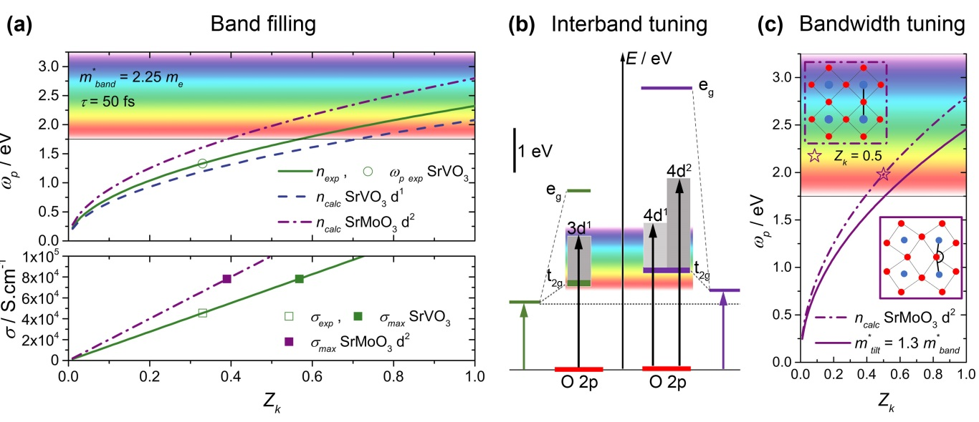
Figure 1. (a) Top panel: Calculated plasma frequency ω_{p} as a function of the renormalization factor Z_{k} using equation 1 with $m_{band}^{*}$= 2.25 m_{e} for the theoretical (blue dashed line) and reported (solid green line) carrier concentration of 3d¹ SrVO₃ and for the theoretical carrier concentration of 4d² SrMoO₃ (purple dash-dot line). The experimental plasma frequency reported for SrVO₃ with Z_{k} = 0.33 is represented with an open green circle^{[7]}. Bottom panel: Conductivity σ as a function of Z_{k} calculated using Equation 2 with a scattering factor τ = 50 fs, to account for the measured mobility, and the reported carrier concentration of SrVO₃ ^{[7]}(solid green line) and for the theoretical carrier concentration of the 4d² SrMoO₃ (purple dash- dot line) together with the reported conductivity of SrVO₃ ^{[7]}(open green square) and the maximum theoretical conductivity corresponding to ω_{p} = 1.75 eV for SrVO₃ (full green square) and SrMoO₃ (full purple square). (b) Schematic energy band diagram illustrating the O 2p – nd inter-band transition for a 3d¹ (left) and 4d¹ and 4d² cation (right) in an octahedral environment. (c) Calculated plasma frequency ω_{p} as a function of the renormalization factor Z_{k} using equation 1 with $m_{band}^{*}$= 2.25 m_{e} for the theoretical carrier concentration of the 4d² SrMoO₃ (dashed dotted purple line) in a cubic structure (purple dash-dot border inset) and a tilted structure (purple border inset) with $m_{tilt}^{*}$= 1.3 $m_{band}^{*}$ (purple line). The purple star represents ω_{p} for Z_{k} = 0.5 which was experimentally determined for SrMoO₃ by photoemission and close to the optimum Z_{k} to maximize the conductivity.^{[8]}

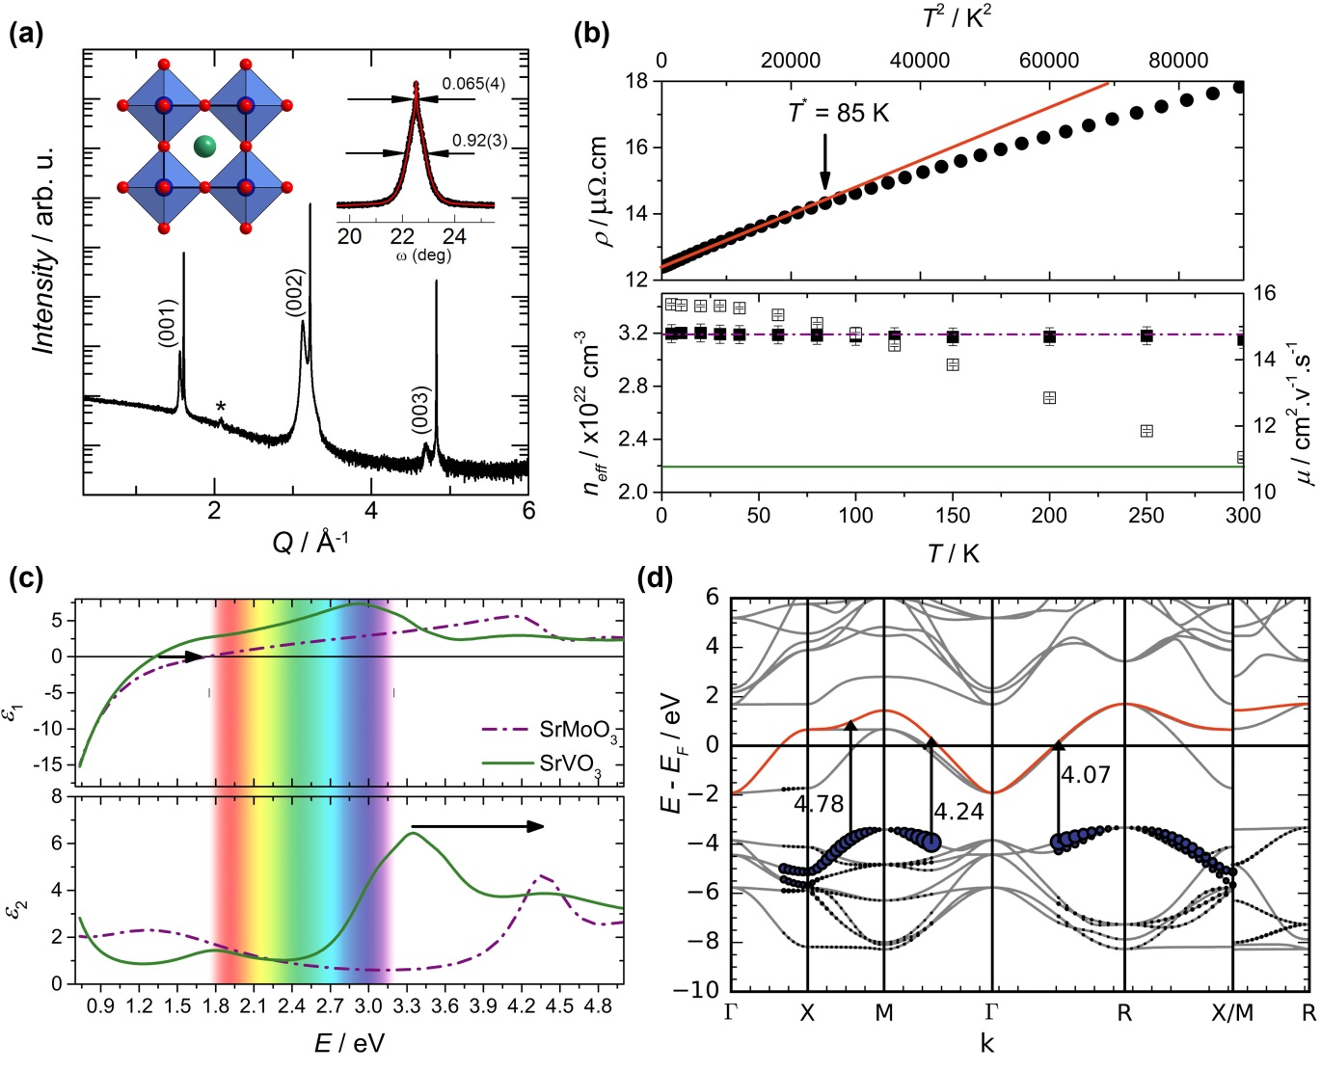
Figure 2. (a) X-ray diffraction pattern of a 47 nm SrMoO₃ thin film, the star corresponds to a minor SrMoO₄ impurity phase. The rocking curve of the (0 0 2) reflection is shown in the right inset, and the cubic untilted structure of SrMoO₃ in the left inset. (b) Top panel: resistivity as function of T², the black dots are experimental data and the red line is a linear fit up to T*. Bottom panel: carrier concentration (black squares) and mobility (open squares) as function of T. The dash-dot purple line corresponds to the theoretical carrier concentration of SrMoO₃ and the green line corresponds to the reported carrier concentration of SrVO₃. ^{[7]} (c) Real part ε₁ (top panel) and imaginary part ε₂ (bottom panel) of the complex dielectric function spectra for SrMoO₃ (purple dash-dot line) and SrVO₃ (green line). (d) Computed transition matrix elements |M(k)|² plotted as a function of k for transitions into t_{2g} unoccupied bands from fully occupied states for SrMoO₃. The red curve shows the unoccupied states, and the radius of the blue dots is proportional to the magnitude of |M(k)|² for a transition from a particular occupied band at a given point in k space.

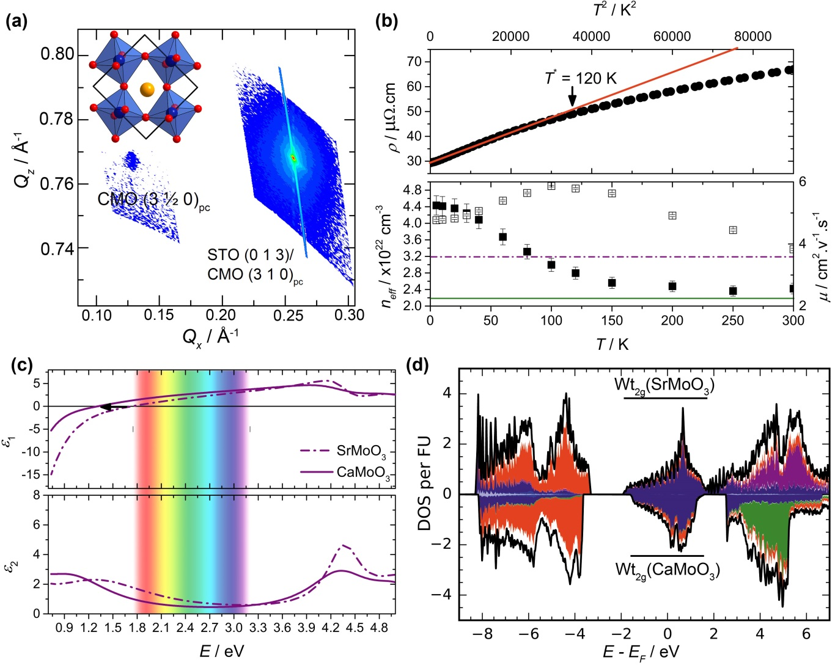Figure 3. (a) Reciprocal space map of a 57 nm thick orthorhombic CaMoO₃ thin film around the (3 1 0)_{p.c}. and (3 ½ 0)_{p.c.} reflections, indexed against the pseudocubic cell. The inset shows the tilted orthorhombic structure of CaMoO₃. (b) Top panel: resistivity as function of T², the black dots are experimental data and the red line is a linear fit up to T*. Bottom panel: carrier concentration (black squares) and mobility (open squares) as function of T. The dash-dot purple line corresponds to the theoretical carrier concentration of SrMoO₃ and the green line the reported carrier concentration of SrVO₃. ^{[7]} (c) Real part ε₁ (top panel) and imaginary part ε₂ (bottom panel) of the complex dielectric function spectra for CaMoO₃ (purple line) and SrMoO₃ (purple dash-dot line). The black arrow in the top panel indicates the decrease in plasma frequency from SrMoO₃ to CaMoO₃ (d) DFT calculated density of states (black lines) and site-projected density of states (Oxygen (red), Calcium (green), Molybdenum (blue) and Strontium (purple)) for SrMoO₃ (top) and CaMoO₃ (bottom).

The chemical control of the electrical and optical properties of non-toxic, earth abundant Mo-based correlated metal perovskite oxides optimizes the transparent conductor performance to match the best-in-class wide band gap semiconductors. The use of the three chemically controllable parameters (i) carrier density, (ii) orbital energy and (iii) bandwidth tune the charge transfer band position, plasma frequency and conductivity.

Keyword
Correlated metals transparent conductor optimization

J. L. Stoner, P. A. E. Murgatroyd, M. O’Sullivan, M. S. Dyer, T. D. Manning, J. B. Claridge, M. J. Rosseinsky* and J. Alaria*

Chemical Control of Correlated Metals as Transparent Conductors

ToC figure ((Please choose one size: 55 mm broad × 50 mm high or 110 mm broad × 20 mm high. Please do not use any other dimensions))
