Effective fungal spore inactivation with an environmentally friendly approach based on atmospheric pressure air plasma
Nataša Hojnik^{1,2}, Martina Modic¹, Yuan Ni³, Gregor Filipič¹, Uroš Cvelbar^{1,2}, James L. Walsh³
¹ Jozef Stefan Institute, Ljubljana, Slovenia.
² Jozef Stefan International Postgraduate School, Ljubljana, Slovenia
³ Department of Electrical Engineering and Electronics, University of Liverpool, Liverpool, United Kingdom.
*Corresponding authors. E-mail: J.L.Walsh@liverpool.ac.uk, uros.cvelbar@ijs.si

ABSTRACT:
Fungal contamination of surfaces is a global burden, posing a major environmental and public health challenge. A wide variety of antifungal chemical agents are available; however, the side effects of the use of these disinfectants often result in the generation of toxic residues raising major environmental concerns. Herein, atmospheric pressure air plasma generated by a surface barrier discharge (SBD) is presented as an innovative green chemical method for fungal inactivation, with the potential to become an effective replacement for conventional chemical disinfection agents, such as Virkon®. Using Aspergillus flavus spores as a target organism, a comparison of plasma based decontamination techniques is reported, highlighting their respective efficiencies and uncovering their underpining inactivation pathways. Tests were performed using both direct gaseous plasma treatment and an indirect treatment using a plasma activated aqueous broth solution (PAB). Concentrations of gaseous ozone and nitrogen oxides were determined with Fourier-transform infrared spectroscopy (FTIR) and Optical emission spectroscopy (OES), whereas hydrogen peroxides, nitrites, nitrates and pH were measured in PAB. It is demonstrated that direct exposure to the gaseous plasma effluent exhibited superior decontamination efficiency and eliminated spores more effectively than Virkon®, a finding attributed to the production of a wide variety of reactive oxygen and nitrogen species within the plasma.

INTRODUCTION:
Moulds play an important role in various ecosystems and are used for the production of different types of foods and food supplements, beverages, enzymes, antibiotics and other pharmaceuticals.¹⁻³ However, moulds are also responsible for a vast amount of global food spoilage and cause damage to a wide range of building materials and household surfaces. Additionally, they are also capable of producing a plethora of harmful organic metabolites. Many of the produced metabolites are proteins which can cause allergic reactions and respiratory diseases.⁴ Especially dangerous are food related fungal species, which are capable of producing toxic metabolites known as mycotoxins, many of which are known human carcinogens, neurotoxins, immunosuppressants and endocrine disruptors.⁵
The occurrence of unwanted mould causes economic loss on a global scale; a challenge made even more pressing by the lack of a truly effective response measure to prevent it. Recently, several studies have indicated that the problems caused by fungal contamination are rising at an alarming rate due to improper agricultural practices and global climate change.⁶⁻⁸ Moreover, globalised economies demand the long distance transport of food from producer to consumer, meaning frequent changes in local climate and long storage times, further exacerbating the issue.⁹ Current approaches to avoid mould contamination usually involve the use of groups of chemicals such as fungicides and disinfectants, where disinfectants are typically alcohol-, peracetic acid-, iodophors-, aldehydes-, chlorine-, peroxygen-based or a mixture of these chemicals.¹⁰ For instance, a recently introduced and widely used liquid disinfectant known as Virkon® is composed of a combination of oxone, sodium dodecylbenzenesulfonate and sulfamic acid plus various inorganic buffers. As a classical antimicrobial agent, it has a wide spectrum of disinfection activity, including effectiveness against fungal species.¹¹ As with other disinfectants, complete fungal inactivation using Virkon® requires a significant exposure, dictating lengthy and complex decontamination procedures which increase the risk of inadvertent exposure and associated potential health risks. Following the inactivation procedure, the disinfectant must be discarded placing a burden on the environment and giving rise to the potential for toxic residues to remain.¹² Given the challenges posed by conventional liquid disinfection agents, new antifungal methods are urgently sought that offer an environmentally friendly ‘soft’ approach, whilst ensuring sufficient fungicidal rates and minimal impact on the treated subject.¹³ Such approaches include non-thermal fungal inactivation methods including UV and pulsed light irradiation, gamma irradiation, and ozonation.¹⁴⁻¹⁸ The fungicidal effect of irradiation techniques is based on indirect action of electrons (e⁻), hydroxyl radicals (OH), hydroxyperoxyl radicals (HO₂), hydrogen peroxide (H₂O₂) and other reactive species formed by radiolysis of cellular water, which leads to lethal structural damages in fungal cells, including DNA strand breakage, cell membrane rapture, or mechanical impairments of cell walls.¹⁴ Ozone (O₃) is highly potent oxidizing agent. With its capability to diffuse through membranes, it is able to attack various constituents in cell membranes, cell walls, and cytoplasm.¹⁹ Recently, a novel non-thermal method known as atmospheric pressure plasma treatment was introduced.²⁰
Cold atmospheric pressure plasma (CAP) technology represents a promising new and green approach to fungal inactivation. ^{21, 22} It has already been proven to be an efficient tool for the inactivation of microbial pathogens and other toxic agents from surfaces and food products, the degradation of pollutants in potable water, treatment of cancer cells and tumours, as well as a host of other applications spanning the domains of environment science, biology, and nanotechnology.²³⁻²⁸ Yet, to date, few studies have explored fungal inactivation with air based CAP.
In principle, the plasma state of matter refers to ionized gas with unique physical and chemical properties. CAP is generated by adding energy (e.g. through an applied electric field) to a gaseous state, resulting in the creation of a mixture of ground and excited state atoms and molecules, electrons, ions, free radicals and UV photons.²⁹ The generation of non-equilibrium atmospheric pressure plasma results in the production of a wide spectrum of reactive oxygen and nitrogen species (RONS) at low temperatures. These species play an important role in the biological activity of CAP due to their high oxidative potential. The most critical among them are atomic oxygen (O) and nitrogen (N), OH, superoxide (O₂⁻), HO₂, O₃, H₂O₂, nitrogen oxides (NO_{x}) and peroxynitrite (ONOO⁻).³⁰
A promising alternative approach compared to directly applying the plasma to a target surface for the purpose of disinfection is to use a ‘plasma activated liquid’. In this modality, CAP is applied to a liquid which initiates a wide variety of interactions between the gaseous CAP species and liquid media, resulting in the diffusion of gaseous RONS into liquid and the creation of unique liquid chemistries that have shown a broad spectrum of biological effects.³¹ The proven antimicrobial activity of both gaseous and liquid RONS originates from the damage they cause to the microbial cell wall and/or membrane, subsequently enabling further reactive species to enter the cell and damage the intercellular components such as organelles and important biomolecules (DNA, RNA and proteins).^{26, 32, 33}
Some studies have indicated that CAP treatments can be effective for the inactivation of various fungal species from the genera Aspergillus, Penicillium, Fusarium and Cladosporium,³⁴⁻³⁸ compared to other non-thermal decontamination approaches such as UV irradiation and ozonation. For instance, a 5.48 log reduction for Aspergillus flavus and a 5.2 log reduction for Aspergillus parasiticus were achieved after a five minutes exposure to an atmospheric pressure fluidized bed air plasma.³⁴ Furthermore, greater than 4 log of Penicillium digitatum spores were inactivated after a seven minute exposure to an atmospheric pressure oxygen CAP system.³⁹ Despite encouraging results from these reported studies, the reported CAP systems cannot be easily applied for real-world large-scale processing or implementation in an industrial environment. Moreover, the detailed physical-chemical pathways at play in the plasma and its biological outcomes in terms of fungal inactivation remain elusive, requiring significantly more investigation in to the technology before it could hope to see widespread industrial adoption. In order to overcome these knowledge gaps, this study focuses on the inactivation of fungal spores using a surface barrier discharge (SBD) CAP system employing only ambient air. One of the main advantages of SBD is its scalability. As previously demonstrated, uniform plasma can be generated over electrode area of 100 mm x 100 mm and can be scaled up or down to required size.⁴⁰ In this study, Aspergillus flavus was chosen as it poses a particular hazard to humans due to its ability to produce highly carcinogenic mycotoxins, known as aflatoxins.⁴¹ The SBD source was used to directly treat fungal spores and to generate plasma activated aqueous broth solution (PAB). The fungicidal efficiency of both direct CAP treatment and application of PAB were compared with a standard 1% Virkon® solution. A host of plasma and liquid diagnostic techniques were employed in order to link the physical and chemical properties of both the gaseous plasma effluent and the composition of the PAB to the biological effects observed. Ultimately, the results of this study indicate that direct air CAP treatment is an extremely effective antifungal agent, providing key advantages over competing approaches by offering an ability to generate high densities of RONS directly at the point of need, using only ambient air and very little electrical power. It is these key attributes that will greatly facilitate the widespread implementation of CAP technology for fungal decontamination, ultimately serving to reduce the need for potentially toxic liquid disinfectants and thus minimising the environmental burden associated with fungal inactivation.

MATERIALS AND METHODS:
CAP system
The highly scalable CAP system used in this investigation was similar to that reported by Ni et al.,⁴² comprising of a plasma generating electrode unit fabricated from a 100 mm diameter, 1 mm thick quartz disc with aluminium electrodes adhered either side. On one face of the quartz disc, the electrodes were connected to a high voltage power source and coated in epoxy resin to prevent plasma formation. On the opposing side of the quartz disc, a counter electrode was created by connecting the strips to the power source ground. On application of a high voltage AC signal, plasma formed around the edges of the grounded electrode. Fig 1(a) shows a schematic representation of the plasma source and 1(b) shows a photograph of the system operating at an applied voltage of 10 kV. To provide the high-voltage, a homemade power source capable of generating voltages ranging from 5 – 15 kV peak to peak at 40 kHz was employed. It is well known that air plasma produced using a SBD under ambient conditions generates an abundance of biologically active RONS. The particular composition of the discharge effluent is strongly influenced by the discharge properties, including the applied voltage and dissipated power.
In this investigation, the CAP system was operated under three different dissipated power regimes obtained by varying the applied voltage. Under low power conditions, with a power of 0.79 W/cm² the gas phase chemistry in the headspace between the active discharge layer and the sample was found to be dominated by reactive oxygen species (ROS). Under high power conditions, with the power set at 1.62 W/cm², the gas composition was dominated by reactive nitrogen species (RNS). A medium power condition was identified, with power set to 1.24 W/cm², simultaneously generating both ROS and RNS chemistries.

Fungal spore preparation
A. flavus spores (strain EXF-532) were provided by the Mycosmo microbiological bank (Ljubljana, Slovenia) and used in all investigations reported here. To produce spores, moulds were first grown on fresh potato dextrose agar (PDA; VWR Chemicals) plates for approximately 7 days at 25 ˚C. Following successful growth, a stock suspension of spores was prepared by flooding the PDA plates with an aqueous solution of tryptic soy broth (TSB; Biolife) including the addition of 0.05% Tween 80 (Acros Organics). Following addition of the broth solution, spores were gently scraped from the surface of the newly formed mycelia using a sterile loop. To achieve the highest possible homogeneity, the stock spore suspension was mixed thoroughly using a sterile injection needle. To determine the concentration of spores in solution, an optical microscope was used with the help of an improved Neubauer Brightline haemocytometer (BRAND®).
CAP treatments
In this study, the plasma source was used to generate a broad spectrum of long-lived RONS, as shown in Fig 2(a), these species were applied to the sample using two alternate approaches; one involving the direct exposure of spores to the gas phase effluent of the plasma, shown in Fig 2(b) and the other involving the plasma treatment of aqueous broth solution and subsequent application of the PAB to the spores, shown in Fig. 2(c). To accommodate these different tests, one-third of the prepared spore solution was deposited on to glass cover slips to give a surface concentration of 10⁶ spores and allowed to dry for five minutes. These samples were used to assess the effectiveness of a gas phase CAP treatment. The experimental approach used to directly expose fungal spores is presented in Fig. 2(b). To assess the potential of PAB for inactivation of fungal spores, 3 ml of sterile aqueous broth solution with 0.05% Tween 80 was exposed to plasma under the same conditions used in the gas phase treatment scenario. The resulting PAB was subsequently added to the spore solution for the purpose of decontamination, as presented in Fig. 2(c). Finally, the remaining third of the prepared spore solution was reserved to assess the decontamination efficacy of Virkon®, a commonly used disinfection agent with strong fungicidal action providing a valuable benchmark from which to compare respective plasma treatments.
During CAP treatments, the SBD electrode was positioned on top of an open Petri dish lid containing either a glass cover slip hosting fungal spores or the aqueous TSB broth solution. In all cases, the distance between the active discharge and the sample was fixed at 5 mm. For all tests involving liquid treatment, the CAP system was placed on a magnetic stir plate, and the sample continually stirred at 225 rotations per minute.
To treat the spores deposited directly on to a glass coverslip, CAP was applied at low, medium and high power for time durations of 30, 60, 120, 240 and 480 seconds. Following CAP exposure, the coverslips were washed with 1 ml of sterile broth solution. Serial decadal dilutions of this solution were prepared and plated on to fresh PDA plates followed by incubation for 2 days at 25 ˚C. Following incubation, colonies were counted and converted to logarithmic values. For experiments involving PAB, the solutions including both spores and PAB were transffered to microcentrifuge tubes and incubated for 3, 6 and 24 hours at 37 °C in shaking incubator at 150 rpm. Following incubation, serial decadal dilutions of the spore samples were plated on to fresh PDA plates and colonies forming were counted. To provide a comparison with conventional methods, the spore solution was also exposed to a 1% aqueous solution of Virkon® (Du Pont). This was achieved by spraying the Virkon® on to spores deposited on a glass coverslip for 480 s, which is equivalent to the longest plasma exposure time. In the case of spore suspension treatment, spores were exposed to Virkon® for 3, 6, and 24 hours. In all cases, tests were performed in triplicate to provide a statistically robust comparison.
Metabolic activity (XTT test) of spores
After treatment, the metabolic activity of the spores was assessed using a Mitochondrial activity test (XTT test). This was achieved by adding a 10 ml solution of PBS (Sigma Aldrich) containing a 10 mM concentration of XTT (2,3-Bis-(2-Methoxy-4-Nitro-5-Sulfophenyl)-2H-Tetrazolium-5-Carboxanilide; Alfa Aesar). Prior to the test, a 1 µl of menadione (2-Methylnaphthalene-1,4-dione; Acros Organics) prepared in 100 % acetone (VWR Chemicals) was added to the solution. For the test, 50 µl of the sample, containing a concentration of 10⁶ spores/ml, was placed in a 96-well plate and mixed with 50 µl of saline solution and 50 µl XTT reagent. The well plates were then incubated at 37 °C for two hours in the dark to form the coloured XTT formazon product. The absorbance at 450 nm wavelength was measured after 4, 8, 12, 16, 20, and 24 hours.

Scanning electron microscopy
Mould spores exposed to both the CAP gas phase effluent and PAB were first submerged in a 2.5 % glutaraldehyde fixative solution and incubated overnight. The samples were then dehydrated in a series of increasing ethanol concentrations, finally being placed in 100% ethanol. After that, samples were dried in hexamethyldisilazane (HMDS). Once in 100% HMDS, spores were placed on aluminium SEM holders and coated with a 6 nm platinum layer to prevent charging effects during analysis. SEM (Jeol JSM-7600F) was performed at 2 kV.

Plasma activated liquid analysis
Immediately following the generation of PAB, the pH level was measured using a Hanna instruments HI 98129 combined pH and conductivity probe. To further understand the chemical composition of the activated liquid, colorimetric tests were performed to measure hydrogen peroxide (H₂O₂), nitrite (NO₂⁻) and nitrate (NO₃⁻) concentrations. To determine the presence of H₂O₂, a ferric-xylenol orange complex (xylenole orange, sorbitol and ammonium iron sulfate; Sigma-Aldrich) was added to the treated solution and the absorbance measured at 560 nm. NO₂⁻ concentrations were evaluated using a standard Griess reagent assay (Griess reagent system; Promega) examining absorbance values at 540 nm. The NO₃⁻ concentration was determined in plasma treated deionized water by measuring the absorbance at 200 nm followed by comparison with the standard calibration curve. The measurements of NO₃⁻ in plasma treated deionized water were compared against the values determined in PAB using test stripes (Quantofix® Nitrate/Nitrite test strips).
Fourier-transform infrared spectroscopy analysis
Generation of CAP using an SBD produces a wealth of long-lived chemical species that are able to travel well beyond the confines of the visible discharge. To analyse the long-lived gas phase species under low, medium and high power operating conditions the SBD electrode unit was placed within a sealed enclosure, and the effluent from the system was drawn through a Fourier-transfor infrared (FTIR) gas cell (multi-pass design with 16 m path length) using a small vacuum pump (< 1 l/min). A Jasco FT/IR-4000 spectrometer with a mid-IR optical bench from 7800 cm⁻¹ to 500 cm⁻¹ was used to record the resulting IR absorption spectrum. Measurements were taken with a resolution of 4 cm⁻¹ and each spectrum comprised of 25 individual acquisitions averaged. To obtain the concentration of relevant species from the absorption spectra, a fitting procedure based on a comparison of peak area against standard reference profiles obtained from the Pacific Northwest National Laboratory (PNNL) library was implemented.⁴³ The standard reference data was collected at 1 part-per-million-meter (ppm-meter) resolution at 296 K with a path length of 1 m. To obtain the concentration, C, of a particular molecule from the absorption spectra, the equation C ­= ­A /(B.l) was used, where A is the area of the FTIR peak of a particular species, B is the standard peak area, and l is the difference between the experimental gas cell path length and the path length used to obtain the reference data.
Optical Emission Spectroscopy
Optical emission spectroscopy (OES) was used to obtain an indication of the nature of excited species produced in the discharge layer and to assess the rotational and vibrational temperature of the plasma. A fibre optic coupled spectrometer (Ocean Optics HR2000+) with a spectral resolution of ~0.5 nm was employed to record the emission spectra from the discharge under low, medium and high power operating conditions. To obtain the rotational and vibrational temperature the recorded emission spectra was compared against synthetic spectra of the Nitrogen Second Positive series, generated using the commercial software Specair, and the best fit temperature obtained.
Sample temperature measurements
A thermocouple probe was used to measure the sample temperature as a function of treatment time. The probe was positioned on the glass cover slip or within the liquid sample and the temperature recorded at 30 second intervals throughout plasma exposure.

Statistical analysis
Three replicate samples were conducted for each time point in the experiment. One way and two way ANOVA was used to evaluate the significant difference between the experiment groups (GraphPad Prism 7).
Results and discussion:
Antifungal effect of gaseous plasma treatment
A. flavus spores deposited on glass cover slips were directly exposed to the CAP effluent under the plasma generation conditions outlined in the experimental methods section. The antifungal effect of the treatment is highlighted in Fig. 3. From the figure it is clear that a 480 second CAP treatment resulted in considerable spore inactivation, exceeding a 5 log reduction under both the low and high power conditions (Fig. 3(a) and (c)). In general, the log reduction increased with exposure time and applied power. The highest power condition gave the most rapid level of inactivation, reaching a 2.19 log reduction after just 120 seconds of exposure (Fig. 3(c)). Conversely, the low power condition showed a very little effect until 240 seconds, at which point a rapid increase in the level of inactivation occurred, ultimately achieving complete inactivation (defined as ˂1 log surviving CFU) within 480 seconds (Fig. 3(a)). To provide a comparison of CAP inactivation efficacy against a widely used liquid decontamination agent, spores were spread on a glass cover slip and exposed to a 1% Virkon® solution for a total of 480 s. Under such conditions, no reduction in viable spores was observed (Fig. 3(a)-(c)). Such results indicate that gas phase plasma treatment is considerably more effective than a standard Virkon® solution. These findings were supported by the XTT analysis, which highlights a minor decrease in the metabolic activity of Virkon® treated spores; in contrast, plasma treated spores exhibited significantly reduced activity at considerably shorter exposure times (Fig. 3(d)-(f)).
Insight into the mode of inactivation during CAP exposure can be obtained from SEM images of the treated spores. The typical cases of untreated, CAP treated, and Virkon® treated spores under two different levels of magnification are presented in Fig. 4. As seen in Fig. 4(b) and 4(e), a high power plasma treatment resulted in considerable structural damage to the A. flavus spores. It was observed that a large percentage of the treated spores exhibited similar levels of structural damage and were surrounded by considerable cell debris. In contrast, Virkon® treated spores, presented in Fig. 4(c) and (e), showed little difference from the untreated spores.
To explain the observed decontamination results and aid in identification of the most likely underpinning inactivation pathways involved in gas phase CAP treatment FTIR, OES and temperature measurements were made. Initially, to rule out thermal effects, a thermocouple was placed at a position 5 mm beneath the SBD electrode. In all cases thermal equilibrium was reached within 120 seconds of CAP exposure and temperatures of 35ºC, 48ºC and to 52ºC were measured for the low, medium and high power conditions, respectively. While these temperatures are not insignificant, studies have demonstrated that such temperatures are incapable of achieving a significant level of mould spore inactivation on the timescales considered in this study.⁴⁴ Such results provide a strong indication that thermal effects are not the primary inactivation mechanism. To gain an insight into the composition of the plasma, OES was employed to capture the optical signature of the excited species within the discharge layer. The overlaid emission spectra of the discharge operating under low, medium and high power conditions is displayed in Fig. 5(a). The spectra reveal that in all cases the excited nitrogen second positive series was the dominant emission, appearing between 290 nm and 410 nm. No other significant emission lines were observed within the 280 – 600 nm wavelength range regardless of operating power. Given the emission data was calibrated for intensity it is possible to conclude that the light intensity produced by the CAP over the UVC, UVB and UVA ranges is well below that known to have an impact on the growth of A. flavus spores, with levels around µW·cm⁻²·nm⁻¹. Therefore UV effects from the CAP device can also be neglected, a finding consistent with previous studies.⁴⁵
Further analysis of the second positive system makes it possible to obtain an estimate of the gas temperature within the discharge layer. It is well known that under the atmospheric pressure conditions the rotational temperature of excited nitrogen is in thermodynamic equilibrium with the background gas. By comparing the recorded emission spectra against a synthetic spectra calculated at a known temperature an approximation of the gas temperature was obtained. As shown in the insert of Fig. 5(a), the best-fit temperature at the highest plasma power was found to be 340 K with an error of +/- 25 K. This value corresponds well with the thermocouple measurements made at the sample location.
Beyond UV and thermal effects, it is well known that air plasma generated at atmospheric pressure creates highly reactive short-lived species, e.g. O, OH, N and O₂⁻, which diffuse away from the plasma region, rapidly reacting to form a variety of longer-lived RONS, including O₃, H₂O₂, nitric oxide (NO), and other NO_{x}.⁴⁶ The density of some of these species can be quantified from FTIR absorption measurements obtained during plasma operation, as shown in Fig. 5(b). Under low power conditions, it can be seen that O₃ is the primary long-lived product of the discharge. O₃ is primarily produced in the discharge layer through a three-body reaction involving atomic oxygen (1).
O + O₂ + M → O₃ + M (1)
Conversely, under high power conditions, the composition of the discharge effluent is dominated by NO_{x} including nitrous oxide (N₂O) and nitrogen dioxide (NO₂) (Fig. 5(b)). The origins of the transition between O₃ dominated to NO_{X} dominated discharge chemistries is twofold: firstly, as discharge power increases, the rate of thermal decomposition of O₃ rapidly increases.⁴² Secondly, an increased power yields more NO which acts to poison O₃ production by simultaneously reducing O₃ through direct decomposition to NO₂ and through the consumption of O, a key precursor for O₃ formation (2 – 3).⁴⁷
O₃ + NO → NO₂ + O₂ (2)
O + NO + M → NO₂ + M (3)
Time-resolved FTIR measurements reveal the evolution of O₃, NO₂ and N₂O in the discharge effluent and clearly demonstrate the poisoning effect (Figs. 5(c – e)). Under high power operation, O₃ formation is rapidly inhibited as the discharge reactor reaches thermal equilibrium and the nitric oxide concentration increases. As O₃ poisoning occurs, a significant increase in NO₂ is observed. Finally, it is worth pointing out that several key RONS present in the plasma effluent may not be measured using FTIR, either because they do not actively absorb infrared light, or because they react to form alternative species between the discharge chamber and the FTIR gas cell, nitric oxide being a prime exemplar.
The biological effects of RONS are well known. O₃ is a powerful oxidant; it can oxidise organic matter either directly or through OH produced during the decomposition of O₃. Firstly, it interacts with double bonds of unsaturated lipids and the sulphydryl groups of membrane enzymes. This damage causes disruption of cell permeability, leading to leakage and oxidation of intercellular contents and biomolecules such as nucleic acids and eventually the lysis of the cell.⁴⁸ Another potent oxidant produced by CAP is H₂O₂, which has inactivation mechanisms similar to those of O₃. Generally, cytotoxicity caused by H₂O₂ begins with its penetration into the cell and then the production of OH. OH is an extremely potent oxidising agent which can be created from the decomposition of both O₃ and H₂O₂. Its primary targets are cell walls and membranes, therefore all the compounds composing of these two structures. The mechanism of OH reaction with lipids refers to its H-abstraction from the unsaturated carbon bonds of the fatty acids, ending in lipid peroxidation.⁴⁹⁻⁵³ Simultaneously, OH also reacts with membrane proteins by H-abstraction from the α-carbon of the peptide bonds between chain peptide-linked amino acids, resulting in peroxidation of proteins. In comparison with the direct activity of O₃, the mechanism of OH inactivation is less selective.⁵⁴ Given that the SEM images in Figs. 4(b & e) demonstrate that spores subjected to CAP treatment exhibit significant structural changes, it is highly probably that ROS species have an etching effect on the spore wall, creating an entry point for RONS to react further with the intracellular contents.
Some previous studies have hypothesised that the interaction between plasma generated RONS and fungal spores is one of the most likely chemical pathways for inactivation.^{37, 55} When CAP decontamination efficacy is compared against the most frequently used methods for fungi decontamination - conventional UV irradiation or O₃ treatment, the CAP method is significantly more effective. Recent studies of conventional approaches demonstrated that UV-C irradiation achieved a modest 2.8 log reduction of Penicillium expansum spores after a six minute exposure at a light intensity of 3.3 kJ/m².⁵⁶. Similarly, gaseous O₃ was found to be even less effective, with a 3 log reduction achieved for various spores types exposed to 35 ppm of O₃ for 20 minutes.¹⁷ Since the low power CAP treatment accomplished a high inactivation level within a short time frame, it is reasonable to conclude that O₃ alone is not solely responsible. Therefore, the simultaneous exposure to multiple RONS, UV and elevated gas temperatures are likely to result in synergistic effects that accelerate spore inactivation in the presence of plasma.
Antifungal effect of plasma activated broth
Recently, a considerable research effort has been focused on the use of plasma treated liquids for microbial inactivation applications. Examples include the inactivation of Escherichia coli, Pseudomonas fluorescens, Staphylococcus aureus, Candida albicans, etc.^{42, 57} Using a liquid as a carrier for reactive plasma species overcomes some drawbacks associated with a gas plasma treatment including an ability to treat highly porous materials with complex morphologies and enabling the treatment of highly temperature sensitive systems or environments where gaseous plasma cannot be directly used. Another comparative advantage of this treatment modality is the long-lived nature of the PAB (up to one week),⁵⁸ which can be used when needed, without the need to create a plasma.
To assess the potential of PAB for fungal inactivation, a PAB solution was prepared and subsequently used to expose A. flavus spores for varying lengths of time. The inactivation results are presented in Fig. 6(a-c). Clearly, the inactivation efficacy of PAB is significantly lower than the corresponding gas phase treatment. No significant reduction in spore count was observed with the exception of 24 h exposure to PAB created using high power plasma conditions, yielding a 1.04 log reduction. In contrast, exposure to a 1% Virkon® solution led to complete inactivation under all conditions investigated. Interestingly, the metabolic activity of PAB treated spores significantly decreased under all treatment conditions, reaching a value two times lower compared to the control (Fig. 6(d-f)). Given that previous studies have demonstrated the high antimicrobial potential of PAB, the results from Fig. 6 are unexpected since it would be reasonable to assume that similar inactivation pathways are at play. To unravel this, the untreated, PAB treated and Virkon® treated A. flavus spores were analysed by SEM after a six hour incubation in fresh aqueous TSB solution (Fig. 7). From the observed morphology, some minor differences were detected between the untreated (Fig. 7(a) and (d)) and PAB treated spores (Fig. 7(b) and ((e)); however, spores exposed to Virkon® exhibit significant structural damage (Fig. 7(f)). Nevertheless, the growth and the development of hyphae and mycelia of A. flavus exposed to PAB treated with high power CAP was decreased or arrested (Fig. 7(b) and (e)). In comparison, the formation of mycelia can be observed at untreated sample (Fig. 7(a)).
In order to understand the results, the nature of PAB must be considered. CAP interaction with liquid induces a wide range of physicochemical changes. The creation of aqueous phase chemical species is strongly influenced by the type of discharge, its underpinning physical processes and the chemical composition of the surrounding environment, such as the type of gas and liquid used. Mass transport from the plasma phase, through the separating gas layer to the liquid phase, leads to the generation of a wide variety of reactive species in the bulk liquid. In this study, the liquid chemistry is mostly affected by long-lived species despite the relatively short distance between the plasma and the liquid surface, as the most reactive chemical species are confined to the visible discharge layer.⁴⁶ To follow the kinetics of the aqueous phase reactive species, the concentrations of H₂O₂, NO₂⁻, NO₃⁻ and pH were measured as a function of CAP treatment time (Fig. 8).
In Fig. 8(b) we suggest that CAP treatment induces the formation of H₂O₂ in the broth solution. The increase in H₂O₂ concentration is highly dependent on the discharge power employed. For low and high power treatment conditions, the H₂O₂ concentration is increased up to an equilibrium or saturation level. Conversely, PAB created under medium power operation CAP operation showed a different trend, with a continual increase. The highest concentration of H₂O₂ was measured after 480 seconds in the medium power case, at over 1800 µM. Based on recent plasma modelling studies,^{59, 60} it is expected that H₂O₂ present in the liquid phase was either generated in situ or created in the humid air surrounding the plasma generating electrode, through reaction 4.
OH + OH + M H₂O₂ + M (4)
Considering the reasonably large air gap between the plasma layer and liquid surface, it is highly unlikely that OH produced in the discharge will reach the liquid interface in any significant concentration. Consequently, the direct formation of H₂O₂ at the gas-liquid interface will be minimal (Fig. 9). Several studies have used electron spin resonance techniques to measure OH directly in the liquid phase,⁶⁰ this has been attributed to in situ generation pathways involving plasma generated RONS that are capable of transport across the dividing gas layer, pertinent reactions include (5 – 6):
O₃⁻_{aq} + H⁺_{aq} O_{2aq} + OH_{aq} (5)
HO_{3aq} O_{2aq} + OH_{aq}; (6)
The presence of NO₂⁻ was measured using the Griess reagent method. Fig. 8(c) demonstrates that regardless of the plasma power the NO₂⁻ concentration initially increased with treatment time, reaching a peak, followed by a significant decrease with further treatment. Conversely, the NO₃⁻ displays an almost linear increase with treatment time under all power conditions (Fig. 8(d)). Both NO₂⁻ and NO₃⁻ in the CAP treated broth solution are created through numerous reaction pathways. Mass transport of nitrous acid (HNO₂) and nitric acid (HNO₃) from the gas phase to the liquid provides the primary reactants to form NO₂⁻ and NO₃⁻. Once in the liquid, they are hydrolysed to form NO₂⁻, NO₃⁻, and H⁺ (7 – 8)⁶⁰:
HNO_{2liq} ↔ NO₂⁻_{liq} + H⁺_{liq}; (7)
HNO₃⁻_{liq} ↔ NO₃⁻_{liq} + H⁺_{liq} (8)
Another important pathway involved in the creation of these ionic species involves NO and NO₂ generated in the gas phase downstream of the discharge layer (9 – 10)⁶⁰:
2NO_{2liq} + H₂O_{liq} NO₂⁻_{liq} + NO₃⁻_{liq} + 2H⁺_{liq} (9)
NO_{liq} + NO_{2liq} + H₂O_{liq} 2NO₂⁻_{liq} + 2H⁺_{liq} (10)
Eventually, the concentration of H⁺ rises to a level where hydrolysis reactions are inhibited, contributing to a reduction of pH,^{33, 60} which can also be observed in the presented study. The pH level decreased over time under all examined power conditions, reaching a pH of 2.4 after 480 seconds of exposure (Fig. 8(a)) in the highest power case. The results presented in Fig. 8 and the observed drop in NO₂⁻ concentration can be explained by considering its reaction with dissolved O₃ and NO₃ to become NO₃⁻, reactions 11 and 12.⁶¹ Under the observed acidic conditions, NO₃⁻ is also generated through the reaction of NO₂⁻ with H₂O₂, forming short-lived ONOO⁻ via reaction (13).^{33, 60}
O_{3liq} + NO₂⁻_{liq} O_{2liq} + NO₃⁻_{liq} (11)
NO_{3liq} + NO_{2liq} NO_{2liq} + NO₃⁻ (12)
NO₂⁻_{liq} + H₂O_{2liq} + H⁺_{liq} ONOO⁻_{liq} + H₂O_{liq} (13)
Based on the liquid chemistry analysis detailed in Fig. 8, the low rate of fungal spore inactivation observed in Fig. 6 remains somewhat surprising. The PAB contained significant amounts of RONS such as H₂O₂, NO₂⁻ and NO₃⁻. Moreover, it is assumed that under acidic conditions ONOO⁻ is generated. Several recent studies have indicated that ONOO⁻ is one of the most potent oxidizing molecules in the field of biology and is a key agent in oxidative stress mechanisms. It is able to oxidize organic molecules directly or through H⁺ or CO₂-catalyzed homolysis (yielding NO₂., OH, or carbonate anion radical CO₃^{.-}). As for direct reactivity, it has affinity with key parts of proteins such as thiols, iron/sulphur centres, and zinc fingers. The lifetime of ONOO⁻ is relatively short, nonetheless, it can still cross cellular membranes and reach deep within the cell, enabling it to interact with most of the important biomolecules. Because of its instability, measuring the amount of ONOO⁻ produced is a considerable challenge.^{32, 62, 63}
To explain the significant difference in inactivation efficiency between spores exposed to plasma gas phase species and those exposed to PAB, the persistence of the fungal spores must be considered. These difference could be attributed to the surface characteristics of Aspergillus spp. spores which have extremely hydrophobic properties due to the presence of proteins known as hydrophobins. These proteins cause spores to clump together and form aggregates in aqueous solution by association of their hydrophobic molecules with each other rather than with other molecules within the liquid.⁶⁴ Hydrophobic properties of the surface of the spores in relation with their insufficient inactivation in water was already discussed in the study by Ouf et al., where double atmospheric pressure cold plasma was used with intention to inactivate different mould species during water washes of fruit.⁶⁵ Conversely, spores spread on glass and allowed to dry are not protected with liquid and are therefore far less likely to form such aggregates, and are therefore more vulnerable to the reactive plasma species. This is in agreement with the SEM images presented in Fig. 5 and 7, where plasma treated spores display considerable damage after gas phase exposure, and little change after PAB exposure. It is well known that O₃ and related ROS are important in terms of fungicidal activity of liquids.⁶⁶ In the case of this study, it was assumed that only a small amount of O₃ reached the aqueous phase due to its low Henry’s law constant, and the number of potential loss pathways arising due to the presence of other plasma generated species, especially at a low pH. In all cases, the pH of the PAB was seen to drop and it is commonly accepted that the fungicidal effect in acidic conditions is less significant since many mould species tolerate low pH.⁶⁷ This is not the case when PAB is used as an antimicrobial agent, since many bacterial species are significantly less tolerant to a low pH compared to their fungal counterparts. Nevertheless, a low pH can affect the electrostatic properties of the mould spores, resulting in an increase of zeta potential, meaning spores are likely to be more dispersed throughout the liquid volume, which can negatively affect the development of mould hyphae, mycelia and arrest mould growth.⁶⁸
Overall, it is clear that gas phase CAP treatment is an extremely effective and environmentally friendly method for fungal inactivation, which requires no consumables and produced no harmful residues. Based on the results presented, a greater understanding of CAP technology gas been uncovered and thus may accelerate the translation of this innovative green technology for the decontamination of food, living areas or use in other relevant environments. Conversely, the results with plasma treated liquid did not demonstrate promising results. The difference between surface and liquid inactivation efficacy was attributed to the hydrophobic surface properties of spores, which makes them considerably more resilient to RONS when in the liquid phase.
Acknowledgements:
Authors acknowledge the funding from Slovenian Research Agency (ARRS) on grant no. N3-0059 and M-ERA.net 2014 project “PlasmaTex”. JLW acknowledges funding support from the UK Engineering and Physical Sciences Research Council (EPSRC), grant no. EP/N021347/1.
References:
1. Tamang, J. P.; Watanabe, K.; Holzapfel, W. H., Review: Diversity of Microorganisms in Global Fermented Foods and Beverages. Frontiers in Microbiology 2016, 7, 377.
2. Nelson, J. H., Production of blue cheese flavor via submerged fermentation by Penicillium roqueforti. Journal of Agricultural and Food Chemistry 1970, 18, (4), 567-569.
3. Demain, A. L.; Martens, E., Production of valuable compounds by molds and yeasts. The Journal Of Antibiotics 2016, 70, 347.
4. Portnoy, J. M.; Jara, D., Mold allergy revisited. Annals of Allergy, Asthma & Immunology 2015, 114, (2), 83-89.
5. Marin, S.; Ramos, A. J.; Cano-Sancho, G.; Sanchis, V., Mycotoxins: Occurrence, toxicology, and exposure assessment. Food and Chemical Toxicology 2013, 60, 218-237.
6. Haleem Khan, A. A.; Mohan Karuppayil, S., Fungal pollution of indoor environments and its management. Saudi Journal of Biological Sciences 2012, 19, (4), 405-426.
7. Jouany, J. P., Methods for preventing, decontaminating and minimizing the toxicity of mycotoxins in feeds. Animal Feed Science and Technology 2007, 137, (3), 342-362.
8. Vardoulakis, S.; Dimitroulopoulou, C.; Thornes, J.; Lai, K.-M.; Taylor, J.; Myers, I.; Heaviside, C.; Mavrogianni, A.; Shrubsole, C.; Chalabi, Z.; Davies, M.; Wilkinson, P., Impact of climate change on the domestic indoor environment and associated health risks in the UK. Environment International 2015, 85, (Supplement C), 299-313.
9. Nellemann, C., The environmental food crisis: the environment's role in averting future food crises: a UNEP rapid response assessment. UNEP/Earthprint: 2009.
10. Korukluoglu, M.; Sahan, Y.; Yigit, A., The fungicidal efficacy of various commercial disinfectants used in the food industry. Annals of microbiology 2006, 56, (4), 325.
11. Hernndez, A.; Martro, E.; Matas, L.; Martın, M.; Ausina, V., Assessment of in-vitro efficacy of 1% Virkon® against bacteria, fungi, viruses and spores by means of AFNOR guidelines. Journal of Hospital Infection 2000, 46, (3), 203-209.
12. Pechter, E.; Rosenman, K. D., Occupational health risks associated with use of environmental surface disinfectants in health care. American journal of infection control 2016, 44, (12), 1755-1756.
13. Morris, C.; Brody, A. L.; Wicker, L., Non-thermal food processing/preservation technologies: a review with packaging implications. Packaging Technology and Science 2007, 20, (4), 275-286.
14. Calado, T.; Venâncio, A.; Abrunhosa, L., Irradiation for Mold and Mycotoxin Control: A Review. Comprehensive Reviews in Food Science and Food Safety 2014, 13, (5), 1049-1061.
15. Aron Maftei, N.; Ramos-Villarroel, A. Y.; Nicolau, A. I.; Martin-Belloso, O.; Soliva-Fortuny, R., Pulsed light inactivation of naturally occurring moulds on wheat grain. Journal of the science of food and agriculture 2014, 94, (4), 721-6.
16. Pala, C. U.; Toklucu, A. K., Effects of UV-C Light Processing on Some Quality Characteristics of Grape Juices. Food and Bioprocess Technology 2013, 6, (3), 719-725.
17. Hudson, J. B.; Sharma, M., The Practical Application of Ozone Gas as an Anti-fungal (Anti-mold) Agent. Ozone-Science & Engineering 2009, 31, (4), 326-332.
18. Jeong, R. D.; Shin, E. J.; Chu, E. H.; Park, H. J., Effects of Ionizing Radiation on Postharvest Fungal Pathogens. Plant Pathology Journal 2015, 31, (2), 176-180.
19. Varga, L.; Szigeti, J., Use of ozone in the dairy industry: A review. International Journal of Dairy Technology 2016, 69, (2), 157-168.
20. Yagyu, Y.; Sakudo, A., Current Technology and Applications of Gas Plasma for Disinfection of Agricultural Products: Disinfection of Fungal Spores on Citrus unshiu by Atmospheric Pressure Dielectric Barrier Discharge. 2016; p 111-120.
21. Misra, N. N.; Schlüter, O.; Cullen, P. J., Chapter 1 - Plasma in Food and Agriculture. In Cold Plasma in Food and Agriculture, Academic Press: San Diego, 2016; pp 1-16.
22. Niemira, B. A., Cold plasma decontamination of foods. Annual review of food science and technology 2012, 3, 125-142.
23. Heo, N. S.; Lee, M.-K.; Kim, G. W.; Lee, S. J.; Park, J. Y.; Park, T. J., Microbial inactivation and pesticide removal by remote exposure of atmospheric air plasma in confined environments. Journal of bioscience and bioengineering 2014, 117, (1), 81-85.
24. Jiang, B.; Zheng, J.; Qiu, S.; Wu, M.; Zhang, Q.; Yan, Z.; Xue, Q., Review on electrical discharge plasma technology for wastewater remediation. Chemical Engineering Journal 2014, 236, 348-368.
25. Min, S. C.; Roh, S. H.; Niemira, B. A.; Sites, J. E.; Boyd, G.; Lacombe, A., Dielectric barrier discharge atmospheric cold plasma inhibits Escherichia coli O157:H7, Salmonella, Listeria monocytogenes, and Tulane virus in Romaine lettuce. International Journal of Food Microbiology 2016, 237, 114-120.
26. Scholtz, V.; Pazlarova, J.; Souskova, H.; Khun, J.; Julak, J., Nonthermal plasma — A tool for decontamination and disinfection. Biotechnology Advances 2015, 33, (6, Part 2), 1108-1119.
27. Weltmann, K. D.; von Woedtke, T., Plasma medicine-current state of research and medical application. Plasma Physics and Controlled Fusion 2017, 59, (1).
28. Laroussi, M.; Kong, M.; Morfill, G., Plasma medicine: applications of low-temperature gas plasmas in medicine and biology. Cambridge University Press: 2012.
29. Fridman, A.; Kennedy, L. A., Plasma physics and engineering. CRC press: 2004.
30. Lu, X.; Naidis, G. V.; Laroussi, M.; Reuter, S.; Graves, D. B.; Ostrikov, K., Reactive species in non-equilibrium atmospheric-pressure plasmas: Generation, transport, and biological effects. Physics Reports 2016, 630, 1-84.
31. Locke, B. R.; Lukes, P.; Brisset, J.-L., Elementary Chemical and Physical Phenomena in Electrical Discharge Plasma in Gas–Liquid Environments and in Liquids. In Plasma Chemistry and Catalysis in Gases and Liquids, Wiley-VCH Verlag GmbH & Co. KGaA: 2012; pp 185-241.
32. Lukes, P.; Brisset, J.-L.; Locke, B. R., Biological Effects of Electrical Discharge Plasma in Water and in Gas–Liquid Environments. In Plasma Chemistry and Catalysis in Gases and Liquids, Wiley-VCH Verlag GmbH & Co. KGaA: 2012; pp 309-352.
33. Lukes, P.; Dolezalova, E.; Sisrova, I.; Clupek, M., Aqueous-phase chemistry and bactericidal effects from an air discharge plasma in contact with water: evidence for the formation of peroxynitrite through a pseudo-second-order post-discharge reaction of H2O2 and HNO2. Plasma Sources Science & Technology 2014, 23, (1).
34. Dasan, B. G.; Boyaci, I. H.; Mutlu, M., Inactivation of aflatoxigenic fungi (Aspergillus spp.) on granular food model, maize, in an atmospheric pressure fluidized bed plasma system. Food Control 2016, 70, 1-8.
35. Hashizume, H.; Ohta, T.; Jia, F. D.; Takeda, K.; Ishikawa, K.; Hori, M.; Ito, M., Inactivation effects of neutral reactive-oxygen species on Penicillium digitatum spores using non-equilibrium atmospheric-pressure oxygen radical source. Applied Physics Letters 2013, 103, (15).
36. Ishikawa, K.; Mizuno, H.; Tanaka, H.; Tamiya, K.; Hashizume, H.; Ohta, T.; Ito, M.; Iseki, S.; Takeda, K.; Kondo, H.; Sekine, M.; Hori, M., Real-time in situ electron spin resonance measurements on fungal spores of Penicillium digitatum during exposure of oxygen plasmas. Applied Physics Letters 2012, 101, (1).
37. Ouf, S. A.; Basher, A. H.; Mohamed, A.-A. H., Inhibitory effect of double atmospheric pressure argon cold plasma on spores and mycotoxin production of Aspergillus niger contaminating date palm fruits. Journal of the Science of Food and Agriculture 2015, 95, (15), 3204-3210.
38. Suhem, K.; Matan, N.; Nisoa, M.; Matan, N., Inhibition of Aspergillus flavus on agar media and brown rice cereal bars using cold atmospheric plasma treatment. International Journal of Food Microbiology 2013, 161, (2), 107-111.
39. Hashizume, H.; Ohta, T.; Takeda, K.; Ishikawa, K.; Hori, M.; Ito, M., Oxidation mechanism of Penicillium digitatum spores through neutral oxygen radicals. Japanese Journal of Applied Physics 2014, 53, (1).
40. Wang, D.; Zhao, D.; Feng, K.; Zhang, X.; Liu, D.; Yang, S., The cold and atmospheric-pressure air surface barrier discharge plasma for large-area sterilization applications. Applied Physics Letters 2011, 98, (16), 161501.
41. Hojnik, N.; Cvelbar, U.; Tavčar-Kalcher, G.; Walsh, J. L.; Križaj, I., Mycotoxin Decontamination of Food: Cold Atmospheric Pressure Plasma versus “Classic” Decontamination. Toxins 2017, 9, (5), 151.
42. Ni, Y.; Lynch, M.; Modic, M.; Whalley, R.; Walsh, J., A solar powered handheld plasma source for microbial decontamination applications. Journal of Physics D: Applied Physics 2016, 49, (35), 355203.
43. Sharpe, S. W.; Sams, R. L.; Johnson, T. J. In The PNNL quantitative IR database for infrared remote sensing and hyperspectral imaging, Applied Imagery Pattern Recognition Workshop, 2002. Proceedings. 31st, 2002; IEEE: 2002; pp 45-48.
44. DOYLE, M. P.; MARTH, E. H., Thermal Inactivation of Conidia From Aspergillus flavus and Aspergillus parasiticus. Journal of Milk and Food Technology 1975, 38, (11), 678-682.
45. Osman, M.; Elsayed, M. A.; Mohamed, Y. A. H.; Abo-Zeid, A. M., Effect of ultraviolet irradiation on germination and growth in Aspergillus flavus and Penicillium notatum. Mycological Research 1989, 92, (3), 293-296.
46. Hasan, M. I.; Walsh, J. L., Numerical investigation of the spatiotemporal distribution of chemical species in an atmospheric surface barrier-discharge. Journal of Applied Physics 2016, 119, (20), 203302.
47. Shimizu, T.; Sakiyama, Y.; Graves, D. B.; Zimmermann, J. L.; Morfill, G. E., The dynamics of ozone generation and mode transition in air surface micro-discharge plasma at atmospheric pressure. New Journal of Physics 2012, 14, (10), 103028.
48. Khadre, M. A.; Yousef, A. E.; Kim, J. G., Microbiological aspects of ozone applications in food: A review. Journal of Food Science 2001, 66, (9), 1242-1252.
49. Machala, Z.; Chládeková, L.; Pelach, M., Plasma agents in bio-decontamination by dc discharges in atmospheric air. Journal of Physics D: Applied Physics 2010, 43, (22), 222001.
50. Marnett, L. J., Lipid peroxidation—DNA damage by malondialdehyde. Mutation Research/Fundamental and Molecular Mechanisms of Mutagenesis 1999, 424, (1), 83-95.
51. Kiwi, J.; Nadtochenko, V., New Evidence for TiO2 Photocatalysis during Bilayer Lipid Peroxidation. The Journal of Physical Chemistry B 2004, 108, (45), 17675-17684.
52. Nadtochenko, V. A.; Rincon, A. G.; Stanca, S. E.; Kiwi, J., Dynamics of E-coli membrane cell peroxidation during TiO2 photocatalysis studied by ATR-FTIR spectroscopy and AFM microscopy. Journal of Photochemistry and Photobiology a-Chemistry 2005, 169, (2), 131-137.
53. Bacsa, R.; Kiwi, J.; Ohno, T.; Albers, P.; Nadtochenko, V., Preparation, testing and characterization of doped TiO2 active in the peroxidation of biomolecules under visible light. The Journal of Physical Chemistry B 2005, 109, (12), 5994-6003.
54. Davies, M. J., The oxidative environment and protein damage. Biochimica Et Biophysica Acta-Proteins and Proteomics 2005, 1703, (2), 93-109.
55. Dasan, B. G.; Boyaci, I. H.; Mutlu, M., Nonthermal plasma treatment of Aspergillus spp. spores on hazelnuts in an atmospheric pressure fluidized bed plasma system: Impact of process parameters and surveillance of the residual viability of spores. Journal of Food Engineering 2017, 196, 139-149.
56. Syamaladevi, R. M.; Adhikari, A.; Lupien, S. L.; Dugan, F.; Bhunia, K.; Dhingra, A.; Sablani, S. S., Ultraviolet-C light inactivation of Penicillium expansum on fruit surfaces. Food Control 2015, 50, 297-303.
57. Laurita, R.; Barbieri, D.; Gherardi, M.; Colombo, V.; Lukes, P., Chemical analysis of reactive species and antimicrobial activity of water treated by nanosecond pulsed DBD air plasma. Clinical Plasma Medicine 2015, 3, (2), 53-61.
58. Traylor, M. J.; Pavlovich, M. J.; Karim, S.; Hait, P.; Sakiyama, Y.; Clark, D. S.; Graves, D. B., Long-term antibacterial efficacy of air plasma-activated water. Journal of Physics D-Applied Physics 2011, 44, (47).
59. Sakiyama, Y.; Graves, D. B.; Chang, H.-W.; Shimizu, T.; Morfill, G. E., Plasma chemistry model of surface microdischarge in humid air and dynamics of reactive neutral species. Journal of Physics D: Applied Physics 2012, 45, (42), 425201.
60. Liu, Z. C.; Liu, D. X.; Chen, C.; Li, D.; Yang, A. J.; Rong, M. Z.; Chen, H. L.; Kong, M. G., Physicochemical processes in the indirect interaction between surface air plasma and deionized water. Journal of Physics D: Applied Physics 2015, 48, (49), 495201.
61. Liu, D. X.; Liu, Z. C.; Chen, C.; Yang, A. J.; Li, D.; Rong, M. Z.; Chen, H. L.; Kong, M. G., Aqueous reactive species induced by a surface air discharge: Heterogeneous mass transfer and liquid chemistry pathways. Scientific Reports 2016, 6.
62. Naitali, M.; Herry, J. M.; Hnatiuc, E.; Kamgang, G.; Brisset, J. L., Kinetics and Bacterial Inactivation Induced by Peroxynitrite in Electric Discharges in Air. Plasma Chemistry and Plasma Processing 2012, 32, (4), 675-692.
63. Beckman, J. S.; Koppenol, W. H., Nitric oxide, superoxide, and peroxynitrite: the good, the bad, and ugly. American Journal of Physiology-Cell Physiology 1996, 271, (5), C1424-C1437.
64. Mamane‐Gravetz, H.; Linden, K., Relationship between physiochemical properties, aggregation and uv inactivation of isolated indigenous spores in water. Journal of Applied Microbiology 2005, 98, (2), 351-363.
65. Ouf, S. A.; Mohamed, A.-A. H.; El-Sayed, W. S., Fungal Decontamination of Fleshy Fruit Water Washes by Double Atmospheric Pressure Cold Plasma. Clean-Soil Air Water 2016, 44, (2).
66. Kang, M. H.; Pengkit, A.; Choi, K.; Jeon, S. S.; Choi, H. W.; Shin, D. B.; Choi, E. H.; Uhm, H. S.; Park, G., Differential Inactivation of Fungal Spores in Water and on Seeds by Ozone and Arc Discharge Plasma. Plos One 2015, 10, (9).
67. Wheeler, K. A.; Hurdman, B. F.; Pitt, J. I., Influence of pH on the growth of some toxigenic species of Aspergillus, Penicillium and Fusarium. International Journal of Food Microbiology 1991, 12, (2), 141-149.
68. Wargenau, A.; Fleißner, A.; Bolten, C. J.; Rohde, M.; Kampen, I.; Kwade, A., On the origin of the electrostatic surface potential of Aspergillus niger spores in acidic environments. Research in Microbiology 2011, 162, (10), 1011-1017.

FIGURES CAPTIONS
Figure 1. (a) Schematic of air SBD plasma system used for fungal spore inactivation; (b) photograph of CAP system operating under high-power conditions.
Figure 2. Diagrammatic representation of CAP treatment methodologies: (a) CAP system and the key short- and long-lived plasma generated RONS; (b) direct CAP treatment of A. flavus spores; (c) CAP treatment of aqueous tryptic soy broth solution and subsequent exposure of A. flavus spores to plasma activated broth solution (PAB).
Figure 3. CAP effluent treatment of A. flavus spores: (a), (b) and (c) log numbers of new grown spore units after low, medium and high power plasma treatment with a comparison provided against a 1% Virkon® solution. The initial concentration of spores for (a), (b) and (c) was 1.3 x 10⁶ CFU/ml. An one way ANOVA was performed between treated samples and control samples (0 s). P values – 0,0332 (*); 0,0021 (**); 0,0002 (***); <0,0001 (****); (d), (e), (f) metabolic activity of spores exposed to low, medium and high power plasma and a 1% Virkon® solution comparison.
Figure 4. Characteristic scanning electron microscopy images of A. flavus spores after exposures to the direct CAP treatment and a 1% Virkon® solution under 10000 x magnification ((a), (b), (c)) and 25000 x magnification ((d), (e), (f)): (a) and (b) untreated sample (control); (b) and (e) sample treated with CAP at high power for 120 s with marked plasma produced spore morphology damage; (c) and (f) sample treated with 1% Virkon® for 480 s.
Figure 5. Gas Chemical composition of plasma gas phase produced by air SBD operated at low, medium and high dissipated power; (a) OES and vibrational and rotational temperature of electrons; (b) FTIR spectra of long-lived species; (c) ozone content; (d) nitrogen dioxide content; (e) nitrous oxide content.
Figure 6. Exposure of A. flavus spores to plasma activated broth (PAB) generated under low, medium and high power conditions for 480 s with a comparison provided against a 1% Virkon® solution: (a), (b), (c) log numbers of new grown spore units after exposure to PAB and Virkon® for 3 h, 6 h and 24 h. The initial concentration of spores for (a), (b) and (c) was 2.1 x 10⁶, 3.8 x 10⁶ and 2.5 x 10⁶ CFU/ml, respectively. An one way ANOVA was performed comparing results of treated samples to control (0 s). P values – 0,0332 (*); 0,0021 (**); 0,0002 (***); <0,0001 (****); (d), (e), (f) metabolic activity of spores exposed to PAB and Virkon® for 3, 6, and 24 hours.
Figure 7. Characteristic scanning electron microscopy images of A. flavus spores after a 6 hour exposure to PAB and a 1% Virkon® solution under 5000 x magnification ((a)-(c)) and 25000 x magnification ((d)-(f)): (a) and (c) sample incubated in untreated aqueous TSB broth solution (control) with marked mycelia; (b) and (e) sample treated with PAB; (c) and (f) sample treated with 1% Virkon® solution.
Figure 8. Liquid phase chemistry of PAB. Created using CAP under low, medium and high dissipated powers. A two way ANOVA was performed comparing results of treated samples to control (0 s); (a) pH values of PAB; (b) concentration of hydrogen peroxide. All treated samples were significantly different compared to control (P ≤ 0,001); (c) concentration of nitrite. All treated samples were significantly different (P ≤ 0,001) with exceptions of those treated for 30 s with low power plasma and 480 s with medium and high power plasma; (d) concentration of nitrate. Significant differences (P ≤ 0,001) occurred after 240 s of exposure to low and medium power plasma, and after 120 s of exposure to high power plasma.
Figure 9. Schematic of main reactions during the CAP treatment of liquid.

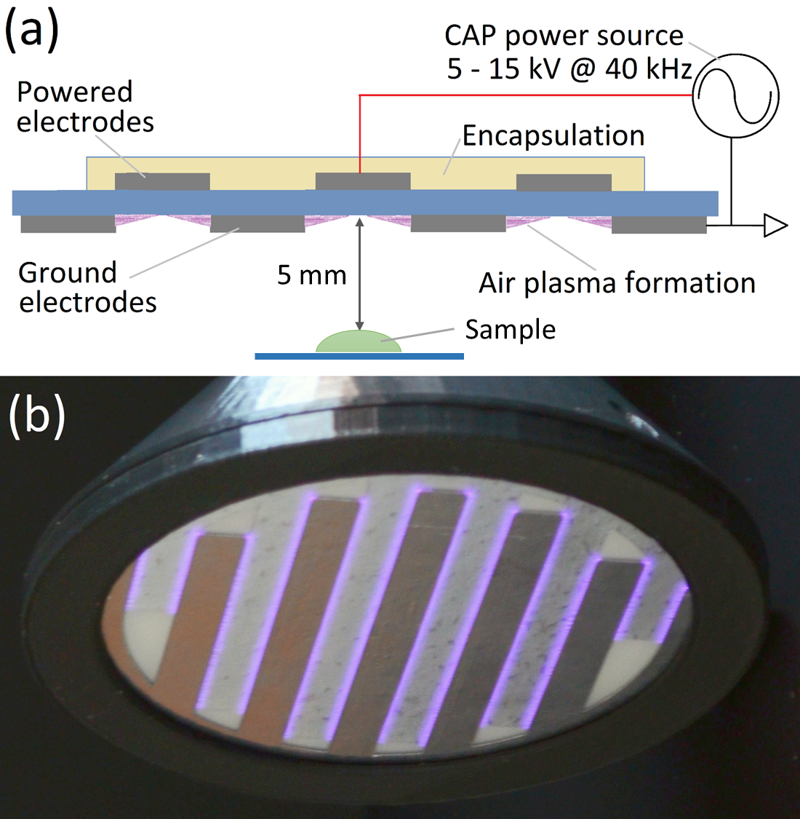
Figure 1.

Figure 2.
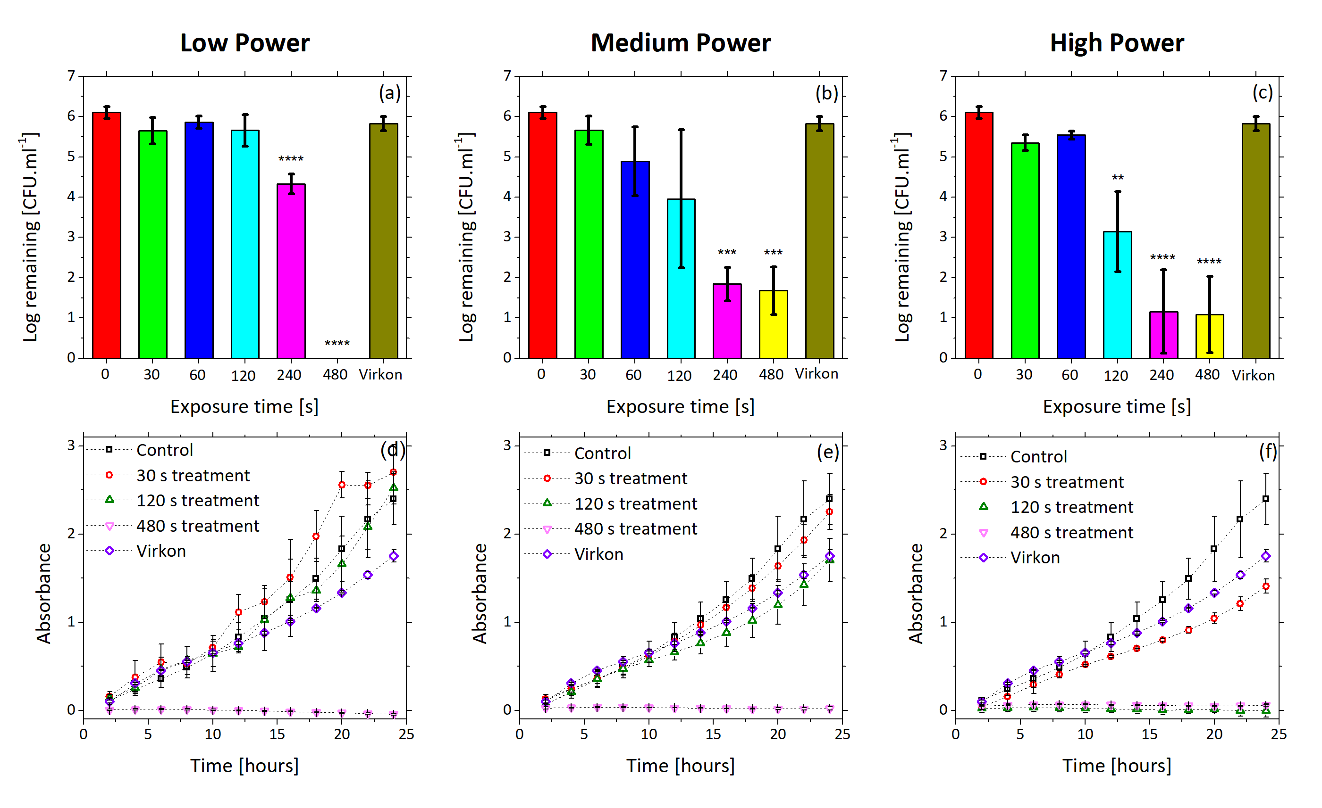
Figure 3.

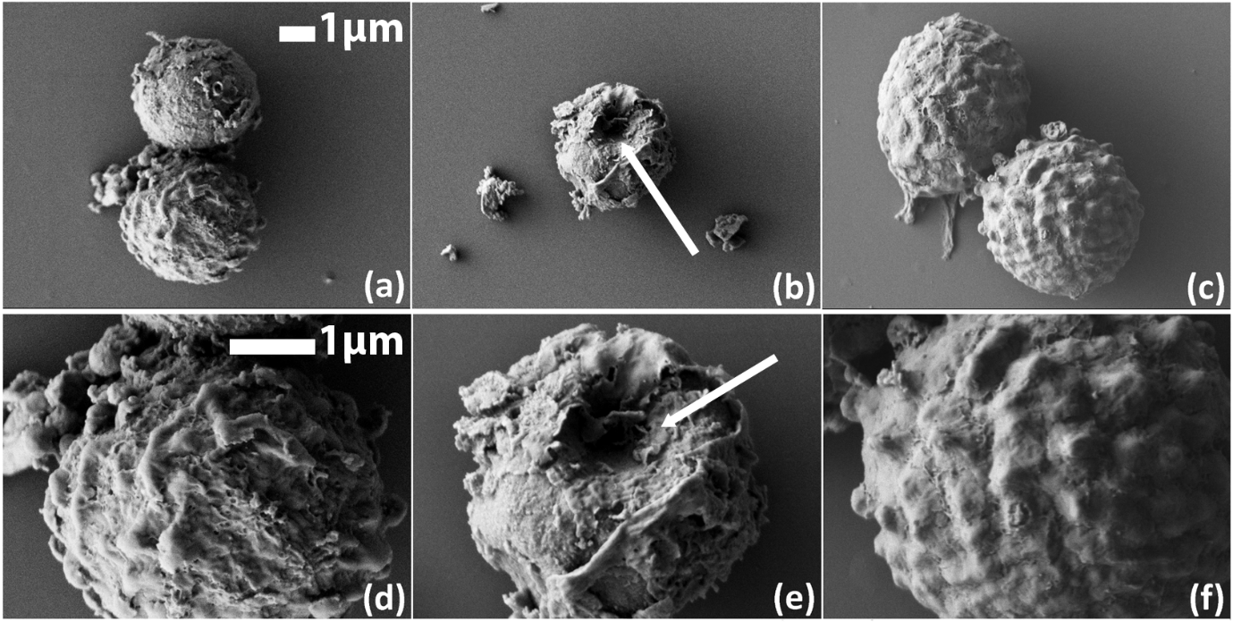
Figure 4.
Figure 5.

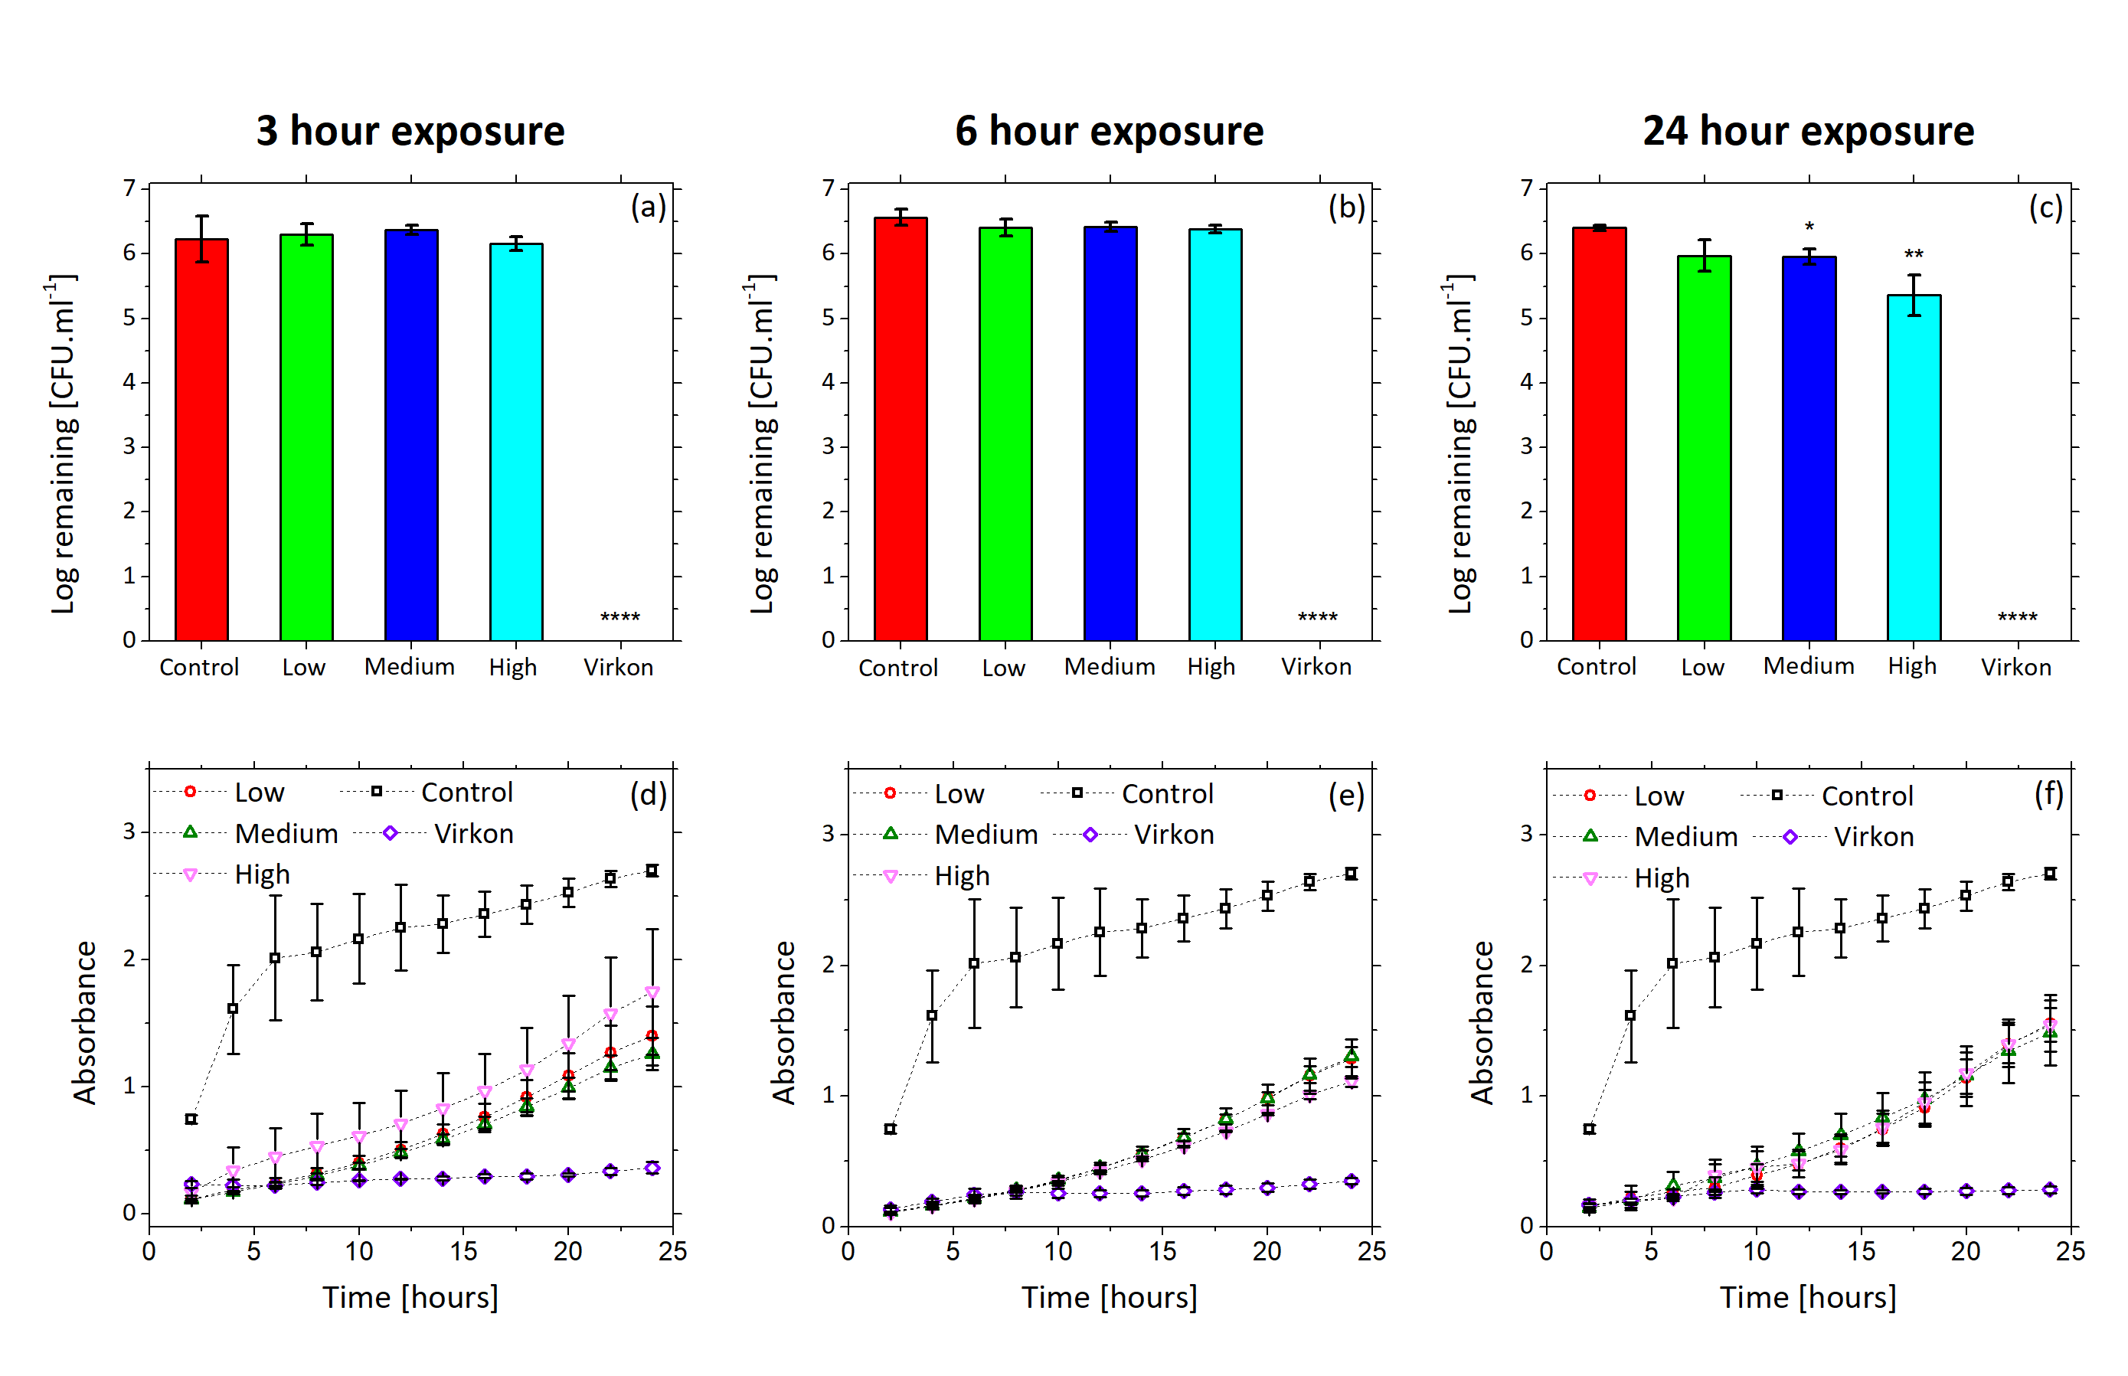
Figure 6.
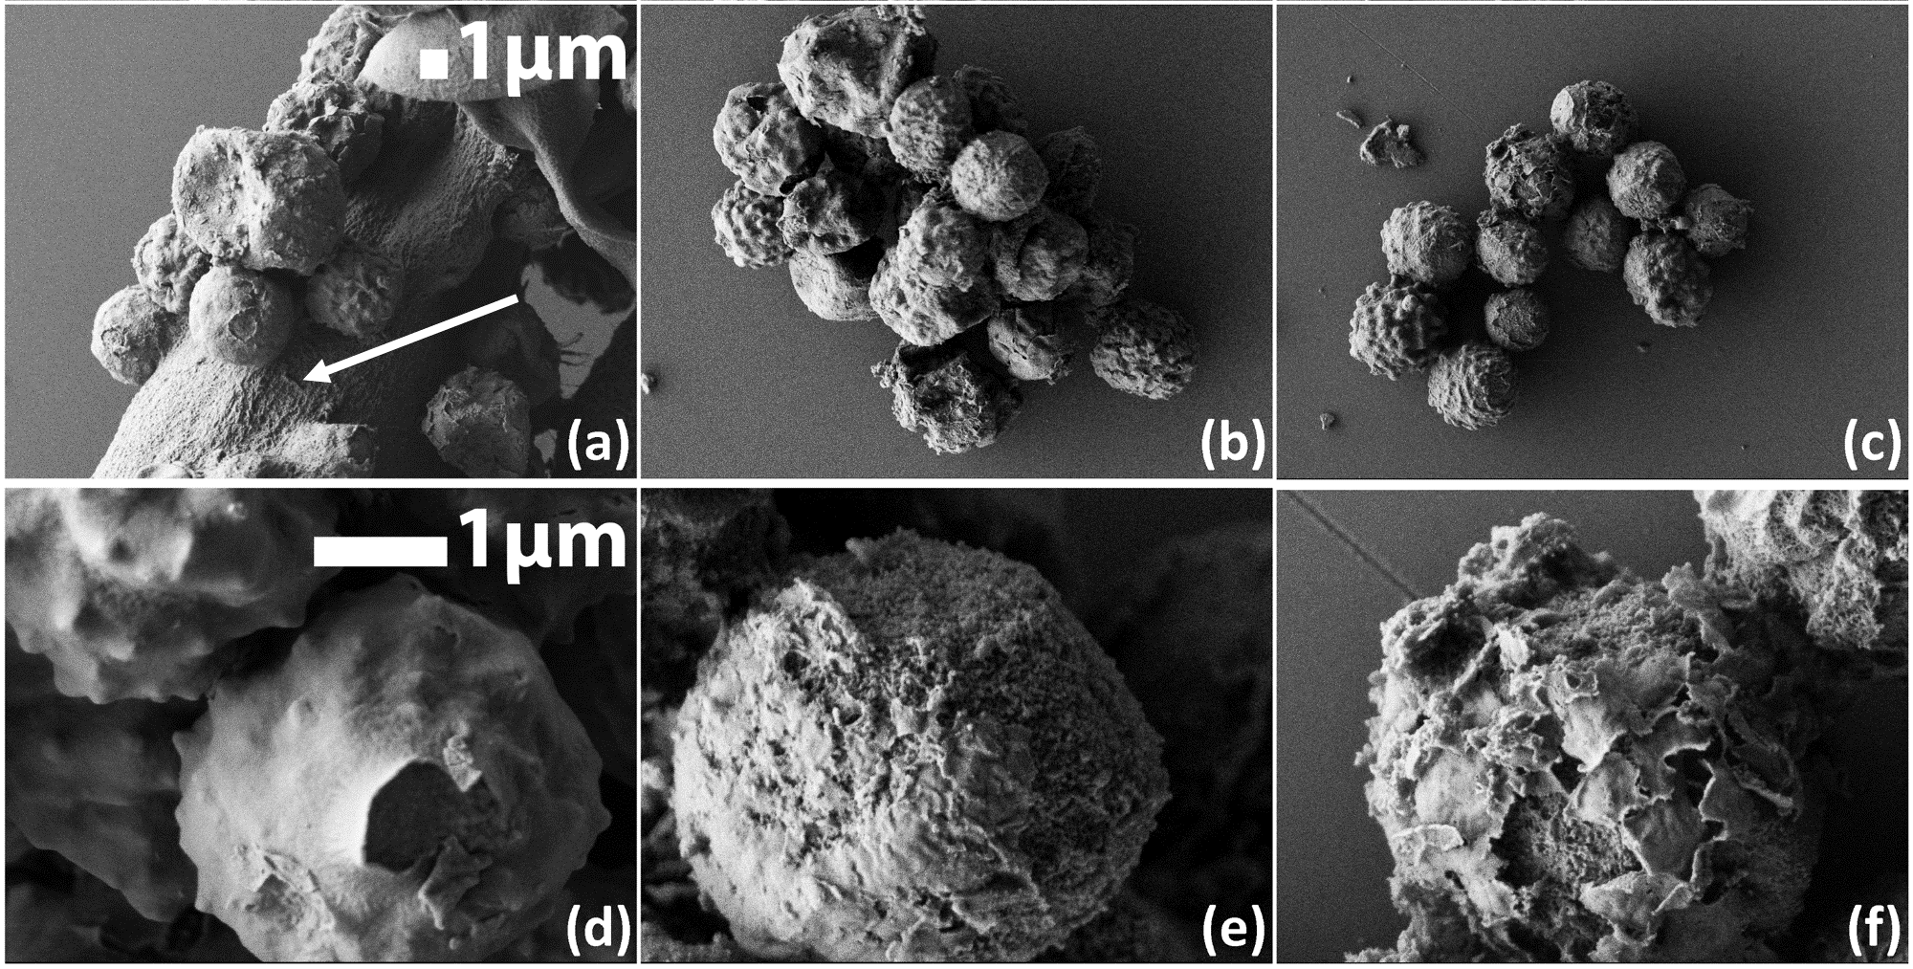
Figure 7.

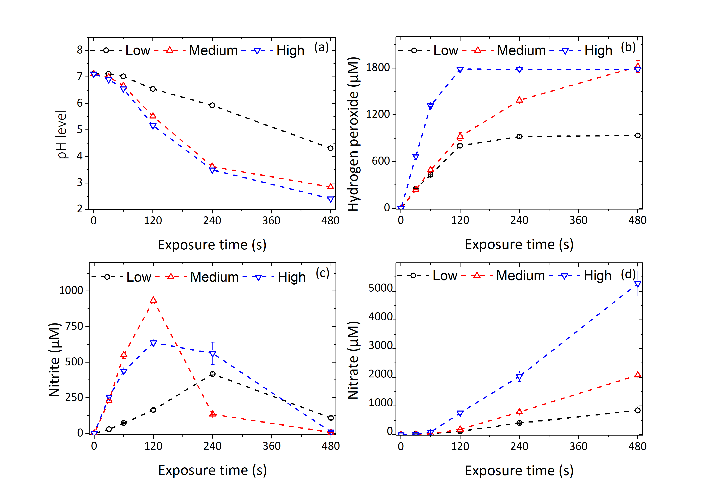
Figure 8.
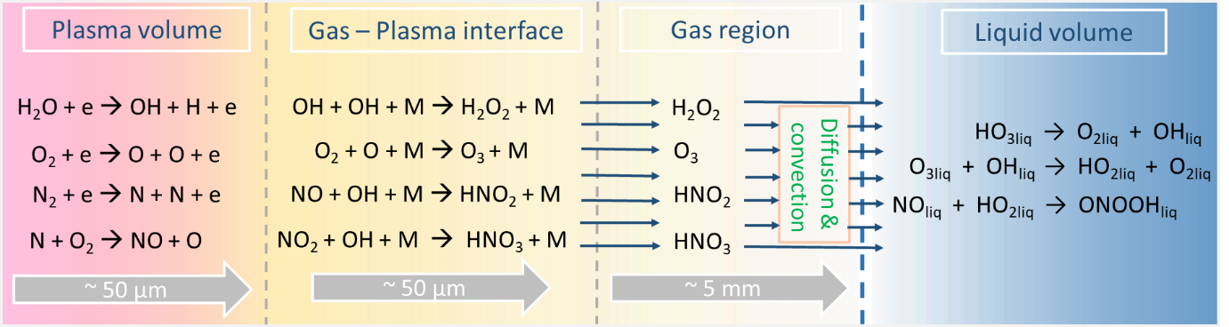
Figure 9.

SUPPORTING INFORMATION
Table S1. Comparison of nitrite and nitrate content between plasma activated deionized water (PAW) and plasma activated broth solution (PAB), using test strips.
Figure S1. CAP effluent treatment of A. flavus spores spread on agar plates: (a), (b) and (c) log numbers of new grown spore units after low, medium and high power plasma treatment. A one way ANOVA was performed between treated samples and control samples (0 s). P values – 0,0332 (*); 0,0021 (**); 0,0002 (***); <0,0001 (****).
Figure S2. Liquid phase chemistry of PAB, obtained after the plasma treatment of 0.5 ml of broth solution; (a) pH values of PAB; (b) concentration of hydrogen peroxide; (c) concentration of nitrite; (d) concentration of nitrate.
Figure S3. Liquid phase chemistry of PAB, obtained after the plasma treatment of 1.5 ml of broth solution; (a) pH values of PAB; (b) concentration of hydrogen peroxide; (c) concentration of nitrite; (d) concentration of nitrate.

Table S1.
Concentration (mg/L)
Low power |  | Medium power |  | High power
PAW | PAB | PAW | PAB | PAW | PAB
10 | 10 | 10 | 10 | 0 | 0
10 | 10 | 10 | 10 | 10 | 10
10 | 10 | 10 | 10 | 25 | 25
25 | 25 | 25 | 25 | 50 | 50
25 | 25 | 100 | 100 | 100 | 100
50 | 50 | 250 | 250 | 250 | 250

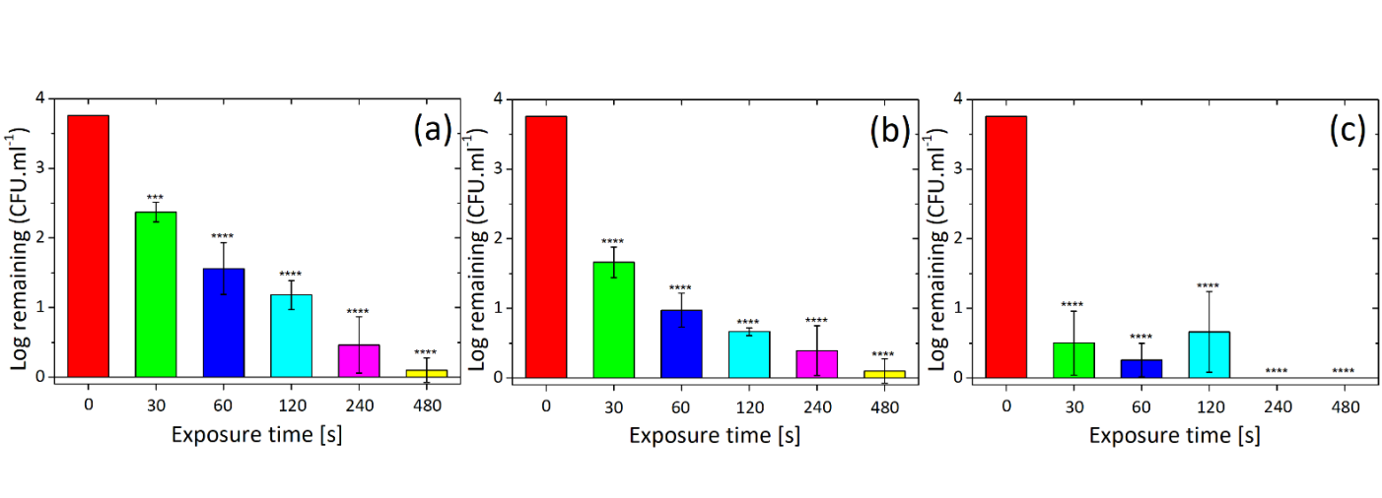
Figure S1.
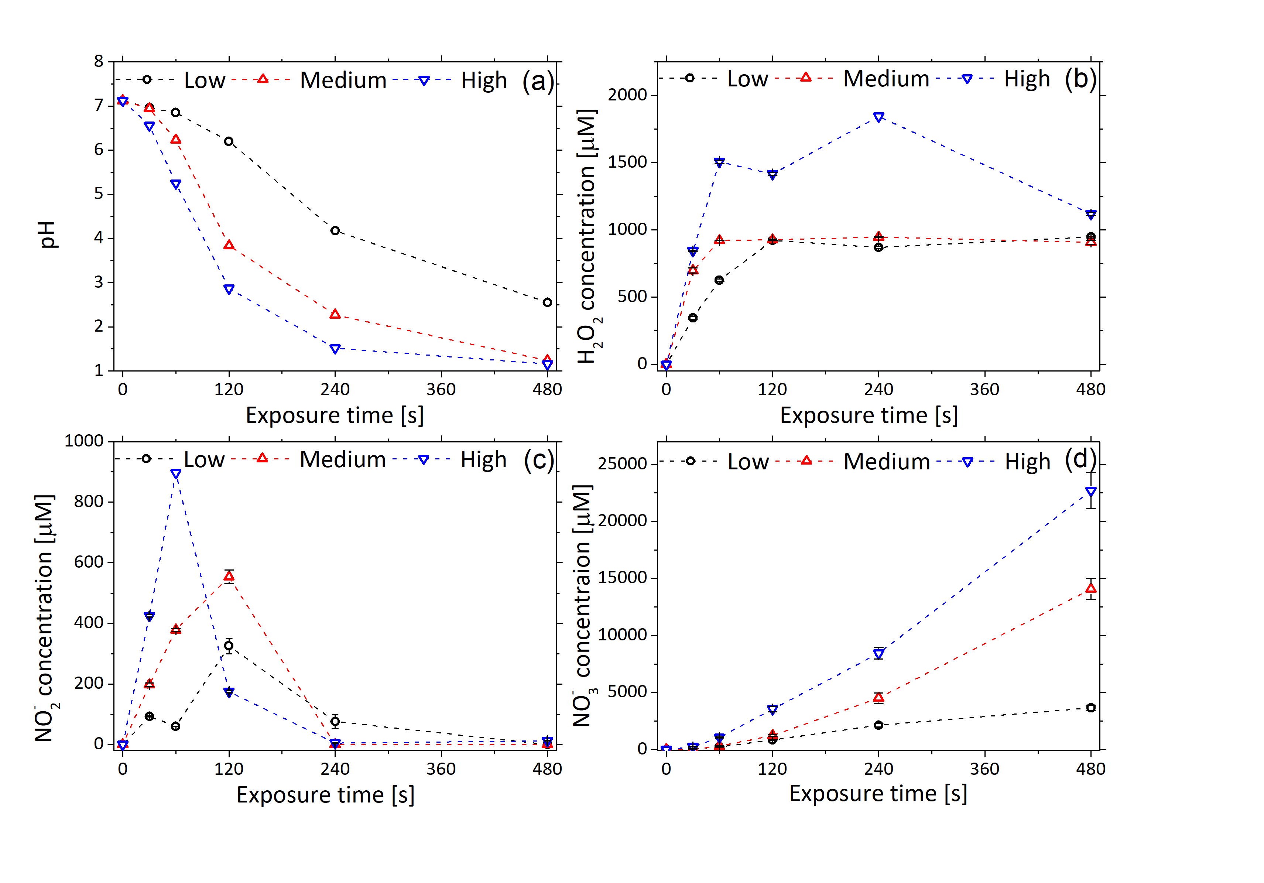Figure S2.

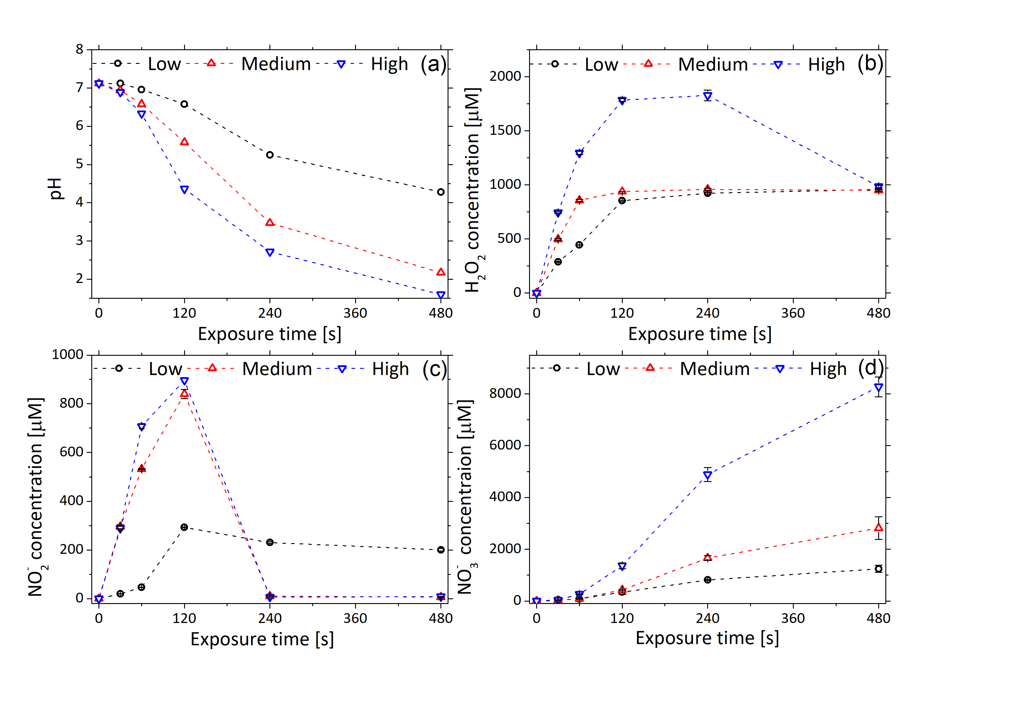
Figure S3.

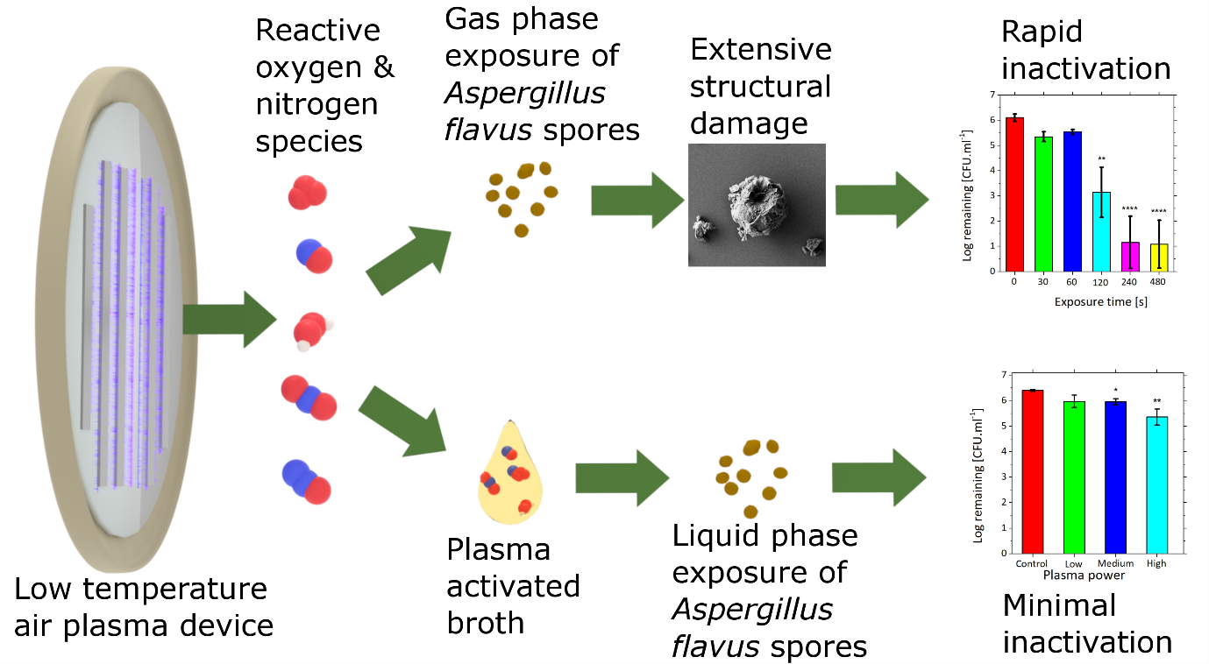
TOC

