Introducing forensic entomology in cases of suspect animal neglect
John McGarry¹, Emily Ratsep², Lorenzo Ressel¹, Gail Leeming¹, Emanuele Ricci¹, Ranieri Verin¹ Richard Blundell¹, Anja Kipar^{1,3} Udo Hetzel^{1,3}, James Yeates⁴
Corresponding author: Dr John McGarry, Institute of Veterinary Science, University of Liverpool, United Kingdom, L3 5RP. Telephone 0151 794 1518. J.W.Mcgarry@liverpool.ac.uk

Author affiliations:
- Institute of Veterinary Science, University of Liverpool, United Kingdom, L3 5RP
- Department of Pathobiology rm-1149, Ontario Veterinary College, University of Guelph, Guelph, Ontario, Canada N1G 2W1
- Authors current address: Institute of Veterinary Pathology, University of Zurich, Vetsuisse Faculty, Winterthurerstrasse 268, 8057 Zürich, Switzerland
- Royal Society of the Prevention of Cruelty to Animals. Redhill, Sussex, United Kingdom, RH13 9RS

Abstract

Cases of arthropod-infested, abandoned or abused animals are sometimes brought to the attention veterinarians by animal welfare authorities, with the requirement for a full post mortem examination towards criminal or civil proceedings. In these situations entomology is an important support tool for the pathologists’ investigation, since the presence of arthropod life cycle stages serve as reliable forensic markers, especially for blowflies which form the first waves of activity following death. In the present study, seventy cadavers from a total of 544 referred to the Institute of Veterinary Science, University of Liverpool, between 2009-2014 displayed evidence of infestation. Here, we introduce principles of applied entomology and simplified approaches for estimating the minimum time since death, relevant in the context of routine submissions and the broad remit of individual cases. Despite often limited availability of scene of the crime and local thermal data, the interpretation of the minimum post mortem interval has nonetheless proved valuable as an adjunct to the expert pathology report. However, future developments and enhanced accuracy in this area of animal welfare requires resource and training in expertise, and agreed standardisation of both laboratory and field procedures.
Key words: Forensic entomology, pathology, animals, neglect, post mortem interval

Introduction

Arthropods colonise animal cadavers in predictable waves, starting with familiar metallic coloured blowflies in the family Calliphoridae, followed by the flesh flies (Sarcophagidae) and certain members of other dipteran families, mainly the Muscidae, Fannidae, Sepsidae, Phoridae Sphaeroceridae and Stratiomyidae. As the body decomposes further and dries out, beetles, mites, moths and other groups comprise the typical arthropod community (Mégnin 1894, Goff 1993, Anderson 2001, Gennard 2008). For the forensic entomologist, identification of these invading arthropods is extremely important, as the types and stages present at any one point are equivalent to the hands of a biological clock, indicating over hours, days, weeks, months or even years, the timeline since death.
Providing they can gain access, it is the members of the pioneering blowflies which are very first to the scene - indeed these species can detect odour emissions from the very early stages of animal death (Cragg 1955, Anderson 2001) to feed on the body secretions and to oviposit, often around the natural body orifices. Eggs then hatch to first stage larvae which feed, grow and moult twice to the final the third stage. When fully mature, ‘maggots’, as they are colloquially known, enter the post-feeding or ‘wandering’ phase in order to seek out a dry substrate for pupariation, which may actually be located some distance away from the cadaver itself (Green 1951). The life cycle stages of the urban blue bottle Calliphora vicina (Robineau-Desvoidy, 1830) are shown Fig1. The duration of each period - egg, larval stage and puparia - is different for different species (Greenberg and Kunich 2005) and, under optimal conditions, rates of development follow species-specific trajectories which are strongly dependent on the ambient temperature (Greenberg 1991, Wall and others 1992, Donovon and others 2006).

Figure 1. Life cycle stages of Calliphora vicina. (a) Adult female, approx. 1cm (b) Eggs, approx. 1mm (c) Second (4-7mm), third stage (7-18mm) larvae and (d) a puparium

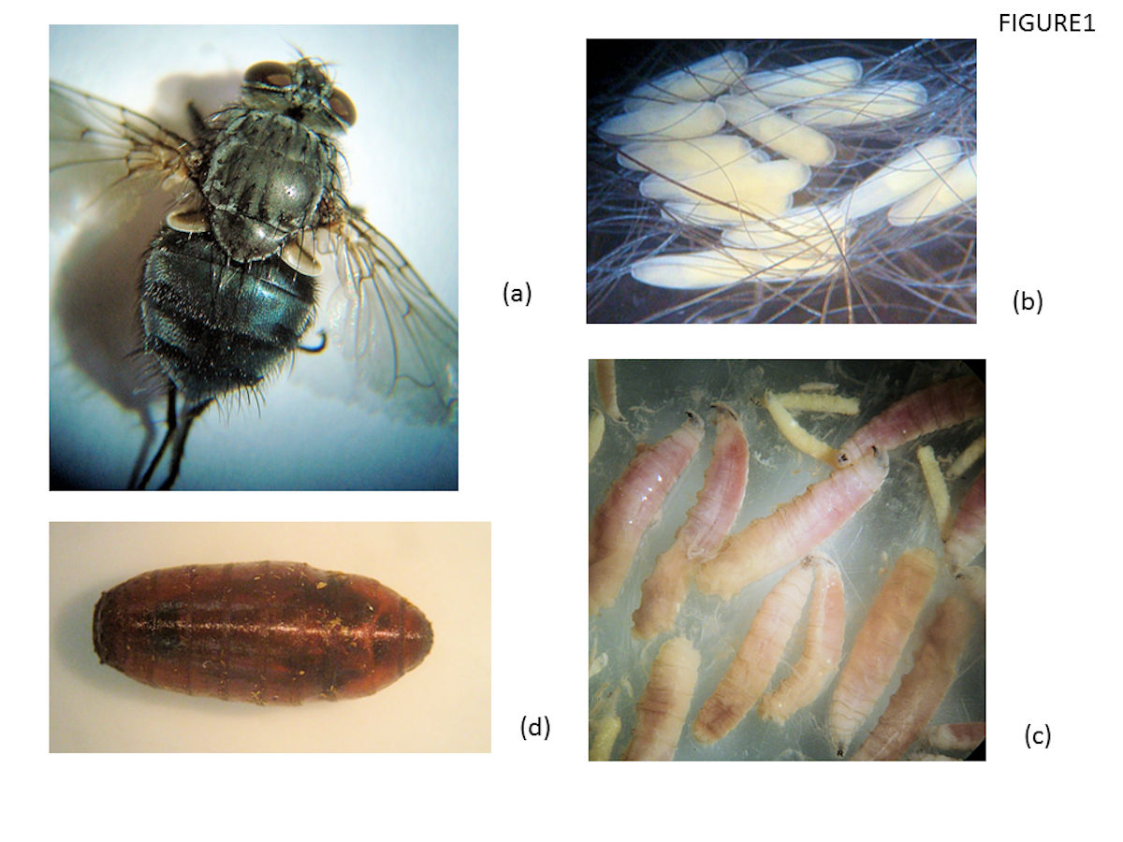

Various forensically important blowfly species are found worldwide, each having a concise geographical distribution, characteristic seasonal patterns of activity and host-seeking behaviour. In the UK, for example, the green bottle Lucilia sericata (Meigen) is an outdoors (exophilic) summer species abundant in both rural and urban areas, and is most active on warm days between May-September (Wall and others 1992, Greenberg and Kunich 2005). This fly readily colonises dead animals but, as veterinarians are well aware, under certain conditions it is attracted to skin in a poor or soiled condition, and can then causes the highly pathogenic condition known as primary facultative cutaneous myiasis. In contrast, Calliphora spp. are cold weather-adapted (Faucherre and others 1999, Greenberg 1971, Greenberg 1973) and may be active all year around. The life cycle of Calliphora vicina is readily completed on dead animals both inside the home and outdoors, but principally in urban areas. This contrasts with a closely related species, Calliphora vomitoria (Linnaeus, 1758) which predominates in rural regions (Smith 1989, Greenberg and Kunich, 2005). The distribution, biology and development of the many forensically important blowflies has been studied on most continents [Zumpt 1965, Smith 1986, Greenberg and Kunich, 2005, Martins 2013) and for the UK species, descriptions and biology are available in classical publications (Erzinḉlioglu 1985, Erzinḉlioglu 1987, Smith, 1986).
The veterinary pathologist is often required by animal welfare officials to estimate the minimum period of time elapsed since death - the post-mortem interval (PMI_{min}), and this has been necessary in recent years for an unfortunately large and increasing throughput of submissions seen at the Institute of Veterinary Science in Liverpool. Here we introduce forensic entomology to Veterinary practioners and welfare officials, outlining the basic concepts for identification of blowflies and other common arthropods of forensic importance in northern England, and listing examples of entomological fauna collected from domestic pets in northern England between 2009 and 2014. We describe simplified approaches for estimating PMI_{min,} by applying an accumulated degree day model, laboratory growth rates or observations on arthropod succession which have supported the pathologists expert opinion in successful owner prosecution cases.

Materials and methods

Animal necropsies
A total of 544 carcases mainly recovered from mainly urban settings in northern England were submitted by the Royal Society for the Prevention of Cruelty to Animals (RSPCA) to the Division of Pathology, Institute of Veterinary Science, University of Liverpool, for a full forensic post mortem examination between 2009 and 2014. Of these, 70 cases carried entomological evidence, and recovered arthropods were processed and identified as below.
Processing fly larvae for identification
During the gross post mortem examination, all body sites and orifices of cadavers were thoroughly examined for arthropods. The largest (and therefore oldest) examples of third stage dipteran larvae were processed for identification by relaxation in water at 80°C so that specimens extended to their full length, and were then stored in 70% ethanol. Subsequently, the cephalopharyngeal skeletons as well as the anterior and posterior spiracles were sliced off using a scalpel blade and cleared for 5 min with a drop of 5% potassium hydroxide on a microscope slide, prior to rehydration and serial dehydration in ethanol. These sections were transferred to xylene and mounted on a glass slide for examination at low (x40) and high (x400) power of a compound microscope. These morphological features and other species-specific criteria were used to identify larval diptera (Erzinḉlioglu 1985, Smith 1986, Erzinḉlioglu 1987, Velasquez and others 2010). When possible, species identification was confirmed by comparison with archived type specimens (W.N. Beesley collection, Liverpool University and (more rarely) by examining adults reared in the laboratory from field-recovered larvae. Fig 2 shows the mouthpart detail, the posterior end and spiracle preparations from a third stage larva of Calliphora vicina.
Figure 2. Some morphological features of third stage larvae of Calliphora vicina
- The mouth hooks and position of the accessory oral sclerite, aos. (b) posterior end; Ps denotes the two posterior spiracles (c) detail of a posterior spiracles, showing the three slits, the peritreme (p) and the enclosed button (bu)

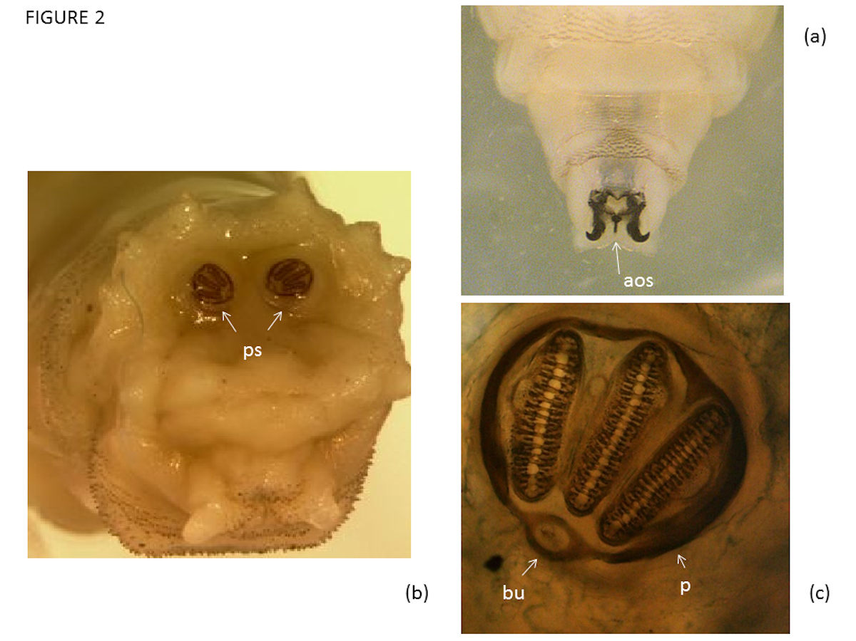

The life cycle stages of other arthropods were identified as far as possible using the keys and descriptions of Smith (1986, 1989) and Gennard (2008). Occasionally specimens were identified by area specialists, as in the case of the Phoridae and certain Muscidae (Dr Henry Disney, University of Cambridge, UK) or in consultation with the British Museum (Natural History).
Estimation of PMI_{min}

Important sources of information on growth rates of blowflies of forensic importance in the UK are shown in Table 1. For blowflies, PMI_{min} estimates were carried out only when the insect stage could be identified, and progressed subject to availability of growth data for the species in question; the accuracy and interpretation of the PMI_{min} carried caveats which included assurances of appropriate cadaver storage (animals were usually frozen immediately on discovery if post mortem was delayed, or chilled and delivered for necropsy same day) so that no further insect development had occurred prior to necropsy. Other criteria influencing methodology and interpretation of the PMI_{min} were environmental: ease of access of flies to the cadaver and reliability of thermal data. Effects of fluctuating and low temperature episodes on development and the possibility larval diapauses are considered in the discussion section.

Calculation of accumulated degree days (ADD)
Calculations of ADD were used whenever possible for blowflies found on cadavers outdoors and exposed to fluctuating temperatures, for example cadavers found in gardens. The method assumes that immature calliphorid growth does not occur below a certain specific threshold, i.e. the base temperature specific for onset of development of that species. There is also an upper limit above which the rate of growth slows down but between the two values the growth rate is more or less linear with temperature. Once the larval specimens have been identified and accurately measured, the ‘theoretical period’ required for growth to reach this stage is determined from published laboratory data for the species in question (Table 1). The ADD are a summed product of time and temperature, calculated as follows: Local meteorological data is acquired retrospectively for each day, several weeks or months since the body was found. The means of the daily minimum and maximum temperatures are calculated, having first subtracted the insect’s base temperature for development from these daily values. These daily means are summed until the theoretical ADD (available form laboratory insect rearing data) is reached. The number of days taken to reach this value is the estimate the PMI_{min} . In the present study, temperature data were collated from the meteorological station nearest to where the cadavers were found, assisted by the Meteorological Office, Exeter, Devon, United Kingdom.

Direct use of insect growth charts
This approach was deemed most appropriate when the body has been discovered indoors and when environmental temperatures were thought not to have fluctuated significantly during the period under scrutiny: values were read directly from published growth data in the form of charts and diagrams (Table 1). Thus, the time taken to reach an observed larval size (length) of a particular species or its puparial stage was determined from data for that species obtained under a range of controlled laboratory temperatures. Using field samples, the full extended length of the largest (assumed oldest) larvae present is first measured and the time since egg hatch can be read directly from a graph (known as an isomegalen), which plots progressive larval size (L₁, L₂, L₃) against time, at a range of constant temperatures. Similarly, isomorphen diagrams are available for some species to assess the time required for the post-feeding larvae (ie. late stage larvae which have voided the gut and left the cadavers) or puparial stage to reach that morphological time point.
PMI_{min} estimates from observations on sequential colonisation
Cadavers were investigated for entomological fauna consistent with the classical arthropod succession, and known to be associated with various stages of decay. The following summarised sequential time markers (Smith 1986) were used: blowflies in the genera Calliphora and Lucilia comprise the first wave of activity and are associated with the fresh stage and early autoloysis; the later second and third wave may also be formed from these species but might include the fleshflies (Sarcophaga spp.), the latter being attracted to putrefaction and bacterial activity within the first 3 months. As bloat occurs and fats are rancid, beetles in the family Dermestidae and the fruit flies Drosophila spp. may be in evidence; as subsequent fermentation proceeds, some 3-6 months after death, larvae of Fannia cannicularis (Linnaeus, 1761) and F. scalaris (Fabricus, 1794) may be in evidence or those in the family muscidae, such as Hydrotaea dentipes (Fabricus, 1805) which occur between 4-8 months following death. Saprophagous flies in the family Phoridae may be present in this 5th wave of cadaver-visiting arthropods and, as further desiccation occurs, predatory and forage mites and insects of stored food products colonise the cadaver, after some 12 months to 3 years. During this late time frame, beetles e.g Attegenus spp. and moths e.g Tineola spp. can be found. In some situations bodies buried under soil and rubbish attract coffin flies (e.g. Megaselia spp).
Figure 3. Examples of arthropods colonising cadavers, and approximate size
- Dermestes lardarius, 5mm; from case 8, Table 2 (b) a larval dermestid beetle, 5mm. From case 6, table 2 (c) a staphylinid beetle, 10mm (d) Larvae of Sarcophaga 1.6cm; from case 1, table 2 (e) L₃ of Fannia canicularis, 6mm; from case 6, table 2 (f) L₃ of Hydrotaea dentipes, 8mm; from case 8 table 3 (g) Megaselia adult fly, 6mm from case 8, table 4 (h) phorid pupa, 6mm
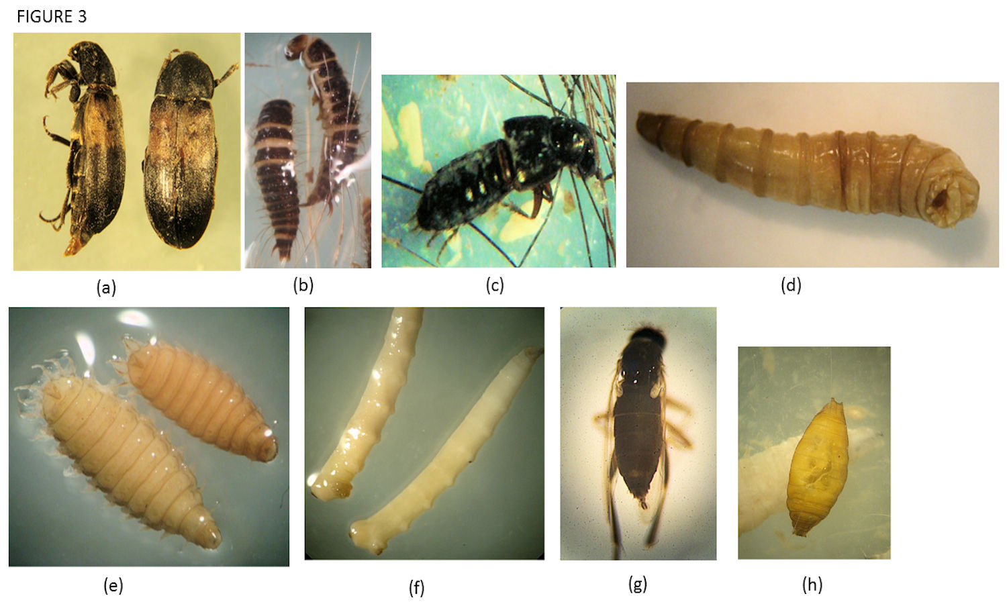
Case studies
Case study 1 represents a domestic male rabbit (submission 2, table 3, supplementary file ) that had been found dead with two others in an exposed hutch in the garden on 28th November 2011, and delivered the same day for post mortem; it was kept at 0°C for two days, after which a full post mortem examination was performed. Abandonment was suspected and for this investigation, a PMI_{min} could be calculated using available ADD data.
Case study 2 was a domestic short hair cat (submission 5, table 4, supplementary file ) that had been one of three animals (2 cats, one dog) thought to have been left unattended and found dead in the same room in a house on 7th June 2010. The cat was subject to a full post mortem examination on the same day and a PMI_{min} was estimated from constant temperature growth charts.
Case study 3 represents decomposed carcase of a tan, Staffordshire bull terrier type dog (submission 6, table 2, supplementary file). It had been found dead in a back yard with another dog. Abandonment was suspected and in this case observations on arthropod species composition contributed to the estimation of PMI_{min}.
Results
3.1 Entomological findings in submissions
The 70 small animal cases with arthropod infestation included dogs, cats, rabbits, ferrets and chickens. Calliphora vicina or Lucilia sericata as single species infestations were recorded on 27 and 9 cadavers respectively (38.5%; 13.8%). Infestation of the same cadaver by both these blowflies species was recorded in 5 cases (7%); evidence of calliphorid fly eggs with no other arthropods present was also seen in 5 cases (7%). In many situations all life cycle stages were recovered - eggs, first, second, third stage larvae, occasionally puparia; in some cases brown/black and degenerated larvae were recorded (submissions 5&13, Table 2, supplementary file). 24 cases (34%) showed evidence of multiple arthropod species colonisation and included a range of combinations of Sarcophaga spp , Fannia spp., Hydrotaea spp., Sepsidae, Phoridae, Sphaeceridae, Stratiomyidae and dermestid beetles. Protophormia terraenovae (Robineau-Desvoidy, 1830), Cynomyia mortuorum (Linaeus, 1761), macrochelid predatory mites and moth larvae were other arthropods noted. Fig 3 shows examples of common arthropods identified in cases of sequential colonisation. Of the total submissions, 33 cases are summarised in Tables 2-4 (supplementary files) which illustrate the typical fauna and circumstances/location of discovery.

Field application of the ADD model - Case study 1
The rabbit carcass was in poor condition and the claws were long, suggesting a poor care condition. There was a severe general reduction in skeletal muscle and bony prominences were palpable due to muscle atrophy. On external examination the eyes were missing and numerous maggots were present in the eye sockets. The skin of the face was matted and wet with no grossly detectable subcutaneous adipose tissue. Fly larvae were present in the skin and subcutis as well as the pharynx and the skin over the face and perineal area and were also found scattered throughout the body. Fifty representative samples of larvae from different body regions were identified as third stage larvae of Calliphora vicina, the largest of which measured 13mm after processing. Calculation of ADD (and from it the PMI_{min} ) is explained in 2.3.1. It takes 75 ADD for larvae to reach this observed size under controlled laboratory conditions (Donovon and others 2006). The means of the maximum and minimum daily temperatures for two weeks (from 28th to 14th Nov) prior to discovery of the carcass were obtained from the nearest meteorological station (Manchester airport) some 6K distance from the scene. Mean daily temperatures for the period under scrutiny were, respectively, 8°C (14thNov ) 9°C , 10°C, 8°C, 11°C, 10°C, 7°C, 9°C, 9°C, 7°C, 10°C, 8°C, 9°C, 9°C, 8°C (28th Nov). For this species, when a threshold of development of 3.5°C (Davies and Ratcliff 1994) is applied (i.e. subtracted from each of the above values) and those values then summed, a range of 75-79.5 ADD is reached in 14-15 days; it was concluded therefore that the rabbit died in the hutch between the 14thand 15thNovember.

Field application of data from laboratory growth charts and tables - Case study 2
The cat carcass exhibited marked post mortem changes including desiccation. The body demonstrated reduced muscle bulk and adipose tissue was inconspicuous. The skin was absent in many areas and the head was detached at the level of the last cervical vertebrae. The visceral organs were severely decomposed, demonstrating both desiccation and discoloration. On examination five late third stage calliphorid larvae were found scattered within the body cavities. The crops of which showed evidence of some feeding but the specimens were black and decomposed. There were also seven early second instar larvae present and several puparia were recovered from the dry parts of the cadaver, some of which had hatched.
In this case, the empty C. vicina puparia were the oldest forensic marker and evidence that an entire life cycle had been completed during the period of investigation.
Enquires by RSPCA officials showed that the room had been heated and maintained between 20 and 22°C for an undetermined but period of time while the house was unoccupied and unattended. The PMI_{min} was therefore derived directly from growth data according to Greenberg and Kunich (2002) in that the time required for eggs of C. vicina to develop to emerged adults is approximately 44.5, 22.8 or 19.4 days at constant mean temperatures of 12.5°C, 19°C and at 22°C respectively. Based on the expected room temperature, the PMI_{min} for this investigation was set at between 19-23 days.

Observations on sequential colonisation by arthropods - Case study 3
The dog carcase was covered by haired skin over the dorsal aspect; skin on the ventral aspect was absent. The skin was dry, inflexible and hard. The soft tissues of the internal organs, eyes, gingiva, mucous membranes etc. were largely absent, with only strands of dark brown to black hard material remaining. The skeleton appeared intact, although soft tissues of the joints were largely absent and the bones could be separated quite easily. Insects recovered at necropsy included three empty pupal cases and L₃ larvae of the latrine fly Fannia cannicularis (Fig 3e) and examples of larval Dermestes lardarius (Fig 3b), the larder beetle, together with several shed larval cuticles. The distinctive arthropod fauna present are associated the 3rd and 4th wave of insect activity, it was possible to estimate a PMI_{min} of 3-6 months
Discussion
Arthropod-infested animal carcases form part of the case material submitted to veterinary pathologist by animal welfare authorities for a full post mortem examination. An entomological examination is a relevant part of the work-up, in particular for those cases where animals are found dead and suspected to have been abandoned prior to death, and where the time of death is crucial for any potential prosecution. These outcomes are sometimes used to challenge the owner’s claim that the animals had been left for a short period only and in healthy circumstances with adequate nutrition.
The three field situations emphasise the need to gather, identify and analyse all entomological evidence, both at the ‘scene of the crime’ and in the post mortem room. For example, had the empty puparia in case 2, been missed, the PMI_{min} would have been underestimated, and wrongly based on analysis of the larval stages only: searching for puparia and emerged adults is therefore very important otherwise a complete first wave blowfly life cycle may be missed. That said, there may be problems recovering such evidence, not least in, say, garden soil, and the post feeding stages of both L. sericata and C. vicina are very mobile, capable of migrating many meters away from a cadaver (Green, 1951, Cragg, 1955). Besides the collection of insect evidence, other records at the scene should include an evaluation of ease of access by insects (open windows for example) since, after ambient temperature, this is the second most important variable affecting decomposition (Mann and others 1990). The indoor or outdoor positioning of the cadaver, if the animal was buried or water logged, and thermal recordings at the scene are other important records relevant to a case.
The first case involving rabbit cadavers outdoors utilised established ADD information as a means for assessing the PMI_{min}; this approach is, in general, likely deemed more accurate compared to direct interpretation of laboratory growth rates, and would be most applicable for cases involving blowflies (Gennard 2008). But important biological limitations restrict the interpretation of real life situations, reviewed by Donovan and others (2006) and by Greenberg and Kunich (2005), as unknown variables exist. One of these is that threshold temperatures of development for Calliphora vicina are not identical, and much appears to depend upon geographical location. For example, Davies and Radcliffe (1994) demonstrated a threshold of 3.5°C in northern England but Donovan and others (2006) found larvae of the same species, but originating from London, could develop at 1°C. Therefore in Case 1, a significantly shorter PMI_{min} would be obtained had the baseline of 1°C been used in the calculation, rather than 3.5°C; using 1°C as a threshold would mean the rabbit died around the 19th November, a difference of approx. 4 days, and indicating that the animal had been dead for 10-11 days. Interestingly, this latter period correlates with the findings of Reiter (1984) had the mean temperature over the entire period of scrutiny (8.8°C), been used to estimate the PMI _{min}. Issues of threshold temperatures apart, the effects of field temperature fluctuations on larval blowfly growth appear ambiguous; Davies and Ratcliffe (1994) showed an acceleration of larval growth occurred in the laboratory for Lucilia sericata and Protophormia terraenovae when reared over a range of alternating temperatures compared to constant temperatures, but this was not the case for Calliphora vicina, for which growth was slowed down. Another consideration lies in the fact that local meteorological data may not represent the true temperatures experienced by the growing stages on the body, an anomaly addressed in homicide investigations by taking temperatures at the scene for 3-5 days after discovery of a body, and using regression analysis to adjust the meteorological data to reflect conditions at the crime scene (Gennard 2008). Other finite analysis for homicide cases but not possible for the present work, includes practices such as taking measurements of the metabolic heat generated by the larval mass, which itself may affect growth rates. Criteria which affect diptera PMI_{min} estimates are reviewed by Campobasso and others (2001) and Greenberg and Kunich (2005)
Further difficulties in PMI _{min} arise when animals are discovered in winter or during cold spells at other times of the year, since around the base lines for larval development, growth can be subject to cycles of arrest and reactivation (Ames and Turner 2003). This may have affected larval viability, evident in the present work, because larvae occasionally presented as flattened, dead brown or even black specimens on fresh cadavers. But the causes of larval death are speculative and could perhaps be a result of the effects of direct sunlight, heavy rain and drowning, the onset of anaerobic conditions and other density-dependent effects such as overcrowding. Whatever the cause, time to death estimates will be underestimated where larvae have clearly experienced retarded development or have died in situ on the cadaver, as was shown in a case where larvae of Lucila sericata (flies active in warm weather) were discovered on a dog cadaver in January (submission 13, table 2). Variable temperatures are a forensic reality which affect PMI_{min} estimates and their effects on insect growth rates require further study.
Almost all cases reported here involved dead animals, and the most common blowflies were C. vicina and L. sericata, the latter a serious pest throughout the UK in sheep rearing areas (Bisdorff and others 2015). We have demonstrated L. sericata to be a common species in urban areas in northern England. We also investigated a case of advanced primary myiasis due to this fly, represented by a moribund, subsequently euthanized dog, brought into a veterinary surgery in May (dog 14, Table 2). This raises the question of how important myiasis is as the cause of death in all neglected animals, and indeed the relative roles of L. sericata as a primary myiasis species and C. vicina as a secondary fly capable of developing in necrotic tissue. Little work has been done in this area, but a survey of pet animal myiasis in Canada where dogs were the most common pets presenting with myiasis, showed that L. sericata was the primary causative agent in urban settings and usually, but not exclusively, infested animals kept outside (Anderson and Huitson 2004).

In summary, cases of arthropod-infested neglected and dead animals are sometimes brought to the attention of animal welfare authorities and veterinary pathology laboratories. The veterinary forensic entomologist is then faced with several challenges which include identifying the species and determining the most advanced stages of development, accessing the thermal history and gaining an accurate understanding of circumstances at the scene of the crime. Using field cases, we describe situations where infesting species were successfully identified and age-graded. For estimates for the PMI_{min} , a choice of whether to use accumulated mean degree day analysis or to compare growth rates at constant temperatures, or a combination of the two, is dictated by many of the circumstantial factors, bearing in mind the degree of accuracy which is possible or most appropriate. While it would be highly desirable - as for human cases - to invest time in sourcing optimal local thermal data and to analyse events using accumulated degree hours (rather than ADD and growth charts used here), at the present time expertise and resource is lacking for the increasing numbers of cases of suspect animal neglect. Limitations also exist when interpreting the general assumptions for colonisation data. However, we have applied the methods described here in successful legal prosecutions, alongside gross pathology observations.
The present article aims to promote skills in applied forensic entomology for veterinary practioners, to the advancement of companion animal welfare. Towards this aim, although it is helpful for an investigator to understand that The Fly can indeed ‘see’ him die, for the discipline to progress, priorities must include the provision of training for veterinary staff, technicians and animal welfare field officers and standardised laboratory and field procedures.

Acknowledgements
We wish to thank the officers of the Royal Society for the Prevention of Cruelty to Animals for submitting the cases.

References

ANDERSON, G. (2001) Insect succession on carrion and its relationship to determining time of death. In Forensic entomology: The utility of arthropods in Legal Investigations. Ed J.H. Byrd and J.L Castner. CRC Press, Boca Raton, pp 143-177.

ANDERSON, G.S., HUITSON, N.R. (2004) Myiasis in pet animals in British Columbia: the potential for forensic entomology for determining duration of possible neglect. Canadian Veterinary Journal 45, 993-998.

AMES C. & TURNER, B. (2003) Low temperature episodes in the development of blowflies: implications for post mortem interval estimation. Medical and Veterinary Entomology. 17, 178-186.

BISDORFF, B., MILNES, A. & WALL, R (2015) Prevalence and regional distribution of scab, lice and blowfly strike in Great Britain. Veterinary Record 158, 749-752

CAMPOBASSO, C, P., DI VELLA, G. & INTRONA, F. (2001) Factors affecting decomposition and Diptera colonisation. Forensic Science International 120, 18-27.

CLARK, K., EVANS, L. & WALL, R (2006) Growth rates of the blowfly Lucilia sericata on different body tissues. Forensic Science International 156 (2-3), 145-149.

CRAGG, J.B. (1955) The olfactory behaviour of Lucilia species (Diptera) under natural conditions. Annals of Applied Biology 44, 467-477.

DAVIES, L. & RADCLIFFE, G.G (1994) Development rates of some pre-adult stages in blowflies with reference to low temperatures. Medical and Veterinary entomology 8, 245-254

DONOVON, S.E., HALL, M.J.R., TURNER, B.D. & MONCRIEFF,C.B. (2006) Larval development rates for a forensically important fly Calliphora vicina (Diptera, Calliphoridae) over a range of temperatures. Medical and Veterinary Entomology. 20,106-114

ERZINḉLIOGLU, Y.Z. (1985) Immature stages of British Calliphora and Cynomya with a re-evaluation of the taxonomic characters of the larval Calliphoridae (Diptera) Journal of Natural History 19, 69-96
ERZINḉLIOGLU, Y.Z. (1987) The larvae of some blowflies of Medical and Veterinary importance. Medical and Veterinary Entomology 1, 121-125
FAUCHERRE, J., CHERIX, D. & WYSS, C. (1999) Behaviour of Calliphora vicina (Diptera:Calliphoridae) under extreme conditions. Journal of Insect Behaviour 12, 687-690

GENNARD, D.E. (2008) Forensic entomology. An introduction. Wiley and Sons Press, Chichester UK

GOFF, M.L (1993) Estimation of post mortem interval using arthropod development and successional patterns. Forensic Science Review 5(2), 81-94

GRASSENBERG, M. & REITER, C. (2001) Effect of temperature on Lucilia sericata (Diptera: Calliphoridae) development with special reference to the isomegalen- and isomorphen-diagram. Forensic science International.120, 32-36

GREEN, A.A. (1951) The control of blowflies infesting slaughter-houses I. Field observations of the habits of blowflies. Annals of Appied Biolology 38, 475-494

GREENBERG, B (1971) Flies and Disease Volume 1. Ecology, classification and biotic associations. Princeton: Princeton University press.

GREENBERG, B (1973) Flies and Disease Volume 2. Biology and Disease Transmission. Princeton: Princeton University press.

GREENBERG, B (1991) Flies as forensic indicators. Journal of Medical Entomology 28, 565-577.

GREENBERG, B. & KUNICH, J.C. (2005) Entomology and the Law. Flies as forensic indicators. Cambridge University Press, UK.

KAMAL, A.S. (1958) Comparative study of thirteen species of sarcosaprophagous Calliphoridae and Sarcophagidae (Diptera) I. Bionomics. Annals of the Entomological Society of America. 51, 261-271

MANN, R.W., BASS, W.M. & MEADOWS, L. (1990) Time since death and decomposition of the human body: variables and observations in case and experimental field studies, Journal of Forensic Science 35, 103-111

MÉGNIN, J.P. (1894) La faune des cadavres. Application de l’entomologie à la médicine légale. Encyclopedie Scientifique des aide-memoire. Paris:G.Masson and Gauthier-Villars.

REITER, C. (1984) Zum Wachstumsverhalten der Maden der blauen Schmeißfliege Calliphora vicina. Zeitschrift fur Rechtsmedizin. 91, 295-308

SMITH, K. (1986) A manual of forensic entomology. British Museum (Natural History). Cornell University Press. http://www.taxonomy.be/gti_course/taxonspecific/Smith_1986.pdf
(accessed November 2017)
SMITH, K. (1989) An introduction to the immature stages of British flies. Diptera, larvae, with notes on eggs, puparia and pupae. Handbooks for the identification of British Insects, 10 (14). Royal Entomological Society of London.

WALL, R., FRENCH, N. & MORGAN, K.L. (1992) Effects of temperature on the development and abundance of the sheep blowfly Lucilia sericata (Diptera: Calliphoridae). Bulletin of Entomological Research, 82, 125-131
VELASQUEZ, Y., MAGANA, C., MARTINEZ-SANCHEZ, A. & ROJO, S. (2010) Diptera of forensic importance in the Iberian Peninsula: larval identification key. Medical and Veterinary Entomology 24, 293–308
ZUMPT. F. (1965) Myiasis in man and Animals in the Old world. A Textbook for physicians, Veterinarians and zoologists. Butterworths, London.
MARTINS, G., DOS SANTOS, W.E. CREÃO-DUARTE, A.J., DA SILVA, L.B.G. & OLIVEIRA, A.A.F. (2013) Estimate of post mortem interval through forensic entomology in a canine (Canis lupus familiaris Linnaeus 1758) in Cabedelo-PB, Brazil: case report.
Arquivo Brasileiro de Medicina Veterinária e Zootecnia 65 (4), 1107-1110.

