Re-collections: Working With Objects from Communist Romania

Alyssa Grossman

Anthropologist’s Statement:

My research is about everyday sites and practices of memory work in post-communist Bucharest. As an anthropologist, I have been incorporating filmmaking and other visual, experimental, sensory, and collaborative practices into my ethnographic fieldwork to explore both individual and cultural processes of remembering the past.

Rather than focusing on predictable “official” arenas of memory production, such as archives, monuments, or museums, I investigate recollections that surface in unexpected and “unofficial” contexts: neglected corners of the city, interiors of people’s homes, the all-too underexplored realms of everyday life. I look at when and where such memories appear; how they materialize through discourses, images, and objects; how they weave in and out of public and private spaces. I regard these sites and practices as a lens for understanding the contemporary dynamics of Romanian post-communist transition—over two decades following the 1989 revolution that ended Ceaușescu’s long and brutal dictatorship there.

During my recent fieldwork in Bucharest, I asked people from a range of backgrounds and generations to go through their household possessions and find something to donate to me. I was looking for objects that somehow had associations with the communist period before 1989. But rather than political items or deliberately collected souvenirs, I was interested in things that had been tucked away and forgotten about—commonplace, everyday artifacts that now might seem old, shabby, unimportant. I accompanied my interlocutors as they rifled through cupboards, closets, and chests of drawers, and uncovered forgotten belongings in pantries, basements, balconies, and attics. Once they decided on something to give me, I asked them to write a few sentences about what their object was and what it meant to them. I filmed my donors reading these statements, which often led to several hours of reminiscing.

The objects that I collected are not spectacular in and of themselves. They are everyday household items that were once valued, then neglected, and eventually forgotten about over time. Many of them are connected to mundane domestic routines that everyone experiences as part of day-to-day life—an ice cube tray, a set of cookbooks, a shopping bag. Some are mass-produced, like the inkwell and the knitting needles. Others are unique, like the hand-dyed scarf and the darning mushroom. But all of them are recognizable, identifiable to those who have lived through a particular era in Romania, yet still vaguely familiar to those who have not. They relate to individual, personal experiences, but also to broader collective memories and associations.

Now they have become part of a new ethnographic collection, where they can speak about themselves and to each other in new ways. The artifacts in this collection do not illustrate people’s stories, but rather incorporate such memories into their own forms, carrying various layers of recollection across time and space. To turn to Walter Benjamin, the power of objects emerges precisely after they have been removed from circulation, torn from their original contexts, and “systematically misquoted” by their collector, to unsettle and disturb the present. New configurations of old detritus and leftover fragments bring together disparate pieces of history—not in a linear or chronological way, but in a disruptive and dialectical fashion. Such collections of objects no longer merely document the past; they pave the way for the formulation of multiple pasts, and for generating alternative means of understanding the present.

These particular artifacts and their accounts found their way into several chapters of my PhD thesis, Chorographies of Memory: Everyday Sites and Practices of Remembrance Work in Post-socialist, EU-era Romania (2010, University of Manchester). They also formed the basis of a video installation, Memory Objects, Memory Dialogues (2011), which I co-directed with the visual artist Selena Kimball. Below I present a catalogue of all nineteen objects in my collection, along with excerpts from the donors’ written texts.

Cloth sack
also known as a PPC or Poate Pica Ceva (Something Might Appear)

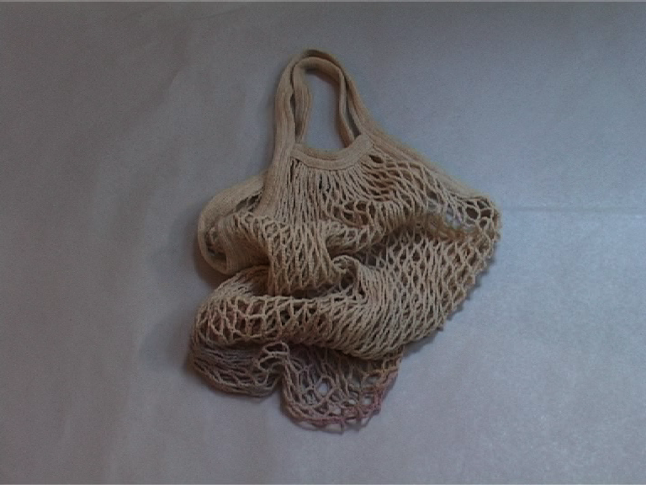

1985. Winter. Four in the morning. Standing in the queue at the “Venus” grocery store in Piaţa Dorobanţilor in Bucharest. Maybe they will bring some meat. If so, they will allow only one kilogram per person. After an hour, at five in the morning, my feet are frozen and my ears have become numb. I try to wrap the sack around my ears to keep them warm. At five-thirty I can’t take it anymore and I go back home.

—Eugen, 71, pensioner (former mathematics teacher)

Pickling jar

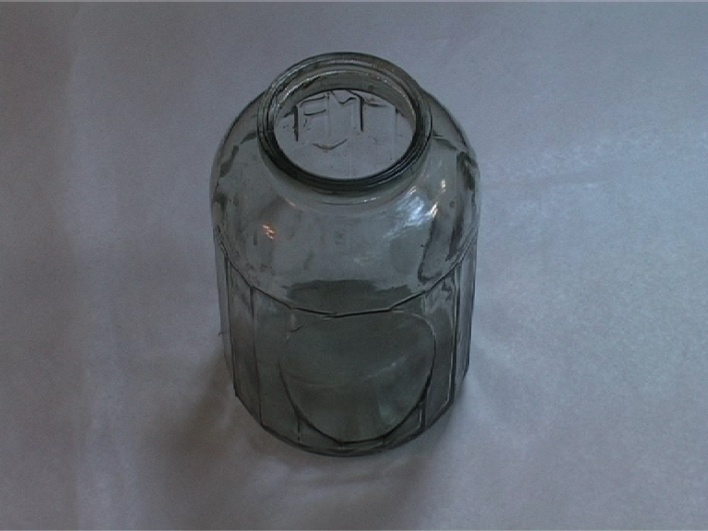

Ever since I can remember, in the autumn, our family would make various types of preserves, even when there was still food to be found in the shops. For example, for the winter, we would put up cucumbers, red peppers, and cabbage for sarmale, and I would make jam out of cherries, sour cherries, apricots, plums, and other fruit. One recipe that I like very much is for pickled peppers in vinegar. Here is the recipe:
60 large red peppers
1 liter vinegar, 1 cup sugar, 2 cups water
1 cup oil
100 grams salt
Bay leaf, peppercorns, garlic

Boil the vinegar with the water, sugar, salt, oil, bay leaf, and pepper. Wash the peppers and cut them in quarters, bring them to a boil, then put them in the jars, one tucked inside another, until the jar is filled. When finished, pour the hot vinegar mixture into the jars, cover with cellophane or lids, and heat in the oven for about 5 minutes to sterilize. Recipe guaranteed. Bon appetit!

—Elena, 79, housewife

Vegeta

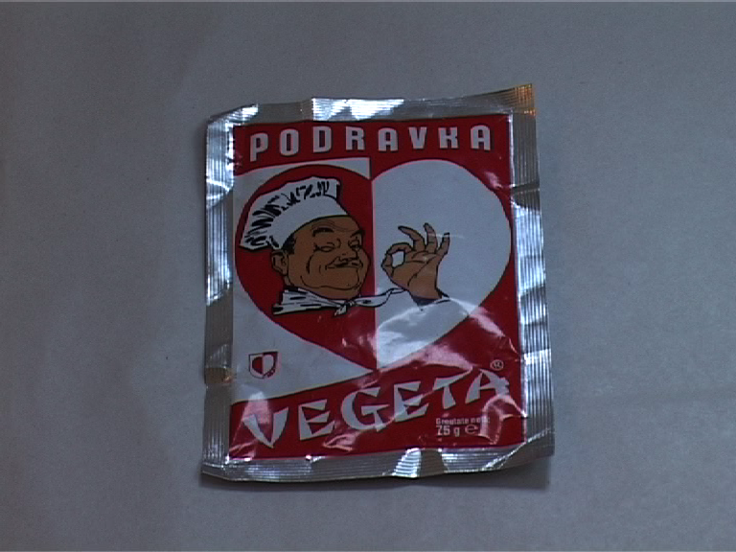

Vegeta is a “wonder” condiment, produced in the former Yugoslavia, more precisely in Croatia. It gives all soups and meals an extraordinary flavor. I recall that it was never absent from my grandparents’ kitchen. During the Ceauşescu era, friends, acquaintances, and relatives would bring Vegeta to Romania from abroad… I remember hearing stories from older colleagues, students during the “time of Ceauşescu,” about how they would always bring along some extra packets of Vegeta from Serbia to sell in Romania, in order to round out their student budgets and allow them a little “extravagance” from time to time, such as eating at the canteen in the Intercontinental Hotel.

—Eugenia, 33, actress

Cookbooks

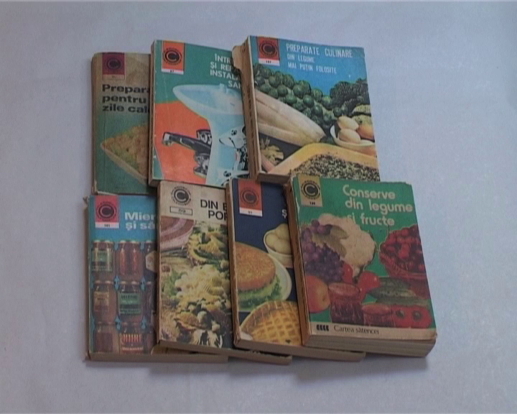

For your Romanian archives, here are some old cookbooks, twenty or twenty-five years old, filled with recipes that I don’t think I ever tried. But I still bought these cookbooks because more of them appeared as food was becoming scarce in the shops! It was probably a kind of compensation.

—Ioana, 63, art historian

Seltzer bottle

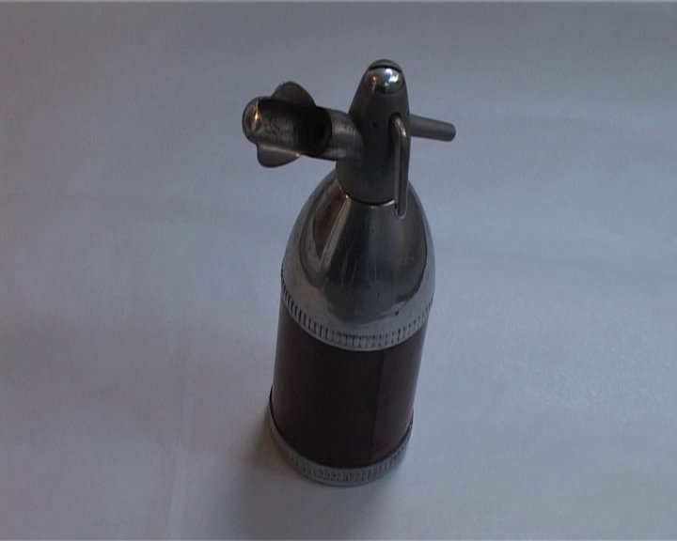

Back then, the seltzer bottle was the ordinary person’s mineral water. It was never absent from the table. Men used it most often to make spritzers [a mixture of wine and carbonated water]. When I was little, I was often sent to the seltzer bottle shop to exchange the cartridges, which I didn’t enjoy doing. But I liked drinking carbonated water from the seltzer bottle, even though I preferred natural mineral water from the spring. I remember Sundays in my grandmother’s courtyard, with the table filled with good food, and the seltzer bottle there to cool you off in the summer heat.

There were several types of seltzer bottles. The older models were made of glass and wrapped in a wire mesh bag. The more “modern” style was made of colored metal. This object is one of the everyday things I grew up with, but now it provokes in me a funny nostalgia.

—Monika, 37, ceramicist

Ice cube tray

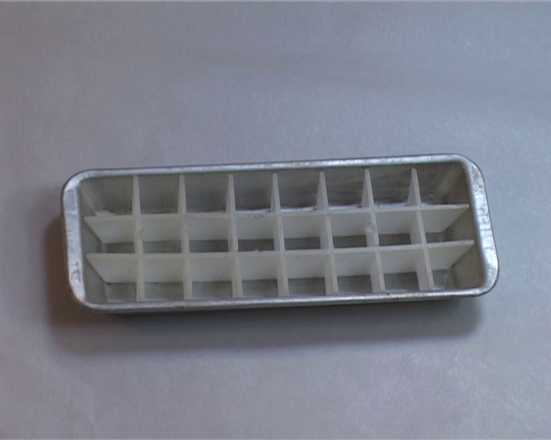

This is from the “Fram” fridge, also called the “Polar Bear”: our old refrigerator that used a lot of energy, in which I made cantaloupe ice cream for the first time. It spilled all over the fridge because the freezer didn’t work properly. When we bought another fridge, an “Arctic” from Găeşti, in 1978, our poor “Fram” ended up as… a chicken coop in the countryside.

—Fotinica, 55, human resources assistant

Scarf

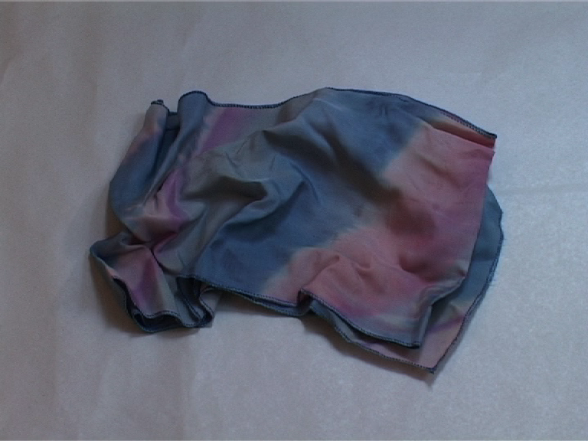

I looked around my flat and couldn’t find anything that reminded me of my life before 1989. I started searching through my closets and finally found a hand-dyed scarf given to me around 1980. Nowadays they don’t make these anymore, because the Fine Arts shops where they were sold no longer exist, at least I don’t know about them if they do.

Everything sold there was considered a luxury item, of good taste, maybe because artists or people connected with art made them. But the prices were sometimes out of the ordinary person’s range.

So, aside from purchases by people who had extra money to spend on themselves (very few, at any rate!), everything that came from a Fine Arts shop was fated to be a gift.

—Alina, 62, ethnologist

Porcelain bibelot

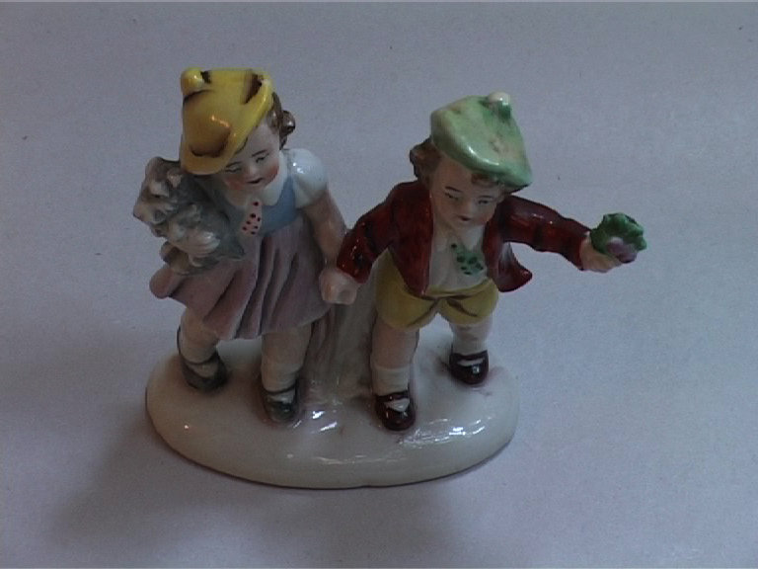

I don’t know why, but whenever I see this kind of kitsch, the band Mondial comes to mind, and their song “Porcelain Bibelot Love.” Written by Minulescu, it was one of the first songs that I remember hearing on the radio. In Minulescu’s time, porcelain probably had different connotations.

—Dorel, 60, lepidopterist

Eyeglass frames

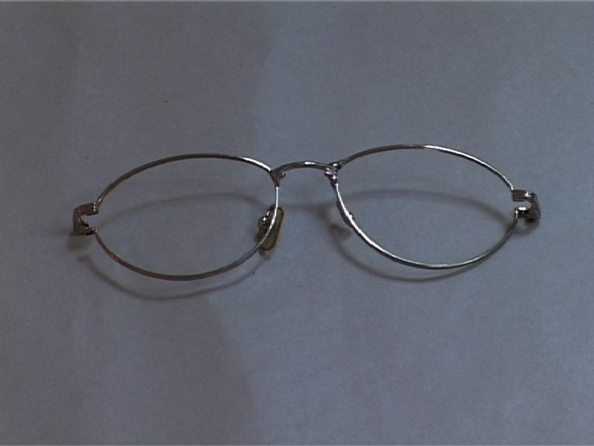

These eyeglass frames ended up in this state after they got broken. I then used the rest of the parts in order to repair other frames. This was necessary because eyeglass frames were very rare during communist times. These glasses are from my personal collection of frames that served as spare parts for future repairs.

—Marius, 60, electronic engineer

Circular knitting needles from Germany

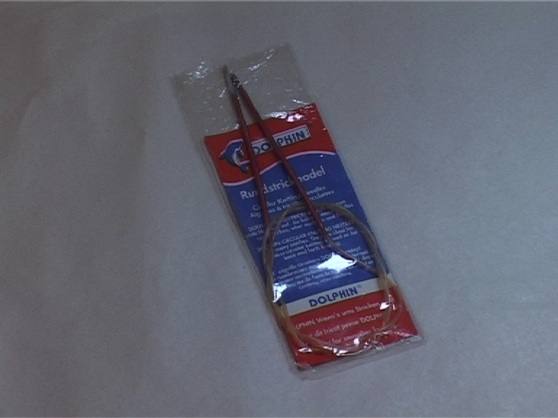

As I very much liked all sorts of handiwork (sewing, crocheting, knitting), I acquired a lot of thread, yarn, and tools that could satisfy these passions. These stashes were necessary, as I was not always able to find what I wanted in the shops.

The knitting needles I used spanned an entire evolutionary range, from homemade ones to more refined aluminum ones that were lighter but still uncomfortable to use because of their size. The circular ones from Germany were special because you could work more easily with them, but also because you couldn’t get them unless they were brought in from abroad, and for a pretty price. But they were worth it!

—Tania, 57, economist

Wooden mushroom for darning socks

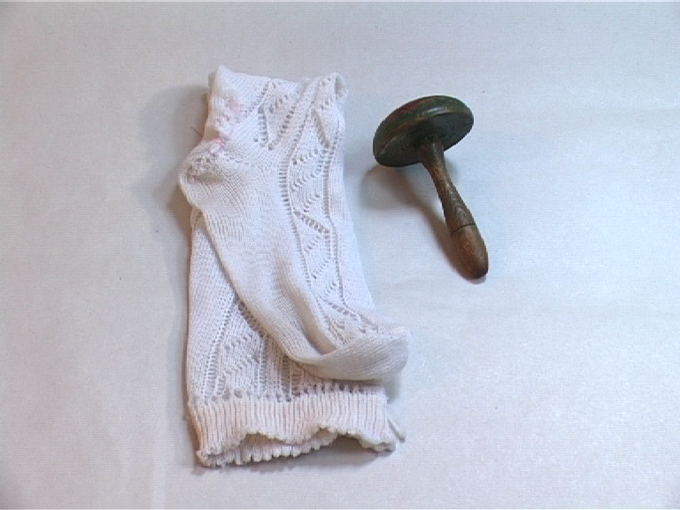

This mushroom spent a few dozen years under the pile of darning socks in my mother’s sewing basket. She turned it [on a lathe] and painted it, back in the days when she was making wooden painted toys and selling them wherever she could. The pile of socks and stockings waiting to be darned would get smaller, but I never saw it completely disappear, even for a day, as long as I lived at home. The colors painted on the mushroom’s cap have rubbed off, probably onto my mother’s fingers.

—Irina, 69, university professor (French literature)

School uniform

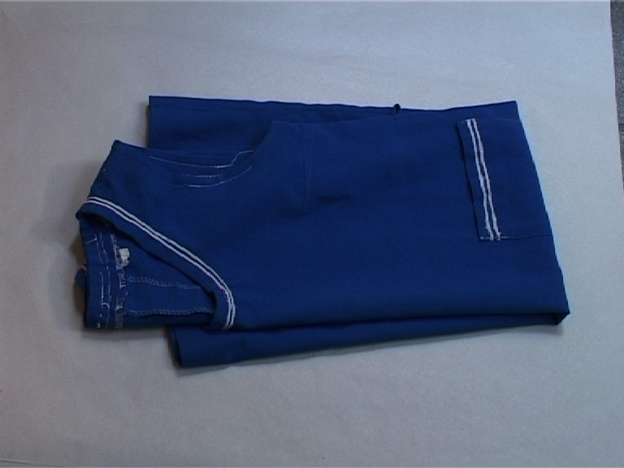

This school uniform was first worn by my cousin and then passed down to me. I would have handed it down to someone else if we still had to wear uniforms after 1989. My white socks were part of my school uniform, and they always kept me from playing. They were always supposed to be spotless.

—Sorina, 30, PhD candidate (American literature)

Ink; pencil holder

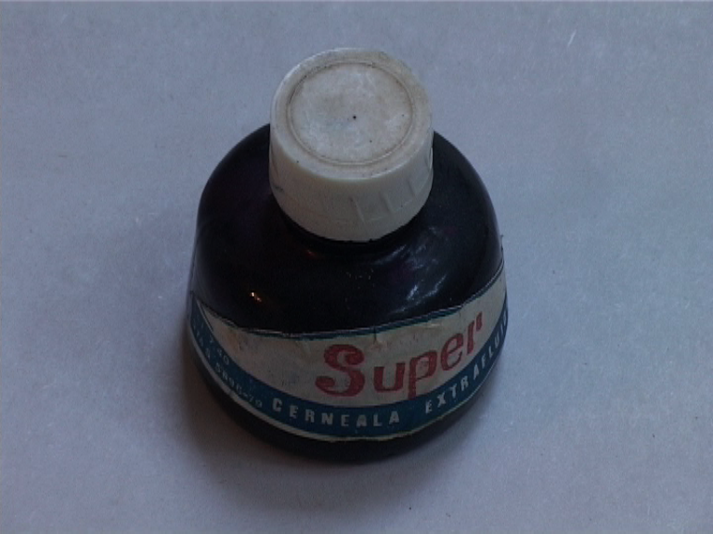

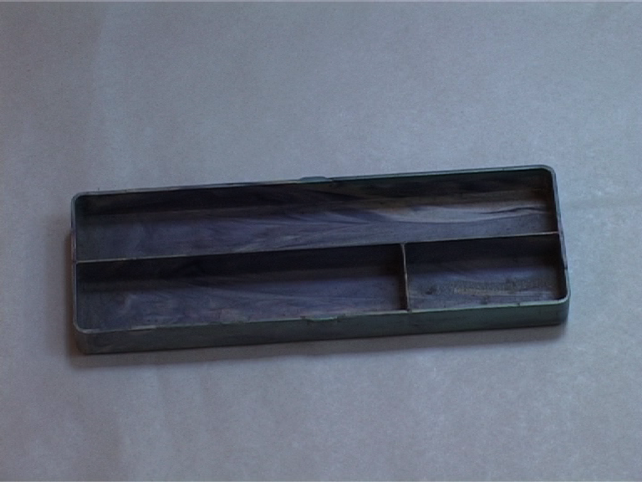

Ink for doing your homework. Ink that leaves blue stains on your fingers, proving that you are diligent and that you do your homework. The same ink that I used for making designs (like in the Rorsarch experiment) and for “taking fingerprints,” like in the French detective films with Alain Delon and Lino Ventura.

Cheap plastic pencil holder, with enough space for carrying an eraser, a pen, and two pencils. Ugly pencil holder that you tried to get rid of. It would either break in the second trimester, or at the end of the school year you would use it in art class for holding water when painting with watercolors.

—Dan, 33, MBA student

Photographic portrait, School No. 155, Bucharest

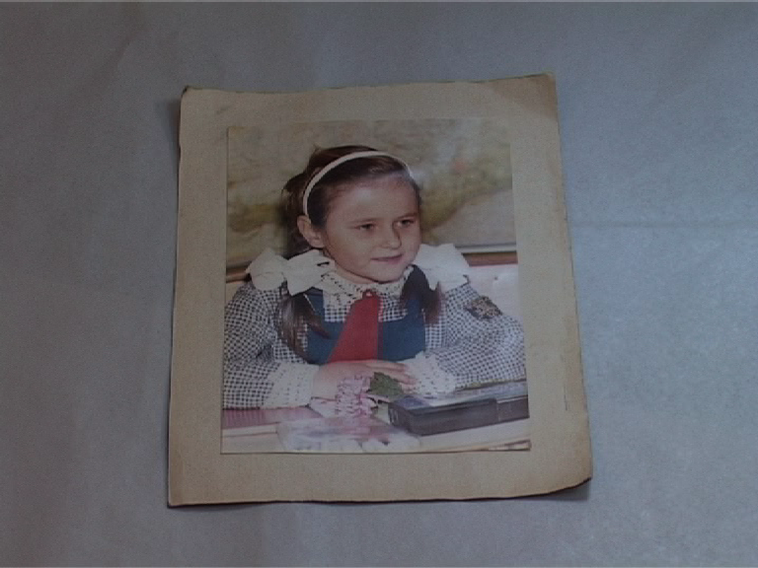

Falcon of the Fatherland [the “Young Pioneers” communist organization]. Gliga, Teodora. Hair braided by my grandmother, collar and cuffs also embroidered by her or by one of my aunts. I didn’t yet have all of my adult teeth. The pencil case belonged to a classmate, who got it as a present from someone abroad.

—Teodora, 28, post-doctoral researcher (neuroscience)

Set of moving slides for the 4th grade: “History of the Fatherland,” 1975

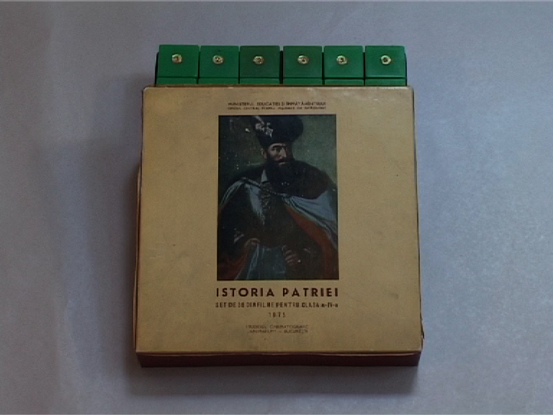

Moving slides rolled into my life for at least ten years, from the late 1970s until just before the Revolution. They were read out loud by my parents or my kindergarten teachers, allowing them to exercise their theatrical skills. I would stumble over the words, which confirmed the educational nature of the slides.

The “History of the Fatherland” slides were ones that my parents bought for me on vacation somewhere in the countryside. I don’t remember ever having projected them, though I must have seen one or two of the rolls. There are thirty-six rolls, all in the textbook style of that era. Now, after many years, when I rediscovered the box of these slides, the photograph on its cover popped into my mind: the well-known portrait of Mihai the Brave. And it was less a recognition of the actual slides, which I didn’t have much of a connection to—and more of a reminder of how Romanian history used to be taught.

—Daniela, 33, psychiatrist
Almanacs

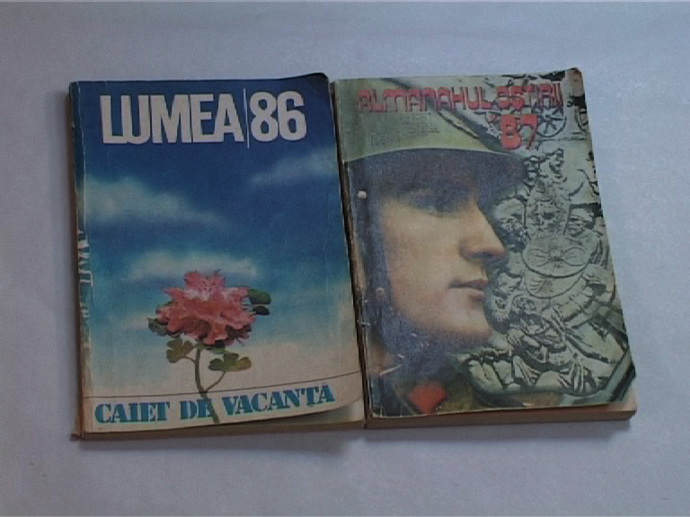

Almanacs were usually read from back to front. The entertainment section was at the end: games of logic, self-knowledge tests, stupid jokes and caricatures. The closer you got to the middle of the book, the more you were provoked. Researchers from the University of Bremen had discovered a new type of plant… Western Europe was depicted in black and white, filled with drug addicts and homeless people… Americans were “uneducated” because eighty percent of them didn’t know the name of their own President.

Then, finally, the first page: the photograph of Ceauşescu. In profile. Perfect for coloring in. For adding moustache, glasses, and goatee. Things forbidden to children. And in order to avoid committing such antics, you definitely needed to be educated by the Children’s Almanac. Or trained in the philosophy of the Scientific and Technical Almanac (Darwinist). Or accustomed to inhaling the pages of the Army Almanac. Socially dedicated—like all readers of the Scintillating Almanac.

—Călin, 36, museum treasurer, writer, musician

Manual typewriter, “Hermes Media 3”

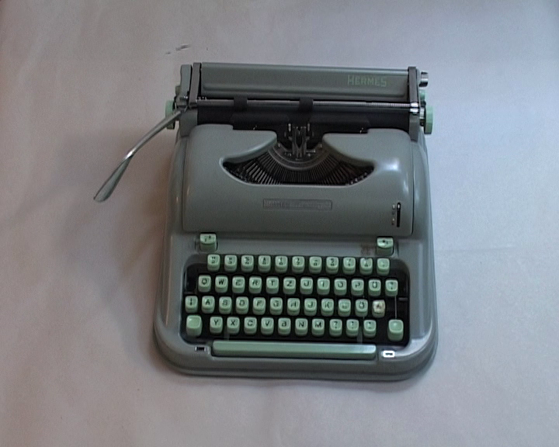

I wouldn’t have thought of donating this typewriter, something I’ve been familiar with since childhood, if in the 1980s people hadn’t become so obsessed with these machines. Back then, in order to discourage their use as a means of producing anti-Ceauşescu propaganda, there was a law that all owners of typewriters had to register them at their district’s militia office, leaving a sample page showing the typeface of every key of their typewriter. During those years, this was the strangest queue of all: the typewriter queue in front of the militia office. This operation would be repeated every January because they also wanted to record the extent to which the keys were inevitably wearing away.

— Zoltán, 61, university professor (sociology and communication)

Irving Wohlfarth (2005), “ET CETERA? The Historian as Chiffonier,” in Peter Szondi (ed.), Hope in the Past: On Walter Benjamin, Vol. 2—Modernity. London and New York: Routledge, p. 194.

