Hydrologically-connected and isolated floodplains in channelized streams: impacts on plant communities under a temperate monsoonal climate

Yunsoo Chuª, Seung-Nam Jin^{b}, Josu G. Alday^{c}, Rob H. Marrs^{d}, Kang-Hyun Cho^{b, d, *}

ª National Institute of Ecology, Seocheon 33657, Republic of Korea
^{b} Department of Biological Sciences, Inha University, Incheon 22212, Republic of Korea
^{c} Department of Crop and Forest Sciences—AGROTECNIO Center, Universitat de Lleida, 25198 Lleida, Spain
^{d} School of Environmental Sciences, University of Liverpool, Liverpool L69 3GP, UK

* Corresponding author (Kang-Hyun Cho)
E-mail address: khcho@inha.ac.kr
Telephone number: +44 7427 766921
Fax number: +82 32 8608842

Abstract
The aim of this study was to understand the changes of floodplain vegetation following the disruption of lateral connectivity from streams by levee construction under the temperate monsoonal conditions of South Korea. We compared the plant community structure and selected environmental variables in paired floodplains, one connected to the stream inside a levee and the other isolated by a levee. Cluster analysis of the vegetation identified ten plant communities and their associated indicator species. There were clear differences in communities between the connected floodplains and isolated floodplains. Pioneer and early-successional communities, which are resistant to flood disturbance, were found only in the connected floodplains. In contrast, diverse aquatic-macrophytic communities, adapted to long flood duration, and late-successional communities sensitive to flooding disturbance were found mainly in the isolated floodplains. β-turnover was the main driver in species composition in both types of floodplain. The isolated floodplains had a longer flood duration and the soils had a finer texture, higher soil moisture content and were more acidic compared to connected floodplains. Flood duration and topological elevation were identified as the most important environmental variables with respect to plant community composition. Our results suggest that reinstatement of lateral connectivity is necessary to restore the fluvial native vegetation in the isolated floodplains of a region with a monsoonal climate.

Keywords

Floodplain restoration, Indicator species, Lateral connectivity, Levee, Stream, Vegetation

Introduction
Connectivity in the landscape can be defined as the flow of energy, matter and organisms between landscape components (Ward et al., 2002). In riverine landscapes, a four-dimensional model has proved useful to describe such connectivity; three spatial dimensions, (1) flow along the stream (longitudinal), (2) flow between the stream and riparian and upper areas (lateral), (3) flow between the channel and the hyporheic zone (vertical), interact with variation over time (temporal) (Ward, 1989; Jansson et al., 2007). Lateral connectivity is of especial importance for riverine ecology because it impinges on the floodplain; the area of land adjacent to a river or stream that is inundated periodically by the food pulse overflow (Junk et al., 1989). Because of this frequent inundation, floodplains have properties of both aquatic and terrestrial ecosystems, and can be viewed as a typical example of an ecotone (Thoms, 2003). Floodplains provide many ecological functions such as flood attenuation, water quality improvement and the provision of biodiversity, producing benefits essential for ecosystem health (Ward et al., 1999; Opperman et al., 2010).
In South Korea, as in many other areas across the world, pre-1960, the floodplains were recognized primarily as fertile agricultural land (Lee & Yu, 2001). However, the frequent inundation damage caused by monsoonal rains, which can produce torrential downpours between July and August, has brought about a change in stream management policy. Starting in the 1960s, most streams have been modified through the creation of straight, artificial channels and levees, designed to control flood water movement and flooding (Ward, 1998; Woo, 2010). This change from traditional management has generated large areas of abandoned former stream-channels and floodplains. The connectivity between these former isolated floodplains and the main river has either disappeared, or it remains in a managed state, where inundation is only allowed in a controlled way via floodgates placed within levees. In these situations, the disconnection of lateral connectivity has reduced the availability of riverine habitats because of the reduction of stream scale, inundation periods and restricted transfer of organisms and nutrients (Gergel, 2002). Thus, the environments in these isolated floodplains have changed relative to their former state in many ways including their hydraulic, hydrologic, topographic, and soil properties. However, there have been few attempts to quantify the effects of isolation on floodplain plant communities.
Floodplain plant communities are likely to respond to such changes in connectivity. For example, any change in hydrologic regime will affect both vegetation distribution and structure within isolated floodplains by reducing, (1) dispersal and retention of propagules in the water flow (e.g., Nilsson et al., 2002), (2) nutrient inputs (e.g., Tockner et al., 1999), (3) physical destruction of colonized vegetation by scouring (e.g., Rood et al. 2003), and (4) by changing inundation and exposure conditions which influence those plants that can withstand the physiological stresses (e.g., Baldwin & Mitchell, 2000). The alteration of hydrologic regimes also influences riparian plant communities indirectly though associated changes in soil and water properties (Hupp & Osterkamp, 1996). Based on this knowledge, therefore, we expect that different plant communities will occur within the isolated floodplains compared to those in connected floodplains, and these might in time change into lentic wetland communities (e.g., Leyer, 2006; Carli & Bayley, 2015).
Currently, various ecological restoration projects are in progress worldwide where lateral connectivity between channels and floodplains are being improved. In Europe, for example, early floodplain restoration schemes started in the mid-1990s in the Rheinvorland-Süd on the Upper Rhine and the Bourret on the Garonne (Moss & Monstadt, 2008), and on the Elbe River near Lenzen (Moss, 2007). In the USA, examples of floodplain restoration can be found in the catchment area of Chesapeake Bay in Maryland and in the Emiquon Preserve on the Illinois River (Hassett et al., 2007; Hine et al., 2017). In South Korea, which has a temperate monsoonal climate, restoring connectivity between isolated, abandoned floodplains and their river main channel is in its infancy. It has been implemented only in the Hampyeongcheon and Cheongmicheon streams through levee set-back. There is, therefore, little information on the effectiveness of this new type of management from an ecological perspective to inform future policy development. This study aimed to provide an initial ecological assessment of isolated and connected floodplains under a temperate monsoonal climate, with its severe summer rainfall.
We hypothesized that there would be differences in both the developing plant community structure and environment variables between the two floodplain types, primarily because of the loss of natural lateral connectivity in the isolated floodplain. Hence, we described and compared the plant communities found in four paired, connected/isolated floodplains in three rivers in South Korea, identifying those plant communities that were restricted to one floodplain type. Thereafter, we determined how these communities were related to a range of environmental variables. Finally, to better understand the processes involved, we assessed how species diversity differed between the two floodplain types by estimating β-diversity; partitioning it into turnover and nestedness-resultant components (Baselga & Orme 2012). A final aim of this study was to inform restoration projects elsewhere in region where connectivity between the main channel and isolated floodplains is to be re-created. Central to this last aim was the derivation of indicator species to assist managers describe the plant communities at the practical field level in those floodplains experiencing a monsoonal climate.

Methods

Study sites
This study was carried out on the three channelized streams, the Cheongmicheon, Hwanggujicheon, and Seomgang Streams, all located in the center of the Korean Peninsula (Fig. 1); the stream lengths and watershed areas are 57 km and 990 km² for the Cheongmicheon Stream, 30 km and 340 km² for the Hwanggujicheon Stream, and 55 km and 150 km² for the Seomgang Stream (HRFC, 2017). These floodplains are typical of those occurring on mildly-sloping floodplains of medium-sized streams; they all occurred on relatively flat land with similar soils. Within these streams, we selected four study sites where remnant, former floodplains remained outside the stream levee, providing to some extent natural conditions; there were two sites (Jeomdong, JD; Wolpo, WP) on the Cheongmicheon Stream and one site on the other two streams (Fig. 1, Table 1, and Fig. S1 of Online Resource). The isolated floodplains were disconnected from the main channel between 10 and 48 years ago (Table 1). In South Korea the riverine vegetation reaches a quasi-equilibrium state very rapidly presumably through effects of monsoonal flooding; here we confirmed through field observations that the vegetation in the IF was relatively stable after 10 years isolation. Currently, these sites are located in rural areas adjacent to large rice paddies. The stream widths between both levees range between 200 and 300 m. They are a typical of mid-river locations with gentle slopes with sandy river beds. Within each study site, we compared two floodplains, one, denoted CF, which was connected hydrologically to the stream channel inside a levee and one, denoted IF, which was isolated from the channel by a levee. The IFs were formerly-connected to the stream channel, but are now disconnected by the levee, and partially-hydrologically-connected to the channel via floodgates.

Vegetation sampling
We surveyed the distribution and community structure of the plant communities at the CFs and IFs at the four study sites between June 2015 and July 2016. One to six transects were established across the floodplains at regular intervals depending on the floodplain size and the diversity of the vegetation communities present. Quadrats were installed in every physiognomically-different plant community detected along the transect (quadrat size; 2 m x 2 m in herb, 5 m x 5 m in shrub, 10 m x 10 m in tree communities). When the distribution range of the plant community was wide, the additional quadrats were installed every 20 m within the community. The numbers of quadrats per transect varied between 3 and 19. The species cover inside each quadrat was scored using the following cover classes (100 = >95%; 90 = 85-94%; 80 = 75-84%; 70 = 65-74%; 60 = 55-64%; 50 = 45-54%; 40 = 35-44%; 30 = 25-34%; 20 = 15-24%; 10 = 5-14%; 5 = 2-4%; 1 = 0.5-1%; + = <0.5%). We sampled 160 quadrats in total; 107 quadrats along 12 transects in the IFs and 53 quadrats along 6 transects in the CFs. The main species detected are presented in Table S1 of Online Resource. The nomenclature of vascular plant species follows the Korean Plant Names Index (KFS, 2017) and the Integrated Taxonomic Information System (ITIS, 2017) for Phragmites australis (Cav.) Trin. ex Steud.

Geomorphological and hydrological survey
We measured the average elevation and annual flood duration for each quadrat sampled. The geomorphology in the CFs and IFs of each study site was surveyed using a ProMark 700 Global Navigation Satellite System (GNSS) receiver (Spectra Precision, USA) along the established line transects. The topographic elevation of the plant community was calculated using the average elevation of each community above the ordinary (median) water level. The water level of the study sites was measured every hour from December 22, 2015 to December 31, 2016 using automatic water level data loggers (HOBO U20L-01, Onset, USA). The data loggers were installed at the wetland pond in the IF and on the main channel in the CF at each study site. Annual flood duration for each plant community was calculated using the water level data and the average elevation for each plant community. If the water level was greater than the elevation of the plant community, it was deemed to be inundated.

Soil sampling and analysis
Soil was sampled at each vegetation-sampling quadrat. After removing the litter layer, topsoil was cored from the surface to 10 cm depth. Soil moisture content was measured by weight loss after drying for 48 hours at 105℃. The collected soil samples were then dried for 2 weeks and sieved to pass a 2 mm mesh. Organic matter was measured by loss-on-ignition (4 h at 550℃ in a furnace, Thermolyne 67100, USA), electric conductivity and soil pH (1:5 soil: water, w/v) were measured using a conductivity meter (Model 162, Orion, USA) and pH meter (Model 920A, Orion, USA), respectively. Soil texture was determined using the hydrometer method (Sheldrick & Wang, 1993).

Data analysis
All statistical analyses were performed in the R Statistical Environment (R version 3.4.0, R Core Team, 2017). First, in order to characterize plant communities in both floodplain types (IF/CF), an hierarchical cluster analysis was performed using the plant cover dataset using the 'hclust' function (method= 'ward.D2') in the 'vegan' package (Oksanen et al., 2016). The plant community groups derived from the cluster plot were then classified into groups using the 'cutree' function (Oksanen et al., 2016). We selected a cut of 10 clusters based on visual inspection of the dendrogram and a previous check of the ideal groups using the ‘cascadeKM’ function (Oksanen et al., 2016). This method was complemented by selecting only groups in which at least one indicator species was included in each group and the indicator value of one of them was as close to 1 as possible. Indicator species were then extracted for each group using the 'multipatt' function ('indicspecies' package, De Caceres et al., 2016). We also calculated the Shannon diversity index in each group using the 'diversity' function (Oksanen et al., 2016).
Second, the relative importance of hydro-geomorphological variables (i.e. elevation and flood duration) vs. soil variables (i.e. soil texture, organic matter, moisture content and pH) as predictors of floodplain vegetation composition was evaluated by variation partitioning analyses using the ‘varpart’ function ('vegan' package, Oksanen et al., 2016). Afterwards, Permutational Multivariate Analysis of Variance (PMAV) using Euclidean distance was used to examine and quantify the differences in environmental variables between floodplain types (IF/CF). Thereafter, to visualize the relationships between the floodplain types and environmental factors Principal Components Analysis (PCA) was used, performed with the 'rda' function ('vegan' package, Oksanen et al., 2016). Linear mixed-effects models (LME) were then used to test for differences in geomorphological, hydrological and soil variables between floodplain types using the ‘lme’ function in the ‘nlme' package (Pinheiro et al., 2016). LME was used to accommodate the spatial sampling structure, here IF/CF or vegetation group were considered fixed factors and study-sites nested within transects and plots as random factors to account for spatial autocorrelation.
Third, PMAV was used to test difference in plant species composition between floodplain types (IF/CF), while, the relationships among plant communities and floodplains where described using non-metric multidimensional scaling (NMDS). Here, plant species cover transformed with the logarithm (log (x+1)) was analyzed by 'metaMDS' function, while the 'envfit' function (both 'vegan' package, Oksanen et al., 2016) was used to passively overlap the environmental factors over ordination. The significance of the variables was assessed using permutation tests (4999 permutations).
Fourth, to understand the response of the plant community to the lateral connectivity we categorized the functional traits of plant species and then applied these data to the plant community ordination. We classified the plant species according to life longevity (i.e. summer annual, winter annual, biennial, perennial), grow form (i.e. submerged hydrophyte, free-floating hydrophyte, floating-leaved hydrophyte, emergent hydrophyte, hygrophyte, mesophyte) and growth habit (i.e. tree & shrub, forb, graminoid, vine) (Choung et al., 2012) (Table S1 of Online Resource). The significant species traits assessed using permutation tests (4999 permutations) were passively overlapped over the NMDS ordination of plant communities using 'envfit' function (Oksanen et al., 2016).
Finally, we estimated for each floodplain type and site the turnover (β_{SIM}) and nestedness-resultant (β_{NES}) components of β-diversity (β_{SOR}) following the procedure for partitioning of β-diversity proposed by Baselga & Orme (2012). Kernel density curves were constructed by resampling 10 sites from each flood type 1000 times and computing the average β_{SIM} and β_{NES}. Only floodplain results were reported since site ones were similar to floodplain results. At the same time, the “betadisper” function from vegan package (Oksanen et al., 2016) was used to evaluate differences in multivariate dispersion of floodplains as a proxy for multi-dimensional β-diversity (Anderson et al., 2011).

Results

Vegetation types in hydrologically-connected and isolated floodplains
The classification of the quadrats sampled in the floodplains produced ten identifiable community groups within the CFs and IFs on basis of species composition and their abundances (Fig. 2). Six of the ten community groups were common to both CF and IF (community groups 3, 4, 5, 6, 7, 8); two community groups were confined to CF (Groups 1, 2) and two to IF (Groups 9, 10) (Table 2). Permanova analysis indicated that isolation in the IF influenced plant species composition significantly relative to CFs (PMAV, F=12.82, r²=0.08, P<0.001). These ten plant community groups could be distinguished on the basis of 15 indicator species (P<0.001 except for Group 8 P<0.01, Table 3); the community groups and their indicator species are:
Group 1: Phragmites japonica Steud.-dominated, tall-herbaceous community widely-distributed in the floodplain regularly disturbed by flood in CF.
Group 2: Short herbaceous communities dominated by Persicaria nodosa (Pers.) Opiz, Echinochloa crusgalli var. oryzicola (Vasinger) Ohwi and Echinochloa crus-galli (L.) P. Beauv. with low cover on the sand or gravel bar disturbed very frequently by flooding in CF.
Group 3: Short herbaceous communities dominated by invasive plant species, for example Conyza canadensis (L.) Cronquist, Artemisia princeps Pamp., Setaria viridis (L.) P.Beauv.; they showed the greatest Shannon species diversity index and tended to be a disturbed community within the drier parts of the higher elevations in both CF and IF.
Group 4: Humulus japonicus Sieboid & Zucc.-dominated community with climbing herbaceous species covering fallen reeds and other herbs; this was a typical invasive community and found in disturbed habitats in both CF and IF.
Group 5: Miscanthus sacchariflorus (Maxim.) Benth.-dominated, tall-herbaceous community with very dense shoots and very low species diversity; this was found on the higher elevations in both CF and IF.
Group 6: Salix koreensis Andersson-dominated community of trees and shrubs (mainly willows) having P. australis, P. japonica, and M. sacchariflorus in the understory; this was found in floodplain wetlands and levee slopes in mainly IF.
Group 7: P. australis–dominated, tall-herbaceous community widely distributed in mainly IF.
Group 8: Floating-macrophytic communities dominated by Trapa japonica Flerow, Leersia japonica (Honda) Honda and others in ponds on the floodplain of CF and mainly on the lower elevation of IF.
Group 9: Submerged or short emergent-macrophytic communities dominated by Hydrilla verticillata (L.f.) Royle, Potamogeton crispus L., and Alisma orientale (Sam.) Juz. found in ponds within the IF.
Group 10: Tall, emergent-macrophytic community dominated by Zizania latifolia (Griseb.) Turcz. ex Stapf and accompanied with Actinostemma lobatum (Maxim.) Maxim. ex Franch. & Sav., Persicaria thunbergii (Siebold & Zucc.) H. Gross, Typha angustifolia L., Scirpus radicans Schkuhr, and the liana, Actinostemma lobatum (Maxim.) Maxim. ex Franch. & Sav., this was found in shallow water around a pond within the IF.

Environmental characteristics of the hydrologically-connected and isolated floodplains
Variation partitioning showed that hydro-geomorphological variables accounted for 9% of the total variance in community composition, soil variables accounted for 11% of the total variance, with 6% shared between them. The PCA of the environmental variables explained 50% and 19% of the total variation on the first two axes (Fig. 3). There were clear significant differences between the CFs and IFs (PMAV, F=32.23, r²=0.18, P<0.001; Fig. 3). The CFs were located on right of the first axis and were correlated with greater sand content, higher soil pH and higher elevation whereas the IFs were correlated with greater flood duration, greater clay and silt content, higher soil organic matter concentration and soil electric conductivity, but lower soil pH (Fig. 3). Significant differences by LME were detected between the two floodplain types for four variables; (1) flood duration (mean values 20 days/year in CF vs 172 days/year in IF, F=15.09, P<0.01), (2) soil moisture (15% CF vs 27% in IF, F=19.40, P<0.001), (3) soil texture (77% in CF vs Sand 62% in IF, F=7.90, P<0.05; 5.7% in CF vs Clay 9.4% in IF, F=5.70, P<0.05), and (4) pH (6.4 in CF vs 6.1 in IF, F=8.17, P<0.05) (Fig. S2 in Online Resource). Among these factors, flood duration, soil moisture, silt and clay content were greater in the IF than the CF and soil pH was greater in the CF than the IF. Other environmental variables showed no significant differences between floodplain types (P>0.05).

Relationship between vegetation and environmental factors
The NMDS showed clearly how vegetation groups occupied different regions of the ordination space (stress value 0.1444; Fig. 4). Axis 1 was correlated positively with flood duration, soil moisture, soil electrical conductivity, and clay content and negatively with elevation, sand content, and soil pH (Table S3 in Online Resource). Axis 2 was correlated positively with sand content and soil electrical conductivity, and negatively with clay and silt content, and elevation (Fig. 4c). From a species trait perspective, axis 1 was positively correlated with free floating, floating-leaved, and submerged hydrophytes, and negatively with mesophytes and hygrophytes, and axis 2 was mainly positively correlated with summer annuals and forbs, and negatively correlated with perennials and trees/shrubs (Fig. 4b). Quadrats of the IFs were located horizontally along the axis 1, and those of the CFs were placed vertically along the axis 2 (Fig. 4d). Quadrats of both floodplains overlapped at the left bottom of the biplot. Quadrat plots in Groups 1 and 2 were detected only the CFs and were positioned mainly in the upper left quadrant of the first axis (Fig. 4e), where the indicator species for Group 1 (P. japonica) and Group 2 (E. crus-galli, E. crusgalli var. oryzicola, and P. nodosa) were located (Fig. 4a) and winter annuals and vines were abundant (Fig. 4b). The plant communities of these plots were distributed at the coarser, more basic, and less wet soil and shorter-flooded area of the CF (Fig. 4c). Quadrats in Groups 9 and 10 detected only in the IFs were positioned on the right of the first axis (Fig. 4h), where their indicator species were found (P. crispus, H. verticillata, A. orientale in Group 9 and Z. latifolia, A. lobatum in Group 10) (Fig. 4a), and submerged and emergent hydrophytes were frequent (Fig. 4b). This position was correlated with finer, wetter, acidic soils, and with longer periods of flooding (Fig. 4c). Quadrats of the other groups found in both floodplain types were located in intermediate positions. Groups 3, 4, and 5 were located mainly in the bottom left quadrant (Fig. 4f), Groups 6 and 7 were similar but in a more central position, and Group 8 was positioned at the positive end of Axis 1 but straddled the lower and upper right quadrants showing the greater multivariate variation (Fig. 4g). In Groups 6, 7, and 8, more than 85% of the plots were sampled from the IFs (Table 2). A comparison of environmental characteristics by the vegetation group showed that the Group 1 and 2 had a shorter flood duration and a coarser soil, and Group 8, 9 and 10 had a lower topography, a longer flood duration, a higher moisture content and higher electrical conductivity of soils (Table S4 in Online Resource). In terms of plant traits, Group 8 had a high frequency of free floating and floating leaved hydrophytes and Group 5 and 6 had a high appearance of trees/shrubs (Fig. 4b).

Community β-diversity partitioning
The β-diversity partitioning analysis showed that isolated and connected floodplains had similar values of total dissimilarity defined as β_{SOR} (Fig. 5 and details in Table S2 of Online Resource), being in both cases species turnover (β_{SIM}) the main reason of variation in species composition (β_{SIM}-CF=0.85 vs β_{SIM}-IF= 0.84; P=0.685). By contrast, compositional dissimilarity due to nestedness (β_{NES}) played a residual role in both types of floodplains (β_{NES}-CF=0.04 vs β_{NES}-IF=0.03; P=0.654). At the same time, multidimensional β-diversity is nearly three times greater in IF than in CF sites (0.20 vs 0.07 respectively; F=6.43, P=0.012), suggesting a greater variability in species compositions among sampling plots in isolated floodplains than in connected ones (i.e. biotic differentiation).

Discussion
Artificial levees, built to prevent floods and damage in the surrounding landscape, are common features of river management worldwide (Covino 2017; Wohl 2017). When levees are formed, there is a loss of lateral connectivity between the bankside vegetation and the stream, as levees prevent floodwater from flowing into the floodplains. The installation of levees to control floodwater in South Korean rivers is particularly important because of the monsoonal rainfall, with exceptionally high summer rainfall (Woo, 2010). Studies elsewhere have shown that disruption in lateral connectivity induces distinct changes in vegetation composition and structure, which are related to changed environmental conditions, e.g. flood duration, water condition and soil particle size (Amoros & Bornette, 2002; Gergel, 2002; Leyer, 2006). Here, we assessed the differences in plant community structure between isolated and connected floodplains in South Korea and relate it to a range of environmental factors.

Differences in vegetation between hydrologically-connected and isolated floodplains
A major outcome from this study was the identification of ten plant community groups. Although six community groups were found in both floodplain types, two were restricted to CF and two to IF. Community groups 1 and 2 were restricted to the CF and both were found at the sand bar at the edge of the water channel. Community group 2 was composed mainly of annuals (E. crusgalli var. oryzicola, E. crus-galli and P. nodosa) at low cover; these species germinate quickly after flooding and complete their life-history (Cho & Cho, 2005). Several annual alien species (Ambrosia trifida L., Panicum dichotomiflorum Michx.) and the ruderal A. princeps were found occasionally in this community group. Community group 1, dominated by P. japonica is composed mainly of perennials and can be considered the second pioneer stage (Lee et al., 2009). Community groups 9 and 10, dominated by emergent macrophytes (Z. latifolia, A. orientale) and submerged macrophytes (P. crispus, H. verticillata) were only found only in the IF, where the frequency and magnitude of flooding was low and stable, with stagnant waterbodies present. The other community groups represent a successional sequence to the levee where community groups 5 and 6, dominated by M. sacchariflorus and Salix koreensis/P. australis were present respectively; the latter where flood disturbance was minimal (mainly IF, and occasionally in CF) (Lee et al., 2009). Analysis of species traits confirmed that the life longevity, life cycle and growth habit of species changed from annual herbs that tolerate flooding in the early-successional stage to perennial trees/shrubs in the late-successional stage. Our results for floodplains experiencing a monsoonal hydrologic regime are similar to those successions reported in plant communities on temperate floodplains (Bornette et al., 1998; Tockner et al., 1999; Amoros & Bornette, 2002; Leyer, 2006). It is likely, therefore, that it may be possible to transfer ecological restoration methods developed for use in temperate floodplains to monsoonal floodplains, although clearly evaluation of their success should be evaluated in the future. β-diversity in both types of floodplain were similar with species turnover being the main driver affecting the differences in species composition between IF and CF floodplains (Baselga & Orme, 2012). The intentional connection of the isolated floodplains to the channel may promote biotic homogenization by increase of the flood disturbances.
In Korean rivers, the disturbance caused by flooding is intensified by human activities such as river management and recreation (Woo, 2010). Disturbance was particularly important in structuring the distribution of community groups 3 and 4. Group 3 was dominated by diverse ruderals, e.g. C. canadensis, A. princeps, S. viridis, Glycine soja Siebold & Zucc. and had the greatest diversity (Shannon index) whereas Group 4 had a very low diversity, but was dominated by lianas including H. japonicus, a climbing plant that provides dense cover and prevents the formation of a diverse plant community (Brunel et al., 2010). Indeed, H. japonicus is one of the most notorious invasive lianas in riparian areas of Korea (Kim et al., 2012).

Environment differences between hydrologically-connected and isolated floodplains
It was also expected that environmental change would occur in the IFs where the exchange of materials and energy with the main channels is blocked or limited due to reduced lateral connectivity with the streams (Gergel, 2002; Leyer, 2006). These changes will be reinforced by accompanying changes in vegetation structure and distribution (Amoros & Bornette, 2002; Leyer, 2006). Here, we show that in the IF, flood duration was longer, the substrate texture finer, soil moisture higher, and soil pH more acidic compared to the CF. The finer-textured soils in the IF is presumably a result of the reduced water flow associated with levee construction (Bornette et al., 1998). These finer soils hold greater water content and produce a lower pH (Leyer, 2006).

Relationship between vegetation and environment according to the lateral connectivity
Two major environmental gradients were detected. The first correlated with annual flood duration and the second with the elevation above the ordinary water level. The annual flood duration was identified as the most crucial factor confirming that water regime has in determining plant community development in floodplains (Casanova & Brock, 2000). In areas with long flooding periods, aquatic-macrophytic communities were mainly found in the IF. Isolation of floodplains induced the lentic environments where a larger area was flooded for longer and disturbance by water flow was relatively low. Even in the CF, floating-macrophytic communities dominated by T. japonica and L. japonica and other free-floating hydrophytes were found in ponds of floodplain and in channels with a low water velocity. The floating hydrophytes seem to have a greater tolerance to water-level fluctuation due to a monsoonal flood and to be easily recruited after flood disturbances than submerged and emergent hydrophytes (Sakurai et al., 2017). Along this gradient, the functional traits of plant species graduaonlly changed from free floating, floating-leaved, and submerged hydrophytes to hygrophytes and mesophytes.
The second gradient described the vegetation zonation with elevation and was found in the both IF and CF. from low elevation with P. nodosa and P. japonica, through S. koreensis and M. sacchariflorus at the highest elevations, a typical riparian successional sequence (Cho & Cho, 2005). These plant communities were more common in the IF than CF, almost certainly because successional change is not blocked in the IF by frequent flood disturbance.

Conclusions
We have confirmed that under the monsoonal rainfall conditions found in Korea isolation from the stream channel by the levee construction generates significant differences in the type and distribution of plant communities, and their associated hydrological, geomorphological and pedological properties. The plant community differences were brought about mainly by the changes in flood duration but modified by elevation. A diverse wetland vegetation succession ranging from submerged to emergent and then late-successional stages was found with increasing elevation in the IF, lotic and natural fluvial communities were not detected in the IF indicating that isolation impacts negatively on the natural, riverine plant communities. In South Korea, the CFs harbor migratory fish, amphibians and reptiles and some species of conservation concern that are adapted to the periodic flood disturbance in the CF, e.g. Fish, Acheilognathus koreensis Kim and Kim; Amphibians, Glandirana rugosa Temminck et Schlegel; Reptiles, Eremias argus (Peters); Herbs, Aster altaicus var. uchiyamae Kitam.; Ant-lions, Hagenomyia micans MacLachlan; Birds, Charadrius dubius Scopoli. Lateral connectivity is important for the sustainability of these taxa threatened by the blocking of lateral connectivity in the channelized rivers by levee construction. To restore a more natural fluvial ecosystem measures to improve the lateral connectivity between the stream and floodplain are needed, and a range of management options are available that might include levee removal, levee lowering, and weir management (Reckendorfer et al., 2013). If these were options were implemented, the plant community descriptions provided here, identifiable by their indicator species will be a useful tool for monitoring and validating such ecological restoration projects. Our results, therefore, provide a preliminary basic framework to guide the projects to improve connectivity between IF and main streams in Korea, and possibely elsewhere where there is a monsoonal climate.

Acknowledgments
We thank Hyunsuk Cho and Jongseo Won of Inha University for their helping the field survey. We thank the editor and reviewers for their thoughtful comments and efforts towards improving our manuscript. This research was supported by a grant from the River Restoration Program for Developing Coexistence between Nature and Human (Green River) (12 technological innovation C02) of the Ministry of Land, Infrastructure and Transport, Republic of Korea. JGA was supported by a Ramón y Cajal fellowship of Spanish Ministry of Economy, Industry and Competitiveness (RYC-2016-20528).

References
Amoros, C. & G. Bornette, 2002. Connectivity and biocomplexity in waterbodies of riverine floodplains. Freshwater Biology 47: 761-776.
Anderson, M. J., T. O. Crist, J. M. Chase, M. Vellend, B. D. Inouye, A. L. Freestone, N. J. Sanders, H. V. Cornell, L. S. Comita, K. F. Davies & S. P. Harrison. 2011. Navigating the multiple meanings of β diversity: a roadmap for the practicing ecologist. Ecology Letters 14: 19-28.
Baldwin, D. S. & A. M. Mitchell, 2000. The effects of drying and re‐flooding on the sediment and soil nutrient dynamics of lowland river–floodplain systems: a synthesis. River Research and Applications 16: 457-467.
Baselga, A. & C. D. L. Orme. 2012. betapart: an R package for the study of beta diversity. Methods in Ecology and Evolution 3: 808-812.
Bornette, G., C. Amoros & N. Lamouroux, 1998. Aquatic plant diversity in riverine wetlands: the role of connectivity. Freshwater Biology 39: 267-283.
Brunel, S., G. Schrader, G. Brundu & G. Fried, 2010. Emerging invasive alien plants for the Mediterranean Basin. EPPO Bulletin 40: 219–238.
Carli, C. M. & S. E. Bayley, 2015. River connectivity and road crossing effects on floodplain vegetation of the upper Columbia River, Canada. Ecoscience 22: 97-107.
Casanova, M. T. & M. A. Brock, 2000. How do depth, duration and frequency of flooding influence the establishment of wetland plant communities? Plant Ecology 147: 237-250.
Cho, H. J. & K. H. Cho, 2005. Responses of riparian vegetation to flooding disturbance in a sand stream. KSCE Journal of Civil Engineering 9: 49-53.
Choung, Y. S., W. T. Lee, K. H. Cho, K. Y. Joo, B. M. Min, J. O. Hyun & K. S. Lee, 2012. Categorizing Vascular Plant Species Occurring in Wetland Ecosystems of the Korean Peninsula. Center for Aquatic Ecosystem Restoration, Chuncheon, South Korea. (In Korean)
Covino, T. 2017. Hydrologic connectivity as a framework for understanding biogeochemical flux through watersheds and along fluvial networks. Geomorphology 277: 133-144.
De Caceres, M., F. Jansen & M. M. De Caceres, 2016. Package ‘indicspecies’. http://cran.r-project.org, Accessed on 12 December 2016.
Gergel, S. E., 2002. Assessing cumulative impacts of levees and dams on floodplain ponds: A neutral‐terrain model approach. Ecological Applications 12: 1740-1754.
Hassett, B. A., M. A. Palmer & E. S. Bernhardt, 2007. Evaluating stream restoration in the Chesapeake Bay Watershed through practitioner interviews. Restoration Ecology 15: 563-572.
Hine, C. S., H. M. Hagy, M. M. Horath, A. P. Yetter, R. V. Smith & J. D. Stafford, 2017. Response of aquatic vegetation communities and other wetland cover types to floodplain restoration at Emiquon Preserve. Hydrobiologia 804: 59-71.
HRFC, 2017. Water Resources Management Information Systems. Han River Flood Control Office, Seoul, Korea. http://www.wamis.go.kr/ENG/, Accessed on 30 August 2017.
Hupp, C. R. & W. R. Osterkamp, 1996. Riparian vegetation and fluvial geomorphic processes. Geomorphology 14: 277-295.
ITIS, 2017. The Integrated Taxonomic Information System. https://www.itis.gov/, Accessed on 30 August 2017.
Jansson, R., C. Nilsson & B. Malmqvist, 2007. Restoring freshwater ecosystems in riverine landscapes: the roles of connectivity and recovery processes. Freshwater Biology 52: 589-596.
Junk, W., P. B. Bayley & R. E. Sparks, 1989. The flood pulse concept in river-floodplain systems. In Dodge, D. P. (ed), Proceedings of the International Large River Symposium (LARS). Canadian Special Publication of Fisheries and Aquatic Sciences 106: 110-127.
KFS, 2017. Korean Plant Names Index. Korea Forest Service, Daejeon, Korea. http://www.nature.go.kr, Accessed on 30 August 2017.
Kim, D. H., H. Choi & J. G. Kim, 2012. Occupational strategy of Persicaria thunbergii in riparian area: rapid recovery after harsh flooding disturbance. Journal of Plant Biology 55: 226-232.
Lee, C. S. & Y. H. Yu, 2001. Development and outlook of restoration ecology as an ecology for the future. Korean Journal of Ecology 24: 191-202. (in Korean)
Lee, C. S., Y. C. Cho, H. C. Shin & S. Park, 2009. Differences between sand and gravel bars of streams in patterns of vegetation succession. Journal of Ecology and Environment 32: 55-60.
Leyer, I., 2006. Dispersal, diversity and distribution patterns in pioneer vegetation: the role of river-floodplain connectivity. Journal of Vegetation Science 17: 407-416.
MOLIT, 2001. The Maintenance Master Plan of the Seomgang River. Ministry of Land, Infrastructure and Transport, Sejong, Korea. (in Korean)
MOLIT, 2007. The Maintenance Master Plan of the Hwanggujicheon River (Supplement). Ministry of Land, Infrastructure and Transport, Sejong, Korea. (in Korean)
MOLIT, 2011. The Master Plan of the Cheongmicheon River (the revised version). Ministry of Land, Infrastructure and Transport, Sejong, Korea. (in Korean)
Moss, T. & J. Monstadt, 2008. Restoring Floodplains in Europe: Policy Contexts and Project Experiences. IWA Publishing, London.
Moss, T., 2007. Institutional drivers and constraints of floodplain restoration in Europe. International Journal of River Basin Management 5: 121-130.
Nilsson, C., E. Andersson, D. M. Merritt & M. E. Johansson, 2002. Differences in riparian flora between riverbanks and river lakeshores explained by dispersal traits. Ecology 83: 2878-2887.
Oksanen, J., F. G. Blanchet, R. Kindt, P. Legendre, P. R. Minchin, R. B. O’Hara, G. L. Simpson, P. Solymos, M. H. H. Stevens & H. Wagner, 2016. Package ‘vegan’, community ecology package. http://vegan.r-forge.r-project.org, Accessed on 12 December 2016.
Opperman, J. J., R. Luster, B. A. McKenny, M. Roberts & A. W. Meadows, 2010. Ecologically functional floodplains: connectivity, flow Regime, and scale. Journal of the American Water Resources Association 46: 211-226.
Pinheiro, J., D. Bates, S. DebRoy & D. Sarkar, 2016. nlme: Linear and nonlinear mixed effects models. R package version 3.1-117. http://CRAN.R-project.org/package= nlme, Accessed on 12 December 2016.
R Core Team, 2017. R: A language and environment for statistical computing. Vienna, Austria. http://www.R-project.org, Accessed on 10 September 2017.
Reckendorfer, W., A. Funk, C. Gschöpf, T. Hein & F. Schiemer, 2013. Aquatic ecosystem functions of an isolated floodplain and their implications for flood retention and management. Journal of Applied Ecology 50: 119-128.
Rood, S. B., C. R. Gourley, E. M. Ammon, L. G. Heki, J. R. Klotz, M. L. Morrison, D. Mosley, G. G. Scoppetone, S. Swanson & P. L. Wagner, 2003. Flows for floodplain forests: a successful riparian restoration. BioScience 53: 647-656.
Sakurai, Y., K. Yabe & K. Katagiri, 2017. Factors controlling changes in the aquatic macrophyte communities from 1984 to 2009 in a pond in the cool-temperate zone of Japan. Limnology 18: 153-166.
Sheldrick, B. H. & C. Wang, 1993. Particle size distribution. In Carter, M. R. (ed), Soil Sampling and Methods of Analysis. Canadian Society of Soil Science, Lewis Publishers, London: 499-511.
Thoms, M. C., 2003. Floodplain–river ecosystems: Lateral connections and the implications of human interference. Geomorphology 56: 335-349.
Tockner, K., D. Pennetzdorfer, N. Reiner, F. Schiemer & J. V. Ward, 1999. Hydrological connectivity and the exchange of organic matter and nutrients in a dynamic river–floodplain system (Danube, Austria). Freshwater Biology 41: 521-535.
Ward, J. V., 1989. The four-dimensional nature of lotic ecosystems. Journal of the North American Benthological Society 8: 2-8.
Ward, J. V., 1998. Riverine landscapes: Biodiversity patterns, disturbance regimes, and aquatic conservation. Biological Conservation 83: 269-278.
Ward, J. V., K. Tockner & F. Schiemer, 1999. Biodiversity of floodplain river ecosystems: ecotones and connectivity. Regulated Rivers: Research and Management 15: 125-139.
Ward, J. V., K. Tockner, D. B. Arscott & C. Claret, 2002. Riverine landscape diversity. Freshwater Biology 47: 517-539.
Wohl, E. 2017. Connectivity in rivers. Progress in Physical Geography 41: 345-362
Woo, H., 2010. Trends in ecological river engineering in Korea. Journal of Hydro-environment Research 4: 269-278.

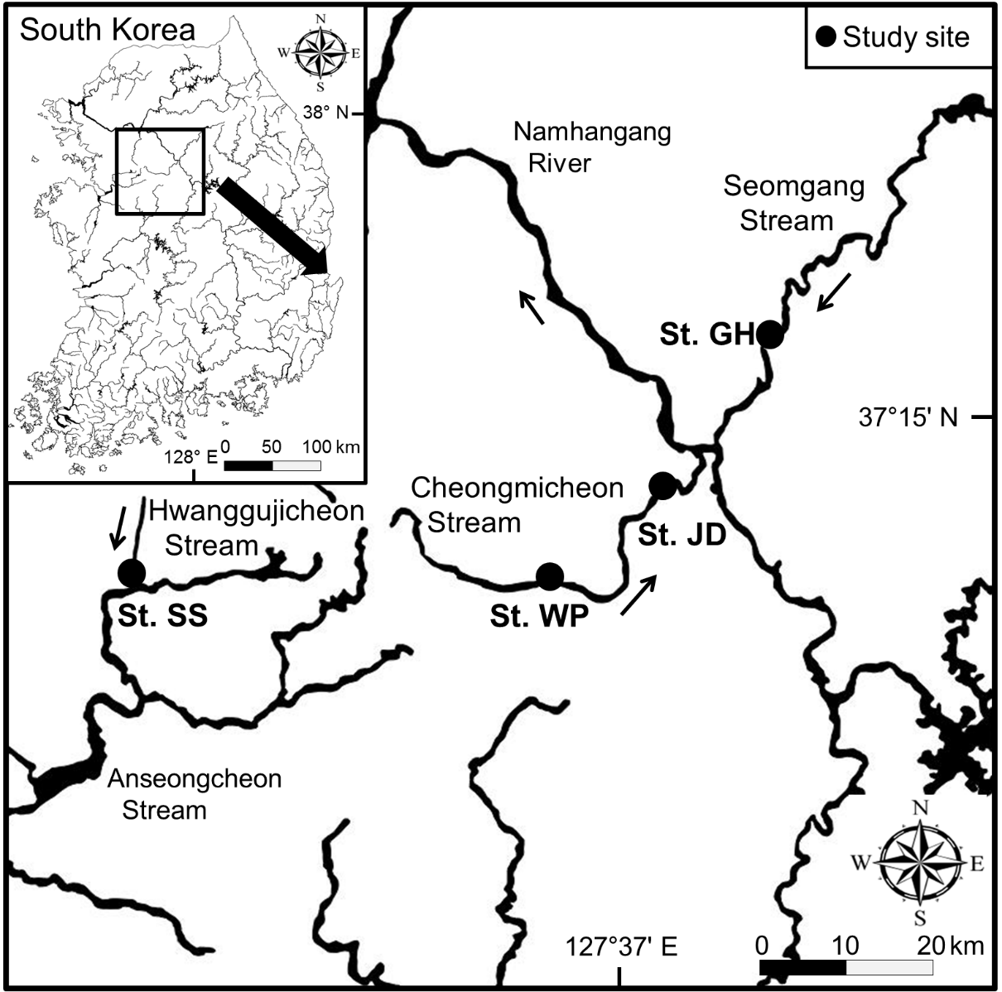
Fig. 1. Location of the four study sites in South Korea. Each one has floodplains that are hydrologically-connected to, and isolated from, the stream channel (St. GH, Ganhyeon; St. JD, Jeomdong; St. SS, Songsan; St. WP, Wolpo)

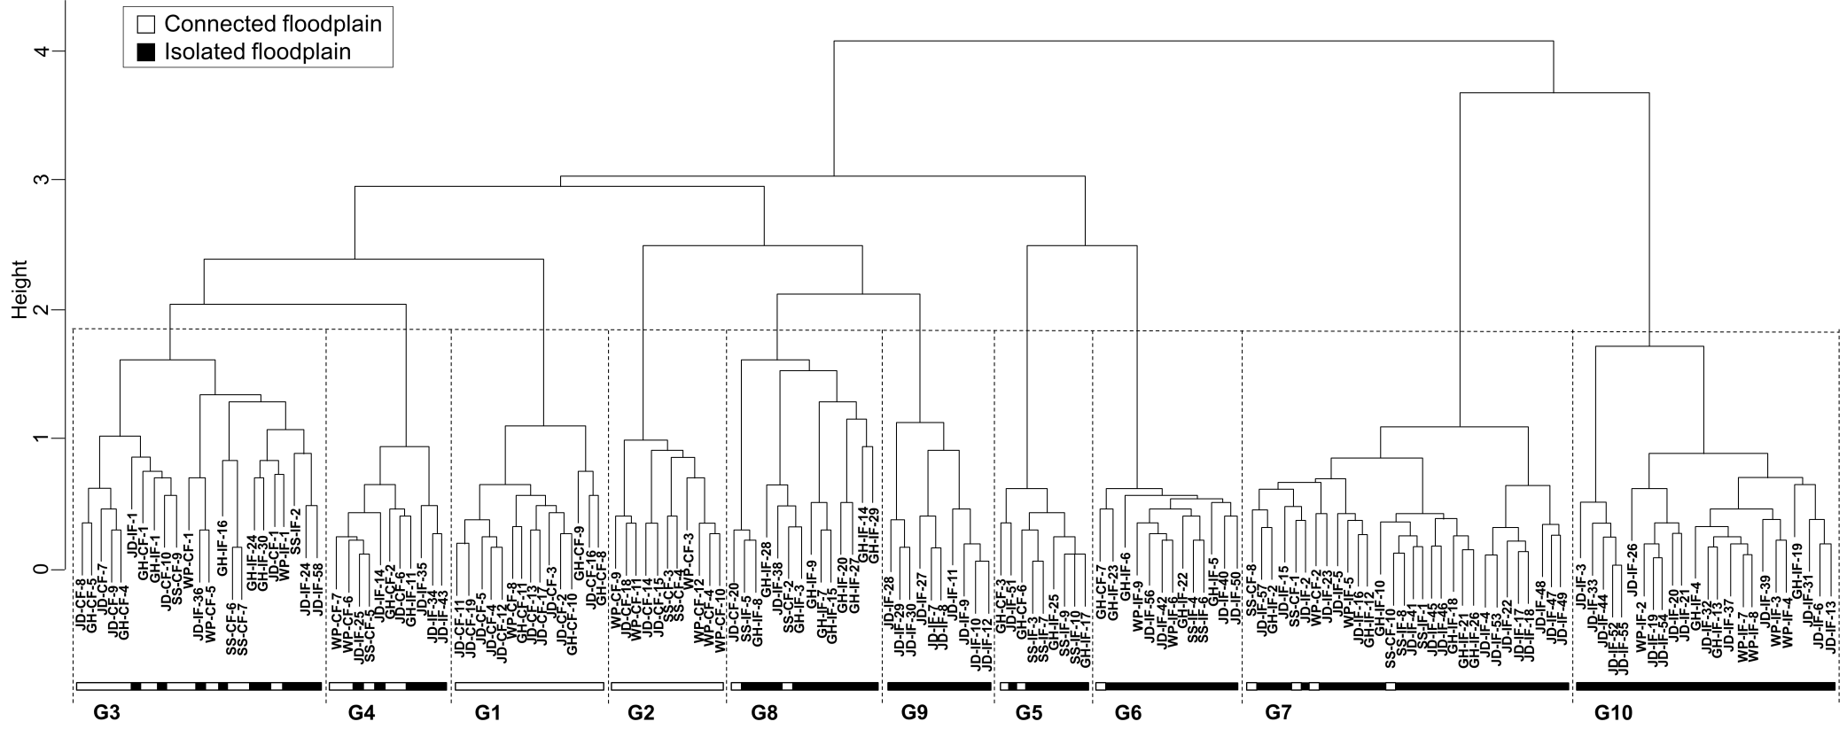
Fig. 2. Classification of the plant community groups of the floodplains that are hydrologically-connected (open horizontal bar) to, and isolated (closed bar) from, the stream channels in South Korea. Box symbols represent main community groups. Codes: the first two characters, site name in Table 1; the next two characters CF, connected floodplain; IF, isolated floodplain; the last numeral = quadrat number

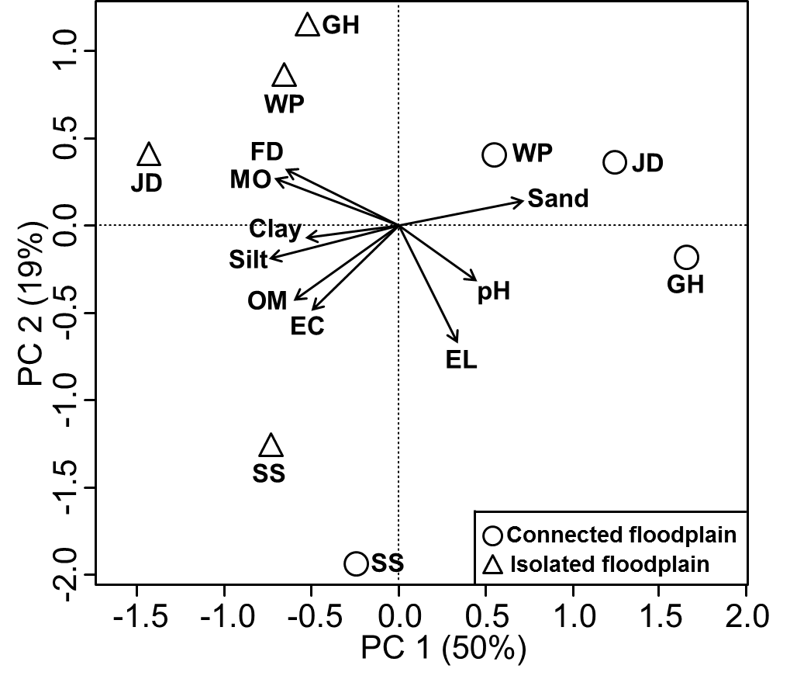
Fig. 3. Biplot of Principal Components Analysis (PCA) of the environmental variables from the connected and the isolated floodplains in South Korea The length and angle of arrows show the contribution of a particular environmental variable to the PCA axes. The open circle indicates the connected floodplain and the open triangle indicates the isolated floodplain (EC, soil electrical conductivity; EL, topographic elevation; FD, flood duration; MO, soil moisture; OM, soil organic matter. Other abbreviations are provided in Table 1.)

(a) Species | (b) Species traits
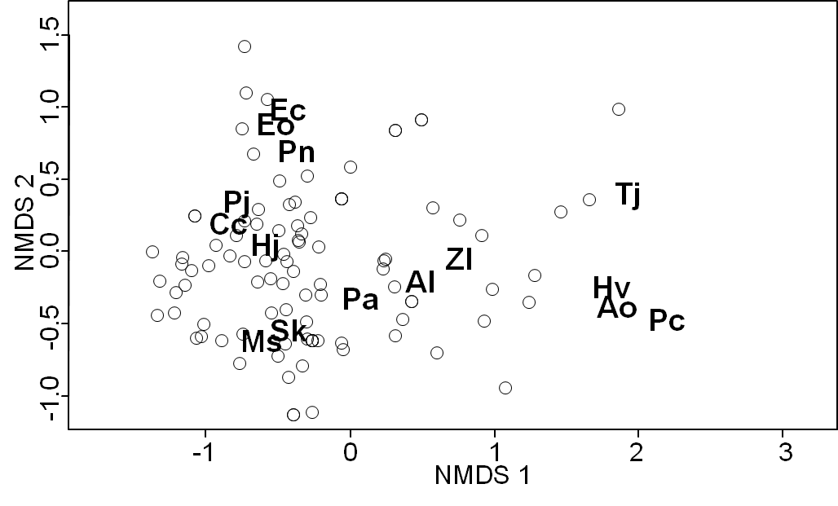 | 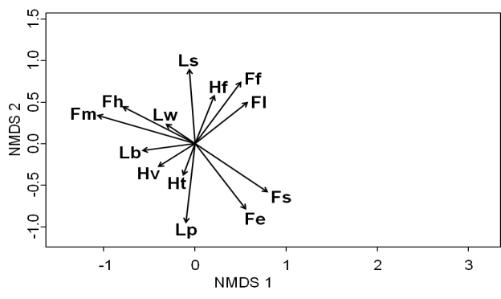
(c) Environmental variables | (d) Quadrats; IF versus CF
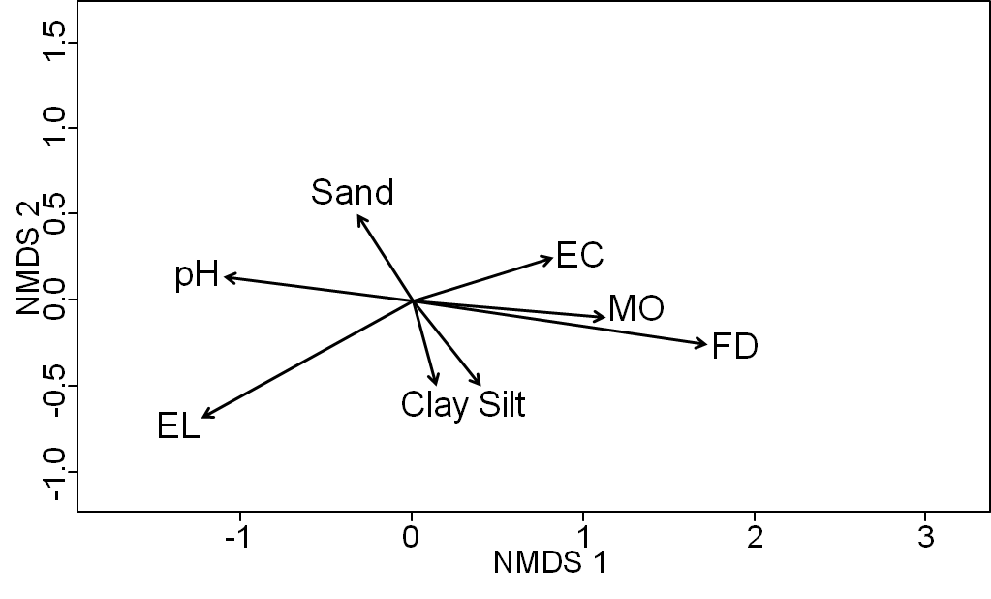 | 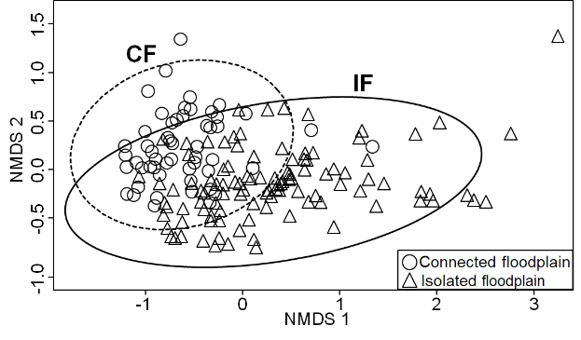
(e) Quadrats; Groups 1 & 2 | (f) Quadrats; Groups 3, 4 & 5
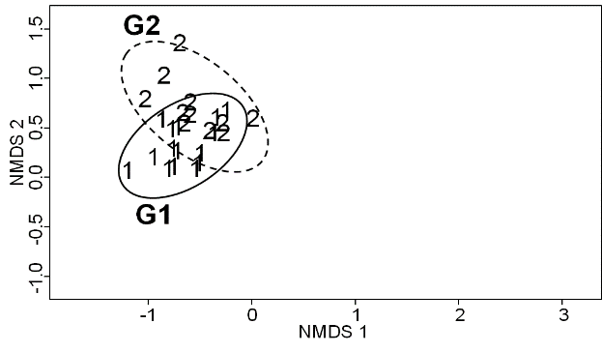 | 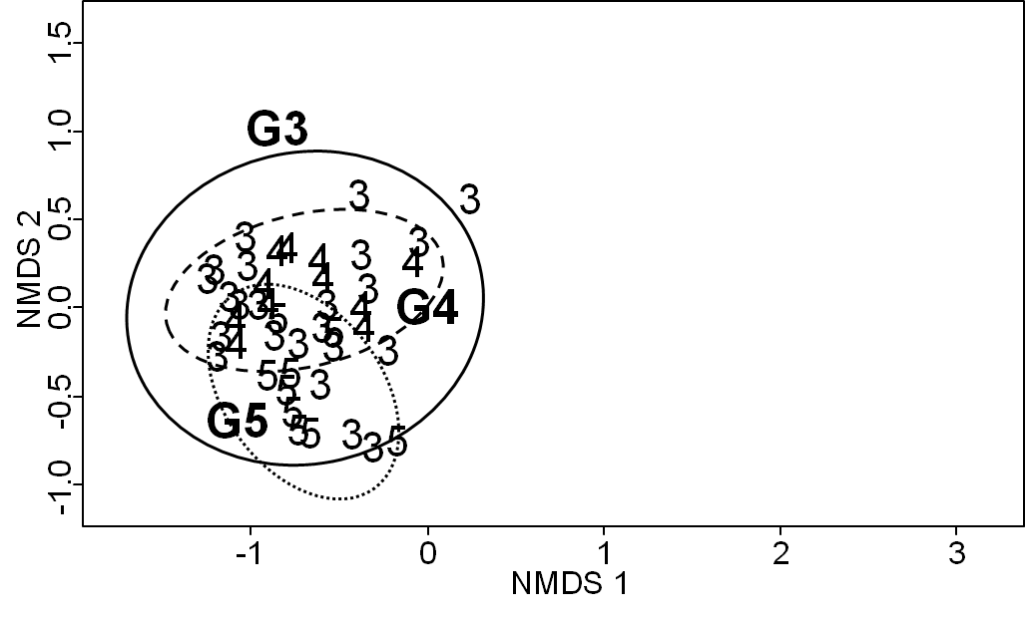
(g) Quadrats; Groups 6, 7 & 8 | (h) Quadrats; Groups 9 & 10
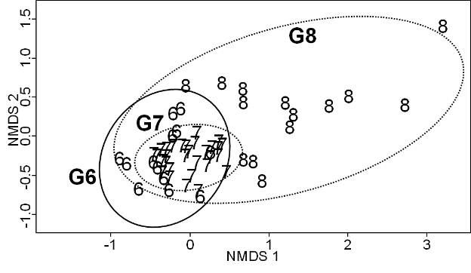 | 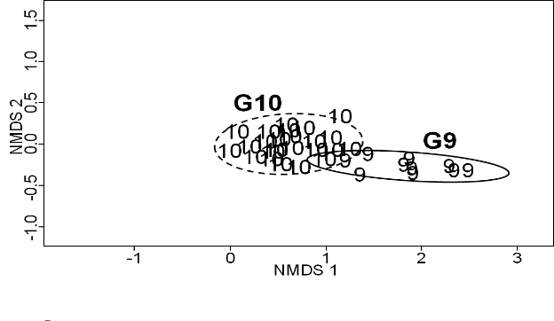
Fig. 4. Biplots of non-metric multidimensional scaling (NMDS) using vegetation in the connected and the isolated floodplains in South Korea: (a) Distribution of all species with indicator species identified by abbreviation (Table 3), (b) species traits (codes for the species traits: Fe = emergent hydrophytes, Ff = free-floating hydrophytes, Fh = hygrophytes, Fl = floating-leaved hydrophytes, Fm = mesophytes, Fs = submerged hydrophytes, Hf = forbs, Hg = graminoids, Ht = trees and shrubs, Hv = vines, Lb = biennials, Lp = perennials, Ls = summer annuals, Lw = winter annuals), (c) environmental variables (codes for the environmental variables: EC = soil electrical conductivity, EL = topographic elevation, FD = flood duration, MO = soil moisture), (d) arrangement of all quadrats, isolated floodplain (IF) = triangle and solid lines, connected floodplain (CF) = circle and dotted lines, and (e-h) arrangement of quadrats according to the plant communities described in Table 2. All ellipses illustrate 95% confidence intervals
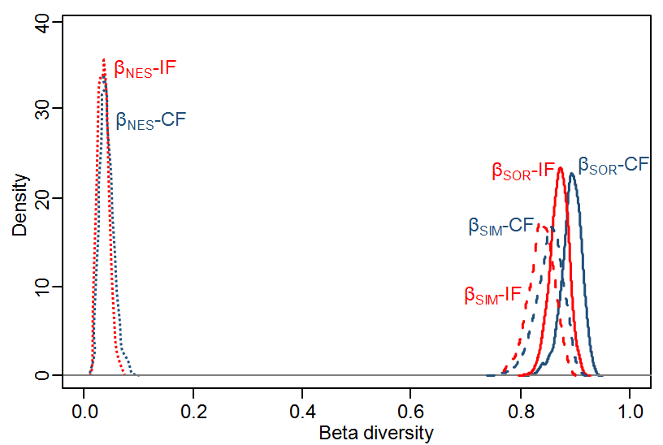
Fig. 5. β-diversity partitioning in plant species composition of all sites combined in the connected (CF, blue line) and isolated floodplains (IF, red line) in South Korea (solid lines, β_{SOR}; dashed lines, β_{SIM}; dotted lines, β_{NES})

Table 1. Abbreviation and location of the study sites in South Korea, each with connected and isolated floodplains, along with the time since isolation by levee construction and the land-use of the adjoining areas
Stream | Study site | Abbreviation | Latitude | Longitude | Time since isolation by leveeª  (yr) | Land-use
Cheongmicheon | Jeomdong | JD | 37°11'N | 127°41'E | 34 | Agricultural land, pump-drainage station
 | Wolpo | WP | 37°05'N | 127°34'E | 48 | Agricultural land, pump-drainage station
Hwanggujicheon | Songsan | SS | 37°06'N | 126°59'E | 10 | Agricultural land
Seomgang | Ganhyeon | GH | 37°21'N | 127°50'E | 38 | Agricultural land, Forestry, Residential
ª data derived from MOLIT (2001, 2007, 2011).
Table 2. Characteristics of community structure and percent allocation of sampling quadrats of the ten major plant community groups identified within the connected (CF) and the isolated (IF) floodplains
Group | Dominant species | Sub-dominant species | Cover of dominant sp. (%) | No. of species | Diversity index | Allocation of quadrats (%)
 |  |  |  |  |  | CF | IF
1 | Phragmites japonica | Artemisia selengensis,  Artemisia princeps,  Humulus japonicus | 70 | 35 | 2.12 | 100 | 0
2 | Echinochloa crusgalli var. oryzicola,  Echinochloa crus-galli,  Persicaria nodosa | Ambrosia trifida,  Artemisia princeps,  Panicum dichotomiflorum | 40 | 21 | 2.35 | 100 | 0
3 | Conyza canadensis,  Artemisia princeps,  Setaria viridis,  Glycine Soja | Digitaria ciliaris,  Pueraria lobata,  Galium spurium var. echinospermon | 30 | 52 | 3.27 | 57 | 43
4 | Humulus japonicus | Persicaria senticosa,  Pueraria lobata,  Setaria viridis | 80 | 32 | 1.99 | 45 | 55
5 | Miscanthus sacchariflorus | Artemisia princeps,  Humulus japonicus | 90 | 15 | 1.52 | 22 | 78
6 | Salix koreensis | Phragmites australis,  Phragmites japonica,  Miscanthus sacchariflorus | 80 | 40 | 2.15 | 8 | 92
7 | Phragmites australis | Persicaria thunbergii | 80 | 52 | 2.18 | 13 | 87
8 | Trapa japonica,  Typha angustifolia,  Leersia japonica | Salvinia natans,  Oenanthe javanica | 70 | 23 | 2.56 | 14 | 86
9 | Potamogeton crispus,  Hydrilla verticillata,  Alisma orientale | Trapa japonica,  Typha angustifolia | 40 | 8 | 1.45 | 0 | 100
10 | Zizania latifolia | Actinostemma lobatum,  Persicaria thunbergii,  Typha angustifolia,  Scirpus radicans | 70 | 19 | 1.92 | 0 | 100

Table 3. Major indicator species of the ten major plant community groups identified within the connected and the isolated floodplains
Group | Indicator species | Abbreviation | P value | Indicator valueª
1 | Phragmites japonica | Pj | <0.001 | 0.854
2 | Echinochloa crusgalli var. oryzicola | Eo | <0.001 | 0.981
 | Echinochloa crus-galli | Ec | <0.001 | 0.897
 | Persicaria nodosa | Pn | <0.001 | 0.562
3 | Conyza canadensis | Cc | <0.001 | 0.566
4 | Humulus japonicus | Hj | <0.001 | 0.753
5 | Miscanthus sacchariflorus | Ms | <0.001 | 0.932
6 | Salix koreensis | Sk | <0.001 | 0.887
7 | Phragmites australis | Pa | <0.001 | 0.860
8 | Trapa japonica | Tj | <0.01 | 0.489
9 | Potamogeton crispus | Pc | <0.001 | 0.946
 | Alisma orientale | Ao | <0.001 | 0.925
 | Hydrilla verticillate | Hv | <0.001 | 0.624
10 | Zizania latifolia | Zl | <0.001 | 0.882
 | Actinostemma lobatum | Al | <0.001 | 0.663
ª Indicator value is an index with a maximum value of 1.00 occurring when a species is restricted to one group and present in all samples of the group.

Online Resource: Supplementary Material

Hydrologically-connected and isolated floodplains in channelized streams: impacts on plant communities

Hydrobiologia

Yunsoo Chuª, Seung-Nam Jin^{b}, Josu G. Alday^{c}, Rob H. Marrs^{d}, Kang-Hyun Cho^{b, d, *}

ª National Institute of Ecology, Seocheon 33657, Republic of Korea
^{b} Department of Biological Sciences, Inha University, Incheon 22212, Republic of Korea
^{c} Department of Crop and Forest Sciences—AGROTECNIO Center, Universitat de Lleida, 25198 Lleida, Spain
^{d} School of Environmental Sciences, University of Liverpool, Liverpool L69 3GP, UK

* Corresponding author (Kang-Hyun Cho)
E-mail address: khcho@inha.ac.kr
Telephone number: +82 32 860 7698

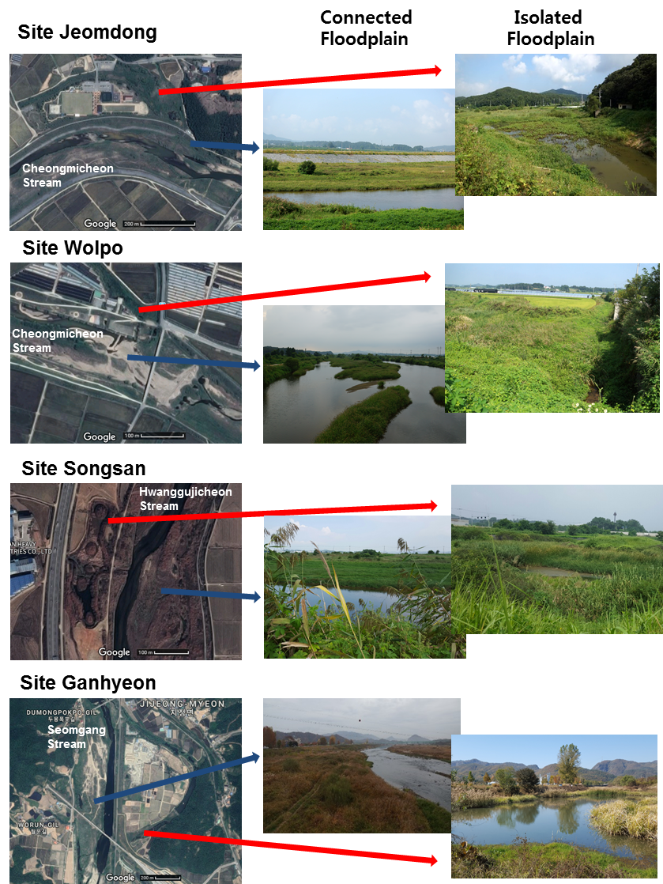

Fig. S1. Satellite image and photographs of the connected and isolated floodplains at the study sites in South Korea

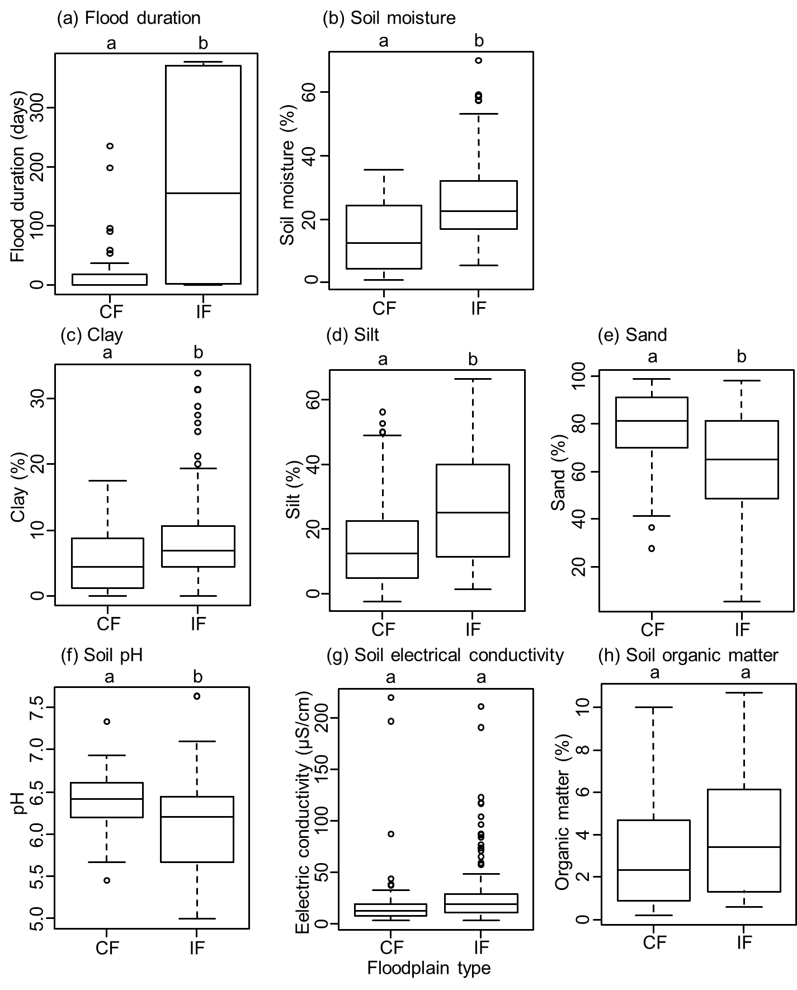
Fig. S2. Comparison of environmental factors between the connected (CF) and the isolated (IF) floodplains in South Korea: (a) flood duration, (b) soil moisture content, (c) clay content, (d) silt content, (e) sand content, (f) soil pH, (g) soil electrical conductivity and (h) soil organic matter content. Different letters above the graph indicate significant differences between mean vales of the two floodplain types (P<0.05). In the box plot, the horizontal thick line shows the median. The bottom and top of the box show the 25th and 75th percentiles, respectively. The upper whisker shows the largest data point that is less than 1.5 times the interquartile range above the 75th percentile, and the lower whisker shows the smallest data point that is less than 1.5 times the interquartile range above the 25th percentile. The open circles outside the whiskers show the outliers.

Table S1. Major plant species found in the study floodplains and their functional traits
Scientific name | Abbreviation | Species traitª
 |  | Life longevity | Growth form | Growth habit
Actinostemma lobatum | Al | Ls | Fe | Hv
Alisma orientale | Ao | Lp | Fe | Hf
Ambrosia trifida | At | Ls | Fm | Hf
Artemisia princeps | Ar | Lp | Fm | Hf
Artemisia selengensis | As | Lp | Fh | Hf
Bidens frondosa | Bf | Ls | Fh | Hf
Carex dimorpholepis | Cd | Lp | Fh | Hg
Conyza canadensis | Cc | Lw | Fm | Hf
Digitaria ciliaris | Dc | Ls | Fm | Hg
Echinochloa crus-galli | Ec | Ls | Fh | Hg
Echinochloa crusgalli var. oryzicola | Eo | Ls | Fh | Hg
Eichhornia crassipes | Es | Lp | Fl | Hf
Galium spurium var. echinospermon | Ga | Lw | Fm | Hv
Glycine soja | Gs | Ls | Fm | Hv
Humulus japonicus | Hj | Lp | Fm | Hv
Hydrilla verticillata | Hv | Lp | Fs | Hf
Leersia japonica | Lj | Lp | Fe | Hg
Miscanthus sacchariflorus | Ms | Lp | Fh | Hg
Oenanthe javanica | Oj | Lp | Fe | Hf
Panicum dichotomiflorum | Pd | Ls | Fm | Hg
Persicaria nodosa | Pn | Ls | Fm | Hf
Persicaria senticosa | Ps | Ls | Fm | Hv
Persicaria thunbergii | Pt | Ls | Fh | Hv
Phalaris arundinacea | Pr | Lp | Fh | Hg
Phragmites australis | Pa | Lp | Fe | Hg
Phragmites japonica | Pj | Lp | Fh | Hg
Potamogeton crispus | Pc | Lp | Fs | Hf
Pueraria lobata | Pl | Lp | Fm | Hv
Salix koreensis | Sk | Lp | Fh | Ht
Salvinia natans | Sn | Ls | Ff | Hf
Scirpus radicans | Sr | Lp | Fe | Hg
Setaria viridis | Sv | Ls | Fm | Hg
Spirodela polyrrhiza | Sp | Ls | Ff | Hf
Trapa japonica | Tj | Ls | Fl | Hf
Typha angustifolia | Ta | Lp | Fe | Hg
Zizania latifolia | Zl | Lp | Fe | Hg
ª Lp, perennial; Ls, summer annual; Lw, winter annual; Fe, emergent hydrophyte; Ff, free-floating hydrophyte; Fl, floating-leaved hydrophyte; Fs, submerged hydrophyte; Fh, hygrophyte; Fm, mesophyte; Hf, forb; Hg, graminoid; Ht, tree and shrub; Hv, vine.

Table S2. β-diversity partitioning of the plant species composition in the connected and isolated floodplains at the study sites in South Korea.
Study site | Connected floodplain |  |  | Isolated floodplain
 | β_{SOR} | β_{SIM} | β_{NES} | β_{SOR} | β_{SIM} | β_{NES}
Jeomdong | 0.852 | 0.799 | 0.053 | 0.863 | 0.811 | 0.052
Wolpo | 0.788 | 0.752 | 0.035 | 0.808 | 0.723 | 0.084
Songsan | 0.840 | 0.790 | 0.050 | 0.787 | 0.708 | 0.079
Ganhyeon | 0.834 | 0.805 | 0.029 | 0.897 | 0.860 | 0.037

Table S3. Correlation between the environmental properties and the first two axes of the non-metric multidimensional scaling (NMDS) of the floodplain vegetation in the Cheongmicheon, Hwanggujicheon, and Seomgang Streams, South Korea. The correlation coefficients were derived from a permutation test (n=1000). Significance level: * P<0.05, ** P<0.01, *** P<0.001, ^{ns} not significant at α=0.05.
Variable | Abbreviation | Axis 1 | Axis 2 | R² | P
Topographic elevation | EL | -0.930 | -0.367 | 0.389 | 0.000***
Flood duration | FD | 0.989 | -0.145 | 0.632 | 0.000***
Soil moisture | MO | 0.986 | -0.165 | 0.254 | 0.000***
Clay content | Clay | 0.264 | -0.964 | 0.048 | 0.015*
Silt content | Silt | 0.581 | -0.813 | 0.067 | 0.003**
Sand content | Sand | -0.492 | 0.870 | 0.070 | 0.002**
Soil pH | pH | -0.907 | 0.419 | 0.247 | 0.000***
Soil Electrical conductivity | EC | 0.899 | 0.436 | 0.182 | 0.000***
Soil Organic matter | OM | 0.361 | -0.948 | 0.012 | 0.391^{ns}

Table S4. Comparison of environmental variables of the ten major plant community groups identified within the connected and the isolated floodplains. The different superscripts in the same column indicate the significant difference at α=0.05 (EL, topographic elevation above annual median water level; FD, flood duration; MO, soil moisture; OM, soil organic matter; EC, soil electrical conductivity)
Group | EL  (m) | FD  (days/year) | MO  (%) | OM  (%) | pH | EC  (μS/cm) | Sand  (%) | Silt  (%) | Clay  (%) | n
1 | 1.1±0.2^{abc} | 15±6^{d} | 11.1±2.4^{d} | 1.9±0.6^{b} | 6.5±0.1ª | 12.0±1.9^{b} | 83±5ª | 12±4^{b} | 5±1^{b} | 15
2 | 0.6±0.2^{bcd} | 17±6^{cd} | 14.4±3.8^{cd} | 2.2±0.7^{b} | 6.4±0.1^{abc} | 30.9±18.9^{ab} | 86±3ª | 10±3^{b} | 4±1^{b} | 11
3 | 2.2±0.3ª | 18±8^{d} | 13.3±1.7^{d} | 3.6±0.5^{ab} | 6.5±0.1ª | 18.6±3.2^{b} | 70±4^{ab} | 23±3^{ab} | 7±1^{b} | 23
4 | 1.8±0.4^{ab} | 19±19^{cd} | 20.6±2.2^{bcd} | 4.4±1.0^{ab} | 6.5±0.1^{ab} | 32.5±16.7^{ab} | 71±5^{abc} | 24±5^{ab} | 5±1^{b} | 11
5 | 2.1±0.5^{ab} | 13±8^{cd} | 16.0±2.4^{bcd} | 3.5±0.6^{ab} | 6.5±0.1^{ab} | 11.4±1.2^{ab} | 73±5^{abc} | 21±4^{ab} | 6±2^{ab} | 9
6 | 1.4±0.3^{ab} | 59±24^{cd} | 23.9±4.8^{abcd} | 4.6±0.8^{ab} | 6.0±0.1^{abcd} | 23.0±7.4^{ab} | 63±6^{abc} | 27±5^{ab} | 10±2^{ab} | 13
7 | 1.1±0.3^{bc} | 111±25^{c} | 27.7±2.2^{abc} | 5.1±0.4ª | 6.3±0.1^{ab} | 21.9±5.9^{b} | 58±5^{bc} | 31±4ª | 11±2^{ab} | 30
8 | -0.1±0.1^{cd} | 304±25^{ab} | 37.1±3.9ª | 4.4±0.8^{ab} | 6.0±0.2^{bcd} | 60.1±14.5ª | 70±5^{abc} | 25±5^{ab} | 5±1^{b} | 14
9 | -0.7±0.0^{d} | 375±0ª | 26.6±4.4^{abcd} | 1.6±0.5^{b} | 5.8±0.1^{cd} | 42.3±9.1^{ab} | 72±5^{abc} | 22±5^{ab} | 6±1^{ab} | 10
10 | -0.1±0.1^{d} | 262±26^{b} | 30.2±4.2^{ab} | 3.3±0.6^{ab} | 5.7±0.1^{d} | 43.6±7.6^{ab} | 48±6^{c} | 38±5ª | 14±2ª | 24

