Abstract: This paper examines bots - software applications that automate web-based tasks, and which often mimic human interaction and communication - to consider sociological responses to software design and computer programming. Leveraging design methodologies for critical sociological purposes allows us to envision programming as (a) a means of opening up 'black boxes' by engaging more directly with the code through which software applications are executed, and (b), indicates the potential for sociology practitioners to design software ourselves - to build applications that fulfil the radical promise of sociology by intervening in social processes. To concretise these ideas, this paper presents two stories about social media bots developed by the author; ‘Philbot’ (a Facebook random status generator) and ‘@_Zen_Bot_’ (a Twitter service that provides mock lifestyle advice to users). On the basis of this demonstration, this paper proposes a near-future vision of sociology where Programming-as-Social-Science features as a core research method/skill/tool.

Keywords: bots; digital methods; 'hacktivism'; Programming-as-Social-Science (PaSS).

My Unexpectedly Militant Bots: A Case for Programming-as-Social-Science
Phillip Brooker (University of Liverpool)

Bots are, in abstract, software applications that automate internet-based tasks on behalf of humans. Typically interactive, they co-generate sociality by engaging human users conversationally. We routinely encounter bots in our day-to-day dealings with software and devices – for instance, we invite Siri (Apple), Cortana (Microsoft) and Alexa (Amazon) into our homes as personal assistants capable of responding to voice and/or text input to look up information, schedule meetings, play media and shop for consumer products. Despite these high profile and (seemingly) benign examples, bots have simultaneously emerged as a contemporary moral panic, due to their widespread proliferation and capacity to ‘pass’ as human. Bots have become recognised for their roles in nefarious activities, including attempts to attract men to the notorious Ashley Madison affair-arranging service by harnessing between 12,000 and 70,000 bots to create an illusion of readily available women subscribers (Hern, 2015; Newitz, 2015) and providing human/American-looking cover for large-scale Russian electioneering in Donald Trump’s 2016 presidential campaign (Guynn, 2018; Shugerman, 2018). Bots have long been a significant element of the internet and the interactions facilitated therein – in 2009, bots were responsible for 24% of all Twitter activity (Sysomos.com, 2009), and in 2016 accounted for more than half (51.8%) of total web traffic (Zeifman, 2016). As a result of their ubiquity and import, bots have become known (and feared) cultural objects in academia and culture alike.

This proliferation of bots has also suggested a capacity for digital technologies to function as sites of political deliberation and ‘hacktivism’ (Jordan, 2002; Jordan and Taylor, 2004) – the disruption of social injustice via (‘homemade’/’grassroots’) computational and technological innovations. As such, spaces like social media platforms are not just forums for talking about socially-relevant issues (though that is part of what goes on there: cf Brooker et al, 2015, 2018; Feltwell et al, 2017), but where digital automated tools can be, and routinely already are, leveraged to assist in that work. As such, bots demand sociological consideration. Much of the concern around bots has focussed on their capacity for difficult-to-detect deception; to mimic human communication well enough to effect large-scale ideological and/or behavioural influencing (Aiello et al, 2012; Boshmaf et al, 2011; Ferrara et al, 2016; Haustein et al, 2016; Shao et al, 2017). I disagree with the reactionary ‘scaremongering’ perspective propounded by such authors, instead suggesting that sociologists engage more directly with bots on the level of their code to provide researchers a way to treat bots as both topic and resource, and to start to think about how we might use bots to intervene critically (ie resist, mitigate, counteract) in problematic social processes evident online. Because of this, I suggest that sociologists are now duty-bound to become better-acquainted and better-skilled with computer programming as the medium through which socially-relevant innovations (including bots) are designed, built and executed. Similar experimentation with programming languages is not as new to other fields such as software studies and digital humanities (cf. Internetstiftelsen (2016), Manovich (2013), Montfort (2016), Parrish (2016, 2018), Webstock (2017) and Wardrip-Fruin (2009)) as it is sociology. However, though a detailed investigation of how and why other fields have developed programming skills might provide interesting points of comparison for us, the different disciplinary context of sociology (where programming skills are, as yet, largely absent) offers an opportunity to willingly and gleefully define the problems and solutions for ourselves.

To this end, this paper explores the idea of programming bots as a new form of engaging in (digital) social interactions of relevance to sociological practice. This begins with a discussion of software design as a critical sociological issue, and an examination of literature around bots as devices within which design implications become activated. From here, I present two stories about bots I have built and their (unintended) sociological relevance, as a way to demonstrate these issues not just in abstract but in terms of the code that constructs them. This is followed by some more general reflections on the idea of programming as a social research method, suggesting that programming is a vital tool for responding to emerging issues and is potentially transformative across the social sciences in terms of how we understand and intervene in the world.

Software Design as a Sociological Concern

Design, as with any human activity, is an inherently political and ideological exercise – this is long-known to Science and Technology Studies (STS) and Human-Computer Interaction (HCI) researchers amongst others¹. Software can be designed with built-in social injustices. One example is Google Translate’s algorithm which (before it was corrected) translated from Turkish (a gender neutral language that refers to people with ‘o’) to English (which uses separate words for ‘she’ and ‘he’ etc) in such a way that un-gendered sentences became sexist – non-gendered statements in Turkish produced gender biases when Google-translated into English (eg ‘he is a doctor’, but ‘she is a nurse’) (Shams, 2017). Another example is the now-retired Tay, Microsoft’s Twitter chatbot, which almost immediately upon implementation began to post highly offensive (particularly racist and sexist) tweets after having been purposely fed such input via conversations with malicious trolls (Neff and Nagy, 2016; Perez, 2016). Reflecting on how these results were motioned in the design stages, we might note that Google Translate draws on frequencies of word usage to inform how it genders terms from non-gendered languages, and was as such built to reinforce the dominant ideological gender biases that users fed it. Similarly, by uncritically taking conversational cues from other Twitter users, Tay was not primed to resist hateful commentary but in fact built to platform it. Both examples thereby exhibit (lazy, ill-thought-out) design choices that result in the magnification of social injustice.

However, software design also has the potential to make critical, provocative and positive interventions. For instance, Bogost highlights Molleindustria’s The McDonald’s Videogame, which puts players in charge of the McDonald’s production environment – ‘the third-world pasture where cattle are raised as cheaply as possible; the slaughterhouse where cattle are fattened for slaughter; the restaurant where burgers are sold; and the corporate offices where lobbying, public relations and marketing are managed’ (2007: 29). To generate profit, players must decide whether or not to pursue ‘questionable business practices’ (2007: 30) such as feeding cattle cheap animal by-products, and bribing health officers when the inevitably diseased meat makes it into restaurants. Another example is the (now defunct) @DroptheIBot: a Twitter bot that sought out tweeters using the term ‘illegal immigrant’ and automatically responded to them with ‘People aren’t illegal. Try saying “undocumented immigrant” or “unauthorized immigrant” instead.’ (BBC News, 2015). @DroptheIBot was on the whole received negatively by those who triggered it – some users did not appreciate being ‘corrected’ by a bot, others did not recognise @DroptheIBot as a bot at all and were hostile towards the perceived butting-in. This, coupled with the frequency of its responses contravening Twitter’s terms and conditions, saw the account subsequently suspended. Reflecting on what the objectives of these designed softwares are, we might note that The McDonald’s Videogame engages players in the (questionable) morality of global fast food business practices, to foster critiques of them. Similarly, in locating and interrupting the usage of the term ‘illegal immigrant’, @DroptheIBot aimed to topicalise the dehumanising function of the term for those it refers to. Both The McDonald’s Game and @DroptheIBot signify a potential role for software design in responding and reacting to social injustices.

Thinking about design in this way opens design up as a sociological matter, as evidenced in Lupton’s (2018) vision of ‘design sociology’. As Lupton outlines, the concept of design:

‘refers to developing an idea about a product, system, service or policy to meet human needs and devising a plan for executing that idea...A design problem is developed, which the actions of designers need to address to achieve a better solution for relevant stakeholders...Design involves an iterative process of problem solving that includes identifying the practices and needs of end users, generating and testing ideas and then implementing them.’ (Lupton, 2018: 2)
The user-oriented focus of design, therefore, leads to a preoccupation with sociologically-relevant concerns – as Lupton notes, ‘Like sociologists and other social researchers...many design researchers now focus their attention on the sociotechnical contexts of design as a practice and the sociocultural dimensions of the objects and systems that emerge from and are enacted through these practices’ (2018: 3). Moreover, this natural affinity of design and sociology is also useful in terms of widening the scope and impact of sociological research beyond existing practice:

‘One of the strongest contributions that design sociology can make is to inspire creative thinking not only for sociologists but also for people, groups or organisations outside academia who take part in their research, developing multiple vantage points, new ways of telling and showing...Using design methods can be a playful and enjoyable way for research participants to engage in social research, with the potential to elicit ideas and responses that would not emerge from more traditional sociological methods.’ (Lupton, 2018: 6)

Taking Lupton’s vision of design sociology as a platform, we can begin to think about drawing in distinctive design methodologies to sociology’s remit – though there are a multitude of design methodologies (see Lupton (2018) and Wilkie et al (2015)), Di Salvo’s (2012) adversarial design stands as one particularly compelling example, especially within the context of bots. Adversarial design is political, inasmuch as it enables and facilitates agonism (ie the acknowledgement and encouragement of disruption and conflict as a vehicle for deliberation). As Di Salvo notes, ‘Adversarial design is a kind of cultural production that does the work of agonism through the conceptualization and making of products and our experiences of them’ (2012: 2) – in short, adversarial design is about designing software and technology that generates confrontational/disruptive user experiences, for the purposes of encouraging users to break out of uncritical/taken-for-granted/dominant-ideological/status-quo thinking around the issues ignited by the technology. Di Salvo notes adversarial design principles in Amy and Klara; an experimental art engineering project by Marc Böhlen. Amy and Klara ‘are physically instantiated as stationary boxes that are painted hot pink [invoking gender], equipped with speakers and that curse at and argue with each other’ (Di Salvo, 2012: 77). In the installation, a conversation is started between the robots using text-to-speech and automated speech recognition algorithms (with input drawn from online lifestyle magazines) – though Amy and Klara’s conversation may start amicably, inevitable ‘misunderstandings’ instigate the gradual escalation of the conversation into arguments, personal insults and, eventually, silent sulking. The purpose of the confrontational relationship designed into Amy and Klara is to provoke thinking around what kinds of communication we might normally expect people (women particularly) to hold publically, by designing intentionally counter-intuitive conversational practices into robotic devices which would not normally feature them; for instance, compare Amy and Klara to more congenial and subservient personal assistants such as Siri, Cortana and Alexa.

Hence, software design is a contested and contestable social tool – a space where social problems can be created and magnified, but one where such problems can also be highlighted and addressed. What follows is a narrowing-down of these ideas to a more specific focus on bots as designed-and-designable technologies.

Bots as a Moral Panic/Bots as Positive, Creative and Playful
Turning now to social media bots (as a type of bot of recent interest both culturally and academically), there has been a shift from depicting bots as insidious infections against which platform users must inoculate themselves, to a more nuanced understanding that reflects the different functions bots hold for those that build and use them.
In an early study of bots, Boshmaf et al set out the ‘problem’ as follows:
‘during the 2008 U.S. presidential election, social media was heavily employed by Obama’s campaign team who raised about a half a billion dollars online, introducing a new digital era in presidential fundraising...Moreover, it has been argued that OSNs [Online Social Networks], as democracy-enforcing communication platforms, were one of the key enablers of the recent Arab Spring in the Middle East...Such a global integration of social media into everyday life is rapidly becoming the norm, and arguably is here to stay...But what if some of the content in social media...is not written by human beings?’ (Boshmaf et al, 2011: 93)
The worry here is three-fold: first, that bots make up a limitless army of automated political agents that appear human (but which transcend, tirelessly, humans’ ability to reach others online). Second, that such bots can effect behavioural/attitudinal change in humans deceived by them² through relatively simple online interactions (such as following other users, visiting others' profiles, sending them messages, etc). Third, that such influence is used to spread misinformation for political/ideological purposes (cf Shao et al, 2017). Hence, the recommendations of such studies have been around limiting the damage-potential of bots; typically advocating more effective methods of distinguishing between bot and human activities online (eg Haustein et al, 2016) or culling bots from platforms altogether (eg Shao et al, 2017). These studies present a picture of bots as fundamentally deceptive and manipulative, coming from without and requiring decisive intervention.
However, rather than focus on whether or not content produced by bots is indistinguishable from that of humans, others prefer to begin elsewhere: ‘The question is no longer whether bots can pass, but how social interaction with them may be meaningful’ (Jones, 2015: 1), and what interactions with bots can tell us about ourselves (Weil, 2017; Bollmer and Rodley, 2017. As Jones elaborates, bots:
‘both elicit and operate within particular contexts and constraints that rely on the symbolic construction of reality...The expressions and exchanges visible on social media ought not therefore be analyzed and interpreted solely without context or without consideration of their symbolic and affective dimensions, whether originating in humans or machines.’ (Jones, 2015: 1-2).
Coupling this focus on the situated practical context of bot-human interaction with the idea of design (via Lupton (2018) and Di Salvo (2012)) opens up a space to think about understanding bot-human interaction as playful, creative, positive and/or useful both culturally and sociologically. Nishimura takes such an approach in an examination of ‘semi-autonomous fan-fiction’ on the (primarily) public social media platform Twitter:
‘When using Twitter in Japanese, one encounters many self-declared bot accounts, including bots that actively respond to the tweets [posts] of those that follow them. There are also ‘character bots’, or automated programs designed to ‘behave’ like the characters from popular anime, manga (comic books) and video games...followers enjoy conversing with character bots knowing full well that they are automated programs and designed to behave as fictional characters.’ (Nishimura, 2017: 128).
For the communities of bot-creators and bot-users Nishimura investigates, these bots do not ‘deceive’. They are not feared because they are ‘unreal’, but are instead valued for what they add to popular fiction entertainment formats – moments of interactivity between fans and characters which cannot happen elsewhere (eg in TV or comic books). As Nishimura notes, these bots ‘need not...”pass” as humans to be successful. Rather, successful interactions can emphasize the bots non-humanness’ (Nishimura, 2017: 129), treating non-humanness as an interactional resource wherein the fictional aspect is integral to the interaction.
With a similar focus on bots as creative and playful, Massanari (2017) explores what makes a good bot on the social voting platform Reddit (where users shape what is seen on the platform by upvoting good content and downvoting bad, to make good content more visible). As she notes, ‘Play serves as an organizing function on Reddit, becoming a way for the community to be created and maintained’ (Massanari, 2017: 113-114). Bots have emerged as a significant element to the ‘carnivalesque’ aspects of the platform, with bot-building becoming a relatively well-established practice amongst sections of Reddit’s user-base (cf Long et al, 2017). As a result, bots undertake a variety of functions, from the automation of mundane forum (‘subreddit’) moderation tasks (eg u/AutoModerator, which can format titles according to subreddit rules and flag offensive or rule-breaking content), to providing entertainment and silliness for the sake of it (eg u/SlothFactsBot which scrapes for comments where users mention the word ‘sloth’, and replies with a randomly-generated fact about sloths). Massanari outlines bot qualities often reported favourably:
‘Good bots are polite...Good bots are useful and informative...Good bots are unobtrusive [ie are invited to speak rather than interrupt]...Good bots are not one-off creations, but engage with the Reddit community over a long period of time. This also means that their creators are flexible and responsive to requests for changes and are sensitive to community norms.’ (Massanari, 2017: 123)
Though ‘many of the qualities that make a Reddit bot “good” are the same ones that are valued in Reddit members generally’ (Massanari, 2017: 123), as with Nishimura (2017) there is no requirement that these bots attempt to pass for human - rather, a bot’s worth is measured on the basis of whether or not it can provide useful and/or playful functions whilst not being overly disruptive to human Redditors and their activities on the site.
Hence, there is no need to begin with a notion of bots as furtive, fearsome, or at odds with humans as they have previously been characterised (cf Aiello et al, 2012; Boshmaf et al, 2011; Ferrara et al, 2016; Haustein et al, 2016; Shao et al, 2017) - in other contexts, bots are tools and toys that integrate openly, harmlessly and even positively with users (Nishimura, 2017; Massanari, 2017). Wilkie et al (2015) take a similar view when they apply bots as tools for provoking sociologically-relevant data in their study of communications around energy consumption, which involves:
‘prompting Twitter responses through the use of software research robots (henceforth Bots), which contribute in routinely odd and contrary ways to the normal flow of exchanges. Bots are therefore methodological interventions that are overtly constitutive of the material that is gathered, but in ways that are open, ambiguous or troublesome.’ (Wilkie et al, 2015: 80)
To Wilkie et al, bots stand as a realisation of ‘speculative methodology’: an intervention ‘designed to “prompt” (as much as probe) emergent enactments that can problematize existing practices...and open up the prospective’ (2015: 98) to draw out attitudes and experiences that might otherwise remain out of sight. This usage of bots as data generators/gatherers can be viewed as a (successful) attempt to incorporate bots into the sociological fold; to harness them for sociological service (eg data collection). However, when we view these ideas through the focussed lens of design as an active and purposive process (as I suggest above, via Lupton (2018) and Di Salvo (2012)), we can begin also to think about bots as having the potential to perform a wider range of sociologically-relevant functions, and more generally, about computer programming as a multipurpose toolkit for understanding and intervening in the (digital) social world in lots of different ways. To this end, I now present two stories of bots I have built that undertake such work.
My Unexpectedly Militant Bots

What follows are two stories about social media bots I have developed and implemented, and an exploration of the ways in which they impact on my social world. Both were originally designed for play - as projects not originally explicitly intended for sociological purposes beyond helping me practice and develop my skills with Python (as my programming language of choice). Nonetheless, circumstances arising since the implementation of each bot have re-contextualised their automated activities as more ‘militant’ (though designating these bots as such is done with tongue firmly in cheek, and their militance will be discussed more fully later). Reflecting on these bots, and their new roles as (playful, non-serious) ‘activists’ offers a way into thinking about the potential for computer programming to be taken up as a core social science research skill/method, and why we might want to do so.

Philbot

‘Philbot’ is an automated Facebook status generator that has provided my Facebook profile with one status per day between 17.00 and 21.00 (barring maintenance periods when the bot has been offline) between June 2016 and August 2018 (when Facebook's rules around API (Application Programming Interface) usage were changed, which effectively terminated it³. The statuses themselves were randomly generated from chunks of phrases (written by myself) which are formulated into things that grammatically make sense but for the most part are the kind of nonsense that I find funny. The purpose of the bot was the automatic, randomised production of the kinds of legible (and, to me at least, humorous) drivel I might manually produce. Some examples of Philbot’s status updates are in Figure One below (users who are not me or Philbot are redacted using individual colours for anonymity).

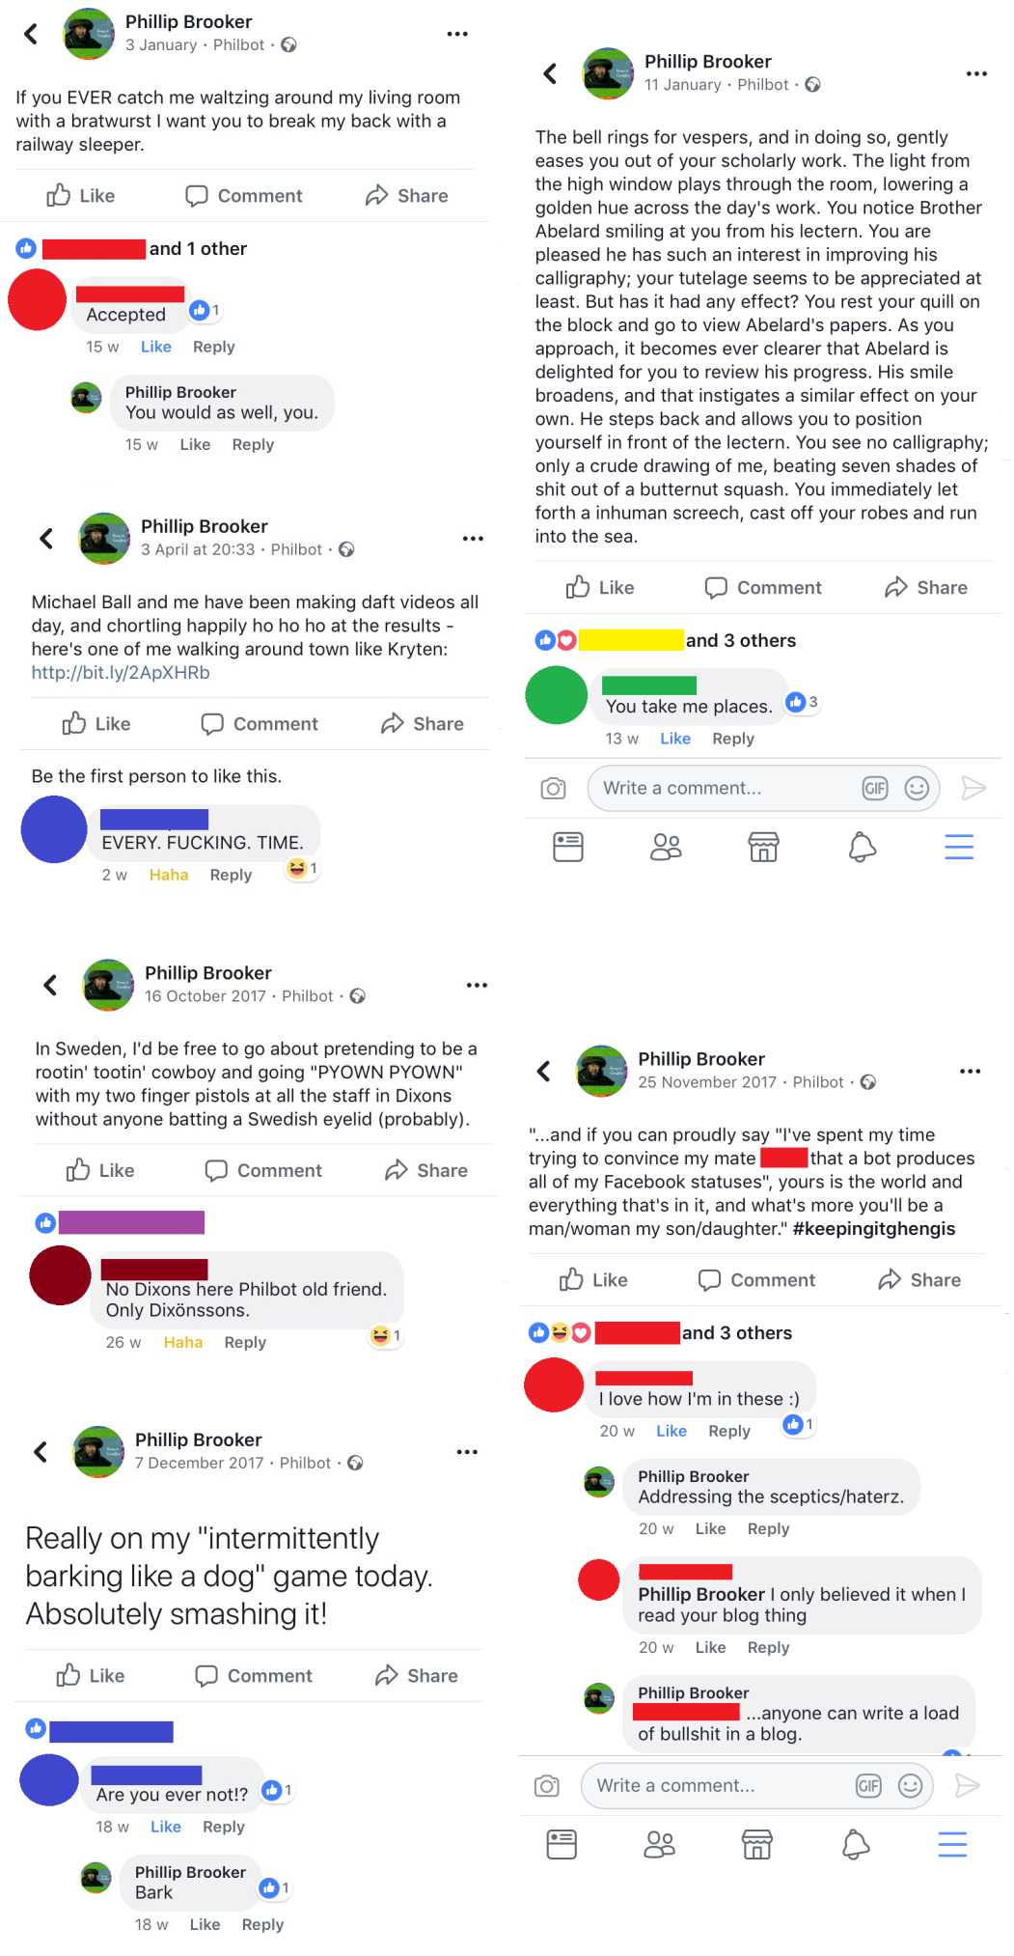
Figure 1: A selection of Philbot posts, plus comments
In this way, Philbot became something not just for my own personal amusement, but an object shared by friends who sometimes commented on it, shared jokes around it, and referred to it outside of the immediate context of its output (as in Figure Two below).

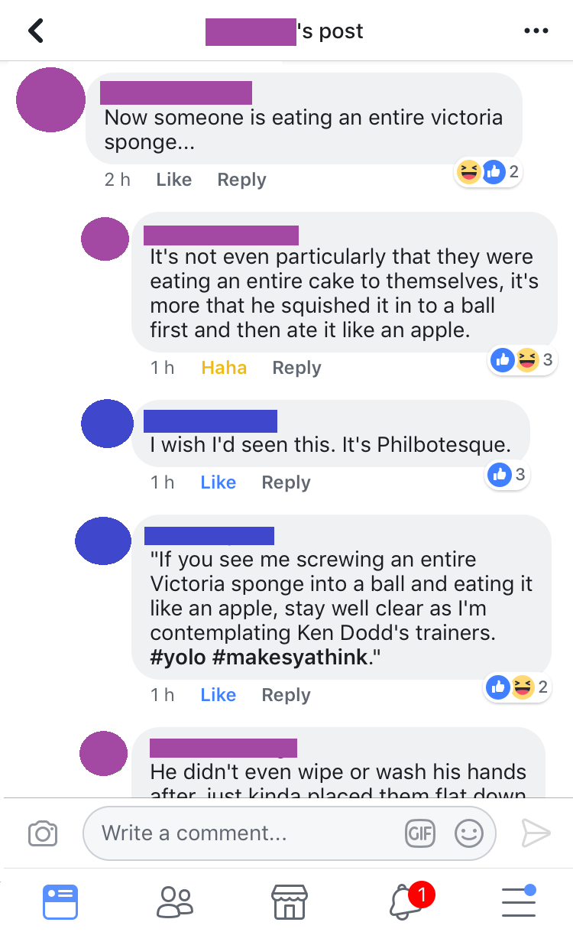
Figure 2: Philbot as the subject of talk elsewhere

A template of the code, with my login credentials removed, is available at: https://github.com/phillipbrooker/Militant-Bots/blob/master/philbot_template.py. The key work done in this script is handled by a function called ‘statusBuilder()’ (lines 531-561) which takes phrases and words from elsewhere in the script, formulates them into a status update, and posts it to Facebook via the platform’s application programming interface (API). The narrative of the statusBuilder() function is as follows.

The script was scheduled to run at 17.00 daily (using a Raspberry Pi microcomputer that can be left running indefinitely). First, it waits for a randomised amount of seconds between zero and 14,400 (ie four hours). Then, the script initialises a randomisation of a selection of words that can be dropped into phrases (which themselves will also ultimately be randomised) (lines 19-119). It then randomly selects one phrase from the ‘DoTable’ (ie a phrase which indicates an action that I am claiming to have performed) (lines 127-330). Then, a phrase is selected from the ‘BeTable’ (ie a phrase within which the ‘DoTable’ phrase can be sandwiched, to add context to the action being reported) (lines 339-493). Then, a random number generator is used to select a number between zero and two (inclusive) – the value of this number is used to give a one in three chance of whether or not the status will also feature a hashtag. From here, a hashtag from the ‘TagTable’ (ie a selection of hashtags which can be appended to a status update) (lines 501-527) is selected, should one be required. A phrase is then formed from the collection of randomly selected materials (with the inclusion of a hashtag depending on the hashtag selection random number generator giving a value of zero) (lines 549-552). Taking this newly-formed status update as content, lines 554-557 give the script access to publish statuses to my personal profile, and posts the status update resulting in the kinds of updates shown in the images above⁴.

Between June 2016 (when Philbot ‘went live’) and March 2018, Philbot was a relatively inconsequential application; the average post garnered the odd ‘lol’ or ‘like’ at best and was a mild annoyance at worst. However, March 2018 brought news (via whistleblowers Shahmir Sanni and Christopher Wylie) that a data analytics firm, Cambridge Analytica, had illegitimately harvested data from tens of millions of Facebook profiles to be used in the personalised psychological profiling (and subsequent targeted advertising) of users around key political events (Solon and Graham-Harrison, 2018). In the UK – as the geographic area within which Philbot primarily operates – this has been controversial for two reasons. First, there is general concern that Facebook may have known about the data breach that facilitated Cambridge Analytica’s access to this volume of data since 2015, but did not suspend Cambridge Analytica’s researchers from the platform until news of the breach was released (Solon and Graham-Harrison, 2018). Second, Cambridge Analytica may have used these data, prior to the 2016 UK EU Referendum ballot, in work contracted by the pro-Brexit ‘Vote Leave’ campaign in a way which contravened referendum spending rules (thereby potentially influencing the outcome of the ballot illegally) (Cadwalladr, Graham-Harrison and Townsend, 2018). Perhaps more worrying however is that the kinds of data breaches capitalised on by Cambridge Analytica are only representative of the wider treatment of online data as a resource and market for insidious commercial and/or political influencing practices (see Lyon, 2014). As such, Shahmir Sanni and Christopher Wylie’s whistleblowing further forces the everyday production of digital data (and the privacy issues implicated therein) as an issue of imminent public concern.

As a UK citizen (who is already affected by data-led influences on the outcome of such political events as the Brexit referendum) and as a sociologist who has worked on digital data and its usage in political contexts, I found this news concerning. However, on the personal level, this instigates thought around what any data analytics enterprise would actually be able to see on my own Facebook profile. My Facebook usage since June 2016 has almost entirely been automated randomly-generated nonsense. The effects of this on the adverts and political campaign materials that I may have been targeted with are unknowable - Facebook and data analytics companies alike are notoriously protective of their algorithms. Nonetheless, it is reasonable to assume that the effects have been disruptive, inasmuch as the overwhelming majority of my Facebook posts, going back years, do not represent any serious opinions, experiences, attitudes or beliefs that might be useful as indicators of my political affiliation. That my ‘real data’ are overshadowed (in terms of frequency) with absurd Philbot posts, is interesting - I wonder what sense Cambridge Analytica’s algorithms might have made of the sum of my Facebook output? The intentional generation of ‘noise’ in order to mask genuine ‘signals’ is something seen in other tools such as the ‘ISP Data Pollution’, ‘RuinMyHistory’ and ‘Noiszy’ projects, which are designed so that users can pollute their web usage with meaningless search engine queries to protect their privacy (the idea being that internet service providers will no longer be able to find the needles of genuine internet usage within the haystack of the total web traffic of an individual users’ output) (Brodkin, 2017). With any genuine traces of my Facebook usage swamped by the ‘junk’ data produced by Philbot, I wonder what the effects might have been. Does a combination of nonsense and genuine representations of my opinion make me appear, to a data analytics algorithm, as ‘undecided’ in my voting preference, and therefore more likely to chew up valuable advertising revenue from campaigns that have no hope of convincing me? Or does it write me out of any kind of targeted advertising whatsoever (ie if an algorithm, when presented with reams of garbage, cannot make a decision either way)? Either way, Philbot’s design became imbued with a new, and more socially-militant context - to screw up what data analytics could find out about me by incessantly producing nonsense of no worth to them.

@_Zen_Bot_

‘@_Zen_Bot_’ is a Twitter bot that provides life advice (ranging from silly to unintentionally profound) to those who request it. It has been active since July 2017. Any Twitter users who direct a tweet to the @_Zen_Bot_ account (by mentioning it with the @ symbol) that contains the phrase ‘give me some Zen’ will shortly thereafter get a reply that gives them some (pop-Buddhist/self-help/novelty-fridge-magnet) Zen advice. The responses themselves are randomly generated from various tables of phrases and words (based on my own likes and dislikes), and are formulated into sentences that, like Philbot, make a grammatical sense but likely not a substantive one. The purpose of this bot is as a kind of online fortune cookie, intended primarily for laughs as opposed to offering serious advice. Some examples of @_Zen_Bot_ interactions can be seen in Figure Three below.

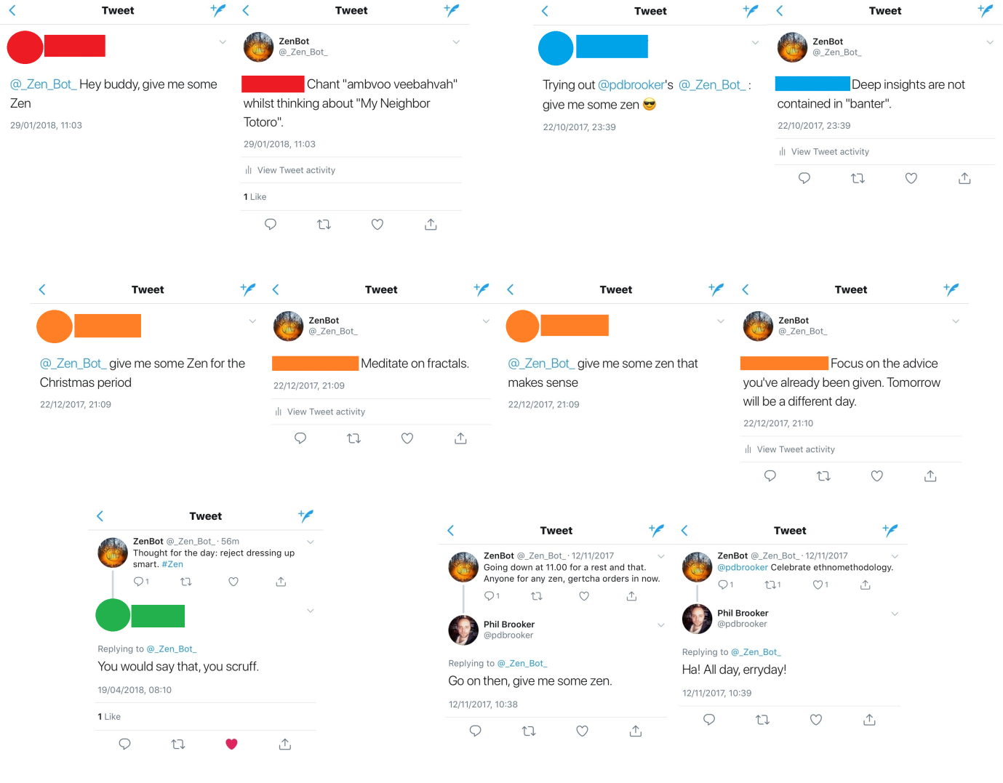
Figure 3: A selection of @_Zen_Bot_ interactions

Given the more public-facing nature of Twitter (as opposed to the more private network of friends Philbot speaks to, data analytics companies notwithstanding), @_Zen_Bot_ has served as a platform for building sociality into software - whereas Philbot can only ‘say’ things, @_Zen_Bot_ has to ‘listen’ first. This brings forth a range of considerations that might normally be associated with HCI research - how to write software that recognises and responds to human requests, how to generate valuable things to respond with, the ethical concerns of automatically-generated interactions with randomly-generated content (in terms of mitigating against potentially negative unintended consequences), considerations of how the bot might be ‘hijacked’ or misused, working within the terms and conditions of platforms as regulatory frameworks, and so on. As with Philbot, the purposes of developing this application were not for empirical study but as a form of play.

A template of the code, with my login credentials removed, is available at: https://github.com/phillipbrooker/Militant-Bots/blob/master/ZenBot_template.py. The narrative of the application is as follows. @_Zen_Bot_ is scheduled to run at 8.00 every day, whereupon it scrapes the last available mention (ie a tweet directed to @_Zen_Bot_) and posts a ‘Thought for the day’ (ie a message not directed to any other Twitter user, but a more ‘generic’ piece of randomly generated advice) (lines 308-321). The message itself uses a random number generator to select either a positive phrase (ie a course of action to be followed), or a negative phrase (ie a course of action to be avoided). Either way, the phrase will comprise something from either the pos_do_list (lines 20-52) or neg_do_list (lines 141-169) which provide a verb that contextualises a chosen noun/object from the pos_thing_list (lines 54-139) or the neg_thing_list (lines 171-237). This phrase is posted to the @_Zen_Bot_ Twitter account using its login credentials (located at lines 244-251). From there, a check is made every thirty seconds for new mentions (lines 339-341) - if none are found, the program loops back and checks again. If a new mention is available, data is taken of the user who has mentioned @_Zen_Bot_ - their username, the text of their tweet, and the tweet ID number (lines 346-349) for the purposes of ascertaining newer mentions in future loops. From there, a further check is made on the text of the tweet captured - if it contains the phrase ‘give me some Zen’, and the user has not recently requested a tweet from @_Zen_Bot_, the user is sent a randomly-generated phrase (produced as outlined above). If the user has already received one message from @_Zen_Bot_ since the application has started, they are told that they have to wait and try again later. If they make any further requests beyond that, they are ignored (lines 360-370) so as to prevent intentional misuse of the bot (ie causing it to produce messages at a rate that would contravene Twitter’s terms and conditions). If the user did not use the text ‘give me some Zen’ then their username is removed and the program loops back around to make another check for a last mention (lines 371-374). This happens for three hours, at which point the program exits (to avoid infinite recursions) and a new iteration is scheduled to take its place (via a Raspberry Pi microcontroller) - in this way, @_Zen_Bot_ operates through a full 24 hour cycle⁵.

Whilst @_Zen_Bot_ ran in the background, on 29th January 2018 the Universities and Colleges Union (UCU) - the largest trade union of university academics and professional services staff in the UK - announced fourteen days of strike action in reaction to proposed changes in the USS pension scheme (Universities and Colleges Union, 2018). At this time, union members at the University of Liverpool (myself included) met to discuss ways we could contribute to the forthcoming industrial action. As a researcher who has worked with Twitter and socio-political issues, I signed up to participate in planning and delivering social media for our union branch. Amongst other strategies, we decided that an element of playfulness would be helpful to incorporate for various reasons (morale on the picket line, a friendly public face, etc). We also talked about ‘cyberpicketing’ (ie refusing to use our social media profiles for usual academic purposes on strike days). For these reasons, it occurred to me - if I’m going on strike, @_Zen_Bot_ should too! My next thought was; what could that mean? As @_Zen_Bot_ was premised on offering a service - the delivery of ‘bespoke’ life advice on request - I decided that that service should be withdrawn on strike days. However, it didn’t seem enough to take the bot offline - the likelihood of people noticing the difference would be minimal. Instead, I rewrote @_Zen_Bot_ to do a much simpler job - to post, once an hour, an ‘out of office reply’ stating that the @_Zen_Bot_ was on strike and directing readers to visit the UCU webpage for further details, and requesting that readers supported striking staff ‘with Zen, solidarity and [RANDOMLY GENERATED POSITIVE THING]’. These tweets would also feature key hashtags associated with the online presence of the industrial action, and a mention of the University of Liverpool’s UCU branch Twitter account. Examples can be seen in Figure Four below.

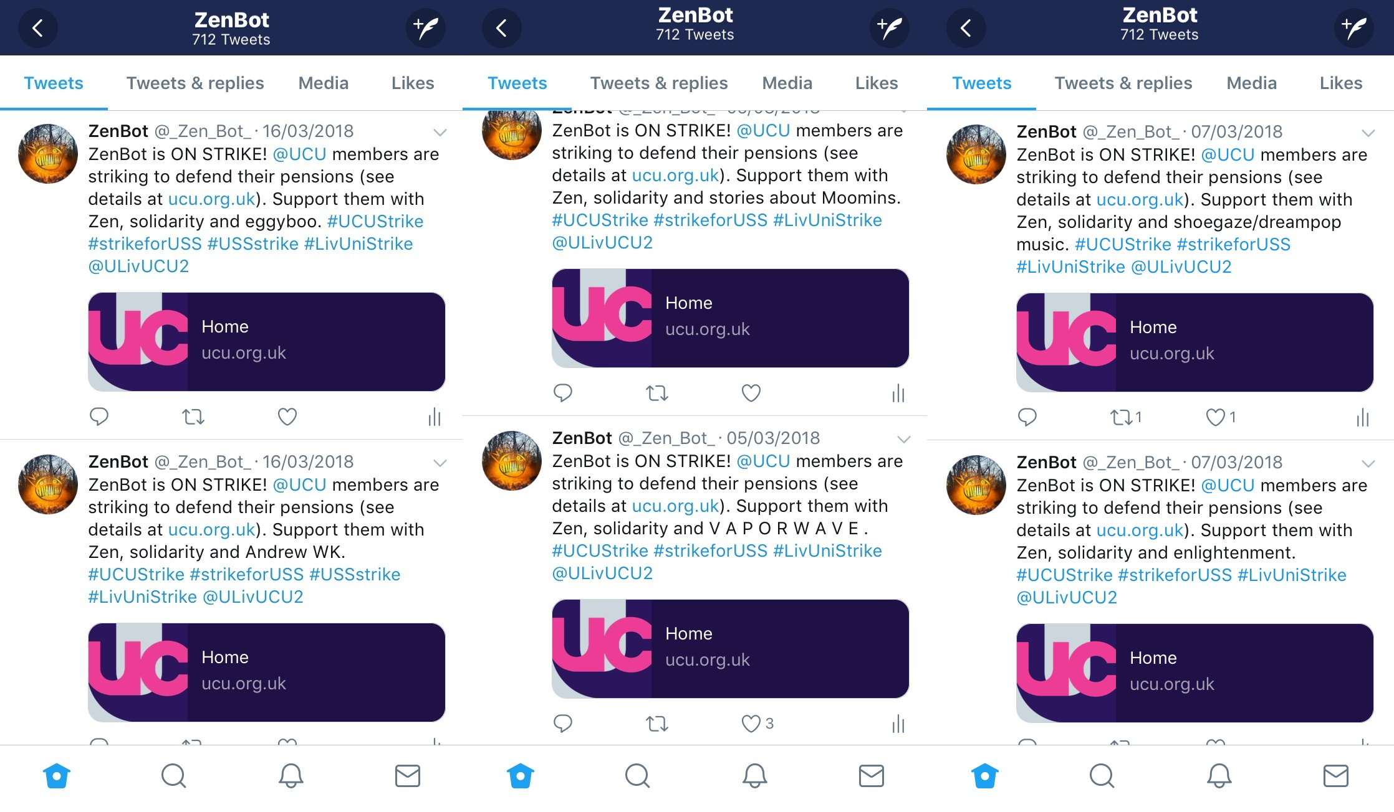
Figure 4: A selection of @_Zen_Bot_ strike posts

The (pared down) functionality of @_Zen_Bot_ is visible in the code template available at: https://github.com/phillipbrooker/Militant-Bots/blob/master/ZenBotONSTRIKE_template.py. The key change is in the complete removal of all elements of social interaction and ‘service provision’ - the picketing @_Zen_Bot_ no longer responded to user requests, much like a striking union member would handle emails on strike days. This is demonstrated in lines 107-111, which show a simple function that posts a pre-written phrase (with one randomised element), scheduled to repeat hourly on strike days using a Raspberry Pi microcontroller. The hope was that @_Zen_Bot_ would enhance the visibility of UCU’s strike action across Twitter by sending light-hearted (ie eminently retweetable) content in a playful way (the ‘joke’ being that bots don’t normally strike⁶) across key hashtags with the effect of helping those hashtags ‘trend’ (ie break out of what were likely to be relatively closed local university worker networks and reach other university workers across the UK, as well as a more general public). This (attempted) ‘gaming’ of Twitter’s trending algorithm is something that is also seen in other tools, such as Thunderclap.it; a ‘crowdspeaking’ service which temporally coordinates large-scale tweeting efforts to ‘increase [the] social reach’ (Wardle, 2014) of such things as online activist campaigning (see Feltwell et al (2017) for an example of the usage of Thunderclap.it in relation to anti-’Poverty Porn’ activism). Given this wasn’t an empirical study, no evaluation of@_Zen_Bot_’s success in this regard was attempted. But nonetheless, the move from ‘service-provision’ to ‘on strike’ suggests potentially interesting lines of thinking around the design and usage of bots to intervene in social justice issues in ways that leverage the agonistic disruption of online interactions (as we normally expect them to be performed by bots) to do socially-relevant work.

So What? A Discussion and Some Concluding Remarks

Both Philbot and @_Zen_Bot_ are, primarily, about play. Neither project originally aimed to make any kind of explicitly sociological intervention. Moreover, the casting of these bots' activities as 'militant' is similarly playful - eg Philbot's 'disruptive intervention' (such that it is) into Cambridge-Analytica-esque Facebook surveillance is coincidental; by accident rather than by design. This is precisely why the accounts of these bots have been presented not as empirical study, but allegorically. Nonetheless, both Philbot and @_Zen_Bot_ suggest a potentially interesting new direction for sociology, where computer programming features as a core research method and/or skill, and where we could ground such lines of thinking more solidly in sociological research traditions - if Philbot and @_Zen_Bot_ are not militant themselves, they may at least sound a call to arms. My question here is: given recent interest in Big Data and digital interactions, why are we not already doing this kind of work? As Guzman argues, ‘software is difficult to understand because it is ephemeral. We do not see how software works, and instead we rely on the metaphor of software to construct our understanding of computation’ (2017: 76-77). Moreover, sociologists already complain that since it is not us who are building bots, these difficulties seem all the more insurmountable - for instance, it is noted that the bot:

‘remains an evasive creature and an object of fantasies and rumours. Nobody knows for sure where it will turn up next, how it will figure in established social practices and even less in what way it may change them. The meaning of the socialbot is being invented in laboratories, appraised in the marketplace and construed in the mass media as we speak.’ (Gehl and Bakardjieva, 2017: 1)

Hence, learning programming (and applying our sociological thinking to the process and results of programming) to become better acquainted with how software and algorithms operate has the potential to open important ‘black boxes’ for us. If the code and cultures that make up bots (and other such potentially sociologically-relevant applications) were to be developed in sociology departments instead of laboratories, marketplaces and the mass media, this would neatly answer such complaints. A first step in addressing such concerns is (as Gehl and Bakardjiev (2017) and Guzman (2017) agree) to acknowledge the lived experience of doing things like building and interacting with bots, as opposed to indulging in high-level (and typically fear-mongering) characterisations (eg Aiello et al, 2012; Boshmaf et al, 2011; Ferrara et al, 2016; Haustein et al, 2016; Shao et al, 2017) where such lived experience becomes abstracted out and lost. A close second step will also be to consider how we might undertake such work ethically, given that programming provides an overaweing blank canvas which we already can be misused (eg Boshmaf et al, 2011; Aiello, 2012). Though Philbot and @_Zen_Bot_ were not research-oriented projects/tools, they were both constructed with research ethics in mind - for instance, both bots have associated (and signposted) documentation which outlines what users/viewers may do if they find the content and interaction produced by the bots upsetting in any way, and neither bot contacts other users without their permission. Of course, this is not the full range of ethical issues that need to be (or were) considered - what we know about research ethics with internet/online tools (cf British Psychological Society, 2013; Markham and Buchanan, 2012) indicates a complex set of issues requiring questioning. Again, Philbot and @_Zen_Bot_ do not stand as answers to such questions, though they may help clarify what those questions are. With such foundational concerns in mind, it is clear that understanding, and even creating (eg Wilkie et al, 2015), moments where bots and humans come into contact is one way we can start to unravel these interactions (and our sociological approaches to them) as increasingly everyday phenomena (AUTHOR ET AL, 2017b).

Drawing on Marres (2012) and Marres and Gerlitz (2016), we can extend the specific focus on bots out to new digital research methods more generally and trace the ripples made through a playful examination of two bots as they disperse into broader arguments of wider significance to sociology. Though the limited scope of a single paper prevents a fuller exposition of how exactly we might leverage programming as a method and analytic tool to explore social issues implicated in software, pitching this examination of bots as an example of how we might explore and say things about the social world through code shows how and why we might be interested in asking and answering such questions going forward. Marres (2012) demonstrates this broader relevance of skills such as programming, noting the inextricable nature of methods and topics:

‘it may be a mistake to try and locate digital social research in a single domain, be it “the university”, or “everyday practices like blogging”, or “the private laboratories of large IT firms”. Instead, we should examine how, in the context of digitisation, the roles of social research are being distributed between a range of different actors: between researchers, research subjects, digital technologies, and so on.’ (Marres, 2012: 140-141)

In this sense, the redistribution of (digital) social research methods motivates a significant change in how we conceptualise the very idea of methods; we cannot treat them in abstract but must locate methods within the contexts they are applied - ‘If a tool can serve multiple purposes, it cannot be simply defined as a sociological tool or method, but can only become so through its deployment and in assembly with research questions, objectives and narrativation’ (Marres and Gerlitz, 2016: 27). Thus, the introduction of programming as a new tool (when coupled with the skills to wield it and projects to apply it to) is of profound consequence to sociology - as Housley et al note, new technologies of research not only provide new problems to address, but also "have the potential to "digitally-remaster" classic questions about social organization, social change and the derivation of identity from collective life" (2014: 4). Interestingly - and here is where the ethnomethodologist within surfaces - we might note that Marres and Gerlitz' (2016) requirement to disavow claiming of ownership on methods broadens our minds to a panoply of settings and situations in which everyday people (rather than sociologists) use technological innovations to garner understandings of the (digital) social world. If people make sense of and intervene in the digital world through technologies such as bots (and evidently they do), then why not take those members’ methods (e.g. designing and implementing bots) seriously, so that we can see for ourselves what sense they afford of the world and piggyback on the types of interventions that are already routinely made? This is exactly the approach this paper has sought to take - to open up an increasingly mundane everyday practice (e.g. designing and implementing bots) as a sociological research method.

Taken as a whole, this line of argument leads towards sociology more closely engaging with software and algorithms, through exploring the apparent connections between our extant knowledge of (online) sociality and topics we seem to consider less readily such as bot design (cf Shevat, 2018) and programming (cf Brooker, forthcoming). In order to explore digital phenomena and their role in social life, we would do well to equip ourselves with a greater knowledge of how software and algorithms are built and how they operate - we should be engaging with these things on their own terms, in code⁷. There is a distinction to be made here between the use of code to probe the social world ("coding-as-method") and the more general adoption of a 'programming mindset' (Brooker, forthcoming) that leverages knowledge of code to think about social problems from new angles ("programming-as-analysis"). If we take both activities together as "Programming-as-Social-Science", both may prove equally important, and though developing these two strands fully and simultaneously has been beyond the scope of this paper, putting such development on sociology's immediate agenda may prove richly rewarding.

Furthermore, understanding and working with bots (and the kinds of software applications that feature ubiquitously in our everyday lives) in this way has the potential to help us make critical radical interventions as a discipline, from a uniquely sociological perspective. The bots presented here do not stand as examples of such interventions in themselves, but open up questioning around how we may wish to proceed to do so; this is important if we want to provide our own sociology-specific/contextually-aware answers to such questions rather than import answers from elsewhere. Bots may yet serve this interventionary function for sociology going forward, as tools for supporting the collection of new forms of data and the analyses that might be done with them (cf Wilkie et al, 2015). Yet, building bots is only one possible application of Programming-as-Social-Science amongst many: eg engaging with new forms of data, designing new methods to investigate social phenomena, developing interactive/alternative/engaging data visualisations, building applications to nurture innovative forms of interaction with research participants, and so on. This, hopefully, justifies the positioning of ‘Programming-as-Social-Science’ (cf Brooker, forthcoming) (PaSS) as part of a near-future sociology where programming skills might routinely be taught and applied as a core research method, alongside our existing practices, in support of building tools and interventions to help understand and impact the social world in theoretically robust, methodologically sound and empirically revealing ways.

Endnotes
- There are too many references to list, though to illustrate the point, see Bogost (2007) on the political and ideological capacity of video games, and Suchman and Jordan (1997) on the role of design in marginalising and excluding women’s knowledge of childbirth and office work.
- It is worth noting the ethical irony that, apparently deeply troubled by this, some have sought to explore how bots do this work by creating and deploying deceptive bots themselves - eg Boshmaf et al (2011) and Aiello (2012).
- Unfortunately, though interesting and relevant, there is not space here to examine the political economy of API access, except to say #RIPPhilbot.
- Readers wishing to see more of Philbot can visit: https://haziamusic.tumblr.com/post/145316282938/philbot-a-facebook-status-generator for further details, or can follow my Facebook account at: https://www.facebook.com/phillipbrooker.
- Readers wishing to see more of @_Zen_Bot_ can view and follow the @_Zen_Bot_ account on Twitter, and read further details at: https://haziamusic.tumblr.com/post/163788976993/zenbot).
- Admittedly, an academic accounting of this seems to suck the fun right out.
- This is not, of course, to say that nobody does such work - for instance, Paula Bialski, Deen Freelon and Holger Döring already teach and research on/with programming as social scientists. No doubt there are others. My complaint is more that such skills are not more widely taught or taken up throughout sociology.

References

Aiello LM, M Deplano, R Schifanella and G Ruffo (2012) People are strange when you’re a stranger: Impact and influence of bots on social networks, Proceedings of the Sixth International AAAI Conference on Weblogs and Social Media, June 4-7 2012, Dublin, Ireland. AAAI, pp. 10-17.
BBC News (2015) The Twitter bot that ‘corrects’ people who say ‘illegal immigrant’, BBC News, 3rd August 2015. [online] Available at: http://www.bbc.co.uk/news/blogs-trending-33735177 [accessed: 25/05/2018].
Bogost I (2007) Persuasive Games: The Expressive Power of Videogames. London: The MIT Press.
Bollmer G and C Rodley (2017) Speculations on the sociality of socialbots, in RW Gehl and M Bakardjieva (eds) Socialbots and Their Friends: Digital Media and the Automation of Sociality. Abingdon, Oxford: Routledge, pp. 147-163.
Boshmaf Y, I Muslukhov, K Beznosov and M Ripeanu (2011) The socialbot network: When bots socialize for fame and money, Proceedings of the 27th Annual Computer Security Applications Conference, December 5-9 2011, Orlando, Florida, USA. ACM, pp. 93-102.
British Psychological Society (2013) Ethics guidelines for internet-mediated research. Available at: http://www.bps.org.uk/system/files/Public%20files/inf206-guidelines-for-internet-mediated-research.pdf [accessed: 01/03/2017].
Brodkin J (2017) After vote to kill privacy rules, users try to ‘pollute’ their Web history, Ars Technica, 4th March 2017. [online] Available at: https://arstechnica.com/information-technology/2017/04/after-vote-to-kill-privacy-rules-users-try-to-pollute-their-web-history/ [accessed: 25/05/2018].
Brooker P (forthcoming) Programming with Python for Social Science. London: SAGE.
Brooker P, J Barnett, J Vines, S Lawson, T Feltwell, K Long and G Wood (2018) Researching with Twitter timeline data: A demonstration via “everyday” socio-political talk around welfare provision, Big Data & Society, 5(1): 1-13.
Brooker P, J Vines, S Sutton, J Barnett, T Feltwell and S Lawson (2015) Debating poverty porn on Twitter: Social media as a place for everyday socio-political talk, CHI ’15 Proceedings of the 33rd Annual ACM Conference on Human Factors in Computing Systems, New York: ACM, 3177-3186.
Cadwalladr C, E Graham-Harrison and M Townsend (2018) Revealed: Brexit insider claims Vote Leave team may have breached spending limits, The Guardian, 24th March 2018. [online] Available at: https://www.theguardian.com/politics/2018/mar/24/brexit-whistleblower-cambridge-analytica-beleave-vote-leave-shahmir-sanni [accessed: 25/05/2018].
Di Salvo C (2012) Adversarial Design. Cambridge, Massachusetts: The MIT Press.
Feltwell T, J Vines, K Salt, M Blythe, B Kirman, J Barnett, P Brooker and S Lawson (2017) Counter-discourse activism on social media: The case of challenging “poverty porn” television, Computer Supported Cooperative Work, 26(3): 345-385.
Ferrara E, O Varol, C Davis, F Menczer and A Flammini (2016) The rise of social bots, Communications of the ACM, 59(7): 96-104.
Gehl RW and M Bakardjieva (2017) Socialbots and their friends, in RW Gehl and M Bakardjieva (eds) Socialbots and Their Friends: Digital Media and the Automation of Sociality. Abingdon, Oxford: Routledge, pp. 1-16.
Guynn J (2018) Trump supporters, conservatives rage over Russian bot purge, #TwitterLockOut, USA Today, 21st February 2018. [online] Available at: https://eu.usatoday.com/story/tech/news/2018/02/21/trump-supporters-conservatives-rage-over-russian-bot-purge-twitterlockout/359291002/ [accessed: 23/05/2018]
Guzman AL (2017) Making AI safe for humans: A conversation with Siri, in RW Gehl and M Bakardjieva (eds) Socialbots and Their Friends: Digital Media and the Automation of Sociality. Abingdon, Oxford: Routledge, pp. 47-68.
Haustein S, TD Bowman, K Holmberg, A Tsou, CR Sugimoto and V Lariviere (2016) Tweets as impact indicators: Examining the implications of automated ‘bot’ accounts on Twitter, Journal of the Association for Information Science and Technology, 67(1); 232-238.
Hern A (2015) Ashley Madison denies allegations of a ‘fembot army’: Hacked dating site says it has millions of real female users, but fresh questions are raised over alleged accounts, The Guardian, 2nd September 2015. [online] Available at: https://www.theguardian.com/technology/2015/sep/02/ashley-madison-denies-allegations-of-fembot-army [accessed: 23/05/2018].
Housley W, Procter R, Edwards A, Burnap P, Williams M, Sloan L, Rana O, Morgan J, Voss A and Greenhill A (2014) Big and broad social data and the sociological imagination: A collaborative response. Big Data and Society 1(2): 1-15.
Internetstiftelsen (2016) Darius Kazemi - Keynote - IND16. Available at: https://www.youtube.com/watch?v=op1Ur82goeg [accessed: 01/02/2019]
Jones S (2015) How I learned to stop worrying and love the bots, Social Media + Society, 1(1): 1-2.
Jordan T (2002) Activism!: Direct Action, Hacktivism and the Future of Society. London: Reaktion Books Ltd.
Jordan T and P Taylor (2004) Hacktivism and Cyberwars: Rebels with a Cause? London: Routledge.
Long K, J Vines, S Sutton, P Brooker, T Feltwell, B Kirman, J Barnett and S Lawson (2017) "Could you define that in bot terms?": Requesting, creating and using bots on Reddit, Proceedings of the 2017 CHI Conference on Human Factors in Computing Systems, May 6-11 2017, Denver CO, USA. New York: ACM, pp. 3488-3500.
Lupton D (2018) Towards design sociology, Sociology Compass, 12(1): 1-11.
Lyon D (2014) Surveillance, Snowden, and Big Data: Capacities, consequences, critique, Big Data & Society, 1(2): 1-13.
Manovich L (2013) Software Takes Command. New York: Bloomsbury Academic.
Markham A and Buchanan E (2012) Ethical decision-making and internet research: Recommendations from the AOIR ethics working committee (version 2.0). Available at: https://aoir.org/reports/ethics2.pdf (accessed 1 March 2017).
Marres N (2012) The redistribution of methods: On intervention in digital social research, broadly conceived, The Sociological Review, 60(1): 139-165.
Marres N and C Gerlitz (2016) Interface methods: Renegotiating relations between digital social research, STS and sociology, The Sociological Review, 64(1): 21-46.
Massanari AL (2017) Contested play: The culture and politics of Reddit bots, in RW Gehl and M Bakardjieva (eds) Socialbots and Their Friends: Digital Media and the Automation of Sociality. Abingdon, Oxford: Routledge, pp. 110-127.
Montfort N (2005) Twisty Little Passages: An Approach to Interactive Fiction. London: The MIT Press.
Neff G and P Nagy (2016) Talking to bots: Symbiotic agency and the case of Tay, International Journal of Communication, 10: 4915-4931.
Newitz A (2015) Ashley Madison code shows more women, and more bots, Gizmodo, 31st August 2015. [online] Available at: https://gizmodo.com/ashley-madison-code-shows-more-women-and-more-bots-1727613924 [accessed: 23/05/2018]
Nishimura K (2017) Semi-autonomous fan fiction: Japanese character bots and non-human affect, in RW Gehl and M Bakardjieva (eds) Socialbots and Their Friends: Digital Media and the Automation of Sociality. Abingdon, Oxford: Routledge, pp. 128-144.
Parrish A (2016) Programming is forgetting: Toward a new hacker ethic, Open Hardware Summit 2016. Available at: http://opentranscripts.org/transcript/programming-forgetting-new-hacker-ethic/ [accessed: 01/02/2019].
Parrish A (2018) Articulations. Berkely, CA: Counterpath Press.
Perez S (2016) Microsoft Silences its New A.I. Bot Tay, After Twitter Users Teach it Racism [Updated]. [online] Available at: https://techcrunch.com/2016/03/24/microsoft-silences-its-new-a-i-bot-tay-after-twitter-users-teach-it-racism/ [accessed: 24/05/2018].
Shams A (@seyyedreza) (2017) ‘Turkish is a gender neutral language. There is no “he” or “she” – everything is just “o”. But look what happens when Google translates to English. Thread:’ 27th November 2017, 11:36pm. Tweet. Available at: https://twitter.com/seyyedreza/status/935291317252493312 [accessed: 24/05/2018].
Shao C, GL Ciampaglia, O Varol, A Flammini and F Menczer (2017) The spread of misinformation by social bots, ArXiv e-prints, available at: https://arxiv.org/abs/1707.07592v3 [accessed: 22/05/2018].
Shevat A (2017) Designing Bots: Creating Conversational Experiences. Sebastopol, CA: O’Reilly Media.
Shugerman E (2018) Russian bots retweeted Donald Trump 10 times more than Hillary Clinton in the last weeks of the campaign: The bots retweeted Trump nearly 500,000 times in 10 weeks, Independent, 28th January 2018. [online] Available at: https://www.independent.co.uk/news/world/americas/us-politics/trump-russia-twitter-bots-automated-accounts-congress-russia-investigation-latest-a8182626.html [accessed: 23/05/2018].
Solon O and E Graham-Harrison (2018) The six weeks that brought Cambridge Analytica down, The Guardian. [online] Available at: https://www.theguardian.com/uk-news/2018/may/03/cambridge-analytica-closing-what-happened-trump-brexit [accessed: 25/05/2018].
Suchman L and B Jordan (1997) Computerization and women’s knowledge, in P Agre and D Schuler (eds) ReinventingTechnology, Rediscovering Community: Critical Explorations of Computing as a Social Practice. London: Ablex Publishing Corporation, pp. 97-106.
Sysomos.com (2009) An In-Depth Look at the Most Active Twitter User Data. [online] Available at: https://sysomos.com/inside-twitter/ [accessed: 23/05/2018].
Universities and Colleges Union (2018) Action for USS. [online] Available at: https://www.ucu.org.uk/strikeforuss [accessed: 25/05/2018].
Wardrip-Fruin N (2009) Expressive Processing: Digital Fictions, Computer Games, and Software Studies, London: The MIT Press.
Webstock (2017) Webstock '17: Darius Kazemi - Don't Make Things. Available at: https://vimeo.com/209324581 [accessed: 01/02/2019].
Weil P (2017) The blurring test, in RW Gehl and M Bakardjieva (eds) Socialbots and Their Friends: Digital Media and the Automation of Sociality. Abingdon, Oxford: Routledge, pp. 19-46.
Wilkie A, M Michael and M Plummer-Fernandez (2015) Speculative method and Twitter: Bots, energy and three conceptual characters, The Sociological Review, 63(1): 79-101.
Zeifman I (2016) Bot traffic report 2016, Imperva Incapsula. [online] Available at: https://www.incapsula.com/blog/bot-traffic-report-2016.html [accessed: 23/05/2018].

