Residents’ perspectives on defining neighbourhood: mental mapping as a tool for participatory neighbourhood research
Gemma Catney, Diane Frist, Leona Vaughn

Abstract
Definitions of neighbourhood in the Social Sciences are complex, varying in their characteristics (for example, perceived boundaries and content) and between residents of that neighbourhood (for example, by class and ethnicity). This study employs an under-utilised methodology offering strong potential for overcoming some of the difficulties associated with neighbourhood definitions. A mental mapping exercise involving local residents is showcased for an ethnically diverse working-class neighbourhood in south Liverpool. The results demonstrate distinctions between residents in the geographical demarcation of the area and the features included, with important implications for how neighbourhood is best measured and understood. We suggest that one size does not fit all in definitions of neighbourhood, and that mental mapping should form a more common part of a neighbourhood researcher’s toolkit.

Keywords
Community, identity, interviews, mental/cognitive mapping, neighbourhood, participatory methods

Introduction
Neighbourhoods constitute an important basis for a diverse range of studies across the Social Sciences. However, it is rarely the case that the ‘spatial unit’ of the neighbourhood being researched is easily defined. According to Castree et al. (2013), neighbourhood denotes: An urban residential area, generally small enough to be covered easily on foot. It is sometimes assumed that neighbourhoods are also communities defined by social interaction or defined by geographical boundaries such as major roads, parks, or rivers, but this need not be the case. The degree to which inhabitants of a neighbourhood identify with the area or interact with others is an empirical question. (2013: 13).
Qualitative researchers interested in social issues at the neighbourhood level may face a plethora of difficult yet fundamental questions before embarking on their fieldwork: Which places (streets, housing areas, community buildings) should be included in the study? Is the demarcation of neighbourhood boundaries consistent across social groups (gender, age, generation or ethnicity)? Most researchers grappling with these questions will recognise that there is often no one definable ‘neighbourhood’, that neighbourhood means different things to different people, and that it varies at different times and across contexts. This raises important conceptual and methodological questions about how to most appropriately define the area under study, which in turn has implications for how fieldwork is conducted and how research questions are framed. As Galster previously recognised ‘ironically, while all those concerned with cities seem to understand the term “neighbourhood” in its common usage, no one seems to be able to agree on exactly what it means or how it should be spatially specified.’ (1986: 243).
The problem of defining neighbourhood has to be overcome in studies that seek to explore a social issue within a given community, particularly when that research is intrinsically concerned with understanding neighbourhood dynamics. There is a vast array of such studies, spanning multiple disciplines and various methodological approaches. A far from exclusive set of examples include research concerned with: place-making by migrant groups (Pemberton and Phillimore, 2018); neighbourhood effects (see van Ham et al., 2012); diversity, segregation and social trust (Catney, 2016a, 2016b; Gundelach and Freitag, 2014); health (Cummins et al., 2007); and crime (Hirschfield et al., 2014). For all such studies, defining neighbourhood boundaries with as much accuracy as possible will avoid generating potentially misleading research findings. Of course, ‘accuracy’ is difficult to determine, but it is intuitive that a project which seeks to understand the role of neighbourhood effects on the life-chances of individuals will need a clear definition of that neighbourhood, especially one which resonates with those exposed to these effects – the neighbourhood’s residents. This paper argues that, where possible, a definition of neighbourhood generated by its residents has more utility for social inquiry than one generated by the researcher(s). Pre-defined spatial units, such as Census administrative boundaries, rarely have a perfect match with the lived experiences of individuals (see Dorling, 1998, Kwan, 2002; Brown and Knopp, 2006; 2008). A flexible definition of neighbourhood, which has the potential to be socially meaningful, is more fruitfully defined by those who live, work and socialise in that environment. A ‘mental mapping’ approach (Golledge and Stimson, 1997; Gould and White, 1974; Kitchin, 1994; Lynch, 1960; Orleans, 1973; Pocock, 1976) to neighbourhood definitions offers such flexibility. The potential of this under-utilised methodology is the focus of this paper.
We draw on a research project which aimed to explore the role of people and place in shaping and reinforcing neighbourhood identity. It sought to do so in a case study area in south Liverpool with a strong sense of community(/ies), which can be traced back generations. As such, it was essential that the researchers tackled the issue of neighbourhood definitions from the outset. The adoption of a creative participatory methodology allowed for flexible definitions of neighbourhood by residents. This further illuminated the significance of the multiplicity of understandings of ‘neighbourhood’, which informed how such research might proceed, and how the ensuing results are interpreted. It is argued that the specific mental mapping approach utilised in this project has great potential for other studies concerned with themes around neighbourhood or community. Moreover, the identification of socially meaningful boundaries is one problem this methodology can help to tackle. More specifically to the themes explored in this study, the technique, used alongside more conventional in-depth interviews with residents, is also useful for understanding better the ways in which specific factors create and reinforce neighbourhood identity and belonging.
As our literature review demonstrates, a range of studies makes use of the mental mapping approach. However, the methodology is far from commonplace in a researcher’s toolbox, which we argue is a missed opportunity. The paper next briefly reviews the complexities around defining neighbourhood, before considering some previous work that has employed a mental mapping approach. Context for the Liverpool-based case study site is then provided, before a detailed discussion of the methodology utilised and results generated. The paper concludes with some reflections on the utility of mental mapping.

What is in a neighbourhood (and what is not)?
A complex and varied literature has attempted to consider the question, what is a neighbourhood? Geographers, who have used both qualitative and quantitative methods to delineate and theorise definitions, have predominantly made such offerings and meanings of neighbourhood.
Neighbourhood is multi-scalar, with various roles and meanings at each spatial scale, and different implications for what and where might be included within the limits of a neighbourhood. A body of (largely quantitative) research has attempted to identify at which spatial scale(s) a neighbourhood can be defined as such, developing methods for understanding the impact of varying scales of inquiry in exploring social phenomena at the small area level (see Lloyd, 2014). In other work, Kearns and Parkinson (2001) drew on Suttles’ (1972) schema to identify three broad scales at which neighbourhoods might be identified, and which have differing functions: (i) the home area (within 5–10 minutes’ walk from place of residence), where identity and belonging may be most predominantly felt; (ii) the locality (for example a housing estate), which may represent a particular social status; and (iii) the region (for example, a larger urban district), containing broader social, leisure and employment networks. The functionality of neighbourhoods has been used in other studies for definitional purposes; for example, Galster (2001) proposed a commodity-orientated definition of neighbourhood, based on a ‘bundle’ of spatially-based social, economic, structural, environmental, and behavioural attributes.
Determining the boundaries which might be drawn around a neighbourhood – that is, delimiting its spatial extent – is far from straightforward, yet is likely to be helpful to researchers interested in where and whom might be included in their field work site. Quantitative studies concerned with modelling small area data typically define neighbourhoods using spatial or attribute data for pre-defined small zones (for example, census administrative units), connectivity between areas (for example, via distances between zones), through (dis)similarity between the population characteristics of zones, or through using interaction data (Lloyd et al., 2014). These studies have considerable utility for exploring patterns and processes across multiple neighbourhoods, where a consistent set of zones is needed as a base for analyses. Yet for work which aims to explore any aspect of the lived experience of neighbourhood, a more grounded approach to defining neighbourhood may be required.
As studies using qualitative methods have shown, neighbourhood can be fluid; their boundaries and functions, and the perceptions of them (for both residents and ‘outsiders’), may vary between people and over time, and will be context-dependent. For example, in their study of boundary definitions of four neighbourhoods in Denver, Campbell et al. (2009) demonstrated how a consensus on what constitutes a neighbourhood varied, depending on (i) the physical and institutional characteristics of the neighbourhood (for example roads, rivers, parks); (ii) demographic factors such as race/ethnicity and class; (iii) symbolic neighbourhood identities held by residents (such as place allegiances), and (iv) fear of crime from within and outside the neighbourhood. Added to these is the unpredictability of neighbourhood changes that are often externally driven (Galster, 2001), for example through gentrification.
The making of ‘neighbourhood identities’ are thus inter-connected to issues of identities of self and place (Buttimer 1980, Proshansky et al., 1983; Relph, 1976; Tuan, 1980). Proshansky et al. (1983) explicitly posit that place identity is a ‘substructure’ of self-identity, defining it as the feelings, meanings and understandings a person has about a physical setting which can develop either a sense of ‘place belongingness’ or indeed ‘place aversion’. The activity spaces literature offers a powerful example of how spatial knowledge about an area can have an impact on the ways in which an area is navigated and experienced (Perchoux et al., 2013). This therefore reminds us of how defining the spatial horizons of individuals needs to be flexible and account for the social, demographic and cultural differences which might impact upon how an area is perceived (Boschmann and Cubbon, 2014: Dorling, 1998; Green et al., 2005; Kwan, 2002; Matei and Ball-Rokeach, 2005; Proshansky et al., 1983). Green et al. (2005) explored the role of area perceptions on the labour market engagement of disadvantaged young people in Belfast, demonstrating how religious differences affected not only the ways in which young people searched for employment opportunities, but their knowledge of where such opportunities may lie. Their study helps to illustrate how perceptions of neighbourhood are influenced by individuals’ experiences and allegiances and vary across cultural groups.
Mental maps provide a useful tool for responding to the complexities surrounding issues of spatial scale, boundaries and functionality, and possible differences in definitions of neighbourhood between individuals dependent on their own characteristics (such as gender, class, ethnicity), by offering a means of defining neighbourhood led by residents rather than researchers, but also as a way of better understanding how neighbourhoods are perceived, used and experienced.

Mental mapping for flexible neighbourhood definitions
Mental mapping – also referred to as cognitive mapping – became recognised, through the seminal works of Lynch (1960) and Gould and White (1974), as a powerful method for understanding the ways in which people visualise a place based on their own experiences and perceptions. Lynch identified the core elements by which people construct their image of the city, including paths, edges, districts, nodes, and landmarks. Gould and White examined ways of measuring, representing and interpreting residential preferences, concentrating on the reconstruction of preference surfaces, whereby rankings of perceived residential desirability can be represented cartographically through isolines and other outputs. Following this early work on mental maps, Pocock (1976) attempted to classify mental map styles and identify how they differed between population groups (by age, gender and class).
Mental mapping can visually capture experiences of place ranging from the minutiae of the everyday to more macro structural forces (Downs and Stea, 1974; 1977 in Gieseking, 2013). Yet there has been an under-utilisation of mental mapping as a tool for exploring neighbourhood dynamics in the Social Sciences. This is surprising given the value of this approach, as demonstrated through various projects spanning a diversity of themes, particularly in children’s studies (possibly partly reflecting the user-friendly style of this method). Gillespie (2010) used sketch mapping to explore place perceptions among children in a US settlement. This study revealed the importance of cultural boundaries and differences in socialisation processes in Amish and non-Amish children’s experiences of their home environment. Wridt (2010) mapped children’s perceptions and neighbourhood utilisation for physical activity in a deprived community in Denver, demonstrating the potential power of a participatory mapping method (in this case combined with a qualitative GIS approach) for understanding better the factors (including the social and built environment) which influence children’s physical activity. Halseth and Doddridge (2000) demonstrated the utility of cognitive mapping by children for neighbourhood planning as an inclusive tool for a generally under-consulted ‘user group’. As a final example, den Besten (2010) employed mental mapping to better understand the processes by which immigrant children in Paris and Berlin develop local belonging in their neighbourhoods. This work both supported and challenged prevalent perceptions about stigmatised areas, showing the unequal access to resources some children experience in neighbourhoods, but also the very positive social interactions experienced by the children in these suburban locales.
This paper focuses on one form of participatory mapping which has as its aim not cartographic accuracy, but freedom of expression, allowing participants to create their own cartographic space, which may distort distances, and highlight or omit features. In contrast, cartographic accuracy is an important characteristic of citizen/community mapping and Public Participation GIS (PPGIS), which have blossomed in the last couple of decades. Developments in the availability of open source software and freely-available base data have enabled non-expert users to create their own spatial data and to analyse data which already exist. There are numerous examples of the PPGIS in diverse social and environmental settings (Mukherjee, 2015). These include community-led planning, regeneration of neighbourhoods, and service delivery (see, for example, Kingston 2007). Boschmann and Cubbon epistemologically and methodologically distinguish the emerging technologies for methods to acquire qualitative environmental and spatial geographic information about people’s feelings and behaviours towards their physical settings. This specifically relates to separating the cartographically imprecise mental mapping method, which involves ‘paper-and-pencil free-form spatial drawings on blank paper’, from contemporary cartographically accurate sketch maps (2014: 238). This does not diminish the benefits of mental mapping as a distinct form of inquiry, which contributes to the democratisation of countermapping practices (Crampton, 2010). In fact, we suggest through the following case study, that mental mapping without restrictions of cartographic boundaries has the potential to deepen significantly our understanding of the complex inter-relationship of experiences, feelings and relationships with physical settings in the processes of developing neighbourhood identity and belonging.

Case study context: Liverpool 8
Liverpool 8 is an ethnically diverse working class area that offers an excellent case study for the use of mental mapping, for several reasons.The postcode name ‘L8’ is distinct in its common use by those both inside and outside its formal boundaries to define the neighbourhood and its community. The city’s concentrated and longstanding minority Black settlement before the mass migrations of the 1950s and 1960s (Costello, 2001), as well as its high rates of historical inter-racial mixing (Frost, 2008), has given Liverpool a uniqueness. These are important components in the growth of a community that continues to articulate a strong sense of community(/ies), which can be traced back over many generations.
Painful experiences of exclusion, marginalization and racism form a salient part of Liverpool 8’s long history that stretches back to the nineteenth century. This continues to inform the community’s collective memory. Liverpool’s apparent uniqueness of this experience has helped intensify community solidarity in the area. An important component of this relates to a history of processes that have confined Liverpool’s Black community within a small area of the city and its simultaneous exclusion from areas outside. This has been sustained over several generations (Frost, 1996). Moreover, a eugenicsinformed ‘study’ of this community in the 1930s (Christian, 2008) and the subsequent hurt and anger it induced, has resulted today in a deep legacy of suspicion and distrust of those from outside wishing to do work with or about this community. Strong neighbourhood identities with Liverpool 8 have subsequently been reinforced through a series of divisive and discriminatory events not unique to Liverpool. This included police harassment and racism throughout the 1970s and 1980s, 1980s urban unrest rooted in socioeconomic inequalities, racial discrimination, and coercive policing, as well as broader issues around unemployment, poverty and exclusion (Ben-Tovim, 1986; Law and Henfrey, 1981; Roberts et al., 1992; Frost et al., 2011; Frost et al., 2013). Self-organisation and community defence that emerged in response to such developments have helped strengthen community bonds and solidarity.
The postcode area of Liverpool 8 includes part of the wards of Riverside and Princess Park. During the 1980s urban unrest the national press erroneously referred to the site of the disturbances as ‘Toxteth’. Whilst Toxteth includes Liverpool 8, it is in fact much larger and forms part of the parliamentary constituency of Liverpool Riverside. Significantly, those local to the area understood the unrest at the time as occurring in the heart of Liverpool 8 rather than Toxteth – an area well known for police racism and abuse that was particularly intense during this period. Since then, the terms ‘Toxteth’ and ‘Liverpool 8’ are used interchangeably across Liverpool to denote a reference point for both the 1980s and 2011 unrest. Subjective identities with neighbourhood become more important in light of such experiences.

Application of the mental mapping methodology
The project was interdisciplinary in nature, led by a Sociologist and a Geographer with differing but complementary expertise in issues around community, identity, ethnic diversity and inequalities. A Sociologist with strong links in the local area provided research assistance. The interdisciplinary perspectives brought to the project allowed the methodology to develop without strong, and potentially inhibiting, disciplinary boundaries.
A series of in-depth interviews and mental mapping with local residents occurred over a period of 18 months.1 16 participants were drawn from across the city: a combination of people who had lived their whole life in Liverpool 8 (also referred to locally as L8), who had come to live in Liverpool 8 from elsewhere, who had lived in Liverpool 8 and now lived elsewhere, and who had never lived in the area but identified themselves as being part of the Liverpool 8 community.2 The seven female and nine male participants spanned the ages of 18 to 61 years, with half of the participant group under 40. The parts of Liverpool 8 represented were as diverse as the ethnicities of the participants, with specific efforts to represent those areas of Liverpool 8 traditionally viewed and presented separately from the Toxteth district. Three participants identified as White and the remainder were of Black and Minority Ethnic heritage, including Pakistani, Black African and Caribbean and mixed heritages including Chinese, Jewish and Irish. Local links held by the researcher in the field, or the status of ‘insider researcher’ (Merton, 1972), held associate privileges for access and credibility but also raised issues of confidentiality, objectivity and bias on the part of the researcher and the researched which were actively acknowledged and sensitively addressed.
Participants were asked about their biographical story, their relationship to Liverpool 8 in respect of familial, work, education or community ties, their perceptions of where Liverpool 8 began and ended for them, and their experiences of the area, which fostered feelings of pride, identity and belonging in the past and the present.
An initial pilot study with two interviewees partly tested the questions being asked – their clarity, relevance, comprehensiveness – and partly ascertained how participants responded to the mapping exercise. Consenting participants initially drew their maps as a separate exercise after the interview questions. However, as additional information was unearthed during mapping about how and why perceptions of identity and belonging linked to particular areas or buildings, the exercise was adapted and integrated alongside the semi-structured interview, informing the flow of discussion.
The mapping exercise was verbally explained by the field worker, roughly as follows: ‘Using the A4 (blank) sheet of paper and pen provided, sketch a rough map of the area that you feel comprises ‘Liverpool 8’. Add anything you think is important [prompters: schools, pubs, main roads, housing developments, etc.] and feel free to mark/write your views [e.g., ‘this area is really important to the community because…’, etc.].’ Participants were given complete freedom in how they drew their maps in terms of the scale, style and content, and with no time limits for the mapping exercise. A pre-defined base map was not used as we were keen to provide participants with as much flexibility as possible, and to avoid steering their definitions of Liverpool 8. The resultant maps commonly included streets, edges (perceived boundaries of Liverpool 8), buildings such as houses and community hubs (schools, churches, pubs, etc.), and public parks. All maps included labels of these features, and some included annotations that are more detailed. Maps varied markedly in levels of detail, orientation, and scale.
Showcasing the technique: results
To demonstrate the utility of the technique, in this case for understanding factors that drive and reinforce neighbourhood belonging and place identity, this section will provide an overview of some of the core findings from the mental mapping exercise. Six of the mental maps generated through the study illustrate the kinds of information the exercise yielded. Several major themes emerged from the fieldwork, incorporating aspects of the physical, social, cultural, emotional, historical and political landscape of the area.

The importance of community hubs
Lynch’s (1960) early work on mental maps recognised the importance of nodes and landmarks as key features of an individual’s mental map. In our study, the identification of ‘hubs’ – specific places in the neighbourhood which were central to the participant’s perception of the area and where residents could meet, socialise, shop, or worship together – proved hugely important. This parallels Gillespie’s (2010) study of Amish children, where specific locations such as home and church had immense significance on perceptions of place. Hubs commonly identified for Liverpool 8 included schools, churches, parks and pubs, as well as community youth clubs such as the Methodist and Unity Centres. Places regarded as important to participants was hugely revealing. A notable feature across the maps produced was the commonality of both the significance of hubs in the community and the specific hubs selected to be added to the maps.
As examples: Figure 1a shows the importance to one participant of parks and open spaces, the Methodist and Unity community centres, and the library. In the accompanying interview, while drawing the map and reflecting on places of significance to this participant, she commented, ‘Sefton Park stands out for me. I didn’t go to any youth clubs…. Church – I forgot that. We’ve always gone to church. It was like an African church. It was the Unity…’ (30–39, female, Black). Figure 1b also includes two local parks, each bordered by a large circle, as well as a church, all located close to this participant’s home. The map in Figure 1c highlights youth and night clubs, a shopping area, and schools.
While most of the cited hubs in the community were contemporary, nostalgia from several participants was notable. For the most part these places had been personally experienced; they were places frequently visited by residents in their youth, including community centres, which had since closed. For those who had lived in the area a long time, there was a sense of nostalgia about specific streets – places where they had gone to school, interacted with neighbours, attended events, and used local shops and services. Likewise, memories about past places of residence were commonly shared through interviews and in some maps. However, some interviews revealed an inherited nostalgia, not necessarily experienced first-hand but transmitted intergenerationally; younger participants would talk about hubs in the community which their parents or grandparents had recalled to them fondly. This tended not to be reflected in the maps, yet was discussed during several interviews, and resonates with Blokland’s (2009) discussion of how shared memories impact on processes of place-making. Importantly, Blokland notes that these memories are seldom ‘collective’, and may be absorbed, inherited and reinforced differently between different communities.

The role of people in place identity
Just as physical factors played an important role in defining neighbourhood and community, so too did the ways in which communities socially self-identified with geographical areas. The relationships that existed with family, friends, neighbours and the wider community were dominant in the maps, and demonstrated the importance of the positive role of people in feelings about neighbourhood and belonging. Figure 1a includes the participant’s best friend’s house (‘Bessie mate’), Figure 1b includes the participant’s Grandmother’s house (‘Nan’s’) as well as his own home, while Figure 1c marks the participant’s Mother’s house and several of her friends’ houses.
People’s identity and belonging with the physical area of Liverpool 8 reflected the ‘substructure’ of self-identity (Proshansky et al., 1983) that relates to its ethnic/racial diversity, class identity, and how it is valued as a place of safety where people felt accepted and comfortable. One participant born in Liverpool 8 commented, ‘I know everybody, and I know what to expect. I know what it’s going to be like. I know that it is a safe place. I know that. In terms of comfortableness, you do think of safety and I know it’s a totally safe place for me…’ (18–29, female, Black). Juxtaposed with safety is the notion of vulnerability. Another resident born in Liverpool 8 explained that ‘there are places I still wouldn’t go to. There are places in Liverpool I would see no reason why I would be there. I just wouldn’t feel comfortable to be there as a Black person.’ (18–29, female, Black).
Indeed, safety was a feature which emerged as highly valued through some of the maps. Participants would discuss ‘no go’ (sic) areas, often omitting these from the maps of their Liverpool 8. Such narratives have to be contextualised and understood within broader historical and contemporary experiences of racial abuse and attacks outside imagined physical boundaries of Liverpool 8. A number of interviewees raised this issue of ‘no-go’ areas as a significant boundary marker, having firsthand experience of this or knowing of others’ experiences. This not only reflected their spatial distancing from these areas, but also suggested that ‘ethnic boundaries’ formed an important part of the physical and perceived demarcation of the edge of the neighbourhood (for allied findings see Campbell et al., 2009).
Interestingly, however, some maps did include these ‘no go’ areas, in particular a White working class neighbourhood to the south-west of Liverpool 8 where several participants had experiences of verbal and physical racist attacks. In this case, the accompanying interview narrative suggested that residents wished to include this area in their definitions since it formed a core part of their perception of the edge of their physical and social activity space.
Despite these experiences, Liverpool 8 represented a safe place for residents, and, as with the identification of ‘no go’ areas, feelings of belonging through safety were expressed through the positive representations of places on participants’ maps, and their interview narrative. When asked what does Liverpool 8 mean to you? one participant born in Liverpool 8 answered ‘A safe place. A place where if the worst happened – someone maybe physically or verbally attack you because of your identity – you’d hope people would step out to help… I definitely feel part of the Liverpool 8 community.’ (40–49, female, Black Mixed heritage).

Definitions of neighbourhood
One of the most revealing aspects of the maps was the boundaries which were used to delineate participants’ versions of ‘their’ Liverpool 8. The places which were included were illuminating, but so too were those which were omitted, and how this compared between participants. Consistent with previous research (for example, Campbell et al., 2009), many maps shared common boundaries in physical structures such as major roads. In this specific study, the major roads of Parliament Street to the north and Lodge Lane to the east were frequently used to demarcate the edges of the neighbourhood. The participant’s map in Figure 2a showed a very clear demarcation of their Liverpool 8 as dictated by major roads; a configuration which he, and other participants, referred to as the ‘Toxteth Triangle’ in their interviews: ‘Well this is the Toxteth Triangle – Lodge Lane is the end of Liverpool 8, Park Road is the end of Liverpool 8 and Parliament Street is the end of Liverpool 8. To me. Well having said that it isn’t, ‘cause you’ve got Canning Street and Husky haven’t you? And where I was born is that way. See it used to be more of a circle and now it’s become a triangle since the riots. So Myrtle Street is in. Where I live now is inside the triangle. The home’ (50–59, male, Black Mixed heritage).
Yet there were some interesting differences relating to which places were included or omitted at these edges. One Liverpool-born Black participant had a Mixed White-Chinese grandparent; her Father had lived in Chinatown, and she included Chinatown in her map (Figure 2b), while others regarded this area as part of the centre of the city and not part of Liverpool 8. Another participant’s Liverpool 8 definition was also clearly influenced by her Father’s experiences: ‘… my Dad has always said to me Liverpool 8 goes down to the waterfront and that’s what’s in my mind. My Dad was a product of the dockland and Chinatown community, and the genetic makeup of Liverpool 8 is how it is because of the dockland communities, […] you know the divide of Dingle and Toxteth […]. If you drive down Grafton Street and the waterfront it all says L8 on it, […] I don’t drive down to the docklands to get my groceries or go for a coffee, I go to Lodge Lane or Lark Lane…’ (18–29, female, Black).
One resident, a male in his early twenties, reflected that there was a generational difference in neighbourhood identification. This participant had been brought up in Liverpool 8 and still lived in the area, but had a professional job in the city centre. The spatial boundaries of his Liverpool 8 were notably wider than many of the other participants and stretched as far as the city centre (Figure 1b). Both his map and interview material reflected his broader geographical perspective, an outcome of working and socialising in a wider network, both spatially and socially.
Several participants commented on how determining the boundary of their neighbourhood was a difficult exercise. Some argued that there were several neighbourhoods within the area, each with their own identity. While these feelings were not expressed directly in the sketch maps, this was a dominant theme in several interviews. For example, ‘There’s definitely more than one Liverpool 8 community. People will define it differently. The town side people which could include the top of Chinatown, Cathedral Walks all down to the docks, those affiliated more with the Dingle, Grafton street, Mill street, they’d say it’s L8 and I couldn’t say it’s not, it’s just not my area […]. I think Liverpool 8 is definitely in different areas, I’d separate it to south of Lodge Lane, north of Lodge Lane, south of Princes and north of Princes – little communities within communities’. (30–39, female, Black).

Scales of neighbourhood
Residents often remarked on the significance of their immediate neighbourhood – the streets on which they live, the block where they grew up. These ‘micro neighbourhoods’, often ascribed with a nickname such as ‘the Welsh Streets’, ‘Smithdown’, ‘Granby’, ‘the Holy Land’, ‘Berkeley’, demonstrated the multiple levels of place identity and formed an important basis for social interaction. This was reflected in the maps through the identification of specific localities that were at odds with the scale of the rest of the map. In many cases, particular streets and areas were identified across generations as always having been part of Liverpool 8. Such streets were often larger on the map than we would expect given the representation of other features on the map; Figures 1b and 2c provide clear examples of this scale inflation.

Pride of place
Another dominant theme to emerge from the fieldwork related to expressions of pride in Liverpool 8, most commonly articulated as a powerful self-identification with the area. The strong community identity and sense of belonging associated anecdotally with Liverpool 8 was confirmed and reinforced through the fieldwork, whereby the interviews were used as a tool for participants to express feelings of allegiance and loyalty. When reflecting on what Liverpool 8 meant to them, some participants commented: ‘I love Liverpool 8. I live there now, the street I live in today my family moved in in 1975 and we are still in that street. I wouldn’t leave that street. The only way I’m leaving that street is in a coffin.’ (50–59, male, Black Mixed heritage); ‘It is where I was born and it’s where I will always come back to… For me Liverpool 8 is home. I will always look at Liverpool 8 as home.’ (40–49, male, Black Mixed heritage); ‘It means home. It means culture. It means comfort in a way – I’m used to it, it’s what I know.’ (30–39, female, Black); ‘I like to say I’m from Liverpool 8’ (40–49, male, White); ‘Liverpool 8 to me? Home. Home. It’s the best place to live for me… There wouldn’t be another city in England I’d like to live in.’ (50–59, male, Black Mixed heritage); ‘It was more than just a postcode. The south end as I knew and as I know it now, well it’s just got more warmth to it. I feel totally safe there. I can be myself.’ (60–69, Female, Mixed heritage Chinese).
Interestingly, while these sentiments were revealed via in-depth interview discussions, no maps included specific annotations on pride of place. Indeed, the maps taken in isolation did not necessarily reflect the narrative which accompanied the map-making process, albeit that expressions of community identity and pride were reflected in the identification of places of significance. This seeming mismatch on the surface emphasises the importance of pairing the mapping exercise with verbal data collection.

Conclusions
A mental mapping approach to neighbourhood-based research is a participatory activity which can act as a powerful means of engaging local communities in the task of defining the neighbourhood under study. We have argued that there are important limitations with researcher-led definitions of neighbourhood, and attempted to demonstrate the importance of involving local residents in this aspect of the research process. A mental mapping methodology has aided flexibility in neighbourhood definitions, using Liverpool 8 (L8) as a case study.
The value of this methodology is highlighted through the research findings. Liverpool 8 offered a valuable case study for utilising a mental mapping approach as it enabled us to capture the sense and strength of community and identity. The inclusion of: different generational groups and genders; diverse racial/ethnic identity (including White British); and those who currently live/have lived in Liverpool 8 or have some association with the area, meant we were able to look across diverse components of this community and identify socially significant themes and patterns.
The mapping exercise illuminated the core ways in which residents of the area perceive, understand, represent, and use their community. It legitimised neighbourhood definitions used in the research, avoiding a formalised demarcation of the area, which was likely to have limited social relevance. The method, in line with other studies, reminded us that no one strict definition of a neighbourhood exists, and that any definitions are highly variable between people, over time, and across contexts. Since ‘there is no single, generalisable interpretation of neighbourhood’ (Kearns and Parkinson, 2001: 2103), we argue that researchers should aim to embrace the multiplicity of neighbourhoods, and that neighbourhood-based studies need to recognise that one size does not fit all in determining neighbourhood boundaries.
Specifically to this study, the mental mapping exercise revealed the importance of people (family, friends and neighbours) and community hubs (parks, churches and schools – both present and past) in creating and reinforcing place identity, over time and across generations. Proshansky and colleagues refer to this as the ‘environmental past’ (1983: 59) which is part of creating a place identity over time. In this study participants relayed the importance of people and place in both the present and the past, which allowed an insight into how identity was perceived by those who had been life-long residents in Liverpool 8, those who had newly arrived, or long-left. The maps also revealed how boundary definitions were in many ways consistent between participants, yet sometimes varied, dependent on the participants’ specific experiences, characteristics, and heritage. It is beyond the scope of this paper to systematically explore the impact of these factors on neighbourhood belonging and identity, but this would be a fruitful avenue for future work.
A pride in Liverpool 8, and strong sentiments of neighbourhood allegiance, were hinted at through the mapping exercise, although more strongly expressed through the accompanying in-depth interviews. Likewise, specific place-based challenges formed a dominant strand of the interviews with residents and yet did not emerge so clearly through the maps. While the theme of safety was revealed through the maps, other issues such as negative external perceptions of Liverpool 8, deprivation, shortages in housing and employment opportunities, gentrification and the erosion of community, and the tensions between what residents referred to as ‘old’ and ‘new’ communities, were not. This raises an important methodological point for reflection; while the mapping exercise enabled a more detailed understanding of the drivers of neighbourhood belonging, the interviews offered an invaluable accompanying narrative to the meaning behind what was included – and excluded – from the maps. Where practical, and dependent on the research questions, it is likely that the mental mapping methodology is best used in conjunction with in-depth interviews.
Another potential limitation of this method is the willingness to participate in a mental mapping exercise due to participants’ sensitivity to their own graphical or drawing skills (Shalev, 2008). In this study, responses to the exercise were generally positive, and participants embraced the process. However, some felt uncomfortable with the exercise and only participated in the interview. Refusals were mostly based on the lack of time or skill that they thought it would take to complete.
Additionally, the task of portraying one’s image of a neighbourhood onto a blank sheet of paper and representing this ‘accurately’ is very challenging. In the process of Catney et al. 15 explaining the method to those who asked for more guidance, a level of bias was inevitably introduced, for example through steering participants towards drawing the parts of their Liverpool 8 that may relate to school and family. Reflecting on the process, one participant (who did engage with the mapping exercise) remarked in his interview: I don’t believe that community is defined by a physical boundary. I believe community is defined by the spirit that exists between people and a desire to come together as a people among shared values and commonly held beliefs and ideas. That of itself is not something that can be easily mapped, ‘cause the physical people move and the physical map stays the same. I mean, I know a lot of Black people who became affluent and moved out of Liverpool 8 but still consider themselves to be a part of Liverpool 8, because they were born in Liverpool 8, or Liverpool 8 suggests a set of common values that they subscribe to. (40–49, male, Black Mixed heritage).
Despite these limitations, the more flexible understanding of what constitutes a neighbourhood – informed by the residents of that neighbourhood – has potential utility for a diverse range of studies. It allows for a fairer reflection of the lived experiences of that neighbourhood than a preprescribed definition, such as that offered by administrative boundaries, and therefore has the potential to better inform studies of neighbourhood dynamics. Yet the potential benefits of this approach are not just academic; if researchers are able to identify a more ‘authentic’ representation of the neighbourhood under study, then any policy solutions to challenges identified are more likely to be of value. Such studies may also be more likely to have an impact if public voices have been listened to, and indeed actively involved, in the research process.

Acknowledgements
Sincere gratitude is expressed to all the participants in this study – the neighbours of Liverpool 8. Thank you to the British Academy for their financial support for this work. Thanks to Suzanne Yee for assistance with the reproduction of the maps. The authors would also like to thank the Project Advisory Group and all others who fed into the project.
Funding
The author(s) disclosed receipt of the following financial support for the research, authorship, and/ or publication of this article: This research was funded by the British Academy, for the project The Role of People and Place in Neighbourhood Identity: Belonging and Social Inclusion (Grant Reference: SG142055).
Notes
1. The Research Assistant was employed part-time whilst undertaking doctoral research. Sampling across generations, genders, ethnicities and the need to avoid interviewing residents partaking in previous studies resulted in a fieldwork period of 18 months. No notable changes which could impact on our results occurred within the area during the research period.
2. Including in the study those who had never lived in the area offered an important additional perspective; they displayed a close affinity and relationship with the area through family, friends, or identity as an area of historical Black presence.

References
Ben-Tovim G, Gabriel J, Law I and Stredder K (1986) The Local Politics of Race. London:
Macmillan.
Blockland T (2009) Celebrating local histories and defining neighbourhood communities: placemaking in a gentrified neighbourhood. Urban Studies 46(8): 1593–1610.
Boschmann EE and Cubbon C (2014) Sketch maps and qualitative GIS: using cartographies of
individual spatial narratives in geographic research. The Professional Geographer 66(2):
236–248.
Brown M and Knopp L (2006) Places or polygons? Governmentality, scale, and the census in The
Gay and Lesbian Atlas. Population, Space and Place 12(4): 223–242
Brown M and Knopp L (2008) Queering the map: the productive tensions of colliding epistemologies. Annals of the Association of American Geographers 98(1): 40–58.
Buttimer A (1980) Home, reach and the sense of place. In: Buttimer A and Seamon D (eds) The
Human Experience of Space and Place. London: Croom Helm, 166–187.
Campbell E, Henly JA, Elliott DS and Irwin K (2009) Subjective constructions of neighborhood
boundaries: lessons from a qualitative study of four neighborhoods. Journal of Urban Affairs
31(4): 461–490
Castree N, Kitchin R and Rogers A (2013) A Dictionary of Human Geography. Oxford: Oxford
University Press.
Catney G (2016a) The changing geographies of ethnic diversity in England and Wales, 1991-2011.
Population, Space and Place 22(8): 750–765.
Catney G (2016b) Exploring a decade of small area ethnic (de-)segregation in England and Wales.
Urban Studies 53(8): 1691–1709.
Christian M (2008) The Fletcher report 1930: a historical case study of contested black mixed
heritage Britishness. Journal of Historical Sociology 21(2–3) 213–241.
Costello R (2001) Black Liverpool: The Early History of Britain’s Oldest Black Community,
1730–1918. Liverpool: Picton.
Crampton JW (2010) Mapping: A Critical Introduction to Cartography and GIS. Chichester:
Wiley-Blackwell.
Cummins S, Curtis S, Diez-Roux AV and Macintyre S (2007) Understanding and representing ‘place’ in health research: a relational approach. Social Science and Medicine 65(9):
1825–1838.
den Besten O (2010) Local belonging and ‘geographies of emotions’: immigrant children’s experience of their neighbourhoods in Paris and Berlin. Childhood 17(2): 181–195.
Dorling D (1998) Human cartography: when it is good to map. Environment and Planning A 30:
277–288.
Downes RM and Stea D (eds) (1974) Image and Environment: Cognitive Mapping and Spatial
Behaviour. New York: Hodder & Stoughton Educational.
Frost D (1996) Racism and social segregation: settlement patterns of West African seamen in
Liverpool since the nineteenth century. Journal of Ethnic and Migration Studies 22(1): 85–95.
Frost D (2008) The maligned, the despised and the ostracised: working-class white women, interracial relationships and colonial ideologies in nineteenth- and twentieth-century Liverpool. In:
Haggerty S, Webster A and White N (eds) The Empire in One City? Liverpool’s Inconvenient
Imperial Past. Manchester University Press: Manchester, pp. 143–64.
Frost D and Phillips R (2011) Liverpool ’81: remembering the riots Liverpool: Liverpool
University Press.
Frost D and North P (2013) Militant Liverpool: A City on the Edge Liverpool: Liverpool University
Press.
Galster GC (1986) What is neighbourhood? An externality-space approach. International Journal
of Urban and Regional Research 10(20): 243–263.
Galster GC (2001) On the nature of neighbourhood. Urban Studies 38(12): 2111–2124.
Gieseking JJ (2013) Where we go from here: the mental sketch mapping method and its analytic
components. Qualitative Inquiry 19(9): 712–724.
Gillespie CA (2010) How culture constructs our sense of neighborhood: mental maps and children’s perceptions of place. Journal of Geography 109(1): 18–29.
Golledge RG and Stimson RJ (1997) Spatial Behaviour: A Geographic Perspective. New York:
Guilford.
Gould P and White R (1974) Mental Maps. Winchester: Allen and Unwin.
Green A, Shuttleworth I and Lavery S (2005) Young people, job search and local labour markets:
the example of Belfast. Urban Studies 42(2): 301–324.
Gundelach B and Freitag M (2014) Neighbourhood diversity and social trust: an empirical analysis
of interethnic contact and group-specific effects. Urban Studies 51(6): 1263–1256.
Halseth G and Doddridge J (2000) Children’s cognitive mapping: a potential tool for neighbourhood planning. Environment and Planning B 27(4): 565–582.
Hirschfield A, Birkin M, Brunsdon C, Malleson N and Newton N (2014) How places influence
crime: the impact of surrounding areas on neighbourhood burglary rates in a British city.
Urban Studies 51(5): 1507–1072.
Kearns A and Parkinson M (2001) The significance of neighbourhood. Urban Studies 38(12):
2103–2110.
Kingston R (2007) Public participation in local policy decision-making: the role of web-based
mapping. The Cartographic Journal 44(2): 138–144.
Kitchin R (1994) Cognitive maps: what are they and why study them? Journal of Environmental
Psychology 14: 1–19
Kwan M (2002) Feminist visualization: re-envisioning GIS as a method in feminist geographic
research. Annals of the Association of American Geographers 92(4): 645–661.
Law I and Henfrey J (1981) History of Race and Racism in Liverpool 1660–1950. Liverpool:
Merseyside Community Relations Council.
Lloyd CD (2014) Exploring Spatial Scale in Geography. Wiley Blackwell: Chichester.
Lloyd CD, Catney G and Shuttleworth IG (2014) Measuring neighbourhood segregation using
spatial interaction data. In: Lloyd CD, Shuttleworth IG and Wong DWS (eds) Socio-Spatial
Segregation: Concepts, Processes and Outcomes. Bristol: Policy Press, pp. 65–90.
Lynch K (1960) The Image of the City. Cambridge: MIT Press.
Matei SA and Ball-Rokeach S (2005) Watts, the 1965 Los Angeles riots, and the communicative construction of the fear epicentre of Los Angeles. Communication Monographs 72(3):
301–323.
Merton RK (1972) Varieties of political expression in sociology. American Journal of Sociology
78(1): 9–47.
Mukherjee F (2015) Public Participatory GIS. Geography Compass 9: 384–394.
Orleans P (1973) Differential cognition of urban residents: effects of social scale on mapping.
In: Downes RM and Stea D (eds) Image and Environment: Cognitive Mapping and Spatial
Behaviour. Chicago: Aldine, 115–130.
Pemberton S and Phillimore J (2018) Migrant place-making in super-diverse neighbourhoods:
moving beyond ethno-national approaches. Urban Studies 55(4): 733–750.
Perchoux C, Chaix B, Cummins S and Kestens Y (2013) Conceptualization and measurement
of environmental exposure in epidemiology: accounting for activity space related to daily
mobility. Health and Place 21: 86–93.
Pocock DCD (1976) Some characteristics of mental maps: an empirical study. Transactions of the
Institute of British Geographers, New Series 1(4): 493–512.
Proshansky HM, Fabian AK and Kaminoff R (1983) Place identity: physical world socialisation of
self. Journal of Environmental Psychology 3(1): 57–83.
Relph E (1976) Place and Placelessness. London: Pion Limited.
Roberts K, Connolly M and Parsell G (1992) Black youth in the Liverpool labour market. New
Community 18(2): 209–228.
Shalev K (2008) Sketch maps: an old technique with new applications. Issues in Forensic
Psychology 8: 56–67.
Suttles G (1972) The Social Construction of Communities. Chicago, IL: University of Chicago
Press.
Tuan YF (1980) Rootedness versus sense of place. Landscape 24(1): 3–8.
van Ham M, Manley D, Bailey N, Simpson L and Maclennan D (eds) (2012) Neighbourhood
Effects Research: New Perspectives. Springer: Dordrecht.
Wridt P (2010) A qualitative GIS approach to mapping urban neighborhoods with children
to promote physical activity and child-friendly community planning. Environment and
Planning B 37(1): 129–147.

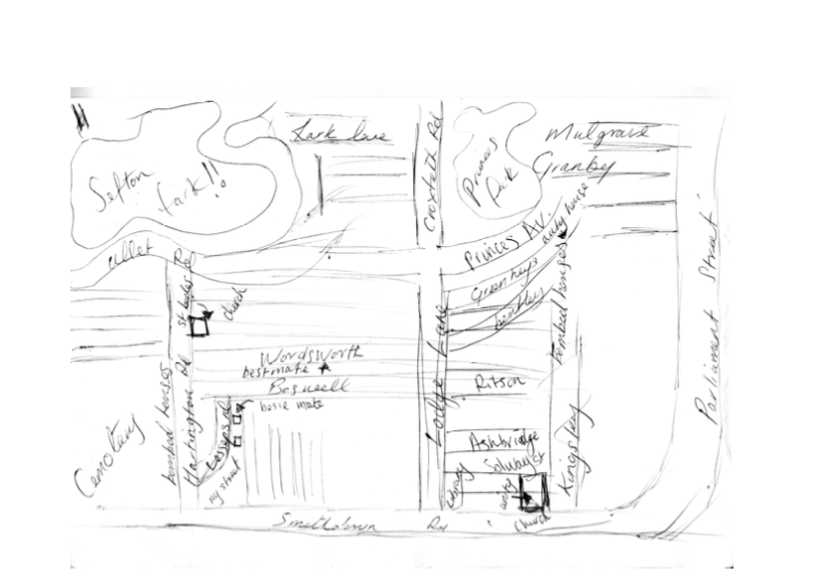

Figure 1. Mental maps of participants: (a) 30-39, female, Black; (b) 18-29, male, Black Mixed heritage; (c) 50-59, female, Mixed heritage Irish and Chinese.
297x215mm (300 x 300 DPI)

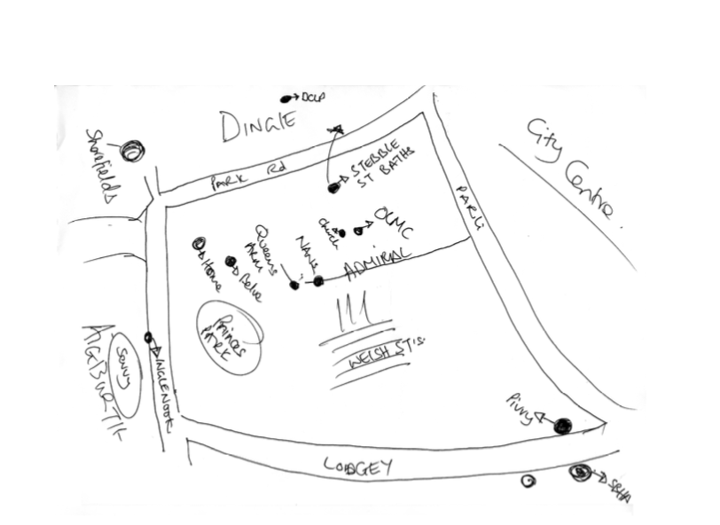

Figure 1. Mental maps of participants: (a) 30-39, female, Black; (b) 18-29, male, Black Mixed heritage; (c) 50-59, female, Mixed heritage Irish and Chinese.
297x215mm (300 x 300 DPI)

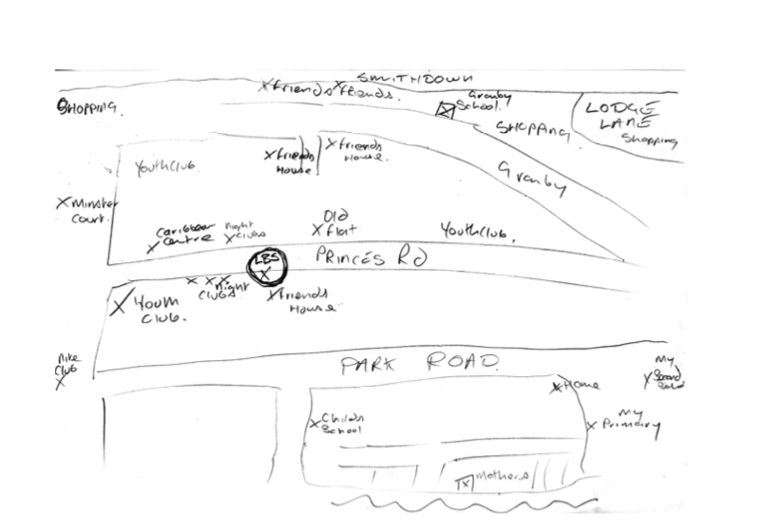

Figure 1. Mental maps of participants: (a) 30-39, female, Black; (b) 18-29, male, Black Mixed heritage; (c) 50-59, female, Mixed heritage Irish and Chinese.
297x208mm (300 x 300 DPI)

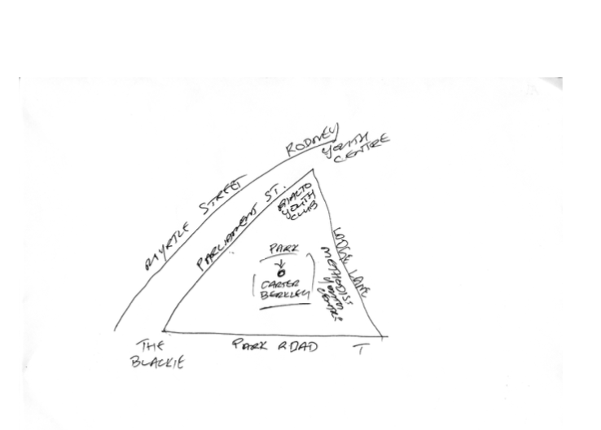

Figure 2. Mental maps of participants: (a) 50-59, male, Black Mixed heritage; (b) 18-29, female, Black; (c) 40-49, male, White
297x215mm (300 x 300 DPI)

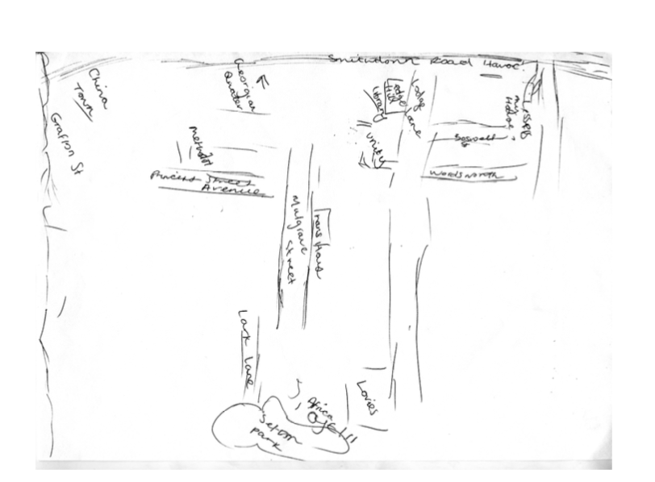

Figure 2. Mental maps of participants: (a) 50-59, male, Black Mixed heritage; (b) 18-29, female, Black; (c) 40-49, male, White
297x215mm (300 x 300 DPI)

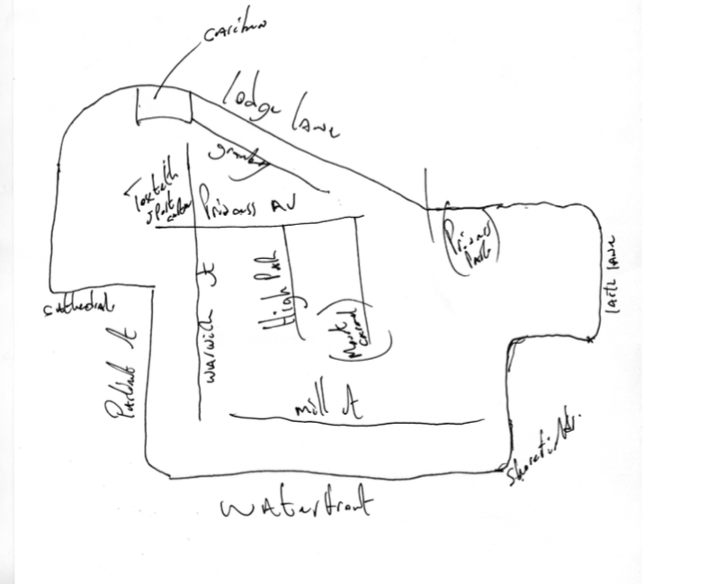

Figure 2. Mental maps of participants: (a) 50-59, male, Black Mixed heritage; (b) 18-29, female, Black; (c) 40-49, male, White
215x207mm (300 x 300 DPI)

