Identification of Torsional Receptances

Sung-Han Tsai a,b, Huajiang Ouyang a*, Jen-Yuan Chang b

a School of Engineering, University of Liverpool, Liverpool L69 3GH, UK

b Department of Power Mechanical Engineering, National Tsinghua University, Taiwan

# Abstract

Identification of torsional receptances of shaft structures has been a challenge. This paper presents a method for measuring or estimating high-quality torsional receptances using two different methods based on the Receptance Decoupling Technique. In both methods, a T-block needs to be attached to facilitate the generation of torsion, and only the numerical receptance data of the T-block cast in a simple theoretical model and a few measured receptance data of the assembled system are required. Both methods are studied and assessed in numerical simulation, and the more robust method is further validated in experiments. The usage of rotational accelerometer is shown to significantly improve the quality of the estimation when the noise level is high. It is demonstrated that high-quality torsional receptances can be indirectly measured with high repeatability using the proposed method and thus can be used subsequently to identify torsional modal parameters, update finite element models, make structural modifications, or implement active torsional vibration control. Due to ubiquitous use of rotating machines, this novel method has significant applications.

Keywords:

Torsional receptance measurement; Modal parameter identification; Modal Analysis; Rotor-bearing system; Angular accelerometer.

# Introduction

Although the techniques and the theories of experimental modal analysis (EMA) have been developed and widely applied to many engineering fields, the accurate measurement of rotational frequency response functions (FRFs) for the purpose of EMA is still a big challenge. The spatial incompleteness of information of rotational degrees of freedom (DoFs) has a direct adverse influence especially on structural modification, substructure coupling/decoupling, and model updating. As for structural modification, the translational receptance data would be sufficient for simple modifications such as a rigid mass or a translational grounded spring; however, the rotational receptances are necessarily required when rotational DoFs are heavily involved in the modifications. Similarly, the quality of estimation from substructure coupling or decoupling techniques also depends on the availability of rotational DoFs data in many cases. With regard to model updating, providing the experimental frequency response functions (FRFs) of rotational DoFs in addition to translational FRFs is considered to be essential since general structures have both kinds of DoFs.

For the rotational FRFs measurement, the torsional FRFs measurement can be seen as a special case in which vibration occurs around a longitudinal axis (of rotation) of an object (usually a shaft). Therefore, the measurement of torsional FRFs can be very useful and important in practice whenever power needs to be transmitted, for example, the driveline in cars [1], the power transmissions in wind turbines [2], or the rotor in electric motors [3].

From the experiment point of view, the difficulties in directly obtaining torsional FRFs can be broadly grouped into two aspects: (1) the measurement of torsional response and (2) the excitation and the measurement of a torque. The first aspect is relatively easy as there are various sensors available for measuring angular displacement, angular velocity, angular acceleration, or current signal [4]. Janssens and Britte [5] summarized and compared several kinds of sensors for measuring angular quantities. In summary, coder-based sensors such as magnetic pickups, optical encoders [6], or magnetic encoders are used for angular displacement measurement; laser Doppler vibrometer [7, 8] can directly measure the angular velocity, and the angular acceleration can be measured by sets of two linear accelerometers, or angular accelerometers [9]. Except for non-contact sensors, additional devices such as slip rings or telemetry systems are required to transmit the signal, which inevitably increase the cost and introduce additional noise to the signal.

On the other hand, there has not been an ideal solution for the excitation and the measurement of a moment/torque. To date, a few studies have reported their attempts to solve the problem. Champoux *et al.* [10] used two synchronized impact hammers to generate moments on a steel plate; additionally, use of a conventional twin shaker configuration, which provided two out of phase excitations, was studied [11-13]. Sihler [14] proposed that a three-phase electrical motor or generator could be used as a torsional exciter for large rotary machines to produce continuous torque with adjustable frequency and amplitude. For small rotary machines, Drew and Stone [15] investigated and evaluated the applicability of a 1.7-kW AC servo-drive system. They suggested that the torsional damping and stiffness characteristics of the servo-drive system with respect to motor speed had to be determined experimentally to model the drive accurately, but the damping and stiffness characteristics might not be very consistent when using different techniques. Later, Drew *et al.* [16] extended their previous work to excite torsionally variable inertia effects in a single cylinder engine. Instead of using electromagnetic exciters, Cho *et al.* [17] utilized magnetostrictive patch transducers (MPT), which were mainly used for nondestructive ultrasonic testing [18], to generate torsional impulses through changing the external magnetic field. Two permanent magnets were installed in the MPT to boost the actuation power, and the same transducer was also used as a sensor to measure the torsional response. Although in theory it is possible to obtain rotational FRFs through the exciters and sensors mentioned above (direct measurement), the accuracy, quality, and the coherence of the FRFs are likely to be poor in practice. In other words, the application of the experimental FRFs could be quite limited. They could be used to roughly identify the torsional natural frequencies and the mode shapes but cannot be applied to structural modification, substructure coupling, or model updating where accurate FRFs are required. For this reason, to get accurate measured torsional FRFs should be a big step forward in vibration measurement and subsequent structural dynamics and control.

Since it is not likely to obtain high-quality and accurate torsional FRFs directly, some indirect methods have to be sought. However, indirect measurement methods for torsional FRFs are rarely reported compared with those for rotational FRFs in bending. In fact, the methods for these two types of FRFs are expected to be related. In the following paragraphs, some studies relevant to these methods are reviewed and summarized, which can be broadly classified as: FRF/Modal expansion [19], finite-difference technique, and block attachment.

The basic idea of FRF expansion is to use a number of measured FRFs to estimate the FRFs at the unmeasured locations. Ewins [20] demonstrated that theoretically one can derive a point FRF $h_{kk}$ (at location *k*) through the measurement of another point FRF $h_{jj}$ (at location *j*) and a cross FRF $h_{kj}$ (between locations *k* and *j*), but the process could be restricted in practice due to modal incompleteness (residual problem) and spatial incompleteness. Avitabile and O’Callahan [21] implemented System Equivalent Reduction Expansion Process (SEREP) to expand the measured modal vectors to rotational DoFs and proposed two additional frequency-based approaches to compensate the truncation effect for both translational and rotational DoFs. Drozg *et al.* [22] demonstrated that a response model (a full FRF matrix) can be obtained using modal expansion, which is based on at least one full column in the FRF matrix, and Lagrange Multiplier Frequency Based Substructuring (LM FBS) method. Recently, an FRF expansion strategy for nonlinear structures was proposed by Wang *et al* [23].

The Finite-difference technique, which was first introduced by Sattinger [24], is essentially based on the spatial derivative of translational data measured from discrete data points to obtain the rotational quantities. According to the locations of the measurements and the excitations, different approximations of the derivative including backward difference, central difference, or forward difference could be made. Duarte and Ewins [25] compared the results estimated from different orders of differentiation approximation and considered the compensation of the residual term when modal parameters were used. It was also pointed out in several papers [26, 27] that the spacing between data points would affect the quality of the results and the positions of antiresonances of rotational FRFs in practice. Gibbons *et al.* [28] showed that the finite-difference technique could be unstable when spacing is too large or too small and thus proposed a procedure that could be used to experimentally obtain an optimal spacing. Schmitz [29] tried to measure the torsional response of a twist drill tool-holder-spindle-machine assembly and applied Receptance Coupling Substructure Analysis (RCSA) [30] to decouple the additional adapter structure and the twist drill; however, the results were not satisfactory due to the complexity of the twist drill model and the coupling between the bending and the torsional responses. Yang *et al.* [31] improved Schmitz’s work by modelling the geometry of the cutter in great detail, including distributed damped-elastic contact condition between the tool holder and the cutter, and removing the adapter’s mass effect.

For block attachment, the general purpose of attaching a structure is that a moment/torque can be generated by a force acting at a distance away from the location of interest to be measured. Several configurations of attachments were proposed, which could take the forms of a T-shape, an I-shape, an L-shape, or an X-shape. Sanderson and Fredo [12] and Sanderson [13] studied the rigid configurations of the T-shape and the I-shape and considered two types of bias errors (the rotational inertia of the configurations and the rotational velocity) in the measurement in which two shakers were used to produce a moment. The use of a rigid L-shaped structure was studied by Cheng and Qu [32] with a similar approach. They primarily focused on excluding the mass or rotational inertia introduced by the attachment to reflect the rotational receptance. Montalvao *et al.* [33] applied a receptance coupling technique to estimate rotational receptance without generating a moment, but the results have a limited frequency band and the problem could be ill-conditioned as it is sensitive to changes in data.

Mottershead *et al.* [34] considered the elasticity of the attachment when estimating rotational FRFs. They applied a T-block as a modification to the parent structure and proposed a multi-input, multi-output estimator for estimating (two translational and one rotational) in-plane receptances. The estimation made use of the forces and linear displacements measured on the T-block and included mass and the stiffness matrixes of the T-block model, thereby improving the conditioning of the problems. This work was later extended by Mottershead *et al.* [35] to determine a full 6x6 matrix of receptances using an X-block. The work presented by Lv *et al.* [36] might be the first attempt to successfully estimate the torsional receptance of a shafting structure. The estimation process can be broken down into two steps: (1) estimation at the joint of the T-block when the T-block and the shafting structure are assembled, and then (2) estimation at the connection location of the shafting structure and the T-block. It was shown that the bending natural frequencies of the whole structure would appear in the estimated torsional receptance if noise was present. In the experiment part, the T-block was replaced by a straight beam and only the first step of estimation was carried out.

In this paper, torsional receptance of a shafting system is indirectly measured through a T-block. Two techniques are proposed, and they require only a few receptances from the T-block itself (simulation) and the assembled structure (measurement). The work is mainly inspired by [36], but the techniques have been extended and improved in this study. A T-block can now be used in practice and the torsional receptance is estimated in one procedure (as opposed to the two procedures in [36]); furthermore, the appearance of bending natural frequencies in the estimated torsional receptance is resolved. The paper is organized as follows. In section 2, the theoretical developments of the methods are presented. In Section 3, the methods are evaluated through a simulation model. Section 4 gives the experimental results of one of the method. Conclusions are drawn in Section 5.

# Theoretical development

Two receptance-based approaches for the estimation of torsional receptance are developed in this section. Receptance decoupling technique is briefly introduced first and then followed by derivations of the two different techniques.

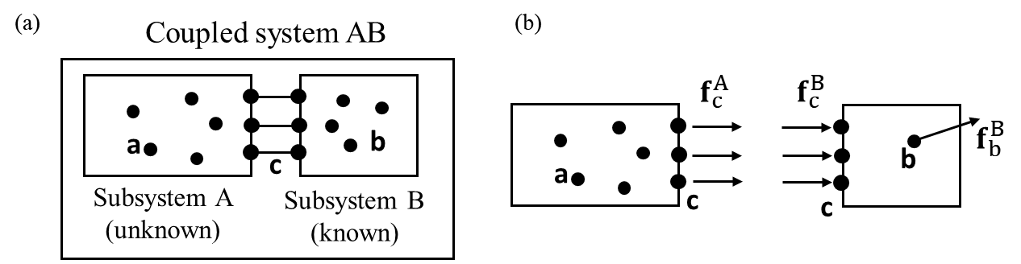

Fig. 1. Coupling of substructures: (a) the coupled system and (b) the free body diagram of each subsystem.

As shown in Fig. 1(a), a coupled system AB is composed of subsystem A and subsystem B, which are rigidly connected through a few connection coordinates denoted as “c” that is shared by both subsystems. The coordinates of subsystem A and subsystem B that are not “c” are denoted as “a” and “b”, respectively. The displacement-force relationship of the coupled system and the subsystems in the frequency domain can be defined as:

|  |  |  |
| --- | --- | --- |
|  | $$\left\{\begin{matrix}u_{c}^{AB} \\ u_{b}^{AB}\end{matrix}\right\}=\left[\begin{matrix}H_{cc}^{AB} & H_{cb}^{AB} \\ H_{bc}^{AB} & H_{bb}^{AB}\end{matrix}\right]\left\{\begin{matrix}f_{c}^{AB} \\ f_{b}^{AB}\end{matrix}\right\}$$ | (1) |
|  | $$\left\{\begin{matrix}u_{c}^{B} \\ u_{b}^{B}\end{matrix}\right\}=\left[\begin{matrix}H_{cc}^{B} & H_{cb}^{B} \\ H_{bc}^{B} & H_{bb}^{B}\end{matrix}\right]\left\{\begin{matrix}f_{c}^{B} \\ f_{b}^{B}\end{matrix}\right\}$$ | (2) |

and

|  |  |  |
| --- | --- | --- |
|  | $$u_{c}^{A}=H_{cc}^{A}f_{c}^{A}$$ | (3) |

Suppose that one is only interested in the receptances of unknown subsystem A at the connection coordinates, governed by Eq. (3), while some of the receptance data of the coupled system, governed by Eq. (1), and the receptances of subsystem B, governed by Eq. (2), are known. Furthermore, it is assumed that the coupled system is excited by external force $f_{b}^{AB}$ on the coordinates associated with subsystem B. For this purpose, the influence from subsystem B has to be removed from the coupled system in order to find $H_{cc}^{A}.$ It is worth mentioning that Eqs. (2) and (3) do not represent the “stand alone” subsystems but pertain to the coordinates of subsystem A and B in the coupled system as illustrated in Fig. 1(b). Therefore, the force equilibrium and displacement compatibility conditions applied at coordinates c can be defined as:

|  |  |  |
| --- | --- | --- |
|  | $u_{c}^{AB}=u_{c}^{B}=u_{c}^{A}$, $f_{c}^{AB}=f_{c}^{A}+f_{c}^{B}$ | (4) |

Additionally, the internal coordinates of and the external forces on subsystem B can be expressed as:

|  |  |  |
| --- | --- | --- |
|  | $u_{b}^{AB}=u_{b}^{B}$, $f_{b}^{AB}=f_{b}^{B}$ | (5) |

According to Eq. (4) and Eq. (5), subtracting Eq. (1) by Eq. (2) leads to

|  |  |  |
| --- | --- | --- |
|  | $$\left\{\begin{matrix}0 \\ 0\end{matrix}\right\}=\left[\begin{matrix}H_{cc}^{AB} & H_{cb}^{AB} \\ H_{bc}^{AB} & H_{bb}^{AB}\end{matrix}\right]\left\{\begin{matrix}f_{c}^{AB} \\ f_{b}^{AB}\end{matrix}\right\}-\left[\begin{matrix}H_{cc}^{B} & H_{cb}^{B} \\ H_{bc}^{B} & H_{bb}^{B}\end{matrix}\right]\left\{\begin{matrix}f_{c}^{B} \\ f_{b}^{B}\end{matrix}\right\}$$ | (6) |

Extracting the first row of equations in Eq. (6) and applying Eq. (5) give

|  |  |  |
| --- | --- | --- |
|  | $$\left[\begin{matrix}H_{cc}^{B} \\ H_{bc}^{B}\end{matrix}\right]f_{c}^{B}=\left[\begin{matrix}H_{cc}^{AB} \\ H_{bc}^{AB}\end{matrix}\right]f_{c}^{AB}+\left[\begin{matrix}H_{cb}^{AB}-H_{cb}^{B} \\ H_{bb}^{AB}-H_{bb}^{B}\end{matrix}\right]f_{b}^{B}$$ | (7) |

The internal forces at the connection coordinates of subsystem B can be expressed as:

|  |  |  |
| --- | --- | --- |
|  | $$f_{c}^{B}={\left[\begin{matrix}H_{cc}^{B} \\ H_{bc}^{B}\end{matrix}\right]}^{+}\left(\left[\begin{matrix}H_{cc}^{AB} \\ H_{bc}^{AB}\end{matrix}\right]f_{c}^{AB}+\left[\begin{matrix}H_{cb}^{AB}-H_{cb}^{B} \\ H_{bb}^{AB}-H_{bb}^{B}\end{matrix}\right]f_{b}^{B}\right)$$ | (8) |

where ${[ ]}^{+}$ denotes the generalized inverse matrix operation. If there is no external force applied to the connection coordinates of the coupled system, i.e. $f_{c}^{AB}=0$, $f_{c}^{A}$ can then be obtained through Eq. (4), which is

|  |  |  |
| --- | --- | --- |
|  | $$f_{c}^{A}={\left[\begin{matrix}H_{cc}^{B} \\ H_{bc}^{B}\end{matrix}\right]}^{+}\left[\begin{matrix}H_{cb}^{AB}-H_{cb}^{B} \\ H_{bb}^{AB}-H_{bb}^{B}\end{matrix}\right]f_{b}^{B}$$ | (9) |

Similarly, $u_{c}^{A}$ can be found through Eqs. (2) and (4)

|  |  |  |
| --- | --- | --- |
|  | $$u_{c}^{A}=\left({H_{cc}^{B}\left[\begin{matrix}H_{cc}^{B} \\ H_{bc}^{B}\end{matrix}\right]}^{+}\left[\begin{matrix}H_{cb}^{AB}-H_{cb}^{B} \\ H_{bb}^{AB}-H_{bb}^{B}\end{matrix}\right]+H_{cb}^{B}\right)f_{b}^{B}$$ | (10) |

From Eqs. (9) and (10), it can be seen that if the receptance submatrices of subsystem B and system AB are known, $H_{cc}^{A}$ can be determined through Eq. (3). The receptance submatrices of subsystem B that is an attached simple structure will be obtained from an accurate theoretical model, while the receptance submatrices of system AB will be obtained through a few measurements. It is important to mention that in the formulation above, the process from Eqs. (6) to (8), follows the work proposed by D’Ambrogio and Fregolent [37]. Next, Eqs. (9) and (10) are extended and explicitly applied to the estimation of torsional receptance of a subsystem for Method 1.

*Method 1:*

The schematic of the problem considered in this paper is shown in Fig. 2 in which a T-block (subsystem B) is attached to a shafting system (subsystem A). The aim is to estimate the torsional receptance at the connection coordinate of the shafting system.

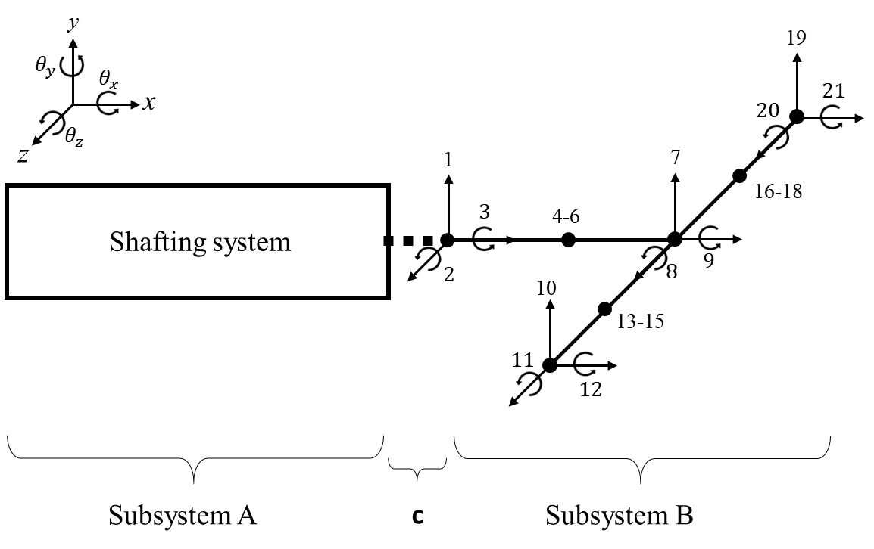

Fig. 2. The schematic of the assembly of a shafting system and a T-block.

For the purpose of demonstration, the T-block is represented by 6 beam elements in which each node has three degrees of freedom (DoFs), which are lateral deflection, rotation for bending, and angle of twist, all in the local coordinate system, and are numbered sequentially from the leftmost node; globally, they are denoted as $y, { θ}_{x}, and θ_{z}$, respectively. Therefore, in this case, the T-block has 21 DoFs in total. For Method 1, a force is assumed to be applied at DoF 10. Accordingly, Eq. (7) can be explicitly written as:

|  |  |  |
| --- | --- | --- |
|  | $$\left[\begin{matrix}h_{1,1}^{B} & h_{1,2}^{B} & 0 \\ h_{2,1}^{B} & h_{2,2}^{B} & 0 \\ 0 & 0 & h_{3,3}^{B} \\ h_{10,1}^{B} & h_{10,2}^{B} & h_{10,3}^{B}\end{matrix}\right]\left\{\begin{matrix}f_{1}^{B} \\ f_{2}^{B} \\ f_{3}^{B}\end{matrix}\right\}=\left\{\begin{matrix}h_{1,10}^{AB}-h_{1,10}^{B} \\ h_{2,10}^{AB}-h_{2,10}^{B} \\ \begin{matrix}h_{3,10}^{AB}-h_{3,10}^{B} \\ h_{10,10}^{AB}-h_{10,10}^{B}\end{matrix}\end{matrix}\right\}f_{10}^{AB}$$ | (11) |

From Eq. (1) and Eq. (4), it can be seen that $u_{3}^{A}=h_{3,10}^{AB}f_{10}^{AB}$. By subtracting this relationship from the third row of Eq. (11), it gives $h_{3,3}^{B}f_{3}^{B}-u_{3}^{A}=-h_{3,10}^{B}f_{10}^{AB}$. Then, rearranging Eq. (11) to include $u_{3}^{A}$, which shows that

|  |  |  |
| --- | --- | --- |
|  | $$\left[\begin{matrix}h_{1,1}^{B} & h_{1,2}^{B} & 0 & 0 \\ h_{2,1}^{B} & h_{2,2}^{B} & 0 & 0 \\ 0 & 0 & h_{3,3}^{B} & -1 \\ h_{10,1}^{B} & h_{10,2}^{B} & h_{10,3}^{B} & 0\end{matrix}\right]\left\{\begin{matrix}f_{1}^{B} \\ f_{2}^{B} \\ f_{3}^{B} \\ u_{3}^{A}\end{matrix}\right\}=\left\{\begin{matrix}h_{1,10}^{AB}-h_{1,10}^{B} \\ h_{2,10}^{AB}-h_{2,10}^{B} \\ \begin{matrix}-h_{3,10}^{B} \\ h_{10,10}^{AB}-h_{10,10}^{B}\end{matrix}\end{matrix}\right\}f_{10}^{AB}$$ | (12) |

The internal torque $f_{3}^{B}$ and torsional displacement ${ u}_{3}^{A}$ can be calculated by solving Eq. (12), and therefore $h_{3,3}^{A}$ can be calculated as ${-u_{3}^{A}}/{f_{3}^{B}}$. The solutions are:

|  |  |  |
| --- | --- | --- |
|  | $${f_{3}^{B}}/{f_{10}^{AB}=}[\left(h_{1,10}^{AB}h_{2,1}^{B}h_{10,2}^{B}-h_{1,10}^{AB}h_{2,2}^{B}h_{10,1}^{B}\right)+\left(h_{2,10}^{AB}h_{1,2}^{B}h_{10,1}^{B}-h_{2,10}^{AB}h_{1,1}^{B}h_{10,2}^{B}\right) \\ +\left(h_{1,1}^{B}h_{10,2}^{B}h_{10,2}^{B}-h_{1,1}^{B}h_{2,2}^{B}h_{10,10}^{B}\right)+\left(h_{1,2}^{B}h_{2,1}^{B}h_{10,10}^{B}-h_{1,2}^{B}h_{10,1}^{B}h_{10,2}^{B}\right) \\ +(h_{10,1}^{B}h_{2,2}^{B}h_{10,1}^{B}-h_{10,1}^{B}h_{2,1}^{B}h_{10,2}^{B})]/det⁡(A)$$ | (13) |

And

|  |  |  |
| --- | --- | --- |
|  | $${u_{3}^{A}}/{f_{10}^{AB}=}[(h_{1,10}^{AB}h_{3,3}^{B}\left(h_{2,1}^{B}h_{10,2}^{B}-h_{2,2}^{B}h_{10,1}^{B}\right)+h_{2,10}^{AB}h_{3,3}^{B}\left(h_{1,2}^{B}h_{10,1}^{B}-h_{1,1}^{B}h_{10,2}^{B}\right) \\ +h_{10,10}^{AB}h_{3,3}^{B}\left(h_{1,1}^{B}h_{2,2}^{B}-h_{1,2}^{B}h_{2,1}^{B}\right)-h_{1,1}^{B}h_{2,2}^{B}h_{10,10}^{B}h_{3,3}^{B}+h_{1,1}^{B}h_{2,2}^{B}h_{10,3}^{B}h_{10,3}^{B} \\ +h_{1,1}^{B}h_{3,3}^{B}h_{10,2}^{B}h_{10,2}^{B}+h_{1,2}^{B}h_{2,1}^{B}h_{3,3}^{B}h_{10,10}^{B}-h_{1,2}^{B}h_{2,1}^{B}h_{10,3}^{B}h_{10,3}^{B}-h_{1,2}^{B}h_{3,3}^{B}h_{10,1}^{B}h_{10,2}^{B} \\ -h_{2,1}^{B}h_{3,3}^{B}h_{10,1}^{B}h_{10,2}^{B}+h_{2,2}^{B}h_{3,3}^{B}h_{10,1}^{B}h_{10,1}^{B})]/det⁡(A)$$ | (14) |

where **A** is the 4-by-4 matrix on the left-hand side of Eq. (12). The determinant function in each equation will be cancelled out when calculating for $h_{3,3}^{A}$; however, for the sake of completeness, det(**A**) is $h_{1,1}^{B}h_{2,2}^{B}h_{10,3}^{B}-h_{1,2}^{B}h_{2,1}^{B}h_{10,3}^{B}$ in this example.

*Method 2:*

Although in Method 1 the torsional receptance of the shafting system could be quickly estimated through a single modal test (one impact hammer test), the result might be prone to the noise since the contaminated measured receptances are multiplied and added, as can be seen in Eqs. (13) and (14). For this reason, Method 2 is proposed, and it is later shown that Method 2 is more robust to noise and generally provides better estimations than Method 1.

First, in order to distinguish the internal DoFs that are measured by sensors from those that are subject to external forces, Eq. (2) is rewritten as:

|  |  |  |
| --- | --- | --- |
|  | $$\left\{\begin{matrix}u_{c}^{B} \\ u_{b^{m}}^{B}\end{matrix}\right\}=\left[\begin{matrix}H_{cc}^{B} & H_{cb^{f}}^{B} \\ H_{b^{m}c}^{B} & H_{b^{m}b^{f}}^{B}\end{matrix}\right]\left\{\begin{matrix}f_{c}^{B} \\ f_{b^{f}}^{B}\end{matrix}\right\}$$ | (15) |

where the subscripts $b^{m}$ and ${ b}^{f}$ represent the measured internal DoFs and the internal DoFs subject to external forces, respectively. Based on Eq. (15), the following two equations can be established:

|  |  |  |
| --- | --- | --- |
|  | $$f_{c}^{B}={H_{b^{m}c}^{B}}^{-1}\left(u_{b^{m}}^{B}-H_{b^{m}b^{f}}^{B}f_{b^{f}}^{B}\right)$$ | (16) |

and

|  |  |  |
| --- | --- | --- |
|  | $$u_{c}^{B}=H_{cc}^{B}{H_{b^{m}c}^{B}}^{-1}\left(u_{b^{m}}^{B}-H_{b^{m}b^{f}}^{B}f_{b^{f}}^{B}\right)+H_{cb^{f}}^{B}f_{b^{f}}^{B}$$ | (17) |

By implementing Eq. (4), it can be shown that

|  |  |  |
| --- | --- | --- |
|  | $$u_{c}^{B}=u_{c}^{A}=-H_{cc}^{A}f_{c}^{B}$$ | (18) |

Substituting Eq. (16) and Eq. (17) into Eq. (18) leads to

|  |  |  |
| --- | --- | --- |
|  | $$\left[\begin{matrix}Q & R\end{matrix}\right]\left\{\begin{matrix}u_{b^{m}}^{B} \\ f_{b^{f}}^{B}\end{matrix}\right\}=-H_{cc}^{A}\left[\begin{matrix}{H_{b^{m}c}^{B}}^{-1} & T\end{matrix}\right]\left\{\begin{matrix}u_{b^{m}}^{B} \\ f_{b^{f}}^{B}\end{matrix}\right\}$$ | (19) |

where

|  |  |  |
| --- | --- | --- |
|  | $Q=H_{cc}^{B}{H_{b^{m}c}^{B}}^{-1}$, $R=H_{cb^{f}}^{B}-H_{cc}^{B}{H_{b^{m}c}^{B}}^{-1}H_{b^{m}b^{f}}^{B}$, and $T=-{H_{b^{m}c}^{B}}^{-1}H_{b^{m}b^{f}}^{B}$ | (20) |

It can be shown that (see Appendix)

|  |  |  |
| --- | --- | --- |
|  | $$\left\{\begin{matrix}u_{b^{m}}^{B} \\ f_{b^{f}}^{B}\end{matrix}\right\}=\left[\begin{matrix}\left(E{T_{b^{m}}}^{-1}H_{b^{m}b^{f}}^{AB}T_{b^{f}}\right)+\left(H_{b^{m}b^{f}}^{B}-EH_{b^{m}b^{f}}^{B}\right) \\ I\end{matrix}\right]f_{b^{f}}^{B}=Uf_{b^{f}}^{B}$$ | (21) |

where $E={H_{b^{m}c}^{B}H_{b^{m}c}^{B}}^{+}, and T_{b^{m}}$ and $T_{b^{f}}$ are the coordinate transformation matrixes for responses and excitations, respectively. Since $f_{b^{f}}^{B}∈ C^{b^{f}}$, the resulting unmeasured receptances can be estimated by

|  |  |  |
| --- | --- | --- |
|  | $$H_{cc}^{A}=-\left(\left[\begin{matrix}Q & R\end{matrix}\right]U\right){\left(\left[\begin{matrix}{H_{b^{m}c}^{B}}^{-1} & T\end{matrix}\right]U\right)}^{+}$$ | (22) |

# Numerical simulation

In this section, both approaches proposed in the previous section are applied to a damped numerical model. The influence of removing the damping of the T-block and that of the presence of noise in FRFs are studied and evaluated. Later, a number of selections of the locations of excitations and measured responses are assessed. Finally, a fine FE model of the T-block is presented to provide FRFs for the estimation technique in practice.

## Theoretical model

The theoretical model for this study is built based on a real laboratory test rig, which can be considered as a rotor-bearing system. The schematic of the test rig and the T-block is shown in Fig. 3. The test rig contains 3 sets of bearings, a circular shaft, a gear, and two identical discs. The shaft made of mild steel has the following properties: $E=205 GPa, ρ=7850 kg m^{-3}, υ=0.33, l=1 m, and d=17 mm$, and is modelled by Timoshenko beam elements. Each disc has mass of 0.67 kg, polar moment of inertia 7.653×10-4, and diametric moment of inertia 4.025×10-4. The gear has mass of 1.03 kg, polar moment of inertia 7.6142×10-4, and diametric moment of inertia 4.69×10-4 . Bearings are treated as isotropic grounded springs, and each bearing has two translational stiffness (2×107 N/m in *y*- and *z*-direction) and two rotational stiffness (26 Nm/rad in $θ_{y}$- and $θ_{z}$-direction).

In this simulation model, the T-block has the same material properties as the shaft and has a square cross-section with a width of 17 mm. For the sake of simplicity, it is modelled by 6 Timoshenko beam elements as shown in Fig. 2. Therefore, the detailed features, such as holes or the influence of the attached sensors, are not included in this simulation. It is worth mentioning that a multi-freedom constraint (MFC) is applied to take account of the problem of overlapping material. In this case, the node in the middle of the beam along the z-axis is chosen to be the master node while the node from another beam connected to the master node is the slave node. Lastly, the numerical model is assumed to be proportionally damped. As suggested by Silva [38], metal structures with joints and supports typically have damping ratios below 7%. The damping matrix is defined as $\left[C\right]=16.7863\left[M\right]+8.5041×{10}^{-6}\left[K\right]$, causing modes to have 1% to 3% of damping ratios for the frequencies below 1000 Hz. The undamped natural frequencies of the original shafting system and the assembled system below 1000 Hz are listed in Table 1.

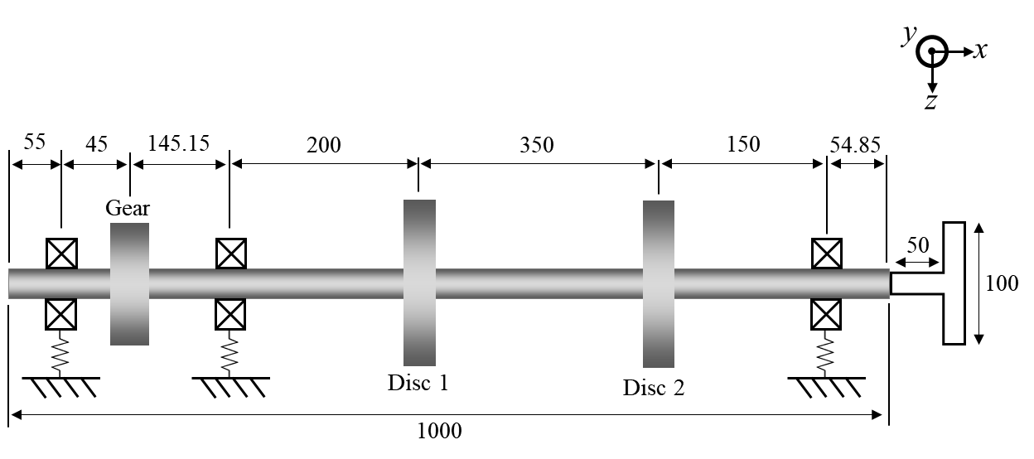

Fig. 3 The schematic of the numerical model (unit: mm).

Table 1. The natural frequencies of the shafting system and the assembled system. (T denotes torsional natural frequency)

|  |  |  |
| --- | --- | --- |
|  | Shafting system | Assembled system |
| Natural frequency (Hz) | 66.0  172.6  242.9 (T)  421.7 (T)  422.1  494.9  890.9 | 63.3  157.1  227.4 (T)  275.2  411.1 (T)  423.9  513.6  662.8 (T)  905.9 |

The scenarios of estimating the torsional receptance through Method 1 and Method 2 are (see Fig. 2):   
Method 1: an external excitation is applied at DoF 10 and the responses at DoFs 1, 2, and 10 are measured.  
Method 2: two external excitations are applied separately at translational DoFs 13 and 16 and the corresponding responses to each excitation at DoFs 7 and 9 are measured.

The exact point torsional receptance at the tip of the shafting system is plotted together with the estimation results from Method 1 and Method 2 in Fig. 4. It is clear that both methods can yield the exact FRF when noise is not present.

## The removal of the damping of the T-block

In the previous case, the models and the measured FRFs are both assumed to be lightly damped, but damping could be difficult to determine when modelling the T-block. Therefore, in this example, the damping is removed from the model of the T-block while the shafting system and the assembled system are still assumed to be proportionally damped, and then the estimation results are assessed by comparing them with the exact FRFs. The results of using undamped T-block are presented in Fig. 5. By the observation of the magnitude and phase plots, it can be seen that the estimation results almost overlap with the exact FRFs; however, with a closer look, gaps between the estimated FRFs and the exact FRFs can be noticed, which is accounted for by the removal of damping of T-block. In this case, the mean and the variance of the magnitude differences for the two methods in dB scale from the exact FRF are both close and small, which are 0.0029 and 0.0027 for Method 2 and 0.0029 and 0.0029 for Method 1. However, it could be reasonable to surmise that the effect of removing the damping of the T-block could increase when the size of the T-block gets larger since its influence on the dynamic behaviour of the assembled system increases when its size gets bigger. In order to confirm the speculation, the width of the T-block in Fig. 3 is increased from 10 cm to 30 cm, and the corresponding results (10 - 700 Hz) are shown in Fig. 6. It is clear that the magnitudes of the estimated FRFs are lower than the exact FRFs at the resonances and that the estimated FRFs start to lose their accuracies in high frequencies. This loss of accuracy in high frequencies could be caused by the assumption of proportional damping in this simulation model. The modal damping increases as the frequency gets higher in a proportional damping model; thus, the FRF curves can differ much from those without damping, leading to errors in the prediction of torsional FRFs. Although, in practice, the damping of the T-block itself is not expected to be large (<1%), care should be taken to avoid using a T-block that is too big or heavily damped in order to mitigate the effect as a result of the exclusion of the damping in the model of the T-block; besides, the T-block should not be too small in order to impart a sufficient moment/torsion. Generally, the size should be considered carefully and should vary on a case-by-case basis (depending on the parent structure).

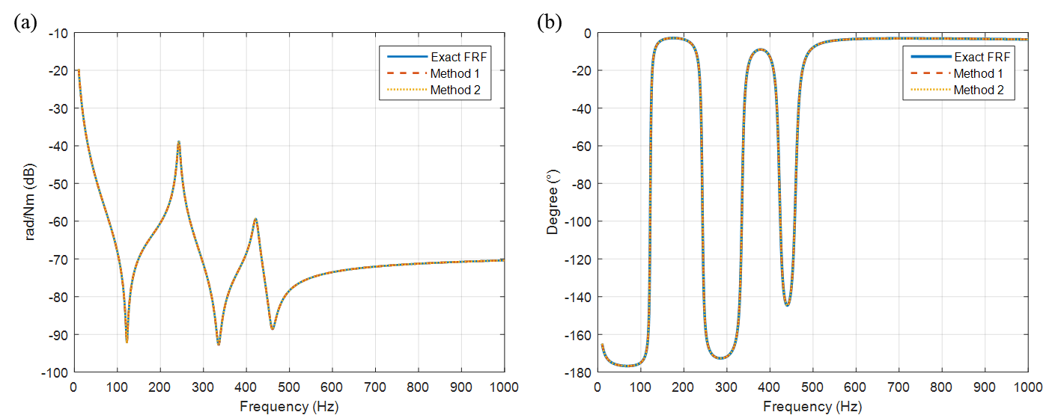

Fig. 4. Comparison of the exact FRF and estimated FRFs: (a) Magnitude and (b) Phase.

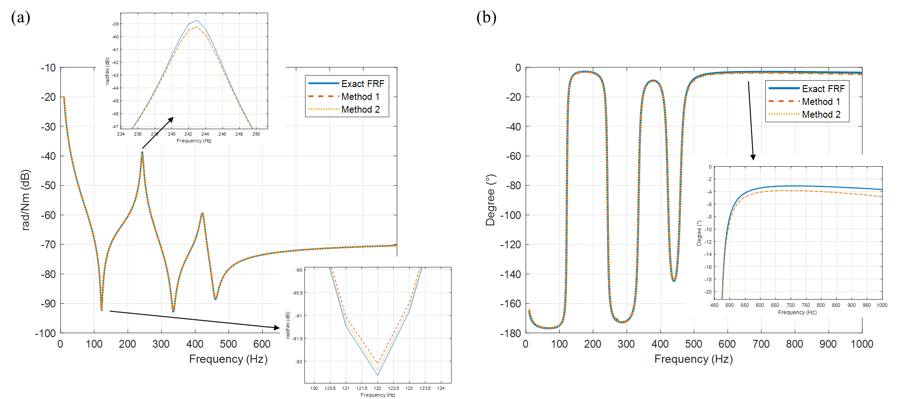

Fig. 5. The estimated torsional receptance when the damping of the T-block is excluded: (a) Magnitude and (b) Phase.

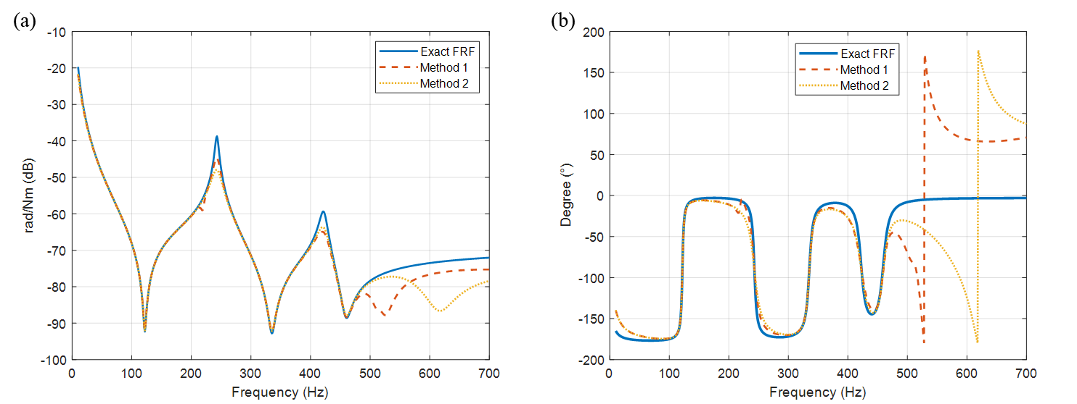

Fig. 6. The estimated torsional receptance when the damping of a longer T-block is excluded: (a) Magnitude and (b) Phase.

## The inclusion of noise in FRFs

In order to further assess the robustness of the methods, numerical noise is then added to the FRFs of the coupled system that are to be obtained experimentally in practice (but the damping of the T-block is neglected). A magnitude-dependent contaminated FRF at frequency $ω$ is defined as:

|  |  |  |
| --- | --- | --- |
|  | $$\tilde{h}(ω)=(1+\frac{γ}{100}∙randn)∙h(ω)$$ | (23) |

where $γ$ is noise level in (%) and randn is a normally distributed random number whose mean and standard deviation are 0 and 1, respectively. For instance, Fig. 7 shows some of the contaminated FRFs in which the noise level is set to 10%, and the resulting estimations obtained are compared with the exact FRF in Fig. 8. In this example, the results are the averages of 10 estimations whose FRFs are randomly contaminated through Eq. (23).

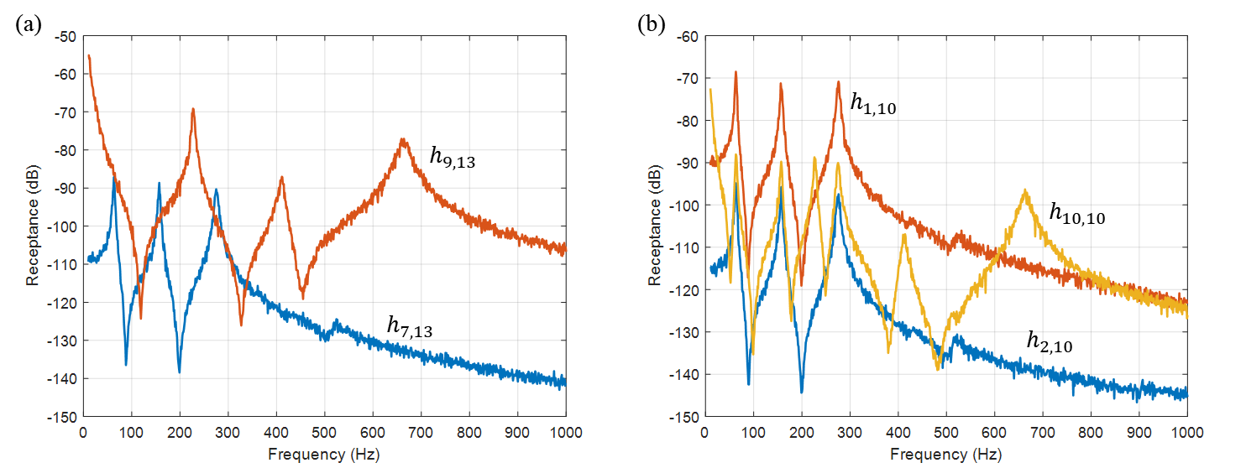

Fig. 7. FRFs with added numerical noise used in (a) Method 2 and (b) Method 1.

It can be seen that, in general, both methods can produce fairly accurate estimations especially below 800 Hz. The mean and the variance of the amplitude differences in dB scale in the frequency range of 10 – 1000 Hz, which are given in Table 2, are used to compare the performance of the methods. It is clear that Method 2 is better than Method 1 since these figures of Method 2 are much smaller than those of Method 1 and that the estimation produced by Method 1 has several unexpected peaks other than the torsional natural frequencies. It can further be found that those unwanted peaks occur near the bending natural frequencies of the assembled system (see Fig. 7 and Table 1). In addition to this, the estimated FRFs seem to be more sensitive to noise in the high-frequency range, which might result from the relatively smaller response in the receptances used for the estimations (see Fig. 7).

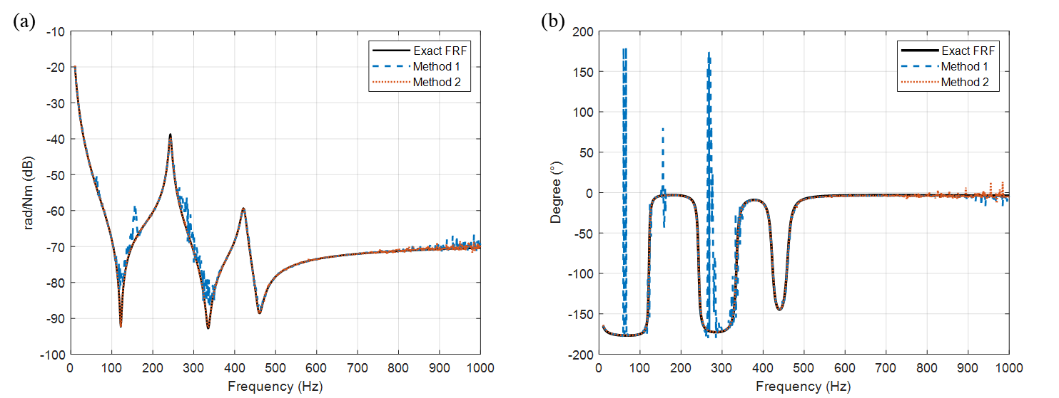

Fig. 8. The estimation of torsional receptance with noisy FRFs: (a) Magnitude and (b) Phase.

Table 2. The mean and the variance of the magnitude difference in FRFs (10 - 1000 HZ).

|  |  |  |
| --- | --- | --- |
|  | Method 1 | Method 2 |
| (Mean, Variance) of magnitude difference in dB | (0.2237, 2.3280) | (0.0383, 0.0871) |

## Further discussion on Method 2

*Choice of responses and excitations*

In the previous discussion, it has been demonstrated that both methods work well when noise is not present and that Method 2 performs better than Method 1 when noise is present. Therefore, Method 2 is chosen to be further studied and evaluated. When implementing Method 2, the question of “which DoFs on the T-block should be selected for measured responses and excitations” would first arise and is of great importance to the quality of the estimated receptance.

To answer the question of the selection of measured responses, attention should be first paid to the formulation of Method 2, namely, Eqs. (19) to (22). In the formulas, it can be noticed that the inversion of $H_{b^{m}c}^{B}$ is heavily involved, thus possibly causing numerical difficulties in the results. In order to avoid that, $b^{m}$ should be selected so as not to make $H_{b^{m}c}^{B}$ singular or close to singular; additionally, it is believed that including the rotational response (DoF 9 in Fig. 2) is crucial for obtaining better estimations since Eq. (22) is essentially solved in a least-squares sense. Considering these two points, several options for $b^{m}$ are available, and different selections of measured responses can have different levels of robustness against the presence of noise in the measured FRFs.

On the other hand, regarding the excitations, there are mainly three key factors to be considered. One is the quality of the FRF measurements in practice, another is the generation of torsion, and the last one is the number of excitations required to obtain sufficiently accurate estimations. If a modal impact test is to be carried out, generating a clear impact is vital for acquiring high-quality measurements. By considering this along with the generation of torsion, excitations should be applied on the “wings” of the T-block. As double impacts are likely to happen in this test setup, locations of the excitations should not be too close to the tips of the wings (similar to the case of hitting the tip of a cantilever beam); that is to say, in Fig. 2, DoFs 13 and 16 could be a better choice than DoFs 10 and 19. On the other hand, if a Shaker Test is implemented in the measurement, the issue of double impacts can be circumvented. In that case, excitations on DoFs 13 and 16 could be a better choice as a greater torsional excitation can be generated.

To answer the question of the number of excitations required and the influence that different selections of measured responses can make, a number of simulations are carried out. In the simulation, a set of noisy FRFs (10% noise level) are used for different combinations of excitation DoFs and response DoFs, and the results are compared through the mean and variance of the amplitude difference from the exact FRF within the range of 10 - 700 Hz in dB scale. For the sake of clarity, only a few cases are presented so as to give a general picture. The results are presented in Fig. 9, and some findings are summarized below:

1. The method is rather easy to implement since it is possible to obtain a clear estimation by a single modal impact test.
2. Increasing the number of excitations can improve the quality of the estimation while increasing the number of measured translational responses might not necessarily have the same beneficial effect.
3. Including the rotational response (DoF 9) can significantly improve the robustness of the estimation when the level of noise is high in the measurements and thus ought to be considered in the measurement.

It is worth mentioning that, in the case of using noise-free FRFs, all the combinations listed in Fig. 9 produce exactly the same correct results except for the case of excitation at DoF 13 and measured response at DoF 10. The estimated torsional receptance in the last example of Fig. 9 is given in Fig. 10, and the corresponding mean and variance are -0.035 and 0.373, respectively. The exact FRF and the estimated receptance are generally in good agreement, but some fluctuations (due to noise) on the magnitude and the phase curves can also be noticed.

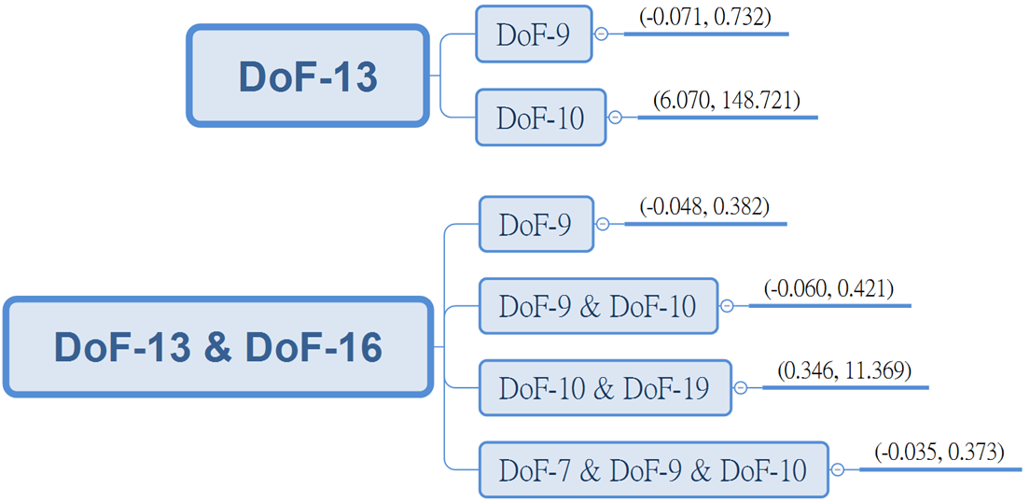

Fig. 9. Different combinations of excitations and responses. The blocks, from left to right, represent the DoFs for excitation, DoFs for measured responses, and the mean and variance of the corresponding result.

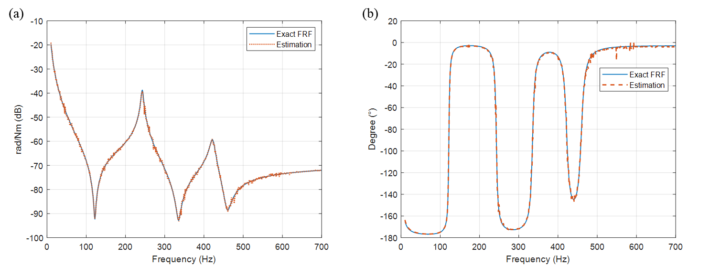

Fig. 10. Estimated torsional receptance: (a) Magnitude and (b) Phase.

*Comparison with Lv’s approach [36]*

As this work is mainly inspired by Lv’s paper, a comparison of Method 2 proposed in this paper and their approach is presented to highlight the differences and improvements. Fig. 11 shows the estimated torsional FRFs using different approaches in which the noise levels of the required measured FRFs are both set to 10%. The main differences between these two approaches are (1) The choice of DoFs for responses and excitations and (2) the two-step procedure in Lv’s approach in which the receptance at DoF 9 is first estimated and the torsional FRF of the parent system is then estimated based on the receptance at DoF 9 (please see [36] for more details). The DoFs for responses and excitations for Method 2 are DoFs 7, 9, 10 and DoFs 13, 16, and those for Lv’s method are DoFs 10, 19 and DoFs 10, 19. From this figure, overall, it is clear that Method 2 is more robust against measurement noise. The mean and variance of magnitude difference from the exact FRF in dB scale for Method 2 are (-0.0229, 0.6221), and that for Lv’s approach are (-0.0518, 4.0060). Through a closer inspection, it can be seen that the FRF from Lv’s approach is prone to having extra peaks (pointed by the arrows) whose locations are close to the bending natural frequencies of the assembled system and that it fails to clearly capture the anti-resonances. These issues have been reported in Lv’s paper, and the proposed Method 2 is shown to successfully resolve the issues and produce a more reliable result.

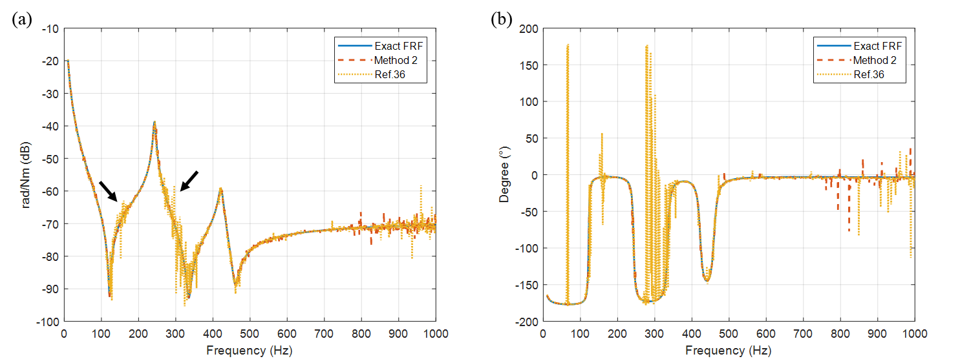

Fig. 11. Comparison of FRFs obtained from Method 2 and Lv’s approach: (a) Magnitude and (b) Phase.

The underlying causes for the differences between Method 2 proposed in this paper and Lv’s approach are further discussed and revealed through the following four targeted case studies.

* Case 1: Lv’s approach is used to estimate the torsional FRF. The DoFs are the same as the original paper, which are DoFs 10, 19 for both responses and excitations.
* Case 2: Method 2 is implemented in Lv’s two-step approach, but the “internal” receptances, which are estimated in the first step and passed to the second steps, include the DoFs in all three directions, $y, { θ}_{x}, and θ_{z}.$ Originally, only *y* direction is considered.
* Case 3: This is similar to Case 2, but it includes one more rotational response at DoF 9 in the first step.
* Case 4: Method 2 is directly used to estimate the torsional FRF. The DoFs for responses are DoFs 9, 10, 19 and those for excitations are 10 and 19.

As the normally-distributed artificial noise is randomly added, 50 estimations are generated for each case to evaluate their error distribution. Examples of the resulting FRFs of the four cases are plotted in Fig. 12. It can be seen that all the estimated FRFs are generally close to the exact FRF but show different levels of variations (robustness against noise). To evaluate the performance, the probability density function of variations for each case is estimated using kernel density estimation (KDE) with Gaussian kernel and Silverman’s rule of thumb [39] bandwidth estimator. The probability density functions are plotted in Fig. 13.

Case 2 is designed to answer the question whether omitting the “internal” receptances in ${ θ}_{x}, and θ_{z}$ directions in Lv’s two-step approach would degrade the result (as it is assumed in a beam element that torsional DoF is uncoupled with other DoFs but the excitations applied on the T-block do as well excite responses in the ${ θ}_{x}, and θ_{z}$ directions). Results show that Case 2 only has a slight improvement over Case 1 given that the most likely value for variance drops only slightly from 4.0158 to 3.7003; nonetheless, it is reasonable to presume that the influence of including the ‘internal’ receptances can become more noticeable when the T-block gets larger. Case 3 again clearly demonstrates the importance of including a measured rotational response as it reduces the most likely value for variance significantly to 1.0628. The unwanted peaks in Cases 1 and 2 have disappeared when including the rotational receptance at DoF 9 in Case 3. Lastly, Case 4 still outperforms Case 3 even though these two cases have the same selected DoFs for response and excitation. Method 2 proposed in this paper is able to produce estimations in one go and take into account receptances in all three directions, thus possibly avoiding the additional numerical errors that the two-step procedure in Lv’s approach introduced; moreover, Method 2 provides the flexibility in selecting DoFs for response and excitation without difficulty. These are probably the main reasons that make Method 2 a more robust method.

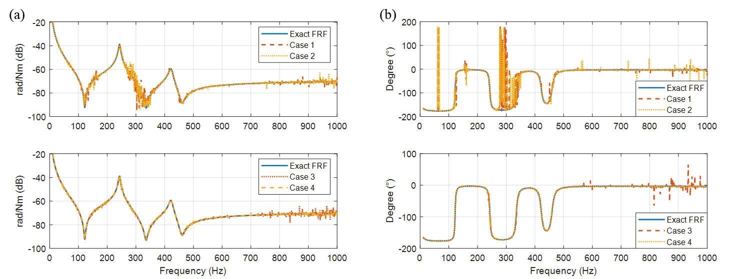

Fig. 12. The resulting FRFs of different cases: (a) Magnitude and (b) Phase plot.

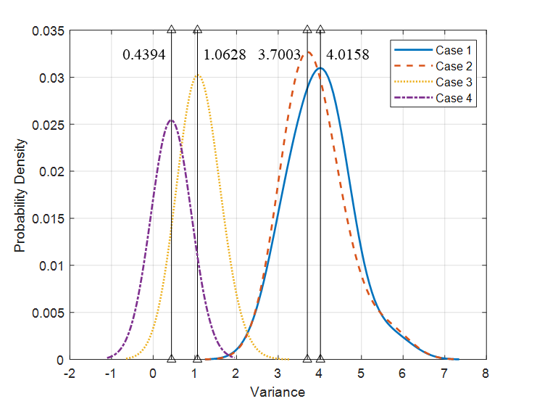

Fig. 13. Probability density functions for four different cases.

## Model updating of the T-block

In reality, the T-block might include several geometrical features or interference with the attached sensors, and thus a more detailed and accurate model has to be generated to represent the real structure. Fig. 14(a) shows the T-block that is used in practice for Method 2. The models of the translational accelerometer and the rotational accelerometer are Kistler 8728A500 and Kistler 8840, weighing 1.6 grams and 22 grams, respectively. The rotational accelerometer is attached to the T-block by a single socket head cap screw. It is found that the resonant frequencies and the accuracy of acceleration measurement are affected by the mounting torque of the rotational accelerometer; hence, care has to be taken to ensure the mounting torque is set to the value specified by the provider, which is 2 Nm in this case.

A finite element model of the T-block shown in Fig. 14(b) is built in Abaqus using quadratic hexahedral elements of type C3D20R, and the total number of nodes and elements are 12934 and 2704, respectively. The green square spots in Fig. 14(b) show the nodes with point masses representing translational accelerometers, and the rotational accelerometer is modelled as a point mass away from the T-block at reference point 1 (RP-1). The motion of the regions around the hole on the T-block close to the rotational accelerometer is constrained to reference point 2 (RP-2). Then, RP-1 is connected to RP-2 through springs in 4 DoFs ($y,z, θ_{y}, and θ_{z}$) in order to take the interaction into consideration, and the other two DoFs ($x and θ_{x}$) are assumed to be rigidly connected. The springs are assumed to be isotropic, i.e. the spring constants in *y* and *z* directions are the same.

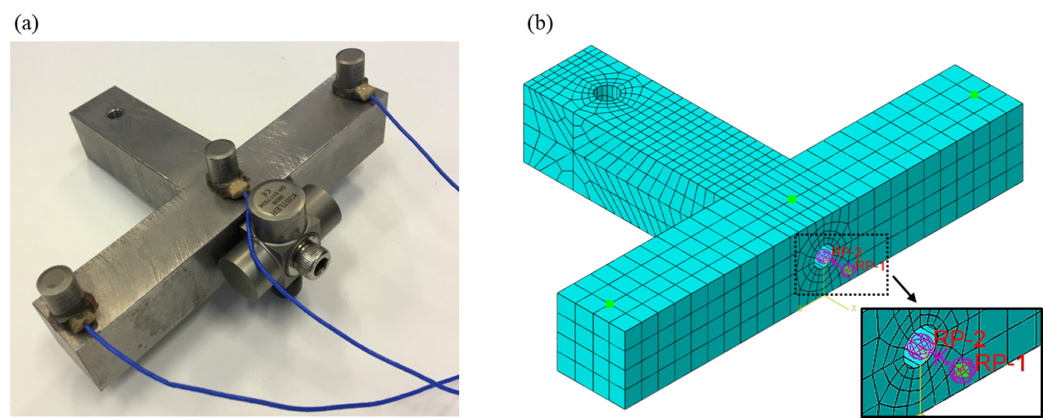

Fig. 14. T-block (a) the real structure (b) FE model.

Modal analysis is carried out to find the natural frequencies of the free-free T-block with those sensors attached, and the inverse eigensensitivity method is implemented to update the model parameters. The updated parameters are chosen to be Young’s Modulus and the translational spring stiffness between RP-1 and RP-2 since the natural frequencies are found to be insensitive to the change of Poisson’s ratio and the rotational spring stiffness. Three experimentally identified natural frequencies are used for the updating, thus leading to an over-determined problem. The updated natural frequencies and the system parameters are given in Table 3 and Table 4, respectively. Although the updated Young’s modulus is on the high side, it remains within the reasonable range. From Table 3, it is clear that the model matches the experimental results well as all the errors are less than 0.05%.

Table 3. Comparison of experimental and numerically determined natural frequencies.

|  |  |  |  |
| --- | --- | --- | --- |
|  | Experiment | Updated Model | Error |
| Natural frequency (Hz) | 6193.25 | 6195.1 | 0.0299 % |
| 8844.27 | 8840.7 | -0.0404 % |
| 13272.25 | 13274 | 0.0132 % |

Table 4. System parameters.

|  |  |  |  |  |  |
| --- | --- | --- | --- | --- | --- |
| Young’s Modulus (GPa) | 219.63 | Poisson’s ratio | 0.33 | Density (kg/m3) | 7853.7 |
| Rotational spring stiffness (Nm/rad) | 105 | Translational spring stiffness (N/m) | 3.944×107 |  |  |

# Experimental validation

In the previous sections, Method 2 has been studied and evaluated in a numerical simulation and a detailed FE model of the T-block is built and updated; therefore, Method 2 is ready to be verified and further assessed in practice.

## Torsional receptance estimation

The laboratory test rig for the experimental validation, on which the numerical model depicted in Fig. 3 is based, is shown in Fig. 15 below.

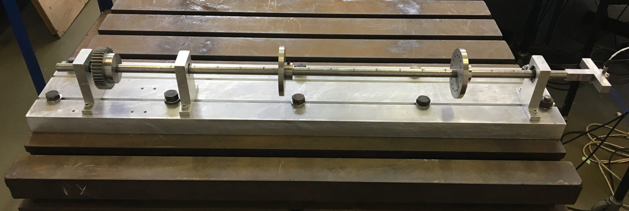

Fig. 15. The laboratory shafting structure.

For the sake of discussion, the definition of the DoFs of the experimental setup and the measured FRFs are still labelled and defined based on the schematic in Fig. 2. The scenario is to apply modal impact tests on the assembled structure and the selection for forces and measured responses are DoFs 13 and 16 and DoFs 7, 9, and 10, respectively. Some of the measured FRFs are shown below in Fig. 16 and the frequency range is set within the range of from 10 to 1000 Hz. As can be seen from Fig. 16, there are potentially three torsional natural frequencies for the assembled structure below 1000 Hz, and there are several prominent bending natural frequencies among them. The accelerometer at the tip (DoF 10) is able to capture frequencies for both the bending (DoF 7) and torsion (DoF 9).

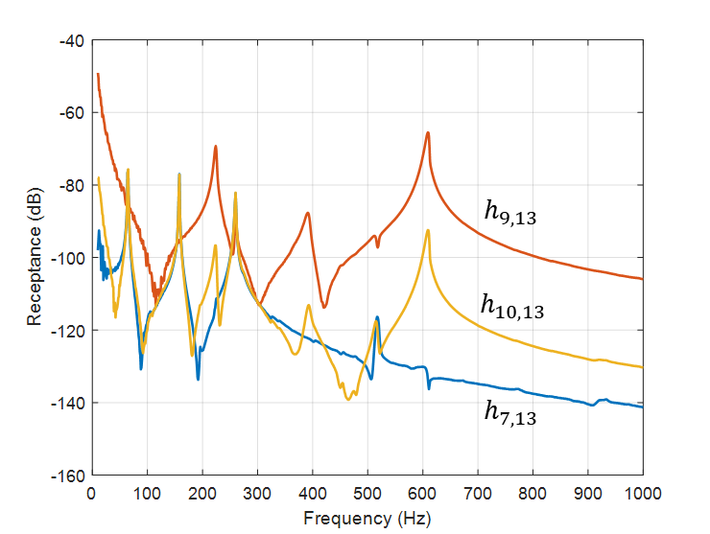

Fig. 16. Measured FRFs of the assembled structure.

Through the measured FRFs and the FRFs obtained from the FE model of the T-block, torsional receptances of the shafting system can be estimated. It should be pointed out that the coordinates used in the simulation model and experiment have to be the same to ensure the estimated receptances is accurate. Moreover, it is also suggested that any near-zero singular value of $H_{b^{m}c}^{B}$ could be treated as zero when calculating the pseudoinverse of $H_{b^{m}c}^{B}$ in order to remove noise [40] in which choosing the right threshold can be a difficult task and varies on a case-by-case basis. The results of using FRFs in Fig. 16 are given in Fig. 17. Both of the magnitude and the phase of the estimated FRF are quite clear within the frequency range; the change of phase angle is clear when the frequency passes through the resonances and anti-resonances. The appearance of bending natural frequencies in torsional receptance, which is reported in Lv’s paper [36], does not occur in this method. However, some small fluctuations and changes of phase can be noticed for frequencies below 100 Hz. A comparison of the results with Fig. 4 suggests that the estimated FRF matches the trend pretty well and that the response level is roughly at the same order, in relation to the experimental results.

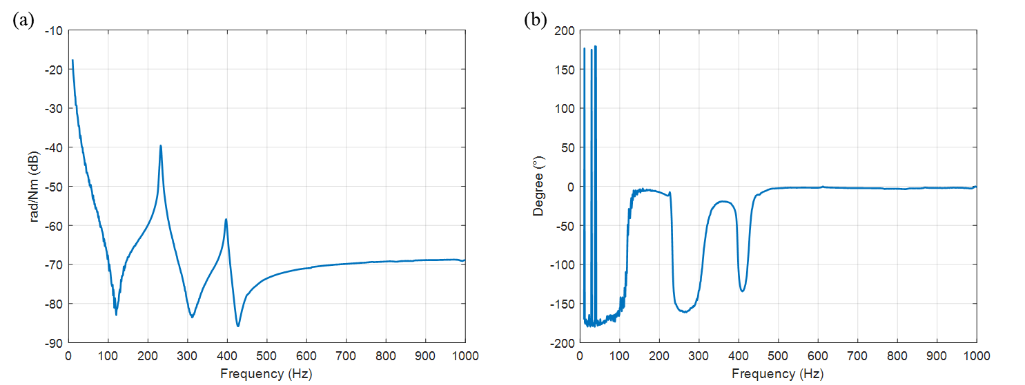

Fig. 17. Estimated torsional receptance: (a) Magnitude and (b) Phase.

## Modal parameter estimation

The polyreference least-squares complex frequency-domain method (p-LSCF), which is also called “PolyMAX” in the software Test.Lab by LMS, is implemented to identify the poles of the estimated torsional receptance. p-LSCF is a multipledegree of freedom method operating on FRFs, yielding global estimations of poles and modal participation factors, and the equivalent method in time domain is the well-known least-squares complex exponential method (LSCE) [41]. Compared with other frequency-domain methods, p-LSCF has several advantages [42], for example, (1) it produces clear stabilization diagrams which allow users to select the “physical” poles, hence omitting the “mathematical” poles which are mainly caused by the presence of noise in the measurements, (2) it does not suffer from numerical instability problem as it is formulated in the z-domain, and (3) it introduces weightings in the least-squares cost function to take into account the quality or differences among measurements, hence improving the quality of estimation.

In general, it is suggested to over-specify the denominator polynomial order (model order) in the right matrix-fraction model [43] when carrying out the p-LSCF method. Therefore, in this example, the model order is set to the range of 9 to 17 although there are potentially only two natural frequencies that can be found in this frequency range (rigid body modes are excluded). In the process of constructing the stabilization diagram, the poles of an order are compared with the poles that are one-order lower to determine whether the poles are stable or not. In this case, the tolerances for undamped natural frequency and damping ratio are set to 1% and 5%, respectively. The stabilization diagram is presented in Fig. 18 in which the stable frequencies and stable poles (both frequency and damping are stable) are denoted as circles and asterisks. It can be seen that the stabilization diagram is quite clear; nearly all the stable frequencies and stable poles are found to lie along the two resonant frequencies.

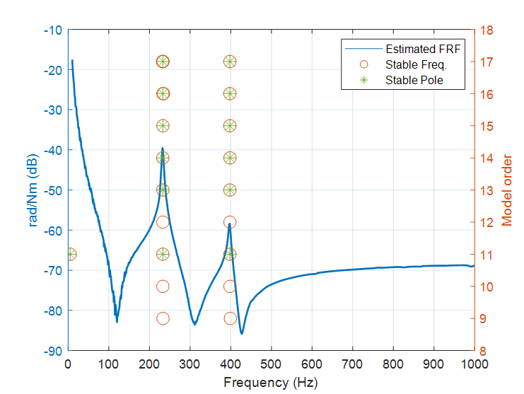

Fig. 18. Stabilization diagram from p-LSCF.

The natural frequencies and the damping ratios of some of the stables poles are summarized in Table 5. Through Fig.18 and Table 5, it can be noticed that the frequencies are relatively stable compared with the damping ratios throughout the model orders and that the damping ratios become more stable in high model orders. For the sake of demonstration, the averaged natural frequency and damping ratio at the two resonances in Table 5 are: 233.15 Hz with 1.16% of damping and 397.84 Hz with 1.44% of damping.

Table 5. Natural frequency and damping of stable poles.

|  |  |  |  |  |
| --- | --- | --- | --- | --- |
| Model order | 11 | 13 | 15 | 17 |
| Stable poles | 232.82 Hz, 1.28% | 233.87 Hz, 1.15% | 232.90 Hz, 1.11% | 232.99 Hz, 1.08% |
| 398.00 Hz, 1.59% | 397.82 Hz, 1.38% | 397.76 Hz, 1.39% | 397.77 Hz, 1.39% |

## Repeatability of the estimated receptances

In the study of FRF estimations, the consistency of the result is of great importance. In order to examine the consistency of the torsional receptance estimation, 10 estimations are all plotted together in dotted lines in Fig. 19. Each estimation is derived from the average of 10 measured FRFs. In addition to this, a correlation check is implemented to assess the closeness between the estimations. The correlation check is based on the discrepancies in amplitude, and thus the amplitude correlation coefficient $κ$ can be defined as:

|  |  |  |
| --- | --- | --- |
|  |  | (24) |

where $h_{a}\left(ω\right)$ is the average of the 10 torsional receptance estimations, and $h_{x}\left(ω\right)$ is any one of the 10 estimations. The coefficient returns a value between 0 and 1 at each frequency. There are in total 10 sets of amplitude correlation coefficients at the frequency range of 10 to 1000 Hz, and the averaged of them is plotted together with the magnitude and phase plot in Fig. 19. It can be noticed that, on the whole, the repeatability of the estimations is high (most coefficients are higher than 0.99) and that the estimations at resonances and anti-resonances tend to have a relatively lower repeatability. Some fluctuations can also be seen especially in the low frequency range. Moreover, there is a lack of phase consistency roughly below 100 Hz in the phase plot; the magnitudes of the phase are roughly the same, but the signs are reversed. The main reason for these inconsistencies in low frequency is believed to be due to the use of ICP sensors in the measurement; therefore, choosing sensors having higher sensitivity at low frequencies can possibly circumvent the problem.

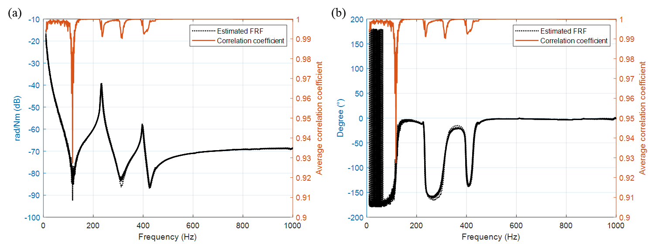

Fig. 19. Ten torsional receptance estimations: (a) Magnitude and (b) Phase.

The average of the 10 estimated torsional receptances in Fig.19 is given in Fig. 20 along with its stabilization diagram. Table 6 summarizes the natural frequencies and damping ratios of some of the stable poles in the diagram, and the averaged values for natural frequencies and damping ratios are: 232.95 Hz with 1.15% of damping and 398.09 Hz with 1.39% of damping, which are very close to the figures previously identified using a single torsional receptance estimation.

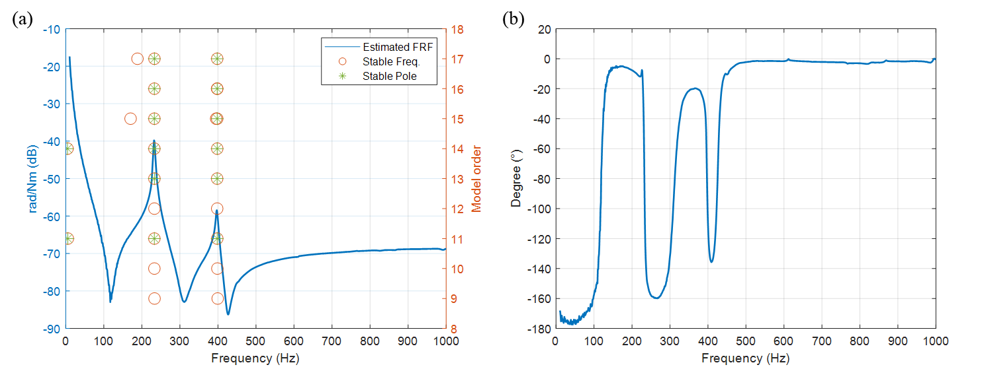

Fig. 20. The averaged torsional receptance: (a) Magnitude and the stabilization diagram and (b) Phase.

Table 6. Natural frequency and damping of stable poles.

|  |  |  |  |  |
| --- | --- | --- | --- | --- |
| Model order | 11 | 13 | 15 | 17 |
| Stable poles | 232.92 Hz, 1.27% | 232.97 Hz, 1.12% | 232.90 Hz, 1.10% | 232.99 Hz, 1.10% |
| 398.21 Hz, 1.51% | 397.96 Hz, 1.35% | 398.11 Hz, 1.36% | 398.07 Hz, 1.35% |

## Synthesis of frequency response functions

Once a stable pole is identified, a noise-free synthesized FRF can be calculated, which is produced by the so-called pole-residue model [44] evaluated along the frequency axis ($jω$) shown by the equation:

|  |  |  |
| --- | --- | --- |
|  | $$H_{ij}\left(jω\right)=\sum_{r=1}^{n}{\left(\frac{ψ_{ir}l_{rj}}{jω-λ_{r}}+\frac{ψ_{ir}^{*}l_{rj}^{*}}{jω-λ_{r}^{*}}\right)-\frac{{LR}_{ij}}{ω^{2}}+{UR}_{ij}}$$ | (25) |

where *i* and *j* are locations of response and input; *n* is the number of modes involved in the curve-fitting of the FRF; $λ_{r}$ are the poles that occur in complex conjugate pairs; $ψ_{ir}$ and ${ l}_{rj}$ are mode shapes and modal participation factors, and ${LR}_{ij}$ and ${UR}_{ij}$ are the lower and upper residue terms that represent out-of-band modes. As the poles are estimated by p-LSCF and the corresponding stabilization diagram, the only unknowns are the complex conjugate pairs of $ψ_{ir}$ and $l_{rj}$, and of ${LR}_{ij}$ and ${UR}_{ij}$. Since the information is rich in the frequency domain, the unknowns can be solved in a weighted least-squares sense. The results are shown in Fig. 21 below, which shows that the synthesized FRF matches the estimated FRF well and that it removes the unwanted noise to produce clearer information.

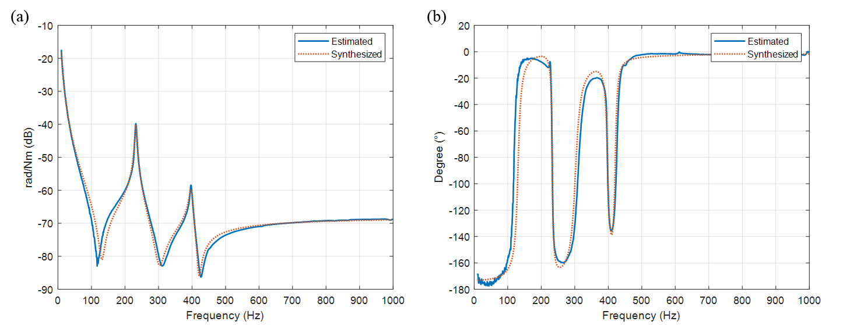

Fig. 21. The synthesized FRF of the averaged torsional receptance: (a) Magnitude and (b) phase.

## Different selections of the responses

As mentioned and demonstrated numerically in Section 3.1.3, different selections of measured responses can result in different qualities of estimations, and thus it is important to evaluate the real differences in practice. In this section, three more selections of responses are tested. The same set of measurement data in the previous section is used, and the measured response(s) is simply selected from the data set. Therefore, the additional cases for the selections are DoFs 9 and 10, DoF 9 only, and DoFs 7 and 10. The experimental results are presented in Fig. 22 and 23. First, it is clear that there is not much difference between the estimation of using DoFs 7, 9, and 10 and that of using DoFs 9 and 10, which implies that the inclusion of translational response of DoF 7 does not seem to improve or deteriorate the result. Second, solely using the rotational response at DoF 9 seems to be able to produce a clear estimation; however, there is an unexpected drop at around 260 Hz, which is, in fact, a bending natural frequency of the assembled system. It can be shown from the FRF in Fig. 16 that the rotational accelerometer also senses the bending natural frequency at about 260 Hz, which accounts for the appearance of the drop in the estimated torsional receptance. This unwanted drop can be removed by applying modal parameter identification technique and generating a synthesized torsional receptance as demonstrated in Section 4.2 and 4.4. Finally, in the last case in which the rotational response is not included, a quite clear estimation can also be produced by only using two translational responses: DoFs 7 and 10, and the results are almost the same as the ones in the first cases. As a matter of fact, this finding does not contradict the numerical results in Section 3.1.3, and just implies that the noise level of the current measured FRFs is low; thus, in this case, adding the rotational response does not much improve the quality of the results.

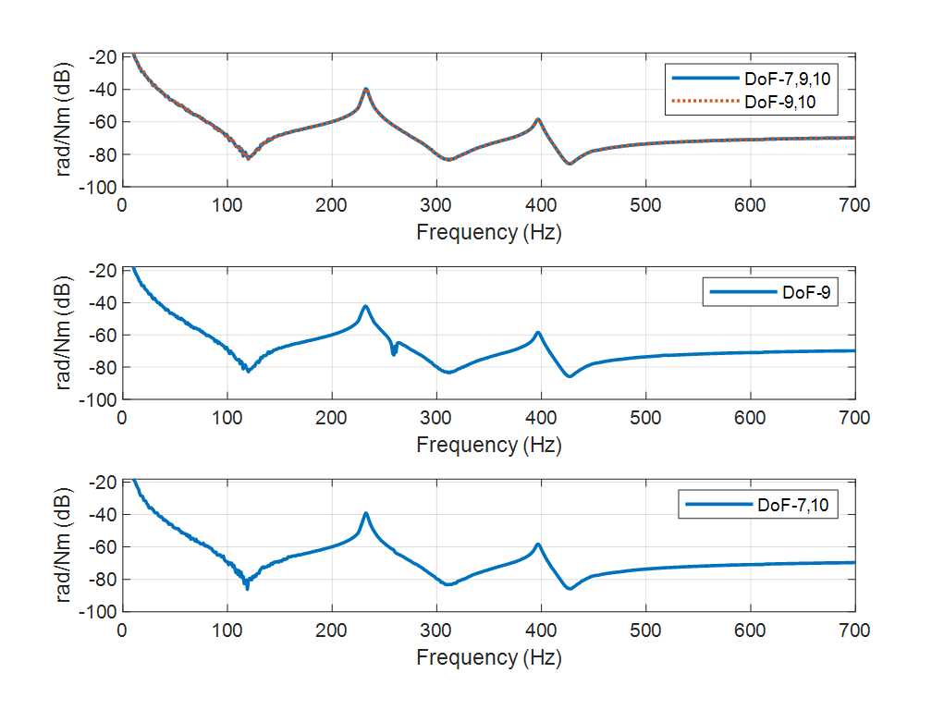

Fig. 22. The magnitude plot of different selections of responses.



Fig. 23. The phase plot of different selections of responses.

# Conclusions

Two receptance-based techniques (Method 1 and 2) for the measurement of the torsional receptance of a shafting system are presented. The torsional receptance is indirectly measured through an attachment of a T-block and using both numerical and measured receptances. In the simulation, both techniques are shown to be accurate when noise is not present in the FRFs, but Method 2 is later found to be more robust against noise. For this reason, Method 2 is further assessed under different combinations of modal testing arrangements. One of the merits of Method 2 is the ability to incorporate rotational accelerometers, and it has been shown that including the rotational response in the process of estimating torsional receptance can improve the quality of the results when the noise level in the measurements is high.

Method 2 is then implemented on a laboratory test rig consisting of a shaft with one gear and two discs on three sets of bearings to show its applicability in practice. The estimated torsional receptance is shown to be quite clear, and thus the torsional modal parameters then can be easily identified. Moreover, the repeatability of the torsional receptance is proven to be very high. Lastly, different selections of measured responses are evaluated, which suggests that, for Method 2, it is possible to obtain clear results using only translational responses when the noise level in the measurements is low.

The current approach is capable of producing good estimations of torsional receptances at the ends of a shafting system. Future work could include the implementation of this method in model updating, structural modification for passive vibration control, or active vibration suppression. An estimation of torsional receptances at arbitrary locations along a shafting system is also worth future investigations. In addition, although the main focus of this paper is the estimation of torsional receptances, the proposed method can also be extended to rotational receptance estimations.

**Acknowledgements**

The first author is grateful for the support of the UoL-NTHU Dual PhD Programme.

# References

following two equations can be

1. A.R. Crowther and N. Zhang, *Torsional finite elements and nonlinear numerical modelling in vehicle powertrain dynamics.* Journal of Sound and Vibration, 2005. **284**(3): p. 825-849.

2. S. Wei, J. Zhao, Q. Han, and F. Chu, *Dynamic response analysis on torsional vibrations of wind turbine geared transmission system with uncertainty.* Renewable Energy, 2015. **78**: p. 60-67.

3. R. Yacamini, K.S. Smith, and L. Ran, *Monitoring torsional vibrations of electro-mechanical systems using stator currents.* Journal of Vibration and Acoustics, 1998. **120**(1): p. 72-79.

4. P.J. Tavner, *Review of condition monitoring of rotating electrical machines.* IET Electric Power Applications, 2008. **2**(4): p. 215-247.

5. K. Janssens and L. Britte. *Comparison of torsional vibration measurement techniques*. 2014. Berlin, Heidelberg: Springer Berlin Heidelberg.

6. Y. Li, F. Gu, G. Harris, A. Ball, N. Bennett, and K. Travis, *The measurement of instantaneous angular speed.* Mechanical Systems and Signal Processing, 2005. **19**(4): p. 786-805.

7. L. Xiang, S. Yang, and C. Gan, *Torsional vibration measurements on rotating shaft system using laser doppler vibrometer.* Optics and Lasers in Engineering, 2012. **50**(11): p. 1596-1601.

8. P. Giuliani, D. Di Maio, C.W. Schwingshackl, M. Martarelli, and D.J. Ewins, *Six degrees of freedom measurement with continuous scanning laser doppler vibrometer.* Mechanical Systems and Signal Processing, 2013. **38**(2): p. 367-383.

9. M. Dumont and N. Kinsley, *Using accelerometers for measuring rotational degrees-of-freedom.* SOUND & VIBRATION, 2016: p. 11.

10. Y. Champoux, V. Cotoni, B. Paillard, and O. Beslin, *Moment excitation of structures using two synchronized impact hammers.* Journal of Sound and Vibration, 2003. **263**(3): p. 515-533.

11. L.H. Ivarsson and M.A. Sanderson, *MIMO technique for simultaneous measurement of translational and rotational mobilities.* Applied Acoustics, 2000. **61**(3): p. 345-370.

12. M.A. Sanderson and C.R. Fredö, *Direct measurement of moment mobility: Part I: A theoretical study.* Journal of Sound and Vibration, 1995. **179**(4): p. 669-684.

13. M.A. Sanderson, *Direct measurement of moment mobility: Part II: An experimental study.* Journal of Sound and Vibration, 1995. **179**(4): p. 685-696.

14. C. Sihler, *A novel torsional exciter for modal vibration testing of large rotating machinery.* Mechanical Systems and Signal Processing, 2006. **20**(7): p. 1725-1740.

15. S.J. Drew and B.J. Stone, *Torsional (rotational) vibration: excitation of small rotating machines.* Journal of Sound and Vibration, 1997. **201**(4): p. 437-463.

16. S.J. Drew, D.C. Hesterman, and B.J. Stone, *The torsional excitation of variable intertia effects in a reciprocating engine.* Mechanical Systems and Signal Processing, 1999. **13**(1): p. 125-144.

17. S.H. Cho, S.W. Han, C.I. Park, and Y.Y. Kim, *High-frequency torsional modal testing of a long cylinder by magnetostriction.* Applied Physics Letters, 2007. **91**(7): p. 071908.

18. Y.Y. Kim and Y.E. Kwon, *Review of magnetostrictive patch transducers and applications in ultrasonic nondestructive testing of waveguides.* Ultrasonics, 2015. **62**: p. 3-19.

19. P. Avitabile. *Model reduction and model expansion and their applications Part 1 - Theory*. in *Conference Proceedings of the Society for Experimental Mechanics Series*. 2005.

20. D.J. Ewins, *On predicting point mobility plots from measurements of other mobility parameters.* Journal of Sound and Vibration, 1980. **70**(1): p. 69-75.

21. P. Avitabile and J. O'Callahan, *Frequency response function expansion for unmeasured translation and rotation DoFs for impedance modelling applications.* Mechanical Systems and Signal Processing, 2003. **17**(4): p. 723-745.

22. A. Drozg, G. Čepon, and M. Boltežar, *Full-degrees-of-freedom frequency based substructuring.* Mechanical Systems and Signal Processing, 2018. **98**: p. 570-579.

23. X. Wang, T.L. Hill, and S.A. Neild, *Frequency response expansion strategy for nonlinear structures.* Mechanical Systems and Signal Processing, 2019. **116**: p. 505-529.

24. S. Sattinger, *Method for experimentally determining rotational mobilities of structures.* Shock Vib. Bull.;(United States), 1980. **50**.

25. M.L.M. Duarte and D.J. Ewins, *Rotational degrees of freedom for structural coupling analysis via finite-difference technique with residual compensation.* Mechanical Systems and Signal Processing, 2000. **14**(2): p. 205-227.

26. O. Özşahin, A. Ertürk, H.N. Özgüven, and E. Budak, *A closed-form approach for identification of dynamical contact parameters in spindle–holder–tool assemblies.* International Journal of Machine Tools and Manufacture, 2009. **49**(1): p. 25-35.

27. A.S. Elliott, A.T. Moorhouse, and G. Pavić, *Moment excitation and the measurement of moment mobilities.* Journal of Sound and Vibration, 2012. **331**(11): p. 2499-2519.

28. T.J. Gibbons, E. Öztürk, and N.D. Sims, *Rotational degree-of-freedom synthesis: An optimised finite difference method for non-exact data.* Journal of Sound and Vibration, 2018. **412**: p. 207-221.

29. T.L. Schmitz, *Torsional and axial frequency response prediction by RCSA.* Precision Engineering, 2010. **34**(2): p. 345-356.

30. B. Jetmundsen, R.L. Bielawa, and W.G. Flannelly, *Generalized frequency domain substructure synthesis.* Journal of the American Helicopter Society, 1988. **33**: p. 55-64.

31. Y. Yang, W.-H. Zhang, Y.-C. Ma, and M. Wan, *Generalized method for the analysis of bending, torsional and axial receptances of tool–holder–spindle assembly.* International Journal of Machine Tools and Manufacture, 2015. **99**: p. 48-67.

32. L. Cheng and Y.C. Qu, *Rotational compliance measurements of a flexible plane structure using an attached beam-like tip, part 1: analysis and numerical simulation.* Journal of Vibration and Acoustics, 1997. **119**(4): p. 596-602.

33. D. Montalvão, A. Ribeiro, N. Maia, and J. Silva, *Estimation of the rotational terms of the dynamic response matrix.* Shock and Vibration, 2004. **11**(3-4): p. 333-350.

34. J.E. Mottershead, A. Kyprianou, and H. Ouyang, *Structural modification. Part 1: rotational receptances.* Journal of Sound and Vibration, 2005. **284**(1–2): p. 249-265.

35. J.E. Mottershead, M. Ghandchi Tehrani, D. Stancioiu, S. James, and H. Shahverdi, *Structural modification of a helicopter tailcone.* Journal of Sound and Vibration, 2006. **298**(1–2): p. 366-384.

36. B. Lv, H. Ouyang, W. Li, Z. Shuai, and G. Wang, *An indirect torsional vibration receptance measurement method for shaft structures.* Journal of Sound and Vibration, 2016. **372**: p. 11–30.

37. W. D’Ambrogio and A. Fregolent, *Promises and pitfalls of decoupling procedures.* Proceeding of 26th IMAC. Orlando (USA), 2008.

38. C.W. de Silva, *Vibration and Shock Handbook*. 2005: CRC Press.

39. B.W. Silverman, *Density estimation: For statistics and data analysis*. Density Estimation: For Statistics and Data Analysis. 2018. 1-175.

40. G. Strang, *Introduction to Linear Algebra*. 2016: Wellesley-Cambridge Press.

41. W. Heylen, S. Lammens, and P. Sas, *Modal analysis theory and testing*. 1998: Katholieke Universiteit Leuven.

42. B. Peeters, H. Van der Auweraer, P. Guillaume, and J. Leuridan, *The PolyMAX Frequency-Domain Method: A new standard for modal parameter estimation?* Shock and Vibration, 2004. **11**(3-4).

43. B. Cauberghe, *Applied frequency-domain system identification in the field of experimental and operational modal analysis.* Ph.D. Thesis, Vrije Universiteit, Brussel, Belgium, 2004.

44. N.M.M. Maia and J.M. Montalvão e Silva, *Theoretical and experimental modal analysis*. Mechanical engineering research studies: Engineering dynamics series 9. 1997: Taunton, Somerset : Research Studies Press, 1997.

# APPENDIX

The displacement-force relationship of a coupled system (AB) composed of subsystem A and subsystem B in the frequency domain can be defined as

|  |  |  |
| --- | --- | --- |
|  | $$\left\{\begin{matrix}u_{c}^{AB} \\ u_{b^{m}}^{AB}\end{matrix}\right\}=\left[\begin{matrix}T_{c} & 0 \\ 0 & T_{b^{m}}\end{matrix}\right]\left\{\begin{matrix}u_{c}^{B} \\ u_{b^{m}}^{B}\end{matrix}\right\}=\left[\begin{matrix}H_{cc}^{AB} & H_{cb^{f}}^{AB} \\ H_{b^{m}c}^{AB} & H_{b^{m}b^{f}}^{AB}\end{matrix}\right]\left\{\begin{matrix}f_{c}^{AB} \\ f_{b^{f}}^{AB}\end{matrix}\right\}$$ | (A1) |

In this equation, the coupling conditions, Eq. (4) and (5), and the coordinate transformation matrixes of the responses, $T_{c}$ and $T_{b^{m}}$, are also included. Subtracting Eq. (A1) by Eq. (13) gives

|  |  |  |
| --- | --- | --- |
|  | $$\left\{\begin{matrix}0 \\ 0\end{matrix}\right\}=\left[\begin{matrix}{T_{c}}^{-1} & 0 \\ 0 & {T_{b^{m}}}^{-1}\end{matrix}\right]\left[\begin{matrix}H_{cc}^{AB} & H_{cb^{f}}^{AB} \\ H_{b^{m}c}^{AB} & H_{b^{m}b^{f}}^{AB}\end{matrix}\right]\left\{\begin{matrix}f_{c}^{AB} \\ f_{b^{f}}^{AB}\end{matrix}\right\}-\left[\begin{matrix}H_{cc}^{B} & H_{cb^{f}}^{B} \\ H_{b^{m}c}^{B} & H_{b^{m}b^{f}}^{B}\end{matrix}\right]\left\{\begin{matrix}f_{c}^{B} \\ f_{b^{f}}^{B}\end{matrix}\right\}$$ | (A2) |

Rearranging Eq. (A2) by moving $f_{c}^{B}$ to the right hand side of the equation and applying another coupling condition, $f_{b^{f}}^{AB}=T_{b^{f}} f_{b^{f}}^{B},$ give

|  |  |  |
| --- | --- | --- |
|  | $$\left[\begin{matrix}H_{cc}^{B} \\ H_{b^{m}c}^{B}\end{matrix}\right]f_{c}^{B}=\left[\begin{matrix}{T_{c}}^{-1}H_{cc}^{AB} \\ {T_{b^{m}}}^{-1}H_{b^{m}c}^{AB}\end{matrix}\right]f_{c}^{AB}+\left[\begin{matrix}{T_{c}}^{-1}H_{cb^{f}}^{AB}T_{b^{f}}-H_{cb^{f}}^{B} \\ {T_{b^{m}}}^{-1}H_{b^{m}b^{f}}^{AB}T_{b^{f}}-H_{b^{m}b^{f}}^{B}\end{matrix}\right] f_{b^{f}}^{B}$$ | (A3) |

Extracting the second row of Eq. (A3) and assuming that $f_{c}^{AB}$ is equal to zero result in

|  |  |  |
| --- | --- | --- |
|  | $$f_{c}^{B}={H_{b^{m}c}^{B}}^{+}\left({T_{b^{m}}}^{-1}H_{b^{m}b^{f}}^{AB}T_{b^{f}}-H_{b^{m}b^{f}}^{B}\right)f_{b^{f}}^{B}$$ | (A4) |

where $∎^{+}$ denotes the pseudoinverse. Thus, $u_{b^{m}}^{B}$ in Eq. (2) can be written as

|  |  |  |
| --- | --- | --- |
|  | $$u_{b^{m}}^{B}=H_{b^{m}c}^{B}{H_{b^{m}c}^{B}}^{+}\left({T_{b^{m}}}^{-1}H_{b^{m}b^{f}}^{AB}T_{b^{f}}-H_{b^{m}b^{f}}^{B}\right)f_{b^{f}}^{B}+H_{b^{m}b^{f}}^{B}f_{b^{f}}^{B}$$ | (A5) |

which can be grouped into two parts for a clearer representation

|  |  |  |
| --- | --- | --- |
|  | $$u_{b^{m}}^{B}=\left(E{T_{b^{m}}}^{-1}H_{b^{m}b^{f}}^{AB}T_{b^{f}}\right)f_{b^{f}}^{B}+\left(H_{b^{m}b^{f}}^{B}-EH_{b^{m}b^{f}}^{B}\right)f_{b^{f}}^{B}$$ | (A6) |

where $E=H_{b^{m}c}^{B}{H_{b^{m}c}^{B}}^{+}$.