Measurement of fusional vergence: a systematic review

Carla Costa Lança, PhD¹ and Fiona J Rowe, PhD, DBO²

1 Singapore Eye Research Institute

2 Department of Health Services Research, University of Liverpool, Liverpool L69 3GL, UK

Address for correspondence
Dr Carla Costa Lança, Singapore Eye Research Institute, The Academia, 20 College Road, Discovery Tower Level 6, Singapore 169856 email: carla.lanca@seri.com.sg

Disclosures

The authors report no conflicts in relation to this study.

Contributions
CL is the guarantor. Both authors have written this article and contributed to the development of the selection criteria, the risk of bias assessment strategy and data extraction criteria.

ABSTRACT
Background: Fusional amplitudes are important for clinical practice in diagnosing and managing binocular vision anomalies. Several measurement methods can be used to assess fusional amplitudes. However, those methods are not interchangeable, and measurement repeatability has been questioned.
Objectives: To compare the normative values of tests for the measurement of fusional vergence and to investigate sources of heterogeneity of diagnostic accuracy including: age, variation in method of assessment, study design and size, type (convergent, divergent, vertical, cyclo) and severity of strabismus (constant/intermittent/latent).
Data sources: Bibliographic databases were searched up to March 2018, including Cochrane registers, PubMed, Web of ScienceTM, Google Scholar and Science Citation Index. Trial registers and conference proceedings were hand searched.
Review methods: The review observed and reported according to the PRISMA guidelines and was registered with PROSPERO. The I² was used to show the percentage of observed total variation across studies that is due to real heterogeneity rather than chance. The results of the different studies and the overall effect (under the random effects model) are shown.

Results: Eighty-one studies were included in the review. Heterogenous information about break vergence amplitudes is reported for the step method (I²>50%; p<0.05) in children. Four parameters were reported consistently to affect measurements; age, method of assessment, order of testing and target size. For the smooth technique break vergence values heterogeneity was not present in children and adults (I²=0%; p>0.05).
Limitations: The results are based on cross-sectional studies that were performed independently from each other, with different examiners, methods of examination and different populations.
Conclusions: The source of heterogeneity between studies for vergence break points measured with the step vergence method seems to be linked with age. Normal vergences reported in children had considerable heterogeneity compared with adults. In clinical practice the population based vergence ranges measured with the step method in children should not be used as one single criterion. For the smooth technique normative population data can be used.

Funding: There were no sources of financial or other support for the review.

INTRODUCTION

Rationale
Fusional amplitudes are the result of a reflex (motor response) to a sensory stimulus caused by the images of the object of regard drifting off one fovea, causing disparity and involving a subsequent corrective movement of both eyes to maintain fusion and avoid diplopia.¹ The stability of binocular vision depends on good fusional amplitudes and in the presence of vergence system anomalies a great variety of symptoms are elicited interfering with visual comfort and academic performance.² The fusion reflex is responsible for maintaining heterophoria compensation, so knowing what proportion of the total vergence amplitude is needed to compensate a deviation, is important to the clinician.³
Through the years, clinical measurements of fusional amplitudes have been used to provide information about binocular vision and the patient’s ability to cope with a deviation.^{4,5} Although this relationship empirically may seem to be very strong, weak correlations between fusional amplitudes and angle of deviation have been reported in the literature.^{6,7} This could mean that other factors in combination with fusional amplitudes may also contribute to this relationship.
Differences have been reported between fusional vergence for eso versus exo deviations^{7–10} and ways of calculating the fusional reserve ratio change according to Sheard’s criterion, which appears mostly applicable in exodeviations. The criteria state that fusional reserve opposing the heterophoria should be at least twice the magnitude of the angle of deviation^{11–13} corresponding to a fusion reserve ratio of 2.0.¹⁴ Percival criterion have been described for esodeviations stating that the patient should operate in the middle third of the vergence range.¹³ One of the factors significantly related to fusional vergence ranges in children with myopia was the extent of heterophoria, with an observed trend in the same direction as would be clinically expected (i.e., greater esophoria is associated with greater base-out (BO) ranges at both distance and near, but smaller base-in (BI) ranges at near).¹⁵
Positive fusional vergence is reported to be lower in the presence of an exophoria with asthenopic symptoms.¹³ In an intermittent exotropia, binocular alignment is achieved by convergence mechanisms, but if diminished horizontal fusional vergences are present the control of the deviation may be poor.^{13,14,16} However, the role of convergence in the control of intermittent exodeviations is currently unclear and this topic warrants further investigation.
Increasing the amplitudes of fusional vergence is one of the main aims of orthoptic treatment.¹⁷ Although, reliability of different methods of measurement of binocular vision have been investigated over the last 50 years¹⁸, there are no uniform normative values of fusional amplitudes, especially in children, even though standards for vergence have been established since the 1940s.⁶ Even in normal subjects there is some evidence that vergence behaviour can be different across subjects. A study in a non-academic population sample showed that the vergence behaviour varied in normal subjects,¹⁹ with some subjects showing slow divergence responses.
There is some evidence that children have different fusional reserve from adults,^{2,6,20} but this may relate to methodological differences reported in the literature on fusional vergence when measured with the prism bar method. The major concern with some of the published norms is that they are based on cross-sectional studies that were performed independently of each other by different examiners and have yet to be confirmed by a longitudinal study.¹⁵
No validated protocol exists for the measurement of the prism fusion ranges. Many studies report on how fusional vergence ranges can be measured using different techniques (rotary prism, prism bar, loose prisms and synoptophore) and stimuli, leading to different ranges being reported in the literature. Repeatability of the different methods available and the equivalence between them is also important.³
In addition, some studies do not agree in what order fusional vergence^{8,21–25} should be measured to provide the essential information on which to base clinical judgements on compensation of deviations. When performing fusional vergence testing the most commonly accepted clinical technique is to first measure negative fusional vergence followed by a measurement of positive fusional vergence²⁶ to avoid affecting the value of vergence recovery because of excessive stimulation of convergence.^{21,22} Von Noorden recommended using vertical fusion amplitudes in between horizontal amplitudes (base-out, base-up, base-in, and base down) to prevent vergence adaptation.²³ Others place the base of the prism in the direction opposite to that used to measure the deviation to increase the vergence demand.^{8,25}
In a previous study it was reported that 97% of the Orthoptist respondents were assessing fusional amplitudes using a prism bar.²¹ For that reason and to treat and diagnose binocular vision disorders, it is necessary to have a valid protocol for the measurement of the step vergence. Adding to this it is also important to know normal mean results in order to classify an individual as normal or abnormal. To access this information the following review was done to respond to two objectives.

Objectives
To compare the normative values of tests for the measurement of fusional vergence and to investigate sources of heterogeneity of diagnostic accuracy including: age, variation in method of assessment, study design and size, type (convergent, divergent, vertical, cyclo) and severity of strabismus (constant/intermittent/latent).

METHODS
We conducted a review aiming to collect all evidence related to fusional vergence measurements and adaptation in the presence of eso versus exo deviations. The review was undertaken using PRISMA guidelines (Appendix 1).^{27,28} This review was registered with PROSPERO²⁸
(http://www.crd.york.ac.uk/PROSPERO/display_record.asp?ID=CRD42016037133).

Types of studies
The following types of studies were included in the review: randomised controlled trials, controlled trials, prospective and retrospective cohort studies, observational studies and case-controlled studies. Case reports and letters were excluded. All languages were included, and translations were obtained when necessary. We included studies of children and adult participants reporting on how fusional vergence ranges were measured, including the measurement technique, order, and stimuli (size and distance) used. Studies reporting fusional vergences in the presence of eso versus exo deviations were also included.

Participants
We set no age restrictions in our protocol. This review reports measurements of normative fusional vergences from the age of 4,5 years to 70 and above, extracted from the published literature.

Target conditions
The target conditions were constant or intermittent manifest strabismus or latent strabismus of any type and severity (esotropia, exotropia, vertical deviation, cyclo deviation, exophoria, esophoria).

Information sources and Search strategy
Bibliographic databases were searched up to March 2018. We used systematic strategies to search key electronic databases, including Cochrane registers and electronic bibliographic databases. In an effort to identify further published data, we searched electronic registers in PubMed and Google Scholar. Additionally, hand search of journals and conference transactions and citation tracking using Web of Science Cited Reference Search were performed for all included studies. We also searched the reference lists of review articles about fusional amplitudes up to 2016. In addition, we used the orthoptic search facility weblink (http://pcwww.liv.ac.uk/~rowef/index_files/page646.htm) to search in Orthoptic journals and Conference Transactions which are not electronically listed: British and Irish Orthoptic Journal, American Orthoptic Journal, Australian Orthoptic Journal, European Strabismus Association, International Strabismus Association and the International Orthoptic Association. Search terms are described in table 1.

Definitions

- Fusional vergence is the ability to fuse with prisms, starting from a state of spontaneous fusion (also called vergence reserve or vergence amplitude in some studies).^{7,14,29} For this review the following terms are synonyms: positive base-out (BO) for convergence and negative base-in (BI) for divergence.
- Fusion break point is the prism strength at which the patient reports diplopia or an heterotropia develops with no subsequent recovery to motor fusion.⁷
- Recovery point is the prism strength at which fusion is regained.⁷
- Total convergence amplitude is the sum of the angle of deviation and the convergence reserve.¹⁴
- Blur point is a measure of the amount of relative (free from accommodation) fusional vergence. This finding indicates that the limit of fusional vergence has been reached, and accommodation is no longer held on the target.³
- Step vergence is an assessment of disparity vergence using a hand-held prism bar with the advantage of providing normal seeing conditions in the presence of peripheral cues.³⁰ The prism requires the use of asymmetrical vergence using steps of different prismatic powers.
- Methods to assess fusion amplitudes: there are several methods to measure fusional amplitudes (e.g. by using a prism bar, rotary prisms or the synoptophore).^{29–32} Those methods measure different aspects of fusion.^{33,34} For example, the synoptophore and Risley prisms measure smooth vergence (tonic fusion; slow system driven by prism adaptation) and the prism bar measures the step vergence (phasic fusion; fast system driven by retinal disparity).³⁵
- Prism adaptation or vergence adaptation is the change in the tonic vergence position of the eyes that occurs with sustained vergence effort.²⁴ Heterophoria changes in the direction of the adapting prism and decays back to its pre-adaption value when adaptation occurs.³⁶

Selection process and quality assessment
The titles and abstracts identified from the search were independently screened by the two authors through each phase of the review (screening, eligibility and inclusion) using the pre-stated inclusion criteria. The full papers of any studies considered potentially relevant were considered and the selection criteria applied independently by two reviewers. We resolved disagreements at each step by discussion between the two review authors. If a disagreement remained, we requested the opinion of a third reviewer.
Due to the theme of the review it was expected that most of studies designs were observational. To analyse the relevance of the study designs in our inclusion criteria the PRISMA checklist for systematic reviews (Appendix 1), plus the STROBE (Strengthening the Reporting of Observational Studies in Epidemiology) checklist for cohort, case-control, and cross-sectional studies were used (Appendix 2).³⁷ An adapted version of the STROBE statement was used with 18 items and 20 items were used for the PRISMA checklist.

Data collection process
Pre-designed data extraction forms were used to gather information on sample size, study design, type of deviation, vergence order of assessment and population type. Data were extracted and documented by one researcher (CL) and verified by another (FR). Data about country of study, quality appraisal, risk of bias, participants and target condition was also extracted.

Statistical analysis

MedCalc, version 18.9 was used for the statistical analysis. The primary outcome was the break point for positive and negative vergences. We analysed these as continuous variables. If an included study did not report a particular outcome (missing data, for example, reported means but not standard deviations for the follow-up data), we did not include that study in the analysis of that outcome. We carried out a statistical analysis to compare the following variables between studies for children and adults:
- Break point of negative vergence for near and distance,
- Break point of positive vergence for near and distance.
We used a generic inverse variance mean analysis method with random-effects model for all statistical analyses. The I² statistic was used to show the percentage of observed total variation across studies that is due to real heterogeneity rather than chance. A value of 0% indicates no observed heterogeneity, and larger values show increasing heterogeneity. For values above 50% we explored the individual trial characteristics to identify potential sources of heterogeneity. The results of the different studies, with 95% CI, and the overall effect (under the random effects model) with 95% CI are illustrated in a forest plot graph. A p value of less than 0.05 was accepted as significant.
Secondary outcomes included measurement technique, target type, distance of measurement, order of assessment, ocular dominance, examiner encouragement, refractive status, type and severity of heterophoria and strabismus, and age. We analysed these as categorical variables. When the information was of heterogeneous nature, a narrative analysis was undertaken.

RESULTS OF THE SEARCH
The present systematic review includes results from the published work for the last 35 years. Patients between the age of 4 and 93 years old were included. The search results are outlined in Table 1. Eighty-one articles were included. Of the included studies, none of which were RCTs, 45 were cross sectional observational studies, 16 were cohort prospective observational studies, and 12 were case-control studies. Consequently, quality appraisal of study was assessed using the STROBE checklist (Appendix 3). Six literature reviews were also included, and quality appraisal of study was assessed using the PRISMA Checklist (Appendix 4).

Table 1 – Results of the Search.
Sources | Search terms | Results (n)
PubMed | "Strabismus"[Mesh] AND "Esotropia"[Mesh] AND "Exotropia"[Mesh] AND "fusional vergence"[All Fields] | 2
 | "Strabismus"[Mesh] AND "fusional vergence"[All Fields] | 59
 | "Strabismus"[Mesh] AND "Vergence amplitude"[All Fields] | 1
 | "Strabismus"[Mesh] AND "Dynamic vergence"[All Fields] | 3
 | "Strabismus"[Mesh] AND "Disparity vergence"[All Fields] | 13
 | "Strabismus"[Mesh] AND "Vergence adaptation"[All Fields] | 30
 | "Strabismus"[Mesh] AND "Vergence movements"[All Fields] | 18
 | "Strabismus"[Mesh] AND "Motor fusion"[All Fields] | 46
 | "Strabismus"[Mesh] AND "Fusion reserve ratio"[All Fields] | 1
 | "Vision, Binocular"[Mesh] AND "Fusional vergence" | 50
 | "Vision, Binocular"[Mesh] AND "Prism fusion range" | 1
 | "Vision, Binocular"[Mesh] AND "Fusional system" | 15
 | "Vision, Binocular"[Mesh] AND "Vergence adaptation" | 19
 | "Vision, Binocular"[Mesh] AND "Vergence amplitude" | 5
 | "Vision, Binocular"[Mesh] AND "Dynamic vergence" | 4
 | "Vision, Binocular"[Mesh] AND "Disparity vergence" | 27
 | "Vision, Binocular"[Mesh] AND "Vergence movements" | 39
 | "Vision, Binocular"[Mesh] AND "Motor fusion" | 27
 | ("Vision, Binocular"[Mesh]) AND "Vision Disparity"[Mesh] AND fusion | 114
 | ("Vision, Binocular"[Mesh]) AND "Convergence, Ocular"[Mesh] AND fusion | 66
 | Measurements Accuracy AND Prism fusion range | 1
 | Accuracy AND Fusional vergence | 5
 | Accuracy AND Vergence amplitude | 10
 | Heterophoria AND fusional vergence | 95
Cochrane | Binocular vision AND fusional vergence | 17
 | Fusion AND strabismus | 15
 | Vergence AND binocular function | 3
Orthoptic search facility weblink | Vergence | 59
 | Motor Fusion | 4
 | Prism Fusion Range | 8
Web of ScienceTM | Strabismus AND fusional vergence | 79
 | Strabismus AND "Vergence amplitude" | 2
 | "Binocular vision" AND "Fusional vergence" AND heterophoria | 19
Google Scholar | "Step vergence" | 142
 | "Smooth vergence" AND heterophoria | 21
 | "Fusion reserve ratio" | 3
 | "Fusional reserves" AND heterophoria AND "Motor Fusion" | 36
 | "Rotary prism" and "fusional vergences" | 25
 | "Synoptophore" AND "prism bar" AND "fusional vergences" | 19
Total |  | 1103
Number of duplicates |  | 435
Total after removing duplicates |  | 668
Titles excluded (eg. Case reports, studies of anomalous conditions or monkey studies) |  | 302
Total after Titles selection |  | 366
Abstracts excluded |  | 159
Total after abstracts selection |  | 207
Full text excluded |  | 108
Full text not available or article in other languages (Swedish; Polish) |  | 18
Full text from other sources |  | 1
Total after full text selection |  | 81

QUALITY OF THE EVIDENCE
Ten papers reported 100% of the items requested by the adapted STROBE checklist. Thirty papers reported 90% or more of the requested items, 26 papers reported 80 to 89%, 7 papers reported 70 to 79% and one reported 67%. Only one reported less than 50% (44%). Only 56% of papers reported limitations of their studies. The failure to provide such criteria hampers one’s understanding and interpretation of some of the findings in the studies. Results from all papers were reported and the individual results for each paper are outlined in Appendix 3.
Six review papers were analysed using the PRISMA Checklist. Five papers reported 55% of the items requested as the reviews were not systematic (literature reviews with qualitatively evidence using subjective methods to collect studies) and 1 paper reported 50% (Appendix 4).

RESULTS
Clinical implications
Vergence disorders are a consequence from deficits of binocular fixation which result in a failure or inability of fusion to maintain comfortable alignment and binocular vision.³⁸ Mechanisms required to maintain binocular single vision are of clinical importance and have implications on a successful plan of treatment.
Motor fusion was reported to be related with the performance of fine motor skills (bead and pegboard tasks) in subjects aged 12 to 35 years of age.^{39,40} Subjects with fusion were quicker at the larger bead task than those without fusion, supporting the hypothesis that fusion is of major benefit to performance of sensorimotor tasks.³⁹ Median base-out break/recovery amplitudes only dropped below 25Δ in subjects with normal binocular vision when monocular visual acuity was artificially reduced by nine lines or more.⁴⁰ Degraded base-out break amplitudes were a significant contributor to an increase in task performance times, and when task difficulty was increased.
Horizontal fusional vergences are essential but can interact with torsional disparity. According to Georgievski et al.⁴¹ study torsional disparity of 6º or more significantly degrades horizontal fusional vergence and stereopsis. Clinically, these results might imply that planning for successful surgery for superior oblique palsies and cyclovertical incomitant strabismus have to take the level of torsion in consideration. Normal values for incyclovergence and excyclovergence were reported to be of 12° (break point) and 8° (recovery point) using a polaroid stereoprojector.⁴² Comparing the normal subjects with superior oblique palsy subjects the incyclovergence recovery point was significant diminished, improving after 1 month of follow-up. Intorsion and extorsion tolerance are reported by the authors as parameters that are better indicators of cyclofusional potential.

Sources of heterogeneity of diagnostic accuracy
Prism fusion ranges measured by the step vergence technique
Table 2 (negative fusional vergences - NFV) and 3 (positive fusional vergences - PFV) provide data from fusional vergence range measurements by the step vergence technique at near and distance. Mean, median and SD are provided where available. Eleven studies with 862 participants between the age of 4 and 70 years old, mainly young adults, were included. We also included 11 studies with participants; 4574 between the age of 5 and 16 years old. Heterogeneity considering adults and children together was very high (I²=89%; p$<$0.0001). One of the factors reported in the literature to be associated with a change in fusional vergences is age.^{30,31,43} For this reason, we separated the analysis between adults and children.
NFV breaks for near (Figure 1 (a): I²=0%; p=0.8432) and distance in adults (Figure1 (c): I²=0%; p=0.9874) had no heterogeneity. Heterogeneity for NFV in children was above 50% for both near (Figure 1 (b): I²=51%; p=0.0242) and distance (Figure 1 (d): I²=93%; p$<$0.0001). We saw that the normative data followed the same pattern in children for the base-out amplitude. PFV breaks for near (Figure 2 (a): I²=14%; p=0.3210) and distance in adults (Figure 2 (c): I²=36%; p=0.1794) had heterogeneity values below 50%. However, for PFV breaks in children there was significant heterogeneity for near (Figure 2 (b): (I²=76%; p$<$0.0001) and distance (Figure 2 (d): I²=75%; p=0.0001). The coefficient of repeatability using objective measurements of fusional vergences with prism bars indicates greater variability for convergence in all groups (adults, pre-schoolers and infants).⁴⁴ Those measurements are associated with higher standard deviations that reflect the unequal sizes of the prism bar, with larger steps at the higher end of the bar.⁵ The prisms steps increase by unequal step sizes up to 5Δ starting at 20Δ in prisms bars. Data is not normally distributed³⁵ and non-parametric analysis is advised. From the 11 studies in adults presented in table 2 only four show median values. Also, the step vergence method has an instrumental error (±2Δ) that should be taken account when comparing the differences between the means for each age group.² When the instrumental error is similar or greater than mean values differences between groups should be considered unreliable from the clinical standpoint and not clinically significant. Dynamics of convergence is faster and more vibrant than that for divergence⁴⁵, indicating that separate mechanisms control slow convergence and divergence.⁴⁶ Divergence movements not only differ from convergence movements, but depend on initial vergence position (velocities are higher for targets initially at near).⁴⁷
The two highest values for negative vergence break points for near in adults were reported by Goss & Becker³⁴ (21.4±9.4Δ) and Narbheram & Firth⁴ (18.6±8.7Δ). Similarities between both studies are found in the participants; young adults and students. The use of non-naïve subjects can be one of the reasons for the higher values, that increase with practice and can be higher in participants from the academic world (especially orthoptic and optometry students) compared with other naïve populations. Criterion of one standard deviation below the mean is a reasonable level to set. However, the variability of base-in findings for near, as judged from the standard deviations, is high, apart from 33 controls assessed by Sharma et al.⁴⁸ where the standard deviation for the break point was only 2.0. Negative vergence break points for distance show less variation between studies with a minimum mean value of 7±4Δ reported by Wesson⁴⁹ and a maximum mean value of 9.7±4.3Δ reported by Narbheram & Firth.⁴

Table 2 – Negative fusional vergences (NFV) measured with the step vergence technique in adults and children.
Study | Design | Sample |  | Target size and  distance | Order | Break/recovery Prism fusion ranges (Mean±SD)
 |  | Size  (n=) | Age |  |  | NFV
 |  |  |  |  |  | Near | Distance | 3 m
Participants between the age of 4 and 70 years old; mainly young adults
1982; Wesson⁴⁹ | Cross-sectional | 79 | 4-70 | 1.4° at 40cm & 20/40 at 6m | R | 13±7/10±5 | 7±4/4±2 | --
1997; Narbheram & Firth⁴ | Cross-sectional | 20 | 18-35 | 20/20 for near & distance | U | 18.6±8.6/ 11.0±4.4 | 9.7±4.3/ 5.9±2.2 | --
2000; Tuff et al.⁵¹ | Cohort | 5 | 18-25 | 20/20 for distance | R | -- | 9.6±3.85 | --
2008; Antona et al.³ | Cohort | 61 | 19.74±2.5 | 20/25 at 40cm and 6m | R | 12.1±3.4/ 9.8±3.0  B=8.8±3.4 | 8.6±1.9/ 6.3±1.8 | --
2002; Melville & Firth⁵² | Cross-sectional | 28 | 18-23 | 6/9 Snellen letter at 33cm | R | 14.2±4.0 | -- | --
2008; Sharma et al.⁴⁸ | Case control | 33 controls | 6-42 | Accommodative target at 33 cm & 6m | U | 10.3±2.0/  8.1±1.9 | 7.6±1.5/  5.6±1.5 | --
2010; Rowe⁸ | Cross-sectional | 22 | 19-23 | 20/20: central  20/30: para-foveal  20/200: peripheral  At near, distance and 3m. | R | M  10/8; B:10  10/8; B:10  12/10; B:11 | M  6/4; B:6  6/4; B:6  6/4; B:6 | M  6/4; B:6  8/6; B:8
2011; Goss & Becker³⁴ | Cross-sectional | 50 | Young adults | 20/40 at 40cm | BI 1st (only RE) | (M)  21.4±9.4(20)/ 12.0±4.1(12)  B:19.4±9.4(17) | -- | --
2012; Conway et al.¹² | Cross-sectional | 500 | 18-59 | 20/30 at 40cm & 6m | U | 13.3±4.5/ 10.5±4.0 B:10.0±3.3 | 8.8±2.3/ 6.2±1.9 | --
2013; Fray²¹ | Cohort | 50 | 20-65 | 20/40 at 33cm & 6m | R | Mean; M (IQR*)  15;14 (12,18)/  12.1;12 (10,14.8) | Mean; M (IQR*)  7.1; 6 (6,8)/  4.9; 4 (4, 6) | --
2013; Schultinga et al.⁵³ | Cohort | 55 | 17-28 | Fixation light at 30cm and 3m  Dominant and non-dominant eye | R | M!  With BSG: 10  Without BSG: 13 | M!  With BSG: 8  Without BSG: 8 | --
2017; Fray⁵⁴ | Cohort | 99 | 20-70 | Parafoveal-sized 20/40 Snellen letter | R | Group 1: 16/12.8  Group 2: 13.6/10.8 | Group 1: 7.2/4.9  Group 2: 7.2/5.1 | --
School children between the age of 5 and 16 years old
1989; Scheiman et al.³⁰ | Cross-sectional | 45  341 | 6  7-12 | 20/30 at 40cm | BI 1st (only RE) | 12±5/ 6±4  12±5/ 7±4 | -- | --
1996; Lam et al.*⁵⁵ | Cross-sectional | 162 | 4,5-5,5 | Lang accommodative target at near and a cartoon (14in) at 6m | U | 15.5±4.5/ 12.3±4.3 | 8.9±2.7/ 5.7±2.9 | --
2004; Jiménez et al.² | Cross-sectional | 1016  1015 | 6-12 | 20/30 at 40cm & Far: Snellen optotype corresponded to highest visual acuity | BI 1st | 11±3/ 7±3 | 6±2/ 4±2 | --
2005; Lyon et al.⁵⁶ | Cross-sectional | 453  426 | 6-8  9-11 | U target size at 40 cm & 20/100 at distance | BI & D 1st (only RE) | (M)  16±7(16)/ 10±5(10)  16±7(16)/ 10±5(10) | (M)  7±4(6)/ 4±3(4)  8±4(8)/ 5±3(4) | --
2011; Anderson et al.¹⁵ | Cohort | 114 | 7-13 | Picture of U target size at near & 20/25 at distance | BI & BO for D 1st | 13±5/ 10±4 | 7±2/ 5±2 | --
2012; Liebermann.⁷ | Case control | 38 | 5-13 | 33cm & 6m with an accommodative target | BI 1st | 15±3 | 6±2 | --
2012; Radaković et al.⁶ | Cross-sectional | 152 | 6-7 | 20/40 at 33cm & 6m | BI 1st (only RE) | 16.2±4.1/ 10.2±3.2 | 7.3±2.1/ 4.3±1.9 | --
2015; Fu et al.²⁹ | Case control | 86 controls | 8-15 | 20/40 at 33cm & 6m | BI & D 1st | 15.9±0.5 | 8.8±0.3 | --
2016; Ajrezo et al.⁴³ | Cross-sectional | Total:68  42  26 | 5-16  5-9  10-16 | 30cm & 5m | BI 1st | 17.0±0.3  18.1±0.3  15.3±0.6 | 4.8±0.2  4.5±0.2  5.2±0.4 | --
2016; Lança & Rowe⁵⁷ | Cross-sectional | 530 | 6-14 | 20/30 at 33cm & 20/100 at 6m | BI 1st & D1st | 9.7±2.0 | 7.0±1.8 | --
Legend: BI – Base-in; B – Blur; BO – Base-out; BSG – Bagolini striated glasses; D – Distance; IQR - Interquartile range; NFV - Negative Fusional Vergence; SD – Standard deviation; R – Randomized; RE – Right eye; M – Median; U – Unknown; * Values before breakdown. !Only median values are reported.
The variability of PFV findings, as judged from the standard deviations, was greater than that of NFV findings in adults. The studies in adults with less variation for both distances were those of Sharma et al⁴⁸ and Conway et al¹². Over the entire sample the mean PFV break values ranged from 19±10Δ⁴⁹ to 56.9±12.0Δ⁴ for near and from 11±4Δ⁴⁹ to 33.2Δ⁴ for distance. This variation appears clinically significant. However, attention should be made to the method used for measurements and choice of study participants. Two prism bars were used in the Narbheram & Firth study⁴, which may account for the higher mean PFV value along with the consideration that study participants were non-naïve orthoptists. Measurements of fusional amplitudes can also be influenced by errors when the prism is split between the two eyes.⁵⁰ A study by Bath and Firth⁵⁰ concluded that using the Clement Clarke plastic prism bar in the “frontal” position (position typically used in clinic) rather than the calibrated Prentice position overestimates the measurement of the PFV prism fusion range at near. The blur, break and recovery points at near and the recovery point at distance were significantly greater when measured using the Clement Clark prism bar compared with the Gulden prism bar.
Scheiman et al.³⁰ suggest that lower norms should be used for children aged 6-years old, as the results showed significant differences when compared with children aged 7 to 12-years old. Chen and Abidin³² also reported significant age differences for fusional reserves. However, the authors do not report the exact values for each age group, which weakens the analysis of the results. Lyon et al.⁵⁶ found statistically significant differences between first grade and fourth grade students regarding distance (1.8Δ difference) and near (2.9Δ difference) but only for base in recovery. Ajrezo et al.⁴³ on the contrary found that at near distance, values of divergence and convergence decrease significantly as the children age increases. The results of this study need to be analyzed carefully as the size of the fixation target used is unknown. Although there was no correlation between fusional amplitudes and time screen exposure; there was a decrease of convergence amplitude that increased significantly with time of screen exposure and age. The authors claim that convergence performance may improve because children spend more time using near distance fixations, but this subject need further research on the cause-effect relationship as other confounding variables may be involved.

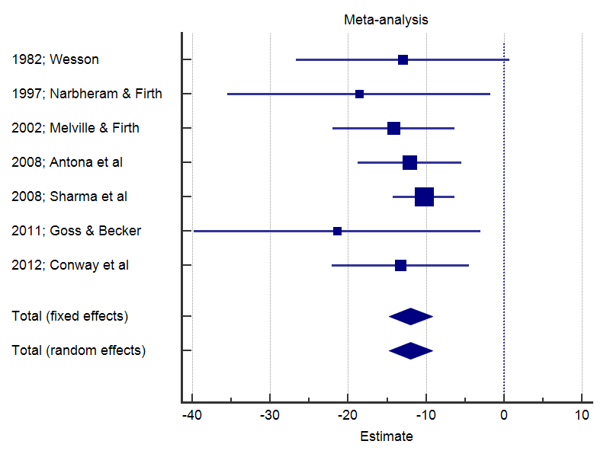 | 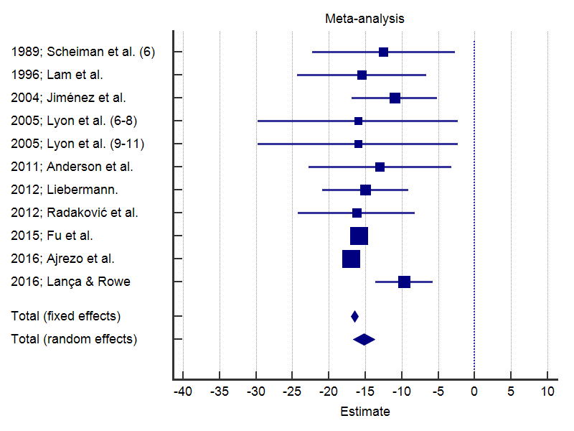
- NFV for near in adults (I2=0%; p=0.8432) | - NFV for near in children (I²=51%; P=0.0242)
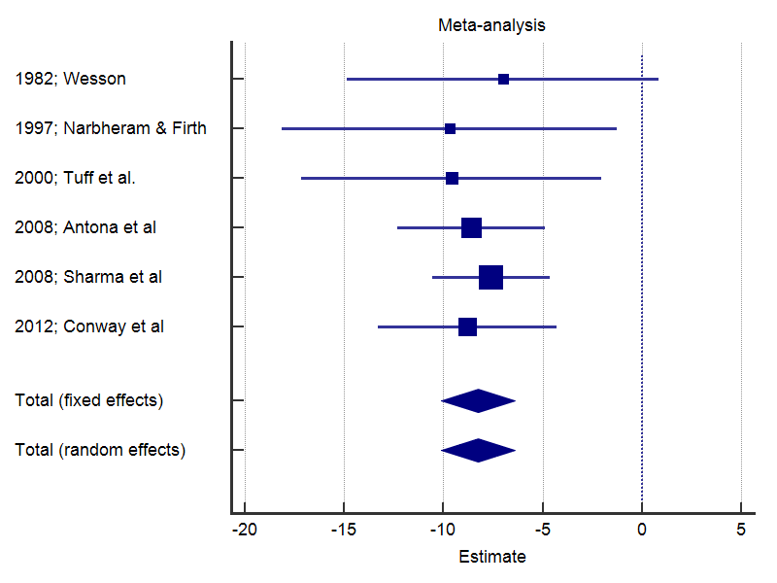 | 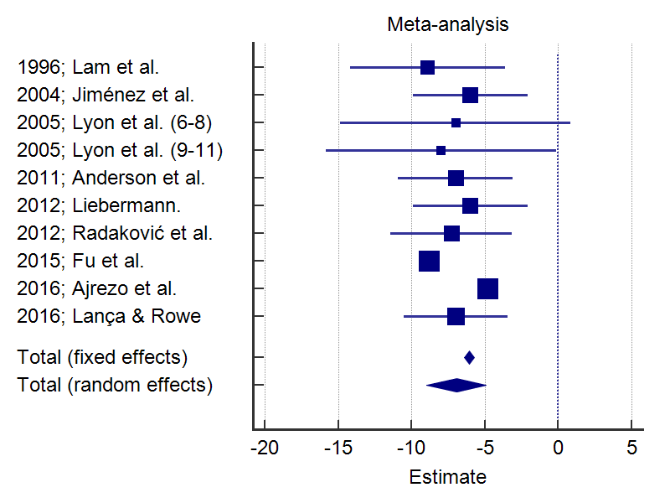
- NFV for distance in adults (I²=0%; p=0.9874) | - NFV for distance in children (I²=93%; p$<$0.0001)

Figure 1 – Forest plots for break fusional negative vergences reported using the step vergence technique.

Table 3 – Positive fusional vergences (PFV) measured with the step vergence technique in adults and children.
Study | Design | Sample |  | Target size and  distance | Order | Break/recovery Prism fusion ranges (Mean±SD)
 |  | Size  (n=) | Age |  |  | PFV
 |  |  |  |  |  | Near | Distance | 3 m
Participants between the age of 4 and 70 years old; mainly young adults
1982; Wesson⁴⁹ | Cross-sectional | 79 | 4-70 | 1.4° at 40cm & 20/40 at 6m | R | 19±10/14±7 | 11±4/7±1 | --
1997; Narbheram & Firth⁴ | Cross-sectional | 20 | 18-35 | 20/20 for near & distance | U | 56.9±12.0/ 37.7±12.7 B:37.7±9.5 | 33.2±10.2/ 22.7±11.3 B:24.4±10.7 | --
2002; Melville & Firth⁵² | Cross-sectional | 28 | 18-23 | 6/9 Snellen letter at 33cm | R | 45.6±22.2  B=30.1±11.3 | -- | --
2008; Antona et al.³ | Cohort | 61 | 19.74±2.5 | 20/25 at 40cm and 6m | R | 28.9±9.1/ 19.7±6.0  B=17.1±6.5 | 23.3±7.7/ 14.5±4.2  B=12.9±5.2 | --
2008; Sharma et al.⁴⁸ | Case control | 33 controls | 6-42 | Accommodative target at 33 cm & 6m | U | 27.8±6.3/ 22.2±5.5 | 20.7±4.7/ 17.4±3.9 | --
2010; Rowe⁸ | Cross-sectional | 22 | 19-23 | 20/20: central  20/30: para-foveal  20/200: peripheral  At near, distance and 3m. | R | M  25/20; B:25  27.5/22.5; B:25  35/30; B:35 | M  16/12; B:16  17/14; B:16  25/16; B:25 | M  20/15 B:18  25/16  B:25
2011; Goss & Becker³⁴ | Cross-sectional | 50 | Young adults | 20/40 at 40cm | BI 1st (only RE) | (M)  28.9±11.0 (30)/ 16.0±7.5 (16)  B=26.7±11.0 (27.5) | -- | --
2012; Conway et al.¹² | Cross-sectional | 500 | 18-59 | 20/30 at 40cm & 6m | U | 27.1±8.2/ 19.3±7.1 B:18.3±6.7 | 20.8±6.4/ 11.7±3.8 B:9.8±4.2 | --
2013; Fray²¹ | Cohort | 50 | 20-65 | 20/40 at 33cm & 6m | R | Mean; M (IQR*)  36.6; 40 (30, 45)/  32.2; 35 (25, 40) | Mean; M (IQR*)  26.8; 25.8 (20, 30.5)/  19; 16 (12, 21) | --
2013; Schultinga et al.⁵³ | Cohort | 55 | 17-28 | Fixation light at 30cm and 3m  Dominant and non-dominant eye | R | M!  With BSG: 33  Without BSG: 38 | M!  With BSG: 33  Without BSG: 33 | --
2017; Fray⁵⁴ | Cohort | 99 | 20-70 | Parafoveal-sized 20/40 Snellen letter | R | Group 1: 33.5/28.1  Group 2: 35.2/31.9 | Group 1: 25.8/18.3  Group 2: 25.3/18.3 | --
School children between the age of 5 and 16 years old
1989; Scheiman et al.³⁰ | Cross-sectional | 45  341 | 6  7-12 | 20/30 at 40cm | BI 1st (only RE) | 19±7/ 10±5  23±8/ 16±6 | -- | --
1996; Lam et al.*⁵⁵ | Cross-sectional | 162 | 4,5-5,5 | Lang accommodative target at near and a cartoon (14in) at 6m | U | 28.9±5.6/ 23.4±5.1 | 14.5±5.5/ 10.6±5.2 | --
2002; Chen & Abidin³² | Cross-sectional | 60 | 7-12 | 20/30 at 40cm & 6m | U (only RE) | 19.4±9.4/ 14.6±8.9 | -- | --
2004; Jiménez et al.² | Cross-sectional | 1016  1015 | 6-12 | 20/30 at 40cm & Far: Snellen optotype corresponded to highest visual acuity | BI 1st | 18±8/ 13±6 | 17±7/ 11±6 | --
2005; Lyon et al.⁵⁶ | Cross-sectional | 453  426 | 6-8  9-11 | U target size at 40 cm & 20/100 at distance | BI & D 1st (only RE) | (M)  21±11(18)/ 13±8(12)  21±11(18)/ 13±8(12) | (M)  12±7(10)/ 6±4(6)  12±7(10)/ 7±5(6) | --
2011; Anderson et al.¹⁵ | Cohort | 114 | 7-13 | Picture of U target size at near & 20/25 at distance | BI & BO for D 1st | 30±9/ 24±7 | 20±9/ 15±6 | --
2012; Radaković et al.⁶ | Cross-sectional | 152 | 6-7 | 20/40 at 33cm & 6m | BI 1st (only RE) | 29.6±6.6/ 21.6±7.5 | 13.7±4.4/ 7.3±3.6 | --
2015; Fu et al.²⁹ | Case control | 86 controls | 8-15 | 20/40 at 33cm & 6m | BI & D 1st | 31.1±1.4 | 26.5±1.5 | --
2016; Ajrezo et al.⁴³ | Cross-sectional | Total:68  42  26 | 5-16  5-9  10-16 | 30cm & 5m | BI 1st | 38.2±1.0  40.2±0.9  34.8±2.0 | 18.7±0.7  19.6±0.9  17.4±1.2 | --
2016; Lança & Rowe⁵⁷ | Cross-sectional | 530 | 6-14 | 20/30 at 33cm & 20/100 at 6m | BI 1st & D1st | 20.2±5.0 | 13.1±3.2 | --
Legend: BI – Base-in; B – Blur; BO – Base-out; BSG – Bagolini striated glasses; D – Distance; IQR - Interquartile range; PFV - Positive Fusional Vergence; SD – Standard deviation; R – Randomized; RE – Right eye; M – Median; U – Unknown; * Values before breakdown. !Only median values are reported.

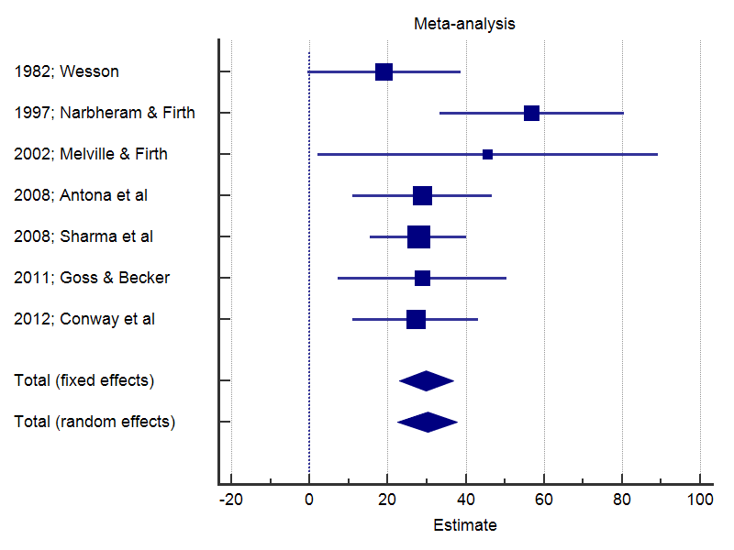 | 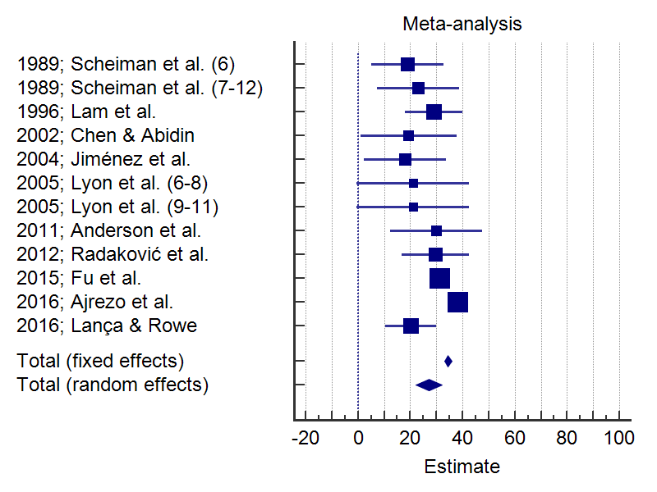
- PFV for near in adults (I²=14%; p=0.3210) | - PFV for near in children (I²=76%; p$<$0.0001)
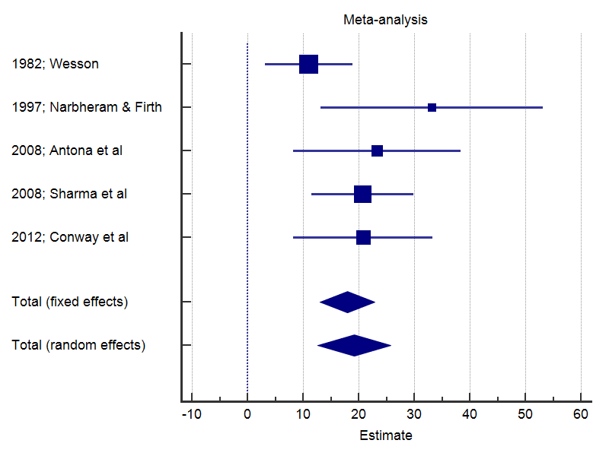 | 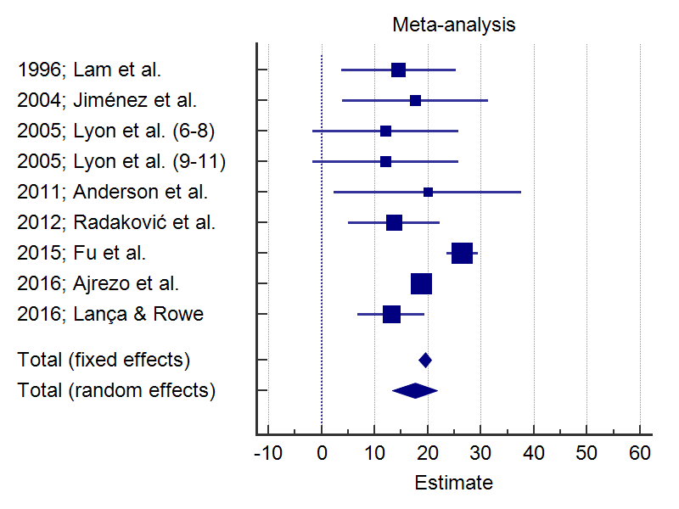
- PFV for distance in adults (I²=36%; p=0.1794) | - PFV for distance in children (I²=75%; p=0.0001)
Figure 2 – Forest plots for break fusional positive vergences reported using the step vergence technique.

Anderson et al.¹⁵ observed greater base-out ranges than other studies for children aged 7 to 13 years old. One of the reasons for these findings is that the examiners gave subjects the opportunity to regain fusion and continue beyond the first point at which a break occurred. Lança and Rowe⁵⁷ achieved comparable results to Lyon et al.⁵⁶ for fusional convergence ranges at distance. The values are smaller compared with the other studies and may be due to the use of the same target size. Lança and Rowe assessed a larger cohort consisting predominantly of exophoric children. Similar results were found by Radaković et al⁶ in a cohort of children, mainly exophoric.
Wesson did not find any significant impact in vergences when analyzing the effect of gender and age as independent variables in 79 subjects aged 4 to 70 years old.⁴⁹ However, a recent study reports that the frequency and amplitude of accommodation to lenses and vergence to prisms increases with age (subjects between the age of 2.0 months to 40.8 years)⁵⁸. This tendency seems to change in the elderly. Álvarez et al.³¹ observed 271 subjects between the age of 21 and 80 and concluded that age has a significant effect (negative correlation) on base-in (reduction of approximately 0.05Δ/year) and base-out (reduction of approximately 0.07Δ/year) recovery when measured with the smooth vergence technique with a Risley rotary prism (table 5). Mean base-in recovery decreased by 2.5Δ and mean base-out recovery decreased by 3.3Δ between the youngest and oldest age groups. However, standard deviation for base-out recovery was higher for the oldest subject group in this study showing that variation was greater in the older subjects. Fray⁵⁴ also found a significant negative correlation between age and the convergence break and recovery points, but no significant correlation for divergence. Other studies support this change in the elderly (60 and 93 years of age) describing a reduction in the adaptation⁵⁹, with longer vergence duration (longer deceleration phase) than in young adults.^{60,61}

Prism fusion ranges measured by the smooth vergence technique
Table 4 provides data from fusional vergence ranges measurements by the smooth vergence technique at near and distance from 9 studies. Participants (n>931) ranged between the age of 6 and >70 years old. Mean, median and SD are provided where available. Compared with the step vergence measurements, smooth vergence measurements show less variation and lower standard deviations. However, there are still considerable high standard deviations for base out range measurements, confirming the trend for convergence. Heterogeneity for break points was not present (I²=0%; p>0.05) in adults, nor in children.
The two highest mean values for negative vergence break points for near were found by Jorge et al¹⁸ (22.9±5.4Δ) and Goss & Jackson⁶² (21±4Δ). This result is similar to what was found when analyzing measurements with the step method in the present study. However, Jorge et al¹⁸ report results which require careful analysis. Theirs was a prospective study with University students that developed a myopic shift with a mean change in refractive error of -0.29±0.38D after 3 years of follow-up.¹⁸ Twenty-two percent of the subjects experienced a change of at least -0.50D and the authors verified a significant difference in the heterophoria (for near the heterophoria change from esophoria to exophoria) and the break, recovery and blur points for fusional ranges. For the break and blur points a reduction was found after 3 years associated with an increase in the recovery point. The authors concluded that the refractive state did not influence the binocular system or accommodation with the exception of a trend towards higher positive break values at distance in hyperopes (26.1±7.6Δ) compared with emmetropes (20.9±9.1Δ) and myopes (22.7±9.8Δ). Also, base-in break values for distance were significantly higher in the refractive group who displayed a myopic shift for distance (no change in refractive error=12.2±3.6Δ; change≥0.50D=15.8±6.8) and near (no change in refractive error=22.4±5.2Δ; change≥0.50D=24.8±5.5) meaning that fusional divergence may act as predictor of a myopic shift in young adults. Many parameters of binocular vision have been studied in subjects with ametropia, specially myopic subjects.^{18,63–65} Goss and Jackson⁶³ developed a prospective study with children who became myopic after 3 years of study. The authors concluded that near blur points were more convergent in children who become myopic, but results were not statistically significant.
Negative vergence mean break points for distance follow the same trend of the step measurements, showing less variation between studies, with a minimum mean value of 8.6±2.3Δ reported by Álvarez et al³¹ in the elderly (>70 years old) and a maximum mean value of 13.0±4.6Δ reported by Jorge et al. in a sample of young subjects (20.6±2.3 years old).¹⁸ In Jorge et al’s study¹⁸ negative vergence break point are on average 5Δ higher than those obtained by Álvarez³¹ in subjects aged 21 to 30 years old.
Over the entire sample of >931 patients the mean base-out break values ranged from 14/8 (standard deviation is not reported)⁶⁶ to 29.7±9.0Δ¹⁸ for near and from 10.9±4.6Δ⁶⁷ to 23.8±8.8Δ¹⁸ for distance. This variation is clinically significant. However, the values are lower compared with step measurements.
The smooth vergence technique using the Risley rotary prism on the phoropter has shown short-term repeatability.³³ Using hand-held rotary prims Wesson and Amos⁶⁶ studied reliability between two clinicians and found good reliability between examiners. The authors concluded that the use of monocular hand-held rotary prism leads to lower break values than binocular rotary prisms due to the larger peripheral stimulus induced by binocular viewing.

Table 4 – Normal prism fusion ranges measured with the smooth vergence technique (Risley rotary prism).
Study | Design | Sample |  | Target size and  distance | Order | Break/recovery prism fusion ranges (Mean±SD)
 |  | Size  (n=) | Age  (years) |  |  | NFV |  | PFV
 |  |  |  |  |  | Near | Distance | Near | Distance
 |  |  |  |  |  | Break/recovery
1985; Wesson and Amos⁶⁶ | Cross-sectional | 84 | 6-70 | 1.4° at 40cm & 20/40 at 6m | R | 13/8? | 7/4? | 14/8? | 12/6?
2006; Álvarez et al³¹ | Cross-sectional | 271  57  52  48  44  43  27 | 21-30  31-40  41-50  51-60  61-70  >70 | Vertical row of 3 optotypes with 20/25, 20/22 and 20/20 size at 6m | BI 1st | -- | 9.5±2.8/5.2±2.2  9.6±3.1/4.8±2.5  9.5±2.6/4.0±2.1  8.9±2.0/3.7±2.0  8.8±2.3/2.9±2.0  8.6±2.3/2.7±2.1 | -- | 19.3±8.2/8.2±5.4  18.2±9.0/6.3±5.0  20.3±8.2/5.2±3.6  19.7±8.8/5.3±3.9  19.2±7.3/3.9±3.8  16.7±7.3/4.9±7.6
2008; Antona et al.³ | Cohort | 61 | 19.74±2.5 | 20/25 at 40cm and 6m | R | 16.0±4.3/  8.2±4.0  B:11.7±3.8 | 10.0±2.4/  5.3±2.0 | 29.2±8.4/  19.2±6.8  B:22.1±6.8 | 24.7±7.4/  11.8±5.7  B:15.7±6.4
2008; Jorge et al.¹⁸ | Cohort | 118 | 20.6±2.3 | 20/25 at 40cm and 6m  1st exam (baseline)  2nd exam (after 3 years) | BI1st; D 1st | 22.9±5.4/11.5±4.6  B=15.8±5.1  19.6±5.6/11.8±4.9  B=13.9±6.0 | 13.0±4.6/5.2±2.1  10.7±3.7/6.0±2.4 | 29.7±9.0/13.7±7.6  B=19.7±8.2  28.0±9.6/15.9±8.6  B=20.6±8.0 | 23.8±8.8/8.0±5.4  B:13.1±5.7  22.1±8.5/10.6±6.5  B:12.0±5.6
2010; Razavi et al.⁶⁷ | Cross-sectional | 111 | 20-40 | 2 lines below BCVA (≥20/25) at 40cm & 6m | BO 1st; D 1st | 13.9±5.0/10.6±4.5 B=8.0±3.8 | 7.4±3.0/ 4.8±2.4 B=3.8±1.7 | 15.5±6.2/12.4±6.2 B=9.2±4.1 | 10.9±4.6/ 7.9±3.8 B:5.1±2.6
2011; Goss & Becker³⁴ | Cross-sectional | 50 | Young adults | 20/40 at 40cm | BI 1st (only in the RE) | 20.8±5.0 (M:22)/ 10.9±4.9 (M:12)  B:17.0±5.7 (M:18) | -- | 25.9±9.7 (M:26)/ 12.6±9.4 (M:8)  B:23.0±10.1 (M:22) | --
2016; Daniel & kapoula⁶⁸ | Case-control | 21 normals | 18-24 | Unknown target size at near and distance | U | 15.8±5.1 | 11.7±5.6 | 23.3±6.6 | 11.3±4.9
1991; Jackson & Goss⁶² | Cross-sectional | 244 | 7.9-15.9 | Single Snellen 20/20 at 40cm and three letters at 4/4 visual acuity | BI1st; D 1st | 21±4/ 9±4; B:15±6 | 12±3/ 4±2 | 27±8/ 10±6; B:21±8 | 23±8/6±5; B:14±6
1996; Goss & Jackson⁶³ | Cohort | Children | U | U target size at 40cm and 4m  Emmetropic  Myopic | 4m BI; 4m BO; 40cm BI;  40cm BO | 18.5±4.1/ 8.1±3.8  B:13.6±5.1  18.5±4.4/ 7.6±4.9  B:11.4±5.1 | 11.0±3.5/3.4±1.8  10.3±2.5/3.5±1.5 | 28.2±7.9/ 10.7±6.0  B:20.5±7.3  27.6±7.5/ 11.5±5.4  B:23.0±7.1 | 23.3±9.1/ 7.2±5.0  B:12.8±5.8  22.6±7.7/ 7.5±4.0  B:12.7±5.6
2010; Álvarez & Puell⁶⁹ | Case-control | 32 normal | 8-13 | 20/30 at 40cm and a vertical row of 3 optotypes with 20/25, 20/22 and 20/20 size at 6m | BI 1st | 17.6±5.7/ 9.0±4.5 B:11.5±6.6 | 11.1±3.4/5.0±2.4 B:11.5±6.6 | 25.1±7.2/ 12.4±4.8 B:18.7±7.8 | 17.8±6.1/ 7.9±3.5 B:11.4±6.0
Total | -- | >931 | 6 to >70 | -- | -- | -- | -- | -- | --
Legend: B – Blur; BCVA – Best corrected visual acuity; BI – Base-in; BO – Base-out; D – Distance; NFV – Negative Fusional Vergence; M – Median; PFV – Positive Fusional Vergence; RE – Right eye; U – Unknown; R – Randomized. ---------- Hashed line separates adults and elderly from children. ?Only mean values are reported.

Variation in method of assessment
A study undertaken by Goss and Becker³⁴ demonstrated high coefficients of agreement between prism bar vergences and rotary prisms in the phoropter (a lower coefficient of agreement indicates better agreement) suggesting that both techniques cannot be used reciprocally. The prisms bar vergences tended to be higher, especially for base-in recovery and base-out blur, break and recovery. Contrary to the study undertaken by Goss and Becker³⁴ the step vergence technique results showed lower NVF means when compared with the smooth technique. This result supports the conclusion that both techniques are not interchangeable. The implications for clinical practice are that the same technique should be used in follow-up of patients.
The measurements taken by the use of step vergence have some advantages, including the presence of peripheral cues representing a more natural environment for testing when comparing with the phoropter.⁴⁹ The higher measurements using this technique can be due to a greater input from peripheral vision.
Antona et al.³ found better repeatability for base-in measurements (differences under 0.5Δ) and less intra-subject variability than base-out (differences >2Δ) at near and distance for both the phoropter rotary prisms and prism bar. The authors report that among the factors that may affect repeatability are accommodation and proximal convergence. These are minimal at distance leading to lower variability during measurements at distance. The type and amount of heterophoria did not correlate with the variability of fusion measures. In the same study the authors found higher break points when using the phoropter rotary prisms, while recovery points were higher for the prism bar method. This can be attributed to stimulation of binocularity using rotary prisms when compared to an introduction of a monocular prism in the step vergence measurement.
O’Conner and Stephenson³⁵ did not find significant differences between the median vergence values between the synoptophore, Risley prisms and step vergence. However, the authors found considerable variation on an individual basis, regardless of whether they were measuring tonic or phasic fusion. On the contrary, Daum et al¹⁷ found differences in positive vergences (blur and recovery points) between evaluators when using prism bars compared to the amblyoscope that showed no significant differences. Also, there were significant higher values in women compared with men using prisms.
The vergence facility test may also be used to measure the vergence system, using the speed with which an individual recovers from fusion in the presence of fast changes in vergence demand.⁵² The measurements of this test do not seem to correlate with vergence amplitudes and reliability measurements need to be made to demonstrate the utility of this test for clinical practice.
One study determined vertical vergence range with the step method and found base down values of 5Δ to base up 4Δ for near fixation and base down 4Δ to base up 3Δ at distance fixation.⁸ Although, measurements appear to be slightly greater at near than distance, the difference is not clinical significantly.⁷⁰ Ulyat et al⁷⁰ found median values for break points of 6Δ for 33cm and 1m; 5.5Δ for 4m and 6m. Regarding the recovery points the authors reported median values of 4Δ at 33cm and 1m and 3.5Δ at 4m and 6m. Vertical fusion amplitude in adults (n=54) has been shown to increase linearly over the range of convergence stimuli.⁷¹ Richardson and Firth found that the greater the induced vertical divergence, the smaller the horizontal fusional amplitude.⁷²

Target type, size and distance
Published studies report that measurements of fusional amplitudes can be influenced by encouragement, order of assessment and target size.^{8,21} According to Rowe⁸ there is a significant difference when comparing fusional convergence measurements at near using a central target size and a peripheral target size in adults (n=22). A higher measure is obtained with a peripheral target (median break=35Δ) in comparison to a central (median break=25Δ) or parafoveal target (median break=27.5Δ). Results reported by Feldman at al.³³ corroborated these findings. The authors compared fusional ranges measured by Risley prisms, vectograms and computer orthopter and concluded that vergence ranges are dependent upon the size of the stimulus, amount of detail, method of presentation and type of stimulus (flat fusion vs stereoscopic). Hainey et al.,⁵ using a 20/200 target size, also corroborate those findings and report higher mean values for distance and recovery points during convergence (non-dominant eye: break=36.3±8.5Δ and recovery=26.5±7.0Δ; dominant eye: break=32.7±8.6Δ and recovery=22.9±6.7Δ). According to Jones and Stephens the addition of peripheral contours on or near the plane containing the fixation point increases the effectiveness of the fusion stimulus.⁷³ The magnitude of vergence adaptation has been shown to produce a slowest rate of adaptive decay in the presence of larger adapting stimulus.⁷⁴
Bagolini glasses are sometimes used while performing the prism fusion amplitude to verify the disruption of binocular vision.⁵³ However, according to Schultinga et al.⁵³ this technique significantly reduces fusional ranges at near (break and recovery points). The normal ranges of this study, specifically base-out measurements, are higher than other studies (Table 2). One of the reasons for this can be the use of a different target (fixation light). Also, the majority of the subjects were optometry and orthoptic students in comparison to naïve subjects in the other studies.
Measurements through the synoptophore also need to take account of the target size. Daum et al ⁷⁵ conducted a study on 34 healthy asymptomatic young adults. The subjects were randomly divided into two groups and training to expand vergence ranges was implemented (group 1 = smooth, slow activities; group 2 = stepwise, phasic tasks). Both groups improved fusional ranges. However, group 2 showed greater changes in their vergence capabilities. The standard deviation reported is very high for base out ranges, showing a great variability of measurements. The fusional ranges were measured with fusion slides of 1.72°. Fu et al.²⁹ used a bigger target with slides of 6° horizontally and 8° vertically. Although, slides were greater, negative fusional fusional ranges were similar when measured at distance. The results should be analysed prudently when trying to compare with other studies, as amplitudes of convergence and divergence were calculated as the break points minus the points of simultaneous perception.
A study by Rowe⁸ with horizontal fusional range measurements at 3 m showed measurements comparable with 6 m. Similar results were found by Ulyat et al^{.70} for vertical ranges at distance fixation of 4m and 6m. There is a statistically significant difference between motor fusion amplitude at 1/3m and 6m; results that confirm the need to test amplitudes for both distances.^{54,76} Near measurements are significantly higher and are influenced by proximal convergence.

Order of assessment
The rationale for order of testing is that convergence responses stimulated during the base-out measurements produce vergence adaptation or a fusional aftereffect (increase in the output of the slow disparity-vergence mechanism), that bias temporarily the subsequent base-in values.^{22,74}
According to Fray^{21,54} divergence break and recovery points are significantly lower when tested after convergence. In the two studies conducted by Fray^{21,54} the measured heterophoria was incorporated into the final value of the fusional amplitudes for each participant (n=50; n=99). Convergence was not significantly affected by order of testing. Sassonov et al²⁶ found that divergence amplitudes for near (6/9 target at 40cm) measured after convergence amplitudes were significantly lower on average than those measured before convergences amplitudes (n=30 subjects between the age of 18 and 30 years old). Base-in values decreased from 20.1±5.9Δ, when base-in was tested first, to 14.1±4.5Δ when base-out was tested first. These findings are in accordance with Rosenfield et al²² observations, who found a statistically significant reduction in the subsequently measured base-in recovery value using the phoropter (mean reduction=1.4Δ) in 10 adults with a mean age of 32.1 years.
Wesson did not find an influence in the order of testing (starting base-in or base-out).⁴⁹ The subjects included in this study had small and compensated heterophorias from ortho to 4Δ exophoria at distance and orthophoria to 7Δ exophoria at near. Wesson and Amos subsequently conducted a study to analyze the effect of assessment order with hand-held rotary prisms and the results show no statistical differences in clinical testing of vergences.⁶⁶ A literature review by Rosenfield⁷⁴ concludes that although there is a significant reduction in the subsequently base-in recovery value, the total vergences and breaks values are not significantly affected by vergence adaptation.
The results of several studies^{21,22,26} indicate that base-out vergence range testing induce significant vergence adaptation, suggesting that the adaptation results from an increase in innervation during the course of stimulation. The rationale is that the dissociated position of the nonfixating eye will be temporally more convergent.⁷⁴ Although statistically significant those differences reported in the literature may not be clinically relevant. The instrumental error should be considered when analysing the differences between the means for each group. The change in vergence ranges observed when order of testing is varied falls within the normal range of variability of this parameter. Thus, Rosenfield et al²² recommend to measure compensating range for the heterophoria first to avoid bias in the range from a preceding measurement. A literature review⁵⁹ by Firth describes that even when adaptation occurs, after a 2 minute period fusional vergences return to a level similar to that before the horizontal deviation was induced.

Encouragement
Fray²¹ tested the effect of encouragement and found that it has a statistically significant effect on convergence amplitudes when compared with no encouragement (median break point=25.5Δ compared with 25Δ; median recovery point=16Δ compared with 14Δ). Divergence measures are less affected.⁵⁴ Based on the results of both studies^{21,54} that Fray conducted, the author suggests that the clinician can use measures with and without encouragement to learn more about the potential for fusion. These results are in line with Sreenivasan et al’s study⁴⁴ that found convergence ranges significantly larger in expert adults (38±2.1Δ) compared with naïve adults (20±9.2Δ). Based on these results the authors concluded that convergence ranges of naïve subjects could be improved if they are properly instructed to keep the target single. The use of instructions to keep the target single may invoke additional voluntary vergence.⁴⁴ Base out values increase with practice and can be higher in participants from the academic world (orthoptic and optometry students) compared with other populations as reported by Melville and Firth’s study.⁵² The majority of the studies do not provide details about the precise instructions given to the participants and these instructions might influence results. According to Dwyer³⁸ the clinician should also take in consideration that there is considerable binocular adaptability in response to general health status, time of the day and emotional state.

Ocular dominance
Ocular dominance has been referred to as one the factors that might influence values of fusional reserves. The influence of the eye controlling the binocular vision has been studied and controversy arises over its influence. However, several studies did not find significant differences in the measurements regardless of the dominant or fixating eye.^{5,49,53,66} Hainey et al.⁵ used a simplified version of the pointing test where the subject has to clasp their hands together with both forefingers stretched out fixating an object at distance and has to report which finger is in line with the target when closing either eye. Although the mean break and recovery base out measurements were greater fixing with the non-dominant eye (break=36.3±8.5Δ; recovery=26.5±7.0Δ) than the dominant eye (break=32.7±8.6Δ; recovery=22.9±6.7Δ) there were no significant changes. Wesson determined eye dominance by the “hole-in-the-hand” technique in 79 subjects and concluded that there is no statistical difference when the prism bar testing was done on the dominant or non-dominant eye.⁴⁹ Wesson and Amos conclude that there is no difference in testing regarding ocular dominance using the hand-held rotary prism.⁶⁶ Also, Jainta and Jaschinski did not find differences in the binocular parameters when the presentation of sentences changed from the right to the left eye.⁷⁷

Refractive error and heterophoria
Published studies agree in finding a lack of relationship between heterophoria measurements, age and gender in the infant years.^{2,6,20,78} After 6 years of age there is a greater incidence of heterophoria, which can be related with an increase in near work activities.^{20,79} One study reported that near heterophoria in children with myopia became more exophoric over 10 years of follow-up whereas near base out fusional ranges decreased.¹⁵
Anderson et al.¹⁵ found a longitudinal decrease in convergence ranges (break point decreased 9.4Δ for near) in children aged 7 to 13 years old with myopia becoming more exophoric during school years. The implications of those findings for clinical practice might be that compensating convergence ranges decrease when near heterophoria becomes more divergent. Near convergent point was significantly associated with lower base-out ranges (1Δ for every 1cm of recession). In the same study esophoria was associated with greater base-out ranges (0.3Δ increase in base-out range for every 1Δ greater esophoria). Greater interpupillary distance was associated with greater base-in ranges. Although, all the children were myopic, and the results cannot be generalized for all refractive states there was no significant relationship between the fusional ranges and magnitude of myopia.
Sreenivasan et al.⁴⁴ found no significant correlation between refractive error and fusional ranges for either age group (pre-schoolers and infants). However, the infants included in this study had typical amounts of uncorrected hyperopia. Risovic et al.⁸⁰ found no significant differences in vergence amplitudes for near and far fixation, fusion amplitude, heterophoria and near point of convergence between myopia and hypermetropia groups.
Heterophoria can be influenced by the position maintained by the eyes for a specific task (convergent or divergent position) leading the heterophoria in the direction that the eyes were maintained.⁸¹ Sreenivasan et al.⁶⁵ found significant differences in children with exophoria comparing both emmetropes (greater shift) and myopes with significant reduction of the deviation (convergent adaptation) after 4 minutes for near fixation. Myopic heterophoria-normals showed a small but significant divergent shift after 20 minutes of sustained fixation. Also, refractive type showed a significant main effect such that myopes displayed greater accommodative lags compared to emmetropes. Results of the study support the relationship between heterophoria and fusional vergence required to overcome the heterophoria, resulting in greater amounts of vergence adaptation. For example, the presence of exophoria precipitates an increase in fusional convergence and accommodative convergence such that binocular measures are greater than monocular values.
Radaković et al.⁶ found a weak but significant correlation between the heterophoria and fusional vergences. In their study exophoria for near distance (n=111) was over-represented compared with orthophoria (n=24) and esophoria (n=17). A study undertaken by Lança and Rowe⁵⁷ corroborate the weak correlation between fusional divergence and angle at near in non-strabismic children (n=539 between the age of 6 and 14 years old). However, a significant but weak inverse correlation between fusional convergence and angle at near was found. In the same study, exophoric children had lower fusional convergence ranges compared with children with orthophoria and esophoria. In adults Razavi et al⁶⁷ did not find any significant correlation between the amount of exophoria and convergence amplitudes for near and distance. In Rowe’s⁸ study when comparing exo versus eso deviations, no significant differences were obtained between the combined measures for divergence and convergence ranges. Fray⁵⁴ corroborates this results, finding no correlation between heterophoria and fusional amplitude. However, heterophoria measurements were incorporated into the final value of fusional amplitude which may account for the differences between studies. If the correlation between heterophoria and fusional amplitudes is non-significant or very weak, generalised fusional amplitude data may not be clinically useful in making decisions regarding normal values. What appears to be most useful is to consider the individual PFV or PFV, versus the exo and eso angle of deviation respectively, and evaluating further whether the fusion reserve ratio according to Sheard’s criteria (fusional reserve opposing the heterophoria should be at least twice the magnitude of the angle of deviation)¹³ accounts sufficiently for the true threshold for a normal patient.
Several studies did not find significant differences in CA/C (convergent accommodation / convergence) and AC/A (accommodative convergence / accommodation) between emmetropes and myopes.^{18,64,82} It seems that some patients may increase their positive fusional vergence limits through vergence adaptation resulting in reduced convergence accommodation without influence in the measures of AC/A or CA/C.⁸²
Heterophoria measurements show that 44% of subjects need long periods of dissociation time (25-30 min) to dissipate slow fusional vergence and reach a stable heterophoric position.⁸³ Implications for clinical practice might be that if changes > 2PD are observed after a 5 minute period of dissociation, the period of continuous dissociation should be continued for a further 20 minutes. However, the benefits of such measurements regarding the type of treatment (e.g. surgery or prisms) has not been proved yet. One study suggests to assess the patient’s heterophoria adaptation during the orthoptic therapy, using the number of alternations in the alternate cover test to reveal the full heterophoria.⁸¹ Post-training increments in positive fusional vergence lead to a reduction in the exophoria at near but not for distance.⁸² The results of these studies have implications in clinical practice showing that patients with binocular vision problems might have vergence adaptation problems that may improve with orthoptic therapy. The activity of the fast system reflects the change in fusional amplitudes and the slow fusional vergence system reflects change in heterophoria. However, the decrease of fusional amplitudes with prism adaptation was only demonstrable for large values of the adapting prism and statistically significant only for base-in prism adaptation.³⁶
To test the capacity of the vergence system to adapt to prism-induced heterophorias Tuff et al.⁵¹ examined base-in fusional vergence in five young adult subjects before and after wearing a 10Δ base-out Fresnel prism. The authors concluded that there were no statistically significant differences between the before and after the adaptation period. Based on these results the authors advise that clinical measurements should be done testing the range that compensates for the patients heterophoria first. Momeni-Moghaddam et al.⁸⁴ found that stereoacuity recovery precedes complete heterophoria adaptation and is slower when adapting to divergence, responding faster to near targets than to distant.

Type of strabismus and severity of strabismus
The use of cover-uncover and fusional vergence testing in a patient with an exodeviation improves the sensitivity (83%) and specificity (93%) for evaluating the control of the deviation.⁸⁵ Reduced convergence amplitudes are associated with poor control of an exodeviation.^{48,85} Patients with intermittent exotropia have poor convergence and divergence amplitudes preoperatively when compared with normal subjects between the age of 6 and 42 years.⁴⁸ Convergence reserves and fusion recovery point at distance fixation were found to be subnormal in children aged between 3 and 17 years old (n=64) with intermittent exotropia.¹⁴
In Fu et al’s study²⁹ convergence amplitude was significantly lower (n=92) compared with normal children at both distance and near with an increase in the mean distance between recovery and break points. According to Sharma et al.⁴⁸, although the amplitude is affected for both distances, convergence amplitude for distance was found to be more adversely affected than for near.⁴⁸ Similar behaviour was observed with fusional divergence break points in children with distance intermittent exotropia being normal at near but bimodal at distance, with a reduction in distance fusional divergence.⁷
One study found divergence amplitudes to be higher than those for non-strabismic children.²⁹ The angle of deviation could be one of the reasons for this result, as the mean amount of intermittent deviation (38.3±14.8Δ) was higher than other studies. Also, the normative control vergences amplitudes applied to the study were different. Curiously, in the same study²⁹ the synoptophore was used to measure fusional amplitudes (smooth vergence assessed with the deviation neutralized). The results of the measurements using this method did not show significant differences in the mean divergence amplitudes comparing children with intermittent exotropias with the non-strabismic children.
Both vergence amplitudes (convergence and divergence) seem to be linked as break and recovery points for convergence and divergence are correlated at near and distance.^{7,48,67} Also, there is a good correlation between distance and near amplitudes in patients with intermittent exotropia.⁴⁸ A clinical implication of this finding might be that only measurements for one of the distances are needed to provide sufficient information for the management of these patients.
Grisham et al⁸⁶ found increases in fusional divergence in esophoria correlated with decreases in tracking rate during orthoptic treatment. Also, exophorics with uncompensated exophoria had improved recovery and increases in fusional amplitudes as the tracking rate improved.
Liebermann et al.⁷ reported a weak and inverse correlation between divergence break point and angle of deviation at near in 32 children with distance intermittent exotropia type. Hatt et al. did not find a significant correlation between the convergence reserves and angle of deviation at distance, but found an inverse correlation at near with larger angles of intermittent exotropia associated with smaller convergence reserves.¹⁴ Results from Conway et al’s study¹² in adults corroborate this finding showing that there is a good correlation between the exodeviation at near and the opposing fusional amplitude (blur, break and recovery), in both the symptomatic group of patients and the entire group.

Convergence Insufficiency and symptoms
Convergence Insufficiency, a binocular vision dysfunction, has a prevalence of 17.6% in children aged 8 to 12 years old (n=415) using two or more diagnostic signs.⁸⁷ Classic textbook descriptions of the condition include the presence of an exophoria greater for near, a remote near point of convergence and decreased positive fusional vergence.²³ Rouse et al.⁸⁷ found a slight significant decrease in the blur point for the negative fusional amplitude in patients with convergence insufficiency. However, the authors concluded this decrease was not clinically significant.
A review of 58 papers by Daum⁸⁸ show that symptoms and decreased positive fusional vergences for near were the only criteria named in more than one-half of the studies. Distance exodeviation, negative vergences, visual acuity, refraction and stereopsis were about the same as population norms.
Asthenopia has been linked with abnormal heterophorias and abnormal fusional ranges. One study aimed to demonstrate the effect of fusional vergence-generated binocular stress.⁸⁹ The results indicated no significant correlation between ratings of asthenopia before and after induced vergence in the normal population. Another study failed to show any significant correlation between the vergence levels and the level of asthenopia.¹⁷ Although the sample was small (n=18; 8 female and 10 male) there were higher levels of asthenopia reported by women. Similarly Daum et al⁹⁰ found that women were greatly represented in the symptomatic group. The reasons for these results are not known and this topic needs further research. There are some factors that can potentially explain these results. First, the symptoms are based on a subjective judgment and second it might be that females are more likely to have binocular symptoms or react more severely to symptoms.
Symptom scores in patients with convergence insufficiency (55.1±5.9 years) were significantly associated with near heterophoria, associated heterophoria and near point of convergence after prism treatment, but not with break points for positive fusional vergence.⁹¹ The low repeatability of vergence measurements may influence the results. Differences between amplitudes of the associated (measured with binocular fusion) and dissociated (measured with fusion disruption) measures of heterophoria might be due to slow fusional vergence activated during binocular fusion.⁴⁶ Reduced ability to adapt to 6Δ BO at 40 cm was found in subjects with convergence insufficiency, whereas no difference was found in vertical adaptation.⁹²

Orthoptic/optometric treatment
One study shows that normal subjects (n=34) when trained via the stepwise or phasic paradigm compared with subjects trained with smooth activities showed greater increases in both negative and positive vergences.⁷⁵ However, there are contradictory results as Daum et al¹⁷ found that subjects between the ages of 23 and 31 years, using computerized slow training rate, showed significant increases in positive vergence rates measured by the major amblyoscope comparing with subjects submitted to training with fast rates. Both studies used different settings, techniques and populations, which impair comparisons. Zwierko and co-workers⁹³ found a significant improvement in convergence fusional ranges measured with the synopthophore in twenty-four female athletes (21.6±0.7 years) after 8 weeks of treatment. No significant difference was found in fusional divergence ranges.
Luu and Abel⁹⁴ conducted a research study and verified that the majority of the non-strabismic subjects (students between 17 and 25 years of age) showed no change in the maximum vertical fixation disparity magnitude after prism training. However, vertical motor fusion increased significantly after training in the target group comparing with the controls, showing improvements only for the motor component of the binocular vision. Hocking and Gage⁷⁶ did not find significant correlation between the strength of sensory fusion and motor fusion in 36 adults.

Reading and student populations
Vergence is one of the important factors supporting reading and helping to maintain binocular single vision.⁶⁸ One study reports a correlation between the adjusted vergence angles during reading fixations and the individual heterophoria.⁷⁷ The larger the exophoria became, the larger the difference between binocular and monocular reading. The mean first fixation duration for binocular reading increased with larger heterophorias and decreased in monocular reading, showing that stress under the binocular system may induce longer times to adjust vergence. Additionally, the authors found that the subgroup with heterophoria had smaller fusional reserves measured with prisms.
Mean distance base-in break and recovery values were found to be significantly lower in poor readers than those recorded in normal controls in Álvarez and Puell’s study.⁶⁹ The authors report that the recoveries in the study group were nearly 2Δ more than those obtained for the control group. A recent study found a correlation between positive fusional vergences (PFV) at near and interference in the Stroop test (higher PFV associated to less interference).⁶⁸ The authors suggest that vergence control and cognitive functions are linked to an attentional vector.
Vergence amplitudes for near and distance and fusion amplitudes measured by the Synoptophore were found to be lower in student populations compared with nonstudent populations.⁸⁰

LIMITATIONS
The majority of the results are based on cross-sectional studies that are performed independently from each other, with different examiners, methods of examination and different populations. The testing techniques employed are not consistent. Also, not all studies incorporate measured heterophorias in the final value of the fusional amplitude. Future studies should aim to include core outcome sets with a minimum number of outcome measures using validated measurements to enable future comparisons of studies and meta-analysis.

CONCLUSIONS
We carried out a systematic literature review of published normative data for fusional vergences. The source of heterogeneity between studies for vergence break points measured with the step vergence method appears to be linked with age. Normal vergences reported in children had considerable heterogeneity compared with adults. For the smooth technique we did not find heterogeneity for vergenve break points in adults or children. There is still considerable diversity in the reported literature on what clinical criteria constitute normal functioning for vergences measured with the step method in children. For these reasons in clinical practice the population based vergence ranges measured with the step method in children should not be used as one single criterion and a battery of tests to reinforce the diagnosis is advisable. For the smooth technique normative population data can be used.
When considering a diagnosis of whether a person’s binocular fusional status is normal or abnormal, it is not possible to apply one set of ranges for PFV or NFV because maintenance of a normal asymptomatic ocular motor system is dependent on multiple contributing factors with key aspects being age, type and extent of ocular deviation. At an individual level, all these factors must be computed to determine full compensation (normal fusion) or partial/absent compensation (abnormal fusion).

References
1. Pratt-Johnson J. Central disruption of fusional amplitude. Brit j Ophthal. 1973;57:347-350.
2. Jiménez R, Pérez MA, García JA, González MD. Statistical normal values of visual parameters that characterize binocular function in children. Ophthalmic Physiol Opt. 2004;24:528-542. doi:10.1111/j.1475-1313.2004.00234.x
3. Antona B, Barrio A, Barra F, Gonzalez E, Sanchez I. Repeatability and agreement in the measurement of horizontal fusional vergences. Ophthalmic Physiol Opt. 2008;28(5):475-491. doi:10.1111/j.1475-1313.2008.00583.x
4. Narbheram J, Firth A. Prism fusion range: blur point, break point, and recovery point. Br Orthopt J. 1997;54(2):2-6.
5. Hainey J, Cleary M, Bed LW. Does ocular dominance influence the clinical measurement of fusional amplitude? Br Orthopt J. 1999;56:72-76.
6. Radakovic M, Ivetic V, Naumovic N, Canadanovic V, Stankov B. Heterophoria and fusional convergence and divergence in preschool children. Med Glas Ljek Komore Zenicko-doboj Kantona. 2012;9(2):293-298.
7. Liebermann L, Hatt SR, Leske DA, et al. Assessing Divergence in Children with Intermittent Exotropia. Strabismus. 2012;20(1):11-16. doi:10.3109/09273972.2012.655838.
8. Rowe FJ. Fusional vergence measures and their significance in clinical assessment. Strabismus. 2010;18(2):48-57. doi:10.3109/09273971003758412
9. Kim EH, Granger-Donetti B, Vicci VR, Alvarez TL. The relationship between phoria and the ratio of convergence peak velocity to divergence peak velocity. Investig Ophthalmol Vis Sci. 2010;51(8):4017-4027. doi:10.1167/iovs.09-4560
10. Dowley D. Heterophoria. Optom Vis Sci. 1990;67(6):456-460.
11. Sheard C. Zones of ocular comfort. Am J Optom. 1930;7(1):9-25.
12. Conway ML, Thomas J, Subramanian A. Is the Aligning Prism Measured with the Mallett Unit Correlated with Fusional Vergence Reserves? Bui B V., ed. PLoS One. 2012;7(8):e42832. doi:10.1371/journal.pone.0042832
13. Scheiman M, Wick B. Clinical Management of Binocular Vision: Heterophoric, Accomodative and Eye Movement Disorders. 3th ed. Philadelphia: Lippincott Williams & Wilkins; 2008.
14. Hatt SR, Leske DA, Mohney BG, Brodsky MC, Holmes JM. Fusional convergence in childhood intermittent exotropia. Am J Ophthalmol. 2011;152(2):314-319. doi:10.1016/j.ajo.2011.01.042
15. Anderson H, Stuebing KK, Fern KD, Manny RE. Ten-Year Changes in Fusional Vergence, Phoria, and Nearpoint of Convergence in Myopic Children. Optom Vis Sci. 2011;88(9):1060-1065. doi:10.1097/OPX.0b013e31822171c0
16. Jampolsky A. Ocular divergence mechanisms. Trans Am Ophthalmol Soc. 1970;68:730-822.
17. Daum KM, Rutstein RP, Eskridge JB. Efficacy of computerized vergence therapy. Am J Optom Physiol Opt. 1987;64(2):83-89.
18. Jorge J, de Almeida JB, Parafita MA. Binocular vision changes in university students: a 3-year longitudinal study. Optom Vis Sci. 2008;85(10):E999-E1006. doi:10.1097/OPX.0b013e3181890d35
19. Tyler CW, Elsaid AM, Likova LT, Gill N, Nicholas SC. Analysis of human vergence dynamics. J Vis. 2012;12(11):21, 1-19. doi:10.1167/12.11.21
20. Chen AH, O’Leary DJ, Howell ER. Near visual function in young children. Part I: Near point of convergence. Part II: Amplitude of accommodation. Part III: Near heterophoria. Ophthalmic Physiol Opt. 2000;20(3):185-198.
21. Fray KJ. Fusional amplitudes: exploring where fusion falters. Am Orthopt J. 2013;63:41-54. doi:10.3368/aoj.63.1.41
22. Rosenfield M, Ciuffreda K, Ong E, Super S. Vergence adaptation and the order of clinical vergence range testing. Optom Vis Sci. 1995;72(4):219-223.
23. Noorden G von, Campos E. Binocular Vision and Ocular Motility: Theory and Management of Strabismus. 6th ed. St Louis: Mosby; 2002.
24. Cooper J. Clinical implications of vergence adaptation. Optom Vis Sci. 1992;69(4):300-307.
25. Arnoldi K. Orthoptic Evaluation and Treatment. (Wilson ME, Trivedi RH, Saunders RA, eds.). Berlin, Heidelberg: Springer Berlin Heidelberg; 2009. doi:10.1007/978-3-540-68632-3
26. Sassonov O, Sassonov Y, Koslowe K, Shneor E. The Effect of Test Sequence on Measurement of Positive and Negative Fusional Vergence. Optom Vis Dev. 2010;41(1):24-27.
27. Moher D, Liberati A, Tetzlaff J, Altman DG. Preferred Reporting Items for Systematic Reviews and Meta-Analyses: The PRISMA Statement. PLoS Med. 2009;6(7):e1000097. doi:10.1371/journal.pmed.1000097
28. Shamseer L, Moher D, Clarke M, et al. Preferred reporting items for systematic review and meta-analysis protocols (PRISMA-P) 2015: elaboration and explanation. BMJ. 2015;349(jan02 1):g7647-g7647. doi:10.1136/bmj.g7647
29. Fu T, Wang J, Levin M, Su Q, Li D, Li J. Fusional Vergence Detected by Prism Bar and Synoptophore in Chinese Childhood Intermittent Exotropia. J Ophthalmol. 2015:1-6. doi:10.1155/2015/987048
30. Scheiman M, Herzberg H, Frantz K, Margolies M. A normative study of step vergence in elementary school children. J Am Optom Assoc. 1989;60(4):276-280.
31. Palomo Alvarez C, Puell MC, Sánchez-Ramos C, Villena C. Normal values of distance heterophoria and fusional vergence ranges and effects of age. Graefe’s Arch Clin Exp Ophthalmol. 2006;244:821-824. doi:10.1007/s00417-005-0166-5
32. Chen AH, Abidin A. Vergence and accommodation system in Malay primary school children. Malasyan J Med Sci. 2002;9(1):9-15.
33. Feldman JM, Cooper J, Carniglia P, Schiff FM, Skeete JN. Comparison of fusional ranges measured by Risley prisms, vectograms, and computer orthopter. Optom Vis Sci. 1989;66(6):375-382.
34. Goss DA, Becker E. Comparison of near fusional vergence ranges with rotary prisms and with prism bars. Optometry. 2011;82(2):104-107. doi:10.1016/j.optm.2010.09.011
35. O’Connor AR, Stephenson G. Comparison of tonic and phasic measures of motor fusion. In: IOA Congress 2008 Transactions. ; 2008:162-165.
36. Stephens GL, Jones R. Horizontal fusional amplitudes after adaptation to prism. Ophthalmic Physiol Opt. 1990;10(1):25-28. doi:10.1111/j.1475-1313.1990.tb01101.x
37. von Elm E, Altman DG, Egger M, Pocock SJ, Gøtzsche PC, Vandenbroucke JP. The Strengthening the Reporting of Observational Studies in Epidemiology (STROBE) statement: guidelines for reporting observational studies. J Clin Epidemiol. 2008;61(4):344-349. doi:10.1016/j.jclinepi.2007.11.008
38. Dwyer PS. Clinical criteria for vergence accommodation dysfunction. Clin Exp Optom. 1991;74(4):112-119. doi:10.1111/j.1444-0938.1991.tb04622.x
39. O’Connor AR, Birch EE, Anderson S, Draper H. Relationship between binocular vision, visual acuity, and fine motor skills. Optom Vis Sci. 2010;87(12):942-947. doi:10.1097/OPX.0b013e3181fd132e
40. Piano MEF, O’Connor AR. The effect of degrading binocular single vision on fine visuomotor skill task performance. Invest Ophthalmol Vis Sci. 2013;54(13):8204-8213. doi:10.1167/iovs.12-10934
41. Georgievski Z, Sleep M, Koklanis K. Simulated torsional disparity disrupts horizontal fusion and stereopsis. J AAPOS. 2007;11(2):120-124. doi:10.1016/j.jaapos.2006.09.022
42. Sharma P, Prasad K, Khokhar S. Cyclofusion in normal and superior oblique palsy subjects. J Pediatr Ophthalmol Strabismus. 36(5):264-270.
43. Ajrezo L, Wiener-Vacher S, Bucci M, Bui-Quoc E. Influence of Screen Exposure on Vergence Components from Childhood to Adolescence. Int J Ophthalmol Eye Sci. 2016;4(1):170-177. doi:10.19070/2332-290X-1600036
44. Sreenivasan V, Babinsky EE, Wu Y, Candy TR. Objective Measurement of Fusional Vergence Ranges and Heterophoria in Infants and Preschool Children. Investig Opthalmology Vis Sci. 2016;57(6):2678. doi:10.1167/iovs.15-17877
45. Bhavsar M, Alvarez TL, Semmlow JL, Bergen M. Decreased dynamics in the adaptation phase signifies that short term adaptation exists in convergence and divergence ocular movements. In: 2003 IEEE 29th Annual Proceedings of Bioengineering Conference. IEEE; :3-4. doi:10.1109/NEBC.2003.1215965
46. Schor C. Fixation of disparity: a steady state error of disparity-induced vergence. Am J Optom Physiol Opt. 1980;57(9):618-631.
47. Alvarez TL, Semmlow JL, Pedrono C. Divergence eye movements are dependent on initial stimulus position. Vision Res. 2005;45(14):1847-1855. doi:10.1016/j.visres.2005.01.017
48. Sharma P, Saxena R, Narvekar M, Gadia R, Menon V. Evaluation of distance and near stereoacuity and fusional vergence in intermittent exotropia. Indian J Ophthalmol. 2008;56(2):121-125.
49. Wesson MD. Normalization of prism bar vergences. Am J Optom Physiol Opt. 1982;59(8):628-634.
50. Bath JK, Firth AY. Prism fusion range: Gulden versus Clement Clarke plastic prism bar. Br Ir Orthopt J. 2007;4:58-64.
51. Tuff L, Firth A, Griffiths H. Prism vergence measurements following adaptation to a base out prism. Br Orthopt J. 2000;57:42-44.
52. Melville AC, Firth AY. Is there a relationship between prism fusion range and vergence facility? Br J Ophthalmol. 2002;59:38-44.
53. Schultinga L, Burggraaf F, Polling JR, Gutter M. Bagolini glasses: do they affect the horizontal prism fusion amplitude? Strabismus. 2013;21(2):127-130. doi:10.3109/09273972.2013.787632
54. Fray KJ. Fusional Amplitudes: Developing Testing Standards. Strabismus. 2017;25(3):145-155. doi:10.1080/09273972.2017.1349814
55. Lam SR, LaRoche GR, Becker I De, Macpherson H, De Becker I, Macpherson H. The Range and Variability of Ophthalmological Parameters in Normal Children Aged 4½ to 5½ Years. J Pediatr Ophthalmol Strabismus. 1996;33(5):251-256. doi:10.3928/0191-3913-19960901-10
56. Lyon DW, Goss DA, Horner D, Downey JP, Rainey B. Normative data for modified Thorington phorias and prism bar vergences from the Benton-IU study. Optometry. 2005;76(10):593-599. doi:10.1016/j.optm.2005.08.014
57. Lança C, Rowe FJ. Variability of fusion vergence measurements in heterophoria. Strabismus. 2016;24(2):63-69. doi:10.3109/09273972.2016.1159234
58. Bharadwaj SR, Candy TR. Accommodative and vergence responses to conflicting blur and disparity stimuli during development. J Vis. 2009;9(11):4-4. doi:10.1167/9.11.4
59. Firth AY. Vergence adaptation: a phenomenon of normal binocular vision. Br Ir Orthopt J. 2005;2:3-7.
60. Yang Q, Le T-T, Kapoula Z. Aging effects on the visually driven part of vergence movements. Invest Ophthalmol Vis Sci. 2009;50(3):1145-1151. doi:10.1167/iovs.08-2474
61. Chen Y-F, Lee Y-Y, Chen T, Semmlow J, Alvarez TL. Review: Behaviours, Models, and Clinical Applications of Vergence Eye Movements. J Med Biol Eng. 2010;30(1):1-15.
62. Jackson TW, Goss DA. Variation and correlation of standard clinical phoropter tests of phorias, vergence ranges, and relative accommodation in a sample of school-age children. JAmOptomAssoc. 1991;62(0003-0244 SB-IM):540-547.
63. Goss DA, Jackson TW. Clinical findings before the onset of myopia in youth: 2. Zone of clear single binocular vision. Optom Vis Sci. 1996;73(4):263-268.
64. Rosenfield M, Gilmartin B. Assessment of the CA/C ratio in a myopic population. Am J Optom Physiol Opt. 1988;65(3):168-173. http://www.ncbi.nlm.nih.gov/pubmed/3364525.
65. Sreenivasan V, Irving EL, Bobier WR. Effect of heterophoria type and myopia on accommodative and vergence responses during sustained near activity in children. Vision Res. 2012;57:9-17. doi:10.1016/j.visres.2012.01.011
66. Wesson MD, Amos JF. Norms for hand-held rotary prism vergences. Am J Optom Physiol Opt. 1985;62(2):88-94.
67. Razavi ME, Poor SSH, Daneshyar A. Normative Values for the Fusional Amplitudes and the Prevalence of Heterophoria in Adults (Khatam-Al-Anbia Eye Hospital - 2009). Iran Soc Ophthalmol. 2010;22(3):41-46.
68. Daniel F, Kapoula Z. Binocular Vision and the Stroop Test. Optom Vis Sci. 2016;93(2):194-208. doi:10.1097/OPX.0000000000000774
69. Palomo-Alvarez C, Puell MC. Binocular function in school children with reading difficulties. Graefe’s Arch Clin Exp Ophthalmol. 2010;248:885-892. doi:10.1007/s00417-009-1251-y
70. Ulyat K, Orthoptics B, T AYFDBO, Dbo HJG, Unit A, Hospital RH. Quantifying the vertical fusion range at four distances of fixation in a normal population. Br Ir Orthopt J. 2004;1:43-45.
71. Bharadwaj SR, Hoenig MP, Sivaramakrishnan VC, et al. Variation of binocular-vertical fusion amplitude with convergence. Invest Ophthalmol Vis Sci. 2007;48(4):1592-1600. doi:10.1167/iovs.06-1018
72. Richardson GA, Firth AY. The effect of induced vertical divergence on horizontal fusional amplitudes. Br Ir Orthopt J. 2009;6(0):71-74.
73. Jones R, Stephens GL. Horizontal fusional amplitudes: Evidence for disparity tuning. Investig Ophthalmol Vis Sci. 1989;30(7):1638-1642.
74. Rosenfield M. Tonic vergence and vergence adaptation. Optom Vis Sci. 1997;74(5):303-328. doi:10.1097/00006324-199705000-00027
75. Daum KM. A comparison of the results of tonic and phasic vergence training. Am J Optom Physiol Opt. 1983;60(9):769-775.
76. Hocking G, Gage J. The relationship between the strength of sensory fusion and motor fusion amplitude. Br Orthopt J. 2002;59:45-49.
77. Jainta S, Jaschinski W. Individual differences in binocular coordination are uncovered by directly comparing monocular and binocular reading conditions. Investig Ophthalmol Vis Sci. 2012;53(9):5762-5769. doi:10.1167/iovs.12-9707
78. Letourneau J, Giroux R. Nongaussian distribution curve of heterophorias among children. Optom Vis Sci. 1991;68(2):132-7.
79. Walline JJ, Mutti DO, Zadnik K, Jones LA. Development of phoria in children. Optom Vis Sci. 1998;75(8):605-610. http://www.ncbi.nlm.nih.gov/pubmed/9734805.
80. Risovic DJ, Misailovic KR, Eric-Marinkovic JM, Kosanovic-Jakovic NG, Milenkovic SM, Petrovic LZ. Refractive errors and binocular dysfunctions in a population of university students. Eur J Ophthalmol. 2008;18(1):1-6.
81. Fogt N, Toole AJ. The effect of saccades and brief fusional stimuli on phoria adaptation. Optom Vis Sci. 2001;78(11):815-824.
82. Thiagarajan P, Lakshminarayanan V, Bobier WR. Effect of Vergence Adaptation and Positive Fusional Vergence Training on Oculomotor Parameters. Optom Vis Sci. 2010;87(7):487-493. doi:10.1097/OPX.0b013e3181e19ec2
83. Rosenfield M, Chun TW, Fischer SE. Effect of prolonged dissociation on the subjective measurement of near heterophoria. Ophthalmic Physiol Opt. 1997;17(6):478-482. http://www.ncbi.nlm.nih.gov/pubmed/9666921.
84. Momeni-Moghaddam H, Eperjesi F, Kundart J, Mostafavi-Nam K. Stereoacuity as an indicator of prism adaptation. Curr Eye Res. 2014;39(8):775-779. doi:10.3109/02713683.2014.883410
85. Arnoldi KA, Reynolds JD. Assessment of amplitude and control of the distance deviation in intermittent exotropia. J Pediatr Ophthalmol Strabismus. 2008;45(3):150-153. doi:10.3928/01913913-20080501-05
86. Grisham JD, Bowman MC, Owyang LA, Chan CL. Vergence orthoptics: Validity and persistence of the training effect. Optom Vis Sci. 1991;68(6):441-451. doi:10.1097/00006324-199106000-00005
87. Rouse MW, Hyman L, Hussein M, Solan H. Frequency of convergence insufficiency in optometry clinic settings. Optom Vis Sci. 1998;75(2):88-96.
88. Daum KM. Characteristics of convergence insufficiency. Optom Vis Sci. 1988;65(6):426-438. doi:10.1097/00006324-198806000-00002
89. Feldman JM, Cooper J, Reinstein F, Swiatoca J. Asthenopia induced by computer-generated fusional vergence targets. Optom Vis Sci. 1992;69(9):710-716.
90. Daum KM, Rutstein RP, Houston G, Clore KA, Corliss DA. Evaluation of a new criterion of binocularity. Optom Vis Sci. 1989;66(4):218-228.
91. Pang Y, Teitelbaum B, Krall J. Factors associated with base-in prism treatment outcomes for convergence insufficiency in symptomatic presbyopes. Clin Exp Optom. 2012;95(2):192-197. doi:10.1111/j.1444-0938.2011.00693.x
92. Brautaset RL, Jennings JM. Horizontal and vertical prism adaptation are different mechanisms. Ophthalmic Physiol Opt. 2005;25(3):215-218. doi:10.1111/j.1475-1313.2005.00276.x
93. Zwierko T, Puchalska-Niedbał L, Krzepota J, Markiewicz M, Woźniak J, Lubiński W. The effects of sports vision training on binocular vision function in Female University Athletes. J Hum Kinet. 2015;49(1):287-296. doi:10.1515/hukin-2015-0131
94. Luu CD, Abel L. The plasticity of vertical motor and sensory fusion in normal subjects. Strabismus. 2003;11(2):109-118. doi:10.1076/stra.11.2.109.15105

APPENDIX

Appendix 1 – PRISMA 2009 Checklist

Section/topic | # | Checklist item | Reported on page #
TITLE
Title | 1 | Identify the report as a systematic review, meta-analysis, or both.
ABSTRACT
Structured summary | 2 | Provide a structured summary including, as applicable: background; objectives; data sources; study eligibility criteria, participants, and interventions; study appraisal and synthesis methods; results; limitations; conclusions and implications of key findings; systematic review registration number.
INTRODUCTION
Rationale | 3 | Describe the rationale for the review in the context of what is already known.
Objectives | 4 | Provide an explicit statement of questions being addressed with reference to participants, interventions, comparisons, outcomes, and study design (PICOS).
METHODS
Protocol and registration | 5 | Indicate if a review protocol exists, if and where it can be accessed (e.g., Web address), and, if available, provide registration information including registration number.
Eligibility criteria | 6 | Specify study characteristics (e.g., PICOS, length of follow-up) and report characteristics (e.g., years considered, language, publication status) used as criteria for eligibility, giving rationale.
Information sources | 7 | Describe all information sources (e.g., databases with dates of coverage, contact with study authors to identify additional studies) in the search and date last searched.
Search | 8 | Present full electronic search strategy for at least one database, including any limits used, such that it could be repeated.
Study selection | 9 | State the process for selecting studies (i.e., screening, eligibility, included in systematic review, and, if applicable, included in the meta-analysis).
Data collection process | 10 | Describe method of data extraction from reports (e.g., piloted forms, independently, in duplicate) and any processes for obtaining and confirming data from investigators.
Data items | 11 | List and define all variables for which data were sought (e.g., PICOS, funding sources) and any assumptions and simplifications made.
Risk of bias in individual studies | 12 | Describe methods used for assessing risk of bias of individual studies (including specification of whether this was done at the study or outcome level), and how this information is to be used in any data synthesis.
Summary measures | 13 | State the principal summary measures (e.g., risk ratio, difference in means).
Synthesis of results | 14 | Describe the methods of handling data and combining results of studies, if done, including measures of consistency (e.g., I²) for each meta-analysis.

Section/topic | # | Checklist item | Reported on page #
Risk of bias across studies | 15 | Specify any assessment of risk of bias that may affect the cumulative evidence (e.g., publication bias, selective reporting within studies).
Additional analyses | 16 | Describe methods of additional analyses (e.g., sensitivity or subgroup analyses, meta-regression), if done, indicating which were pre-specified.
RESULTS
Study selection | 17 | Give numbers of studies screened, assessed for eligibility, and included in the review, with reasons for exclusions at each stage, ideally with a flow diagram.
Study characteristics | 18 | For each study, present characteristics for which data were extracted (e.g., study size, PICOS, follow-up period) and provide the citations.
Risk of bias within studies | 19 | Present data on risk of bias of each study and, if available, any outcome level assessment (see item 12).
Results of individual studies | 20 | For all outcomes considered (benefits or harms), present, for each study: (a) simple summary data for each intervention group (b) effect estimates and confidence intervals, ideally with a forest plot.
Synthesis of results | 21 | Present results of each meta-analysis done, including confidence intervals and measures of consistency.
Risk of bias across studies | 22 | Present results of any assessment of risk of bias across studies (see Item 15).
Additional analysis | 23 | Give results of additional analyses, if done (e.g., sensitivity or subgroup analyses, meta-regression [see Item 16]).
DISCUSSION
Summary of evidence | 24 | Summarize the main findings including the strength of evidence for each main outcome; consider their relevance to key groups (e.g., healthcare providers, users, and policy makers).
Limitations | 25 | Discuss limitations at study and outcome level (e.g., risk of bias), and at review-level (e.g., incomplete retrieval of identified research, reporting bias).
Conclusions | 26 | Provide a general interpretation of the results in the context of other evidence, and implications for future research.
FUNDING
Funding | 27 | Describe sources of funding for the systematic review and other support (e.g., supply of data); role of funders for the systematic review.

From: Moher D, Liberati A, Tetzlaff J, Altman DG, The PRISMA Group (2009). Preferred Reporting Items for Systematic Reviews and Meta-Analyses: The PRISMA Statement. PLoS Med 6(7): e1000097. doi:10.1371/journal.pmed1000097

Appendix 2 – STROBE Statement: checklist of items that should be included in reports of observational studies

 | Item No. | Recommendation | Page  No. | Relevant text from manuscript
Title and abstract | 1 | (a) Indicate the study’s design with a commonly used term in the title or the abstract
 |  | (b) Provide in the abstract an informative and balanced summary of what was done and what was found
Introduction
Background/rationale | 2 | Explain the scientific background and rationale for the investigation being reported
Objectives | 3 | State specific objectives, including any prespecified hypotheses
Methods
Study design | 4 | Present key elements of study design early in the paper
Setting | 5 | Describe the setting, locations, and relevant dates, including periods of recruitment, exposure, follow-up, and data collection
Participants | 6 | (a) Cohort study—Give the eligibility criteria, and the sources and methods of selection of participants. Describe methods of follow-up  Case-control study—Give the eligibility criteria, and the sources and methods of case ascertainment and control selection. Give the rationale for the choice of cases and controls  Cross-sectional study—Give the eligibility criteria, and the sources and methods of selection of participants
(b) Cohort study—For matched studies, give matching criteria and number of exposed and unexposed
Case-control study—For matched studies, give matching criteria and the number of controls per case
Variables | 7 | Clearly define all outcomes, exposures, predictors, potential confounders, and effect modifiers. Give diagnostic criteria, if applicable
Data sources/ measurement | 8* | For each variable of interest, give sources of data and details of methods of assessment (measurement). Describe comparability of assessment methods if there is more than one group
Bias | 9 | Describe any efforts to address potential sources of bias
Study size | 10 | Explain how the study size was arrived at

Quantitative variables | 11 | Explain how quantitative variables were handled in the analyses. If applicable, describe which groupings were chosen and why
Statistical methods | 12 | (a) Describe all statistical methods, including those used to control for confounding
 |  | (b) Describe any methods used to examine subgroups and interactions
 |  | (c) Explain how missing data were addressed
(d) Cohort study—If applicable, explain how loss to follow-up was addressed
Case-control study—If applicable, explain how matching of cases and controls was addressed
Cross-sectional study—If applicable, describe analytical methods taking account of sampling strategy
 |  | (e) Describe any sensitivity analyses
Results
Participants | 13* | (a) Report numbers of individuals at each stage of study—eg numbers potentially eligible, examined for eligibility, confirmed eligible, included in the study, completing follow-up, and analysed
 |  | (b) Give reasons for non-participation at each stage
 |  | (c) Consider use of a flow diagram
Descriptive data | 14* | (a) Give characteristics of study participants (eg demographic, clinical, social) and information on exposures and potential confounders
 |  | (b) Indicate number of participants with missing data for each variable of interest
 |  | (c) Cohort study—Summarise follow-up time (eg, average and total amount)
Outcome data | 15* | Cohort study—Report numbers of outcome events or summary measures over time
 |  | Case-control study—Report numbers in each exposure category, or summary measures of exposure
 |  | Cross-sectional study—Report numbers of outcome events or summary measures
Main results | 16 | (a) Give unadjusted estimates and, if applicable, confounder-adjusted estimates and their precision (eg, 95% confidence interval). Make clear which confounders were adjusted for and why they were included
 |  | (b) Report category boundaries when continuous variables were categorized
 |  | (c) If relevant, consider translating estimates of relative risk into absolute risk for a meaningful time period

Other analyses | 17 | Report other analyses done—eg analyses of subgroups and interactions, and sensitivity analyses
Discussion
Key results | 18 | Summarise key results with reference to study objectives
Limitations | 19 | Discuss limitations of the study, taking into account sources of potential bias or imprecision. Discuss both direction and magnitude of any potential bias
Interpretation | 20 | Give a cautious overall interpretation of results considering objectives, limitations, multiplicity of analyses, results from similar studies, and other relevant evidence
Generalisability | 21 | Discuss the generalisability (external validity) of the study results
Other information
Funding | 22 | Give the source of funding and the role of the funders for the present study and, if applicable, for the original study on which the present article is based
*Give information separately for cases and controls in case-control studies and, if applicable, for exposed and unexposed groups in cohort and cross-sectional studies.

Appendix 3 – Quality Appraisal Using the STROBE Checklist

Reference | Study type | Quality Appraisal Using the STROBE Checklist
 |  | Intr. | Methods |  |  |  |  |  |  |  | Results |  |  |  |  | Discussion
 |  | 3 | 4 | 6 | 7 | 8 | 9 | 10 | 11 | 12 | 13 | 14 | 15 | 16 | 17 | 18 | 19 | 20 | 21
Ajrezo et al., 2016 | Cross-sectional | + | + | - | + | + | + | + | + | + | + | + | + | + | + | + | - | + | +
Álvarez and Puell, 2010 | Case-control | + | + | + | + | + | + | + | + | + | + | + | + | + | + | + | + | + | +
Álvarez et al, 2006 | Cross-sectional | + | + | + | + | + | + | + | + | + | + | + | + | + | + | + | - | + | +
Alvarez et al., 2005 | Cross-sectional | ? | + | + | + | + | - | - | + | + | + | - | + | + | + | + | + | + | +
Anderson et al., 2011 | Cohort | + | + | + | + | + | + | + | + | + | + | + | + | + | + | + | + | + | +
Antona et al., 2008 | Cohort | + | + | + | + | + | + | + | + | + | + | + | + | + | + | + | - | + | +
Arnoldi and Reynolds, 2008 | Cohort | + | + | + | + | + | + | ? | + | + | + | + | + | + | ? | + | + | + | ?
Bath and Firth, 2007 | Cross-sectional | + | + | + | + | + | + | + | + | + | + | + | + | + | + | + | - | + | -
Bharadwaj and Candy, 2014 | Cross-sectional | + | + | + | + | + | + | - | + | + | + | + | + | + | + | + | + | + | +
Bharadwaj et al., 2007 | Cross-sectional | + | + | + | + | + | + | + | + | + | + | + | + | + | + | + | - | + | +
Bhavsar, 2003 | Cross-sectional | + | + | ? | - | + | ? | - | + | - | + | - | + | - | - | + | + | - | -
Brautaset and Jennings, 2005 | Case-control | + | + | + | + | + | + | - | + | + | + | + | + | + | + | + | - | + | -
Chen and Abidin, 2002 | Cross-sectional | + | + | + | + | + | - | + | + | + | + | + | + | + | + | + | - | + | +
Conway et al, 2012 | Cross-sectional | + | + | - | + | + | + | + | + | + | + | + | + | + | + | + | - | + | +
Daniel and Kapoula, 2015 | Case-control | + | + | + | + | + | + | + | + | + | + | + | + | + | + | + | + | + | +
Daum and Eskridge, 1987 | Case-control | + | + | + | + | + | + | - | + | + | + | + | + | + | + | + | + | + | +
Daum et al., 1989 | Case-control | + | + | + | + | + | + | ? | + | + | + | + | + | + | + | + | + | + | +
Daum, 1983 | Case-control | + | + | + | + | + | + | + | + | ? | + | + | + | + | ? | + | + | + | +
Feldman et al., 1989 | Cross-sectional | + | + | + | + | + | + | + | + | + | + | + | + | + | + | + | + | + | ?
Feldman et al., 1992 | Cross-sectional | + | + | + | + | + | + | + | + | + | + | + | + | + | + | + | + | + | +
Fogt and Toole, 2001 | Cross-sectional | + | + | + | + | + | + | - | + | + | + | ? | + | + | + | + | + | + | ?
Fray, 2013 | Cohort | + | + | + | + | + | + | - | + | + | + | + | + | + | + | + | + | + | +
Fray, 2017 | Cohort | + | + | + | + | + | + | - | + | + | + | + | + | + | + | + | + | + | +
Fu et al., 2015 | Case-control | + | + | + | + | + | + | - | + | + | + | + | + | + | + | + | + | + | +
Georgievski et al., 2007 | Cross-sectional | + | + | - | + | + | + | + | + | + | + | + | + | + | + | + | + | + | +
Goss and Becker, 2010 | Cross-sectional | + | + | + | + | + | + | + | + | + | + | + | + | + | + | + | + | + | ?
Goss and Jackson, 1996 | Cohort | + | + | + | + | + | + | + | + | + | + | + | + | + | + | + | + | + | ?
Grisham et al., 1991 | Cohort | + | + | - | + | + | - | + | + | + | + | + | + | + | + | + | - | + | +
Hainey et al, 1999 | Cross-sectional | + | + | + | + | + | - | + | + | + | + | + | + | + | + | + | + | + | +
Hatt et al., 2011 | Case-control | + | + | + | + | + | + | - | + | + | + | ? | + | + | + | + | + | + | +
Hocking and Gage, 2002 | Cross-sectional | + | + | - | + | + | - | + | + | + | + | + | + | + | + | + | - | + | +
Jackson & Goss, 1991 | Cross-sectional | + | + | + | + | + | - | + | + | + | + | + | + | + | - | + | + | + | +
Jainta and Jaschinski, 2012 | Cross-sectional | + | + | - | + | + | + | + | + | + | + | + | + | + | + | + | - | + | -
Jiménez et al., 2004 | Cross-sectional | + | + | + | + | + | + | + | + | + | + | + | + | + | + | + | - | + | +
Jones and Stephens, 1989 | Cross-sectional | + | + | - | + | + | - | - | + | + | + | + | + | + | + | + | - | + | +
Jorge et al., 2008 | Cohort | + | + | + | + | + | + | + | + | + | + | + | + | + | + | + | + | + | +
Lam et al., 1996 | Cross-sectional | + | + | + | + | + | + | + | + | + | + | + | + | + | + | + | - | + | +
Lança and Rowe, 2016 | Cross-sectional | + | + | - | + | + | + | + | + | + | + | + | + | + | + | + | + | + | +
Liebermann et al., 2012 | Case-control | + | + | + | + | + | + | + | + | + | + | + | + | + | + | + | + | + | +
Luu and Abel, 2003 | Case-control | + | + | + | + | + | + | + | + | + | + | + | + | + | + | + | - | + | -
Lyon et al, 2005 | Cross-sectional | + | + | + | + | + | + | + | + | + | + | + | + | + | + | + | - | + | +
Melville and Firth, 2002 | Cross-sectional | + | + | - | + | + | + | + | + | + | + | + | + | + | + | + | + | + | +
Momeni-Moghaddam et al., 2014 | Cross-sectional | + | + | ? | + | + | + | + | + | + | + | + | + | + | + | + | - | + | +
Narbheram and Firth, 1997 | Cross-sectional | + | + | + | + | + | + | + | + | + | + | + | + | + | + | + | - | + | +
O'Connor and Stephenson, 2008 | Cross-sectional | + | + | + | ? | + | + | ? | + | + | + | + | + | + | + | + | + | - | -
O’Connor et al., 2010 | Cross-sectional | + | + | + | + | + | + | + | + | + | + | + | + | + | + | + | + | + | +
Pang, et al., 2012 | Cohort | + | + | + | + | + | + | - | + | + | + | + | + | + | + | + | + | + | -
Piano and O’Connor, 2013 | Cohort | + | + | + | + | + | + | + | + | + | + | + | + | + | + | + | - | + | +
Radaković et al., 2012 | Cross-sectional | + | + | + | + | + | + | - | + | + | + | + | + | + | + | + | - | + | ?
Razavi et al, 2010 | Cross-sectional | + | + | + | + | + | + | + | + | + | + | + | + | + | + | + | - | + | +
Richardson and Firth, 2009 | Cross-sectional | + | + | + | + | + | + | + | + | + | + | + | + | + | + | + | - | + | +
Risovic et al., 2008 | Case-control | + | + | - | + | + | + | + | + | + | + | + | + | + | + | + | - | + | -
Rosenfield and Gilmartin, 1988 | Cross-sectional | + | + | + | + | + | ? | + | + | + | + | + | + | + | + | + | + | + | ?
Rosenfield et al., 1995 | Cohort | + | + | - | + | + | + | + | + | + | + | + | + | + | + | + | - | + | +
Rosenfield et al., 1997 | Cross-sectional | + | + | + | + | + | + | - | + | + | + | + | + | + | + | + | + | ? | -
Rouse et al., 1998 | Cross-sectional | + | + | + | + | + | + | + | + | + | + | + | + | + | + | + | + | + | +
Rowe et al., 2010 | Cross-sectional | + | + | + | + | + | + | - | + | + | + | + | + | + | + | + | + | + | +
Sassonov et al., 2010 | Cross-sectional | + | + | - | + | + | - | + | + | + | + | + | + | + | + | ? | - | + | +
Scheiman et al., 1988 | Cross-sectional | + | + | + | + | + | + | + | + | ? | + | + | + | + | ? | + | + | + | +
Schor, 1980 | Cross-sectional | + | + | + | + | + | + | - | + | - | + | + | + | - | + | + | + | + | ?
Schultinga et al., 2013 | Cohort | + | + | + | + | + | + | + | + | + | + | + | + | + | + | + | + | + | ?
Sharma et al., 1999 | Cohort | + | + | + | + | + | - | - | + | - | + | - | + | + | + | + | ? | + | ?
Sharma et al., 2008 | Case-control | + | + | + | + | + | + | - | + | + | + | + | + | + | + | + | + | + | +
Sleep and Georgievski, 2004 | Cross-sectional | + | + | - | + | + | - | + | + | + | + | + | + | + | + | + | - | + | -
Sreenivasan et al., 2012 | Cross-sectional | + | + | + | + | + | + | - | + | + | + | + | + | + | + | + | + | + | +
Sreenivasan et al.,2016 | Cross-sectional | + | + | + | + | + | + | + | + | + | + | + | + | + | + | + | + | + | +
Stephens, 1990 | Cross-sectional | + | + | - | + | + | - | - | + | + | + | + | + | + | + | + | - | + | +
Thiagarajan et al., 2010 | Cohort | + | + | + | + | + | + | - | + | + | + | ? | + | + | + | + | + | + | ?
Tuff et al., 2000 | Cohort | + | + | - | + | + | + | + | + | + | + | + | + | + | + | + | - | + | -
Tyler et al., 2012 | Cross-sectional | + | ? | ? | + | + | + | + | + | + | + | + | + | + | + | + | + | + | +
Ulyat et al., 2004 | Cross-sectional | + | + | + | + | + | + | + | + | + | + | + | + | + | + | + | - | + | -
Wesson and Amos, 1985 | Cross-sectional | + | + | + | + | + | + | + | + | + | + | + | + | + | + | + | - | + | -
Wesson, 1982 | Case-control | + | + | + | + | + | + | + | + | + | + | + | + | + | + | + | - | + | +
Yang et al., 2009 | Case-control | + | + | + | + | + | + | - | + | + | + | + | + | + | + | + | + | + | +
Zwierko et al., 2005 | Cohort | + | + | + | + | + | + | + | + | + | + | + | + | + | + | + | + | + | +

Legend: + Reported; - Not reported;? Unclear

Appendix 4 – Quality Appraisal Using the PRISMA Checklist

Reference | Study type | Quality Appraisal Using the PRISMA Checklist
 |  | Intr. | Methods |  |  |  |  |  |  |  |  |  | Results |  |  |  |  |  | Discussion
 |  | 3 | 4 | 6 | 7 | 8 | 9 | 10 | 11 | 12 | 15 | 16 | 17 | 18 | 19 | 20 | 21 | 22 | 24 | 25 | 26
Daum, 1988 | Review (not systematic) | + | + | - | - | - | - | - | + | + | - | - | - | + | + | + | + | - | + | + | +
Dwyer, 1991 | Review (not systematic) | + | + | - | - | - | - | - | + | + | - | - | - | + | + | + | + | - | + | + | +
Cooper, 1992 | Review (not systematic) | + | + | - | - | - | - | - | + | + | - | - | - | + | + | + | + | - | + | + | +
Chen et al., 2010 | Review (not systematic) | + | + | - | - | - | - | - | + | + | - | - | - | + | + | + | + | - | + | + | +
Firth, 2005 | Review (not systematic) | + | + | + | - | - | - | - | + | + | - | - | - | + | + | + | + | - | + | + | +
Rosenfield, 1997 | Review (not systematic) | + | + | - | - | - | - | - | + | + | - | - | - | + | + | + | + | - | + | + | +

Legend: + Reported; - Not reported; ? Unclear

