Ionic Species in a Naphthalene Plasma: Understanding Fragmentation Patterns and Growth of PAHs
Martin Alliati, David Donaghy, Xin Tu, James W Bradley
Department of Electrical Engineering and Electronics, University of Liverpool, Liverpool L69 3GJ, UK

Abstract
The role of Polycyclic Aromatic Hydrocarbons (PAHs) in the Interstellar Medium (ISM) is a key question in astrophysics. Moreover, our limited understanding of the plasma-driven processes of PAHs in the ISM motivates the present study on naphthalene as a model compound. In this work, a mass spectrometric characterisation of the positive and negative ionic species in a naphthalene plasma was carried out. According to our findings, the main naphthalene dissociation channels upon electronic excitation proceed through hydrogen or acetylene loss. In addition, we report experimental evidence of the hydrogen abstraction-acetylene addition mechanism taking place under plasma conditions, which contributes to our understanding of the growth of PAHs. Regarding negative ions, species belonging to the astrochemically relevant family of polyynyl anions were detected, i.e. C₄H⁻ and C₆H⁻. We postulate that the latter could be formed in a ‘top-down’ chemistry as fragments of PAHs. Finally, our results show that negative ions add to neutral naphthalene molecules yielding larger anions, which suggests that negatively charged species may also play a role in the growth of PAHs.

Keywords: Low pressure; Radio-frequency; Capacitively coupled plasma; Quadrupole mass spectrometry; Naphthalene; PAHs; Ionic species; Negative ions; Interstellar Medium.

Introduction
Molecules are everywhere in the Universe, accounting for a highly diverse organic inventory and playing a role in several processes that drive the evolution of the interstellar medium (ISM) ¹. Moreover, their various rotational, vibrational and electronic transitions allow us to probe the Universe in great detail. The vast majority of the interstellar objects ever observed show infrared (IR) spectra dominated by strong and broad emission features that are generally ascribed to large polycyclic aromatic hydrocarbons (PAHs) ^{1,2}. It is clear that the carriers of these features represent an important component of the ISM and their role in the Universe is a key question in astrophysics and astrochemistry. PAHs have an impact in the ionization balance and heating of the interstellar gas, thus controlling the phase structure of the ISM of galaxies ². These molecules are also central to the chemical complexity of space, being one of the two main molecular reservoirs of carbon in regions of planet formation ². Despite numerous advances in the existing body of knowledge about PAHs, many aspects remain unexplored or not fully understood, e.g. their catalytic activity, their interaction with the interstellar gas and dust grains, the details of their formation and agglomeration into carbonaceous grains, among others.
The composition of the interstellar PAH family changes according to the local physical conditions, resulting in variations in the PAH IR spectral signature within different sources ^{3,4}. In fact, PAHs are energetically processed by UV photons, energetic ions and electrons in the ISM, which affect their structure yielding less stable species ^{5,6}. It has been theoretically proved that the interaction with energetic electrons in a hot post-shock gas can destroy PAHs via C₂H_{n}-loss from the periphery of the molecule ⁶. However, these plasma-induced chemical and physical processes are not completely understood due to a lack of experimental and theoretical data on plasma processing of PAHs.
Besides the ISM, PAHs on Earth are environmental pollutants generated by incomplete combustion of organic materials, both form natural and anthropogenic sources ⁷. Among natural causes, open burning, volcanic activity and natural petroleum losses can be highlighted. Nonetheless, anthropogenic causes predominate including residential heating, motor vehicle exhaust, coal gasification, petroleum refining operations and several production processes (asphalt, coke, aluminium, etc.). From a toxicology perspective, the carcinogenic and/or mutagenic properties of PAHs turn them into a threat to human health, and thus remediation technologies for their removal are being tested, including plasma processing ^{7–9}.
Naphthalene (C₁₀H₈) is the smallest PAH and serves well as a model compound for this and many other studies. The photostability of this molecule has been extensively studied, indicating that the main dissociation channels at low photon energies involve the loss of a hydrogen atom or an acetylene molecule (C₂H₂) ^{10–15}. In terms of naphthalene excitation by electron impact, a systematic study on PAHs reports its ionisation potential to be 8.2 eV ¹⁶. The electron impact ionisation cross section has also been determined experimentally ¹⁷. In addition, the stability of naphthalene under high energy electron impact (1 keV) has been studied by means time-of-flight mass spectrometry, focusing on the C₂H₂-loss dissociation channel ¹⁸. As regards plasma processing of naphthalene, the literature is scarce. Plasma polymerisation of naphthalene has been studied to produce light-emitting films by plasma enhanced vapour deposition ¹⁹. Besides, a plasma polymerisation study of unsaturated hydrocarbons includes naphthalene but not under plasma conditions, thus reporting only a neutral species mass spectrum ²⁰. To the best of our knowledge, there is no precedent study on the mass spectrometric determination of the positive and negative plasma ions in a pure naphthalene plasma.
The above described research challenges and environmental problematics account for the relevance of PAHs and plasma processing of PAHs as subjects of interest. In this work, we intend to map the fragmentation patterns of PAHs upon exposure to energetic electrons. Hence, a mass spectrometric study of the ions formed by decomposition of naphthalene under non-thermal plasma conditions was carried out. The experiments were conducted in a low pressure radio-frequency capacitively coupled plasma and both positive and negative plasma ions were detected by means of quadrupole mass spectrometry.

Experimental arrangement
A schematic representation of the radio-frequency (RF) plasma discharge used in this study is presented in Figure 1. The plasma chamber consisted of a glass cross-tube with a copper electrode around it. Through this arrangement, a capacitively coupled plasma could be generated inside the chamber by applying AC voltage to the electrode. The latter was connected to an RF power source (13.56 MHz) via a manual impedance matching unit. Measurements were taken at several discharge power values in the range from 10 to 95 W. The plasma was pulsed by a pulse generator when necessary, i.e. for the detection of negative ions (see below). All flanges were grounded to a same reference point. The vacuum chamber was connected to a turbo pump backed up by a rotary pump which produced a backing pressure of ~21 Pa, as indicated by the Pirani gage (P1). The vacuum inside the chamber reached a base pressure of ~2.7×10⁻³ Pa, as indicated by the Penning gage (P3).
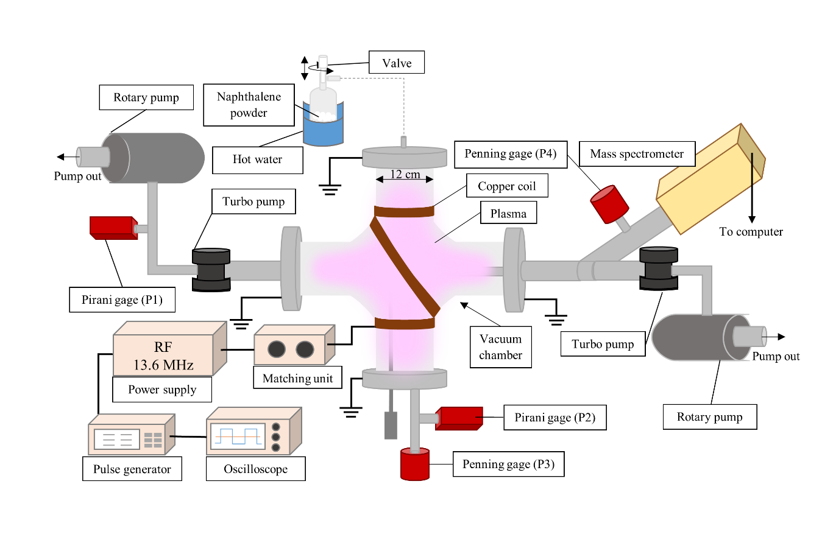
Figure 1 – Schematic diagram of the experimental setup
A glass bulb containing naphthalene powder (Sigma Aldrich, 99+%) was also connected to the chamber and placed inside a metal flask. The lid of the bulb had an internal screw that sat on the bulb’s neck and acted as a valve between the bulb and the chamber. When a high vacuum was achieved in the chamber, this valve was opened to pump out the residual air from inside the bulb and the naphthalene powered started to sublimate. Afterwards, boiling water was poured into the metal flask, submerging the bulb in a water bath to enhance vaporisation. In this way, naphthalene vapours were introduced into the chamber causing the pressure to raise up to around 0.67 Pa, which could be regulated with the bulb’s valve. Therefore, all the measurements were taken at a stable pressure of 0.67 Pa, as indicated by the Pirani gage (P2).
This arrangement allowed to generate a pure naphthalene plasma inside the chamber, which resulted suitable for studying the fragmentation patterns of this molecule under plasma conditions. To that end, a HIDEN EQP 1000 Quadrupole Mass Spectrometer was used. The EQP-1000 is capable of detecting neutral species (RGA mode) as well as both positive and negative plasma ions (SIMS mode). In RGA mode, the neutral molecular beam is internally ionized by a beam of electrons at 71 eV and the ions generated by electron impact ionization inside the mass spectrometer are accelerated towards the detector. By contrast, in SIMS mode the molecular beam is already ionized by the plasma and the plasma-generated ions must be extracted by applying voltages to the ion optics electrodes. The mass spectrometer was fitted with a small extraction orifice (50 µm diameter) in order to minimise the probability of electric field and plasma sheath penetration into the low-pressure region. Therefore, in SIMS mode, the mass spectrometer essentially measures a flux of ions through that orifice. A turbo pump in series with a rotary pump reduced the operating pressure of the mass spectrometer to around 1.3×10⁻⁴ Pa, as indicated by the Penning gage (P4). The mass spectrometer was connected to the HIDEN HAL IV PNIC interface and MASsoft Professional 6.2 was used to record the scans.
To the best of our knowledge, detecting negative ions on a continuous wave discharge is not possible as the sheath formed in front of the orifice of the mass spectrometer repels negative ions with kinetic energy lower than the plasma potential, preventing them from entering the instrument ²¹. In this work, this problem was circumvented by measuring the negative ions during the off-phase of a pulsed discharge, as indicated in the literature ^{22–25}. The RF power was then on/off modulated with a low frequency (50 Hz) square wave by means of an AIM-TTi TG2000 20 MHz DDS function generator. The off-time of the pulsed discharge represents a crucial trade-off: while it must be sufficiently long to allow the diffusion of negative ions to the mass spectrometer ²¹, we found that longer off-times are detrimental for the stability of the plasma. In this work, a 50 Hz square wave with 50% symmetry was the only combination of on/off times (10 ms each) that allowed for a detection of negative ions.
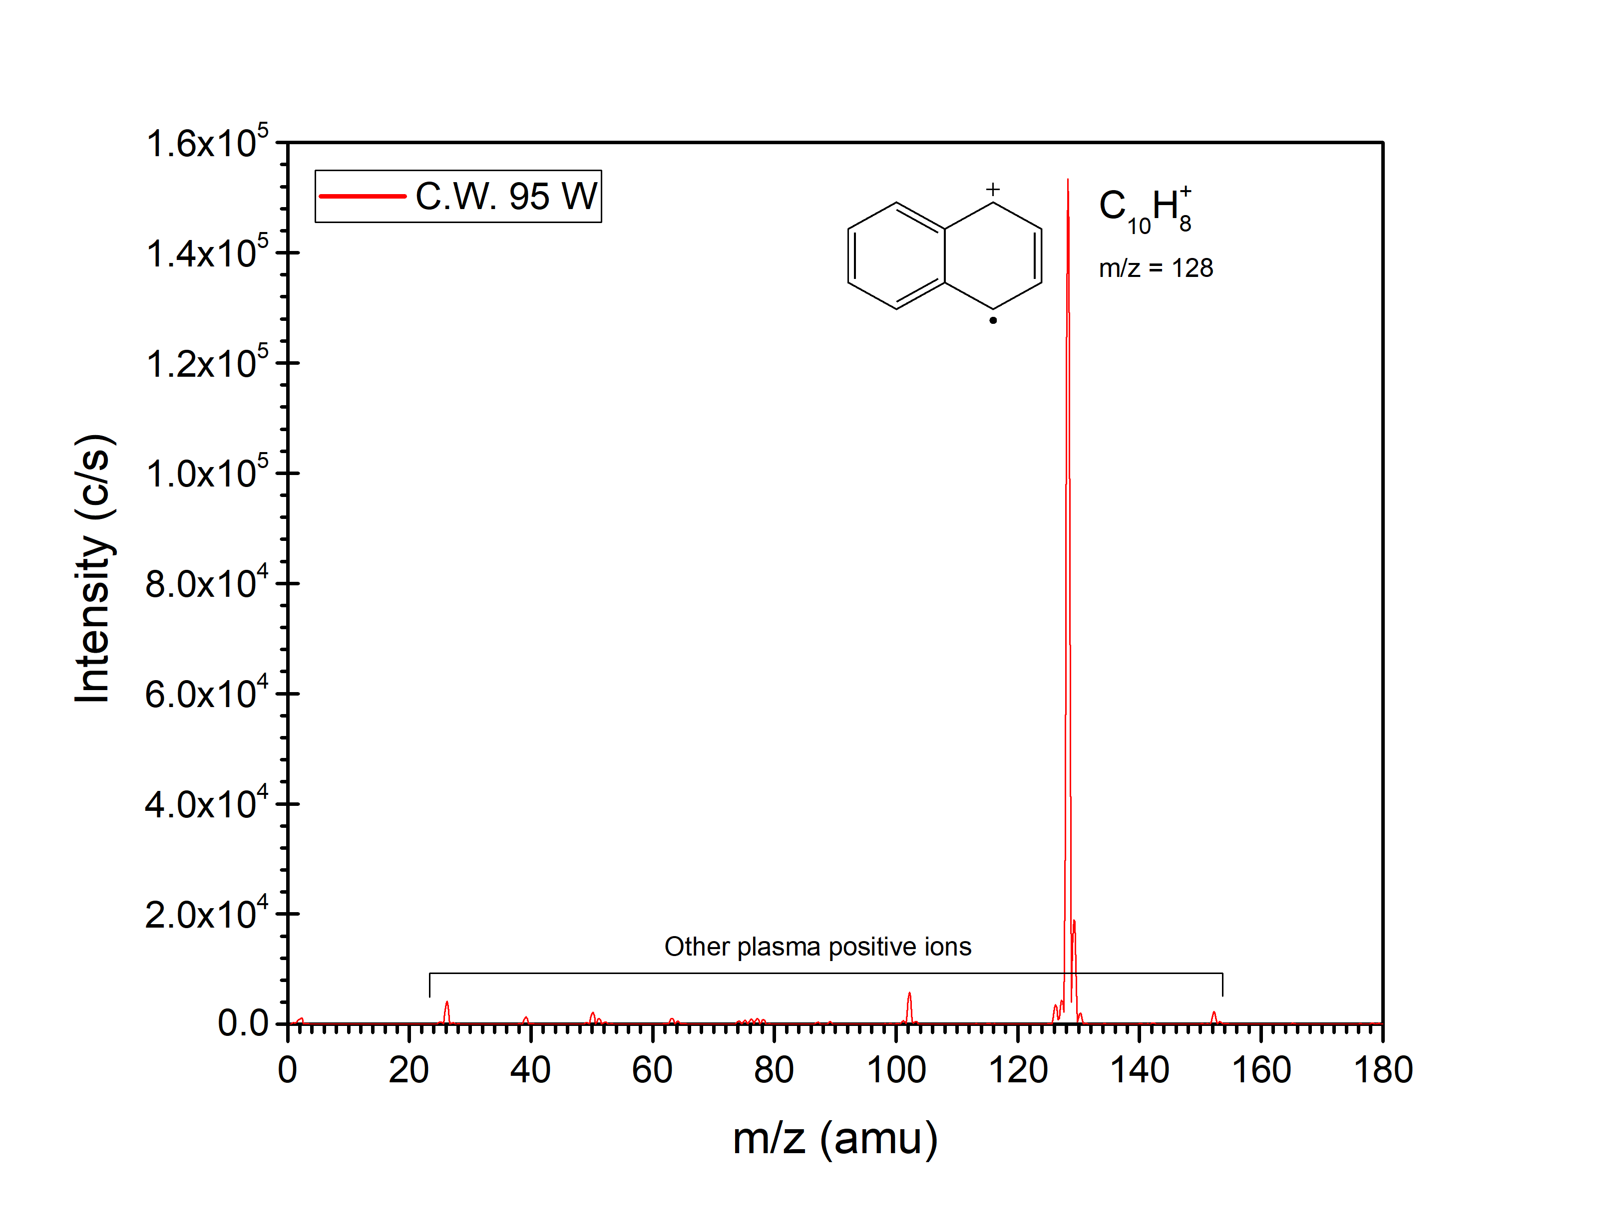
Figure 2 – Positive ions mass spectrum at 95W. The peak at m/z = 128 amu corresponds to the naphthalene radical cation (C₁₀H₈⁺) and represents the main component of the plasma, with all other plasma ions showing signals one order of magnitude lower. C.W. stands for continuous wave.

Results and Discussion
  - Positive ions
Mass spectra of positive ions in the RF capacitively coupled plasma were collected at 0.67 Pa and several discharge power values in the range 10-95 W, using the SIMS mode of the mass spectrometer. Each spectrum was averaged over 3-4 scan cycles. Figure 2 shows the spectrum recorded at 95 W, featuring a strong peak at m/z = 128 amu that corresponds to the naphthalene radical cation (C₁₀H₈⁺). The latter is the main cation in the naphthalene plasma as the signals of all the other ions detected are roughly an order of magnitude lower than that of C₁₀H₈⁺. Hence, even at the highest power applied in this work, the fragmentation of the molecule is still incipient. Nonetheless, there is a correlation between the power applied and the degree of fragmentation, which is highlighted in Figure 3. The latter presents the spectra collected at different discharge power values ranging from 10 to 95W. In Figure 3, each spectrum is normalised by the peak at m/z = 128 amu (C₁₀H₈⁺), which allows for a direct comparison of the degree of fragmentation between different spectra. The reader is referred to the Supporting Information for the non-normalised spectra at each discharge power (see Figures S1-S4).
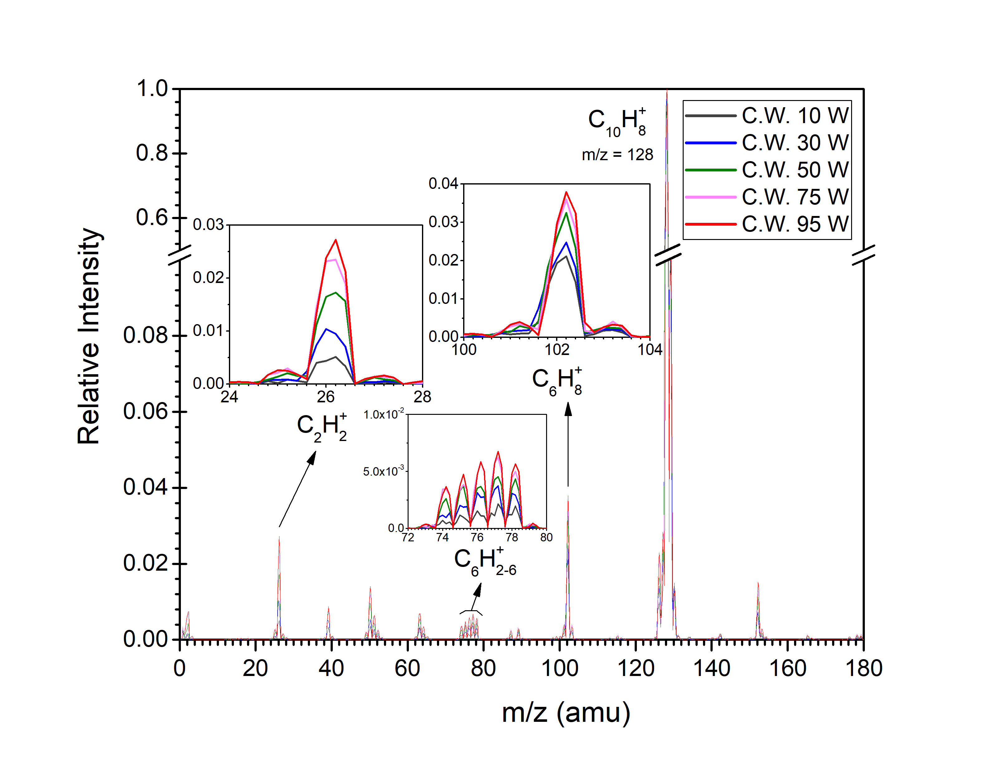
Figure 3 – Spectra at different discharge power values in the range from 10 to 95 W. Spectra are normalised by the peak at m/z = 128 amu, corresponding to the naphthalene radical cation (C₁₀H₈⁺), which allows for a direct comparison of the degree of fragmentation between different spectra. Although the degree fragmentation of the naphthalene molecule is limited, there is a clear correlation between the applied power and the fragmentation, as shown in the individual peak graphs.
The fragmentation patterns of naphthalene under plasma conditions are analysed based on the spectrum recorded at 95W, given that the qualitative results are analogous for every discharge power. To this end, a logarithmic plot of the scan at 95 W is presented in Figure 4 while those corresponding to the remaining conditions are included in the Supporting Information (see Figures S5-S8). Various peaks in Figure 4 are broaden both to the left and to the right by one or two units, thus indicating addition or loss of hydrogen atoms. For instance, the peak at m/z = 128 amu appears to be broaden by peaks at m/z = 127 amu and m/z = 126 amu, which indicate the loss of one or two hydrogen atoms resulting in C₁₀H₇⁺ and C₁₀H₆⁺, respectively. This result is in agreement with the reported photodissociation channels ^{10–15} and also with a theoretical study on the chemistry of the naphthalene radical cation which indeed predicts loss of both atomic and molecular hydrogen ²⁶. In addition, the peaks at m/z = 129 amu and m/z = 130 amu can be ascribed to super-hydrogenated forms of the naphthalene cation (C₁₀H₉⁺ and C₁₀H₁₀⁺, respectively). Even though a minor contribution of isotopic ¹³C to m/z = 129 amu is expected, it could not be high enough to explain the strength of this signal (~2×10⁴ c/s).
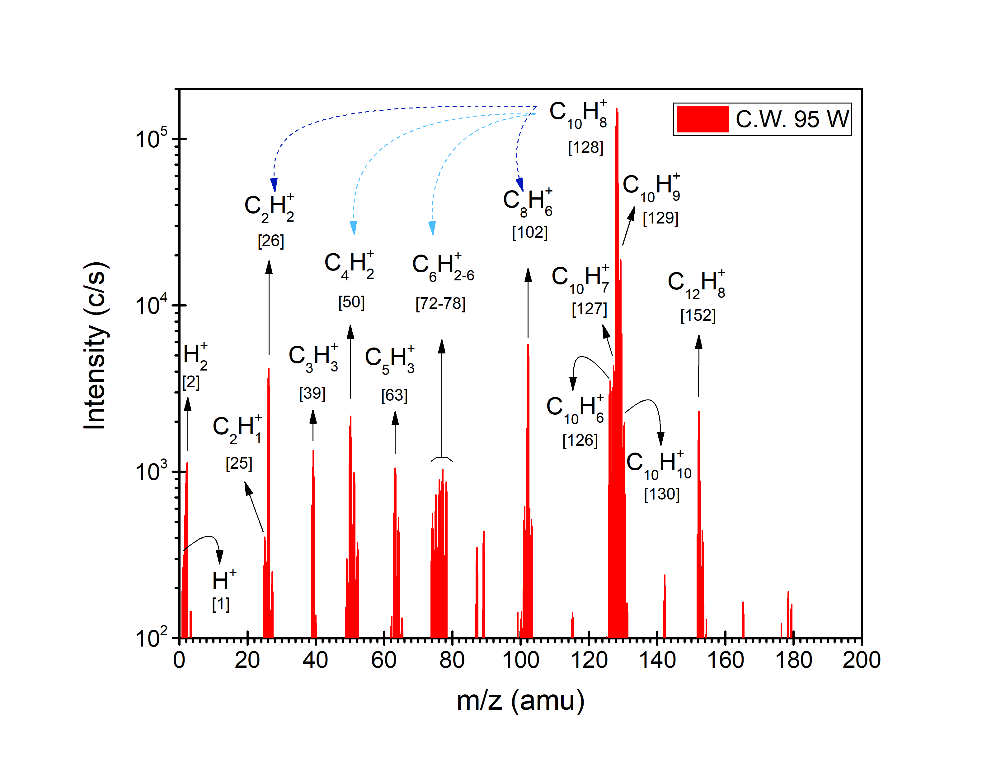
Figure 4 –Positive ions mass spectrum at 95W in logarithmic scale. The dashed arrows represent the postulated fragmentation patterns giving rise to each signal. The number in squared brackets indicate the m/z ratio of a given peak.
The main naphthalene fragments are represented by the peaks at m/z = 26 amu and m/z = 102 amu, assigned to species with the formulae C₂H₂⁺ and C₈H₆⁺, respectively. This suggests that the major dissociation channel of the naphthalene radical cation involves the loss of an acetylene molecule (C₂H₂), giving rise to cation detected at m/z = 102 amu (see dark blue dashed arrows in Figure 4). The neutral acetylene molecule could be further ionised in the plasma by electron impact or charge exchange interactions and thus, appear in the spectrum at m/z = 26 amu. The fragmentation proposed is in agreement with the photodissociation related literature ^{10–15}. Moreover, this process has been theoretically described as involving several isomerisation routes of the naphthalene radical cation which lead to different isomers of the resulting C₈H₆⁺cation ²⁶. According to this theoretical study, the isomers pentalene and phenylacetylene are more likely to form than benzocyclobutadiene ²⁶. However, there is experimental evidence for the formation of the latter isomeric form of C₈H₆⁺ upon dissociation of the naphthalene radical cation ¹⁵. Besides, from an astrophysical perspective, it has also been reported that PAHs in a hot post-shock gas are destroyed by electron collisions via C₂H_{n} loss ⁶.
Among the remaining fragments in Figure 4, the most abundant ones appear to be those corresponding to the signals at m/z = 50 amu and m/z = 72-78 amu. The latter group of peaks can be ascribed to a benzene cation and several dehydrogenated forms of it, given than well defined peaks can be identified for every mass in the range m/z = 72-78 amu. In fact, the highest contribution is found at m/z = 77 amu although the difference in the signal for adjacent peaks is rather small (unlike other cases where there is one clear major contributor to the peak). The naphthalene radical cation could split and form a benzene cation (C₆H₆⁺, m/z = 78 amu), which could then be dehydrogenated in the plasma to give rise to the group of peaks m/z = 72-78 amu. In this case, the remaining fragment of the naphthalene radical cation would have the molecular formula C₄H₂, thus explaining the signal at m/z = 50 amu (C₄H₂⁺, see light blue dashed arrows in Figure 4). This mechanism finds theoretical support as the naphthalene radical cation has been reported to split into a benzene radical cation (C₆H₆⁺) and a butadiyne molecule (C₄H₂)^{15,26}. In our experiment, the latter should be further ionised in the plasma in order to contribute to the positive ions spectrum and explain the peak at m/z = 50 amu.
Additional mechanisms could also be considered for the formation of ions leading to the peaks at m/z = 72-78 amu in order to explain why the signal at 77 amu is higher than the rest. A phenyl cation (C₆H₅⁺) could be formed from the de-hydrogenated naphthalene cation (C₁₀H₇⁺) upon loss of a butadiyne molecule, as reported in the literature ¹⁵. In addition, among the isomers of the cation at m/z = 102 amu (C₈H₆⁺), the phenylacetylene molecule offers a relatively straightforward route to benzene-like structures. Upon loss of the ethynyl radical (C₂H₁), the remaining fragment would be a phenyl cation (C₆H₅⁺), contributing to the signal at m/z = 77 amu. Then, if the ethynyl radical was further ionised in the plasma, it would account for the signal at m/z = 25 amu (C₂H₁⁺). However, no theoretical support could be found for this route.
The last Naphthalene fragments to analyse are those accounting for the peaks at m/z = 39 amu and m/z = 63 amu. These signals could be ascribed to species with molecular formulae C₃H₃⁺ and C₅H₃⁺, respectively. On a recent study, C₅H₃⁺ has been reported to form together with C₃H₃ and C₂H₂ upon electron impact dissociation of naphthalene at 1 keV ¹⁸. Despite the much lower electron energy in the present work, this mechanism could explain the presence of C₃H₃⁺ and C₅H₃⁺ in our system. In addition, one of the isomeric forms of the cation at m/z = 102 amu (C₈H₆⁺), i.e. pentalene, seems to offer a straightforward route to forming C₃H₃⁺ and C₅H₃⁺ by splitting its two rings. However, no theoretical or experimental works could be found in the literature to support this suggested mechanism.
Finally, the scan of positive ions (Figure 4) shows a signal at m/z = 152 amu, which is clearly not a naphthalene fragment as its mass is higher than 128 amu. This signal corresponds to a cation with molecular formula C₁₂H₈⁺, which could be acenaphthalene or ethynylnaphthalene. However, there is no theoretical evidence to support a statement on relative stability of these two isomeric cations. Nonetheless, given the mass difference between this peak and that of naphthalene (24 amu), and considering the presence of C₂H₂⁺ in the system, we postulate that the hydrogen abstraction – acetylene addition (HACA) mechanism is implied in the formation of C₁₂H₈⁺. The HACA mechanism has been widely employed to rationalise the growth of PAHs in the ISM and circumstellar outflows of carbon stars ^{1,27–33}. Recently, some experimental evidences of this mechanism under combustion-like conditions or thermal activation have been reported ^{29,30,34,35}. To the best of our knowledge, the present study shows the first experimental evidence of a PAH molecule undergoing a HACA reaction under plasma conditions. It is also interesting to note that no acetylene was added to the system, unlike other experimental studies ^{29,30,34}. Rather, acetylene was formed as a fragment of naphthalene and then reacted with other naphthalene molecules leading to C₁₂H₈⁺. Adding acetylene to the system may help this mechanism to take place at a larger scale or subsequent times. In this regard, the almost negligible but still present signal at m/z = 178 amu could point us in the right direction indicating that anthracene or phenanthrene could be formed in this experimental setup if acetylene was added to the system.
  - Negative ions
Figure 5 shows a mass spectrum of the negative ions present in a naphthalene plasma, which main feature is the detection of polyynyl anions. The main peaks of this scan are located at m/z = 49 amu and m/z = 73 amu, corresponding to butadiynyl (C₄H⁻) and hexatriynyl (C₆H⁻) anions, respectively. In fact, a small signal corresponding to the next ion on this series (C₈H⁻, octatetraynyl anion) can be seen at m/z = 93 amu. The presence of these carbon chain anions in the interstellar medium was first theorised ³⁶ and then confirmed by radio-astronomy detection techniques in 2006 ³⁷. This milestone triggered a systematic study of the negative ions in space, before which the existing body of knowledge on their astrophysical role was limited to H⁻ ³⁸. Since then, polyynyl anions have been detected in many sources like dark clouds and prestellar cores ^{39–42}.
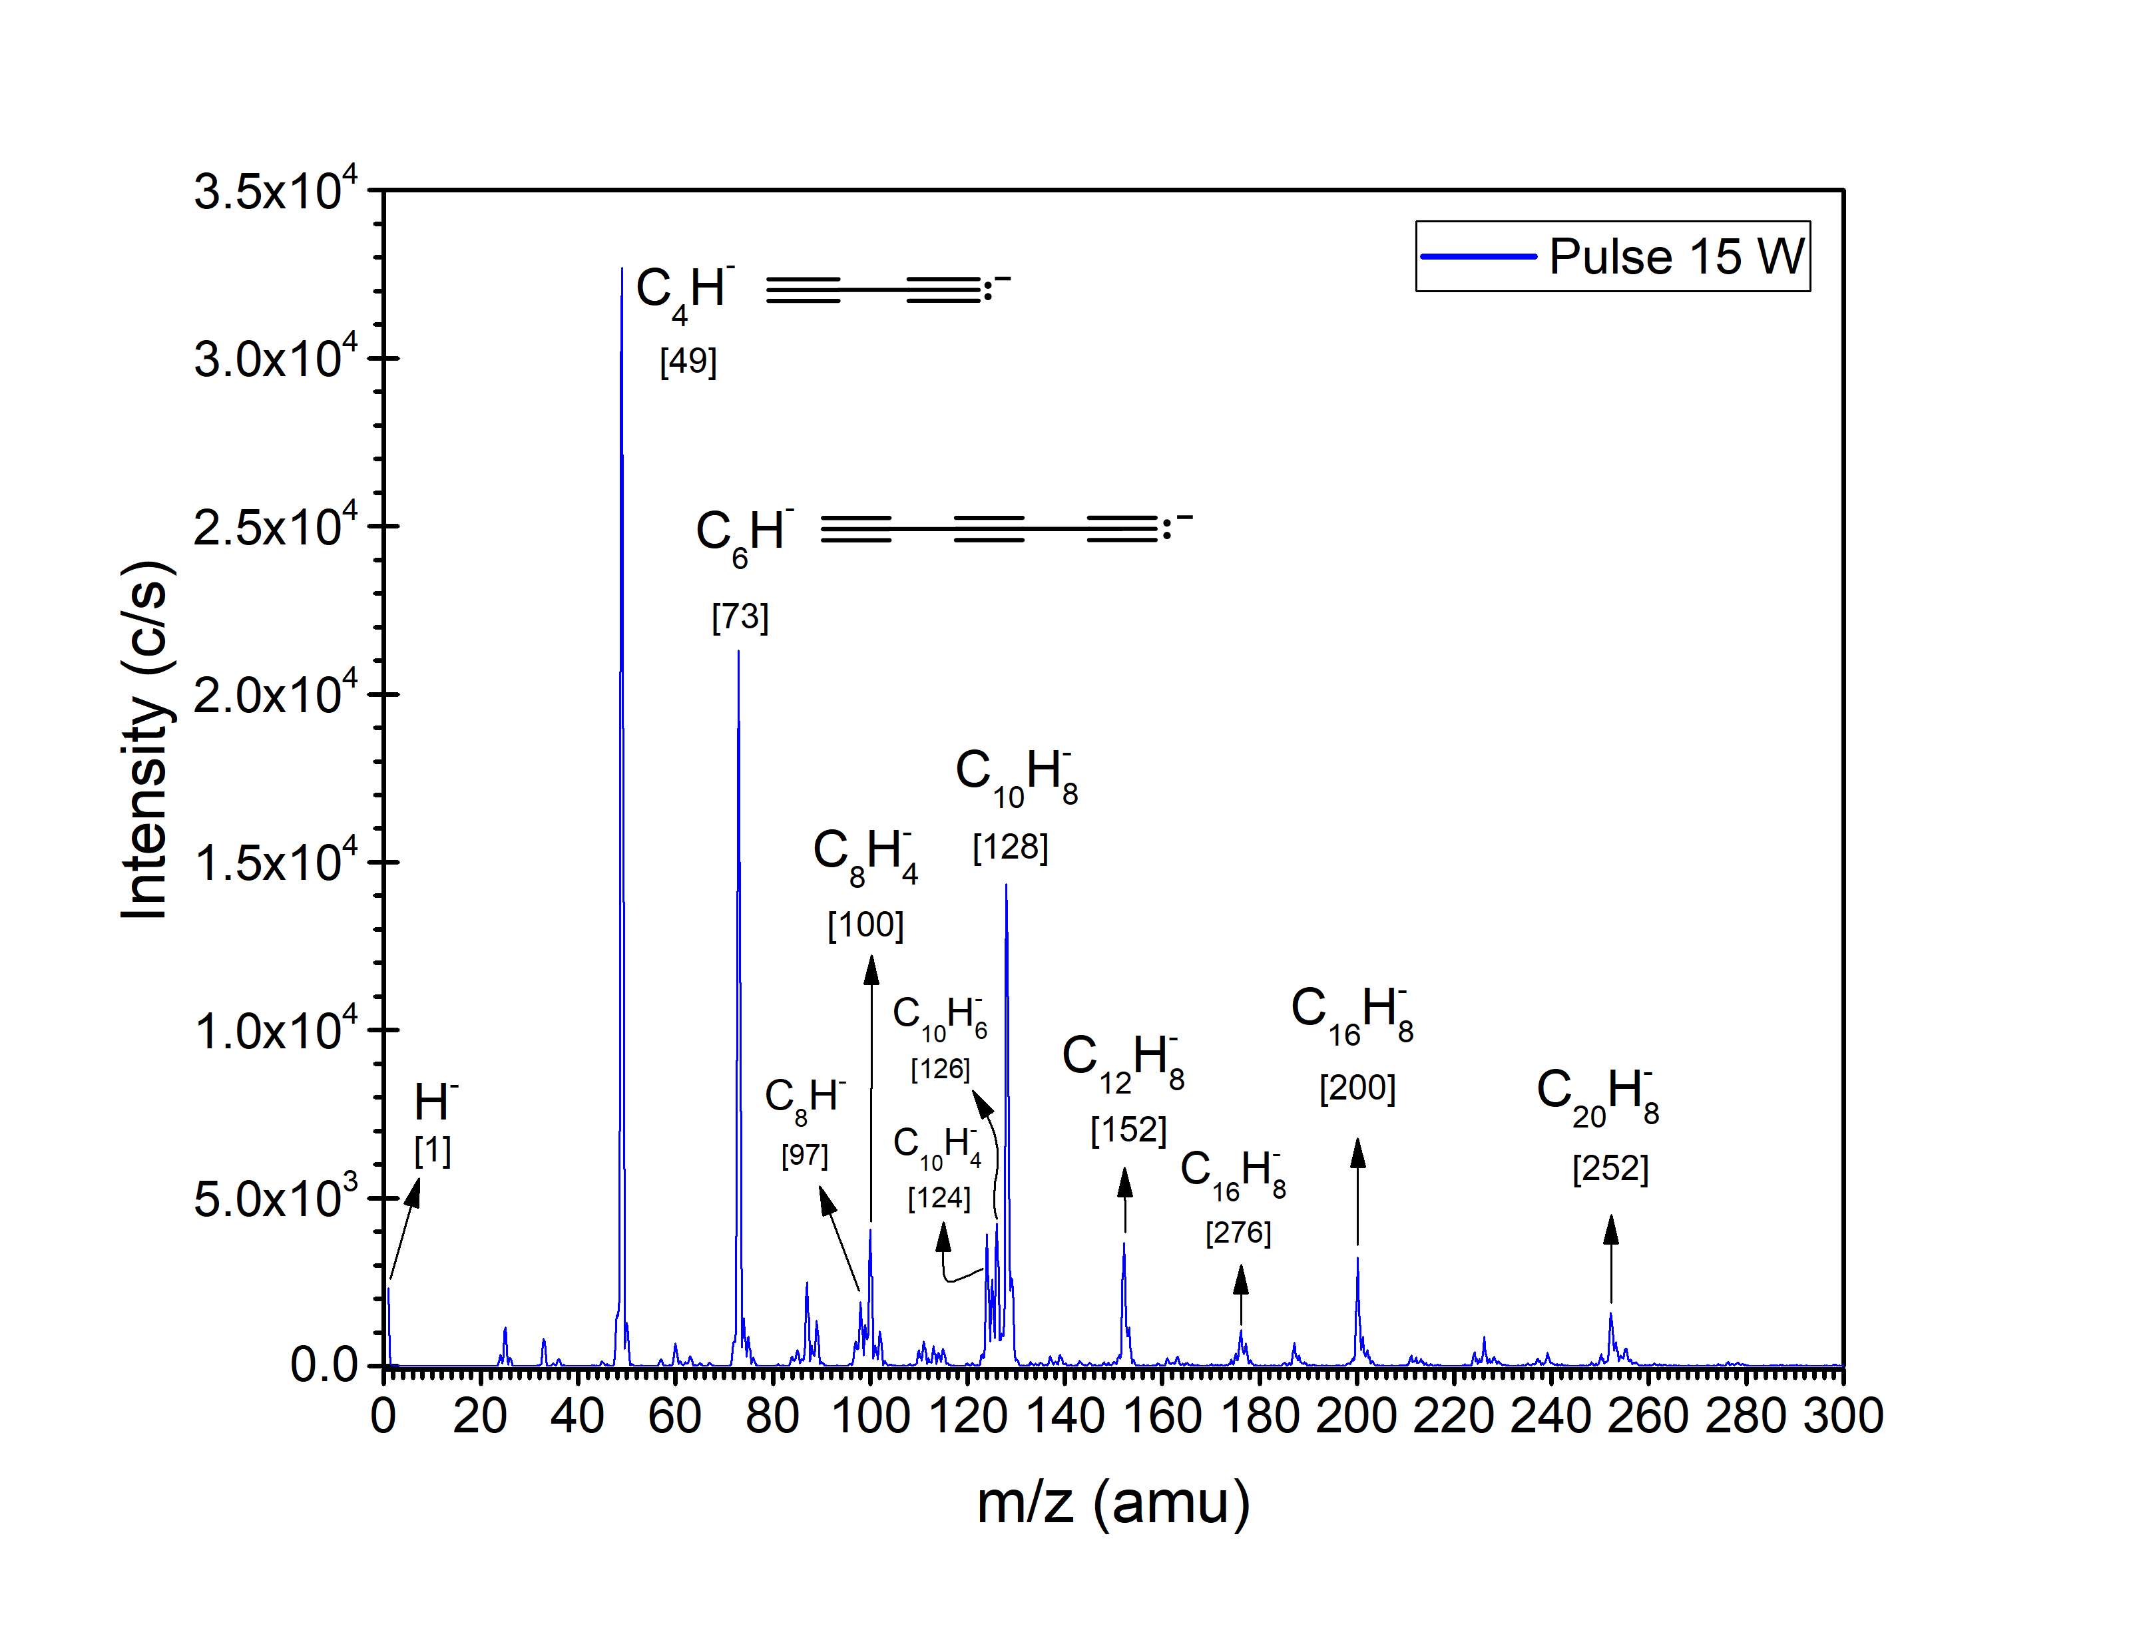
Figure 5 - Negative ion spectrum recorded on a 15 W pulsed discharge with a 50 Hz - 50% symmetry square wave. The number in squared brackets indicate the m/z ratio of the peak.
The formation of polyynyl anions is thought to proceed via electron attachment to the corresponding polyyne ³⁸. These poly-acetylenic precursors are thought to be formed through a “bottom-up” chemistry based on acetylene polymerisation ³⁸ or addition reactions ⁴³. However, as an outlook to the future, it has been postulated that polyynyl anions might also be produced in a “top-down” chemistry upon destruction of PAHs ³⁸. In this work, we present experimental evidence that polyynyl anions can be formed as fragments of naphthalene. We postulate this mechanism based on the low concentration of acetylene in the system and the low pressure of the experiment. The occurrence of collisions between acetylene and naphthalene molecules can be understood only on the grounds of the great abundance of neutral naphthalene in the system (see the discussion on the HACA mechanism in Section 3.1). Nevertheless, we believe that collisions between 2 or even 3 acetylene molecules to yield polyynes are extremely unlikely in this system (see discussion on collision frequencies in the Supporting Information). There must be a mechanism other than acetylene polymerisation that accounts for the formation of the polyynes, precursors of the polyynyl anions C₄H⁻ and C₆H⁻. Hence, we postulate that mechanism to be naphthalene fragmentation. It is worth noting that the formation of butadiyne as a naphthalene fragment was found in this experiment (see peak at m/z = 50 amu in Figure 4) and it was reported elsewhere as one of the various possible fragmentation routes of the naphthalene radical cation ^{15,26}. Based on this, we believe that the polyyne which precedes the ionisation to C₄H⁻ is formed in a top down chemistry, as a fragment of naphthalene. Besides, the signal at m/z = 74 amu in the so-called set of benzene-like peaks (identified as fragments of naphthalene in Figure 4) could account for the poly-acetylenic precursor needed to form C₆H⁻ by electron attachment.
Apart from the polyynyl anions, the scan in Figure 5 shows some other minor contributions from different species, e.g. the signal at m/z = 128 amu, which can be assigned to a naphthalene anion (C₁₀H₈⁻). This peak appears broaden to lower but only even m/z ratios, indicating that this anion could lose molecular (rather than atomic) hydrogen. It is plausible to consider electron attachment as a channel to explain the formation of this anion in terms of electron impact reactions with naphthalene.
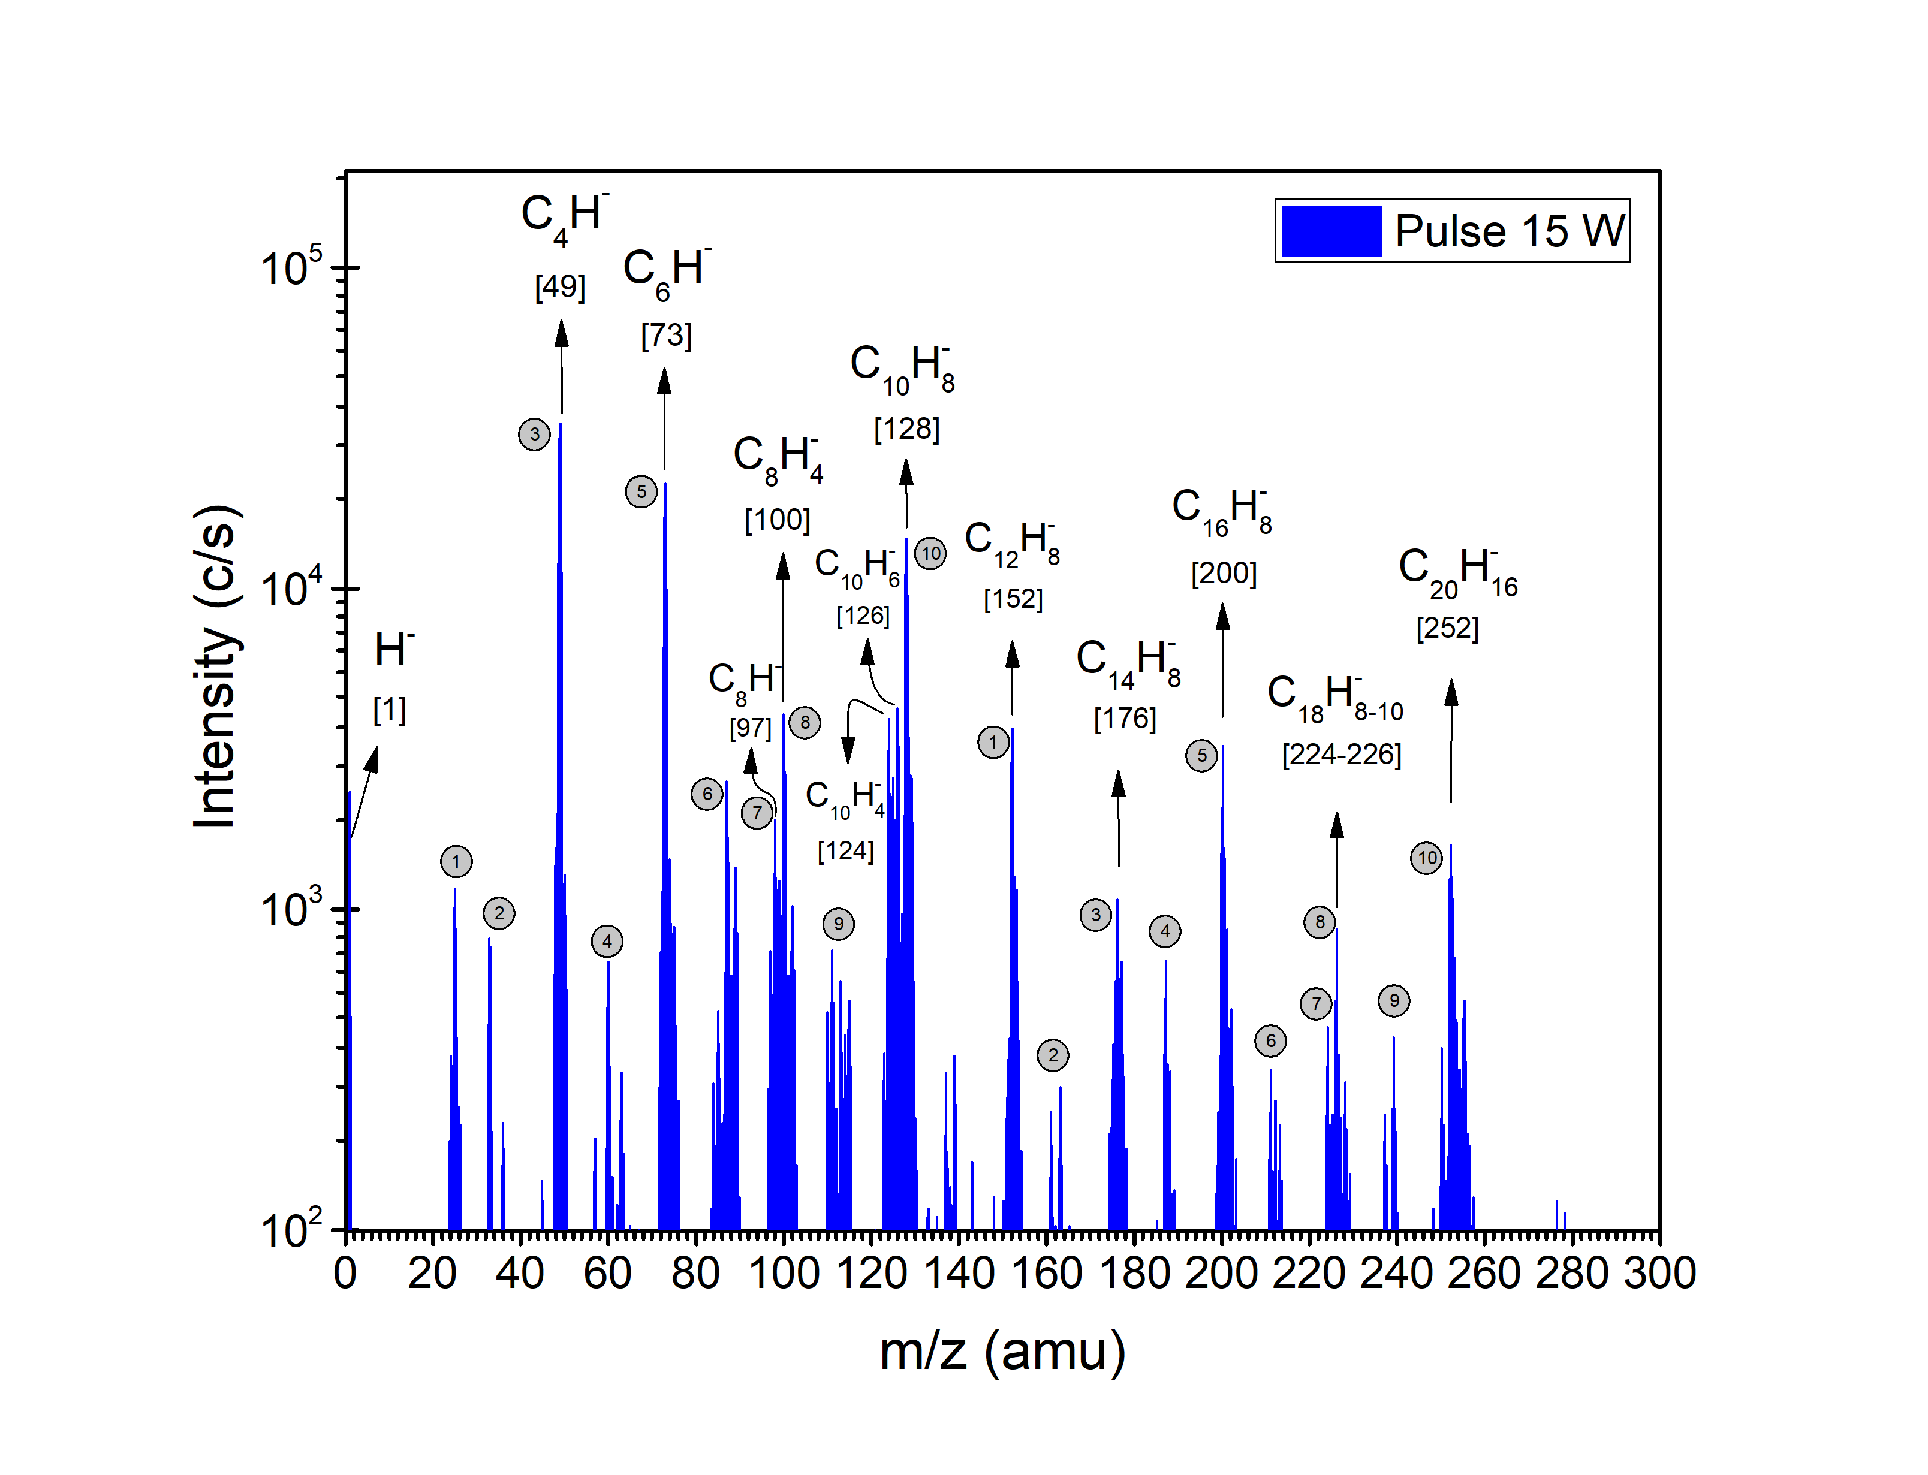
Figure 6 – Negative ion spectrum in logarithmic scale. The number in squared brackets indicate the m/z ratio of the peak. Each peak below m/z = 128 amu has a corresponding signal at an m/z ratio 126-128 units higher, which can be followed by the grey circles. This indicates that negative ions are added to naphthalene molecules (eliminating hydrogen atoms in most cases), which implies the ability of larger molecules to stabilise negative charges.
Finally, there are some other peaks for which attempting an isomeric identification is challenging at this stage. However, a single mechanism could be postulated in order to explain their formation. Figure 6 presents the negative ion spectrum in logarithmic scale, allowing for a detailed analysis of smaller peaks and providing some visual aids for the mechanism proposed. First, we highlight that numerous signals exhibit an m/z ratio higher than that of naphthalene, which was not the case for the positive ion spectra (see Figure 4). Most importantly, there is almost a perfect match between the m/z ratios of the peaks above and below m/z = 128 amu if the latter signals are increased by 126-128 amu. This implies the addition of all the negative ions found below m/z = 128 amu to neutral naphthalene molecules in the plasma, resulting in a larger anion (after losing one or two hydrogen atoms in most cases). Concisely, the peaks at m/z ratios 25, 49, 60, 73 and 97 amu find their correlatives at m/z ratios 152, 176, 187, 190, 200 and 224 amu, respectively (see grey circles in Figure 6). All these ions differ in mass by 127 amu, and thus they would add to a naphthalene molecule by losing one hydrogen atom. The ions at 33 and 35 amu, which can be correlated with those at 161 and 163 amu, would not lose any hydrogen in their addition. The trend is similar for the ions at m/z ratios 100, 111 and 113 amu, correlated with those at m/z ratios 226, 237 and 239 amu (see grey circles in Figure 6). In these cases, two hydrogen atoms should be subtracted as the difference of masses is of 126 amu, which could indicate binding with two different carbon atoms. Lastly, it seems logic to correlate the naphthalene anion peak (m/z = 128 amu) with the last signal of the spectrum, at m/z = 252 amu (see grey circles in Figure 6). The relation between this peaks could be rationalised by considering the addition of this anion to a neutral naphthalene molecule upon the elimination of 4 hydrogen atoms. A benzo[a]pyrene anion (C₂₀H₁₂⁻) would result from this interaction, with an m/z ratio of 252 amu. The same occurs for the peaks at m/z ratios of 87 and 98 amu, correlated with those at 211 and 213, however a structure could not be identified in this case. Overall, the detection of several ions heavier than naphthalene and their relation to the lighter ions could find their cause in the aiding nature of pulsed plasmas for polymerisation ⁴⁴. Otherwise, these findings would suggest that the growth of PAHs could also proceed through negative ions. Moreover, it would be in agreement with the role of large PAHs as the main carriers of negative charge in the ISM ⁴⁵.

Conclusions
In the context of plasma processing of PAHs, quadrupole mass spectrometry has been used to study the fragmentation patterns of naphthalene under non-thermal plasma conditions. Both positive and negative ions have been detected and identified. The formation mechanisms of such ions have been addressed in terms of naphthalene electron impact ionisation and dissociation reactions.
Positive ion spectra were recorded at different discharge power values in the range from 10 to 95 W. Our results show that the main positive ion is the naphthalene radical cation (C₁₀H₈⁺, m/z = 128 amu), with a signal over an order of magnitude higher than those of every other ions (naphthalene fragments). The spectra produced in this work also confirm that the main naphthalene dissociation channels under plasma conditions proceed through hydrogen- loss or acetylene-loss. These processes lead to several species identified in the positive ion scans, i.e., C₁₀H₇⁺, C₁₀H₆⁺, C₈H₆⁺, C₆H₂₋₆⁺, C₄H₂⁺, C₂H₂⁺ and H⁺, among others. Besides fragments, we detected signals at m/z ratios consistent with acenaphthalene (C₁₂H₈⁺), which represent experimental evidence of the hydrogen abstraction-acetylene addition mechanism taking place under plasma conditions. Moreover, these experiments contribute to our understanding of the growth of PAHs in terms of the HACA mechanism.
Regarding negative ions, our system allowed for the detection of species belonging to the astrochemically relevant series of polyynyl anions, namely C₄H⁻, C₆H⁻ and C₈H⁻. Most importantly, these ions (or their poly-acetylenic precursors) would be formed in a ‘top-down’ chemistry as fragments of a PAH, rather than a ‘bottom-up’ sequence through acetylene polymerisation, as previously thought. Finally, our results indicate that the anions in this plasma interact with neutral naphthalene molecules to form larger negative ions, binding to one or more carbon atoms and eliminating hydrogen atoms accordingly. For instance, we found peaks at an m/z ratio consistent with benzo[a]pyrene, which would imply the addition of a naphthalene anion to a neutral naphthalene molecule while losing four hydrogen atoms. These results suggest that negative ions could play a role in the growth of PAHs as well.

Acknowledgement
We acknowledge the European Union (EU) and Horizon 2020 funding awarded under the Marie Skłodowska-Curie action to the EUROPAH consortium (grant number 722346).

References
(1) Tielens, A. The Molecular Universe. Astrochem. Astrobiol. 2013, 85 (SEPTEMBER), 35–72. https://doi.org/10.1007/978-3-642-31730-9_2.
(2) Tielens, A. Interstellar Polycyclic Aromatic Hydrocarbon Molecules. Annu. Rev. Astron. Astrophys. 2008, 46 (1), 289–337. https://doi.org/10.1146/annurev.astro.46.060407.145211.
(3) Peeters, E.; Hony, S.; Van Kerckhoven, C.; Tielens, A. G. G. M.; Allamandola, L. J.; Hudgins, D. M.; Bauschlicher, C. W. The Rich 6 to 9 Um Spectrum of Interstellar PAHs. Astron. Astrophys. 2002, 390 (3), 1089–1113. https://doi.org/10.1051/0004-6361:20020773.
(4) Sloan, G. C.; Jura, M.; Duley, W. W.; Kraemer, K. E.; Bernard-Salas, J.; Forrest, W. J.; Sargent, B.; Li, A.; Barry, D. J.; Bohac, C. J.; et al. The Unusual Hydrocarbon Emission from the Early Carbon Star HD 100764: The Connection between Aromatics and Aliphatics. Astrophys. J. 2007, 664, 1144–1153. https://doi.org/10.1086/519236.
(5) Allamandola, L. J.; Tielens, A. G. G. M.; Barker, J. R. Interstellar Polycyclic Aromatic Hydrocarbons: The Infrared Emission Bands , the Excitation/Emission Mechanism, and the Astrophysical Implications. Astrophys. J. 1989, 71, 733–775.
(6) Micelotta, E. R.; Jones, A. P.; Tielens, A. G. G. M. Polycyclic Aromatic Hydrocarbon Processing in a Hot Gas. 2010, 37. https://doi.org/10.1051/0004-6361/201015741.
(7) Abdel-Shafy, H. I.; Mansour, M. S. M. A Review on Polycyclic Aromatic Hydrocarbons: Source, Environmental Impact, Effect on Human Health and Remediation. Egypt. J. Pet. 2016, 25 (1), 107–123. https://doi.org/10.1016/j.ejpe.2015.03.011.
(8) Fazekas, P.; Bódis, E.; Keszler, A. M.; Czégény, Z.; Klébert, S.; Károly, Z.; Szépvölgyi, J. Decomposition of Chlorobenzene by Thermal Plasma Processing. Plasma Chem. Plasma Process. 2013, 33 (4), 765–778. https://doi.org/10.1007/s11090-013-9459-3.
(9) Gao, J.; Ma, C.; Xing, S.; Sun, L.; Liu, J. Polycyclic Aromatic Hydrocarbon Emissions of Non-Road Diesel Engine Treated with Non-Thermal Plasma Technology. Korean J. Chem. Eng. 2016, 33 (12), 3425–3433. https://doi.org/10.1007/s11814-016-0222-3.
(10) Jochims, H. W.; Rasekh, H.; Rühl, E.; Baumgärtel, H.; Leach, S. The Photofragmentation of Naphthalene and Azulene Monocations in the Energy Range 7-22 EV. Chem. Phys. 1992, 168 (1), 159–184. https://doi.org/10.1016/0301-0104(92)80118-F.
(11) Ho, Y. P.; Dunbar, R. C.; Lifshitz, C. C—H Bond Strength of Naphthalene Ion. A Reevaluation Using New Time-Resolved Photodissociation Results. J. Am. Chem. Soc. 1995, 117 (24), 6504–6508. https://doi.org/10.1021/ja00129a013.
(12) Gotkis, Y.; Oleinikova, M.; Naor, M.; Lifshitz, C. Time-Dependent Mass Spectra and Breakdown Graphs. 17. Naphthalene and Phenanthrene. J. Phys. Chem. 1993, 97 (47), 12282–12290. https://doi.org/10.1021/j100149a031.
(13) Ruhl, E.; Price, S. D.; Leach, S. Single and Double Photoionization Processes in Naphthalene between 8 and 35 EV. J . Phys. Chem 1989, 93, 6312–6321. https://doi.org/10.1021/j100354a011.
(14) Jochims, H. W.; Ruhl, E.; Baumgartel, H.; Tobita, S.; Leach, S. Size Effects on Dissociation Rates of Polycyclic Aromatic Hydrocarbon Cations: Laboratory Studies and Astrophysical Implications. Astrophys. J. 1994, 420, 307–317.
(15) West, B.; Joblin, C.; Blanchet, V.; Bodi, A.; Sztáray, B.; Mayer, P. M. On the Dissociation of the Naphthalene Radical Cation: New IPEPICO and Tandem Mass Spectrometry Results. J. Phys. Chem. A 2012, 116 (45), 10999–11007. https://doi.org/10.1021/jp3091705.
(16) Wacks, M. E.; Dibeler, V. H. Electron Impact Studies of Aromatic Hydrocarbons. I. Benzene, Naphthalene, Anthracene, and Phenanthrene. J. Chem. Phys. 1959, 31, 1557. https://doi.org/10.1063/1.1730652.
(17) McConkey, J. W.; Trajmar, S. Excitation of Naphthalene by Electron Impact. J. Phys. B At. Mol. Opt. Phys. 1992, 25.
(18) Najeeb, P. K.; Kadhane, U. Relative Stability of Naphthalene, Quinoline and Isoquinoline under High Energy Electron Impact. Int. J. Mass Spectrom. 2017, 414, 23–30. https://doi.org/10.1016/j.ijms.2016.12.011.
(19) Rajabi, M.; Ghassami, A. R.; Abbasi Firouzjah, M.; Hosseini, S. I.; Shokri, B. Electroluminescence and Photoluminescence of Conjugated Polymer Films Prepared by Plasma Enhanced Chemical Vapor Deposition of Naphthalene. Plasma Chem. Plasma Process. 2013, 33 (4), 817–826. https://doi.org/10.1007/s11090-013-9449-5.
(20) Gillon, X.; Houssiau, L. Plasma Polymerization Chemistry of Unsaturated Hydrocarbons: Neutral Species Identification by Mass Spectrometry. Plasma Sources Sci. Technol. 2014, 23 (4). https://doi.org/10.1088/0963-0252/23/4/045010.
(21) Benedikt, J.; Hecimovic, A.; Ellerweg, D.; Von Keudell, A. Quadrupole Mass Spectrometry of Reactive Plasmas. J. Phys. D. Appl. Phys. 2012, 45 (40). https://doi.org/10.1088/0022-3727/45/40/403001.
(22) Deschenaux, C.; Affolter, A.; Magni, D.; Hollenstein, C.; Fayet, P. Investigations of CH4 , C2H2 and C2H4 Dusty RF Plasmas by Means of FTIR Absorption Spectroscopy and Mass Spectrometry; 1999; Vol. 32.
(23) Howling, A. A.; Sansonnens, L.; Dorier, J.-L.; Hollenstein, C. Dusty Plasma Formation: Physics and Critical Phenomena. Theor. approach J. Appl. Phys. 1994, 75, 173106. https://doi.org/10.1063/1.356413.
(24) Howling, A. A.; Sansonnens, L.; Dorier, J. L.; Hollenstein, C. Time-Resolved Measurements of Highly Polymerized Negative Ions in Radio Frequency Silane Plasma Deposition Experiments. J. Appl. Phys. 1994, 75 (3), 1340–1353. https://doi.org/10.1063/1.356413.
(25) Howling, A. A.; Sansonnens, L.; Dorier, J. L.; Höllenstein, C. Negative Hydrogenated Silicon Ion Clusters As Particle Precursors In Of Silane Plasma Deposition Experiments. J. Phys. D. Appl. Phys. 1993, 26 (6), 1003–1006. https://doi.org/10.1088/0022-3727/26/6/019.
(26) Solano, E. A.; Mayer, P. M. A Complete Map of the Ion Chemistry of the Naphthalene Radical Cation? DFT and RRKM Modeling of a Complex Potential Energy Surface. J. Chem. Phys. 2015, 143 (10). https://doi.org/10.1063/1.4930000.
(27) Cherchneff, I. The Formation of Polycyclic Aromatic Hydrocarbons in Evolved Curcumstellar Environments. EAS Publ. Ser. 2011, 46, 177–189. https://doi.org/10.1051/eas/1146019.
(28) Contreras, C. S.; Salama, F. Laboratory Investigations of Polycyclic Aromatic Hydrocarbon Formation and Destruction in the Circumstellar Outflows of Carbon Stars. Astrophys. Journal, Suppl. Ser. 2013, 208 (1). https://doi.org/10.1088/0067-0049/208/1/6.
(29) Yang, T.; Troy, T. P.; Xu, B.; Kostko, O.; Ahmed, M.; Mebel, A. M.; Kaiser, R. I. Hydrogen-Abstraction/Acetylene-Addition Exposed. Angew. Chemie - Int. Ed. 2016, 55 (48), 14983–14987. https://doi.org/10.1002/anie.201607509.
(30) Yang, T.; Kaiser, R. I.; Troy, T. P.; Xu, B.; Kostko, O.; Ahmed, M.; Mebel, A. M.; Zagidullin, M. V.; Azyazov, V. N. HACA’s Heritage: A Free-Radical Pathway to Phenanthrene in Circumstellar Envelopes of Asymptotic Giant Branch Stars. Angew. Chemie - Int. Ed. 2017, 56 (16), 4515–4519. https://doi.org/10.1002/anie.201701259.
(31) Kislov, V. V; Islamova, N. I.; Kolker, A. M.; Lin, S. H.; Mebel, A. M. Hydrogen Abstraction Acetylene Addition and Diels-Alder Mechanisms of PAH Formation: A Detailed Study Using First Principles Calculations. 2005. https://doi.org/10.1021/ct0500491.
(32) Ghesquière, P.; Talbi, D.; Karton, A. The Reaction of the Benzene Cation with Acetylenes for the Growth of PAHs in the Interstellar Medium. Chem. Phys. Lett. 2014, 595–596, 13–19. https://doi.org/10.1016/j.cplett.2014.01.040.
(33) Richter, H.; Howard, J. B. Formation of Polycyclic Aromatic Hydrocarbons and Their Growth to Soot-a Review of Chemical Reaction Pathways. Prog. energy Combust. Sci. 2000, 26, 565–608.
(34) Parker, D. S. N.; Kaiser, R. I.; Troy, T. P.; Ahmed, M. Hydrogen Abstraction/Acetylene Addition Revealed. Angew. Chemie - Int. Ed. 2014. https://doi.org/10.1002/anie.201404537.
(35) Sánchez, N. E.; Millera, Á.; Bilbao, R.; Alzueta, M. U. Polycyclic Aromatic Hydrocarbons (PAH), Soot and Light Gases Formed in the Pyrolysis of Acetylene at Different Temperatures: Effect of Fuel Concentration. J. Anal. Appl. Pyrolysis 2013, 103, 126–133. https://doi.org/10.1016/j.jaap.2012.10.027.
(36) Millar, T. J.; Herbst, E.; Bettens, R. P. A. Large Molecules in the Envelope Surrounding IRC110216. Mon. Not. R. Astron. Soc 2000, 316, 195–203.
(37) McCarthy, M. C.; Gottlieb, C. A.; Gupta, H.; Thaddeus, P. Laboratory and Astronomical Identification of the Negative Molecular Ion C ₆ H ⁻. Astrophys. J. 2006, 652 (2), L141–L144. https://doi.org/10.1086/510238.
(38) Millar, T. J.; Walsh, C.; Field, T. A. Negative Ions in Space. Chem. Rev. 2017, 117 (3), 1765–1795. https://doi.org/10.1021/acs.chemrev.6b00480.
(39) Brünken, S.; Gupta, H.; Gottlieb, C. A.; McCarthy, M. C.; Thaddeus, P. Detection of the Carbon Chain Negative Ion C8H- in TMC-1. Astrophys. J. Lett. 2007, 664 (1), L43. https://doi.org/doi:10.1086/520703.
(40) Cernicharo, J.; Guélin, M.; Agúndez, M.; Kawaguchi, K.; Mccarthy, M.; Thaddeus, P. Astronomical Detection of C4H− , the Second Interstellar Anion. A&A 2007, 467, 37–40. https://doi.org/10.1051/0004-6361:20077415.
(41) Remijan, A. J.; Hollis, J. M.; Lovas, F. J.; Cordiner, M. a; Millar, T. J.; Markwick-Kemper, a J.; Jewell, P. R. Detection of C8H- and Comparison with C8H toward IRC +10216. Astrophys. J. 2007, 664, L47–L50. https://doi.org/10.1086/520704.
(42) Gupta, H.; Brünken, S.; Tamassia, F.; Gottlieb, C. A.; Mccarthy, M. C.; Thaddeus, P. Rotational Spectra or the Carbon Chain Negative Ions C4H and C8H. Astrophys. J. 2007, 655, 57–60.
(43) Zaidi, A. A.; Hu, A.; Wesolowski, M. J.; Fu, X.; Sanderson, J. H.; Zhou, Y.; Duley, W. W. Time of Flight Mass Spectrometry of Polyyne Formation in the Irradiation of Liquid Alkanes with Femtosecond Laser Pulses. Carbon N. Y. 2010, 48 (9), 2517–2520. https://doi.org/10.1016/j.carbon.2010.03.026.
(44) Fraser, S.; Short, R. D.; Barton, D.; Bradley, J. W. A Multi-Technique Investigation of the Pulsed Plasma and Plasma Polymers of Acrylic Acid: Millisecond Pulse Regime. J. Phys. Chem. B 2002, 106 (22), 5596–5603. https://doi.org/10.1021/jp012406j.
(45) Lepp, S.; Dalgarno, A. Heating of Interstellar Gas by Large Molecules or Small Grains. Astrophys. J. 1988, 335, 769–773.

TOC Graphic
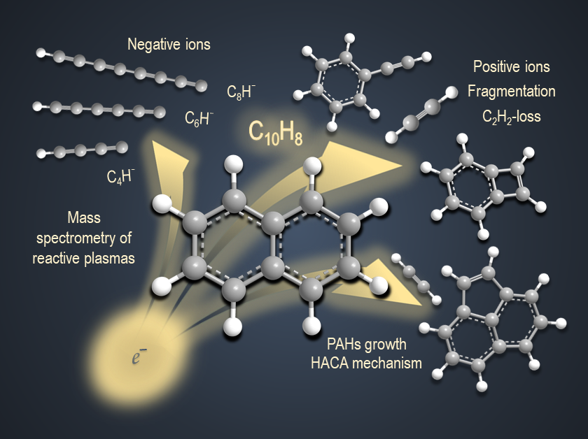

Corresponding author, xin.tu@liverpool.ac.uk
Corresponding author, j.w.bradley@liverpool.ac.uk.

