HOW TO QUANTIFY CLAY-COAT GRAIN COVERAGE IN MODERN AND ANCIENT SEDIMENTS
LUKE J. WOOLDRIDGE^{1, 2}*, RICHARD H. WORDEN¹*, JOSHUA GRIFFITHS¹, JAMES E.P. UTLEY¹,
¹School of Environmental Sciences, University of Liverpool, Liverpool L69 3GP, U.K.
²BP Upstream Technology, Chertsey Road, Sunbury, Middlesex TW16 7LN, UK
*1Corresponding authors (e-mail: r.worden@liv.ac.uk)

ABSTRACT
A major limiting factor in efforts to develop a predictive capability for the distribution of clay-coat-derived positive reservoir quality anomalies, in deeply-buried sandstones, has been the lack of a reliable and user-independent method to quantify the extent of clay-coat coverage. Clay minerals attached to grain surfaces as coats (rims) have been reported to inhibit quartz cementation during prolonged burial heating and so preserve reservoir quality deep in sedimentary basins. The completeness of clay-coat grain coverage is the principal factor that controls the effectiveness of quartz cement inhibition and the preservation of elevated primary porosity. Being able to quantify extent of clay-coat grain coverage is thus of paramount importance in facilitating predictive models for the distribution of clay-coat-derived enhanced reservoir quality.
This study presents one qualitative and two new quantitative methods that are capable of detailing: (i) the extent of the grain covered by attached clay material, and (ii) the volume of clay minerals attached to grain surfaces as clay coats. This study focused on the surface sediments in the Ravenglass Estuary, UK, and involved the use of a combination of scanning electron microscopy (SEM) and scanning electron microscope energy dispersive spectrometry (SEM-EDS) to characterize clay-coat coverage. Datasets produced in this study document the distribution of clay coats across the marginal marine system and allow the assessment and comparison of each technique.
The results reveal that existing qualitative classification schemes poorly resolve clay-coat variability in sand-dominated sediment typical of sand flats, tidal bars, and outer estuarine depositional environments. A key outcome is that current predictive models based on qualitative data sets for the distribution of clay coats in deeply buried sandstones potentially underestimate the distribution and grain coverage in such settings. However, the two new methods presented here, using SEM and SEM-EDS images, for the quantification of clay-coat grain coverage and the volume of grain-coating clay minerals, produce comparable quantitative spatial distribution trends with the volume (thickness) and completeness of grain coverage decreasing with distance towards the open ocean. The novel SEM and SEM-EDS clay-coat quantification techniques reported in this study are applicable to both modern and ancient sediments, and provide a method to construct a robust predictive capability for clay-coat-derived reservoir quality in ancient and deeply buried sandstones.
Keywords: Clay-coat distribution, clay-coat coverage, clay-coat volume, sandstone reservoir quality prediction, modern analogue

INTRODUCTION
The presence of clay minerals arranged as coats (rims) on sand-grain surfaces has been reported to exert a fundamental control on the diagenetic and reservoir quality characteristics of deeply buried sandstones (Ajdukiewicz and Larese 2012; Bloch et al. 2002; Worden et al. in press; Worden and Morad 2003). Complete clay coats on sand-grain surfaces (those covering 100% of grain surfaces) can preserve primary porosity through the inhibition of porosity-occluding, authigenic quartz cement (Bloch et al. 2002; Dowey et al. 2012; Ehrenberg 1993).
The need to explore, predict, and develop economically-viable, deeply buried petroleum prospects (> 3 km) has driven significant research in establishing a predictive capability for the distribution of clay-coated grains, via a range of core-based (Gould et al. 2010; Saïag et al. 2016; Skarpeid et al. 2017), and modern-analogue approaches (Dowey 2013; Dowey et al. 2017; Wooldridge et al. 2017a; Wooldridge et al. 2017b). Experimental work (Ajdukiewicz and Larese 2012; Lander et al. 2008) and core-based investigations (Bloch et al. 2002; Ehrenberg 1993; Skarpeid et al. 2017; Stricker and Jones 2016) have suggested that the completeness of the coat (here defined as the fraction of surface area of grains covered by attached clay material) is the principal factor governing the effectiveness of quartz cement inhibition and thus the preservation of good reservoir quality. The processes controlling the origin and distribution of clay-coated sand grains is not the focus of this work, but they have been reviewed previously (Ajdukiewicz and Larese 2012; Dowey et al. 2012; Dowey et al. 2017; Wise et al. 2001; Wooldridge et al. 2017a; Wooldridge et al. 2017b; Worden and Morad 2003). Note that very thin (< 1 µm), but complete, clay coats can inhibit quartz cement so that there is a need to detail the degree of coverage as well as the total amount (volume) of grain-coating clay (Ajdukiewicz and Larese 2012; Bloch et al. 2002). The aim of this work is to describe existing and new methods available for the quantification of grain-coat coverage in modern and ancient sediment.

Development of Clay-Coat Coverage Methods
The protocol for classifying clay-coat coverage has been developed, principally, over the last eight years (Ajdukiewicz and Larese 2012; Dowey 2013; Gould et al. 2010; Saïag et al. 2016; Wooldridge et al. 2017a; Wooldridge et al. 2017b) and has involved: (i) the qualitative visual estimation of clay-coat coverage (Dowey et al. 2017) or (ii) the assignment of the sample via morphological characteristics, or an estimation of grain surface-area coverage, into defined bin classes (Gould et al. 2010; Saïag et al. 2016).
Qualitative characterisation has been applied to modern-analogue studies (Dowey 2013; Dowey et al. 2017), experimental work (Ajdukiewicz and Larese 2012), and core-based analysis (Gould et al. 2010; Saïag et al. 2016). The richest dataset from the qualitative characterisation of clay-coat coverage was by Dowey et al. (2017) on the distribution of clay-coated sand grains from the Anllóns Estuary, Galicia, northwest Spain. The approach included estimating the total perimeter length of a grain covered by attached clay coats (i.e., independent of clay-coat thickness), relative to the proportion that is a clean surface, in order to constrain clay-coat coverage. The study involved 6,500 coat-coverage measurements with a reported repeatability error of approximately ± 2%.
Clay-coat classification based exclusively on morphology was undertaken by Gould et al. (2010) on the Lower Cretaceous Scotian Basin reservoir sandstones, with four classes defined, based on a qualitative 1 to 4 classification scale of attached coats, where 1 is no, or trace, coats and 4 is well-developed, thick and continuous coats. Similarly, Saïag et al. (2016) used a three-fold classification for the Permian tidal sandstones of the Bonaparte Basin, Australia, where 1 represents total grain coverage, 0.5 represents partial coat coverage, and 0 represents an absence of grain coats.
The development of predictive models for clay-coat-controlled reservoir quality in ancient and deeply buried sandstones (Dowey et al. 2017; Saïag et al. 2016; Wooldridge et al. 2017b) has been hindered by the inability to quantify the extent of clay-coat coverage on sand grains. This study has developed a qualitative methodology for clay-coat characterization and two new quantitative methods. The qualitative method uses categorical bin classes based on SEM images of whole sediment; the two quantitative methods measures the fraction of the perimeter of a grain that is covered by attached clay and the volume of clay present as clay coats, both using SEM analysis of polished sections. It is envisioned that the development of standard protocols for obtaining quantified, reproducible values of clay-coat coverage will facilitate better direct comparisons between studies of both modern and ancient clay-coated sand-grains and thus advance the science and the application of reservoir quality prediction.
The study is focused on the Ravenglass Estuary, UK (Fig. 1) and addresses the following questions:
- Do qualitative and quantitative clay-coat classification methodologies produce comparable data?
- Does quantifying clay-coat grain coverage produce data comparable to the quantification of the volume of clay-coat material?
- What is the significance of any differences in distribution pattern for clay coats revealed by the different techniques?

Materials
This study initially focused on surface samples from the macro tidal Ravenglass Estuary, UK (SD 07608 96761) (Lloyd et al. 2013; Wooldridge et al. 2017b). The dataset encompasses fluvial to shallow-marine depositional environments. The sedimentary framework has been documented previously by Wooldridge et al. (2017b) (Fig. 1). The mixed-energy Ravenglass Estuary has an inter tidal area of 5.6 km² fed by three rivers, the Esk, the Mite, and the Irt, and is connected to the Irish Sea via a single 500m-wide tidal inlet that dissects the coastal barrier spits (Fig. 1) (Wooldridge et al. 2017b).
This study includes results from 38 surface samples that were analyzed via scanning electron microscope energy dispersive spectrometry (SEM-EDS), using a QEMSCAN® system (Armitage et al. 2010; Wooldridge et al. 2017b). Surface samples were selected to encompass the range of intertidal depositional environments to produce a complete fluvial to marine transect of clay-coat variability. The data set is combined with 112 resin-impregnated, thin sections of polished grain mounts, and 181 loose-sediment grain mounts, previously reported in Wooldridge et al. (2017a); Wooldridge et al. (2017b), respectively. Being able to directly compare differences in clay-coat distribution derived from qualitative and quantitative methodologies is of paramount importance in assessing the ability of each method to characterize clay-coat heterogeneity across marginal marine depositional environments. Spatial distribution maps were constructed using the interpolated functions in ArcGIS (https://www.arcgis.com).
The study has also employed a small suite of Lower Jurassic chlorite-cemented sandstones from a petroleum reservoir from the North Sea Basin, in order to test the applicability of methods for grain coat analysis developed for the modern sediments of the Ravenglass Estuary.
METHODS

Defining Clay-Coat Coverage by Qualitative Techniques
Clay-coated grains were categorized, from SEM images of loose-sediment grain mounts, from the Ravenglass Estuary into five principal classes, defined by coat morphology and an estimation of clay-coat grain coverage (surface grain area) (Fig. 2). As described in Wooldridge et al. (2017b), categorical bin classes are defined as: (1) complete absence of attached clay coats, (2) less than half of the grains have a small ( ̴1 to 5 %) surface area of attached clay coats, (3) every grain exhibits at least ̴5 to 15% surface area of attached clay-coats, (4) clay coats observed on every grain with the majority exhibiting extensive ( ̴15 to30%) surface-area grain coverage, and (5) extensive 30% surface area covered by clay coats observed on every grain.

Defining Clay-Coat Coverage by Quantitative Techniques
Measuring Clay-Coat Coverage: the Cross-Sectional Perimeter Length Method: Petrog.---Quantifying the length of a grain perimeter that is covered by attached clay coats involved using the Petrog statistical system (Pantopoulos and Zelilidis 2012; Wooldridge et al. 2017a). Petrog is commonly used for point counting with its automated stepping stage and software that stores, collates, and analyzes point-counted petrographic data (PETROG System, Conwy Valley Systems Ltd (CVS), UK). In conjunction with CVS, the Petrog software was developed during this research, creating a new Petrog perimeter tool, to import SEM petrographic images (virtual images) and to quantify clay-coat grain coverage (Fig. 3). In order to quantify micrometer-scale clay coats (Fig. 1C to I), a number of backscattered electron microscope images were collected, at a resolution appropriate to visualize the clay coats on 50 sand grains per sample, and then analyzed with the new Petrog perimeter tool. The method involved defining the total perimeter length of a grain (Fig. 3, red line) and then manually selecting the length that is covered by attached clay-coating material (Fig. 3, green nodes) (i.e., independent of clay-coat thickness) to calculate the percentage perimeter of the grain covered by clay-coat material. Repeat analysis showed an average ± 1.7% error based on 50 analyzed sand grains per sample (Wooldridge et al. 2017a).
The advantages of this method are: (i) the produced data of clay-coat grain coverage are comparable to the majority of modern analogue (qualitative) studies (Dowey 2013; Dowey et al. 2017) and (ii) it is possible to import any pre-existing image, of appropriate resolution, of clay-coated sand grains (e.g. light optical, SEM, or SEM-EDS) and perform the analysis. A potential limitation of the method is consistency in identifying clay coats, which is not trivial owing to SEM resolution and the nature of grayscale images, for thin (< 2 μm) thick coats (i.e., typical of outer estuarine sediments) (Fig. 1F, G).
Calculating Clay-Coat Coverage: Volume of Clay Minerals Present as Coats: SEM-EDS.--- Scanning electron microscope energy dispersive spectrometry (SEM-EDS) methods enable quantitative, in-situ, mineralogical imaging of micrometer-scale textures (e.g., clay-mineral coats) to a particle-size resolution of 1 µm (Armitage et al. 2010; Wooldridge et al. 2017b). The SEM-EDS system (QEMSCAN®) comprises a scanning electron microscope, fast energy-dispersive spectrometers (EDS), a microanalyzer, and an electronic processing unit (Armitage et al. 2016; Wooldridge et al. 2017b) using the software suite iDiscover. Mineralogical quantification is performed via two EDS detectors with analyses compared to a library of spectra with each analysis point automatically assigned to a specific mineral. The output includes a backscatter electron image (Fig. 4A) and a fully quantitative map of mineralogy (framework grains, cements and clay minerals) and pore spaces (Fig. 5) with values presented as image-area percentage and imaged-area mass percentage (Fig. 4) (Wooldridge et al. 2017b).
The QEMSCAN® granulometry function permits the digital “sieving” of imaged sediment mineral particles by grain size into bin classes, e.g., clay, silt, and sand (Fig. 4C), based on the long axis of each particle. It is then possible to digitally sieve by grain size the component clay mineralogy (e.g., chlorite) (Fig. 4E).
Some phyllosilicate minerals are present in lithic grains, e.g., chlorite in volcanic rock fragments (Worden and Morad 2003), and are thus part of the coarse-grained fraction of the sediment (Fig. 4C, D). Other phyllosilicate minerals are present as coarse tabular grains (Worden and Morad 2003). In its current form, such coarse-grained material cannot form detrital sand-grain coats because it is the same size as the host sand grains.
The spatial resolution limit of the SEM-EDS is slightly less than 1 μm, as defined by the fundamental physics of the interaction between an electron-beam and a polished-section (Emery and Robinson 1993), and so cannot detect isolated, submicrometre-scale clay crystals. Previous studies of clay coats have revealed that they are composed of fine- and medium-silt-grade material (and finer-grained material) (Dowey 2013; Dowey et al. 2017; Wooldridge et al. 2017b) (Fig. 5). Therefore a 32 μm grain-size cut-off was initially employed to discriminate material that was incorporated in grain coats. Analysis of samples from the Ravenglass Estuary (Fig. 5) revealed that the majority of chlorite and kaolinite crystals in grain coats are 16 μm, so that a 32 μm grain size cut-off was used for grain-coating illite and a 16 μm grain-size cut-off was used for grain-coating chlorite and kaolinite (Wooldridge et al. 2017b).
The approach adopted is predicated on the assumption that any monomineralic, clay particulate clast > 16 µm (for chlorite or kaolinite) or > 32 µm (for illite) in the sediment is present as components of either clay-rich lithic fragments or other aggregates (Figs. 4, 5) and do not form clay coats. The discrimination of clay minerals based on size produces a quantified value for the total volume (image area) of clay in a sediment assemblage that is present as grain coats.
The advantages of this approach are that: (i) the method is quantitative and automated once the initial size parameters have been established, (ii) the method provides information on clay-coat mineralogy, (iii) the data format (volume of clay present as clay coats) is comparable to clay-coat volumes derived from point-count measurements (the format for the majority of studies of ancient clay-coated sandstone), (iv) it is possible to extract sedimentological information in the form of grain size, sorting, lithic assemblage, and textural data, to permit direct comparisons between clay-coat characteristics and sedimentological heterogeneities, (v) it is possible to import the SEM-EDS images into Petrog (see method above) and calculate exact values of clay-coat grain coverage for comparison (i.e., by enhanced identification of color-coded clay coats, Fig. 5), and (vi) the method gives an indication of the thickness of attached clay-coat material and not just the degree of grain coverage.

RESULTS
Clay coats in these modern estuarine sediments consist of clay minerals, clay- to silt- size lithics, and biologically produced materials (e.g., diatoms), forming discontinuous accumulations of predominantly clay minerals attached to grain surfaces (Figs. 1, 5). Strands of clay material extend into the pore from the grain and link framework grains via a bridge to produce a webbed texture that is consistent with previously reported marginal-marine clay-coat characteristics (Dowey 2013; Dowey et al. 2017) (Fig. 1 C to I). Important observations are that clay coats are heterogeneous across marginal-marine sediments (Fig. 6) and that clay coats in the sand-dominated, inner- and outer- estuarine, depositional environments (e.g., tidal flat, tidal bars, and foreshore) exist as thin, discontinuous accumulations, found preferentially in grain indentions (e.g., Fig. 1D).

Clay-Coat Distribution Patterns in the Modern Ravenglass Estuary
Figure 6 represents the spatial distribution trends of clay-coat grain coverage across the Ravenglass Estuary as defined by: (i) qualitative (Fig. 6A) (Wooldridge et al., 2017b), (ii) quantitative clay-coat coverage (Fig. 6B) (Wooldridge et al., 2017a), and (iii) quantitative volume of clay coats (Fig. 6C).
Qualitative characterization of clay coats reveals that outer-estuary sediment contains no more than minor quantities of attached clay coats and an overarching trend of increasing coverage with distance away from the open ocean (i.e., towards the tidal limit) and with distance from the main ebb channel (Fig. 6A).
The Petrog-based quantitative clay-coat method revealed a strong heterogeneity in clay-coat coverage within inner-estuarine depositional environments ranging from < 1% to > 50% with values increasing upstream towards the tidal limits (Fig. 6B, Table 1). Outer-estuarine sediments display a more homogeneous distribution, ranging from 4.3% to < 1%, with most grains exhibiting partial attached clay coats, increasing with proximately to the tidal inlet (Fig. 6B, Table 1).
The SEM-EDS-based quantitative clay-coat method to determine the volume of clay coats also revealed a strong heterogeneity ranging from 2 to 18% with values increasing with distance away from the open ocean and towards the tidal limit (Fig. 6C, Table 1). Sediment with clay-coat volumes > 5% are confined to inner-estuarine depositional environments (Fig. 6C). Sediment samples with clay coat volumes > 7% are confined to mixed- and mud-tidal flats and tidal-bar depositional environments of the inner estuary (e.g., compare Fig 1B to 6C, Table 1). The central estuarine zone sediments display a progressive increase in clay-coat volume across the tidal-flat succession from < 3 %, in the outermost sand-flat, to 18% in the upper mudflat (compare Fig. 6C to 1B). The marine end of the estuary (i.e., foreshore, pro-ebb delta and tidal inlet) showed a broadly homogeneous distribution with values ranging from 2.2 to 4.4%. The dataset reveals a progresive decrease in the volume of graincoating clay minerals from the inner estuary to the outer estuary (Fig. 6C). Values are summarized in Table 1.

Effect of Qualitative and Quantitative Classification Procedures on the Distribution Trends of Clay-Coated SandGrains in the Ravenglass Estuary
The overall distribution trends of the extent (coverage and volume) of detrital-clay-coated grains for the qualitative and quantitative methodologies are similar (Fig. 6). All methods reveal reduced or absent clay-coat coverage in the high-energy-foreshore, tidal-inlet, sand flats, and tidal-bar depositional environments (compare Fig. 6 to 1B). These figures indicate that each technique is capable of differentiating the relative extent of clay coats across marginal-marine sediments.
The two quantitative methods display detailed patterns of variability in the extent of clay-coat coverage in the sand-dominated, high-energy settings (i.e., foreshore, tidal inlet, sand-flats, and tidal bars; Figs 6B and C). Spatially, an incremental increase in the abundance of clay-coat coverage can be observed in progressing from the pro-ebb delta to the inner estuary (Fig. 6B, 6C).
Where the percentage of clay-coat coverage is greater than 50% (Fig. 6B) this equates to 12-18% clay-coat volume (Fig. 6C). Also, samples with < 30% clay-coat coverage have a clay-coat volume corresponding to < 6%. Overall, this indicates a reduced clay-coat volume (thickness) that equates to a reduced clay-coat coverage (Fig. 7C).
In the coarser-grained sediments that tend to have less well-developed clay coats, the qualitative technique does not adequately discriminate the variability of clay-coat coverage detailed by the quantitative approaches (compare Fig 6A to 6B and 6C). For example, bin class 1 (defined as < 1% clay-coat coverage) encompasses a range of samples that contain up to 10% clay-coat coverage as determined by the quantitative clay-coat coverage method (Petrog) (Fig. 7A).
It is apparent that many of these marginal marine sediments have < 10% clay coverage (Fig. 7C). The exceptions tend to be mud-flat and mixed-tidal-flat samples (compare Fig. 1 to 6) which have > 10% clay-coat coverage and > 5% clay-coat volume (Fig. 7C). The volume of clay-coat material correlates broadly with increased grain coverage (Fig. 7C). Figures 7A and B illustrate that qualitative (bin class) classification of clay coats are unable to differentiate between low degrees of clay-coat coverage.

Application of Quantitative Classification Procedures to Lower Jurassic Chlorite-Cemented Sandstones
A high-resolution SEM-EDS image (step size of 1 μm), with an area of 4 mm², was here generated from a polished thin section of a Lower Jurassic chlorite-cemented, marginal-marine sandstone in order to illustrate the applicability of the techniques developed for modern sediments to oil and gas reservoir samples.
Petrog was used to define the average clay-coat coverage for the entire 4 mm² area of the SEM-EDS image (Fig. 8) producing data analogous to Figure 6B from the modern sediments. The sample contained an average of 12% clay-coat coverage.
The digital sieving tool in the iDiscover software suite (available to QEMSCAN users) was then applied to the same 4 mm² area (Fig. 9). A significant proportion of the clay present in this sample was not grain-coating. Figures 9C, D, and E detail the distributions of chlorite, kaolinite and illite illustrating the capability of SEM-EDSfor resolving grain-coating clay, clay-rich clasts, grain-replacive clay, and detrital phyllosilicates. In this sample, the digital sieve limit for monomineralic clay-coat entities was set to < 32 μm (long axis). Clay entities > 32 μm were not classed as grain-coating. Note that this clay size will probably vary between different petroleum reservoirs thus requiring petrographic analysis ahead of subsequently automated SEM-EDS data processing. Based on SEM-EDS methods, the sample contained an average of 7% clay-coat volume.

DISCUSSION
This comparative study of techniques for clay-coat characterization llustrates that, despite the broadly comparable distribution trends between qualitative and quantitative methodologies, there is a need to apply quantitative analytical techniques to accurately resolve the distribution of clay-coated sand grains in marginal-marine, sand-dominated sediments. Qualitative methodologies poorly resolve clay coats with < 10% average grain coverage (i.e., outer-estuarine sediments).
The discrepancy in the distribution of clay-coated sand grains between the two quantitative techniques (compare Fig. 6B to 6C) in the foreshore samples potentially results from the challenge presented in manually resolving thin and discontinuous coats using backscattered SEM images. The ability to identify and quantify such thin, discontinuous coats is fundamental because, as noted by Bloch et al. (2002), minor amounts of clay (as little as 1 to 2% of the rock volume) can coat a relatively large surface area of sandstone grains and are potentially capable of inhibiting quartz cementation.
Previous schemes for predicting the characteristics of clay coats in the subsurface have been based exclusively on qualitative methodologies (Dowey 2013; Dowey et al. 2017; Wooldridge et al. 2017b). The work presented here confirms the potential usefulness of such qualitative schemes in predicting large-scale spatial trends in clay-coat extent (coverage and volume), due to the broad, overall correlation between qualitative and quantitative techniques (Figs. 6,7).
The trend in clay coat coverage distribution, in the Ravenglass Estuary (Fig. 6.6) is broadly comparable to the spatial distribution patterns of clay coats in surface sediments reported for the mesotidal Anllóns Estuary, NW Spain (Dowey 2013; Dowey et al. 2017) as determined by qualitative characterization.
The proven use of of the two quantitative methods for ancient and deeply buried sandstones means that they can be applied to calculate clay-coat coverage and the volume of coating clay from ancient sediments, as illustrated from a North Sea reservoir sandstone in Figures 8 and 9. An advantage of these quantitative techniques is that they produce datasets of clay-coat distribution that are directly comparable between modern analogue and subsurface core-based investigations.

IMPLICATION FOR FUTURE HYDROCARBON EXPLORATION AND APPRAISAL
The clay coats characterized in this study are characteristic of detrital-clay coats (Wooldridge et al. 2017b) which have been reported to be potential precursors to the clay coats that are present in numerous deeply buried sandstones (Ajdukiewicz and Larese 2012; Bloch et al. 2002; Wise et al. 2001; Worden and Morad 2003). Diagenetic clay coats have been interpreted to derive from the recrystallization of clay coats that formed during deposition (i.e., from detrital-clay coats) (Ajdukiewicz and Larese 2012; Bloch et al. 2002). The ability to produce fully quantitative analogue data sets of clay-coat distribution across modern systems will lead to models that are potentially capable of being used to predict reservoir quality in sandstones.
The ability to define the volume of clay-coat material is of significance because, as shown by Aagaard et al. (2000) in experiments replicating burial diagenesis, discontinuous detrital-clay coats transform (neoform) into complete diagenetic-grain coats. The implication of this is that even with discontinuous (detrital) clay coats, it would require only a minor amount of clay material (1 to 2% of the rock volume) to transform and completely coat a relatively large surface area of sandstone with clay minerals that are capable of inhibiting quartz cementation (Bloch et al. 2002). The ability to measure the volume of clay-coat material (Fig. 6C) and detrital-clay-coat coverage (Fig. 6B) thus permits an enhanced understanding of the potential post-diagenetic extent (thickness and grain coverage) of clay coats in deeply buried sandstones.
This study illustrates the distribution of clay-coated sand-grains across a modern marginal-marine system, an environment of deposition comparable to many notable ancient clay-coated sandstones, such as the Tilje Formation, Norway (Ehrenberg 1993), the Garn Formation, Norway (Storvoll et al. 2002), and the Lower Cook Formation, Knarr Field, Norway (Skarpeid et al. 2017). Sandstones originally deposited in marginal-marine settings represent a potential 54% of all reported chlorite-coated sandstone reservoirs (Dowey et al. 2012) so that our novel quantitative maps of clay-coat volume (Fig. 6C) can be applied, by analogy, to aid the prediction of best reservoir quality in deeply buried, marginal marine sandstones. It is noteworthy that the qualitative methodology for measuring clay-coat coverage cannot resolve clay coats with less than 10% coverage (Fig. 6A and 7A) so that quantitative techniques should be employed for both modern sediment and ancient deeply buried sandstone reservoirs.

CONCLUSION
- Trends in clay-coat distribution, obtained via qualitative and quantitative methodologies, have been compiled to produce the most complete view of clay-coat heterogeneity across a marginal-marine system.
- Quantitative datasets produced using (i) SEM-EDS and digital sieving and (ii) image analysis of BSEM images, for the spatial distribution of the clay-coat volume (indication of thickness) revealed an increase in a landward direction with the greatest volumes of grain-coating clay minerals in the inner-estuarine tidal-bar and tidal-flat depositional environments.
- The greatest volumes of grain-coating clay minerals occur in the mud-flat samples (< 18%) with up to 4% in foreshore sediment assemblages.
- Qualitative and quantitative methodologies produced broadly comparable trends in clay coat distribution. However, qualitative techniques inadequately characterized clay-coat variability in the sand-dominated sediments with < 10% average grain coverage (e.g., sand flat, tidal bars, foreshore, and pro-ebb delta).
- The SEM-EDS- and BSEM-image-analysis techniques to determine grain-coat coverage, developed for modern sediments have here been shown to work for ancient, deeply buried sandstone reservoir samples.
- Current predictive models for the distribution of clay coats in deeply buried sandstones, based exclusively on qualitative data sets, potentially underestimate the distribution area and extent of clay-coat grain coverage.
ACKNOWLEDGMENT
This work was carried out as part of the Chlorite Consortium at Liverpool University (UK), sponsored by BP, BG, Shell, Eni, Statoil, Petrobras, Woodside, and Chevron oil companies. The encouragement and constructive comments by Journal Associate Editor Marsha French and reviewers Alan Butcher and Saturnina Henares Ladrón De Guevara are greatly appreciated. Thanks, is given to FEI and Thermo Fisher for the loan of the QEMSCAN® system to the University of Liverpool (UK).
References
Aagaard, P., Jahren, J.S., Harstad, A.O., Nilsen, O., and Ramm, M., 2000, Formation of grain-coating chlorite in sandstones. Laboratory synthesized vs. natural occurrences: Clay Minerals, v. 35, p. 261-269.
Ajdukiewicz, J.M., and Larese, R.E., 2012, How clay grain coats inhibit quartz cement and preserve porosity in deeply buried sandstones: Observations and experiments: American Association of Petroleum Geologists Bulletin, v. 96, p. 2091-2119.
Armitage, P.J., Worden, R.H., Faulkner, D.R., Aplin, A.C., Butcher, A.R., and Iliffe, J., 2010, Diagenetic and sedimentary controls on porosity in Lower Carboniferous fine-grained lithologies, Krechba field, Algeria: A petrological study of a caprock to a carbon capture site: Marine and Petroleum Geology, v. 27, p. 1395-1410.
Armitage, P.J., Worden, R.H., Faulkner, D.R., Butcher, A.R., and Espie, A.A., 2016, Permeability of the Mercia Mudstone: suitability as caprock to carbon capture and storage sites: Geofluids, v. 16, p. 26-42.
Bloch, S., Lander, R.H., and Bonnell, L., 2002, Anomalously high porosity and permeability in deeply buried sandstone reservoirs: Origin and predictability: American Association of Petroleum Geologists Bulletin, v. 86, p. 301-328.
Brockamp, O., and Zuther, M., 2004, Changes in clay mineral content of tidal flat sediments resulting from dike construction along the Lower Saxony coast of the North Sea, Germany: Sedimentology, v. 51, p. 591-600.
Dowey, P.J., 2013, Prediction of clay minerals and grain coatings in sandstone reservoirs utilising ancient examples and modern analogue studies: University of Liverpool, [Ph.D. thesis], 390 p.
Dowey, P.J., Hodgson, D.M., and Worden, R.H., 2012, Pre-requisites, processes, and prediction of chlorite grain coatings in petroleum reservoirs: A review of subsurface examples: Marine and Petroleum Geology, v. 32, p. 63-75.
Dowey, P.J., Worden, R.H., Utley, J., and Hodgson, D.M., 2017, Sedimentary controls on modern sand grain coat formation: Sedimentary Geology.
Ehrenberg, S.N., 1993, Preservation of anomalously high-porosity in deeply buried sandstones by grain coating chlorite - examples from the Norwegian continental shelf: American Association of Petroleum Geologists Bulletin, v. 77, p. 1260-1286.
Emery, D., and Robinson, A.G., 1993, Inorganic geochemistry: application to petroleum geology: Oxford, Blackwell, 254 p.
Gould, K., Pe-Piper, G., and Piper, D.J.W., 2010, Relationship of diagenetic chlorite rims to depositional facies in Lower Cretaceous reservoir sandstones of the Scotian Basin: Sedimentology, v. 57, p. 587-610.
Lander, R.H., Larese, R.E., and Bonnell, L.M., 2008, Toward more accurate quartz cement models: The importance of euhedral versus noneuhedral growth rates: American Association of Petroleum Geologists Bulletin, v. 92, p. 1537-1563.
Lloyd, J.M., Zong, Y., Fish, P., and Innes, J.B., 2013, Holocene and Lateglacial relative sea‐level change in north‐west England: implications for glacial isostatic adjustment models: Journal of Quaternary Science, v. 28, p. 59-70.
Pantopoulos, G., and Zelilidis, A., 2012, Petrographic and geochemical characteristics of Paleogene turbidite deposits in the southern Aegean (Karpathos Island, SE Greece): Implications for provenance and tectonic setting: Chemie der Erde-Geochemistry, v. 72, p. 153-166.
Saïag, J., Brigaud, B., Portier, É., Desaubliaux, G., Bucherie, A., Miska, S., and Pagel, M., 2016, Sedimentological control on the diagenesis and reservoir quality of tidal sandstones of the Upper Cape Hay Formation (Permian, Bonaparte Basin, Australia): Marine and Petroleum Geology, v. 77, p. 597-624.
Skarpeid, S.S., Churchill, J.M., Hilton, J.P., Izatt, C.N., and Poole, M.T., 2017, The Knarr Field: a new development at the northern edge of the North Sea: Geological Society, London, Petroleum Geology Conference series, p. 445-454.
Storvoll, V., Bjorlykke, K., Karlsen, D., and Saigal, G., 2002, Porosity preservation in reservoir sandstones due to grain-coating illite: a study of the Jurassic Garn Formation from the Kristin and Lavrans fields, offshore Mid-Norway: Marine and Petroleum Geology, v. 19, p. 767-781.
Stricker, S., and Jones, S.J., 2016, Enhanced porosity preservation by pore fluid overpressure and chlorite grain coatings in the Triassic Skagerrak, Central Graben, North Sea, UK: Geological Society, London, Special Publications, v. 435, p. SP435. 4.
Wise, S., Smellie, J., Aghib, F., Jarrard, R., and Krissek, L., 2001, Authigenic smectite clay coats in CRP-3 drillcore, Victoria Land Basin, Antarctica, as a possible indicator of fluid flow: a progress report: Terra Antartica, v. 8, p. 281-298.
Wooldridge, L.J., Worden, R.H., Griffiths, J., Thompson, A., and Chung, P., 2017a, Biofilm origin of clay-coated sand grains: Geology, v. 45, p. 875-878.
Wooldridge, L.J., Worden, R.H., Griffiths, J., and Utley, J.E., 2017b, Clay-coated sand grains in petroleum reservoirs: understanding their distribution via a modern analogue: Journal of Sedimentary Research, v. 87, p. 338-352.
Worden, R.H., Armitage, P.J., Butcher, A., Churchill, J., Csoma, A., Hollis, C., Lander, R.H., and Omma, J., in press, Petroleum reservoir quality prediction: overview and contrasting approaches from sandstone and carbonate communities, in Armitage, P.J., Butcher, A., Churchill, J., Csoma, A., Hollis, C., Lander, R.H., Omma, J., and Worden, R.H., eds., Reservoir Quality of Clastic and Carbonate Rocks: Analysis, Modelling and Prediction. Special Publication: London, Geological Society.
Worden, R.H., and Morad, S., 2003, Clay minerals in sandstones: Controls on formation, distribution and evolution: In: Clay mineral cements in sandstones (eds. Worden, R.H. and Morad, S.) International Association of Sedimentologists Special Publications, v. 34, p. 3-41.

Figure captions
Figure 1 Location and depositional environment maps of the Ravenglass Estuary. A) The Ravenglass Estuary, in the UK. B) Regional map showing the study area and component depositional environments (Wooldridge et al. 2017a; Wooldridge et al. 2017b). Tidal flats have been subdivided based on the quantified (Laser Granulometry using a Beckman Coulter LS200) sand percentage into: sand flat (> 90% sand), mixed sand mud flat (50 to 90% sand) and mud flat (15 to 50% sand) (Brockamp and Zuther 2004). C, D, E, F, G, H, I) Scanning-electron-microscopy (SEM) images of surface clay-coated sand grains. Arrows indicate regions of attached clay-coat material. Numbers show sample locations in part B.
Figure 2 Scanning-electron-microscopy (SEM) images of surface clay-coated sand-grains and schematic representation of clay-coating extent. A-C) illustrate classification of clay-coat extent into classes based on morphology and the visual calculation of the surface-area coverage. A) Complete absence of attached clay coats (group 1). B) Every grain exhibits at least ̴5 to 15% surface area of attached clay-coats (group 3). C) Extensive > 30% surface area covered by clay coats observed on every grain (group 5).
Figure 3. Scanning-electron-microscopy (SEM) image of clay-coated sand grains (mixed tidal flat) from the Ravenglass estuary, showing the cross-sectional perimeter length method (Petrog) of clay-coat quantification. A) SEM image. B) SEM image, with red line indicating the user-defined perimeter of the sand grain. C) SEM image with user-defined locations of attached clay-coat material (green) and locations on the grain devoid of clay coating (yellow).
Figure 4 Scanning electron microscope-energy-dispersive spectrometry (SEM-EDS) images of an estuarine tidal-flat sediment sample showing the SEM-EDS method of calculating clay-coat volume. A) Backscattered electron image. B) SEM-EDS image of the bulk mineralogy. C) SEM-EDS image of the mineralogical mapped and digitally sieved component particles of the whole sample. D) SEM-EDS image of chlorite clay minerals present within the whole sample organized on particle size (long axis). E) SEM-EDS image of the component chlorite mineral particles that are > 16 µm and thus removed from clay-coat calculations.
Figure 5 Scanning electron microscope-energy-dispersive spectrometry (SEM-EDS) images of clay-coat mineralogy from surface-mud flat (A, B), mixed-flat (C, D), and sand-flat (E, F) depositional environments. Numbers (1, 2, and 3) in Figure 1B indicate sample locations.
Figure 6 Distribution maps of clay-coat coverage across the Ravenglass marginal marine system. A) Map of clay-coat coverage (qualitative characterizations) (n = 181) (Wooldridge et al., 2017b). B) Quantitative map of clay-coat coverage (Petrog method) (n = 112) (Wooldridge et al., 2017a). C) Quantitative map of clay-coat volume (SEM-EDS method) (n = 38).
Figure 7 Cross-plots of clay-coat characteristics as determined via different quantification methods. A) Plot of qualitative clay-coat coverage (bin classes) against quantitative clay-coat coverage (Petrog method). B) Plot of qualitative clay-coat coverage (bin classes) against quantitative volume of coating clay (SEM-EDS method). C) Plot of quantitative clay-coat coverage against quantitative volume of coating clay.
Figure 8 A) Scanning electron microscope–energy-dispersive spectrometry (SEM-EDS) of a Lower Jurassic chlorite-cemented sandstone, North Sea reservoir, showing the cross-sectional perimeter length method (Petrog). B) Image illustrating step 1 of the method, defining the perimeter length of each grain. C) Image illustrating the technique of clay-coat-coverage characterization (yellow nodes; grain outline; green nodes: location of attached clay coats).
Figure 9 A) Images of scanning electron-microscope–energy dispersive spectrometry (SEM-EDS) of a Lower Jurassic chlorite-cemented sandstone, North Sea reservoir, showing the SEM-EDS method for calculating clay-coat volume. B) Enlarged SEM-EDS image identifying the presence of clay-coat coverage. C, D, E) are images depicting the internal distribution of the component clay-mineral assemblage (e.g., clay coats, pore-filling, or grain-replacing chlorite, kaolinite, and illite).
Table Captions
Table 1 Clay-coat heterogeneity of the Ravenglass Estuarine system. The table compares qualitative (SEM) and quantitative (Petrog and SEM-EDS) methods for assessing grain-coat coverage.

Figure 1 Location and depositional environment maps of the Ravenglass Estuary. A) The Ravenglass Estuary, in the UK. B) Regional map showing the study area and component depositional environments (Wooldridge et al. 2017a; Wooldridge et al. 2017b). Tidal flats have been subdivided based on the quantified (Laser Granulometry using a Beckman Coulter LS200) sand percentage into: sand flat (> 90% sand), mixed sand mud flat (50 to 90% sand) and mud flat (15 to 50% sand) (Brockamp and Zuther 2004). C, D, E, F, G, H, I) Scanning-electron-microscopy (SEM) images of surface clay-coated sand grains. Arrows indicate regions of attached clay-coat material. Numbers show sample locations in part B.
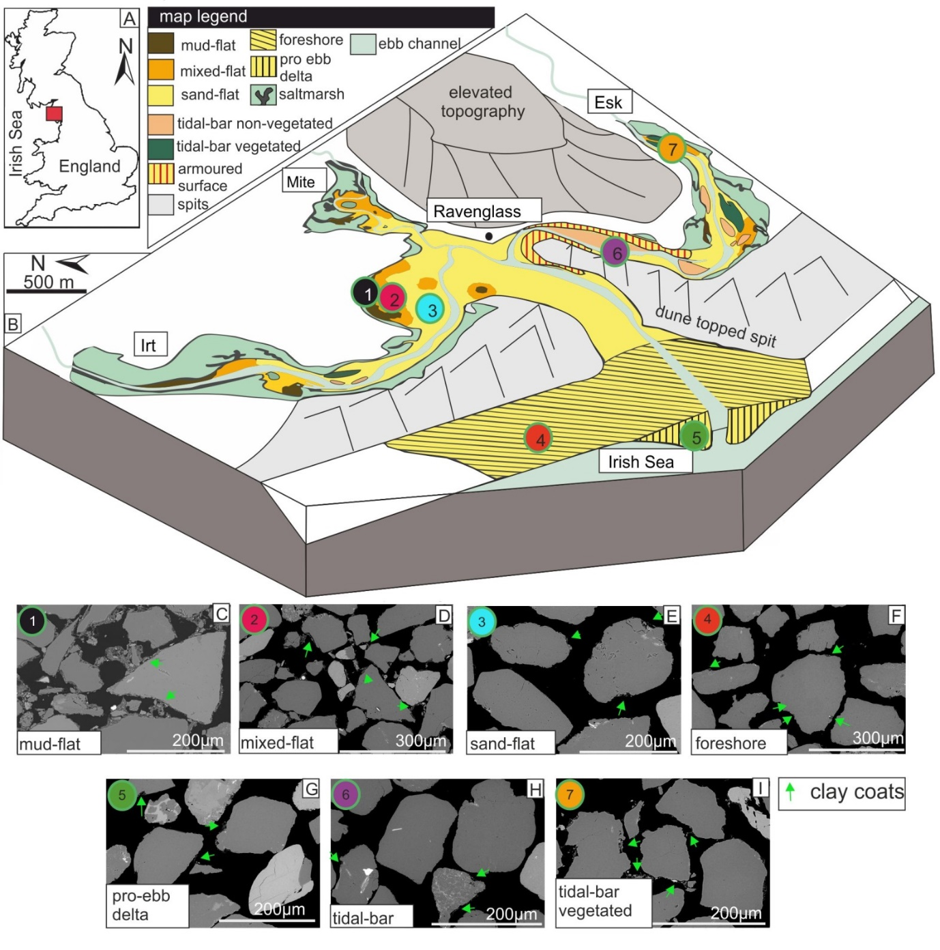
Figure 2 Scanning-electron-microscopy (SEM) images of surface clay-coated sand-grains and schematic representation of clay-coating extent. A-C) illustrate classification of clay-coat extent into classes based on morphology and the visual calculation of the surface-area coverage. A) Complete absence of attached clay coats (group 1). B) Every grain exhibits at least ̴5 to 15% surface area of attached clay-coats (group 3). C) Extensive > 30% surface area covered by clay coats observed on every grain (group 5).
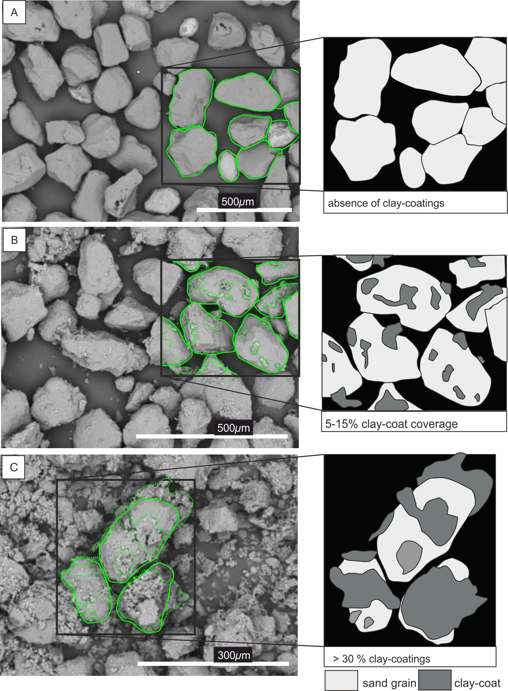

Figure 312. Scanning-electron-microscopy (SEM) image of clay-coated sand grains (mixed tidal flat) from the Ravenglass estuary, showing the cross-sectional perimeter length method (Petrog) of clay-coat quantification. A) SEM image. B) SEM image, with red line indicating the user-defined perimeter of the sand grain. C) SEM image with user-defined locations of attached clay-coat material (green) and locations on the grain devoid of clay coating (yellow).
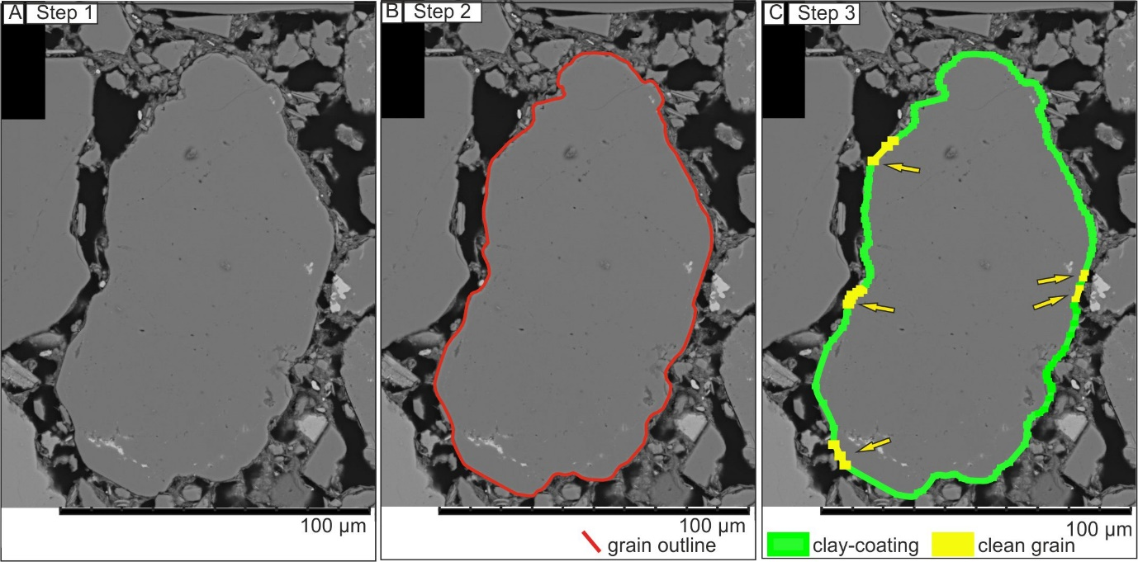

Figure 4 Scanning electron microscope-energy-dispersive spectrometry (SEM-EDS) images of an estuarine tidal-flat sediment sample showing the SEM-EDS method of calculating clay-coat volume. A) Backscattered electron image. B) SEM-EDS image of the bulk mineralogy. C) SEM-EDS image of the mineralogical mapped and digitally sieved component particles of the whole sample. D) SEM-EDS image of chlorite clay minerals present within the whole sample organized on particle size (long axis). E) SEM-EDS image of the component chlorite mineral particles that are > 16 µm and thus removed from clay-coat calculations.
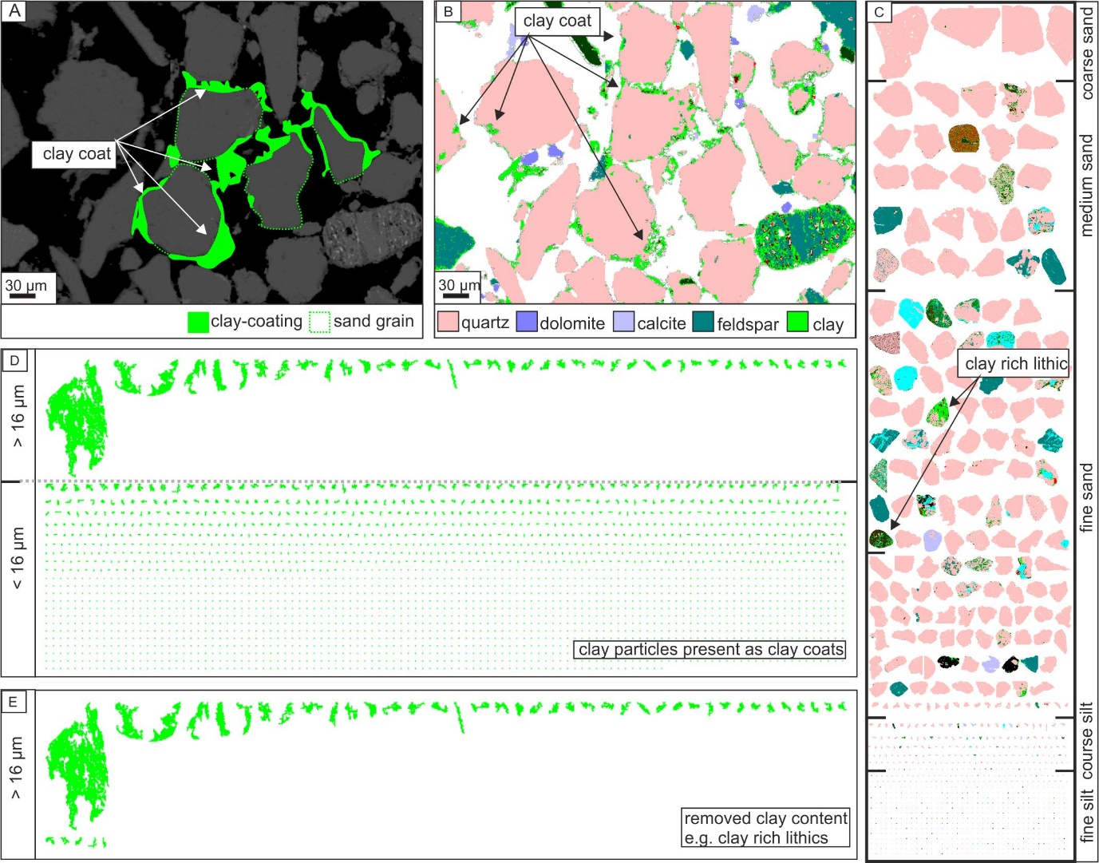

Figure 5 Scanning electron microscope-energy-dispersive spectrometry (SEM-EDS) images of clay-coat mineralogy from surface-mud flat (A, B), mixed-flat (C, D), and sand-flat (E, F) depositional environments. Numbers (1, 2, and 3) in Figure 1B indicate sample locations.
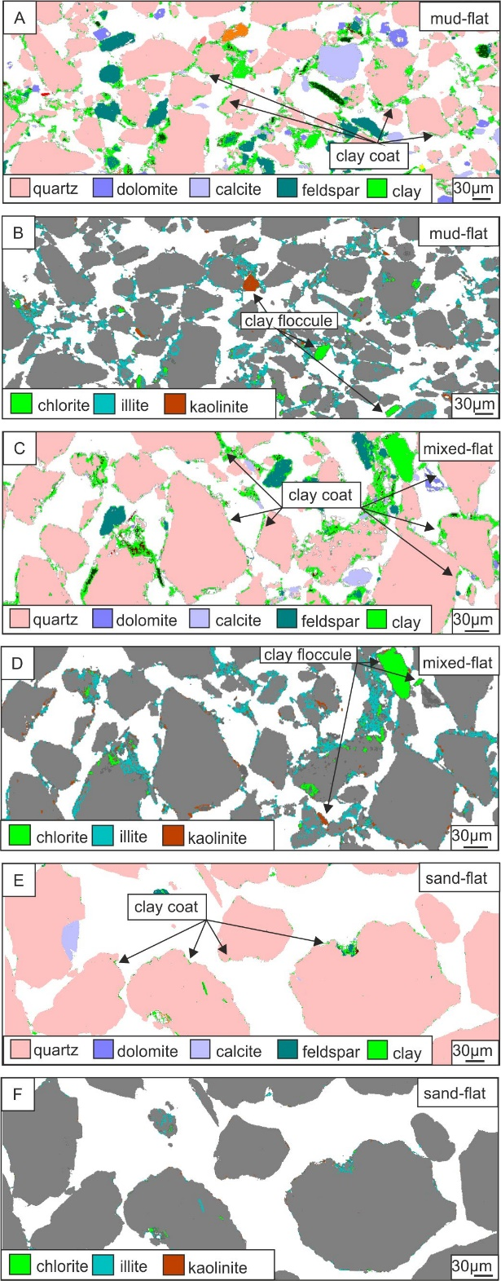
Figure 6 Distribution maps of clay-coat coverage across the Ravenglass marginal marine system. A) Map of clay-coat coverage (qualitative characterizations) (n = 181) (Wooldridge et al., 2017b). B) Quantitative map of clay-coat coverage (Petrog method) (n = 112) (Wooldridge et al., 2017a). C) Quantitative map of clay-coat volume (SEM-EDS method) (n = 38).
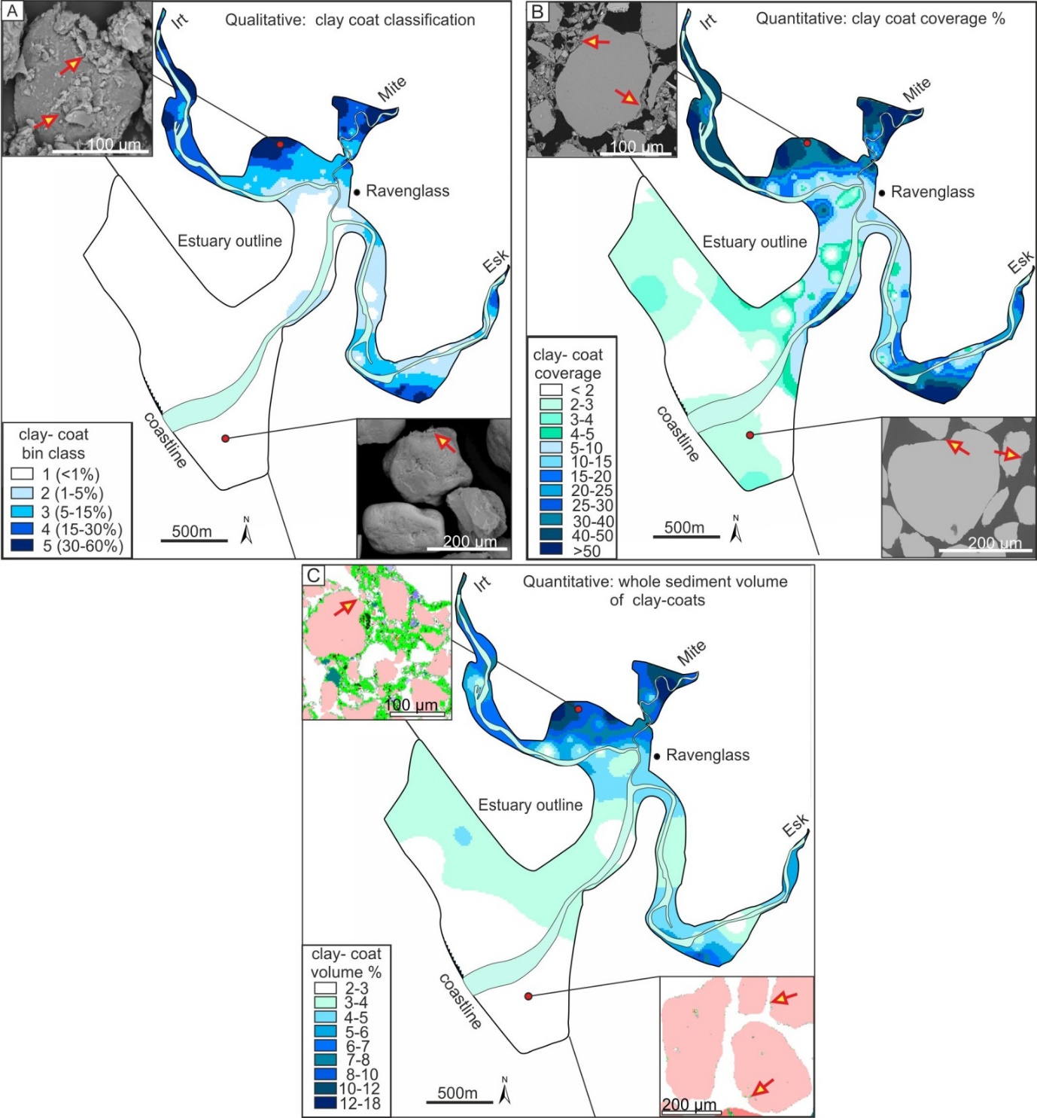

Figure 7 Cross-plots of clay-coat characteristics as determined via different quantification methods. A) Plot of qualitative clay-coat coverage (bin classes) against quantitative clay-coat coverage (Petrog method). B) Plot of qualitative clay-coat coverage (bin classes) against quantitative volume of coating clay (SEM-EDS method). C) Plot of quantitative clay-coat coverage against quantitative volume of coating clay.
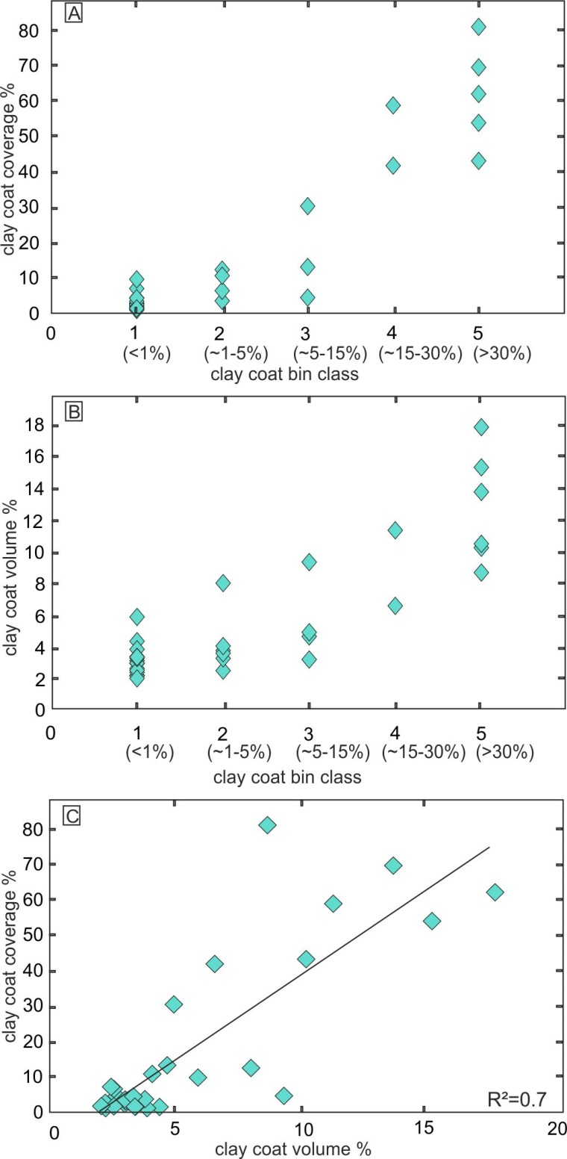

Figure 8 A) Scanning electron microscope–energy-dispersive spectrometry (SEM-EDS) of a Lower Jurassic chlorite-cemented sandstone, North Sea reservoir, showing the cross-sectional perimeter length method (Petrog). B) Image illustrating step 1 of the method, defining the perimeter length of each grain. C) Image illustrating the technique of clay-coat-coverage characterization (yellow nodes; grain outline; green nodes: location of attached clay coats).
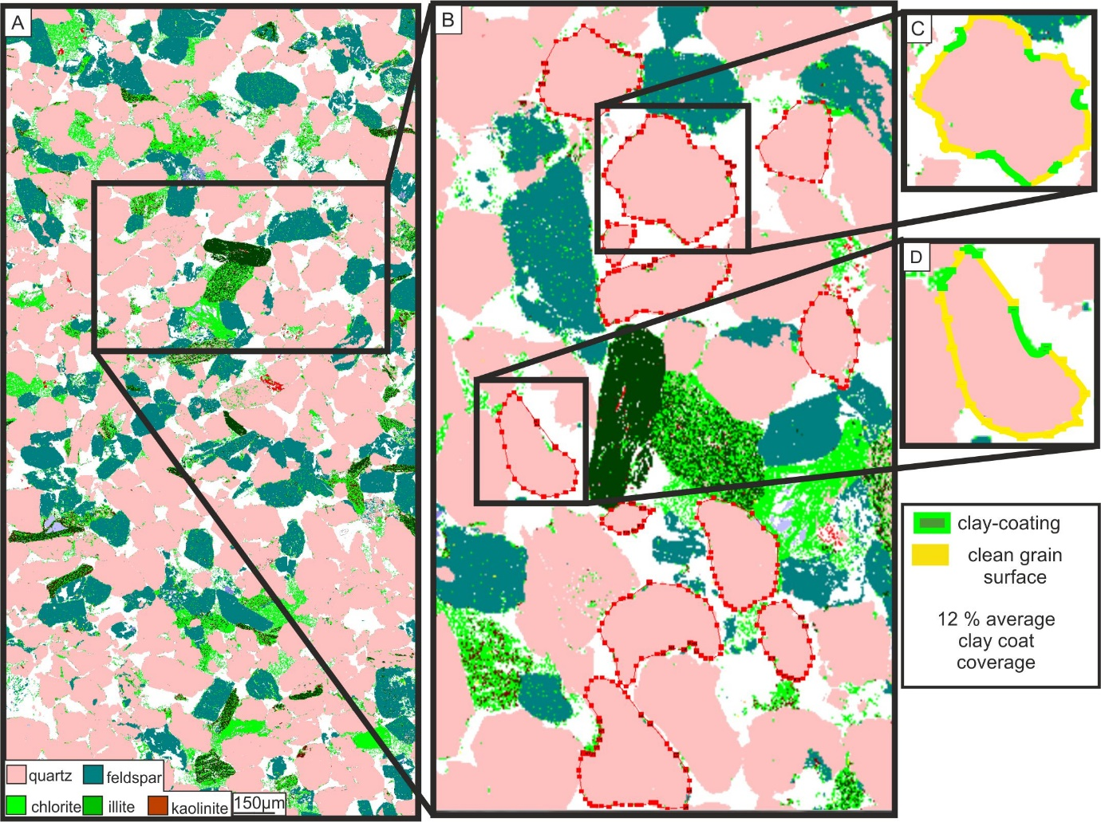

Figure 9 A) Images of scanning electron-microscope–energy dispersive spectrometry (SEM-EDS) of a Lower Jurassic chlorite-cemented sandstone, North Sea reservoir, showing the SEM-EDS method for calculating clay-coat volume. B) Enlarged SEM-EDS image identifying the presence of clay-coat coverage. C, D, E) are images depicting the internal distribution of the component clay-mineral assemblage (e.g., clay coats, pore-filling, or grain-replacing chlorite, kaolinite, and illite).
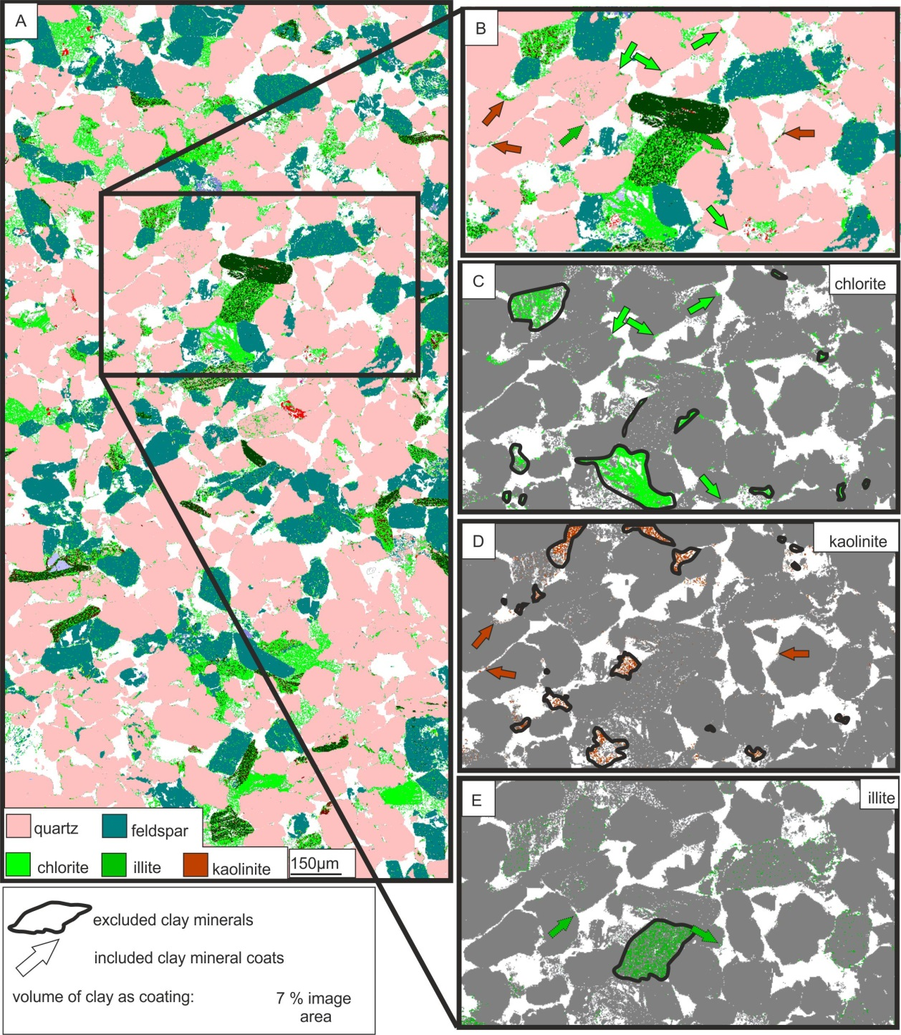

Table 1 Clay-coat heterogeneity of the Ravenglass Estuarine system. The table compares qualitative (SEM) and quantitative (Petrog and SEM-EDS) methods for assessing grain-coat coverage.
