CIRP Manufacturing Systems Conference 2019
An Ontology for Supporting Digital Manufacturability Analysis
Ji Han^{a,}*, Dirk Schaeferª
ª Division of Industrial Design, University of Liverpool, Brownlow Hill, Liverpool, L69 3GH, UK

* Corresponding author. Tel.: +44 (0)151 793 4429. E-mail address: ji.han@liverpool.ac.uk
Abstract
Cloud-Based Design and Manufacturing refers to a service-oriented networked product development model. It involves digital design and manufacturing processes, such as designing a product using CAD and generating prototypes via additive manufacturing. Unfortunately, designs that look fine on the CAD screen often turn out misshaped on the 3D-printer. The root cause of this is a mismatch between CAD geometry and 3D-printer capabilities. In this paper, the authors investigate this issue and propose an ontology for capturing core data of CAD models and 3D-printers with the aim to support smart digital design-to-manufacture analysis apps for matching suitable printers to design models.

© 2019 The Authors. Published by Elsevier Ltd. This is an open access article under the CC BY-NC-ND license (http://creativecommons.org/licenses/by-nc-nd/3.0/)
Peer-review under responsibility of the scientific committee of the 52nd CIRP Conference on Manufacturing Systems.
Keywords: Cloud-Based Design and Manufacturing; Industry 4.0; 3D-Printing; Ontology; Digital Design for Manufacture; Manufacturability Analysis

- Introduction
Cloud-Based Design and Manufacturing (CBDM) is a service-oriented networked product development model that allows consumers to configure, select, and use customized product realization resources, such as computer-aided design/manufacturing (CAD/CAM) tools [1]. Wu et al. [2] concluded that the benefits of CBDM are enhanced functionality, anytime and anywhere access, cost efficiency, secure and high volume data storage, high flexibility and high throughput. The characteristics of CBDM along with an increasing number of CAD and CAM platforms, such as Fusion 360 and NX, have provided consumers with the possibility of designing and then manufacturing a product or prototype via the cloud.
Additive manufacturing is a manufacturing process that has mostly separated cost and complexity as well as the capability of manufacturing complex hierarchical structures [3]. Low-cost desktop 3D-printers, involving FDM (fused deposition modelling) printers, are used increasingly nowadays for rapid manufacturing. However, products or models, which look fine on CAD computer screens, often come out misshaped on 3D-printers.
Goguelin et al. [4] claimed that the root causes of this problem involve: the data imported into the 3D-printer, inappropriate design features, and the mismatch between CAD geometry and 3D-printer capabilities. Errors in CAD models would reduce the manufacturability. This is generally caused by the .STL file format, which exhibits various penitential issues such as missing facets and overlapping facets [5]. The mismatch between geometry requirement and printer capability often requires experts to solve this issue. Understanding the capabilities of different 3D-printers is the first and the most important phase of selecting an appropriate printer to manufacture the designed digital models. Capabilities of FDM 3D-printers include items such as dimensional accuracy and overhanging angle limit, while these capabilities vary from printers to printers [4].
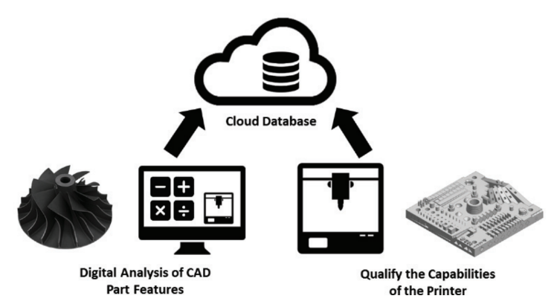
Alafaghani et al. [6] indicated that accuracies of the geometric dimensions of FDM parts are limited by the nozzle diameter, filament material property, layer thickness, and X, Y, Z positioning resolution. Shahrain et al. [7] explored that the top five FDM process parameters affecting the dimension accuracy of printed parts are the component size, extruder temperature, platform temperature, print orientation, and layer thickness. Basavaraj and Vishwas [8] claimed that 0.1 mm layer thickness, 30° orientation angle and 0.8mm shell thickness are the optimum FDM process parameters while using Nylon. Valerga et al. [9] showed that filament materials without pigmentation generally results in a better geometric dimension accuracy as well as a better surface quality. The surface quality of an FDM part is also related to the layer thickness, extrusion temperature, and extrusion width [10, 11].
Environmental conditions, such as the humidity of material storage environment and the temperature and moisture during printing affect FDM processes as well. However, these environmental factors mainly affect the mechanical properties of the FDM parts [9, 12]. Another limitation of FDM is the small build volume, which might force a design to be segmented into smaller parts [6].
In the manufacturing industry, increasing information complexity, lack of accessible knowledge repositories, insufficient information retrieval tools, and inconsistent terminology have generated a significant challenge in knowledge sharing and reuse [13]. Ontologies are thereby considered effective means for solving these issues, due to the information sharing capability. Additionally, ontologies are often used to support reasoning as well as manage and reuse data to assist design for manufacturing, aiming at reducing production costs without decreasing product quality [14].
The aim of this paper is to explore an approach to construct ontologies involving core data of CAD models and 3D-printers through embracing real-world datasets to solve the mismatch problem, and ultimately eliminate misshaped prints. The implementation of such an ontology in CBDM, or more specifically, a cloud-based manufacturability assistant can decrease the amount of expert knowledge required for producing successful 3D-printed designs.
The following section reviews related research projects on cloud-based manufacturability assistants as well as ontologies in design and manufacturing. Section 3 presents the structure of the ontology proposed and the approaches of constructing the ontology. Discussion and conclusions are presented in the last two sections, respectively.

- Related Work
  - Cloud-Based Manufacturability Assistant
A cloud-based manufacturability assistant, which bridges the gap between the digital world and the physical world via the cloud is proposed by Goguelin et al. [4] and depicted in Fig.1. The assistant involves two stages: 1. Analyzing the part features or geometry of digital CAD models; 2. Ascertaining the capabilities of 3D-printers for physical prints of the CAD models. It is considered a smart approach of design for additive manufacturing facilitating designers to produce complex physical parts, which are difficult for conventional subtractive manufacturing, at a low cost [15].

Fig.1. Schematic of a cloud-based manufacturability assistant [4]
The first stage is to upload a digital CAD model (.STL file) for inspection to ensure the model does not have like the ones described in the previous section. The geometry or features of the digital model, such as overall part dimensions and 3D-printer manufacturability features involving overhang angles, sharp corners, thin regions and openings, need to be analyzed.
The next stage is to select appropriate printers through the cloud to produce the physical CAD model. A capability map is a documentation of the capabilities of a 3D-printer, which is uploaded onto the cloud. Different printers possess different capabilities, and thereby possess different capability maps. Values derived from the capability maps of the selected printers are used for comparison with the manufacturability analysis results produced at the first stage. The CAD model can be sent to a selected printer if the digital model is within the tolerances specified from the capability map of the printer. Users will receive feedback to either modify the digital model or to select other printers if the model could not align with the manufacturability of the existing printers on the cloud.
In order to realize the two stages involved in the cloud-based manufacturability assistant, a method to formalize this data for sharing and reusing is required. Utilizing ontologies involving formalized data derived from CAD-models and 3D-printers could be a potential method.
  - Ontologies in Design and Manufacturing
An ontology is an explicit formal specification of a shared conceptualization of a domain involving entities and their relationships [16-19]. It is a metadata schema providing machine-understandable concepts with explicitly defined semantics [20], which is significant in representing and exchanging knowledge [21]. It is used to formalize the knowledge in a domain in a manner that makes it reusable, shareable and accessible [22]. Ontologies possess well-defined structures of knowledge, which are machine understandable, enabling automatic reasoning. However, ontologies often require to be manually designed for new use-cases [23].
Ontologies are used in a variety of fields, involving both design and manufacturing. In design, ontologies are used to support creative idea generation [24], informational retrieval [25], product family design [26], design query expansion [27], and so forth. Besides, a number of ontology models, such as the FBS (function-behavior-structure) ontology for representing objects and processes [18, 28], the Design Ontology for product development [29], and the ontology for complex design engineering information exploration [30], have been developed to support various design activities.
As illustrated in the first section, ontologies are used commonly for supporting manufacturing. Chang et al. [14] indicated that using ontologies for design for manufacturing (DFM) could benefit the reuse of existing data, identify inconsistencies and errors in data, and support decision making involving complex technical and economic criteria.
Wu et al. [31] claimed that semantic web (ontology) could facilitate CBDM in design and manufacturing data representation, which thereby supports designers and engineers in sharing and reusing these data in an effective and efficient manner.
A number of research projects have explored the use of ontologies in manufacturing. For example, Chhim et al. [13] proposed an ontology based on product design and manufacturing process for manufacturing knowledge reuse; Lin et al. [32] explored a manufacturing system engineering ontology for supporting semantic interoperability and knowledge reuse across groups; Panetto et al. [33] presented a product ontology to facilitate technical data interoperability within the manufacturing process environment.

  - Ontologies in Additive Manufacturing
Additive manufacturing is a challenging and complex process, even for expert designers, as it is difficult to select appropriate variable values without formal and structured guidelines to achieve desired physical prints [15, 34]. The increasing varieties of 3D-printers developed have led to various printer capabilities, such as minimum layer thickness and wall thickness. Ontologies could be used to capture and organize these data to support designers, especially novices, in additive manufacturing.
Dinar and Rosen [15] proposed a design for additive manufacturing (DFAM) ontology to store domain and experimental knowledge, guide designers in a tutoring system, and be employed as the basis of a CAD tool. Based on this DFAM ontology, Kim et al. [35] proposed an advanced DFAM ontology involving three high-level classes: feature, parameter and additive manufacturing capability. This new version of the DFAM ontology aims to formalize a knowledge base to store and reuse expert knowledge. Liang [36] proposed a new ontology, AM-OntoProc, for modelling and re-utilizing knowledge to support process planning in additive manufacturing. However, these ontologies could not support digital design-to-manufacture analysis for matching suitable printers to design models.
- An Ontology for Supporting Digital Manufacturability Analysis
  - The Digital Manufacturability Analysis Ontology
Based on related studies on ontologies and the schematic of the cloud-based manufacturability assistant proposed by Goguelin et al. [4], we have proposed an ontology to support digital manufacturability analysis (DMA) and ultimately realize the manufacturability assistant. The essential structure of the DMA ontology is shown in Fig.2.
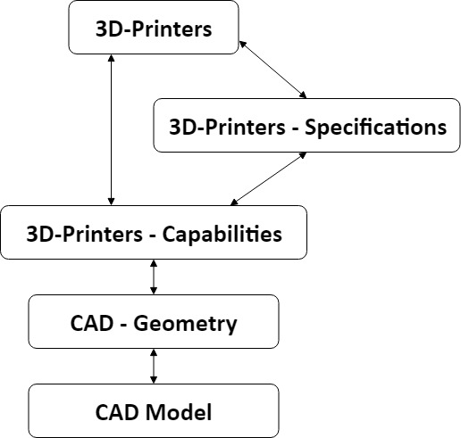
Fig.2. The essential structure of the DMA ontology
The main objectives of the DAM ontology are to: (1) capture essential data of CAD models and 3D-printers; (2) establish relations between CAD models and feature geometry, as well as 3D-printers and printer capabilities; (3) match CAD model geometry with appropriate printer capabilities.
As shown in Fig.2, the DAM ontology involves five elements, alternatively five types of manufacturability-related data. CAD model refers to the digital CAD file, such as a digital model in the format of .STL file. CAD geometry involves dimensions of parts and features such as overhang angles, sharp corners, thin walls and openings. According to [4-12], the core capabilities of a 3D-printer involve: minimum layer thickness, minimum wall thickness (x-y plane), minimum rectangle size (x-y plane), minimum circle size (x-y plane), tolerance for loose (x-y & z planes), geometric deviation if printed on angle, minimum distance between features, print orientation, extruder temperature, platform temperature, and filament material property (the filament loaded on the 3D-printer). Moreover, more misshaped print and geometric accuracy related capabilities of 3D-printers will be added through future research. 3D-printer specifications involve build volume, print speed, supported materials, layer resolution, and so forth, which are the technical characteristics of the printer provided by the manufacturers. 3D-printers refer to the different models of printers, for instance, the Ultimaker 3, the MakerBot Replicator + and the Up Box.
The relations between CAD geometry and CAD model can be established through decomposing the digital model into slices or layers for analysis to identify features, such as dimensions, sharp corners and thin walls, involved in the model.
The sub-ontology involving data of 3D-printers, printer specifications and their relationships can be constructed by using data mining and machine learning. The data-driven approach of constructing unsupervised learning ontology networks proposed by Shi et al. [30] could be implemented to achieve this. Information of 3D-printers and specifications are stored electronically and digitally on the internet, which facilitates the data-mining process.
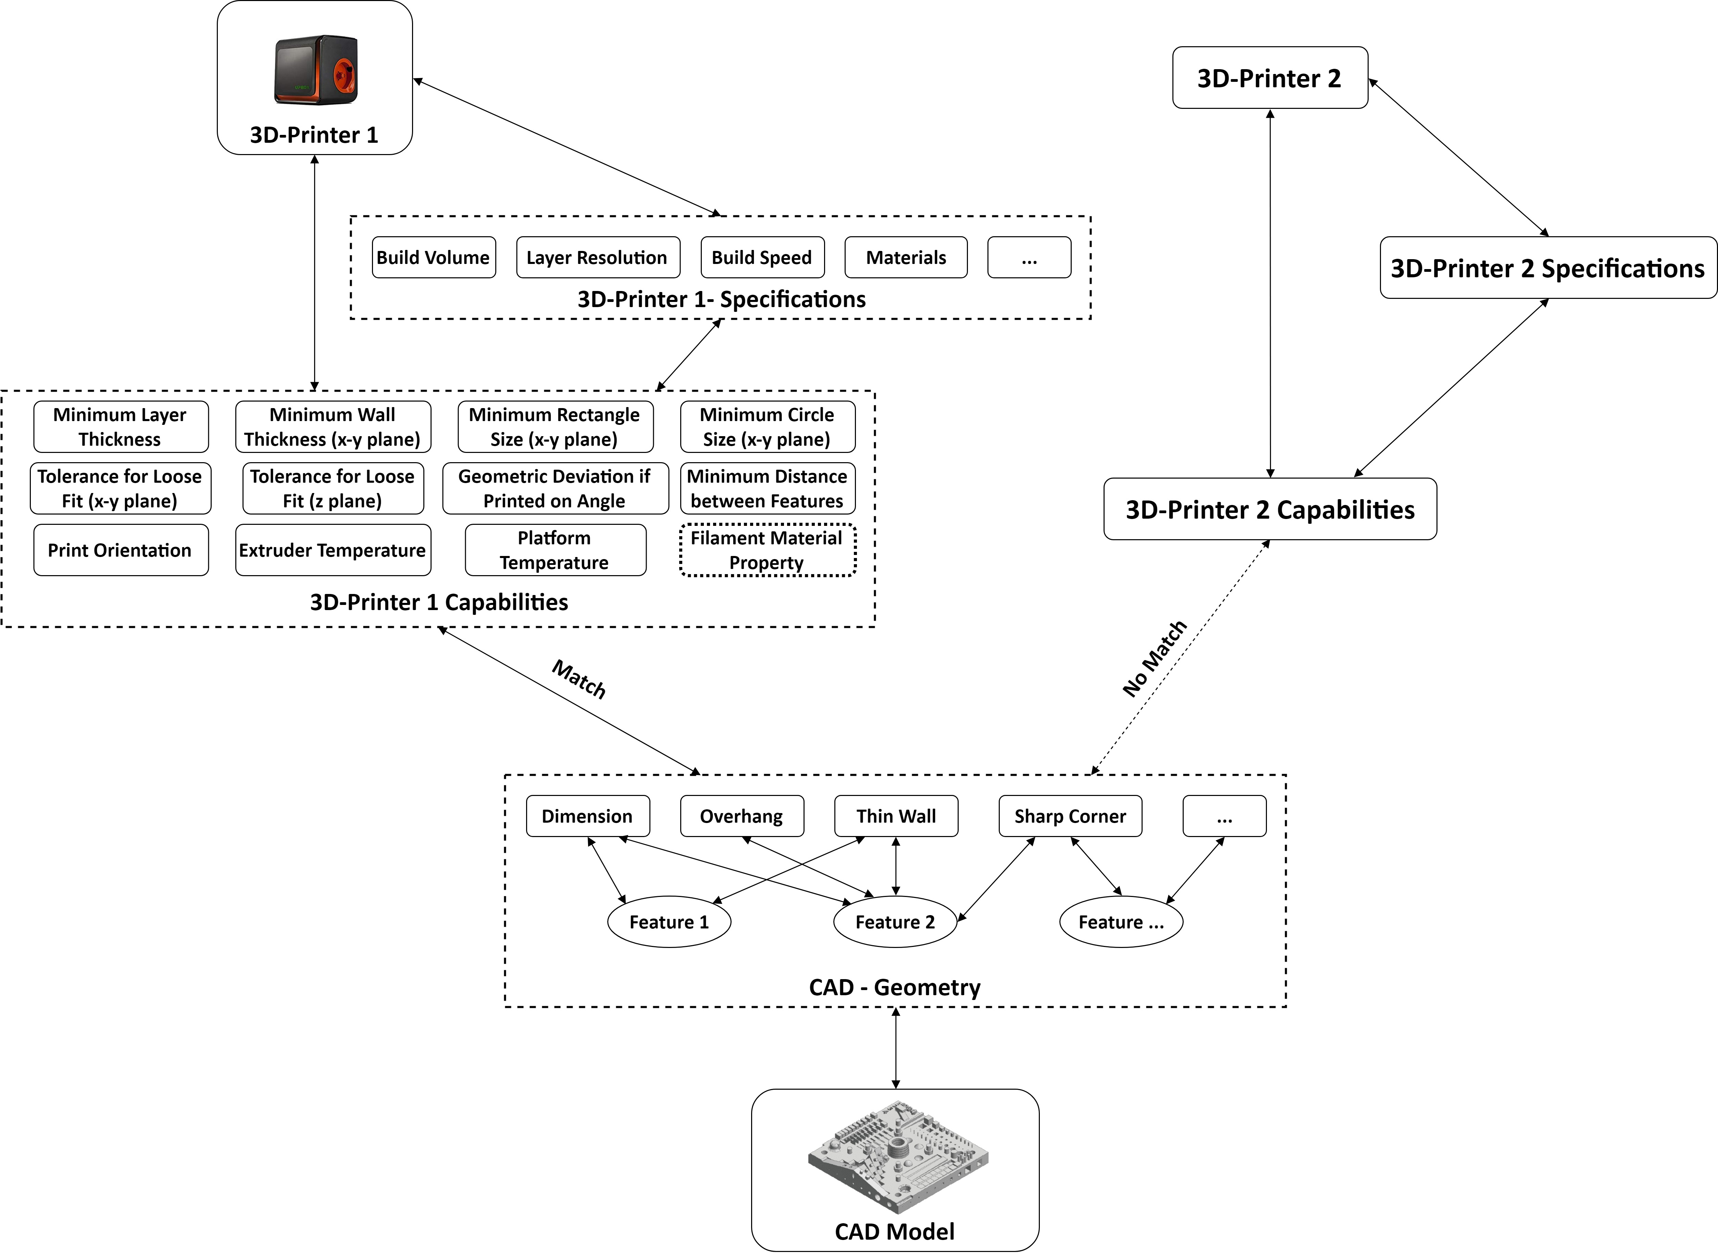
Items involved in the 3D-printer capabilities are related to the 3D-printer specifications as well as the printer per se. For example, the layer resolution in the 3D-printer specifications is related to the minimum layer thickness in the 3D-printer capabilities, and the build volume in the specifications is related to the capability of the maximum print sizes. However, it seems that not all the printer capabilities could be derived from the specifications. For instance, it is challenging to derive the minimum circle and rectangle sizes from the 3D-printer specifications. Goguelin et al. [4] employed qualitative and quantitative methods to measure the capabilities of a 3D-printer by using a standard test part. Visual inspections were used as a qualitative approach for measuring capabilities such as minimum readable font size, maximum overhang angle without support structures, and minimum feature size of a cone. Other capabilities, such as minimum wall thickness, minimum circle and rectangle sizes, geometric deviation if printed on angle, and minimum distance between features, were measured quantitatively by using micrometers, microscopes and Vernier calipers. Constructing ontologies that involve 3D-printers, specifications and capabilities might be time-consuming as some capabilities need to be measured manually.
The construction of the relations between 3D-printer capabilities and CAD model geometry is a matching process. Matching indicates that a printer capability could satisfy a CAD geometry feature. For instance, the minimum wall thickness of a printer is 1mm, while a thin wall feature involved in a CAD model is 1.5mm. Thus, the printer capability could satisfy this CAD model feature, which implies a match between the printer capability of minimum wall thickness and this thin wall feature of the CAD model. However, all the printer capabilities need to match with all the features of the digital CAD model, in order to establish an overall matching relation between the capabilities of a printer and the digital CAD model. An algorithm is needed to be explored for constructing the sub-ontology involving printer capabilities and CAD model geometry.
Fig.3. An example of the proposed DMA ontology
The DMA ontology structure is illustrated above involving potential approaches of constructing the ontology. The implementation of this ontology into the cloud-based manufacturability assistant could help users select appropriate 3D-printers for manufacturing various digital CAD models.
  - An Example of the DMA Ontology
An example of using the DMA ontology in the cloud-based manufacturability assistant to select an appropriate printer based on a given CAD model is shown in Fig.3. The CAD model is analyzed and decomposed into different features, and a sub-ontology of the CAD model and its geometry is thereby constructed. The sub-ontology involving different types of 3D-printers along with specifications and capabilities is constructed for matching with the geometry of the digital CAD model. The capabilities of 3D-printer 1 could satisfy all the features involved in the CAD model, but the capabilities of 3D-printer 2 could not meet all the features. As shown in Fig.3, there is a ‘match’ relation between the CAD model geometry and the 3D-printer 1 capabilities, while there is a ‘no match’ relation between the CAD geometry and the 3D-printer 2 capabilities. Therefore, 3D-printer 1 is an appropriate one to manufacture the digital CAD model, while 3D-printer 2 is not applicable. As a result, the users could select and find a 3D-printer 1 on the cloud for manufacturing the model avoiding misshaped print. While there are more than one 3D-printer suitable for producing the given CAD model, the selection of the printer is mainly based on non-capability related factors such as printer location, availability, and printing price.
- Discussion
In this paper the authors proposed and explored an ontology, namely the DMA ontology, for supporting digital manufacturability analysis processes, such as matching suitable printers to design models. It complements other existing ontologies, such as DFAM [15, 35] and AM-OntoProc [36], which are aimed at storing and reusing expert knowledge as well as supporting process planning. The DMA ontology could be implemented into the cloud-based manufacturability assistant proposed by Goguelin et al. [4] to support the selection of appropriate printers to avoid misshaped prints. However, there exist several challenges to producing such a DMA ontology.
The first challenge is the construction of the sub-ontology involving 3D-printers and the capabilities. As illustrated above, it is challenging to derive some of the printer capabilities from the specifications directly, such as the maximum overhang angle without support structures. In addition, the specifications of different printers provided by different manufacturers do not have the same standard. Therefore, qualitative and quantitative manual processes could be employed to measure the capabilities of a 3D-printer. However, the sub-ontology construction based on the manual measurement processes could be time-consuming. Crowdsourcing, which is identified as ‘a valuable paradigm in the open design movement’ [37], could be used to obtain the knowledge of different 3D-printers’ capabilities from the crowd. This could support the construction of the sub-ontology of the 3D-printers and corresponding capabilities. Another approach to constructing this sub-ontology is to investigate a computational algorithm to derive capabilities from the printer specifications provided by manufactures.
The second challenge is the matching between the printer capabilities and the CAD geometry. Some of the design features are correlated to specific capabilities directly, such as thin walls and minimum wall thickness as well as dimensions and the printer build volume. However, several printer capabilities might be needed jointly to satisfy complex geometry features such as sharp corners and sharp edges. This requires a further investigation to identify which type of feature is related to which printer capabilities. This could assist the construction of the ‘match’ and ‘no match’ relations between the CAD geometry and 3D-printer capabilities.
The third challenge is to unify the different sub-ontologies of DMA ontology. As illustrated above, different sub-ontologies are constructed through using different methods. For example, the sub-ontology of a 3D-pinter and its capabilities is constructed through a manual measurement process and utilizing crowdsourcing, while the sub-ontology of a 3D-printer and its specifications is constructed by using data mining and machine learning. Therefore, an algorithm needs to be explored to synthesize all the sub-ontologies to produce a holistic DMA ontology.
The last challenge is that the construction of the DMA ontology might be a dynamic process, due to numerous digital CAD models and geometry features, as well as the growing number of different 3D-printers. Therefore, the DMA ontology needs to obtain new data dynamically to support the matching between various digital CAD models and appropriate 3D-printers.
- Conclusions and Future Work
Additive manufacturing methods, such as using low-cost FDM 3D-printers, are often used in rapid prototyping and manufacturing nowadays. However, one of the most common issues of 3D-printing is that digital models that look fine on CAD systems often turn out misshaped on 3D-printers. A root cause of this problem is the mismatch between CAD geometry and 3D-printer capabilities involving significant FDM process parameters, such as component size, extruder temperature, platform temperature, print orientation, and layer thickness, which affect geometric dimension accuracy of printed parts.
In this paper the authors presented an ontology to analyze digital manufacturability in order to solve the mismatch issues between CAD geometry and 3D-printer capabilities. The ontology, named the DMA ontology, could be implemented into the cloud-based manufacturability assistant to help users select appropriate 3D-printers on the cloud for manufacturing digital CAD models. The aim of using the DMA ontology is to fundamentally solve the common printing problems of misshaped prints. The DMA ontology could support individuals, such as designers, engineers, students and amateurs, who have insufficient expert knowledge in FDM printers to select suitable printers for producing successful 3D-printed designs.
This study has provided new insights into Cloud-Based Design and Manufacturing, utilizing the cloud to support digital manufacturability analysis. This could help users and consumers to manufacture successful prototypes and models through using additive manufacturing, with a minimum amount of expert knowledge.
Future studies are planned to explore the challenges indicated in the discussion section. Further, a DMA ontology involving a number of 3D-printers is planned to be implemented into the cloud-based manufacturability assistant to provide more details of how the ontology may function through conducting a series of case studies, and ultimately justify the feasibility and usefulness of the DMA ontology.
References
[1] Wu D, Rosen DW, Wang L, Schaefer D. Cloud-based design and manufacturing: A new paradigm in digital manufacturing and design innovation. Computer-Aided Design. 2015;59:1-14. doi: 10.1016/j.cad.2014.07.006
[2] Wu D, Greer MJ, Rosen DW, Schaefer D. Cloud manufacturing: Strategic vision and state-of-the-art. Journal of Manufacturing Systems. 2013;32(4):564-79. doi: 10.1016/j.jmsy.2013.04.008
[3] Gibson I, Rosen D, Stucker B. Additive Manufacturing Technologies - 3D Printing, Rapid Prototyping, and Direct Digital Manufacturing. New York: Springer-Verlag; 2015.
[4] Goguelin S, Colaco J, Dhokia V, Schaefer D. Smart Manufacturability Analysis for Digital Product Development. Procedia CIRP. 2017;60:56-61. doi: 10.1016/j.procir.2017.02.026
[5] Leong KF, Chua CK, Ng YM. A study of stereolithography file errors and repair. Part 1. Generic solution. The International Journal of Advanced Manufacturing Technology. 1996;12(6):407-14.
[6] Alafaghani Aa, Qattawi A, Ablat MA. Design consideration for additive manufacturing: fused deposition modelling. Open Journal of Applied Sciences. 2017;7(06):291-318.
[7] Shahrain M, Didier T, Lim GK, Qureshi AJ. Fast Deviation Simulation for ‘Fused Deposition Modeling’ Process. Procedia CIRP. 2016;43:327-32. doi: 10.1016/j.procir.2016.02.004
[8] Basavaraj CK, Vishwas M. Studies on Effect of Fused Deposition Modelling Process Parameters on Ultimate Tensile Strength and Dimensional Accuracy of Nylon. IOP Conference Series: Materials Science and Engineering. 2016;149:012035.
[9] Valerga AP, Batista M, Salguero J, Girot F. Influence of PLA Filament Conditions on Characteristics of FDM Parts. Materials (Basel, Switzerland). 2018;11(8):1322. doi: 10.3390/ma11081322
[10] McCullough EJ, Yadavalli VK. Surface modification of fused deposition modeling ABS to enable rapid prototyping of biomedical microdevices. Journal of Materials Processing Technology. 2013;213(6):947-54.
[11] Ahn D, Kweon J-H, Kwon S, Song J, Lee S. Representation of surface roughness in fused deposition modeling. Journal of Materials Processing Technology. 2009;209(15):5593-600.
[12] Kim E, Shin Y-J, Ahn S-H. The effects of moisture and temperature on the mechanical properties of additive manufacturing components: fused deposition modeling. Rapid Prototyping Journal. 2016;22(6):887-94. doi: 10.1108/RPJ-08-2015-0095
[13] Chhim P, Chinnam RB, Sadawi N. Product design and manufacturing process based ontology for manufacturing knowledge reuse. Journal of Intelligent Manufacturing. 2017. doi: 10.1007/s10845-016-1290-2
[14] Chang X, Rai R, Terpenny J. Development and Utilization of Ontologies in Design for Manufacturing. Journal of Mechanical Design. 2010;132(2):021009--12. doi: 10.1115/1.4000697
[15] Dinar M, Rosen DW. A Design for Additive Manufacturing Ontology. Journal of Computing and Information Science in Engineering. 2017;17(2):021013--9. doi: 10.1115/1.4035787
[16] Gruber TR. A translation approach to portable ontology specifications. Knowledge acquisition. 1993;5(2):199-220.
[17] Lin J, Fox MS, Bilgic T. A requirement Ontology for engineering design. Concurrent Engineering. 1996;4(3):279-91. doi: 10.1177/1063293x9600400307
[18] Gero JS, Kannengiesser U. A function–behavior–structure ontology of processes. Artificial Intelligence for Engineering Design, Analysis and Manufacturing. 2007;21(4):379-91. doi: 10.1017/S0890060407000340
[19] Raad E, Evermann J. The role of analogy in ontology alignment: A study on LISA. Cognitive Systems Research. 2015;33:1-16. doi: 10.1016/j.cogsys.2014.09.001
[20] Maedche A, Staab S. Ontology learning for the semantic web. IEEE Intelligent systems. 2001;16(2):72-9.
[21] Obitko M, Snasel V, Smid J, Snasel V, editors. Ontology Design with Formal Concept Analysis. CLA; 2004.
[22] Darlington MJ, Culley SJ. Investigating ontology development for engineering design support. Advanced Engineering Informatics. 2008;22(1):112-34. doi: 10.1016/j.aei.2007.04.001
[23] Kiritsis D, El Kadiri S, Perdikakis A, Milicic A, Alexandrou D, Pardalis K, editors. Design of Fundamental Ontology for Manufacturing Product Lifecycle Applications2013; Berlin, Heidelberg: Springer Berlin Heidelberg.
[24] Han J, Shi F, Chen L, Childs PRN. A computational tool for creative idea generation based on analogical reasoning and ontology. Artificial Intelligence for Engineering Design, Analysis and Manufacturing. 2018;32(4):462-77. doi: 10.1017/S0890060418000082
[25] Li Z, Ramani K. Ontology-based design information extraction and retrieval. Artificial Intelligence for Engineering Design, Analysis and Manufacturing. 2007;21(2):137-54.
[26] Liu Y, Lim SCJ, Lee WB. Product Family Design Through Ontology-Based Faceted Component Analysis, Selection, and Optimization. Journal of Mechanical Design. 2013;135(8):081007.
[27] Shi L, Setchi R. Ontology-based personalised retrieval in support of reminiscence. Knowledge-Based Systems. 2013;45:47-61.
[28] Gero JS, Kannengiesser U. The Function-Behaviour-Structure Ontology of Design. In: Chakrabarti A, Blessing LTM, editors. An Anthology of Theories and Models of Design: Philosophy, Approaches and Empirical Explorations. London: Springer London; 2014. p. 263-83.
[29] Štorga M, Andreasen MM, Marjanović D. The design ontology: foundation for the design knowledge exchange and management. Journal of Engineering Design. 2010;21(4):427-54.
[30] Shi F, Chen L, Han J, Childs P. A Data-Driven Text Mining and Semantic Network Analysis for Design Information Retrieval. Journal of Mechanical Design. 2017;139(11):111402--14. doi: 10.1115/1.4037649
[31] Wu D, Thames JL, Rosen DW, Schaefer D. Enhancing the Product Realization Process With Cloud-Based Design and Manufacturing Systems. Journal of Computing and Information Science in Engineering. 2013;13(4):041004--14. doi: 10.1115/1.4025257
[32] Lin HK, Harding * JA, Shahbaz M. Manufacturing system engineering ontology for semantic interoperability across extended project teams. International Journal of Production Research. 2004;42(24):5099-118. doi: 10.1080/00207540412331281999
[33] Panetto H, Dassisti M, Tursi A. ONTO-PDM: Product-driven ONTOlogy for Product Data Management interoperability within manufacturing process environment. Advanced Engineering Informatics. 2012;26(2):334-48. doi: 10.1016/j.aei.2011.12.002
[34] Liu X, Rosen DW, editors. Ontology Based Knowledge Modeling and Reuse Approach of Supporting Process Planning in Layer-Based Additive Manufacturing. 2010 International Conference on Manufacturing Automation; 2010 13-15 Dec. 2010. doi: 10.1109/ICMA.2010.40
[35] Kim S, Rosen DW, Witherell P, Ko H. A Design for Additive Manufacturing Ontology to Support Manufacturability Analysis. 2018(51753):V02AT3A036. doi: 10.1115/DETC2018-85848
[36] Liang JS. An ontology-oriented knowledge methodology for process planning in additive layer manufacturing. Robotics and Computer-Integrated Manufacturing. 2018;53:28-44. doi: 10.1016/j.rcim.2018.03.003
[37] Forbes HL, Schaefer D. Crowdsourcing in product development: Current state and future research directions. DS92: Proceedings of the DESIGN 2018 15th International Design Conference2018. p. 579-88.

