Please cite the paper as:

Chen, L., Wang, P., Dong, H., Shi, F., Han, J., Guo, Y., Childs, P.R.N., Xiao, J. & Wu, C., 2019. An artificial intelligence based data-driven approach for design ideation. Journal of Visual Communication and Image Representation, 61, pp. 10-22. doi: 10.1016/j.jvcir.2019.02.009.

An artificial intelligence based data-driven approach for design ideation

Liuqing Chen, Pan Wang, Hao Dong, Feng Shi, Ji Han, Yike Guo, Peter R.N. Childs, Jun Xiao, Chao Wu

Abstract:
Ideation is a source of innovation and creativity, and is commonly used in early stages of engineering design processes. This paper proposes an integrated approach for enhancing design ideation by applying artificial intelligence and data mining techniques. This approach consists of two models, a semantic ideation network and a visual concepts combination model, which provide inspiration semantically and visually based on computational creativity theory. The semantic ideation network aims to provoke new ideas by mining potential knowledge connections across multiple knowledge domains, and this was achieved by applying ‘‘step-forward” and ‘‘path-track” algorithms which assist in exploring forward given a concept and in tracking back the paths going from a departure concept through a destination concept. In the visual concepts combination model, a generative adversarial networks model is proposed for generating images which synthesize two distinct concepts. An implementation of these two models was developed and tested in a design case study, which indicated that the proposed approach is able to not only generate a variety of cross-domain concept associations but also advance the ideation process quickly and easily in terms of quantity and novelty.

Keywords: Idea generation, Artificial intelligence in design, Data-driven design, Generative adversarial networks, Semantic network analysis, Network visualisation, Computational creativity

- Introduction

In the early stage of a design process, idea generation is often needed for conceptual design in order to explore the design solution space for a given a design problem. Idea generation tends to encompass all the elements of a thought cycle, from creative formulation to innovative manifestation of ideas, and includes generating a number of ideas, a variety of ideas, and creative and valuable ideas. How to effectively generate novel and useful design ideas continues to be a critical issue for both design scholars and practitioners [1]. A variety of ideation methodologies have been developed and employed. Bio-inspired design is a methodology dating back to the nineteenth century which tries to obtain inspiration from biology and applies to different design fields, such as architecture and product design [2]. Design-by-analogy is a knowledge-based design methodology on how to identify analogies and analogous domains for analogous design, such as the WordTree Design-by-Analogy method proposed by Linsey and Wood [3]. There are some popular idea generation approaches that have widely been used in design practice, and these approaches generally increase the idea productivity of participants by guiding the direction of their thoughts. For example, morphological analysis is used by creating a morphological chart in which identified subfunctions are listed and solutions for each subfunction are created [4].

With the advent of interest in big-data, massive information stored in digital forms provides a convenient way for people to explore knowledge. Recently, there has been a trend of learning new patterns by exploring large datasets [5]. Generating ideas in a data-driven way expands the design space to discover new feasible designs [6]. During an ideation process, potential stimuli such as analogies and bio-inspired knowledge can be provided by artificial intelligence based data-driven algorithms. In this paper, by reviewing existing approaches for ideation, we propose an integrated artificial intelligence based data-driven approach for design idea generation, not only in a semantic way but also in a visual way. Two different models are discussed in the proposed approach, and are implemented for verification in a design case study. The main contributions of this paper can be summarized as follow:

(1). An integrated approach, which combines data-driven and artificial intelligence techniques, is proposed for design ideation, which aims to efficiently improve the ideation process.

(2). A semantic ideation network model consisting of algorithms of “step-forward” and “path-track” is proposed and implemented for retrieving far associated concepts which are then visualised in a semantic network graph as creativity stimuli.

(3). A model for generating novel synthesized images as stimuli of ideation is proposed. This utilizes the state-of-the-art generative adversarial networks to learn images presenting two distinct concepts, and outputs the learnt features in the form of the image.

(4). A case study is conducted to demonstrate the proposed approach, while evaluating how the developed approach is able to help generate ideas and how it performs.

- Related work

There have been many design ideation approaches proposed from both traditional and computational creativity research. To facilitate the review and further evaluation of the proposed approach, we divide ideation approaches into three categories according to their computer-based automation levels. The traditional ideation approaches fall into the lowest level of automation, they are mostly developed based on design principles and design thinking methodologies. The program-based ideations are the automation implementations of traditional ideation, or integrations of the advantages of several design approaches. The highest automaton level is data-driven which relies on data analysis exclusively. In each category, an example is highlighted to illustrate related techniques and for comparing corresponding approaches.

2.1. Traditional ideation approaches
An ideation approach needs to effectively influence the thinker during idea generation. A number of traditional ideation approaches have been developed from different perspectives. Design heuristics focuses on identifying ideation strategies used by engineers when they solve design problems [7]. It is defined as cognitive prompts which guide designers towards the exploration of design solutions. Albers et al. studied creativity from the perspective of product generation engineering (PGE), in which three types of variation (carryover, embodiment and principle variation) are presented for developing the new generation of technical products [8]. These three types of variation show how analogy can be used in produce generation development. SPALTEN is a methodology proposed for problem-solving by identifying the phases of product development as well as the overall aim in the form of a marketable product [9].

Analogical reasoning has been well known for producing creativity, Goel and Bhatta introduced model-based analogy (MBA) which provides a process account of acquisition, access, and use of a class of design patterns (called generic teleological mechanisms, GTMs). Their study has shown how structure-behaviour-function (SBF) models enable the acquisition of GTMs and how adapting familiar designs meet new design requirements in the access, transfer, and use of previously learned GTMs [10]. Vattam et al. developed an interactive knowledge-based design environment DANE for capturing the functioning of biological systems with SBF schema. DANE interactively facilitate biologically inspired design by identifying biological systems relevant to a given design problem and aiding the understanding of biological systems’ functioning [11].

Distant analogies play an important role in analogical reasoning. By parametrically manipulating semantic distance in analogical solution, it has been demonstrated that creativity is associated with distant analogies from the view of neuroscience [12]. Using spreading activation, Wolverton and Hayes-Roth [13] proposed a method for retrieving distant analogies in a large cross-domain semantic network. Crean and O’Donoghue [14] proposed a RADAR model for analogy retrieval based on the “derived attributes” technique, which was able to retrieve both semantically related and unrelated domains. In engineering design, Christensen and Schunn [15] reveal that analogy serves three functions when developing novel design concepts, which are problem identification, problem-solving and concept explanation.

2.2. Program-based ideation approaches
Program-based ideation tries to generate ideas and support the ideation process in a computer-aided way. Self et al. demonstrated that the digital sketching tool significantly increased the focus of attention compared to conventional sketching with pen and paper when doing a conceptual design work [16]. Mohan et al. created an instrument which was able to capture the sequence of search and solution strategies in association with ideation states while providing a range of ideation methods such as TRIZ and Biomimetics [17]. Huo et al. developed Window-shaping which used a tangible mixed-reality (MR) interaction metaphor for design ideation, and it allowed direct creation of 3D shapes on and around physical objects [18]. Wang proposed a context-awareness systematic approach for idea cultivation, construction, integration, and evaluation in a dynamic discovery process [19]. Chakrabarti et al. proposed an idea generation model by providing analogies from both natural and artificial worlds, and the model was implemented in software for automated analogical search of relevant ideas from databases to solve a given problem [20], but its data entries were quite limited and its ideation process was not fully understood.

Taking Han’s Combinator as an example, this is an image-stimuli computer program for ideation based on combinational creativity theory [21]. The Combinator aims to help novice designers, as well as experienced designers, generate ideas by presenting associated images in an overlapped form, thereby tackling challenges in fast-moving product design markets. In the software, users are free to provide a keyword, then choose how many nouns and in which way they would like to combine images. Combined images can be automatically presented to inspire designers according to their settings. As images are combined by putting them together but not synthesizing them, inspirations from such a combination approach are limited.

2.3. Data-driven ideation approaches
Rather than derive from design thinking or design principles, data-driven ideation approaches are developed based on data-driven creativity, which is an emerging branch of computational creativity placing data in the centre of creativity tool design [22]. Chan et al. revealed the effectiveness of analogical data in innovative design by conducting a case study of generating solution concepts for an engineering problem with provided U.S. patent database [23]. Varshney et al. proposed a big data approach for a computational creativity system with a case study on the generation of culinary recipes and menus [24], [25]. Lin et al. developed a Personalized Creativity Learning System (PCLS) to provide personalized learning paths for optimizing the performance of creativity with data mining techniques [26]. Amitash et al. developed an ideation tool called I-get to generate perceptual pictorial metaphors and novel ideas with its FISH (Fast Image Search in Huge database) data mining algorithm [27]. Toh et al. developed and empirically tested a data mining approach for evaluating creativity of large sets of design ideas in order to improve the efficiency and reliability of creativity evaluation [28].

Taking the associative browser Refinery as an example, Refinery users are allowed to specify the ‘frontier’ of their knowledge from literature by interacting with results. Specifically, by voting on results to express their degree-of-interest, users are able to identify desired documents from literature datasets with the support of bottom-up exploration of large and heterogeneous network data. Benefitting from its random-walk algorithm, the system computes the degree-of-interest scores for associated content, and visualizes the heterogeneous query nodes, facilitating serendipitous discovery and stimulating continued creativity [29]. Even though the network based browser enables users to explore heterogeneous data in a visualised way, creative knowledge (associations in Refinery) is obtained from voting scores in which human effort is involved.

Usually, traditional approaches require expertise in order to use them effectively (such as TRIZ) and a physical environment to proceed (such as gathering people in a meeting room), even though they are simple and easy to conduct. With the benefit of computing, program-based approaches are able to help generate ideas without high levels of subject-specific expertise, and guide the ideation process in a semi-autonomous way. Compared with program-based ideation, data-driven approaches are able to delve into creativity with data mining techniques exclusively rather than implement creativity theories where human intelligence is involved. However, current data-driven approaches focus on data mining and retrieval techniques [30], [31] but fail to provide data-driven strategies for creative thinking. Specifically, even though network based associative browser like refinery is a good way for exploration and visualisation, users are only able to retrieve associations or analogies without being guided to think creatively [32]. Besides, most data are expressed in a semantic way even it can be visualised in a graph, which means visual data (images) is less studied for idea generation. And a great deal of research is inspired by human attention mechanism, such as image memorability prediction [33], [34], image retrieval [31], [35], land mark search [30], [36], [37], which benefit us to learn ideas in a visual way. Han’s Combinator attempted to combine associated or analogical images as stimuli for creativity but failed to synthesize them into one image. By recognising the above issues, two models are explored for helping produce semantic ideas and visual ideas respectively, and are integrated based on combinational creativity.

- Proposed ideation approach

3.1. Theoretical basis of computational creativity for ideation
By having observed a large number of examples of human creativity, Boden [38] distinguishes three processes of creativity for modelling in artificial intelligence: combinatorial creativity, exploratory creativity, and transformational creativity. In exploratory creativity, Boden views the exploration of conceptual spaces as a territory map exploration, in which all possibilities could be encompassed such as serendipity and creativity. Wiggins [39] summarises Boden’s descriptive hierarchy of creativity, and proposes a framework for characterising exploratory creativity. Toivonen defines exploratory creativity as looking for patterns, rules, or models of a fixed type in given data from the view of data mining [40].

Arthur Koestler proposed a model of creative thinking which is referred to as bisociation. In this model, technical problems are solved by bridging knowledge in two otherwise not – or only very sparsely – connected domains whereas knowledge in a given domain is associated [41]. Transferring bisociation to a data analysis scenario places the discovery question on patterns across domains whereas the research question of pattern discovery in individual domains has already been tackled [42]. Of interest Dubitzky et al. compare bisociation with Boden’s definition of combinational creativity and regards them as aligned with each other, and they proposed a framework for bisociation from the view of computational creativity based on their observations [43]. Chan’s cognitive study also demonstrated that the combination of far-domain, less-common examples results in more novel solution concepts for innovative design tasks [23].

Combining Koestler’s bisociation with Boden’s exploratory creativity, a basic data-driven ideation approach can be extracted: taking datasets as a knowledge repository which can be explored like a territory map, and data can be seen as different locations distributed in the map. When collecting data in the knowledge repository from different domains, and comprehending any implicit or explicit relationships between the data, a creative idea then can be provoked by combining two in the map.

To facilitate such a map-like creative ideation process, two models, a semantic ideation network and a visual concepts combination model, are introduced in the following sections. The semantic ideation network provides a meaningful way to retrieve and visualise data so that inspirations are expected to be generated during the retrieval and visualisation process. Given two concepts which may not be perceived as closely associated, the visual concepts combination model is able to blend both concepts in a visualised way.

3.2. Semantic ideation network
An information network has many advantages in terms of data structure and data visualisation [40], [43]. It is flexible and allows integration of a large amount of information from various domains with varying quality in a flexible way [44]. In various knowledge discovery fields, network-based visual analytic tools are designed to relieve information overload and assist browsing knowledge, such as associative browser Refinery introduced in Section 2 [37]. The network structure provides a quantitative representation of the ‘interconnectedness’ between elements, while the network composition describes the characteristics of the network’s constituent elements and quantifies the diversity of those attributes. The network’s elements are referred to as nodes, and the relationship between two nodes commonly represented as a line and referred to as edges [45].

Currently, available network databases such as WordNet, ConceptNet, and YAGO are ontology-based but the relations between ontologies are semantically close that it is difficult to stimulate creative ideas [46]. For example, given the keyword “desalination”, the results retrieved from ConceptNet are salt, process, desalinator, separating and so on. But with far association based retrieval techniques, results can be more useful, such as solar energy, reverse osmosis, hydrophobic membrane [47]. Therefore, it is essential to construct a far-associated semantic network for information retrieval. The general network construction process includes data collection, data pre-processing, network data construction and network analysis. Usually, data sources can be obtained in multiple ways, such as web crawling, harvest and support industry. In the data preprocessing step, compared to traditional unsupervised statistical approaches like TF-IDFs [48], linguistic approaches are better at capturing both semantic and syntactic meanings in natural language processing (NLP) tasks, such as shallow general NLP framework [49]. In the syntactical level of a shallow framework, the analysis includes tokenizing, part-of-speech tagging (POS tagging), disambiguating and phrase chunking. While semantic triples, which are a kind of data structure containing two concept words or phrases and their relation, are constructed by matching predefined words and phrases. Recently, supervised methods have shown better performance benefiting from advanced machine learning frameworks, such as support vector machines (SVM), conditional random fields (CRF) and deep neural networks. Lample etc. [50] proposed a neural architecture combining bidirectional long short-term memories (LSTMs) and conditional random fields, which achieved state-of-the-art performance in named entity recognition (NER) task. Similarly, an increasing number of models based on convolutional neural network (CNN) and recurrent neural network (RNN) perform at the top of relation extraction (RE) and relation classification task [51].

Network data construction is a process defining edges and assigning weights to nodes and edges. According to Shi’s [52] implicit knowledge discovery method, we assume that all the keywords extracted from the same location (such as the same sentence or same paragraph) have internal associations between each other, and one unit of weight is added to the edge while a reduced weight r (0 ≤ r ≤ 1) is added to external associations where the same keywords are shared in other locations. In a semantic network, we define close relation as an explicit association which is directly represented by edges in the network, therefore thousands of explicit associations (edges) join together and constitute the backbone of a semantic network. Far relation is defined as an implicit association which is represented by the paths going through a series of nodes bridged by edges.

To capture implicit associations rather than explicit ones in a constructed semantic network, raw weights of nodes are normalised in two different settings [47]. As shown in Eq. (1), ${\overline{ω}}_{ij}^{g}$represents the significance of an edge which is normalised across the whole network. $ω_{min}$and $ω_{max}$ are the minimum and maximum value of the raw weights throughout the whole network, and $ω_{ij}$ refers to the raw weight of the edge between node i and j. Eq. (2) is used to express the relative importance of explicit associations from the local perspective, where S_{i} denotes the sum of raw weight at node i.

After weight normalisation, a disparity filter is utilized to remove those associations which have relatively lower weights, in order to relieve the load of network graph size and improve the quality of associations. Given that a normalised weight ${\overline{ω}}^{l}$of an associated node of degree d is assigned by a uniform distribution, its probability density taking a specific value x is shown in Eq. (3). The disparity filter considers an edge as statistically heterogeneous if the normalised weight w rejects the above hypothesis. Therefore, by setting a significant level α, the edge of a node is regarded as an association if its normalised weight and corresponding node’s degree d satisfy Eq. (4), and the edge can be preserved if both connected nodes satisfy the equation.

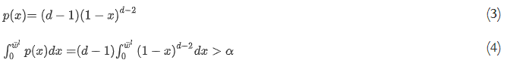

When a semantic network is constructed, the next step is to facilitate network analysis and response network retrieval requests from frontend users. According to Boden’s exploratory creativity discussed in Section 3.1, we propose two algorithms to proceed with the analysis, called “step-forward” and “path-track” respectively. “step-forward” initiates the network retrieval from a given node in a network, and retrieve other nodes and edges around this node based on how far it is required to explore, where the steps means the number of edges going through. This retrieval is implemented by calculating the probability of stepping from the initial node to the node after (n – 1) steps:

With the localised weight ${\overline{ω}}^{l}$ in the above equation, the fewer steps involved in the retrieval, the closer associations will be retrieved, which means domain-specific knowledge will more likely be surrounded nearby. To obtain implicit associations, step amount (n – 1) and the localised weight ${\overline{ω}}^{l}$ are the two key parameters need to be optimised in real cases. But we do not choose the node of last time step as the new idea, we choose the best node from all nodes of step. Training data can be collected from existing successful demonstrations in literature, such as the gold standard example of “migraine – magnesium” referred in [53].

“Path-track” retrieves possible paths from one node to another node, where both nodes can either be picked up from a network graph or be arbitrary ones. The “path-track” algorithm helps capture those implicit knowledge hidden in the pathway from a departure node to a destination node, and form a mind map for ideation. It is implemented by calculating the distance of a path from a departure node K₁ to a destination node K_{t} through t-1 steps:

We use the sum of weights to express the distance of the path from departure to destination, because different node has its own weight and the sum of them can express implicit knowledge hidden in the pathway. The globalised weight ${\overline{ω}}^{g}$ keeps network path being retrieved from a global perspective, which means the nodes along the path would be more likely to represent cross-domain knowledge. Obviously, the shortest path from node K1 to node Kt is not the desired retrieval result for implicit knowledge discovery, and similarly, the steps (t-1) and globalised weight ${\overline{ω}}^{g}$ should be optimised according to the characteristics of the different data source. And the procedure of path-track is to understand how the path track from a departure node to a destination node, and create a new idea of it. According to the theory of combinational creativity [38], the idea from the path-track can be proved to be brand new.

We use the evaluation method of retrieving concepts and retrieving relations [47] to assess our model. And the result of the evaluation of this model has also been proved to be valid.

3.3. Visual concepts combination
Assuming a basic idea is generated when exploring the semantic ideation network proposed in Section 3.2, and this idea could be sparked by combining two nodes in the network representing two different concepts (far association). Even though the person who comes up with this idea may have a basic mind of how to combine these two concepts, which is referred as a bisociation by Koestler, it could stimulate the person further if this bisociation idea is shown in a visualised way. As an implementation of Koestler’s bisociation, given two concepts in each bisociation, the visual concepts combination model aims to produce a bisociative image which synthesizes both concepts.

The generation of photo-realistic images which synthesize two distinct concepts computationally is a challenging problem. Recently, with the increasing popularity of deep neural networks among supervised learning methods, Generative Adversarial Networks (GAN) have shown promising achievements in the context of computer vision. They are composed of two models, a generator G, and a discriminator D, which are two neural networks trained separately to compete with each other [54]. The generator G is modelled to transform a random vector z into an image, such as x_{G} = G(z) where the noise vector z is sampled from a distribution P_{z} such as a uniform or Gaussian distribution. G is trained to reproduce the true data distribution P_{data} by generating images that are difficult for the discriminator D to differentiate from real images, as shown in Eq. (7).

Meanwhile, the discriminator D takes an image as input and outputs the probability of an image to be real. D aims to be trained to output a low probability when fed a “fake” image, and estimate a high probability for the sample from true data distribution. Thus the discriminator D and generator G are trained adversarially to improve their capability by optimizing the following objective function [54]:

Generative Adversarial Neural networks have been used in many tasks related to image generation. Wu et al. [55] trained generative convolutional neural networks to generate 3D chairs, tables and cars given object type, viewpoint and colour. Isola et al. [56] investigated conditional adversarial networks for image-to-image translation problems, such as transform a sketch to a well-fined colourful image, which is a necessary work in the product design industry. Zhang et al. [57] proposed stacked Generative Adversarial Networks (Stack-GAN) to generate photo-realistic images based on text description, but their model is only capable of synthesizing images from one category. Zhu et al. [58] proposed Cycle-Consistent Adversarial Networks (Cycle GAN) for learning to translate an image from style A to style B, but their model is not able to combine the features from the two styles. The purpose of our model may be similar to Cycle GAN, but the Cycle GAN model is to generate image in target domain Y from source domain X, then reconstruct the image in source domain X from target domain X. However, our model generates an image containing the features from the concept 1 but retaining the shape from concept 2 by two different discriminator to combine these two concepts. In this paper, we investigate how to produce images which synthesize important features from two concepts which fall into two distinguishing categories using GAN formulation.

As a supervised learning method, two datasets are established first by collecting images representing two known concepts. No pre-processing is required to be applied to train images except to keep all images at the same resolution. Two inputs are the training images representing their corresponding concepts, and the Gaussian distribution is used as the noise distribution Z for a generator. We also create two discriminators for each of the datasets, and then apply the deep convolutional generative adversarial networks (DCGANs) [59] to train the generator and two discriminators, as shown in Fig. 1. For each discriminator, the last convolution layer is flattened and fed into a single sigmoid output. During the period of convolution network, it won’t extract the specific features from the two different datasets. First, the output of the last convolution layer is directly used as an input for the deconvolutional network, so we do not set a specific rule for choosing the feature. Second, we use this generator to do creative work. The visual idea will be not creative enough if we set it to extract the specific feature which can be imagined by a human.

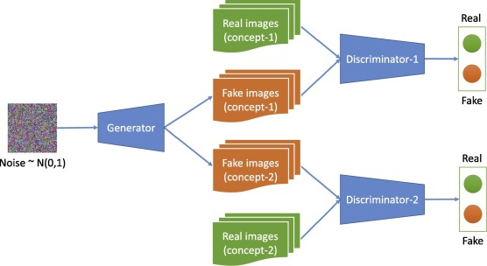
Fig. 1. Generative adversarial networks model

- Implementation

4.1. Implementation of semantic ideation network
The semantic ideation network has been developed as a webpage which is the user interface for users’ exploration and visualisation. When opening the webpage, a user is required to type in a keyword related to a design task in the search box. Then three options are provided: “step-forward”, “path-track” and “combination” (implementation of visual concepts combination model). In “step-forward”, the user chooses the steps by which the keyword is associated. The more steps are chosen, the further the associations go forward. The minimum number of steps for users to choose is available from one to five in this implementation, while the maximum number of steps is not limited as it depends on the retrieval results available on provided datasets. By clicking “Show Results” button, a list of associations and a graph of the semantic network are shown on the webpage. For “path-track”, in addition to the previously typed keyword as a departure point of a path, the user has to type in another keyword as a destination point. Similarly, a list of paths and a graph of the semantic network are generated showing how the two keywords are associated with other concepts in between when clicking “Show Results”.

The interface is implemented with HTML/CSS/JavaScript techniques, while using D3’s force-undirected network layout [60] and jQuery libraries for visualisation. From the perspective of visualisation, network graph is interactive in a webpage, specifically, operations including drag, move, zoom in and zoom out are allowed to manipulate the graph within any devices including PC, tablet or mobile phone. Furthermore, the weight of each node is visualised into its size and the strength of each edge is visualised into its length as well. The query and network analysis engine is developed in Python, in which the NetworkX library [61] is used to store and retrieve graph data.

As this model is implemented for design idea generation, its design knowledge data is mainly collected from design websites using web crawling while general knowledge data from a variety of domains are collected from Wikipedia. The design websites crawled include design blog websites, such as Yanko design, designboom, dezeen, and design award websites, such as the red dot and iF design award. The raw data captured from crawled texts are nouns and noun-phrases of subjects and objects including adj + noun, noun + noun, gerund, gerund phrase, etc., and they are detected using natural language processing (NLP) techniques such as tokenization and POS tagging in Stanford CoreNLP [62]. Afterwards, these essential concepts are used as nodes in the semantic ontology network, and their relations are constructed if they appear in the same sentence or clause. These relations are filtered by the proposed disparity filter, and then are assigned with weights by applying the frequent itemset mining rules, and normalised as discussed in Section 3.2.

4.2. Implementation of visual concepts combination model
As the architecture of the proposed model is shown in Fig. 1, it composes of two discriminators and one generator. The generator follows the design philosophy of DCGAN [59], which is a deconvolutional network with 200 values of Gaussian distribution as input, using batch normalization and leaky-relu. To stabilize the training, the discriminators do not use batch normalization.

Given two types of images x_{A} and x_{B}, and two discriminators for each of them, we optimize the following min-max problem:

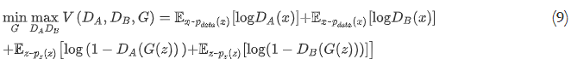

We explain our symbols in the Table 1 for the better understanding. Assuming that x_{A} is a target image which is similar to the product we want to design (e.g. a spoon), x_{B} is style image which we want x_{A} have these types of features (e.g. leaf). As these two types of images belong to different distributions, the difficulty of the generator is high, so the discriminators are more likely to converge quickly and lead to failure on generator. To solve this problem, we used three tricks:

- As mentioned previously, batch normalization is used on the generator.
- Soft and noisy labels on discriminators are used when inputting real images into them; we then replaced the labels of 1 to a random number between 0.7 and 1.2. This method is also well known as label smoothing.
- We make the x_{A} by transforming an RGB-based colourful image into a greyscale image, so the generator only learns the shape feature from x_{A}.
Table 1. Notations in the equation.

For training, the Adam optimization approach is used with a momentum of 0.5. The learning rate is set to 0.002 with batch size of 128 and train for 500,000 iterations.

The evaluation of a creative product is hard to define, and it depends on the different feeling from different people. It is not appropriate to evaluate the ability of creativity by an equation, so we rank the generated images based on the following criteria by human:
- Whether the generated image keeps the feature from source image A.
- Whether the generated image keeps the feature from source image B.
- Whether the generated image combine the features from source image A and B.

Then we averaged all human ranks to calculate the quality scores (2 for best, 0 for worst) for the compared methods, as shown in Table 2. The result shows that our method outperformed other method in following aspects:

Table 2. Human evaluation of our method and Cycle GAN
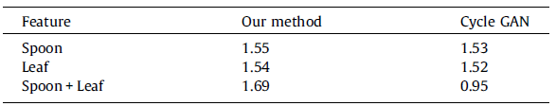

Combining the features: The results show that our method can generate images combing two features that captured from the source images and the generated images are also convincing. While the Cycle GAN can only transform the images from feature A to feature B.

Maintaining the source features: Our method is also able to maintain the features of the raw images. Our method not only just mix the features from different objects, but combine them on condition that their former feature is still convincing. Compared with the result of Cycle GAN, our images is still convincing enough.

- Case study

5.1. Design tasks
To verify the proposed two models, two factors were considered when choosing a design task for the case study. As this design ideation approach targets not only professional designers but also ordinary people, background knowledge for understanding the design task should be at a low level so that participants are able to focus on the ideation process exclusively. Another factor considered is the incoherence between the semantic ideation network and visual concepts combination model. As the visual concepts combination model needs time to collect training data and train the proposed model, it is impractical in the case study for the visual concepts combination model to generate corresponding synthesized images given two arbitrary concepts. As a solution to this issue in our case study, the semantic ideation network and visual concepts combination model were tested in two slightly different design tasks.

With consideration of the above factors, the design tasks used in our case study were to design a spoon, and were conducted in two sessions. For each session, five minutes were given for the use of provided ideation tool, and additional five minutes were then given for recording generated ideas on white sheets including sketch and description. In the first session, participants were required to meet two requirements: the spoon can be at least used to assist in eating soup; the more ideas, the better. The participants were told that this was an open-minded design task, they could break through the classic shape of a spoon. In the second session, participants were required to meet one more requirement: designing a spoon which should be inspired from the natural leaf. The inspiration could be various, such as borrowing elements or features from the leaf, or provoked by seeing an image containing leaf.

In the case study, we had two groups of participants completing all design tasks. One is the treatment group, participants in this group used our developed semantic ideation network in the first session, and the visual concepts combination model in the second session. Another control group had no access to the developed ideation tool but was allowed to use Google (in session-1) and Google Image (in session-2) search engine to help with natural brainstorming. Each group consisted of twelve participants who were engineering students specialising at different disciplines, and only two in each group had the background of design engineering.

For participants of the treatment group in the first session, inspirations can be obtained by exploring the semantic ideation network with two main functions: “step-forward” and “path-track”. “Step-forward” provides far associations from multiple domains when given a keyword or phrase. “path-track” shows association paths between two keywords or phrases given by a participant. All results are shown in the semantic network graph in which it is convenient for users to understand the causality between keywords and obtain inspirations.

Before the developed visual concepts combination model is ready for use in the second session, 3772 images of spoon and 7408 images of leaf were collected as training data,2 samples are shown as in Fig. 2. All images are kept in the resolution of 256 × 256, and without pre-processing, they are trained with proposed GAN model for 500,000 epochs. And we also test our model on the public dataset like ImageNet, and the result is also convincing. But we choose our own dataset to display the best results. Then the trained model was used as a backend to support the ideation process of treatment group in the second session. As what we proposed is a machine learning model, after being well trained, it is able to automatically generate an unlimited number of synthesized images which contains elements from both spoon and leaf. For example, Fig. 3 shows the images randomly generated by our model, although the objects in these images do not look natural, features such as colour, shape, texture and functioning from spoon and leaf are synthesized. By observing images produced by the model, potential inspirations of how to combine spoon and leaf may be obtained.

Fig. 2. Samples of training datasets (left: spoons; right: leaves)

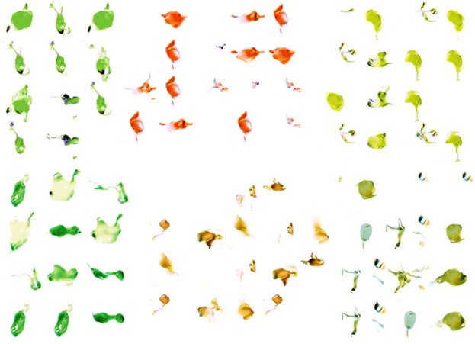
Fig. 3. Randomly synthesized images by proposed GAN model

Before the beginning of each session, a brief introduction and explanation of the design task were given. The participants in the treatment group were taught how to use our developed ideation models even though it was already user-friendly to use. In both sessions, all participants were given white sheets to document their ideas, which prompted participants to both sketch and describe their ideas. Ideation sheets were collected and de-identified when both sessions ended, and were used in data analysis.

5.2. Data analysis
The analysis of collected data utilizes a standard set of metrics employed in design science literature for the purpose of evaluating ideation outcome, which are: novelty, quality, variety, and quantity as first introduced by Shah and adapted by Chan et al. [23], [63]. Novelty is a measure of uniqueness of a design solution, and was defined as the degree to which a particular solution type was unusual within a space of possible solutions. Quality is a measure of the feasibility of a developed design or system in question to satisfy design requirements. For example, in the second session of our design study, the assessment of quality might be to estimate if designed spoon contains elements from leaf and how reasonable and convenient the spoon can be used to eat soup. Variety measures the degree of diversity of the explored solution space during ideation. The generation of similar ideas indicates a lower variety, which means a lower probability of finding better ideas among the total possible solution space. Quantity is a direct and basic measure of the number of ideas produced. For our design task, quantity was calculated based on a total number of ideas generated by each individual in each group. These four metrics are usually measured independently, for example, if two ideas from the same participant are very similar to each other, they are accounted as two in terms of quantity, but the variety of the group of ideas is relatively low.

Consensual Assessment Technique (CAT) was utilized for measurement of novelty, quality, and variety. This technique is the most widely used metric for assessing the performance of creative work samples based on knowledgeable raters’ intuitions about what the metrics mean in a field [64], and it gives the advantage of capturing aspects of creative work that are difficult to judge or define objectively. In this technique, two raters independently perform subjective ratings of every solution and then evaluate the levels of consensus reached across judges. The two raters for our case study were experts in the product design field, having completed at least three years of design engineering product design coursework. The level of rater expertise in our study is comparable to other research using CAT [65].

After all ideation sheets were collected from both groups, they were presented in front of the two raters. With CAT, the two raters evaluated all ideas, based on their novelty, quality, variety, and quantity independently. During the evaluation, the raters did not know the ideas were created in two groups with different ideation approach. 75 ideas generated from session 1 and 60 ideas generated from session 2 were presented on papers in a different order for each rater. Consistent with Consensual Assessment Technique, we asked the raters to score each concept using a scale from 1 to 7 (where 1 is the “lowest” of a category – lowest novelty, lowest quality, and 7 is the “highest”) based on their understanding of the design field and estimation of ideas relative to one another. The raters completed several rounds of scoring when considering exclusively one of the two metrics (novelty and quality). In each rating task, the raters were given the full range of ideas placed in a random order in the first round of rating, and were instructed to place these ideas into piles labelled from 1 to 7. From the second round, as raters already had a clearer mind of the scale and all ideas, they rearranged all ideas again by moving ideas into different piles as needed until there were no more changes. Each rating task ended when the rater thought all ideas had been well placed into appropriate piles. Overall, each rater scored 75 ideas generated in the first session, and 60 ideas generated in the second session, in terms of novelty and quality.

The variety scores were completed in a similar way with CAT approach. The raters evaluated the variety of the whole set of ideas generated by a single participant on a seven-point scale. The piles in this rating task shown the variety of each individual’s set of ideas on a scale from 1 (not varied) to 7 (most varied). The set size of ideas could be different as each participant generated a different number of ideas. The raters scored 24 idea sets from the first session, and the same number of sets from the second session, in term of variety.

In the final rating round, each individual’s idea set was assessed based on the number of ideas generated in order to evaluate quantity (also known as fluency). All these above coding work was conducted on the separate time period for each round. The consensus between raters on each independent measure was evaluated based on a computed percent of the adjacent agreement, which is proposed by Stemler [66]. For each scale with seven levels, the consensus was considered to be reached for one same rating task where a score was given if the score given by one rater did not differ by more than one point above or below the score given by another rater. As a result, the percentages of adjacent agreement between raters were 80% for session 1 and 81% for session 2 in term of novelty; for quality, the percentages were 85.3% and 71.7% respectively; and the percentage of variety were 91.7% in session 1 and 79.2% in session 2. To estimate consistency between raters, Cohen’s Kappa value was calculated for each metric as well, which are listed in Table 3. When calculating Cohen’s Kappa, the scale was transformed from the original seven scales to three scales. Specifically, scores of 1 and 2 fall into the category “Low”, the score of 3, 4 and 5 falls into category “Normal”, and the score of 6 and 7 falls into category “High”. As it can be seen from Table 3, all values are greater than 0.50, which is typically considered as acceptable and reliable for the scoring results based on the CAT approach.

Table 3. Calculated adjacent agreement percentage and Cronbach’s coefficient
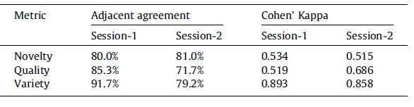

5.3. Results
The average of two raters’ scores for each rating was used in the statistical analysis. We did a normality check first using the Shapiro-Wilk’s W test across both groups in two sessions, and all the p values obtained were bigger than 0.05, which meant that our data did not fall into normal distributions. Then the independent Mann-Whitney U test was chosen to interpret the coded data. Examples of high and low scores in terms of the metrics of novelty and quality are introduced in Table 4. The average CAT scores of ratings for each experimental group in terms of novelty, quality, and variety are shown in Fig. 4 (for session 1) and Fig. 5 (for session 2). In session 1, for novelty and quality of generated ideas, there is no significant difference between treatment group and control group (p = 0.147 and p = 0.433, respectively). However, the treatment group performed significantly better than the control group in terms of idea variety (0.023). In session 2, there is still no difference for idea quality between treatment group and control group (p = 0.516), and for variety, no significant difference was observed between two experimental groups (p = 0.295). For novelty, the treatment group scored significantly higher than the control group (p = 0.027). The average number of ideas generated for each group in each session is shown in Fig. 6. For both sessions, the treatment group generated more ideas than control group.

Table 4. Examples of low and high scoring ideas
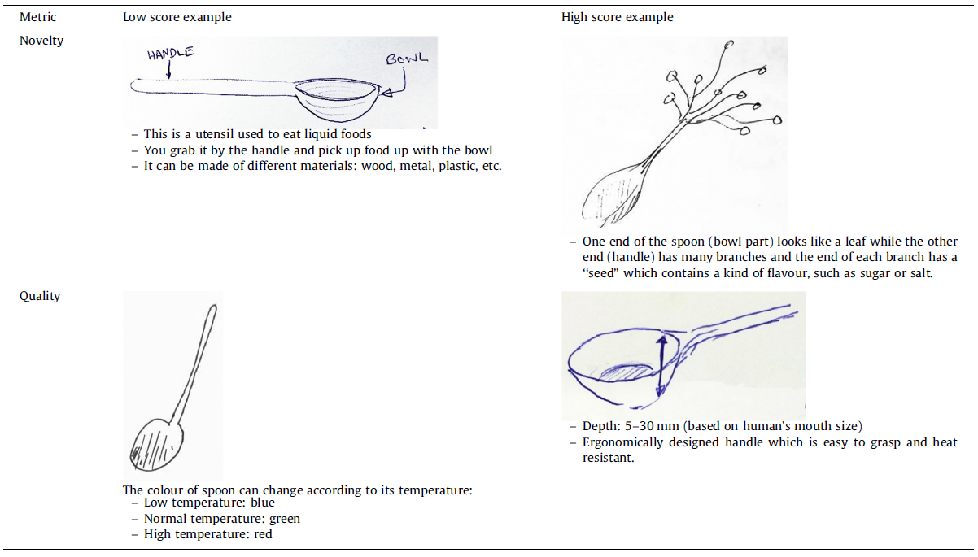

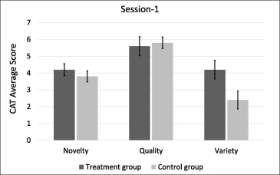
Fig. 4. Results of CAT scores for ideas generated in two groups in session-1

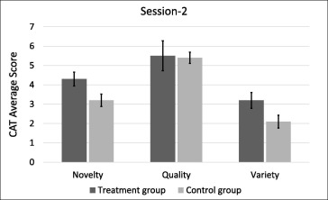
Fig. 5. Results of CAT scores for ideas generated in two groups in session-2

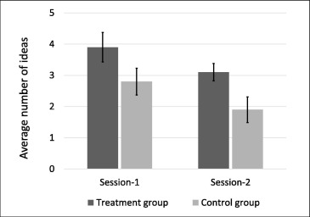
Fig. 6. The average number of ideas generated

5.4. Discussion
By comparing the scores rated by two expert raters with CAT, the ideas generated by two groups are evaluated in terms of novelty, quality, variety and quantity. In the first session 1 of our case study, treatment group outperformed control group with higher variety, and quantity, which means the proposed semantic network ideation model shown better performance by producing more ideas (by 48% higher quantity) with high diversity (by 75% higher variety). To further verify the contribution of algorithms in the model, the expert raters reviewed the treatment group’s ideas written down in ideation sheets, they found most of the ideas were the results of combining concepts appeared in their search results using the semantic ideation network’s “step-forward” and “path-track” functions. This means within a limited time, our approach provided some effective inspirations for the participants quickly compared to the brainstorming plus Google approach used by the control group. For example, when searching “spoon” with two steps chosen in “step-forward”, the “spoon → coffee → drink → straw” was retrieved as one of the results appeared in the semantic graph. Then an idea came up by combining “spoon” and “straw” and was illustrated by a participant as shown in Fig. 7. This example additionally indicated that the proposed algorithm has the capacity of retrieving useful far associated concepts for users in ideation. In contrast, from the observation of participants’ ideation sheets, it is found that it happened more frequently in control group that participants tended to stick on similar ideas which fell into the same thinking direction. For instance, there was one participant in the control group came up with four ideas of designing a spoon which looked like banana, palm, carrot and cat’s claw respectively. In the treatment group, benefiting from our weight normalization algorithms (localization and globalization), our model is able to retrieve concepts from multiple domains upon a single request, and then the variety of generated ideas would be high if the participants utilized these retrieved results.

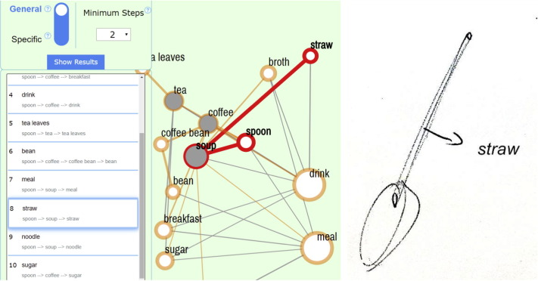
Fig. 7. “Straw” was found in the network (left) and the idea was illustrated (right)

However, the results revealed that the semantic network ideation model did not contribute much more in terms of idea novelty and quality compared to the brainstorming plus Google approach. We found several possible factors explaining the similar performance of novelty between two groups. Among all the ideas generated in session-1, we found few ideas which were evaluated as high novelty appeared in both groups, which means that few participants in control group were able to reach the same level of creativity as well as the treatment group did. Daly [65] also indicated that alternative idea generation methods may work to promote creativity to the same degree but in different ways. Another interesting finding was that even though the participants in treatment group had the high possibility to find the node “leaf” when using our developed model in session-1, only one participant wrote down the idea of combining “leaf” into the spoon design. It suggests that there is still a gap between receiving inspiration and comprehend inspiration which remains for further studies. We also explored the reason for treatment group’s similar results in term of ideation quality compared with control group. As quality means how an idea meets requirements and how the idea can be implemented in a realistic way, we found those ideas fell into low quality either did not completely comply with requirements or were unspecific to implement them. Taking one participant’s idea as an example, the idea was “To have a spoon that can clean itself to avoid wetting out hands” which was not clear enough for a spoon design.

In the second session, treatment group performed better than control group in terms of quantity and novelty, which means that the proposed visual concepts combination model shown better performance by producing more idea (by 41% higher quantity) with high originality (by 34% higher novelty). Similarly, the contribution of algorithms in the combination model was verified by reviewing the ideas generated by participants in treatment group and their related images generated by our model. As the example shown in Fig. 8. When one participant in treatment group saw the image generated by our model, then a novel idea of designing a leaf-like spoon with an animal standing on the top was provoked. However, the rated variety of both groups did not achieve a high level. This may be due to the task design as “leaf” is shaped dominant rather than functional dominance, and this can be explained from the generated ideas in which the majority are aesthetically novel while functional novelty is rarely involved.

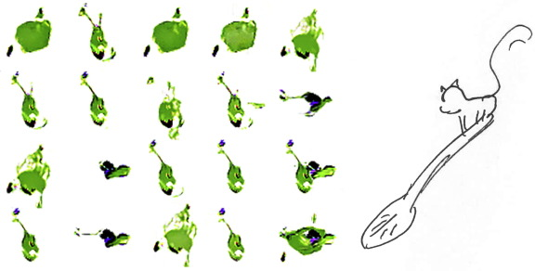
Fig. 8. leaf-inspired spoons generated by the model (left) and the idea illustrated (right)

Overall, in our integrated approach, the semantic ideation network model focuses on far association retrieval and exploration, and followed by the visual concepts combination model where synthesized combinational design is visualised by means of artificial intelligence techniques. Compared with VISUALIZEIT [67], a similar idea generation tool which is able to synthesize concepts representations through component flow graphs (CFGs) based concept generator, clustering analysis, and visualisation interface, the concepts retrieved by our proposed approach are semantically far associated rather than functional associated, and the concepts synthesis results are visualised in images instead of semantic words or phrases.

- Conclusion and future work

In this paper, an integrated approach containing two models, semantic ideation network and visual concepts combination, are developed to bring inspiration in a semantic and a visual way respectively based on computational creativity theory. According to results of our case study, the semantic ideation network is able to provide a variety of cross-domain associations and progress the ideation process forward quickly and easily by using the “step-forward” and “path-track” algorithms. In the visual concepts combination model, generative adversarial networks based algorithm generated a variety of images which synthesize “spoon” and “leaf” for ideation in a design task. The approach appeared to be able to produce semantic and visual stimuli for ideation, and improve the quantity, variety, and novelty of ideas generated.

As the proposed approach focus on far associated concepts retrieval and visual concepts synthesis, function-based analysis is missing through the whole ideation process. For a complex engineering design problem with multiple functions, the proposed approach might be not sufficient compared with those function analysis based models, such as function-behaviour-structure (FBS) model [68]. This issue is expected to be addressed by bringing in a systematic functional analysis model, concepts will be then retrieved based on both functionality and degree of association, and synthesized based on characteristics of functional components and aesthetic features. But such a visual synthesis of multiple concepts could be challenging as it requires a much more powerful generator in proposed GAN model.

Although the proposed artificial intelligence based data-driven approach has been used for design ideation in a case study, it could potentially be used for other general purposes in which idea generation activities are needed, such as advertising and commercial innovation for strategy. The datasets for the semantic ideation network can be either large and general or small but specific, the minimum requirement is that the data collected has to be covered across multiple domains so that bisociations can be captured. There are no specific limitations when applying visual concepts combination model except the incoherence issue, the model can be used to generate images directly once it is well trained on specific datasets depending on the task.

Acknowledgments
This work is supported by Fundamental Research Funds for the Central Universities, Artificial Intelligence Research Foundation of Baidu Inc., Zhejiang University and Cybervein Joint Research Lab, Zhejiang Natural Science Foundation (R19F020009, LZ17F020001), National Natural Science Foundation of China (61572431), Key R\&D Program of Zhejiang Province (2018C01006), Program of China Knowledge Center for Engineering Sciences and Technology, Program of ZJU and Tongdun Joint Research Lab, Joint Research Program of ZJU and Hikvision Research Institute, and Major Scientifc Research Project of Zhejiang Lab (No. 2018EC0ZX01-1). The authors would also like to acknowledge China Scholarship Council (CSC) and Jaywing plc. for their support in doctorial funding, and Nvidia for donating a Titan-Xp GPU used in this work.

Reference:

[1] J.-R. Chou, An ideation method for generating new product ideas using TRIZ, concept mapping, and fuzzy linguistic evaluation techniques, Adv. Eng. Inf. 28 (4) (2014) 441–454.
[2] K. Fu, D. Moreno, M. Yang, K.L. Wood, Bio-inspired design: an overview investigating open questions from the broader field of design-by-analogy, J. Mech. Design 136 (11) (2014), 111102-111102-111118.
[3] J.S. Linsey, K. Wood, A. Markman, Increasing innovation: presentation and evaluation of the wordtree design-by-analogy method, in: Proc. ASME 2008 International Design Engineering Technical Conferences and Computers and Information in Engineering Conference, American Society of Mechanical Engineers, 2008, pp. 21–32.
[4] G. Smith, J. Richardson, J.D. Summers, G.M. Mocko, Concept exploration through morphological charts: an experimental study, J. Mech. Design 134 (5) (2012) 051004.
[5] D. Braha, Data Mining for Design and Manufacturing: Methods and Applications, Springer Science & Business Media, 2013.
[6] W. Chen, M. Fuge, Beyond the known: detecting novel feasible domains over an unbounded design space, J. Mech. Design 139 (11) (2017) 111405.
[7] S.R. Daly, S. Yilmaz, J.L. Christian, C.M. Seifert, R. Gonzalez, Design heuristics in engineering concept generation, J. Eng. Educ. 101 (4) (2012) 601–629.
[8] A. Albers, N. Bursac, S. Rapp, PGE-product generation engineering-case study of the dual mass flywheel, in: Proc. DS 84: Proceedings of the DESIGN 2016 14th International Design Conference.
[9] A. Albers, N. Burkardt, M. Meboldt, M. Saak, SPALTEN problem solving methodology in the product development, in: Proc. ICED 05: 15th International Conference on Engineering Design: Engineering Design and the Global Economy, Engineers Australia, p. 3513.
[10] A.K. Goel, S.R. Bhatta, Use of design patterns in analogy-based design, Adv. Eng. Inf. 18 (2) (2004) 85–94.
[11] S. Vattam, B. Wiltgen, M. Helms, A.K. Goel, J. Yen, DANE: fostering creativity in and through biologically inspired design, in: Design Creativity 2010, Springer, 2011, pp. 115–122.
[12] A.E. Green, D.J. Kraemer, J.A. Fugelsang, J.R. Gray, K.N. Dunbar, Neural correlates of creativity in analogical reasoning, J. Exp. Psychol. Learn. Mem. Cogn. 38 (2) (2012) 264.
[13] M. Wolverton, B. Hayes-Roth, Retrieving semantically distant analogies with knowledge-directed spreading activation, in: Proc. AAAI, pp. 56–61.
[14] B.P. Crean, D. O’Donoghue, RADAR: Finding analogies using attributes of structure, in: Proc. Irish Conference on Artificial Intelligence and Cognitive Science, Springer, pp. 20–27.
[15] B.T. Christensen, C.D. Schunn, The relationship of analogical distance to analogical function and preinventive structure: the case of engineering design, Memory Cognit. 35 (1) (2007) 29–38.
[16] J. Self, M. Evans, E.J. Kim, A comparison of digital and conventional sketching: implications for conceptual design ideation, J. Design Res. 14 (2) (2016) 171– 202.
[17] M. Mohan, J.J. Shah, S. Narsale, M. Khorshidi, Capturing ideation paths fordiscovery of design exploration strategies in conceptual engineering design, in: Design Computing and Cognition’12, Springer, 2014, pp. 589–604.
[18] K. Huo, K.R. Vinayak, K. Ramani, Window-shaping: 3D design ideation by creating on, borrowing from, and looking at the physical world, in: Proc. Tangible and Embedded Interaction, pp. 37–45.
[19] H. Wang, Y. Ohsawa, X.H. Hu, F.J. Xu, Idea discovery: a context-awareness dynamic system approach for computational creativity, Stud. Comput. Intell. 564 (2015) 99–111.
[20] A. Chakrabarti, P. Sarkar, B. Leelavathamma, B. Nataraju, A functional representation for aiding biomimetic and artificial inspiration of new ideas, Ai Edam 19 (2) (2005) 113–132.
[21] J. Han, F. Shi, P. Childs, The combinator: a computer-based tool for idea
generation, in: Proc. DS 84: Proceedings of the DESIGN 2016 14th International Design Conference, pp. 639–648.
[22] N. Kelly, J.S. Gero, Situated interpretation in computational creativity, Knowl.- Based Syst. 80 (2015) 48–57.
[23] J. Chan, K. Fu, C. Schunn, J. Cagan, K. Wood, K. Kotovsky, On the benefits and pitfalls of analogies for innovative design: Ideation performance based on analogical distance, commonness, and modality of examples, J. Mech. Design 133 (8) (2011) 081004.
[24] F. Pinel, L.R. Varshney, D. Bhattacharjya, A culinary computational creativity system, in: Computational Creativity Research: Towards Creative Machines, Springer, 2015, pp. 327–346.
[25] L.R. Varshney, F. Pinel, K.R. Varshney, D. Bhattacharjya, A. Schoergendorfer, Y.- M. Chee, A Big Data Approach to Computational Creativity, arXiv preprint arXiv:1311.1213, 2013.
[26] C.F. Lin, Y.-C. Yeh, Y.H. Hung, R.I. Chang, Data mining for providing a personalized learning path in creativity: an application of decision trees, Comput. Educ. 68 (2013) 199–210.
[27] A. Ojha, H.-K. Lee, M. Lee, I-get: a creativity assistance tool to generate perceptual pictorial metaphors, in: Proceedings of the 3rd International Conference on Human-Agent Interaction, ACM, Daegu, Kyungpook, Republic of Korea, 2015, pp. 311–314.
[28] C.A. Toh, E.M. Starkey, C.S. Tucker, S.R. Miller, Mining for creativity: determining the creativity of ideas through data mining techniques, in: Proc. ASME 2017 International Design Engineering Technical Conferences and Computers and Information in Engineering Conference, American Society of Mechanical Engineers, pp. V007T006A010-V007T006A010.
[29] S. Kairam, N.H. Riche, S. Drucker, R. Fernandez, J. Heer, Refinery: visual exploration of large, heterogeneous networks through associative browsing, Comput. Graphics Forum 34 (3) (2015) 301–310.
[30] L. Zhu, Z. Huang, X. Liu, X. He, J. Sun, X. Zhou, Discrete multimodal hashing with canonical views for robust mobile landmark search, IEEE Trans. Multimedia 19 (9) (2017) 2066–2079.
[31] L. Zhu, Z. Huang, Z. Li, L. Xie, H.T. Shen, Exploring auxiliary context: discrete semantic transfer hashing for scalable image retrieval, IEEE Trans. Neural Networks Learn. Syst. 29 (11) (2018) 5264–5276.
[32] L. Chen, F. Shi, J. Han, R.P. Childs, A network-based computational model for creative knowledge discovery bridging human-computer interaction and data mining, in: Proc. International Design Engineering Technical Conferences & Computers and Information in Engineering Conference (ASME IDETC/CIE).
[33] P. Jing, Y. Su, L. Nie, X. Bai, J. Liu, M. Wang, Low-rank multi-view embedding learning for micro-video popularity prediction, IEEE Trans. Knowl. Data Eng. 30 (8) (2018) 1519–1532.
[34] P. Jing, Y. Su, L. Nie, H. Gu, J. Liu, M. Wang, A framework of joint low-rank and sparse regression for image memorability prediction, IEEE Trans. Circuits Syst. Video Technol. (2018), 1-1.
[35] L. Xie, J. Shen, J. Han, L. Zhu, L. Shao, Dynamic multi-view hashing for online image retrieval, in: Proceedings of the 26th International Joint Conference on Artificial Intelligence, AAAI Press, Melbourne, Australia, 2017, pp. 3133–3139.
[36] L. Zhu, Z. Huang, X. Chang, J. Song, H.T. Shen, Exploring consistent preferences, in: Proceedings of the 2017 ACM on Multimedia Conference – MM’17, 2017, pp. 726–734.
[37] J. Li, K. Lu, Z. Huang, L. Zhu, H.T. Shen, Transfer independently together: a generalized framework for domain adaptation, IEEE Trans. Cybern. (2018) 1– 12.
[38] M.A. Boden, The Creative Mind: Myths and Mechanisms, Routledge Press, 2004.
[39] G.A. Wiggins, A preliminary framework for description, analysis and comparison of creative systems, Knowl.-Based Syst. 19 (7) (2006) 449–458.
[40] H. Toivonen, O. Gross, Data mining and machine learning in computational creativity, Wires Data Min. Knowl. 5 (6) (2015) 265–275.
[41] A. Koestler, The Act of Creation, Macmillan, Oxford, England, 1964.
[42] M.R. Berthold, Bisociative Knowledge Discovery, Springer, Heidelberg [ua], 2012.
[43] W. Dubitzky, T. Kötter, O. Schmidt, M.R. Berthold, Towards creative information exploration based on Koestler’s concept of bisociation 7250 (2012) 11–32.
[44] M. Wang, W. Chen, A data-driven network analysis approach to predicting customer choice sets for choice modeling in engineering design, J. Mech. Design 137 (7) (2015) 071409.
[45] J. Scott, Social Network Analysis, Sage, 2012.
[46] E. Agirre, E. Alfonseca, K. Hall, J. Kravalova, M. Pasca, A. Soroa, 2009, A study on similarity and relatedness using distributional and wordnet-based approaches, in: Proceedings of Human Language Technologies: The 2009 Annual Conference of the North American Chapter of the Association for Computational Linguistics, pp. 19–27.
[47] F. Shi, L. Chen, J. Han, P. Childs, A data-driven text mining and semantic network analysis for design information retrieval, J. Mech. Design 139 (11) (2017), 111402–111402-111414.
[48] S. Beliga, Keyword Extraction: A Review of Methods and Approaches, University of Rijeka, Department of Informatics, Rijeka, 2014.
[49] Z. Li, K. Ramani, Ontology-based design information extraction and retrieval, Ai Edam 21 (2) (2007) 137–154.
[50] G. Lample, M. Ballesteros, S. Subramanian, K. Kawakami, C. Dyer, Neural Architectures for Named Entity Recognition, HLT-NAACL, 2016.
[51] S. Zheng, J. Xu, P. Zhou, H. Bao, Z. Qi, B. Xu, A neural network framework for relation extraction: learning entity semantic and relation pattern, Knowl.- Based Syst. 114 (2016) 12–23.
[52] F. Shi, L. Chen, J. Han, P. Childs, Implicit knowledge discovery in design semantic network by applying Pythagorean means on shortest path searching, International Design Engineering Technical Conferences & Computers and Information in Engineering Conference (ASME IDETC/CIE), 2017.
[53] M. Juršicˇ, B. Cestnik, T. Urbancˇicˇ, N. Lavracˇ, Cross-domain literature mining: Finding bridging concepts with CrossBee, in: Proceedings of the 3rd International Conference on Computational Creativity, 2012, pp. 33–40.
[54] I. Goodfellow, J. Pouget-Abadie, M. Mirza, B. Xu, D. Warde-Farley, S. Ozair, A. Courville, Y. Bengio, Generative adversarial nets, Adv. Neural Inf. Process. Syst. (2014) 2672–2680.
[55] J. Wu, C. Zhang, T. Xue, B. Freeman, J. Tenenbaum, Learning a probabilistic latent space of object shapes via 3d generative-adversarial modeling, Adv. Neural Inf. Process. Syst. (2016) 82–90.
[56] P. Isola, J.-Y. Zhu, T. Zhou, A.A. Efros, Image-to-image translation with conditional adversarial networks,‘‘ arXiv preprint arXiv:1611.07004, 2016.
[57] H. Zhang, T. Xu, H. Li, S. Zhang, X. Huang, X. Wang, D. Metaxas, Stackgan: Text to photo-realistic image synthesis with stacked generative adversarial networks, arXiv preprint arXiv:1612.03242, 2016.
[58] J. Zhu, T. Park, P. Isola, A.A. Efros, Unpaired image-to-image translation using cycle-consistent adversarial networks, in: Proc. 2017 IEEE International Conference on Computer Vision (ICCV), pp. 2242–2251.
[59] A. Radford, L. Metz, S. Chintala, Unsupervised representation learning with deep convolutional generative adversarial networks, arXiv preprint arXiv:1511.06434, 2015.
[60] M. Bostock, V. Ogievetsky, J. Heer, D(3): data-driven documents, IEEE Trans. Vis. Comput. Graph 17 (12) (2011) 2301–2309.
[61] D.A. Schult, P. Swart, Exploring network structure, dynamics, and function using NetworkX, in: Proceedings of the 7th Python in Science Conferences (SciPy 2008), 2008, pp. 11–16.
[62] C.D. Manning, M. Surdeanu, J. Bauer, J.R. Finkel, S. Bethard, D. McClosky, The stanford corenlp natural language processing toolkit, ACL (System Demonstrations) (2014) 55–60.
[63] J.J. Shah, S.M. Smith, N. Vargas-Hernandez, Metrics for measuring ideation effectiveness, Des. Stud. 24 (2) (2003) 111–134.
[64] T.M. Amabile, The social psychology of creativity: a componential conceptualization, J. Pers. Soc. Psychol. 45 (2) (1983) 357.
[65] S.R. Daly, C.M. Seifert, S. Yilmaz, R. Gonzalez, Comparing ideation techniques for beginning designers, J. Mech. Design 138 (10) (2016) 101108.
[66] S.E. Stemler, A comparison of consensus, consistency, and measurement approaches to estimating interrater reliability, Pract. Assess., Res. Evaluat. 9 (4) (2004) 1–19.
[67] K. English, A. Naim, K. Lewis, S. Schmidt, V. Viswanathan, J. Linsey, D.A. McAdams, B. Bishop, M.I. Campbell, K. Poppa, Impacting designer creativity through IT-enabled concept generation, J. Comput. Inf. Sci. Eng. 10 (3) (2010) 031007.
[68] J.S. Gero, U. Kannengiesser, The situated function–behaviour–structure framework, Des. Stud. 25 (4) (2004) 373–391.

