# Effect of the unstable vibration of the disc brake system of high-speed trains on wheel polygonalization

Wu BW1, QF Qiao2, Chen GX1, Lv JZ1, Zhu Q1, Zhao XN1, Ouyang H3

*1State Key Laboratory of Traction Power, Tribology Research Institute, Southwest Jiaotong University, Chengdu, Sichuan 610031, China*

*2CRRC Qingdao Sifang Locomotive & Rolling Stock Co., Ltd., Qingdao, China*

*3School of Engineering, University of Liverpool, Brownlow Street, Liverpool L69 3GH, UK*

**Abstract**: This paper conducts a detailed investigation into the formation mechanism of the wheel polygonalization of high-speed trains and its influence factors through numerical simulation. A finite element modelling including two rails, one wheelset, and three disc brake units is set up to study the formation mechanism of the wheel polygonalization of high-speed train based on the point of view of frictional self-excited vibration. Using the finite element complex analysis, the dynamic stability of the wheelset-track-disc brake system is studied. In addition, the influence factors on the wheel polygonalizaition are investigated. Results show that when the longitudinal creep forc is unsaturated, the 21-order polygonal wear of wheels is easy to occur due to the self-excited vibration of the disc brake unit. When the longitudinal creep force is saturated, the 12-order polygonal wear of wheels probably occurs due to the self-excited vibration of the disc brake unit. The bigger the friction coefficient between the brake disc and pad, the greater the occurrence propensity of the polygonal wear of wheels. Too large or too small vertical fastener damping is disadvantageous for suppressing wheel corrugation. However, increasing the lateral fastener damping is beneficial for reducing polygonal wear of wheels. When the vertical fastener stiffness is 25 MN/m, 7-order, 9-order and 14-order wheel polygonalization are easy to occur. A higher lateral fastener stiffness is beneficial for the suppression of the wheel polygonalization.

**Keywords**: out-of-roundness (OOR) of wheel; wheel polygonalization; wheel polygonal wear; wheel-rail system; friction self-excited vibration

## 1. Introduction

Polygonal wear is a common uneven wear around train wheels, which is also called wheel corrugation [1]. Polygonal wear is a very familiar appearance in high-speed train wheels, urban rail vehicles and subway trains. Polygonal wheels can result in severe oscillation of the wheel-rail contact force, which cause vehicle track systems to vibrate severely, and the amplitude of the vibration is proportional to the speed of the train. Field measurement data show that the vertical acceleration on the axlebox caused by the polygonal wheel can get up to 300 g [2]. Such a violent vibration can cause the end cover of the axlebox and the bolt to loosen or even fall off, which poses a great threat to the train operation safety. Meanwhile, the periodic impact force caused by the polygonal wheels can be as high as 400 kN [3], which can lead to fatigue cracks or even fracture of the structural components such as axles, bearings, wheels, rails and fasteners [4]. Additionally, polygonal wheels also engender annoying wheel-rail noise, which affects the residents along the railway line and the comfort of the passengers [5]. At present, the most frequently used method to remedy polygonal wheels is wheel turning. However, wheel turning is very expensive and time-consuming. Suppressing or even eliminating the wheel polygonalization is the best solution through the study of its formation mechanism.

For many years, a lot of researches have been done to reveal the formation mechanisms of wheel polygonalization. Johansson and Nielsen [6, 7] discussed the causes and aftereffects of various types of wheel tread defeats. In another article [8], they investigated the impact load between the wheels and the rails due to wheel flats, local spalls caused by contact fatigue cracking, long local defeats and wheel polygonalization on Sweden railway lines. Johansson [9] found that an initial irregularity was formed under the clamping of a three-jaw chunk during profiling of subway wheels in the process of investigating polygonal wheels in Sweden. Brommundt [10] established a wheel-rail dynamic interaction model with two degrees of freedom to study wheel polygonalization by using a perturbation technique. The results showed that the growing wheel polygonalization was a result of the interaction between the rotational inertia of the wheels and the initial irregularity, and the faster the train speed, the more quickly the lower harmonics of non-circularity formed. Meywerk [11] presented a flexible wheelset-rail model to analyse the formation and the development of wheel polygonalization. The results showed that the first and the second order bending vibration modes of the wheelset have an important influence on the growth of wheel polygonalization. A vehicle-track dynamic interaction model considering material wear was proposed by Morys [12] to study OOR phenomena. Morys found that wheel polygonalization appeared as a result of bending modes of the wheelset excited by oscillating wheel-rail contact force when a wheelset was running on stiff rails. Johansson and Andersson [13] developed a vehicle-track interaction model coupled with a wear model to investigate wheel tread polygonalization. Their results showed that the vertical resonance at approximately 40Hz and the antiresonance at 165Hz were the dominant wavelength-fixing mechanisms of the wheel OOR. Meinke [14] found that the wheelset eccentricity might also result in wheel tread polygonalization. Jin et al [1] investigated the wheel OOR through a field test and a numerical simulation, and found that the cause of the common nine-order polygonal wheels in China’s metro trains was due to the first order bending mode of the wheelset. Chen [2, 15], one of the present authors, considers that wheel polygonalization is a result of the friction-induced vibration of the wheelset-track system aroused by saturated wheel-rail creep force. So far, the research on wheel polygonalization has mostly focused on low order and low frequency polygonalization. However, with the increasing speed of trains, wheel polygonalization with high orders and high excited frequencies becomes more and more prominent and needs urgent studies. According to the investigation into wheel polygonalization in China’s high-speed railway [16], wheel polygonalization with excited frequency 500-700Hz and 18-23 orders appeared, and generated noise with frequency 500-700 Hz in the vehicles. At present, the generation mechanism for wheel polygonalization appears not to be fully understood [17]. The authors think that the cause of wheel polygonalization of China’s high-speed train is the friction-induced vibration of a wheel-rail-disc brake system.

In China, a high-speed train consists of several powered carriages and several trailer carriages. Both the powered and trailer carriages are equipped with disc brake systems. The trailer car is braked by a disc brake system. The powered car is braked by both a disc brake system and an electromagnetic braking device. Electromagnetic braking is always used. When the electromagnetic braking force is insufficient, the disc brake is used as a supplement. When a train is braked, frictional self-excited vibration of the disc brake system is easy to occur [18-21]. When the vibration is transmitted to the wheel-rail system, the wheel-rail contact force also oscillates. Under the action of longitudinal wheel-rail creep force, therefore, polygonal wear of the treads will occur.

The purpose of this paper is to clarify the formation mechanism of wheel polygonalization. A finite element model with friction coupling is set up, which includes a wheelset, two rails and three disc brake units. Using the complex eigenvalue analysis capacity of ABAQUS, the dynamic stability of the wheelset-track-disc brake system is studied through the commercial finite element package ABAQUS. The relationship between wheel polygonalization and the unstable modes of the system is analysed, and the influence factors of wheel polygonalization are investigated in detail.

## 2. Simulation model and theoretical method

### 2.1. The contact modeling of the wheelset-track-disc brake system

The high-speed railway track system is composed of rails, track slab, and ballastless bed. To simplify the model, the influence of the track slab and the ballastless bed is not considered due to their weights which are much heavier than those of the wheelset and rails in this paper. Therefore, the track system model of the high-speed railway only consists of two rails and a wheelset. When the train negotiates a straight track in a steady-state, the wheel-rail contact positions on both sides of the wheelset are identical, both are located at the top of rails. As shown in Figure 1, *N*L is the normal contact force on the left contact point and *N*R is the normal contact force on the right contact point. *δ*L is the left contact angle, and *δ*R is the right contact angle. *F*VL, *F*LL are the vertical and lateral left primary suspension forces, respectively. *F*VR, *F*LR are the vertical and lateral right primary suspension forces, respectively. The vertical stiffness of each rail fastener is *K*V and the lateral stiffness is *K*L, respectively. The vertical damping of each rail fastener is *C*V and the lateral damping is *C*L, respectively.

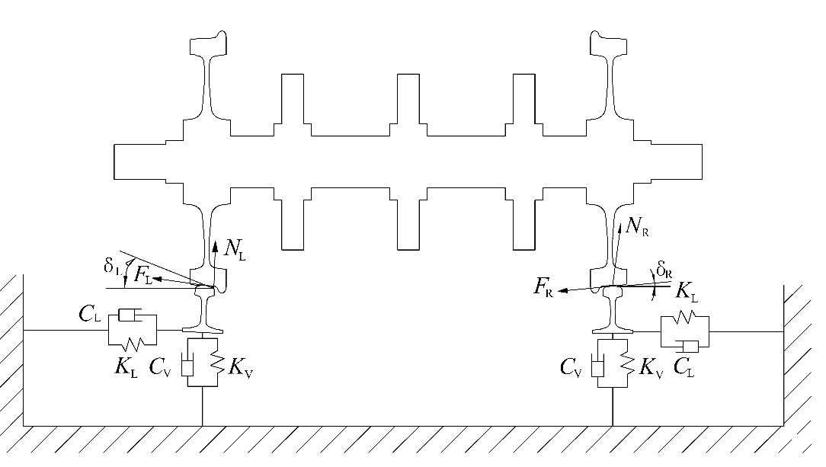

left rail

right rail

Fig. 1. Wheel-rail-disc brake contact model

### 2.2. The finite element modeling of wheelset-track-disc brake system

A finite element modelling for the wheelset-track-disc brake system is set up using ABAQUS 6.10, as shown in Fig. 2. The model includes a wheelset, two rails, and six friction pairs of a disc brake system. The brake discs used in China’s high-speed trains are ventilated discs. Considering the limitation of ABAQUS code and reducing the computation time cost, the ventilated discs are simplified to solid discs, which is not believed to change the conclusions drawn from the simulation results. Fig. 2 illustrates the details of the model: the wheelset is placed in the middle of the rails so that the effect of the fixed boundary condition at the ends of the rails on the simulation results can be mitigated. The rail length has a great influence on the simulation result. The reflected wave at both ends of the rails will affect the simulation result, if the length of rail is too short. But an overlong rail will result in an unbearable computation time cost. The length used in the FE model is a compromise between the computational accuracy and efficiency. In this paper, this is taken as the span length of 60 fasteners according to references [22-24]. The rail is fastened to the track slab by fastening and rail pads, the rail pads and fastening are simplified as a series of massless dampers and springs in the model, as shown in Fig. 2(b). The springs and dampers are uniformly distributed on each node. The incompatible hexahedral element with 8 nodes (C3D8I) is used to mesh the model. The model has 437957 solid elements, 1260 spring elements and 1260 damping elements with 500066 nodes. The contact relationships between the rail and the wheel, between brake pads and brake discs, and between brake levers and brake brackets are established in the model. The hard contact are adopted to describe their normal contact properties, the tangential contact properties are described by the penalty function method, the Coulomb friction model are used to described the relationship between the normal contact force and the tangential force at the contact interfaces.

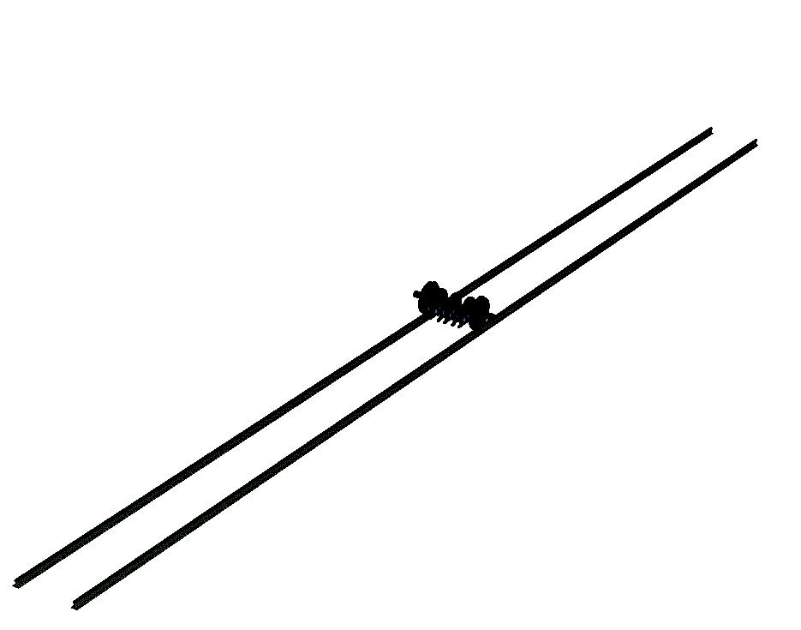

(a)

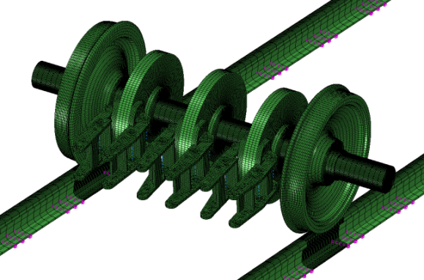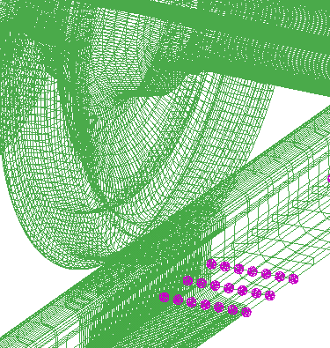

**springs and dampers**

(b)

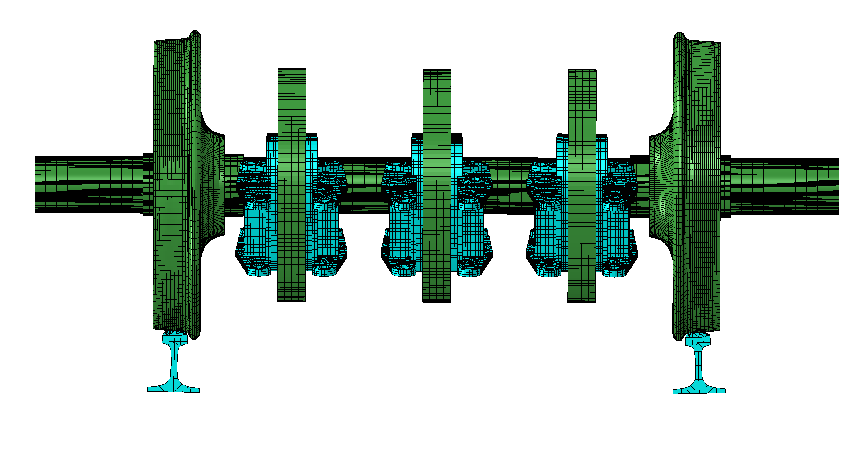

(c)

Fig. 2. The finite element modeling of wheelset-track-disc brake system, (a) the overview of the model; (b) details of the model; (c) the front view of the model.

The vertical suspension force *F*VR=*F*VL=75000 N and the lateral suspension force *F*LR=*F*LL=0 are applied to each axle end as the external load. The contact angles on both sides of the wheelset both are 3.709° when the train negotiates a straight track. The spacing of fasteners is 625 mm. The vertical stiffness value of each fastener is set as *K*V=50 MN/m and the lateral stiffness value is set as *K*L=28MN/m. The vertical damping value of each fastener is set as *C*V=30 kNs/m and the lateral damping is set as *C*L=20 kNs/m [2], respectively. The wheel nominal diameter is 840 mm, the wheel has a worn tread profile. The braking force applied to the brake lever is 10 kN. The disc brake system is consisting of the brake disc, the brake pad, the pad bracket and the brake lever. The brake disc is fixed on the axle of the wheel. The brake pad is bound to the pad bracket using the tie constraint of ABAQUS. The hinge and link connector of ABAQUS are used to simulate the movement relationship between brake lever and pad bracket, so that the pad bracket can rotate around one end of the brake lever. The hinge and link connector of ABAQUS are used to simulate the locating pin, so that the brake lever can only rotate around its fulcrum. The friction coefficient between the brake pad and the brake disc is 0.4 [25], and the one between the rail and wheel is 0.3 [26]. The contact between the brake bracket and the brake lever is frictionless. The forward speed of the vehicle is 300 km/h. The parameters of the wheelset-track system are shown in Table 1. A linear elastic material model is adopted in the model. The material property parameters are shown in Table 2.

Tab 1. Parameters of the wheelset-track system

|  |  |  |
| --- | --- | --- |
| Notation | Parameter | Value |
| *F*VR, *F*VL (N) | Vertical suspension force | 75000 |
| *F*LR, *F*LL (N) | Lateral suspension force | 0 |
| *K*V (MN/m) | Vertical fastener stiffness | 50 |
| *K*L (MN/m) | Lateral fastener stiffness | 28 |
| *C*V (kNs/m) | Vertical fastener damping | 30 |
| *C*L (kNs/m) | Lateral fastener damping | 20 |

Tab 2. Material property parameters of the wheelset-track-disc brake system

|  |  |  |  |
| --- | --- | --- | --- |
| Part | Density (kg/m3) | Modulus of elasticity (MPa) | Poisson's ratio |
| wheelset | 7800 | 210000 | 0.3 |
| Rail | 7800 | 210000 | 0.3 |
| Brake disc | 7300 | 207000 | 0.3 |
| Brake pad | 2500 | 8100 | 0.3 |
| Pad bracket | 5600 | 100000 | 0.3 |
| Brake lever | 7000 | 190000 | 0.3 |

### 2.3. Finite element method for the friction-induced vibration of the wheelset-track-disc brake system

When a vehicle passes through a sharp curve track, the wheel-rail creep forces at both wheels of the leading wheelset may become saturated [27]. In that case, the friction-induced vibration of a wheelset-track system aroused by the wheel-rail friction force may causes rail corrugation [27] or wheel polygonalization [2, 15]. Similarly, when the train is braked, the friction forces between the brake pad and the brake disc, and between the rail and the wheel probably cause self-excited vibration of the wheel-track-disc brake system, which probably leads to wheel polygonalization. In this paper, the motion stability of the wheel-track-disc brake system is studied using the complex eigenvalue analysis capacity of ABAQUS package. A brief account for the theoretical method is presented as follows. The motion equation of the wheelset-track-disc brake system is expressed by the following matrix equation [28]:

 (1)

where [*K*], [*C*] and [*M*] represents the stiffness matrix, the damping matrix, and the mass matrix, respectively. *x*,  and  are the nodal displacement, velocity and acceleration vectors, respectively. The corresponding eigenvalue equation of equation (1) can be expressed as follows:

 (2)

where *ϕ* is the eigenvector, and *λ* is the eigenvalue. [*C*] and [*K*] are asymmetric due to the friction. The solution of equation (2) mostly consists of conjugate complex pairs. First, the natural frequencies and corresponding vibration modes of the system are extracted before the complex modal analysis. When ignoring the damping matrix [*C*] and the non-symmetric terms of stiffness matrix [*K*], the eigenvalue *λ* becomes a pure imaginary number *λ*=*iω* and equation (2) becomes:

 (3)

where  is the circular frequency, [*K*s] is the symmetric part of stiffness [*K*]. *z* is the real eigenvectors. The subspace projection method is used to solve equation (3), a series of characteristic vectors *z*1,...., *z*N can be obtained. The new matrix can be obtained by projecting the original matrix in the subspace with *z*1,...., *z*N as the basis vector:

 (4)

 (5)

 (6)

Substituting equations (4), (5) and (6) into (2) gives:

 (7)

which is then solved using the QZ method for a generalised asymmetrical eigenvalue problem. The complex eigenvectors of the original system can be obtained by

 (8)

The general solution of equation (7) is

 (9)

where *x*(*t*)is the nodal vibration displacement with time. The dynamic stability of the system can be estimated by the real part of the eigenvalue. From Equation (9), we can see that when *α*i ＞ 0, *x*(*t*) will increase exponentially with time *t*, which indicates that the vibration of the system is enlarging and the system is unstable. But not all vibrations with a real part larger than zero will amplify infinitely due to the system damping. In order to estimate the propensity of the unstable vibration, the effective damping ratio is introduced, which is defined as:

 (10)

where Im(λ) represents the imaginary part of the eigenvalue, Re(λ) represents the real part. The necessary condition for the unstable vibration of the system is that the effective damping ratio is less than zero. Generally speaking, the unstable vibration can overcome the system damping and develop as long as the equivalent damping ratio is less than -0.001. The smaller the equivalent damping ratio, the more likely the corresponding unstable vibration will occur.

### 2.4. Polygonal wear analysis

In this section, the relationship between the friction-induced vibration of the wheelset-track-disc and wheel polygonalization will be expounded. Brockley [29] proposed a wear model:

 (11)

where *K* represents the wear constant, *w* represents the wear rate, *H* represents the friction power (*H*=*FV*). *F*, *C* and *V* is the tractive force,the durability friction work rate, and the relative velocity, respectively. Equation (11) can be used to understand the formation mechanism of wheel polygonalization. In the case of tractive contact between the wheel and the rail, *F* can be expressed as follows:

 (12)

where *N* is the normal contact force. *B* and *D* are constants that can obtained from the experimental curve of the traction-slip ratio as:

,  (13)

where *μ*\* is the maximum traction coefficient, *ς*\* is the critical slip ratio, both can be obtained from experimental curve of the traction-slip ratio. *v* is the train speed. The friction work rate can be expressed as follows:

 (14)

In the case of a constant longitudinal creepage, the friction work rate *H* will varies with the normal contact force *N*. The total normal force becomes the dominant factor affecting the friction work rate. When the friction-induced vibration aroused by the wheel-rail friction force, and the disc-pad friction force between the brake pads and brake discs occurs, the wheel-rail normal contact force will fluctuate in the same way [24], which will cause the friction power *H* to fluctuate at the same frequency. Finally, the wear volume *w* will also fluctuate in the same way as the friction power, according to equation (11). As a consequence, undulant wear occurs on the circumference of the wheel tread, i.e., the polygonal wear of wheels is created. The order of wheel polygonalization can be determined by the following equation:

 (15)

where *n* is the order of wheel polygonalization, *f*R is the vibration frequency of the self-excited vibration, *D* is the diameter of the wheel, *V* is the velocity of the vehicle.

## 3. Results and discussion

### 3.1. Modes of friction-induced vibration of the wheelset-track-disc brake system

When the wheelset rolls on a straight track, the longitudinal wheel-rail creepage is defined as follow:

 (16)

where *V*r is the vehicle velocity, *R* the actual rolling radius, *ω*r the angular velocity of the wheelset.

When *V*r-*ω*r*R=*0, the wheelset rolls freely on the rails, the longitudinal wheel-rail creepage is equal to zero, and the tangential wheel-rail force is equal to zero, correspondingly. When *V*r-*ω*r*R*>0, the wheelset is under braking, and there is a positive longitudinal creepage between the wheel and rail. When *V*r-*ω*r*R*<0, the wheelset is being driven, and there is a negative longitudinal creepage. In the section, the free rolling of the wheelset is simulated to investigate the unstable vibration of the system induced by the brake disc-pad friction force. Under the conditions of the vehicle speed of 300km/h, the suspension force 75000 N and the braking normal force of 10 kN, the angular velocity of the wheelset is 198.5275 rad/s when it rolls freely on the rails.



(b)

(a)

Fig. 3. Unstable vibration frequencies of the wheelset-track-disc brake system when the longitudinal creepage *ζ*=0; (a) all unstable vibrations; (b) partial details.

Generally, the frequency of wheel polygonalization is less than 1200 Hz. Therefore the simulation is limited to the range of 20-1200 Hz. Fig. 3(a) shows the distribution of unstable vibration frequencies when the longitudinal creepage *ζ*=0 or when the wheelset rolls freely on the rails. Fig. 3(b) is the partial details of Fig. 3(a). Because the tangential wheel-rail force is zero when the wheelset rolls freely on the rail, it can be concluded that the unstable vibration is induced by the friction force between the brake pads and the brake discs. As shown in Fig. 3, there are 12 unstable vibration frequencies with the effective damping ratio less than zero, including 10 unstable vibrations with the absolute effective damping ratio greater than 0.001. An unstable frequency of 1056.7 Hz has the minimum effective damping ratio of -0.2531; the second smallest effective damping ratio of -0.02317 is associated with an unstable frequency of 650 Hz. These two unstable vibrations are most likely to occur in practice. Fig. 4 shows their mode shapes. From Fig. 4(a), it can be seen that the friction-induced vibration with the frequency of 650 Hz takes place mainly on the rails, the wheels and the three discs. As shown in Fig. 4(b), the unstable vibration with the frequency of 1056.7 Hz takes place mainly on the intermediate disc. When the unstable vibrations cause the wheel-rail normal contact forces to fluctuate at the same frequency, the wheel polygonalizaition will be created under the action of the longitudinal creep force. Obviously, the unstable vibrations shown in Fig. 4 are mainly attributed to the instability of the disc brake systems. Because the longitudinal creepage between the wheel and the rail is zero, and the friction force between the wheel and the rail is zero. Disc brake squeal is a well-known physical phenomenon, which occurs during brake applications of automotives and airplanes. Numerous studies reveal that brake squeal is emitted when the instability of the disc brake system occurs, which is mainly due to the mode coupling mechanism of the disc brake system [31-34].

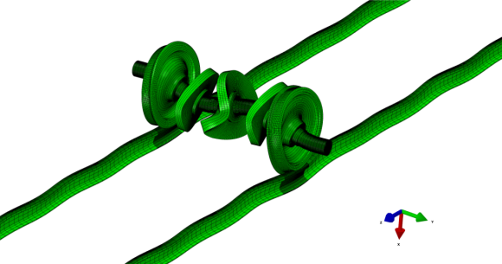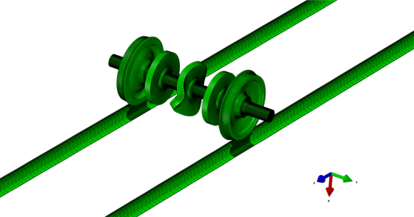

(b)

(a)

Fig. 4. Modes of unstable vibrations when the longitudinal creepage *ζ*=0: (a) at *f*R =600.27 Hz; (b) at *f*R =1056.7 Hz.



Fig. 5. Wheel-rail normal contact forces on both rails.



Fig. 6. PSD analysis of the wheel-rail normal contact forces on both rails.

To validate whether the wheel-rail normal contact forces will fluctuate at the same frequency as the friction-induced vibration, the transient dynamic analysis of wheelset braking on a straight track is carried out. In order to exclude the effect of friction force between the wheel and the rail, the free rolling of the wheelset is simulated in the dynamic model. In that case, the tangential force between the wheel and the rail is zero. A forward speed of 300 km/h and a rotational speed of 198.5275 rad/s are imposed on the wheelset in the explicit dynamic model. A translation speed of 300 km/h is applied to the disc brake system to ensure that the relative translation speed between the brake system and the wheelset is zero. A concentrated force of 10 kN is applied to the brake lever to simulate the braking process. Due to the long computation time of the explicit dynamic model, only the braking process of 0.3 s is simulated, in which, we assume that the speed of the wheelset and the braking system is constant, because the variation of the velocity is very small in such a short time. The other boundary conditions are the same as those of the complex eigenvalue model. Fig. 5 shows the wheel-rail normal contact forces on both rails in time domain. From Fig. 5, it can be seen that the wheel-rail normal contact forces fluctuate intensely with time. The maximum amplitude of the fluctuation is up to 400 kN. In the simulation, there is no geometric irregularity between the wheels and rails. Therefore, it can be concluded that the fluctuation of the wheel-rail normal contact forces is caused by friction-induced vibration of the wheelset-track-disc brake system. The normal contact forces on both sides of the wheelset are similar to each other. Fig. 6 shows the power spectral density (PSD) of the normal contact forces. The left wheel-rail normal contact force has one main frequency of 1160 Hz. The right wheel-rail normal contact force has one main frequency of 1168 Hz. The other two main frequencies are about 700 Hz and 880 Hz. From Figure 3, we can see that there are three unstable vibrations with the smallest effective damping ratioes, their frequencies are about 1056.7 Hz, 770 Hz and 650 Hz, respectively. As is shown in Figure 6, the main frequencies of the normal force are around 1168 Hz, 880 Hz and 704 Hz, respectively. The relative error are 10.5%, 14.3% and 8.3%, respectively. This is because the transient dynamic analysis and the complex eigenvalue analysis use different methods to solve the motion equation of the friction system. The complex eigenvalue analysis calculates the general solution of the equations of motion by using the subspace projection method. This is a frequency domain approach. On the other hand, the transient dynamic analysis uses the explicit time integration to calculate the dynamic response of the friction system in the time domain. The two approaches are known to produce different results that should not be far away from each other, which is confirmed by the above results of frequencies [24]. The above analysis proves that the friction-induced vibration of the disc brake system can cause the normal contact forces on the contact surfaces of wheels and rails to fluctuate at the same frequency. According to Formula (11), the friction work on the contact surfaces of wheels and rails will also fluctuate at the same frequency as the normal force fluctuates. It is worth noting that the friction work fluctuation is only one of the necessary conditions for the wheel polygonalizaition, the longitudinal creepage between the wheels and the rails is another necessary condition. In this section, the wheelset free rolling (i.e. the longitudinal creepage is zero) is simulated.

### 3.2. Effect of the longitudinal creepage

In Section 3.1, the unstable vibration of the wheelset-track-disc brake system with wheelset free rolling (i.e. the longitudinal creepage is zero) is studied. As described in Section 2.4, only under the action of the longitudinal wheel-rail creep force, the unstable vibration can cause the wheel polygonalization. In practice, the relative sliding or relative sliding tendency between the rail and the wheel always exists to provide the force to drive the vehicle forward or to brake the vehicle. Especially in braking, there is a large longitudinal wheel-rail creepage. In extreme cases when the creep force becomes saturated, the wheels even slide on the rails. In this section, the effect of the self-excited vibration on the polygonalization for different levels of longitudinal creepage is studied. In the analysis, the longitudinal creepage varies from 0 to 0.7 at an interval of 0.1.



(c)

(d)

(a)

(b)



(f)

(e)

Fig. 7. Unstable vibration distributions of the wheelset-track-disc brake system for different longitudinal creepage; (a) the longitudinal creepage *ζ*=0.1; (b) *ζ*=0.2; (c) *ζ*=0.3; (d) *ζ*=0.4; (e) *ζ*=0.5; (f) *ζ*=0. 6.

Fig. 7 shows the evolution of effective damping ratios *ζ* and the distribution of self-excited vibration frequencies for different longitudinal creepages. Comparing Fig. 7(a) with Fig. 3, the non-zero longitudinal creepage has a great influence on the unstable vibrations of the system. When the longitudinal creepage increases from 0 to 0.1, the unstable vibration with a frequency of 1056.7 Hz disappears. Instead, unstable vibration at a frequency of around 650 Hz has the minimum effective damping ratio. As shown in Figs. 7(a)-(f), the frequencies of the self-excited vibrations and the distribution of the effective damping ratio do not change significantly when the longitudinal creepage varies from 0.1 to 0.6. As shown in Fig. 7, the self-excited vibration with the frequency of 650 Hz has the minimum effective damping ratio for all levels of longitudinal creepages. According to formula (13), the self-excited vibration probably leads to the 21-order polygonal wear of the wheels.



Fig. 8. Dimensionless creep force vs longitudinal creepage curve.

Noting that the Coulomb’ law of friction in ABAQUS is used to calculate the longitudinal wheel-rail creep force. According to the Coulomb’ law, the longitudinal creep force is linear with the longitudinal creepage, which is different from the theory of Vermeulen and Johnson. As shown in Fig. 8, the longitudinal creep force calculated by the theory of Vermeulen and Johnson obviously is greater than that calculated by the Coulomb’ law in the range of longitudinal creepage 0-0.7. However, as an approximation, the Coulomb’ law can be used to reflect the relationship between the creep force and the creepage.

According to the theory of Vermeulen and Johnson, when the longitudinal creepage is approximated to about 0.7, the wheel-rail creep force becomes saturated and slipping is easy to occur. In that case, the self-excited vibration is induced by the friction force between the rail and the wheel. The distribution of the effective damping ratio of the self-excited vibrations is shown in Fig. 9. As shown in Fig. 9, there are 5 unstable self-excited vibration modes. Among them, the self-excited vibration with the frequency of 367.93 Hz has the minimum effective damping ratio of -0.001, which is most likely to occur. The corresponding mode shape is shown in Fig. 10. It is obvious that the friction-induced vibration occurs on the wheels, rails and the discs, and the yaw motion of the wheelset probably takes place. According to the formula (13), the self-excited vibration probably causes the 12-order polygon wheels. The effective damping ratios of the other self-excited vibrations are greater than -0.001, which are not thought to be sufficient to overcome the system damping to induce wheel polygonalization.



Fig. 9. Unstable frequencies of the wheelset-track-disc brake system when the longitudinal creepage is 0.7.

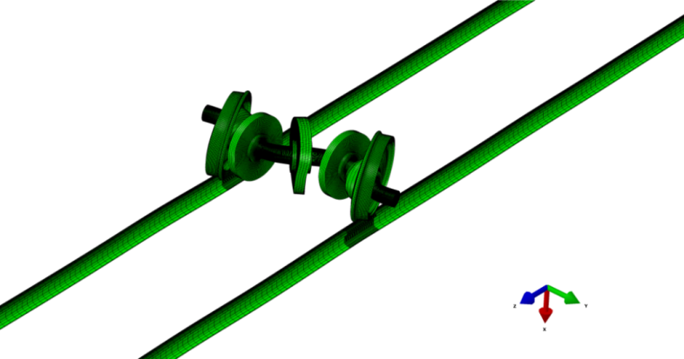

Fig. 10. Mode of the self-induced vibration when the longitudinal creepage is 0.7

### 3.3. Effect of the friction coefficient between the brake pads and brake discs

When the train is under braking, due to the temperature rise of the friction interface, material wear and so on, the friction coefficient between the brake pad and brake disc is constantly changing. The friction coefficient is a key factor to affect self-excited vibration of the wheelset-track-brake disc system. It is generally accepted that the greater the friction coefficient, the stronger the propensity of friction-induced self-excited vibration. In this section, the effect of the friction coefficient between the brake disc and pad is investigated in detail. The friction coefficient varies from 0.2 to 0.6 at an interval of 0.1. In the analysis, the longitudinal wheel-rail creepage remains unchanged at 0.6, and the wheel-rail friction coefficient remains unchanged at 0.3.



(b)

(a)



(e)

(d)

(c)

Fig. 11. Effect of the friction coefficient between the brake disc and pads on unstable vibration of the wheelset-track-disc brake system: (a) *μ*=0.2; (b) *μ*=0.3; (c) *μ*=0.4; (d) *μ*=0.4 and (e) *μ*=0.6.

The effect of the brake disc-pad friction coefficient on the self-excited vibration of the system is shown in Fig. 11. As shown in Fig. 11(a), there are 8 self-excited vibration frequencies when the friction coefficient is equal to 0.2. When the friction coefficient increases to 0.4, the number of the self-excited vibration frequencies increases to 13. As shown in Figs. 11(a)-(e), the number of the self-excited vibration frequencies and their absolute effective damping ratios increase significantly with the friction coefficient, which means that the greater the friction coefficient, the more easily the polygonal wear of wheels occurs. The frequency of the self-excited vibration which most likely causes the polygonal wear of wheels is about 650 Hz for different levels of friction coefficient.

3.4. Effect of the fastener damping

The fastener damping of high-speed railway is mainly provided by the rail pads between the sleepers and the rails. The rail pad material is generally rubber, whose damping is about 75 kNs/m. Due to aging of the rubber material, its damping changes with time. In this section, the effect of the fastener vertical and lateral dampings on the self-excited vibration is studied. When studying the effect of the vertical damping, the lateral damping is kept constant at 20 kNs/m, and the vertical damping varies within the range of 0 to 90 kNs/m. When the lateral damping is studied, the vertical damping is kept constant at 30 kNs/m. The lateral damping varies within the range of 0 to 100 kNs/m.



(a)



(c)

(b)



(e)

(d)

Fig. 12. Effect of the vertical fastener damping on unstable vibration of the wheelset-track-disc brake system: (a) *C*V=0; (b) partial detail of (a); (c) *C*V=30 kNs/m; (d) *C*V=60 kNs/m; (e) *C*V=90 kNs/m.

The effect of the vertical fastener damping on the self-excited vibration is shown in Figs. 12 (a)-(e). Fig. 12 (b) gives a partial detail of Fig. 12 (a). From Fig. 12, it can be seen that the unstable frequencies of the self-excited vibration which most likely occurs are 600 Hz, 650Hz and 800Hz for different vertical fastener dampings. Therefore, the 19-order or 21-order and 25-order polygonalization may be formed when the vertical fastener damping varies within the range of 0 to 90 kNs/m. From Fig.13, it is found that the effective damping ratio of the self-excited vibration becomes smaller with the increase of the vertical damping in the range of 0 to 60 kNs/m, which means that the occurrence propensity of self-excited vibration decreases with the increase of the vertical damping within that vertical range. However, when the vertical damping continues to increase to 90 kNs/m, the absolute effective damping ratio becomes larger, which means that the occurrence possibility of the polygonal wear of wheels becomes larger. Therefore, it can be concluded that too low or too high vertical fastener damping is easy to cause the wheel polygonalizaition.



(a)



(c)

(b)

# 

(e)

(d)

Fig. 13.Effect of the lateral fastener damping on unstable vibration of the wheelset-track-disc brake system: (a) *C*L=0; (b) partial detail of (a); (c) *C*L=20 kNs/m; (d) *C*L=50 kNs/m; (e) *C*L=100 kNs/m.

The effect of the lateral fastener damping on the friction-induced vibration of the wheelset-track-disc brake system is shown in Figs. 13 (a)-(e), Fig. 13 (b) gives a partial detail of (a). From Fig.13, it is found that the frequency of the self-excited vibration which is the most likely to occur is 600 Hz when the lateral fastener damping is zero, and when the lateral damping is larger than zero, the self-excited vibration with a frequency of 650 Hz is most likely to occur. It also can be seen that the absolute effective damping ratio of the self-excited vibration decreases obviously with the increase of the lateral damping, which means the possibility of wheel polygonalization decreases. It is suggested that increasing the lateral fastener damping is beneficial to suppressing wheel polygonalization.

### 3.5. Effect of the fastener stiffness

The rail fastener stiffness is different for different railway tracks or different sections of the same track. The rail fastener stiffness is generally located in the range of 10-100 MN/m. In this section, the effect of the vertical and lateral fastener stiffness on the self-excited vibration of the wheelset-track-disc brake system is investigated in detail. In order to study the effect of the vertical stiffness, the lateral stiffness is kept constant at 28 MN/m. The vertical stiffness varies in the range of 25-100 MN/m. When studying the effect of the lateral stiffness, the vertical stiffness is assumed to remain unchanged at 50 MN/m, and the lateral stiffness varies in the range of 10-50 MN/m.



(a)



(c)

(b)



(e)

(d)

Fig. 14.Effect of the vertical fastener stiffness on the unstable vibration of the wheelset-track-disc brake system: (a) *K*V=25 MN/m; (b) partial detail of (a); (c)*K*V=50 MN/m; (d) *K*V=75 MN/m; (e) *K*V=100 MN/m.

The effect of the vertical fastener stiffness on the friction-induced vibration of the wheelset-track-disc brake system is shown in Fig. 14. Fig. 14(b) gives a partial detail of Fig. 14(a). From Figs. 14 (a) and (b), it is found that when the vertical stiffness is 25 MN/m, the frequencies of self-excited vibrations most likely occur at 204 Hz, 425 Hz and 600 Hz, respectively, which probably lead to 7-order, 14-order and 19-order polygonal wear of wheels, correspondingly. When the vertical stiffness is greater than 25 MN/m, the self-excited vibration at the frequency of 650 Hz most likely occurs. From Figs. 14 (a)-(e), it is found that the effective damping ratio of the self-excited vibration is the minimum when the vertical fastener stiffness is 75 MN/m, which means that too low or too high vertical fastener stiffness is easy to cause wheel polygonalization.



(a)

(b)



(c)

Fig. 15. Effect of the lateral fastener stiffness on the unstable vibration of the wheelset-track-disc brake system for different: (a) *K*L=10 MN/m; (b) *K*L=28 MN/m; (c)*K*L=50 MN/m.

The effect of the lateral fastener stiffness on the self-excited vibration of the wheelset-track-disc brake system is shown in Fig. 15. From Figs. 15(a)-(c), it is seen that when the lateral fastener stiffness varies in the range of 10-50 MN/m, self-excited vibration at the frequency of 650 Hz most likely occurs, and the value of effective damping ratio decreases with the increase of the lateral fastener stiffness, which means the occurrence possibility of wheel polygonalization decreases with the increase of the lateral fastener stiffness. Therefore, it can be concluded that a higher lateral fastener stiffness is beneficial for the suppression of wheel polygonalization.

## 4. Conclusions

This paper studies the formation mechanism of wheel polygonalization of China’s high-speed trains through numerical simulation based on the point of view of friction-induced vibration causing wheel polygonalization. In the numerical simulation, a finite element model of a wheelset-track-disc brake system on a straight track is established and its dynamic stability is analysed using the complex eigenvalue analysis. The formation mechanism of wheel polygonalization and its influence factors are investigated in detail. The conclusions can be drawn as follows:

(1) When the train is braked, under the action of the longitudinal wheel-rail creep force, the self-excited vibration induced by the friction force between the brake pad and brake disc may cause wheel polygonalization.

(2) In the longitudinal creepage range of 0.1-0.7, the wheel-rail longitudinal creepage has little effect on the unstable vibration of the wheelset-track-disc brake system. The self-excited vibration at the frequency of 650 Hz most likely occurs in that range, which can result in 21-order polygonal wear of wheels. When the longitudinal creep force becomes saturated, the self-excited vibration of the wheelset-track-disc brake system induced by the friction between the rail and the wheel can result in 12-order polygonal wear of wheels.

(3) The friction coefficient between the brake pad and the brake disc affects strongly the self-excited vibration of the wheelset-track-disc brake system. The 21-order polygonal wear of wheels is easy to occur for different friction coefficient. The larger the friction coefficient, the higher the occurrence propensity of the wheel polygonalization.

(4) Too high or too low vertical fastener damping is easy to cause wheel polygonalization. When the vertical damping is 60 kNs/m, the occurrence possibility of wheel polygonalization is the lowest. Increasing the lateral fastener damping is helpful to suppress wheel polygonalization.

(5) Too high or too low vertical fastener stiffness is also easy to cause the wheel polygonalization. When the vertical stiffness is 25 MN/m, the self-excited vibrations will probably lead to 7-order, 14-order and 19-order polygonal wear of wheels. When the vertical stiffness is larger than 25 MN/m, the 21-order polygonal wear of wheels are easy to take place. A higher lateral fastener stiffness is beneficial for suppressing wheel polygonalization.

## Acknowledgements

The authors thank the financial support from National Natural Science Foundation of China (No. 51775461).

## References

1. Jin X, Wu L, Fang J, et al. An investigation into the mechanism of the polygonal wear of metro train wheels and its effect on the dynamic behaviour of a wheel/rail system. Vehicle System Dynamics, 2012, 50(12): 1817-1834.
2. Chen GX, Cui XL, Wang K. Generation mechanism for polygonalization of wheel treads of high-speed trains. Journal of Southwest Jiaotong University, 2016, 51(2-3): 244-250.(in Chinese)
3. Ahlbeck D R. A study of dynamic impact load effects due to railroad wheel profile roughness. Vehicle System Dynamics, 1988, 17(sup1): 13-16.
4. Wu X, Chi M, Wu P. Influence of polygonal wear of railway wheels on the wheel set axle stress. Vehicle System Dynamics, 2015, 53(11): 1535-1554.
5. Zhang J, Han G, Xiao X, et al. Influence of wheel polygonal wear on interior noise of high-speed trains. Journal of Zhejiang University Science A, 2014, 15(12): 1002-1018.
6. Nielsen J C O, Johansson A. Out-of-round railway wheels-a literature survey. Proceedings of the Institution of Mechanical Engineers, Part F: Journal of Rail and Rapid Transit, 2000, 214(2): 79-91.
7. Nielsen J C O, Lundén R, Johansson A, et al. Train-track interaction and mechanisms of irregular wear on wheel and rail surfaces. Vehicle System Dynamics, 2003, 40(1-3): 3-54.
8. Johansson A, Nielsen J C O. Out-of-round railway wheels—wheel-rail contact forces and track response derived from field tests and numerical simulations. Proceedings of the Institution of Mechanical Engineers, Part F: Journal of Rail and Rapid Transit, 2003, 217(2): 135-146.
9. Johansson A. Out-of-round railway wheels—assessment of wheel tread irregularities in train traffic. Journal of Sound and Vibration, 2006, 293(3): 795-806.
10. Brommundt E. A simple mechanism for the polygonalization of railway wheels by wear. Mechanics Research Communications, 1997, 24(4): 435-442.
11. Meywerk M. Polygonalization of railway wheels. Archive of Applied Mechanics, 1999, 69(2): 105-120.
12. Morys B. Enlargement of out-of-round wheel profiles on high speed trains. Journal of Sound and Vibration, 1999, 227(5): 965-978.
13. Johansson A, Andersson C. Out-of-round railway wheels—a study of wheel polygonalization through simulation of three-dimensional wheel–rail interaction and wear. Vehicle System Dynamics, 2005, 43(8): 539-559.
14. Meinke P, Meinke S. Polygonalization of wheel treads caused by static and dynamic imbalances. Journal of Sound and Vibration, 1999, 227(5): 979-986.
15. Chen GX, Jin XS, Wu PB, et al. Finite element study on the generation mechanism of polygonal wear of railway wheels. Journal of the China Railway society, 2011, 33(1): 14-18 (in Chinese)
16. Wu Y, Du X, Zhang H, et al. Experimental analysis of the mechanism of high-order polygonal wear of wheels of a high-speed train. Journal of Zhejiang University-SCIENCE A, 2017, 18(8): 579-592.
17. Jin X. Key problems faced in high-speed train operation. Journal of Zhejiang University Science A, 2014, 15(12): 936-945.
18. Ouyang H, Cao Q, Mottershead J E, et al. Vibration and squeal of a disc brake: modelling and experimental results. Proceedings of the Institution of Mechanical Engineers, Part D: Journal of Automobile Engineering, 2003, 217(10): 867-875.
19. Ouyang H, Mottershead J E, Li W. A moving-load model for disc-brake stability analysis. Journal of vibration and acoustics, 2003, 125(1): 53-58.
20. Nack W V. Brake squeal analysis by finite elements. International Journal of Vehicle Design, 2000, 23(3-4): 263-275.
21. Ouyang H, Mottershead J E, Cartmell M P, et al. Friction-induced vibration of an elastic slider on a vibrating disc. International Journal of Mechanical Sciences, 1999, 41(3): 325-336.
22. Cui X L, Chen G X, Yang H G, et al. Effect of the wheel/rail contact angle and the direction of the saturated creep force on rail corrugation. Wear, 2015, 330: 554-562.
23. Cui X, Chen G, Zhao J, et al. Field investigation and numerical study of the rail corrugation caused by frictional self-excited vibration. Wear, 2017, 376: 1919-1929.
24. Qian W J, Chen G X, Ouyang H, et al. A transient dynamic study of the self-excited vibration of a railway wheel set–track system induced by saturated creep forces. Vehicle System Dynamics, 2014, 52(9): 1115-1138.
25. Liu P, Zheng H, Cai C, et al. Analysis of disc brake squeal using the complex eigenvalue method. Applied acoustics, 2007, 68(6): 603-615.
26. Wu T X. Parametric excitation of wheel/track system and its effects on rail corrugation. Wear, 2008, 265(9-10): 1176-1182.
27. Chen G X, Zhou Z R, Ouyang H, et al. A finite element study on rail corrugation based on saturated creep force-induced self-excited vibration of a wheelset–track system. Journal of Sound and Vibration, 2010, 329(22): 4643-4655.
28. Yuan Y. An eigenvalue analysis approach to brake squeal problem, Proceedings of the 29th ISATA Conference. Automotive Braking Systems, Florence, Italy, June. 1996: 3-6.
29. Brockley C A, Ko P L. An investigation of rail corrugation using friction-induced vibration theory. Wear, 1988, 128(1): 99-106.
30. Vermeulen P J, Johnson K L. Contact of nonspherical elastic bodies transmitting tangential forces. Journal of Applied Mechanics, 1964, 31: 338.
31. N.M. Kinkaid, O.M. O’ Reilly, P. Papadopoulos, Automotive disc brake squeal, J. Sound Vib. 267 (2003) 105-166.
32. R.A. Ibrahim, Friction-induced vibration, chatter, squeal, and chaos. Part 2. Dynamics and modeling, Appl. Mech. Rev. 47 (7) (1994) 227-253.
33. D.A. Crolla, A.M. Lang, Brakes noise and vibrations-the state of the art, in: Proceedings of the Leeds-Lyon Symposium on Tribology, 1990, 165-174.
34. Antti Papinniemi, Joseph C.S. Lai, Jiye Zhao, Lyndon Loader, Brake squeal: a literature review, Applied Acoustics, 2002, 391-400.