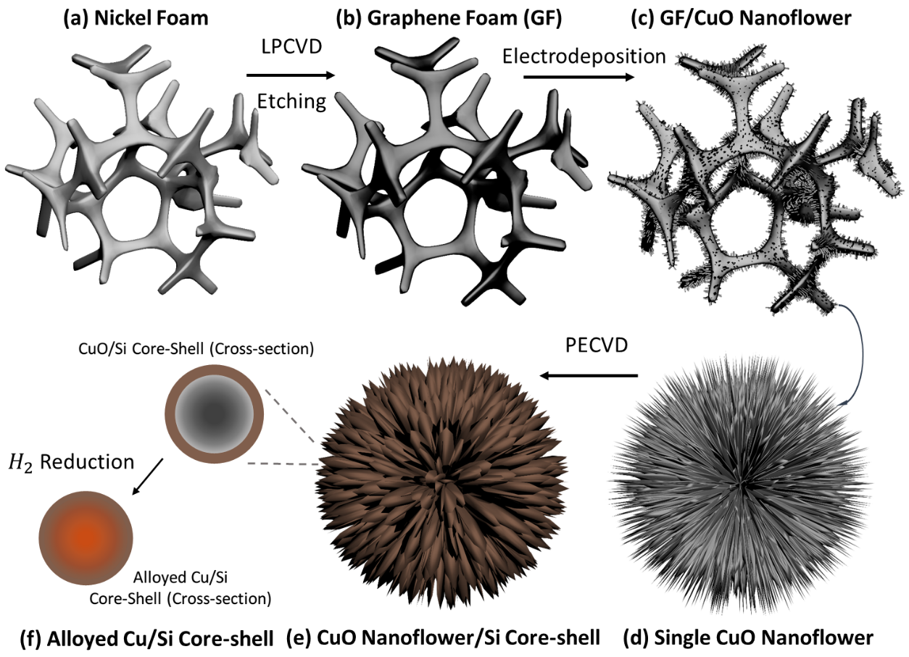
Figure 1 Schematic of synthesizing alloyed Cu/Si core-shell NFs on the three-dimensional graphene foam (3DGF).

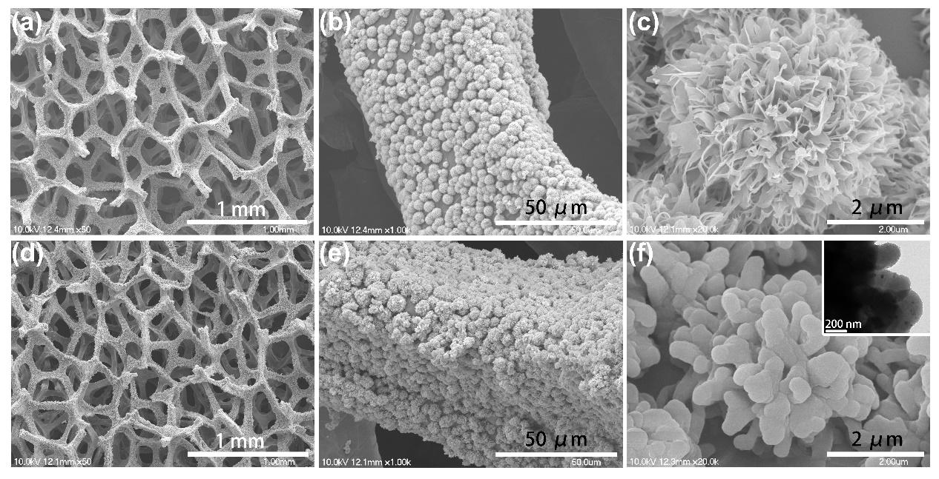
Figure 2 (a, b) low- and high-magnification SEM characterization of CuO NFs anchored on 3DGF; (c) partial enlarged detail of a single CuO NF; (d, e) low- and high-magnification SEM of Cu/Si core-shell NFs grown on 3DGF; (f) partial enlarged detail of a single Cu/Si core-shell NF by SEM characterization. The insert shows the TEM image of Cu/Si core-shell structure on the single NF.

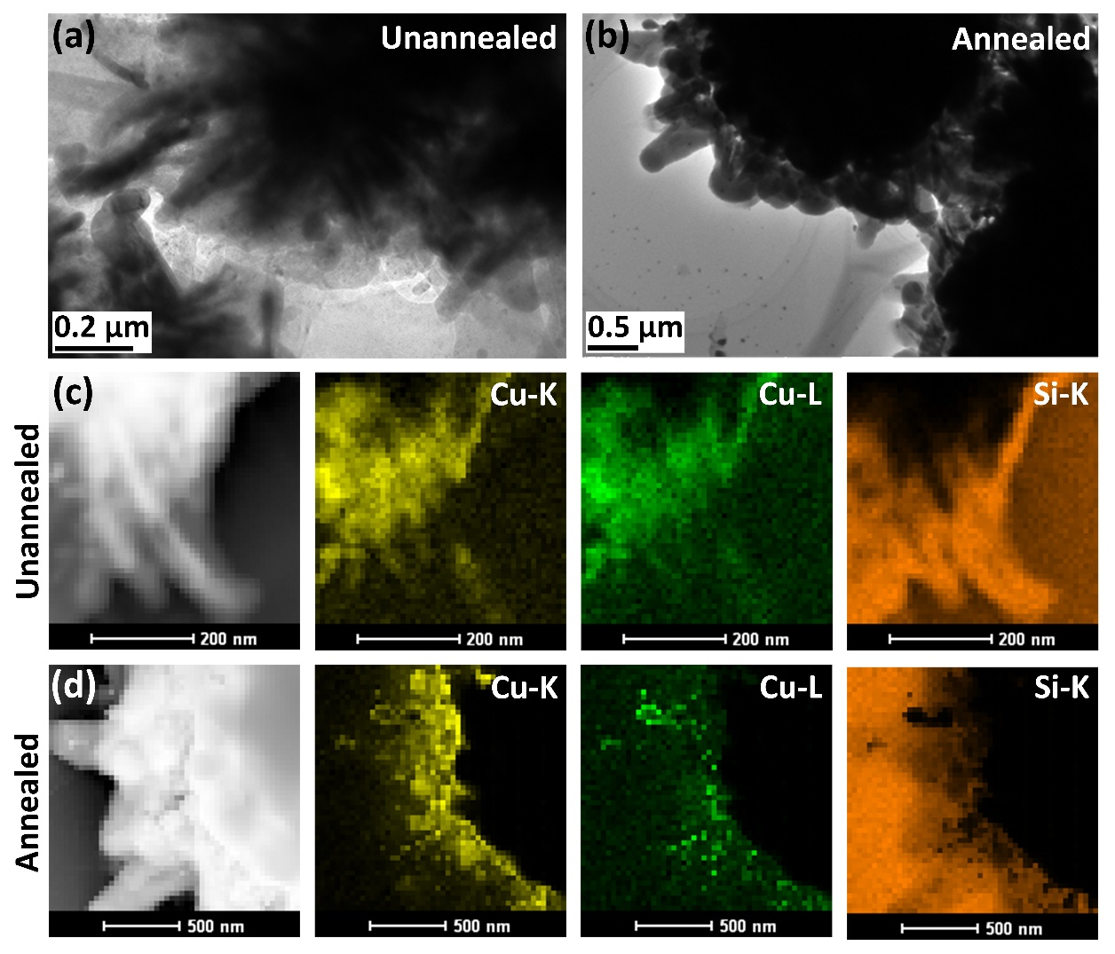
Figure 3 (a, c) TEM image and EDS mapping of the unannealed CuO/Si Core-Shell NFs on 3DGF, (b, d) TEM image and EDS mapping of the Cu/Si Core-Shell NFs on 3DGF annealed in hydrogen atmosphere at 450 °C for 4h.
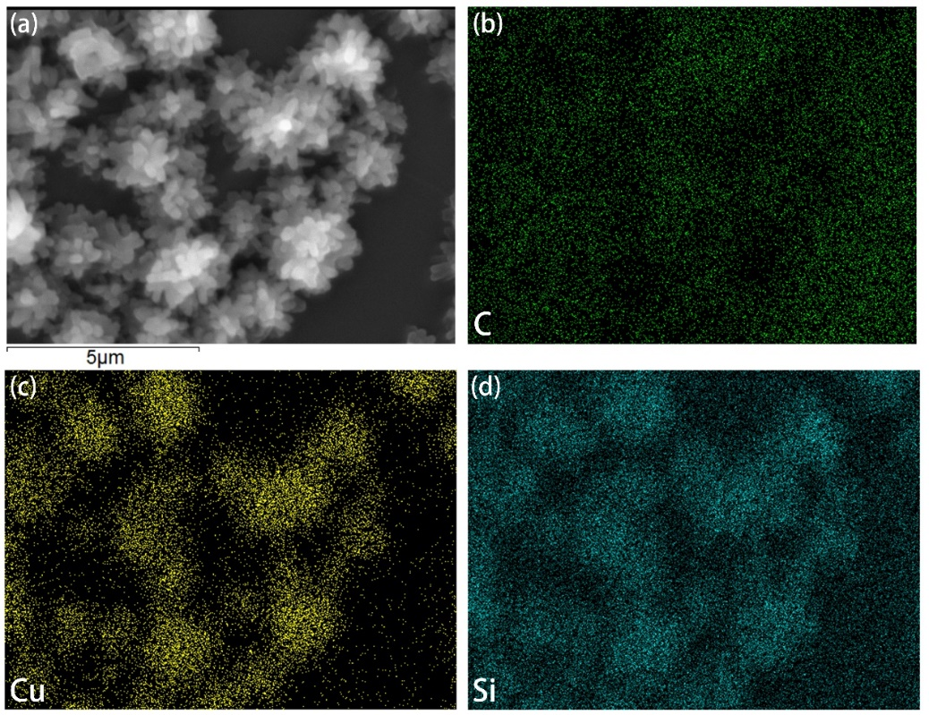
Figure 4 a) SEM image of the Cu/Si Core-Shell NFs on 3DGF, b-d) corresponding EDS carbon, copper, and silicon elemental mapping.

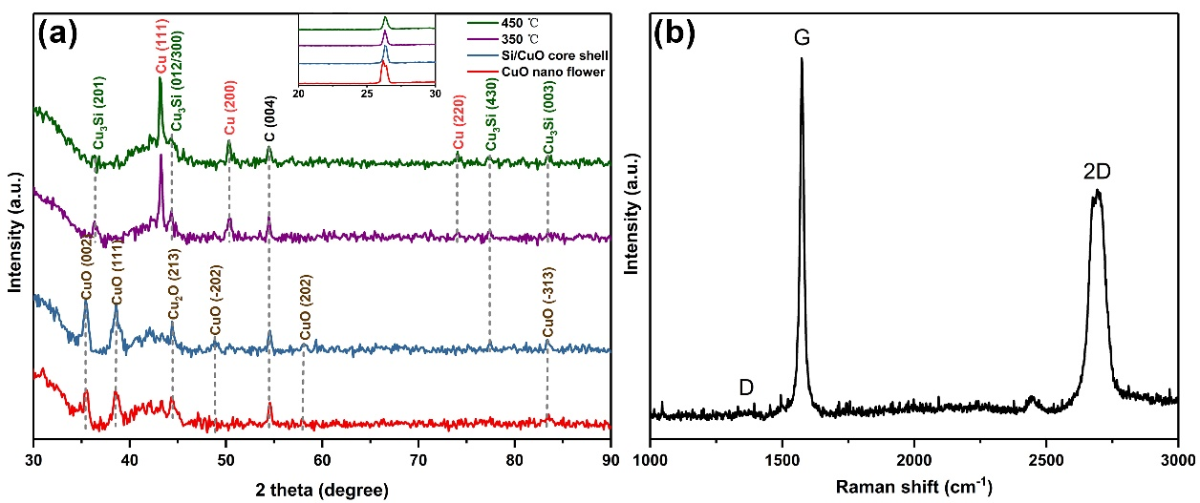
Figure 5 (a) XRD spectra of CuO NFs, CuO/Si core-shell structure, and alloyed Cu/Si core-shell structure after annealing at 350 °C and 450 °C; (b) Raman spectra of 3DGF.

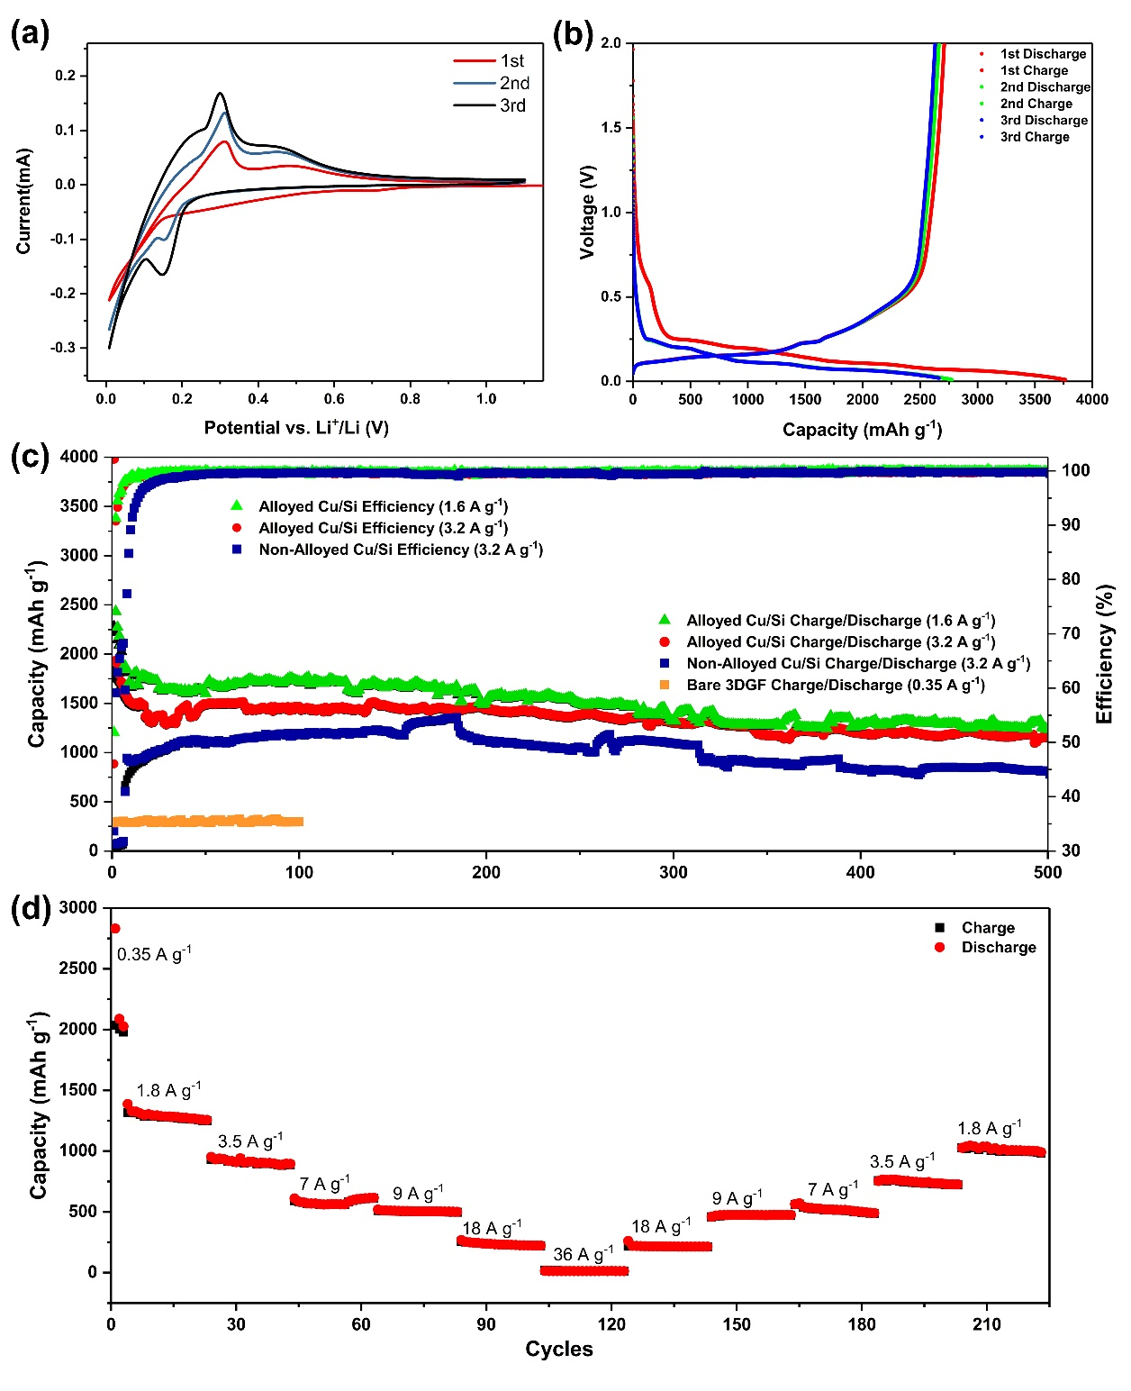
Figure 6 The cycling performance of the alloyed Cu/Si core-shell NFs anode materials with CR2032 coin cell configuration: (a) The cyclic voltammetry (CV) curves of alloyed Cu/Si core-shell NFs in the first three cycles with the scan rate of 0.1mV s⁻¹ between 0.01 V to 1.1 V; (b) The voltage profiles of Cu/Si NFs anode in the first three cycles at 0.35 A g⁻¹; (c) The cycling performance of alloyed Cu/Si anode with charge/discharge current density of 1.6 A g⁻¹, 3.2 A g⁻¹ and non-alloyed Cu/Si anode with charge/discharge current density of 3.2 A g⁻¹; (d) The rate performance of alloyed Cu/Si core-shell NFs anode.

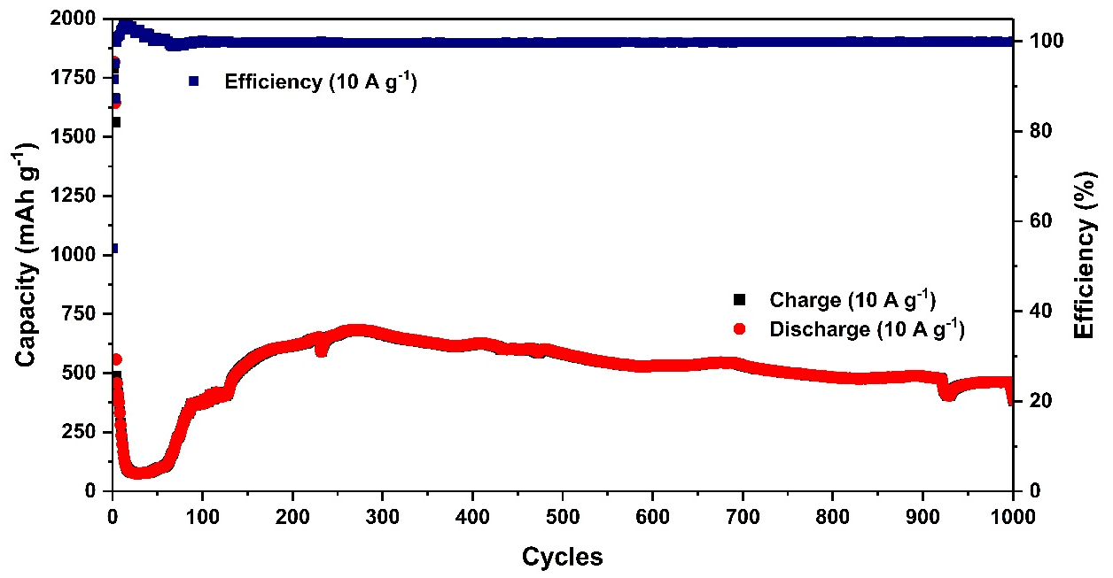
Figure 7 The long-term cycle performance of the alloyed Cu/Si NFs anode with a charge/discharge current density of 10 A g⁻¹.

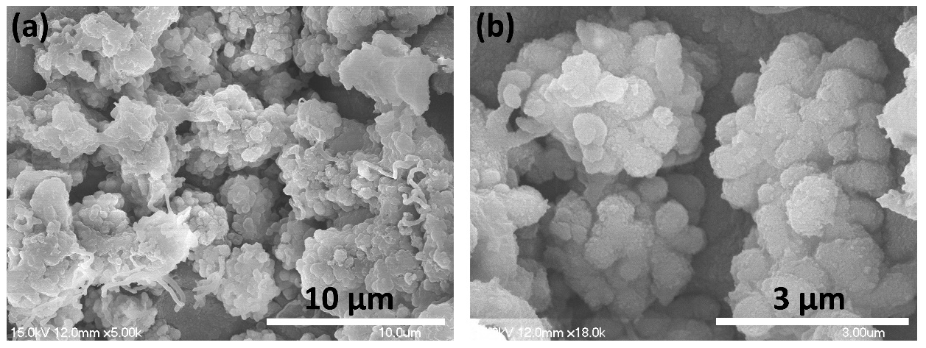
Figure 8 (a, b) Low- and high-magnification SEM characterization of the Cu/Si Core-Shell NFs on 3DGF after 50 cycles with a charge/discharge current density of 1.6 A g⁻¹.

