Supplementary Materials

Alloyed Cu/Si core-shell nanoflowers on the three-dimensional graphene foam as an anode for lithium-ion batteries
Chenguang Liu^{a,b}, Yinchao Zhao^{a,b}, Ruowei Yi^{c,d}, Yi Sun^{a,b}, Yinqing Li^{e}, Li Yang^{c*}, Ivona Mitrovicª, Stephen Taylorª, Paul Chalker^{e}, Cezhou Zhao^{b*}

ªDepartment of Electrical Engineering and Electronics, University of Liverpool, Liverpool L69 3GJ, UK
^{b}Department of Electrical and Electronic Engineering, Xi’an Jiaotong-Liverpool University, Suzhou 215123, China
^{c}Department of Chemistry, Xi’an Jiaotong-Liverpool University, Suzhou, Jiangsu 215123, China
^{d}Stephenson Institute for Renewable Energy, Department of Chemistry, University of Liverpool, Liverpool L69 7ZD, UK
^{e}Dongguan Hongde Battery Ltd. Co., Dongguan 523649, China
^{f}Centre for Advanced Materials, University of Liverpool, L69 3GH, UK

*Corresponding authors.
E-mail addresses: cezhou.zhao@xjtlu.edu.cn (C. Zhao); li.yang@xjtlu.edu.cn (L. Yang)
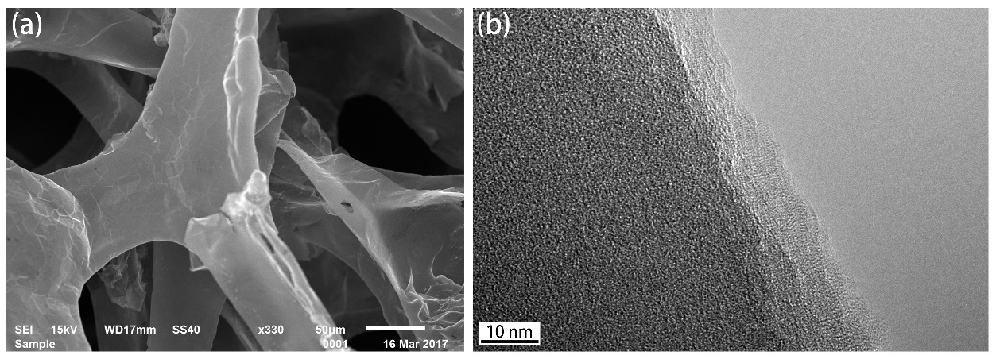
Figure S1 a) SEM characterization of bare as-prepared three-dimensional graphene foam (3DGF), b) TEM characterization of bare as-prepared 3DGF.

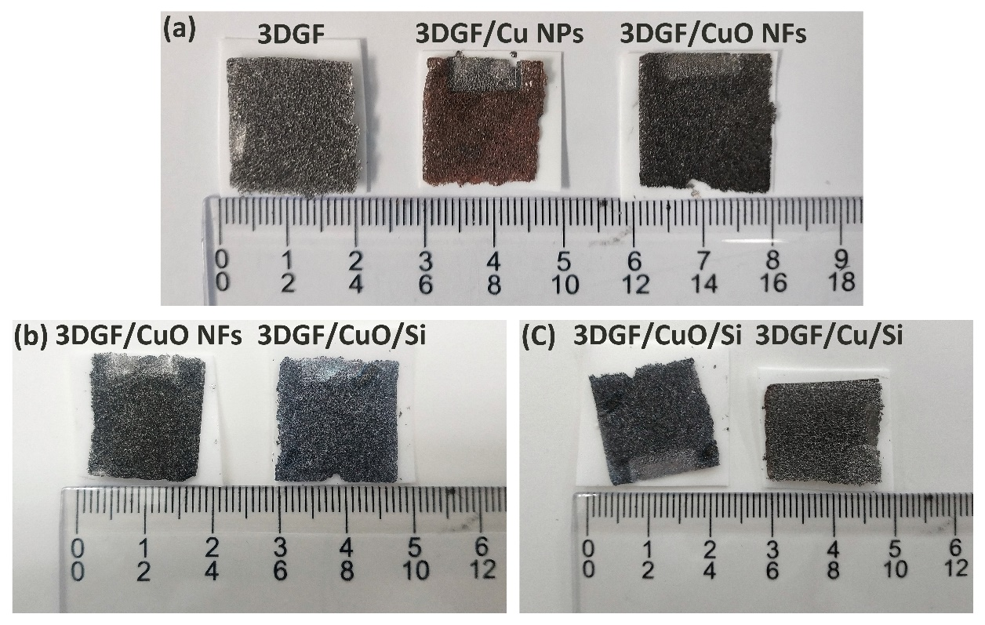
Figure S2 Optical images of (a) 3DGF, 3DGF/Cu nanoparticles (NPs), and 3DGF/CuO NFs samples; (b) 3DGF/CuO NFs and 3DGF/CuO/Si NFs samples; and (c) 3DGF/CuO/Si NFs and 3DGF/Cu/Si NFs samples.

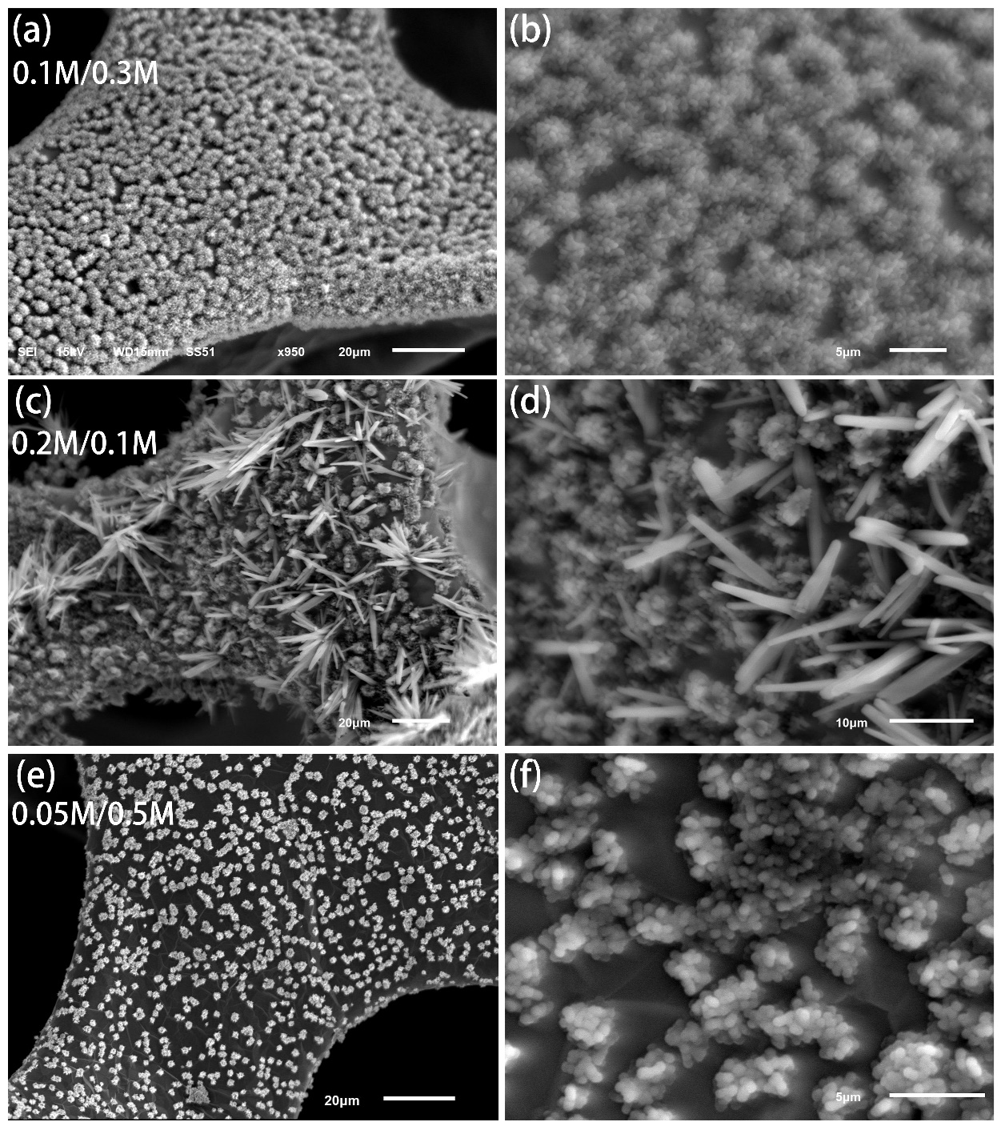
Figure S3 Typical SEM images of Cu/Si nanoflowers (NFs) grown on 3DGF with different distribution at different magnifications. The number inserted indicate the concentration of CuSO₄ and H₂SO₄ sources in electrochemical deposition electrolyte.

Table S1 Analysis of Raman spectrum of as-prepared 3DGF
 | FWHM (cm⁻¹) of G band | FWHM (cm⁻¹) of 2D band | Intensity ratio G/2D | Number of layers
Bare 3DGF  (this work) | 17.1 | 71.3 | 0.56 | ~4
Ref. [1] | 13.0 | 60.4 | 0.59 | 3
 | 13.4 | 63.0 | 0.48 | 4
 | 12.6 | 65.0 | 0.41 | 5

References
[1] D. Yoon, H. Moon, H. Cheong, J. Choi, J. Choi, B. Park, Journal of the Korean Physical Society, 55 (2009) 1299-1303.

