**Multi-Point Forming using Mesh-Type Elastic Cushion: Modelling and Experimentation**

A Tolipov1, A Elghawail1, M Abosaf1, D Pham1 and H Hassanin2, K Essa1

*1 Department of Mechanical Engineering, School of Engineering, University of Birmingham, Edgbaston, Birmingham B15 2TT, UK.*

*2 School of Engineering, University of Liverpool, Liverpool L69 3BX, UK*

# Abstract

There is a growing demand for flexible manufacturing techniques that meet the rapid changes in production technology, processes and innovations. Multi-point forming (MPF) is a flexible sheet metal forming technique where a reconfigurable die can be readily changed to produce various shapes. Parts produced using MFP suffers from geometrical defects such as wrinkling, dimpling and thickness variations. In this paper, a multi-point forming process using a novel mesh-type elastic cushion was proposed in order to improve the quality of the deformed sheet and to minimize the developed defects. Finite element modelling (FEM) and design of experiments (DoE) were used to study the influence of the mesh-type elastic cushion parameters such as the type and the size of the mesh, and the thickness of the cushion on the wrinkling, deviation, and thickness variation of the deformed sheet. The results showed that using elastic cushion with square meshes of a size of 3.5 mm and a thickness of 3 mm reduced the wrinkling from 3.18 mm to 1.98 mm while the thickness variation improved from 98 µm to 19 µm. Finally, the deviation from target shape reduced from 1.7848 mm to 0.0358 mm.

**Keywords:** *Multi-point forming; Mesh-Type Elastic Cushion; Modelling, Design of Experiment.*

# Introduction

Sheet metal forming is a widely used technology for various applications because of their advantages in manufacturing of lightweight metal components. A typical sheet metal forming process requires a die set to shape the sheet metal into the required geometry. However, production of dies is a time consuming and a costly process. Recently, efforts were made to overcome the drawbacks of conventional sheet metal forming. Multipoint forming (MPF) , one of the advanced and flexible manufacturing techniques to produce 3D sheet-metal parts, has been emerged to increase the flexibility of sheet metal forming by using reconfigurable dies. In MPF, individual active punches or pins were employed to form the working surface of the discrete die. MPF technology was first introduced for more than 40 years ago by Nakajima et al [1]. A matrix of round pins mounted on headstock of a NC milling machine was used as a solid die. The device was developed further by the Massachusetts Institute of Technology (MIT) to achieve reconfigurable die for flexible manufacturing of aircraft panel. Since then, several researchers have carried out research studies to develop the technology further. Valjavec and Hardt introduced a closed-loop control method for MPF process to manufacture aircraft panels using reconfigurable die [2]. Park et al. carried out simulation and experimental work to study the effect of stretching on flexible forming [3]. Several MPF methods such as multi-point press, forming sectional MPF, and iterative (MPF) were also proposed to form sheet metals for different applications such as titanium implants, train and ship panels [4, 5].

Although MPF holds a great potential as a cost effective and time saving technology, the products defects such as springback, wrinkles and dimples of the process restrict the penetration of MPF technology into a wide range of applications [6]. Wrinkles are caused by the compressive instability which is initiated by the developed stresses, strain, and geometry of the workpiece, material properties and contact conditions [7]. On the other hand, dimples are caused by the contacts between sheet plate and the pin ends [8]. Furthermore, in MPF, the metal sheet is subjected to a combination of stretching and elastic-plastic deformation. Springback of the sheet metal is caused by the recovery of the elastic deformation [9]. To reduce or eliminate wrinkling on the workpiece during MPF, the punch pressure must be higher than the compressive force induced from the sheet metal. However, increasing the punch pressure may cause dimples and springback problems of the workpiece due to the discrete punch elements. The above-mentioned issues are the serious problems with MPF which deteriorate the product surface quality. As a result, efforts were made to eliminate wrinkles and dimples in MPF. Cai et al. [10] studied the influence of the contact between the pins and metal sheet, mesh size and forming force on the developed defects, such as wrinkling, dimpling, and spring back. They found that a large number of simulations are needed in order to achieve a defect free design shape. Paunoiu et al. [11] researched the effect of the type of the pins on the sheet deformation of sheet metals in MPF with a fixed setup in terms of thickness, developed stress, and spring back. They found that there is a strong correlation between the pin types and the products quality and therefore pins types must be selected carefully optimised. Researchers have used elastic cushion sandwiching the metal sheet and carried out finite element analysis (FEA) with subsequent experimentation to optimise appropriate thickness of the elastic cushion. Quan et al. [12] investigated the effect of the elastic cushion thicknesses to improve the quality of the formed sheet metal of AZ31B. Cai et al. [10] carried out FE simulation and experimental study into dimpling, wrinkling, and spring-back using different process parameters. Zareh-Desari et al. [13] confirmed that the elastic cushion layers are essential elements in MPF and has improved the geometrical accuracy of the deformed sheet.

Paunoiu et al. [14] used a dynamic FE models and studied the impact of the elastic cushion and tool geometry on the sheet deformation. They found that the elastic cushion had contributed on improving the surface quality of the deformed sheet. Kareem and Imad [15] studied the influence of localised deformation on the quality of the deformed sheet and the importance of using the elastic cushion in reducing the formation of dimples but they also found that using a very thick elastic cushion degrades the accuracy of the fabricated part. On the other hand, Essa et al [16-18] studied the effect of elastic material, friction coefficient and thickness on the surface quality. They were able to optimise the elastic material type and thickness for better products quality parts.

To the best of the authors’ knowledge, many researchers used solid elastic cushions to improve the quality of the deformed sheets in MFP process but no study was found of using mesh-type elastic cushion to replace the typical solid one. In this work, a novel mesh-type elastic cushion was proposed aiming to improve surface quality of the MFP process. Finite element modelling and design of experiments were employed to optimise the mesh type elastic cushion parameters. The effect of the cushion thickness, mesh size and the type on the quality of the deformed parts in terms of wrinkling, thickness variation, and maximum deviation was investigated.

# Experimental and Modelling

# Experimental work

The experimental work of the MPF process was carried out using a MPF device as shown in Figure 1. There were 600 pins for each array, with 30 rows in the x- direction and 20 columns in the z- direction, the square pin cross section was $10×10$ mm with a 10 mm tip radius and with 0.25 mm gap between adjacent pins. The height of the pins was adjusted by rotating a lead screw.

Figure 1: Experimental Setup of MPF process

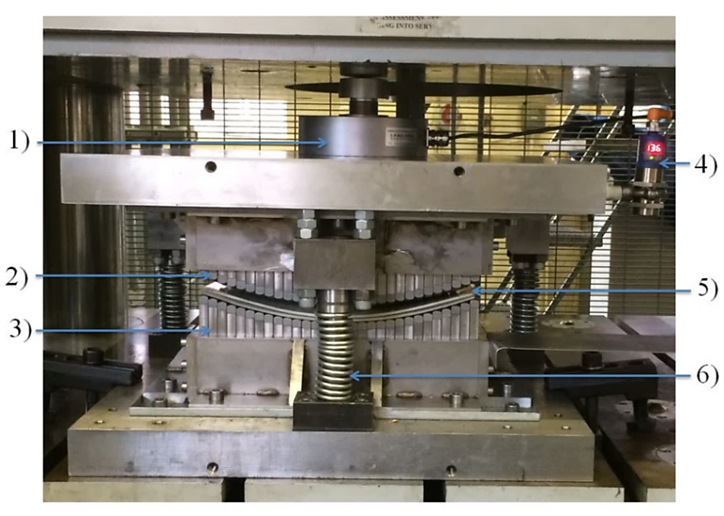

Punch Load Cell

Upper die

Lower die

Distance sensor

Cushion & blank sheet

Punch spring

A blank sheet of DC05 steel with 1-mm thickness was used in this work. The mechanical properties of the DC05 blank sheet were obtained in order to feed them to the numerical simulation. A Zwick/Roell tensile test machine with an extensometer attached to the specimen gage length (University of Birmingham) was used according to the ASTM E8 standard. Samples of the DC05 sheet material were cut at 0, 45º, and 90 º with respect to the blank sheet rolling direction to investigate the effect of the rolling direction on the mechanical properties of the samples. The tensile test results are shown in Figure 2a. They indicate that the rolling direction had no significant effect on the tensile testing results and therefore the blank sheet material was considered as isotropic material. In addition to the experimental data, a power law equation was also applied to represent the stress of the sheet material, see equation 1 [16].

$σ=kε^{n}$ (1)

where σ is the true stress, k is the coefficient of strength, ε is the true strain, and n is the strain hardening. The mechanical properties of the DC05 sheet material are shown in Table 1.

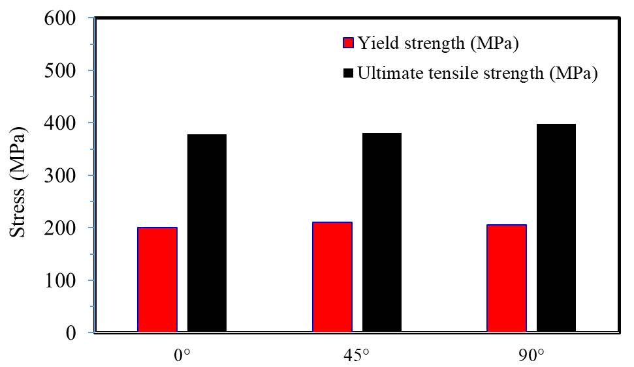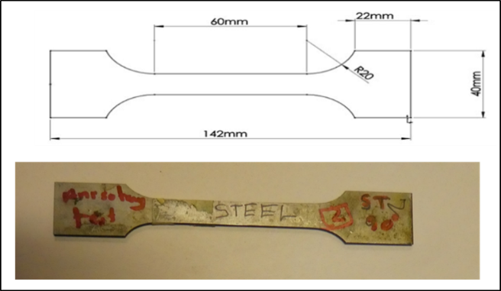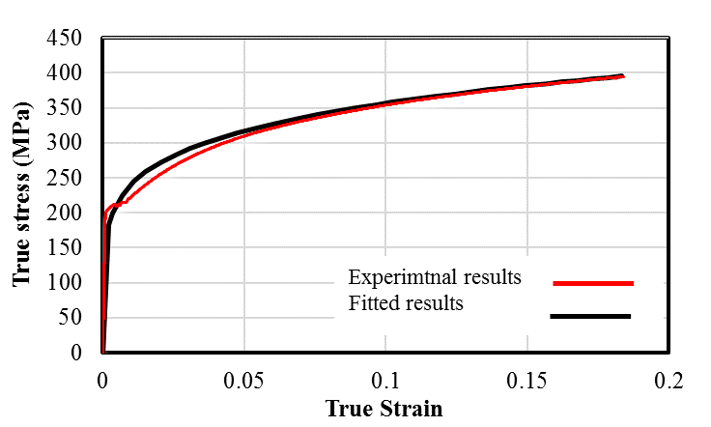

(a)

(b)

Experimental results

Fitted results

Figure 2: (a) Tensile test results of the samples cut at 0, 45º, and 90 º with respect to the rolling direction, (b) Experimental and fitted tress strain curve for steel DC05 test.

Table 1: Mechanical properties of DC05 blank sheet

|  |  |
| --- | --- |
| Property/Units | Value |
| Density/(kg/m3) | 7850 |
| Young’s modulus /(GPa) | 220.3 |
| Yield stress/(MPa) | 200.6 |
| Poisson’s ratio | 0.3 |
| Strength coefficient k/(MPa) | 527.13 |
| Strain-hardening exponent (n) | 0.17 |

A Mesh-Type elastic cushion was prepared using polyurethane A-90 as it is one of the durable materials used in the MFP process [16]. Table 2 shows the solid and mesh-type elastic cushions used in the experiments.

Table 2: Solid and mesh type cushions used in the experiment.

|  |  |  |
| --- | --- | --- |
| Solid Cushion | Square hole type | Circular hole type |
| 300 $×$ 200 mm | 300 $×$ 200 mm | 300 $×$ 200 mm |
|  |  |  |

The polyurethane A-90 properties were obtained using a Zwick tensile test machine and subjected to a compression test and according to the authors’ previous research work [16]. The results of compression test were compared with three mathematical models before using them in the FE simulation. These models were Yeoh, Neo-Hooke and Mooney–Rivlin. Figure 3 shows a comparison between the three models and the compression results. As shown, there is an agreement between the experimental results and Mooney–Rivlin model. Therefore, this model was used in the FE simulation as a nonlinear hyper-elastic. The profile of the deformed sheet was measured using a Coordinate Measuring Machine (CMM) with geomatics. The deformed surface was scanned with a grid of points with a spacing of 4 mm in the X and Y directions.

Figure 3: Nominal compression stress–strain diagram of polyurethane A-90 compared to Yeoh, Neo-Hooke and Mooney–Rivlin models.

# Modelling

A FE model was developed to study the MPF process with mesh-type elastic cushion. The model consists of a pair of pins matrices forming the die and the punch, respectively, a blank sheet, and two sheets of mesh-type elastic cushion. The pins of the die and punch are square shaped with hemispherical tips. Figure 4 represents the FE model and its components. SolidWorks was used to construct the model and simulated by using ABAQUS Explicit. As the model is symmetric, only one quarter of the model was used to speed up the computational time. The sheet and elastic cushion were modelled as deformable bodies and C3D8R quadratic element type was used. Five elements through the sheet thickness has been used as recommended by Wang, S., et al [19]. The element size is 1mm and a total of 182250 elements were used to mesh one-quarter of the sheet while a total of 49140 elements were used for the elastic cushion. The pin size is 10 mm was recommended in previous investigation by Abosaf et al [16]. Therefore, each of the punch and die contains 300×200 pins and each single pin has10 mm tip radius. The pins were modelled as discrete rigid bodies. Symmetric boundary conditions were applied to the sheet and elastic cushion. The die is fixed in X, Y and Z directions while the punch is fixed in X and Z directions only and free to move in Y axis as shown in Figure. Surface to surface contact between the pins and elastic cushion as well as between the elastic cushion and sheet metal is used. Coulomb Friction has been implemented and coefficient of friction of 0.05 and 0.1 were used as recommended by Abosaf et al [16].The dimensions of the sheet metal were 155 mm × 100 mm × 1 mm and those of the elastic cushion were 155 mm × 105 mm × 3 mm. Figure 5 shows the boundary conditions and the meshing models. Coulomb friction has been used in this FE model presented in this investigation. Coulomb friction is widely used in multi-point forming where values between 0 - 0.1 were tested [16]. An explicit solver was employed in the simulation to avoid convergence problems because the large number of elements used.

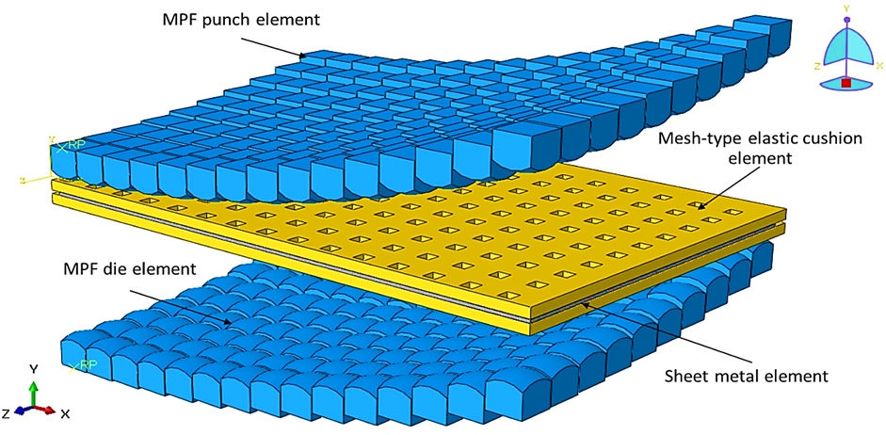

Figure 4: 3D model of MPF process with mesh-type layered polyurethane.

|  |  |
| --- | --- |
|  | |
| A) Boundary conditions | B) Mesh model |

Figure 5: Boundary conditions and meshing of the MPF model.

The FE model was experimentally validated using the set-up reported by Abosaf et al [16]. Figure 6 shows a comparison between the experimental and simulated forces with respect to the die displacement. There was a good agreement between the two curves. The force slightly increased until the die displacement reaches about 30 mm followed by a rapid increase until the displacement reach about 40 mm. The maximum predicted force was 45.2kN while the experimental one reached 45.0 kN as the upper and lower dies are closed.

Experimental

Simulation

Figure 6. Comparison between experimental and simulated forces.

**3.2 Optimisation using design of experiments**

Design of experiments (DOE) and analysis of variance (ANOVA) have been widely reported to be useful in studying the effect of process parameters on the process responses of many manufacturing industries [20-23] and in sheet forming [9, 16]. The process parameters included in this work were the cushion thickness, the size of the cushion mesh and geometry of the mesh (circular and square). The mesh sizes has been chosen carefully based on preliminary study to determine the extreme cases of mesh size. The mesh size must not exceed the pin size otherwise direct contact between the pin and sheet will occur which will lead to dimpling defect. On the other hand, if the mesh size is too small, the effect of mesh on quality characteristics becomes insignificant. Values between 2-4mm were found to be reasonable. As for the other process parameters, the levels were selected based on similar published investigations [16].

The levels of parameter was low, medium and high as shown in Table 3. Three responses parameters were considered to assess the quality of the proposed mesh-type cushion. These response parameters were the wrinkling, thickness variation and maximum deviation. Face centred response surface method was used to create the design matrix with a set of 17 experiments.

Table 3. Levels of the DOE process parameters

|  |  |  |  |  |
| --- | --- | --- | --- | --- |
| Process parameters | Units | Levels | | |
| Low | Intermediate | High |
| Elastic cushion mesh size (A) | mm | 2*2 | 3*3 | 4*4 |
| Elastic cushion thickness (B) | mm | 3 | 6 | 9 |
| Elastic Cushion mesh- type (C) | - | - | Square/Circular | - |

# Results and Discussion

# Effect of process parameters

The experimental process parameters and the corresponding wrinkling, sheet metal thickness, thickness variation and maximum deviation of the deformed sheet are listed in Table 4. The table shows that samples fabricated using square hole of a size of 2.29 mm and thickness of 8.12 mm showed the minimum wrinkling and deviation while samples fabricated using circular hole of a size of 3 mm and thickness of 3 mm showed the minimum thickness variation. The DOE results were statistically analysed using Design Expert 7.0 software. Investigation of the significant process parameters were carried out using the Analysis of Variance (ANOVA). A significance level of 5 was used, which means that P-value less than 0.05 represents a significant factor while P-value more than 0.05 P-value represents insignificant factor. Table 5 shows the P values for the process parameters under investigation and their interactions. The table shows that the wrinkling, thickness variation and the maximum deviation are strongly affected by the mesh size and the cushion thickness as well as the interaction between cushion thickness and cushion type. One the other hand, the mesh type was found insignificant in the process.

Table 4. Experimental analysis and simulation results

|  |  |  |  |  |  |  |  |
| --- | --- | --- | --- | --- | --- | --- | --- |
| Exp. Run | Factor  1 | Factor  2 | Factor  3 | Response  1 | Response  2 | Response  3 | Response  4 |
| A: Mesh size | B:Cushion thickness | C:Mesh-type | Wrinkling | Sheet metal Thickness | Thickness Variation | Maximum Deviation |
| 1 | 2.29 | 3.88 | Square | 1 | 1 | 0.003217 | 1.32 |
| 2 | 4 | 6 | Circular | 1.65 | 0.99 | 0.005451 | 0.56 |
| 3 | 3.71 | 3.88 | Circular | 1.5 | 1 | 0.003266 | 1.34 |
| 4 | 3.71 | 3.88 | Square | 1.5 | 1 | 0.003883 | 1.36 |
| 5 | 3 | 9 | Circular | 0.81 | 1 | 0.009041 | 0.89 |
| 6 | 3 | 6 | Circular | 0.79 | 1 | 0.003817 | 0.79 |
| 7 | 2 | 6 | Square | 1.15 | 1 | 0.006134 | 1.08 |
| 8 | 3 | 3 | Square | 0.65 | 1 | 0.00164 | 0.35 |
| 9 | 3 | 6 | Square | 0.79 | 1 | 0.007452 | 0.65 |
| 10 | 3 | 9 | Square | 0.34 | 1 | 0.009041 | 1.03 |
| 11 | 3.71 | 8.12 | Circular | 1.11 | 1 | 0.008974 | 2.11 |
| 12 | 2.29 | 8.12 | Circular | 1.45 | 1 | 0.007974 | 0.74 |
| 13 | 3.71 | 8.12 | Square | 0.5 | 1 | 0.007208 | 0.72 |
| 14 | 3 | 3 | Circular | 1 | 1 | 0.001983 | 0.68 |
| 15 | 2.29 | 3.88 | Circular | 1.5 | 1 | 0.003217 | 1.32 |
| 16 | 4 | 6 | Square | 1.65 | 1 | 0.007451 | 0.56 |
| 17 | 3 | 6 | Circular | 0.79 | 1 | 0.007817 | 0.78 |
| 18 | 2.29 | 8.12 | Square | 0.27 | 0.89 | 0.008356 | 0.06 |

Table 5. P-values of each process parameters

|  |  |  |  |
| --- | --- | --- | --- |
| Response factors /  Significant factors | Wrinkling | Thickness variation | Maximum Deviation |
| Cushion mesh size (A) | 0.0001 | 0.0001 | 0.0001 |
| Cushion thickness (B) | 0.0021 | 0.0001 | 0.0001 |
| Cushion mesh-type (C) | 0.139 | 0.3147 | 0.6715 |
| Parameter interactions | (AB)=0.3811  (AC)=0.0502  (BC)=0.0559 | (AB)=0.3538  (AC)=0.1273  (B×C) 0.0057 | (AB)=0.6338  (AC)=0.4373  (BC)=0.5472 |

Figure 7 shows the effect of the mesh size and the cushion thickness on the wrinkling of the deformed sheet, as they are significant factors in the process. The figure shows that wrinkling increases with the increasing of the mesh size and the decreasing of the cushion thickness. In this case, the mesh size is much larger than the amount of the deformation of the cushion, which resulted in areas of the sheet metal with a direct contact with the pins. This causes areas with high-developed pressure and non-uniform stress distribution across the sheet, which increases the wrinkling effect. On the other hand, when small mesh size is used, no direct contact between pins and sheet surface occurs. Instead, the cushion material flows towards the holes and prevent any undesired material build-up between the pins. Additionally, large cushion thickness allows more uniform stress distribution across the sheet. A minimum wrinkling of 1.71mm was achieved at a hole size of 3.5 mm and a cushion thickness of 3mm.

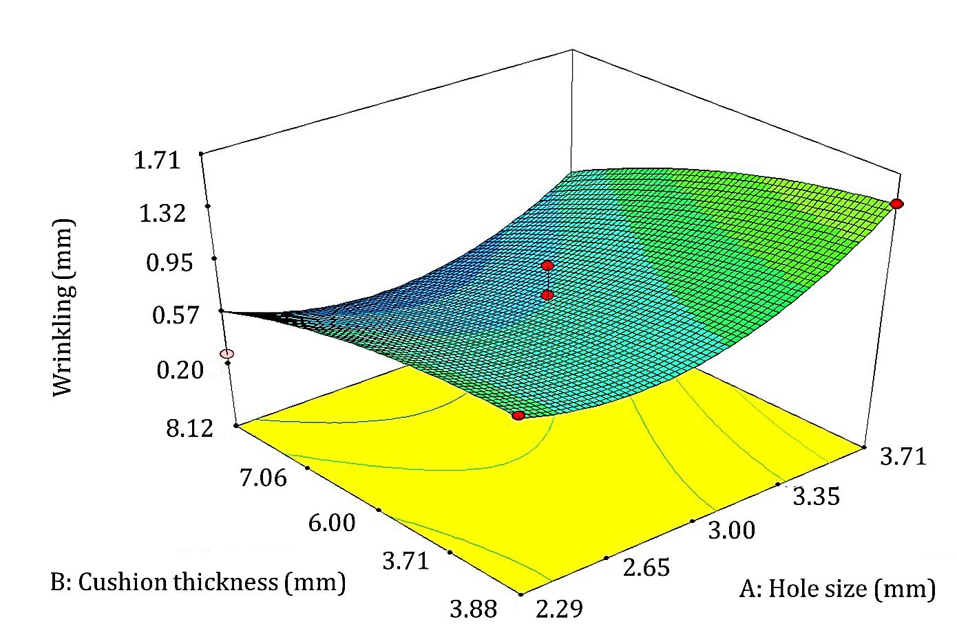

Mesh size (mm)

Figure 7. Effect of hole-size and elastic cushion thickness on wrinkling

Figure 8 shows the thickness variation as a function of the mesh size and the cushion thickness. The figure indicates that minimum thickness variation can be achieved by using small mesh size and thick cushion. Biaxial expansion of the cushion material is expected to me more significant when using thick cushion. However, this will be resisted by the high friction between the cushion and sheet thickness which leads to non-uniform deformation [16]. The lateral deformation and friction can both be reduced by using thin cushion with small holes i.e. small mesh size. Additionally, when large mesh size is used, dimpling becomes more significant due to the direct contact between the pint and sheet surface. This leads to non-uniform thickness distribution and large thickness variation. A minimum thickness variation of 0.017 mm was achieved at a mesh size of 3.5 mm and a cushion thickness of 3 mm.

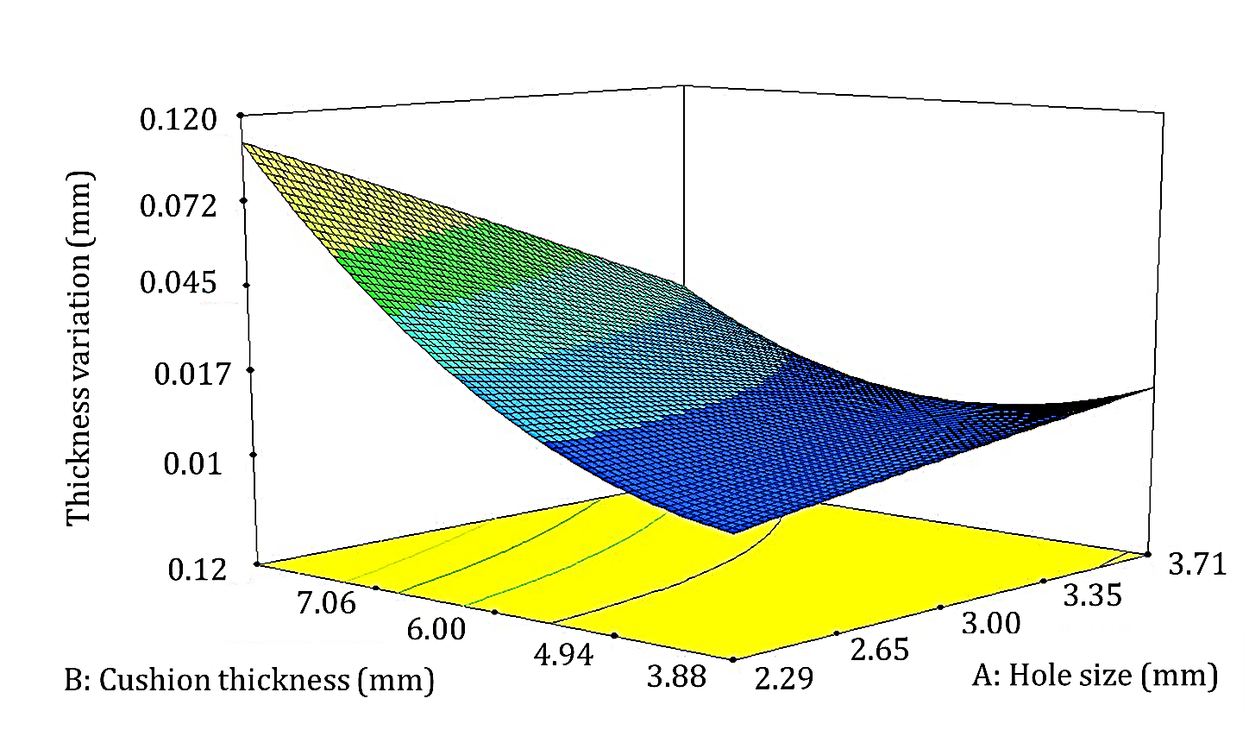

0.0

Mesh size (mm)

Figure 8. Effect of mesh size and cushion thickness on the thickness variation.

Figure 9 shows the effect of the mesh size and the cushion thickness on the maximum deviation of the deformed sheet. The figure shows that the maximum deviation increases as the cushion thickness increases while slightly affected by the mesh size. In this case, any small change in the thickness of the cushion affects the local sheet thinning. In particular, when a thin elastic cushion is used, local deformation by individual pins becomes more noticeable and thus maximum deviation changes. A minimum maximum deviation of 0.60 mm was achieved at a mesh-size of 3.88 mm and a cushion thickness of 3.01 mm.

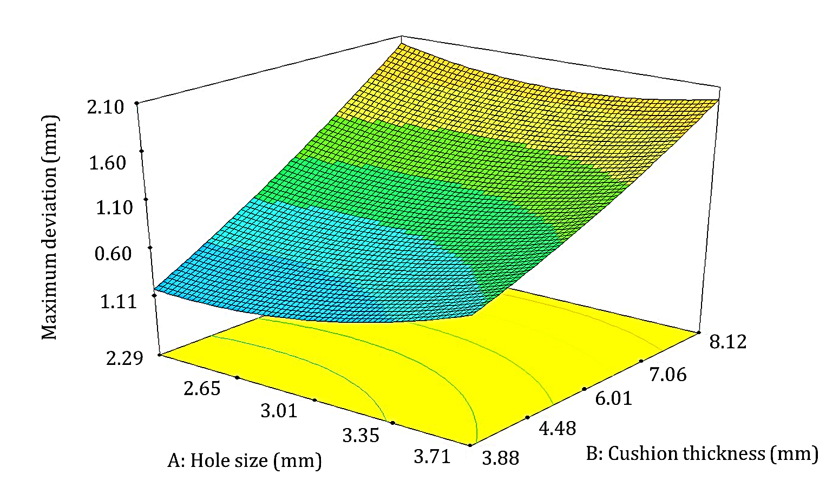

Mesh size (mm)

Figure 9. Effect of elastic cushion thickness and mesh-size on maximum deviation.

# Optimisation of process parameters

An empirical equation was developed to present the response surfaces (the wrinkling, thickness variation and the maximum deviation) as a function of mesh-size and cushion thickness using the following equation:

Response = bo + b1A + b2B + b3C + b4AB + b5AC + b6BC + b7A2 + b8B2 + b9C2 (2)

where bi are responses coefficients based on the main and interaction of the process parameters, A is the mesh size, B is the elastic cushion thickness and C is the mesh-type. The values of the coefficients for the wrinkling, maximum deviation and thickness deviation are shown in Table 6

Table 6. Response surface model coefficients for the wrinkling and thickness deviation

|  |  |  |  |
| --- | --- | --- | --- |
| Coefficient | Wrinkling (mm) | Thickness variation (mm) | Maximum deviation (mm) |
| bo | 1.84755 | 3.60633 | -0.02307 |
| *b*1 | -3.10900×10-3 | 1.16540×10-3 | -0.021315 |
| *b*2 | -0.13927 | 5.97254×10-3 | -0.022133 |
| *b*3 | 0.37777 | 0.56882 | -0.019781 |
| *b4* | 3.00000×10-5 | 2.65000×10-5 | 0.010012 |
| *b*5 | -1.938E-004 | 1.763E-004 | 0.047207 |
| *b*6 | 4.000E-003 | -0.0143 | -0.018003 |
| *b*7 | 5.715E-006 | -3.201E-006 | 0.024241 |
| *b8* | 3.144E-003 | 5.059E-003 | -0.023006 |
| *b9* | -0.024222 | +4.54510E-003 | 0.0184457 |

Equation 2 was used to obtain the optimum process parameters. The aim of the optimisation was to minimize wrinkling and thickness variation. For a MPF process with 10 mm pins diameters, 46.0 kN die force, 400 mm radius of curvature, the best process parameters to achieve minimized wrinkling and thickness variation are mesh size of 3.5 mm and cushion thickness of 3.0 mm. The above-mentioned optimised parameters were used for validation. Table 7 shows a comparison between the predicted and the measured responses of the samples prepared using the optimum process parameters. As shown in the table, the measured maximum deviation responses and thickness variation are slightly less than the predicted ones while measured wrinkling is about 1 mm higher than the predicted wrinkling.

Table 7: The predicted and experimentally validated responses

|  |  |  |  |
| --- | --- | --- | --- |
|  | Wrinkling[mm] | Max. deviation[mm] | Thickness variation[mm] |
| Predicted | (2.08900E-007)≈0 | 1.0267 | 0.1000 |
| Measured | 1.0741 | 0.0358 | 0.01932 |

# Comparison between solid and mesh-type cushions

A comparison between the use of solid and mesh-type cushions in the MFP on the developed pressure on the blank sheet is shown in Figure 10. The developed pressure was higher, non-uniform and affected larger areas when using solid cushion as shown in Figure 10(a) than when using mesh-type cushion, see Figure 10 (b). In particular, the maximum positive and negative pressures were +278 MPa, - 201 MPa when using solid cushions while they were +224 MPa, - 193 MPa when using mesh-type cushion. In addition, it can be noted that when using mesh-type cushion the pressure is also more homogenous. This is may be attributed to the physical response of the mesh-type cushion when being deformed during MPF process. As the pins of the dies deforms the voids of the mesh-type cushion allows the deformed cushion to expand/deform more uniformly than when using solid cushion. The more uniform deformation of cushion leads to uniform stress distribution which r reduces the formation of wrinkling and thickness variation.

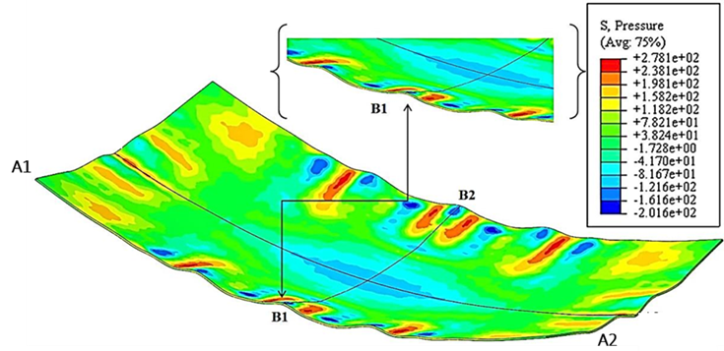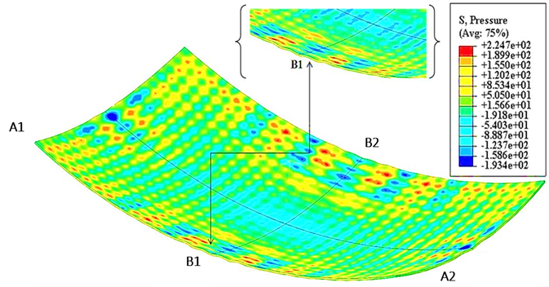

(a)

(b)

Figure 10: Developed pressure on the blank sheet using (a) solid cushion, (b) mesh-type cushion.

The developed pressure distribution shown in Figure 10 affects the deformed shape and its response parameters such as wrinkling. To verify the results, the optimum results were used to fabricate double curved panel from DC05 steel using mesh-type and solid cushions. Figure 11 shows a comparison between the scanned profiles of two sheet blanks made formed using mesh-type and solid cushions. As shown, the sheet formed using mesh-type cushion is more in agreement with the target profile than the sheet formed using solid cushion. In addition, the wrinkling is clearly notable for the sheet formed using solid cushion.

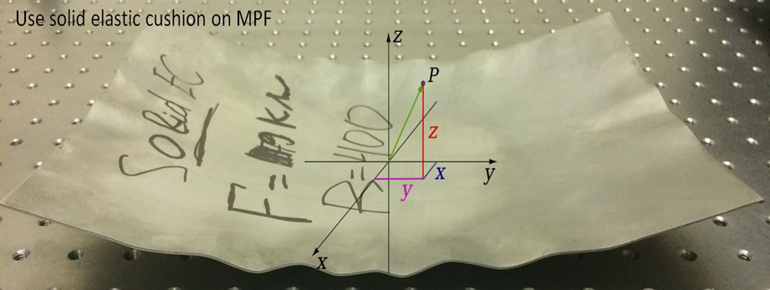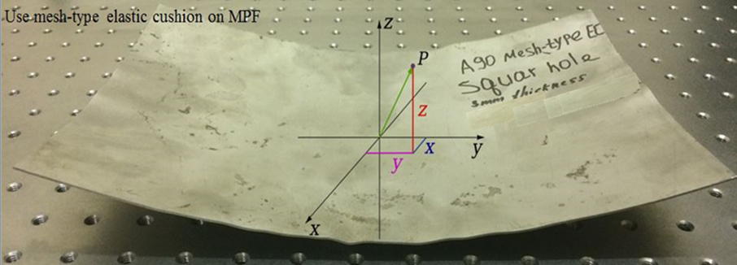

(a)

(b)

(c)



Experimental results mesh-type elastic cushion

R=400 Target model

Experimental results solid elastic cushion

Figure 11: (a) Profile of the target model compared to the scanned profile of the sheet made using mesh-type and solid cushions, (b) Deformed sheet using solid cushion, (c) Deformed sheet using mesh-type cushion.

# Conclusions

This work proposes the use of mesh-type elastic cushion to replace the current solid elastic cushion in the MPF process. The developed simulation model results were found in agreement with the experimental measurements. Design of experiments were used to study the significant parameters of the mesh-type elastic cushion and to optimize them. It was found that, the use of mesh-type elastic cushion during MPF process was very efficient to improve wrinkling, thickness variation and maximum deviation when compared to those made using solid cushion. The mesh-type cushion thickness and mesh size were found significant factors while mesh hole type was found insignificant. The wrinkling was found to be highly affected by the mesh size while the thickness variation and maximum deviation were found significantly influenced by the change of the cushion thickness. The optimum conditions were found to be square meshes of a size of 3.5 mm and a thickness of 3 mm. At these conditions, wrinkling were improved from by 37 % while the thickness variation was improved by 80 % and the maximum deviation was improved by 98 %.

# References

[1] N. Nakajima, (1969), A Newly Developed Technique to Fabricate Complicated Dies and Electrodes with Wires, Bulletin of JSME, 12:1546-1554.

[2] M. Valjavec, D.E. Hardt, (1999), Closed-loop shape control of the stretch forming process over a reconfigurable tool : precision airframe skin fabrication, Proceedings of ICEME 99:1-11.

[3] J.-W. Park, Y.-B. Kim, J. Kim, B.-S. Kang, (2014), Study on multiple die stretch forming for curved surface of sheet metal, International Journal of Precision Engineering and Manufacturing, 15:2429-2436.

[4] J. Chen, W. Fu, M. Li, Y. Wang, Y. Deng, Research on formability of multi-point press forming for 08Al and 2024-O sheet, in: Key Engineering Materials, 2017, pp.:124-132.

[5] J.-J. Chen, M.-Z. Li, W. Liu, C.-T. Wang, (2005), Sectional multipoint forming technology for large-size sheet metal, The International Journal of Advanced Manufacturing Technology, 25:935-939.

[6] Q. Erhu, L. Mingzhe, L. Rui, Z. Liang, Y. Zhuo, (2018), Inhibitory effects of a flexible steel pad on wrinkling in multi-point die forming, International Journal of Advanced Manufacturing Technology, 95:2413-2420.

[7] H. Peng, H. Liu, X. Zhang, Numerical investigation of wrinkle for multi-point thermoforming of Polymethylmethacrylate sheet, in: IOP Conference Series: Materials Science and Engineering, 2017.

[8] M. Abebe, K. Lee, B.S. Kang, (2016), Surrogate-based multi-point forming process optimization for dimpling and wrinkling reduction, International Journal of Advanced Manufacturing Technology, 85:391-403.

[9] A. Elghawail, K. Essa, M. Abosaf, A. Tolipov, S. Su, D. Pham, (2017), Prediction of springback in multi-point forming, Cogent Engineering, 4:1400507.

[10] Z.-Y. Cai, S.-H. Wang, M.-Z. Li, (2008), Numerical investigation of multi-point forming process for sheet metal: wrinkling, dimpling and springback, The International Journal of Advanced Manufacturing Technology, 37:927-936.

[11] V. Paunoiu, P. Cekan, E. Gavan, D. Nicoara, (2008), Numerical Simulations in Reconfigurable Multipoint Forming, International Journal of Material Forming, 1:181-184.

[12] G.-Z. Quan, T.-W. Ku, B.-S. Kang, (2011), Improvement of formability for multi-point bending process of AZ31B sheet material using elastic cushion, International Journal of Precision Engineering and Manufacturing, 12:1023-1030.

[13] B. Zareh-Desari, B. Davoodi, A. Vedaei-Sabegh, (2017), Investigation of deep drawing concept of multi-point forming process in terms of prevalent defects, International Journal of Material Forming, 10:193-203.

[14] V.T. V Paunoiu, C Maier, N Baroiu, G Bercu, (2011), Study of the tool geometry in reconfigurable multipoint forming, The Annals of Dunărea de Jos University of Galaţi, Fascicle V, Technologies In Machine Building:1221-4566.

[15] A.k. Alhameedi, influence of die elements shapes on process parameters in multi-point sheet metal forming process, 2013.

[16] M. Abosaf, K. Essa, A. Alghawail, A. Tolipov, S. Su, D. Pham, (2017), Optimisation of multi-point forming process parameters, The International Journal of Advanced Manufacturing Technology, 92:1849-1859.

[17] A. Elghawail, K. Essa, M. Abosaf, A. Tolipov, S. Su, D. Pham, (2018), Low-cost metal-forming process using an elastic punch and a reconfigurable multi-pin die, International Journal of Material Forming.

[18] A.A. Tolipov, A. Elghawail, S. Shushing, D. Pham, K. Essa, (2017), Experimental research and numerical optimisation of multi-point sheet metal forming implementation using a solid elastic cushion system, Journal of Physics: Conference Series, 896:012120.

[19] S. Wang, Z. Cai, M. Li, Y. Lan, (2012), Numerical simulation on the local stress and local deformation in multi-point stretch forming process, International Journal of Advanced Manufacturing Technology, 60:901-911.

[20] A. Galatas, H. Hassanin, Y. Zweiri, L. Seneviratne, (2018), Additive Manufactured Sandwich Composite/ABS Parts for Unmanned Aerial Vehicle Applications, Polymers, 10:1262.

[21] H. Hassanin, F. Modica, M.A. El-Sayed, J. Liu, K. Essa, (2016), Manufacturing of Ti–6Al–4V Micro-Implantable Parts Using Hybrid Selective Laser Melting and Micro-Electrical Discharge Machining, Advanced Engineering Materials, 18:1544-1549.

[22] H. Hassanin, L. Finet, S.C. Cox, P. Jamshidi, L.M. Grover, D.E.T. Shepherd, O. Addison, M.M. Attallah, (2018), Tailoring selective laser melting process for titanium drug-delivering implants with releasing micro-channels, Additive Manufacturing, 20:144-155.

[23] K. Essa, H. Hassanin, M.M. Attallah, N.J. Adkins, A.J. Musker, G.T. Roberts, N. Tenev, M. Smith, (2017), Development and testing of an additively manufactured monolithic catalyst bed for HTP thruster applications, Applied Catalysis A: General, 542:125-135.