Effect of Dapagliflozin on Heart Failure and Mortality in Type 2 Diabetes Mellitus
Short title: Dapagliflozin and Ejection Fraction

Eri T. Kato, MD, MPH, PhD (a), Michael G. Silverman, MD, MPH (b), Ofri Mosenzon, MD、MSc (c), Thomas A. Zelniker, MD, MSc (d), Avivit Cahn, MD (c), Remo H.M. Furtado, MD, PhD (d) Julia Kuder, MS (d), Sabina A. Murphy, MPH (d), Deepak L. Bhatt, MD, MPH (d), Lawrence A. Leiter, MD (e), Darren K. McGuire, MD, MHSc (f), John P.H. Wilding, MD (g), Marc P. Bonaca, MD, MPH (h), Christian T. Ruff, MD, MPH (d), Akshay S. Desai, MD, MPH (i), Shinya Goto, MD, PhD (j), Peter Johansson, MSc (k), Ingrid Gause-Nilsson, MD, PhD (k), Per Johanson, MD, PhD (k), Anna Maria Langkilde, MD, PhD (k), Itamar Raz, MD (c), Marc S. Sabatine, MD, MPH (d), Stephen D. Wiviott, MD (d)

a. Department of Cardiovascular Medicine, Kyoto University Graduate School of Medicine, Kyoto, Japan
b. Cardiology Division, Massachusetts General Hospital, Boston, USA
c. The Diabetes Unit, Department of Endocrinology and Metabolism, Hadassah Medical Center, Hebrew University of Jerusalem, The Faculty of Medicine, Jerusalem, Israel
d. TIMI Study Group, Cardiovascular Division, Brigham and Women's Hospital, Boston, MA, USA
e. Li Ka Shing Knowledge Institute, St. Michael's Hospital, University of Toronto, Ontario, Canada
f. Division of Cardiology, University of Texas Southwestern Medical Center, Dallas, TX, USA
g. Institute of Ageing and Chronic Disease, University of Liverpool, Liverpool, United Kingdom
h. CPC Clinical Research, University of Colorado, CO, USA
i. Cardiovascular Division, Brigham and Women’s Hospital, Boston, MA, USA
j. Department of Medicine (Cardiology), Tokai University Hospital, Isehara, Japan
k. AstraZeneca, Gothenburg, Sweden

Word count: 6380 (2662 words for abstract and text)
Key words: diabetes, ejection fraction, SGLT2 inhibitor, heart failure, mortality

Corresponding Author:
Stephen D. Wiviott, MD
TIMI Study Group, Cardiovascular Division
Brigham and Women’s Hospital
60 Fenwood Road, Suite 7022
Boston, MA 02115 USA
Phone: 617-278-0145 Fax: 617-734-7329
Email: swiviott@bwh.harvard.edu

Abstract

Background:
In DECLARE-TIMI 58, the sodium glucose co-transporter 2 inhibitor (SGLT2i) dapagliflozin reduced the composite endpoint of cardiovascular (CV) death/ hospitalization for heart failure (HHF) in a broad population of patients with T2DM. However, the impact of baseline left ventricular ejection fraction (EF) on the clinical benefit of SGLT2i is unknown.
Methods:
In the DECLARE-TIMI 58 trial, baseline HF status was collected from all patients and EF where available. HF with reduced EF (HFrEF) was defined as EF <45%, and HF without known reduced EF was defined as history of HF without known EF <45%. Outcomes of interest were the composite of CV death/HHF, its components, and all-cause mortality (ACM).
Results:
Of 17,160 patients, 671 (3.9%) had HFrEF, 1316 (7.7%) had HF without known reduced EF and 15,173 (88.4%) had no history of HF at baseline. Dapagliflozin reduced CV death/HHF more in patients with HFrEF (HR 0.62, 95% CI 0.45-0.86) than in those without HFrEF (HR 0.88, 95% CI 0.76-1.02; P-interaction 0.046), in whom the treatment effect of dapagliflozin was similar in those with HF without known reduced EF (HR 0.88, 95% CI 0.66-1.17) and those without HF (HR 0.88, 95% CI 0.74-1.03). Whereas dapagliflozin reduced HHF both in those with (HR 0.64, 95%CI 0.43-0.95) and without HFrEF (HR 0.76, 95%CI 0.62-0.92), it reduced CV death only in patients with HFrEF (HR 0.55, 95% CI 0.34-0.90) but not in those without HFrEF (HR 1.08, 95% CI 0.89-1.31, P-interaction 0.012). Likewise, dapagliflozin reduced ACM in patients with HFrEF (HR 0.59, 95% CI 0.40-0.88), but not in those without HFrEF (HR 0.97, 95% CI 0.86-1.10, P-interaction 0.016).
Conclusion:
In the first SGLT2i CV outcome trial to evaluate T2DM patients stratified by EF, we found that dapagliflozin reduced HHF in patients with and without HFrEF, and reduced CV death and ACM in patients with HFrEF.

Clinical Trial Registration: https://clinicaltrials.gov NCT01730534

Abstract word count:299

Clinical Perspective
What is new?
- DECLARE-TIMI 58 is the only SGLT2i cardiovascular outcome trial to date that had detailed baseline information on patients’ left ventricular ejection fraction.
- In 17,160 patients with T2DM with either established atherosclerotic CV disease (ASCVD) or multiple risk factors for ASCVD, SGLT2 inhibition with dapagliflozin, in addition to standard contemporary CV medicines, reduced the risk of CV death or hospitalization for HF to a greater extent in patients with HF with reduced ejection fraction (HFrEF) than in those without HFrEF.
- This difference was driven by large reductions in CV death and all-cause mortality in patients with HFrEF.

What are the clinical implications?
- Our data warrants a particular consideration for SGLT2i in patients with HFrEF.

Introduction
Type 2 diabetes mellitus (T2DM) is a well-established risk factor for heart failure (HF) ¹. Both the incidence and prevalence of T2DM and HF are increasing globally, in part due to population aging ². While much progress has been made in improving cardiovascular (CV) outcomes in patient with T2DM, reducing the risk of HF and related outcomes in such patients has lagged behind³. This dual epidemic of T2DM and HF creates an urgent need for effective therapies that can address the expected increased burden of HF^{4, 5} in general and specifically among patients with T2DM.
Despite the well-known association between T2DM and HF, there has not previously been any glucose lowering agent that reduces the risk of HF in patients with T2DM. Recently, sodium glucose co-transporter 2 (SGLT2) inhibition has emerged as an important therapeutic modality for reducing CV risk in T2DM. Across three large SGLT2 inhibitor (SGLT2i) CV outcome trials, the Empagliflozin Cardiovascular Outcome Event Trial in Type 2 Diabetes Mellitus Patients (EMPA-REG Outcomes) ⁶, the CAnagliflozin cardioVscular Assessment Study (CANVAS) Program ⁷, and the Dapagliflozin Effect on CardiovascuLAR Events (DECLARE) -TIMI 58 trial ⁸, SGLT2i reduced the risk of the composite of CV death or hospitalization for HF (HHF), changing the landscape of T2DM management as a target for HF prevention ⁶⁻⁸.There are various reports on whether the magnitude of benefit of SGLT2i depends on a history of HF ^{9, 10}. However, the relationship between baseline left ventricular ejection fraction and the benefit of SGLT2 inhibition on reducing CV death and HHF has not been previously reported. In the present analyses, we examined the efficacy and safety of dapagliflozin according to baseline HF status and systolic left ventricular ejection fraction.

Methods
Study Design

The study design, baseline characteristics and main results of the DECLARE-TIMI 58 trial have been published previously ^{8, 11, 12}. In brief, DECLARE-TIMI 58 was a randomized double-blind multinational CV outcome trial comparing10mg dapagliflozin with placebo in 17,160 patients with T2DM with either established atherosclerotic CV disease (ASCVD) or multiple risk factors for ASCVD, and with a creatinine clearance ≥60 mL/min. The emerging data on the benefit of SGLT2i on hospitalization for heart failure prompted comprehensive data collection for each patient’s HF history in DECLARE-TIMI 58. Sites were to collect patients’ history and etiology of HF, baseline EF and functional class as was present at study entry and at all subsequent visit. Per protocol, patients with New York Heart Association (NYHA) Class IV HF were excluded. Patients were followed for a median of 4.2 years with regular visits and laboratory testing. The trial was approved by all institutional review committees and written informed consent was obtained from all patients.

Outcomes
For these prespecified analyses, the key outcomes of interest are the trial’s dual primary composite endpoint of CV death or HHF, its individual components, and all-cause mortality (ACM). HHF was adjudicated according to FDA consensus criteria as an event that fulfilled all of the following criteria: 1) required an admission to the hospital with a primary diagnosis of HF; 2) in-hospital stay ≥24 hour; 3) documentation of new or worsening symptoms due to HF; 4) Objective physical, laboratory or diagnostic evidence of new or worsening HF; and 5) initiation or intensification of treatment for HF. The complete definition of HHF is described elsewhere ⁸. Additional outcomes were major adverse cardiac events (MACE), which included the composite of CV death, myocardial infarction and ischemic stroke, and the renal composite outcome of a sustained decrease in eGFR ≥40% from baseline, end stage renal disease, or renal death, as previously been described ^{8, 11}. The key outcomes were adjudicated in a blinded manner by an independent clinical events committee.

Statistical analysis
Patients were stratified based on the exact EF value if known or by qualitative function as follows. HF with reduced EF (HFrEF) was defined as having prespecified EF cutpoint of <45% or severe/moderate left ventricular systolic dysfunction, with or without a reported history of HF. Patients who did not have HFrEF comprised two groups: patients without history of HF and patients with HF without known reduced EF, the latter defined as those having a history of HF without known EF<45%. In sensitivity analyses, HFrEF patients were subdivided into those with and without a reported history of HF. In addition, patients with HF with confirmed EF ≥45% and those without a documented EF were analyzed separately. Furthermore, outcomes in patients across a range of EF cutpoints were also evaluated.
Baseline characteristics were reported as frequencies and percentages for categorical variables and as medians and interquartile ranges (IQ) for continuous variables, and were compared using the chi-square test for categorical, and Wilcoxon test for continuous variables.
Analyses were performed on an intention-to-treat basis, and safety events were analyzed during the on-treatment period. Hazard ratios (HRs) and 95% confidence intervals (CIs) were determined from Cox regression models that included trial stratification factors. To test for effect modification, the interaction terms were evaluated for baseline cardiac status (HFrEF or not HFrEF) and treatment strategy for each outcome using Cox regression models. Kaplan-Meier method was used to estimate survival functions and the Cox proportional hazards model for estimating the effects of covariates on the hazard of the occurrence of the event. The number needed to treat (NNT) is calculated for all key outcomes of interest as the inverse of the absolute risk difference between the event rate in the dapagflizlozin group and the placebo group.
There was no statistical adjustment for multiple comparisons.
All analyses were performed using SAS software, version 9.3 (SAS Institute Inc., Cary, NC, USA) and Stata version 14.2 (College Station, Tx, USA). A two-sided P<0.05 and confidence intervals excluding 1.0 were considered to indicate statistical significance.

The role of the study sponsor
DECLARE-TIMI 58 was funded by AstraZeneca, however they had no influence on the preparation, content, or decision to submit the manuscript.

RESULTS
Of 17,160 patients, 671 (3.9% of total trial cohort) had an EF <45% and were classified as HFrEF. A total of 1,316 patients (7.7% of the total trial cohort) had a history of HF without a reduced EF (808 with a documented EF≥45% and 508 without a documented EF) and were classified as HF without known reduced EF. The remainder, 15,173 patients (88.4%) had no history of HF and no documented reduced EF (3,723 with a documented EF≥45% and 11,450 with no documented EF).

The baseline demographics of patients with HFrEF, HF without known reduced EF, and without a history of HF are summarized in Table 1. Patients with HFrEF were more likely to be male and have a history of ASCVD, particularly coronary artery disease. Patients with HF without known reduced EF were older, more likely female, and had a higher prevalence of hypertension. Patients with a history of HF, especially those with HFrEF, were generally well treated with high proportions of evidence-based HF therapies, including 86.0% on ACEI or ARB and 80.7% on beta-blockers. Two thirds were receiving diuretics and 30.3% mineralocorticoid receptor antagonists.

As previously reported, overall, dapagliflozin reduced the risk of CV death or HHF by 17% (HR 0.83, 95% CI 0.73-0.95 P=0.005). However, dapagliflozin reduced the risk of CV death or HHF to a greater extent in patients with HFrEF (HR 0.62, 95% CI 0.45-0.86) than in those without (HR 0.88, 95% CI 0.76-1.02, P-interaction 0.046, Figure 1). Among those without HFrEF, the estimates of effect of dapagliflozin did not differ between patients with HF without known reduced EF and those without a history of HF (HR 0.88, 95% CI 0.66-1.17 and HR 0.88, 95% CI 0.74-1.03, respectively) (Figure 1). The heterogeneity was driven by dapagliflozin reducing CV death in patients with HFrEF (HR 0.55, 95% CI 0.34-0.90, P=0.02) but not in those without (HR 1.08, 95% CI 0.89-1.31, P-interaction 0.012). Subtypes of CV death are listed in the Table S1. Likewise, dapagliflozin significantly reduced ACM in patients with HFrEF (HR 0.59, 95% CI 0.40-0.88, P=0.01) but not in those without (HR 0.97, 95% CI 0.86-1.10, P-interaction 0.016). Conversely, dapagliflozin reduced HHF regardless of EF (HR 0.64, 95% CI, 0.43-0.95 for HFrEF, HR 0.76, 95% CI 0.62-0.92 for not HFrEF, P-interaction 0.45), with no heterogeneity of effect between patients with HF without known reduced EF (HR 0.72, 95% CI 0.50-1.04) and those with no history of HF (HR 0.77, 95% CI 0.60-0.97). The benefit of dapagliflozin on reducing CV death, HHF, and ACM in patients with HFrEF appeared early and continued to extend throughout the trial for all of the key outcomes of interests (Figure 2). In contrast, the event curves for HHF only started to diverge after 1 year in patients with HF without known reduced EF and in patients without history of HF.

As expected, there was a gradient of baseline risk with four-year rates of CV death or HHF in the placebo arm that were 27.1%, 14.8%, and 3.9% in patients with HFrEF, HF without known reduced EF, and no history of HF (P<0.01). Coupling the greater baseline risk with the greater relative risk reduction in patients with HFrEF, there were large absolute risk reductions in CV death or HHF, CV death, and ACM, with values of 9.2%, 5.2%, and 6.4%, leading to numbers needed to treat over four years of 11, 19, and 16.

In sensitivity analysis, we subcategorized HFrEF patients by history of presence or absence of reported HF and the results were directionally similar (Figure S1). Analyzing outcomes in patients with HF with EF known to be ≥45% and without known EF, the results were also consistent. We also stratified patients across a range of EF cutpoints to characterize reduced EF, and a gradient of efficacy was observed, with greater relative benefit with dapagliflozin in patients with worse EF, especially those <30% (Figure S2). When confined to the subset of patients with a known EF, the results were consistent; we saw a similar reduction in HHF with dapagliflozin in HFrEF and HF without known EF (HR 0.64, 95% CI 0.43-0.95 vs. HR 0.74, 95% CI 0.48-1.14, P-interaction 0.615), but a greater reduction with dapagliflozin in CV death in patients with HFrEF (HR 0.55, 95% CI 0.34-0.90 vs. HR 1.44, 95% CI 0.83-2.49, P-interaction 0.011). Exploring the association of baseline diuretic use in different HF subgroups, we found no effect modification of dapagliflozin efficacy for any outcome analyzed (Figure S3). Finally, the effects of dapagliflozin on MACE and the renal composite outcomes did not differ by HF subgroup (Figure S4).

Safety outcomes are summarized in Table S2. Serious adverse events occurred more frequently in patients with HFrEF than in those without in both randomized groups. However, the safety profile of dapagliflozin versus placebo did not differ, with no effect modification by HF status (P-interaction for all > 0.05).

Discussion
In the present analyses, we have shown that SGLT2 inhibition with dapagliflozin reduced the risk of CV death or HHF to a greater extent in patients with HFrEF than in those without. This difference was driven by large reductions in CV death and ACM in patients with HFrEF.

SGLT2i have emerged as a class of glucose lowering agents that significantly improve CV outcomes in patients with T2DM. In particular, CV outcomes trials have shown that at least three members of this class robustly reduce the risk of the composite of CV death or HHF¹³. An analysis from EMPA-REG Outcomes suggested no significant heterogeneity of benefit on CV death or HHF with empagliflozin in patient with and without a history of HF. In contrast, in the CANVAS program, there was a greater reduction in the risk of CV death or HHF in patients with a history of HF. However, these analyses did not have the benefit of detailed baseline information on patients’ left ventricular ejection fraction as was collected during the conduct of DECLARE-TIMI 58. DECLARE-TIMI 58 was also unique in that it was the largest SGLT2i CV outcome trial conducted to date, included a broad population, and had CV death or HHF as one of the dual-primary endpoints. These more granular data allowed us to identify EF as a strong tool to determine which patients derived particular mortality benefit from SGLT2i. The high baseline risk and the large relative risk reductions in the subset with HFrEF led to large absolute risk reductions. Thus, only 16 patients with T2DM and HFrEF would need to be treated for four years to prevent a death. Moreover, this benefit was seen in patients who were already treated with standard contemporary CV medicines such as ACEis, ARBs, beta-blockers, and diuretics.

In contrast, our analyses did not show a mortality benefit with dapagliflozin in patients with HF without known reduced EF. However, this finding should be interpreted in the context of the overall trial population. This was not a dedicated HF trial, and the trial included a very small proportion of patients with eGFR<60ml/min/1.73m², and the CV benefits of SGLT2 inhibition tend to be greater in those with worse renal function ¹³.

SGLT2 inhibitors block glucose reclamation in the proximal renal tubules thereby increasing the urinary excretion of both glucose and sodium. However, the interplay between T2DM and HF is complex and multifactorial, and mechanisms of potential benefit in HF may extend beyond simple intravascular volume loss ^{14, 15}. Most recently, the EMPA-HEART trial (NCT02998970), the mechanistic study of empagliflozin, showed that the addition of the SGLT2i reduced left ventricular mass, which has a strong association with cardiac events, particularly HF. However, the study had a small sample size and short follow-up, and while the diuretic effects of SGLT2i may be one of the short-term effects, additional long-term information about left ventricular chamber size, left ventricular volume, and diastolic function may enrich our understanding of the mechanisms by which SGLT2i act to reduce HHF and mortality risk.

Importantly, two-thirds of patients with HFrEF used diuretics at baseline, however, there was no apparent increase in volume depletion events, or acute renal failure events. We also noted no increase in diabetic ketoacidosis, or amputation with the addition of dapagliflozin in this group, which have been among the concerns with SGLT2i agents.

There are some limitations with our study. This was not a trial designed specifically to assess HF patients. To that end, left ventricular EF values were available in 1/3 of the randomized patients, however, this is likely consistent with clinical practice given that just under 40% of DECLARE-TIMI 58 participants had established ASCVD, and only 12% had a known history of HF. Secondly, there are no universally acknowledged definitions for HFpEF, and we used our predefined EF cutpoint based on various guidelines and the literature¹⁶⁻¹⁹. To address these issues, we have confirmed these results with sensitivity analyses using various EF cutpoints and by based on clinical subgroups. Reassuringly, the results consistently showed a greater treatment effect with dapagliflozin in the reduced EF group. Despite these limitations, we had the opportunity to study the impact of EF in more than 5000 patients – the largest group reported for SGLT2i, and our data, together with additional data from ongoing trials in patients with HFrEF and HFpEF with and without T2DM (eg. NCT 03036124, NCT 03619213, NCT 03057977, NCT 03057951, NCT03030235), should provide valuable insights on benefit of SGLT2i on HHF and mortality.

Conclusion
In conclusion, the current study shows that dapagliflozin reduces HHF in broad spectrum of patients with T2DM and high CV risk regardless of EF, with greatest absolute risk reduction in patients at highest risk, and reduces CV death and all-cause mortality in patients with HFrEF

Authors contributions:
ETK contributed to study design, data interpretation, and drafting of the manuscript. MGS, OM, TAZ, AC, RHMF, DLB, LAL, DKM, JPHW, MPB, CTR, ASD, SG, PJ, IGN, PJ, AML, IR contributed to data interpretation, and critical review of the manuscript. JK and SAM contributed to statistical analysis, and critical review of the manuscript. MSS and SDW contributed to study design, data interpretation, and critical review of the manuscript.

Acknowledgements:
TAZ was supported by Deutsche Forschungsgemeinschaft (ZE 1109/1-1), and RHMF was supported by a grant from the Lemann Foundation Cardiovascular Research Postdoctoral Fellowship – Harvard University/Brigham and Women´s Hospital.

Source of Funding: DECLARE-TIMI 58 was funded by AstraZeneca

Disclosures
ETK reports personal fees from AstraZeneca, grants and personal fees from Ono Pharmaceutical, personal fees from Daiichi Sankyo, personal fees from Bristol-Myers Squibb, personal fees from Tanabe-Mitsubishi Pharma, outside the submitted work. MGS reports grants from the John S. LaDue Memorial Fellowship from Harvard Medical School, and from the ZOLL Foundation, TAZ reports a research grant from Deutsche Forschungsgemeinschaft (ZE 1109/1-1), and grants to his institution from Astra Zeneca, grants from Bristol-Myers Squibb, during the conduct of the study. JK and SAM report research grant support through Brigham and Women’s Hospital from Abbott Laboratories, Amgen, AstraZeneca, Critical Diagnostics, Daiichi-Sankyo, Eisai, Genzyme, Gilead, GlaxoSmithKline, Intarcia, Janssen Research and Development, the Medicines Company, MedImmune, Merck, Novartis, Poxel, Pfizer, Roche Diagnostics, and Takeda. SDW reports grants and personal fees from AstraZeneca, grants and personal fees from Bristol Myers Squibb, during the conduct of the study; grants from AMGEN, grants and personal fees from Arena, grants and personal fees from Daiichi Sankyo, grants and personal fees from Eisai, grants and personal fees from EliLilly, grants and personal fees from Janssen, grants, personal fees and other from Merck, grants from Sanofi Aventis, personal fees from Aegerion, personal fees from Allergan, personal fees from Angelmed, personal fees from Boehringer Ingelheim, personal fees from Boston Clinical Research Institute, personal fees from Icon Clinical, personal fees from Lexicon, personal fees from St Jude Medical, personal fees from Xoma, outside the submitted work. IR reports personal fees from AstraZeneca, personal fees from Bristol-Myers Squibb, during the conduct of the study; personal fees from Boehringer Ingelheim, personal fees from Concenter BioPharma/Silkim Ltd, personal fees from Eli Lilly and Company, personal fees from Merck Sharp & Dohme Limited, personal fees from Novo Nordisk, Inc, personal fees from Orgenesis, personal fees from Pfizer, personal fees from Sanofi, personal fees from SmartZyme Innovation Ltd, personal fees from Panaxia, personal fees from FuturRx Ltd, personal fees from Insuline Medical, personal fees from Medial EarlySign Ltd, personal fees from CameraEyes, personal fees from Exscopia, personal fees from Dermal Biomics Inc, personal fees from Johnson & Johnson, personal fees from Novartis Pharma AG, personal fees from Teva, personal fees from Glucome Ltd, personal fees from DarioHealth, outside the submitted work. MPB reports grants from Amgen, AstraZeneca, Merck, Pfizer, personal fees from Aralez, Amgen, AstraZeneca, Bayer, Janssen, Pfizer, Sanofi, during the conduct of the study. OM reports grants and personal fees from AstraZeneca, grants and personal fees from Bristol-Myers Squibb, during the conduct of the study; grants and personal fees from NovoNordisk, personal fees from Eli Lilly, personal fees from sanofi, personal fees from Merck Sharp & Dohme, personal fees from Boehringer Ingelheim, personal fees from Jansen and Jansen, personal fees from Novartis, outside the submitted work. AC reports personal fees from Novonordisk, personal fees from Elli Lilly, personal fees from Sanofi, grants and personal fees from AstraZeneca, personal fees from Boeehringer Ingelheim, personal fees from Merck Sharp & Dohme, personal fees from Glucome, outside the submitted work. RHMF reports grant from the Lemann Foundation Cardiovascular Rrsearch Postdoctoral Fellowship, Harvard University/Brigham and Women’s Hospital, honoraria from AstraZenaca and grants (received from his institution) from AstraZeneca, DalCor, Boehringer, Pfizer, Jansen and Sanofi, outside the submitted work, within the last 36 months. DLB discloses the following relationships - Advisory Board: Cardax, Elsevier Practice Update Cardiology, Medscape Cardiology, Regado Biosciences; Board of Directors: Boston VA Research Institute, Society of Cardiovascular Patient Care, TobeSoft; Chair: American Heart Association Quality Oversight Committee; Data Monitoring Committees: Baim Institute for Clinical Research (formerly Harvard Clinical Research Institute, for the PORTICO trial, funded by St. Jude Medical, now Abbott), Cleveland Clinic, Duke Clinical Research Institute, Mayo Clinic, Mount Sinai School of Medicine (for the ENVISAGE trial, funded by Daiichi Sankyo), Population Health Research Institute; Honoraria: American College of Cardiology (Senior Associate Editor, Clinical Trials and News, ACC.org; Vice-Chair, ACC Accreditation Committee), Baim Institute for Clinical Research (formerly Harvard Clinical Research Institute; RE-DUAL PCI clinical trial steering committee funded by Boehringer Ingelheim), Belvoir Publications (Editor in Chief, Harvard Heart Letter), Duke Clinical Research Institute (clinical trial steering committees), HMP Global (Editor in Chief, Journal of Invasive Cardiology), Journal of the American College of Cardiology (Guest Editor; Associate Editor), Population Health Research Institute (for the COMPASS operations committee, publications committee, steering committee, and USA national co-leader, funded by Bayer), Slack Publications (Chief Medical Editor, Cardiology Today’s Intervention), Society of Cardiovascular Patient Care (Secretary/Treasurer), WebMD (CME steering committees); Other: Clinical Cardiology (Deputy Editor), NCDR-ACTION Registry Steering Committee (Chair), VA CART Research and Publications Committee (Chair); Research Funding: Abbott, Amarin, Amgen, AstraZeneca (including for the DECLARE-TIMI 58 Executive Committee), Bayer, Boehringer Ingelheim, Bristol-Myers Squibb, Chiesi, Eisai, Ethicon, Forest Laboratories, Idorsia, Ironwood, Ischemix, Lilly, Medtronic, PhaseBio, Pfizer, Regeneron, Roche, Sanofi Aventis, Synaptic, The Medicines Company; Royalties: Elsevier (Editor, Cardiovascular Intervention: A Companion to Braunwald’s Heart Disease); Site Co-Investigator: Biotronik, Boston Scientific, St. Jude Medical (now Abbott), Svelte; Trustee: American College of Cardiology; Unfunded Research: FlowCo, Merck, Novo Nordisk, PLx Pharma, Takeda. LAL reports grants and personal fees from AstraZeneca, during the conduct of the study; grants and personal fees from AstraZeneca, grants and personal fees from Boehringer Ingelheim, grants and personal fees from Eli Lilly, grants and personal fees from Janssen, grants and personal fees from Merck, grants and personal fees from Novo Nordisk, grants and personal fees from Sanofi, personal fees from Servier, grants from GSK, outside the submitted work. DKM reports personal fees from AstraZeneca, during the conduct of the study; personal fees from Boehringer Ingelheim, personal fees from Janssen Research and Development LLC, personal fees from Sanofi US, personal fees from Merck Sharp and Dohme Corp., personal fees from Eli Lilly and Company, personal fees from Novo Nordisk, personal fees from GlaxoSmithKline, personal fees from AstraZeneca, personal fees from Lexicon, personal fees from Eisai Inc., personal fees from Esperion, personal fees from Metavant, personal fees from Pfizer, personal fees from Applied Therapeutics, outside the submitted work. JPHW reports personal fees and other from Brigham and Women's Hospital, during the conduct of the study; grants, personal fees and consultancy fees (paid to his institution) from AstraZeneca, personal fees and consultancy fees (paid to his institution) from Boehringer Ingelheim, personal fees and consultancy fees (paid to his institution) from Lilly, grants, personal fees and consultancy fees (paid to his institution) from Novo Nordisk, personal fees and consultancy fees (paid to his institution) from Janssen, personal fees and consultancy fees (paid to his institution) from Napp, personal fees and consultancy fees (paid to his institution) Mundipharma, personal fees, consultancy fees (paid to his institution) from Sanofi, grants, personal fees and consultancy fees (paid to his institution) from Takeda, consultancy fees (paid to his institution) from Wilmington Healthcare, outside the submitted work. CTR reports research grant through institution: Boehringer Ingelheim, Daiichi Sankyo, MedImmune, National Institutes of Health; Honoraria for scientific advisory boards and consulting: Bayer, Bristol Myers Squibb, Boehringer Ingelheim, Daiichi Sankyo, Janssen, MedImmune, Pfizer, Portola SG received research grant from Ono, Pfizer, Sanofi, and Bristol Myer Squib, personal fee from AstraZeneca during the conduct of the study, ASD reports receiving research grants from Novartis and consulting fees from Abbott, AstraZeneca, Biofourmis, Boehringer-Ingelheim, Boston Scientific, Corvidia Therapeutics, DalCor Pharma, Novartis, Regeneron, Relypsa, Signature Medical, Zogenix, outside the submitted work. PJ, IGN, PJ, AML are employees of AstraZeneca. MSS reports Research grant support through Brigham and Women’s Hospital from Abbott Laboratories; Amgen; AstraZeneca; Bayer; Daiichi-Sankyo; Eisai; Gilead; GlaxoSmithKline; Intarcia; Janssen Research and Development; Medicines Company; MedImmune; Merck; Novartis; Poxel; Pfizer; Quark Pharmaceuticals; Roche Diagnostics; Takeda, and consulting fee for Alnylam; Amgen; AstraZeneca; Bristol-Myers Squibb; CVS Caremark; Dyrnamix; Esperion; IFM Therapeutics; Intarcia; Ionis; Janssen Research and Development; Medicines Company; MedImmune; Merck; MyoKardia; Novartis.

References
1. Kannel WB, Hjortland M and Castelli WP. Role of diabetes in congestive heart failure: the Framingham study. Am J Cardiol. 1974;34:29-34.
2. Thrainsdottir IS, Aspelund T, Thorgeirsson G, Gudnason V, Hardarson T, Malmberg K, Sigurdsson G and Ryden L. The association between glucose abnormalities and heart failure in the population-based Reykjavik study. Diabetes Care. 2005;28:612-6.
3. Rawshani A, Rawshani A and Gudbjornsdottir S. Mortality and Cardiovascular Disease in Type 1 and Type 2 Diabetes. N Engl J Med. 2017;377:300-301.
4. Cavender MA, Steg PG, Smith SC, Jr., Eagle K, Ohman EM, Goto S, Kuder J, Im K, Wilson PW, Bhatt DL and Investigators RR. Impact of Diabetes Mellitus on Hospitalization for Heart Failure, Cardiovascular Events, and Death: Outcomes at 4 Years From the Reduction of Atherothrombosis for Continued Health (REACH) Registry. Circulation. 2015;132:923-31.
5. Bertoni AG, Wagenknecht LE, Kitzman DW, Marcovina SM, Rushing JT, Espeland MA and Brain Natriuretic Peptide Subgroup of the Look ARG. Impact of the look AHEAD intervention on NT-pro brain natriuretic peptide in overweight and obese adults with diabetes. Obesity (Silver Spring). 2012;20:1511-8.
6. Zinman B, Wanner C, Lachin JM, Fitchett D, Bluhmki E, Hantel S, Mattheus M, Devins T, Johansen OE, Woerle HJ, Broedl UC, Inzucchi SE and Investigators E-RO. Empagliflozin, Cardiovascular Outcomes, and Mortality in Type 2 Diabetes. N Engl J Med. 2015;373:2117-28.
7. Neal B, Perkovic V and Matthews DR. Canagliflozin and Cardiovascular and Renal Events in Type 2 Diabetes. N Engl J Med. 2017;377:2099.
8. Wiviott SD, Raz I, Bonaca MP, Mosenzon O, Kato ET, Cahn A, Silverman MG, Zelniker TA, Kuder JF, Murphy SA, Bhatt DL, Leiter LA, McGuire DK, Wilding JPH, Ruff CT, Gause-Nilsson IAM, Fredriksson M, Johansson PA, Langkilde AM, Sabatine MS and Investigators D-T. Dapagliflozin and Cardiovascular Outcomes in Type 2 Diabetes. N Engl J Med. 2018.
9. Fitchett D, Zinman B, Wanner C, Lachin JM, Hantel S, Salsali A, Johansen OE, Woerle HJ, Broedl UC, Inzucchi SE and investigators E-ROt. Heart failure outcomes with empagliflozin in patients with type 2 diabetes at high cardiovascular risk: results of the EMPA-REG OUTCOME(R) trial. Eur Heart J. 2016;37:1526-34.
10. Radholm K, Figtree G, Perkovic V, Solomon SD, Mahaffey KW, de Zeeuw D, Fulcher G, Barrett TD, Shaw W, Desai M, Matthews DR and Neal B. Canagliflozin and Heart Failure in Type 2 Diabetes Mellitus: Results From the CANVAS Program (Canagliflozin Cardiovascular Assessment Study). Circulation. 2018.
11. Wiviott SD, Raz I, Bonaca MP, Mosenzon O, Kato ET, Cahn A, Silverman MG, Bansilal S, Bhatt DL, Leiter LA, McGuire DK, Wilding JP, Gause-Nilsson IA, Langkilde AM, Johansson PA and Sabatine MS. The design and rationale for the Dapagliflozin Effect on Cardiovascular Events (DECLARE)-TIMI 58 Trial. Am Heart J. 2018;200:83-89.
12. Raz I, Mosenzon O, Bonaca MP, Cahn A, Kato ET, Silverman MG, Bhatt DL, Leiter LA, McGuire DK, Wilding JPH, Gause-Nilsson IAM, Langkilde AM, Johansson PA, Sabatine MS and Wiviott SD. DECLARE-TIMI 58: Participants' baseline characteristics. Diabetes Obes Metab. 2018;20:1102-1110.
13. Zelniker TA, Wiviott SD, Raz I, Im K, Goodrich EL, Bonaca MP, Mosenzon O, Kato ET, Cahn A, Furtado RHM, Bhatt DL, Leiter LA, McGuire DK, Wilding JPH and Sabatine MS. SGLT2 inhibitors for primary and secondary prevention of cardiovascular and renal outcomes in type 2 diabetes: a systematic review and meta-analysis of cardiovascular outcome trials. Lancet. 2018.
14. Zelniker TA and Braunwald E. Cardiac and Renal Effects of Sodium-Glucose Co-Transporter 2 Inhibitors in Diabetes: JACC State-of-the-Art Review. J Am Coll Cardiol. 2018;72:1845-1855.
15. Heerspink HJ, Perkins BA, Fitchett DH, Husain M and Cherney DZ. Sodium Glucose Cotransporter 2 Inhibitors in the Treatment of Diabetes Mellitus: Cardiovascular and Kidney Effects, Potential Mechanisms, and Clinical Applications. Circulation. 2016;134:752-72.
16. Yancy CW, Jessup M, Bozkurt B, Butler J, Casey DE, Jr., Drazner MH, Fonarow GC, Geraci SA, Horwich T, Januzzi JL, Johnson MR, Kasper EK, Levy WC, Masoudi FA, McBride PE, McMurray JJ, Mitchell JE, Peterson PN, Riegel B, Sam F, Stevenson LW, Tang WH, Tsai EJ and Wilkoff BL. 2013 ACCF/AHA guideline for the management of heart failure: executive summary: a report of the American College of Cardiology Foundation/American Heart Association Task Force on practice guidelines. Circulation. 2013;128:1810-52.
17. Ponikowski P, Voors AA, Anker SD, Bueno H, Cleland JGF, Coats AJS, Falk V, Gonzalez-Juanatey JR, Harjola VP, Jankowska EA, Jessup M, Linde C, Nihoyannopoulos P, Parissis JT, Pieske B, Riley JP, Rosano GMC, Ruilope LM, Ruschitzka F, Rutten FH, van der Meer P and Group ESCSD. 2016 ESC Guidelines for the diagnosis and treatment of acute and chronic heart failure: The Task Force for the diagnosis and treatment of acute and chronic heart failure of the European Society of Cardiology (ESC)Developed with the special contribution of the Heart Failure Association (HFA) of the ESC. Eur Heart J. 2016;37:2129-2200.
18. Borlaug BA and Paulus WJ. Heart failure with preserved ejection fraction: pathophysiology, diagnosis, and treatment. Eur Heart J. 2011;32:670-9.
19. Redfield MM. Heart Failure with Preserved Ejection Fraction. N Engl J Med. 2017;376:897.

Table 1. Baseline characteristics by heart failure category
 | HFrEF  (n=671) | HF without known reduced EF  (n=1316) | No hx of HF  (n=15173)
Age, yrs, median (IQR) | 63 (58, 68) | 65 (60, 69) | 64 (60, 68)
Male | 84.2 | 57.2 | 62.1
Region
North America | 36.8 | 21.9 | 32.5
Europe | 47.8 | 69.8 | 42.1
Latin America | 3.7 | 3.3 | 11.9
Asia Pacific | 11.6 | 5.0 | 13.5
BMI, kg/m2, median (IQR) | 31.6 (28.2, 36.0) | 33.1 (29.5, 37.6) | 31.1 (27.7, 35.2)
Hemoglobin A1c, %, median (IQR) | 8.1 (7.4, 9.2) | 8.2 (7.5, 9.3) | 8.0 (7.3, 9.0)
Duration of diabetes, years, median (IQR) | 10 (5, 16) | 10 (5, 15) | 11 (6, 16)
History of Dyslipidemia | 93.3 | 80.9 | 79.8
Current tobacco use | 14.8 | 13.8 | 14.6
History of hypertension | 87.0 | 95.9 | 89.5
LVEF, %, median (IQR) | 38 (30, 40) | 55 (50, 61) | 60 (55, 65)
NYHA Class
I | 32.4 | 37.5 | NA
II | 56.4 | 55.9 | NA
III | 10.8 | 6.2 | NA
Unknown | 0.5 | 0.5 | NA
Main Etiology of Heart Failure
Non-Ischemic | 15.2 | 14.5 | NA
Ischemic | 63.5 | 49.6 | NA
Unknown | 21.3 | 35.9 | NA
Established ASCVD | 86.1 | 61.7 | 36.8
History of Coronary Artery disease | 96.2 | 86.6 | 78.8
History of Peripheral Arterial disease | 11.4 | 12.6 | 15.3
History of Cerebrovascular disease | 11.4 | 18.1 | 19.5
eGFR by CKD-EPI ,mL/min/1.73 m2, median (IQR) | 83 (66, 95) | 86 (70, 96) | 89 (76, 97)
Baseline medications
Antiplatelet | 81.4 | 72.4 | 59.2
Statin or Ezetimibe | 91.4 | 77.6 | 74.0
ACEi or ARB | 87.9 | 85.3 | 80.7
Beta-blocker | 87.8 | 77.2 | 48.9
Diuretic | 66.9 | 63.1 | 37.5
Loop | 46.3 | 34.9 | 6.8
Thiazide | 13.3 | 17.6 | 22.8
Mineralcorticoid receptor antagonist | 30.3 | 13.8 | 2.5

IQR: interquartile; BMI: body mass index; LVEF: left ventricular ejection fraction; NYHA: New York Heart Association; HF: heart failure; ASCVD: atherosclerotic cardiovascular disease; eGFR: estimated glomerular filtration rate; CKD-EPI: Chronic Kidney Disease Epidemiology Collaboration equation to estimate glomerular filtration rate; ACEi: angiotensin converting enzyme inhibitor; ARB: angiotensin receptor blocker;. Numbers are shown as % unless otherwise indicated. All p<0.001 except for current tobacco use (p=0.735) and history of PAD (p=0.007).

Figure 1. Cardiovascular outcomes by heart failure category
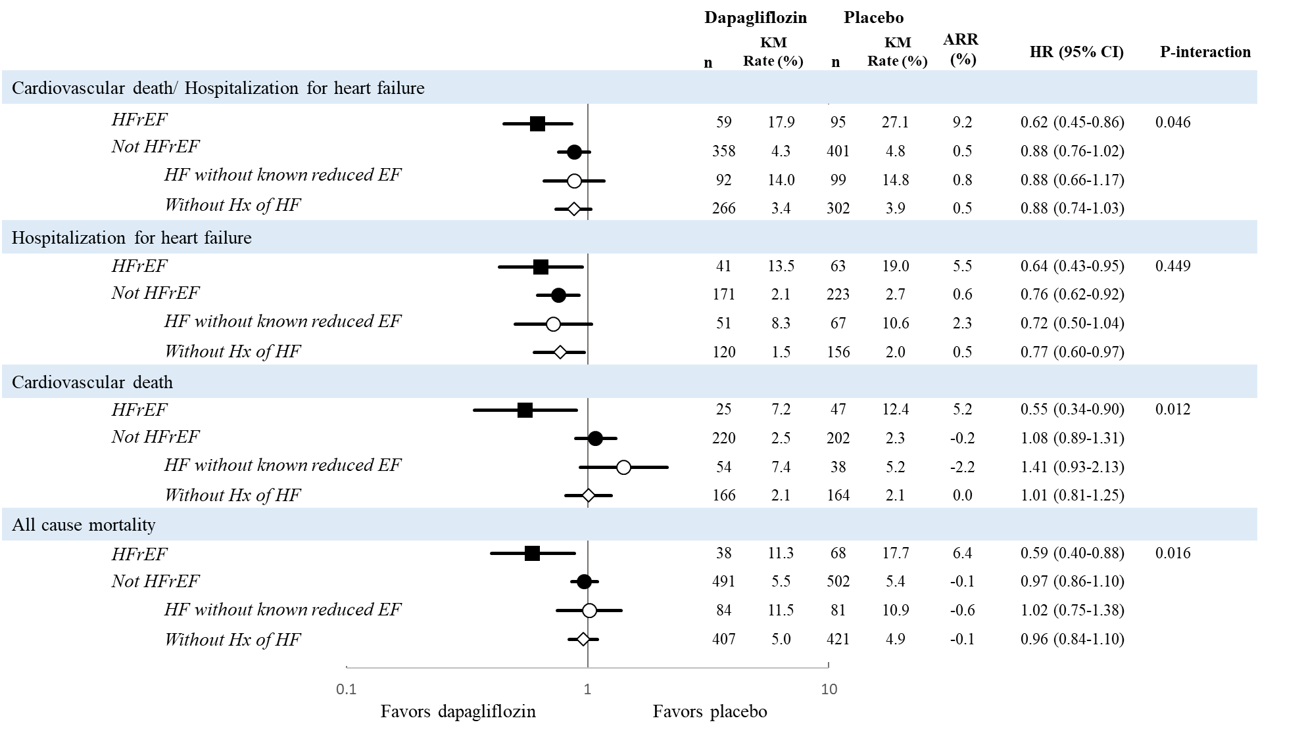

HFrEF: heart failure with reduced ejection
There were 671 patients with HFrEF defined as patients with left ventricular ejection fraction<45% (318 in dapagliflozin group and 353 in placebo group), and 16489 patients without HFrEF (8264 in dapagliflozin group, and 8225 in placebo group). 1316 patients with HF without known reduced EF defined as patients with a history of heart failure without left ventricular ejection fraction <45% (662 in dapagliflozin group, and 654 in placebo group). There were 15173 patients without history of HF and without left ventricular ejection fraction <45% (7602 in dapagliflozin group and 7571 in placebo group).
P-interaction refers to an interaction between HFrEF vs not HFrEF.
Open circles are a subset of the closed circles.

Figure 2. KM curves stratified by different heart failure categories
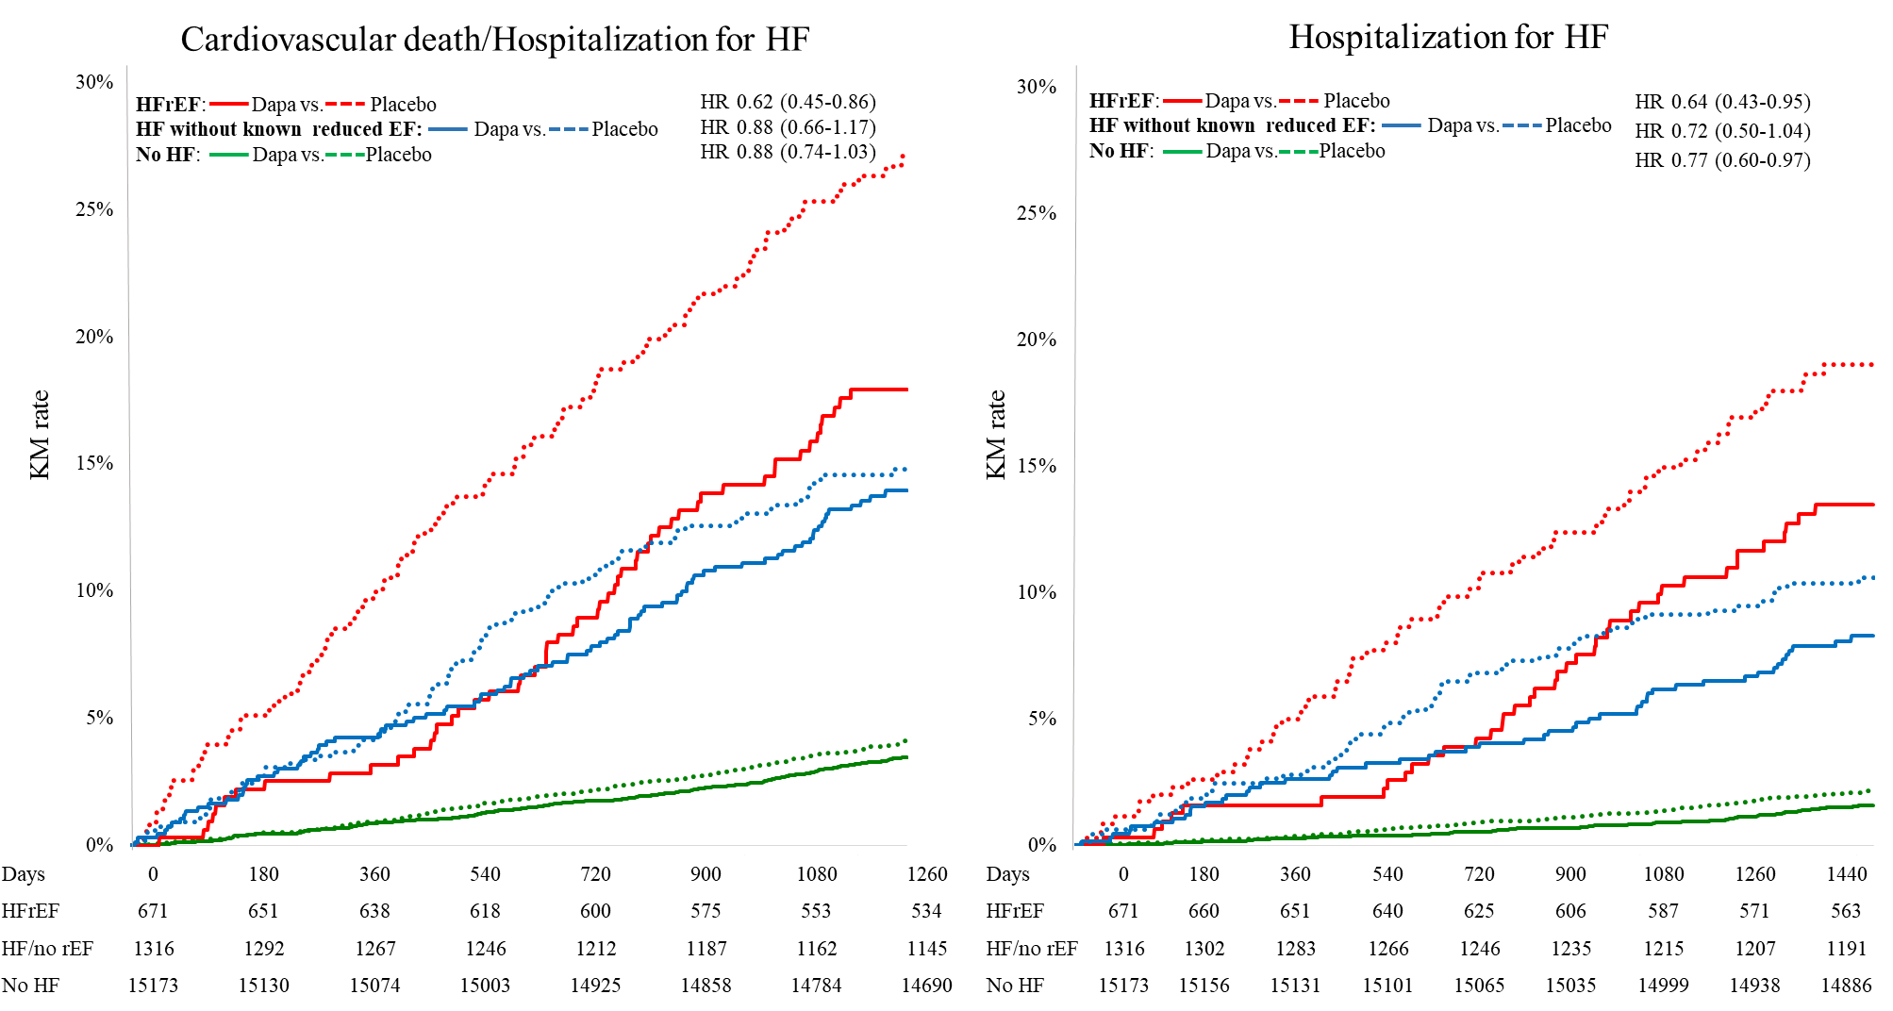

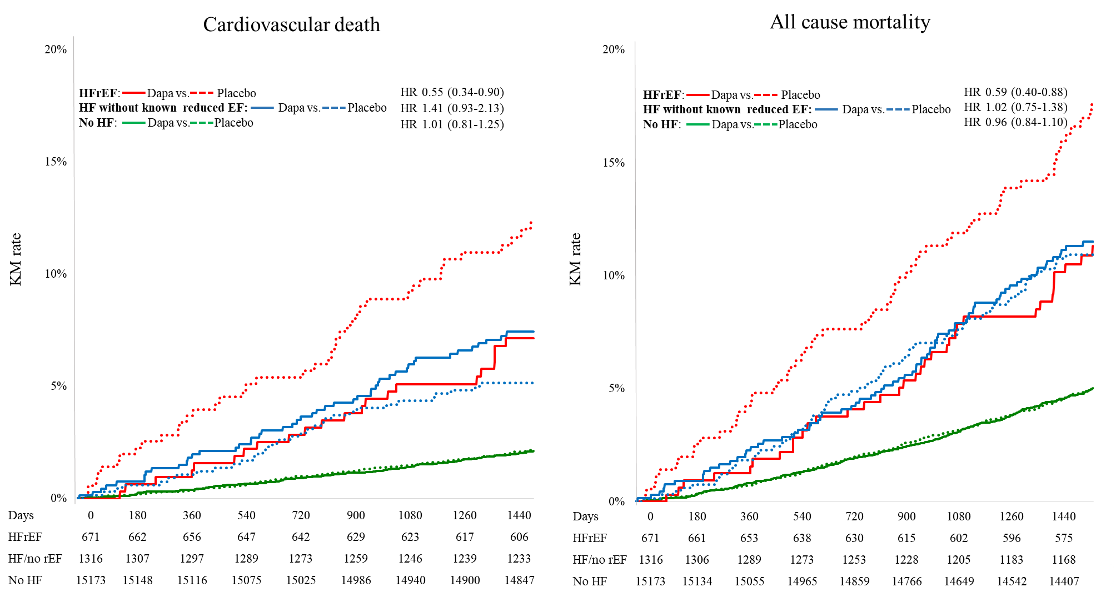
HFrEF: heart failure with reduced ejection fraction; Dapa: dapagliflozin; HF: heart failure; rEF: reduced ejection fraction
The Kaplan Meier rate compares treatment with dapagliflozin vs placebo. The solid line represents dapagliflozin, and dotted line represents placebo. Numbers at risk are shown at the bottom of the figure.

Supplementary

Supplementary material 1. Methods for EF collection
Supplementary Table S1. Causes of death
Supplementary Table S2. Safety endpoints
Supplementary Figure S1. Outcomes by history of heart failure and subcategories
Supplementary Figure S2. Outcomes by different ejection fraction cutpoints
Supplementary Figure S3. Cardiovascular death/hospitalization for heart failure by heart failure category and diuretic use
Supplementary Figure S4. Other endpoints

Supplementary material 1. Methods for EF collection

Echocardiogram, MRI or scintigraphy were acceptable tools for measuring EF, with a preferable presentation being in order of the followings;
1) Exact EF value
2) EF range: the midpoint of the range was used as an exact EF value
3) Qualitative value (normal, mild, moderate, severe); patients with normal EF was considered as EF≥55%, mild as EF 45-55%, moderate as EF 30-45%, and severe as <30%.
If multiple EF values were available at the time of enrolment, the most recent known ejection fraction before randomization was utilized.

Table S1. Causes of death
 | HFrEF |  |  | Not HFrEF |  |  | P-interaction
 | Dapagliflozin (N=318) | Placebo  (N=353) | HR (95% CI) | Dapagliflozin (N=8264) | Placebo  (N=8225) | HR (95% CI)
All cause mortality | 38 (11.9) | 68 (19.3) | 0.59 (0.40-0.88) | 491 (5.9) | 502(6.1) | 0.97 (0.86-1.10) | 0.016
Non CV death | 6 (1.9) | 16 (4.5) | 0.40 (0.16-1.03) | 205 (2.5) | 222 (2.7) | 0.92 (0.76-1.11) | 0.079
CV death | 25 (7.9) | 47 (13.3) | 0.55 (0.34-0.90) | 220 (2.7) | 202 (2.5) | 1.08 (0.89-1.31) | 0.012
Sudden death | 16 (5.0) | 25 (7.1) |  | 125 (1.5) | 118 (1.4)
AMI | 1 (0.3) | 5 (1.4) |  | 27 (0.3) | 31 (0.4)
Stroke | 3 (0.9) | 4 (1.1) |  | 25 (0.3) | 24 (0.3)
HF | 4 (1.3) | 10 (2.8) |  | 23 (0.3) | 13 (0.2)
Other | 1 (0.3) | 3 (0.8) |  | 20 (0.2) | 16 (0.2)

CV: cardiovascular; AMI; acute myocardial infarction; HF: heart failure.
The incident rate of all-cause mortality and cardiovascular death was lower with dapagliflozin group only.
Data are shown as number of events and percentage (n/N)
Table S2. Safety endpoints
Endpoints | HFrEF | Dapagliflozin |  | Placebo |  | Hazard ratio | Cox p-value | P-interaction
 |  | (HFrEF=317, |  | (HFrEF=353,
 |  | Not HFrEF=8256) |  | Not HFrEF=8216)
 |  | n | % | n | %
Serious adverse event
 | Yes | 172 | 56.9 | 196 | 58.8 | 0.87 (0.71-1.07) | 0.194 | 0.754
 | No | 2753 | 35.7 | 2904 | 38.4 | 0.91 (0.87-0.96) | <0.001
Major hypoglycemia event
 | Yes | 7 | 2.5 | 10 | 3.7 | 0.71 (0.27-1.87) | 0.489 | 0.94
 | No | 51 | 0.6 | 73 | 1 | 0.68 (0.47-0.97) | 0.033
Diabetic ketoacidosis
 | Yes | 0 | 0 | 0 | 0 | - | - | -
 | No | 27 | 0.3 | 12 | 0.2 | 2.18 (1.10-4.30) | 0.025
Amputation
 | Yes | 11 | 3.6 | 7 | 2.4 | 1.59 (0.62-4.11) | 0.337 | 0.387
 | No | 112 | 1.4 | 106 | 1.3 | 1.05 (0.81-1.37) | 0.708
Fracture
 | Yes | 23 | 7.7 | 20 | 6.6 | 1.20 (0.66-2.19) | 0.551 | 0.588
 | No | 434 | 5.3 | 420 | 5 | 1.03 (0.90-1.18) | 0.679
Symptoms of volume depletion
 | Yes | 22 | 7.5 | 15 | 5.6 | 1.52 (0.79-2.93) | 0.213 | 0.204
 | No | 191 | 2.5 | 192 | 2.6 | 0.96 (0.79-1.18) | 0.722
Acute renal failure
 | Yes | 23 | 8.2 | 40 | 14 | 0.57 (0.34-0.96) | 0.034 | 0.24
 | No | 270 | 3.4 | 336 | 4.6 | 0.78 (0.66-0.91) | 0.002
Genital infection
 | Yes | 3 | 1.1 | 0 | 0 | - | - | -
 | No | 73 | 0.9 | 9 | 0.1 | 8.01 (4.01-16.01) | <0.001
Urinary tract infection
 | Yes | 3 | 1.1 | 2 | 0.4 | 1.45 (0.24-8.68) | 0.686 | 0.579
 | No | 124 | 1.7 | 131 | 1.8 | 0.92 (0.72-1.17) | 0.492

Safety outcomes analyzed in safety on-treatment period for all endpoints other than amputations, fractures, and malignancy which were analyzed in the safety overal period

Figure S1. Outcomes by heart failure categories and subcategories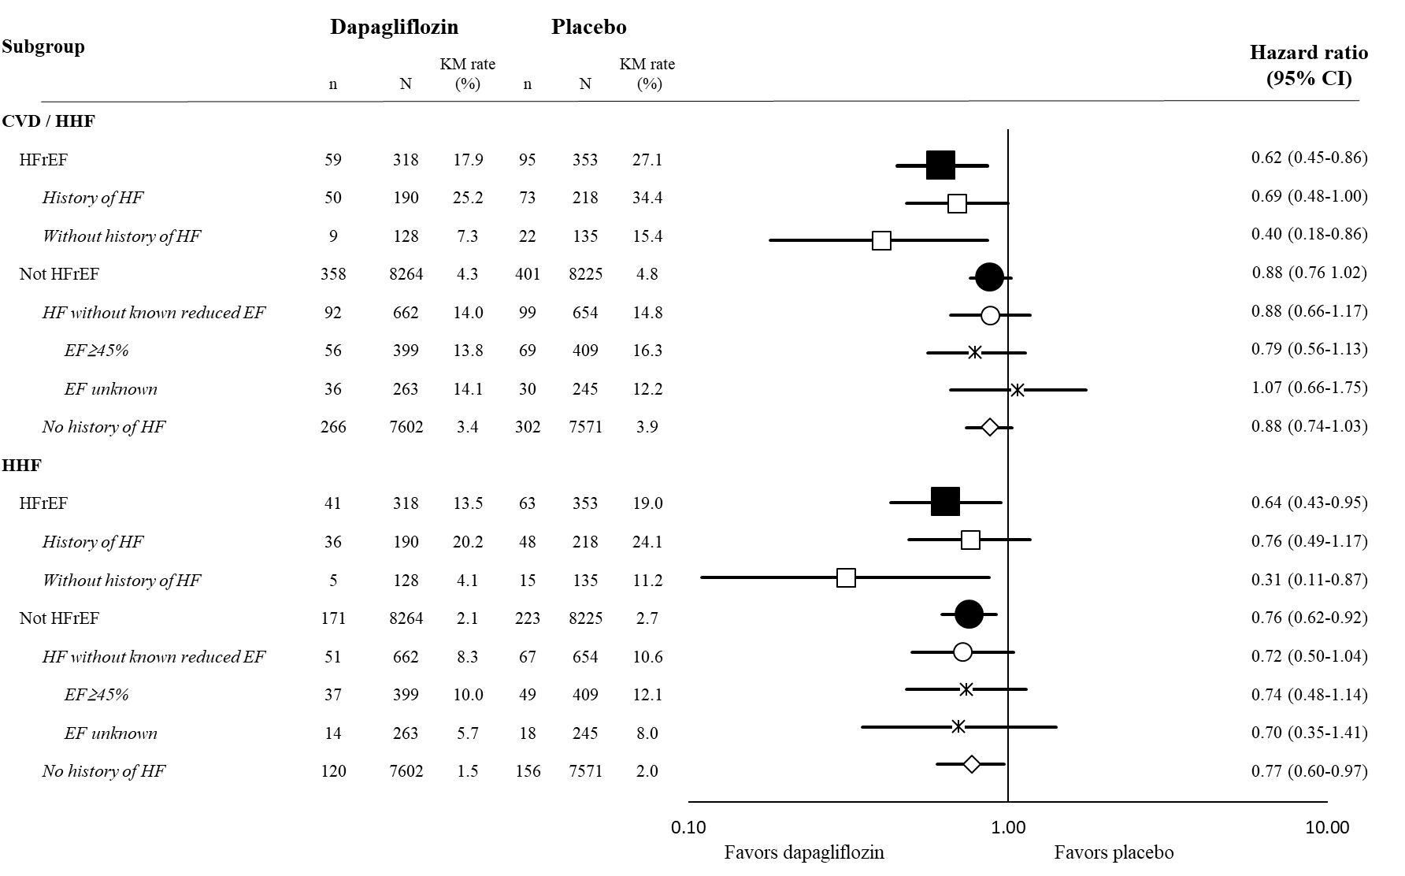
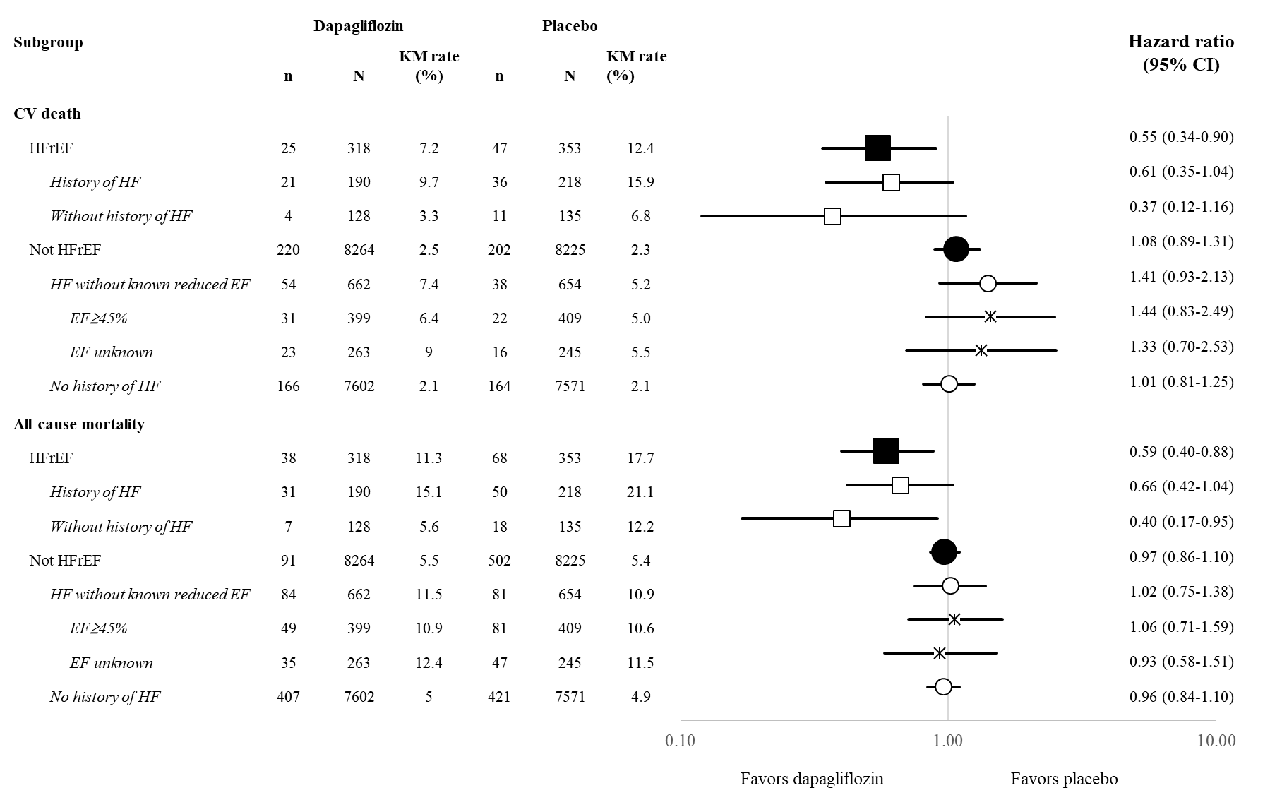
Figure S2. Outcomes by different ejection fraction cutpoints
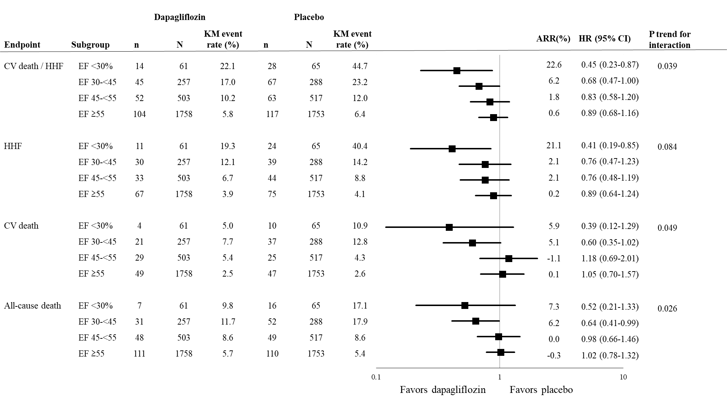
Figure S3. Cardiovascular death/hospitalization for heart failure by heart failure category and diuretic use
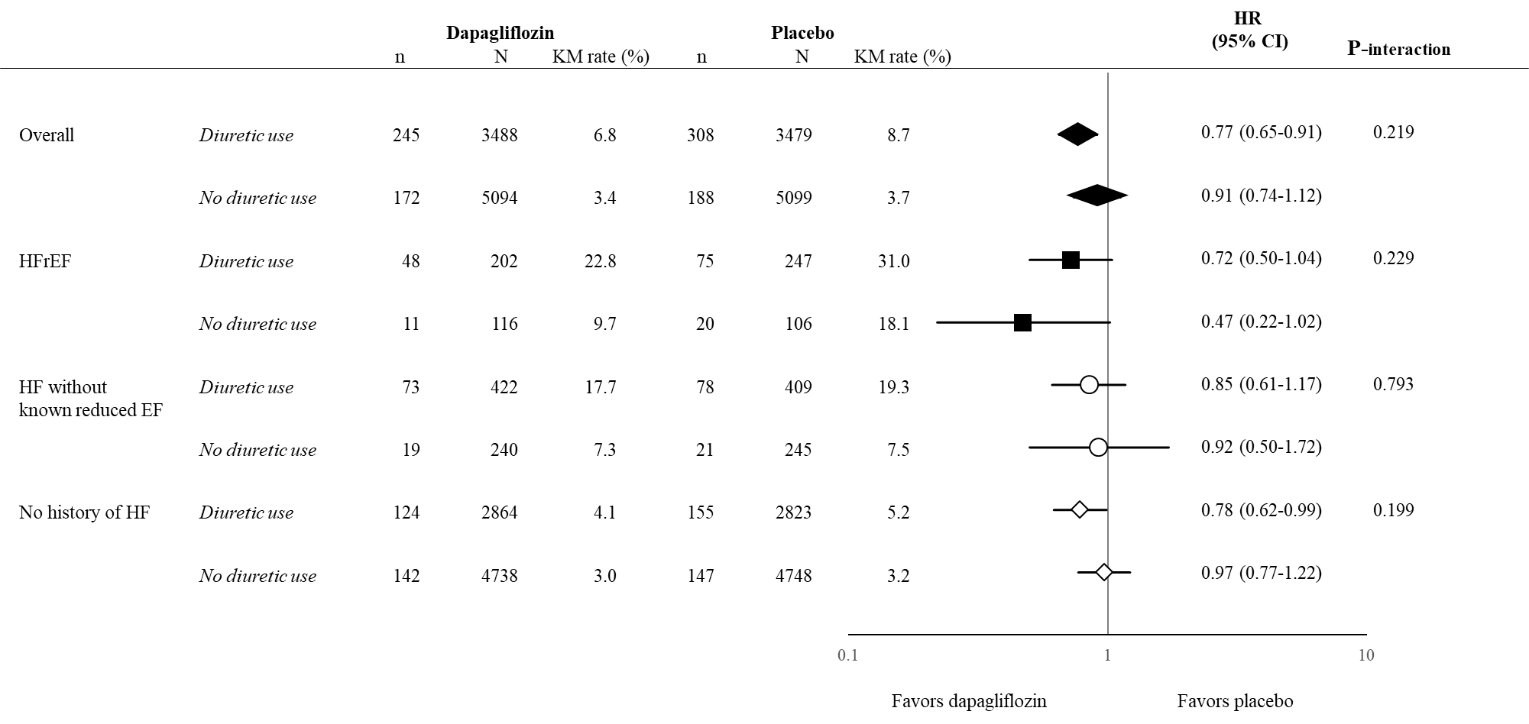

Figure S4. Other endpoints
