Title: Is orofacial pain a pain in the neck?

A.Travers, L. Feinberg, F. O’Neill
Oral Surgery Department, Liverpool University Dental Hospital, Liverpool, UK

Key words:
Orofacial pain, musculoskeletal, adenocarcinoma, metastatic disease, clivus

Correspondence to:
Francis O’Neill
Department of Oral Surgery
Liverpool Dental Hospital
Pembroke Place
Liverpool L3 5PS
UK
Tel.: 01517065245
Fax: 01517065806
email: foneill@liverpool.ac.uk
Abstract

Acute orofacial pain in the head and neck region is a common complaint, however it can be a diagnostic challenge due to the anatomical complexities in this region, sometimes making the origin of pain difficult to source. Accurate diagnosis relies on a systematic evaluation of the patient’s pain history, medical factors and clinical signs and symptoms. An assessment of the patient’s cervical musculoskeletal system is often overlooked but can provide important diagnostic information.
Introduction
Orofacial pain is common with reports as high as 22% of a given population experiencing pain more than once over a 6-month period¹. The head and neck is a complex anatomical region containing multiple general and specialised sensory structures. Dense sensory innervation can lead to a single structure being innervated by multiple nerves and/or multiple structures being served by a single nerve. This can make identifying the origin of a pain and ultimately, diagnosis, difficult. A plethora of disparate medical and dental specialty disciplines share this anatomical area and patients often see multiple clinicians in their healthcare journey.
Orofacial pain requires a systematic approach including a thorough head and neck examination with assessment of the musculoskeletal system and potentially the use of diagnostic local anaesthetic injections. This case study describes an unusual presentation of orofacial pain in a patient who had presented to multiple clinicians.
Case Presentation
A 53-year-old male presented to the oral diagnosis clinic at Liverpool University Dental Hospital complaining of severe ‘toothache’ from the right jaw. It had been present for 5 weeks and the pain was of a constant dull throbbing nature, which would exacerbate spontaneously. The patient described a radiating pain through the right side of his face, temple, neck, which disturbed his sleep. Simple analgesia was insufficient to control his pain.
The patient had presented to his general dental practitioner 10 days previously who diagnosed pain of dental origin and extracted the upper right second premolar (UR5), first molar (UR6) and lower right second premolar (LR5) teeth. Following this treatment, the pain remained unchanged in character, quality or constancy and the patient then attended the Accident and Emergency department in his local hospital. Here the emergency physician considered a potential neuropathic pain secondary to dental surgery as a diagnosis and prescribed oral gabapentin 300mg OD day one, 300mg BD day two and 300mg TDS day three, adjusted to response with a maximum daily dose of 3.6g. He was told to stop his regularly prescribed medication of naproxen 250mg QDS. Following several days of gabapentin, the patient described the pain as getting worse.
He subsequently attended the Oral diagnosis clinic of Liverpool University Dental Hospital where a thorough history and full head and neck clinical examination were conducted. On interrogation of the patient’s medical history he was 6 weeks post left pneumonectomy following a diagnosis of lung adenocarcinoma with localised lymph tissue spread. A whole-body PET scan performed 12 weeks previously was reported as clear of distant metastases. The surgery was expected to be curative and the patient was not being considered for post-operative radiotherapy or chemotherapy. At the time of presentation, he had not undergone a post-op surgical review. He had a history of mild spondylitis of the cervical spine for which he was taking a regular nonsteroidal anti-inflammatory medication, naproxen. Post-operative analgesia which comprised of oromorph and dihydrocodeine was required by the patient during his operative recovery period. He did not smoke or drink alcohol.

On examination there was no evidence of cervical lymphadenopathy or gross asymmetry. All cranial nerves were intact with no clinically detectable neuropathy in any of the distributions of the trigeminal nerve either extra-orally or intra-orally. Positive findings showed tenderness of the right trapezius muscle but without pain referral, and tenderness of the C4 and C5 vertebrae. There was slight tenderness noted over the right temporomandibular joint but there was good mobility and painless function.
Testing of cervical spine range of motion revealed there was clear exacerbation of his facial pain on rotational neck movements. The patient reported that the pain elicited on neck movement had the same character and was felt in the same area of the face as the pain he had presented with.
Intra-oral examination revealed that the soft tissues were normal with exception of recent extraction sockets of UR6, UR5 and LR5 which appeared to be healing satisfactorily. The remaining teeth on the right side showed normal responses to sensibility testing with ethyl chloride. No acute infection was seen clinically.
An orthopantomogram radiograph was taken (see Figure 1). This showed the healing extraction sockets and a small periapical lesion on the lower left second premolar (LL5). This lower left premolar tooth was not symptomatic however and could not account for the patient’s pain. No other obvious bony pathology was seen.

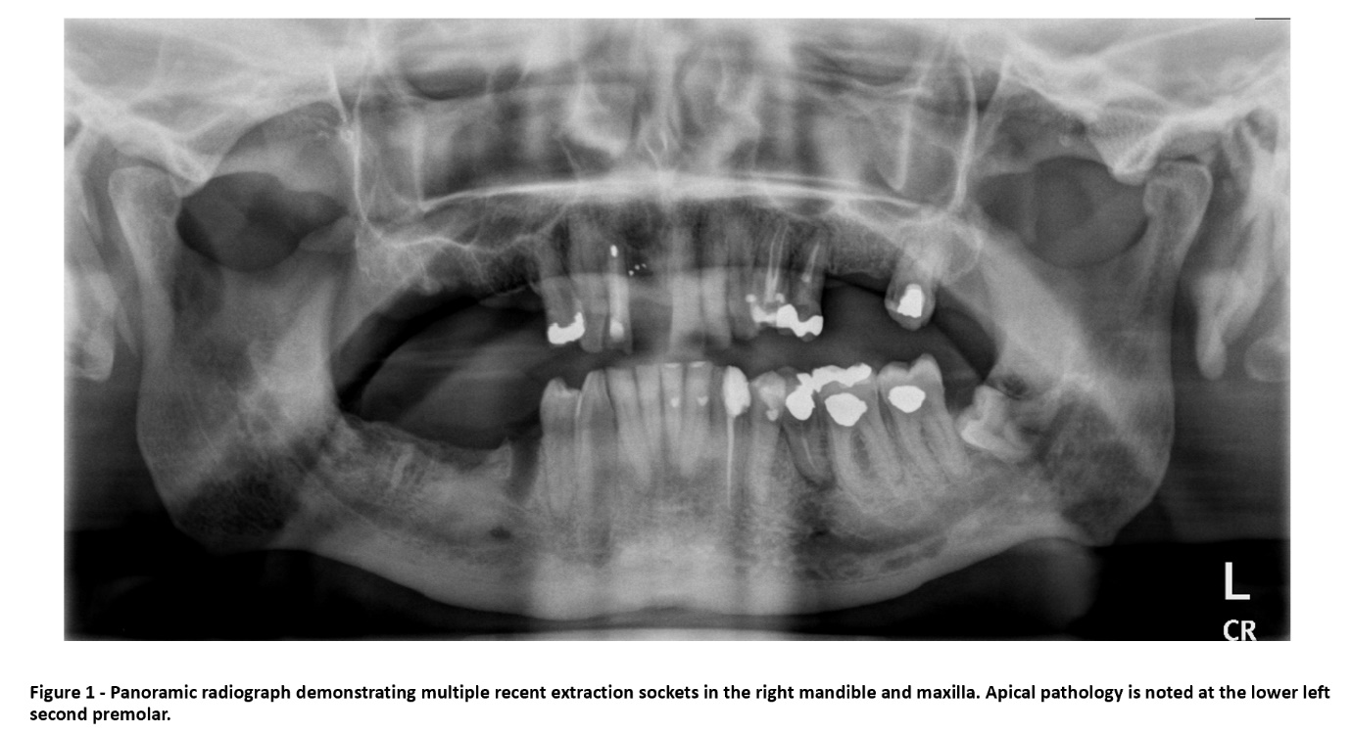
Diagnostic local anaesthetic injections comprising a right inferior alveolar nerve block and serial infiltrations in the upper right quadrant were administered with 2% Lignocaine and 1:80000 adrenaline which successfully anaesthetised the tissues of these nerve distributions; however, did not improve patients pain symptoms. Thus, the use of local anaesthetic excluded pain from a peripheral trigeminal origin and dental involvement was ruled out.
Because the patient experienced a familiar pain elicited on rotation of the neck, pain of neck origin referring to the face was suspected. Differential diagnoses included pain related to previous spondylitis, however given his recent history of a lung neoplasm and with as many as 36% of lung cancer patients having findings of metastatic bone disease², a high index of suspicion was given to the possibility of pain secondary to metastatic disease. Urgent imaging was requested, and the patient advised to restart his naproxen medication.
A CT and MRI head, face and neck with contrast were performed with the CT demonstrating destruction of the right side of the clivus, caused by a likely bony metastasis (see Figure 2). The MRI reported a 1.9cm heterogeneously enhancing discrete mass, which had not yet impinged on the trigeminal cave ‘meckel’s cave’ or the trigeminal branches (see Figure 3). The radiologists report noted, as well as destruction of the clivus, destruction of the apex of the right petrous temporal bone. The patient subsequently underwent targeted radiotherapy to the site of this lesion.
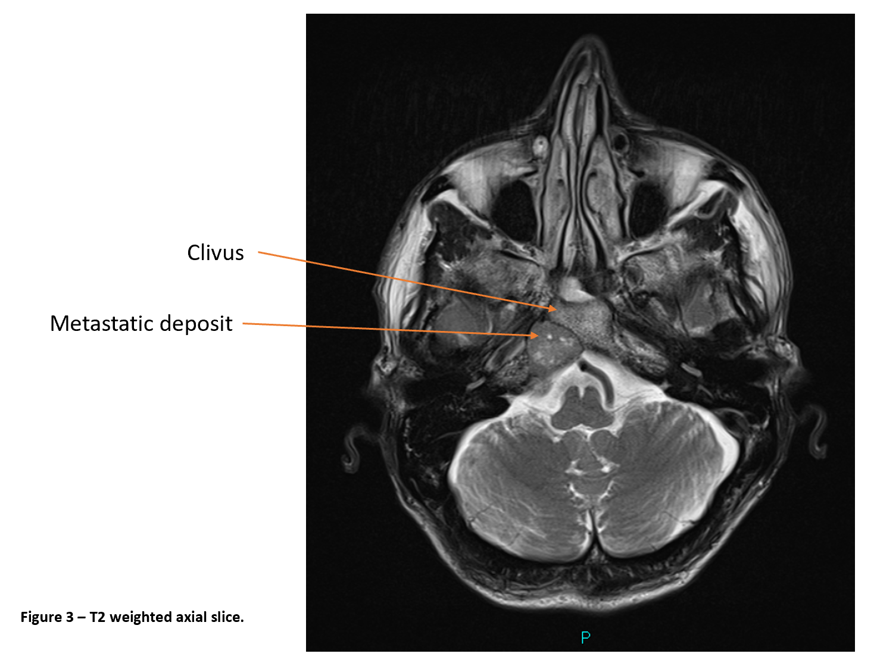
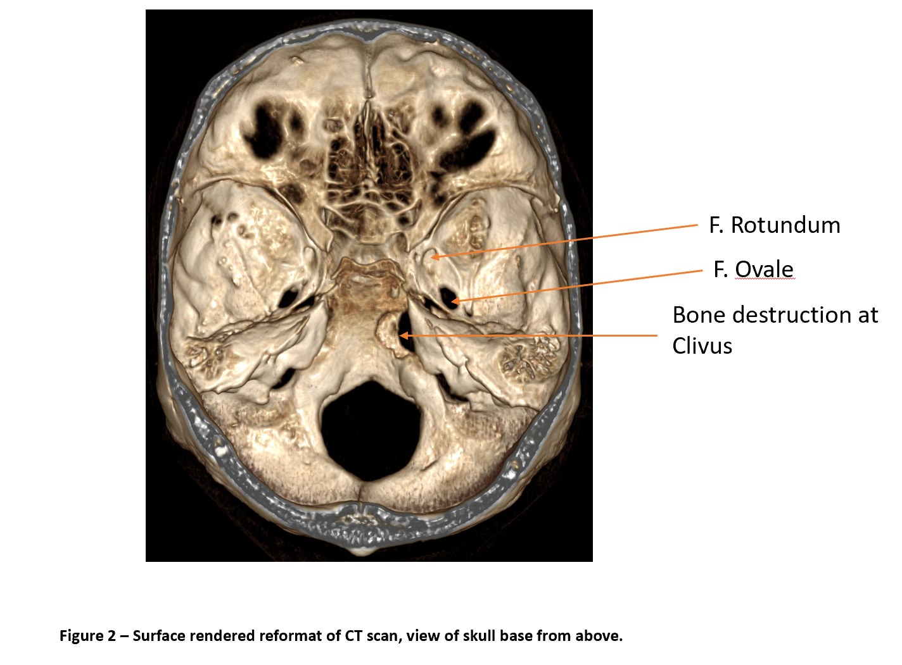
Discussion
This case presented as a diagnostic dilemma for both the patient’s general dental practitioner and the accident and emergency physician. A thorough orofacial pain history and examination including inspection of the head and neck musculoskeletal system was required to make an appropriate differential diagnosis.
Metastatic disease affecting the clivus, is extremely rare^{3,4}. The clivus (Latin for slope) is composed of the posterior portion of the body of the sphenoid bone and the basal portion of the occipital bone, joining in the middle at the spheno-occipital synchondrosis. It supports the brainstem and can be divided into a superior, middle and inferior segments⁵. The metastasis in this case study was situated in the middle segment at the level of the vestibulocochlear nerve. Its location could give rise to two potential mechanisms for the patient’s pain.
1. Tumour invasion of ligaments of the anterior upper cervical spine including the cruciform ligament, anterior atlanto-occipital membrane, and the tectorial membrane. These structures are supplied by branches of the first cervical nerve C1. Afferent pain fibres from C1 merge with trigeminal nerve fibres in the nucleus caudalis of the spinal trigeminal complex. This convergence can underlie referral of pain of neck origin to be felt in the trigeminal region⁶.
2. Tumour invasion and stimulation of meningeal afferents. The posterior surface of the clivus is covered by meningeal membrane for which sensory innervation is supplied by the meningeal branches of the maxillary and mandibular divisions of the trigeminal nerve. Stimulation of meningeal afferents also refers pain to the face⁷.
There was no clinical evidence of neuropathy that may indicate direct effect on the trigeminal nerve branches either by compression or infiltration.
Magnetic resonance imaging showed the metastatic lesion was situated below the level of the trigeminal nerve roots or ganglion and was posterior to Meckel’s cave (see Figure 4). The only evidence of neurological deficit seen in this case was when the patient experienced an isolated abducens nerve palsy some six weeks later and this was attributed to direct compression or invasion of the sixth cranial nerve as it climbs the posterior surface of the clivus⁸.
Rotational movements of the neck examination exacerbated symptoms and increased suspicion for pain of a non-odontogenic cause. An understanding of the nature and the character of the pain felt by the patient allows the clinician to distinguish between potential odontogenic, neuropathic or referred pain; therefore, allowing for greater accuracy and understanding in a pain diagnosis. Testing a patient with multiple sensory modalities to achieve this should be within the skill set of all general dental practitioners.
In conclusion this case emphasizes the importance of a thorough history and examination of patients presenting with orofacial pain. It demonstrates the value of examining head and neck movements routinely in these patients and the use of diagnostic local anaesthetic injections to exclude peripheral origin for the pain.
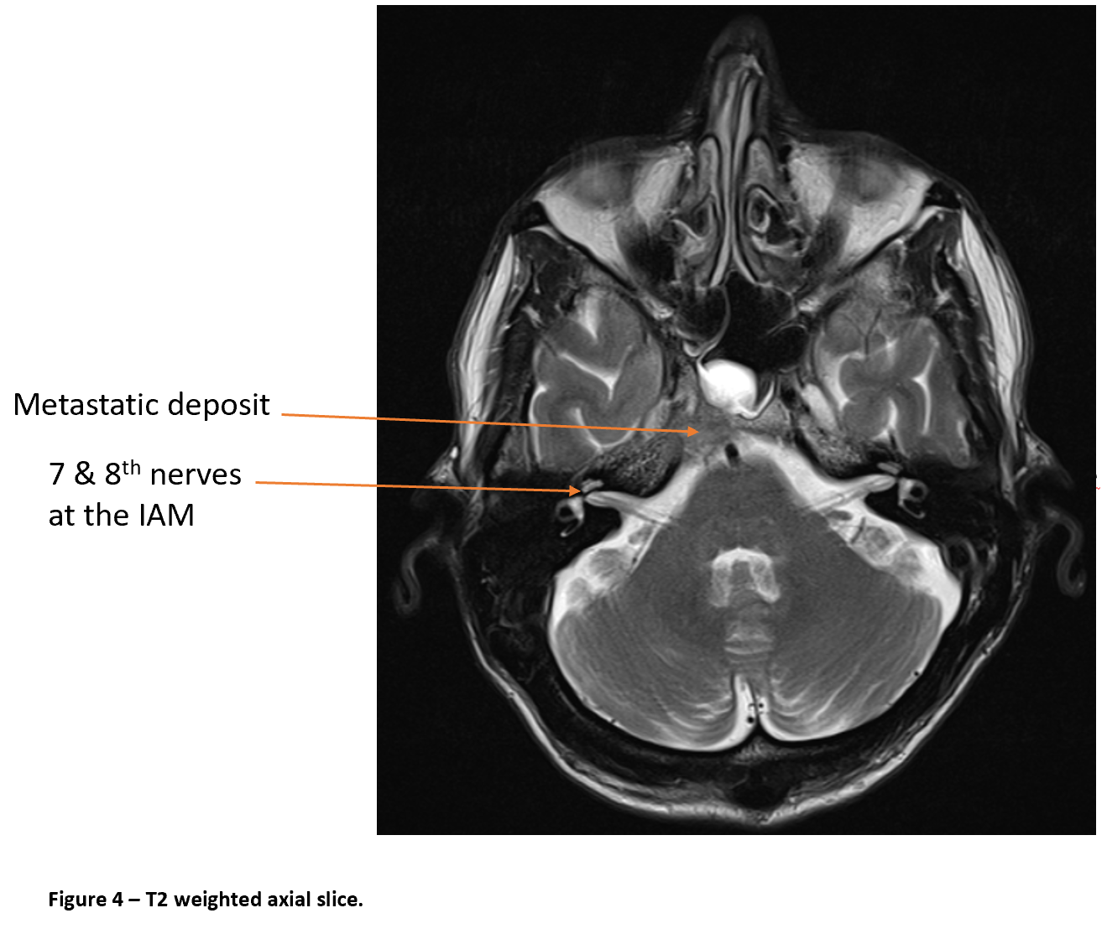
Conflicts of interest
The authors declare that there is no conﬂict of interest and there has been no source of funding.

References
- Lipton JA, Ship JA, Larach-Robinson D. Estimated prevalence and distribution of reported orofacial pain in the United States. J Am Dent Assoc 1993; 124:115-121.
- Turner RC, Lucke-Wold BP, Hwang R, Underwood BD. Lung cancer metastasis presenting as a solitary skull mass. J Surg Case Rep 2016; 6:rjw116.
- Rajinikanth M, Prakash AR, Swathi TR, Reddy S. Metastasis of lung adenocarcinoma to the jaw bone. J Oral Maxillofac Pathol 2015; 19:385-388.
- Zelenak M, Doval M, Gorscak JJ, Cuscela DO. Acute Cavernous Sinus Syndrome from Metastasis of Lung Cancer to Sphenoid Bone. Case Rep Oncol 2012; 5:35-42.
- Hofmann E, Prescher A. The clivus: anatomy, normal variants and imaging pathology. Clin Neuroradiol 2012; 22:123-139.
- Piovesan EJ, Kowacs PA, Oshinsky ML. Convergence of cervical and trigeminal sensory afferents. Curr Pain Headache Rep 2003; 7:377-83.
- Wirth FP, Van Buren JA. Referral of pain from dural stimulation in man. J of Neurosurg 1971; 34:630-42.
- Emmanuel A, Baidoo R, Tubbs S. Chapter 23: Anatomy of the abducens nerve. Nerves and Nerve Injuries Vol 1: History, Embryology, Anatomy, Imaging, and Diagnostics 2015; 351-355.

