Exploring the effect of combinational pictorial stimuli on creative design performance

Min Hua¹, Ji Han², Xuezi Ma³, Peter Childs¹

¹Imperial College London; ²University of Liverpool; ³University of Cambridge

Abstract
Creativity is often said to play a vital role in the product design process, while functionality and aesthetics are considered key factors of actual products. Functionality refers to the performance of a product, and aesthetics represents the visual and ergonomic appeals of the product. However, there appears to be an elusive relation between creativity, functionality and aesthetics. This study explores how functionality, aesthetics and creativity are related to one another in design. Through exploring the definitions and assessments of creativity in design, this study reveals that novelty, usefulness and surprise are the three core elements of design creativity. A case study involving experts evaluating design samples in terms of novelty, usefulness, surprise, functionality, aesthetics and overall creativity is conducted. The results imply that there are no statistically significant relations between creativity, functionality, and aesthetics. Considering the three core elements of design creativity, the results indicate that creativity is only statistically significantly related to novelty. Moreover, our results suggest that creativity and novelty are measuring the same construct.

Keywords: Creativity, Design cognition, Conceptual design, Simulation, Combinational pictorial stimuli

Introduction
Designers commonly use visual stimuli to support design ideation processes. Throughout the design process, especially in the early design stage, designers can be exposed to vast collections of visual stimuli, which are believed associated with design creativity (Guo and McLeod, 2014; Bacciotti, Borgianni and Rotini, 2016). Design creativity refers to the ability 'to develop something new of value' (Childs et al. 2006), which is a vital element in the design. Design studies have provided evidence in support of the view that the use of external stimuli can have an impact on design creativity in a number of ways, e.g. by offering new information/knowledge (Agogué et al., 2011), eliciting emotion/experience (Mougenot et al., 2010) and building far connections (Gassmann and Zeschky, 2008). Therefore, designers are used to searching for visual stimuli serving as important triggers for idea generation. Emerging ideation software and online platforms support this search behaviour by providing stimuli to designers while they are working. Numerous research programmes have been carried out to explore the supporting roles of visual stimuli play in design ideation process (Finke, 1990; Henderson, 1998; Dahl and Moreau, 2002; Yang, Wood and Cutkosky, 2005; Goldschmidt and Smolkov, 2006; Gonçalves, Cardoso and Badke-Schaub, 2014; Borgianni, Rotini and Tomassini, 2017). However, little attention has been paid to explore how stimuli should be delivered to designers during the early design stage. This question is crucial to the effective use of stimuli because previous research studies have indicated that ill-presented stimuli can lead to lower design efficiency or even harm creative production (Goldschmidt and Smolkov, 2006; Siangliulue et al., 2015).
The objective of this paper is to explore if and how combinational pictorial stimuli can affect designers' creative performance. This paper is based on the study conducted by Han et al. (2018). An empirically based experiment was carried out to verify whether designers benefit more from receiving combinational pictorial stimuli (Combinator Group) than those seeing no stimuli (No-tool Group) or randomly presented pictorial stimuli (Google Image Group). The results of this paper suggest that both the Combinator Group and No-tool Group outperformed the Google Image Group, which implies that the form of stimuli delivery can determine the impact on creative output and combinational pictorial stimuli best support design creativity among these 3 conditions.

PREVIOUS RESEARCH ON VISUAL STIMULI
Finke (1990) in his pioneering work Creative Imagery: Discoveries And Inventions in Visualization reported a series of experiments to explore the interplay between mental imagery and external visual stimuli. In the experiments, a set of 15 forms were shown to the subjects, from which 3 randomly selected forms would be named and presented on each trail. Once the forms had been named, the subjects were asked to close their eyes and try to mentally combine the forms into a recognizable design. The subjects were asked to synthesize the forms in 2 minutes and then to draw the design outcomes on paper. These sketches were then rated by judges from the perspective of practicality and originality. According to the results, the subjects scored higher in creativity when they received the specified interpretive categories after completing their forms, whereas the subjects scored lower when they were free to choose interpretive categories at any time. These results indicate that receiving unexpected stimuli and delaying the exposure to stimuli after the ‘preinventive structures’ are completed can enhance creative performance. These findings suggest the importance of the way that stimuli are accessed (e.g. their types, forms and timing of delivery).
Finke and his associates revealed that people can benefit from external stimuli and manipulate them in imagery to make novel and meaningful combinations (Finke and Slayton, 1988; Finke, 1990). Their experiments opened up a new perspective of research based on the insight of mental synthesis, which also inspired many other researchers to take it further. For example, Goldschmidt and her colleagues subsequently reported two important studies which contributed to the literature on creative mental synthesis. In the first, Goldschmidt and Smolkov (2006) carried out an empirical study which experimentally tested how different types of stimuli and their presence in the designers’ working environment can affect design outcomes. The results suggest that the presence of stimuli can influence the quality and originality, only when designers are facing an ill-structured design problem. The effect of stimuli may vary due to the types of design problems and environmental factors. In the second study, Goldschmidt and Sever (2011) switched their research attention to only focus on textual stimuli and its role in supporting creative design performance. They found that the reading of different types of text containing ideas can be inspiring and enhances the originality and creativity of designs. Compared with pictorial stimuli, few studies have been done to explore the impact of textual stimuli on design creativity. This is one of the few studies found in the literature proves that, like pictorial stimuli, textual stimuli also plays a role in the ideation process and has a similar effect on design creativity.
One reason that why design researchers choose to pay more attention to pictorial stimuli is that designers have traditionally been considered as visualizers (Mednick, 1962) and they acknowledge a clear preference for pictorial stimuli over textual or any other types (Muller, 1989; Henderson, 1998; Hanington, 2003; Gonçalves, Cardoso and Badke-Schaub, 2014). Numerous researchers have reported the superior effect of pictorial stimuli over textual ones, especially when it related to form and function design (Paivio, Rogers and Smythe, 1968; Lutz and Lutz, 1977). Pictorial stimuli are believed to be more efficient then textual stimuli, because pictures are easier to memorise and connect to semantic memory than texts, which means less cognitive effort is needed for accessing and storing pictures, and combining them with previous knowledge into novel combinations (Sarkar and Chakrabarti, 2008; Ware, 2010).
According to Paivio’s (1968) dual coding theory, people can process information in both verbal (which includes text or audio) and non-verbal (images and sounds) channels, and these two channels can work either independently or synergistically. Thus, some information can only be processed in texts or pictures, while other information is better delivered in a combinational way than any modality alone (Paivio, Rogers and Smythe, 1968; Ware, 2010). Malaga (2000) reported an experiment in which participants were asked to produce new ideas for a given design task. Textual, pictorial and combined stimuli were provided as sources of inspiration for participants. The results show that pictorial stimuli elicited more creative ideas than textual or combined stimuli. Borgianni et al. (2017) performed a very similar experiment but adopted different creativity metrics for evaluation. Their results show that stimuli fashions play a limited role in the ideation outcomes, and combined stimuli only rated a slightly higher on the creativity test than the two other kinds of stimuli.
The shared insight among all of these studies is that not only the stimuli itself, or its relevant attributes, can have an impact on the creative performance, but also the way to deliver them to the ideator may play a role in this process. Previous studies reported that the superimposed or merged images can lead to more creative outcomes, and the combined images can be stimuli to creativity (Ward and Kolomyts, 2010; Han, Shi and Childs, 2016; Han et al., 2018). The optimal way to deliver visual stimuli for creative inspiration should make the best of pictorial stimuli and avoid the potential cognitive fixation caused by it. Therefore, we have conducted an experiment to test if and how combinational pictorial stimuli can influence the creative design performance.

FORMS OF COMBINATIONAL PICTORIAL STIMULI DELIVERY
We provided two forms of image combination methods (i.e. juxtaposing and superimposing) for delivering stimuli to designers involved in our study. According to Ward and Kolomyts (2010), juxtaposing and superimposing, two basic ways for generating combinational images, have been identified as effective stimuli for creativity. The first method ‘juxtaposing’ is to crop images first and then to merge them next to one another. The second method ‘superimposing’ is to make images semi-transparent and then to superimpose them on one another. For example, Figure 1 shows the original images of a hair dryer and a conch shell, and their juxtaposed image and superimposed image. These two methods can be randomly used to avoid the einstellung effect on designers, whose mind might be blocked because of the overexposure to just one type of idea combination.
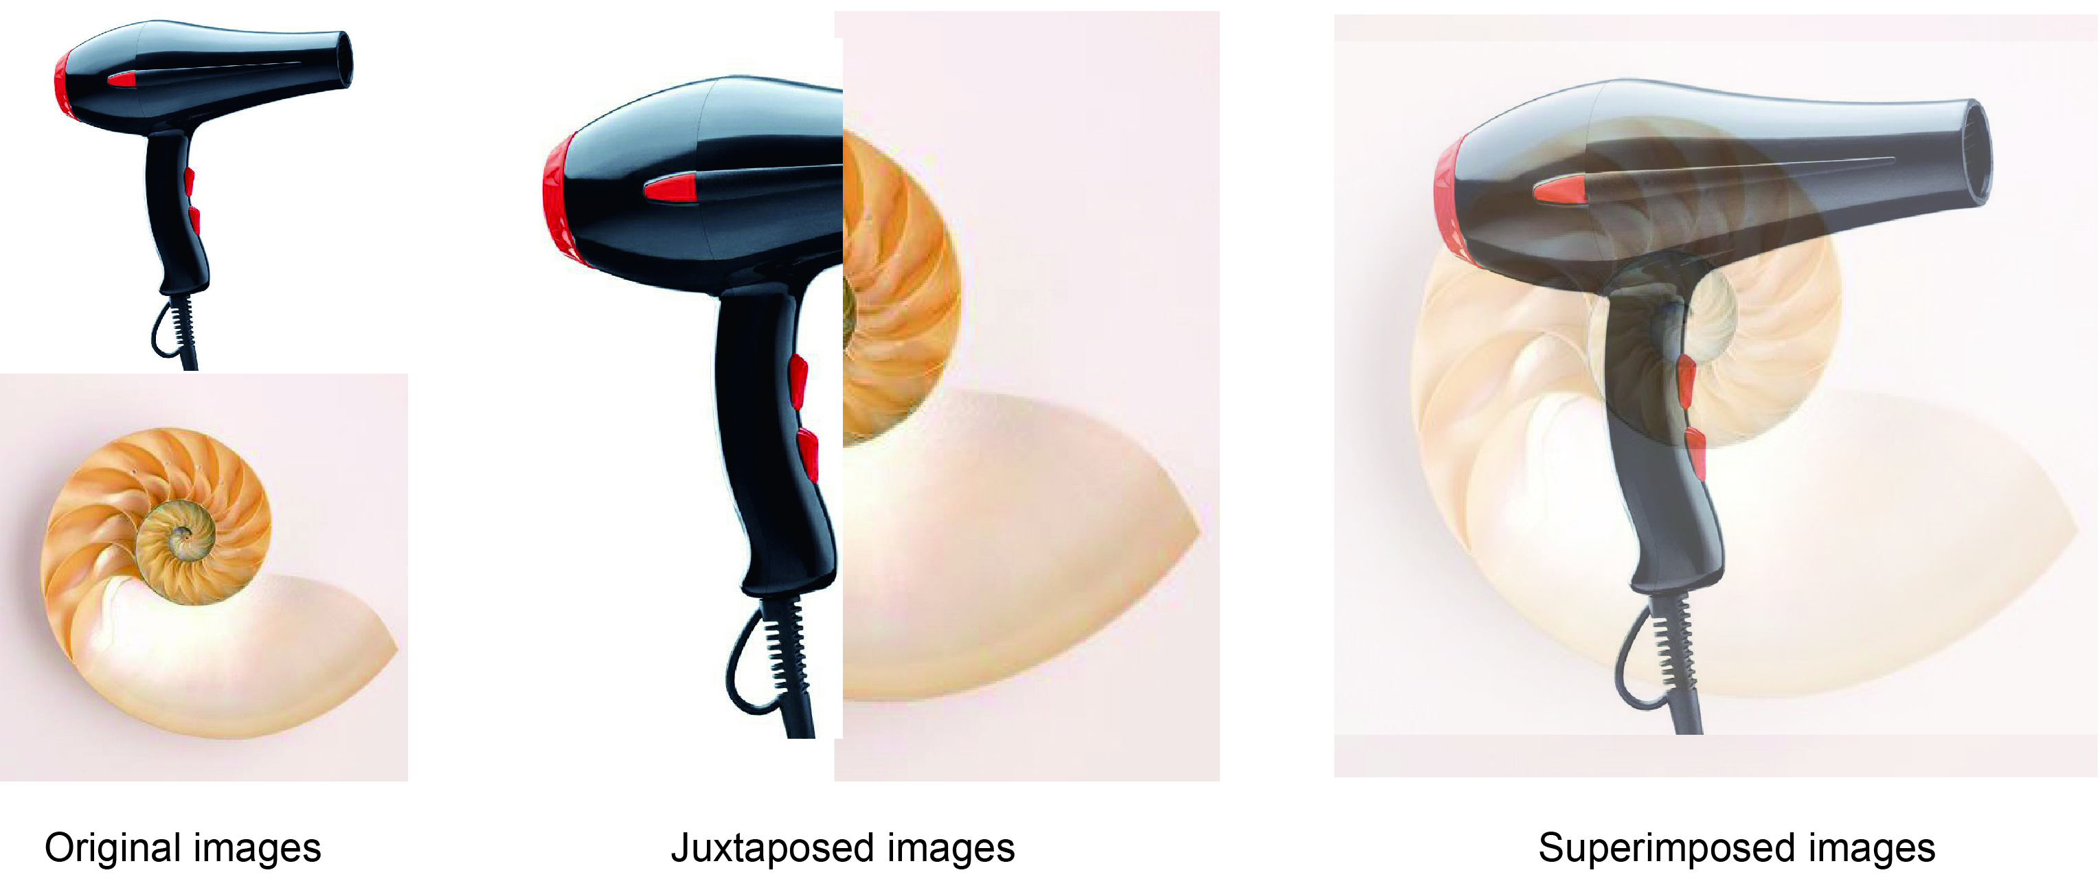
Figure 1. An example of combinational pictorial stimuli

EXPERIMENT
A laboratory experiment was conducted aimed at testing the effectiveness of combinational pictorial stimuli on creative design performance. In this experiment, participants were asked to generate a new design solution for holding sorted garbage with high space utilization. Participants were divided into 3 groups, two of which were respectively supported by exploiting random or combined display of pictorial stimuli as the source of inspiration, while the controlled group saw no stimuli during their ideation process. We used an outcome-based approach proposed by Shah et al. (2003) to evaluate the impact of different conditions on the design outputs, while process-based methods, i.e. observation and follow-up interview, were also adopted as a supplementary. Detailed information about the experiment is given in the following sections: the participants and conditions (sub-section 4.1), the equipment and materials (4.2), the task and procedure (4.3), and the criteria for the assessment of design outcomes (4.4).

Participants and conditions
A total of 36 participants, who were familiar with the predetermined design object ‘dustbins’, were involved in this experiment and the follow-up interview. The participants were interested in the research problem and therefore motivated and volunteered their time to join the experiment. The background of the participants may vary in terms of their gender, age, speciality and design experience. For example, 6 of the participants are considered as experienced designers having over three years of design experience, while the rest of them are design students who are regarded as novice designers. In order to have a fair competition, the participants were evenly divided into 3 groups based on their experience and background and thereby constituted 3 categories (see below) possessing similar capabilities. Detailed information of the participants can be found in Table 1.
- No pictorial stimuli condition (No-tool Group, N=12)
Subjects were provided with general instructions and a description of the design problem. The participants did not have access to the search tool or any other information, other than the design brief. They were also not aware of the existence of the search tool.
- Combinational pictorial stimuli’ condition (Combinator Group, N=12)
The participants had access to combinational pictorial stimuli by adopting a search tool called the Combinator. The participants were allowed to use the Combinator at any point during the ideation process with no time constraints so that they could organize the ideation time as desired. However, no extra time was given to stimuli search.
- ‘Random’ pictorial stimuli condition. (Google Image Group, N=12)
The same instructions and design requirements were assigned to participants. They can use Google Image as the search tool for pictorial stimuli. They were also allowed to use the Google Image at any point during the ideation process with no time constraints. However, no extra time was given to stimuli search.
Table 1. Basic information of participants (Adapted from (Han et al., 2018))
Number of Participants | Basic information
 | Gender |  | Age |  |  | Major |  |  | Professional design experience
 | Male | Female | 18-25 | 26-30 | 31-35 | Industrial Design | Design Engineering | Others | ≥3 years
The No-tool Group | 8 | 4 | 3 | 8 | 1 | 2 | 7 | 3 | 2
TheCombinator Group | 10 | 2 | 2 | 8 | 2 | 3 | 6 | 3 | 2
The Google Image Group | 9 | 3 | 3 | 8 | 1 | 4 | 6 | 2 | 2
Total | 27 | 9 | 8 | 24 | 4 | 9 | 19 | 8 | 6

Equipment and materials
All of the participants were provided with a pen and enough A3-size paper for sketching and writing down their ideas. The Combinator Group and Google Image Group were informed that they would have access to a desktop in front of them so that they could use it to run their search tool. Unlike some other researchers who explored the role of visual stimuli in design or took a step further aiming to develop or test a computational tool (Yang, Wood and Cutkosky, 2005; Mougenot et al., 2008; Cheng, 2016; Han et al., 2018), our stimuli search tools were meant as platforms for studying the interplay between the manner of stimuli delivery and designers’ creative performance. Therefore, we selected two existing platforms Google Image and Combinator as the inspiration search tool. An example of the use of Combinator is as shown below, detailed information about this tool can be found in (Han et al., 2018).
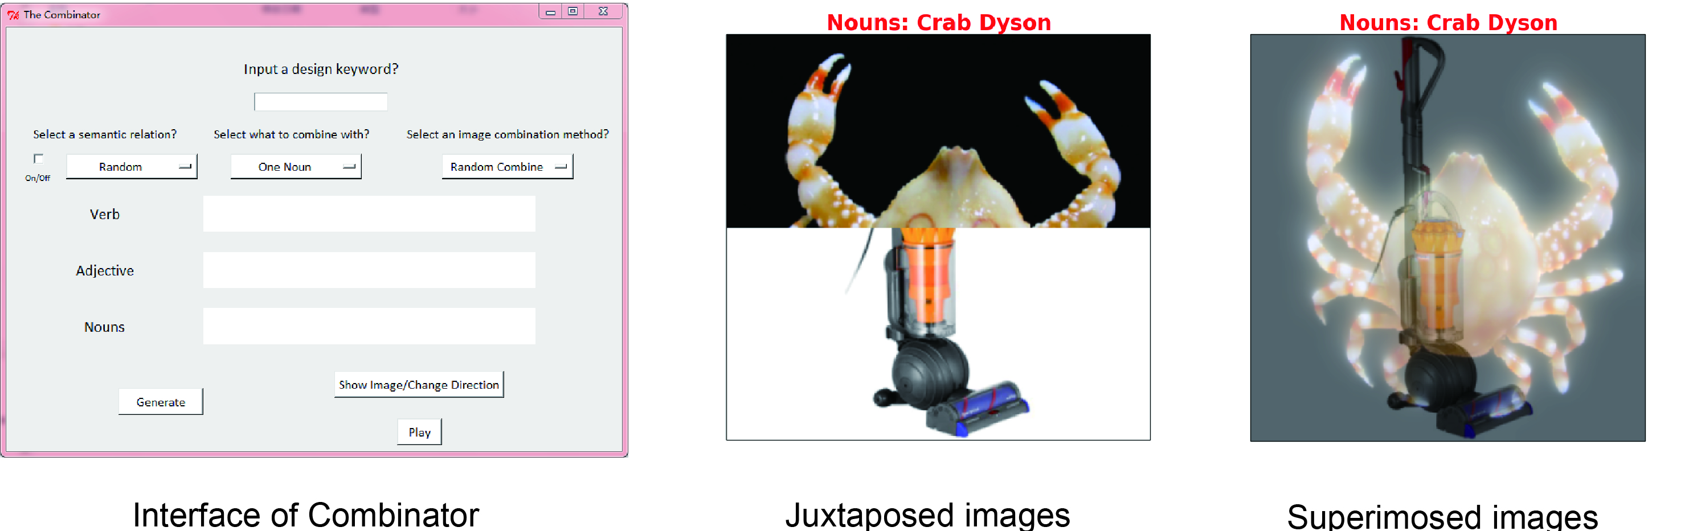
Figure 2. An example of operating Combinator

Task and procedure
Waste sorting and recycling is a challenging problem that needs to be tackled in both home and work environments. The typical way to handle this is to use two or more dustbins which are often space consuming and messy. The main design task in this experiment was to generate a new solution which can address the challenge.
The participants were asked to join the design session one at a time in a quiet room without any interruptions, as one can be influenced by others in the group (Perttula and Sipilä, 2007). Before the experiment started, each participant was given a description of major design needs and requirements, and then was randomly assigned to one of 3 groups, namely Combinator Group, Google Image Group and No-tool Group. The instruction given to them may vary slightly due to the different experiment condition of each group. The Combinator participants were asked to use Combinator for stimuli searching while undertaking ideation, Google Image participants were asked to use Google Image, and No-tool participants were asked to come up with ideas based on their intuition and experience. The observations were conducted silently in order to minimise the impacts on the participants. Interviews were conducted after each participant had accomplished the design challenge.

Criteria for the evaluation of the outcomes
Psychometric measurements are the most commonly used method for creativity evaluation. The evaluation of outcomes can objectively reflect the effectiveness of an idea generation method/tool by assessing creativity psychometrics. Researchers have proposed numerous sets of psychometrics to evaluate design creativity(Shah, Smith and Vargas-Hernandez, 2003; Douglas et al., 2006; Plucker and Makel, 2010; Diedrich et al., 2015). We adopted the widely acknowledged psychometric evaluation method developed by Shah et al. (2003) including four metrics of creativity, namely quantity, quality, novelty, and variety.
According to Shah et al. (2003), the four metrics can be introduced and calculated respectively as follows. Quantity is a measure of the total number of ideas generated which was calculated by direct counting. Variety is a measure of the exploration of solution space during the ideation process. The variety score was calculated by counting the number of idea groups. The idea group was classified according to the different design thinking principles, e.g. focusing on storage problems or focusing on recycling problems. In addition, two expert-level designers were asked to evaluate the ideas respectively under the same guidance of scoring: 10 for excellent, 8 for good, 5 for fair, 3 for poor, and 1 for bad, so that to reduce the subjectivity.
Quality is a measure of the feasibility and appropriateness of an idea with regards to the established design specifications. The quality of an idea was evaluated by rating each of its attributes (i.e. feasibility, waste separation, space saving, easy to use, no odours, and stylish appearance) 1 to 10 from worst quality to best quality. A total weight of 1 was assigned to 6 key attributes according to their importance to the idea as follows, feasibility (0.25), waste separation (0.25), save space (0.25), easy to use (0.1), no odours (0.1), and stylish appearance (0.05). The overall quality of each idea can be calculated from (1). M₁ is the overall quality score of an idea, m is the number of attributes, f_{i} is the weight assigned to the function i, S_{i} is the score of attribute i. The quality score of a participant was the mean quality score of all the ideas generated.
$M_{1}=\sum_{i=1}^{m}{f_{i}S_{i}}$ (1)
Novelty is a measure of the unusualness or unexpectedness of an idea comparing to the others. The novelty of an idea was evaluated by rating each of its key functions (i.e. waste separation and space saving) 1 to 10 from least novelty to most novelty. These two functions were applied with the same weight 0.5(total weight 1), as they are equally significant to a new dustbin design. The overall novelty of each idea can be calculated from (2). M₂ is the overall novelty score of an idea, n is the number of attributes, f_{j} is the weight assigned to the function j, S_{j} is the score of attribute j. The novelty score of a participant was the mean novelty score of all the ideas generated.
$M_{2}=\sum_{j=1}^{n}{f_{j}S_{j}}$ (2)

RESULTS
The following sections present the results from two data sources: the design task (composed by the participants’ idea sketches, observation/videos of the design process, and the recordings of the searching tools) and follow-up interviews.

Statistical results
The Combinator Group generated 53 ideas having access to combinational pictorial stimuli, which is much higher than 26 and 21 ideas produced by No-tool Group and Google Image Group. On average, each participant in the Combinator Group generated 4.42 ideas (SD=1.97), while the participants from No-tool Group and Google Image Group produced 2.17 ideas (SD=1.34) and 1.75 ideas (SD=0.97) on the individual level respectively (see Figure 3). In terms of quality, the difference between the No-tool condition (M=5.87, SD=0.92) and the Google Image condition (M=5.83, SD=0.76) was not significant, while the participants in the Combinator group scored a slightly higher than the participants from the former two groups (M=6.67, SD=0.52). The mean novelty score of the No-tool participants and Google Image participants were 6.35 (SD=0.71) and 5.96 (SD=0.96) respectively, while the Combinator participants scored a 6.78 (SD=0.74). Participants from the Combinator Group demonstrated the most ideas categories (M=3.42, SD=1.38), followed by participants from the No-tool Group (M=1.67, SD=0.98) and Google Image Group (M=1.50, SD=0.67).
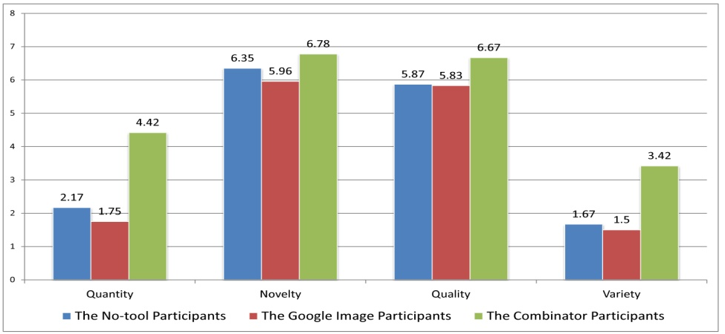
Figure 3. Psychometric evaluation results (Adapted from (Han et al., 2018))
A K test was conducted in order to measure the agreement between the two raters. The test result showed that the K coefficients of quantity, novelty, quality, and variety were 1, 0.57, 0.72, and 1, respectively. These indicated that the two raters had an almost identical agreement on quantity and variety, a substantial agreement on quality, and a moderate agreement on novelty. This has shown the robustness of the evaluated scores.
To identify whether there are statistically significant differences between the means, statistical analysis was conducted by using SPSS Statistics software and the significance levels of the statistical tests are set as 5% (α=0.05) as a convention. A Shapiro-Wilk test was conducted to analyse whether the data of each metric of the three participant groups are normally distributed. According to the result, the data of the Combinator Group are normally distributed, while only the novelty and quality values of the No-tool Group and the Google Image Group are normally distributed, respectively.
As shown in Table 2, an independent sample T-test was conducted to analyse the statistical significant differences in terms of Novelty and Quality, as the data of all the novel and quality scores were normally distributed. As shown in Table 3, a Mann-Whitney U test was conducted to identify the statistical significant differences regarding Quantity and Variety scores, as the scores were not normally distributed. In addition, Cohen’s d was introduced to measure the effect sizes of the significant differences resulting from the independent sample T-test and the Mann-Whitney U test.
Table 2. Independent sample T-test result of ‘Novelty’ and ‘Quality’
Metrics | The Combinator Group and the no-tool Group | The Combinator Group and the Google Image Group | The no-tool Group and the Google Image Group
Novelty | t =1.446, p=0.162, d=0.61 | t =2.336, p =0.029, d=0.96 | t =1.127, p =0.272, d=0.46
Quality | t =2.606, p=0.016, d=1.07 | t =3.150, p =0.005, d=1.29 | t =0.117, p =0.908, d=0.05
Cohen's d value: 0.20 = small, 0.50 = medium, 0.80 = large

Table 3. Mann-Whitney U test result of ‘Quantity’ and ‘Variety’
Metrics | The Combinator Group and the no-tool Group | The Combinator Group and the Google Image Group | The no-tool Group and the Google Image Group
Quantity | p= 0.006, d=1.33 | p= 0.001, d=1.71 | p= 0.479, d=0.36
Variety | p= 0.003, d=1.46 | p= 0.001, d=1.77 | p= 0.844, d=0.60
Cohen's d value: 0.20 = small, 0.50 = medium, 0.80 = large

In Table 2, the p-value of the novelty scores between the Combinator Group and the no-tool Group and between the no-tool Group and the Google Image Group is>0.05, while the p-value of the novelty scores between the Combinator Group and the Google Image Group is ≤0.05. This demonstrates that there are no statistical significant differences in novelty between the Combinator Group and the no-tool Group (t=1.446, p=0.162) with a medium effect size and between the no-tool Group and the Google Image Group (t=1.127, p=0.272) with a medium effect size, but a significant difference between the Combinator Group and the Google Image Group (t=2.336, p=0.029) with a large effect size. In terms of quality, there are statistical significant differences between the Combinator Group and the no-tool Group (t=2.606, p=0.016), as well as the Combinator Group and the Google Image Group (t=3.150, p=0.005), with large effect sizes. However, there are no significant differences between the no-tool Group and the Google Image Group (t=0.117, p=0.908) with a small effect size.
According to table 3, there are statistical significant differences between the Combinator Group and the no-tool Group in terms of quantity (p=0.006) and variety (p=0.001) with large effect sizes. Also, there are significant differences between the Combinator Group and the Google Image Group with regards to quantity (p=0.003) and variety (p=0.001) with large effect sizes. However, there are no significant differences between the no-tool Group and the Google Image Group in quantity (p=0.479) and variety (p=0.844) with medium effect sizes.
According to the statistical analysis above, there is a significant improvement in quantity, quality and variety can be found when comparing the Combinator participants with the Google Image participants and No-tool participants at the individual level. There are no significant improvements in novelty while comparing the Combinator Group and the no-tool Group, but a significant difference between the Combinator Group and the Google Image Group. This indicates that, concerning the conducted design challenge, combinational pictorial stimuli had considerably improved the designers’ fluency, usefulness and flexibility in idea generation while slightly enhanced the originality. In addition, comparing the Google Image participants and No-tool participants, there are slight decreases in all of the four aspects, but with no statistical significant differences. Our results suggest that designers can benefit more from pictorial stimuli presented in a combinational way, while palette presented pictorial stimuli might have little/no impact on design creativity.

Observations and interviews
Observations and video analysis were adopted in our study as process-based evaluation methods. According to a thinking-seeing-moving structure (Cheng, 2016), we recorded the design behaviour sequence of each participant and the amount of time they spent on these design behaviours (e.g. thinking, searching and sketching). We also recorded the reactions of each participant and the images he/she saw. The results suggest that the participants supported by Combinator spent less time than the other participants on the thinking process. This might be because both the knowledge retrieve process for No-tool participants and the image selection process for Google Image participants could be challenging as well as time-consuming, especially for novice designers. In addition, the Combinator participants could always come up with new ideas after being stimulated by the combinational images. This observation is in line with the statistics results which further implies a better chance for creative ideas(Shah, Smith and Vargas-Hernandez, 2003).
After the design task, a follow-up interview was conducted with each of the participants. The participants were asked to reflect on their ideation process and grade themselves from 1 to 10 to describe how creative they feel during this session. A scatter chart method was employed to illustrate the participant evaluation results. As shown in Figure 4, in general, the participants from the Combinator Group had graded themselves with higher scores on creativity level comparing with the other two groups. This indicates that combinational pictorial stimuli had a positive and more significant influence on their ideation process.
Figure 4. Participants evaluation of creativity level: the Combinator VS Google Image VS No-tool

Further analysis of design samples
3 design samples produced by participants from the Combinator Group were selected, as shown in Figure 5. The mechanisms of how combinational stimuli were supporting the ideation process of these selected design samples are briefly described as follows. Figure 5 (a) shows a combinational idea for a ‘Tangram Bin’. In the follow-up interview, the originator of this idea referred back to his ideation process and explained that he was inspired by a superimposed image generated by the Combinator. This inspirational image is made by merging two images of a tangram and a plastic bin. The tangram bin can work similar to a tangram puzzle which allows the users to arrange them freely according to the size of their indoor space. In addition, the process of using this product is also a process for recreation, as it gives users so many possibilities of a wide range of combinational shapes and layouts. Besides, a ‘slide bin’ and a ‘stair bin’ are illustrated in Figure 5 (b) and Figure 5 (c) respectively. These two ideas were also generated by using the combinational pictorial stimuli. These 3 design samples indicate that combinational pictorial stimuli are an effective source of inspiration for improving creative design performance.
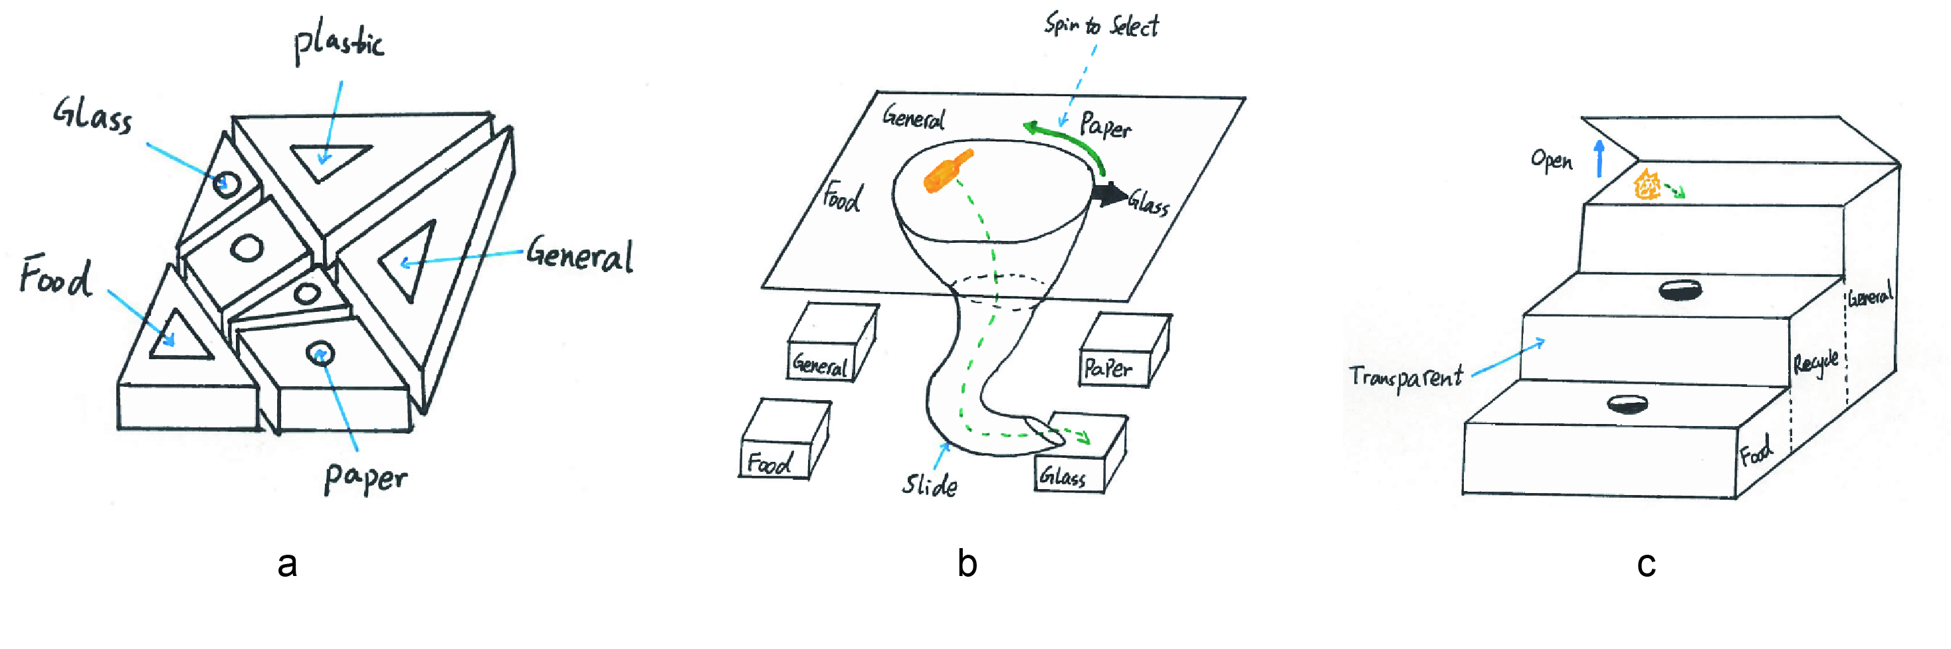
Figure 5. Design samples generated by Combinator participants (Adapted from (Han et al., 2018))

CONCLUSIONS
The research presented in this paper identified that when designers are facing a design challenge, the presence of pictorial stimuli, and the forms they are delivered, can have an influence on the ideation outcomes. According to the results, designers benefit more from pictorial stimuli when they are presented in a combinational way. Exposing designers to combinational pictorial stimuli can improve their creative scores considerably on both quantity and variety, while relatively a small improvement was identified on quality and novelty. This indicates that combinational pictorial stimuli can better support designers in design space exploration, which increases the chances for better ideas and final design success. In contrast, palette presented pictorial stimuli might have little/no impact on design creativity, only slight decreases were identified, but with no statistical significant differences. These findings help to support and refine previous research on creative inspiration. Future research can explore the differences between the combination methods of pictorial stimuli and their impact on design ideation outputs. This line of research may give us a better understanding of the roles that visual stimuli play in design, which is expected to bring us important implications for both design education and design support tool development.

References
Agogué, M., Kazakçi, A., Weil, B. and Cassotti, M. (2011) ‘The impact of examples on creative design: explaining fixation and stimulation effects’, in DS 68-2: Proceedings of the 18th International Conference on Engineering Design (ICED 11), Impacting Society through Engineering Design, Vol. 2: Design Theory and Research Methodology, Lyngby/Copenhagen, Denmark, 15.-19.08. 2011.
Bacciotti, D., Borgianni, Y. and Rotini, F. (2016) ‘An original design approach for stimulating the ideation of new product features’, Computers in industry. Elsevier, 75, pp. 80–100.
Borgianni, Y., Rotini, F. and Tomassini, M. (2017) ‘Fostering ideation in the very early design phases: How textual, pictorial and combined stimuli affect creativity’, in DS 87-8 Proceedings of the 21st International Conference on Engineering Design (ICED 17) Vol 8: Human Behaviour in Design, Vancouver, Canada, 21-25.08. 2017.
Cheng, P.-J. (2016) ‘Development of a mobile app for generating creative ideas based on exploring designers’ on-line resource searching and retrieval behavior’, Design Studies. Elsevier, 44, pp. 74–99.
Childs, P. R. N., Hamilton, T., Morris, R. D. and Johnston, G. (2006) ‘Centre for technology enabled creativity’, in DS 38: Proceedings of E&DPE 2006, the 8th International Conference on Engineering and Product Design Education, Salzburg, Austria, 07.-08.09. 2006, pp. 367–372.
Dahl, D. W. and Moreau, P. (2002) ‘The influence and value of analogical thinking during new product ideation’, Journal of Marketing Research. American Marketing Association, 39(1), pp. 47–60.
Diedrich, J., Benedek, M., Jauk, E. and Neubauer, A. C. (2015) ‘Are creative ideas novel and useful?’, Psychology of Aesthetics, Creativity, and the Arts. Educational Publishing Foundation, 9(1), p. 35.
Douglas, L. D., Jillian, M. H., Thomas, L. R. and Eric, L. S. (2006) ‘Identifying quality, novel, and creative ideas: constructs and scales for idea evaluation1’, Journal of the Association for Information Systems, 7(10), p. 646.
Finke, R. A. (1990) ‘Creative imagery: Discoveries and inventions in visualization.’ Lawrence Erlbaum Associates, Inc.
Finke, R. A. and Slayton, K. (1988) ‘Explorations of creative visual synthesis in mental imagery’, Memory & Cognition. Springer, 16(3), pp. 252–257.
Gassmann, O. and Zeschky, M. (2008) ‘Opening up the solution space: the role of analogical thinking for breakthrough product innovation’, Creativity and Innovation Management. Wiley Online Library, 17(2), pp. 97–106.
Goldschmidt, G. and Sever, A. L. (2011) ‘Inspiring design ideas with texts’, Design Studies. Elsevier, 32(2), pp. 139–155.
Goldschmidt, G. and Smolkov, M. (2006) ‘Variances in the impact of visual stimuli on design problem solving performance’, Design Studies. Elsevier, 27(5), pp. 549–569.
Gonçalves, M., Cardoso, C. and Badke-Schaub, P. (2014) ‘What inspires designers? Preferences on inspirational approaches during idea generation’, Design studies. Elsevier, 35(1), pp. 29–53.
Guo, J. and McLeod, P. L. (2014) ‘The Impact of Semantic Relevance and Heterogeneity of Pictorial Stimuli on Individual Brainstorming: An Extension of the SIAM Model’, Creativity Research Journal. Taylor & Francis, 26(3), pp. 361–367.
Han, J., Shi, F., Chen, L. and Childs, P. R. N. (2018) ‘The Combinator–a computer-based tool for creative idea generation based on a simulation approach’, Design Science. Cambridge University Press, 4. https://doi.org/10.1017/dsj.2018.7
Han, J., Shi, F. and Childs, P. R. N. (2016) ‘The Combinator: A computer-based tool for idea generation’, in Proceedings of the Design 2016 14th International Design Conference, pp. 639–648.
Hanington, B. (2003) ‘Methods in the making: A perspective on the state of human research in design’, Design issues. MIT Press, 19(4), pp. 9–18.
Henderson, K. (1998) On line and on paper: Visual representations, visual culture, and computer graphics in design engineering. MIT press.
Lutz, K. A. and Lutz, R. J. (1977) ‘Effects of interactive imagery on learning: Application to advertising.’, Journal of Applied Psychology. American Psychological Association, 62(4), p. 493.
Malaga, R. A. (2000) ‘The effect of stimulus modes and associative distance in individual creativity support systems’, Decision Support Systems. Elsevier, 29(2), pp. 125–141.
Mednick, S. (1962) ‘The associative basis of the creative process.’, Psychological review. American Psychological Association, 69(3), p. 220.
Mougenot, C., Aucouturier, J.-J., Yamanaka, T. and Watanabe, K. (2010) ‘Comparing the effects of auditory stimuli and visual stimuli in design creativity’, in Proceedings of The Third International Workshop on Kansei.
Mougenot, C., Bouchard, C., Aoussat, A. and Westerman, S. (2008) ‘Inspiration, images and design: an investigation of designers’ information gathering strategies’. Inderscience Publishers.
Muller, W. (1989) ‘Design discipline and the significance of visuo-spatial thinking’, Design Studies. Citeseer, 10(1), pp. 12–23.
Paivio, A., Rogers, T. B. and Smythe, P. C. (1968) ‘Why are pictures easier to recall than words?’, Psychonomic Science. Springer, 11(4), pp. 137–138.
Perttula, M. and Sipilä, P. (2007) ‘The idea exposure paradigm in design idea generation’, Journal of Engineering Design. Taylor & Francis, 18(1), pp. 93–102.
Plucker, J. A. and Makel, M. C. (2010) ‘Assessment of creativity’, The Cambridge handbook of creativity, pp. 48–73.
Sarkar, P. and Chakrabarti, A. (2008) ‘The effect of representation of triggers on design outcomes’, Ai Edam. Cambridge University Press, 22(2), pp. 101–116.
Shah, J. J., Smith, S. M. and Vargas-Hernandez, N. (2003) ‘Metrics for measuring ideation effectiveness’, Design studies. Elsevier, 24(2), pp. 111–134.
Siangliulue, P., Chan, J., Gajos, K. Z. and Dow, S. P. (2015) ‘Providing timely examples improves the quantity and quality of generated ideas’, in Proceedings of the 2015 ACM SIGCHI Conference on Creativity and Cognition. ACM, pp. 83–92.
Sternberg, R. J. and Sternberg, R. J. (1999) Handbook of creativity. Cambridge University Press.
Ward, T. B. and Kolomyts, Y. (2010) ‘Cognition and creativity’, The Cambridge handbook of creativity. Cambridge University Press New York, NY, pp. 93–112.
Ware, C. (2010) Visual thinking: For design. Elsevier.
Yang, M. C., Wood, W. H. and Cutkosky, M. R. (2005) ‘Design information retrieval: a thesauri-based approach for reuse of informal design information’, Engineering with computers. Springer, 21(2), pp. 177–192.

