Pericardial disease in the dog and cat

Abstract
The pericardium is a double-walled sac that surrounds the heart and the roots of the great vessels. Although survival is possible without a pericardium, it does serve several functions; balancing right and left ventricular cardiac output, acting as a barrier for infection and fixing the position of the heart within the thorax. Pericardial disease can have profound effects on the cardiovascular system and can lead to circulatory collapse. Therefore, they need to be identified promptly. This article will briefly review normal pericardial anatomy and physiology. It will then address congenital and acquired pericardial disease processes together with their diagnosis and management.

Keywords
Pericardial effusion; cardiac tamponade; right-sided heart failure; pericardial disease

Introduction
The pericardium can be the subject of many different disease processes; it may not form normally as is the case in peritoneopericardial diaphragmatic hernia (PPDH) or later in life pericardial effusion (PE) may develop, most often secondary to neoplastic or idiopathic disease processes (MacDonald et al. 2009; Mellanby and Herrtage 2005; Stafford Johnson et al. 2006). In certain situations, such as with effusion, pericardial disease can have profound effects on the cardiovascular system and animals may present collapsed (Mellanby and Herrtage 2005; Stafford Johnson et al. 2006). Alternatively, animals may be presented with signs of right-sided heart failure (HF) (Dunning et al. 1998; MacDonald et al. 2009; Mellanby and Herrtage 2005; Stafford Johnson et al. 2006). Pericardial disease can be challenging to identify, but can be equally rewarding when it is treated effectively. This review will discuss congenital and acquired causes of pericardial disease, their diagnosis and management.
Anatomy and physiology
The pericardium is lined by a serous membrane that surrounds the heart and the root of the great vessels (Figure 1). It has an outer fibrous and inner serous component; the serous layer is further divided in to parietal and visceral layers which are continuous with each other. The parietal layer is adhered to the outer fibrous pericardium and the visceral layer forms the epicardium of the heart. Between the parietal and visceral layers is a space that forms the pericardial cavity and is filled, in the normal animal, with a low volume of fluid (approximately 0.25 ± 0.15 ml/kg body weight (Sisson and Thomas 1999)). Typical pericardial fluid is clear, has a low protein concentration and very few cells (Sisson and Thomas 1999).
Life without a pericardium is relatively normal as is often observed in either congenital absence or following surgical removal (Moore and Shumacker 1953). However, the pericardium does serve some important functions and these are outlined in table 1.
Mechanical function | Prevents overfilling.  Promotes diastolic coupling (transmission of intracavitary filling pressures to the opposite side).  Balances right and left cardiac output.  Prevents tricuspid regurgitation when ventricular diastolic pressure is increased.
Membranous/ serosal | Lubrication/ reduces friction.  Equalises gravitational, hydrostatic and inertial forces.  Provides a mechanical barrier to infection.
Metabolic | Immunologic.  Vasomotor.  Fibrinolytic.  Modulates sympathetic neurotransmission and contractility.
Ligamentous | Maintains relatively constant position in the thorax.  Decreases effect of respiration.
Table 1: Functions of the pericardium adapted from (Hoit 2017).
At normal intrapericardial pressure (which is 0 or negative at low cardiac volumes) the pericardium is an elastic structure and it has little effect on cardiac filling. However, in circumstances where the pericardium becomes less compliant, for example with constrictive disease processes or cardiac tamponade, cardiac filling can be compromised (Reddy et al. 1978; Sisson and Thomas 1999).
Congenital pericardial defects
Pericardial defects
Absence of the entire pericardium does not cause clinical signs (Moore and Shumacker 1953) and is usually identified post-mortem (Sisson and Thomas 1999). Congenital partial defects also exist and can carry the risk of partial cardiac herniation. One case of suspected traumatic partial right auricular herniation in a dog has been reported (Schwarz et al. 2005).
Partial defects are most commonly diagnosed at post-mortem examination or during surgery for other reasons and are often incidental findings (Gaag and Luer 1977; Sisson and Thomas 1999). However, partial defects with cardiac herniation have been associated with clinical signs such as syncope (Chapel et al. 2014) and collapse (Schwarz et al. 2005).
Diagnosis can be challenging and relies on multiple imaging modalities (Chapel et al. 2014; Schwarz et al. 2005). Thoracic radiographs may demonstrate an unusual appearance to the cardiac silhouette (Figure 2). A partial defect should be suspected if disproportionate enlargement of the left or right auricle is present on echocardiography in the absence of advanced valvular disease (Chapel et al. 2014; Schwarz et al. 2005) (Figure 3). Computed tomography (CT) is useful to further investigate animals that have suspected partial defects (Schwarz et al. 2005).
Peritoneopericardial diaphragmatic hernia
Peritoneopericardial diaphragmatic hernia is a congenital condition that likely results from incomplete fusion of the septum transversum during embryonic development (Noden and deLahunta 1985). This allows the passage of abdominal organs through the diaphragm and into the pericardial sac. Any number of abdominal organs can pass and a variety of clinical scenarios are encountered such as cardiac tamponade, gastrointestinal obstruction and respiratory compromise (Burns et al. 2013; Reimer et al. 2004). Acquired PPDH is thought not to occur in cats and dogs under normal circumstances as, unlike humans, they have complete separation between the diaphragm and pericardium (Noden and deLahunta 1985).
Clinical signs most often reported include exercise intolerance, tachypnoea, dyspnoea, cough, vomiting and anorexia (Burns et al. 2013; Reimer et al. 2004). Muffled heart sounds are frequently identified on clinical examination (Burns et al. 2013; Reimer et al. 2004) together with heart murmurs and reduced lung sounds (Burns et al. 2013). Investigations of these clinical signs via diagnostic imaging will usually result in PPDH being diagnosed. However, in some instances PPDH will be diagnosed incidentally when thoracic radiographs are evaluated for other reasons.
Peritoneopericardial diaphragmatic hernia is often identified on thoracic radiographs, which show cardiomegaly or enlargement/ distortion of the cardiac silhouette (Burns et al. 2013) (Figure 4). Other findings suggesting that abdominal organs may be contained within the pericardial sac include (Burns et al. 2013; Sisson and Thomas 1999):
- Irregular, lucent areas caused by omental fat
- Gas bubbles or the presence of gas-filled abdominal organs in the pericardial sac
- Lack of definition of the border of the diaphragm (silhouette sign)
- Cranially displaced abdominal organs
Diagnosis can be confirmed with echocardiography, abdominal ultrasound, CT or a combination.
The prevalence of PPDH appears to be higher in cats than dogs (Banz and Gottfried 2010; Burns et al. 2013) and Weimeraners and long haired breeds of cat appear to be predisposed (Banz and Gottfried 2010; Burns et al. 2013; Reimer et al. 2004). Burns et al. (2013) reported that younger cats tend to have a primary diagnosis whereas older cats are more likely to have PPDH identified incidentally.
Surgical repair of the diaphragmatic hernia is the treatment of choice for those animals with clinical signs attributable to PPDH, which then often resolve (Burns et al. 2013; Reimer et al. 2004). Mortality rates and survival times have not been found to be different between animals that undergo surgical repair and those that do not, although most animals managed conservatively are less severely affected than those managed surgically (Burns et al. 2013). Consequently, it may be prudent to monitor an animal with an incidentally identified PPDH as they may not require surgical intervention.
Intrapericardial cysts
These structures have been diagnosed in both dogs (Loureiro et al. 2009; Sisson et al. 1993) and cats (Hodgkiss-Geere et al. 2015; Less et al. 2000; Scruggs and Bright 2010). The majority of these reports have found concurrent PPDH to be present (Hodgkiss-Geere et al. 2015; Less et al. 2000; Scruggs and Bright 2010; Sisson et al. 1993). Often clinical signs such as abdominal distension and exercise intolerance are associated with cardiac tamponade caused by compression of the right side of the heart by the cyst (Hodgkiss-Geere et al. 2015; Less et al. 2000; Scruggs and Bright 2010; Sisson et al. 1993). Intrapericardial cysts will distort the cardiac silhouette on thoracic radiographs (Figure 5) and will be easily identifiable with echocardiography (Hodgkiss-Geere et al. 2015; Less et al. 2000; Scruggs and Bright 2010; Sisson et al. 1993) (Figure 6). Cardiac tamponade may be treated via drainage of the cyst, but ultimately surgical removal of the cyst will be required to resolve clinical signs (Hodgkiss-Geere et al. 2015; Less et al. 2000; Scruggs and Bright 2010; Sisson et al. 1993).
Acquired pericardial diseases
Pericardial effusion
Pericardial effusion has been reported to account for 0.43% of new canine clinical cases examined at one referral veterinary hospital (Tobias 2010). In cats, PE was identified in 2.3% of post-mortem examinations (Rush et al. 1990). Limited data is also available in the human literature, with one study reporting an annual prevalence of 9% at an urban general hospital (Imazio et al. 2010). In people, the prevalence of malignant or infectious aetiologies of PE, secondary to pericarditis, ranges from 15% to 50% (Adler et al. 2015).
Male, middle-aged to older, medium to large breed dogs, particularly golden retrievers have been found to be over represented (MacDonald et al. 2009; Mellanby and Herrtage 2005; Stafford Johnson et al. 2006), however, any breed and size of dog can be affected. In cats the domestic shorthair is the breed most often associated with PE (Davidson et al. 2008; Hall et al. 2007; Rush et al. 1990).
A variety of disorders can result in PE (Table 2). MacDonald et al. (2009) found the most common causes of PE in the dog included haemangiosarcoma, idiopathic pericarditis, mesothelioma and chemodectoma. In cats, HF was identified as the leading cause of PE in two studies (Davidson et al. 2008; Hall et al. 2007). In another study, based on diagnosis of PE at post-mortem examination, feline infectious peritonitis was the most commonly associated disease process (Rush et al. 1990). Other, more unusual causes of PE have been reported in dogs including; cholesterol-based PE secondary to hypothyroidism (MacGregor et al. 2004), steroid-responsive meningitis arteritis (Covey and Connolly 2018; Spence et al. 2019), systemic inflammatory response syndrome of unknown aetiology (Covey and Connolly 2018), nicotine toxicosis (Kim and Lim 2016), intrapericardial granulation tissue (Parra et al. 2009), necrotic adipose tissue (Krentz et al. 2017) and migrating foreign bodies (Guevara et al. 2015).
Idiopathic
Neoplasia e.g. haemangiosarcoma, mesothelioma, chemodectoma, thyroid adenocarcinoma
Congestive heart failure (rarely causes cardiac tamponade)
Septic pericarditis
Left atrial rupture secondary to myxomatous mitral valve disease
Peritoneal-pericardial diaphragmatic hernia (rarely causes cardiac tamponade)
Trauma
Feline infectious peritonitis (unlikely to cause cardiac tamponade)
Coagulopathy
Uraemia (unlikely to cause cardiac tamponade)
Other e.g. cholesterol-based secondary to hypothyroidism, steroid-responsive arterial meningitis
Table 2: Differential diagnosis for pericardial effusion in dogs and cats
Haemodynamic alterations with pericardial effusion
Pericardial effusions start to affect the right side of the heart as soon as intrapericardial pressure is greater than 0 mmHg (Reddy et al. 1990). The volume of PE that results in cardiac tamponade can vary widely and depends on the compliance of the pericardium (Reddy et al. 1978). In an acute process, such as haemorrhage, the pericardium does not have time to hypertrophy. Therefore, a small volume of fluid will rapidly increase intrapericardial pressure, resulting in cardiac tamponade and circulatory collapse (Craig et al. 1968). On the other hand a chronic effusion, as with idiopathic disease, will result in gradual hypertrophy of the pericardium and the volume of effusion can be much greater (as there is greater compliance of the pericardium over time) before signs of right-sided HF secondary to cardiac tamponade are evident (Freeman and LeWinter 1984; Sisson and Thomas 1999).
Chronically occurring cardiac tamponade is a progressive phenomenon, resulting from changes in intrapericardial pressure rather than volume, and has been reported to occur in phases (Reddy et al. 1990). In the early phases intrapericardial pressure is elevated, but still less than right atrial pressure resulting in only mild clinical signs, if any. As pericardial pressure increases right atrial pressure is exceeded and tamponade occurs. Cardiac output will be reduced and clinical signs including exercise intolerance, tachycardia and ascites will be observed. In the final phase the increase in intrapericardial pressure exceeds left-sided filling pressure, resulting in left-sided tamponade and cardiac output is extremely compromised. The animal may be presented collapsed in cardiogenic shock and pulsus paradoxus (see later) may be evident.
The body tries to maintain cardiac output via vasoconstriction, raising heart rate and conserving sodium and water (Sisson and Thomas 1999).
Clinical presentations of pericardial effusion
If there is a low volume PE without tamponade, as is often the case secondary to HF for example, the animal will present with clinical signs related to the underlying disease process and the effusion will be identified on diagnostic imaging. However, if cardiac tamponade is present the animal may present in one of two ways:
- Acute presentation
Acute onset weakness or collapse, hypotension, cardiogenic shock, dyspnoea or even death.
- Chronic presentation
Cardiac tamponade develops more slowly and clinical signs are related to increased systemic venous pressures. Collapse, exercise intolerance, anorexia, vomiting, tachypnoea, weakness or lethargy may be identified from the clinical history (Fahey et al. 2017; Mellanby and Herrtage 2005; Stafford Johnson et al. 2006). On clinical examination muffled heart sounds are common (Stafford Johnson et al. 2006) and jugular distension and ascites may be evident (Mellanby and Herrtage 2005; Stafford Johnson et al. 2006). Hypotension may be identified.
Pulsus paradoxus may or may not be present in either of the above presentations. Pulsus paradoxus is the change in systemic arterial pressure with phase of respiration. It is an exaggeration of what occurs normally in the heart and is defined as a greater than 12 mmHg fall in arterial pressure on inspiration (Curtiss et al. 1988). The pulse becomes weaker on inspiration and stronger with expiration in a cyclical manner.
Diagnostic investigations
- Echocardiography or emergency ultrasound
Many animals with the previously mentioned clinical signs will benefit from point-of-care ultrasound (POCUS). A POCUS examination is often quick (taking 3 minutes or less to perform) and has improved sensitivity and specificity over radiography for the diagnosis of pericardial, pleural or peritoneal effusions (Lisciandro et al. 2009; Lisciandro et al. 2008). Echocardiography is also more sensitive than radiography for the diagnosis of PE and cardiac tamponade and can also be less invasive in an already compromised patient (Cote et al. 2013; Guglielmini et al. 2012; Mellanby and Herrtage 2005; Rush et al. 1990).
Pericardial effusion will appear as an anechoic space around the heart (Figure 7). If cardiac tamponade is present the right atrium and sometimes the right ventricle will collapse in diastole (Figure 7). Cardiac masses might be more readily identified with effusion present and they should be looked for, if possible, paying particular attention to the right atrial region (MacDonald et al. 2009; Tobias 2010) (Figure 8). Complete echocardiography can be performed in stable patients, but if cardiogenic shock is present it should be delayed until after pericardiocentesis.
- Electrocardiography
Electrocardiography is not as sensitive as echocardiography for the diagnosis of PE (Rush et al. 1990). However, abnormalities that might be observed include sinus tachycardia, ST elevation and low voltage QRS complexes (<0.5 mV in dogs in leads I, II, III and aV_{F}) (Sisson and Thomas 1999). Electrical alternans, a beat-to-beat change in amplitude of the QRS complexes, may also be observed. It is caused by swinging of the heart within the fluid-filled pericardial sac (Sisson and Thomas 1999). Arrhythmias may also be identified e.g. ventricular premature complexes (Humm et al. 2009).
- Radiography
The cardiac silhouette may be spherical and static as the blur associated with cardiac contraction and relaxation during radiography examination is no longer apparent (Sisson and Thomas 1999; Stafford Johnson et al. 2006). If cardiac output is severely compromised (cardiogenic shock) pulmonary vessels may appear under perfused in contrast to an animal in left sided HF where the pulmonary veins are often distended (Losonsky 2002). Distension of the caudal vena cava and hepatomegaly may also be observed with PE (Losonsky 2002). If neoplasia is present, metastatic disease might be evident for example a military pattern may be identified on thoracic radiographs with underlying haemoangiosarcoma (MacDonald et al. 2009).
- Cardiac troponin I
Serum cardiac troponin I (cTnI) has been evaluated in dogs with PE to see if it can aid in differentiating between haemangiosarcoma and idiopathic aetiologies (Chun et al. 2010; Shaw et al. 2004). It has been shown that dogs with cardiac haemiangiosarcoma have higher cTnI than dogs with idiopathic effusions (Chun et al. 2010; Shaw et al. 2004). One study demonstrated that a plasma cTnI concentration >0.25 ng/ml had a sensitivity of 81% and specificity of 100% for identifying cardiac haemangiosarcoma as a cause of PE (Chun et al. 2010). However, it must be remembered that this study used a single analyser and so this value is not necessarily applicable to other analysers (Adin et al. 2006).
- Computed tomography
Computed tomography is rarely used for sole diagnosis of PE, but is useful for identifying underlying neoplastic processes (Scollan et al. 2015).
Pericardiocentesis
In the setting of cardiac tamponade pericardiocentesis should be attempted together with intravenous fluid resuscitation, if required. If cardiac tamponade is not present but the clinician feels that pericardiocentesis should be performed to aid diagnosis then a similar approach as outlined below may be adopted. Ideally, an ECG should be placed on the animal in case of myocardial puncture, which may be arrhythmogenic and often causes ventricular premature complexes (Sisson and Thomas 1999).
Pericardiocentesis can be performed from either the left or right side of the thorax, but this author prefers the right-sided approach in order to avoid the coronary circulation and minimize trauma to the lungs via the cardiac notch (Figures 9a-9f). It is important to evaluate any fluid withdrawn for the presence of clotting. Pericardial fluid will not clot (unless very recent haemorrhage has occurred) whereas inadvertent puncture of the myocardium will result in whole blood being withdrawn and subsequent clotting. In the unusual instance where one is not sure, after removing fluid the PE should become markedly less on ultrasound, if it does not then puncture of the myocardium may have occurred and the procedure should be stopped and re-tried, if needed. The packed cell volume (PCV) of the effusion can be obtained and compared to the peripheral blood and they should be different; PCV is often lower in the effusion compared to peripheral blood (de Laforcade et al. 2005). If successful, pericardiocentesis will result in filling of the right side of the heart, improved arterial pressure and a reduction in heart rate.
Fluid withdrawn from the pericardial sac should always be submitted for cytology. Cytological diagnosis is rare, especially in haemorrhagic effusions (Cagle et al. 2014); however, cytology of PE is useful to aid in diagnosis of lymphoma or septic pericarditis for example (MacDonald et al. 2009). Culture of the fluid should be considered based on the cytological findings and on the clinical presentation, for example if septic pericarditis is present the animal may be pyrexic. It is also possible to measure the pH of the effusion; if pH is >7.0 it is often neoplastic or non-inflammatory in aetiology and if <7.0 inflammatory causes should be investigated (Fine et al. 2003).
Adverse events that have been documented post pericardiocentesis including arrhythmias (ventricular tachycardia, atrial fibrillation) and cardiopulmonary arrest (Gibbs et al. 1982; Humm et al. 2009).
Specific causes of pericardial effusion
Idiopathic pericardial effusion
Idiopathic PE is a diagnosis of exclusion following complete diagnostic evaluation. The effusion is often haemorrhagic in appearance, although idiopathic chylous effusions have been reported (Boston et al. 2006). Idiopathic effusions typically accumulate slowly, commonly resulting in clinical signs of right-sided HF rather than collapse (Stafford Johnson et al. 2006). Large volume effusions, especially those causing cardiac tamponade require pericardiocentesis. Approximately 50% of cases will seemingly resolve following initial pericardiocentesis and the other 50% will re-effuse within days to years after the initial event (Stafford Johnson et al. 2006). Pericardiocentesis performed multiple times may result in constrictive pericardial disease (Mellanby and Herrtage 2005) and owners should be made aware of this possibility. Dogs with idiopathic PE treated with subtotal pericardiectomy via thoracotomy have an excellent prognosis, with a 3-year survival rate in one study of 100% (Case et al. 2013). A pericardial window technique via thoracoscopy can also be considered (Atencia et al. 2013; Case et al. 2013). Histopathology of any removed pericardium should be requested (Tobias 2010).
Neoplastic pericardial effusion
In one study neoplasia was the most common cause of PE in dogs, accounting for 71% of cases (MacDonald et al. 2009). Haemangiosarcoma was the most common neoplasm found, mainly affecting the right atrium (MacDonald et al. 2009; Ware and Hopper 1999). Animals that have neoplastic causes of PE are more likely to present collapsed (Stafford Johnson et al. 2006) most likely due to hemorrhage and acute tamponade (Dunning et al. 1998). In a recent study, echocardiography was reported to have a sensitivity of 80% and specificity of 100% for the identification of cardiac masses (MacDonald et al. 2009), but this will depend on operator experience. Cytological analysis should be performed; diagnostic yield is improved when the PCV of the effusion is <10% (Cagle et al. 2014) or in cases of lymphoma (MacGregor et al. 2005).
Masses at the heart base such as chemodectoma and thyroid adenocarcinoma have also been associated with PE (MacDonald et al. 2009). Heart base masses are often seen on echocardiography in association with the ascending aorta. They are usually discrete, encapsulated structures that may compress the great arteries (Tobias 2010).
Mesothelioma is a neoplasm that is also associated with PE but is difficult to diagnose as it rarely causes a discrete mass (Dunning et al. 1998; MacDonald et al. 2009; Stepien et al. 2000). Cytology of effusions often show reactive mesothelial cells, which are very hard to differentiate from neoplastic populations (Sisson and Thomas 1999; Stepien et al. 2000). Immunohistochemistry may be helpful in diagnosing mesothelioma (Milne et al. 2018), but is still in its infancy. Re-effusion within 120 days of pericardiectomy may increase the suspicion of mesothelioma if cardiac masses have not been identified previously (Stepien et al. 2000).
Fine needle aspiration of intracardiac masses is achievable, but should only be considered in experienced hands and not if the mass is associated with any major vessels (Pedro et al. 2016).
If cardiac tamponade is present initial management of PE associated with cardiac masses is the same as for other causes. The owner should be made aware that if pericardiocentesis is performed re-effusion can occur at any time. Upon re-effusion pericardiocentesis may be repeated. The reader is referred to other texts such as (Treggiari et al. 2017) for options of oncological and surgical therapy as it is beyond the scope of this review due to the large variation in tumour and treatment types.
Infectious pericardial effusion
Infectious causes of PE are rare and are often associated with migrating or penetrating foreign bodies (Aronson and Gregory 1995; Guevara et al. 2015; MacDonald et al. 2009). Alternative routes of infection include penetrating wounds, systemic infections or extension of local infections such as endocarditis, pleuritis or pulmonary infections (Casamian-Sorrosal et al. 2008; Lobetti 2007; Majoy et al. 2013). Dogs may present with anorexia, depression, respiratory distress, abdominal distension, collapse, coughing or vomiting (Aronson and Gregory 1995). In one case series more than 50% of the dogs were found to have anaemia and leukocytosis (Aronson and Gregory 1995). The effusion often appears flocculent on echocardiography and grossly may appear purulent (Tobias 2010); it should be submitted for culture and cytology. The treatment of choice is sub-total pericardiectomy and an exploratory thoracotomy together with long-term antibiosis based on culture and sensitivity results (Aronson and Gregory 1995).
Left atrial rupture secondary to myxomatous mitral valve disease
In dogs with severe myxomatous mitral valve disease the left atrium will dilate, damaging the endocardium. Furthermore, eccentric jets of mitral regurgitation can result in jet lesions of the left atrial wall (Sisson and Thomas 1999). These changes can result in rupture of the left atrium. The scenario is acute cardiac tamponade and often cardiogenic shock (Reineke et al. 2008). Echocardiography will usually reveal PE and often a large hyperechoic thrombus like structure extending from the left atrial wall within the pericardial sac (Tobias 2010) (Figure 10). Pericardiocentesis can be performed, but this can lead to further haemorrhage from the rupture site and so would be performed based on the clinical presentation of the dog. A recent study suggests that dogs with no previous history of HF at the time of diagnosis of left atrial rupture have a longer survival time (345 days) compared to dogs with pre-existing HF (Nakamura et al. 2014).
Pericardial effusion is frequently observed in dogs with HF, but it is rarely in large enough volumes to be haemodynamically significant. Therefore, HF should be treated to resolve it.
Constrictive Pericarditis
Constrictive pericarditis should be considered a possibility for any animal with abdominal effusion for which an underlying cause cannot be easily identified. It occurs when the pericardium becomes fibrotic, causing increased ventricular and atrial diastolic pressures (Schwefer et al. 2009). Occasionally, a small volume effusion may be identified on echocardiography; this is known as constrictive-effusive pericarditis.
Tamponade might be present with constrictive-effusive disease, but if effusion is not observed then tamponade is usually absent; instead it is the fibrous pericardium that causes the clinical signs of elevated systemic venous pressure (Thomas et al. 1984). Pulsus paradoxus is uncommon as changes in intrathoracic pressure are not transmitted to the cardiac chambers (Sisson and Thomas 1999). The cause of constrictive disease is not clear, but could include repeated pericardiocentesis, foreign body reaction and previous infective pericarditis (Mellanby and Herrtage 2005; Thomas et al. 1984). Coccidioides immitis has been implicated in constrictive-effusive pericarditis in dogs (Heinritz et al. 2005).
Constrictive disease is extremely challenging to identify. Echocardiography may reveal distension of the caudal vena cava, hepatic venous congestion and altered/ exaggerated transmitral/ tricuspid inflow patterns (Schwefer et al. 2009). Gold standard diagnosis is via cardiac catheterisation and measurement of pressures within the right side of the heart (Sisson and Thomas 1999).
Treatment involves sub-total pericardiectomy and removal of the constricting pericardium from the underlying myocardium, but if there is involvement of the visceral pericardium this is not always curative (Thomas et al. 1984). The pericardium should be submitted for histopathological examination (Heinritz et al. 2005; Thomas et al. 1984).

Conclusions
Pericardial disease is encountered relatively frequently in clinical practice and can be associated with many underlying disease processes both congenital and acquired. Acquired causes of pericardial disease in dogs often result in PE of which idiopathic and neoplastic causes are the most commonly identified. In cats PE is also observed, but is often caused by HF and so is not associated with cardiac tamponade. Acute onset cardiac tamponade can cause severe haemodynamic compromise and, if present, it should be treated as quickly as possible via pericardiocentesis. Chronically accumulating PE often presents with vague clinical signs and ascites. Diagnosis of PE may be suspected based on clinical signs, and ultrasound is often the quickest method of diagnosis. Pericardiocentesis should be performed in cases with cardiac tamponade and it may also be performed for diagnostic purposes if tamponade is not present. Effusion should be submitted for cytology and culture considered after cytological examination. Following pericardiocentesis, treatment options and prognosis depend upon the aetiology.

Keywords
Pericardial effusion; cardiac tamponade; right-sided heart failure; pericardial disease

Key points
- Pericardial disease can be congenital or acquired in dogs and cats.
- The most common causes of pericardial effusion in the dog are neoplasia, such as haemangiosarcoma, and idiopathic disease. In the cat congestive heart failure is the leading cause.
- Pericardial effusion should be considered in an animal that presents either collapsed or with signs of systemic venous congestion such as ascites and jugular distension.
- A thoracic POCUS examination is the quickest method of confirming a pericardial effusion.
- In an animal with haemodynamic compromise pericardiocentesis should be performed as a matter of urgency.
- Treatment and prognosis depend on the underlying cause of the effusion.

References
Adin DB, Oyama MA, Sleeper MM, Milner RJ. 2006. Comparison of canine cardiac troponin i concentrations as determined by 3 analyzers. J Vet Intern Med. 20(5):1136-1142.
Adler Y, Charron P, Imazio M, Badano L, Baron-Esquivias G, Bogaert J, Brucato A, Gueret P, Klingel K, Lionis C et al. 2015. 2015 esc guidelines for the diagnosis and management of pericardial diseases: The task force for the diagnosis and management of pericardial diseases of the european society of cardiology (esc)endorsed by: The european association for cardio-thoracic surgery (eacts). Eur Heart J. 36(42):2921-2964.
Aronson LR, Gregory CR. 1995. Infectious pericardial effusion in five dogs. Vet Surg. 24(5):402-407.
Atencia S, Doyle RS, Whitley NT. 2013. Thoracoscopic pericardial window for management of pericardial effusion in 15 dogs. Journal of Small Animal Practice. 54(11):564-569.
Banz AC, Gottfried SD. 2010. Peritoneopericardial diaphragmatic hernia: A retrospective study of 31 cats and eight dogs. J Am Anim Hosp Assoc. 46(6):398-404.
Boston SE, Moens NM, Martin DM. 2006. Idiopathic primary chylopericardium in a dog. J Am Vet Med Assoc. 229(12):1930-1933.
Burns CG, Bergh MS, McLoughlin MA. 2013. Surgical and nonsurgical treatment of peritoneopericardial diaphragmatic hernia in dogs and cats: 58 cases (1999-2008). J Am Vet Med Assoc. 242(5):643-650.
Cagle LA, Epstein SE, Owens SD, Mellema MS, Hopper K, Burton AG. 2014. Diagnostic yield of cytologic analysis of pericardial effusion in dogs. J Vet Intern Med. 28(1):66-71.
Casamian-Sorrosal D, Fournier D, Shippam J, Woodward B, Tennant K. 2008. Septic pericardial effusion associated with pulmonary and pericardial botryomycosis in a dog. Journal of Small Animal Practice. 49(12):655-659.
Case JB, Maxwell M, Aman A, Monnet EL. 2013. Outcome evaluation of a thoracoscopic pericardial window procedure or subtotal pericardectomy via thoracotomy for the treatment of pericardial effusion in dogs. J Am Vet Med Assoc. 242(4):493-498.
Chapel E, Russel D, Schober K. 2014. Partial pericardial defect with left auricular herniation in a dog with syncope. J Vet Cardiol. 16(2):133-139.
Chun R, Kellihan HB, Henik RA, Stepien RL. 2010. Comparison of plasma cardiac troponin i concentrations among dogs with cardiac hemangiosarcoma, noncardiac hemangiosarcoma, other neoplasms, and pericardial effusion of nonhemangiosarcoma origin. J Am Vet Med Assoc. 237(7):806-811.
Cote E, Schwarz LA, Sithole F. 2013. Thoracic radiographic findings for dogs with cardiac tamponade attributable to pericardial effusion. J Am Vet Med Assoc. 243(2):232-235.
Covey HL, Connolly DJ. 2018. Pericardial effusion associated with systemic inflammatory disease in seven dogs (january 2006 - january 2012). J Vet Cardiol. 20(2):123-128.
Craig RJ, Whalen RE, Behar VS, McIntosh HD. 1968. Pressure and volume changes of the left ventricle in acute pericardial tamponade. Am J Cardiol. 22(1):65-74.
Curtiss EI, Reddy PS, Uretsky BF, Cecchetti AA. 1988. Pulsus paradoxus: Definition and relation to the severity of cardiac tamponade. Am Heart J. 115(2):391-398.
Davidson BJ, Paling AC, Lahmers SL, Nelson OL. 2008. Disease association and clinical assessment of feline pericardial effusion. J Am Anim Hosp Assoc. 44(1):5-9.
de Laforcade AM, Freeman LM, Rozanski EA, Rush JE. 2005. Biochemical analysis of pericardial fluid and whole blood in dogs with pericardial effusion. J Vet Intern Med. 19(6):833-836.
Dunning D, Monnet E, Orton EC, Salman MD. 1998. Analysis of prognostic indicators for dogs with pericardial effusion: 46 cases (1985-1996). J Am Vet Med Assoc. 212(8):1276-1280.
Fahey R, Rozanski E, Paul A, Rush JE. 2017. Prevalence of vomiting in dogs with pericardial effusion. J Vet Emerg Crit Care (San Antonio). 27(2):250-252.
Fine DM, Tobias AH, Jacob KA. 2003. Use of pericardial fluid ph to distinguish between idiopathic and neoplastic effusions. J Vet Intern Med. 17(4):525-529.
Freeman GL, LeWinter MM. 1984. Pericardial adaptations during chronic cardiac dilation in dogs. Circ Res. 54(3):294-300.
Gaag IV, Luer JT. 1977. Eight cases of pericardial defects in the dog. Vet Pathol. 14(1):14-18.
Gibbs C, Gaskell CJ, Darke PGG, Wotton PR. 1982. Idiopathic pericardial hemorrhage in dogs - a review of 14 cases. Journal of Small Animal Practice. 23(9):483-500.
Guevara JL, Holmes ES, Reetz J, Holt DE. 2015. Porcupine quill migration in the thoracic cavity of a german shorthaired pointer. J Am Anim Hosp Assoc. 51(2):101-106.
Guglielmini C, Diana A, Santarelli G, Torbidone A, Di Tommaso M, Baron Toaldo M, Cipone M. 2012. Accuracy of radiographic vertebral heart score and sphericity index in the detection of pericardial effusion in dogs. J Am Vet Med Assoc. 241(8):1048-1055.
Hall DJ, Shofer F, Meier CK, Sleeper MM. 2007. Pericardial effusion in cats: A retrospective study of clinical findings and outcome in 146 cats. J Vet Intern Med. 21(5):1002-1007.
Heinritz CK, Gilson SD, Soderstrom MJ, Robertson TA, Gorman SC, Boston RC. 2005. Subtotal pericardectomy and epicardial excision for treatment of coccidioidomycosis-induced effusive-constrictive pericarditis in dogs: 17 cases (1999-2003). J Am Vet Med Assoc. 227(3):435-440.
Hodgkiss-Geere HM, Palermo V, Liuti T, Philbey AW, Marques A. 2015. Pericardial cyst in a 2-year-old maine coon cat following peritoneopericardial diaphragmatic hernia repair. J Feline Med Surg. 17(4):381-386.
Hoit BD. 2017. Pathophysiology of the pericardium. Prog Cardiovasc Dis. 59(4):341-348.
Humm KR, Keenaghan-Clark EA, Boag AK. 2009. Adverse events associated with pericardiocentesis in dogs: 85 cases (1999-2006). J Vet Emerg Crit Care (San Antonio). 19(4):352-356.
Imazio M, Mayosi BM, Brucato A, Markel G, Trinchero R, Spodick DH, Adler Y. 2010. Triage and management of pericardial effusion. J Cardiovasc Med (Hagerstown). 11(12):928-935.
Kim JH, Lim JH. 2016. Acute fatal pericardial effusion induced by accidental ingestion of cigarette butts in a dog. Can Vet J. 57(2):151-156.
Krentz TA, Schutrumpf RJ, Zitz JC. 2017. Focal intramural pericardial effusion and cardiac tamponade associated with necrotic adipose tissue in a dog. J Am Vet Med Assoc. 251(2):201-205.
Less RD, Bright JM, Orton EC. 2000. Intrapericardial cyst causing cardiac tamponade in a cat. J Am Anim Hosp Assoc. 36(2):115-119.
Lisciandro GR, Lagutchik MS, Mann KA, Fosgate GT, Tiller EG, Cabano NR, Bauer LD, Book BP, Howard PK. 2009. Evaluation of an abdominal fluid scoring system determined using abdominal focused assessment with sonography for trauma in 101 dogs with motor vehicle trauma. J Vet Emerg Crit Care (San Antonio). 19(5):426-437.
Lisciandro GR, Lagutchik MS, Mann KA, Voges AK, Fosgate GT, Tiller EG, Cabano NR, Bauer LD, Book BP. 2008. Evaluation of a thoracic focused assessment with sonography for trauma (tfast) protocol to detect pneumothorax and concurrent thoracic injury in 145 traumatized dogs. J Vet Emerg Crit Car. 18(3):258-269.
Lobetti RG. 2007. Anaerobic bacterial pericardial effusion in a cat. J S Afr Vet Assoc. 78(3):175-177.
Losonsky JM. 2002. The pulmonary vasculature. In: Thrall DE, editor. Textbook of veterinary diagnostic radiology. 4th ed. USA: Elsevier. p. 420-430.
Loureiro J, Burrow R, Dukes-McEwan J. 2009. Canine intrapericardial cyst - complicated surgical correction of an unusual cause of right heart failure. J Small Anim Pract. 50(9):492-497.
MacDonald KA, Cagney O, Magne ML. 2009. Echocardiographic and clinicopathologic characterization of pericardial effusion in dogs: 107 cases (1985-2006). J Am Vet Med Assoc. 235(12):1456-1461.
MacGregor JM, Faria ML, Moore AS, Tobias AH, Brown DJ, de Morais HS. 2005. Cardiac lymphoma and pericardial effusion in dogs: 12 cases (1994-2004). J Am Vet Med Assoc. 227(9):1449-1453.
MacGregor JM, Rozanski EA, McCarthy RJ, Sharkey LC, Winter MD, Brown DJ, Rush JE. 2004. Cholesterol-based pericardial effusion and aortic thromboembolism in a 9-year-old mixed-breed dog with hypothyroidism. J Vet Intern Med. 18(3):354-358.
Majoy SB, Sharp CR, Dickinson AE, Cunningham SM. 2013. Septic pericarditis in a cat with pyometra. J Vet Emerg Crit Care (San Antonio). 23(1):68-76.
Mellanby RJ, Herrtage ME. 2005. Long-term survival of 23 dogs with pericardial effusions. Vet Rec. 156(18):568-571.
Milne E, Martinez-Pereira Y, Scase T, Shaw DJ, McGregor G, Oldroyd L, Scurrell E, Martin M, Devine C, Hodgkiss-Geere H. 2018. Immunohistochemical differentiation of reactive from malignant mesothelium as a diagnostic aid in canine pericardial disease. Journal of Small Animal Practice. 59(5):261-271.
Moore TC, Shumacker HB, Jr. 1953. Congenital and experimentally produced pericardial defects. Angiology. 4(1):1-11.
Nakamura RK, Tompkins E, Russell NJ, Zimmerman SA, Yuhas DL, Morrison TJ, Lesser MB. 2014. Left atrial rupture secondary to myxomatous mitral valve disease in 11 dogs. J Am Anim Hosp Assoc. 50(6):405-408.
Noden DM, deLahunta A. 1985. Respiratory system and partitioning of body cavities. The embryology of domestic animals developmental mechanisms and malformations. Baltimore: Williams & Wilkins p. 279-291.
Parra JL, Mears EA, Borde DJ, Levy MS. 2009. Pericardial effusion and cardiac tamponade caused by intrapericardial granulation tissue in a dog. J Vet Emerg Crit Care (San Antonio). 19(2):187-192.
Pedro B, Linney C, Navarro-Cubas X, Stephenson H, Dukes-McEwan J, Gelzer AR, Kraus MS. 2016. Cytological diagnosis of cardiac masses with ultrasound guided fine needle aspirates. J Vet Cardiol. 18(1):47-56.
Reddy PS, Curtiss EI, O'Toole JD, Shaver JA. 1978. Cardiac tamponade: Hemodynamic observations in man. Circulation. 58(2):265-272.
Reddy PS, Curtiss EI, Uretsky BF. 1990. Spectrum of hemodynamic changes in cardiac tamponade. Am J Cardiol. 66(20):1487-1491.
Reimer SB, Kyles AE, Filipowicz DE, Gregory CR. 2004. Long-term outcome of cats treated conservatively or surgically for peritoneopericardial diaphragmatic hernia: 66 cases (1987-2002). J Am Vet Med Assoc. 224(5):728-732.
Reineke EL, Burkett DE, Drobatz KJ. 2008. Left atrial rupture in dogs: 14 cases (1990-2005). J Vet Emerg Crit Car. 18(2):158-164.
Rush JE, Keene BW, Fox PR. 1990. Pericardial disease in the cat - a retrospective evaluation of 66 cases. Journal of the American Animal Hospital Association. 26(1):39-46.
Schwarz T, Willis R, Summerfield NJ, Doust R. 2005. Aneurysmal dilatation of the right auricle in two dogs. J Am Vet Med Assoc. 226(9):1512-1515, 1500.
Schwefer M, Aschenbach R, Heidemann J, Mey C, Lapp H. 2009. Constrictive pericarditis, still a diagnostic challenge: Comprehensive review of clinical management. Eur J Cardiothorac Surg. 36(3):502-510.
Scollan KF, Bottorff B, Stieger-Vanegas S, Nemanic S, Sisson D. 2015. Use of multidetector computed tomography in the assessment of dogs with pericardial effusion. J Vet Intern Med. 29(1):79-87.
Scruggs SM, Bright JM. 2010. Chronic cardiac tamponade in a cat caused by an intrapericardial biliary cyst. J Feline Med Surg. 12(4):338-340.
Shaw SP, Rozanski EA, Rush JE. 2004. Cardiac troponins i and t in dogs with pericardial effusion. J Vet Intern Med. 18(3):322-324.
Sisson D, Thomas WP. 1999. Pericardial disease and cardiac tumors. In: Fox PR, Sisson D, Moise NS, editors. Textbook of canine and feline cardiology; principles and clinical practice. 2nd ed. Philadelphia: W.B. Saunders Company. p. 679-701.
Sisson D, Thomas WP, Reed J, Atkins CE, Gelberg HB. 1993. Intrapericardial cysts in the dog. J Vet Intern Med. 7(6):364-369.
Spence S, French A, Penderis J, Macfarlane L, Gutierrez-Quintana R, Dickson L, Holmes K, McLauchlan G. 2019. The occurrence of cardiac abnormalities in canine steroid-responsive meningitis arteritis. J Small Anim Pract. 60(4):204-211.
Stafford Johnson M, Martin M, Binns S, Day MJ. 2006. A retrospective study of clinical findings, treatment and outcome in 143 dogs with pericardial effusion. Journal of Small Animal Practice. 45(11):546-552.
Stepien RL, Whitley NT, Dubielzig RR. 2000. Idiopathic or mesothelioma-related pericardial effusion: Clinical findings and survival in 17 dogs studied retrospectively. J Small Anim Pract. 41(8):342-347.
Thomas WP, Reed JR, Bauer TG, Breznock EM. 1984. Constrictive pericardial disease in the dog. J Am Vet Med Assoc. 184(5):546-553.
Tobias AH. 2010. Pericardial diseases. In: Ettinger SJ, Feldman EC, editors. Textbook of veterinary internal medicine diseases of the dog and cat. 7th ed. Missouri, USA: Saunders Elsevier. p. 1342-1352.
Treggiari E, Pedro B, Dukes-McEwan J, Gelzer AR, Blackwood L. 2017. A descriptive review of cardiac tumours in dogs and cats. Vet Comp Oncol. 15(2):273-288.
Ware WA, Hopper DL. 1999. Cardiac tumors in dogs: 1982-1995. J Vet Intern Med. 13(2):95-103.

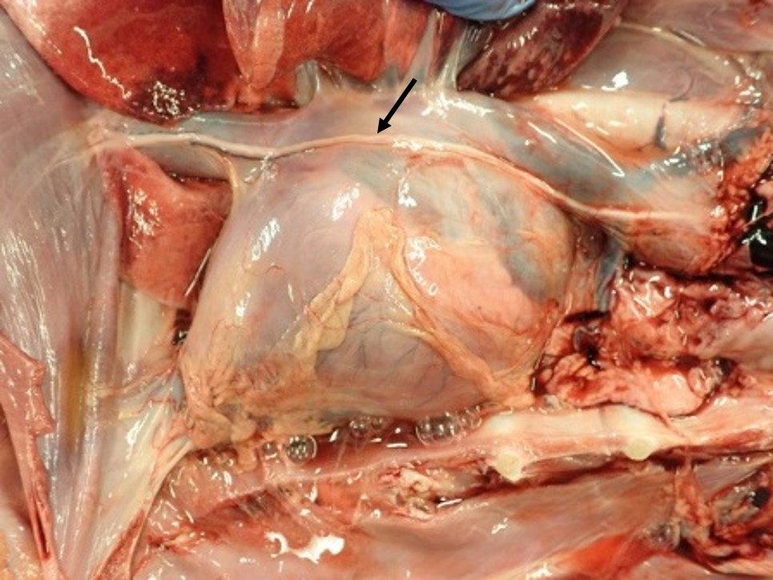
Figure 1: The heart in-situ in a canine thorax. The cranial aspect is to the right of the image. The pericardium surrounds the heart and the root of the great vessels. The phrenic nerve (arrow) can be seen coursing caudally over the pericardium. Courtesy of Dr. Emanuele Ricci, Veterinary Pathology Diagnostic Services, University of Liverpool.

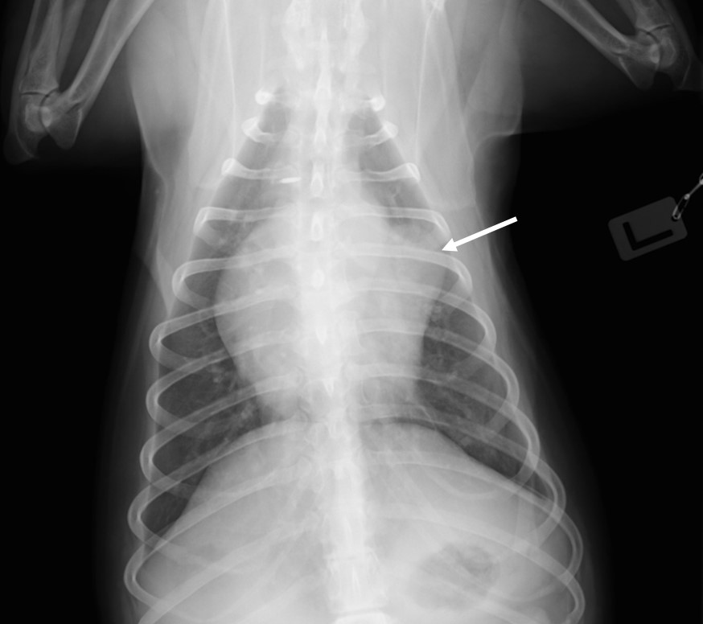

Figure 2: Dorsoventral radiograph demonstrating an unusual cardiac silhouette associated with herniation of the left auricle (arrow).

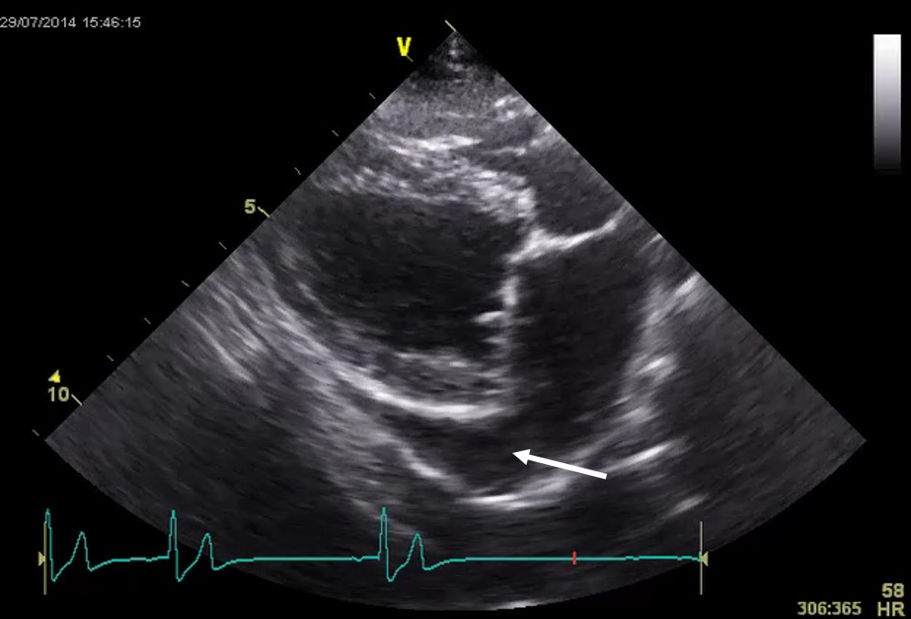
Figure 3: Right parasternal four chamber long axis image showing a disproportionately large left auricle (arrow) in a dog that had herniation of the left auricular appendage diagnosed on CT.

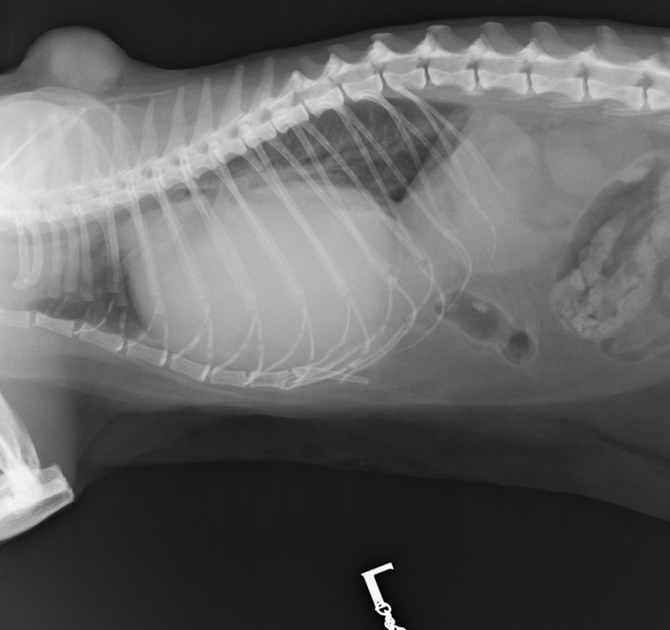
Figure 4: Left lateral radiograph of the thorax in a cat with peritoneopericardial diaphragmatic hernia. The cardiac silhouette is enlarged and distorted and there is lack of a defined diaphragm ventrally.

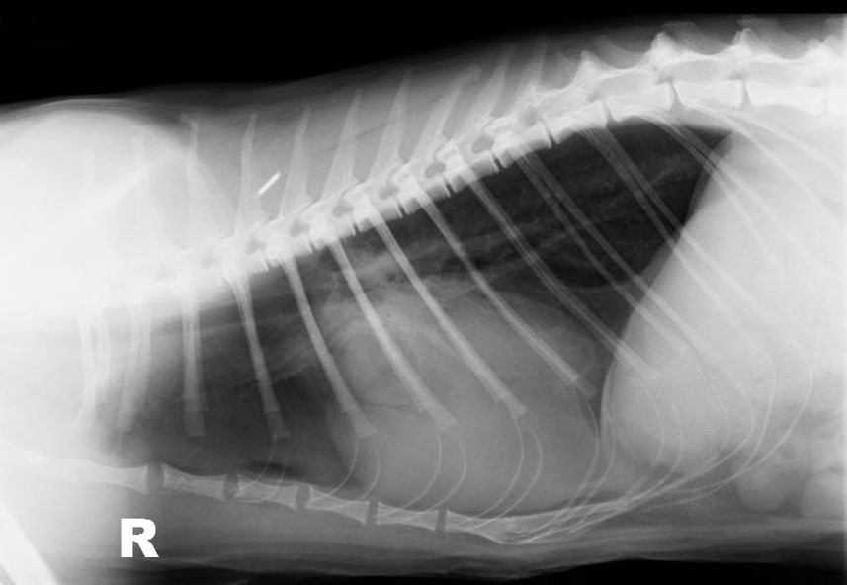
Figure 5: Right lateral thoracic radiograph demonstrating an unusual appearance to the cardiac silhouette and cardiomegaly. An intrapericardial cyst was later diagnosed on CT. Courtesy of Dr. Hannah Hodgkiss-Geere, University of Liverpool.

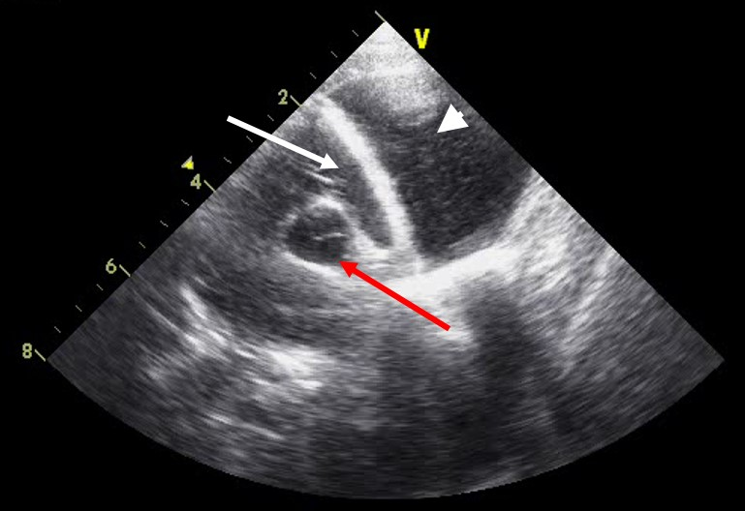
Figure 6: Modified right parasternal short axis image at the base of the heart showing tamponade of the right atrium (white arrow) and a cystic structure adjacent (white arrowhead). The aorta is visible (red arrow). Courtesy of Dr. Hannah Hodgkiss-Geere, University of Liverpool.
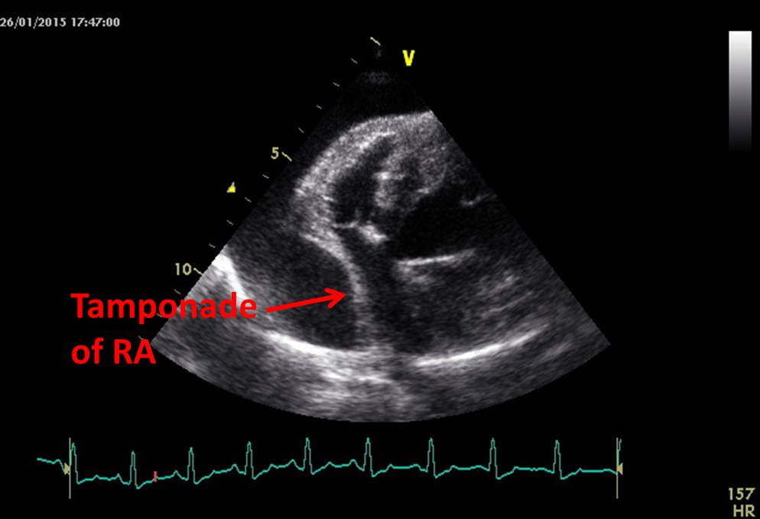
Figure 7: Modified left parasternal image of the right side of the heart showing tamponade of the right atrium (RA) during diastole and a large anechoic area surrounding the heart, consistent with pericardial effusion.

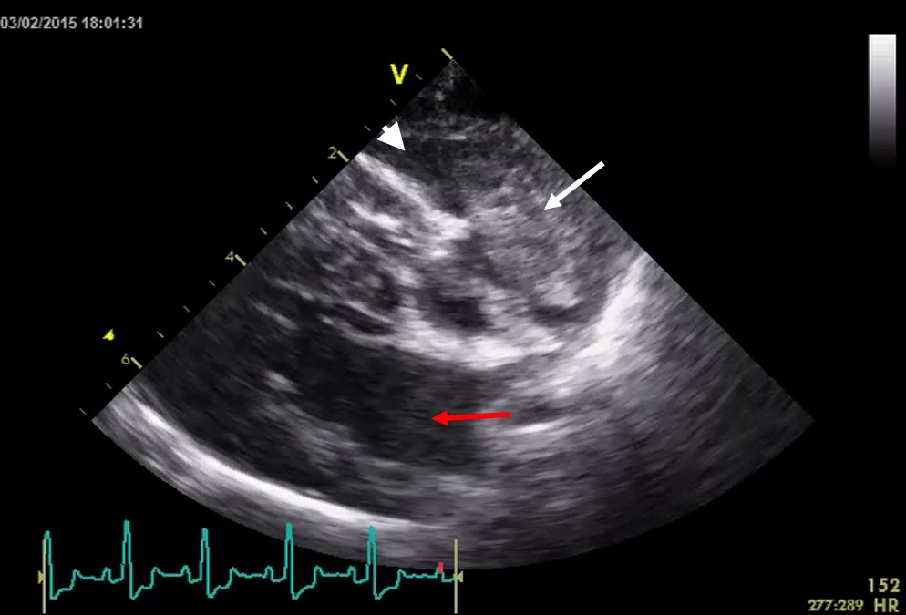Figure 8: Modified right parasternal four chamber long axis image showing a low volume pericardial effusion (arrowhead) and associated right auricular appendage mass (white arrow). The left atrium (red arrow) is shown for reference.

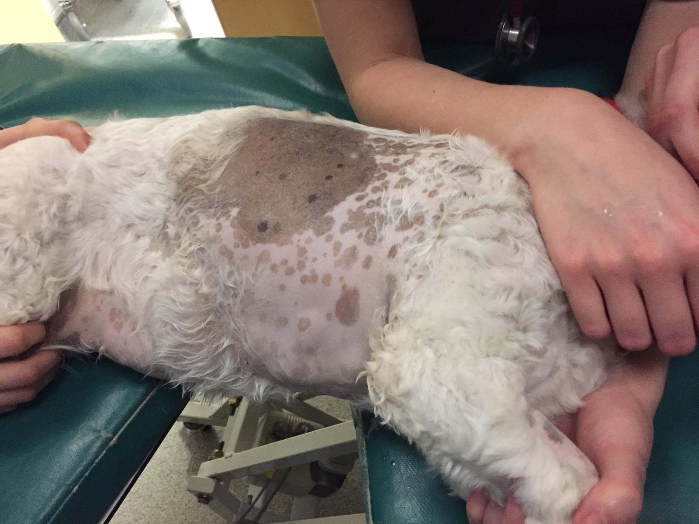
Figure 9a: The dog is positioned and gently restrained in left lateral recumbency and the right lateral region of the thorax is clipped. Mild sedation might be required together with flow-by oxygen provision and ECG monitoring.

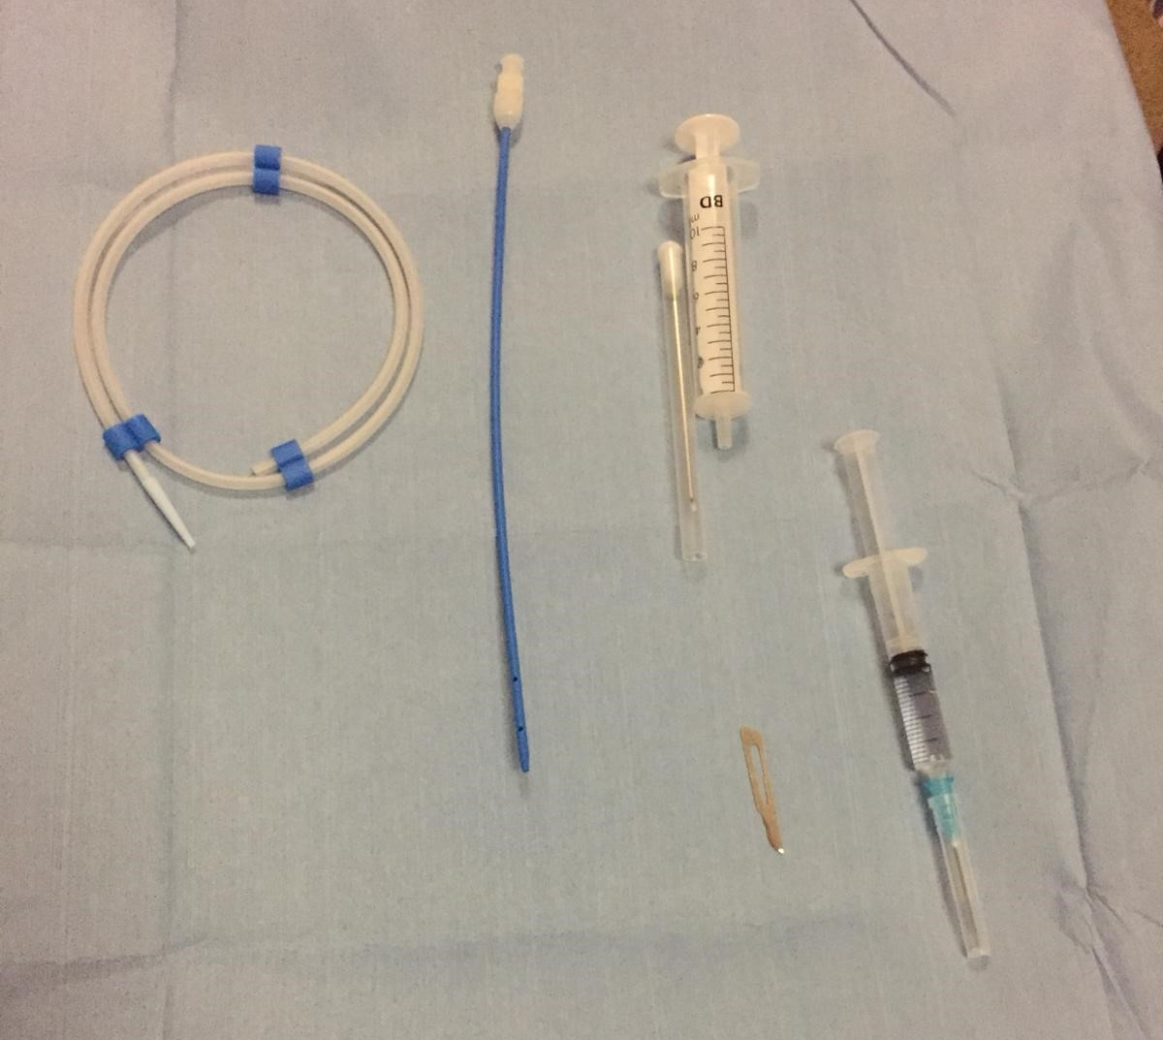
Figure 9b: The equipment required includes a blade, lidocaine, 5ml and 20 or 50ml syringes, 3-way tap, vessel to collect effusion and, ideally, a pericardiocentesis catheter set as shown above.

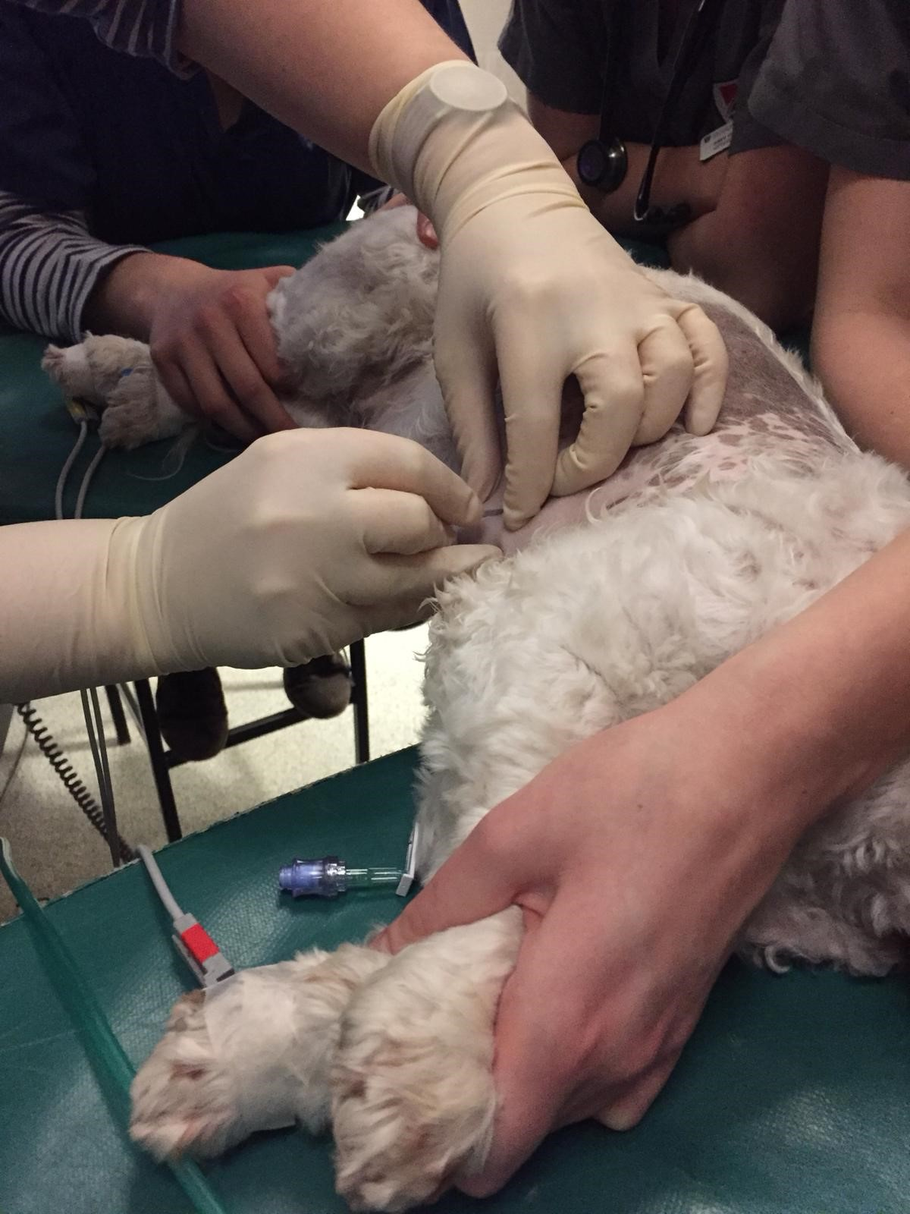
Figure 9c: After infusion of 2% lidocaine between the 5th- 6th intercostal space (or after identification of best location with ultrasound) a small stab incision is made.

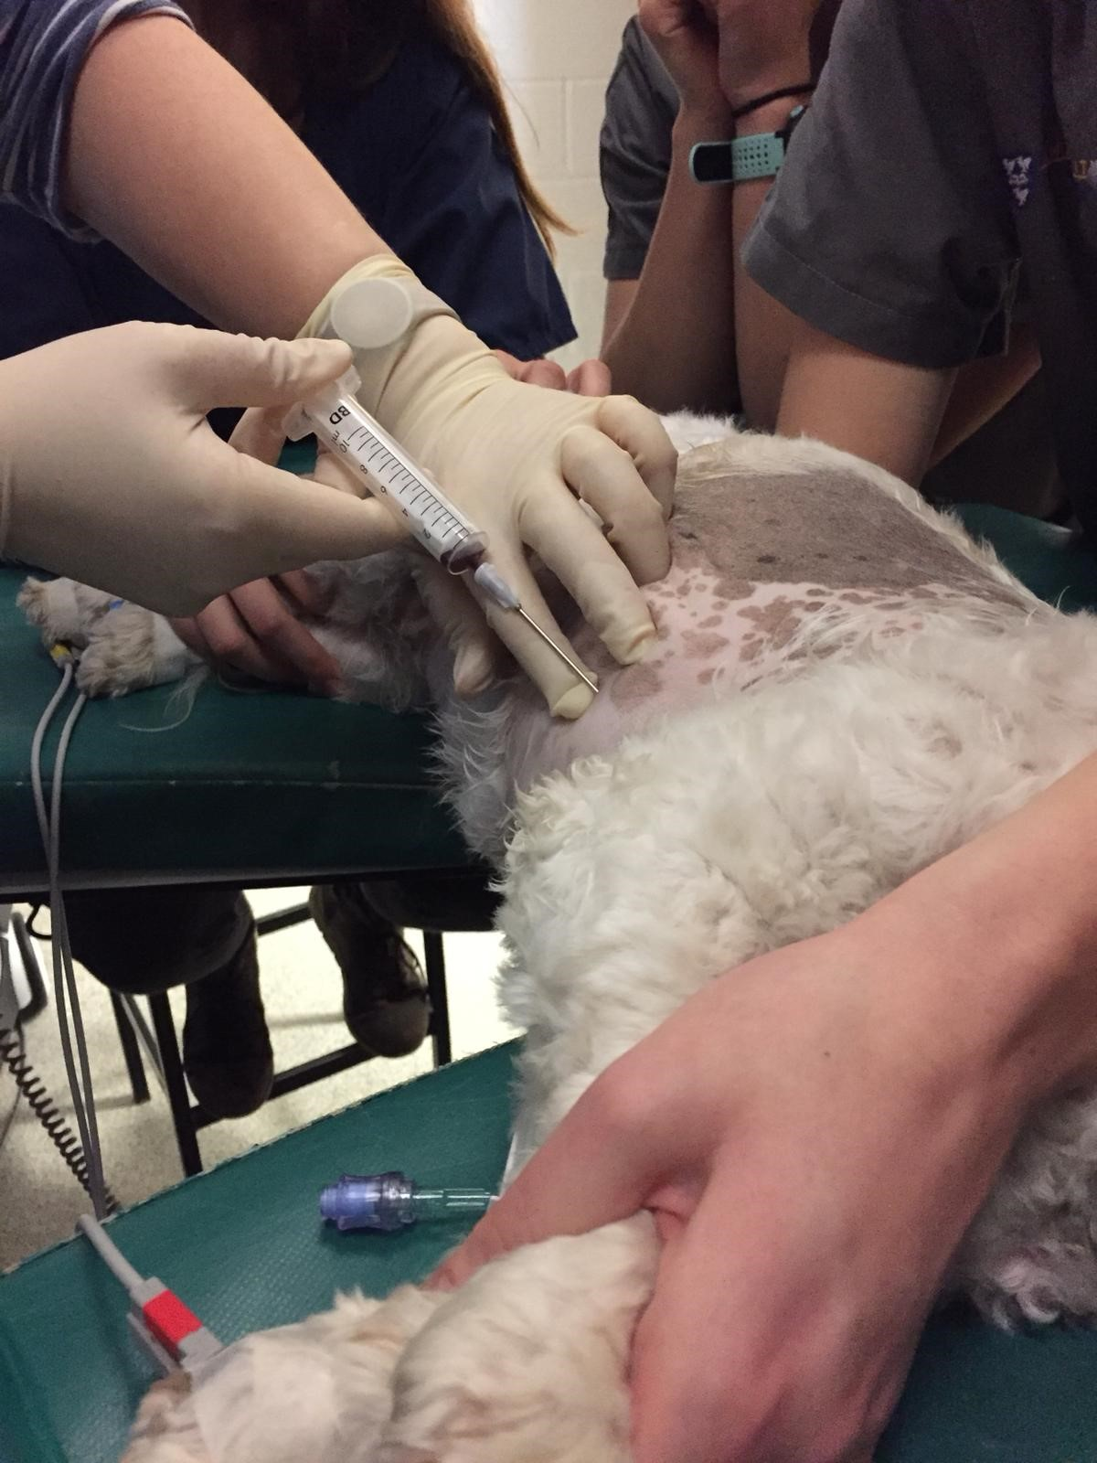
Figure 9d: The needle is then attached to the syringe and inserted at the chosen location. The needle is directed towards the opposite shoulder. A small amount of negative pressure is applied to the syringe once through the skin. This will help to determine entry in to the pericardial space. If the heart is entered by accident ventricular premature complexes may be observed on the ECG.

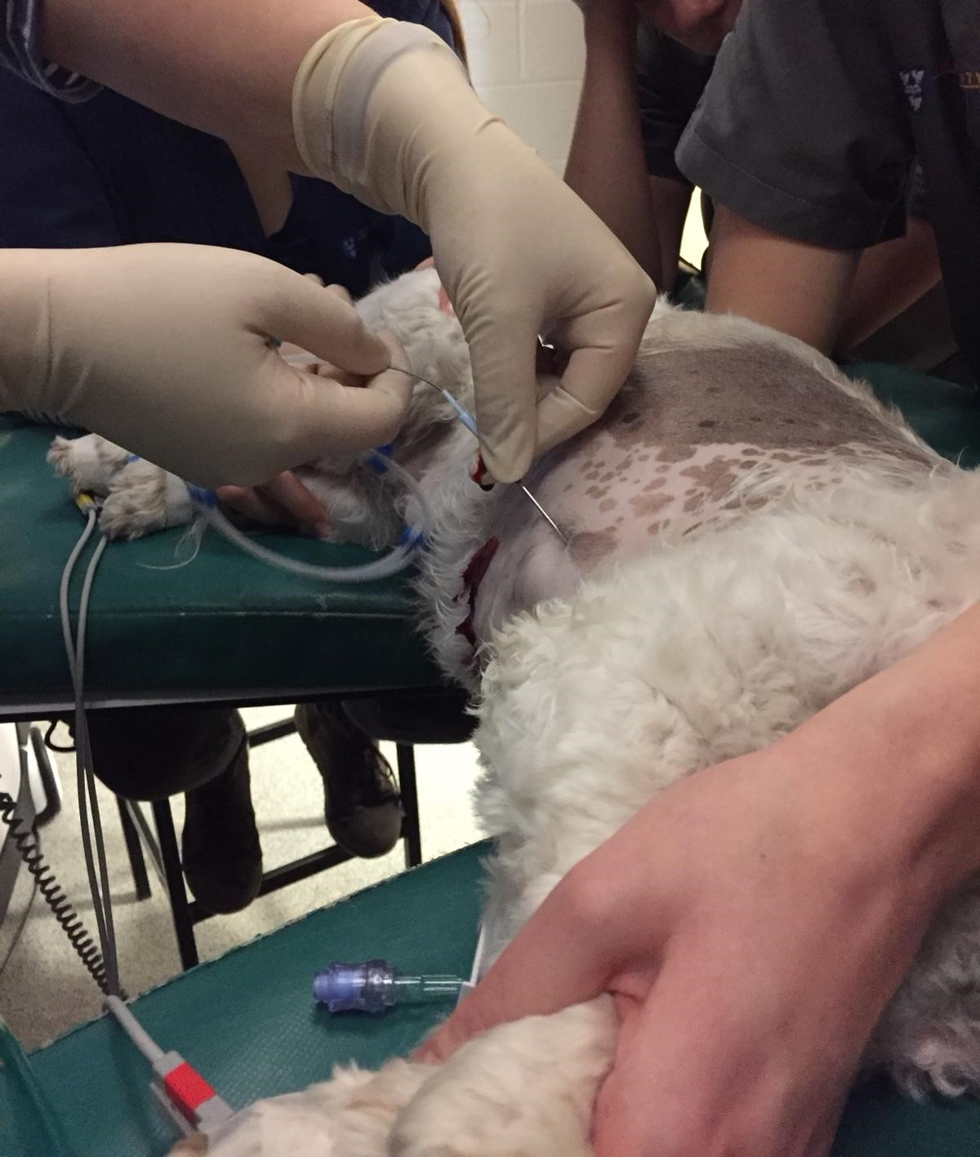
Figure 9e: Once the needle is in the correct position it is held in place and the syringe detached. The guidewire is passed through the needle into the pericardial space. The needle is then removed over the guidewire and the catheter placed over the guidewire into the pericardial space. The guidewire is removed.
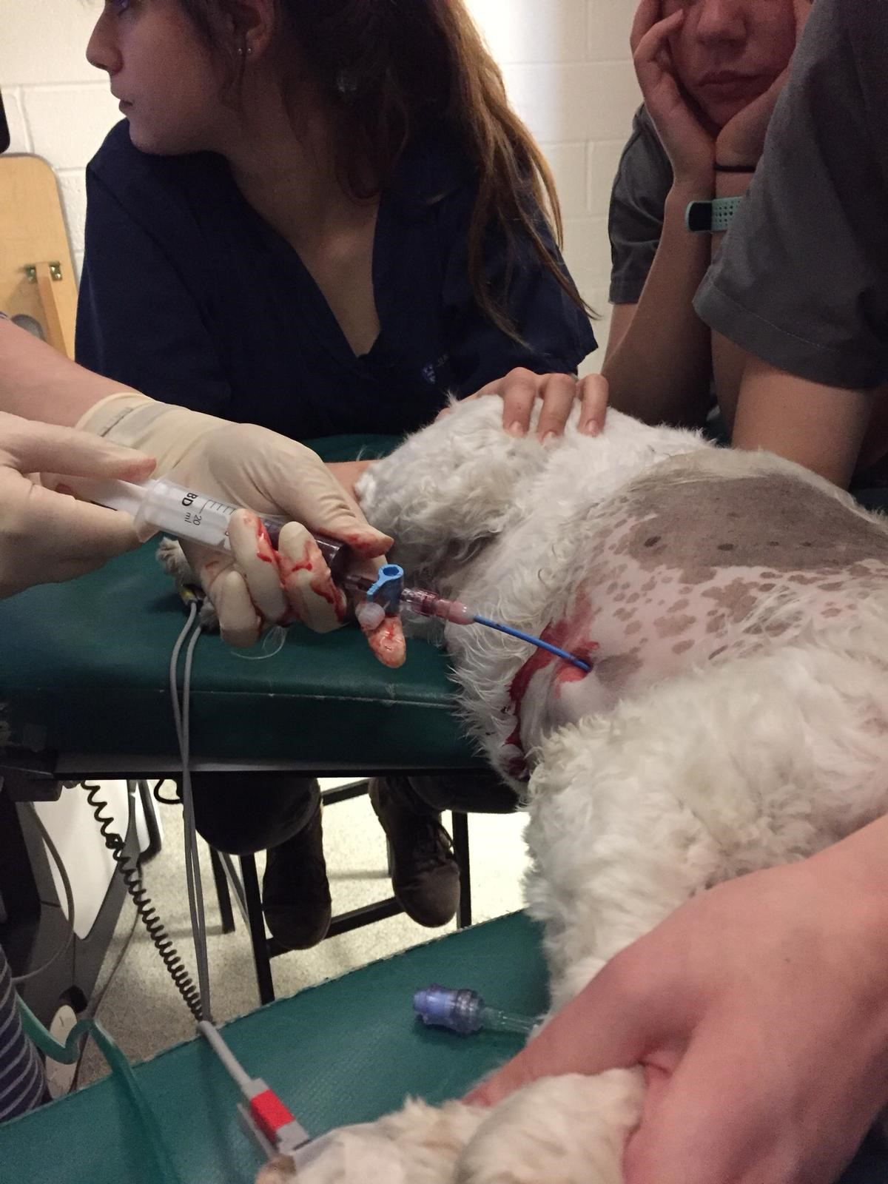
Figure 9f: A 3-way tap is applied to the end of the catheter and a 50ml syringe used to remove the pericardial fluid. It is important to check that the fluid removed does not clot to ensure you are in the correct place. Ultrasound can also be utilized to confirm location. Once all the effusion is drained remove the catheter carefully. A dressing can be applied over the incision and, if needed, it can be closed with tissue glue or a skin staple.

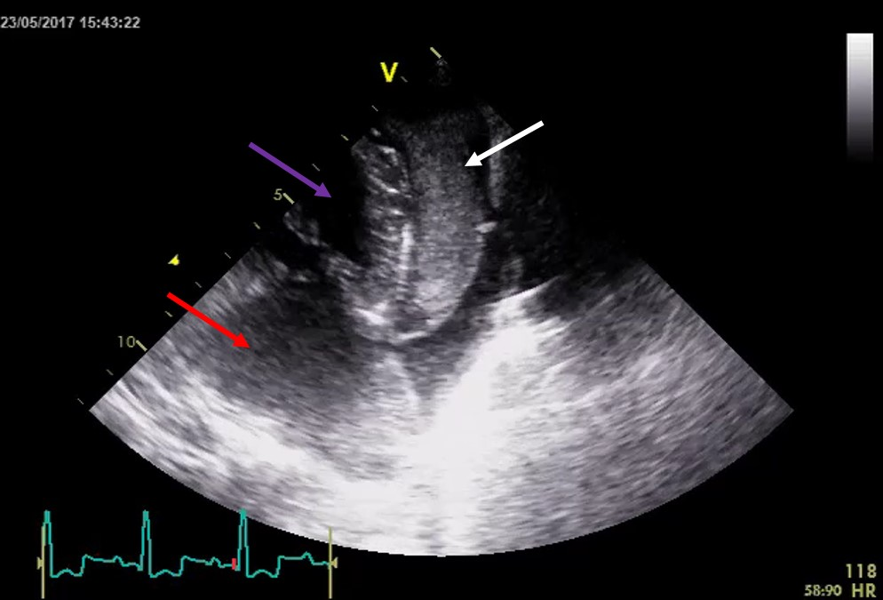
Figure 10: Left parasternal apical four chamber view showing left atrium (red arrow), left ventricle (purple arrow) and a thrombus originating from the left auricle (white arrow).

