F. X. Velarde, an English Expressionist

Andrew Crompton (Corresponding Author)
School of the Arts,
University of Liverpool,
Abercromby Square,
Liverpool, L69 7ZN

crompton@liverpool.ac.uk
0151 794 2643

Dominic Wilkinson
LJMU School of Architecture,
Art and Design Academy
Duckinfield Street
Liverpool

D.E.Wilkinson@ljmu.ac.uk
0151 227 1083

F. X. Velarde, an English Expressionist

Notable undiscovered architects, like undiscovered composers, are implausible, yet F.X. Velarde OBE, 1897-1960, could be just such a person hiding in plain sight. He is obscure because he confined himself to refining Catholic worship on the eve of Vatican II. The churches he designed in the North West of England show an alternative route that modern architecture could have taken based on European expressionism rather than International modernism. The results are playful and picturesque. Many of his churches have a toy like quality. He may have been the last British architect to use the sculpted human form in his work. Today his buildings seem fresh and elegant, but also poignant as they evoke the 1950s and so many of them are threatened.

Introduction

When Britain resumed building after the war a revolution in taste occurred, from then on public works were in the modern style with the Royal Festival Hall leading the way. This revolution can be seen most dramatically in Liverpool's Metropolitan Cathedral, where Gibberd's cone, designed in 1959 was planted on Lutyens's baroque crypt that had been abandoned in 1939. Only a few buildings and architectural careers have any continuity before and after the war. Those that do show us how modernism might have developed gradually rather than arriving suddenly, they show, in fact, a kind of alternative world in which decoration and sculpture continue to be used in a modernist setting. Of these rare links to older ways of building few are more enigmatic than the work of Francis Xavier Velarde.

He has so far avoided fame. He took a road less travelled then died as he was getting into his stride. There have been no followers. Yet whenever enthusiasts gather to discuss modern church architecture his name will be mentioned. Pevsner, an early admirer, described Velarde’s St Monica’s, Bootle, 1936 as an “epoch-making church for England”. Indifferent to self-promotion other than what was necessary to continue in practice with one loyal client, Velarde's life seems insouciant. He wrote little of interest. Fellow architect Jerzy Faczynski collected an archive, but when he died suddenly in 1995 it was forgotten then destroyed in a house clearing accident in 2005. It is still possible to find people who knew Velarde personally, but after more than fifty years the thread is thin. We have sifted what remains to trace his life and work.

Life

He was born and brought up in Liverpool. At school he was, in his own words, a mutt, so he ran away to sea and had seen the world by the time he was sixteen. White-feathered at Exchange Station he volunteered and in October 1917 was gassed at Passchendaele, but returned to service at Cambrai where frostbite split his feet. A horrid car accident in September 1932 smashed his left leg. These injuries caught up with him in later life when he sometimes needed a wheelchair out of doors. “I was his legs” said his younger son, Giles Velarde. Despite this he was the subject of Edward Chambre Hardman’s celebrated photograph, ‘The Mountaineer’ although quite how he got to the top remains unclear.

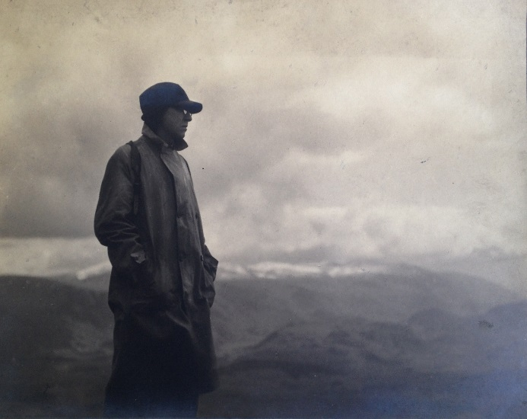

Figure (1) The Mountaineer: F.X. Velarde photographed by Edward Chambre Hardman

Between 1920 and 1924 he studied on a Kitchener Scholarship at the Liverpool School of Architecture where his contemporaries included Maxwell Fry and William Holford. He was a protégé of the theatrical and well connected Professor Charles Reilly, Figure (2), who opened the School to American and European influences, and it was in his company that he travelled to Germany where he came across expressionist buildings that influenced him for the rest of his life.

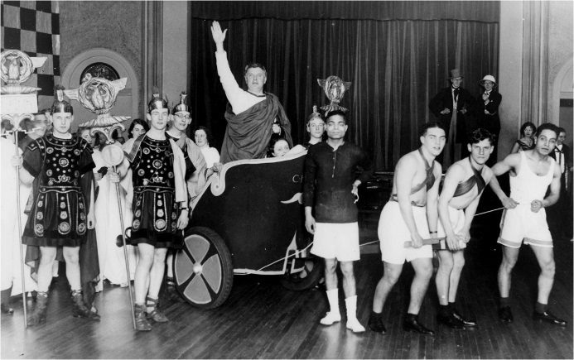

Figure (2). Professor Reilly, Imperator, with students

In 1924 he joined the Liverpool practice Weightman and Bullen. The alternative was put to him by Reilly thus: "You be a dog, and go to America." The arrangement did not last long; he took a school building project out of the office and set up on his own, then helped by Reilly, got his first big commission to build St Matthew’s Church in Liverpool. There followed marriage, family, and a steady practice, supplemented from 1928 by teaching half-time at the School of Architecture where was remembered as giving lectures fifteen minutes long.

His architectural career was straightforward. Before the war he designed three large churches influenced by contemporary expressionist work in Germany. Then, after a wartime break, he reassessed the themes of his early work and built in his mature style, a dozen remarkable suburban churches, and many schools. The schools are of less interest but paid for all the rest. A list of the churches is given at the end; several of them are threatened, a few already lost. Interested readers should not delay in visiting Holy Cross, Bidston, which was his own favourite.

In September 1944 he spoke at a conference called The Church and the Artist that discussed the role of artists be in the post-war reconstruction. Times were hard and new ideas were needed. Sir Eric Maclagen, Director of the British Museum, pointed out that even Wren had been made to build on the cheap and his interiors had been sometimes added later; he advocated some form of mass production. Henry Moore was uncompromising; his work followed its own path not necessarily that of the church. T.S. Eliot thought that the religious dramatist should make his characters as real as the ordinary people he met. Dorothy Sayers was blunt; the church had to address three levels of intelligence at once, '(1) unspoilt children or peasants, (2) those in the Darwinian stage, (3) those who apprehended the modern physicist position.' Velarde stood apart. He was clear where his public stood on Sayer's scale, he spoke of the 'importance of the humble community, which should not be confronted with something very strange.'

His dissenting conservatism was at odds with the progressive mood of the conference, yet being out of step with the world seem never to have troubled him. He drew back from outright modernism, once declining to visit a colleague's new modern house with the excuse, "What should I say if I didn't like it'. Ironically, the modernism which swept the profession after the war now seems mundane and what Velarde proposed in its place seems more exotic as each year passes.

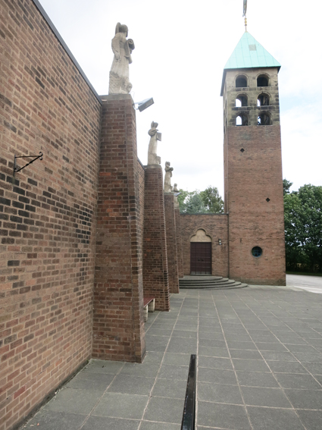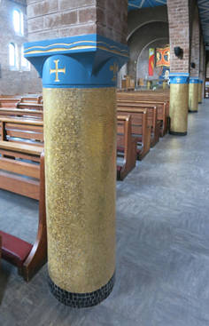

Figure (3) St Theresa's, Upholland.
Figure (4) St Theresa's, Upholland.

Career

Velarde's post-war churches are light hearted, colourful and speak of the 1950s. Many have a campanile like a rocket. St Theresa's at Upholland in Lancashire, 1957, Figure (*), is typical. Like many well designed buildings it seems slightly smaller in life than you expect from a photograph. The picturesque tower has little arches, a Velarde motif that reminded Pevsner of de Chirico. The windowless south wall has buttresses capped with stone angels looking over an area of sloping paving that makes the building look like stage set. The brick volumes of the nave and aisle are easy to read because the wall surface is only perforated by a few small openings, roundels or with round arches or trefoils. The exposed brick continues inside, but now there is colour: ceilings are painted in huge blue or orange diamonds, and there are gold mosaic columns with blue capitals.

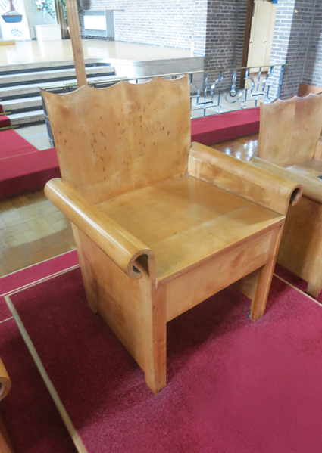

Figure (5) Chairs at St Monica's Bootle by FX Velarde.

There are many imaginative and inventive touches in his work. At St Luke's, Pinner, he used a checkerboard of pink and blue tinted glass to amplify colours from the sky and the adjacent brick building, Figure(13). He designed graceful fittings and furniture. Early railings swirl and skip like something by Lutyens, later ones are rhythmic. Altars are bold stone constructions with gold and geometric designs. Candlesticks are cones and spheres. At St Monica's three beautiful altar chairs made of veneered bent plywood, Figure (5). The scalloped back is like a crown or perhaps a wing, the scrolled arms like a bishops crosier. There is an economy to his work. He spent his money on things you touch such as beautiful ironmongery, tiling and pews. Observing that churches in the course of construction were more attractive than when finished he chose to use fairfaced brickwork internally. He used cast and carved sculpture, alongside trussed roofs, concrete windows and floors. He was pragmatic, once saying to his assistant "I don't want it to be too perfect". One reason the Catholic Church warmed to modern architecture, even though not everyone liked it, was because it was cheaper than traditional. Velarde was a compromise in whom expense and taste were reconciled.

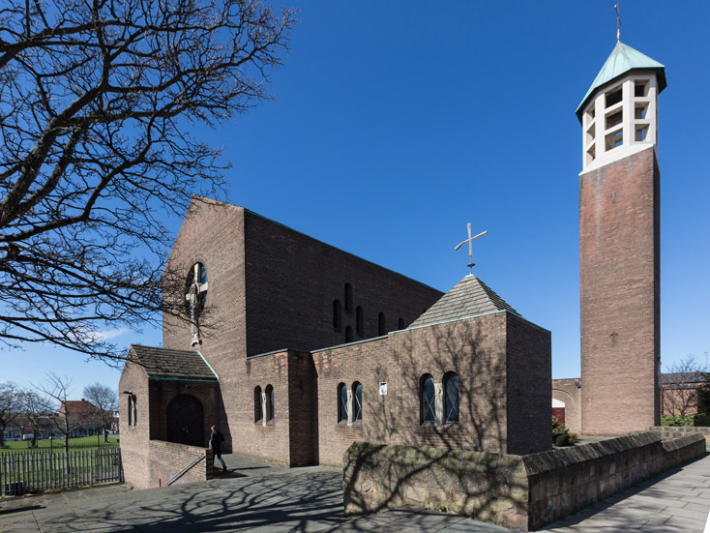

Figure (6) English Martyrs Wallasey 1953

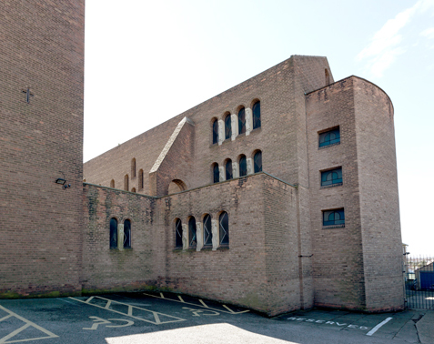

Figure (7) English Martyrs apse

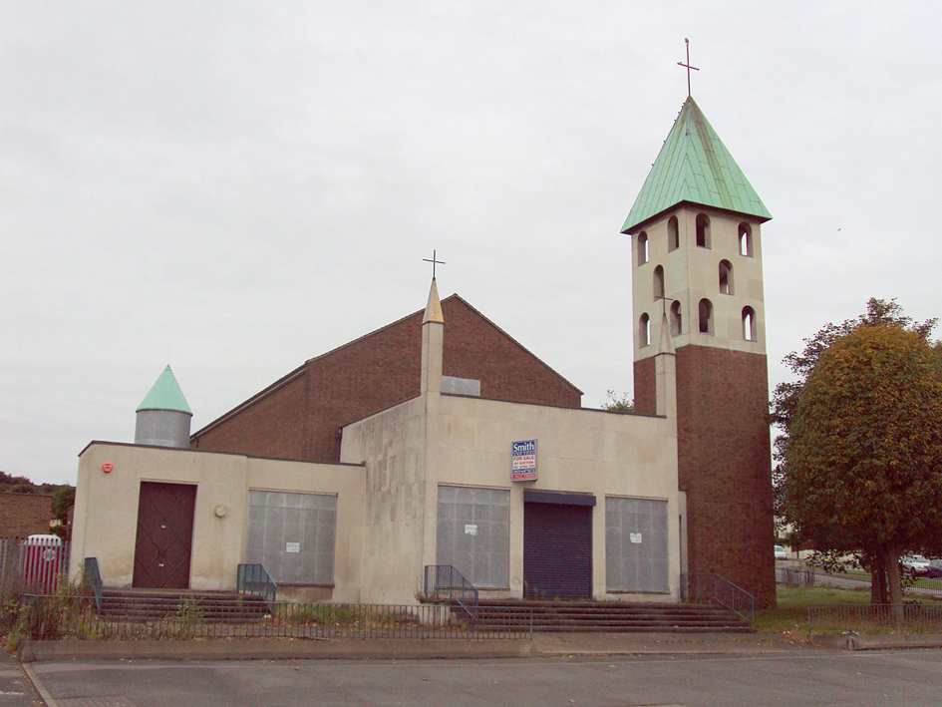
Figure (8) Holy Cross, Bidston, 1959, exterior

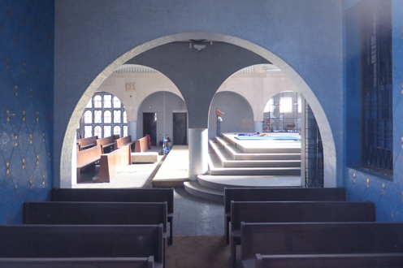

Figure (9) Holy Cross Bidston, Lady Chapel looking across nave.

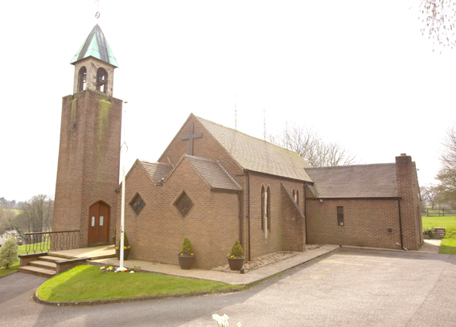

Figure (10) St Cuthbert by the Forest, Mouldsworth, Cheshire 1955

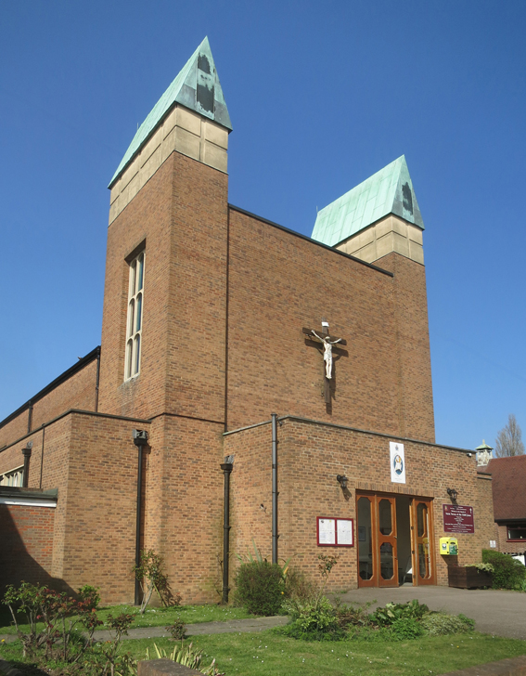

Figure (11) St Teresa's Borehamwood 1961

In an era of white modernism he was pedantic about colour. To stand in the Lady Chapel at Holy Cross is to breathe in blue, Figure (9). At a time when it was belittling to say of an architect that they made patterns he designed bright and powerful grids. Figure (12) shows some of his ceilings. Their reds, blues and yellows were complemented by gold accents around the altar and stations of the cross. Velarde loved gold and often used it in the form of mosaic tiles.

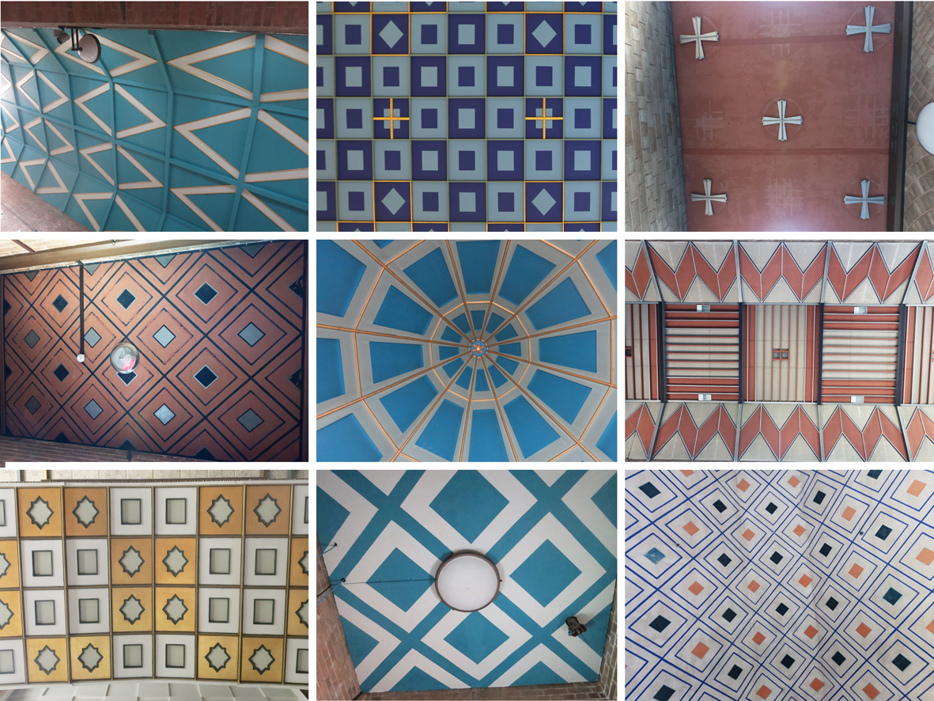

Figure (12) Various Ceilings
Upholland: Pinner : Wallasey
Wallasey : Hindley: Wallasey
Bootle : Upholland : Wallasey

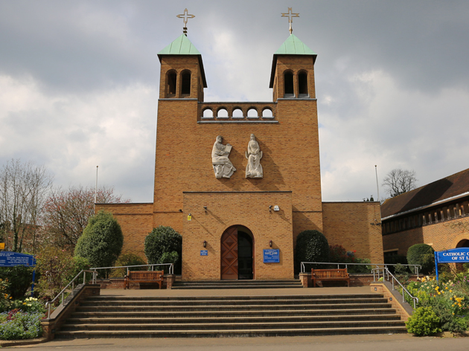

Figure (13) St Luke's Church, Pinner 1957

The last building he designed was St Teresa's, Borehamwood, which was completed on site by his colleague Janet Gnosspelius helped by his son Giles.

In plan form his churches are all between traditional and modern, configured in the spirit of the Liturgical Movement with a low altar rail and priest facing the congregation. He never designed a church in the round and his career ended just as architects responding to Vatican II made 1960s Catholic churches some of the most adventurous buildings in Britain. The last drawings he did were sketches for St Michael and All Angels, Woodchurch, Wirral. After he died it was taken over by his partner Richard O’Mahoney through whom his practice continued. When it opened in 1965 it had ribbed concrete walls beneath a tent-like steel roof and no round arches were to be seen. O'Mahoney was able to let go of traditional forms because Vatican II now allowed it. We can only wonder how Velarde might have responded to that freedom. Perhaps he might have developed like the Böhms, first Dominikus then his grandson Gottfried, who took the expressionist path to its end in incredible fantasies like the pilgrimage church at Neviges. More likely the circumstances in which Velarde could flourish had been fleeting and his work was in fact complete, in which case what little we have of his work represents a different end point of the Expressionist impulse.

By the end he had refined his style to the point where it had become idiosyncratic and its connection to its European origins was lost. Despite having declared that he did not want to do something strange, Velarde's buildings do in fact became progressively more personal and strange. Holy Cross, Bilston, 1959, Figure (8), with its corner pinnacles looks almost like a mosque. The simple volumes and tiny arches of many his buildings look as if they could be made of wooden bricks. St Alexander's Bootle was, as Robert Proctor put it, 'like a child's drawing of a church.' The Velarde style looks simple but one might almost call it faux naive. Whatever you might think of his work he is hard to classify. He was an outsider, in biological terms, a sport. Where did it all come from?

Influences and pre-war churches

The origins of his post-war buildings can be seen in three pre-war churches he designed in successively, the Byzantine, the Art Deco-modern, and the Expressionist styles. Out of these three works he synthesised all that followed. These churches borrowed from buildings he had seen in 1928 when he visited the Pressa exhibition in Cologne that included El Lissitzky's Soviet pavilion, Mendelsohn's pavilion, and Otto Bartning’s Glass Church with its towering westwerk. In Stuttgart he photographed the Weissenhof Estate housing and Paul Bonantz’s railway station. As a young architect he was aware of International Modernism, but drawn to the power of German Expressionism especially the work of Dominikus Böhm. Figure (14) shows an unbuilt Böhm church in which massive block is contrasted to a light hearted form, in this case a brick cube topped with a spiral tower like Borromini at Sant'Ivo. Velarde was never quite as adventurous as Böhm, (or as bizarre as Professor Reilly would have described it), but the brick cube duly appeared in Lancashire in the tower of St Gabriel’s Blackburn, 1932, and at St Monica’s Bootle in 1936. In place of the spiral his later churches had playful campaniles with geometric tops in light coloured concrete.

The massive brickwork in Böhm's churches made a lasting impression on Velarde. At Christus König, Leverkusen Böhm sprinkled the walls with bits of different types of brick and dummy arches to give an effect of age and majesty. The same effect is to be found in German post-war churches where the spolia is real, material from the ruins being available to display. Velarde lets the solid dominate the void and likewise used small interventions, tiny window and crosses, to accentuate the massiveness of his walls. Other motifs from Böhm that appears in Velarde are gridded arrays of small round headed windows with coloured glazing patterns and flat ceilings with downstand beams picked out in colour, (Figures 15 and 16).

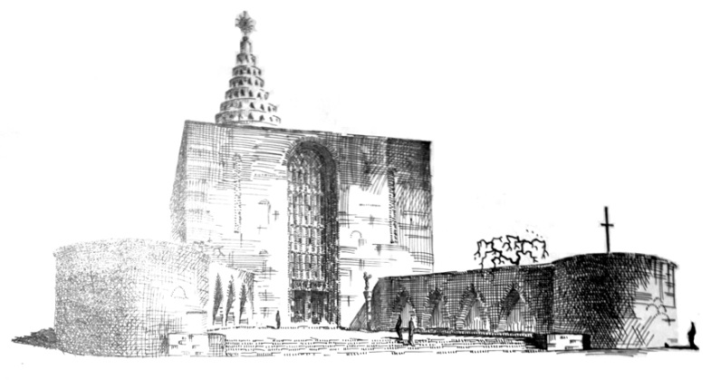

Figure (14) Dominikus Böhm sketch of unbuilt church
Frankfurt Architecture Deutsches Architekturmuseum Archive
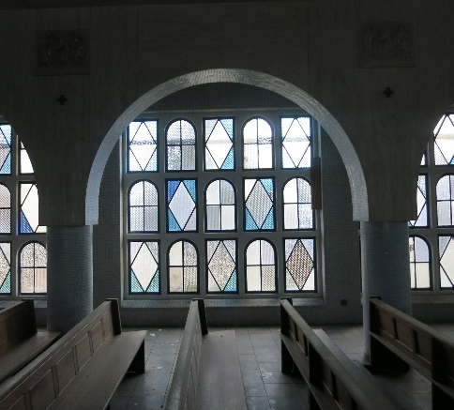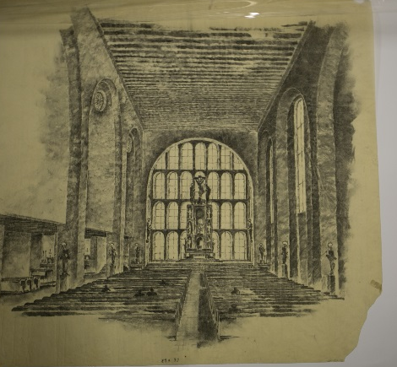

Figure (15) Holy Cross, Bidston, Wirral 1958
Figure (16) Sketch for church interior, (D. Böhm: Deutsches Architekturmuseum archive).
Velarde's first church, St. Matthew’s, 1930, served one of the council housing estates on the new Liverpool ring road. Although it was in the Byzantine style, a stipulation of the charity that paid for the work, his treatment of that style is elastic. Like Bentley’s Westminster Cathedral of 1903 there is fairfaced brickwork inside, but unlike that building there is no dome, except for a gold baldacchino with a Soanian dome in a sanctuary decorated with mosaic zigzags and waves. The arched nave is a powerful space whose broad ribs are in a contrasting colour to the vault like a Piccadilly Line tube station, Figure 17. Its pews, which were originally light and dark green, added to the effect. The low side arches seem Scandinavian; Velarde admired Ivar Tengbom's national romantic Hogalid Church in Stockholm whose twin towers surely served as a model for the St Matthew's campanile as well as the twin towers of several of his later buildings. He never built anything as sumptuous as this again, but there are continuities with his later buildings. The semi-detached campanile, small round arched windows, and narrow aisles all reappear later.

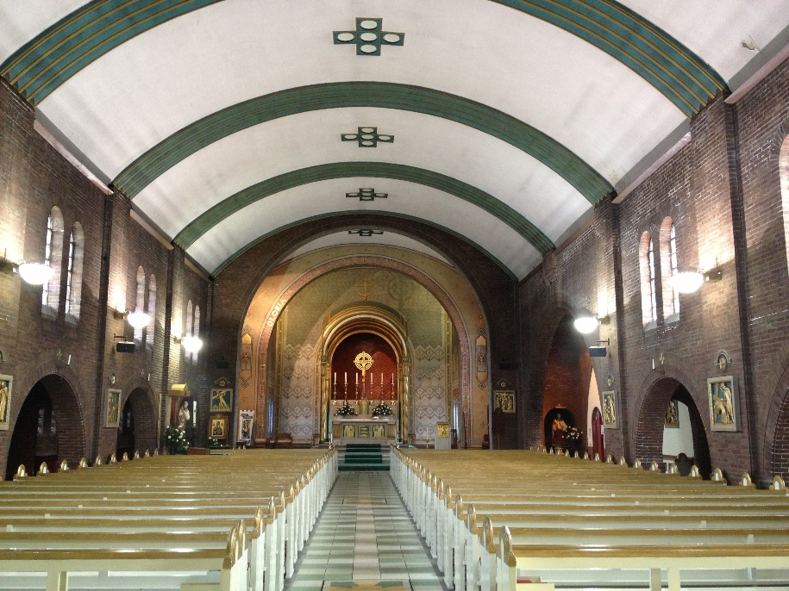

Fig. (17) St Mathew, Clubmoor 1928-30

His second project, St Gabriel’s Blackburn, 1933, is a powerful brick composition whose massing was singled out for praise in a review of Velarde's work in 1938. It shows the influence of Bonatz's Stuttgart railway station. The original design had a deep recessed entrance in the side of the tower, which resembles Böhm’s church at Leverkussen, 1928. The scheme as built employed a more restrained pair of round headed slit windows. Sadly the building you can see today is not quite what it was after structural problems required alterations sufficient to warrant delisting. What remains, however, is still impressive and clearly a Velarde building with its simple brick walls, paired round headed windows and unsymmetrical narrow side aisles.

The interior is tall and simple. The original photographs by Chambre Hardman show daylight falling across plain wall surfaces and capture the power of the bossless arches of the nave and aisles, (Figures 19 & 20). This austere space is relieved by many charming details, such as conical light fittings, and a wonderful chromed steel glazed lobby. Beams across the tower seen from the nave are scalloped, and there are Deco metal railings that would grace any cinema. In this building he moved away from being a period imitator, although he was, and remained for his whole life, faithful to round headed windows.

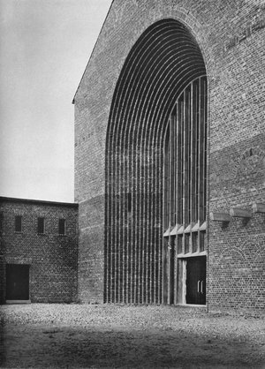

Fig. (18) Christ the King, Leverkusen, D. Böhm 1928
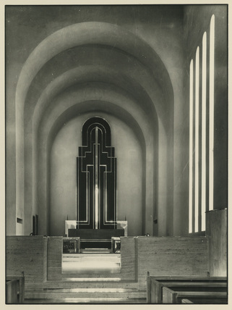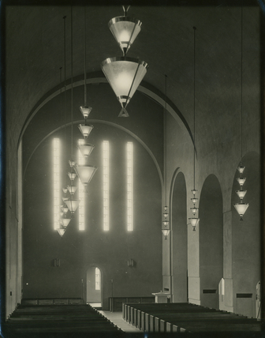

Figure (19) St Gabriel’s Blackburn 1934-6, interior photographs by Chambre Hardman.
Figure (20) St Gabriel’s Blackburn 1934-6, interior photographs by Chambre Hardman.
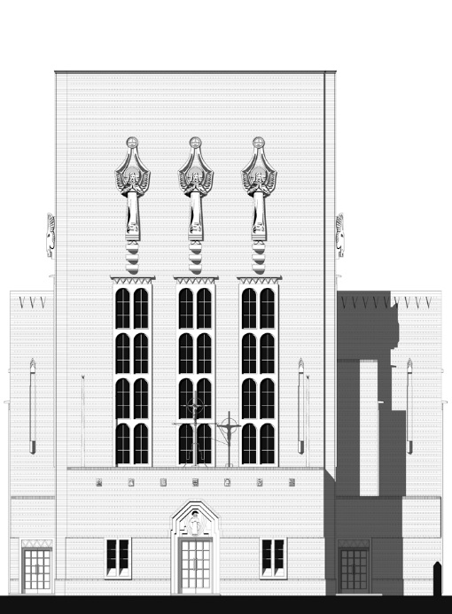

Figure (21) St Monica's, Bootle, West Front.

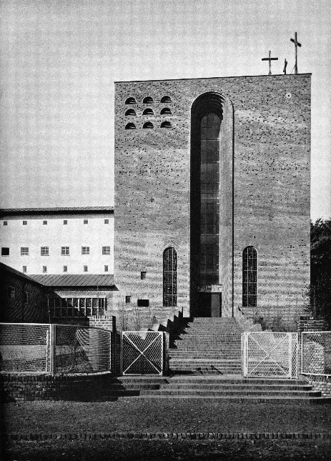

Figure (22) St Kamillius, Munchengladbach D. Böhm 1931

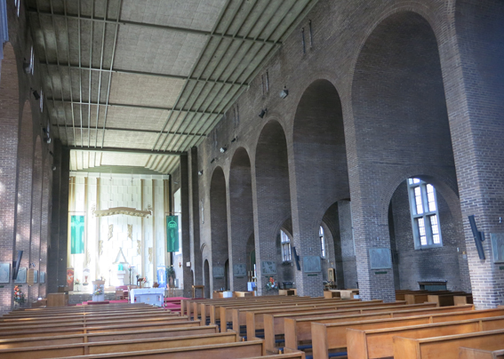

Figure (23) Interior St Monica's Bootle 1936.

Velarde made his name with his third church, St Monica’s Bootle, which appeared in the Architectural Review and was exhibited at the Royal Academy in 1937. Unlike the slightly ambivalent tower at St Gabriel’s it faces the street with a massive tower with angels by H. Tyson-Smith. The arrangement owes something to the westwerk at Böhm's St Kamillus, Monchengladbach 1928-31, Figure (22).

The plan is balanced between being symmetrical and unsymmetrical. A large window on the south side illuminates the sanctuary which is decorated in white and gold. The aisles are different widths, they penetrate the wall piers which become internal buttresses, in turn these go through the flat roof over the aisles where they are again pierced by arches making an arcade on the roof. The semi-circular brick vaults are solemn and strong. The nave is flat with its beams painted green. Velarde did his own structural calculations, sometimes with unpredictable results. At St Monica's the west end arch needed an emergency steel truss which resulted in a surprisingly elegant composite structure.

Built when budgets still allowed a significant input by craftsmen the church is a total composition whose unity survived a reordering in 1984. The bare brickwork inside is offset by a range of fittings either designed by Velarde or by artists such as W.L Stevenson, who created the angel reliefs attached to the reredos as well as the Eric Gill-influenced stations and the statue of Our Lady. The English Martyrs chapel paintings are signed GW, dated 1938, the drawings on glass in the sanctuary windows are by Mrs. W.G. Holford, Rome scholar, in decorative painting. A double layer of glass is used, with the drawing between. There are also delightful chromed altar rails, fluted holy water stoups, and waxed oak doors.

By 1937 he had escaped the academic neo-classicism of his mentor Reilly and influenced by contemporary European architecture earned a reputation for modern, if not modernist churches. He now had all the ingredients of his mature style that we see expressed in his next building, English Martyrs, Wallasey. Unfortunately war intervened in his life for the second time and it could not be started on site until 1952.

Velarde's style

The only thing all his churches have in common is round arches, but there is more to him than a reinterpretation of Romanesque. While teaching at Liverpool University his early preferences were expressed as “Mendelsohn was OK, Corb was not". This suggests we should see him as part of a modern tradition separate and parallel to the Modern Movement, such as Gavin Stamp has identified. In Velarde's words: “if art somehow cuts itself off from tradition, if somehow it fails to give expression to it, then it cuts itself off from life and ceases to be human” Velarde was innovative within a tradition, architecture was always more than a matter of personal expression for him.

This respect for tradition is seen in his architectural vocabulary of load bearing walls, pitched roofs, and small windows. He chose the same materials that were being used for shops and houses throughout post-war Britain; concrete, brick, tiles, steel trusses, mosaic, painted plywood. Yet he is modern of sorts. There are no orders. He preferred asymmetry, usually there is only one aisle, or if two they will be of different sizes. Lighting will be mainly from one side. Stained glass and other leadwork is gone, instead there is tinted glass. His ceilings are not vaulted but flat or segmented, and boldly coloured. His decoration is sparing and related to the structure. Where he incorporates sculpture it will nearly always be in relief and not free standing.

A progressive simplification is seen in his later work except for the unusual Shrine of our Lady of Lourdes, Blackpool, built in 1957. Here, for unknown reasons he had a budget sufficient for a pre-war level of embellishment and abandoned brick and tiles for ashlar stone and a copper roof. There is geometrical carved tracery that could pass as Islamic and west front has a low relief of the crucifixion with God and angels in attendance carved by David John. The interior is striking, here is recent description, '. . . floats a coffered ceiling of a vivid blue and gold . . . and walls of cool grey. There are elements of jazz modern and art deco . . . a highly individual expressive interpretation, . . . although by no means strictly Modern.' Perhaps we see here is how he would have built had budgets not held him back; there would have been more art, more colour, more refinement. In that case the economy he was made to practice might have been a blessing, because if we set the Shrine aside, his move away from applied decoration in favour of basic geometrical forms is what gives his buildings their character.

This simplicity respects the rules given by Ruskin for power in architecture, such as to use basic forms in a single material with small openings. At Upholland the north wall in exposed brick, has one window above two, which emphasises its massiveness. The large brick arches that frame the sanctuary are similarly simple and strong. The monumental qualities we have at St Monica's or St Gabriel's are reproduced in much smaller buildings. This playing with scale is part of their appeal. Perhaps his later churches seem toy-like because their form is borrowed from a larger building.

There is no formula by which his series of churches could be continued. Many, but not all, have brick campaniles, some but not all, have an apse, and so on. The picturesque variety extends to the features themselves, for example his campaniles are square or polygonal, with or without stone tops, with or without multiple openings, attached or not, in pairs or not, and so on. He manages to be surprising while staying within his familiar range of forms. If you wanted to continue in his style you would have to borrow from the whole oeuvre in a creative way. To this extent his work has a unity even though it is hard to say what it consists of, and hard to find anything else quite like it, which is perhaps the why his career has been described as hermetic. The Enda Mariam Orthodox cathedral in Asmara Eritrea, 1938, comes close with its simple forms, colour accents with an almost childlike appeal. It is however, hard to believe that FXV ever knew about this building by an unknown Italian architect. Perhaps they reached similar conclusions from similar roots in Art Deco. If looking for someone else like him we find ourselves in expressionist Germany and Eritrea rather than London or Liverpool then that surely that is sign of how odd he is, and also to recognise that there is something odd or exotic about his work like a blue note in music.

Pevsner said of St Monica's: 'A great pity that the altar wall is so prettified.' Velarde would doubtless have answered that he built for worshipers not critics. The risk in this approach is becoming kitsch, but he avoids it. His selective simplification of traditional church architecture hangs together and it is the Velarde style that one is aware of, not this or that particular form. One sees colour, and inventive and charming spaces that are never vulgar.

By all accounts he was not dogmatic or particularly pious. He expressed himself obliquely: several stories have him drawing details with his stick in pile of sand. It is not possible to do this on a church building site without in some way referring to Jesus drawing with his finger when confronted with the woman taken in adultery. That doodle was used to deflect the question, in a similar way, without ever being explicit, Velarde criticises modernism by showing that there are other ways of building. That other way is playful, colourful, and popular.

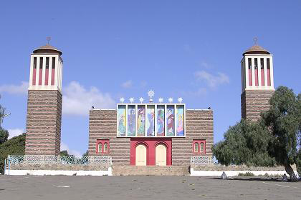

Figure (24) Enda Mariam Orthodox cathedral, 1938, Asmara Eritrea.

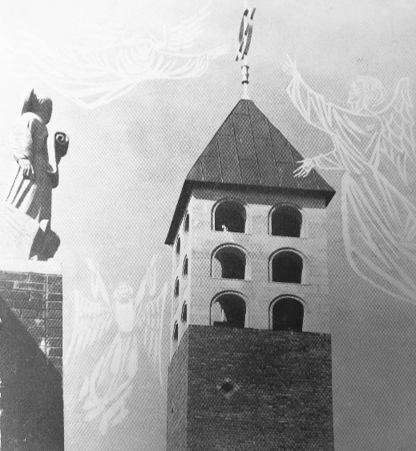

Figure (25) Angels, stone and imagined, 1957.
The Velarde family Christmas card shows the campanile of Upholland Church.

Conclusion
Velarde was Catholic not Anglican, expressionist not modern, provincial rather than London based. Given that his career was truncated one can see why he is not better known. Today his work is acquiring a period charm. His clean and ordered plans, painted patterns, simple forms, vibrant mosaics, with gold highlights, all seem to belong to the 1950s, no less than, say, Lucienne Day or the Festival of Britain.

It happened that Velarde died in the same week as Sir Ninian Comper and their obituaries appeared next to each other in The Builder. With Comper, who was ninety-six and had been apprenticed to Bodley, a living link to the high Victorian era was broken. He had believed in unity by inclusion and promiscuously linked Classical and Gothic styles in his work. Many of his churches had had angels, carved and gilded.

Velarde also built angels. Figured mullions are almost his signature, but even these are missing from his last works. He might well be the last British architect to use the sculpted human form in the wall of a building. At Pinner in 1957 there are carved figures applied to the wall over the front door and that is all. At the posthumous Borehamwood only a crucifix remains. This gives Upholland church, a remnant of old Catholic Lancashire, a certain distinction. Its cast concrete figures on mullions and carved buttresses are one of the many ends of figurative Christian art in Britain. In this place angels pass over from masonry to imaginary, as the Velarde's drawing of 1957 shows in very literal terms, Figure (25).

There has been no one to follow either Comper or Velarde, who were both in their own ways anachronisms, yet with Velarde we cannot be quite sure that his story has ended. It would never have been for him, as it had been for Comper, to restore Westminster Abbey. When Reilly offered to back Velarde as the continuator of Lutyens's abandoned Liverpool cathedral he declined, writing privately 'that to build a church larger than St Peter's Rome, in such a provincial area and at such a great price, is in very bad taste'. He was a humble and stylish pop church architect, if that is not a contradiction, perhaps the time will come when his influence will be felt, with or without angels.

END

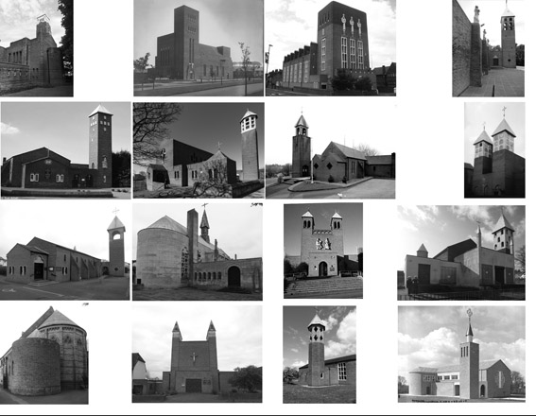

Figure (26) Churches by F.X. Velarde
Top row 1 2 3 4 Second row 5 6 7 8
Third row 9 10 11 12 Bottom row 13 14 15 16.

Pre-war:
1 St Matthew's Clubmoor 1930
2 St Gabriel's Blackburn 1932-3
3 St Monica's Bootle 1936 Grade 2

Post-war:
4 St Teresa's Upholland 1952-7 Grade 2
5 Our Lady of Pity, Greasby, Wirral, 1952
6 English Martyrs, Wallasey, Wirral, 1952-3 Grade 2*
7 St Cuthbert by the Forest, Mouldsworth 1955 Grade 2
8 St Alexander, Bootle, 1955-7 (Demolished)
9 St Winefride, Monksmoor, Shrewsbury, 1956
10 The Shrine, Blackpool, 1956 Grade 2*
11 St Luke's, Pinner, 1957
12 Holy Cross, Bidston, Birkenhead 1959 (Velarde's favourite, Grade 2)
13 St Benedict's, Hindley 1954, Lady Chapel only.

Posthumous:
14 St Teresa's Borehamwood, 1961
15 Our Lady of Pity, Harlescott, 1961
16 St Vincent de Paul and St Louise de Marillac, Potters Bar, 1962
(finished by R. O'Mahoney)

Other work not shown:
Columbo Cathedral competition 1947
The Grail Chapel at Waxwell Farm, Pinner 1955
Church of Our Lady Ampleforth 1944 (drawings only)
St Gabriel's, Alsager, Cheshire, 1953, of lesser interest
St Mary Magdalene, Much Wenlock, Shropshire, 1955 demolished > 2011
Liverpool Metropolitan Cathedral competition 1959 (16th place, drawings lost)
Manses with churches listed above
Private house at 7 Speke Road Liverpool
Schools (in Merseyside and elsewhere in the North).

Acknowledgements
Giles Velarde
Paul Mellon Foundation
Ref 03-2015-G4/58

Notes

For instance E. Vincent Harris's MoD building, 'The Whitehall Monster' was designed before the war yet completed afterwards, is part classical and part modern.
Pevsner, N. Buildings of England: Lancashire: South, (Penguin, 1969) p.93
His published writings are: F. X. Velarde, Notes on Ampleforth Church, Art Notes 1940 Vol IV No.3 Summer p28-9 R. Velarde and F.X. Velarde Modern Church Architecture and some of its Problems. The Clergy Review Vol XXXVIII No.9 September 1953 p513-526 (RV was his brother, a priest). His unpublished works include an essay on the beauty of bricks.
Faczynski, 1917-95 was in the RAF from 1939 then at the Polish School embedded in the Liverpool School of Architecture, and architect of St Mary’s RC Church, Leyland, Lancashire, 1964, (with Weightman and Bullen).
Destruction witnessed by Desmond Fleet, piano dealer, personal communication, (AC 2014). We have collected what remains, including his personal papers and diaries from Giles Velarde which have been deposited the Special Collection at the Sydney Jones Library at Liverpool University.
We interviewed Giles Velarde, Victor Basil, Reginald Ashburner, Neil Fosard, N. Keith Scott, Robert Maxwell.
2014-6 Supported by Paul Mellon, archive research, we have surveyed his buildings, interviews.
Chambre Hardman was a family friend.
Velarde won several prizes, including, in 1925, the Honan scholarship which enabled him to travel. Captain Mathew Honan was a Liverpool architect killed at the Somme in 1916, the travelling scholarship set up in his name is still awarded to this day. Besides the scholarship he left over £14,000 towards the building of a church, which became St Matthews Clubmoor.
Quoted in Facsynski's notes
Our Lady of Lourdes School. Canon Francis: I want you FXV to build this school, I don't like W&Bullen. (Janet Gnosspelius notes).
Sons Julian and Giles. The latter b.1936 is the author of Designing Exhibitions, (London : Design Council, 1988).
He was able to give the churches the attention they needed because his practice had a steady stream of Catholic school work which was not as architecturally significant as his church work.
Proceedings of 'The Church and the Artist', Chichester Sept 15-18th 1944. Delegates included T.S. Eliot, Hans Feibusch, Miss Gluck, Duncan Grant, Eric Maclagen Edward Maufe, Henry Moore, Dorothy Sayers, FXV..
Velarde objected to the - repellent, odd or inscrutable in church art. (in V&V 1953b q. in RP p.41)
Janet Gnosspelius notes 9.1.72 Archive
Pevsner 1969 p.51
in 'Alterations made to Article on Modern Church Architecture' (undated) typed by FXV, in Liverpool University Library Special Collections archive.
Janet Gnosspelius notes 9.1.72 Archive
He wore a large ring which he told people was brass.
Janet Gnosspelius ARIBA (1926-2010), an associate of the F. X. Velarde Partnership later taught at Liverpool School of Architecture. Giles Velarde became noted museum designer and writer.
Robert Proctor, Building the Modern Church, Roman Catholic Church Architecture in Britain 1955-75. (Ashgate, 2014) p32
An outsider, he was questioned by the police during the war because of his foreign sounding name, thought of dropping the 'e'. His sons stopped him.
Die Christliche Kunst XXVI August-September 1930, Zur religiösen Baukunst von Dominikus Böhm ein Deutungsversuch by Karl Gabriel Pfeill p321-328
See especially Christus König, Bischofsheim 1926 and at Christus König, Leverkusen, 1928
A good example is the Annakirche at Duren, by Schwarz, 1956
Other things Velarde took from Germany were low open glazed pavilions with round glazed staircases that he used in his school designs.
The Honan Bequest, in memory of a young architect, Matthew Honan who had been killed on the Somme. Honan had been the designer of a Byzantine church, St Philip Neri, in Liverpool built 1914-20. The list of shares which paid for this is still in archdiocese archive. As a student FXV had been awarded a Honan travel scholarship.
Hogalid's twin towers reappear in Bootle and Pinner. Velarde wrote: 'Swedish modern architecture is considered by many capable men the finest in the world to-day. .. their great church architect Ivar Tengbom in already known for his masterpiece Hogalid Church.' Undated typed notes by FXV, in LU Library archive
His only Anglican commission. Bernard Miller, his School of Architecture contemporary, and FXV both submitted schemes and the low church congregation, assisted by Professor Reilly as assesor, chose Mr Velarde's, despite him being Catholic. (J. Gnosspelius notes)
'It is hard, looking at this building, to realise that the architect was bound by such conditions as economy, byelaws, and the necessity of keeping out the weather.' Considering what happened to the roof this is ironic. '(in) the finely massed exterior of St Gabriel's Blackburn, there is a sense of power and decision.' J.P.Alcock Some Contemporary Church and School Buildings of F.X. Velarde. Art Notes Jan.-Feb., 1938 p35-41
Caused by poor ground conditions.
Drawing by Isaac Crompton
AJ 07 Jan 1937 P12 & AR Jan 1937 p23
Taking Stock: Catholic Churches of England and Wales.
Proctor p29
Robert Maxwell recalling his time as a student at Liverpool University School of Architecture , (personal communication, DW, Jan 2016). Perhaps influenced by Mendelsohn gave a lecture at Liverpool School of Architecture at 1933.
Gavin Stamp, Hanseatic visions: brick architecture in northern Europe in the early twentieth century, Twentieth Century Society 2008
If art somehow cuts itself off from tradition, if somehow it fails to give expression to it, then it cuts itself off form life and ceases to be human; it does not even begin to be great art. ... The true artist ... must be in some degree be a creator; he can never be a mere copyist, plagiarist, or skilful selector form the creative work of the past. It is his function to combine tradition and creativeness, which are not opposed but rightly understood, are completely and even integral to each other. R. Velarde and F. X. Velarde, ‘Modern Church Architecture and Some of Its Problems’, Clergy Review 38 (1953) p513-52
(Bronwen Edwards). from Twentieth Century Soc. building of Month August 2003 (text by Jennifer Freeman).
Fiona Ward, Merseyside Churches in a Modern Idiom: Francis Xavier Velarde & Bernard Miller (Twentieth Century Society Journal 3: 1998) p95-102
In this post war period Velarde's reinterpretation of Romanesque architecture can be viewed as the result of his own hermetic development as an architect. Proctor p35
Pevsner 1969 p93
Janet Gnosspelius notes 9.1.72 on several occasions, such as at Bidston when it was covered with a tarpaulin and so preserved for the QS as evidence of the architects instructions,
(John 8:1-11)
Photo 2015 by Sailko GNU 1.2 license
The Builder Jan 6th 1961
J. N. Comper, On the Atmosphere of a Church. (London: Sheldon Press 1947) p7
FXV diary 28.5.45 records reasons for not accepting the commission to complete Lutyens’s Catholic cathedral in Liverpool. Diary 28.5.45 .. My conviction that to build a church larger than St Peter's Rome, in such a provincial area and at such a great price, is in very bad taste. A very much more modest structure could I believe accommodate the catholic population and be more in the Christian spirit and be more beautiful.

