Monitoring the performance of a passive downdraught evaporative cooling (PDEC) system – a case study of a library in Saudi Arabia

Mohammad Abdullah Alshenaifi and Steve Sharples

School of Architecture, University of Liverpool, Liverpool, UK
E-mail address: m.alshenaifi@liverpool.ac.uk

Abstract: This paper presents field measurements and analysis from the performance monitoring of a Passive Downdraught Evaporative Cooling (PDEC) building in Saudi Arabia. Summer temperatures in Saudi Arabia frequently exceeding 45°C, and daytime relative humidities can be below 20% during the same period. The case study building, Dar Al-Rahmaniah, is a small public library located in the central region of Saudi Arabia. The library consists of three main parts, which include separate sections for men, women and children, and an auditorium. The men’s section was chosen for the monitoring process as it represents the largest part of the library. Two PDEC towers are used to cool the large open space of the library. Central and leeward clerestory openings in the roof exhaust the stale air, allowing the evaporatively cooled air coming down the towers to circulate within the space. The primary aim of this study was to investigate the applicability and effectiveness of the PDEC system in the hot and arid climate of Saudi Arabia. For over 70 days during the summer of 2018, a range of data loggers were installed in the case study building to collect data. Different types of data loggers were used to record various parameters inside and outside the towers and the building, including external and internal dry-bulb temperatures, wet-bulb temperatures, relative humidity and external wind speed and wind directions. The case study provided detailed information about the performance of the PDEC tower in the climate of Saudi Arabia. The results indicated that PDEC Towers can achieve significant cooling for most of the time, but that their effectiveness was influenced by changes in wind direction and wind speed. Some reasons for this loss of effectiveness are discussed.

Keywords: Passive cooling; cooling Tower; PDEC systems.

Introduction
In Saudi Arabia, buildings use around 75% of the country’s total electricity generation, with air conditioning being responsible for most of that consumption (Abuhussain et al, 2018). The majority of electric power generation comes from the direct burning of crude oil, with up to 900,000 barrels per day being used during the summer months (EIA, 2017). If air conditioning use in buildings might be reduced by substituting passive cooling systems, then this could have a significant impact on Saudi Arabia’s energy consumption and greenhouse gas emissions. This study investigated one such cooling system – the Passive Downdraught Evaporative Cooling (PDEC) tower – by monitoring the performance of the system in a real building. The analysis of collected data revealed that this passive system did provide cooling, although the system’s performance was negatively affected by the wind.

Literature and Background
The term ‘passive cooling’ describes a process that relies on a natural environmental heat sink to achieve cooling. Passive cooling strategies can be classified to four major types based on the natural heat sinks: (i) Natural ventilation (night ventilation), (ii) night sky radiation, (iii) ground cooling, (iv) evaporative cooling (Lechner, 2009). Passive Downdraught Evaporative Cooling (PDEC) towers are categorized as a direct evaporative cooling technique. When hot, dry air passes through a water medium, the evaporation of the water occurs as sensible heat is converted into latent heat, and the air temperature decreases as the relative humidity level increases. A PDEC tower consists of a wind catcher at the top of a tower, an evaporative/water medium, and a shaft to deliver the caught, cooled air to an occupied space via openings at the bottom of the tower. Hot and arid climatic regions provide an ideal environment for PDEC systems, and an up to 80% reduction of wet bulb depression (WBD) can be produced, which would ultimately lead to a significant reduction in cooling energy consumption (Alshenaifi et al, 2018). Contemporary applications of PDEC towers can be classified as four different types based on the evaporation method (Ford et al, 2010):

Shower Towers (large droplets of spray)

PDEC with wetted porous ceramic

Cool Towers (wetted pads).

Misting Towers (misting nozzles)

PDEC case study with wetted pads
Zion National Park’s Visitors’ Centre in south-west Utah, USA has two cooling towers incorporated in to the building, and air is cooled naturally by evaporation using four wet pads at the top of the towers. The outdoor summer daytime temperatures range between 35°C and 37°C. Clerestories are designed in the roof to maximise daylighting and improve the air movement with the cooling towers. The building envelope is well insulated to minimise heating and cooling loads. The building was assessed over two years (Torcellini et al, 2004). Results showed that the PDEC towers met most of the cooling requirements and that they contributed significantly in eliminating the use of conventional cooling. In the summer of 2017, the maximum external air temperature in Zion was recorded as around 42°C, while the internal temperature did not exceed 27°C (Ford et al, 2010).

PDEC case study with misting nozzles
The Torrent Research Centre (TRC) in Ahmadabad, India was the first large scale application of misting nozzles spraying into the top of the tower inlet. TRC has six laboratory buildings and some administrative spaces. In each building, the PDEC system is positioned above a central atrium that separates the offices from the laboratories. On the major axis of each building, shafts are built to maximise air circulation and exhaust the warm air out of the building. When the outside temperature reaches its maximum, the PDEC drops the interior temperature by between 10 and 15°C. The system has achieved 64% energy savings in cooling demand when compared to a conventional air conditioning system (Ford et al., 1998).

Case study of Dar Al-Rahmaniah library: Location and Climate
The PDEC building chosen in this study was the Dar Al-Rahmaniah library, which has two PDEC towers. The PDEC towers use the wetted pads approach to cooling. The library is situated in Alghat city, latitude 26.03°N, in the central region of Saudi Arabia. The city is in the north-western part of Riyadh province. Its climate is characterised as hot and arid, with external dry bulb temperatures (DBT) in summer reaching 45°C. The annual average DBT and wet bulb temperatures (WBT) are 36.5°C and 18.8°C, respectively. The library was monitored for over 70 days during the summer of 2018. The daytime relative humidity was typically below 20% during the same period, and the prevailing wind directions during the summer season are north and north-west. Figure 1 shows the library and its two PDEC towers.
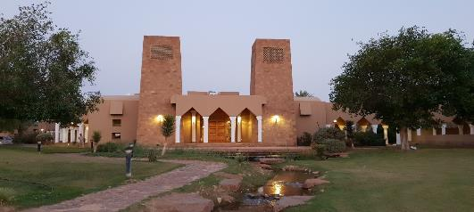
Figure 1: The main entrance of Dar Al-Rahmaniah library and the two PDEC towers

Building Information
It is apparent that the designer of the Library tried to reflect the surrounding environment in the building. The use of construction elements from the same environment, such as straw bale walls covered with earthen plaster and wooden roof structure, gives a clear expression of how the building belongs to its land. The high thermal mass of the used material could provide a cooler internal temperature of the occupied spaces. The main entrance is located on the north-west side of the building between two PDEC towers, with the left-hand tower designated as Tower A in this study and B on the right side of the entrance (Figure 1). It is apparent from the location of the Tower that the design concept is to capture the prevailing summer winds and direct them into the building. The two towers are approximately 10m high with four openings on the top. At the bottom of each Tower, there is one large opening to deliver the cool air to the occupied space. The library is mainly a large open room cooled by the two PDEC towers. Clerestories are placed in the centre of the roof facing north-eastern and south-western side. The leeward clerestory openings in the roof were designed to assure the circulation of the air inside the building. Tables 1 and 2 show the architectural details and construction specifications for the building and the Towers.
Table 1: Construction specifications for the building
 | Construction Specifications
Space height | 4.4m
Library floor area | 443 m²
External walls | 112cm total thickness: earthen plaster finish + straw bales (average size: 95 x 48 x 30cm) + earthen plaster finish
Roof | 10cm light clay straw plaster + 7cm heavy clay plaster + 2cm lime plaster finish
column | Cast in place concrete column

Table 2: PDEC Tower specifications and details for Tower A (B similar)
 | PDEC tower specifications
Tower Height | 10m
Tower cross-section Dimensions | 3.7m x 3.4m (become narrower at the top)
Wind Catcher | Four sides openings at the top (1.5m height x 2m width each)
Supply openings | One supply opening at the bottom of each tower (2m width x 1.8m height)
walls | 46cm total thickness (20cm concrete masonry + 20cm stone block)

Work schedule
Data loggers were installed in the library for more than 70 days from 21st June to the 30th Aug 2018. The recordings were set for 24 hours continuous logging each day with a logging interval of 10 minutes. The library working time is divided into two shifts from Sunday to Thursday. The first shift starts from 09:00 to 12:00 while the second shift is from 16:00 to 20:00. The PDEC Towers were set to work for 24 hours each day.

Monitoring Equipment
Four different data logging equipment were used for the monitoring of the building. The recorded parameters included external and internal dry-bulb and wet-bulb temperature, external and interior relative humidity, external wind speed and wind direction, and internal air velocity. The data logger types used in the monitoring process are explained as follows:

Kestrel 5500
The Kestrel 5500 is a weather meter that can read and record a wide range of parameters. These parameters include wind speed, wind direction, dry-bulb temperature, RH and wet-bulb temperature. The meter is easy to set up and install. This mini weather station was installed above the library roof to record different weather parameters.

Kestrel 5200
The Kestrel 5200 is like the Kestrel 5500. The most apparent difference is that the 5200 meter does not contain a compass, so it cannot read and record wind direction. However, it can record extra parameters such as evaporation rate and moisture content. The Kestrel 5200 could be used to measure internal or external weather parameters. Two Kestrel 5200 were installed at the Tower supply openings to collect the supply air conditions.

EXTECH SDL350 Thermo-Anemometer
The EXTECH SDL350 consist of two parts - the meter and a probe that contains the sensors. The meter is featured by its sensitive sensors, which can record temperature and air velocity readings at low values. The EXTECH SDL350 was chosen to record air velocity readings from within the PDEC Tower.

Rotronic HL-1D
The Rotronic HL-1D is a compact and easy to install data logger. It can record air temperature and relative humidity for a long period. Seven data loggers of this type were installed within the PDEC Tower B and the occupied spaces.

Accuracy
The specifications of the sensors are summarized in Table 3. All the loggers were new and unused, and so the factory calibrations were valid. However, to check consistency between the loggers they were all, before installation in the library, run in a closed room environment for 24 hours. Note that the minimum starting speed for the Kestrel loggers is 0.6m/s. This means that external wind speeds below 0.6m/s will be recorded as zero.
Table 3: Data loggers and sensors specifications
 | Measurement range | Accuracy | Reporting interval
Kestrel 5500 | Temp: -29 to 70°C RH: 10 to 90%, WS: 0.6 to 40m/s | Temp: ±0.5°C RH: ±2% WS: ±3%, compass: ±5° | 10 minutes
Kestrel 5200 | Temp: -29 to 70°C RH: 10 to 90% V: 0.6 to 40m/s | Temp: ±0.5°C RH: ±2% V: ±3% | 10 minutes
EXTECH SDL350 Thermo-Anenometer | Temp: 0 to 50°C V: 0.2 to 25m/s | Temp: ±0.8°C V: ±5% | 10 minutes
Rotronic HL-1D | Temp: -20 to 70°C RH: 0 to 100% | Temp: ±0.3°C RH: ±3.0% | 10 minutes

- Installation
The data loggers mentioned above were installed in different locations in the library and the PDEC towers (Figure 2, 3 and 4). All the data loggers were labelled and numbered to simplify and organise the process of installation. The schematic drawings show the position of the sensors. The mini weather station (Kestrel 5500) was installed centrally above the roof of the library. The meter was raised above the roof by approximately 1.2m. Besides, the meter was shaded as recommended by the manufacturer (Figure 5). Two Kestrel 5200 were installed at the supply openings of Tower A and B at a roughly 1.4m height from the floor. Four temperature and humidity data loggers (H1-1D) were nailed on walls in different locations within the library. These locations include near supply opening of Tower A (computer zone), near supply opening of Tower B (administration zone), the middle of the Library, and the back of the library. The height of the sensors was 1.6m, which provides an ideal position within the occupied spaces. One more H1-1D meter was installed on near the supply opening of an AC unit to collect data of the working hours of the mechanical cooling units. Two H1-1D meters were also installed within Tower B. one was at the top, 2.3m below pads, while the other was at the bottom at a 1.6m height from the floor. The anemometer was installed inside Tower B. The probe sensors were positioned centrally inside the Tower at 2.9m above the floor.

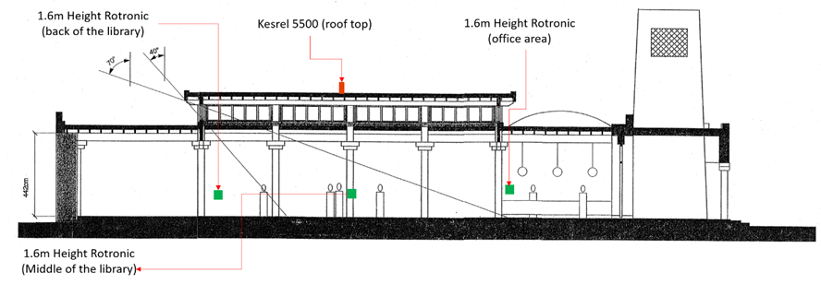
Figure 2: Section A-A

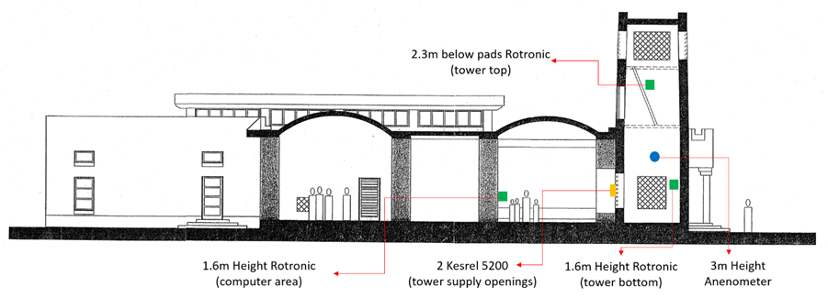
Figure 3: Section B-B

Results and Analyses
For the hot, dry climate of Saudi Arabia, the monitored performance demonstrated the ability of the PDEC system to cool the incoming air. The temperature difference between the external air and that delivered at the bottom of the PDEC towers ranged from 6°C in the early morning to 16°C during the hottest parts of the days (~3.00pm). Despite the PDEC towers providing cooling for most of the time, there was still a need for mechanical cooling as the PDEC towers could not provide enough cooling all the time. It was noted that under certain weather conditions the performance was less effective. The wind speed and wind direction played significant roles in the overall performance of the PDEC.

9.1. Wind Speed
It was apparent from the logged data that the wind speed had a direct influence on the performance of the PDEC towers. Figures 6, 7 and 8 show that the lower the wind speed then the higher the humidity levels and the greater the temperature reductions achieved. On 8th and 9th August, and during a time when the wind speed went above 4m/s, the performance of the two PDEC towers became unstable, leading to fluctuations in the supply air temperature, higher internal air temperatures, and lower humidity levels. As a result, the loss of PDEC cooling had to be offset by mechanical air conditioning, which was running during work hours. This scenario happened frequently during the 26th/27th July and 7th August. A possible explanation for this is that turbulence increased around the tower inlet opening at the top due to the higher wind speeds, as discussed by Kang and Strand (2016). This situation can be seen in the supply air velocity, which decreased during the periods of higher external wind speeds. On the other hand, during calm wind conditions, the towers performed better, leading to lower supply air temperatures.
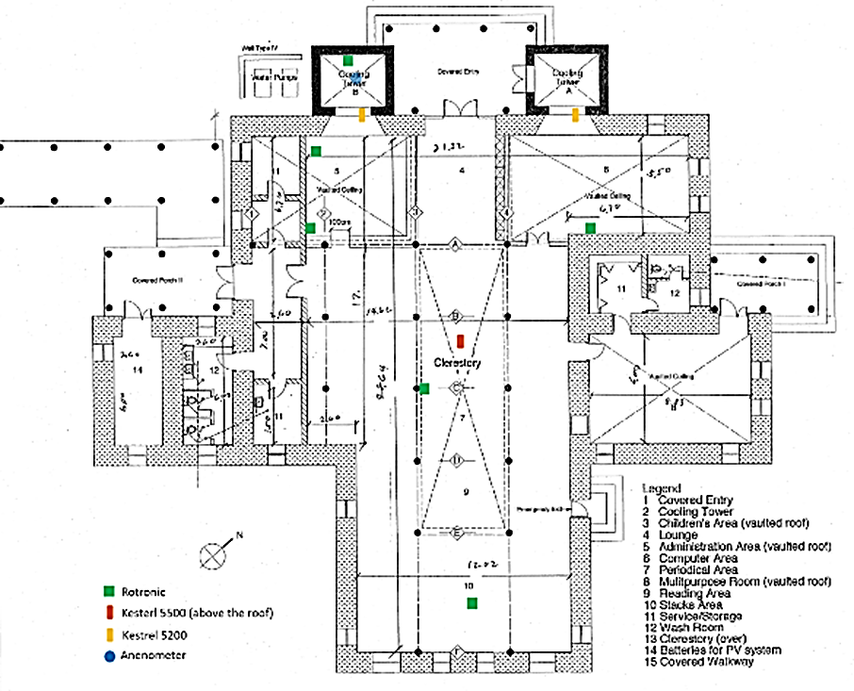
B
B
A
A

Figure 4: Library floor plan showing the location of the data loggers installed

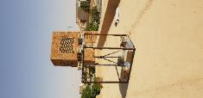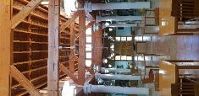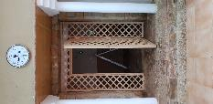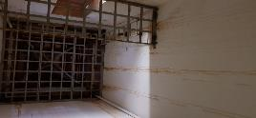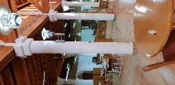
Figure 5: Pictures taken during the installation of the data loggers

9.2. Wind Direction
Although the PDEC towers produced cooled air for most of the time, specific wind directions reduced the size of the cooling of one or both PDEC towers. One finding was that the south and south-west winds had a negative influence on cooling for Tower A. It was observed that
the temperature at the tower at the supply opening went up while humidity levels dropped when winds came from south and south-west directions. This suggests that the south-western clerestory openings in the roof were allowing a positive pressure to be generated in the room that acted against the ingress of cool air from Tower A.
In Figures 9, 10 and 11, Tower B can be seen to have performed better than Tower A at specific times during the 23rd and 24th of June. The supply temperature increased, and humidity levels decreased below 50% for Tower A while Tower B was performing better, with supply temperatures going down to below 20°C at some times. This situation occurred during similar weather conditions where the wind direction bearing was approximately between 140° to 270° (SW). The same situation occurred for several days during the monitoring. These days include 11th, 12th, 13th, 17th, 21st, 22nd, and 24th July, and 2nd, 7th, 9th, 22nd August.
During calm weather, and when winds become north or north-north-west (i.e. directly on to Tower A), Tower A performed better. For these ambient conditions, Tower B’s performance dropped compared to Tower A, and the temperature at the zone near the supply opening of Tower A (computer zone) became lower than the temperature at the Tower B supply opening. Possibly, Tower B could be acting as an exhaust shaft at some points. This scenario happened during weekends or after work hours, which suggests that clerestory openings might have been closed at these times. This situation occurred on the 27th July and 8th August.
9.3 Overall Performance
The overall capacity of the PDEC towers to provide useful levels of cooling performance in the hot, arid climate of Saudi Arabia was demonstrated. Although both towers performed well most of the time, it was apparent that Tower B was more effective than Tower A (Figure 12). This finding could be linked to a couple of reasons. First, the W and SW wind direction has played a role as it was explained previously. Secondly, the layout of the Library could be a reason for that. It can be seen in the floor plan layout that the supply opening of Tower A is facing a wall that creates the computer zone within the Library main space. These obstructions could minimise the airflow from Tower A, which would lead to less performance under certain circumstances. On the other side, Tower B has a direct connection with the library open space with no obstructions.

Figure 6: Wind speed and wind direction for the 8th and 9th August.

Figure 7: External and Internal Relative Humidity during the 8th and 9th August

Figure 8: External DBT, WBT, and internal temperatures for the 8th and 9th August

Figure 11: External DBT, WBT, and internal temperatures for the 22nd – 24 June

Figure 2: Wind speed and wind direction for the 8th and 9th August.

Figure 12: External and Internal Relative Humidity during the 8th and 9th August

Figure 10: External and Internal Relative Humidity for the 22nd – 24th June

Figure 9: Wind speed and wind direction for the 22nd - 24th June

Figure 12: External DBT & WBT, and internal temperatures at Tower A and Tower B supply openings and the middle of the library during the whole monitoring period (70 days)

Conclusion
This paper has presented the analysis and results of the performance of an existing PDEC building – the Dar Al-Rahmaniah Library in Saudi Arabia. The primary objective of this case study was to quantify the actual level of cooling performance of real PDEC towers. The case study provided detailed information about the applicability of the PDEC Tower in the climate of Saudi Arabia. The findings showed that the two PDEC towers provided cooling to the building, although the degree of cooling was affected by prevailing wind speeds and directions. Limitations of the current study include the one season (summer) nature of the measurements (meaning that most winds blew from a narrow range of directions) and the fact that very low wind speeds could not be measured as the weather logger only recorded speeds above 0.6 m/s. Future work will include computer modelling of the Library and the validating of the model against the measured data. If that is successful, then detailed parametric analyses of the case study will be undertaken to provide a better understanding of PDEC performance and contribute to the future design and development of PDEC towers.

References
Abuhussain, M., Chow, D. and Sharples, S., 2018. Assessing the adaptability of the Saudi residential building`s energy code for future climate change scenarios. In: PLEA 2018, 34th International Conference on Passive and Low Energy Architecture. Hong Kong, pp. 73–78.
Alshenaifi, M. and Sharples, S., 2018. Investigating the Impact of Architectural Form and Wind Direction on the Performance of a Passive Downdraught Evaporative Cooling Tower in Saudi Arabia. In: PLEA, 34th International Conference on Passive and Low Energy Architecture. Hong Kong, pp. 294–299.
Ford, B. and Schiano-Phan, R., 2010. The Architecture and Engineering of Downdraught Cooling. PHDC Press, Bologna, Italy.
Ford, B., Patel, N., Zaveri, P. and Hewitt, M., 1998. Cooling without air conditioning: The Torrent Research Centre, Ahmedabad, India. Renewable Energy, 15: pp. 177-182
Kang, D., Strand, R.K., 2016. Significance of parameters affecting the performance of a passive down-draft evaporative cooling (PDEC) Tower with a spray system. Appl. Energy 178.
Lechner, N., 2009. Heating, Cooling, Lighting Susutainable Design Methods for Architects.
Torcellini, P. a, Deru, M., Griffith, B., Long, N., Pless, S., Judkoff, R., 2004. Lessons Learned from Field Evaluation of Six High- Performance Buildings. ACEEE Summer study energy Effic. Build.
U.S. Energy Information Adminstration (EIA), 2017. Country Analysis Brief: Saudi Arabia.

