Evaluating the effect on thermal comfort and energy use of applying the Passivhaus standard to a dwelling in a hot humid climate – a case study in Jakarta, Indonesia

**Roy Candra Sigalingging1, David Chow2 and Steve Sharples2**

1 University of Liverpool, UK, School of Architecture, correspondence email R.C.Sigalingging@Liverpool.ac.uk;

2 University of Liverpool, UK, School of Architecture

**Abstract:** Houses built in tropical countries will experience hot and humid climatic conditions, with high levels of moisture. Together with moisture builds up by occupants’ activity, ventilation for such housing will lead to very high levels of indoor relative humidity. The use of air conditioning to cool rooms and reduce relative humidity in dwellings is an energy-intensive approach but it is also energy-inefficient as the conditioned air is lost through the building envelope via ventilation and air infiltration. The German Passivhaus standard’s approach in tropical housing might be effective in preserving stable interior temperatures, nevertheless special attention is needed to the removal of excess moisture.

The objective of this research was to investigate the thermal comfort and energy-saving implications of applying Passivhaus principles to existing urban row houses in Jakarta, Indonesia. The goal was to achieve the lowest possible carbon emission building whilst maintaining a comfortable and healthy environment. The software model of the existing dwelling was built in IES software and was checked against field measurements of air temperature and relative humidity made in the house. Parametric modelling involved gradually improving insulation levels and air-tightness in the house until the Passivhaus standards were reached. Analyses of the results enabled the optimum insulation and air-tightness settings to be determined for minimizing cooling and dehumidification energy use in the air-conditioning system.

**Keywords:** Passivhaus, hot and humid climate, thermal comfort, low-carbon and low-energy cooling

# Introduction

Indonesia is Located between 6°08′ N–11°15′ S and 94°45′–141°05′ E. According to World Map of the Köppen-Geiger climate classification, Indonesia is included in the Af category, that is equatorial rainforest with fully humid zone (Kottek, Grieser, Beck, Rudolf, & Rubel, 2006). The climate in Indonesia is generally hot and humid, with a relatively small variation of temperature throughout the year. Most of the Indonesian regions experience rainfall between 1000 and 4000 mm/year, with average and maximum outdoor temperature are 26 °C and 37 °C, respectively, while the average relative humidity ranged between 73% and 100% (Santy, Matsumoto, Tsuzuki, & Susanti, 2017).

Population growth and a need for housing have contributed greatly to uncontrolled urban sprawl around the peripheries of Indonesia’s major cities (Rahadi, Wiryono, Koesrindartoto, & Syamwil, 2015). Jakarta, the capital of Indonesia, has a high demand for dwellings. The housing developments are growing mostly into the satellite city by developing new towns. ﻿These new towns mainly consist of low density, single-family houses, and exclusive residential areas for middle- and upper-income groups (Firman, 2004). The thermal performance of these houses tends to make them unsuitable for the effective use of air conditioning (AC). With houses not airtight and poorly insulated, residents tend to lower the air-conditioning temperature setting to achieve their comfort level, resulting in inefficient use of air-conditioning. The monthly average use of electricity consumption households was between 300-400kWh (Santy, Matsumoto, & Susanti, 2016). The application of simple passive cooling measures, such as glazing, shading, insulation, and natural ventilation, to these dwellings can reduce the cooling loads by up to 43% (Omer, 2008). Design principles that use natural ventilation to reduce the dependence of the cooling devices to achieved comfortable condition will provide enough fresh air in the building to keep the occupants healthy. At the same time, this fresh external air will introduce more moisture in to a house during the hot season, which is likely to increase the indoor relative humidity level.

This paper presents the application of the German Passivhaus standard to reduce domestic energy use whilst creating thermal comfort in housing built in the tropical climate of Indonesia. Analysis was done by investigating the typical housing characteristic, building performance (in this case are temperature and relative humidity), and energy consumption. The research then continued by applying the German Passivhaus standard to Indonesian dwellings in order to study the building performance and energy consumption. Passivhaus might be able to suppress the energy consumption, especially for cooling energy needs.

## Adaptive Thermal Comfort

The significance of indoor thermal comfort valuation and measurement is not only associated with achieving thermal satisfaction, but also to control energy usage and improving indoor air quality (Nicol & Humphreys, 2002). The current Indonesian national standard indicates that comfort temperature is ﻿25°C ± 1 °C and relative humidity 60% ± 10% (SNI, 2000). This number is lower than the result from researchers who has researched the comfort temperature for people in Depok area (Jakarta satellite town). The finding was a comfort temperature of ﻿27.6oC (Santy et al., 2016).

The ASHRAE Adaptive Comfort Model was developed from a global database that separated buildings into those that had mechanical system and naturally ventilated buildings (NV). Thermal comfort standards recognize that comfort depends on context. People living with air-conditioned spaces expect homogeneity and cool temperatures, while people who live in naturally ventilated buildings are used to thermal diversity. Their thermal perceptions are likely to extend over a wider range of temperatures than are currently reflected in the old ASHRAE Standard 55 comfort zone (de Dear & Brager, 2002a). The results of this adaptive comfort standard (ACS) are shown in Figure 1.

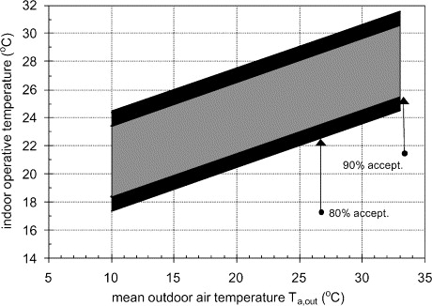

Figure 1 – Proposed adaptive comfort standard (ACS) for ASHRAE Standard 55, applicable for naturally ventilated buildings (de Dear & Brager, 2002b).

The important finding on the ASHRAE adaptive comfort standard study was the difficulty of creating generalization for areas that have mean outdoor temperatures above 23°C. The research indicated that buildings in this zone are unable to maintain thermal comfort, even as defined by the ACS model, for many hours of the day. These uncomfortable buildings came from various regions of Pakistan, Australia, Greece, Singapore, Indonesia, and Thailand (de Dear & Brager, 2002b). This is consistent with the research by Karyono, who found that there are some climatic differences between cities in the lowland and highland in Indonesia, which could lead to the difference on the people’s comfort temperature due to physical adaptation (Karyono, 2018).

## Passivhaus standard

The Passivhaus standard was established as a building concept for residential buildings in Germany. It has the main purpose to deliver excellent cost-effectiveness, especially in the case of new buildings. The German Passivhaus standard, which was originally developed to reduce winter heat losses from north European buildings, is based on the concept of an air-tight envelope. The general criteria of Passivhaus can be seen in Figure 2 (Passivhaus Institute, 2016). The achievement of the initial projects that had very low energy consumption and high thermal comfort levels, has encouraged the spread of the Passivhaus standard to other countries in Europe. The Passivhaus Institute indicate that Passivhaus certified buildings have spread throughout the world. In the database of Passivhaus compiled by iHPA, Passivhaus Institute and Affiliates, there have been thousands of single detached family houses registered as Passivhaus in the several countries, but there are none in Indonesia (Passivhaus Dienstleistung, n.d.).

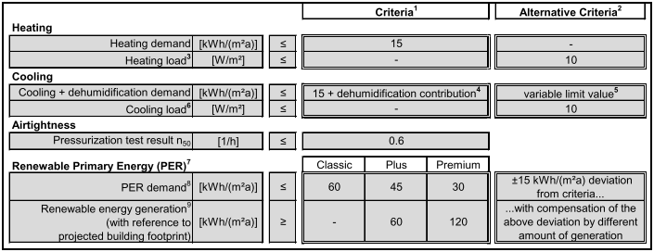Figure 2 – Passivhaus Criteria

Passivhaus buildings achieve thermal comfort by passive measures, such as high levels of insulation, excellent airtightness, good indoor air quality and minimum thermal bridges, supported by a whole house mechanical ventilation system with highly efficient heat recovery (BRE, 2017). Applying the Passivhaus building standard can preserve stable interior temperatures, but in tropical climates with high temperature and high humidity, its airtight envelope might hinder the removal of excess moisture. The Passivhaus standard application must accurately consider moisture balances and the attendant latent loads on the building with a hot and humid climate.

The cooling strategy used in the Passivhaus house built in Louisiana, southern USA, with a high humidity climate, is by using Energy Recovery Ventilators (ERV). Unlike straight heat exchangers, which are commonly used for Passivhaus building in Central Europe, ERV transfers water vapour, which prevents the air from drying out in winter months, and removes outdoor humidity during summer months (MacDonald, 2010). ERV systems transfer moisture from the incoming humid air to the outgoing stale indoor air that is being vented to the outside, making the internal humid air that produced by equipment and building user are remain inside.

# Research methodology

This paper discusses the development of a Passivhaus standard for housing built in Indonesia that work for both thermal comfort and energy efficiency. IES is a commercially available dynamic thermal simulation software. It was used to analyze the building performance of an Indonesian dwelling by creating a building model using information such as: building materials, cooling systems, lights and appliances, and presupposed occupancy schedule from the selected house. A row or terraced house was chosen because this style forms the majority of the existing urban housing stock (Badan Pusat Statistic, 2018). The chosen house is shown in Figure 3. The selected house’s area lied between 50m2 to 69m2 floor area, since this is the most prevalent size for housing in Jakarta Metropolitan Region (Sigalingging et al, 2017). A Jakarta weather file was acquired through the climate-modelling software Meteonorm (Meteotest, 2018). The empirical validation of the model designed by the IES software was determined by comparing the computer simulation results with field experiment data from a target house. This validated model was than used to explore the effects on the indoor environment when applying the Passivhaus standard to the row house, to study the energy needed to achieve thermal comfort.

## Case Study Data and monitoring result

(a)  (b) 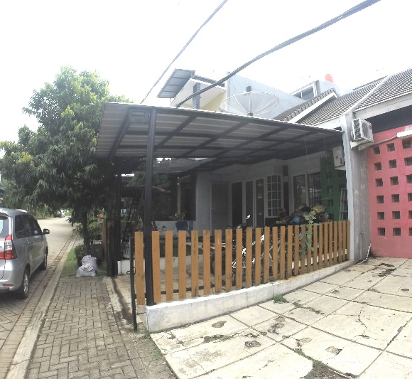

Figure 3 – The case study row house (a) floor plans, (b) exterior view

The house’s walls are made of low brick and bricks; the floor material was dominated by ceramics; roof material are tiles, and the ceiling material is gypsum. The house measures 6 m x 10 m with a total floor area of 55m2, with a floor-to-ceiling height of 2.85m. The building is oriented towards north and is not insulated. The windows material is clear glass with awning on the internal side which gives more privacy to the residences.

House monitoring was done over two periods that represented two different seasons in Indonesia: January – February for the rainy season and September – November for the hot dry season. Loggers were used to monitor the air temperature and relative humidity of two main activity locations in the selected row house (master bedroom and living room (Fig. 4)). Loggers were also used to monitor the outside air temperature and relative humidity, which were used later to validate the computer model. Two types of loggers that were used in this monitoring - Tinytag data loggers and Rotronic data loggers.

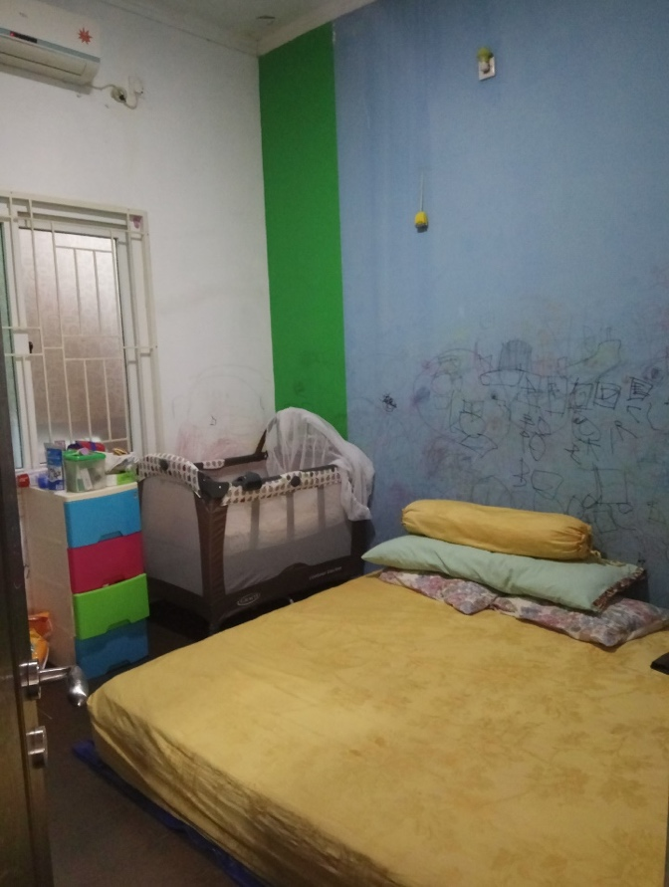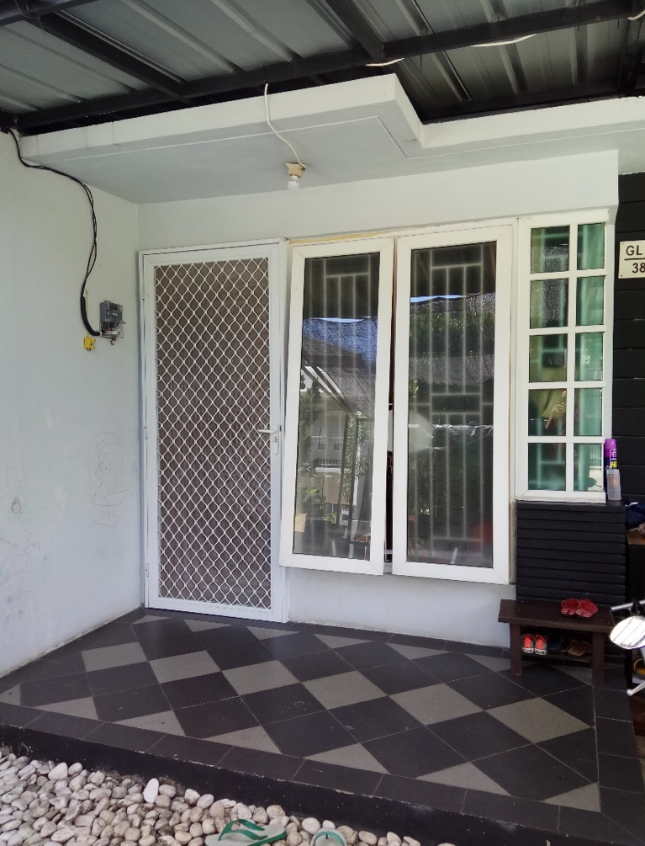

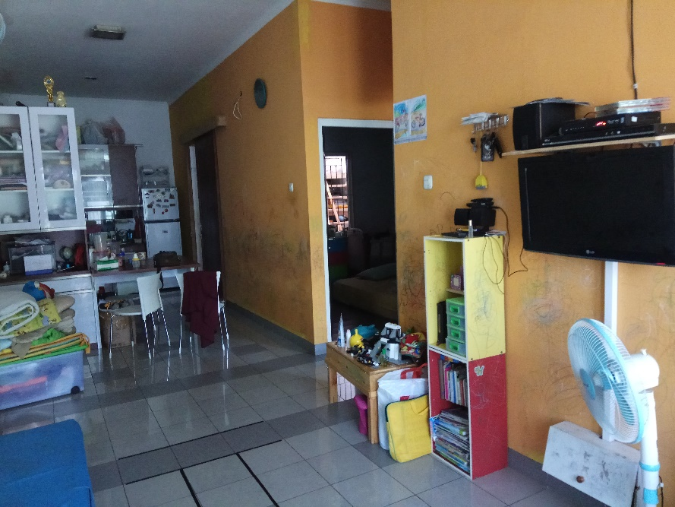

Figure 4 – Logger location in master bedroom, Living area & outdoor area

## IES VE 2018 software Validation

The whole house was modelled in three dimensions using IES VE software with the data obtained from field observations. The building shape is based on the plan provided by the home owner, building materials are from data based on the contractor’s specification, and the occupant activity schedule was gained from field observations. Measured data were used on the empirical validation of the IES VE 2018 model. The building simulation air temperature and relative humidity results will be compared with measured data. To be able to make a comparison, the modelled house was simulated in the same period as the monitoring time period. The building elements used to build the base model in IES VE 2018 can be seen in Table 1.

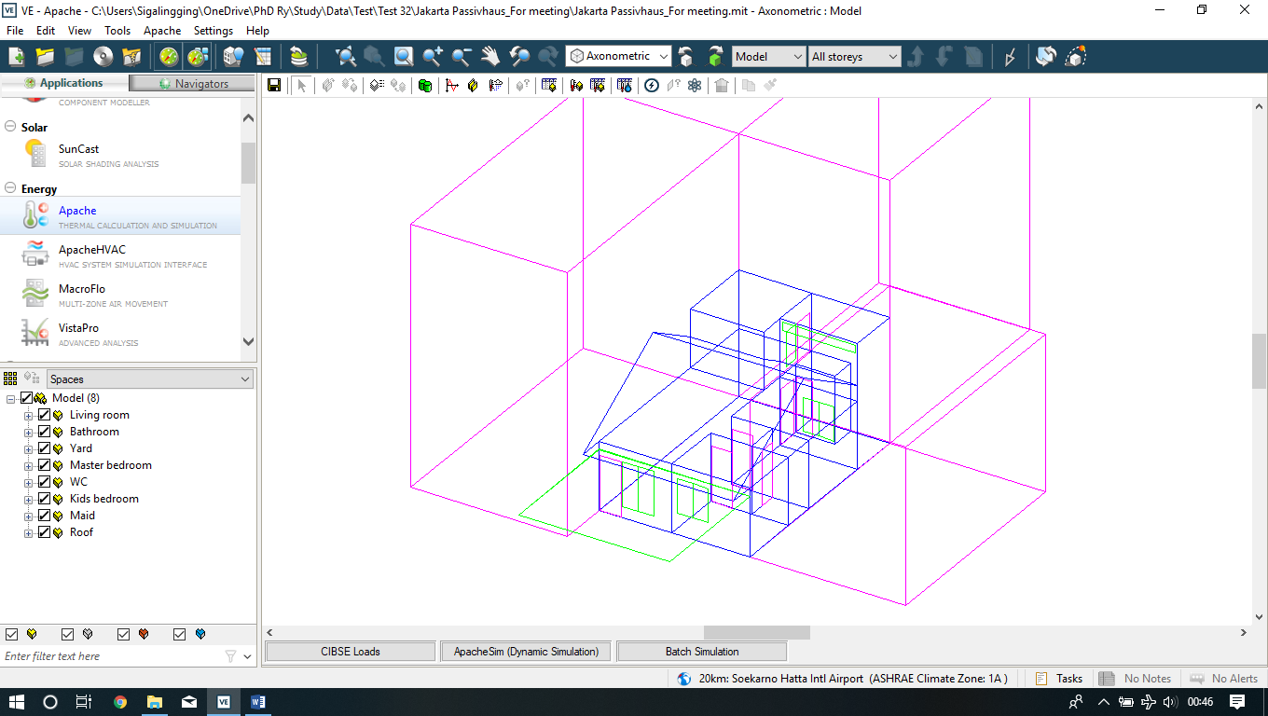

Figure 5 – IES software view

Table 1 – Factors Building elements

|  |  |
| --- | --- |
| **Building Element** | **Constructional layers** |
| External and internal walls | 25 mm thick cement plaster + 100 mm thick clay brick + 25 mm thick cement plaster |
| Party wall | 25 mm thick cement plaster + 100 mm thick clay brick + 25 mm thick cement plaster |
| Floor | 8 mm thick ceramic tile + 22 mm thick cement screed + 100 mm thick concrete slab + soil layer |
| Window | 6 mm thick single layer glass |
| Ceiling | 6 mm thick gypsum board |
| Pitched roof | 20 mm thick roof tile + 25 mm thick timber batten |
| 2nd floor slab | 22 mm thick cement screed + 100 mm thick concrete slab + 20 mm thick cement plaster |

Figure 6 – Measurements and simulation data comparison on Living room

The simulation result from the modelled house in IES VE software was then compared with measured data; the graphs can be seen in Figure 6 and Figure 7. The two main rooms discussed here are the living room and the master bedroom. The living room graph shows that the IES simulation demonstrated the identical fluctuations to the measured data, both for air temperature and relative humidity. From the graphs the air temperature differences were less than 30C, and the relative humidity differences were less than 10%. The bedroom area indicated similar results, where the air temperature of the modelled house had the same fluctuations as the measured data with only a few hours during the day showing 10C differences.

Figure 7 – Measurements and simulation data comparison on master bedroom

A more detailed inspection (Figure 8 and Figure 9) shows that the simulation temperature and relative humidity temperature has relatively the same fluctuation but with slightly differences in the few hours during the day. These differences in the living room and master bedroom results were possibly happening due to logger accuracy and software simulation accuracy. The differences were also possible from the actual sky coverage and wind speed data that were not captured on the site measurements. Other possible reasons for the temperature and humidity differences are from occupant activity that were based on typical behaviours whereas the actual conditions might be slightly different from day to day.

From this validation exercise, it could be seen that the IES VE 2018 software could be used to model the selected house. The validation process indicated that the result produced relatively similar outcomes compared with the field measurement data. The simulation results of the built model in IES VE software shows that the results were satisfactory in displaying the same trend as the measured data.

Figure 8 – One day comparison of measurements and simulation data on living room

Figure 9 – One day comparison of measurements and simulation data on master bedroom

## Evaluating Indicator

The adjustment and calibration process were conducted in accordance with the specifications of the standard ASHRAE 14‐2002 (ASHRAE, 2002). The statistic MBE represents the mean ratio of relative error between two values, as shown in Equation (1), while CV/RMSE represents the average deviation between an actual value and a predicted value as shown in Equation (3). CV/RMSE values are used to assess the differences in the simulated and observed hourly data, to evaluate the prediction accuracy of the simulation result. ASHRAE Guideline 14 defines the acceptable limits for calibration to hourly data as within ±10% MBE and≤30% CVRMSE(hourly) measured at a utilities level (ASHRAE, 2002).

$MBE=\frac{\sum_{i=1}^{N_{S}}{(y_{i}-{\hat{y}}_{i})}}{\sum_{i=1}^{Ns}{y_{i}}}$ (1)

$\hat{Y}s=\frac{\sum_{i=1}^{N_{S}}{y_{i}}}{N_{S}}$ (2)

${CVRMSE}_{(S)}$ = $\frac{\sqrt{\sum_{i=1}^{N_{S}}{\frac{{(y_{i}-{\hat{y}}_{i})}^{2}}{N_{S}}}}}{{\hat{Y}}_{S}}$ (3)

where:

* $y_{i}$: Recorded data
* ${\hat{y}}_{i}$: Simulated data
* $N_{S}$: Sample size
* ${\hat{Y}}_{S}$: Sample mean for recorded data

The evaluation results of the statistical error analysis data for the mean hourly error of measured data versus simulation result are listed in Table 2. The calculation were done for one week period. From the table it can be seen that the results of the simulation comfortably meet the acceptance criteria. The living room’s relative humidity and temperature MBE percentage are very low. The relative humidity in the master bedroom was slightly above the limit, but the temperature MBE percentage was below -1% for the master bedroom. For all measured elements the CVRMSE percentage was below the acceptable limit.

Table 2 – Statistical error data for the mean hourly error of measured data versus simulation result

|  |  |  |
| --- | --- | --- |
| **Measured element** | **MBE (%)** | **CVRMSE (%)** |
| Living room relative humidity | -5.9 | 7.5 |
| Living room Temperature | 0.3 | 3.1 |
| Master Bedroom relative humidity | -10.9 | 14.0 |
| Master Bedroom Temperature | -0.5 | 3.6 |
|  |  |  |

# Application of Passivhaus standard into modelled house

Using the validated modelled house in IES VE 2018, the Passivhaus standard was applied to the selected house. By applying Passivhaus strategies in to the modelled house, the building performance was observed. When one or more Passivhaus criteria were applied to the same building layout, shape, occupancy schedule, and climate data, the effect of Passivhaus standards on the modelled house were explored. This study analysed the effects when the Passivhaus model used air conditioning (AC) and dehumidifiers for cooling and dehumidification to try and achieve thermal comfort for the occupants. The cooling load will be studied through numerical simulation using the IES VE 2018 software program. Both scenarios (existing and Passivhaus dwelling) used the same HVAC system (AC and dehumidifier). In both simulations, AC and dehumidifier was ducted into the living room, master bedroom, and children’s bedroom. Table 3 indicates the material used in the building to correspond to the Passivhaus concept. This Passivhaus model was then used to explore the effects on the indoor environment to study how much energy was needed to bring comfort to the house.

Table 3 – Passivhaus building elements

|  |  |
| --- | --- |
| **Building Element** | **Constructional layers** |
| External and internal walls | 25 mm thick cement plaster + 100 mm thick clay brick + 100 mm XPS Extruded Polystyrene + 25 mm thick cement plaster |
| Party wall | 25 mm thick cement plaster + 100 mm thick clay brick + 100 mm XPS Extruded Polystyrene + 25 mm thick cement plaster |
| Floor | 8 mm thick ceramic tile + 22 mm thick cement screed + 100 mm thick concrete slab + Urea Formaldehyde Foam + soil layer |
| Window | 6 mm thick double layer glass |
| Ceiling | 6 mm thick gypsum board |
| Pitched roof | 20 mm thick roof tile + 25 mm thick timber batten + 100 mm MW Glass Wool (rolls) |

# Comparing the simulation results

The simulation results from the Passivhaus application to the Jakarta house can be seen in Figure 10 and Figure 11. The results show that the Passivhaus building model had air temperatures that were typically 20C lower than simulation results for the original house, although the temperatures of both scenarios were still above 280C. However, both the Passivhaus model and original house simulation results suggest relative humidities that were 60%.

Sequentially implementing Passivhaus requirements in to the housing model revealed some interesting results. By applying all the Passivhaus requirement, but without the floor insulation, the simulation showed a significant energy saving. Air temperatures for the Passivhaus application exclusive of floor insulation are shown in Figures 10 and 11. They indicate that removing floor insulation created lower temperatures in the living room and master bedroom that were maintained below 260C for the selected time period. Applying Passivhaus without floor insulation also created stable relative humidity levels below 60 %.

For the simulation, the AC was set to meet the adaptive comfort temperature for a tropical climate, which is 27.60C. With the ground temperature based in the simulation validation set around 50C lower than outdoor temperature, for the selected period there was more than 75% of the time when the ground temperatures were below the adaptive comfort level (Figure 12). This situation meant that the floor could act as a sink for the heat in the house.

Figure 10 – Hourly air temperatures comparison in living room for Passivhaus approaches and original layout.

Figure 11 – Hourly air temperatures comparison in master bedroom for Passivhaus approaches and original layout.

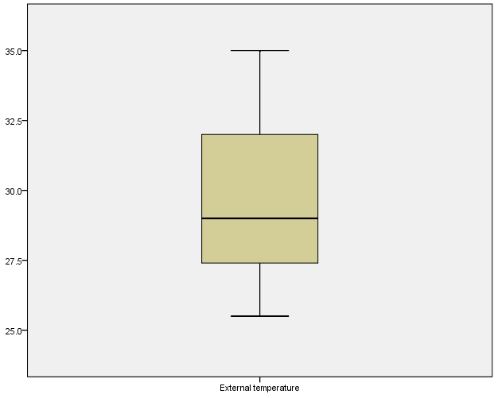

Figure 12 – Box plot of external temperature during the one-week period.

All the scenario energy consumptions were then investigated, to test how the building performance was related to the energy used. The IES simulation results reveal that annual cooling energy used in the building was 11.41 MWh for the house in its original layout, 10.89 MWh for the house if using the full Passivhaus standard and 8.61 MWh if using Passivhaus but without floor insulation. This modelling results show that the building model that applied Passivhaus concepts but excluded floor insulation had the lowest air temperatures and had relative humidities within the comfort range. This scenario also has the lowest energy consumption compare to the other scenarios (Figure 13).

Figure 13 – Yearly space cooling comparison.

# Conclusions

One building has been chosen to study the impact of applying the Passivhaus standard to a typical tropical climate dwelling in the Jakarta Metropolitan Region. Site measurements were carried out to validate the model of the house using IES VE 2018 software. The validated model was then used to study the effect of applying the Passivhaus standard by incrementally applying Passivhaus requirements into the building. Using the same building layout, shape, HVAC system, occupancy schedule, and climate data, the results showed that applying the Passivhaus standard can lower the building temperature and relative humidity to the comfort level with lower energy usage. However, the better performance was found if the Passivhaus application was used without floor insulation. But, the research has also found that to achieve comfort levels for temperature and relative humidity requires high amounts of energy, even though the number is reduced with Passivhaus applications.

# References

Ashrae. (2002). Ashrae Guide and Data Book (Fundamentals). *ASHRAE*

Badan Pusat Statistic, 2018. 2010 Population Census - Household by Region and Floor Area of Dwelling Unit - Indonesia. URL http://sp2010.bps.go.id/index.php/site/tabel?tid=333&wid=0 (accessed 10.1.18).

BRE, 2017. Passivhaus:Basic Principles. URL http://www.passivhaus.org.uk/page.jsp?id=17 (accessed 12.6.18).

de Dear, R.J., Brager, G.S., 2002. *Thermal comfort in naturally ventilated buildings: revisions to ASHRAE Standard 55*. Energy Build. 34, 549–561.

Firman, T., 2004. N*ew town development in Jakarta Metropolitan Region: A perspective of spatial segregation. Habitat Int*. 28, 349–368.

Karyono, T.H., 2018. *Thermal Comfort in Indonesia. In: Sustainable Houses and Living in the Hot-Humid Climates of Asia*. Springer Singapore, Singapore, pp. 115–121.

Kottek, M., Grieser, J., Beck, C., Rudolf, B., Rubel, F., 2006. *World Map of the Köppen-Geiger climate classification updated.* Meteorol. Zeitschrift 15, 259–263.

MacDonald, C., 2010. *Just add body heat: The new Passive Houses are so energy efficient, they make heating and cooling practically irrelevant*. E - Environ. Mag. 22–27.

Meteotest, 2018. *Meteonorm: Irradiation data for every place on Earth*. URL http://www.meteonorm.com/ (accessed 11.20.18).

Nicol, J.F., Humphreys, M.A., 2002. *Adaptive thermal comfort and sustainable thermal standards for buildings*. Energy Build. 34, 563–572.

Omer, A.M., 2008. *Renewable building energy systems and passive human comfort solutions.* Renew. Sustain. Energy Rev. 12, 1562–1587.

Passive House Institute, 2016. *Criteria for the Passive House, EnerPHit and PHI Low Energy Building Standard*. Passiv. House Inst. URL https://passipedia.org/certification/certified_passive_houses/certification_ criteria_in_other_languages (accessed 11.11.18).

Passivhaus Dienstleistung, *n.d. Gebaute Passivhaus Projekte - Beispiele Passivhäuser weltweit*. URL https://passivhausprojekte.de/#k_ (accessed 11.14.18).

Rahadi, R.A., Wiryono, S.K., Koesrindartoto, D.P., Syamwil, I.B., 2015. *Factors influencing the price of housing in Indonesia.* Int. J. Hous. Mark. Anal. 8, 169–188.

Santy, Matsumoto, H., Susanti, L., 2016. *Development of a Passive House Standard for Tropical Climates* (Indonesia) - The Initial Stage Santy#1,. CLIMA 2016 - Proc. 12th REHVA World Congr.

Santy, Matsumoto, H., Tsuzuki, K., Susanti, L., 2017. *Bioclimatic Analysis in Pre‐Design Stage of Passive  House in Indonesia*. Buildings 7, 24.

Sigalingging, R.C., Chow, D., Sharples, S., 2017. *Assessing Cooling Energy Load and Dehumidification in Housing Built to Passivhaus Standard in Jakarta, Indonesia*. In: Design to Thrive - PLEA 2017 Volume II. NCEUB 2017, p. 2165.

SNI, 2000. *Konservasi energi sistem tata udara pada bangunan* *gedung*.

1. **Acknowledgements**

We would like to thank the Indonesia Endowment Fund for Education (LPDP) who supported this study by provided full funding for the PhD student’s research.