Classification: BIOLOGICAL SCIENCES, Ecology

Disentangling the abundance-impact relationship for invasive species

Bethany A. Bradley^{1,2*}, Brittany B. Laginhas², Raj Whitlock³, Jenica M. Allen⁴, Amanda E. Bates⁵, Genevieve Bernatchez⁶, Jeffrey M. Diez⁷, Regan Early⁸, Jonathan Lenoir⁹, Montserrat Vilà¹⁰, Cascade J. B. Sorte⁶

- Department of Environmental Conservation, University of Massachusetts, Amherst MA USA 01003
- Graduate Program in Organismic & Evolutionary Biology, University of Massachusetts, Amherst MA USA 01003
- Institute of Integrative Biology, University of Liverpool, Liverpool L69 7ZB, UK
- Department of Natural Resources and the Environment, University of New Hampshire, Durham, NH 03824 USA
- Memorial University of Newfoundland, Canada
- Department of Ecology and Evolutionary Biology, University of California, Irvine CA USA 92697
- Department of Botany and Plant Sciences, University of California, Riverside, CA 92521, USA
- Centre for Ecology and Conservation, University of Exeter, Penryn Campus, UK
- UR “Ecologie et Dynamique des Systèmes Anthropisés” (EDYSAN, UMR 7058 CNRS-UPJV), Université de Picardie Jules Verne, 1 Rue des Louvels, 80037 Amiens Cedex 1, France
- Estación Biológica de Doñana (EBD-CSIC), Avda. Américo Vespucio 26, Isla de la Cartuja, 41092 Sevilla, Spain

*corresponding author: bbradley@eco.umass.edu; phone 413 545 1764; ORCID 0000-0003-4912-4971
Running head: Negative impacts of increasing invader abundance

Keywords: abundance; community ecology; density-dependence; diversity; ecological impacts; invasive species; per capita effect, response curve
Abstract
In order to predict the threat of biological invasions to native species, it is critical that we understand how increasing abundance of invasive alien species (IAS) affects native populations and communities. The form of this relationship across taxa and ecosystems is unknown, but is expected to depend strongly on the trophic position of the IAS relative to the native species. Using a global meta-analysis based on 1,258 empirical studies presented in 201 scientific publications, we assessed the shape, direction and strength of native responses to increasing invader abundance. We also tested how native responses varied with relative trophic position and for responses at the population vs. community levels. As IAS abundance increased, native populations declined non-linearly by 20%, on average, and community diversity declined linearly by 25%. When at higher trophic levels, invaders tended to cause a strong, non-linear decline in native populations and communities, with the greatest impacts occurring at low invader abundance. In contrast, invaders at the same trophic level tended to cause a linear decline in native populations and communities, while invaders at lower trophic levels had no consistent impacts. At the community level, increasing invader abundance had significantly larger effects on species evenness and diversity than on species richness. Our results show that native responses to invasion depend critically on invasive species’ abundance and trophic position. Further, these general abundance-impact relationships reveal how IAS impacts are likely to develop during the invasion process, and when to best manage them.

Significance statement
The shape (linear vs. non-linear), direction (negative vs. positive), and strength of the relationship between IAS abundance and native species diversity determines which invaders present the greatest risk to ecosystems. Yet, the form of the relationship between abundance and impact was previously unknown. Our meta-analyses reveal a strongly negative, convex relationship between invader abundance and native populations or communities when invaders are at higher trophic levels. Thus, on average, invasive species’ impacts are strongest at low invader abundance, highlighting the need for proactive policies to prevent introduction and eradicate early infestations. When invaders are at the same trophic levels, their impacts tended to be negative and linear, suggesting that treatment could benefit native communities regardless of invasion stage.
Introduction
Invasive alien species (IAS) have negative effects on native species populations (i.e., decreased population sizes) and communities (i.e., reduction in species diversity). These negative impacts have been observed for many invasive alien taxa and across ecosystems (1–5). However, previous syntheses have assessed the effect of invader presence/absence without considering how impact might change with increasing invader abundance. As a result, the general shape of the relationship between invader abundance and native population or community response remains unknown. Understanding how invader impacts change with abundance is critical for predicting the severity of the impacts across recipient ecosystems (3, 6, 7), assessing the costs and benefits of treatment (8, 9) and prioritizing management actions (10).
Frameworks for assessing IAS impacts typically rely on assumed relationships between invader abundance and impact. For example, Parker et al. (11) proposed that an invader’s impacts are a function of its total range, abundance, and per capita effect (I=R*A*E). This equation specifies that impacts increase linearly with abundance, with no density-dependent relationship between abundance and per capita effect. Later impacts frameworks explicitly hypothesized density-dependent relationships, with impacts increasing or decreasing non-linearly with invader abundance (12, 13). The variety of possible relationships between abundance and impact highlights the strong need for an empirical assessment of this fundamental question across taxa (8). Moreover, it is unknown whether relationships between abundance and impact depend on the trophic positions of invading and native species. One review of invasive impacts studies concluded that there was no clear effect of trophic position on impacts (14), while another meta-analysis focused on marine ecosystems suggested that impacts on native species switched from positive to negative if invaders were in lower vs. higher trophic levels, respectively (4).
Classical ecological theory suggests that when an invasive alien species is at a higher trophic level than a native species, the invader is likely to cause a strong non-linear decline in the native species population due to density dependence and a number of processes that alter the per capita effects of the invasive species (Figure 1A) (15, 16). For example, the introduction of a novel alien predator or herbivore can lead to rapid decreases in native prey or plant population sizes (14, 17). Following this initial decline, native populations might later stabilize at lower sizes by persisting in refuges, through adaptation (evolution, phenotypic or behavioral plasticity), or by reaching a lower carrying capacity balanced by immigration of new individuals. These responses would result in a non-linear relationship between invader abundance and native population size. For example, Benkwitt (18) observed a non-linear decline in sizes of native fish populations following the introduction of the predatory invasive lionfish (Pterois volitans) in the Caribbean. Impacts at the community level are also hypothesized to be stronger when the IAS is at a higher trophic level than the invaded native species assemblage (19, 20), but the general shape of the relationship is unknown.
When an invasive alien species is at the same trophic level as a native species, the invader could cause either a linear or non-linear decline in the native species population size (Figure 1B). Competition is the main mechanism for IAS impact when invasive and native species occupy the same trophic level (21). The impacts of competition could be linear if per capita competitive effects are not density-dependent. However, field studies have also shown that competition can be density-dependent, leading to non-linear declines in native species population sizes (22). Impacts at the community level for IAS at the same trophic level vary with the spatial scale of analysis (23), but the shape of the response relative to invader abundance is unknown.
Finally, when an invasive alien species is at a lower trophic level than a native species, the relationship between invader abundance and native species population size could be positive or negative (Figure 1C). The direction of this relationship depends on whether the IAS acts as a novel resource for the native species or reduces resources upon which the native species depends. Previous meta-analyses of invader presence vs. absence suggest that negative impacts may be more likely. For example, the presence of invasive alien plants reduces the abundance of native animals (5), particularly native herbivorous insects (24), which are often specialists of native plants (25). Similarly, invasive primary producers in freshwater systems can have a negative effect on native fish (2), likely by disrupting access to resources. The direction of native community-level responses to IAS at lower trophic levels is even less clear. Previous meta-analyses in marine and freshwater ecosystems have found that invaders at lower trophic levels tended to increase (4) or have no significant overall effect on (2) the diversity of benthic invertebrates at higher trophic levels. Thus, impacts at the community level for IAS at lower trophic levels remain poorly understood.
Here, we present the first global meta-analysis of responses of native species and communities to gradients of IAS abundance, quantifying the direction, strength and shape of this relationship for different trophic interactions. We develop generalizations based on comprehensive empirical evidence of how the abundance-impact relationship varies between a) native population and community responses (e.g., individual species abundance vs. species diversity), b) invader taxon (plant, animal), and c) recipient habitat (freshwater, terrestrial, marine). This analysis of abundance-impact relationships across ecosystems provides a key test of ecological theory related to species and community-level responses to novel species interactions.
Methods
Literature search
We searched the Web of Science core collection for all records through 12/31/2016. Our search terms (Appendix 1) were chosen to identify papers that focused on the impacts of IAS on native populations or communities and that contained information on the abundance or density of the IAS. We assessed the titles of the 7,557 returned papers for those reporting native impacts of an IAS across an abundance gradient. We reviewed the 490 resulting papers to identify those that fit the following criteria: 1) it was either explicit or likely that the native response was caused by the IAS, 2) the paper presented at least four IAS abundance values and corresponding native response values such that shape could be measured, and 3) the paper included empirical data.
The vast majority of relevant papers focused on single IAS, but we also included papers that involved multiple IAS. We only considered papers where the response variable(s) measured native species abundance (biomass, cover, density, or proportion) and/or measured native community response (Shannon diversity, species richness or Pielou evenness). We included observational studies across space (spatial; measurements along an IAS abundance gradient) or over an invasion time series (temporal; IAS abundance changing over time) as well as experimental manipulations of IAS abundance.
Data extraction
Where empirical data were presented graphically, we used the Web Plot Digitizer application (http://arohatgi.info/WebPlotDigitizer/app/) to extract values. If the data were transformed, we back-transformed them. When the raw empirical data were not presented in full, we emailed corresponding authors to request them. When possible, we calculated Shannon diversity and Pielou evenness from abundance and species richness data. Where papers presented multiple datasets, or multiple combinations of IAS abundance and native responses, we extracted these as distinct datasets (hereafter, studies), such that single papers could contribute multiple studies to our analysis.
Data categorization
We extracted trophic relationships between the IAS and native species or community from the paper or sources cited within the paper. Trophic categories included ‘Same’ when the native and IAS occupied the same trophic level; ‘Lower’ when the IAS was at a lower trophic level than the native; and ‘Higher’, when the IAS was at a higher trophic level than the native. When trophic information was not reported, we categorized some interactions based on kingdom (e.g., invasive plant vs. native plant was always ‘Same’; invasive plant vs. native animal was always ‘Lower’). For studies of invasive alien animal vs. native animal with no trophic information presented in the paper, we used a Google Scholar search for the IAS as well as ‘diet’ or ‘feed’ to identify the relative trophic position of the IAS. In cases where the invasive and native animals were fish, we also searched for trophic status in FishBase (www.fishbase.org). Species whose trophic position changed during their life cycle (e.g., fish can switch from competitors at juvenile stages to predators as adults) and species with unknown trophic positions were excluded from the trophic analyses.
In addition to trophic level, we analyzed the results by invader taxon (plant, animal), habitat (terrestrial, freshwater, marine) and study type (spatial, temporal, experimental). Marine algae were categorized as plants. Wetland plants were considered terrestrial, with only floating plants considered freshwater or marine. Experimental studies that took place over space or time were categorized as experimental. Observational studies over both space and time were categorized as multiple.
Meta-analysis
We used two complementary meta-analyses to evaluate the relationship between IAS abundance and native species’ responses at the population and community level. Results from both meta-analyses were used to determine the direction and strength of linear and polynomial components to the invasive abundance–native response relationship. Results from the second meta-analysis were additionally used to reconstruct the average shape of this relationship. Both meta-analyses used a regression model to extract information on response direction, strength and shape (curvature) from the raw IAS abundance–native response data:
y = β₀ + β_{linear}x + β_{poly}x² (Eqn 1)
where y was the native response, x was the IAS abundance, β₀ was the intercept, β_{linear} was the linear regression term, and β_{poly} was the second-order polynomial regression term. The regression model was fit separately to raw data for each study.
The first meta-analysis derived effect sizes from Fisher-transformed partial correlation coefficients associated with each regression term from Equation 1, following (26; hereafter, partial-r meta-analysis):
r = 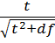 (Eqn 2)
Effect size = 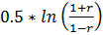 (Eqn 3; Fisher transformation)
where r is the partial correlation coefficient for one of the regression terms in Equation 1 (β_{linear} or β_{poly}), t is the corresponding model t-value, and df are the degrees of freedom associated with the same regression coefficient (26). Partial-r effect sizes were calculated separately for the linear and polynomial terms in Eqn 1, for each study. Effect size measurement error variance (mev) was calculated as 1/ (n − 3), where n is the sample size for a study (27). We mean-centered the IAS abundance (x) for each study before fitting Equation 1. Repositioning of the x-axis to a mean of zero has no impact on invasive abundance–native response shape, but limited dependence between linear and polynomial effect sizes within studies (28). Meta-analysis of the partial-r effect sizes allowed us to determine the strength and direction of linear and polynomial components of the regression fit.
The second meta-analysis derived effect sizes from the three regression terms (β) in Equation 1 (hereafter, slopes meta-analysis). However, an analysis of regression terms requires that IAS abundance and native responses (x and y variables) be on a comparable scale (regression terms are scale dependent 29, 30). Thus, we rescaled the raw data (both invasive abundance, x and native responses, y) by dividing by the maximum raw data value to create a scale of 0-1. We then mean-centered the rescaled IAS abundance values, as before, prior to analysis using Eqn 1 to generate three regression-term effect sizes (β₀, β_{linear}, β_{poly}). We used the regression-model-reported standard error for each regression term as an estimate of effect size mev (30). Results from the slopes meta-analysis were used to determine the shape of the relationship between IAS abundance and native responses, and provided an additional test of the magnitude of linear and polynomial regression terms (Appendix 1).
Bayesian mixed-effects models (MCMCglmm in R version 3.5.1 31, 32) were used for all meta-analyses of the IAS–native response relationship, and to test for variation in invasive impacts among different trophic categories, between community- and population-level responses, in different habitats, and between invasive animals and plants. Full analytical details are presented in Appendix 1.
Data availability
Citations of papers analyzed in this meta-analysis are presented in Appendix 2. R code and data sheets are available at DOI: (Files will be archived on UMass Scholarworks pending manuscript acceptance and linked here).
Results
We analyzed data from 1,258 unique case studies reported in 201 papers. Of the papers included in the dataset, 94 evaluated invasive plants and 107 evaluated invasive animals (Table S3.1). Almost all of the plant studies were terrestrial, whereas studies of invasive alien animals were well distributed across habitat types. Spatially, most of the data were collected in North America, Europe, Australia or New Zealand (Figure S3.1). This pattern is consistent with known biases in the invasion ecology literature (33), but the studies nonetheless encompass a broad range of alien taxa across habitat types.
Native responses to IAS abundance at the population level had a significantly negative linear component but a significantly positive polynomial component, resulting in a non-linear relationship with the most rapid rate of decline in native populations occurring at low invader abundance (Figure 2A,B; summary statistics for model contrasts are given in Table S3.2). Native species populations declined by an average of 20% as IAS abundance increased (Figure 2 B). Native responses to IAS at the community level also had a significantly negative linear component, but no significant polynomial component, resulting in a negative linear shape (Figure 2C,D). Native community diversity declined by an average of 25% as IAS abundance increased (Figure 2D).
Abundance-impact relationships varied substantially and significantly depending on the relative trophic positions of the invasive and native species (Figure 3). When IAS were at a higher trophic level, their impacts on native species populations and communities were strongly negative and non-linear (Figure 3A,D). As IAS at higher trophic levels increased in abundance, there was, on average, a decline of 44% for native populations and 52% for native community-level diversity (Figure 3 A,D). However, both linear and polynomial components to invasive impact shape weakened strongly and significantly as IAS trophic position shifted from higher to below (Figure 3). Native population and community responses declined on average by 19.7% and 27.8%, respectively, when IAS were on the same trophic level. IAS impacts at the same trophic level were significantly negative and non-linear for native populations (Figure 3B), while their impacts on communities were significantly negative and linear (Figure 3E). When IAS were at a lower trophic level, they had no consistent impact on native species or communities (Figure 3C,F).
At the community level, increasing invader abundance had a significant negative effect on native species’ richness, Shannon diversity, and Pielou evenness (Figure 4; Figure S3.2). Although species richness was by far the most commonly reported diversity metric (85 papers, 218 studies), linear impacts were significantly more negative for native species evenness (p=0.004) and diversity (p=0.04; Figure 4). On average (across all trophic categories) there were no significant community-level polynomial components to the IAS abundance–native response relationship. However, species richness showed a marginally non-significant negative polynomial term (p=0.052; impacts on richness were more likely to be weakest at low invader abundance) and the polynomial term for richness was significantly lower than that for evenness (p=0.01; Figure 4).
Compared with trophic position, recipient habitat (terrestrial, freshwater or marine) explained little variation in the impacts of IAS on native species and communities (Figure S3.3). IAS at higher trophic levels generally had strongly negative, non-linear effects on native species and communities regardless of habitat type. IAS responses in freshwater habitats had the strongest convex curvature; polynomial terms were significant in all IAS trophic positions except below. IAS impacts were weakest in marine habitats. Nonetheless, the shape of native impacts was dominated by the effects of trophic position, with strongly weakening linear and polynomial effect sizes from high to low IAS trophic position.
Responses of native species and communities to IAS abundance varied depending on invader taxon (animals and plants; Figure S3.4). Native response shapes for plants and animals were broadly comparable, except when IAS and responding native species were on the same trophic level. Invasive animals and plants at the same trophic level both drove negative impacts in native species, but responses to invasive animals were significantly convex, while those to invasive plants were significantly linear. At lower trophic levels, native responses to invasive animals and plants were weaker. Here, invasive animals had no consistent impacts, but invasive plants had a small but significant negative linear effect (partial-r p=0.002; Figures S3.4). Linear effect sizes did not vary significantly among study types (spatial, temporal, experimental studies; Figure S3.5).
Discussion
Our global meta-analysis is the first to quantify general trends in the direction, shape and strength of the relationship between IAS abundance and native response across trophic levels, invader taxon and recipient habitat. Negative impacts of IAS clearly predominate across terrestrial, freshwater, and marine habitats, and are caused by both animal and plant invaders. Negative impacts are common when IAS are at higher or the same trophic level as native species, and native population or community declines of 20-25% were typical on average. Across different IAS–native trophic interactions, invader taxon, and recipient habitat, there were no general trends of invader abundance having a positive effect on native populations or communities. Our results also show that native responses to IAS can be strongly non-linear (convex), suggesting that impacts are strongest at low levels of IAS abundance during the earliest stages of invasion.
When IAS were at higher trophic levels, impacts were consistently non-linear for both native populations and communities (Figure 3A,D). A non-linear effect on native species populations is supported by ecological theory of predator-prey interactions (Figure 1A). IAS at higher trophic levels are also thought to have stronger effects on native communities than those at other trophic levels (19). However, a general non-linear effect on native communities has not been previously described. Low invader abundance is most likely to occur early in the invasion process. Thus, early detection and rapid response to new invasions (34, 35) will be most effective for reducing impacts of invasive animals, because they are most likely to impose non-linear effects on recipient habitats (Figure S3.4A,B). Similarly, eradicating animal invaders, such as alien mammals on islands (36), is a much more effective means of supporting native species than reducing the populations of abundant animal invaders. If eradication is not possible, our results suggest that once IAS at higher trophic levels reach high abundance, management will be less effective for mitigating impacts.
When IAS were at the same trophic level as natives, our results highlight a consistent, negative impact on both populations and communities (Figure 3B,E). The negative, linear effect suggests that the per capita impacts of these IAS are generally not density dependent. However, our results also suggest that non-linear responses to invaders at the same trophic level are more likely when the native response is at the population level (Figure 3B), in freshwater habitat (Figure S3.3E) and when the IAS is an animal (Figure S3.4B). Density-dependent competition is common in animal species (37). Density-dependent competition has also been observed for plant species (13, 22), but was not evident in our analysis (Figure S3.4D). Thus, density dependent relationships between an invasive and native species at the same trophic level are most likely to occur when the invader is an animal. Our results are also the first to suggest that IAS can precipitate negative, linear effects on native communities at the same trophic level (Figure 3E). For IAS mainly interacting with native communities on the same trophic level (e.g., as competitors), management aimed at reducing IAS abundance could be effective for promoting community diversity at any stage of invasion, especially where those invasive species are plants.
We did not find consistent or significant relationships between IAS abundance and native population or community responses when IAS were at a lower trophic level (Figure 3C, F). Previous meta-analyses have suggested that IAS impacts can cascade from low up to higher trophic levels (2, 5, 24), which could be due to a loss of native resources. For example, native insects tend to be specialists (25); thus, competitive suppression of native plants by invasive alien plants is likely to negatively affect native insects and potentially animals at higher trophic levels that feed on insects (24). In contrast to Thomsen et al. (4), on average we found no consistent impacts of IAS at lower trophic levels in marine habitats (Figure S3.3I). Some marine IAS are foundation species that create new habitat structure, which can increase space and physical resources for native species (38). As with those for other habitats, our results for marine systems suggests that there may be high variance in realized impacts when IAS are at low trophic positions, and no consistent response direction (Figure S3.3I). Overall, the lack of significant positive effects and presence of several weak but significant negative effects suggests that on balance, IAS at lower trophic levels tend to remove resources for native consumers rather than add them. Appropriate IAS management strategies when IAS are at lower trophic positions are likely to be system specific. However, we suggest that management of invasive abundance at any stage of invasion may provide some benefit for native species at higher trophic levels.
Our analysis highlights a consistent, negative effect of IAS abundance across all three community-level metrics (Figure 4). These results contrast with previous findings of increased community richness due to the addition of alien species (39). However, Sax & Gaines (39) focused on the establishment phase of invasion, prior to spread and impact (e.g., 40). Our results show that as invaders become more abundant, community-level impacts are clearly negative. This negative effect was significantly stronger for evenness and diversity than for richness. Species richness is a conservative measure of community-level changes, requiring species extinctions or additions to register change. Metapopulation models of invasive alien plants suggest that they could take hundreds of years to cause extinctions (i.e., a decline in species richness; (7). Our results also suggest that community evenness is likely to decline predominantly linearly whereas richness is more likely to decline more slowly early in the invasion process and more rapidly, later, at high invader abundance (negative polynomial; Figure 4; Figure S3.2). This pattern may be due to a tendency of invasive species to affect common native species early in the invasion process, and rare native species only later (41). While extinctions leading to lower richness may not be apparent until later stages of invasion, changes in species abundance and therefore evenness may occur more quickly and appear to be more sensitive metrics of community change (Figure 4).
In conclusion, regardless of trophic level, taxon, or recipient habitat, we found that increasing the abundance of IAS has pronounced negative impacts on native species populations and communities. In many cases, negative, strongly non-linear relationships suggest that rapid declines in native species’ population sizes can occur at initial stages of the invasion process. The presence of non-linear relationships highlights the increasing need for early detection and rapid response (EDRR) to new IAS (34). EDRR is cost-effective (42) and the only point at which eradication is feasible (43). Increasing trade (44), disturbance (45), and climate change (46) make it likely that IAS will continue to be introduced. Avoiding the ecological impacts of invasive species will require a much stronger commitment to proactive policies designed to prevent novel introductions (45) as well as increased management targeting the early stages of invasion.
Author contributions
BAB, RW, JMD, AEB, and CJBS designed research with contributions from all authors. All authors reviewed titles and abstracts or compiled data on trophic interactions between invaders and natives. BAB, CJBS, BL, and GB extracted/compiled data. RW designed and implemented the meta-analysis framework. BAB, JMA and RW analyzed the data. BAB led the writing with contributions from all authors.

Acknowledgements
We thank E. Beaury, D. Blumenthal, J. Dukes, J. Finn, J. Gill, D. Goldberg, and T. Morelli for valuable discussions. C. Karounos and T. Cross assisted with initial data extraction. This work was initiated at a working group supported by the Albert & Elaine Borchard Foundation and led by CJBS, BAB, AEB and RE. BAB gratefully acknowledges the hospitality of D. Richardson and the Centre for Invasion Biology at Stellenbosch University during an academic sabbatical. MV thanks funding from the projects IMPLANTIN (CGL2015-65346-R) of the Spanish Ministerio de Ciencia, Innovación y Universidades, and i-LINK-1198 from CSIC.
Citations
1. Cameron EK, Vilà M, Cabeza M (2016) Global meta-analysis of the impacts of terrestrial invertebrate invaders on species, communities and ecosystems. Glob Ecol Biogeogr 25(5):596–606.
2. Gallardo B, Clavero M, Sánchez MI, Vilà M (2016) Global ecological impacts of invasive species in aquatic ecosystems. Glob Change Biol 22(1):151–163.
3. Thomsen MS, Olden JD, Wernberg T, Griffin JN, Silliman BR (2011) A broad framework to organize and compare ecological invasion impacts. Environ Res 111(7):899–908.
4. Thomsen MS, et al. (2014) Impacts of marine invaders on biodiversity depend on trophic position and functional similarity. Mar Ecol Prog Ser 495:39–47.
5. Vilà M, et al. (2011) Ecological impacts of invasive alien plants: a meta-analysis of their effects on species, communities and ecosystems. Ecol Lett 14(7):702–708.
6. Cassey P, Blackburn TM, Lockwood JL, Sax DF (2006) A stochastic model for integrating changes in species richness and community similarity across spatial scales. Oikos 115(2):207–218.
7. Gilbert B, Levine JM (2013) Plant invasions and extinction debts. Proc Natl Acad Sci:201212375.
8. Sofaer HR, Jarnevich CS, Pearse IS (2018) The relationship between invader abundance and impact. Ecosphere 9(9):e02415.
9. Yokomizo H, Possingham HP, Thomas MB, Buckley YM (2009) Managing the impact of invasive species: the value of knowing the density–impact curve. Ecol Appl 19(2):376–386.
10. Byers JE, et al. (2002) Directing Research to Reduce the Impacts of Nonindigenous Species. Conserv Biol 16(3):630–640.
11. Parker IM, et al. (1999) Impact: Toward a framework for understanding the ecological effects of invaders. Biol Invasions 1(1):3–19.
12. Thiele J, Kollmann J, Markussen B, Otte A (2010) Impact assessment revisited: improving the theoretical basis for management of invasive alien species. Biol Invasions 12(7):2025–2035.
13. Barney JN, Tekiela DR, Dollete ES, Tomasek BJ (2013) What is the “real” impact of invasive plant species? Front Ecol Environ 11(6):322–329.
14. Ricciardi A, Hoopes MF, Marchetti MP, Lockwood JL (2013) Progress toward understanding the ecological impacts of nonnative species. Ecol Monogr 83(3):263–282.
15. Lotka AJ (1925) Elements of physical biology (Williams & WIlkins, Baltimore, Maryland, USA).
16. Volterra V (1926) Fluctuations in the Abundance of a Species considered Mathematically¹. Nature 118:558–560.
17. Strayer DL (2010) Alien species in fresh waters: ecological effects, interactions with other stressors, and prospects for the future. Freshw Biol 55(s1):152–174.
18. Benkwitt CE (2015) Non-linear effects of invasive lionfish density on native coral-reef fish communities. Biol Invasions 17(5):1383–1395.
19. Moyle PB, Light T (1996) Biological invasions of fresh water: Empirical rules and assembly theory. Biol Conserv 78(1–2):149–161.
20. Estes JA, et al. (2011) Trophic Downgrading of Planet Earth. Science 333(6040):301–306.
21. Levine JM, et al. (2003) Mechanisms underlying the impacts of exotic plant invasions. Proc R Soc Lond B Biol Sci 270(1517):775–781.
22. Law R, Watkinson AR (1987) Response-Surface Analysis of Two-Species Competition: An Experiment on Phleum Arenarium and Vulpia Fasciculata. J Ecol 75(3):871–886.
23. Powell KI, Chase JM, Knight TM (2011) A synthesis of plant invasion effects on biodiversity across spatial scales. Am J Bot 98(3):539–548.
24. Litt AR, Cord EE, Fulbright TE, Schuster GL (2014) Effects of Invasive Plants on Arthropods. Conserv Biol 28(6):1532–1549.
25. Tallamy DW (2004) Do Alien Plants Reduce Insect Biomass? Conserv Biol 18(6):1689–1692.
26. Nakagawa S, Cuthill IC (2007) Effect size, confidence interval and statistical significance: a practical guide for biologists. Biol Rev 82(4):591–605.
27. Borenstein M, Hedges LV, Higgins JPT, Rothstein HR (2011) Introduction to Meta-Analysis (John Wiley & Sons).
28. Schielzeth H (2010) Simple means to improve the interpretability of regression coefficients. Methods Ecol Evol 1(2):103–113.
29. Becker BJ, Wu M-J (2007) The Synthesis of Regression Slopes in Meta-Analysis. Stat Sci 22(3):414–429.
30. Koricheva J, Gurevitch J, Mengersen K (2013) Handbook of Meta-analysis in Ecology and Evolution (Princeton University Press).
31. R Core Team (2018) R: A Language and Environment for Statistical Computing. (R Foundation for Statistical Computing, Vienna.) Available at: https://www.R-project.org.
32. Hadfield JD (2010) MCMC methods for multi-response generalized linear mixed models: the MCMCglmm R package. J Stat Softw 33:1–22.
33. Hulme PE, et al. (2013) Bias and error in understanding plant invasion impacts. Trends Ecol Evol 28(4):212–218.
34. Westbrooks RG (2004) New Approaches for Early Detection and Rapid Response to Invasive Plants in the United States. Weed Technol 18(sp1):1468–1471.
35. Crall AW, et al. (2012) Developing cost-effective early detection networks for regional invasions. Biol Invasions 14(12):2461–2469.
36. Courchamp F, Chapuis J-L, Pascal M (2003) Mammal invaders on islands: impact, control and control impact. Biol Rev 78(3):347–383.
37. Hairston NG, Smith FE, Slobodkin LB (1960) Community Structure, Population Control, and Competition. Am Nat 94(879):421–425.
38. Gutiérrez JL (2017) Modification of Habitat Quality by Non-native Species. Impact of Biological Invasions on Ecosystem Services, Invading Nature - Springer Series in Invasion Ecology., eds Vilà M, Hulme PE (Springer International Publishing, Cham), pp 33–47.
39. Sax DF, Gaines SD (2003) Species diversity: from global decreases to local increases. Trends Ecol Evol 18(11):561–566.
40. Theoharides KA, Dukes JS (2007) Plant invasion across space and time: factors affecting nonindigenous species success during four stages of invasion. New Phytol 176(2):256–273.
41. Powell KI, Chase JM, Knight TM (2013) Invasive Plants Have Scale-Dependent Effects on Diversity by Altering Species-Area Relationships. Science 339(6117):316–318.
42. Leung B, et al. (2002) An ounce of prevention or a pound of cure: bioeconomic risk analysis of invasive species. Proc R Soc Lond B Biol Sci 269(1508):2407–2413.
43. Rejmanek M, Pitcairn MJ (2002) When is eradication of exotic pest plants a realistic goal? Turning the Tide: The Eradication of Invasive Species : Proceedings of the International Conference on Eradication of Island Invasives, eds Veitch CR, Clout MN (IUCN).
44. Bradley BA, et al. (2012) Global change, global trade, and the next wave of plant invasions. Front Ecol Environ 10(1):20–28.
45. Early R, et al. (2016) Global threats from invasive alien species in the twenty-first century and national response capacities. Nat Commun 7:12485.
46. Allen JM, Bradley BA (2016) Out of the weeds? Reduced plant invasion risk with climate change in the continental United States. Biol Conserv 203:306–312.

Figure legends
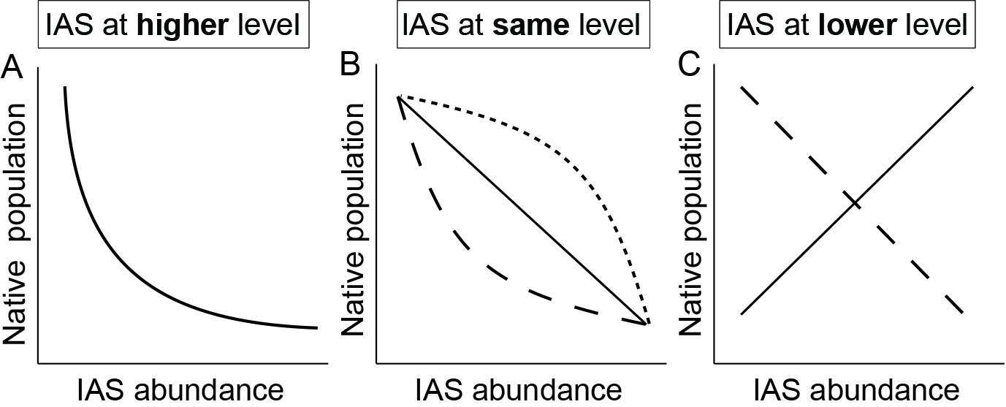
Figure 1. Hypothesized relationships between IAS abundance and native species’ population response. A) IAS at higher trophic levels could prey upon natives, leading to a non-linear decline of native species population sizes. B) IAS at the same trophic level could compete with natives, leading to a linear decline (solid line) if competition is independent of density, or a non-linear decline (dashed lines) if competition is density-dependent. C) IAS at lower trophic levels could provide food or habitat resources, leading to a linear population increase (solid line), or could reduce resources for native species, leading to a linear decrease (dashed line).

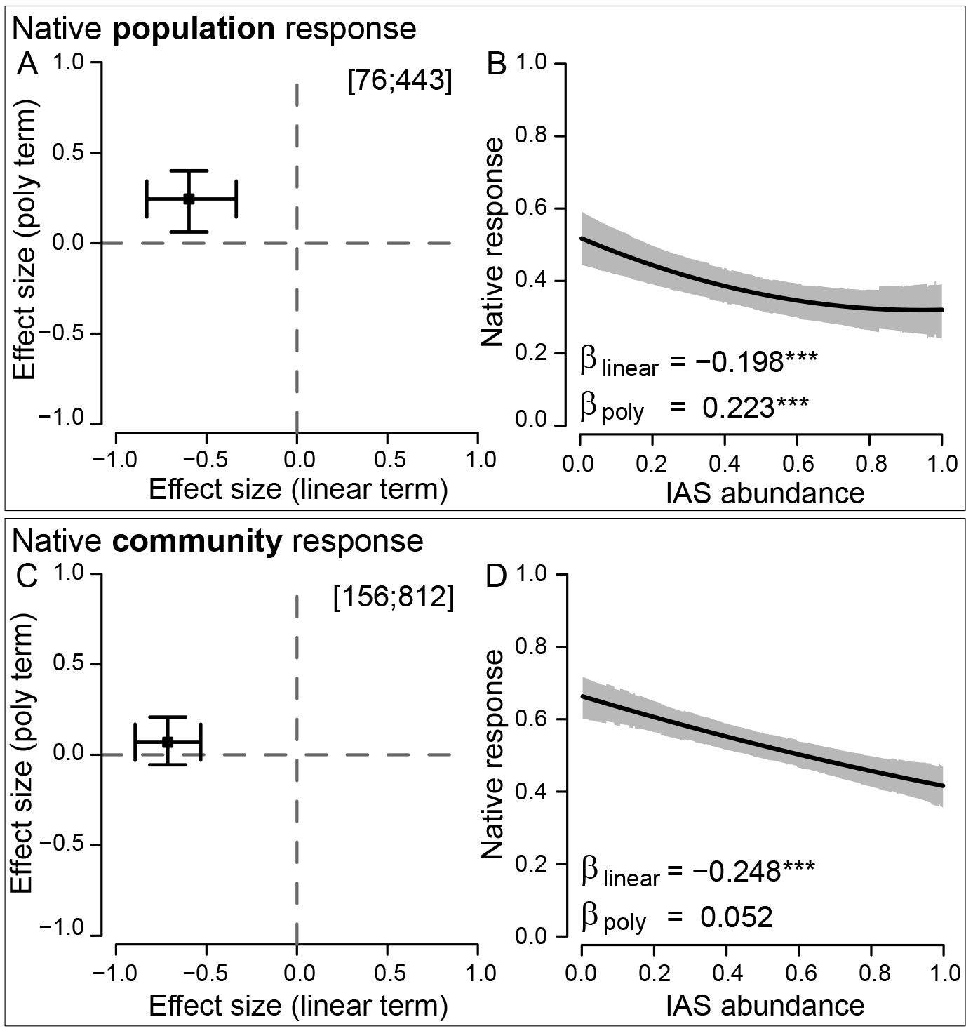
Figure 2. The shape of native species’ responses is curvilinear at the population level but linear at the community level. A) and C) present analyses based on partial-r; B) and D) present the slopes analyses. Numbers in brackets are total papers and studies analyzed. Effect size estimates in A) and C) are statistically supported when 95% credible interval bars do not cross the zero lines. Slopes plots show model predictions (black line) with gray shading indicating the 95% credible zone. Significant linear (β_{linear}) or polynomial (β_{poly}) regression terms are indicated by asterisks († p<0.10; * p<0.05; ** p<0.01; *** p<0.001).
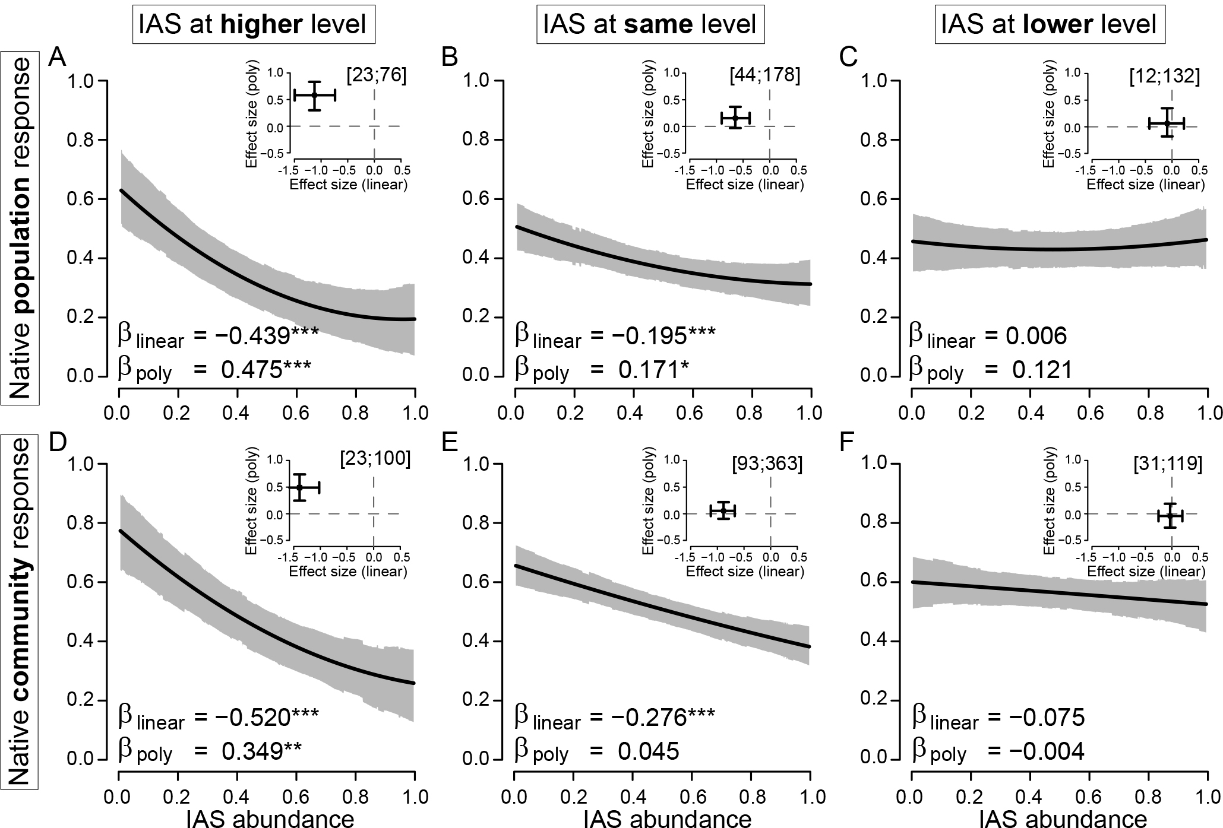
Figure 3. The shape and strength of IAS impacts on native species and communities depends strongly on relative trophic position. Results from the slopes meta-analyses are shown in the main panel and results from the partial-r meta-analyses are inset. (A-C) Native species’ population responses to invaders at higher, the same, and lower trophic levels, respectively. (D-F) Native community-level responses to invaders at higher, the same, and lower trophic levels, respectively. Sample sizes, credible interval bars, zones, and significance categories are as defined in Figure 2.

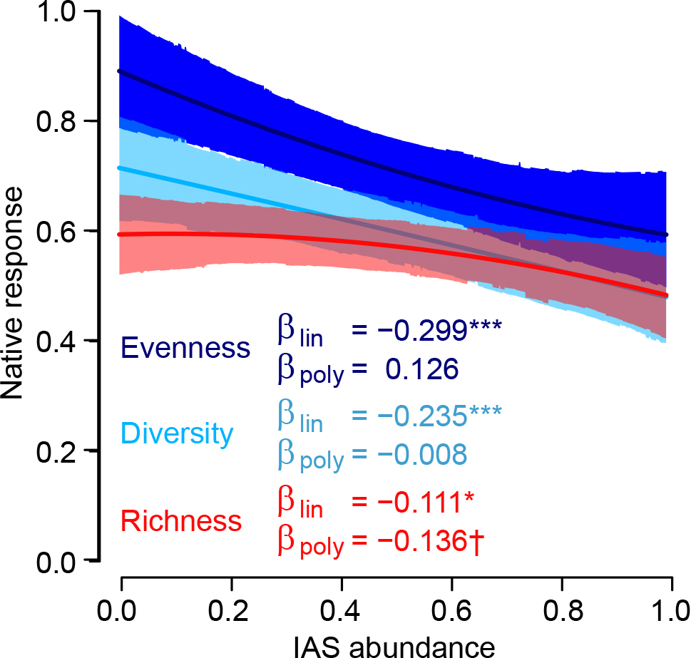
Figure 4. IAS impacts at the community level vary among measures of species diversity. IAS have significant negative linear effects on native community-level richness (red), diversity (cyan), and evenness (blue). There were significant differences between species diversity responses for both linear and polynomial terms, which are reported in the results. Lines show model predictions with shading indicating the 95% credible zone. Significance categories are as defined in Figure 2.

