**Association of high postural sway with fracture risk and mortality in postmenopausal women**

Sarang Latif Qazi1 (MBBS, MPH), Joonas Sirola (MD, PhD)1,2, Heikki Kröger (MD, PhD)1,2, Risto Honkanen (MD, PhD)1, Masoud Isanejad (MPHN)1, Olavi Airaksinen (MD, PhD)3, Toni Rikkonen (PhD)1

1 Kuopio Musculoskeletal Research Unit (KMRU), Mediteknia Building, University of Eastern Finland, P.O. Box 1627, 70211 Kuopio, Finland

2 Department of Orthopaedics, Traumatology and Hand Surgery, Kuopio University Hospital, 70029 Kuopio, Finland

3 Department of Physical and Rehabilitation Medicine, Kuopio University Hospital, P.O. Box 1777, 70211 Kuopio Finland.

**Corresponding author:**

Sarang Latif Qazi

KMRU, Mediteknia Building, University of Eastern Finland, P.O. Box 1627, 70211 Kuopio, Finland, +358469682818, [sarangq@uef.fi](mailto:sarangq@uef.fi)

**Disclosures:** All authors state that they have no conflict of interest.

# Abstract

Impaired balance can lead to an increased risk of falls and fractures in elderly women. Taking postural balance into account along with other fracture risk factors may help identify women who are at higher risk of fractures due to falls. Aim of this prospective cohort study was to study the independent effect of postural sway on fracture risk after controlling for established fracture risk factors. The sample of this study is a stratified random sample of 1568 women born between 1932-1941, residing in Kuopio province, Eastern Finland. Fracture data was obtained through study questionnaires and was verified through hospital records. Mortality data was verified through national registry. Using static posturography, postural sway was recorded for 1568 women at fifth year follow-up. Mediolateral, anteroposterior and total sway parameters were used for analysis. Mean follow-up time for fractures was 10.7 years and 17.5 years for mortality. Subjects in the highest quartile of mediolateral sway (HR 2.0; 95% CI 1.5-2.7), anteroposterior sway (HR 1.4; 95% CI 1.0-1.9) and total sway (HR 1.6; 95% CI 1.2-2.2) were found to be at significantly higher risk of overall fracture when compared with the lowest quartile. The risk persisted after adjustment for fracture risk factors used in the FRAX fracture risk assessment tool. Further, subjects having both low bone density and high postural sway, were at 4.9 times higher risk of fracture (CI 95% 2.6-9.5) when compared with subjects having high bone density along with low postural sway.

Keywords: Balance, postural sway, fracture risk assessment, mortality, general population studies.

# Introduction

Posturography is the measurement of body response in maintaining posture during stable and perturbed conditions.(1) Both static and dynamic posturography utilize pressure plates that record the force used by the body in mediolateral (ML) and anteroposterior (AP) axis for maintaining balance. Difference being that in static posturography the force-plate platform is fixed and stable whereas in dynamic posturography, the subject or the platform itself are deliberately perturbed to test their ability in maintaining balance in unstable conditions.(1)

The advantage of posturography over simple balance tests is that it is easily quantifiable and is sensitive to sway in normal body posture that might not be detected otherwise. These movements are recorded through movement in centre of pressure (COP).(2) Movement in COP is drawn on horizontal and vertical axes from which maximum range of sway in AP and ML direction is measured. Newer systems can extract many components from the COP movement, however simple AP and ML sway measures are the focus of majority of the studies involving postural sway.

Body maintains its balance through synchronized working of muscular and neuronal systems. These include the sensory organs (golgi tendon organs, vestibular system, visual input), systems that process the sensory signals (cerebellum, cerebral cortex ) and muscles that carry out the required movements.(3,4) A decline in these systems due to aging makes a person more prone to falls.(5–7) Even though bone density plays a major role in fracture risk, falls are an equally important risk factor as frequent fallers are at a higher risk for fractures.(8) Few studies have previously studied postural sway as a risk factor for fractures. Some of them measured sway at the waist.(9,10) The Muramatsu study used force plate measures and studied multiple confounding factors.(11)

Taking into account, balance impairment, along with bone density can help identify those at highest risk of fractures.(12) Our aim was to investigate if body sway measures are useful for long term fracture and mortality risk prediction after adjustment for muscle strength and other fracture risk factors. In addition, to study the combined effect of low bone mineral density (BMD) and high postural sway on fracture and mortality risk.

# Materials and Methods

## Study design

The Osteoporosis Risk Factor and Prevention (OSTPRE) Study is a population based prospective cohort study that was started in 1989 to investigate genetic and acquired factors associated with fractures, falls, BMD and bone loss in perimenopausal and postmenopausal women. The cohort consisted all the 14220 women born during the period of 1932- 41 and residing in Kuopio Province, Finland in 1989 (Figure 1).

Baseline inquiry was carried out in 1989 and measurements were taken for 3222 randomized subjects during 1989 - 1991. The fifth-year inquiry was carried out in 1994 with its respective clinical measurements during the period of 1994-1997.

At the fifth year follow up, which is regarded as the baseline for this study, a postural sway measurement protocol was introduced. Altogether 1568 women from the original OSTPRE measurement population (3222) underwent the body sway measurements during this period.

## Measurements

Postural stability was measured using a force plate (Pikosystems, Tampere, FINLAND). Movement in COP was recorded on paper for 30 seconds. After each recording, maximum amplitude of sway in the AP and ML direction was measured manually using a ruler (Supplemental Figure 1).

A dual x-ray absorptiometry (DXA) bone densitometry was performed (Lunar DPX, Madison, WI, USA) at the left femoral neck. Measurements were carried out according to the manufacturer guidelines at the time being. Age, weight (kg) and height (cm) at the time were recorded. Weight of the participants was measured in light indoor clothing usinga digital calibrated scale (Philips, type HF 351/00) and height was measured with a calibrated measurement scale fixed on a wall. Quadriceps strength was measured with knee extensor bench (Metitur, Finland) and reported in kg force (kgf).

## **Fracture and mortality data**

Subjects were followed up in five-year intervals for a period of 15 years till the 20th year (2009) questionnaire (Figure 1). Fracture data was collected with enquiries and verified through medical records during the mean follow-up time of 10.7 years after posturograpohy. Altogether,1205 subjects returned the year 2009 questionnaire with 245 subjects dropping out during the study. In total, 316 subjects reported fractures, while 217 deaths were observed through national registry, with the mean follow up time of 17.5 years.

## Covariates

Covariates for the analysis were chosen based on the risk factors utilized in FRAX fracture risk assessment tool. (13) These include age, sex, weight, height, DXA femoral neck BMD in g/cm2, current smoking status, consumption of three or more units of alcohol per day (one unit = bottle of beer/cider, glass of wine/portion of strong spirits/alcohol), current oral glucocorticoid use or previous use for more than three months, previous fracture history, parents’ history of hip fracture and presence of rheumatoid arthritis or secondary osteoporosis. FRAX was calculated from the OSTPRE sample data by the courtesy of FRAX developers (add reference Kanis+Johansson).-

## Statistical analysis

A total of 1450 subjects were included in the final analyses. Altogether, 118 subjects were excluded from the final analysis, 102 because of incomplete baseline information on covariates and a further 16 subjects because they did not return any questionnaires after the baseline.

Study participants were categorized into quartiles of mediolateral, anteroposterior and total body sway. Comparison for dichotomous covariates between groups was carried out using Chi square test for homogeneity while one-way ANOVA was used for continuous covariates. Only five women had reported greater than 3 units per day alcohol consumption, therefore Fisher’s exact test was used for within group comparison for alcohol consumption.

Cox regression analysis was performed using postural sway measures as independent variables with lowest sway category as the reference. Adjusted models were used to test the independent effect of body sway on fracture and mortality risk. All covariates were entered simultaneously in the model.

To assess the cumulative effect of BMD and postural sway on fracture and mortality, BMD in tertile and t and mediolateral body sway in quartile were used to create 12 risk categories based on combining BMD and ML sway score (lowest risk category being BMD 3|ML sway 1 and the highest risk category being BMD 1|ML sway 4). Cox regression analysis was used to assess fracture and mortality risk between these groups using BMD 3|ML sway 1 as the reference category.

# Results

Cut off points for quartiles of all sway parameters (ML, AP, Total), the number of subjects in each of these quartiles and number of overall fractures and deaths are described in Table 1.Baseline characteristics for of the study population are shown in Table 2 for the whole population and for subjects divided along quartiles of total body sway. The results of Chi square test of homogeneity and Fischer’s exact test showed no differences in proportions of binomial covariates between quartiles of total body sway. There was a significant difference in weight of women the first quartile and the women in second, third and fourth quartile. In comparison with the first quartile of total sway, the women in the fourth quartile also had higher mean femoral neck BMD and mean knee extension strength at baseline.

In the Cox regression analyses for fracture and mortality risk, high mediolateral sway was the strongest balance component associated with increased fracture risk in unadjusted (HR 2.0, CI95 1.5-2.7, p <0.001) and adjusted model (HR 1.9, CI95 1.4-2.6, p <0.001) (Table 3). Kaplan-Meier survival curves for fracture incidence in different quartiles of ML sway are given in Figure 2.

ML, AP and total sway, all were significantly associated with crude mortality risk in unadjusted Cox regression models. However, the association was lost after adjustment for age, parents’ fractured hip history, smoking history and knee extension strength. Unadjusted hazard ratios for fracture and mortality between quartiles of mediolateral, anteroposterior and total sway are summarized in figure 3.

Subjects categorized according to combined score of BMD and postural sway with their respective fracture and mortality risk are presented in Table 4. Mediolateral sway was used to estimate fracture risk and total sway was used for mortality risk as they were the strongest parameters associated with these outcomes according to Cox models. A combination of low BMD and high mediolateral sway (BMD tertile 1, ML sway quartile 4) incurred the highest risk of fracture (HR 4.9 CI 2.6-9.5, p <0.001) in comparison to reference subjects in high bone density and low postural sway (BMD tertile 3, ML sway quartile 1) group (Figure 4). In addition, the highest total sway combined with the lowest BMD was also at the highest risk of mortality (HR 2.6 CI, 1.3-5.4, p <0.01).

# Discussion

Our study investigated the degree of body sway and a risk of fracture in elderly women over 15 year of follow-up. In addition to total body sway, both main components (anteroposterior and mediolateral) were analysed separately.

Mediolateral direction of the postural sway was most strongly associated with a long-term fracture risk. Women in the highest quartile of ML sway having a two times higher risk of fracture compared to the reference group, which was independent of possible covariates. The only clinical risk factors along with ML sway that were significantly associated with fracture risk were BMD, height and weight. However, age did not appear as a significant factor. A previous study by Nguyen and colleagues made an observation that age acts as a surrogate marker for other factors such as physical fitness, muscle strength, weight and postural sway, and loses its significance when these factors are introduced into the model.(9) Their study further mentions that Hui et al. also identified age as a significant fracture risk factor but considered it a surrogate marker for other age related factors for fracture.(14)

Women in the highest quartile of any of the three sway parameters (ML, AP, total sway) had a 1.6 times higher risk of mortality. The significance was lost after adjusting for covariates. Age, previous fracture, smoking and leg extension strength were the factors that were associated with mortality risk in all the models.

In groups derived using composite score of BMD and ML body sway, a consistently increasing risk was observed with decreasing femoral neck bone density and increasing mediolateral body sway. Subjects in the highest risk category (high body sway, low bone density) had a 5.2 times higher risk of fracture when compared with the reference group (low body sway, high bone density). A previous study with postural sway measured at waist demonstrated a 16% increase in annual fracture risk among subjects having high postural sway, low bone density and low knee extension strength.(9)

Women in the group of high total sway and low BMD were at the highest risk for mortality. Having a low BMD along with low total sway did not confer a significantly higher mortality risk whereas a combination of high bone density with high total sway was still a significant risk factor for mortality.

A wide number of factors contribute to an increased postural sway. Sarcopenia, defined as decline in muscle mass and strength with aging, is one important determinant.(15) In addition, sarcopenic obese people have demonstrated a higher postural sway on static posturography as compared to non-sarcopenic non-obese people.(16) Low muscle strength alone has also shown significant correlation with increased postural sway.(17)

Osteoporosis have been associated with high postural sway, but the relationship may not be causal because of muscle-bone interaction i.e. weak muscle strength is also associated with weak bones.(18–20) The effect of nutrition and exercise on composition of both muscle and bone might also explain why sarcopenia and increased postural sway are known to be accompanied by osteoporosis.(21,22)

Increased postural sway translates into falls that in presence of low BMD determine the risk for fracture.(10,23–25) Adding postural sway to fracture risk prediction tools might improve their predictive ability. In one study, multiple postural sway components were positively associated with FRAX scores. However, after adjusting for covariates in a regression model, only ML sway (measured while standing on a 4-inch-thick foam) was significantly associated with FRAX scores. In the same study, mediolateral sway measured using static posturography (standing on foam, eyes closed) demonstrated ability to differentiate between fracture and no fracture groups with area under curve (AUC) of 0.66 (p = 0.10).(27)

Our results are in alignment with previous studies, supporting the addition of postural sway in fracture risk assessment. However, the results of this study are generalizable only for elderly Finnish women because fall risk varies among different populations.(28,29)

# Conclusion

High postural sway, mediolateral most strongly, is an independent predictor of increased fracture risk in postmenopausal women. A combination of low bone density and high postural sway can pose a higher risk of fracture than either of the risk factors alone. High postural sway is also associated with an increased all-cause mortality; however the risk is non-significant after adjusting for other factors.

## Acknowledgements Any foundation? Cultural FOundation of Northern sawo.

## Author roles

Study design: TR, JS and SQ. Study conduct: SQ, TR, JS. Data collection: SQ, TR, MI. Data analysis: SQ, TR, JS. Data interpretation: SQ, TR, JS, HK. Drafting manuscript: SQ, TR, JS, HK. Revising manuscript content: TR, JS, HK, RH, OA, MI, SQ. Approving final version of manuscript: TR, JS, HK, RH, OA, MI, SQ. SQ takes responsibility for the integrity of the data analysis.

# References

1. Bloem BR, Visser JE, Allum JHJ. Chapter 20 Posturography. Handbook of Clinical Neurophysiology. Elsevier; 2003.

2. Prieto TE, Myklebust JB, Hoffmann RG, Lovett EG, Myklebust BM. Measures of postural steadiness: differences between healthy young and elderly adults. IEEE Trans Biomed Eng. 1996;(9):956–66

3. Manchester D, Woollacott M, Zederbauer-Hylton N, Marin O. Visual, Vestibular and Somatosensory Contributions to Balance Control in the Older Adult. J Gerontol. 1989;(4):M118–27

4. Alexander NB. Postural Control in Older Adults. J Am Geriatr Soc. 1994;(1):93–108

5. Lord SR, Rogers MW, Howland A, Fitzpatrick R. Lateral stability, sensorimotor function and falls in older people . J Am Geriatr Soc. 1999;(9):1077–81

6. Goble DJ, Coxon JP, Wenderoth N, Van Impe A, Swinnen SP. Proprioceptive sensibility in the elderly: degeneration, functional consequences and plastic-adaptive processes . Neurosci Biobehav Rev. 2009;(3):271–8

7. Lord SR, Clark RD, Webster IW. Physiological factors associated with falls in an elderly population. J Am Geriatr Soc. 1991;(12):1194–200

8. Lord SR, Sambrook PN, Gilbert C, et al. Postural stability, falls and fractures in the elderly: results from the Dubbo Osteoporosis Epidemiology Study. Med J Aust. 1994;(11):684–5, 688–91

9. Nguyen T, Sambrook P, Kelly P, et al. Prediction of osteoporotic fractures by postural instability and bone density. BMJ. 1993;(6912):1111–5

10. Nguyen ND, Pongchaiyakul C, Center JR, Eisman JA, Nguyen T V. Identification of high-risk individuals for hip fracture: a 14-year prospective study. J Bone Miner Res. 2005;(11):1921–8

11. Nakamura K, Oshiki R, Kobayashi R, et al. Postural sway velocity predicts osteoporotic fracture in community-dwelling elderly Japanese women: the Muramatsu Study. Age Ageing. 2011;(1):132–5

12. Dargent-Molina P, Favier F, Grandjean H, et al. Fall-related factors and risk of hip fracture: the EPIDOS prospective study. Lancet. 1996;(9021):145–9

13. Kanis JA, Johnell O, Oden A, Johansson H, McCloskey E. FRAXTM and the assessment of fracture probability in men and women from the UK. Osteoporos Int. 2008;(4):385–97

14. Hui SL, Slemenda CW, Johnston CC. Age and bone mass as predictors of fracture in a prospective study. J Clin Invest. 1988;(6):1804–9

15. Ochi M, Tabara Y, Kido T, et al. Quadriceps sarcopenia and visceral obesity are risk factors for postural instability in the middle‐aged to elderly population. Geriatr Gerontol Int. 2010;(3):233–43

16. Huo YR, Suriyaarachchi P, Gomez F, et al. Phenotype of sarcopenic obesity in older individuals with a history of falling. Arch Gerontol Geriatr. 2016;255–9

17. Carter ND, Khan KM, Mallinson A, et al. Knee extension strength is a significant determinant of static and dynamic balance as well as quality of life in older community-dwelling women with osteoporosis. Gerontology. 2002;(6):360–8

18. Liu-Ambrose T, Eng JJ, Khan KM, Carter ND, McKay HA. Older women with osteoporosis have increased postural sway and weaker quadriceps strength than counterparts with normal bone mass: overlooked determinants of fracture risk? J Gerontol A Biol Sci Med Sci. 2003;(9):M862-6

19. Brech GC, Plapler PG, de Souza Meirelles E, Marcolino FMD, Greve JMD. Evaluation of the association between osteoporosis and postural balance in postmenopausal women. Gait Posture. 2013;(2):321–5

20. Kamide N, Fukuda M, Miura H. The relationship between bone density and the physical performance of ambulatory patients with Parkinson’s disease. J Physiol Anthropol. 2008;(1):7–10

21. Sirola J, Kröger H. Similarities in acquired factors related to postmenopausal osteoporosis and sarcopenia. J Osteoporos. 2011;536735

22. Sjoblom S, Suuronen J, Rikkonen T, et al. Relationship between postmenopausal osteoporosis and the components of clinical sarcopenia . Maturitas. 2013;(2):175–80

23. Nguyen T V, Eisman JA, Kelly PJ, Sambrook PN. Risk factors for osteoporotic fractures in elderly men. Am J Epidemiol. 1996;(3):255–63

24. Nguyen ND, Eisman JA, Center JR, Nguyen T V. Risk factors for fracture in nonosteoporotic men and women. J Clin Endocrinol Metab. 2007;(3):955–62

25. Louer CR, Boone SL, Guthrie AK, et al. Postural Stability in Older Adults with a Distal Radial Fracture. J Bone Joint Surg Am. 2016;(14):1176–82

26. Lundin H, Saaf M, Strender L-E, et al. Gait speed and one-leg standing time each add to the predictive ability of FRAX. Osteoporos Int. 2017;(1):179–87

27. Bhattacharya A, Watts NB, Dwivedi A, et al. Combined Measures of Dynamic Bone Quality and Postural Balance--A Fracture Risk Assessment Approach in Osteoporosis. J Clin Densitom. 2016;(2):154–64

28. Franse CB, Rietjens JA, Burdorf A, et al. A prospective study on the variation in falling and fall risk among community-dwelling older citizens in 12 European countries. BMJ Open. 2017;(6):e015827

29. Davis JW, Nevitt MC, Wasnich RD, Ross PD. A Cross-Cultural Comparison of Neuromuscular Performance, Functional Status, and Falls Between Japanese and White Women. Journals Gerontol Ser A Biol Sci Med Sci. 1999;(6):M288–92

# Figure legends

Figure 1: Participants for the study were recruited form the OSTPRE cohort that was started in 1989 and consisted of 14220 born between 1932-41 and living in the Kuopio province of Finland. Out of these measurements were carried out for 3222 participants. During the 5th year measurement in 1994 (baseline for this study), postural sway was measured in randomized 1568 participants from the measurement group. Due to missing covariate data, form these 1568 participants, 102 subjects were excluded from this study. A further 16 subjects were excluded because they had not returned the study questionnaires after the baseline. A total 1450 participants were finally included in this study.

Figure 2: Kaplan Meier hazard curves for all fractures in subjects divided according to quartiles of mediolateral sway (Log rank, p<0.001).

Figure 3. Cox proportional hazards ratios for quartiles of mediolateral, anteroposterior and total sway. Mediolateral sway was the strongest predictor for fracture risk in fourth quartile (HR 2.0 [CI 95% 1.5-2.7]. Anteroposterior sway was the strongest predictor for mortality risk in third quartile (HR 1.8 [CI 95% 1.2-2.6]).

Figure 4. Subjects were distributed according to tertile of bone mineral density (BMD) and quartiles of mediolateral (ML) postural sway. Using a combination score of BMD and postural sway, subjects were distributed into nine groups (e.g. BMD 1 ML sway 1, BMD 2 ML sway 1… BMD 1 ML sway 2, and so on). Using BMD Q3 and ML sway Q1 as the reference group (i.e. high BMD and low postural sway) Cox regression analysis was carried out and hazard ratio for fracture in each group was calculated. Highest risk for fracture was observed in the group with lowest BMD and highest ML sway (4.9 [CI95% 2.6-9.5]). The numbers above the bars show number of subjects in each category.

# Tables

|  |  |  |  |  |  |
| --- | --- | --- | --- | --- | --- |
| **Table 1. Cut off points for postural sway and number of fracture/deaths in each quartile of body sway** | | | | | |
|  | Quartile 1 | Quartile 2 | Quartile 3 | Quartile 4 | Total |
| **Mediolateral sway** |  |  |  |  |  |
| Number of subjects | 391 | 343 | 373 | 343 | 1450 |
| Cut-off for ML sway **(**mm) | <18 | 18 - 21 | 22 - 27 | >27 |  |
| Number of fractures | 67 | 64 | 82 | 103 | 316 |
| Number of deaths | 45 | 47 | 56 | 59 | 207 |
|  |  |  |  |  |  |
| **Anteroposterior sway** |  |  |  |  |  |
| Number of subjects | 375 | 377 | 354 | 344 | 1450 |
| Cut-off for AP sway **(**mm) | <23 | 23 - 27 | 28 - 34 | >34 |  |
| Number of fractures | 75 | 81 | 71 | 89 | 316 |
| Number of deaths | 39 | 56 | 60 | 52 | 207 |
|  |  |  |  |  |  |
| **Total sway** |  |  |  |  |  |
| Number of subjects | 348 | 363 | 364 | 375 | 1450 |
| Cut-off for Total sway **(**mm) | <41 | 41 - 48 | 49 - 59 | >59 |  |
| Number of fractures | 66 | 64 | 82 | 104 | 316 |
| Number of deaths | 38 | 50 | 56 | 63 | 207 |

|  |  |  |  |  |  |
| --- | --- | --- | --- | --- | --- |
| **Table 2. Baseline characteristics of the total study population (n=1450), presented in quartiles of total sway with their respective mean (SD) or proportions.** | | | | | |
|  | All subjects (n 1450) | 1st quartile of total sway (n 348) | 2nd quartile of total sway (n 363) | 3rd quartile of total sway (n 364) | 4th quartile of total sway (n 375) |
| Age (years)† | 59.4 (2.9) | 59.2 (3.0) | 59.4 (2.8) | 59.5 (2.8) | 59.7 (3.0) a |
| Weight (kgf)† | 72.1 (12.7) | 68.9 (11.2) | 71.8 (12.9) b | 73.1 (12.8) c | 74.4 (13.0) c |
| Height (cm)† | 160.0 (5.5) | 159.4 (5.4) | 159.8 (5.3) | 160.4 (5.3) a | 160.3 (5.8) |
| BMD femoral neck (g/cm2)† | 0.900 (0.125) | 0.886 (0.126) | 0.902 (0.123) | 0.902 (0.125) | 0.910 (0.124) a |
| Alcohol 3+ units/day (yes)†† | 5 (0.3%) | 3 (0.8%) | 1 (0.3%) | 1 (0.3%) | 0 (0.0%) |
| Rheumatoid arthritis (yes)†† | 41 (2.8%) | 13 (3.7%) | 9 (2.5%) | 10 (2.7%) | 9 (2.4%) |
| Currently smoking (yes)†† | 259 (17.9%) | 68 (19.5%) | 65 (17.9%) | 56 (15.4%) | 70 (18.7%) |
| Secondary osteoporosis (yes)†† | 240 (16.5%) | 56 (16.0%) | 64 (17.6%) | 56 (15.4%) | 64 (16.9%) |
| Parent fractured hip (yes)†† | 139 (9.6%) | 33 (9.5%) | 37 (10.2%) | 37 (10.2%) | 32 (8.5%) |
| Fracture before baseline (yes)†† | 284 (19.6%) | 70 (20.1%) | 61 (16.8%) | 72 (19.8%) | 81 (21.6%) |
| Glucocorticoid use (yes)†† | 104 (7.2%) | 26 (7.5%) | 29 (8.0%) | 29 (8.0%) | 20 (5.3%) |
| Knee extension strength (kgf) | 31.7 (11.6) | 32.5 (11.4) | 32.2 (11.3) | 32.6 (11.7) | 29.7 (11.8) b |
|  |  |  |  |  |  |
| *Sway parameters* |  |  |  |  |  |
| Mediolateral sway (mm)† | 23.6 (11.1) | 14.9 (3.2) | 19.8 (3.3) c | 23.6 (4.4) c | 35.4 (14.8) c |
| Anteroposterior sway (mm)† | 29.4 (11.2) | 19.7 (3.4) | 25.0 (3.4) c | 30.1 (4.5) c | 42.3 (13.2) c |
| Total sway (mm)† | 53.0 (20.2) | 34.6 (4.4) | 44.6 (2.2) c | 53.6 (3.1) c | 77.6 (23.5) c |
|  |  |  |  |  |  |
| *Outcome measures* |  |  |  |  |  |
| Fractures during follow-up †† | 316 (21.9%) | 66 (19.0%) | 64 (17.9%) | 82 (22.5%) | 104 (27.7%) b |
| Number of deaths†† | 207 (14.2%) | 38 (10.9%) | 49 (13.5%) | 56 (15.4%) | 63 (16.8 %) |
| a p < 0.05  b p < 0.01  c p < 0.001  † presented as ‘mean value (SD)’. Groups compared using ANOVA, with first group as the reference.  †† presented as proportion of group. Groups compared using Chi square test of homogeneity with first group as the reference. | | | | | |

|  |  |  |  |  |
| --- | --- | --- | --- | --- |
| **Table 3. Risk of fracture and death according to total, mediolateral and anteroposterior sway with their respective hazard ratios (CI 95%)** | | | | |
|  | Fracture | | Mortality | |
|  | Unadjusted HR | Adjusted HR | Unadjusted HR | Adjusted HR |
| ***Total sway*** |  |  |  |  |
| 1st quartile (ref) | 1 | 1 | 1 | 1 |
| 2nd quartile | 0.9 (0.7-1.3) | 1.0 (0.7-1.3) | 1.2 (0.8-1.9) | 1.3 (0.8-1.9) |
| 3rd quartile | 1.2 (0.9-1.7) | 1.2 (0.9-1.7) | 1.4 (0.9-2.2) | 1.4 (1.0-2.2) |
| 4th quartile | 1.6 (1.2-2.2) b | 1.6 (1.2-2.2) b | 1.6 (1.1-2.4) b | 1.5 (1.0-2.2) |
| Height (cm) |  | 1.02 (1.00-1.04) a |  | NS |
| Weight (kg) |  | 1.01 (1.00-1.02) b |  | NS |
| BMD (g/cm2) |  | 0.046 (0.017-0.128) c |  | NS |
| Age (years) |  | NS |  | 1.1 (1.0-1.2) c |
| Parent fractured hip (yes)†† |  | NS |  | 1.4 (1.0-1.9) a |
| Currently smoking (yes) |  | NS |  | 1.9 (1.4-2.6) c |
| Knee extension strength (kgf) |  | NS |  | 0.98 (0.97-0.99) b |
|  |  |  |  |  |
| ***Mediolateral sway*** |  |  |  |  |
| 1st quartile (ref) | 1 | 1 | 1 | 1 |
| 2nd quartile | 1.1 (0.8-1.5) | 1.1 (0.8-1.6) | 1.2 (0.8-1.8) | 1.2 (0.8-1.8) |
| 3rd quartile | 1.4 (1.0-1.9) | 1.3 (1.0-1.8) | 1.3 (0.9-1.9) | 1.2 (0.8-1.8) |
| 4th quartile | 2.0 (1.5-2.7) c | 1.9 (1.4-2.6) c | 1.6 (1.1-2.3) a | 1.4 (0.9-2.1) |
| Height (cm) |  | 1.02 (1.00-1.04) a |  | NS |
| Weight (kg) |  | 1.01 (1.00-1.02) a |  | NS |
| BMD (g/cm2) |  | 0.047 (0.017-0.130) c |  | NS |
| Age (years) |  | NS |  | 1.1 (1.0-1.2) c |
| Parent fractured hip (yes)†† |  | NS |  | 1.4 (1.0-1.9) a |
| Currently smoking (yes) |  | NS |  | 1.9 (1.4-2.6) c |
| Knee extension strength (kgf) |  | NS |  | 0.98 (0.97-0.99) b |
|  |  |  |  |  |
| ***Anteroposterior sway*** |  |  |  |  |
| 1st quartile (ref) | 1 | 1 | 1 | 1 |
| 2nd quartile | 1.1 (0.8-1.5) | 1.1 (0.8-1.5) | 1.5 (1.0-2.3) | 1.5 (1.0-2.3) a |
| 3rd quartile | 1.0 (0.7-1.4) | 1.1 (0.8-1.4) | 1.8 (1.2-2.6) b | 1.7 (1.1-2.5) b |
| 4th quartile | 1.4 (1.0-1.9) a | 1.4 (1.0-1.9) a | 1.6 (1.0-2.4) a | 1.4 (0.9-2.2) |
| Height (cm) |  | 1.02 (1.00-1.04) a |  | NS |
| Weight (kg) |  | 1.01 (1.00-1.02) b |  | NS |
| BMD (g/cm2) |  | 0.047 (0.017-0.130) c |  | NS |
| Age (years) |  | NS |  | 1.1 (1.0-1.1) c |
| Parent fractured hip (yes) |  | NS |  | 1.4 (1.0-1.9) a |
| Currently smoking (yes) |  | NS |  | 1.9 (1.4-2.6) c |
| Knee extension strength (kgf) |  | NS |  | 0.98 (0.97-0.99) b |
| a p < 0.05  b p < 0.01  c p < 0.001  the following covariates were introduced in the adjusted models: alcohol consumption, presence of rheumatoid arthritis, secondary osteoporosis and glucocorticoid use were not significant in any of the models (Data not shown). | | | | |

|  |  |  |  |
| --- | --- | --- | --- |
| **Table 4. Hazard ratio for fracture and mortality using combined score of BMD and postural sway tertiles in a Cox regression analysis** | | | |
| ***Hazard ratio for Fractures*** | | | |
|  | High BMD † | Medium BMD | Low BMD |
| 1st quartile ML sway (ref) | 1 | 1.9 (0.9 - 3.8) | 2.9 (1.5 - 5.6) b |
| 2nd quartile ML sway | 1.1 (0.5- 2.5) | 1.6 (0.8 - 3.2) | 3.6 (1.9 - 6.9) c |
| 3rd quartile ML sway | 1.7 (0.8 - 3.5) | 3.0 (1.5 - 5.8) c | 3.2 (1.7 - 6.2) c |
| 4th quartile ML sway | 2.9 (1.5 - 5.7) b | 3.8 (2.0 - 7.4) c | 4.9 (2.6 - 9.5) c |
| ***Hazard ratio for Mortality*** | | | |
|  | High BMD † | Medium BMD | Low BMD |
| 1st quartile ML sway (ref) | 1 | 1.8 (0.9-3.8) | 1.1 (0.5-2.5) |
| 2nd quartile ML sway | 1.6 (0.7-3.6) | 1.3 (0.6-2.8) | 1.8 (0.8-3.8) |
| 3rd quartile ML sway | 1.6 (0.7-3.3) | 1.7 (0.8-3.5) | 1.8 (0.8-3.9) |
| 4th quartile ML sway | 1.8 (0.9 - 3.8) | 1.9 (0.9-3.9) | 2.6 (1.3-5.4) b |
|  | | | |
| a p < 0.05  b p < 0.01  c p < 0.001  † T-score values for category High (> -0.29), Medium (-0.29 to -1.17), Low (< -1.17) | | | |

# Figures

Figure 1. Flow Diagram of the study.



Figure 2. Kaplan-Meier hazard curves for any fracture according to quartiles  
 of mediolateral sway (Log rank, p<0.001)

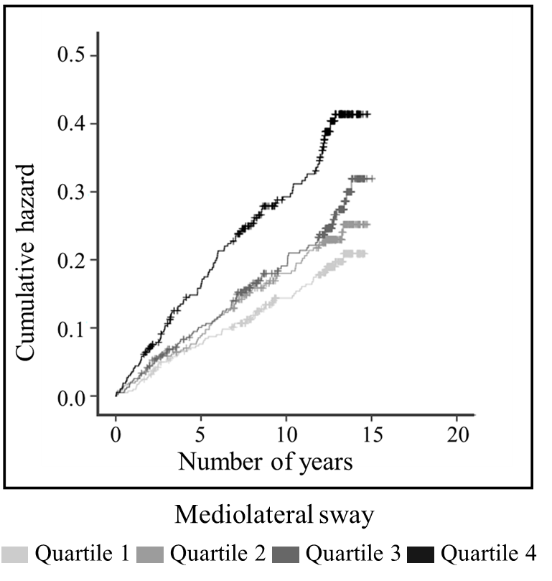

Figure 3. Hazard ratios for (A) mortality and (B) fracture risk according to quartiles of mediolateral, anteroposterior and total sway.

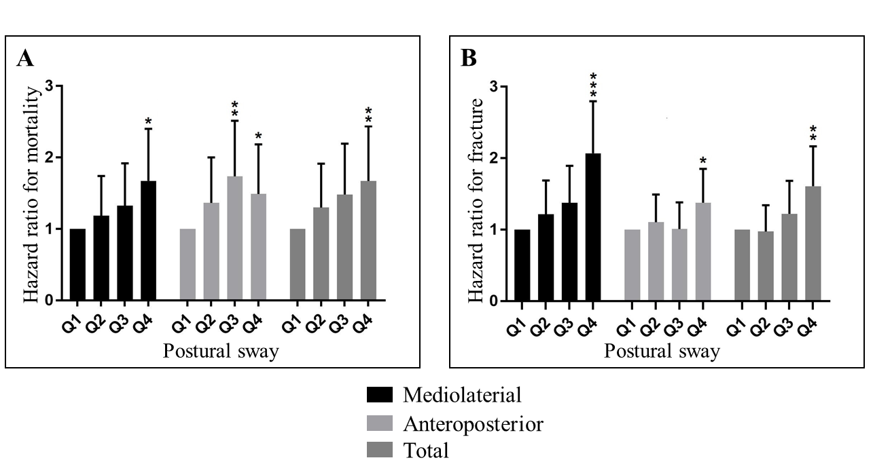

Figure 4. Hazard ratios for fracture according to combined tertiles of bone mineral density and quartiles of mediolateral postural sway, using ML sway Q1|BMD T3 as reference quartile. Numbers above the bars indicate the number of subjects in each category.

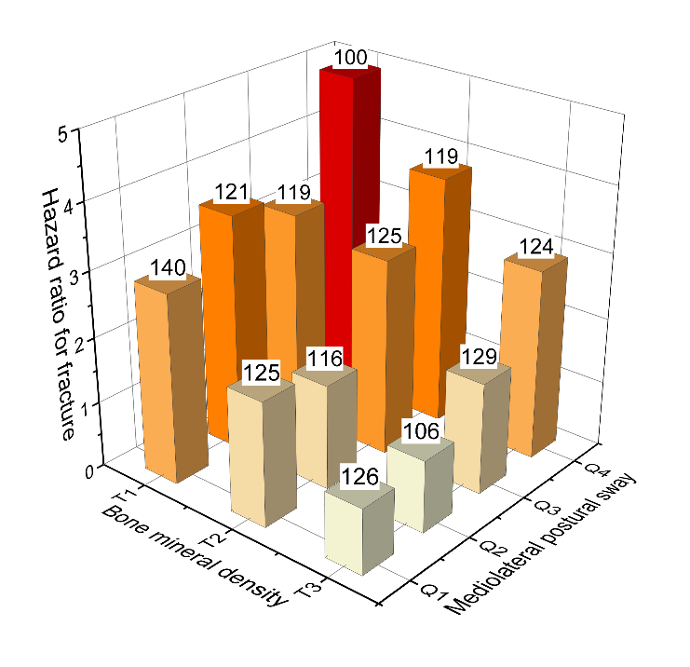

# Supplementary data

Supplementary figure 1. A sample posturography reading from posturograph used for this study.

