Title: Music video as party political communication: Opportunities and limits
Abstract
Relations between political parties and music are fraught with issues over effectiveness, limitations and opportunities. On the one hand, political parties and movements use the appeal of popular music to attract audiences who otherwise may not be attentive to their views. On the other hand, mixing the two has seen music and politics “reduced to their lowest common denominator” (Street 1988, 50). Here, I examine how political parties employ popular music to articulate party specific discourses. Leaning on Multimodal Critical Discourse Studies and musicology, I analyse the lyrics, visuals and musical sounds of musical advertisements prepared for two Turkish political events: A parliamentary election campaign and a presidential referendum campaign. Through a detailed analysis I reveal the discourses articulated, how these are articulated and the strengths and shortcomings of musical advertisements as a means of communicating party political discourses.
Keywords: Turkey, AKP, referendum, music videos, political communication, Multimodal Critical Discourse Analysis
- Introduction
Though relations between popular music and politics are an academic quagmire (Hesmondhalgh and Negus 2002, 7), politicians have a long and close history with popular music. Since 1930s America, Democrats and then Republicans (1980s) have employed music as part of their campaigns. Bruce Springsteen’s “Born in the USA” was part of Reagan’s 1984 campaign and more recently, Donald Trump used Aerosmith’s “Dream On,” Neil Young’s “Rockin’ in the free World,” and REM’s “It’s the end of the World as we know it (And I feel fine),” in his 2016 presidential campaign, much to the dislike of the musicians. In the UK, the 1983 British Conservatives were sung to by Lindsey de Paul, Labour sponsored a tour by Billy Bragg in the 1980s and D:Ream’s “Things can only get better” was an integral part of Tony Blair’s 1997 campaign. Less mainstream groups also use music, such as the National Front’s use of Oi music to attract new recruits.
Politicians and the recording industry both benefit from close mutual relations. Politicians borrow the power of popular music to bring people together, exploit musicians’ political connections and their personal interests to appeal to young voters. Record executives also benefit, aiming “to purchase influence in the political establishment” (Street 1988, 50). However, not all academics and participants believe close relations actually work, with benefits uncertain for both (Frith 1981). Audiences do not like being preached to and concerts used for political parties or causes “tend to attract people who care more about the music than the cause”, many times resulting in “the politics and the music … reduced to their lowest common denominator” (Street 1988, 50).
In Turkey, music videos are produced for the mainstream parties as an integral part of political campaigns. The ruling Justice and Development Party (AKP) had one produced in 2011 for a federal election campaign and another in the build up to the 2017 presidential referendum. These were regularly played on mainstream television, before and after live rallies and shared on the internet. In these musical offerings, choices are made in lyrics, visuals and musical sounds. In this paper, I carry out a close reading of these to reveal what political discourses are articulated and how this is done in order to reveal the strengths and shortcomings of music video as a means of communicating party political discourses.
- Political context
Politics in Turkey have been dominated by President Recep Tayyip Erdoğan and AKP since coming to power in 2002. AKP is an economically liberal and socially conservative political party with an emphasis on its Islamic roots and future (Yeşiltaş 2009). With success in some sectors of Turkey’s economy there has been record unemployment and poverty in others (Sümer and Yaşlı 2010, 17). The national parliamentary elections in 2011 were critical in terms of AKP’s power projectory. Despite Erdoğan’s campaign focusing on its economic record and a nationalistic platform which “alienated many Kurds” (Letsch 2011), AKP’s elites aimed to win a large majority in order to change the constitution from a parliamentary system into an executive presidency. If AKP could win 330 or more seats in the 550-seat parliament, it would be able to make such changes, placing Erdoğan as president, a possibility the opposition parties were united against (Esen and Ciddi 2011). AKP won a majority of 327 seats, falling short of its constitution-changing goal.
Though a plethora of political events have taken place since 2011, such as the 2013 Gezi Park protests and subsequent crackdown, the 15 July 2016 attempted coup and the recurring state of emergencies thereafter, one major event was the 16 April 2017 referendum which asked voters to change Turkey’s parliamentary system into an executive presidential one. Amongst a raft of changes, the new system proposed giving the president sweeping powers. S/he would become the head of the executive, the head of state, retain ties to a political party, appoint ministers, prepare the budget, choose the majority of senior judges, enact certain laws by decree, announce a state of emergency and dismiss parliament. In short, the proposed system would create “a one-man system that jeopardizes legislative and judicial independence and consolidates them in the office of the president” (Ekim and Kirisci 2017). Without the checks and balances other presidential systems enjoy, critics claimed “an all-powerful president would spell the death knell of democracy” (“Why did Turkey” 2017).
The campaign was bitterly contested during a state of emergency where dissenting voices were jailed. International observers, including the Organization for Security and Co-operation in Europe and the Council of Europe, criticised the referendum campaign which was conducted on an “uneven playing field.” Media coverage of the campaign reflected this unevenness with the “Yes” (to Erdoğan’s changes) campaign receiving more than ten times the amount of coverage to the “No” campaign (“Turkish No voices struggling to be heard” 2017). Many called into question the fairness of such an important referendum taking place during a state of emergency, described by Reporters without Borders (RSF) as “draconian”. However, AKP used the political instability and recent terrorist attacks to articulate a discourse of the need for strength and stability which could only be achieved by an executive presidency. AKP argued that Turkey’s constitution needed modernising and streamlining to avoid unworkable parliamentary coalition governments, something Turkey experienced in the 1980s and 1990s. AKP further argued that the president was elected directly by the people and no longer needed a prime minister who was also elected by the people. The new system “would make Turkey’s government stronger and more decisive and better able to defend the country against external threats like terrorism and internal threats like the Kurdish insurgency and coup plots” (Sanchez 2017). These arguments were opposed to the opposition’s claims that the new system created a dictatorship. Amidst video evidence and independent claims of vote rigging, ballot box stuffing, independent observers being barred from polling stations, police harassment, the inclusion of 1.5 million unstamped/ invalid ballots, the “yes” campaign won by a margin of 1.1 million, making up 51.4% of votes. Through vote rigging and ballot stuffing alone, scholars claim that “the impact of these irregularities on the election outcome was decisive in transforming Turkey into an executive presidency” (Klimek et el 2017, 5).
- Sample and Approach
The two AKP music videos analysed are from the 2011 election and the 2017 referendum campaigns. Both were major political events, one about party choice and the other about changing the political system, though it can be argued that both were about Erdoğan’s popularity. The videos have collectively received over three million hits on YouTube. The six year gap between the two events gives the analysis an historical perspective on changes in political discourses as AKP becomes more entrenched in Turkish politics.
I use musicology-informed Multimodal Critical Discourse Studies (MCDS) to analyse the chosen music videos examining lyrics, visuals and musical sounds. This approach has the advantage of revealing the way each mode works to articulate discourses “on a particular occasion, in a particular text” (Kress and van Leeuwen 2001, 29). It also addresses concerns that much video analysis ignores musical sounds, them “usually relegated to the status of sound track” (Goodwin 1993, 4). MCDS finds its origins in Critical Discourse Analysis (CDA) and Halliday’s (1985) functional grammar which assume linguistic and visual choices reveal broader discourses articulated in texts (Kress and van Leeuwen 2001). MCDS draw out the details of how broader discourses are communicated and how the different modes play slightly different roles (Machin and Mayr 2012). These discourses can be thought of as models of the world and project certain social values and ideas which contribute to the (re)production of social life. The aim of analysis is to reveal what kinds of social relations of power, inequalities and interests are perpetuated, generated or legitimated in texts both explicitly and implicitly (van Dijk 1993).
Van Leeuwen and Wodak (1999) point out how discourses are articulated through social practices being recontextualised. Here, recontextualisations of social actors and their actions are examined where I consider what is absent or present from an account and how places, participants and their actions are substituted in texts. The roles of metaphors are also examined. Furthermore, I examine how musical sounds communicate ideas, attitudes and identities, through cultural references and specific meaning potentials (van Leeuwen 1999; Machin 2010; Machin and Richardson 2012). This musical analysis leans on work by Way (2018) by considering how the six major domains of sound identified by van Leeuwen (1999) articulate political discourses. These domains do not dictate what listeners understand but affect experiential meaning potential of sounds (van Leeuwen 1999, 94). Musicians manipulate domains such as perspective connoting social distance, music’s adherence (or not) to regularity, how sounds interact with each other, melody, voice quality, timbre and the modality of sounds. These domains are considered, where relevant, to reveal the role musical sounds make in articulating party political discourses in music videos.
- Analysis
4.1 2011 election campaign video
AKP’s 2011 election campaign was centred around nationalism and the economy with the aim of changing the constitution. Here we examine the “Biz hepimiz Turkiyeyiz/ We are all Turkey” video to reveal what political discourses are articulated and how this is done.
4.1.i National unity in lyrics
National unity is a dominant discourse in this video. According to Anderson (1991) nationalism always involves imagining a community united by shared interests and characteristics, despite all the inequalities that in fact exist. This imagining is discursive, emphasising intra-national uniformity within a world of nations, each being unique (Wodak, de Cillia, Reisigl and Liebhart 1999, 2). Creating a sense of national unity was essential for AKP in order to appeal to a large part of the population. This would ensure a large parliamentary majority needed for constitutional change. Such a discourse is drawn upon in this video’s lyrics.
Pronouns are used extensively to articulate national unity. Fairclough (2003, 149) identifies pronouns which promote “us” and “them” divisions and construct groups and communities, used to serve politicians’ purposes (Fairclough 1989, 148; Billig 1995, 106). Here, “we,” “us,” and “our” are used extensively, as in “we suffered” and “let’s remain together.” Using these inclusive pronouns not only suggests groups but also keeps songs “highly accessible to all” (Machin 2010, 87). Furthermore, “we” also suggests the vocalist is singing for the many, a united “people”. This message is emphasised by “we” appearing eleven times, alongside “us” a further three times. Here is a clear case of overlexicalisation, where a word appears more than would normally be expected and used to emphasise, in this case the discourse of unity (Kress 1985). Other lyrics, musical sounds and visuals make clear who is a part of the national unity connoted.
4.1.ii Exclusive Turkish Nationalism articulated multimodally
The nation AKP connotes is united around conservative and Islamic values. Vocal and instrumental arrangement are key to this. Singing and playing the same notes at the same time connotes social unison by emphasising a sense of belonging while de-emphasising individuality (van Leeuwen 1999, 79). The song’s vocal arrangement starts with a single female voice. With each line, more and more people join her, all singing the same notes. Instrumentation increases as the song progresses, again playing the same notes as the vocals. The visuals parallel the sound with people visually joining the singing and playing as the song continues connoting a community of people united in their support for AKP. But this unity has social and religious conservative connotations. The song is the popular “fantazi” sub-genre of Turkish art music, steeped in tradition and conservatism. Turkish art music dates back to the earliest years of Turkey’s Ottoman past, a time of religious and social conservative values. For most Turks, “identifying with art music often involved a conservative political orientation, hospitable to the recuperations of the Ottoman past and Islam in public life” (Stokes 2010, 15). Instrumentation also connotes conservatism and links to the Ottoman times. The tambour with strings, oud, folk drum, tambourine, and reed flute are dominant. By choosing this genre and these instruments, the video references tradition and conservative values, appealing to those who share such values and excludes those who do not.
In much of its political discourse, AKP refers to a secular past when “the people”, including those with religious affiliations, were discriminated against by Turkey’s elite (Way 2016; Özbudun and Hale 2010, 78). In lines like “Same path we passed,” a common history is connoted, a history of hard times suggested by having to pass paths as opposed to singing and dancing, which is represented in the present (see below). “Our summer is one, our winter is one” on the one hand, connotes togetherness through “our” pleasant times suggested by “summer.” On the other hand, “our winter” also connotes togetherness, though during the cold, difficult times.
Musical choices during these lines further connote a dark past. Cooke (1959, 103) notes that a high pitch has the meaning potential of effort and energy, which may suggest something positive, whilst low pitches suggest relaxation, low effort but also something more serious. Furthermore, a descending melody has the meaning potential of sadness, thoughtfulness and inward looking while an ascending melody may suggest energy and positivity (van Leeuwen 1999). Here, the pitch of the lead singer’s voice drops and a lower male voice becomes dominant suggesting seriousness. The descending melody adds to a sense of a dark past. These choices emphasise the seriousness of the past whilst the offer of hope is suggested in an upward movement of the melody at the end of each phrase.
A dark secular past is one part of AKP’s discourse which sees Sunni Islam as the “glue” which binds Turkey’s population together. Erdoğan regularly claims “Religion is cement and it is our most important unitary element. It has been like that through our history” (“Başbakan Erdoğan” 2015). But Erdoğan is not referring to all religions, indicated by his well-publicised Islamic-inspired piety and making speeches while grasping a Koran and not other religious texts. In the lyrics “Hearts are the same, prayers are the same” and “We are one of God’s creatures” not only draw upon religious lexica such as “prayers” and “god,” but also exclude by presupposing that all voters conduct religion in a similar manner. Presuppositions are “a taken-for-granted, implicit claim embedded within the explicit meaning of a text or utterance” (Richardson 2007, 63). They are powerful ideological tools which enforce ideologies without questioning them (ibid., 187). To refer to the same prayers and God excludes all those who do not value Sunni Islam, including Turkey’s secularists, Alevis, Shias, Sufis, Christians, and Jews. It is lines like these which exclude as much as include and shape AKP’s vision of Turkish nationalism.
Visuals further connote AKP’s vision of Turkish unity. There is a fairly even mix of males and females from all ages within the voting population. Many shots include heterosexual couples who sing to each other then, in unison, sing to the camera. These choices naturalise the idea of happy, singing, united, heterosexual couples praising AKP together. In other shots, the background sees men clapping along to women moving their hands and singing in the foreground. Their actions of singing and moving together connote unity, though also suggest men encourage “their women” to support AKP. Considering AKP’s stance on women, it is hardly surprising men would be represented in this “knowing” role.
There is also a variety of Turkish groups represented. However, again this is selective. Traditional folk clothes identify groups from the Aegean, Sufi dancers, and conservative Kurds. Non-traditional clothes include baggy clothes and headscarves on women whilst men have short hair, collared shirts, ties and jackets. These choices identify “us” as steeped in tradition and conservative. Figure one is indicative of AKP’s Turkey. This is a group shot which has the meaning potential of de-emphasising the individual and emphasising the importance of a team or group (Machin 2007, 118–119). Here, it is religious and socially conservative Turks who are emphasised. Equally telling is who is not represented (van Leeuwen 1996). Clothes related to Western and liberal values such as men’s casual or sports clothes and women’s short skirts and revealing outfits are excluded.
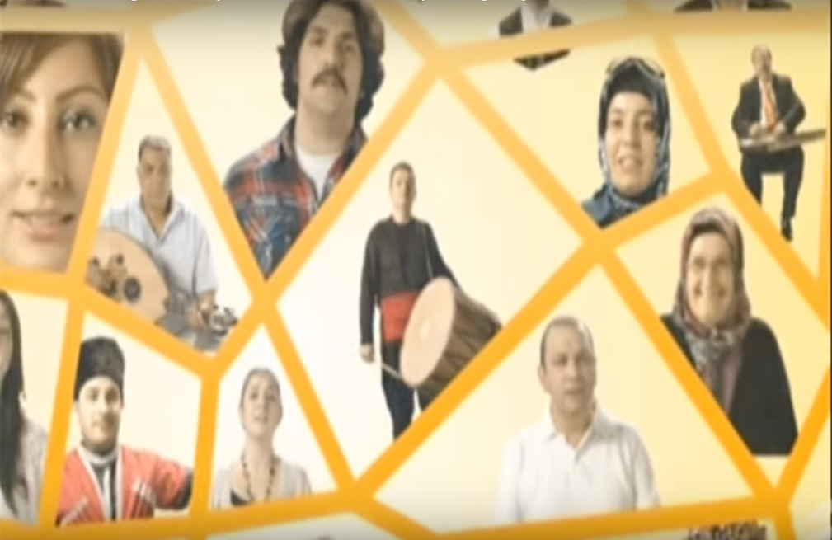
Figure 1: AKP’s Turkey
4.1.iii Positivity around the economy and AKP in musical choices
The economy under AKP at this time was beneficial to some and harmful to others. Despite the economy being part of AKP’s campaign, the video makes no direct reference to it. Instead, positivity surrounding the present under AKP is connoted in lines such as “Songs are the same, ballads are the same, we sing it together.” Unlike the past when “we” crossed paths in the winter, now “we” sing, play, dance and celebrate together.
Musical choices also connote positivity. The lead singer’s vocal style is key to this. Her voice which is salient throughout the song, is smooth, loud, and open-throated. Smooth sound qualities are valued and related to a sense of an ideal, connoting positivity (van Leeuwen 1999, 132). Her loudness resembles a “call” to join her, while her open-throated style suggests confidence and a lack of tension (van Leeuwen 1999, 130). Vocals at the song’s beginning are high pitched with little pitch movement. Van Leeuwen (1999) observes that small melodic movements at a high pitch give a sense of “tenderness.” It is here in the lyrics past suffering is represented, connoting sympathy towards the past. During the verses, melody further suggests positivity, with it relying heavily on the first and the fifth (figure two is a visual representation of the melody – one and eight being the key notes of B). Machin (2010, 107) observes that firsts and fifths are notes which “anchor the melody to the scale” and “allow the music to feel ‘easy’ or ‘rounded’.” The first line of the song starts on the fifth (F#) and then moves up to the high first. It makes small moves between the sixth and seventh and then finishes back on the fifth. With lyrics and visuals which connote unity and praise for AKP, melody makes these ideas feel natural and easy. In the second line of the verse, we see a change in melodic direction. Here the line starts on the seventh, a note associated with “thoughtfulness and longing” (Machin 2010, 219). Notes then descend gradually one note at a time with lyrics of “same mountain,” “same God,” “our summer is one,” and “roses of the same garden,” connoting thoughtfulness about unity (van Leeuwen 1999). The two note upward melodic change at the end of the line offers hope and energy suggesting though there have been problems in the past, there is hope now and in the future (ibid.).

Figure 2: Verse
Common actions by smiling participants in the visuals also represent AKP and voting for AKP positively. Aside from singing, dancing, playing and celebrating, a cross section of participants swing their hands with their palms up, a common gesture used for emphasis while talking. These people do this motion while singing, “We are the roses of the same garden. Let’s do it again, again, again.” Lyrics are simultaneously superimposed on the image to emphasise not only positivity and unity but also to instruct voters to continue to vote for AKP in “Let’s do it, again, again, again”. Musical choices emphasise these instructions. Unlike the melody elsewhere which flows smoothly, during these instructions rhythm is disrupted, with pauses between each lyric of “again”. This is a relatively energetic attack on the melodic phrase and a disruptive melody, drawing listeners’ attention (Tagg 1984, 32). The combination of lyrics, visuals and musical sounds connotes positivity around AKP and voting for them.
4.1.iv Erdoğan as leader in visuals
The final two shots make clear that it is AKP under the guidance of a strong confident Erdoğan which unites Turkey. The last shot is AKP’s lightbulb logo. This is preceded by a close-up of Erdoğan with the written text “Together we are Turkey” (figure three). The written text again draws on an exclusive form of national unity, the “we” representing the approximately 40–50 percent of voters who support AKP. In this image, Erdoğan wears clothes like “his people”, a white shirt and no tie. Facial hair and haircut are similar to the men depicted in the video. The background of this image and those before are the same colour connoting commonality. But, he is different. He does not sing and dance and smile at the camera. Instead, he looks on with approval, empowered by his lack of action. The camera looks up to Erdoğan, suggesting power (Machin 2007). Abousnnouga and Machin (2010, 144) note that subjects in war monuments look off to the horizon, with the meaning potential “of wanting the public to see the soldiers as part of a different world, one of the glory of God . . . metaphorically [looking] to the future and high ideals.” Here, Erdoğan’s gaze is similar, looking thoughtful, full of high ideals and into the future. He looks up, almost as though in prayer. Facial expressions make clear he is proud of his “flock” who sing and dance for his party.
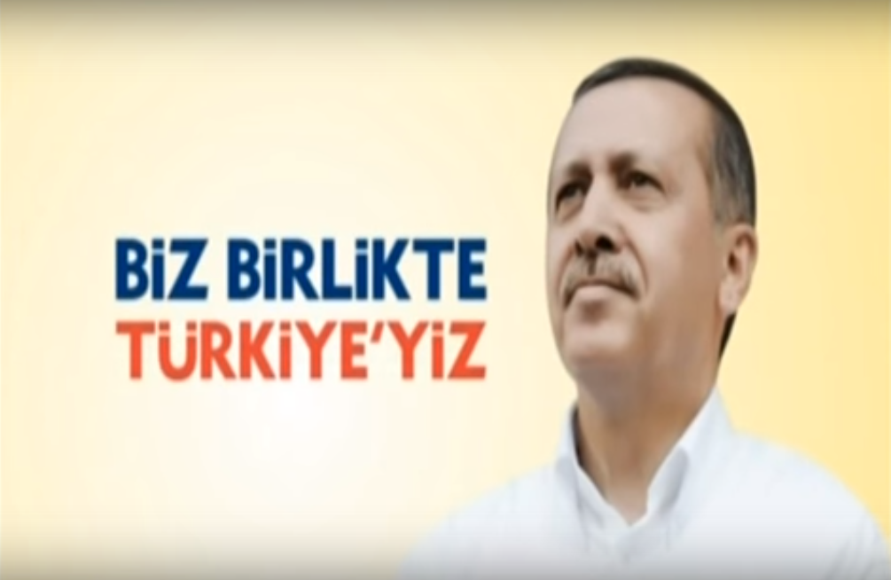
Figure 3: Erdoğan
4.2 2017 Referendum campaign video
Six years after AKP’s 2011 parliamentary victory, the government once again put music video to work, this time releasing “Millionca Evet/ Million times Yes” as part of the referendum campaign for the much coveted executive presidential system. Dominant discourses during the campaign can be summed up as “the old constitution is flawed making for weak coalition governments who are ineffective in dealing with internal and external threats”. Visuals in the video represent a journey from a village by a man who joins a convoy of “Yes” campaigners to a political rally. Like 2011, lyrics, visuals and musical sounds articulate discourses of positivity surrounding AKP and national unity, albeit a more conservative view this time. The song is again in the Art Music Fantazi sub-genre, used to suggest positivity about the presidential system.
4.2.i A united nation in lyrics and visuals
Like the 2011 video, pronouns play a role in connoting national unity. In the lyrics, “we” is overlexicalised, appearing in every line. Other lexical terms like “united”, “collaborated” and “blend together” further articulate unity. The repeated chorus “80 million became one heart, We are Turkey” suggests the whole Turkish population of 80 million is united, “we” sharing “one heart”. This inclusion is emphasised through metaphors of “brotherhood”. Ironically, during this campaign Erdoğan and AKP locked up politicians, journalists, academics, and students in unprecedented numbers (disproportionally Kurds) and named those who did not support the referendum as “traitors”.
Visuals emphasise unity in two ways. During the “80 million became one heart, We are Turkey” choruses, the main protagonist sings along as he drives to an AKP rally (figure four). Here, a close up shot connotes intimacy and a point of identification. His facial expressions suggest sincerity and heartfelt emotions. He is active singing and waving his hands to the music. It is these shot choices and actions which emphasise the lyrics of unity. All the while, external shots show the motorcade of cars with “Yes” flags constantly increase in size. Here, again visuals emphasise lyrics of “strength in numbers” and unity behind AKP’s “Yes” campaign.
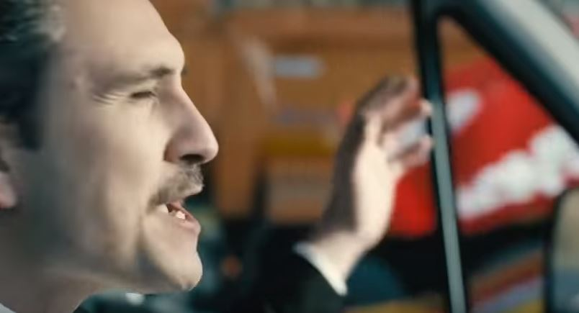
Figure 4: Strength in unity
Though unity is connoted in the lyrics, the line “All of us are Turkey, We are one nation” excludes many in Turkey. Here is a hint of an exclusive form of nationalism, a part of AKP discourse throughout the campaign which courted ultra-nationalist parties and their supporters. The lexica “one nation” comes from a traditional Turkish nation-building refrain seen, for instance, in the gateway to many military camps which reads, “One nation, one flag, one state.” Though nationalists embrace this, many Kurds do not (Schleifer 2013). Considering Erdoğan’s actions, including sending predominant Kurdish politicians to jail and launching a military assault on its Kurdish population, excluding them in the lyrics is not a surprise.
4.2.ii A conservative, male-dominant nation in visuals and musical sounds
The type of Turkish nation articulated in this video is made obvious in the visuals and sounds. Like 2011, the Turkey envisioned here is conservative. But unlike the previous video, it is more exclusive, visuals prioritising conservatively dressed men at the expense of women and non-conservative voters. There are no shots of non-conservative Turks. The vast majority of shots are of men, with many face shots allowing viewers symbolic closeness and points of identification. Typical of these are the main protagonist seen in figure four described above. Most crowd shots are men. Even the interior shot of school children on a bus are boys. Throughout the video, men drive vehicles, join the convoy, wave flags out of car windows, play instruments and ride motorcycles. There are only a small fraction of shots of women and an even smaller number of close ups, thereby discouraging any sort of point of identification and empowerment (van Leeuwen 1996). The women that are represented have their hair covered, a symbol of religious piety. Women have little agency, confined to subservient roles such as housewife, flag waving fan (very few of these) and peasants working fields. The only woman represented with agency rides a horse and holds a “Yes” flag. But even here, she is flanked by a man doing the same while she wears unrevealing clothes and has her hair pulled back, all connoting conservatism.
It is not just the role of women which connotes traditional values steeped in Islam. Almost all men sport facial hair, synonymous with Islam. A number of shots include male musicians playing traditional instruments associated with Art Music and Islam. Representations of characters in the opening scene exemplifies this. The main protagonist wears a black suit, black tie and a white collared shirt, indicating not only an important event is about to ensue, but also classic conservative clothing (figure five). He sports a moustache and has tidy short hair, typical of AKP supporters. He kisses the hand of his mother and father, a sign of respect in Islam. Excluded is any contact with his wife, displaying piety. The house is typical of a village house, emphasising AKP’s connection with rural, conservative Turkey, a large part of their voting base. His children and wife respectfully watch the actions of the father. The wife is a “good” nurturing mother, connoted by her arms protectively draped over her children. Like the older mother figure, her hair is covered. But it is in the style preferred by AKP, indicating her loyalty to the party.
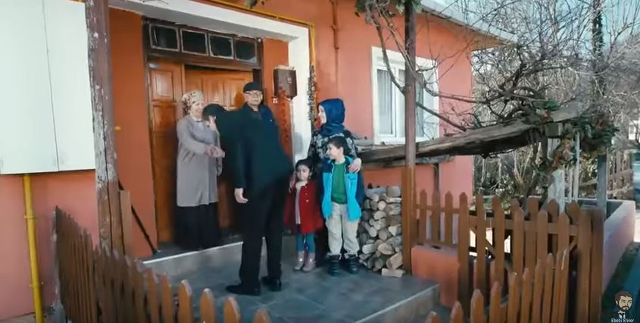
Figure 5: Traditional values

As is the case with the 2011 video, choosing a song from the Art Music Fantazi genre connotes conservatism and Islam. Tradition is further connoted through the choice in instrumentation, moreso than in the previous video. In 2011, percussion was a mix of traditional and Western drums. Here, drumming is performed by the large davul and a daire (or tef) which is a traditional Turkish tambourine. Both of these instruments are regularly used by small groups of musicians at weddings and other celebrations. Musicians usually wear traditional costumes and encourage audiences to dance traditional Halay or Horon folk dances. Here, these instruments are upfront in the hierarchy of sound giving importance and connoting tradition. This is unlike the lightly distorted guitar sounds which can be heard in the background. This sound suggests a number of things. Distorted guitars are most associated with rock and heavy metal. This sound may have been chosen to suggest a “heaviness” or seriousness to the referendum unlike a light acoustic guitar would. It may also be there to hint at modernity. All the same, its background role suggests its lack of importance relative to tradition, Islam and conservatism suggested throughout.

4.2.iii Support for the referendum and one man rule articulated multimodally

In the song’s verse (repeated four times), the lyrics recontextualise voting yes to “We say yes to reinvigoration” and “Escalation for our country, for our nation”. “Reinvigoration” and “escalation” are vague representations of changing the constitution and ignores the many voices which opposed such a change. During these lines, visuals show smiling people waving “Yes” flags and driving vehicles with “Yes” painted on them, including the main protagonist who smiles throughout with “Yes” clearly in the foreground on the bonnet of his van. It is unclear how a political change from a democratic parliament to one man gaining extraordinary powers will see the country’s “reinvigoration” and “escalation”. However, here proposed changes are represented positively for “our” country and nation.
Musical sounds in the choruses further connote support for presidential rule. Throughout the song, a deep male voice dominates the hierarchy of sound with instrumental accompaniment. During the choruses, a choir of predominantly male voices sing the same notes and words at the same time “behind” the solo singer. It is a “strong” sound of unity, like a football chant, voices with throats open connoting confidence and bravado (van Leeuwen 1999). All the same, the lead male’s voice “leads” the others, a metaphor for a single politician leading Turkey. Deep male voices add gravity to the message in the way females singing high notes would not (van Leeuwen 1999). As such, these choices suggest unity, one dominated by males and led by a single man.
4.2.iv Positivity for AKP and Erdoğan in visuals
AKP is represented as important. A poster of AKP’s Prime Minister is seen on the protagonist’s van a number of times. It is a shoulder shot of him looking directly at viewers in a demand image, wearing a suit and tie, demanding respect and connoting power. Ironically, part of the changes to the constitution is the role of Prime Minister disappears. In another shot, a close up of a large luxury coach’s number plate reads “AK 1”, telling voters that AK Party is number one. The journey itself metaphorically connotes positivity around AKP. Cars are not Porsches and BMWs, but Renaults and Dacias and motorcycles are of a similar standard, all suggesting the working class, not upper class. This is the heartland of AKP’s power. The convoy drives from the country into Istanbul, evident by the infamous “Third Bridge”. This bridge was opened by AKP in 2016 and has come under much criticism from environmentalists and for being a poor use of money (Way 2015). However, here it is a symbol of AKP, progress and neoliberal economics. The journey ends at a “Yes” AKP political rally in Istanbul, a “mega-city” with connotations of progress, wealth and the homeland of Erdoğan’s political career. Through scenes of thousands waving “Yes” flags, AKP is represented positively and important.

Erdoğan does not feature in the lyrics, visuals or sounds, with the exception of one shot near the end. Image six is the culmination of the video’s visual narrative when the convoy arrives at a political rally. Shots directly preceding this show happy crowds chanting and waving “Yes” flags. There are many close ups of bearded men of various ages staring at the camera, waving flags and giving the four fingered hand wave popularised by the Muslim Brotherhood in Egypt and used extensively by Erdoğan. It is details like these which remind viewers that this rally is about Erdoğan. Though his face is excluded, a detail shot of a chest and a ringed hand remind voters of Erdoğan’s marital status, a part of his piety. His hand performs a petting motion on his chest, a traditional sign of respect and salutation with connotations of tradition and conservatism. This action is in response to the mass of almost frenzied fans who have congregated for the referendum rally. Here video reflects reality, where Erdoğan spoke daily to large crowds to encourage them to vote yes. Choosing to exclude a face shot is part of playing down concerns about one-man rule. Despite Erdoğan being very popular in Turkey, many supporters of AKP were concerned about the changes. By omitting Erdoğan (mostly) from the visuals but having reminders of him, his importance and relevance are connoted without drawing on discourses which emphasise his power and irritate authoritarianism concerns.

Figure 6: AKP politician
- Conclusion
Both the 2011 election and the 2017 presidential referendum were important political events which have shaped the political landscape in Turkey. It is through these events that Erdoğan and AKP have tightened their grip on power to the extent that questions Turkey’s commitment to democratic ideals. The music videos analysed here were an essential part of these political campaigns. This paper has considered what exactly they tell Turkish voters in order to consider the limits and potential of music videos as political communication.
AKP’s 2011 election campaign focussed on the economy and a version of Turkish nationalism. The 2017 presidential referendum campaign represented the change to an executive presidency as a way to strengthen Turkish democracy by streamlining political processes in order to face internal and external threats such as coalition governments and terrorism. The campaign de-emphasised actual changes to laws which many considered anti-democratic. Analysis has revealed how both music videos use a variety of semiotic resources to articulate discourses of nationalism and support for Erdogan, AKP and voting (for party or constitutional change). The type of nation suggested through these videos is not inclusive, but exclusive to those who support the party. The videos also articulate slightly different discourses reflective of changes in AKP over the time. Lyrics from 2017 suggest a more nationalistic tone, whilst musical sounds and visuals are used to connote a more socially and religiously conservative Turkey. Though all three modes are employed to support the “Yes” vote, musical sounds lend support for the type of governance being promoted by AKP: One man leading a nation of active males.
So what does this tell us about music video as political communication? Like other forms of political campaign activities, the party, candidates and agendas are represented positively. Music videos do not make their political points through reason, argumentation and debate. Instead, through sounds, visuals and lyrics, videos simplify complex social and political issues to work on voters affectively. They appeal to our vision of what our nation means to us. They package issues and debates into sing-along musings of happiness and a bright future. There are no logical clear-cut arguments about policies and laws, just vague musings of national unity, descriptions of what it is to be a good citizen and who will lead us into a better tomorrow.
As such, music video as political communication affects us and divides us. By prioritising self-interested representations, music video excludes those who do not subscribe to their values and beliefs. In our case, these exclude those in Turkey who do not value religious and social conservatism, those who value secularism over political Islam, those who question AKP and its policies and those who worry about one-man rule. What we can conclude from this analysis is music video plays a role in affectively confirming loyalty to those who support a party or cause, but offers very little in terms of communicating policies and laws which directly effect voters’ lives.

References
Abousnnouga, Gill and David Machin. 2010. “Analysing the language of war monuments.” Visual Communication 9(2): 131–149. https://doi.org/10.1177/1470357210369884
Anderson, Benedict. 1991. Imagined Communities: The reflections on the Origin and Spread of Nationalism. London: Verso.
“Başbakan Erdoğan: din bir cimentodur ve şu anda en onemli birleştirici unsurumuzdur”. 2015. AK Parti accessed 20 December 2015, http://www.akparti.org.tr/site/haberler/basbakan -erdogan-din-bir-cimentodur-ve-su-anda-en-onemli-birlestirici-unsur/5641#1
Billig, Michael. 1995. Banal Nationalism. London: Sage.
Cooke, Deryck. 1959. The Language of Music. Oxford: Clarendon paperbacks.
Ekim Sinan and Kemal Kirisci. 2017. “The Turkish Constitutional Referendum Explained.” The Brookings Institute accessed 1 May 2018, https://www.brookings.edu/blog/order-from-chaos/2017/04/13/the-turkish-constitutional-referendum-explained/
Esen, Berk and Sinan Ciddi. 2011. “Turkey’s 2011 elections: An emerging dominant party system?” Rubin Center accessed 20 December 2015, http://www.rubincenter.org/2011/10/ turkey%E2%80%99s-2011-elections-an-emerging-dominant-party-system/
Fairclough, Norman. 2003. Analysing Discourse: Textual Analysis for Social Research. London: Routledge.
Fairclough, Norman. 1989. Language and Power, Harlow: Pearson Education.
Frith, Simon. 1981. Sound effects. New York: Pantheon.
Goodwin, Andrew. 1993. Dancing in the Distraction Factory: Music Television and Popular Culture. London: Routledge.
Halliday, M.A.K. 1985. An Introduction to Functional Grammar. London: Edward Arnold.
Hesmondhalgh, David and Keith Negus (eds.). 2002. Popular Music Studies. London: Arnold.

Klimek, Peter, Raul Jimenez, Manuel Hidalgo, Abrahim Hinteregger and Stefan Thurner. 2017. “Election forensic analysis of the Turkish Constitutional Referendum 2017”. Cornell University accessed 5 May 2018, https://arxiv.org/pdf/1706.09839.pdf
Kress, Gunther. 1985. Linguistic Processes in Sociocultural Practice, Victoria, Australia: Deakin University Press.
Kress, Gunther and Theo van Leeuwen. 2001. Multimodal Discourse. London: Hodder Education.
Letsch, Constanze. 2011. “Recep Erdoğan wins by landslide in Turkey’s general election.” The Guardian, June 13 accessed 1o June 2015, http://www.theguardian.com/world/2011/jun/13/ recep-erdogan-turkey-general-election
Machin, David. 2010. Analysing Popular Music. London: Sage.
Machin, David. 2007. Introduction to Multimodal Analysis. London: Hodder Education.
Machin, David and Andrea Mayr. 2012. How to Do Critical Discourse Analysis: A Multimodal Introduction. London: Sage.
Machin, David and John E. Richardson. 2012. “Discourses of unity and purpose in the sounds of fascist music: A multimodal approach,” Critical Discourse Studies 9(4): 329–345. https://doi.org/10.1080/17405904.2012.713203
Özbudun, Ergun and William Hale. 2010. Islamism, Democracy and Liberalism in Turkey: The Case of the AKP. London: Routledge.
Richardson, John E. 2007. Analysing Newspapers: An Approach from Critical Discourse Analysis. London: Palgrave Macmillan.

Sanchez, Raf. 2017. “Turkey referendum: Everything you need to know about president Erdoğan's bid for more power.” The Telegraph accessed 1 May 2018, https://www.telegraph.co.uk/news/2017/03/31/turkey-referendum-everything-need-know-president-erdogans-bid/

Schleifer, Yigal. 2013. “Turkey: One Nation, One Flag, One State, One Man”. Eurosianet accessed 4 May 2018, https://eurasianet.org/s/turkey-one-nation-one-flag-one-state-one-man
Stokes, Martin. 2010. The Republic of Love: Cultural Intimacy in Turkish Popular Music, London: University of Chicago Press.

Street, John. 1988. Rebel Rock: The Politics of Popular Music. Oxford: Basil Blackwood.
Sümer, Çağdaş and Yaşlı, Fatih. 2010. Hegemonyadan Diktoryaya AKP ve Liberal-Muhafazakar İttifak. Ankara: Tan Kitapevi Yayınları.
Tagg, Philip. 1984. “Understanding musical time sense.” In Tvarspel – Festskrift for Jan Ling (50 a°r). Goteborg: Skriften fran Musikvetenskapliga Institutionen. Accessed 5 January 2011, http://www.tagg.org/articles/xpdfs/timesens.pdf
“Turkish No voices struggling to be heard”. 2017. BBC. Accessed 8 April 2017, http://www.bbc.com/news/world-europe-39518180
van Dijk, Tuen. 1993. “Principles of critical discourse analysis.” Discourse and Society 4(2): 249-283.

van Leeuwen, Theo. 1999. Speech, Music, Sound. London: Macmillan Press.
van Leeuwen, Theo. 1996. “The representation of social actors.” In Texts and Practices – Readings in Critical Discourse Analysis, edited by Carmen Caldas-Coulthard and Malcolm Coulthard, 32–70. London: Routledge.
van Leeuwen, Theo and Ruth Wodak. 1999. “Legitimising immigration: A discourse historical approach.” Discourse Studies 1(1): 83–118.

Way, Lyndon. 2018. Popular Music and Multimodal Critical Discourse Studies: Ideology, control and resistance in Turkey since 2002. London: Bloomsbury
Way, Lyndon. 2016. “Protest music, populism, politics and authenticity: the limits and potential of popular music's articulation of subversive politics.” Journal of Language and Politics 15(4): 422-446. https://doi.org/10.1075/jlp.15.4.03way
Way, Lyndon. 2015. Spaces of protest in Turkish popular music.” In Relocating Popular Music, edited by Ewa Mazierska and Georgina Gregory, 27–43. London: Palgrave.

“Why did Turkey hold a referendum?” BBC 16 April 2017, accessed 4 May 2018, https://www.bbc.co.uk/news/world-europe-38883556
Wodak, Ruth, Rudolf de Cillia, Martin Reisigl and Karin Leibhart. 1999. The discursive construction of national identity. Edinburgh: Edinburgh University Press.
Yeşiltaş, Murat. 2009. “Soft balancing in Turkish foreign policy: the case of the 2003 Iraq War.”Perceptions 14(1): 25-51.
About the author
Lyndon C.S. Way received his PhD in Journalism from Cardiff University. He is a communications and media lecturer at the University of Liverpool. He has published on the multimodal nature of popular music, digital popular culture and news. He has co-edited a book on music as multimodal discourse and written a monograph on Turkish music and politics. Presently, he is writing a book entitled ‘Analysing Politics and Protest in Digital Popular Culture’ (Sage 2020).

Contact details: Communications and Media Department, University of Liverpool, 19 Abercromby Square, L69 3BX Lyndon.Way@liverpool.ac.uk

Video can be found at https://www.youtube.com/watch?v=StXtADrPOkI.
Video can be found at https://www.youtube.com/watch?v=Xs-UEG5ebtg.

