Utilisation of Volumetric Magnetic Resonance Imaging for Baseline and Surveillance Imaging in Neuro-oncology
Introduction
Volumetric MR imaging sequences have improved greatly over the years but continue to be reserved for surgical and radiotherapy planning purposes and clinical trials, rarely forming part of routine contrast enhanced studies of the brain [1]. The authors would like to highlight the value of these sequences in routine neuro-oncological clinical practice in both baseline (diagnostic) and surveillance imaging, especially with regard to brain metastases and meningioma. The NICE guidelines for brain tumours in adults were published in July 2018 [2] and recommend both pre and post contrast volumetric imaging as part of the standard structural imaging protocol for glioma, meningioma and brain metastases. A more detailed protocol on specific sequences and technicalities of sequence acquisition has been published by the British Society for Neuroradiologists (BSNR) and this also recommends volumetric imaging sequences for glioma [3]. Although these recommendations exist, routine volumetric image acquisition in brain imaging has yet to find widespread adoption into clinical practice.
Advantages
There are several advantages of performing volumetric imaging at baseline. First, it may negate the need for an additional MRI study to obtain the volumetric sequences necessary for either surgical or radiotherapy planning thereby saving the patient from a repeated, unnecessary second dose of gadolinium contrast medium [4], and by reducing duplicate imaging which would be a cost saving for the NHS. Second, the inclusion of volumetric sequences in surveillance imaging protocols would allow the application of co-registration techniques, which have been shown to increase sensitivity in identifying pathological changes [5]. Co-registration techniques are readily available on most PACS systems. Furthermore, it “future proofs” any scans acquired, so that retrospective analysis can be performed at a later stage including quantitative volumetric assessment [6,7] or “radiomic” approaches utilising textural analysis [8]. Volumetric measures also detect tumour growth more accurately (Figure 1) and are increasingly being utilised in drug development trials [9].
There is evidence suggesting quantitative volumetric measurements can provide additional prognostic information with regard to glioma. In low-grade glioma, changes in volume growth rate on T2 and FLAIR sequences can predict early malignant de-differentiation [10] and have shown better prediction of malignant transformation compared to baseline volumetric measurement, relative cerebral blood volume (perfusion imaging) and measurements of apparent diffusion co-efficient (diffusion imaging) [11]. Following surgical treatment for glioblastoma, a recent study has suggested that it is the actual volume of the tumour residuum rather than extent of resection, which has a greater effect on patient prognosis [12]. Interestingly, a comparison of two-dimensional RANO criteria and volumetric measurements in the first 12 weeks of bevacizumab treatment for GBM did not demonstrate an advantage to performing a quantitative volumetric measurement over the more simple two-dimensional RANO measures[13], although not acknowledged by the authors, the acquisition of a volumetric sequence would ensure more reliable comparison with preceding studies via co-registration techniques to improve the accuracy of the two-dimensional measures. The routine incorporation of volumetric sequences into neuro-oncology imaging protocols would allow these measurements to be more easily made, if so desired. Manual delineation of tumour volumes is time consuming and can be prone to inter and intra-observer error but software is now readily available which allows automated volume measurement and has been shown to be more reliable than manual delineation [14].
Practically, volumetric acquisitions typically take 7-8 minutes to perform per sequence and can be reformatted into any plane thus negating the need to acquire two different non-contiguous slice sequences (typically taking 4-5 minutes per acquisition). This is a more time efficient method and the ability to reformat in any plane removes the ambiguity over whether contrast enhancement is genuine or a vascular entity (Figure 2). Consensus papers on recommendations for standardized protocols for clinical trials for glioma [1] and neurofibromatosis [15] provide excellent guidance on which post contrast T1 protocols to use for volumetric imaging and these would be applicable to metastases and meningioma as well. The authors of these papers acknowledge that alternative and potentially improved volumetric sequences compared to the recommendations are available, but at the time of publication, these sequences were not as widely available as they are today.
Perceived disadvantages
Some radiologists and reporting radiographers may have concerns that the production of more imaging slices will both increase the error rate and take longer to review. There is no published evidence to support this. In fact, an early study of volumetric imaging demonstrated an increase in lesion conspicuity [16]. Whilst we acknowledge that radiological review and interpretation of volumetric 3D imaging may be more time consuming this is unlikely to equate to a directly correlated increment in time in relation to the number of image slices, since volumetric image interpretation is processed by the radiologist in a different manner to 2D image interpretation [17].
Whilst manual segmentation and quantification of tumour volumes is time consuming and can demonstrate considerable inter and intra-observer variability, validated software is readily available which provides automated and semi-automated methods of tumour volumetric assessment that is reliable and robust [14].
Conclusion
Volumetric imaging can increase efficiency in scan duration, aid diagnostic certainty removing ambiguity over genuine lesions and artefacts, and future proofs studies for more formal volumetric quantification when needed. Although, manual quantification of tumour volume is time consuming and can be error prone, this is not essential in the routine clinical reporting of neuro-oncology scans. If formal volumetric quantification is desired, validated, reliable and robust software is readily available which can perform this rapidly and accurately.
Overall, the benefits of performing volumetric imaging as part of the standard radiological assessment in clinical neuro-oncology seem to outweigh any perceived disadvantages.

References
1. Ellingson BM, Bendszus M, Boxerman J, Barboriak D, Erickson BJ, Smits M, et al. Consensus recommendations for a standardized Brain Tumor Imaging Protocol in clinical trials. Neuro-oncology. 2015. pp. 1188–98.
2. Brain tumours (primary) and brain metastases in adults | Guidance and guidelines | NICE. NICE. Available from: https://www.nice.org.uk/guidance/ng99
3. Core Imaging Protocol for Brain Tumours [Internet]. Available from: http://bsnr.org.uk/wp-content/uploads/2018/01/BSNR-STANDARDS-BRAIN-TUMOUR.pdf
4. Layne KA, Dargan PI, Archer JRH, Wood DM. Gadolinium deposition and the potential for toxicological sequelae - A literature review of issues surrounding gadolinium-based contrast agents. Br J Clin Pharmacol. 2018;84:2522–34.
5. Burdett J, Stevens J, Flügel D, Williams E, Duncan JS, Lemieux L. Increased sensitivity to pathological brain changes using co-registration of magnetic resonance imaging scans. Acta Radiol. 2006;47:1067–72.
6. Soon WC, Fountain DM, Koczyk K, Abdulla M, Giri S, Allinson K, et al. Correlation of volumetric growth and histological grade in 50 meningiomas. Acta Neurochir (Wien). 4 ed. Springer Vienna; 2017;159:2169–77.
7. Hashiba T, Hashimoto N, Izumoto S, Suzuki T, Kagawa N, Maruno M, et al. Serial volumetric assessment of the natural history and growth pattern of incidentally discovered meningiomas. Journal of Neurosurgery. 2009;110:675–84.
8. Ortiz-Ramón R, Larroza A, Ruiz-España S, Arana E, Moratal D. Classifying brain metastases by their primary site of origin using a radiomics approach based on texture analysis: a feasibility study. Eur Radiol. Springer Berlin Heidelberg; 2018;75:5–10.
9. Bachelot T, Romieu G, Campone M, Diéras V, Cropet C, Dalenc F, et al. Lapatinib plus capecitabine in patients with previously untreated brain metastases from HER2-positive metastatic breast cancer (LANDSCAPE): a single-group phase 2 study. Lancet Oncol. 2013;14:64–71.
10. Rees J, Watt H, Jäger HR, Benton C, Tozer D, Tofts P, et al. Volumes and growth rates of untreated adult low-grade gliomas indicate risk of early malignant transformation. Eur J Radiol. 2009;72:54–64.
11. Brasil Caseiras G, Ciccarelli O, Altmann DR, Benton CE, Tozer DJ, Tofts PS, et al. Low-grade gliomas: six-month tumor growth predicts patient outcome better than admission tumor volume, relative cerebral blood volume, and apparent diffusion coefficient. Radiology. Radiological Society of North America, Inc; 2009;253:505–12.
12. Xing Y, Wang X. Which Parameter Is More Important for the Prognosis of New-Onset Adult Glioblastoma: Residual Tumor Volume or Extent of Resection? World Neurosurg. 2018;116:e444–51.
13. Gahrmann R, van den Bent M, van der Holt B, Vernhout RM, Taal W, Vos M, et al. Comparison of 2D (RANO) and volumetric methods for assessment of recurrent glioblastoma treated with bevacizumab-a report from the BELOB trial. Neuro-oncology. 2017;19:853–61.
14. Ertl-Wagner BB, Blume JD, Peck D, Udupa JK, Herman B, Levering A, et al. Reliability of tumor volume estimation from MR images in patients with malignant glioma. Results from the American College of Radiology Imaging Network (ACRIN) 6662 Trial. Eur Radiol. Springer-Verlag; 2009;19:599–609.
15. Dombi E, Ardern-Holmes SL, Babovic-Vuksanovic D, Barker FG, Connor S, Evans DG, et al. Recommendations for imaging tumor response in neurofibromatosis clinical trials. Neurology. Wolters Kluwer Health, Inc. on behalf of the American Academy of Neurology; 2013;81:S33–40.
16. Brant-Zawadzki M, Gillan GD, Nitz WR. MP RAGE: a three-dimensional, T1-weighted, gradient-echo sequence--initial experience in the brain. Radiology. 1992;182:769–75.
17. Boer den L, van der Schaaf MF, Vincken KL, Mol CP, Stuijfzand BG, van der Gijp A. Volumetric image interpretation in radiology: scroll behavior and cognitive processes. Adv Health Sci Educ Theory Pract. Springer Netherlands; 2018;260:875–20.

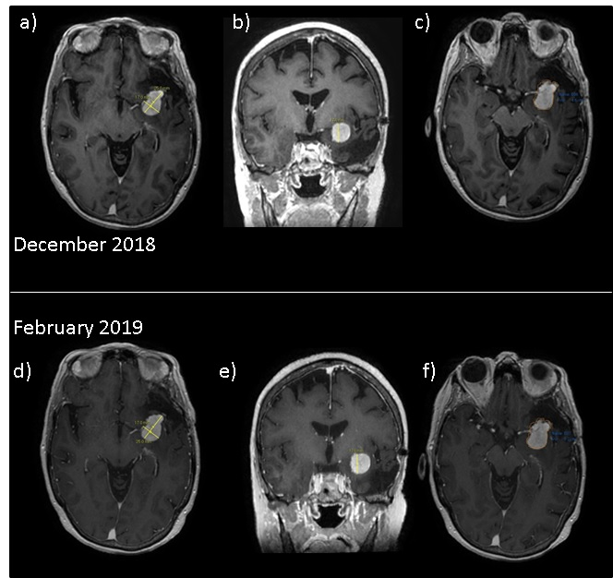Figure 1. Post contrast T1 weighted imaging of a patient with a recurrent left sphenoid meningioma. a) and b) Axial and coronal reformats from a volumetric post contrast T1 acquisition demonstrating conventional maximum trans-axial and coronal 2-dimensional measurements from December 2018 with c) demonstrating the semi-automated volumetric measure of the meningioma recurrence. d), e) and f) show corresponding images to a), b) and c) acquired 2 months later in February 2019 demonstrating no measurable change on conventional 2-dimensional measurements but an approximately 8% increase in volume when quantitative volumes are obtained increasing from 4.8 cm² to 5.2 cm².

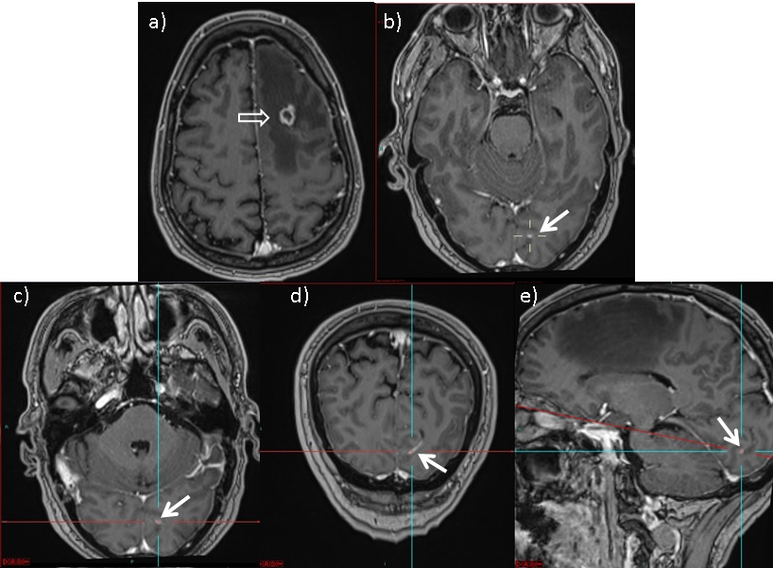Figure 2. a) Axial T1 MPRAGE showing a left frontal cerebral metastasis from renal cell carcinoma (open white arrow) b) The solid white arrow identifies an indeterminate focus of enhancement in the left occipital lobe, there is uncertainty on this axial imaging whether this reflects a separate small metastasis. c), d) and e) Standard axial, coronal and sagittal reformats of 3D imaging respectively shows enhancement (solid white arrow) is linear on the coronal reformat and, in fact, represents a vessel rather than a second metastatic deposit.

