Impact of ENSO 2016-17 on regional climate and malaria vector dynamics in Tanzania.
Katharina Kreppel ^{1,2,3,4*}, Cyril Caminade ^{4,5*}, Nicodem Govella ¹, Andrew P. Morse^{5,6}, Heather M. Ferguson ³ and Matthew Baylis ^{4,5}

*These authors contributed equally to the work

¹ Department of Environmental Health and Ecological Sciences, Ifakara Health Institute, Dar es Salaam, Tanzania, ² School of Life Sciences and Bio-Engineering, Nelson Mandela African Institution of Science and Technology, Arusha, Tanzania, ³ Institute of Biodiversity Animal Health and Comparative Medicine, University of Glasgow, UK, ⁴ Department of Epidemiology and Population Health, Institute of Infection and Global Health, University of Liverpool, UK, ⁵ NIHR Health Protection Research Unit in Emerging and Zoonotic Infections, Liverpool, UK,⁶ Department of Geography and Planning, University of Liverpool, U.K..

Corresponding author: katharina.kreppel@nm-aist.ac.tz, Department of Environmental Health and Ecological Sciences, Ifakara Health Institute, Dar es Salaam, Tanzania
Abstract (300 words max)
Large scale modes of climate variability, including the El Niño Southern Oscillation (ENSO) and the Indian Ocean Dipole (IOD), have been shown to significantly impact mosquito-borne diseases in the Tropics, including malaria. However, the mechanistic cascade from ENSO and the IOD, to induced changes in regional climate and ultimately mosquito abundance and behaviour is poorly understood. Mosquito population dynamics, behaviour and their potential to transmit disease are all sensitive to micro-climatic conditions. The warm phase of ENSO (El Niño) tends to be associated with increased precipitation and outbreaks of various vector-borne diseases, while the cold phase (La Niña) can cause drought during the short rains over East Africa. .
The sensitivity of Anopheles mosquito population dynamics and host-seeking behaviour to ENSO and to the resulting micro-climatic conditions, were investigated in the Kilombero-Valley in Tanzania. From June-2016 to September-2017, changes in the timing and intensity of the rainy seasons and temperature due to the ENSO 2016-17 were observed. Mosquitoes were collected using Centres for Disease Control and Prevention (CDC) light traps indoors and Mosquito Electrocuting Traps in- and outdoors. Changes in abundance and biting behaviour of Anopheles arabiensis and Anopheles funestus were correlated with climate and micro-climate.
The impacts of El Niño on climate and mosquito abundance were not clear. However, the study area experienced a drought due to La Niña during which both vector species declined significantly. An. arabiensis densities stayed more stable at higher temperatures and were found in higher numbers outdoors with respect to An. funestus. For both species, indoor temperature and season determined their host-seeking location, with higher temperatures and the wet season driving them outside.
The study confirmed the influence of ENSO and micro-climate on malaria vector abundance and host-seeking behaviour, generating hypotheses for predicting the impact of future ENSO on malaria risk and vector control. Our observation of higher outdoor biting during warmer conditions indicates that indoor vector control strategies may become proportionally less effective during this time.
Keywords: El Niño Southern Oscillation, Malaria, Climate, Mosquito Behaviour, Micro-climate, Anopheles

- Introduction
Despite sucessful control efforts and a vast reduction in cases and deaths over the last decade, malaria is still a major public health concern in many parts of the world (Bhatt, Weiss et al. 2015, WHO 2018). Over ninety percent of all malaria cases and deaths occur in sub-Saharan Africa, and malaria continues to be the most significant mosquito-borne disease hampering public health and socio-economic development in this region. The World Health Organisation estimated that there was an increase of two million cases between 2016 and 2017 globally (WHO 2018) and climate is considered a possible contributor. In most endemic regions of sub-Saharan Africa, mosquitoes of the Anopheles gambiae (An. gambiae s.s. and An. arabiensis its sibling species) and Anopheles funestus complex are the primary vectors for malaria (Collins and Besansky 1994, Donnelly, Licht et al. 2001, Sinka, Bangs et al. 2012). There has been widespread and consistent demonstration of strong association between seasonal precipitation and abundance of these vectors because of the dependence of their aquatic larval stages on standing water (Lindblade, Walker et al. 1999, Oesterholt, Bousema et al. 2006, Zhou, Munga et al. 2007, Kelly-Hope, Hemingway et al. 2009, Bomblies 2012). Additionally, other microclimatic variables such as temperature have significant impacts on several aspects of adult vector fitness, behaviour and transmission potential (Bayoh and Lindsay 2003, Kulkarni, Kweka et al. 2006). For example, the gonotrophic cycle of mosquitoes (e.g. time between biting and laying eggs) shortens and adult survivorship increases with temperature up to a thermal tolerance threshold, beyond which their fitness is impaired (Paaijmans, Imbahale et al. 2010). Additionally, the sporogonic development rate of malaria parasites within vectors increases with temperature, thus increasing their transmission potential (Shapiro, Whitehead et al. 2017). These mosquito demographic and epidemiological parameters ultimately determine rates of human exposure to infected mosquito bites.

Microclimatic and seasonal environmental variation can also impact human exposure to malaria in another way: by altering the timing and location where vectors bite. Currently, malaria vector control in Africa is primarily conducted through application of insecticides inside houses (Hemingway 2014). This is based on use of Long lasting Insecticidal Nets (LLINs) and Indoor Residual Spraying (IRS); both of which are very successful in reducing malaria in Africa (Bhatt, Weiss et al. 2015). The success of LLINs is based on their ability to exploit the behavioural predisposition of African malaria vectors to primarily feed on humans (anthropophagy) during sleeping hours, inside houses (endophagy), and rest indoors after feeding (endophily) (Lyimo and Ferguson 2009, Killeen, Marshall et al. 2017). These behaviours increase the probability of vectors coming into contact with insecticides either during host-seeking (e.g. LLINs) or resting on walls after blood feeding (e.g. IRS). Consequently, the upscaling of these control measures has coincided with a substantial decrease in malaria vector abundance (Bayoh, Mathias et al. 2010, The mal E. R. A. Consultative Group on Vector Control 2011), and the near eradication of highly anthropophagic and endophilic vectors, such as An. gambiae, in particular settings (Bayoh, Mathias et al. 2010, Russell, Lwetoijera et al. 2010, Mwangangi, Mbogo et al. 2013).
The host-seeking and resting behaviour of malaria vectors has previously been shown to be influenced by the micro-climate of their immediate environment (Paaijmans and Thomas 2011, Ngowo, Kaindoa et al. 2017). However, the relationship between larger-scale climate phenomena such as the El Niño Southern Oscillation (ENSO), micro-climate and mosquito host-seeking behaviour are less clear. Understanding the mechanistic cascade from the ENSO, to induced changes in regional climate, and ultimately mosquito abundance and host-seeking behaviour is important in times of a changing climate and increasing insecticide resistance. Indoor-based control methods may be increasingly challenged both by insecticide resistance and climate-driven changes in vector behaviour.

The Kilombero Valley in southern Tanzania has experienced historically high malaria transmission with 226 infective bites per person per year in 2012 (Lwetoijera 2014). Since then, it has seen a reduction in infective bites to 15.9 ib/p/yr in 2015 (Kaindoa 2017, Finda, Limwagu et al. 2018) due to control measures (LLINs and IRS). The availability of high quality historical data on vector ecology and transmission, and a high coverage with LLINs make this valley a good model for quantifying impacts of extreme climate events in areas of Africa were transmission has also been declining.

Worldwide the warm phase of ENSO, El Niño, is associated with the movement of warm waters from western part to the eastern part of the Pacific Ocean. El Niño has been associated with infectious disease outbreaks, including Rift Valley fever, malaria, and cholera; increased risk of arbovirus and malaria transmission in Latin America and Southeast Asia; and outbreaks of malaria and cholera in India (Hales, Weinstein et al. 1999, Chretien, Anyamba et al. 2015, Anyamba, Chretien et al. 2019). El Niño leads to a warming of the atmosphere in the Tropics which can last several months to a year after the event (Tyrrell, Dommenget et al. 2015). El Niño often causes flooding over eastern Africa during the short rainy season (Oct to Dec), while its influence on the long rains (Mar to May) is less clear (Nicholson 2017). The effect of ENSO on malaria incidence in East Africa significantly varies regionally. During the 1958-59 El Niño, very conducive climate conditions resulted in three million additional malaria cases in the highlands of Ethiopia (Fontaine, Najjar et al. 1961). During the 1997-98 El Niño, higher temperatures and increased precipitation resulted in increased malaria prevalence in the highlands and north-eastern Kenya (Brown, Issak et al. 1998). In contrast, an overall reduction of malaria cases was reported in the Usambara mountains of Tanzania during the 1997-98 El Niño which was attributed to heavy rainfall washing away mosquito breeding sites (Lindsay, Bødker et al. 2000). Conversely, an increase in malaria cases was reported at lower elevations for two other locations (Kagera and Morogoro) in Tanzania that year (Carlstedt, Brabin et al. 2004). The cold phase of ENSO, La Niña, tend to be associated with colder and drier conditions over East Africa (Omumbo, Lyon et al. 2011). The relationship between La Niña, regional climate anomalies and malaria burden has not been extensively studied.

The Indian Ocean dipole is an oscillation of sea-surface temperatures (SSTs) in which the western part of the Indian Ocean becomes alternately warmer and then colder than the eastern part of the Indian Ocean. The positive phase of the IOD (when the western part is warmer than the eastern part of the Indian Ocean) has also been associated with flood conditions during the short rains (Oct to Dec) over Eastern Africa (Behera, Luo et al. 2005). A positive phase of the IOD tends to increase easterlies crossing the Indian Ocean, bringing more moisture to eastern Africa during the short rains.

To fully understand the impacts of these climate anomalies on vector borne diseases, thorough surveillance of vectors and their behaviour through all phases is needed. This study therefore aims to primarily determine the effects of ENSO 2015-16 on malaria vector abundance and host-seeking behaviour, as a means to understand the potential impact of these events on malaria transmission and to inform control strategies.

2. Methods

2.1 Study area
Mosquito vectors were collected in the Kilombero River Valley of southern Tanzania (7°44´to 9°26´ S/35°33´to 36° 56´E) in four villages: Kidugalo, Lupiro, Minepa and Sagamaganga (Fig. 1). The primary malaria vectors throughout this area are Anopheles arabiensis, (member of the An. gambiae s.l. complex) and An. funestus s.l. (Mwangangi, Mbogo et al. 2013, Lwetoijera 2014, Mayagaya, Nkwengulila et al. 2015, Finda, Limwagu et al. 2018).
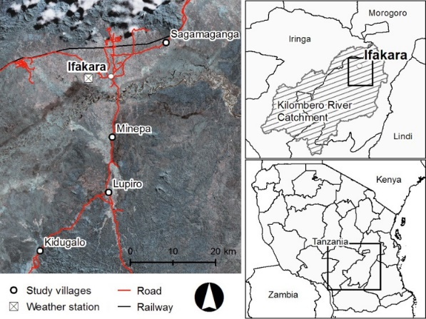
Figure 1: Study site in the Kilombero Valley in Kilombero and Ulanga districts, Tanzania, showing Ifakara and the four study villages as well as the location of weather station. Entomological and environmental data was collected for all four villages.
2.2 Experimental Design
Entomological surveillance was carried out to investigate associations between climate variables and vector abundance, species composition and biting behaviour (biting time and location) between June 2016 and September 2017. Malaria vectors were repeatedly sampled in each village at the same four households for four consecutive days each month. On the first day of sampling, an index house was selected in each village on the basis of being accessible, and the presence and willingness of residents to participate. Three additional houses were recruited in the vicinity of the index house to achieve the required sample size (4 households), with houses being within 100-200m of one another. In each set of houses, two houses were selected where livestock were kept (e.g. goats or cattle), and two without, because of the known impact on vector species composition and location of biting.
2.3 Trapping methodology
Two trapping methods were used to sample host-seeking mosquitoes throughout the study. CDC Miniature light traps were used to collect mosquitoes host seeking indoors at night. Additionally we introduced a relatively new sampling method; Mosquito Electrocuting Traps (MET) which provide an exposure-free method to directly measure mosquito landing rates on people in indoor and outdoor settings. Mosquito Electrocuting Traps can be used to sample mosquitoes attempting to feed on a human volunteer from 6pm-6am) in indoor and outdoor settings (Maliti, Govella et al. 2015, Govella, Maliti et al. 2016). In June 2016 host-seeking mosquitoes were collected with CDC light traps in four houses for four nights in each village. From July 2016, CDC light traps were used in three out of the four houses, with mosquito electrocuting traps being used at the remaining house (one indoors and one outdoors). Trap types were rotated each night following a Latin square design. These methods were selected because Centers of Disease Control and Prevention (CDC) light traps provide a widely used proxy of overall mosquito abundance and indoor biting rates (Briët, Huho et al. 2015), while MET traps give information on hourly biting time and location. CDC light traps were deployed from 6pm to 6am every night by placing them approximately 1.5 m above ground and close to the foot of a bed in which between one and four people were sleeping under a LLIN. Collections with METs were also conducted from 6pm to 6am. The MET is composed of four electrified panels positioned in a square surrounding the lower legs of a seated volunteer, that intercept and kill mosquitoes on approach, while the rest of the volunteer’s body is protected by netting. Each hour, the MET was turned off for 15 minutes to allow mosquitoes caught on the surface to be removed, recorded and stored. At the house allocated for MET collection, one trap was positioned within a living room and another outside (~5m from house), on each night as described elsewhere (Govella, Maliti et al. 2016). The volunteers sitting in the MET traps were swapped between indoor and outdoor trapping stations every hour to minimize bias due to differing attractiveness to mosquitoes. Additional data on mosquito abundance and species composition based on CDC light trap collections (indoors) from a previous study (2012-2015, Kreppel et al. in preparation) in the same villages (350 households) were used as a baseline for comparison with non- El Nino years.
2.4 Mosquito identification and molecular analyses
All mosquitoes collected in traps were killed by chloroform. The number and sex of those morphologically identified as belonging to the An. gambiae s.l or An. funestus s.l. complex or Culex species were recorded (Edwards 1941, Gillies and De Meillon 1968, Gillies and Coetzee 1987). A subset of An. gambiae s.l. collected (n=5600, 22% of total) were identified to species level by polymerase chain reaction (PCR) (Scott, Brodgon et al. 1993). For this, 5 individual mosquitoes were sampled from each trap per night. Mosquitoes were sampled for indoor and outdoor MET separately. With an amplification rate of 92.5%, laboratory results confirmed them all to be An. arabiensis. On this basis of the predominance of An. arabiensis in the An. gambiae s.l. tested here and in other concurrent studies in the area (Govella, Chaki et al. 2009, Marsden, Lee et al. 2014, Maliti, Govella et al. 2015, Kaindoa, Ngowo et al. 2017), all An. gambiae s.l. collected were assumed to be, An. arabiensis. PCR analysis was also conducted on members of the Anopheles funestus s.l. to identify them to species level (n=2104, 20% of total, amplification rate 87.6%)(Koekemoer, Kamau et al. 2002). The majority of An. funestus s.l. specimens were identified to be An. funestus funestus (97%) followed by An. rivulorum (1.4%) and An. funestus lessonii (1.1%). Additionally, mosquitoes were pooled in batches of a maximum of 10 per sampling tube per trap type, per night (An. arabiensis: n=14700, 59% of total and An. funestus: n=7890, 75% of total) Enzyme Linked Immunosorbent Assays (ELISA) were used to test for presence of Plasmodium malaria parasites (Beier, Perkins et al. 1990).
2.5 Environmental data
Indoor temperature and humidity were recorded with Tiny Tag Plus 2 data loggers (Gemini data loggers, UK, Ltd) placed inside houses on each night of sampling (approximately 1m above the ground). These data were used to calculate the indoor saturation deficit for each house using established methods (Allen 1998). Season was defined for each sampling month as wet or dry depending on the monthly amount of rainfall. A month with rainfall over 1mm per day on average was defined as “wet”.
Daily climate data was retrieved from different sources. Daily rainfall (mm) and temperature (ºC) were obtained from the Ifakara GloBe weather station (GRWS 100 Campbell Scientific) installed at the Ifakara Health Institute (IHI) (8.11417 ºS, 36.67484 ºE) within the floodplain (see Fig. 1). The weather station has been recording from 18th November 2014. To calculate anomalies (e.g. departure from the long term means), we utilized gridded climate data. Daily rainfall data from the Climate Hazards group Infrared Precipitation with Stations (CHIRPS) dataset at 0.05º x 0.05º spatial resolution was used for the period 1981-2017 (Funk, Peterson et al. 2015). Monthly gridded temperature data (0.5º x 0.5º resolution) which combines weather station data from the Global Historical Climatology Network version 2 with the Climate Anomaly Monitoring System was utilised for the same period (Fan and van den Dool 2008). Monthly anomalies were calculated with respect to the 1981-2017 period for the gridded products. A comparison between gridded and weather station data is provided for rainfall on Fig. S1 and for temperature on Fig. S2. Time variability is well reproduced by the gridded data; but both CAMS and CHIRPS data tend to overestimate temperature and rainfall over Ifakara. The Nino 3.4 index data (calculated as monthly sea surface temperature anomalies with respect to 1981-2010 climatology over the region 5ºN-5ºS and 170-120ºW) and the Dipole Mode Index (calculated as the difference between the average SST in the region 50-70ºE and 10ºS-10ºN minus the average SST in the box 90-110ºE and 10ºS-0ºN) based on the HadISST data (Rayner, Parker et al. 2003) were downloaded from KNMI climate explorer (https://climexp.knmi.nl/selectindex.cgi?id=someone@somewhere).
2.6 Ethics

Before the study began, meetings were held with community leaders in all villages during which they were informed about the purpose of the study and their participation requested. After their permission had been granted, the study team visited each village and informed consent was obtained from each head of household where mosquito trapping was conducted. The study was previously approved by the Ifakara Health Institutional Review Board (Institutional Ethics Clearance: Certificate number IHI/IRB/No: 037-2016). It was further approved by the University of Liverpool ethics board (RETH001036).

2.7 Analysis and models

The potential environmental drivers of vector abundance and host-seeking location (indoors vs outdoors) were investigated in generalized linear mixed models that included explanatory variables of nightly minimum, mean and maximum temperature (in °C) and relative humidity (RH in %) indoors, saturation deficit indoors (in kPa) and season (wet or dry). Effects of temperature, humidity and saturation deficit on mosquito abundance and host-seeking location were investigated using Generalized Linear Mixed Models (GLMMs) with the ‘glmmTMB’ package in R statistical software (Mollie E. Brooks 2017). Mosquito abundance was estimated as the mean number of vectors caught per CDC light trap per night and in MET per hour. In all models, all micro-climatic variables and season were fitted as fixed effects while household id, date and trap number were fitted as random effects. Model selection was conducted using the Akaike Information Criterion (AIC), by sequentially selecting models with lower AIC values and the rule of parsimony (Bolker, Brooks et al. 2009). For the models on host-seeking location, the hourly number of mosquitoes collected by MET was fitted as the response variable, while trap location (in- or outdoors) was fitted as a two-way interaction term to all fixed effects. Hour of collection was included as random effect nested in house. Data was modelled as following a negative binomial distribution due to the degree of overdispersion in the data (using a test for overdispersion by (Cameron and Trivedi 1990).

3. Results
3.1 Mosquito bionomics
A total of 28799 mosquitoes were collected using CDC light traps during 778 trap nights across the study (Table 1). A further 9061 mosquitoes were collected with METs (combined indoors and outdoors), across 215 trap nights. With both methods, more than twice as many An. arabiensis were caught than An. funestus, with the majority of collected female mosquitoes unfed (Table 1). Infection rates with Plasmodium falciparum were 0.013% for An. arabiensis and 0.025% in the An. funestus.
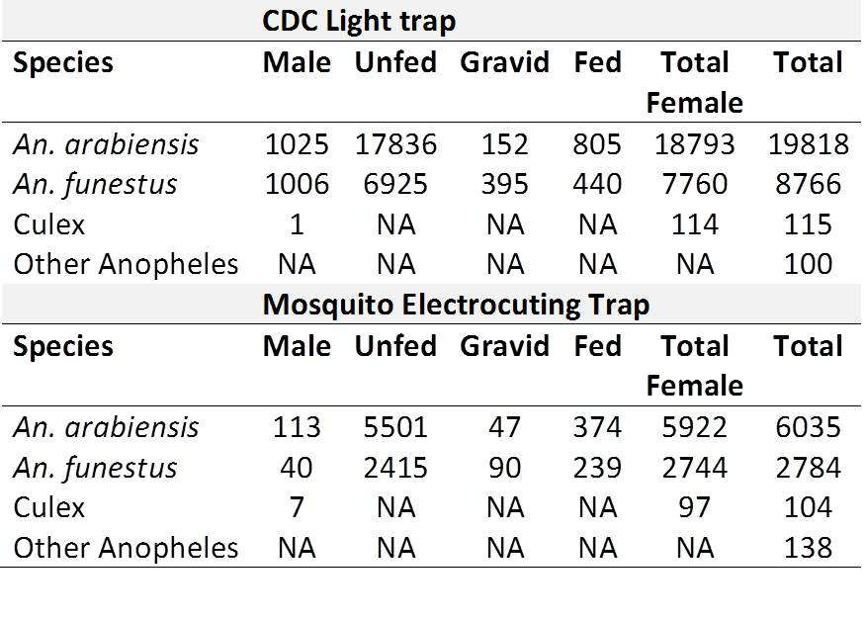

Table 1: Number of mosquitoes collected throughout the study by species, sex and abdominal status in Centre for Disease Control and Prevention light traps and Mosquito Electrocuting Traps.
3.2 ENSO, regional climate anomalies and mosquito dynamics
The 2015-16 El Niño was one of the strongest events on record. This event started in Oct-Nov 2014, peaked during the boreal winter 2015 before declining during the boreal spring 2016. This warm event was followed by a mild La Niña signal from June 2016 to January 2017 (Fig. S1a & Fig. S3a). The SST signal in the Indian Ocean was not very clear in 2016; however, a moderate positive phase of the IOD occurred in 2017 (Fig. S1a). In Ifakara, rainfall tends to occur from November until May, with a peak in March-April (Fig. S1b & Fig. S3c). During the study period from June 2016 to September 2017, mean monthly temperature oscillated between 23ºC and 30ºC (Fig. S1b and Fig. S3b). The warmest months are usually between October and January (Fig. S3b).
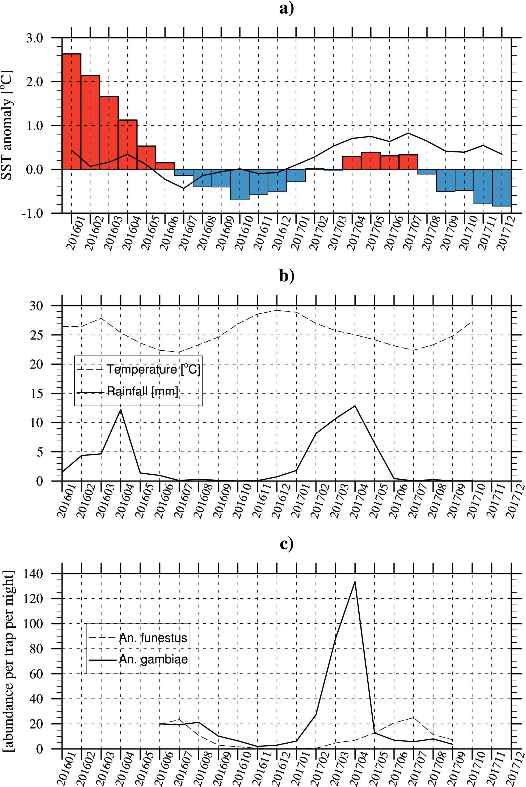
Figure 2: Comparison of a) Nino3.4 index (bars) and DMI index (solid line) (ºC), b) rainfall (mm) and temperature (ºC) conditions for Ifakara (weather station data) for the period 2016-17. c) Averaged Anopheles mosquito abundance for all villages (catch per trap per night based on CDC traps) for the same period.

On average, the positive (negative) phase of ENSO, El Niño (La Niña), is associated with increased (decreased) rainfall conditions over eastern Africa during the short rains (Fig. S4g). The positive (negative) phase of the IOD is also associated with increased (decreased) precipitation over Tanzania (Fig. S4h). The relationship between rainfall in Tanzania and the IOD is even more pronounced than ENSO during the short rains as shown by Behera et al., 2005 (Behera, Luo et al. 2005). One of the wettest short rain season occurred in 1997 in Tanzania, when both positive phases of the IOD and ENSO co-occurred (Fig. S4b). In 2015, wetter than average conditions were observed over Tanzania (Fig. S4c), however, 2015 was not as wet as 1997. La Niña events in 1982, 1997 and 2016 were mostly related to drier than average conditions in Tanzania (Fig. S4d-e-f). The relationship between ENSO, DMI and land temperature in Tanzania is not significant and not clear, when long term trends are removed (Fig. S5). However, colder than average conditions are associated with the positive phase of the DMI (Fig. S5h) over northern Tanzania. This temperature signal is consistent with increased rainfall conditions (Fig. S4h) which tend to cool the land surface.
Anopheles arabiensis density peaked in phase during the February-April rainy reason, with An. funestus peaking 2-3 months later (May-August with a peak in July, see Fig. S1c & Fig. S3d). Despite some differences across study sites, this feature was relatively robust around the Kilombero Valley (Fig. S6). Climate anomalies (e.g. departures from the long term mean), warmer (colder) temperatures were experienced during El Niño (La Niña) events in Ifakara (Fig. S7b). During El Niño 2015-16, more rainfall was observed over the region (Fig. S7c). Conversely, a significant drought occurred during the following La Niña between October 2016 and February 2017 (Fig. S7c). These results for Ifakara are consistent with the aforementioned findings at country scale (Fig. S4 and Fig. S5).
Populations of both Anopheles vector species crashed below detection during the drought associated with La Niña (Oct 2016-Feb 2017). Drought conditions (Fig. S7c) and lower abundance (Fig S7d) were previously observed from January to March 2012. The population crash was more pronounced for An. funestus than An. arabiensis (Fig. S7d). Lagged monthly correlations between temperature and mosquito abundance were not significant using a standard Pearson test (Fig. S8a and S8b). However, rainfall was significantly positively correlated with An. funestus at a 2 months lag (r = 0.64, p<0.001, Fig. S4d).
3.3 Effects of micro-climate on host seeking location and abundance
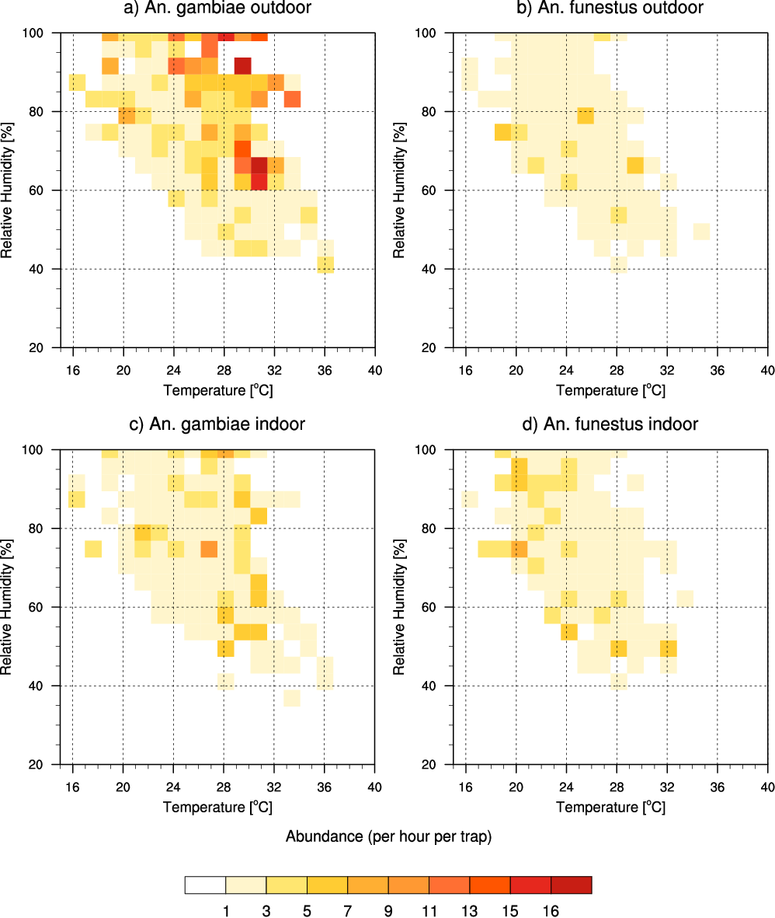
Figure 3: Mosquito abundance (catch per trap per hour based on the MET) dependencies to temperature (ºC – x-axis) and relative humidity (% - y-axis). Results are shown for a) An. gambiae caught outdoor and c) indoor and b) An. funestus caught outdoor and d) indoor.
More An. arabiensis were caught outdoors than indoors (Fig. 3a, 3c and S9) while the opposite was observed for An. funestus (Fig. 3b, 3d and S9a). No mosquitoes were caught when night-time relative humidity dropped below 40% (Fig. 3), with vector abundance highest when RH > 60%. Very few An. funestus were caught when mean temperature exceeded 32ºC (Fig. 3b and 3d). In contrast, the abundance of An. arabiensis was relatively stable between 24ºC and 32ºC, and the maximum suitable temperature was found to be 36ºC (Fig. 3a).

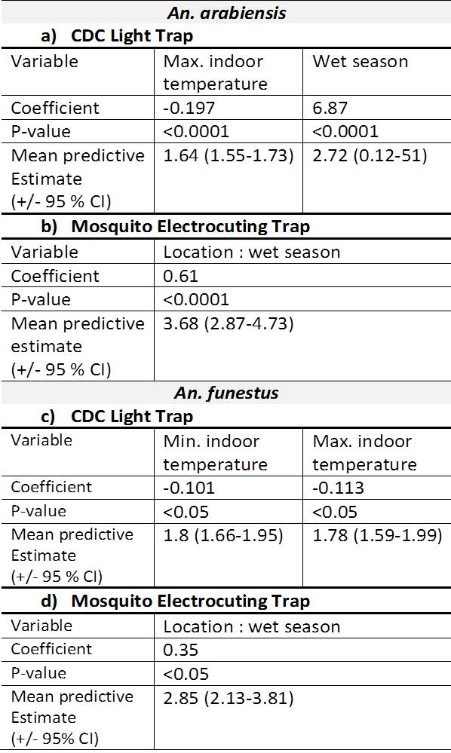
Table 2: The association of micro-climate variables and season for host-seeking An. arabiensis with a) the predicted mean abundance per night per CDC light trap and b) the estimated change in the exophily (“location” refers to indoor versus outdoors) and for host-seeking An. funestus with c) the predicted mean abundance per night per CDC light trap and d) the estimated change in the exophily. Only variables with a p-value below 0.05 are shown.
The mean number of An. arabiensis collected per CDC trap per night was negatively associated with maximum indoor temperature and showed a positive association with the wet season (Table 2a). The abundance of An. funestus catches was negatively associated with increasing temperature (minimum and maximum, Table 2b).
Exophily, defined as the relative proportion of mosquitoes caught in outdoor vs indoors METs, was predicted to increase in the wet season for both vector species outdoors of the total MET catch (Table 2b).
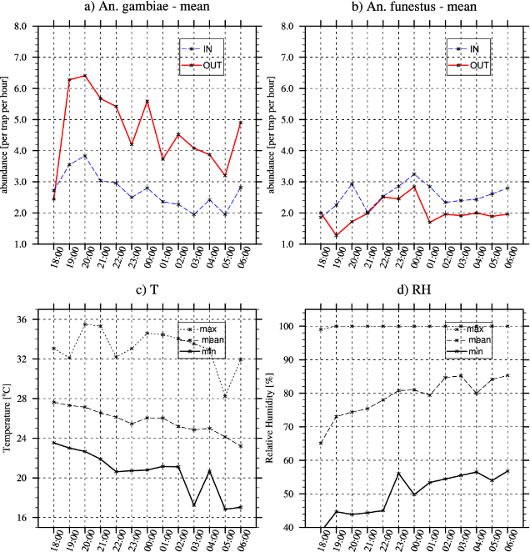
Figure 4: Hourly abundance for a) An. arabiensis and b) An. funestus (indoor and outdoor, per trap per night based on the MET data) averaged for all villages. c) Hourly temperature (ºC) and d) relative humidity (%). All data are averaged for all villages. The mean, minimum and maximum were calculated using daily data from May 2016 to Sep 2017.
An. arabiensis and An. funestus exhibited differences in the timing of their nightly host seeking (Fig. 4). Specifically, An. arabiensis, was very active from early evening (18.00) until midnight, mostly outdoors (Fig. 4a). Biting rates of An. arabiensis decreased after midnight following the observed decrease in temperature and increase in RH. A secondary peak in An. arabiensis biting activity was observed in the early morning hours, when temperature increases again (06.00). Conversely, An. funestus, which was mostly caught indoors, was most active in the middle of the night between 23.00 and 01.00.
4. Discussion

In the face of climate change impacts on East Africa, understanding the effects of climate (synoptic scale) and micro-climate on disease vector abundance and behaviour is essential. We investigated the relationship between ENSO, regional climate and micro-climate on two major malaria vector populations, An. arabiensis and An. funestus, in Tanzania.
Because of the juxtaposition of ENSO onto global warming in 2016-17, the Kilombero Valley in Tanzania, an area of historically high malaria transmission, has seen changes in the timing and intensity of the rainy seasons and temperature. In turn, the effect of ENSO on the malaria vector populations in the Kilombero Valley proved to be complex and vector specific.
The relationship between the 2015-16 El Niño, regional climate anomalies and the Anopheles population in the study area was not straightforward. However, we highlighted a robust relationship between the following La Niña, regional drought conditions and the crash of the vector population in the area. Such sudden and strong decline in mosquito numbers has not been observed in the region during years with normal dry season conditions (Ngowo, Kaindoa et al. 2017). The sudden decline was more pronounced for An. funestus which also consistently showed a more limited tolerance to high temperature conditions than An. arabiensis. However, data was limited and baseline data was derived from information collected throughout the previous 3+ years only. Due to this relatively short, but high quality record, extended by our study, continuing to monitor mosquito dynamics would be beneficial.

Almost twice as many An. arabiensis as An. funestus were caught with all trap types. In line with other studies, malaria vector populations showed strong seasonality (Koenraadt, Githeko et al. 2004, Ngowo, Kaindoa et al. 2017).
Notably, An. arabiensis numbers peaked in phase with rainfall, while An. funestus numbers were highest 2-3 months after the rainfall peak as seen in the previous year 2015 (Ngowo, Kaindoa et al. 2017). This is most likely related to their respective larval ecology – An. funestus develops much slower than An. arabiensis (Kirby and Lindsay 2009, Lyons, Coetzee et al. 2013) and prefers still, clean, more permanent water bodies, while An. arabiensis happily breeds in temporary waterbodies (Gillies and Meillon 1968, Minakawa, Mutero et al. 1999, Charlwood, Vij et al. 2000, Gimnig, Ombok et al. 2001). During the rainy season, breeding sites become turbid, while water bodies become an oasis of still and clean water during the dry season - making them highly attractive for oviposition and increasing the survival of An. funestus’ offspring, increasing their density. Laboratory studies also indicate a negative effect of temperatures above 28°C and fluctuating temperatures on An. funestus’ larval development and adult survival (Charlwood 2017). The peak rainy season in Tanzania is associated with both, high temperature and temperature fluctuations.

In the Kilombero Valley region, overall temperature seems favourable year round for Anopheles and did not show any correlation to mosquito abundance, but it had a marked effect on the micro-climate level. At a local scale, higher temperatures inside houses were associated with decreased abundance of anophelines (Table 2a). In our study, the highest temperature at which An. funestus were caught indoors was 32°C which is in line with published maximum threshold of survival for anophelines (Mordecai, Paaijmans et al. 2013, Ngowo, Kaindoa et al. 2017). An. arabiensis proved to be more resilient to high temperatures and was even collected at 36 °C. Unsurprisingly, An. arabiensis numbers were positively associated with the wet season, while there was a negative relationship with maximum temperature. The apparently higher sensitivity to micro-climatic conditions by An. funestus was confirmed by our GLMM model showing negative associations with both minimum and maximum temperature. Other variables such as village, RH and saturation deficit did not seem to influence host-seeking mosquito abundance indoors, even though both populations decreased dramatically during the period of drought. The lack of significant effect of RH could point to the existence of thresholds which were not captured by our model type. The influence of micro-climate on the location of host-seeking vectors as measured by the METs, showed an increase of the proportion of anophelines caught outdoors during the wet season. An. arabiensis and An. funestus exhibited significant differences in their night time host-seeking behaviour. An. arabiensis was caught at much higher numbers outdoors and in the early evening hours. While indoor numbers gradually decreased throughout the night, outdoor numbers showed another peak at midnight. The majority of An. funestus on the other hand, was consistently caught indoors.

The known, more flexible behaviour of An. arabiensis (Fornadel, Norris et al. 2010, Russell, Govella et al. 2011, Gordicho, Vicente et al. 2014), including increased outdoor feeding earlier in the evening (Norris and Norris 2013, Kaindoa 2017), has serious implications for the success of vector control. Mosquitoes that bite outdoors and earlier in the evening, before people get under their LLIN, as reported by other studies (Tirados, Costantini et al. 2006, Maliti 2016), tend to avoid the main control strategy used against them. On the other hand, Anopheles funestus was found to be highly endophilic in our study and this is confirmed by others (Gillies and De Meillon 1968, Pates and Curtis 2005, Lounibos 2007) which makes it more vulnerable to LLINs and most likely caused its decline in many areas after the introduction of control methods (Meyrowitsch, Pedersen et al. 2011, Zhou, Afrane et al. 2011). With ENSO now occurring in a warmer background, due to climate change (Cai, Borlace et al. 2014), the impact of the warm El Niño phase may exacerbate malaria transmission, while the impact of the cold La Niña phase might reduce it.

5. Conclusion

While the effect of El Niño could not be established in this study, La Niña caused drought at a regional scale which led to decreased mosquito abundance. In terms of micro-climate, our study confirmed that temperature and to a lesser extent RH has an impact on vector behaviour, with new control strategies for outdoor biting vectors early in the evening urgently needed.

Acknowledgements:
We thank the communities of the Kilombero and Ulanga district, Tanzania for allowing us to work in their areas and houses. We are grateful to the field team from the Ifakara Health Institute, Morsad Nywage and Robert Kasubiri for working tirelessly throughout the project and to the staff at the IHI laboratory.
This project “Impact of El Niño on malaria vector dynamics in Tanzania: observation, improvement and unleashing forecasting potential” was funded by NERC under grant agreement NE/P004407/1. This work was also partly funded by the National Institute for Health Research Health Protection Research Unit (NIHR HPRU) in Emerging and Zoonotic Infections at the University of Liverpool in partnership with Public Health England (PHE) and Liverpool School of Tropical Medicine (LSTM). The views expressed are those of the authors and not necessarily those of the NHS, the NIHR, the Department of Health or Public Health England.
Weather station data were contributed from the GlobE Wetland project funded by the German Ministry of Science and Education and Ministry of Economic Cooperation and Development.
We also thank Dr Andy Hardy from Aberystwyth University, UK for the preparation of the study site map.

Dr K Kreppel acknowledges support from the DELTAS Africa Initiative (Afrique One—ASPIRE/ DEL-15-008).

The authors declare no conflict of interest.

Data
The weather station data can be requested by contacting Mrs Fatuma Matwewe at the Ifakara Health Institute, Tanzania (fmatwewe@ihi.or.tz). The gridded climate data is publicly available online. The mosquito abundance data is publicly available on the NERC's Environmental Information Data Centre at https://catalogue.ceh.ac.uk/documents/89406b06-d0aa-4120-84db-a5f91b616053

References

Allen, R., Pereira, LS, Raes, D, Smith, M (1998). "Crop evapotranspiration - Guidelines for computing crop water requirements." Food and Agriculture Organization (FAO); United Nations, FAO, Irrigation and Drainage Paper 56.
Anyamba, A., J.-P. Chretien, S. C. Britch, R. P. Soebiyanto, J. L. Small, R. Jepsen, B. M. Forshey, J. L. Sanchez, R. D. Smith, R. Harris, C. J. Tucker, W. B. Karesh and K. J. Linthicum (2019). "Global Disease Outbreaks Associated with the 2015–2016 El Niño Event." Scientific Reports 9(1): 1930.
Bayoh, M. N. and S. W. Lindsay (2003). "Effect of temperature on the development of the aquatic stages of Anopheles Gambiae Sensu Stricto (Diptera: Culicidae)." Bull Entomol Res 93.
Bayoh, M. N., D. K. Mathias, M. R. Odiere, F. M. Mutuku, L. Kamau, J. E. Gimnig, J. M. Vulule, W. A. Hawley, M. J. Hamel and E. D. Walker (2010). "Anopheles gambiae: historical population decline associated with regional distribution of insecticide-treated bed nets in western Nyanza Province, Kenya." Malar J 9: 62.
Behera, S. K., J.-J. Luo, S. Masson, P. Delecluse, S. Gualdi, A. Navarra and T. Yamagata (2005). "Paramount Impact of the Indian Ocean Dipole on the East African Short Rains: A CGCM Study." Journal of Climate 18(21): 4514-4530.
Beier, J. C., P. V. Perkins, J. K. Koros, F. K. Onyango, T. P. Gargan, R. A. Wirtz, D. K. Koech and C. R. Roberts (1990). "Malaria Sporozoite Detection by Dissection and Elisa to Assess Infectivity of Afrotropical Anopheles (Diptera: Culicidae)." Journal of Medical Entomology 27(3): 377-384.
Bhatt, S., D. J. Weiss, E. Cameron, D. Bisanzio, B. Mappin, U. Dalrymple, K. E. Battle, C. L. Moyes, A. Henry, P. A. Eckhoff, E. A. Wenger, O. Briet, M. A. Penny, T. A. Smith, A. Bennett, J. Yukich, T. P. Eisele, J. T. Griffin, C. A. Fergus, M. Lynch, F. Lindgren, J. M. Cohen, C. L. J. Murray, D. L. Smith, S. I. Hay, R. E. Cibulskis and P. W. Gething (2015). "The effect of malaria control on Plasmodium falciparum in Africa between 2000 and 2015." Nature 526(7572): 207-211.
Bhatt, S., D. J. Weiss, B. Mappin, U. Dalrymple, E. Cameron, D. Bisanzio, D. L. Smith, C. L. Moyes, A. J. Tatem, M. Lynch, C. A. Fergus, J. Yukich, A. Bennett, T. P. Eisele, J. Kolaczinski, R. E. Cibulskis, S. I. Hay and P. W. Gething (2015). "Coverage and system efficiencies of insecticide-treated nets in Africa from 2000 to 2017." eLife 4: e09672.
Bolker, B. M., M. E. Brooks, C. J. Clark, S. W. Geange, J. R. Poulsen, M. H. H. Stevens and J.-S. S. White (2009). "Generalized linear mixed models: a practical guide for ecology and evolution." Trends in ecology & evolution (Personal edition) 24(3): 127-135.
Bomblies, A. (2012). "Modeling the role of rainfall patterns in seasonal malaria transmission." Climatic Change 112(3): 673-685.
Briët, O. J. T., B. J. Huho, J. E. Gimnig, N. Bayoh, A. Seyoum, C. H. Sikaala, N. Govella, D. A. Diallo, S. Abdullah, T. A. Smith and G. F. Killeen (2015). "Applications and limitations of Centers for Disease Control and Prevention miniature light traps for measuring biting densities of African malaria vector populations: a pooled-analysis of 13 comparisons with human landing catches." Malaria Journal 14(1): 1-13.
Brown, V., M. A. Issak, M. Rossi, P. Barboza and A. Paugam (1998). "Epidemic of malaria in north-eastern Kenya." Lancet 352.
Cai, W., S. Borlace, M. Lengaigne, P. van Rensch, M. Collins, G. Vecchi, A. Timmermann, A. Santoso, M. J. McPhaden, L. Wu, M. H. England, G. Wang, E. Guilyardi and F.-F. Jin (2014). "Increasing frequency of extreme El Niño events due to greenhouse warming." Nature Climate Change 4: 111.
Cameron, A. C. and P. K. Trivedi (1990). "Regression-based tests for overdispersion in the Poisson model." Journal of Econometrics 46(3): 347-364.
Carlstedt, A., B. J. Brabin, I. M. Hastings, T. Mutabingwa and U. Uddenfeldt Wort (2004). "Impact of El Niño and malaria on birthweight in two areas of Tanzania with different malaria transmission patterns." International Journal of Epidemiology 33(6): 1311-1319.
Charlwood, J., R. Vij and P. Billingsley (2000). "Dry season refugia of malaria-transmitting mosquitoes in a dry savannah zone of east Africa." Am J Trop Med Hyg 62: 726 - 732.
Charlwood, J. D. (2017). "Some like it hot: a differential response to changing temperatures by the malaria vectors Anopheles funestus and An. gambiae s.l." PeerJ 5: e3099.
Chretien, J.-P., A. Anyamba, J. Small, S. Britch, J. L. Sanchez, A. C. Halbach, C. Tucker and K. J. Linthicum (2015). "Global climate anomalies and potential infectious disease risks: 2014-2015." PLoS currents 7: ecurrents.outbreaks.95fbc94a98fb4695e4049baabfc4692fc8289f.
Collins, F. H. and N. J. Besansky (1994). "Vector biology and the control of malaria in Africa." Science 264(5167): 1874.
Donnelly, M. J., M. C. Licht and T. Lehmann (2001). "Evidence for recent population expansion in the evolutionary history of the malaria vectors Anopheles arabiensis and Anopheles gambiae." Mol Biol Evol 18(7): 1353-1364.
Edwards, F. (1941). "Mosquitoes of the Ethiopian region III. Culicine Adults and Pupae." British Museum (Nat. Hist.).
Fan, Y. and H. van den Dool (2008). "A global monthly land surface air temperature analysis for 1948–present." Journal of Geophysical Research: Atmospheres 113(D1).
Finda, M. F., A. J. Limwagu, H. S. Ngowo, N. S. Matowo, J. K. Swai, E. Kaindoa and F. O. Okumu (2018). "Dramatic decreases of malaria transmission intensities in Ifakara, south-eastern Tanzania since early 2000s." Malaria Journal 17(1): 362.
Fontaine, R. E., A. E. Najjar and J. S. Prince (1961). "The 1958 Malaria Epidemic in Ethiopia." The American Journal of Tropical Medicine and Hygiene 10(6): 795-803.
Fornadel, C. M., L. C. Norris, G. E. Glass and D. E. Norris (2010). "Analysis of Anopheles arabiensis blood feeding behavior in southern Zambia during the two years after introduction of insecticide-treated bed nets." Am J Trop Med Hyg 83(4): 848-853.
Funk, C., P. Peterson, M. Landsfeld, D. Pedreros, J. Verdin, S. Shukla, G. Husak, J. Rowland, L. Harrison, A. Hoell and J. Michaelsen (2015). "The climate hazards infrared precipitation with stations—a new environmental record for monitoring extremes." Scientific Data 2: 150066.
Gillies, M. and M. Coetzee (1987). "A supplement to anophelinae of Africa south of Sahara (Afro-tropical region)." Publication of the South Africa Institute of Medical Research 55: 1 - 143.
Gillies, M. and B. Meillon (1968). The Anophelinae of Africa south of the Sahara (Ethiopian Zoogeographical Region). Johannesburg, S Afric Inst Med Res.
Gillies, M. T. and B. De Meillon (1968). The Anophelinae of Africa south of the Sahara (Ethiopian Zoogeographical Region), Johannesburg: South African Institute for Medical Research, P.O. Box 1038, S. Africa.
Gimnig, J. E., M. Ombok, L. Kamau and W. A. Hawley (2001). "Characteristics of larval anopheline (Diptera: Culicidae) habitats in western Kenya." J Med Entomol 38.
Gordicho, V., J. L. Vicente, C. A. Sousa, B. Caputo, M. Pombi, J. Dinis, G. Seixas, K. Palsson, D. Weetman, A. Rodrigues, A. della Torre and J. Pinto (2014). "First report of an exophilic Anopheles arabiensis population in Bissau City, Guinea-Bissau: recent introduction or sampling bias?" Malar J 13: 423.
Govella, N. J., P. P. Chaki, Y. Geissbuhler, K. Kannady, F. Okumu and J. D. Charlwood (2009). "A new tent trap for sampling exophagic and endophagic members of the Anopheles gambiae complex." Malar J 8.
Govella, N. J., D. F. Maliti, A. T. Mlwale, J. P. Masallu, N. Mirzai, P. C. D. Johnson, H. M. Ferguson and G. F. Killeen (2016). "An improved mosquito electrocuting trap that safely reproduces epidemiologically relevant metrics of mosquito human-feeding behaviours as determined by human landing catch." Malaria Journal 15(1): 465.
Hales, S., P. Weinstein, Y. Souares and A. Woodward (1999). "El Niño and the dynamics of vectorborne disease transmission." Environmental health perspectives 107(2): 99-102.
Hemingway, J. (2014). "The role of vector control in stopping the transmission of malaria: threats and opportunities." Philos Trans R Soc Lond B Biol Sci 369.
https://climexp.knmi.nl/selectindex.cgi?id=someone@somewhere.
Kaindoa, E. W., H. S. Ngowo, A. Limwagu, G. Mkandawile, J. Kihonda, J. P. Masalu, H. Bwanary, A. Diabate and F. O. Okumu (2017). "New evidence of mating swarms of the malaria vector, Anopheles arabiensis in Tanzania." Wellcome Open Research 2: 88.
Kaindoa, M. N., Ngowo HS, Mkandawile G, Mmbando A, Finda M, et al. (2017). "Interventions that effectively target Anopheles funestus mosquitoes could significantly improve control of persistent malaria transmission in south–eastern Tanzania. ." PLoS ONE 12(5): e0177807.
Kelly-Hope, L. A., J. Hemingway and F. E. McKenzie (2009). "Environmental factors associated with the malaria vectors Anopheles gambiae and Anopheles funestus in Kenya." Malaria Journal 8(1): 268.
Killeen, G. F., J. M. Marshall, S. S. Kiware, A. B. South, L. S. Tusting, P. P. Chaki and N. J. Govella (2017). "Measuring, manipulating and exploiting behaviours of adult mosquitoes to optimise malaria vector control impact." BMJ Global Health 2(2).
Kirby, M. J. and S. W. Lindsay (2009). "Effect of temperature and inter-specific competition on the development and survival of Anopheles gambiae sensu stricto and An. arabiensis larvae." Acta Trop 109.
Koekemoer, L., L. Kamau, R. Hunt and M. Coetzee (2002). "A cocktail polymerase chain reaction (PCR) assay to identify the Anopheles funestus (Diptera: Culicidae) group." AmJTrop Med Hyg 6: 78 - 83.
Koenraadt, C. J. M., A. K. Githeko and W. Takken (2004). "The effects of rainfall and evapotranspiration on the temporal dynamics of Anopheles gambiae s.S. And Anopheles arabiensis in a Kenyan village." Acta Trop 90.
Kulkarni, M., E. Kweka, E. Nyale, E. Lyatuu, F. Mosha, D. Chandramohan, M. Rau and C. Drakeley (2006). "Entomological evaluation of malaria vectors at different altitudes in Hai district, northeastern Tanzania." J Med Entomol 43: 580 - 588.
Lindblade, K. A., E. D. Walker, A. W. Onapa, J. Katungu and M. L. Wilson (1999). "Highland malaria in Uganda: Prospective analysis of an epidemic associated with El Niño." Transactions of The Royal Society of Tropical Medicine and Hygiene 93(5): 480-487.
Lindsay, S. W., R. Bødker, R. Malima, H. A. Msangeni and W. Kisinza (2000). "Effect of 1997–98 EI Niño on highland malaria in Tanzania." The Lancet 355(9208): 989-990.
Lounibos, L. P. (2007). "Competitive displacement and reduction." J Am Mosq Control Assoc 23(2 Suppl): 276-282.
Lwetoijera, H. C., Kiware S., Dongus S., Divine G.J., McCall P., Majambere S. (2014). "Increasing role of Anopheles funestus and Anopheles arabiensis in malaria transmission in the Kilombero Valley, Tanzania." Malaria Journal(13): 331.
Lyimo, I. N. and H. M. Ferguson (2009). "Ecological and evolutionary determinants of host species choice in mosquito vectors." Trends Parasitol 25(4): 189-196.
Lyons, C., M. Coetzee and S. Chown (2013). "Stable and fluctuating temperature effects on the development rate and survival of two malaria vectors, Anopheles arabiensis and Anopheles funestus." Parasit Vectors 6.
Maliti, D. V. (2016). "Investigating associations between biting time in the malaria vector Anopheles arabiensis Patton and single nucleotide polymorphisms in circadian clock genes: support for sub-structure among An. arabiensis in the Kilombero valley of Tanzania." Parasites & Vectors 9(1): 109.
Maliti, D. V., N. J. Govella, G. F. Killeen, N. Mirzai, P. C. D. Johnson, K. Kreppel and H. M. Ferguson (2015). "Development and evaluation of mosquito-electrocuting traps as alternatives to the human landing catch technique for sampling host-seeking malaria vectors." Malaria Journal 14(1): 1-15.
Marsden, C. D., Y. Lee, K. Kreppel, A. Weakley, A. Cornel and H. M. Ferguson (2014). "Diversity, differentiation, and linkage disequilibrium: prospects for association mapping in the malaria vector Anopheles arabiensis." G3 (Bethesda) 4.
Mayagaya, V., G. Nkwengulila, I. Lyimo, J. Kihonda, H. Mtambala, H. Ngonyani, T. Russell and H. Ferguson (2015). "The impact of livestock on the abundance, resting behaviour and sporozoite rate of malaria vectors in southern Tanzania." Malaria Journal 14(1): 17.
Meyrowitsch, D. W., E. M. Pedersen, M. Alifrangis, T. H. Scheike, M. N. Malecela, S. M. Magesa, Y. A. Derua, R. T. Rwegoshora, E. Michael and P. E. Simonsen (2011). "Is the current decline in malaria burden in sub-Saharan Africa due to a decrease in vector population?" Malaria Journal 10(1): 188.
Minakawa, N., C. M. Mutero, J. I. Githure, J. C. Beier and G. Yan (1999). "Spatial distribution and habitat characterization of anopheline mosquito larvae in Western Kenya." Am J Trop Med Hyg 61(6): 1010-1016.
Mollie E. Brooks, K. K., Koen J. van Benthem, Arni Magnusson, Casper W. Berg, Anders Nielsen, Hans J. Skaug, Martin Maechler and Benjamin M. Bolker . (2017). " glmmTMB Balances Speed and Flexibility Among Packages for Zero-inflated Generalized Linear Mixed Modeling." The R Journal, 9(2), 378-400.
.
Mordecai, E. A., K. P. Paaijmans, L. R. Johnson, C. Balzer, T. Ben-Horin, E. de Moor, A. McNally, S. Pawar, S. J. Ryan, T. C. Smith and K. D. Lafferty (2013). "Optimal temperature for malaria transmission is dramatically lower than previously predicted." Ecol Lett 16(1): 22-30.
Mwangangi, J. M., C. M. Mbogo, B. O. Orindi, E. J. Muturi, J. T. Midega and J. Nzovu (2013). "Shifts in malaria vector species composition and transmission dynamics along the Kenyan coast over the past 20 years." Malar J 12.
Ngowo, H., E. Kaindoa, J. Matthiopoulos, H. Ferguson and F. Okumu (2017). Variations in household microclimate affect outdoor-biting behaviour of malaria vectors [version 1; referees: 1 approved, 1 approved with reservations].
Nicholson, S. E. (2017). "Climate and climatic variability of rainfall over eastern Africa." Reviews of Geophysics 55(3): 590-635.
Norris, L. C. and D. E. Norris (2013). "Heterogeneity and changes in inequality of malaria risk after introduction of insecticide-treated bed nets in Macha, Zambia." Am J Trop Med Hyg 88.
Oesterholt, M. J. A. M., J. T. Bousema, O. K. Mwerinde, C. Harris, P. Lushino and A. Masokoto (2006). "Spatial and temporal variation in malaria transmission in a low endemicity area in northern Tanzania." Malar J 5.
Omumbo, J. A., B. Lyon, S. M. Waweru, S. J. Connor and M. C. Thomson (2011). "Raised temperatures over the Kericho tea estates: revisiting the climate in the East African highlands malaria debate." Malaria Journal 10(1): 12.
Paaijmans, K., S. Imbahale, M. Thomas and W. Takken (2010). "Relevant microclimate for determining the development rate of malaria mosquitoes and possible implications of climate change." Malar J 9.
Paaijmans, K. P. and M. B. Thomas (2011). "The influence of mosquito resting behaviour and associated microclimate for malaria risk." Malar J 10.
Pates, H. and C. Curtis (2005). "Mosquito behavior and vector control." Annu Rev Entomol 50.
Rayner, N. A., D. E. Parker, E. B. Horton, C. K. Folland, L. V. Alexander, D. P. Rowell, E. C. Kent and A. Kaplan (2003). "Global analyses of sea surface temperature, sea ice, and night marine air temperature since the late nineteenth century." Journal of Geophysical Research: Atmospheres 108(D14).
Russell, T., N. Govella, S. Azizi, C. Drakeley, S. Kachur and G. Killeen (2011). "Increased proportions of outdoor feeding among residual malaria vector populations following increased use of insecticide-treated nets in rural Tanzania." Malar J 10: 80.
Russell, T. L., D. W. Lwetoijera, D. Maliti, B. Chipwaza, J. Kihonda, D. Charlwood, T. A. Smith, C. Lengeler, M. A. Mwanyangala, R. Nathan, B. G. J. Knols, W. Takken and G. F. Killeen (2010). "Impact of promoting longer-lasting insecticide treatment of bed nets upon malaria transmission in a rural Tanzanian setting with pre-existing high coverage of untreated nets." Malar J 9.
Scott, J., W. Brodgon and F. Collins (1993). "Identification of single specimens of Anopheles gambiae complex by polymerase chain reaction." AmJTrop Med Hyg 49: 520 - 529.
Shapiro, L. L. M., S. A. Whitehead and M. B. Thomas (2017). "Quantifying the effects of temperature on mosquito and parasite traits that determine the transmission potential of human malaria." PLOS Biology 15(10): e2003489.
Sinka, M. E., M. J. Bangs, S. Mangiun, Y. Rubio-Palis, T. Chareoviriyaphap and M. Coetzee (2012). "A global map of dominant malaria vectors." Parasite Vectors 5.
The mal E. R. A. Consultative Group on Vector Control (2011). "A Research Agenda for Malaria Eradication: Vector Control." PLoS med 8(1): e1000401.
Tirados, I., C. Costantini, G. Gibson and S. J. Torr (2006). "Blood-feeding behaviour of the malarial mosquito Anopheles arabiensis: implications for vector control." Medical and Veterinary Entomology 20(4): 425-437.
Tyrrell, N. L., D. Dommenget, C. Frauen, S. Wales and M. Rezny (2015). "The influence of global sea surface temperature variability on the large-scale land surface temperature." Climate Dynamics 44(7): 2159-2176.
WHO (2018). "World Malaria Report 2018."
Zhou, G., Y. A. Afrane, A. M. Vardo-Zalik, H. Atieli, D. Zhong, P. Wamae, Y. E. Himeidan, N. Minakawa, A. K. Githeko and G. Yan (2011). "Changing patterns of malaria epidemiology between 2002 and 2010 in Western Kenya: the fall and rise of malaria." PLoS One 6(5): e20318.
Zhou, G., S. Munga, N. Minakawa, A. K. Githeko and G. Yan (2007). "Spatial relationship between adult malaria vector abundance and environmental factors in western Kenya highlands." Am J Trop Med Hyg 77.

