A systematic review of methodology used in the development of prediction models for future asthma attack

Joshua Bridge¹, John Blakey^{2,3}, Laura Bonnett⁴
¹Department of Eye and Vision, University of Liverpool
²Respiratory Medicine, Sir Charles Gairdner Hospital, Perth, Australia
³Medical School, Faculty of Health Sciences, Curtin University, Perth, Australia
⁴Department of Biostatistics, University of Liverpool

Rationale
Clinical prediction models identify clinical factors which predict a clinical outcome in people with a specified medical condition. The objective of this review was to identify methodology used in studies which developed such models for risk of exacerbation in people with asthma. Prediction of exacerbations is potentially highly valuable in informing management decisions. This review aims to determine whether consistent and appropriate methodology is being used and thus whether statistically reliable prognostic models exist and, if not, what further research is needed within the field.

Methods
Five online databases were searched, including MEDLINE and CINAHL using index terms relating to asthma and prognosis. Two independent reviewers extracted data from studies and assessed their quality. Quality assessment was based on an early version of the PROBAST (Prediction study Risk of Bias Assessment Tool) for risk of bias and applicability in prognostic model studies and GRADE. Again, this was undertaken by two reviewers. A meta-analysis of the discrimination and calibration measures was carried out to determine overall performance across models.

Results
Ten unique prognostic models were identified. Quality assessment via PROBAST highlighted that most models were developed with generally acceptable but incomplete methodology. GRADE identified moderate risk of bias in two of the studies. None of the identified models modelled recurrent episodes of asthma instead favouring either presence/absence of the event, or time to first or specified event. Preferred methodologies were logistic regression, and Cox proportional hazards regression. Artificial neural networks were used in one study.
The pooled results showed an overall c-statistic of 0.77 (95% confidence interval 0.73 to 0.80), though individually some models performed no better than chance (see Figure 1). The meta-analysis had an I² value of 99.75% indicating a large heterogeneity between studies. The majority of studies did not include external validation and the performance measures are therefore expected to be optimistic.

Conclusions
There are few prognostic models considering risk of exacerbation for people with asthma. Those that exist show a large heterogeneity and varied methodologies, but were consistent in lacking robust validation and not modelling serial events. Further external validation to determine model performance in new data is now required. Any new models should consider the inclusion of predictors found to be consistently important in existing models and take heed of several methodological issues identified through this review such as minimal sample size and validation to reduce model optimism.
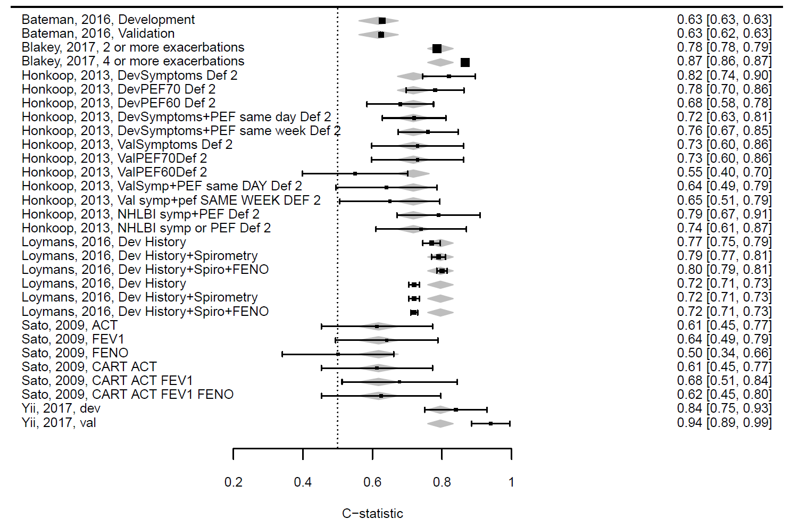
Figure 1: Meta-analysis forest plot

