Dental pain: Dentine Sensitivity, Hypersensitivity and Cracked Tooth Syndrome

- Dr. Nicholas Neil Longridge. BSc (Hons). BDS (Hons). MFDSRCS (Edin).
Doctoral Postgraduate Endodontics Student/NIHR Clinical Fellow/Specialist Registrar; University of Liverpool and The Royal Liverpool and Broadgreen University Hospitals, members of Liverpool Health Partners.
- Prof. Callum Cormack Youngson*. BDS. DDSc. FDS, DRD, MRD, FDS (Rest Dent) RCS (Edin). FDS RCS (Eng). PFHEA.
Professor of Restorative Dentistry/ Honorary Consultant; University of Liverpool and The Royal Liverpool and Broadgreen University Hospitals, members of Liverpool Health Partners.

*Corresponding author:
Prof CC Youngson
Dean of Institute of Clinical Sciences
4.22 Cedar House
Ashton Street
Liverpool. L69 3GE
Email: c.c.youngson@liverpool.ac.uk

Learning outcomes:
Following reading this article you should be able to:
- Explain the contribution of tubular fluid flow to dentinal sensitivity
- Diagnose the most likely causes of pulpal pain based on the presenting history & clinical findings
- Choose the most appropriate management for the sensitive tooth

Abstract
Dentine hypersensitivity is a frequently encountered patient complaint that can present with a number of associated factors including erosion and abrasion. The hydrodynamic mechanism responsible for dentine hypersensitivity is intimately related to the anatomical and physiological composition of teeth. Alterations to the integrity of the enamel and dentine through processes of trauma, decay and toothwear can increase dentine permeability. This gives rise to symptoms of sensitivity as dentinal fluid movement in response to thermal, chemical and mechanical cues stimulate the pulpal Aδ fibres. Restorative procedures can also rapidly change the architecture of the protective enamel and dentine layers leading to pulpal inflammation and increased thermal sensitivity of the tooth.
Patient-reported symptoms of dentine hypersensitivity can be attributed to a number of possible causes and a definitive diagnosis can therefore be difficult. A full history including social and medical factors such as occupation, diet and/or medication is likely to provide significant information to aid a diagnosis. Consideration of occlusal factors should not be overlooked as these may contribute to symptoms arising from a cracked tooth.
Management strategies are linked to the diagnosis - from topically applied desensitising pastes and resin bonding agents to direct restorations and possibly more advanced restorative procedures such as root canal treatment. Management should however be staged to enable more conservative strategies to prevail prior to considering irreversible dental interventions.

Keywords:
Dentine sensitivity, Dentine hypersensitivity, dental pain, pulpal inflammation, dentine tubules, dentinal fluid, erosion, cracked tooth syndrome.

Introduction
It will be clear to all dental clinicians that dentine hypersensitivity is a very real issue affecting their patients, with one extensive study noting that the prevalence can be as high as 42% in young European adults⁽¹⁾. It is also apparent that the sensitivity of any exposed dentine can vary considerably from patient-to-patient or even tooth-by-tooth within the same patient. The aim of this article is to explain why this may be the case, define hypersensitive dentine and consider a differential diagnosis for this condition which should include a consideration of a cracked tooth. The article will also suggest strategies for dealing with hypersensitive dentine/teeth based on the underlying physiology of the tooth.

Even after many decades of investigation, there is still some debate as to the precise mechanism underlying dentinal sensitivity. A minority of authors consider that the extension of the odontoblast process throughout the dental tubule, coupled with ‘tight’ and ‘gap’ cellular connections between the odontoblast cell bodies, provides a mechanism for dentinal sensation. However, the hydrodynamic theory^{(2,3)} has considerably the greatest support amongst the dental community and the likelihood of this theory being correct tends to be confirmed by the success of most topically applied desensitising agents⁽⁴⁾.
Irrespective of the actual mechanism of dental sensation, it is often difficult to define objectively when dentinal sensitivity becomes ‘hypersensitive’. In general terms, where the reaction to a normal stimulus is greater than expected, the subjective term hypersensitive dentine is used and there are a number of key reasons why this may be experienced. Hypersensitive dentine needs to be differentiated from the hypersensitive pulp caused by caries, so a thorough clinical and radiographic examination is required. However, in the absence of de novo or recurrent caries the history of the condition and its nature will often clarify the diagnosis.
Before considering the diagnostic features further it is worth revisiting the structure and function of the dentine-pulp complex in health as these impact upon the perception of dentinal sensitivity.
The structure of the dentine-pulp complex in health.
The tissues that form the dental pulp and dentine are reliant upon migration of neural crest cells into contact with the oral epithelium⁽⁵⁾ at around 10 days of gestation⁽⁶⁾, with neural crest interactions also resulting in elements of the cornea and cochlea. The various interactions between the tissue layers responsible for tooth formation initially results in differentiation of odontoblasts. This, ectomesenchymal derived tissue, then initiates amelobast formation in the epithelial tissue leading to the formation of insensitive enamel. The ectomesenchyme in the dental papilla is therefore directly responsible for the development of both the dentine and the dental pulp. These sensitive tissues are thus, intrinsically, functionally and embryologically intimately related⁽⁷⁾, even though their very different physical properties often make dentists think of them as distinct entities.
The dental pulp gains its sensitivity from the pulpal nerve supply and there are 2 main types of fibres responsible for pain sensation found in the pulp: myelinated Aδ, which tend to be concentrated more peripherally around the pulp chamber and unmyelinated C fibres. The latter, although distributed throughout the pulpal space, tend to be more concentrated in the central portions of the pulp⁽⁸⁾.
Each cellular system within the pulp serves a purpose and it is becoming increasingly apparent that dental pulp mesenchymal cells, alongside fibroblasts within the pulp chamber, can differentiate into odontoblast-type cells to aid hard tissue repair and release a large number of factors affecting subsequent vascular and neural responses to inflammation.
The relationship of dental pulpal tissues to the dentine is represented diagrammatically in Figure 1.
The dental pulp is a unique tissue enclosed, as it is, by dentine. As the root canal system, including the pulp chamber, is clearly unable to accommodate any substantial increase in the volume of the pulpal tissue, inflammatory responses of the pulp are restricted by the lack of ability for the tissues to swell. To compensate for this lack of compliance within the pulp chamber, arteriovenous shunts, which are particular to the dental pulp, can help to reduce the pulpal intracellular fluid pressure in the presence of inflammation⁽⁹⁾.
Dentinal fluid flows and pulpal sensitivity
There are several factors that are critical to the level of sensitivity of a tooth. In a completely intact tooth (a closed system) there will be minimal outward fluid flow from the dentine. However, when eating very hot or cold foods and drinks, convection currents within the tubular fluid will cause some shearing of the Aδ nerve fibres adjacent to the tubule pulpal orifices, thereby providing some discomfort. This is generally regarded as normal sensitivity of teeth.
Any factors which increase the rate of fluid flow will tend to result in greater sensitivity and several of these are explained by the Pouiselle equation⁽¹⁰⁾:
Q = ∆Pπr⁴
8ɳ l

Where Q = volume of fluid flow,
∆P = Pulpal pressure
r = radius of tubule (increases towards the pulp)
ɳ = viscosity of dentinal fluid (increases towards the pulp)
l = length of tubule

In a case where we assume no change in tubular fluid viscosity or pulpal pressure, a cavity that shortened a tubule to half its length would tend to increase the fluid flow by 32x compared to an intact tubule. Deepening that to one quarter of its original length would result in an increased fluid flow by a factor of 1024x. This explains why deeper cavities in freshly cut dentine are much more sensitive (however, where reparative dentine has reduced or obliterated the pulpal aspect of the dentinal tubules, thereby markedly reducing fluid flow, carious dentine removal will usually be significantly less uncomfortable).

Even in an apparently intact tooth there will be a fluid flow through dentine in the order of 18.1pLs⁻¹mm⁻²⁽¹¹⁾, as all dental tissues are slightly permeable (hence the effectiveness of tooth whitening agents). The overall tooth permeability can be increased by enamel defects (such as hypoplastic enamel) leading to increased sensitivity⁽¹²⁾ of these teeth. It has been calculated that the threshold for pain sensation in humans is 3.92nLs⁻¹mm⁻² for outward flow (some 215x the ‘normal’ flow rate) and 5.75 nLs⁻¹mm⁻² for inward flow⁽¹³⁾.
In clinical practice other factors also come into play:

- Aδ & C dental pulp fibres
A simplification of dentinal sensitivity is that fluid outflow stimulates the generally, peripherally sited, Aδ fibres⁽¹⁴⁾. These small diameter (1-6 µm), but myelinated, nerve fibres conduct action potentials relatively rapidly and so the perception of the pain related to short-acting dentinal fluid movement has a rapid onset, but also tends to resolve quickly.
In a more inflamed pulp, the C fibres (0.1-2µm) also start to become more involved⁽¹⁴⁾. These are smaller unmyelinated nerves which conduct more slowly, but which are stimulated by mediators of inflammation. These, initially, will tend to produce a less intense pain but one of longer duration. In the absence of apical inflammation, without proprioceptive fibres being present within the pulp, the tooth concerned will be difficult for the patient to identify. At this point there will be stimulation of both Aδ and C fibres giving initial dentinal sensitivity, but with an associated longer dull ache.
When the pulp becomes more, and irreversibly, inflamed the concentration of mediators of inflammation will lead to apparently spontaneous episodes of dull throbbing pain often aggravated by local changes in blood pressure. The role of the Aδ fibres tends to become less prominent as the pulp becomes progressively inflamed, with temperature reaction becoming more mediated by C fibres⁽¹⁵⁾. Extreme sensitivity to heat may eventually develop as an end stage of reversible pulpitis, but with time this disappears, as the coronal pulpal tissue becomes progressively necrotic. More apically placed C fibres will now be responsible increasingly for pain conduction and, as inflammatory mediators diffuse from the pulp system into the apical tissues, the tooth becomes tender to apical pressure and the pain localisable due to stimulation of the many proprioceptive fibres that are present in the periodontium. Recent research continues to increase our understanding of the correlation between a clinical diagnosis of pulpitis and the histological status of the pulp. The identification that viable radicular pulp may often be present in cases of severe reversible and irreversible pulpitis has driven an interest in more conservative and biologically considered treatment modalities⁽¹⁶⁻¹⁹⁾.
Paradoxically, the tooth may now appear non-vital, but it has been observed that C fibres (which do not respond readily to EPT⁽²⁰⁾) can persist in tissues with low oxygen concentrations and conduct pain until complete pulpal necrosis occurs⁽²¹⁾. This explains the commonly encountered situation where, to all intents and purposes, a tooth considered to be non-vital is exquisitely tender to root canal instrumentation. In these circumstances it is more accurate to describe the pulp as non-viable rather than non-vital.

- Pulpal fluid pressure:
This is important in the hydrodynamic theory of dentine sensitivity as the rate of fluid flow is linked to dentinal pain, and fluid under higher pressure will tend to move more rapidly outwards under stimulus. Conversely, if an inward direction of fluid flow is initiated the pulpal pressure will rise further.
With an understanding of the neural, vascular and cellular responses to inflammation and the effect of pulpal blood pressure a number of factors explaining dentinal sensitivity have direct clinical relevance.
Although most blood pressure effects occur in the circulation outside the pulp⁽⁹⁾, the common finding that a toothache is worse when lying down, and often pulsatile, relates to the local increase of blood pressure in the tissues around the tooth, and slightly within the pulp. An increase in intrapulpal blood pressure will tend to increase fluid flows if (as is common) there are open dentinal tubules. This could be beneficial in preventing bacteria or their products from travelling down the tubules to cause further irritation, but the downside is that inflamed pulps are more sensitive than uninflamed.
Normal pulpal arteriole pressures are in the order of 40-45mmHg⁽²²⁾ with lower pressures of 30-36mmHg found in pulpal capillaries⁽²³⁾ and overall pulpal interstitial fluid pressures have been calculated as 14.1cmH₂O (10.4mmHg)⁽²⁴⁾. However, in an inflamed pulp the pressure may be as much as three times higher⁽²⁵⁾.
In the case of a normally intact but pulpally inflamed tooth (which therefore has a resultant increase in ∆P in the Pouiselle equation) being exposed to cold, there will be a marked outward movement of dentinal fluid and this will be experienced as pain ⁽¹³⁾ via Aδ fibre stimulation. In more irreversibly pulpitic teeth however, it is often noted that cold can relieve the discomfort. This may be explained by a transient reduction in the overall pulpal pressure due to dentinal fluid outward flow. Conversely, irreversible pulpitis is often aggravated by the application of heat. This is due to the net inflow of dentinal fluid into a pulp with an already elevated intrapulpal pressure, leading to increased C fibre discharge.
- Alterations to dentine
Dentine is a densely tubular structure with the number of tubules varying between facial, lingual and radicular surfaces but consistently higher more coronally⁽²⁶⁾. For this reason, coupled with its proximity to hot and cold substances, most hypersensitive dentine is found around the cervical aspect of the tooth, where there has been gingival recession and/or toothwear but the more coronal enamel is intact.
Dentinal tubules are initially covered by; enamel, gingivae and/or cementum. However, trauma and gingival conditions leading to recession will expose large numbers ^{(27,28)}. Factors which affect the fluid flow will include: site of tooth where tubules are exposed⁽²⁶⁾, the presence or absence of a smear layer⁽²⁹⁾ and the functional versus anatomic diameter of the tubules⁽³⁰⁾.
Hypersensitive dentine can be limited to a group of teeth, one tooth, or even one aspect of a tooth, and is related to the fluid flow that is affected by the local dentine structure. Common aggravating factors are those which expose dentinal tubules that would otherwise be covered e.g. Gingival recession, Erosion (from dietary or gastric acids) or abrasion.
The effects of these may also be modified by other factors that may have caused pulpal irritation including: tooth whitening agents ^{(31,32)} or trauma from the occlusion⁽³³⁾ as well as the response being affected by the environment (as both air and water are colder in Winter).
It is worth noting that whilst attrition may also lead to the exposure of dentine, one response of this, usually gradual process (which can also occur in slowly progressing dentinal caries) is the possible release of soluble growth factors that had been incorporated into the dentine matrix during its formation⁽³⁴⁾. The subsequent diffusion of these (e.g. TGF-β1, IGF-1, OP-1) down the tubules may stimulate the production of reparative dentine at the pulpal surface. Slowly progressive attrition is therefore seldom a cause of dentinal sensitivity. However, if this is coupled with erosion the rapid loss of tooth substance, greater than can be addressed by reparative processes, can have significant effects on sensitivity.
Erosion
The role of erosion in contributing to dentinal sensitivity has been recognised for many years⁽²⁹⁾, and a causal relationship has been demonstrated by the examination of a large dataset of patients with severe erosive toothwear⁽³⁵⁾.
Acid erosion of a dentinal smear layer, or other obstruction of the opening of a dentinal tubule is not always instantaneous, often leading patients to miss a cause-and-effect relationship. Whilst many drinks and foodstuffs (Table 1) are, by their nature acidic, few patients will suffer from immediate sensitivity as a result of direct contact (the general exception being where a cold acidic drink is swilled around the teeth rather than swallowed directly). Some alcoholic drinks are also acidic (Table 1) although, except in professional wine-tasters, the consequences are usually indirect.
Alcohol functions as a gastric irritant and, where the patient undergoes nocturnal or silent reflux, dentinal sensitivity will often take place the day following alcohol, rather than directly at the time of consumption. This is also often the case where the patient tends to eat a large meal just before sleeping (for example due to shift-working). A patient suffering from dentine hypersensitivity should therefore be questioned regarding the timing and size of their last meal of the day, to determine whether they are likely to suffer regurgitation during the night. As well as the timing and quantity it is worth asking what type of food is eaten - spicy foods also act as a gastric irritant leading to increased gastric acid secretion and an increased risk of reflux. A history of frequent antacid or proton-pump inhibitor use (e.g Omeprazole) is therefore helpful to identify those at greater risk of dentine hypersensitivity.
Predictably, citrus drinks are particularly likely to aggravate the situation, due to the chelation of the citric acid to the hydroxyapatite. This can be aggravated by subsequent abrasion from toothbrushing where the toothpaste will be rendered more abrasive to the softened tooth surface. This is common where a ‘healthy breakfast’ consists of a fruit salad followed by toothbrushing and so patients should be encouraged to brush their teeth before breakfast, or delay brushing for 30 minutes to allow some remineralisation from saliva.
As well as dietary (extrinsic) sources of acid, intrinsic sources of erosion from gastric acid are closely linked to voluntary or involuntary disorders e.g. Gastro-oesphageal Reflux Disorder (GORD), bulimia nervosa, hyperemesis gravidarum. Patients with xerostomia (possibly secondary to medication) are also at increased risk due to the lack of remineralisation from saliva. Any patient who presents with dentine hypersensitivity should therefore be risk-assessed for the likely contributing factors. However, irrespective of the source of the acid, the dissolution of any protective dentinal smear layer will lead to increased numbers of exposed dentinal tubules with a greater functional radius and the risk of greater fluid flows (due to an increase in the πr⁴ component of the Pouiselle equation).
Clinical Management of Dentine Hypersensitivity
The ideal situation is where the causative agent is recognised and can be reduced by simple methods such as dietary modification. With time the dentine will become less permeable due to normal repair mechanisms, and the tooth return to normal sensitivity. Often however it is necessary to try to reduce the dentinal permeability on a temporary or more permanent basis. Use of desensitising toothpastes that may contain strontium acetate, calcium sodium phosphosilicate (CSPS), stannous fluoride or arginine calcium carbonate to occlude the openings of the dentinal tubules can be effective⁽³⁶⁾. Use of toothpastes containing potassium nitrate are also effective, possibly by diffusing down the dentinal tubules and blocking intra-dental nerve conduction⁽³⁷⁾. Although a shortcoming of the occlusion of the tubules by toothpastes is their vulnerability to subsequent dissolution by acids or saliva, as well as being worn away by further toothbrushing or other abrasives, agents that precipitate intratubular crystals should be more effective for longer⁽³⁸⁾.

Professionally applied fluoride varnishes may also enhance hydroxyapaptite formation in the tubules. Alternatively, a variety of resins, based on dentine-bonding systems, have been developed for dentine hypersensitivity where those form a polymeric barrier that is more resistant to subsequent acid dissolution. In more severe cases, placement of adhesive restorations can be indicated and in extremis root canal treatment. However, this, alongside extraction should be considered as a treatment of last resort.
In the absence of caries, alongside the diagnosis of dentine hypersensitivity, we should also consider whether the tooth is cracked.
Cracked tooth syndrome
The large number of literature reviews surrounding this subject testimony to its enduring relevance to modern clinical practice, and the difficulty in diagnosing the condition⁽³⁹⁻⁴³⁾.
There are a number of reasons why teeth crack, with contributions from anatomical, ‘iatrogenic’ and even culinary factors. Cracked vital teeth often pose a diagnostic dilemma for the clinician as they can present in a patient who may also suffer from dentinal hypersensitivity but, even in the straightforward case, the apparently contradictory nature of the presenting symptoms complicates the definitive diagnosis.
Humans, uniquely, eat intentionally heated and chilled foodstuffs, often alternating between these during a meal. The thermal expansion and contraction of dental enamel leads to microcracks in this, naturally occurring ceramic-based material^{(44).} When coupled with low frequency loading generated by chewing, there can be propagation of these enamel cracks. However, these are not usually problematic unless there is an additional underlying issue.
Intra-coronal dental restorations can contribute by weakening the tooth structure⁽⁴⁵⁾ and older cavity designs, employing sharp internal line angles, aggravate this even further by stress concentration. If a cusp is an excursive, functional or parafunctional, contact this makes a cracked tooth more likely to be symptomatic. (Figure 2)
Whilst a careful examination of the functional occlusion is required, the diagnosis of cracked tooth is often gained from the history, so a history of any trauma to the teeth or jaws should be elucidated at an early stage. Anatomically, upper first premolars are particularly prone to cracks running from the mesial to distal marginal ridges. This is partly due to their bicuspid occlusal form, but also due to the reduced corono-radicular bulk resulting from the presence of the mesial canine fossa, as well as a root furcation. Trauma from the opposing tooth (as a result from a blow to the lower jaw) or inadvertent biting on a hard material (e.g. as may occur with ‘granary’ or stone-ground bread) can therefore result in catastrophic fracture of this tooth (Figure 3).
The pain history associated with a cracked tooth may appear confusing as it often contains elements that are strongly suggestive of dentine hypersensitivity but the patient will usually also complain of occasional tenderness on biting (but only with specific types of food) suggesting periapical periodontitis. However, the duration of the discomfort - which can remain severe and unchanged over many years - coupled with an absence of swelling or radiographic changes can suggest non-odontogenic pain diagnoses such as trigeminal neuralgia or persistent orofacial pain. Radiographic examination usually fails to visualise the crack as it will tend to lie in the same plane as the film (mesio-distally). However, very occasionally, a bucco-lingual crack may be seen on a radiograph, usually in a lower molar (Figure 4).
A far more predictable special investigation for a cracked tooth is transillumination, and a simple composite curing light can prove very effective in this regard. When using this technique, it is worth distinguishing small surface level cracks (enamel crazing) from a more substantial crack involving dentine. In the latter case the transilluminated light will not cross the crack line across the cusps. To further improve the effectiveness of this technique it is recommended that it should take place without the operating light shining into the mouth, to maximise the contrast (Figure 5).
Once a crack has been identified, the next stage is to assess whether this tooth is responsible for the patient’s pain. The patient can be asked to close firmly and slowly onto a resilient material (e.g. plastic saliva ejector or rubberised dental mirror handle) and then asked to open quickly. If the tooth is the one responsible, the identification is usually immediate. The mechanism behind this is illustrated in Figure 6.
More refined tools, such as a FracFinder® or ToothSlooth® can help identify specific cusps contributing to the pain. It is worth bearing in mind that, where a blow has been received to the mandible, multiple teeth may have cracks and require treatment. However, use of an orthodontic band can help to definitively assess whether a tooth is the cause of the patient’s pain, by splinting the crack, and allowing the patient to function unhindered between appointments thus confirming the diagnosis definitively (Figure 7).
Having identified the tooth/teeth, a number of considerations have to be borne in mind to determine the prognosis. A simplified version of Talim & Gohil’s classification of 1974⁽⁴⁶⁾ can be applied to cracked tooth syndrome. Irrespective of whether the crack is incomplete, or complete, the prognosis tends to decline in the following sequence:
- Crack is confined to enamel (Class I)
- Involving enamel and dentine but not involving the pulp (Class II)
- Fracture of enamel and dentine involving the pulp (Class III)
- Fracture involving the root (Class IV)
When a crack terminates in a subgingival or subalveoar position rather than supragingivally, it is more difficult to manage. Finally, the direction of travel (horizontal, oblique or vertical) can be superimposed upon this such that: a horizontal fracture of enamel only has an excellent prognosis; an oblique fracture of the enamel and dentine has a moderate prognosis; a fracture involving the pulp has a poor prognosis, but a vertical fracture involving the root has, effectively, a hopeless prognosis.
Unfortunately, there is still very little high-quality clinical research to be able to inform treatment decisions but, in general terms:
Single cusp fracture:
- Identifiable fracture extending supra gingivally (very good prognosis – remove cusp and restore [see Fig 2]).
- Crack extending obliquely sub gingivally (moderate prognosis – reduce cusp height and overlay with adhesive restoration⁽⁴⁷⁾ to prevent further cusp flexure [see Fig 5]).
Multiple cusps:
- Mesio-distal or bucco-lingual where the supragingival extent can be visualised (good prognosis - remove fractured cusps and place an extracoronal*, restoration⁽⁴⁸⁾).
*It is recognised that extracoronal restorations are destructive of tooth tissue but the preparation shape tends to result in forces that ‘close’ cracks during loading. Full crowns should be used where indicated but, following the principles of minimally invasive dentistry, alternative designs should be considered first. Simple occlusal coverage by resin-retained metal, in the form of a ‘bonnet’ design, would be the least destructive design that would not produce opening forces on the crack. For aesthetic reasons ceramic may be preferred but will tend to be more destructive (due to the thickness required for durability of the material). Whilst onlay restorations can be used in place of extracoronal restorations, it is best to use adhesive cavity designs that do not result in forces exerted during loading that would wedge the, already cracked tooth, apart.
- Where the extent cannot be clearly seen, cut an occlusal cavity to determine extent of fracture. If it extends through the midline it is highly likely that root canal treatment will be required – especially if the crack continues into the roof of the pulp chamber. In these circumstances the prognosis is moderate to poor. Root canal treatment and an extracoronal restoration will be required.
- If, after commencing root canal treatment, the crack is seen to extend to the floor of the pulp chamber the prognosis of the tooth is best considered hopeless.

References.
- West NX, Sanz M, Lussi A, Bartlett D, Bouchard P, Bourgeois D. Prevalence of dentine hypersensitivity and study of associated factors: A European population-based cross-sectional study. J Dent. 2013; 41: 841-851.
- Gysi A. An attempt to explain the sensitiveness of dentine. Br J Dent Sci. 1900; XLIII: 865 -868.
- Brännström M. Sensitivity of dentine. Oral Surg Oral Med Oral Path. 1966; 21: 517-526.
- Seong J, Davies M, Macdonald E, Claydon N, West N. Randomized clinical trial to determine if changes in dentine tubule occlusion visualized by SEM of replica impressions correlate with in vivo assessment of tubule occlusion. Am J Dent. 2018; 31: 189-194.
- Mitsiadis TA, Graf D. Cell fate determination during tooth development and regeneration. Birth Defect Res. 2009; 87: 199-211.
- Nanci A. ﻿Development of the Tooth and Its Supporting Tissues. In: Nanci A. Ten Cate's Oral Histology: Development, Structure, and Function. 9th Edition, Amsterdam, Elsevier, 2017
- Pashley DH. Dynamics of the pulpo-dentin complex. Crit Rev Oral Biol. 1996; 7: 104-133.
- Fristad I, Bergreen E, Structure and Functions of the Dentin-Pulp complex. In: Hargreaves KM (Ed) Cohen’s Pathways of the Pulp Expert Consult. 11th Edition, Amsterdam, Elsevier, 2017.
- Berggreen E, Bletsa A, Heyeras KJ. Circulation in normal and inflamed dental pulp. Endod Topics. 2010; 17: 2-11.
- Pashley DH. Dentin: A dynamic substrate – a review. Scanning Microscop. 1989; 3: 161-176.
- Vongasavan N, Matthews B. Fluid flow through cate dentine in vivo. Archs Oral Biol. 1992; 37: 175-185.
- Seow WK. Developmental defects of enamel and dentine: challenges for basic science research and clinical management. Aus Dent J. 2014; 59: 143-154.
- Chaoenlarp P, Wanachantararak S, Vongsavan N, Matthews B. Pain and the rate of dentinal fluid flow produced by hydrostatic pressure stimulation of exposed dentine in man. Archs Oral Biol. 2007; 52: 625-631.
- Yu CY, Abbott PV. Pulp microenvironment and mechanisms of pain arising from the dental pulp: From an endodontic perspective. Aus Endod J. 2018; 44: 82-98.
- Närhi M, Yamamoto H, Ngassapa D, Hirvonen T. The neurophysiological basis and the role of inflammatory reactions in dentine hypersensitivity. Arch Oral Biol. 1994; 39 (Suppl): 23S-30S.
- Ricucci D, Loghin S, Siqueira J Jr. Correlation between clinical and histologic pulp diagnoses. J Endod. 2014; 40: 1932–1939.
- Hashem D, Mannocci F, Patel S, Manoharan A, Brown JE, Watson TF. et al. A clinical and radiographic assessment of the efficacy of calcium silicate indirect pulp capping: a randomized controlled clinical trial. J Dent Res. 2017; 94: 562–568
- Wolters WJ, Duncan HF, Tomson PL, Karim IE, McKenna G, Dorri M. et al. Minimally invasive endodontics: a new diagnostic system for assessing pulpitis and subsequent treatment needs. Int Endod J. 2017; 50: 825–829.
- Duncan HF, Cooper PR, Smith AJ. Dissecting dentine - pulp injury and wound healing responses: consequences for regenerative endodontics. Int Endod J. 2019; 52: 261-266.
- Närhi M, Virtanen A, Kuhta J, Huopaniemi T. Electrical stimulation of teeth with a pulp tester in the cat. Scan J Dent Res. 1979; 87: 52-58.
- England MC, Pellis EG, Michanowicz AE. Histopathogic study of the effect of pulpal disease upon nerve fibres of the human dental pulp. Oral Surg Oral Med Oral Path Oral Radiol. 1974; 38: 783-790.
- Matthews B, Andrews D, Wanachantararak S. Biology of the dental pulp with special reference to its vasculature and innervation. In: Addy M Embery G, Edgar WM, Orchardson R (Eds) Tooth Wear and Sensitivity. London, Martin Dunitz, 2000.
- Orchardson R, Cadden SW. An update on the physiology of the dentine-pulp complex. Dent Update. 2001; 28: 200-209.
- Ciucchi B, Bouillaguet S, Holz J, Pashley DH. (Dentinal fluid dynamics in human teeth, in vivo. J Endod. 1995; 21: 191-194.
- Heyeras KJ, Bergreen E. Interstitial fluid pressure in normal and inflamed pulp. Crit Rev Oral Biol Med. 1999; 10: 328-336.
- Schellenberg U, Krey G, Boshardt D, Nair P. Numerical density of dentinal tubules at the pulpal wall of human permanent premolars and third molars. J Endod. 1992; 18: 104-109.
- Gaberoglio R, Brännström M. Scanning electron microscopic investigation of human dentinal tubules. Archs Oral Biol. 1976; 21: 355-362.
- Williams C, Wu Y, Bowers DF. ImageJ analysis of dentin tubule distribution in human teeth. Tissue Cell. 2015; 47: 343-348.
- Pashley DH, Michelich V, Kehl T. Dentin permeability: Effects of smear layer removal. J Prosthet Dent. 1981; 46: 531-537.
- Michelich V, Pashley DH, Whitford GM. Dentin permeability: A comparison of functional versus anatomical tubular radii. J Dent Res. 1978; 57: 1019-1024
- Anderson DG, Chiego DJ, Glickman GN, McCauley LK. A clinical assessment of 10% carbamide peroxide gel on human pulp tissue. J Endod. 1999; 25: 247-250.
- Soares DG, Basso FG, Scheffel DS, Hebling J, De Souza Costa C. Responses of human dental pulp cells after application of a low concentration bleaching gel to enamel. Archs Oral Biol. 2015; 60: 1428-1436.
- Caviedes-Bucheli J, Azuero-Holguin MM, Correa-Ortiz JA, Aguilar-Mora MV, Pedroza-Florez JD, Ulate E, et al. Effect of experimentally induced occlusal trauma on substance P expression in human dental pulp and periodontal ligament. J Endod, 2011; 37: 627-630.
- Kalyva M, Padadimitriou S, Tziafas D. Transdentinal stimulation of tertiary dentine formation and intratubular mineralization by growth factors. Int Endod J. 2010; 43: 382-392.
- O’Toole S, Bartlett D. The relationship between dentine hypersensitivity, dietary acid and erosive tooth wear. J Dent. 2017; 67: 84-87.
- West NX, Seong J, Davies M. Management of dentine hypersensitivity: efficacy of professionally and self-administered agents. J Clin Periodontol. 2015; 42 (Suppl): S256-S302.
- Markowitz K, Bilotto G, Kim S. Decreasing intradental nerve activity in the cat with potassium and divalent cations. Archs Oral Biol. 1991; 36: 1-7.
- Arnold WH, Prange M, Naumova EA. Effectiveness of various toothpastes on dentine tubule occlusion. J Dent. 2015; 43, 440-449.
- Gibbs JW. Cuspal fracture odontolgia. Dent Digest. 1954; 60: 158-160.
- Guertsen W. The cracked-tooth syndrome: clinical features and case reports. Int J Periodontol Rest Dent. 1992; 12: 395-405.
- Fox K, Youngson C. Diagnosis and treatment of the cracked tooth. Prim Dent Care. 1997; 4: 109-113.
- Lynch CD, McConnell RJ. The cracked tooth syndrome. J Can Dent Assoc. 2002; 68: 470-475.
- Lubisich EB, Hilton TJ, Ferracane J. Cracked teeth: A review of the literature. J Esthet Restor Dent. 2010; 22: 1-13.
- Lloyd BA, McGinley MB, Brown WS. Thermal stress in teeth. J Dent Res. 1978; 57: 571-582.
- Reeh ES, Messer HH, Douglas WH. Reduction in tooth stiffness as a result of endodontic and restorative procedures J Endod. 1989; 15: 512-516.
- Talim ST, Gohil KS. Management of coronal fractures of permanent posterior teeth. J Prosthet Dent. 1974; 31: 172-183.
- Opdam NJ, Roeterrs JJ, Loomans BA, Bronkhorst EM. Seven-year clinical evaluation of painful cracked teeth restored with a direct composite resin restoration. J Endod. 2008; 34: 808-811.
- Krell KV, Rivera EM, A six-year evaluation of cracked teeth diagnosed with reversible pulpitis: treatment and prognosis. J Endod. 2007; 33: 1405-1427.

Table 1 Common foodstuffs and associate acids
Foodstuff | Main acid constituent
Yoghurt | lactic
Vinegars, (including pickles & salad dressings) | acetic
Ketchup | acetic, phosphoric
Cola | phosphoric, carbonic
Sports/Energy Drinks | carbonic, citric
Wine- varies by grape variety | tartaric, malic, pyruvic, α-ketoglutaric, fumaric, galacturonic
Cider | malic
Coffee | chlorogenic, citric, formic acetic, malic, glycolic, lactic, pyroglutamic
Fruit – varies by species | citric, malic, quinic, tartaric, oxalic, α-ketoglutaric, lactic

Figure 1. Diagram representing outward flow of dentinal fluid (green arrows) Dentine (D), connecting odontoblast processes, predentine (P), odontoblast bodies with tight junctions, an Aδ nerve fibre (black) and a capillary passing through the cell free zone, an arteriole and venule with an arteriovenous shunt (AVS), fibroblasts (F), and a C nerve fibre (brown).

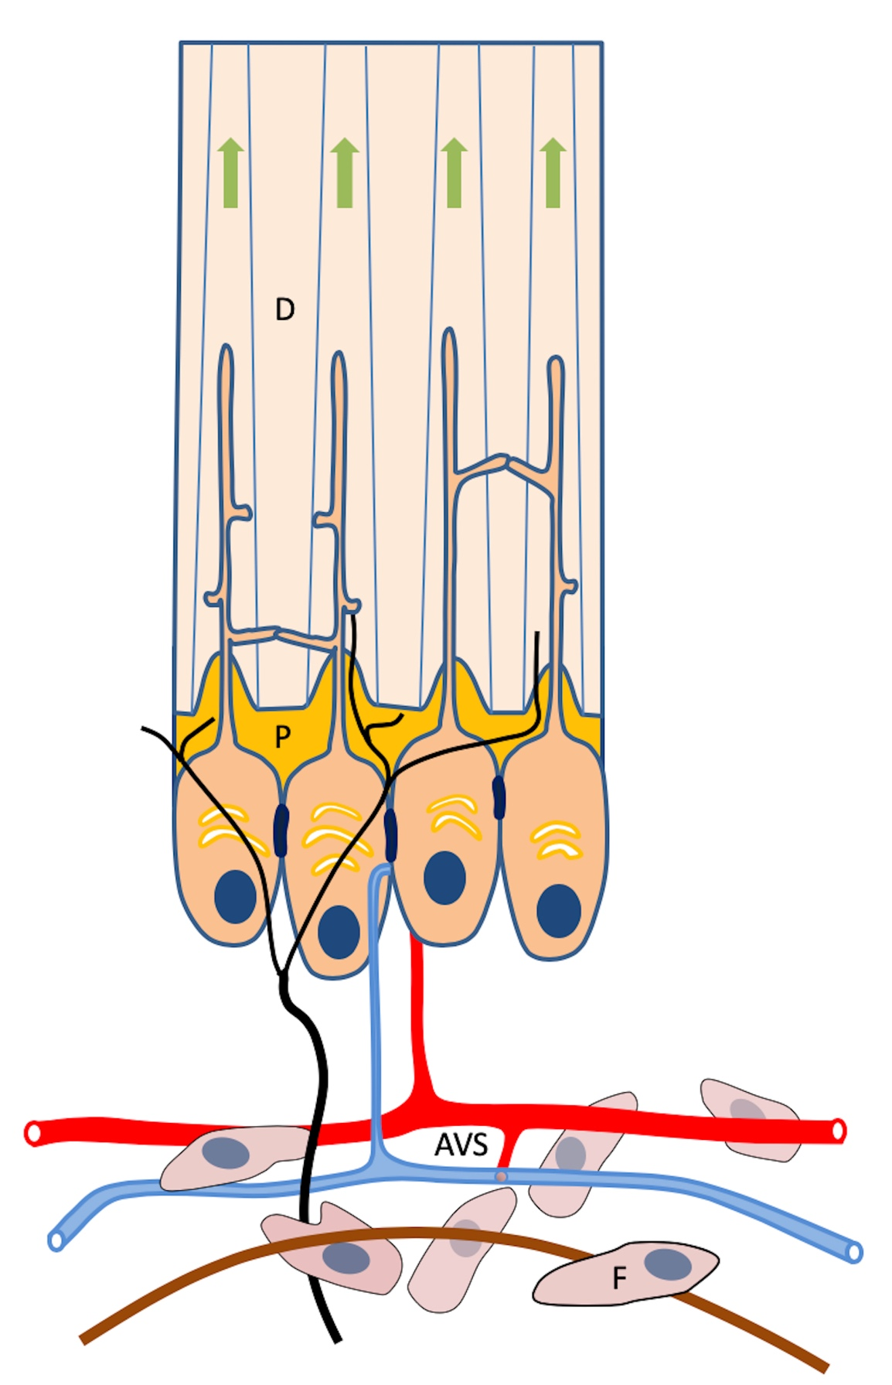
Figure 2. Sharp internal line angles in a tooth cavity predisposing to cusp fracture (arrowed).

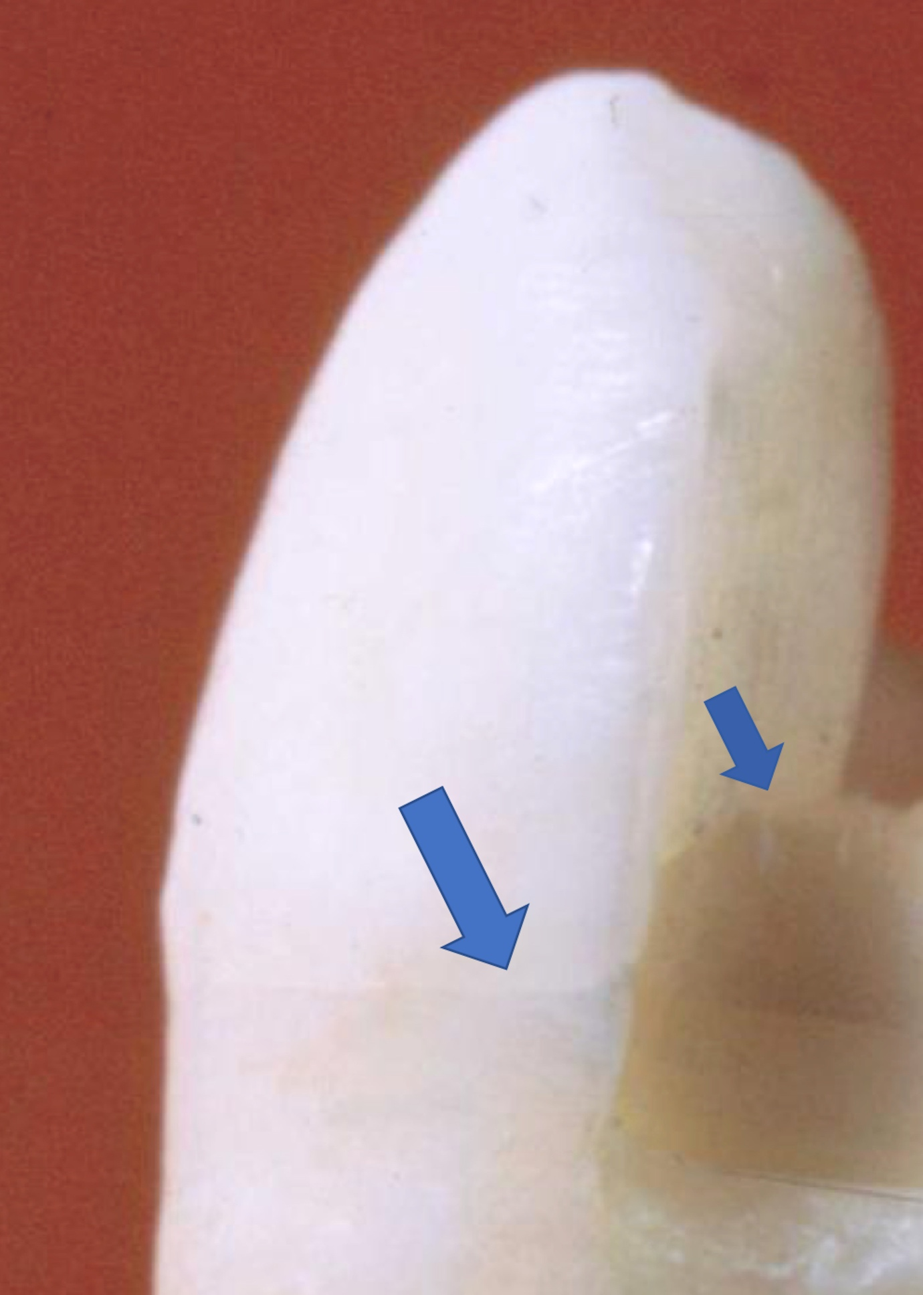

Figure 3. Forces applied to upper first premolar predisposing to fracture. Note the reduced bulk of dentine arising from the occlusal form, the internal pulpal anatomy and root configuration.
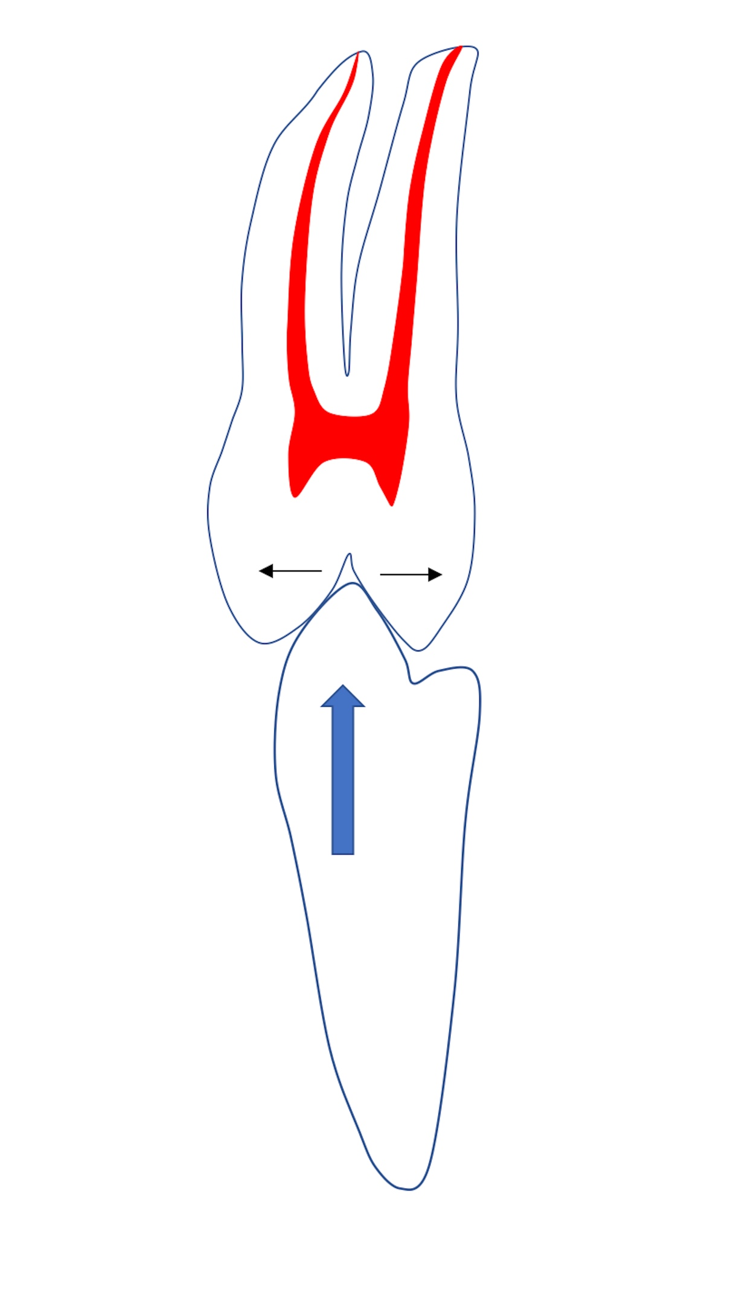
Figure 4. Vertical crack (arrowed) visible on radiograph of lower right second molar.

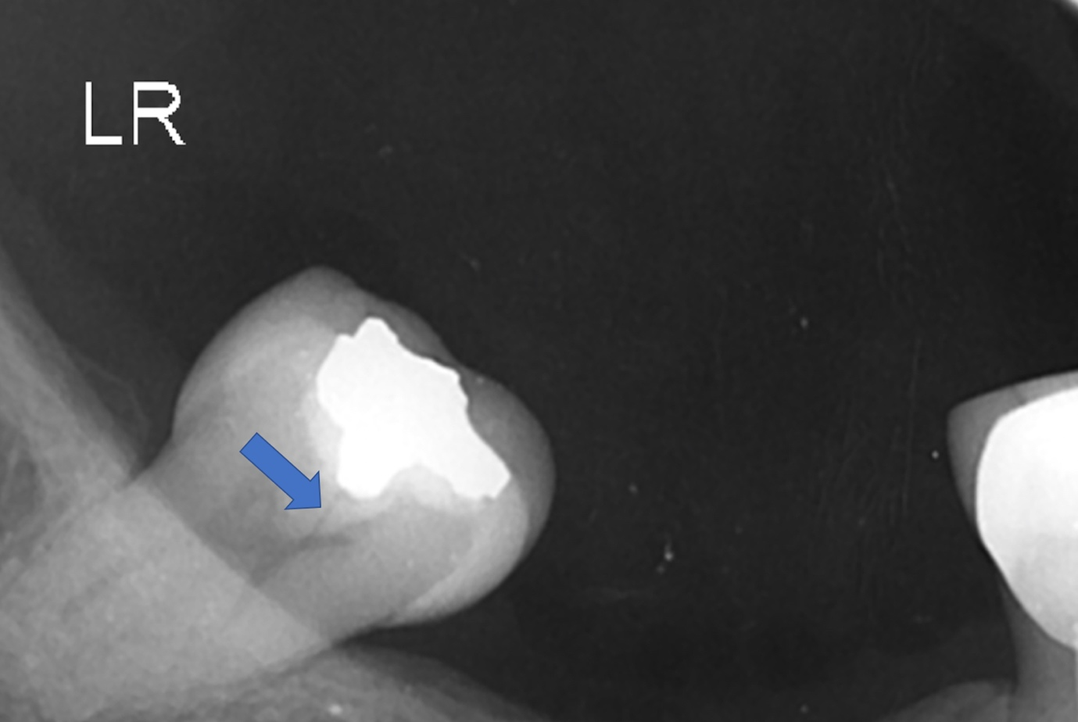

Figure 5. Transilluminated lower right second molar demonstrating (incomplete) oblique fracture of mesio lingual cusp (Class II) Courtesy of Prof Fadi Jarad, University of Liverpool.

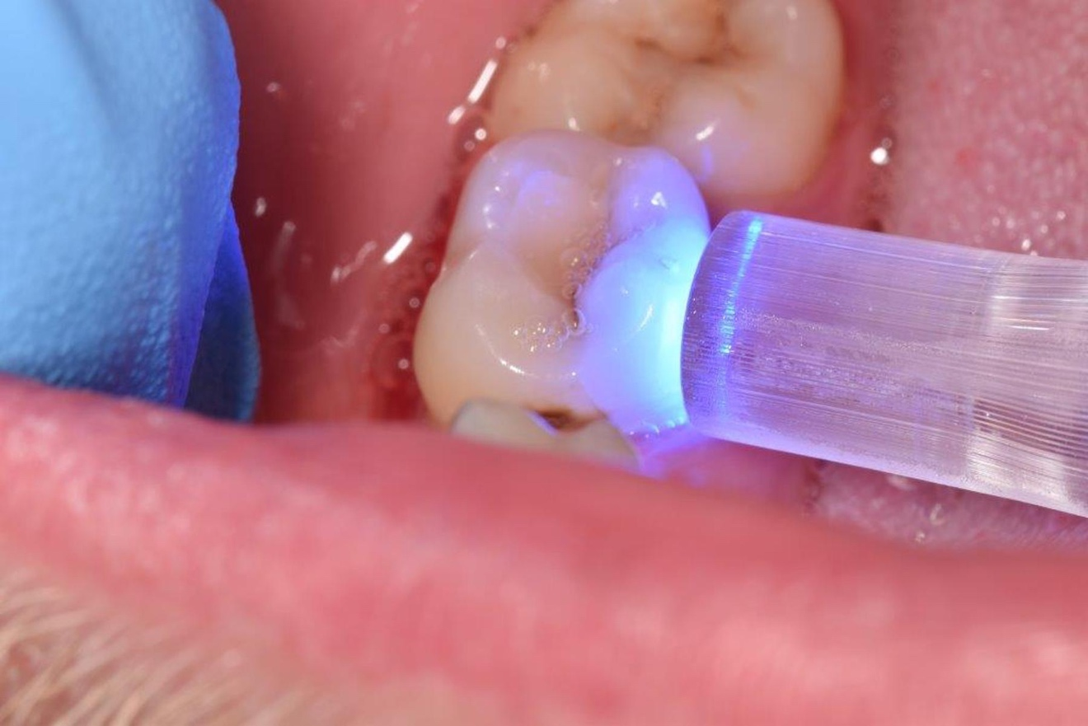

Figure 6. Illustration of mechanism explaining why pain is felt during ‘unloading’ when checking for a cracked tooth.
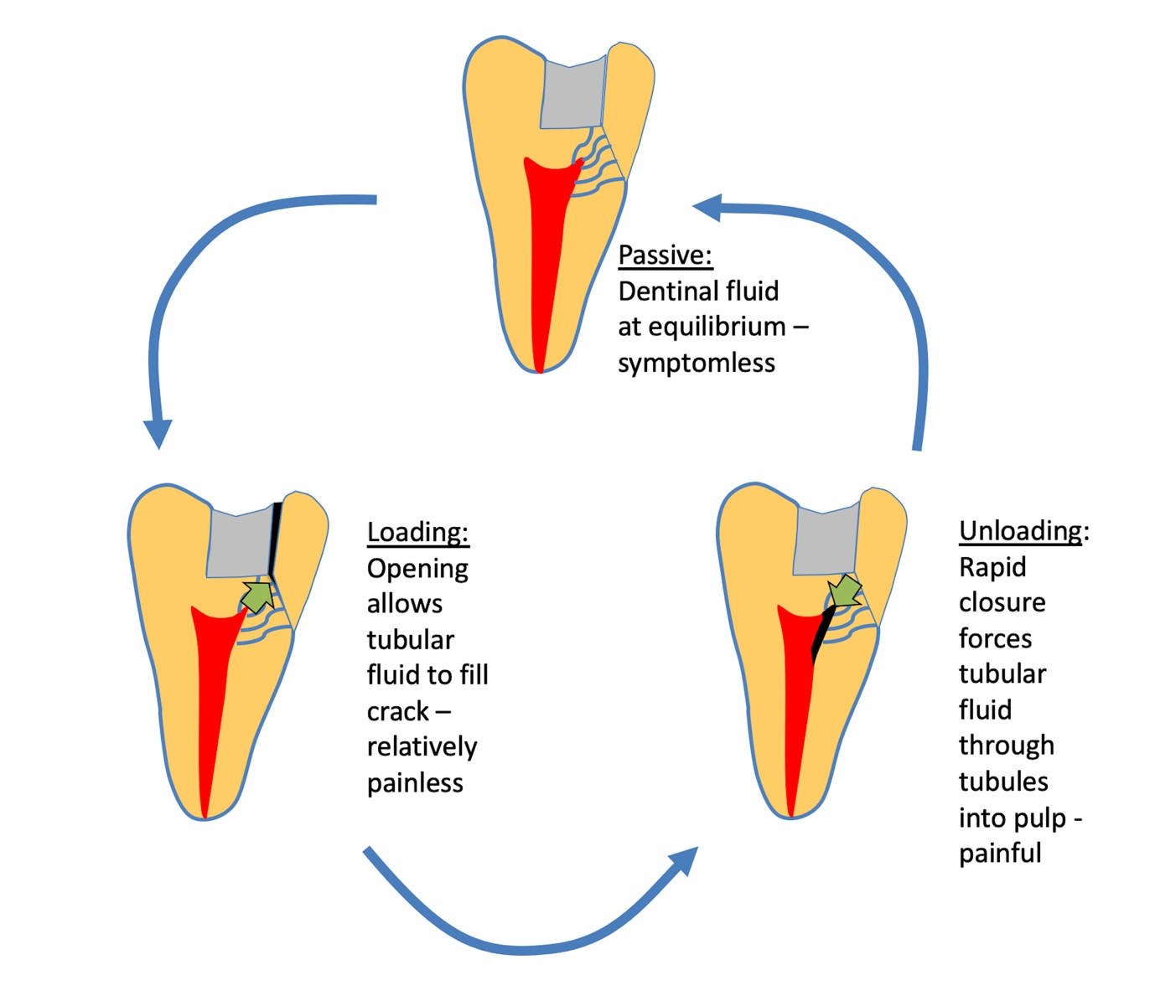

Figure 7. Temporary placement of orthodontic band to relieve symptoms and confirm diagnosis (same case as Fig. 5) Courtesy of Prof Fadi Jarad, University of Liverpool.
