Targeted plasma functionalization of titanium inhibits polymicrobial biofilm recolonization and stimulates cell function

Martina Modic^{1,3}, Janez Kovač¹, John R. Nicholls², Špela Kos⁴, Gregor Serša⁴, Uroš Cvelbar¹⁺ and James L. Walsh^{3*}
¹Department of Surface Engineering and Electronics, Jozef Stefan Institute, Ljubljana, 1000, Slovenia.
²School of Aerospace, Transport and Manufacturing, Cranfield University, Cranfield, MK43 0AL, UK.
³Department of Electrical Engineering and Electronics, University of Liverpool, Liverpool, L69 3GJ, UK.
⁴Department of Experimental Oncology, Institute of Oncology Ljubljana, Ljubljana, 1000, Slovenia.

ABSTRACT: Biofilm contamination on an implanted medical device represents a particularity resilient reservoir of infection that inevitably leads to device failure. In this study, we demonstrate that an atmospheric pressure air plasma treatment can simultaneously eradicate biofilm contamination whilst beneficially functionalizing the underlying surface, creating long-lasting characteristics that inhibit microbial recolonization and promote fibroblast proliferation. By comparing two contrasting plasma treatments the interplay between plasma generated reactive species, biofilm contamination and the underlying surface was uncovered. The composition, wettability and topography of titanium surfaces were characterized using X-ray photoelectron spectroscopy, water contact angle measurements and atomic force microscopy. Exposure to plasma generated chemical species created nanoscale surface features and the introduction of oxygen and nitrogen containing functional groups, resulting in changes to the surface wettability. Using a polymicrobial biofilm model comprising of E. coli and S. epidermidis, it was shown that plasma can effectively eliminate biofilm contamination from the surface, while simultaneously functionalizing the surface to inhibit recolonization. To assess the biocompatibility of treated surfaces the adhesion and proliferation of murine fibroblasts was assessed using fluorescent microscopy, cell viability assays and flow cytometry. It was shown that plasma exposure led to surface characteristics that promote fibroblast adhesion and proliferation.

KEYWORDS: Cold atmospheric plasma, implant associated infections, microbial recolonization, surface functionalization, reactive oxygen and nitrogen species.
- Introduction
In natural and manmade environments, bacterial biofilms are ubiquitous, yet the significance of biofilm contamination in a clinical setting is often underestimated [1]. Biofilms have a complex architecture, with physiologically organized bacterial microcolonies. It is the structure and organization of the biofilm that conveys numerous advantages over unprotected planktonic cells, providing protection against immune system defense and the diffusion of antibiotics. Several studies have posited that resistance against antimicrobial agents in a biofilm can be up to 1000 times greater compared to single cells [2]. Such contamination presents a particularly virulent form of infection and provides ideal conditions for the emergence of multidrug-resistant colonies. A plethora of life-threatening infections can arise as a result of biofilm formation on indwelling and implanted medical devices, such as urinary catheters, mechanical heart valves, prosthetic joints and endotracheal tubes [3]. In the field of orthopedics, infections related to biofilm colonization of prosthetic devices are one of the most serious and devastating complications. In such cases, complex and expensive revision procedures are typically required, often involving an attempt to clean the device in-vivo or its complete removal and replacement [4]. Despite the incidence of such cases being relatively low, estimated to be in the range of 0.5 – 5% for total joint replacements, the large population of patients with orthopedic implants means such infections have a major impact in terms of morbidity, mortality and medical costs [5].
One of the most common bacterial species linked to orthopedic implant-related infections are coagulase-negative Staphylococcus species. More than 40 % of all infections are linked to species from this Gram-positive bacterial genus, with S. epidermidis and S. aureus being the most commonly diagnosed bacteria in implant related infections [6]. Infections often arise because the surface of the implanted device provides an ideal environment for bacterial adhesion and the formation of biofilms, which can reach a thickness of more than 100 mm in some cases [7]. Orthopedic implant infections can develop during different stages of patient´s medical treatment; pre-operatively, when infections are associated with fraction fixation, intra-operatively and during the post-operative period, mainly because of abnormal wound healing. The development of biofilms on an implant surface is a highly dynamic and competitive process, involving different constituents, such as extracellular matrix (ECM) proteins, host cells (endothelial cells, fibroblast, bone cells) and microorganisms. Initially, the adsorption of proteins and macromolecules of ECM occurs, and under normal physiological conditions, these components govern the adhesion, migration, proliferation and differentiation of tissue cells. In the case of implanted material, ECM bound on the surface can also act as a substrate for bacterial attachment thus a competitive process is initiated. A positive surgical outcome relies on the ability of fibroblast to adhere and proliferate on the surface of implant, rather than bacterial colonization and ultimately biofilm formation [8].
A number of different technologies are currently under investigation to inhibit biofilm formation on implanted devices. Certainly, the deposition of functional coatings on to devices prior to implantation has shown promise, with drug eluting coatings [9-11], bactericidal coatings [12-14], adhesion resistant chemistries [15, 16], and nano-topologies all demonstrating the potential to prevent device colonization [17, 18]. While these approaches are highly successful in vitro, it is not clear how effective they are in vivo or how they affect clinical outcomes. Alternative approaches focusing on the in-situ cleaning of a contaminated device are also under investigation, including the use of electrical stimulation on the orthopedic implant surface [19, 20], applied pulsed electromagnetic fields [21], laser-generated shockwaves [22] and sonication [23]. Such methods typically rely on a mechanical mode of action to remove adhered bacteria from the implant surface; clearly, these methods are highly successful ex-vivo, but their application in-vivo is problematic meaning recurrent infections are unavoidable [7].
Low temperature plasma is an alternative technique that has shown great promise for both the surface functionalization of medical implants and the rapid decontamination of biofilms on clinical surfaces. Low and atmospheric pressure plasmas have long been used to functionalize biomaterials [24], including the creation of protein-resistant surfaces [25], the modification of surfaces to promote haemocompatibility and encourage cell adhesion [26, 27], and the introduction of antimicrobial characteristics [28]. Beyond surface functionalization, low temperature plasma has been used to remove microbial contamination from a wide range of biomaterials [29], including the destruction of biofilms from both polymeric and metallic surfaces [30-32]. Developments within the field of atmospheric pressure plasma technology have enabled the creation of plasma devices capable of creating stable discharges in ambient air that produce controlled mixtures of highly Reactive Oxygen and Nitrogen Species (RONS) directly at the point of need. While the interplay between the plasma, biofilm contamination and the underlying surface is complex and not yet fully understood, there exists an exciting possibility that such plasmas could be used to simultaneously decontaminate and functionalize an implant surface in-vivo, thus removing the infection whilst imparting preferential surface characteristics to promote cell attachment and inhibit bacterial recolonization.
In this study, we investigated the surface treatment of medical grade titanium using two common atmospheric pressure air plasma systems. By comparing and contrasting the unique characteristics of each plasma treatment, their ability to inactivate polymicrobial biofilms whilst simultaneously imparting long-lasting antimicrobial and cell-promoting characteristics over timescales that are relevant for post-surgery wound healing were uncovered. It was demonstrated that a direct plasma treatment, where highly reactive RONS interact with the titanium surface, had a significant and beneficial impact on both the composition and morphology of the surface whilst being able to simultaneously eliminate biofilm contamination. The study unravels the complex interaction between biofilm contamination and the underpinning surface during and after plasma treatment; ultimately demonstrating that a targeted air plasma treatment can be successfully applied to decontaminate and functionalize a titanium surface in a single step. These results suggest that a targeted air plasma treatment could play a considerable role in the fight against implant-associated infections.

- Materials and methods
  - Titanium sample preparation
Commercially available titanium coupons with a diameter of 12.7 mm were obtained from Bio Surface Technology Corp. (Bozeman, MT, USA). Prior to testing, all coupons were polished to a high finish using Chemical-Mechanical Planarization (CMP). Following polishing, samples were washed with absolute ethanol in an ultrasonic bath for 10 minutes and autoclaved under standard autoclaving conditions before biological experiments.
  - Plasma treatment
To treat the titanium samples two contrasting plasma devices were utilized, an indirect surface barrier discharge (referred to as an ‘indirect’ treatment) and a direct plasma jet (referred to as ‘direct’ treatment), shown in Fig. 1(a) and 1(b) respectively. In the direct treatment scenario, highly reactive RONS such as O, OH, NO and O₂⁻ are able to impinge directly on the sample surface. Figure S1 in the supplementary material provides further insight in to the nature of the RONS generated by the jet device used in this study. In contrast to the direct treatment scenario, only longer-lived RONS reach the titanium surface in the indirect treatment scenario. Mass transport from the plasma region to the sample is driven by diffusive and connective processes allowing sufficient time for the highly reactive RONS produced within the plasma to undergo secondary reactions prior to reaching the titanium surface. Consequently, only longer-lived and less reactive neutral RONS, such as O₃, H₂O₂ and N₂O, interact with the surface. Further details on the composition of RONS produced during the indirect treatment using both Optical Emission Spectroscopy and Fourier Transform Infrared spectroscopy are included in the supplementary material, figure S1. Notably, the long-lived RONS produced within the indirect treatment used in this study undergo a rapid transition from the Reactive Oxygen Species (ROS) mode to a Reactive Nitrogen Species (RNS) mode. A comprehensive analysis of the ROS to RNS transition and a complete description of the long- and short-lived chemical species created in both the direct and indirect treatments can be found in studies of Sakiyama et al. [33], Hasan and Walsh [34], and Deng et al. [35]. Both plasma systems used in this study were developed in-house and further details on their specific characteristics can be found in our previous studies [32, 36, 37].
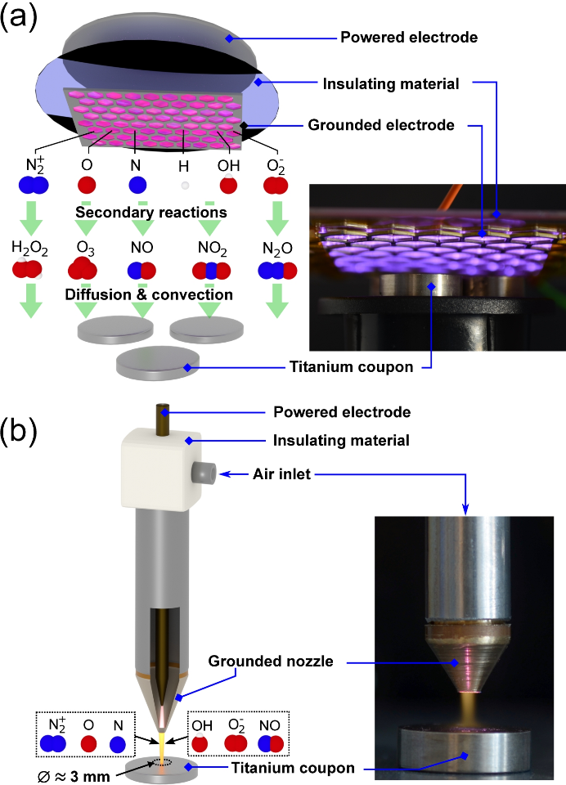
Figure 1: Atmospheric pressure, non-thermal air plasma devices used to simultaneously decontaminate and functionalize titanium surfaces: (a) Indirect plasma system comprising of a surface barrier discharge, insert shows photograph of system operating at an applied voltage of 10 kV and frequency of 20 kHz, and (b) direct plasma system comprising of a plasma jet discharge, insert shows photograph of system operating at applied voltage of 10 kV, frequency of 20 kHz and gas flow rate of 3 liters per minute.

Titanium samples were treated for 1, 2 and 4 minutes. For the indirect treatments, titanium samples were placed 5 mm below the discharge; for the direct treatment, each sample was placed 5 mm from the jet exit, directly within the plasma plume emerging from the nozzle. To ensure a uniform treatment in the direct treatment scenario, each sample was manually moved within the plasma plume in a circular fashion, ensuring that the entire surface was exposed; a process that was maintained for the duration of the treatment.

  - Surface characterization
    - Water contact angle measurement
The surface wettability of titanium samples was assessed with Water Contact Angle (WCA) measurements using a Cam 100 Optical Contact Angle Meter from KSV Instruments Ltd. For each titanium sample, the mean WCA was determined at a minimum of five different locations on the sample surface. Ageing of the plasma treated surfaces was determined by measuring the WCA of samples stored in air or water after 1, 2, 3, 5 and 7 days post exposure to the plasma.
    - Atomic Force Microscopy
The surface roughness and morphology of titanium samples was assessed using atomic force microscopy (AFM) (Solver PRO, NT-MDT, Russia). Silicon cantilevers with a typical resonant frequency of 240 kHz and a spring constant of 11.8 N/m were used to acquire images in semi-contact mode at room temperature under ambient conditions. The scanning rate was 1.5 Hz. Flattening of the raw images was performed before surface roughness analysis. The average surface roughness was determined from images with an area of 3 µm x 3 µm, surface profiles were obtained from the same areas.
    - X-ray Photoelectron Spectroscopy
The chemical composition of titanium surfaces was determined by X-ray Photoelectron Spectroscopy (XPS) analysis. A TFA XPS spectrometer, produced by Physical Electronics Inc. operating under ultra-high vacuum (10⁻⁷ Pa) and equipped with a monochromated Al Kα X-ray source (1486.6 eV) was used. The take-off angle of the electron analyzer in the XPS spectrometer was 45º with respect to sample surface. On each sample, a 0.4 mm diameter area was analyzed to a depth of 3 - 5 nm. Three different locations were analyzed on each sample and the data averaged. High-energy resolution spectra were acquired with an energy resolution of ~0.6 eV and pass energy of 29 eV. The XPS spectra were processed using the software MultiPak, Version 9.5.0. Quantification of the surface composition was performed from XPS peak intensities taking into account the relative sensitivity factors provided by the instrument manufacturer [38].

  - Biological analysis
    - Bacterial culture and biofilm generation
The bacterial strains used for all tests were Staphylococcus epidermidis ATCC 39584 and Escherichia coli ATCC 25922. Bacterial cultures were prepared from a single colony inoculated into 5 ml of Tryptic Soy Broth (TSB) medium and incubated at 37 °C in a shaking incubator Stuart SI500 (Bibby Scientific, Staffordshire, UK) at 200 rpm. The overnight cultures were adjusted with fresh TSB medium to obtain an optical density (OD₆₀₀) of 0.1. Polished titanium coupons were inserted into the holders of a CDC bioreactor (Bio Surface Technology Corp., Bozeman, MT, USA) according to the manufacturer´s instructions. 350 ml of TSB medium with a final bacterial concentration of 1 x 10⁵ CFU/ml was added to the bioreactor and incubated at 37 °C with a stirring rate of 200 rpm.
    - Survival analysis and recolonization
To determine the inactivation efficiency of both plasma systems, single-species and mixed- species biofilms composed of S. epidermidis and E. coli were grown for 24 hours on freshly prepared titanium surfaces. After incubation, the titanium samples were carefully removed from their holders and thoroughly rinsed in phosphate buffer saline (PBS) solution to remove any planktonic bacteria, rendering the sample ready for plasma treatment. Following plasma treatment, samples were placed in Falcon tubes containing 5 ml of TSB medium and vortexed for 10 min using vibratory shaker (VXR basic Vibrax®, IKA, Staufen, Germany) at 2000 rpm to dislodge and disrupt the formed biofilm. Using 100 µl of the bacterial solution from each tube a serial dilution series was produced. 10 µl of each dilution was spread onto an agar plate, a process repeated in triplicate. After 24 hours of incubation at 37 °C the visible colonies were counted to enable quantification of bacterial survival and surface colonization according to so called Miles-Misra method [39]. For S. epidermidis and E. coli mixed biofilms, serial dilutions were plated also onto selective Mannitol Salt Agar to distinguish between the strains. In the case of survival analysis, 100 µl of each dilution was spread on the agar plates in order to increase the sensitivity of the method.
To assess changes in the ability of bacteria to adhere to the surface and form a biofilm, both plasma treated and untreated titanium coupons were placed within the CDC biofilm reactor and incubated. After a four-hour incubation period, directly treated, indirectly treated and untreated coupons were removed from the reactor and the concentration of bacteria on the surface assessed using the method described previously. Samples remaining in the bioreactor were incubated for a further 20 hours (24 hours total incubation time) at which point samples were removed from the reactor. From the samples removed, untreated, directly and indirectly treated coupons were analyzed to determine the surface concentration of bacteria. To assess the level of surface recolonization following plasma treatment, the colonized titanium coupons removed from the CDC bioreactor were subjected to a plasma treatment. Following this treatment, the samples were returned to the bioreactor for further incubation, after an additional 24 hours, samples were removed from the bioreactor and the concentration of bacteria on the surface assessed.
    - Determination of bacterial viability by XTT metabolic assay
The XTT assay (Merck KGaA, Darmstadt, Germany) was performed according to the protocol described by Flynn et al. [30]. 50 µl samples of each biofilm suspension were transferred to the wells of a 96-well plate containing 50 µl of TSB and 20 µl of XTT stock solution. Bacterial metabolic activity was monitored at 450 nm for 12 hours using a microplate reader (Spark 10M, Tecan, Männedorf, CH).
    - Cell cultures
Murine fibroblasts L929 (American Type Culture Collection, ATCC, Manassas, VA, USA) were cultured in advanced minimum essential medium (AMEM, Life Technologies, Carlsbad, CA, USA) supplemented with 5% FBS, 10 mM/l L-glutamine, 100 U/ml penicillin, and 50 mg/ml gentamicin in a 5% CO₂ humidified incubator at 37°C. Cells were maintained in monolayers until they reached 80-90% confluence.
    - Determination of Cell viability
The viability of cells cultured on titanium surfaces was quantified using PrestoBlue Cell Viability Reagent (Life Technologies, Carlsbad, CA, USA). For all experimental groups, 5x10⁴ cells were seeded on prepared titanium samples, placed in 24-well plates (Thermo Fischer Scientific, Waltham, MA, USA). Cells were incubated at 37°C in a 5% CO₂ humidified incubator for 24 hours. Following incubation, the media was removed and replaced with PrestoBlue Viability Reagent, diluted appropriately in cell media. After a further 30 minutes of incubation, the fluorescent intensity was measured with a microplate reader (Infinite 200, Tecan, Männedorf, CH).
    - Cell visualization
Before L929 fibroblasts were seeded on to the titanium samples, the cells were fluorescently stained with Carboxyfluorescein succinimidyl ester (CFSE) dye, which passively diffuses into cells, covalently couples to intracellular molecules and is retained within the cells for several days. For cell visualization, a CFSE Cell Division Tracker Kit (BioLegend, San Diego, CA, USA) was used according to the manufacturer´s instructions. Briefly, cells were re-suspended in 0.5 μM of CFSE solution and incubated for 15 minutes at room temperature whilst being protected from light. To inhibit staining, cell culture media containing 10% FBS was added to the treated cells. Prior to further analysis, cells were incubated for 10 minutes at room temperature. For all experimental groups, 5x10⁴ CFSE stained cells were seeded on to prepared titanium samples placed in 24-well plates. Cells were incubated at 37°C in a 5% CO₂ humidified incubator for 24 hours. Following incubation, the media was replaced and images were captured using a fluorescent microscope (IX-70 Olympus, Hamburg, Germany) under 10x magnification.
    - Biofilm visualization
Confocal light microscopy was used to assess the bacterial attachment and early biofilm development of untreated and plasma treated titanium samples after 4 and 24 hours of incubation. Coupons were thoroughly rinsed in PBS and the remaining biomass adhered to the surface was stained with a 0.2 % v/v crystal violet solution for 20 minutes. After staining, samples were again thoroughly rinsed with dH₂O to remove any residual dye. Following air-drying of the surface, an Axio CSM 700 (Carl Zeiss, Jena, Germany) confocal light microscope was used to exam the remaining biomass. On each sample, a minimum 10 random areas were chosen for inspection. The percentage of surface covered with biomass was calculated from the resulting images, using the open-source software package ImageJ (NIH, Bethesda, Maryland, USA). The morphology of biofilms following plasma exposure was examined using a Scanning Electron Microscope (SEM) (Helios Nanolab 650, Keithley Instruments Inc., Ohio, USA). After rinsing the samples in PBS, biofilms were fixed with 2.5% glutaraldehyde solution and then dehydrated in a gradient of ethanol concentrations (50%, 60%, 70%, 80%, 90%, 95% and 100%). Samples were chemically dried using hexamethyldisilizane (HMDS) and sputter coated with carbon prior to imaging.

  - Statistical data analysis
Quantitative results are presented as the mean + standard deviation. All statistical analysis was performed using Prism 7.0 software (GraphPad Software Inc., San Diego, CA, USA). Statistical significance was evaluated using the unpaired t-test, one-way or two-way analysis of variance (ANOVA) test, depending of the experiment type performed. A p-value of ˂ 0.05 was considered as significantly different.

- Results
3.1. Influence of plasma treatment on surface wettability of titanium surfaces
Measurements of WCA showed that the exposure of titanium surfaces to plasma induced significant changes in surface hydrophilicity, shown in Fig. 2(a) and (b). The surface of untreated titanium samples was found to be hydrophobic in nature, with a WCA value greater than 70°. Following indirect plasma treatment, the wettability of the surface increased, reaching approximately 40 - 45° regardless of treatment duration. For direct plasma treatment, a drastic change in wettability was observed; ultimately leading to superhydrophilic characteristics, with a contact angle of less than 10°.

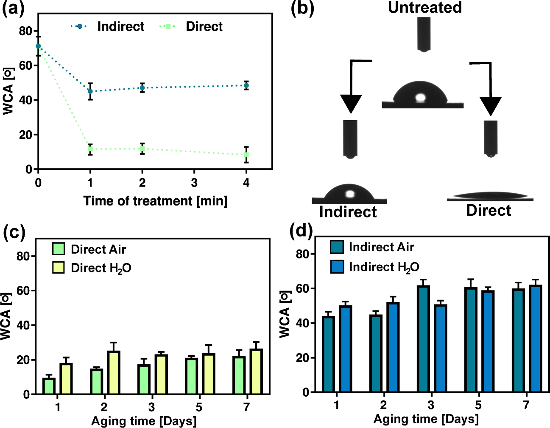
Figure 2: Influence of plasma exposure on water contact angle: (a) Variation in WCA as a function of plasma treatment type and exposure time, (b) Image showing a dH₂O droplet on untreated, indirect and directly treated titanium surface, (c) Ageing of surface wettability under wet and dry storage conditions following direct plasma exposure, and (d) Ageing of surface wettability under wet and dry storage conditions following indirect plasma exposure.

The ageing of plasma induced surface wettability was examined after 1, 2, 3, 5 and 7 days of storage under both wet and dry conditions. Fig. 2(c) shows the ageing of directly treated samples, a small increase in WCA was observed over the initial 24 hours of storage in air, a value that remained relatively constant for the remainder of the test. Under wet storage conditions, the samples showed a gradual increase in hydrophobicity over the duration of the test; however, after 7 days a statistically significant difference in the hydrophilicity remained in comparison to the untreated samples. The ageing of titanium samples exposed to an indirect plasma treatment is shown in Fig. 2(d). Under both wet and dry storage conditions, the WCA showed a gradual increase over the duration of the test. Despite the slight aging effects observed, the difference in WCA between plasma treated samples under wet or dry storage conditions was statistically significant compared to untreated titanium surfaces (p ˂ 0.0001).

3.2. Influence of plasma treatment on the chemistry of the Ti surface
The surface composition and chemical bonding of titanium samples following direct and indirect plasma treatment was investigated using XPS. The surface composition, obtained from low-resolution XPS spectra of treated and untreated titanium samples showed the characteristic peaks of Ti, O, C and N. Notably the adventitious carbon contmaintion detected on all surfaces is typical of titanium and is widely reported in XPS analysis of Ti surfaces. Also some minor elements like Ca, Si and Na were detected in the XPS spectra with concentration less than 1 at.%. Fig. 3(a) and 3(b) show the N/Ti and O/Ti ratio of treated and untreated samples, respectively. From Fig. 3(a) it is clear that both direct and indirect plasma treatments induce an increase in the proportion of nitrogen bound to the surface. In contrast, Fig. 3(b) shows that the O/Ti ratio remained relatively unchanged following an indirect plasma exposure yet significantly increased following a direct exposure. To further investigate the differences in composition and chemical bonding following plasma treatment, high-energy-resolution spectra for C1s, O1s, N1s and Ti2p were acquired. Fig. 3(c) shows the Nitrogen 1s spectra from the untreated, direct and indirectly exposed surfaces; significant differences were apparent between the three cases. The component observed at a binding energy of 400.0 eV corresponds to the presence of NH₂ bonds. Low intensities of this component were observed on all titanium surfaces. In the case of a direct treatment, a clear dominant peak at a binding energy of 402.1 eV was observed and is attributed to the protonated/quaternary ammonium group NH₃⁺[40]. The indirectly treated surface also showed evidence of NH₃⁺ groups, but at significantly lower intensities than the directly treated sample. The most significant peak observed on the indirectly treated sample is located at 406.8 eV and corresponds to NO_{x} species (nitrates) [38, 41], which is found in lesser quantities on the untreated and directly exposed surfaces.

Fig. 3(d) shows the high-resolution Oxygen 1s spectra from the untreated, directly and indirectly treated titanium surfaces. Deconvolution of the O 1s peak revealed three different states of oxygen atoms, these were identified from Moulder et al. [38]. The component marked O1 at a binding energy of 530.3 eV represents oxygen O(2-) in the TiO₂ lattice structure, while the component marked O2 at a binding energy of 531.4 eV is often related to OH groups. Finally, the O3 component at a binding energy of 532.7 eV is typically associated with NO_{x} or H₂O groups, in addition to some other carbon-oxygen species [41, 42]. The XPS spectra of the untreated titanium surface indicates that the majority of oxygen is bonded as oxide (O1) with a smaller proportion in OH bonds; such characteristics are often reported for TiO₂ that readily forms on titanium surfaces. Further oxygen is associated with the O3 component, likely originating from contaminants or adsorbed CO₂ molecules present on the surface. Direct plasma treatment caused a significant change to the nature of oxygen bonds on the surface. The O2 component was significantly increased indicating the intense adsorption of hydroxyl groups. The presence of these species closely correlates to the change of surface energy, highlighted by the WCA measurements (Fig. 2). Direct plasma exposure also reduced the presence of O-atoms in the TiO₂ lattice structure (O1 component) in comparison to the untreated surface. The status of oxygen atoms on the titanium surface following indirect plasma exposure shows similarities with the untreated surface, i.e. a high O1 component and a smaller O2 component. In contrast to the untreated surface, a significant O3 component was observed which is related to NOx species and is attributed to the nature of the RNS dominated gas phase chemistry created during the indirect plasma treatment [38].

High-energy-resolution C 1s XPS spectra before and after plasma treatment are shown in Figure 3(e). The presented C 1s spectra are composed of four different components which are related to the different types of carbon-atom bonds. The component located at a binding energy of 284.8 eV (C1) corresponds to C‒C and/or C‒H bonds; the component at 286.2 eV (C2) corresponds to C‒O and/or C‒N; the component at 287.9 eV (C3) corresponds to O‒C‒O and/or C=O; and the component at 288.9 eV (C4) corresponds to O‒C=O bonds. As can be seen form Fig. 3(e), the shape of the C 1s peak differs significantly between the untreated, direct treated and indirect treated samples. In the case of in-direct plasma treatment, components C2, C3 and C4 are all slightly higher than those observed from the untreated sample; indicating that plasma treatment introduced further functional groups to the sample surface. The directly exposed sample differs significantly, with the C 1s signal indicating significantly higher intensities of components C3 and C4 compared to the in-direct and non-treated samples.

High-energy-resolution spectra of the Ti 2p doublet peak was also acquired and is shown in the supplementary material, the spectra revealed both the Ti 2p_{3/2} and Ti 2p_{1/2} components, appearing at 458.5 eV and 464.2 eV, respectively, with 5.7 eV spin-orbital splitting. Such observations are consistent with the Ti⁴⁺ valence state (TiO₂). Comparison of the spectra from both the untreated and plasma treated surfaces showed no significant difference.

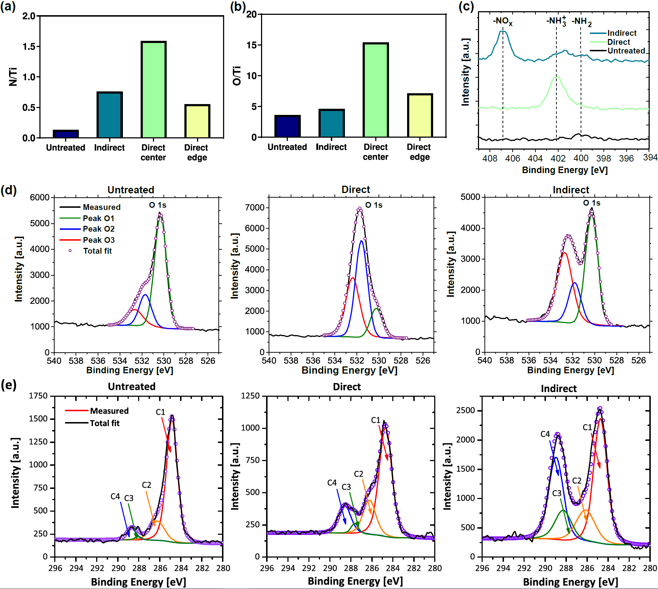
Figure 3: XPS analysis of untreated, directly treated and indirectly treated titanium samples presented as the mean calculated from three randomly selected locations on the sample surface: (a) Nitrogen/Titanium ratio, (b) Oxygen/Titanium ratio, (c) High resolution spectra of Nitrogen 1s, (d) High resolution spectra of Oxygen 1s on the untreated, directly and indirectly treated titanium surfaces, respectively and (e) Deconvoluted high-energy-resolution C 1s spectra on the untreated, directly and indirectly treated titanium surfaces, respectively.

In order to gain an insight into the depth distribution of elements in the subsurface region of samples XPS depth profiling combining XPS analyses with Ar+ ion sputtering was performed. The XPS depth profiles from non-treated and direct plasma treated samples are shown in Figure S3. Both depth profiles are very similar. They show that carbon based contamination is present only on surface as a thin surface layer of thickness of about 1 nm on the non-treated sample and about 2 nm thick layer on the treated sample. Furthermore, XPS depth profiles indicate that a similar Ti-oxide layer is present on the non-treated and direct plasma treated sample. The oxide layer was estimated to be about 5 nm in thickness.

3.3. Influence of plasma treatment on titanium surface morphology.
The impact of plasma treatment on surface roughness and topography was examined using AFM. The average surface roughness of titanium samples was determined from a minimum of three randomly selected measurement areas and is presented as the mean value and standard deviation in Fig. 4(a). The average surface R_{a} for samples prior to plasma treatment was found to be 2.44 (+ 0.77) nm and 1.76 (+ 0.42) nm, respectively. Following plasma exposure, the R_{a} was observed to increase to 3.94 (+ 0.42) nm in the case of an indirect treatment and 2.01 (+ 0.22) nm in the case of direct treatment.

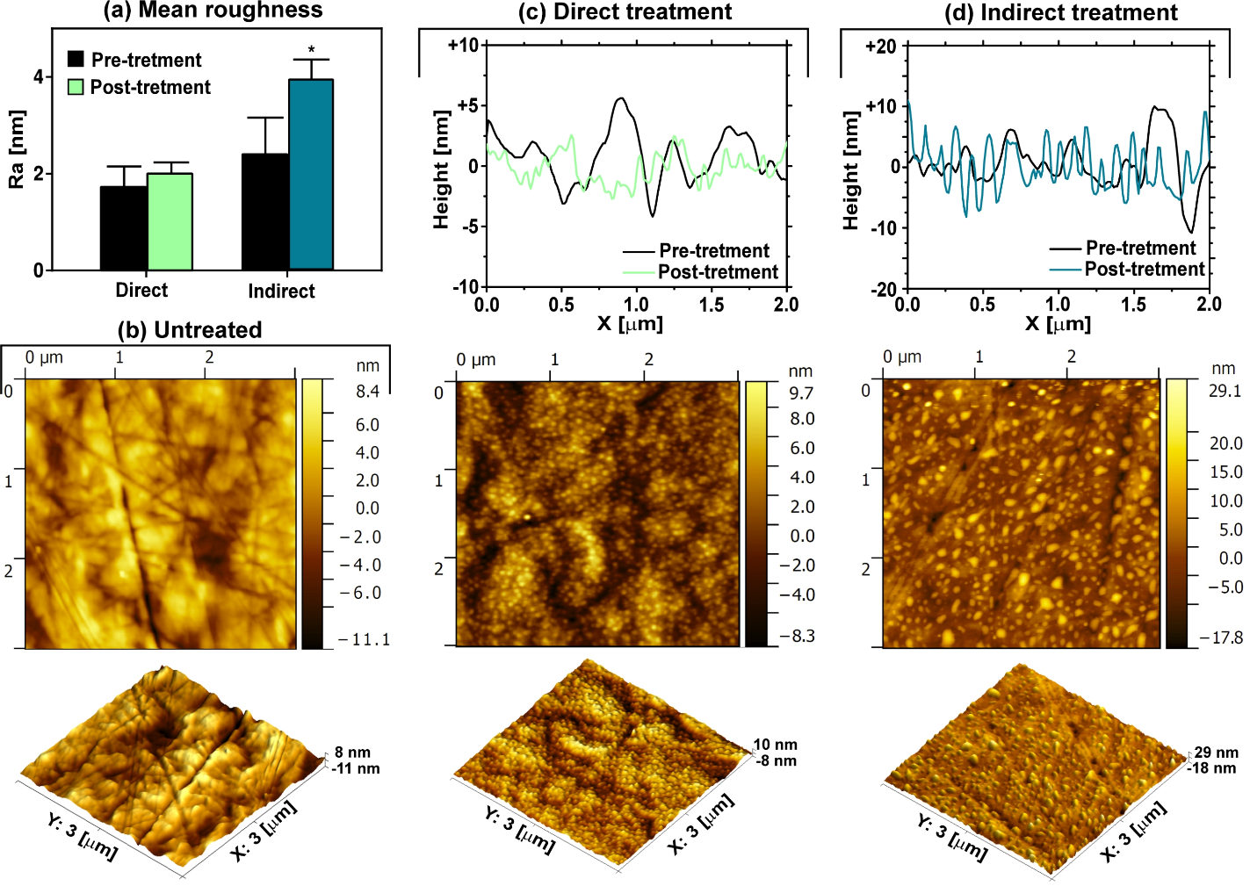
Figure 4: Surface topography of titanium before and after direct and indirect plasma treatment: (a) Mean surface roughness obtained from three randomly selected 3 µm x 3 µm scanning areas obtained before and after plasma exposure, (b) Representative two- and three-dimensional topological images of the untreated titanium surface, (c) Representative two- and three-dimensional topological images of the directly treated titanium surface, with a typical surface profile, and (d) Representative two- and three-dimensional topological images of the indirectly treated titanium surface, with a typical surface profile.

Beyond mean surface roughness, AFM analysis revealed significant differences in morphology between the plasma treated and untreated surfaces, highlighted in Fig. 4(b - d). Following polishing, untreated samples showed some nanoscale surface abrasions, likely resulting from the CMP process. These abrasions appear as a random array of successive deep grooves, associated with the different grades of diamond paste used in the polishing process, Fig. 4(b). From Fig. 4(c) and 4(d) it is clear that plasma treatment causes significant changes, indicating the mechanical damage incurred during polishing was largely eliminated. Examination of the directly exposed samples, presented in Fig. 4(c), indicates that plasma exposure resulted in the nucleation of a continuous oxide film. It is not clear if this is crystalline or amorphous, but the faceted nature of the nano-grains suggests the film is likely crystalline in nature. Additionally, evidence of the underlying alloy grain structure can be seen, suggesting preferential plasma etching at the alloy grain boundaries. Thus, the direct plasma treatment gives rise to active plasma oxidation of the surface, forming a nano-grained titanium surface oxide. Conversely, the indirectly exposed sample, shown in Fig. 4(d), appears as a chemically etched surface, most likely resulting from prolonged exposure to the long-lived neutral RONS. Local rearrangement and nucleation of a new phase can be observed as pyramidal growths.

  - Influence of plasma treatment on bacterial attachment and biofilm formation
The impact of plasma treatment on the attachment of bacteria and biofilm formation is a key consideration. Using E. coli and S. epidermidis, the concentration of bacteria and biomass present on each treated and untreated titanium surface was evaluated after 4 and 24 hours of incubation, using both colony counting and microscopy methods, outlined in Fig. 5(a). Following plasma treatment, statistically significant differences in surface coverage between direct plasma treated and untreated samples was evident after 4 hours, Fig. 5(b). The amount of biomass on directly treated titanium surfaces was found to be 6.2-fold lower, compared to untreated samples. Conversely, indirect exposure had the opposite effect and led to a small increase in surface coverage. A similar trend was observed after a 24 hour incubation period, with indirectly treated samples showing slight, but not statistically significant, differences compared to the untreated samples whereas directly treated surfaces showed a significant 4.2-fold reduction in surface coverage compared to the untreated sample.
Quantitative analysis confirmed that surfaces exposed to a direct plasma treatment had significantly less E. coli and S. epidermidis adhered to their surface, leading to the inhibition of early biofilm development, Fig 5(c). The opposite was observed for indirectly treated surfaces, where plasma treatment was observed to promote bacterial attachment and thus accelerate biofilm formation.

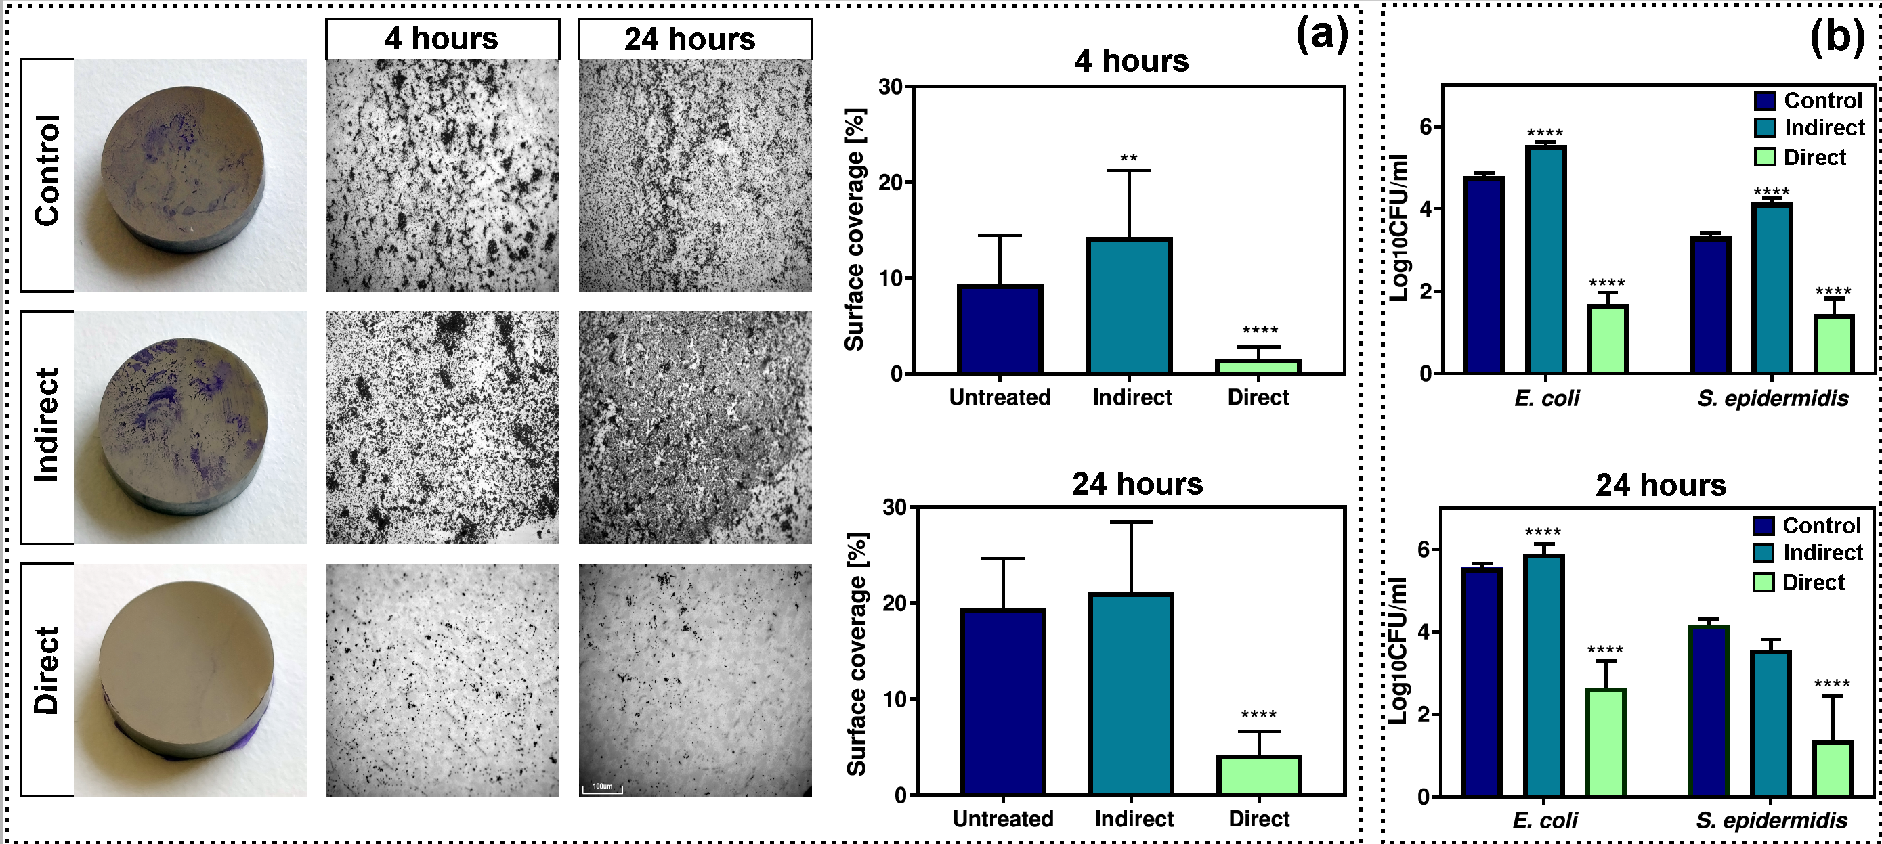
Figure 5: Effect of plasma treatment on bacterial attachment and early biofilm formation: (a) surface coverage of untreated, directly and indirectly treated titanium surfaces after 4 and 24 hours of post-treatment incubation, and (b) Surface concentration of E. coli and S. epidermidis determined using selective agars on untreated, directly and indirectly treated titanium surfaces after 4 and 24 hours of post-exposure incubation.

  - Influence of plasma treatment on fibroblast attachment and viability
To assess the ability of fibroblast cells to attach and proliferate on plasma treated titanium surfaces Murine fibroblasts L929 were seeded on to untreated, indirectly and directly treated titanium samples. Fig. 6(a) shows the representative fluorescent microscope images highlighting the proliferation of L929 cells on each sample surface. From the images shown in Fig. 6 it is clear that a direct plasma treatment encourages cell proliferation, with a considerably higher density of cells being observed on the sample surface compared to both the untreated and indirectly exposed samples. For samples indirectly exposed, no significant differences were observed between the treated and untreated samples. Fig. 6(c) highlights the cell viability after 24 hours, with the results indicating that the directly exposed surface promotes cell attachment, a finding in agreement with the microscope images. In order to quantify the number of adhered cells and their survival after 24 hours of incubation flow cytometry was performed using AnnexinV/PI staining to distinguish between live and dead cells. The results of the analysis are presented in the supplementary information, Fig. S4. The ratio between live and dead cells was significantly higher in the case of directly treated samples; however, the overall number of cells from the directly treated surfaces was found to be much lower compared to the untreated sample. This result is contrary to expectation given the observations made using fluorescence imaging, Fig. 6(a). Further microscope analysis of the samples showed that standard trypsinization step, required to detach adhered cells from the surface prior to flow cytometry was not sufficient to detach cells from the directly treated sample. Consequently, these observations add further evidence to demonstrate that a direct plasma treatment leads to enhanced fibroblast adhesion and proliferation.
To further understand the impact of a directly exposed titanium surface the experimental procedure was modified such that the plasma jet device was held stationary for the duration of the treatment. Using this modified approach, it was possible to ensure that the emerging plasma plume impinged only on a small circular area (~ 10 mm²) at the center of the sample. Beyond this region plasma generated RONS undergo secondary reactions as they are transported by the flowing gas, resulting in a rapid reduction in reactivity. From Fig. 6(b) it is clear that the highest cell concentration is within the central region exposed directly to the highly energetic plasma generated RONS. Beyond the treatment zone a reduction in cell density was observed, with the edges of the sample indicating similar densities to those observed on the untreated sample. These result highlight the importance of the energetic RONS produced within the plasma plume and their spatial localization, in comparison to their less reactive by-products observed beyond the treated zone.
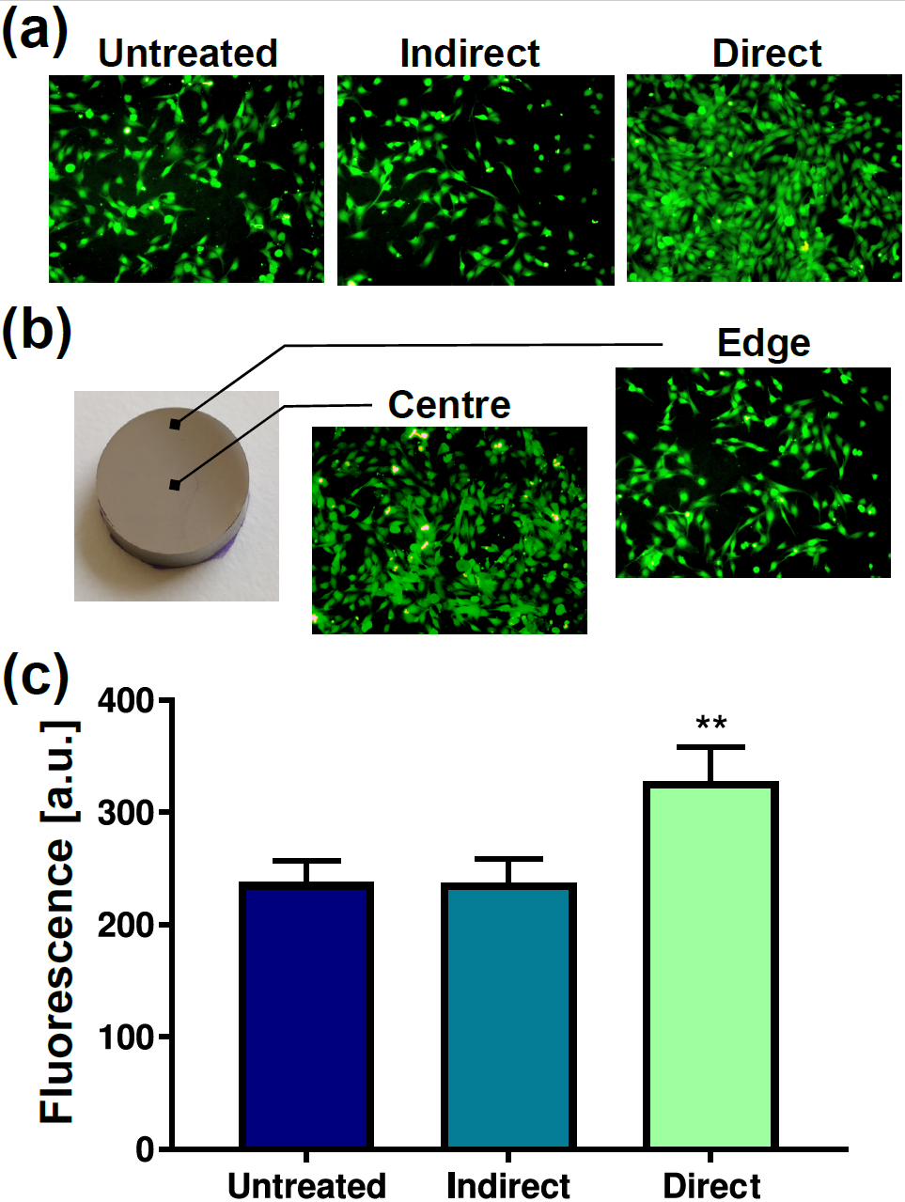
Figure 6: Fibroblast cell attachment and proliferation on untreated, indirectly and directly treated titanium samples: (a) Fluorescence microscope images showing cell proliferation on untreated, directly and indirectly treated samples, (b) fluorescence microscope images showing impact of a stationary direct plasma exposure confined to the sample center, and (c) cell viability following 24 hours of post-exposure incubation.

  - Plasma decontamination of biofilms on the surface of titanium
While it is clear that plasma treatment is capable of modifying the composition and morphology of a titanium surface to achieve a one-step process it is vital that the plasma treatment is also able to efficiently decontaminate single and mixed-species biofilms from the surface. To assess this the procedure shown in Fig. 7(a) was adopted. Representative S. epidermidis and E. coli single and mixed species biofilms were grown on untreated titanium surfaces for 24 hours and subsequently exposed to the direct and indirect plasma treatments. The inactivation results, shown in Fig. 7(a), demonstrate that both plasma treatments were capable of achieving a significant reduction in both single and mixed species biofilms from the sample surface. In the case of an indirect plasma treatment a complete eradication of S. epidermidis, defined as ˂ 1 CFU remaining, was achieved after a one-minute plasma exposure for the single species biofilm case, whereas a two-minute exposure was required to achieve a 6+ log reduction when S. epidermidis was presented in a polymicrobial biofilm. The direct treatment proved to be less efficient, with a four-minute treatment achieving a 5.03 (+ 1.08) log reduction of the S. epidermidis biofilm and a 3.51 (+ 0.56) log reduction of S. epidermidis when presented in a polymicrobial biofilm. E. coli was found to be more susceptible to both plasma treatments, with no significant differences observed between the direct and indirect exposure or the composition of biofilm. Notably, all treatments attained a ˃7 log reduction within 2 minutes of plasma exposure. SEM images of the untreated, directly and indirectly treated mixed species biofilms are presented in Fig 7(b). From the images, it is clear that a direct plasma treatment led to drastic changes in the surface morphology of E. coli cells, with most cells showing evidence of physical membrane damage; conversely, an indirect showed little physical damage to E. coli despite the high level of inactivation. Both direct and indirect plasma exposure had little impact on the structural integrity of S. epidermidis cells, demonstrating the robust nature of their thick outer membrane.
To add further insight in to the inactivation results the XTT metabolic assay was used to assess the viability and survival of bacteria following exposure to plasma. The results, shown in Fig. 7(c), are in good agreement with the inactivation data shown in Fig. 7(a). Following indirect exposure of the single species S. epidermidis biofilms, no metabolic activity was observed regardless of treatment time. Similarly, single species E. coli biofilms were also metabolically inactive after 2 and 4 minutes of indirect and direct plasma exposure, respectively; but showed delayed activity at shorter treatment times albeit significantly lower than that of the untreated samples. For mixed-species biofilms, a 4-minute indirect exposure was sufficient to completely inactive all bacteria, with shorter treatment times delaying the onset of metabolic activity. For direct treatments, all exposure times delayed the onset of metabolic activity; however, no treatment was sufficient to completely inhibit metabolic activity, which is in good agreement with the inactivation results presented in Fig. 7(a).
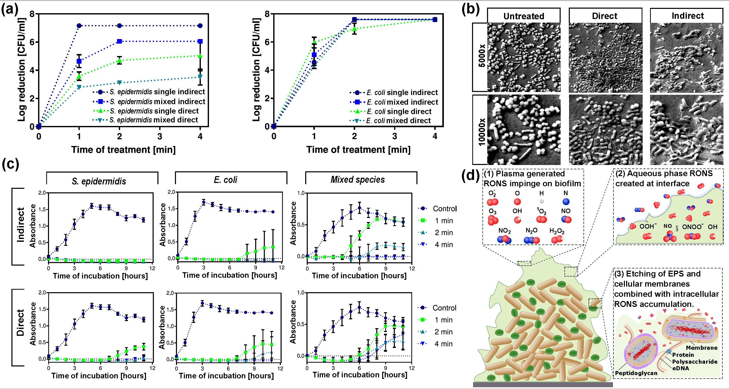
Figure 7: Decontamination of S. epidermidis and E. coli biofilms: (a) Log reduction curves for single and mixed species biofilms following plasma exposure, (b) SEM images showing morphology of bacteria following a 4 minutes direct and indirect plasma exposure, (c) Metabolic kinetic curves of single and mixed species biofilms following 1, 2 and 4 minutes of direct and indirect plasma exposure, and (d) diagram showing the interaction of plasma derived RONS with polymicrobial biofilm EPS and cells.

3.7. Impact of plasma treatment on biofilm recolonization
In an application context, it would be highlight beneficial if a plasma treatment could be used to simultaneously rid the surface of microbial contamination and impart beneficial surface characteristics to inhibit future recolonization. To assess this potential, the experimental procedure shown in in Fig. 8(a) was adopted. Following a 24-hour incubation of untreated titanium samples in a mixed species culture, the colonized surfaces were plasma treated for 4 minutes then returned to the bioreactor with fresh medium and inoculum for a further 24-hour incubation. Following this recolonization step, the number of CFU on each sample was determined for both species using the method outline in section 2.4.2. From Fig. 8(b) it is clear that biofilm development was significantly lower on the directly treated samples for both bacterial species present. Conversely, indirect treatments showed a relatively minor decrease in the level of bacterial recolonization of the treated surface.
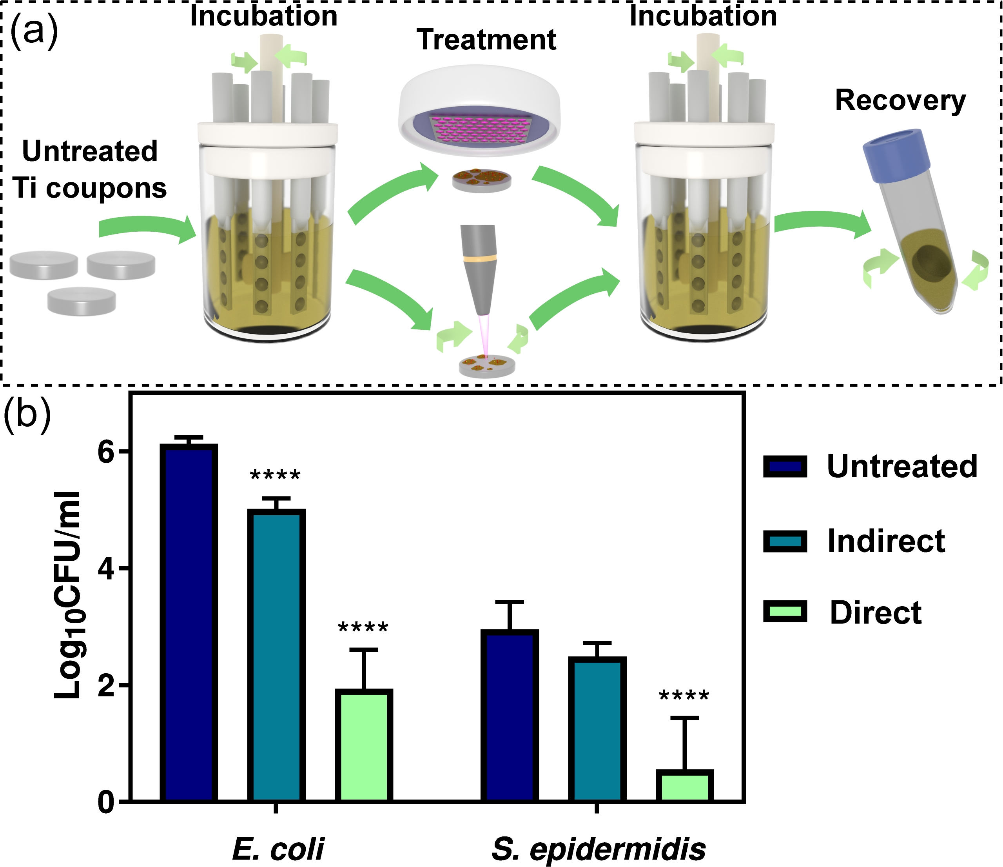
Figure 8: Recolonization of plasma treated surfaces: (a) Experimental procedure to quantify level of bacterial recolonization, and (b) biofilm development after repeated incubation after plasma decontamination of the surface.

- Discussion
Despite over 100 years of progress in orthopedic surgical practice and prosthetic device design, implant-associated infections remain a major complication, with polymicrobial biofilms being a primary cause of implant failure [43]. There is a clear clinical need to develop new strategies to prevent the colonization of devices as and when they are implanted and uncover new technique to assist in minimizing the impact of infection on implanted devices that are already in-use. To address this challenge, we posited that a targeted low temperature air plasma treatment could inactivate biofilm contamination from a titanium implant whilst simultaneously functionalizing the underlying surface, imparting preferential characteristics to promote cell attachment and inhibit biofilm formation. To confirm this hypothesis, two contrasting plasma devices were considered including a direct plasma treatment where a narrow plume of highly reactive neutral and charged RONS impinge directly on to the titanium surface. Conversely, an indirect plasma treatment was also considered, where plasma generated RONS undergo secondary reactions prior to reaching the sample surface resulting in large fluxes of neutral RONS to the titanium surface. By comparing and contrasting the impact of each plasma treatment the interplay between plasma generated RONS, polymicrobial biofilm contamination and the underlying titanium surface was investigated.
Following plasma exposure significant changes to the composition, morphology and wettability of titanium surfaces was observed. Critically, the observed changes were found to be closely linked to the characteristics of each plasma treatment. In the direct treatment scenario, highly energetic species were found to induce drastic changes to the surface wettability, leading to super-hydrophilic characteristics. Furthermore, XPS analysis indicated that a direct plasma treatment led to an increase of polar oxygen groups (such as hydroxyl, carbonyl and carboxyl groups), likely resulting from the direct interaction of energetic ROS with the surface, all contributing to the hydrophilicity of the surface [40]. Conversely, when subjected to an indirect treatment, WCA measurements revealed a modest increase in surface wettability, significantly less than that observed in the direct treatment scenario. XPS analysis of the indirectly exposed surface revealed an increase in the presence of NO_{x} groups, which can be attributed to the abundant gas phase RNS created by the plasma [44]. Given that surface wettability and composition are both considered to be major factors influencing Prokaryotic and Eukaryotic cell attachment on a surface, it is not surprising that the contrasting plasma treatments led to markedly different biological surface characteristics. Surface wettability is especially pertinent during the first stage of biofilm formation, which is driven by hydrophobic/hydrophilic interactions [8]. Due to the plethora of competing factors governing microbial attachment it is extremely difficult to state explicitly what role surface wettability plays; yet, it is generally considered that hydrophobic surfaces promote bacterial attachment. Despite this, results can be unpredictable and the influence of surface wettability is known to vary from bacterial species to species and even between strains [45-47].
The morphology of a surface is also recognized as an influential factor for bacterial adhesion; however, the arithmetic average roughness, R_{a}, typically does not give realistic information about the surface morphology. This is evident in Fig. 4, where the average surface roughness exhibits minor changes following plasma treatment, yet the morphology of the exposed surface varies considerably. For the direct treatment the nucleation of a continuous oxide film can be observed with the appearance nano-grains. Combined with the XPS data presented in Fig. 3, it is suggested that hydrated titanium oxide species are formed most likely in the Anatase form. For the indirect treatment, local rearrangement and nucleation of a new phase can be observed as pyramidal growths, Fig. 4(d). It is highly likely that these growths are the nucleation of a new oxide or nitride phase, most likely TiO or TiN. Both phases are cubic and can form equilibrium structures due to titanium’s ability to adsorb in excess of 30 % oxygen or nitrogen into solution at its surface. Taken in combination with the high-resolution XPS data shown in Fig. 3, it is likely that indirect plasma exposure leads to the nucleation of titanium oxy-nitride.
As a model system to examine the impact of plasma induced surface changes on biofilm development, a mixed species biofilm model composed of S. epidermidis and E. coli was adopted. Such biofilms are highly represented of those frequently found in implant-associated infections and belong to both Gram-negative and Gram-positive bacterial groups. The effects of plasma surface modification were demonstrated via several independent approaches and it was shown that a 4-minute direct plasma treatment significantly reduced early microbial attachment over the first 4 hours of incubation. This trend was maintained over a further 20 hours of incubation. Previous studies have demonstrated that the 6-hour post-implantation period is particularly prone to bacterial colonization of implant surfaces [48], hence the results obtained in this study suggest that the application of a direct plasma treatment could be particularly beneficial. The adhesion of bacteria on a surface is influenced by both its composition and morphology. In terms of morphology, previous studies have illustrated that changes in surface roughness do not necessarily promote bacterial adhesion; the morphology plays a key role. Singh et al. produced controlled nanostructured titanium thin films and studied the adhesion of E. coli and S. aureus on different surface morphologies [18]. Their results indicated that bacterial adhesion was enhanced up to a surface roughness of 20 nm while further increases of R_{a} resulted in decreased bacterial adhesion. The dimension and aspect ratio of the surface nanostructures was observed to play a role in promoting bacterial adhesion. Furthermore, hydrothermally synthesized TiO₂-anatase coatings with different surface properties have been used to study bacterial adhesion. Surface roughness, topography, surface charge and wettability were all considered and it was reported that the surface topography had the predominant effect on the attachment of E. coli [17]. In contrast to these and many other previous studies [49], the nanoscale structures created by the indirect and direct plasma treatments used in this study ranged in height from +/- 10 nm and +/- 5 nm, respectively; and are thus considerably smaller than those considered previously. Furthermore, an inevitable consequence of plasma treatment is that a change to both the surface composition and morphology is unavoidable, as the two phenomena cannot be separated. Given that both plasma treatments led to the formation of nanoscale surface features yet only the directly exposed surface exhibited super-hydrophilic properties, it is likely that changes to the surface composition and wettability are primarily responsible for the observed reduction in microbial attachment.
A stable connection between the biomaterial surface and the surrounding tissue is also an important point that needs to be considered when the long-term success of implants is desired. Indeed, the biocompatibility of metallic titanium is predominantly due to the formation of a 2 – 6 nm thick titanium oxide layer that is thermodynamically stable, chemically inert, and has a low solubility in serum [50, 51]. Factors influencing the adsorption of macromolecules that mediate cell attachment include electrostatic interactions, van der Waals interactions, ionic binding, and hydrophilicity. Indeed, many studies have explored the effects of surface wettability on the adhesion and proliferation of cells. In contrast to bacterial attachment, which is typically promoted by hydrophobic surface characteristics, human and animal cells adhere and proliferate at a higher rate on surfaces that are hydrophilic in nature [52, 53]. Furthermore, it has been demonstrated that fibroblasts respond to the both micro- and nano-scale surface topographies [51]. Previous studies have demonstrated that nanoscale fibers, less than 100 nm in height, are better able to provide guided directionality to the proliferation of the fibroblasts [54]. However, conflicting results have also been reported, where fibroblasts have undergone a decreased tendency to grow onto nanostructured titanium surfaces [54, 55]. Despite the number of studies focused on unravelling the influence of surface topology on cell adhesion and proliferation, few have considered sub-10 nm topologies such as those considered in this study. Given that both plasma treatments considered in this study led to the formation of nano-structures, it is likely that the differences observed in cell attachment are likely attributed to changes in the composition and wettability of the surface. While the direct plasma treatment was shown to significantly enhance cell attachment, a common concern with plasma-functionalized coatings is their longevity; with ageing effects known to have a detrimental impact on the biocompatible properties of the treated surface [56, 57]. Through WCA measurements it was demonstrated that the surface hydrophilicity of directly treated titanium samples showed a very minor reduction over a 7-day period. A finding that demonstrates the beneficial properties introduced through a direct treatment can be maintained over the most critical post-operative wound-healing period, this would be a critical factor in any in-vivo scenario, where the most favorable interaction between the implant material and host cells is sought.
A unique property of low temperature atmospheric pressure plasma is that it enables the non-thermal generation of energetic RONS directly at the point of need, using only air and electricity. This unique characteristic paves the way for such plasmas to be used for the in-vivo decontamination and functionalization of infected implants. To demonstrate this potential, the decontamination efficacy of each plasma treatment on single and mixed species biofilm models comprising of S. epidermidis and E. coli was considered. It is well known that plasma can induce changes in the electrochemical gradient across the membranes of exposed bacteria, leading to the inhibition of enzymes and changes of membrane transport proteins. Such changes in membrane permeability enable the intracellular accumulation of RONS, which react with intracellular components, such as DNA, enzymes, carbohydrates and lipids, changing their structure and function; ultimately resulting in physiological dysfunction and cell death [29]. From the SEM images presented in Fig. 7(b) it is clear that a direct plasma treatment led to drastic changes in the surface morphology of E. coli cells, with most cells showing evidence of physical membrane damage. Such physical damage is indicative of direct etching of the thin, ~10 nm, cellular membrane of this gram-negative organism by highly reactive plasma generated RONS [58]. Conversely, the indirect treatment appeared to cause little structural damage to E. coli cells, indicating that the mode of inactivation is likely to be mediated through the transport of less reactive RONS through the membrane and their subsequent interaction with intercellular components. Both direct and indirect plasma exposure had little impact on the structural integrity of S. epidermidis cells, demonstrating the robust nature of the thick, ~20 – 80 nm, outer membrane and suggesting that diffusion of RONS through the membrane is likely to be the primary mode of inactivation [29, 59]. A diagram showing the proposed interactions of plasma generated RONS species with bacterial cells within the biofilm EPS is presented in Figure 7(d).
The decontamination results clearly demonstrate that both direct and indirect plasma treatments are capable of eliminating biofilm contamination from a titanium surface; however, the observation that an indirect exposure is more efficient than a direct exposure is contrary to expectations. Optical spectroscopy was used to confirm the presence of the excited states of atomic oxygen and nitric oxide in the direct case, Fig. S1, while laser induced fluorescence techniques have been used to quantify reactive ground state species, such as atomic oxygen, in a similar jet system [32]. The antimicrobial properties of these highly reactive and short-lived species are well known. In contrast, few of these highly reactive species are able to reach the sample in the indirect treatment scenario. Charged species, excited states and highly reactive neutrals are all lost at the plasma-gas interface (penetrating << 1 mm in to the gas region); they are incapable of traversing the 5 mm gap between the plasma and sample in any significant concentration [34]. To explain the differences in decontamination efficacy the structure of a biofilm must be considered. Bacteria in a biofilm are organized in microcolonies of cells encased in an exo-polysaccharide (EPS) matrix and separated from other microcolonies by water channels that are used for the delivery of oxygen and nutrients. It is estimated that the water content of a biofilm can be as high as 90 % [60]. Several studies have considered the interaction between direct and indirect air plasma with a liquid. Regardless of the type of treatment, it has been shown that short-lived species, such as atomic oxygen, are unable to propagate beyond the liquid surface [61]. It has also been demonstrated that significant concentrations of highly reactive species, such as hydroxyl radicals, hydrogen peroxide, NO₂⁻/NO₃⁻ and peroxynitrite, can be formed in the bulk liquid through secondary reactions involving longer-lived plasma generated species that are able to penetrate beyond the liquid surface [62-64]. Given that large densities of long-lived species are produced during the indirect plasma treatment, such liquid mediated chemistries could play an important role in enhancing the decontamination efficacy. Another factor affecting the decontamination efficacy of the direct treatment is the limited treatment area of the plasma plume, necessitating continuous movement of the sample to ensure complete surface exposure. In contrast, the indirect system was able to simultaneously treat the entire sample surface without the need to physically move the sample, meaning the entire sample received an equal dosage for the entire duration of the treatment. From a clinical perspective, the complete inactivation of all microorganisms from an infected implant surface would be beneficial yet it is not deemed essential. Reducing microbial attachment and delaying biofilm formation enables cells from the host immune system to adhere to the implant surface, assisting in the removal of microbes and thus avoiding infection following implantation [31].
While it has been demonstrated that a direct plasma treatment is effective in functionalizing titanium to impart beneficial surface characteristics and that the same plasma treatment can eliminate biofilm contamination from the surface, achieving both processes simultaneously would be highly beneficial from a clinical perspective. To assess the potential of plasma to achieve simultaneous decontamination and functionalization polymicrobial biofilms were grown on untreated titanium samples, exposed to a 4-minute plasma treatment and then subjected to a further period of incubation. Through this process it was observed that directly treated samples showed significantly less biofilm recolonization in comparison to the untreated and indirectly treated samples. The results, presented in Fig. 8, provide the first evidence that plasma treatment is a viable proposition to treat infected implants, by eliminating biofilm contamination and preventing recolonization in a single step. Critically, all of the experiments in this study were performed in vitro. To confirm the effectiveness of the approach and further develop plasma technology to tackle implant associated infections, future animal models and clinical studies will be essential to demonstrate how the reduction in bacterial attachment following implant placement and the improved tissue regeneration on plasma treated implants translates into improved long-term clinical outcomes.

- Conclusion
In conclusion, this study demonstrates that different scenarios of low temperature plasma treatment have markedly different impacts on the ability of polymicrobial biofilms to form and fibroblast cells to proliferate on titanium surfaces. While both plasma treatments were shown to be highly effective in eliminating biofilms from the surface, only a direct plasma treatment was able to induce beneficial and long-lasting changes to the surface composition and morphology. To unravel the interaction between microbial colonization, cell attachment and the surface characteristics resulting from each plasma treatment the nature of the plasma generated RONS reaching the sample surface was considered. For direct treatments, highly reactive RONS interacting directly with the titanium surface were shown to have localized effects leading to the creation of superhydrophilic characteristics. To demonstrate how plasma technology could be applied in a clinical scenario, a one-step direct plasma treatment was used to simultaneously eliminate biofilm contamination and functionalize the underlying surface, introducing characteristics to prevent recolonization and accelerate recovery. These findings provide a mechanistic understanding of how distinct plasma conditions influence cell-substrate interactions; providing insight in to the interplay between plasma generated RONS, living cells, and the host surface. Such knowledge is essential to aide in the further development of effective plasma-based therapeutic strategies.

Acknowledgments
The authors are thankful to Dr Gregor Jakša for his support with the XPS measurements. JLW, MM and UC acknowledge the support of the UK Engineering and Physical Sciences Research Council (Project EP/N021347/1), the EU COST AMiCI action (CA15114) and Slovenian Research Agency (research core funding No. P2-0082).

References
[1] D. Lindsay, A. von Holy, Bacterial biofilms within the clinical setting: what healthcare professionals should know, Journal of Hospital Infection, 64 (2006) 313-325.
[2] D. Davies, Understanding biofilm resistance to antibacterial agents, Nat. Rev. Drug Discov., 2 (2003) 114-122.
[3] H.L. Røder, S.J. Sørensen, M. Burmølle, Studying Bacterial Multispecies Biofilms: Where to Start?, Trends in Microbiology, 24 (2016) 503-513.
[4] D.A. Zaruta, B. Qiu, A.Y. Liu, B.F. Ricciardi, Indications and Guidelines for Debridement and Implant Retention for Periprosthetic Hip and Knee Infection, Current Reviews in Musculoskeletal Medicine, (2018).
[5] D. Campoccia, L. Montanaro, C.R. Arciola, The significance of infection related to orthopedic devices and issues of antibiotic resistance, Biomaterials, 27 (2006) 2331-2339.
[6] W. Zimmerli , A. Trampuz , P.E. Ochsner Prosthetic-Joint Infections, New England Journal of Medicine, 351 (2004) 1645-1654.
[7] A. Connaughton, A. Childs, S. Dylewski, V.J. Sabesan, Biofilm Disrupting Technology for Orthopedic Implants: What’s on the Horizon?, Frontiers in Medicine, 1 (2014).
[8] A.B. Zoubos, S.P. Galanakos, P.N. Soucacos, Orthopedics and biofilm - what do we know? A review, Med. Sci. Monitor, 18 (2012) RA89-RA96.
[9] M. Stigter, J. Bezemer, K. de Groot, P. Layrolle, Incorporation of different antibiotics into carbonated hydroxyapatite coatings on titanium implants, release and antibiotic efficacy, J. Control. Release, 99 (2004) 127-137.
[10] J.K. Baveja, M.D.P. Willcox, E.B.H. Hume, N. Kumar, R. Odell, L.A. Poole-Warren, Furanones as potential anti-bacterial coatings on biomaterials, Biomaterials, 25 (2004) 5003-5012.
[11] M. Stigter, K. de Groot, P. Layrolle, Incorporation of tobramycin into biomimetic hydroxyapatite coating on titanium, Biomaterials, 23 (2002) 4143-4153.
[12] K. Jaeger, S. Zenz, B. Jüttner, H. Ruschulte, E. Kuse, J. Heine, S. Piepenbrock, A. Ganser, M. Karthaus, Reduction of catheter-related infections in neutropenic patients: a prospective controlled randomized trial using a chlorhexidine and silver sulfadiazine-impregnated central venous catheter, Annals of Hematology, 84 (2005) 258-262.
[13] J.-E. Lee, J.-C. Park, Kwang H. Lee, Sang H. Oh, H. Suh, Laminin Modified Infection-Preventing Collagen Membrane Containing Silver Sulfadiazine–Hyaluronan Microparticles, Artif. Organs, 26 (2002) 521-528.
[14] R.O. Darouiche, Anti-infective efficacy of silver-coated medical prostheses, Clinical Infectious Diseases, 29 (1999) 1371-1377.
[15] N. Suketa, T. Sawase, H. Kitaura, M. Naito, K. Baba, K. Nakayama, A. Wennerberg, M. Atsuta, An Antibacterial Surface on Dental Implants, Based on the Photocatalytic Bactericidal Effect, Clinical Implant Dentistry and Related Research, 7 (2005) 105-111.
[16] A. Shah, J. Mond, S. Walsh, Lysostaphin-coated catheters eradicate Staphylococccus aureus challenge and block surface colonization, Antimicrob. Agents Chemother., 48 (2004) 2704-2707.
[17] M. Lorenzetti, I. Dogsa, T. Stosicki, D. Stopar, M. Kalin, S. Kobe, S. Novak, The Influence of Surface Modification on Bacterial Adhesion to Titanium-Based Substrates, ACS Appl. Mater. Interfaces, 7 (2015) 1644-1651.
[18] A.V. Singh, V. Vyas, R. Patil, V. Sharma, P.E. Scopelliti, G. Bongiorno, A. Podesta, C. Lenardi, W.N. Gade, P. Milani, Quantitative Characterization of the Influence of the Nanoscale Morphology of Nanostructured Surfaces on Bacterial Adhesion and Biofilm Formation, PLoS One, 6 (2011).
[19] B. Ercan, K.M. Kummer, K.M. Tarquinio, T.J. Webster, Decreased Staphylococcus aureus biofilm growth on anodized nanotubular titanium and the effect of electrical stimulation, Acta Biomater., 7 (2011) 3003-3012.
[20] A.J. van der Borden, H.C. van der Mei, H.J. Busscher, Electric block current induced detachment from surgical stainless steel and decreased viability of Staphylococcus epidermidis, Biomaterials, 26 (2005) 6731-6735.
[21] S.A.W. Pickering, R. Bayston, B.E. Scammell, Electromagnetic augmentation of antibiotic efficacy in infection of orthopaedic implants, J. Bone Joint Surg.-Br. Vol., 85B (2003) 588-593.
[22] V. Kizhner, Y.P. Krespi, L. Hall-Stoodley, P. Stoodley, Laser-Generated Shockwave for Clearing Medical Device Biofilms, Photomed. Laser Surg., 29 (2011) 277-282.
[23] A. Trampuz, K.E. Piper, A.D. Hanssen, D.R. Osmon, F.R. Cockerill, J.M. Steckelberg, R. Patel, Sonication of explanted prosthetic components in bags for diagnosis of prosthetic joint infection is associated with risk of contamination, J. Clin. Microbiol., 44 (2006) 628-631.
[24] H. Yasuda, M. Gazicki, BIOMEDICAL APPLICATIONS OF PLASMA POLYMERIZATION AND PLASMA TREATMENT OF POLYMER SURFACES, Biomaterials, 3 (1982) 68-77.
[25] M. Gu, J.E. Kilduff, G. Belfort, High throughput atmospheric pressure plasma-induced graft polymerization for identifying protein-resistant surfaces, Biomaterials, 33 (2012) 1261-1270.
[26] N.P. Rhodes, D.J. Wilson, R.L. Williams, The effect of gas plasma modification on platelet and contact phase activation processes, Biomaterials, 28 (2007) 4561-4570.
[27] M. Zelzer, R. Majani, J.W. Bradley, F.R.A.J. Rose, M.C. Davies, M.R. Alexander, Investigation of cell–surface interactions using chemical gradients formed from plasma polymers, Biomaterials, 29 (2008) 172-184.
[28] W. Zhang, P.K. Chu, J. Ji, Y. Zhang, X. Liu, R.K.Y. Fu, P.C.T. Ha, Q. Yan, Plasma surface modification of poly vinyl chloride for improvement of antibacterial properties, Biomaterials, 27 (2006) 44-51.
[29] O. Lunov, V. Zablotskii, O. Churpita, A. Jäger, L. Polívka, E. Syková, A. Dejneka, Š. Kubinová, The interplay between biological and physical scenarios of bacterial death induced by non-thermal plasma, Biomaterials, 82 (2016) 71-83.
[30] P.B. Flynn, S. Higginbotham, N.a.H. Alshraiedeh, S.P. Gorman, W.G. Graham, B.F. Gilmore, Bactericidal efficacy of atmospheric pressure non-thermal plasma (APNTP) against the ESKAPE pathogens, International Journal of Antimicrobial Agents, 46 (2015) 101-107.
[31] K. Duske, L. Jablonowski, I. Koban, R. Matthes, B. Holtfreter, A. Sckell, J.B. Nebe, T. von Woedtke, K.D. Weltmann, T. Kocher, Cold atmospheric plasma in combination with mechanical treatment improves osteoblast growth on biofilm covered titanium discs, Biomaterials, 52 (2015) 327-334.
[32] M. Modic, N.P. McLeod, J.M. Sutton, J.L. Walsh, Cold atmospheric pressure plasma elimination of clinically important single- and mixed-species biofilms, International Journal of Antimicrobial Agents, 49 (2017) 375-378.
[33] Y. Sakiyama, D.B. Graves, H.W. Chang, T. Shimizu, G.E. Morfill, Plasma chemistry model of surface microdischarge in humid air and dynamics of reactive neutral species, J. Phys. D-Appl. Phys., 45 (2012) 19.
[34] M.I. Hasan, J.L. Walsh, Influence of gas flow velocity on the transport of chemical species in an atmospheric pressure air plasma discharge, Appl. Phys. Lett., 110 (2017) 4.
[35] X.L. Deng, A.Y. Nikiforov, P. Vanraes, C. Leys, Direct current plasma jet at atmospheric pressure operating in nitrogen and air, J. Appl. Phys., 113 (2013) 9.
[36] Y. Ni, M.J. Lynch, M. Modic, R.D. Whalley, J.L. Walsh, A solar powered handheld plasma source for microbial decontamination applications, Journal of Physics D: Applied Physics, 49 (2016) 355203.
[37] J.L. Walsh, M.G. Kong, Portable nanosecond pulsed air plasma jet, Appl. Phys. Lett., 99 (2011) 3.
[38] J.F. Moulder, W.F. Stickle, P.E. Sobol, Handbook of X-ray photoelectron spectroscopy : a reference book of standard spectra for identification and interpretation of XPS data, Physical Electronics,Inc., Eden Prairie, Minn., 1995.
[39] M.E. Wand, L.J. Bock, J.F. Turton, P.G. Nugent, J.M. Sutton, Acinetobacter baumannii virulence is enhanced in Galleria mellonella following biofilm adaptation, J. Med. Microbiol., 61 (2012) 470-477.
[40] E. Farfan-Arribas, R.J. Madix, Characterization of the Acid−Base Properties of the TiO2(110) Surface by Adsorption of Amines, The Journal of Physical Chemistry B, 107 (2003) 3225-3233.
[41] O. Rosseler, M. Sleiman, V.N. Montesinos, A. Shavorskiy, V. Keller, N. Keller, M.I. Litter, H. Bluhm, M. Salmeron, H. Destaillats, Chemistry of NOx on TiO2 Surfaces Studied by Ambient Pressure XPS: Products, Effect of UV Irradiation, Water, and Coadsorbed K+, The Journal of Physical Chemistry Letters, 4 (2013) 536-541.
[42] J.S. Dalton, P.A. Janes, N.G. Jones, J.A. Nicholson, K.R. Hallam, G.C. Allen, Photocatalytic oxidation of NOx gases using TiO2: a surface spectroscopic approach, Environmental Pollution, 120 (2002) 415-422.
[43] H. Winkler, Treatment of chronic orthopaedic infection, EFORT Open Rev., 2 (2017) 110-116.
[44] T. Shimizu, Y. Sakiyama, D.B. Graves, J.L. Zimmermann, G.E. Morfill, The dynamics of ozone generation and mode transition in air surface micro-discharge plasma at atmospheric pressure, New J. Phys., 14 (2012) 11.
[45] N.R. James, J.A. Jayakrishnan, Surface thiocyanation of plasticized poly(vinyl chloride) and its effect on bacterial adhesion, Biomaterials, 24 (2003) 2205-2212.
[46] D.J. Balazs, K. Triandafillu, Y. Chevolot, B.O. Aronsson, H. Harms, P. Descouts, H.J. Mathieu, Surface modification of PVC endotracheal tubes by oxygen glow discharge to reduce bacterial adhesion, Surf. Interface Anal., 35 (2003) 301-309.
[47] Y. Naito, H. Tohda, K. Okuda, I. Takazoe, ADHERENCE AND HYDROPHOBICITY OF INVASIVE AND NONINVASIVE STRAINS OF PORPHYROMONAS-GINGIVALIS, Oral Microbiol. Immunol., 8 (1993) 195-202.
[48] E.M. Hetrick, M.H. Schoenfisch, Reducing implant-related infections: active release strategies, Chem. Soc. Rev., 35 (2006) 780-789.
[49] A. Tripathy, P. Sen, B. Su, W.H. Briscoe, Natural and bioinspired nanostructured bactericidal surfaces, Advances in Colloid and Interface Science, 248 (2017) 85-104.
[50] S. Faghihi, A.P. Zhilyaev, J.A. Szpunar, F. Azari, H. Vali, M. Tabrizian, Nanostructuring of a titanium material by high-pressure torsion improves pre-osteoblast attachment, Adv. Mater., 19 (2007) 1069-1073.
[51] S.A. Fraser, Y.H. Ting, K.S. Mallon, A.E. Wendt, C.J. Murphy, P.F. Nealey, Sub-micron and nanoscale feature depth modulates alignment of stromal fibroblasts and corneal epithelial cells in serum-rich and serum-free media, Journal of Biomedical Materials Research Part A, 86A (2008) 725-735.
[52] K. Anselme, Osteoblast adhesion on biomaterials, Biomaterials, 21 (2000) 667-681.
[53] L. Bacakova, E. Filova, M. Parizek, T. Ruml, V. Svorcik, Modulation of cell adhesion, proliferation and differentiation on materials designed for body implants, Biotechnology Advances, 29 (2011) 739-767.
[54] V. Chaurey, F. Block, Y.-H. Su, P.-C. Chiang, E. Botchwey, C.-F. Chou, N.S. Swami, Nanofiber size-dependent sensitivity of fibroblast directionality to the methodology for scaffold alignment, Acta Biomaterialia, 8 (2012) 3982-3990.
[55] F.Y. Teng, C.L. Ko, H.N. Kuo, J.J. Hu, J.H. Lin, C.W. Lou, C.C. Hung, Y.L. Wang, C.Y. Cheng, W.C. Chen, A Comparison of Epithelial Cells, Fibroblasts, and Osteoblasts in Dental Implant Titanium Topographies, Bioinorg. Chem. Appl., (2012) 9.
[56] M. Modic, I. Junkar, A. Vesel, M. Mozetic, Aging of plasma treated surfaces and their effects on platelet adhesion and activation, Surface and Coatings Technology, 213 (2012) 98-104.
[57] R.L. Williams, D.J. Wilson, N.P. Rhodes, Stability of plasma-treated silicone rubber and its influence on the interfacial aspects of blood compatibility, Biomaterials, 25 (2004) 4659-4673.
[58] A. Mai-Prochnow, M. Clauson, J.M. Hong, A.B. Murphy, Gram positive and Gram negative bacteria differ in their sensitivity to cold plasma, Sci Rep, 6 (2016) 11.
[59] P.B. Flynn, B.F. Gilmore, Understanding plasma biofilm interactions for controlling infection and virulence, J. Phys. D-Appl. Phys., 51 (2018) 18.
[60] W.M. Dunne, Bacterial adhesion: Seen any good biofilms lately?, Clin. Microbiol. Rev., 15 (2002) 155-+.
[61] D.X. Liu, Z.C. Liu, C. Chen, A.J. Yang, D. Li, M.Z. Rong, H.L. Chen, M.G. Kong, Aqueous reactive species induced by a surface air discharge: Heterogeneous mass transfer and liquid chemistry pathways, Sci Rep, 6 (2016).
[62] J.P. Matthew, S.C. Douglas, B.G. David, Quantification of air plasma chemistry for surface disinfection, Plasma Sources Science and Technology, 23 (2014) 065036.
[63] J.T. Matthew, J.P. Matthew, K. Sharmin, H. Pritha, S. Yukinori, S.C. Douglas, B.G. David, Long-term antibacterial efficacy of air plasma-activated water, Journal of Physics D: Applied Physics, 44 (2011) 472001.
[64] P. Lukes, E. Dolezalova, I. Sisrova, M. Clupek, Aqueous-phase chemistry and bactericidal effects from an air discharge plasma in contact with water: evidence for the formation of peroxynitrite through a pseudo-second-order post-discharge reaction of H 2 O 2 and HNO 2, Plasma Sources Science and Technology, 23 (2014) 015019.

