**Pulsed Laser Deposition of CoFe2O4/CoO hierarchical-type nanostructured heterojuction forming a Z-scheme for efficient spatial separation of photoinduced electron-hole pairs and highly active surface area**

*Y. Popata, M. Orlandia, N. Patelb, R. Edlac, N. Bazzanellaa, S. Guptad, M. Yadavb, S. Pillaie, M.K. Pateld, A. Miotelloa\**

*a Department of Physics, Università degli Studi di Trento, I-38123, Povo, Trento, Italy*

*b Department of Physics and National Centre for Nanosciences & Nanotechnology, University of Mumbai, Vidyanagari, Santacruz (E), Mumbai 400098, India*

*c Consiglio Nazionale delle Ricerche, Istituto Officina dei Materiali, Laboratorio TASC, 34149 Trieste, Italy*

*d School of Engineering, University of Liverpool, Liverpool, L69 3GH, UK*

*e Materials Science and Technology Division, CSIR-National Institute for Interdisciplinary Science and Technology, Thiruvananthapuram, 695019, India*

**\* Corresponding author:** Prof. Antonio Miotello,

**Tel: +39-0461281637,**

**E-mail:** antonio.miotello@unitn.it,

**Abstract:**

The ablation of a target, composed of a homogeneous mixture of Fe & Co metal with H3BO3 powder, produces core-shell type particles on the as-deposited coating surface. Annealing at 600 oC in air transforms the core-shell into urchin-like particles having nanowires of 10-30 nm in diameter and 0.5-1 µm in length, grown radially from the particle surface as a result of the stress created between core and shell. Microstructural and analytical characterization confirms that nanowires are composed of CoFe2O4 and CoO phases forming a heterojunction, which showed outstanding performance as a photocatalyst, requiring half the time for an organic water pollutant degradation reaction in comparison to similarly nanostructured single-metal oxide counterparts (Co3O4 and Fe2O3). Degradation reactions conducted in controlled conditions demonstrate that the urchin-like mixed oxide coatings are highly efficient both in direct photocatalysis and in photo-Fenton reaction. This overall enhancement in activity is due to a synergistic effect created at the heterojunction of CoFe2O4/CoO that allows the formation of a Z-scheme mechanism to facilitate the spatial separation of photoinduced electron-hole pairs. Moreover, the hierarchical urchin-like nanostructures provide a large number of active sites for photocatalytic reactions, while the lower band gap of CoFe2O4 permits better visible light absorption to effectively degrade organic pollutants even under visible light. Based on all the results, a plausible reaction mechanism is proposed related to Z-scheme heterojunction formed with CoFe2O4/CoO.

1. **Introduction**

Recently, a tremendous amount of attention is gained by 3D-hierarchical nanostructures formed by 1D nanowires and/or 2D nanosheets due to the combination of unique properties of each nanostructure obtained in a single material. A wide range of applications in various fields including nanoelectronics, catalysis, bio-medical, separations and sensors have been demonstrated by such hierarchical structures owing to their peculiar properties [1–3]. Specifically in photocatalysis these nanostructures not only provide high surface area but are also efficient in light trapping in the gap, formed between nanostructures, having dimension similar to the wavelength of light. Hierarchical structures of several semiconductor-based photocatalysts like TiO2 [4], ZnO [5], Fe2O3 [6] and WO3 [7] were realized in the past with improved photocatalytic activity towards water splitting, degradation of water pollutants, self-cleaning, and air purification. However, the major problem related to the intrinsic property of semiconductors, the recombination of photogenerated charge carriers, still need to be addressed in such nanostructures. Thus, focus has been diverted from single-component materials towards multicomponent based nanostructures. These multicomponent systems combine various semiconductors, metals, carbon and polymer to form heterojunction in the nanostructured morphology [8]. The heterojunction formed using multicomponent provides unique properties and multiple functionalities, which are not observed in single-component structures and can be used for a wide range of applications. p-n junctions formed between two different semiconductors in 1D heterojunction nanowires (NWs) are very useful for effective charge separation in photocatalytic reactions [9]. Metal-semiconductor heterojunctions are also well suited for such reactions. Multicomponent heterojunctions have been successfully used in other fields like biosensors [10], nanoscale photodetectors [11], separation [12], gene delivery [13], and catalysis [14].

Multicomponent based 3D-hierarchial nanostructures formed by low band gap metal oxides are an optimal solution for three major problems of photocatalysis reactions i.e. low absorption of visible light, electron-hole recombination processes, and low surface area [15,16]. A variety of nanostructured heterojunctions including core-shell, 0D-quantum dots over nanoparticles or nanowires or nanosheets, segment NWs, composite of 2D nanosheets etc. have been synthesized, to date, largely by chemical synthesis techniques. Though giving advantage of facile method, these routes are able to produce primarily powder-based systems having recycling and recovering issues for photocatalytic reaction along with instability of nanostructures which deteriorate with time. Therefore, physical deposition techniques, such as Pulsed Laser Deposition (PLD), are very versatile techniques to manufacture nanostructure-based heterojunctions in form of coating stabilized on any substrate which will solve the issue for reusing.

In terms of photocatalytic materials, single metal oxides of Cobalt or Fe, like Fe2O3, Co3O4 and CoO have gained a lot of interest due to their natural abundance, non-toxic properties and enhanced visible light absorption compared to many other metal oxides along with good photocatalytic activity [17–26]. In our recent work, hierarchical 3D porous/urchin nanostructured Co3O4 and α-Fe2O3 coating with high photocatalytic activity towards degradation of Methlyene Blue (MB) dye was synthesized by pulsed laser deposition (PLD) [21]. Even though Co3O4 is the most stable oxide, CoO catalyst formed through non-equilibrium process such as PLD and mechanical ball milling displays outstanding catalytic property [22]. Also, these coatings exhibit very good chemical and mechanical stability, which allowed them to be tested in a continuous-flow photoreactor coupled to a solar concentrator, for the treatment of real industrial wastewaters [27,28]. Lately more attention is given to ternary mixed metal oxides based on transition metals (Co, Ni, and Fe) such as cobalt ferrite (CoFe2O4) and nickel ferrite (NiFe2O4) with spinel structure for photocatalysis applications [29–31]. These oxides have lower bandgaps (1.2-1.4 eV) than single metal oxides and have the capacity to absorb light in the entire solar spectrum. Their magnetic nature also allows for easy recovery of photocatalyst [32]. However, neither Co nor Ni ferrite displayed the remarkable photocatalytic activity owing to the very rapid recombination of the photogenerated electron-hole pair during the reaction. This problem can be mitigated by formation of heterojunctions by coupling two (or more) different materials leading to an increase in the charge separation and extends the range of visible light absorption due to involvement of two semiconductors of different band gap, thereby improving the photocatalytic response. Thus, the research works are now focused in forming interfaces between CoFe2O4 and single metal oxides or conductors, primarily due to the enhancement in visible light absorption and an improvement in photogenerated charge separation [33–38]. MoS2/CoFe2O4 nanocomposites fabricated by a simple hydrothermal method demonstrated good photocatalytic activity in degradation of RhB and congo red dyes [33]. Improved photoinduced charge separation, due to Z-scheme mechanism, and reduction in aggregation because of thin MoS2 sheets providing large active surface area, were the primary reasons for the enhanced photocatalytic activity. Nanocomposite of CoFe2O4 nanoparticles incorporated in urchin-like TiO2 microspheres synthesized as a smart material for recyclable photocatalysis reactions [34] showed superior photocatalytic activity in degradation of MB dye because of the reduction in recombination of photogenerated charge carriers. A CoFe2O4/g-C3N4 magnetically active nanocomposite synthesized by simple calcination method exhibited good photocatalytic activity towards degradation of MB dye [35]. Synergistic effect between CoFe2O4 and g-C3N4 led to the activation of H2O2 thereby enhancing the photocatalytic activity. Core-shell structured CoFe2O4 incorporated Ag3PO4 nanocomposites prepared by a precipitation approach demonstrated higher degradation efficiency towards MB and RhB dyes [36]. The heterojunction structure of Ag3PO4-CoFe2O4 nanocomposite inhibited the recombination of electrons and holes, along with a reduction in the band gap. Amongst the solutions offered by current literature to improve photocatalysis performance, heterojunction-based Z-scheme designs are promising ones, along with 3D hierarchical nanostructuring. Even after these recent advances on CoFe2O4 and its nanocomposites, implementing these approaches on an industrial scale is still a challenge given the powder form of the catalyst and the need for separation of the catalyst from the system after use, although the latter has been mitigated by a separation method exploiting the magnetic nature of CoFe2O4 [35,37]. Immobilization of the photocatalyst as a coating supported on a substrate would be an ideal solution to avoid this problem. PLD is a very convenient technique in synthesizing such photocatalysts with fine control over the morphology and providing good adhesion with the substrate.

Given these premises, we report here on the fabrication of CoFe2O4/CoO coatings by PLD and forming a Z-scheme heterojunction design in 3D-hierarchical urchin-like nanostructures. The coatings prove to be highly efficient both in direct photocatalysis and in photo-Fenton reaction, with yields higher than similarly structured single-metal oxide counterparts (Co3O4 and Fe2O3). This finding is discussed on the basis of the structural properties of the material and the role of the Z-scheme design and nanostructuring.

1. **Experimental:**

*2.1 Synthesis*

Fe metallic (Alfa Aesar, 325 mesh), Co metallic (Alfa Aesar, 98.5%) and Boric acid (H3BO3, Sigma-Aldrich, >99.5%) powders were mixed in molar ratio of 1:1:1 and the prepared mixture was compressed in the form of a disc to be used as a target for the deposition of mixed oxide coatings by PLD. A KrF excimer laser (Lambda Physik) with an operating wavelength of 248 nm, pulse duration of 25 ns, and repetition rate of 20 Hz was used for deposition. The fluence of the laser was always maintained at 3 J/cm2 for ablation. The PLD apparatus details and the mechanisms involved in the laser matter interactions are presented in our past reports [18,39]. The PLD chamber was evacuated up to a base pressure of 10-6 mbar prior to all the depositions. Deposition of the coating was carried out in an Ar atmosphere at a pressure of 1.5 x 10-2 mbar. The target to substrate distance was fixed at 4.5cm with the substrate positioned parallel to the target. The coatings were deposited on Si and quartz (for characterization) and glass substrates (for photocatalytic activity) maintained at room temperature. Thermal annealing of all the deposited coatings were carried out in air at 500 ºC, 600 ºC (all substrates) and 700ºC (quartz only) for 5 h with a heating rate of 5 ºC/min in order to obtain the hierarchical urchin-like structures of mixed metal oxides.

*2.2 Characterization*

A Scanning Electron Microscope (SEM-FEG, JSM 7001F, JEOL) with 20keV electron beam energy equipped with energy dispersive spectroscopy analysis (EDS, INCA PentaFET-x3) was used for examining the surface morphologies of all the samples prepared by PLD. Transmission Electron Microscopy (TEM) and High resolution TEM (HR-TEM) analyses were performed with a JEOL 2100F Cs-corrected analytical FEG TEM with an accelerating voltage of 200 kV equipped with an energy-dispersive X-ray spectrometer (EDS). Images were analyzed using Digital Micrograph software from Gatan. Copper grids (300 mesh) with Holy-carbon film were used as substrate to prepare samples for TEM analysis. Structural characterization was performed using X-Ray Diffractometer (XRD) with Cu K radiation ( = 1.5414 Å) in grazing angle mode with the incident angle of 1.5°. Micro-Raman spectroscopy was performed using a Labram Aramis Jobin-Yvon Horiba μ-Raman system equipped with a He-Ne laser source (632nm). Absorption spectra were obtained with UV-VIS-NIR absorption spectrophotometer (Varian Cary 5000 UV-VIS-NIR absorption spectrophotometer). Surface composition and chemical states of each element present in the sample were analyzed with X-ray Photoelectron Spectroscopy (XPS) using a PHI 5000 Versa Ⅱ instrument equipped with a monochromatic Al Kα (1486.6 eV) X-ray source and a hemispherical analyzer. Appropriate electrical charge compensation was required to perform the XPS analysis. XANES measurements of the coatings at Co and Fe L2, 3 edges were performed at the APE-HE beam line, in Elettra-Synchrotron, Trieste, Italy [40]. A total electron yield (TEY) detection system was used to collect spectra of the samples and a base pressure of 10-10 mbar was maintained during acquisition of spectra from the samples.

*2.3 Photocatalytic activity*

The photocatalytic activity of the synthesized samples was evaluated by studying the degradation of model MB dye solutions in presence of H2O2 and light. 30ml of MB dye (10 ppm) mixed with 1ml of H2O2 (1M), as an oxidizing agent, in an aqueous solution was used for degradation by photo-Fenton reaction. The catalyst coatings (prepared on glass slide of area 2.5 cm × 7.5 cm) were dipped in the above prepared MB dye solution and kept in the dark for 30 mins at constant stirring to establish adsorption equilibrium between the solution and the catalyst surface. After dark reading, a tungsten lamp (225W) emitting mostly visible light was used as the light source. 1ml of MB dye solution was collected after fixed intervals of time during the reaction to study the amount of degradation by measuring the UV-Vis absorption spectra and analyzing the characteristic peak of MB at 664 nm. All the photocatalysis experiments were performed at room temperature. CO2 evolution was followed in selected experiments by an IR sensor (COZIR Wide range 100 or COZIR Wide range 5) placed in proximity of the solution surface. Note that since the reactor is open, the measurement is not quantitative, but can only show a variation in the atmospheric level of CO2.

1. **Results and Discussion:**

The as-deposited (AD) coating as well as the coatings annealed at different temperatures in air were studied by SEM to get insights on the surface morphologies and the changes that occur upon annealing. The AD coating (**Fig. 1a & 1b**) deposited in Ar atmosphere displays particle-like morphology with a broad particle size distribution from tens of nanometer to few micrometer. Such morphology is expected owing to the phase explosion process taking place below the target surface which comes close to the thermodynamic critical temperature upon irradiating with high laser fluence. The particles constituting the coating surface are in core-shell structure where different contrast between core and shell suggests that the core is composed of heavier elements (Fe and Co) while the covering shell contains lighter elements (mainly B). Irrespective of particle size, the thickness of the shell is in the range of 200-300 nm. The topography of the particles completely changes upon annealing in air at 500 oC (**Fig. 1c & 1d**), 600 oC (**Fig. 1e-1g**) and 700 oC (**Fig. 1h**). At 500˚C, the shell starts to disintegrate leading to the formation of small nanowires (NWs) on the surface of the particles. This indicates initial development of the hierarchical nano-structure which on further annealing at 600˚C leads to complete transformation from spherical particulates to an urchin-like structure with vertically grown NWs from surface of the particulates (**Fig. 1e & 1f**). The length and diameter of the NWs varies from 0.5 to 1 µm and 10-30 nm respectively. Another very important feature established from the image is that the surface coverage density of the NWs in urchin-like particle is very high. In addition to urchin-like particle, some particulates also transform into flower-like structure with nanosheets of thickness 20-25 nm and widths of 800-900 nm (**Fig. 1g)**. Although there are only about 10% of such flower-like particulates, their contribution towards the catalytic activity cannot be neglected. On annealing at even higher temperature (700 °C) both the urchin density as well as the length of NW’s on the urchins increases (tens of micrometres) (**Fig. 1h)**. The obtained morphology is in well agreement with our previous reports [21,41] on the PLD deposited hierarchical urchin-like Fe oxide as well as for Co oxides coatings where the growth mechanism is thoroughly discussed.

The EDS measurement on the overall coating displays Fe/Co ratio of ̴ 1.77 which is higher than that in the target used for deposition, with ratio of 1. This suggests the preferential ablation of Fe as compared to Co during the PLD deposition. Nevertheless, this ratio is quite different for particulates with urchin-like and flower-like nanostructuring that are formed after annealing at 600 ˚C in air for 5h. The magnified EDS mapping on urchin-like particles showed Fe/Co ratio of 0.33 while that for flower-like particles is about 50 (**Fig. S1 and Table S1 of supporting information (SI)**). This indicates that latter is composed of only Fe while former contains mixture of both metals with Co in dominating amount.

As majority of coating surface is covered (90%) with urchin-like particles, further investigations were mainly concentrated on the NWs using TEM. NWs emerging from the particulate having length from 100 to 700 nm with average thickness of 20-35 nm are clearly visible in TEM images (**Fig. S2 of SI**). Several sets of lattice planes are observed on magnifying the single NW in HRTEM image (**Fig 2a, 2b, 2d & 2e**). A set of three d-spacing of 0.14, 0.21 and 0.29 nm are measured in **Fig 2b** where 0.14 nm and 0.29 nm are ascribed to (044) and (022) planes of CoFe2O4 phase (JCPDS file: 22-1086) whereas d-spacing of 0.21nm is common to that of (002) planes of CoO phase (JCPDS file: 75-0533) as well as (004) plane of CoFe2O4 phase. Fast-Fourier Transform (FFT) (**Fig. 2c**) of this NW can be perfectly indexed to CoFe2O4 and CoO phases. Similarly, in another NW shown in **Fig. 2d and 2e**, the lattice plane spacings are measured as 0.24 nm and 0.48 nm. A d-spacing of 0.48 nm can be attributed to (111) planes of CoFe2O4 phase but the value of 0.24 nm is again common to (111) planes of CoO phase as well as (222) planes of CoFe2O4 phase. FFT of this particular NW also confirms these phases (**Fig. 2f**). More images of NWs having mixed phases are shown in **Fig. S3** of SI. EDAX maps of individual NW were recorded to observe the distribution of various elements (**lower panel of Fig. 2**). Both Co and O are uniformly distributed throughout the wire, however, the distribution of Fe varies along the length. The Fe/Co ratio of about 0.31 measured on single NW is in good agreement with the composition of urchin-like particle obtained through EDS in SEM image. This implies that the concentration of Co is more in the NWs coming from a secondary Co phase i.e. CoO. Thus, it can be speculated that the phase of NWs is a mixture of CoFe2O4 and CoO phase.

In order to further confirm the phases in the coatings with urchin-like particle, XRD was performed and reported in **Fig. 3a**. The XRD pattern was acquired with a glancing angle of 1.5o to mainly investigate the crystallinity of the particulates on the coating surface. For AD coating, the peaks centered at 44.7o and 56.1o are assigned to Fe-B and Co-B phases respectively. On annealing at 500 oC, the peak at 56.1o completely disappears, while the intensity of peak at 44.7o decreases. In addition to these peaks, a small peak at 35.6o due to CoFe2O4 phase (JCPDF-22-1086) starts to appear. This CoFe2O4 phase grows prominently at 600 oC with distinct signals at 35.6o and 34.6o. A peak due to α-Fe2O3 is also visible at 33.1o at this temperature. All three peaks are also visible in coating annealed at 700˚C with higher intensity. The signal due to α-Fe2O3 is anticipated to be generated from the flower-like hierarchical structure which contain only Fe as confirmed by EDS. Similar kind of α-Fe2O3 based hierarchical structures are obtained upon deposition of Fe+H3BO3 coating by PLD and annealing at 600˚C in air as reported in our previous work [41]. On the other hand, the signal coming from CoFe2O4 is expected to appear from the urchin-like particles containing both Co and Fe elements which is also confirmed from HRTEM analysis. Although the crystalline phase of CoO is not detected in XRD pattern, its existence cannot be neglected considering the Fe/Co atomic ratio in the NWs. Thus to confirm the phases on the surface of the nanostructured particulates, Raman spectroscopy was performed.

The Raman spectra of AD coating and that annealed at 600˚C in air are reported in **Fig. 3b** in the range of 150 to 800 cm-1 where signature vibrations due to metal oxides are located. The broad nature of the peaks in AD coating indicate that metal oxides are mostly in an amorphous state. Upon annealing at 600˚C, the Raman vibration modes are intensified which is further deconvoluted into six peaks centered at 184, 290, 470, 534, 615 and 682 cm-1. The main peaks at 470 and 682 cm-1 are assigned to T1g and A1g mode of spinel CoFe2O4 phase as well as to Eg and A1g mode of CoO phase respectively [42,43]. Another intense peak at 615 cm-1 is attributed to A1g mode of vibration of only spinel CoFe2O4 phase while the peaks at 184 and 534 cm-1 are pertinent to F2g mode of CoO phase only. This confirms that the coating after annealing at 600˚C in air forms a composite of spinel type CoFe2O4 and CoO phase in an urchin-like structure. Nevertheless, the existence of small amount of α-Fe2O3 in flower-like structure is also observed with a low intensity peak at 290 cm-1 assigned to Eg mode of α-Fe2O3 [44]. Confirmation of the oxides phase can also be carried out by identifying the oxidation state of Fe and Co and its location in the oxide structure using XPS and XANES.

Elements such as Co, Fe, B and O along with residual carbon are detected in the elemental survey scan of XPS. Focus scan of XPS spectra for Fe2p, Co2p, B1s and O1s level are shown in **Fig. 4**. In Fe2p level, two peaks attributed to 2p3/2 and 2p1/2 level are clearly visible in the spectra for all coatings. The deconvolution of 2p3/2 levels for AD coating displays two peaks at 711.3 and 713.4 eV assigned to Fe3+ state in FeOOH and FeBO3 phase [45] respectively, with corresponding satellite peak at higher BE of 718 eV. Both these peaks are also visible for coating annealed at 500˚C but with relatively lower intensity for Fe3+ of FeOOH phase. After annealing at 600˚C and 700˚C, the 2p3/2 level is again deconvoluted into two peaks but with different BE values centered at 710.6 and 712.8 eV due to contribution from Fe3+ ions located in octahedral sites and tetrahedral sites respectively, in spinel CoFe2O4 phase [46]. The shake peak at 718 eV for Fe3+ ions is distinctly evident in the annealed samples. The peak at 710.6 eV is also characteristic of Fe3+ in α-Fe2O3 phase. No signal due to Fe2+ is detected in XPS spectra. Similar signals for Fe3+ at 725.5 eV and corresponding satellite peak at 730.4 eV are visible in 2p1/2 state. In Co 2p XPS spectra, the broad peak in 2p3/2 level is deconvoluted into two peaks, for AD and 500˚C annealed coatings, centred at 781.8 eV and 87.0 eV assigned to Co2+ state in Co(OH)2 and its corresponding satellite peak, respectively [20]. Upon annealing at 600 ˚C and 700 ˚C, three peaks are required to deconvolute the main peak, having BE of 780.1, 781.4 eV and 786.2 eV. The first two peaks are ascribed to Co2+ ions in octahedral site and tetrahedral site of spinel CoFe2O4 [46]. The broad peak at 786.2 eV is the characteristic shake up peak of Co2+ cations in octahedral site. The peak at 780.1 eV also corresponds to Co2+ in CoO phase. Similar to the case of Fe2+, no sign of Co3+ is observed in the spectra. The core-level spectrum of B 1s of AD coating is deconvoluted into three peaks cantered at 191.3 eV (40%), 192.6 eV (15%) and 193.8 eV (45%) which are attributed to B2O3, FeBO3 and H3BO3, respectively. After annealing at 500˚C, the peak of H3BO3 completely disappears leading to transformation into mostly FeBO3 having peak at 192.6 eV which is in majority (66%) as compared to B2O3 (34%) at 191.3 eV. Nevertheless, this ratio is exactly reversed upon annealing at 600 ˚C. The peak at 191.3 eV (64%) due to B2O3 results enhanced in comparison to FeBO3 peak (36%). The content of B2O3 (70%) on the surface further increases by small amount at annealing temperature of 700 ˚C. The spectra of O1s level is composed of two peaks at 530.7 eV and 532.1 eV assigned to FeOOH/Co(OH)2 and B2O3/H2BO3 species, respectively, for AD coating. Upon annealing at 500 ˚C, the peak position due to B2O3 remains as it is but the peak at lower BE shifts to 531.1 eV due to the contribution from FeBO3. The spectra of O1s level required three peaks for deconvolution of broad peak recorded for coatings annealed at 600 oC and 700 oC. The peaks such as 530.1 eV, 531.2 eV and 532.5 eV correspond to the O in metal oxides (CoFe2O4, CoO and α-Fe2O3), FeBO3 and B2O3 respectively. The content of B2O3 increases at highest annealed temperature of 700 oC as confirmed in B 1s spectra. The above XPS results evidently confirm that in AD coating, both the metals are in form of hydroxide (FeOOH and Co(OH)2) while boron is oxidized (B2O3) and small amount is bonded with Fe to form FeBO3. On the contrary, the hierarchical nanostructure formed after annealing at 600 oC mostly contains CoFe2O4, CoO and α- Fe2O3 along with B2O3. Most importantly, no sign of either Fe2+ or Co3+ is identified through XPS, thus discarding the possibility of presence of other oxide phases, such as Fe3O4 and Co3O4, which is in line with XRD, HRTEM and Raman results.

To gain more insights on the oxidation states and local geometry of Co and Fe, XANES analysis was carried on the AD coating and annealed coating at 600 oC in air (**Fig.5**). Fe L2,3 edge of AD coating displayed two peaks at 709.4 and 711.2 eV in L3 region with nearly equal intensity. The former peak arises due to the presence of Fe3+ cation located at tetrahedral site specifically as reported for the FeOOH species [47] while latter peak arises due to Fe3+ positioned in octahedral site. On annealing at 600 oC, the peak at 709.4 reduces but it is still present in the form of a distinct shoulder of the peak 711.2 eV whose intensity remains unchanged. The spectra matches perfectly with that reported for spinel cobalt ferrite where Fe3+ cations are present at both octahedral and tetrahedral sites [48]. Similarly for Co L2,3 edge, the L3 region contains a main peak composed of two peaks at 780.3 eV and 781.4 eV pertinent to Co2+ cations located at tetrahedral and octahedral site for AD coating [48]. The intensity of both these peaks are maintained for the coating annealed at 600 oC. A very small shoulder at 778.6 eV arising from Co3+ state is detected for both the coatings. The formation of Co3+ is supposed to be due to long exposure of samples in air before the measurement which might convert small amount of Co2+ to Co3+. The XANES results likewise confirms that Fe and Co are present mostly in Fe3+ and Co2+ state after annealing at 600 oC leading to the formation of CoFe2O4 phase in majority, along with CoO and α-Fe2O3 phases which again match well with the XPS, Raman, XRD and HRTEM results

The mechanism involved in the formation of urchin-like and flower-like hierarchical particles comprising Co and Fe oxide, respectively, is explained in detail in our previous work on single metal oxide [21,41]. Here, in mixed oxide, the composition and crystal phases involved during the formation of these hierarchical structures is briefly clarified on the basis of the characterization results obtained above. During PLD, the high laser fluence is mainly responsible for phase explosion process occurring just below the target surface which leads to the deposition of particulates of wide range of sizes in the AD coating. These particulates are in the form of core-shell structure, as observed in SEM images, with heavy elements such as Fe and Co forming the core which is covered by light elements such as B and O bonded with Fe and Co. XPS and XANES show the presence of only B2O3, FeBO3, FeOOH and Co(OH)2 on the surface of AD coating. During annealing, mechanical stress is generated between the core and shell due to the large difference between thermal expansion coefficient of metals and metal oxides, borides and hydroxides. In order to release this stress, the shell starts to disintegrate leading to the emerging of core metal in form of NWs on the surface of particulates at 500 ˚C. On further annealing to 600 ˚C and 700 ˚C, these NWs grow in length to further release the stress. The NWs are composed of mixed phases of CoFe2O4 and CoO, formed by metal reacting with O2 in air, as confirmed by the results of XPS, XANES, Raman, XRD, HRTEM and EDS. As there is a preferential ablation of Fe, some core-shell particulates contain only Fe core with Fe-B-O shell. Indeed these specific particulates release stress to form flower-like hierarchal structure having α-Fe2O3. Such nano-structure formation is consistent with that obtained for the coating prepared by PLD using Fe and H3BO3 as target and annealed in air for 600 ˚C [41]. However, majority of hierarchal particulates are composed of urchin-like structure having NWs of mixed oxides of CoFe2O4 and CoO.

As the present synthesized mixed oxide urchin-like coatings will be applied for photocatalysis application, it is mandatory to investigate their optical properties. UV-vis spectra acquired in transmission mode is presented in **Fig. 6a** for coating annealed at 600 ˚C where urchin structure is well developed. The catalyst coating seems to be active in absorbing visible light in the range from 300 to 800 nm. However, CoFe2O4 and CoO are the major phases present in the urchin structure as confirmed by above results, where the former is an indirect band gap semiconductor with value of ̴ 1.2 eV [49,50] and the latter has a direct band gap of ̴ 2.4 eV [51]. Thus, the Tauc representation was plotted for analysis of both indirect as well as direct transitions in **Fig. 6b**. The energy gap value of 1.35 eV and 2.37 eV was measured for indirect and direct transition, respectively. These values are very close to that reported for the band gap of CoFe2O4 and CoO, respectively, thus again confirming the presence of both these phases in the urchin-like nanostructure. Most decisively, this mixed oxide urchin-like coating seems to be very efficient in absorbing visible light.

The effectiveness of the synthesized mixed metal oxide urchin-like hierarchical nanostructure by PLD as a photocatalyst was studied by using it for degradation of model MB dye through a photo-Fenton reaction involving H2O2. The variation in the MB dye concentration as a function of irradiation time was measured by monitoring the variation in the characteristic absorption peak at 664 nm. Adsorption is the major prerequisite condition for any heterogeneous catalytic reaction, thus all the catalyst coatings were kept stirring in the dye solution under dark for 30 min. The role of light, H2O2 and catalyst, in catalytic degradation was first verified by performing the separate degradation of MB dye, (1) in presence of light only, (2) with added H2O2 and light, (3) with coating annealed at 600˚C and light, and (4) combination of all three (H2O2, light and catalyst). The degradation results are presented in **Fig. 7a.** In 60 mins, the degradation of MB dye in light is only 19% which increases to 28% after inclusion of H2O2. Finally adding urchin-like mixed oxide coatings along with H2O2 and light the degradation reaction is almost completed in 60 mins. This indicates that the catalyst coating follows photo-Fenton reaction by generation of OH•radicalsby dissociation ofH2O2. Most importantly, the catalyst coating is also able to degrade 47% of MB dye in absence of H2O2. This suggests that the mixed oxide catalyst coating also works as a pure photocatalyst which might be able to generate hydroxide radicals from adsorbed H2O on the surface. Although the involvement of H2O2 is very useful, the catalyst coating can however also be utilized without H2O2.

It is of paramount importance to understand the impact of mixed oxides phases (CoFe2O4 and CoO) in urchin structure on the photocatalytic activity. Thus the performance of photocatalytic degradation of MB dye with single oxide of Co3O4 urchin-like and α-Fe2O3 flower-like hierarchical nanostructure prepared by same technique is compared with that of mixed oxides urchin-like coating prepared in the present case (**Fig. 7b**). The complete analysis on morphology, structure, composition, phases and chemical states of single oxide coatings prepared with PLD having mainly identical hierarchical structure is reported and discussed in our previous work [21,41]. In all experiments the weight of the catalyst was constant and the irradiated geometric area was maintained around 2.5 cm × 7.5 cm respectively. As observed from **Fig.7b**, CoFe2O4 /CoO mixed oxide urchin-like coating was able to achieve almost complete degradation (97%) of MB dye in just 60 mins which is half of the time required by α-Fe2O3 (120 mins) and less than half time required by Co3O4 (150mins) urchin-like coatings. This evidently proves a significant improvement in photocatalytic activity for the mixed metal oxide coatings achieved by synergic effect created by the heterojunction between CoO and CoFe2O4, lower bandgap of CoFe2O4 and high surface area obtained in urchin-like structure. The smaller bandgap will improve visible light absorption leading to generation of large number of electron-hole pairs which will be separated at the heterojunction formed at the interface of CoO and CoFe2O4 to reduce the recombination problem. On the other hand, the number of exposed active sites will be enhanced by the high surface area in the urchin-like particle. Although the combination of these three features seems to be very effective in enhancing the photocatalytic activity, it is very essential to evaluate the contribution of each one of these features towards efficient degradation reaction.

To investigate the effect of urchin-like structure, the photocatalytic degradation of MB in presence of H2O2 was investigated for the mixed-oxide AD coating and for that annealed at different temperatures of 400˚C, 500˚C, 600˚C and 700˚C in air for 5 h (**Fig. 8a**). Except for coating annealed at 600˚C, all the other coatings showed comparable activity with the catalyst annealed at 700˚C displaying the worst activity. AD coating was able to degrade only 53% in 150 mins mainly due to lack of any urchin-like particle and the required phase on the surface. With annealing at 400 and 500˚C, the coating shows slight improvement in photocatalytic activity (60% and 64% degraded in 150 min respectively) which is attributed to the start of formation of urchin-like particle having NWs of very short length as confirmed by SEM image (Fig. 1d). Only when the urchin with well-developed NWs are formed at 600˚C, it illustrates high photocatalytic degradation of about 97% in just 60 mins. This definitely highlights the role of urchin-like nanostructure providing the large number of active sites obtained through high surface area. The coatings annealed at 700˚C showed very poor adhesion to the substrate, when immersed into the dye solution that indeed caused the peeling of coating in the solution. It is suspected that at this temperature the length of NWs are large thus causing the lifting of urchin-like particulates from the coating surface. These loosely bond particulates are expected to be removed during the catalytic reaction, hence delaying the reaction time. However, the degradation rate attained with 600˚C annealed coating confirms the important role of urchin-like hierarchical structure in enhancing the MB dye degradation.

To explore the formation of heterojunction and its effect on photocatalytic activity, it is necessary to investigate the band edge of both CoFe2O4 and CoO. The band edge of conduction band (CB) and valence band (VB) reported for CoFe2O4 in past literature [52] is located at +0.16 eV and +1.44 eV respectively, having band gap of 1.2 eV. For CoO with band gap of 2.4 eV, the CB and VB are located at +0.9 eV and +3.3 eV respectively [22]. The schematic diagram in **Fig. 9** shows the band edge position of CoFe2O4 and CoO along with the redox potential for O2• radical (O2/O2•) and OH• radical (OH-/OH•) formation at -0.13 eV and +2.4 eV, respectively. Considering the band position of both the semiconductors and the fact that both are p-type semiconductors it will not form p-n type II junction. Rather it will form a z-scheme junction which is only formed in p-p or n-n type semiconductor because the combination of p and n-type semiconductor will create space charge region to inhibit the charge carrier Z-scheme migration [53]. Thus, during light irradiation, the band gap of CoFe2O4 and CoO permits both the semiconductors to absorb visible light to produce electron-hole pairs. The excited electrons from CoO will combine with holes of CoFe2O4 to spatially separate the electrons in CoFe2O4 and holes in CoO which further take part in photocatalysis reaction. As the redox potential of O2/O2• (-0.13 eV) is more negative than the CB edge of CoFe2O4, all the electrons formed during excitation of CoFe2O4 will be utilized to activate H2O2, which is a well-known electron acceptor, to form OH• radical. Alternatively, the VB edge of CoO is more positive than the redox potentials of OH-/OH• formation (2.4 eV), thus the hole accumulated on CoO will participate in formation of OH• radical from the absorbed OH- ion. According to proposed mechanism, OH• radical is the only active radical that will be formed to oxidize the MB dye. To confirm this, the scavenger of OH• radical in form of isopropanol (IPA) was introduced during the reaction with different IPA/H2O2 molar ratios (1, 2 and 4) (**Fig. 8b**). For 60 mins, the amount of MB degradation reduces to 75%, 52% and 25% for IPA/H2O2 molar ratio of 1, 2 and 4 respectively. At highest concentration of IPA, the catalytic activity drastically decreases and the obtained amount of degradation is similar to that achieved with MB + light after 60 mins. For each H2O2 molecule two OH• radicals are generated, thus at IPA/H2O2 ratio of 2, it is expected to be enough to completely stop the reaction because all OH•produced from H2O2 will be scavenged by IPA. Yet this is not the case and the degradation amount (52 %) is decreased by half in 60 mins. This value is consistent with that achieved with using only catalyst and light without H2O2 (47 %) (**fig. 7a**). The observation through this OH• scavenging experiment clarifies two phenomena: 1) OH• is the only active radical formed and is responsible for the degradation of MB and 2) OH• radicals are not only formed by H2O2 activation but also by oxidation of OH**-** ions coming from water molecules adsorbed on the catalyst surface. This proves our hypothesis that CoFe2O4 and CoO forms a Z-scheme type heterojunction to reduce the recombination of electron-hole pair to produce OH• radicals not only in presence of H2O2 by photo-Fenton reaction but also by the oxidation of OH- ions to induce direct photocatalysis in the absence of H2O2. The attained direct photocatalysis due to formation of Z-scheme heterojunction between CoFe2O4 and CoO was also confirmed by comparing with the results of single oxide Co3O4 urchin-like and α-Fe2O3 flower-like coatings tested without H2O2. The degradation of only 15-20% was achieved after 60 mins, thus suggesting that single oxide Co3O4 and α-Fe2O3 are active only in presence of H2O2 where the photo-Fenton type reaction takes place [21,41]. This verifies that formation of Z-scheme heterojunction is mostly accountable for higher photocatalytic activity in mixed oxide in comparison to single oxide urchin-like coating. In addition to the improved photogenerated charge separation at the heterojunction, the higher amount of visible light absorption owing to lower bandgap of CoFe2O4 will also contribute in enhancing the photocatalytic activity of mixed oxide urchin-like coatings, though contribution due to this is difficult to quantify.

To investigate the mineralization of MB dye to H2O and CO2, the photocatalytic activity of the 600oC annealed coating was also done with the CO2 sensor mounted on top of the reaction vessel. The sensor was able to measure the CO2 generated from the photocatalytic reaction revealing an increase in the CO2 level (measured in ppm) as soon as light is irradiated on the catalyst surface (**Fig. S4**) thereby giving the direct proof of MB degradation with CO2 as the by-product.

**Conclusion:**

Hierarchical urchin-like structures of mixed-metal oxides were successfully obtained as coatings by PLD. An in-depth structural characterization revealed CoFe2O4 and CoO as the main components, leading to the formation of heterojunctions. CoFe2O4/CoO shows remarkable photoactivity towards degradation of the organic pollutant, accompanied by CO2 evolution indicating (qualitatively) conversion to inorganic carbon. Almost total degradation (97%) is obtained by CoFe2O4/CoO in half the time with respect to comparable single-metal oxides (60 min. compared with 120 min. for α-Fe2O3 and 150 min. for Co3O4). The enhanced photocatalysis performance is attributed to both the urchin-like structure, resulting in a large surface-area increase, and the formation of a Z-scheme heterojunction between CoFe2O4 and CoO. The latter not only improves charge-separation by spatial separation of photogenerated electron-hole couples, but also activates a direct photocatalysis route for the degradation reaction. Indeed, while the single-metal oxides show only photo-Fenton activity, CoFe2O4/CoO is considerably active (47% degradation in 60 min.) also in absence of H2O2. These findings prove that hierarchical nanostructuring and especially Z-scheme designs are very powerful tools to enhance the photocatalysis performance of materials. Their application here on immobilized photocatalysts, which can be easily recovered and used again, is particularly important from an industrial perspective. Additionally, both materials (Fe, Co and B) and fabrication method (PLD) employed are easily scalable, bringing the photocatalysis technology a step-further towards industrial application. In principle, this technique can be also extended to synthesis of all the ferrites possible in existence as long as the precursors in the form of metallic powders are available.

**Acknowledgements:**

We thank Claudio Cestari and Marco Bettonte for technical help with PLD-targets preparation. N. Patel acknowledge UGC and SERB-DST for providing financial support through Faculty recharge program and Extra Mural project (FILE NO. EMR/2016/003028). S. Gupta acknowledges the research grant from UK Commonwealth Commission through Commonwealth Rutherford Fellowship (INRF-2017-139). M.K. Patel acknowledges the seed funding obtained from EPSRC-GCRF No. 141131/155337 and Dr. Karl Dawson for his help with the TEM operation.

**References:**

[1] Z. Ren, Y. Guo, C.-H. Liu, P.-X. Gao, Hierarchically nanostructured materials for sustainable environmental applications, Front. Chem. 1 (2013) 18.

[2] M. Fang, G. Dong, R. Wei, J.C. Ho, Hierarchical Nanostructures: Design for Sustainable Water Splitting, Adv. Energy Mater. 7 (2017) 1700559. doi:10.1002/aenm.201700559.

[3] C. Lei, M. Pi, B. Cheng, C. Jiang, J. Qin, Fabrication of hierarchical porous ZnO/NiO hollow microspheres for adsorptive removal of Congo red, Appl. Surf. Sci. 435 (2018) 1002–1010. doi:https://doi.org/10.1016/j.apsusc.2017.11.201.

[4] A. Meng, B. Zhu, B. Zhong, L. Zhang, B. Cheng, Direct Z-scheme TiO2/CdS hierarchical photocatalyst for enhanced photocatalytic H2-production activity, Appl. Surf. Sci. 422 (2017) 518–527. doi:https://doi.org/10.1016/j.apsusc.2017.06.028.

[5] Q. Wang, H. Zhou, X. Liu, T. Li, C. Jiang, W. Song, W. Chen, Facet-dependent generation of superoxide radical anions by ZnO nanomaterials under simulated solar light, Environ. Sci. Nano. 5 (2018) 2864–2875. doi:10.1039/C8EN01008K.

[6] K. Cao, L. Jiao, H. Liu, Y. Liu, Y. Wang, Z. Guo, H. Yuan, Lithium-ion Batteries: 3D Hierarchical Porous α-Fe 2 O 3 Nanosheets for High-Performance Lithium-Ion Batteries (Adv. Energy Mater. 4/2015), Adv. Energy Mater. 5 (2015). doi:10.1002/aenm.201570020.

[7] Z. Wang, D. Chu, L. Wang, L. Wang, W. Hu, X. Chen, H. Yang, J. Sun, Facile synthesis of hierarchical double-shell WO3 microspheres with enhanced photocatalytic activity, Appl. Surf. Sci. 396 (2017) 492–496. doi:https://doi.org/10.1016/j.apsusc.2016.10.181.

[8] A.J. Mieszawska, R. Jalilian, G.U. Sumanasekera, F.P. Zamborini, The synthesis and fabrication of one-dimensional nanoscale heterojunctions, Small. 3 (2007) 722–756. doi:10.1002/smll.200600727.

[9] P. Xu, X. Shen, L. Luo, Z. Shi, Z. Liu, Z. Chen, M. Zhu, L. Zhang, Preparation of TiO2/Bi2WO6nanostructured heterojunctions on carbon fibers as a weaveable visible-light photocatalyst/photoelectrode, Environ. Sci. Nano. 5 (2018) 327–337. doi:10.1039/c7en00822h.

[10] L. He, M. Natan, S. Penn, Nanoparticles for bioanalysis, Curr. Opin. Chem. Biol. 7 (2003) 609–615. doi:https://doi.org/10.1016/j.cbpa.2003.08.013.

[11] O. Hayden, R. Agarwal, C.M. Lieber, Nanoscale avalanche photodiodes for highly sensitive and spatially resolved photon detection, Nat. Mater. 5 (2006) 352–356. doi:10.1038/nmat1635.

[12] K.B. Lee, S. Park, C.A. Mirkin, Multicomponent magnetic nanorods for biomolecular separations, Angew. Chemie - Int. Ed. 43 (2004) 3048–3050. doi:10.1002/anie.200454088.

[13] A.K. Salem, P.C. Searson, K.W. Leong, Multifunctional nanorods for gene delivery, Nat. Mater. 2 (2003) 668–671. doi:10.1038/nmat974.

[14] Z. Zhao, W. Zhang, X. Lv, Y. Sun, F. Dong, Y. Zhang, Noble metal-free Bi nanoparticles supported on TiO2with plasmon-enhanced visible light photocatalytic air purification, Environ. Sci. Nano. 3 (2016) 1306–1317. doi:10.1039/c6en00341a.

[15] C. Cheng, A. Amini, C. Zhu, Z. Xu, H. Song, N. Wang, Enhanced photocatalytic performance of TiO2-ZnO hybrid nanostructures, Sci. Rep. 4 (2014) 4181. doi:10.1038/srep04181.

[16] H. Han, F. Riboni, F. Karlicky, S. Kment, A. Goswami, P. Sudhagar, J. Yoo, L. Wang, O. Tomanec, M. Petr, O. Haderka, C. Terashima, A. Fujishima, P. Schmuki, R. Zboril, α-Fe2O3/TiO2 3D hierarchical nanostructures for enhanced photoelectrochemical water splitting, Nanoscale 9 (2017) 134–142. doi:10.1039/c6nr06908h.

[17] T. Warang, N. Patel, A. Santini, N. Bazzanella, A. Kale, A. Miotello, Pulsed laser deposition of Co3O4nanoparticles assembled coating: Role of substrate temperature to tailor disordered to crystalline phase and related photocatalytic activity in degradation of methylene blue, Appl. Catal. A Gen. 423–424 (2012) 21–27. doi:10.1016/j.apcata.2012.02.037.

[18] R. Edla, N. Patel, Z. El Koura, R. Fernandes, N. Bazzanella, A. Miotello, Pulsed laser deposition of Co 3 O 4 nanocatalysts for dye degradation and CO oxidation, Appl. Surf. Sci. 302 (2014) 105–108. doi:10.1016/j.apsusc.2013.10.174.

[19] F. Majid, S. Riaz, A. Naseer, S. Naseem, Structural and Magnetic Properties of BiFe1-xMnO3 Thin Films, in: Mater. Today Proc., 2015: pp. 5748–5753. doi:10.1016/j.matpr.2015.11.122.

[20] T. Warang, N. Patel, R. Fernandes, N. Bazzanella, A. Miotello, Co3O4nanoparticles assembled coatings synthesized by different techniques for photo-degradation of methylene blue dye, Appl. Catal. B Environ. 132–133 (2013) 204–211. doi:10.1016/j.apcatb.2012.11.040.

[21] R. Edla, N. Patel, M. Orlandi, N. Bazzanella, V. Bello, C. Maurizio, G. Mattei, P. Mazzoldi, A. Miotello, Highly photo-catalytically active hierarchical 3D porous/urchin nanostructured Co3O4coating synthesized by Pulsed Laser Deposition, Appl. Catal. B Environ. 166–167 (2015) 475–484. doi:10.1016/j.apcatb.2014.11.060.

[22] L. Liao, Q. Zhang, Z. Su, Z. Zhao, Y. Wang, Y. Li, X. Lu, D. Wei, G. Feng, Q. Yu, X. Cai, J. Zhao, Z. Ren, H. Fang, F. Robles-Hernandez, S. Baldelli, J. Bao, Efficient solar water-splitting using a nanocrystalline CoO photocatalyst - supplementary information, Nat. Nanotechnol. 9 (2014) 69–73. doi:10.1038/nnano.2013.272.

[23] P.C.K. Vesborg, T.F. Jaramillo, Addressing the terawatt challenge: Scalability in the supply of chemical elements for renewable energy, RSC Adv. 2 (2012) 7933–7947. doi:10.1039/c2ra20839c.

[24] M.D. Bhatt, J.S. Lee, Recent theoretical progress in the development of photoanode materials for solar water splitting photoelectrochemical cells, J. Mater. Chem. A. 3 (2015) 10632–10659. doi:10.1039/C5TA00257E.

[25] M. Orlandi, A. Mazzi, G. Arban, N. Bazzanella, P. Rudatis, S. Caramori, N. Patel, R. Fernandes, C.A. Bignozzi, A. Miotello, On the effect of Sn-doping in hematite anodes for oxygen evolution, Electrochim. Acta. 214 (2016) 345–353. doi:10.1016/j.electacta.2016.08.046.

[26] P. Shao, J. Tian, B. Liu, W. Shi, S. Gao, Y. Song, M. Ling, F. Cui, Morphology-tunable ultrafine metal oxide nanostructures uniformly grown on graphene and their applications in the photo-Fenton system, Nanoscale 7 (2015) 14254–14263. doi:10.1039/c5nr03042k.

[27] M. Orlandi, N. Filosa, M. Bettonte, M. Fendrich, M. Girardini, T. Battistini, A. Miotello, Treatment of surfactant-rich industrial wastewaters with concentrated sunlight: toward solar wastewater remediation, Int. J. Environ. Sci. Technol. 16, Issue 4 (2019) 2109–2114. doi:10.1007/s13762-018-2099-7.

[28] M.A. Fendrich, A. Quaranta, M. Orlandi, M. Bettonte, A. Miotello, Solar Concentration for Wastewaters Remediation: A Review of Materials and Technologies, Appl. Sci. 9 (2019) 118. doi:10.3390/app9010118.

[29] H. Zhang, R. Hou, Z.L. Lu, X. Duan, A novel magnetic nanocomposite involving anatase titania coating on silica-modified cobalt ferrite via lower temperature hydrolysis of a water-soluble titania precursor, Mater. Res. Bull. 44 (2009) 2000–2008. doi:10.1016/j.materresbull.2009.06.003.

[30] T.J. Castro, S.W. Silva, F. Nakagomi, N.S. Moura, A.F. Jr, P.C. Morais, Structural and magnetic properties of ZnO – CoFe 2 O 4 nanocomposites, J. Magn. Magn. Mater. 389 (2015) 27–33. doi:10.1016/j.jmmm.2015.04.036.

[31] J.L. Domínguez-Arvizu, J.A. Jiménez-Miramontes, J.M. Salinas-Gutiérrez, M.J. Meléndez-Zaragoza, A. López-Ortiz, V. Collins-Martínez, Optical properties determination of NiFe2O4nanoparticles and their photocatalytic evaluation towards hydrogen production, Int. J. Hydrogen Energy. 42 (2017) 30242–30248. doi:10.1016/j.ijhydene.2017.09.180.

[32] J. Deng, Y. Shao, N. Gao, C. Tan, S. Zhou, X. Hu, CoFe2O4 magnetic nanoparticles as a highly active heterogeneous catalyst of oxone for the degradation of diclofenac in water, J. Hazard. Mater. 262 (2013) 836–844. doi:10.1016/j.jhazmat.2013.09.049.

[33] Y. Zeng, N. Guo, Y. Song, Y. Zhao, H. Li, X. Xu, J. Qiu, H. Yu, Fabrication of Z-scheme magnetic MoS2/CoFe2O4 nanocomposites with highly efficient photocatalytic activity, J. Colloid Interface Sci. 514 (2018) 664–674. doi:10.1016/j.jcis.2017.12.079.

[34] C. Haw, W. Chiu, S. Abdul Rahman, P. Khiew, S. Radiman, R. Abdul Shukor, M.A.A. Hamid, N. Ghazali, The design of new magnetic-photocatalyst nanocomposites (CoFe2O4–TiO2) as smart nanomaterials for recyclable-photocatalysis applications, New J. Chem. 40 (2016) 1124–1136. doi:10.1039/C5NJ02496J.

[35] S. Huang, Y. Xu, M. Xie, H. Xu, M. He, J. Xia, L. Huang, H. Li, Synthesis of magnetic CoFe2O4/g-C3N4 composite and its enhancement of photocatalytic ability under visible-light Colloids Surfaces A Physicochem. Eng. Asp. 478 (2015) 71–80. doi:10.1016/j.colsurfa.2015.03.035.

[36] L. Gan, L. Xu, K. Qian, Preparation of core-shell structured CoFe2O4 incorporated Ag3PO4 nanocomposites for photocatalytic degradation of organic dyes, Mater. Des. 109 (2016) 354–360. doi:https://doi.org/10.1016/j.matdes.2016.07.043.

[37] L. Jing, Y. Xu, S. Huang, M. Xie, M. He, H. Xu, H. Li, Q. Zhang, Novel magnetic CoFe2O4/Ag/Ag3VO4composites: Highly efficient visible light photocatalytic and antibacterial activity, Appl. Catal. B Environ. 199 (2016) 11–22. doi:10.1016/j.apcatb.2016.05.049.

[38] G. He, J. Ding, J. Zhang, Q. Hao, H. Chen, One-step ball-milling preparation of highly photocatalytic active CoFe2O4-reduced graphene oxide heterojunctions for organic dye removal, Ind. Eng. Chem. Res. 54 (2015) 2862–2867. doi:10.1021/ie504706w.

[39] A. Miotello, N. Patel, Pulsed laser deposition of cluster-assembled films for catalysis and the photocatalysis relevant to energy and the environment, in: Appl. Surf. Sci. 278, (2013) pp. 19–25. doi:10.1016/j.apsusc.2012.11.073.

[40] G. Panaccione, I. Vobornik, J. Fujii, D. Krizmancic, E. Annese, L. Giovanelli, F. MacCherozzi, F. Salvador, A. De Luisa, D. Benedetti, A. Gruden, P. Bertoch, F. Polack, D. Cocco, G. Sostero, B. Diviacco, M. Hochstrasser, U. Maier, D. Pescia, C.H. Back, T. Greber, J. Osterwalder, M. Galaktionov, M. Sancrotti, G. Rossi, Advanced photoelectric effect experiment beamline at Elettra: A surface science laboratory coupled with Synchrotron Radiation, Rev. Sci. Instrum. 80 (2009) 43105. doi:10.1063/1.3119364.

[41] R. Edla, A. Tonezzer, M. Orlandi, N. Patel, R. Fernandes, N. Bazzanella, K. Date, D.C. Kothari, A. Miotello, 3D hierarchical nanostructures of iron oxides coatings prepared by pulsed laser deposition for photocatalytic water purification, Appl. Catal. B Environ. 219 (2017) 401–411. doi:10.1016/j.apcatb.2017.07.063.

[42] S. Akhtar, W. An, X. Niu, K. Li, S. Anwar, K. Maaz, M. Maqbool, L. Gao, Toxicity of PEG-Coated CoFe2O4Nanoparticles with Treatment Effect of Curcumin, Nanoscale Res. Lett. 13 (2018) 52. doi:10.1186/s11671-018-2468-7.

[43] X. He, X. Song, W. Qiao, Z. Li, X. Zhang, S. Yan, W. Zhong, Y. Du, Phase- And size-dependent optical and magnetic properties of CoO nanoparticles, J. Phys. Chem. C. 119 (2015) 9550–9559. doi:10.1021/jp5127909.

[44] X. Zhang, Y. Niu, X. Meng, Y. Li, J. Zhao, Structural evolution and characteristics of the phase transformations between  α-Fe2O3, Fe3O4 and γ-Fe2O3 nanoparticles under reducing and oxidizing atmospheres, CrystEngComm. 15 (2013) 8166–8172. doi:10.1039/c3ce41269e.

[45] A.P. Grosvenor, B.A. Kobe, M.C. Biesinger, N.S. McIntyre, Investigation of multiplet splitting of Fe 2p XPS spectra and bonding in iron compounds, Surf. Interface Anal. 36 (2004) 1564–1574. doi:10.1002/sia.1984.

[46] Z. Zhou, Y. Zhang, Z. Wang, W. Wei, W. Tang, J. Shi, R. Xiong, Applied Surface Science Electronic structure studies of the spinel CoFe 2 O 4 by X-ray photoelectron spectroscopy, Appl. Surf. Sci. 254 (2008) 6972–6975. doi:10.1016/j.apsusc.2008.05.067.

[47] J. Everett, E. Céspedes, L.R. Shelford, C. Exley, J.F. Collingwood, J. Dobson, G. Van Der Laan, C.A. Jenkins, E. Arenholz, N.D. Telling, Ferrous iron formation following the co-aggregation of ferric iron and the Alzheimer’s disease peptide β-amyloid (1-42), J. R. Soc. Interface. 11 (2014) 20140165. doi:10.1098/rsif.2014.0165.

[48] L. Martín-García, A. Quesada, C. Munuera, J.F. Fernández, M. García-Hernández, M. Foerster, L. Aballe, J. De La Figuera, Atomically Flat Ultrathin Cobalt Ferrite Islands, Adv. Mater. 27 (2015) 5955–5960. doi:10.1002/adma.201502799.

[49] C. Himcinschi, I. Vrejoiu, G. Salvan, M. Fronk, A. Talkenberger, D.R.T. Zahn, D. Rafaja, J. Kortus, Optical and magneto-optical study of nickel and cobalt ferrite epitaxial thin films and submicron structures, J. Appl. Phys. 113 (2013) 84101. doi:10.1063/1.4792749.

[50] B.S. Holinsworth, D. Mazumdar, H. Sims, Q.C. Sun, M.K. Yurtisigi, S.K. Sarker, A. Gupta, W.H. Butler, J.L. Musfeldt, Chemical tuning of the optical band gap in spinel ferrites: CoFe2O4vs NiFe2O4, Appl. Phys. Lett. 103 (2013) 82406. doi:10.1063/1.4818315.

[51] K.W. Park, A.M. Kolpak, Understanding photocatalytic overall water splitting on CoO nanoparticles: Effects of facets, surface stoichiometry, and the CoO/water interface, J. Catal. 365 (2018) 115–124. doi:10.1016/j.jcat.2018.06.021.

[52] S. Duangjam, K. Wetchakun, S. Phanichphant, N. Wetchakun, Hydrothermal synthesis of novel CoFe2O4/BiVO4 nanocomposites with enhanced visible-light-driven photocatalytic activities, Mater. Lett. 181 (2016) 86–91. doi:https://doi.org/10.1016/j.matlet.2016.06.024.

[53] J. Low, C. Jiang, B. Cheng, S. Wageh, A.A. Al-Ghamdi, J. Yu, A Review of Direct Z-Scheme Photocatalysts, Small Methods. 1 (2017) 1700080. doi:10.1002/smtd.201700080.

**Figures:**

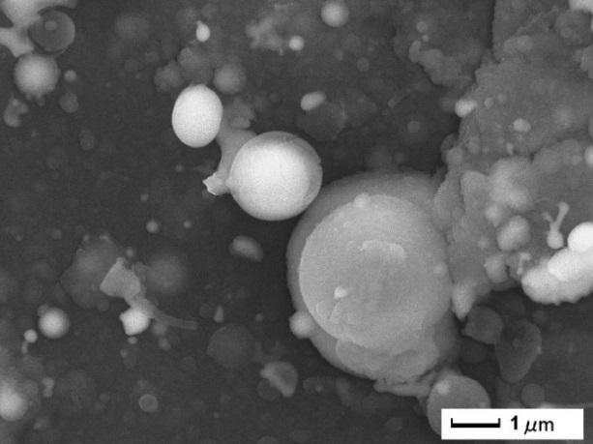 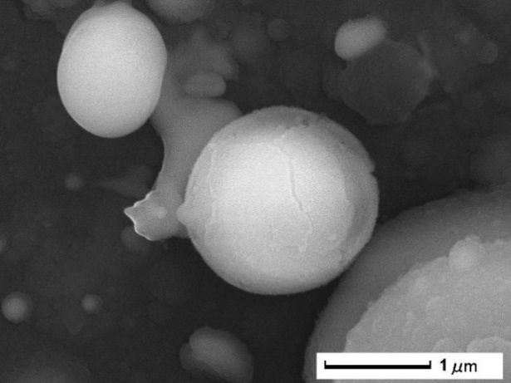

**(b)**

**(d)**

**(a)**

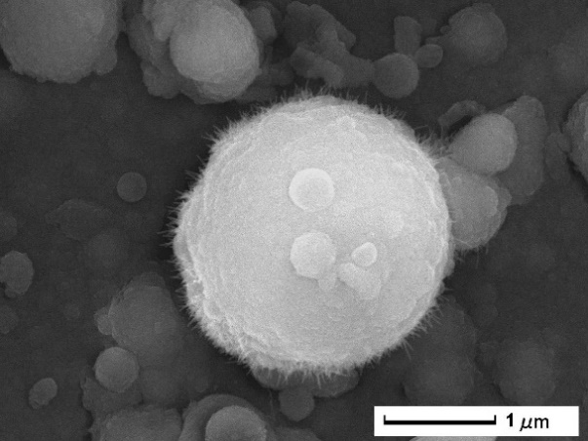 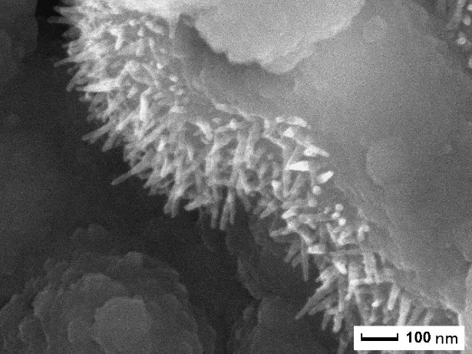

**(c)**

**(c)**

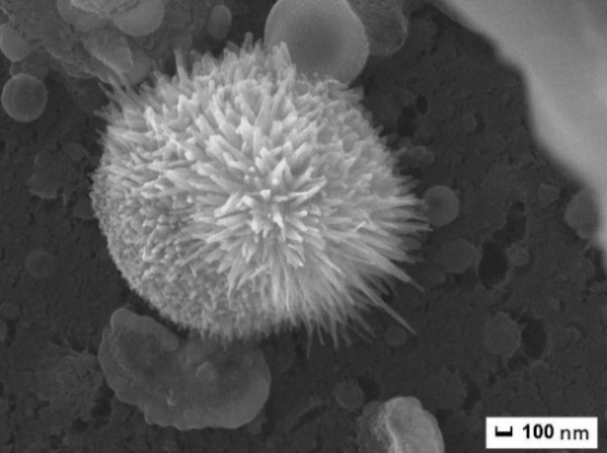 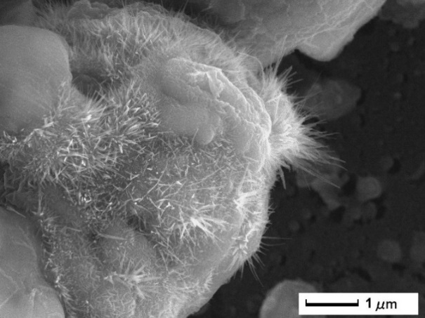

**(f)**

**(b)**

**(e)**

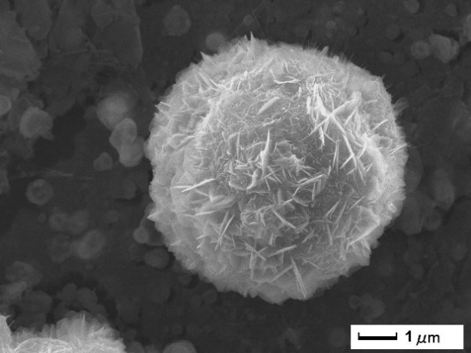 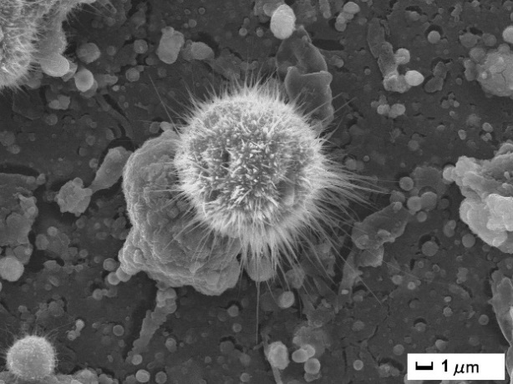

**(g)**

**(h)**

**(b)**

**Figure 1:** SEM images of as deposited coating (a & b) and that annealed at 500oC (c & d), 600°C (e,f &g) and 700°C (h) in air for 5 h.

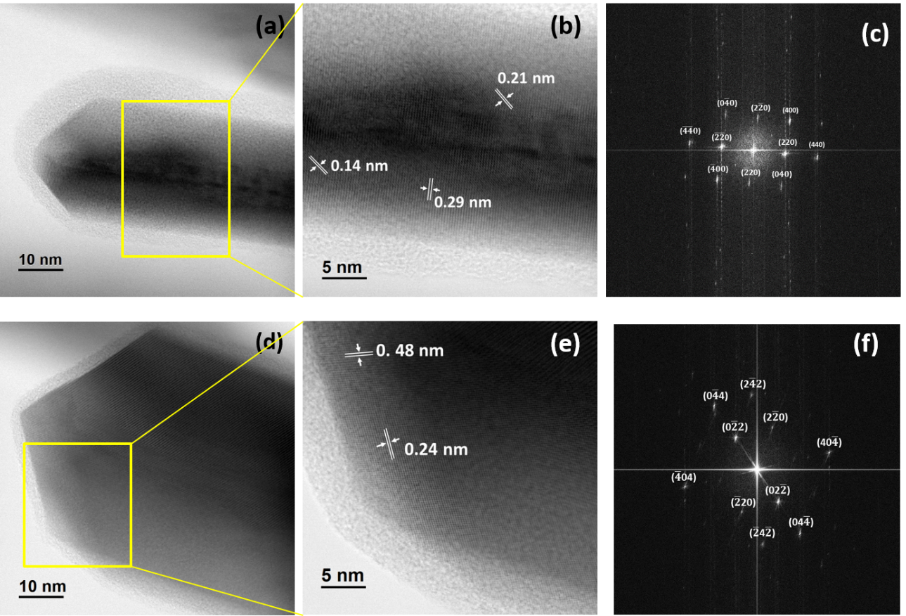

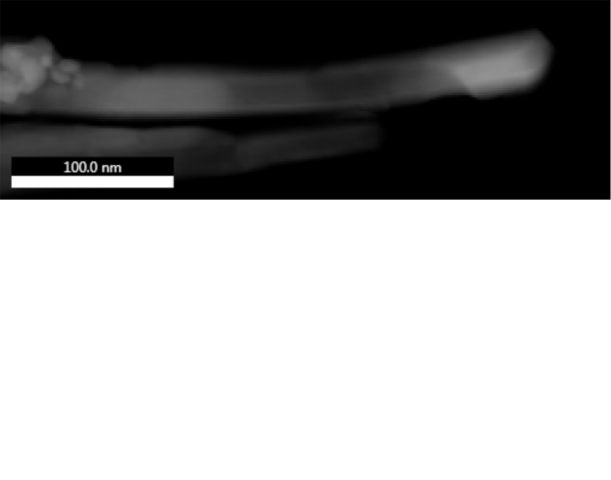 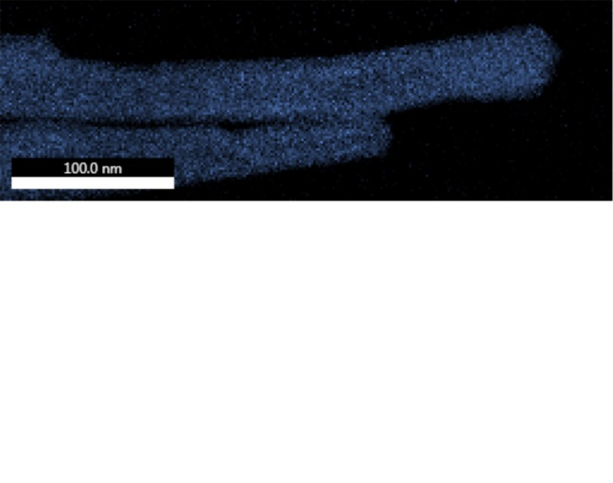 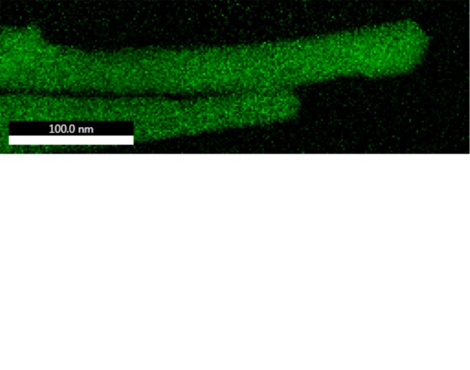 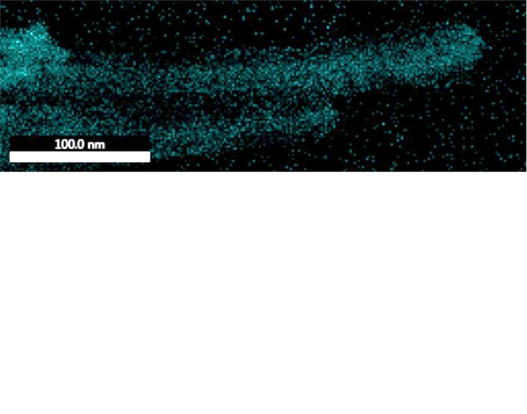

**Fe**

**Co**

**O**

**Figure 2:** TEM (a & d) and HRTEM (b & e) images of single nanowire of urchin stucture formed after annealing the coating at 600 oC for 5 h. The FFT converted electron diffraction patterns (c & f) could be indexed to CoFe2O4 and CoO phases present in this nanowire. Lower panel shows the elemental mapping for nanowires.

**(a)**



**(b)**



**Figure 3:** (a) XRD patterns of as deposited coating and, that annealed at 500˚C, 600˚C, and 700˚C in air for 5 h. (b) Raman Spectra of as deposited coating and that annealed at 600˚C in air for 5 h.



**Fe 2p**



**Co 2p**



**B 1s**



**O 1s**

**Figure 4:** XPS Spectra of Co 2p, Fe 2p, B 1s, and O 1s level of as deposited coating and that annealed at 500˚C, 600˚C, and 700˚C in air for 5 h.

**(b)**

**(a)**



**Figure 5:** XANES Spectra at (a) Fe L2,3 edge (b) Co L2,3 edge, of as deposited coating and that annealed at 600˚C in air for 5 h.

**(a)**



**(b)**



**Figure 6:** (a) UV-Vis absorbance spectra of the PLD deposited coating annealed at 600˚C in air for 5 h, and corresponding (b) Tauc plot to determine direct and indirect band-gap.



**Figure 7:** (a) Percentage degradation of MB dye after 60 mins in presence of PLD despoited coating annealed at 600 oC, H2O2 and visible light. (b) Comparison of performance for Co3O4 urchin-like, α-Fe2O3 hierarchical-like, and CoFe2O4/CoO urchin-like coatings deposited by PLD and annealed in air at 600 oC, for degradation of MB dye in presence of H2O2 and visible light.

**(a)**



**Figure 8:** Time dependent degradation ratio of MB dye solution in presence H2O2, and visible light (a) using mixed-oxide coatings, as deposited by PLD and that annealed at various temperatures 400 oC, 500 oC, 600 oC and 700 oC in air for 5 h and (b) using catalyst coating annealed at 600 oC in presence of isopropanol (IPA) of different molar ratio.

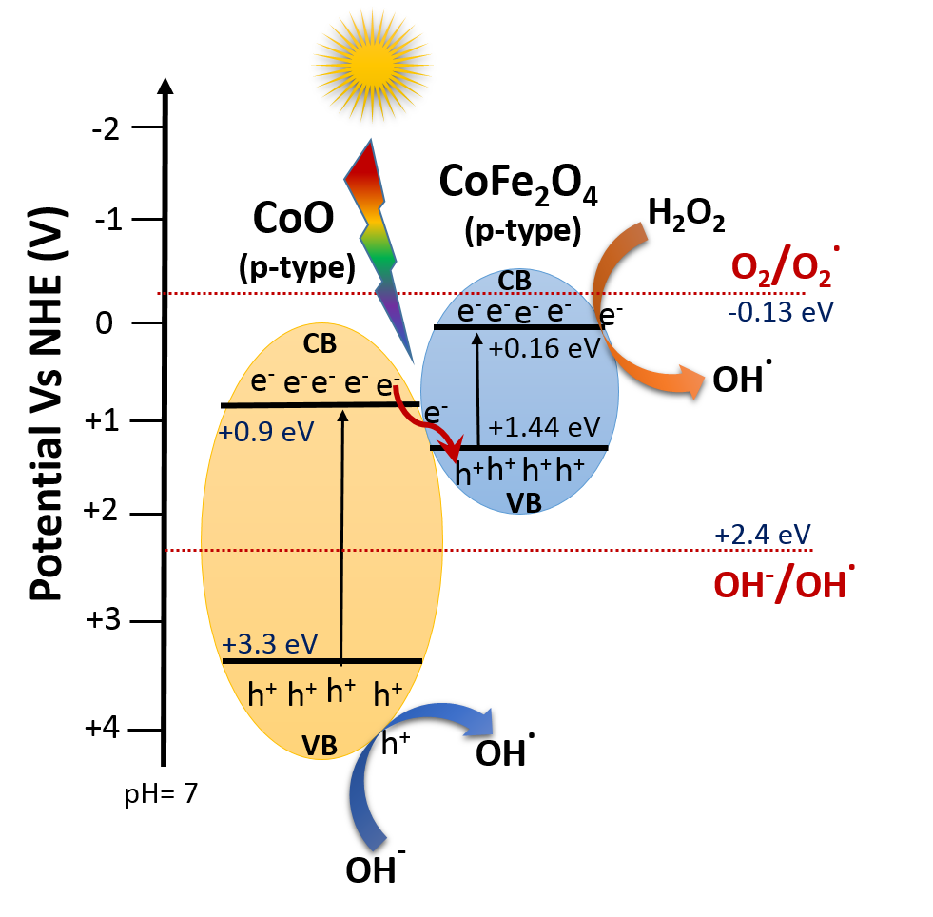

**Figure 9:** Schematic diagram of z-scheme junction between CoO and CoFe2O4 p-type semiconductors.